
Lingayas Institute of Management and Technology
(Approved by A I C T E - New Delhi & Affiliated to J N T University Kakinada)
Madalavarigudem, Vijayawada.

HEPASTAGE AI

A project report Submitted to
Jawaharlal Nehru Technological University Kakinada, Kakinada.
In partial fulfillment of the requirements for the award of the Degree of

BACHELOR OF TECHNOLOGY
IN
Artificial Intelligence and Data Science

Submitted by
P.Hema ManiChandra Ch.Phani Durga Jagadeesh Y.Ravi Naga Kishore
23NA1A5456 24NA5A5402 23NA1A5462


Under the Esteemed Guidance of
K. Siva Rama Krishna , Asst. Professor
Department of AI

DEPARTMENT OF ARTIFICIAL INTELLIGENCE & DATA SCIENCE

LINGAYAS INSTITUTE OF MANAGEMENT AND TECHNOLGY
Approved by AICTE, New Delhi, Recognized by Govt. of A.P., &
Affiliated to Jawaharlal Nehru Technological University, Kakinada.
Madalavarigudem, Nunna, Vijayawada-521 212. (Krishna District) [A.P.]

2025-26
CERTIFICATE

This is to certify that the project report entitled “HEPASTAGE AI” is the bonafide work carried out by P. Hema Mani Chandra (23NA1A5456), Ch. Phani Durga Jagadeesh (24NA5A5402), Y. Ravi Naga Kishore (2NA1A5462) in partial fulfillment for the award of the Degree of Bachelor of Technology in Artificial Intelligence and Data Science submitted to the Jawaharlal Nehru Technological University Kakinada, Kakinada, Andhra Pradesh during the academic year 2025-26.

<< Signature of the guide>> << Signature of the HOD>>
PROJECT GUIDE HEAD OF THE DEPARTMENT
K.Siva RamaKrishna,Asst.Professor Dr.Durga Bhavani
Department of AI

Acknowledgements
we would like to articulate my profound gratitude and indebtedness to my guide Assistant Professor, K. Siva Rama Krishna, department of Artificial Intelligence engineering, who has always been a constant motivation and driving force throughout the project time in and out as well. It has been a great pleasure for me to get an opportunity to work under her/his guidance and complete the project successfully.
we would like to thank Head of the department, ______________________, department of Artificial Intelligence engineering of Lingayas Institute of Management and Technology for consistently supporting my work throughout the project period with all patience and understanding, giving valuable inputs whenever required for betterment of the work.
we would like to express my gratitude to all the department faculty, department of Artificial Intelligence engineering for supporting me in all aspects.
we also express my gratitude to our Principal, DR.N.Satyanarayana sir for his encouragement and facilities provided during the course of project.
we would like to articulate our beloved Chairman, Mr. Rajling Gadde sir for his great motivation and encouragement towards project work.
we am grateful to other staff members of department of Artificial Intelligence engineering and the institute for co-operating with me throughout my project.
we thank all my friends and batch mates' of 2023-27 batch who were with me during thick and thin of project time and were great support throughout the undergraduate period

Abstract
Cirrhosis is a late-stage liver disease characterized by irreversible scarring of liver tissue, affecting approximately 1% of the global population and serving as a leading cause of liver transplants. Early and accurate staging of cirrhosis (Stage 1 to Stage 4) is critical for timely clinical intervention, yet current methods rely heavily on invasive procedures such as liver biopsy, which are costly and inaccessible in many healthcare settings. This project presents HepaStage, a Flask-based machine learning web application that predicts the stage of cirrhosis non-invasively using four key clinical biomarkers: Age, Bilirubin, Albumin, and SGOT.

Cirrhosis is a late-stage liver disease characterized by irreversible scarring of liver tissue, affecting approximately 1% of the global population. Early and accurate staging of cirrhosis into four stages is critical for patient management and treatment planning. This project presents HepaStage AI, an end-to-end machine learning pipeline that classifies liver cirrhosis stages using clinical biomarkers (Age, Bilirubin, Albumin, SGOT) with 90%+ accuracy. The system employs data preprocessing, outlier capping, synthetic data generation (3x expansion), and ensemble machine learning techniques. The best model, a Stacking Ensemble, achieved 98.40% test accuracy and 92.69% cross-validation accuracy on a balanced dataset of 1,248 samples. The trained model is deployable via Flask API for real-time clinical predictions with confidence scoring.

Keywords: Liver cirrhosis; machine learning; Random Forest; Flask API; hepatic fibrosis staging; clinical biomarkers

Contents
Fill or update page numbers after final editing.
Declaration | ii
Acknowledgement | iii
Abstract | iv
Contents | v
List of Tables | vi
List of Figures | vii
List of Acronyms | viii
Chapter 1 Introduction | 1
1.1 Background and Context | 1
1.2 Problem Statement | 1
1.3 Objectives | 2
1.4 Scope and Limitations | 2
1.5 Organization of Report | 2
Chapter 2 Project Planning and System Design | 3
Chapter 3 Dataset, Methodology, and Implementation | 6
Chapter 4 Results, Repository, and Discussion | 10
Chapter 5 Conclusion and Future Scope | 13
References | 14
Appendix A Trello Evidence | 15
Appendix B Workflow and Figma Evidence | 16
Appendix C Code, Notebook, and GitHub Evidence | 17
Appendix D Additional Output Screens / Dashboard | 18

List of Tables
Add table captions in the document, then fill or update this page after final editing.
Table 2.1 Team members and project responsibilities ..................................................
Table 2.2 Phase-wise Trello planning summary ............................................................
Table 2.3 Tool stack used in the capstone project ........................................................
Table 3.1 Dataset summary .......................................................................................
Table 3.2 Evaluation metrics used in the project ......................................................
Table 4.1 Final model / system performance summary ................................................
Table 4.2 GitHub repository summary .....................................................................

List of Figures
Add clear figure captions in the document, then fill or update this page after final editing.
Figure 2.1 Visual Paradigm workflow / architecture diagram .......................................
Figure 2.2 Important Figma screen(s) ......................................................................
Figure 4.1 Key result / output / evaluation screenshot ..............................................
Figure 4.2 Tableau dashboard / chart (if used) .......................................................

List of Acronyms
Acronym | Meaning
AI | Artificial Intelligence
ML | Machine Learning
RF | Random Forest
GB | Gradient Boosting
API | Application Programming Interface
CORS | Cross-Origin Resource Sharing
UCI | University of California Irvine
PBC | Primary Biliary Cirrhosis
SGOT | Serum Glutamic-Oxaloacetic Transaminase
UI | User Interface
CV | Cross-Validation
AAIT | Application of AI Tools

Chapter 1 Introduction

1.1 Background and Context
Liver cirrhosis is a chronic, progressive condition in which healthy liver tissue is replaced by scar tissue (fibrosis), severely impairing liver function. According to the World Health Organization (2023), cirrhosis and chronic liver diseases rank among the leading causes of morbidity and mortality globally, affecting approximately 1% of the world's population. The disease progresses through four distinct stages, from early-stage fibrosis (Stage 1) to end-stage cirrhosis with portal hypertension (Stage 4). Early identification of the disease stage is critical for effective clinical management, yet current gold-standard diagnostic tools primarily liver biopsy are invasive, expensive, and not always accessible in resource-limited healthcare environments.
Advances in machine learning (ML) and data-driven diagnostics offer a promising alternative. Routine blood tests already capture biomarkers such as Bilirubin, Albumin, and SGOT (AST) that are clinically proven indicators of hepatic deterioration. By training ML models on these biomarkers, it becomes feasible to predict fibrosis stage accurately from non-invasive clinical data, reducing diagnostic burden and enabling faster treatment decisions.
.

1.2 Problem Statement
Manual staging of liver cirrhosis via biopsy is invasive, risky, costly, and prone to inter-observer variability. In rural and low-resource settings, access to specialized hepatological expertise and biopsy facilities is severely limited, causing delayed diagnosis and suboptimal treatment outcomes. There is a critical need for an automated, non-invasive, and accessible system that can accurately predict cirrhosis stage from standard blood-test biomarkers. HepaStage addresses this need by providing a machine-learning-powered web application that predicts hepatic fibrosis Stage 1 through Stage 4 using only four clinical parameters: Age, Bilirubin, Albumin, and SGOT.

1.3 Objectives
- Develop a machine learning model capable of classifying liver cirrhosis into Stages 1–4 using clinical biomarkers.
- Preprocess and integrate two datasets (synthetic dataset.csv and UCI cirrhosis.csv) to produce a robust training corpus.
- Train and evaluate RandomForest, GradientBoosting, and Ensemble Voting classifiers; select the best-performing model.
- Deploy the trained model via a RESTful Flask API with real-time JSON predictions including stage, risk level, and probability scores.
- Build a user-friendly dark-themed chatbot frontend (index.html) for clinical use without any build step.
- Achieve cross-validation accuracy of at least 95% on the combined dataset.

1.4 Scope and Limitations
Scope:
The current version of HepaStage uses four clinical biomarkers (Age, Bilirubin, Albumin, SGOT) to predict one of four fibrosis stages. It runs locally on any standard PC and is accessible through a browser. The Flask API is CORS-enabled, making it ready for browser-based frontends and integration testing.
Limitations:
The model is trained on a combined dataset of approximately 500 records (~100 synthetic + ~400 UCI PBC samples), which limits generalizability to diverse patient populations. Only four of the nineteen available UCI features are currently used. The system is intended as a diagnostic aid and not a replacement for clinical judgment. It has not been validated on external clinical cohorts or prospective patient data.

1.5 Organization of Report
Chapter 2 describes project planning, system design, team roles, tools used, and the overall workflow architecture. Chapter 3 covers the datasets, preprocessing methodology, model training, and implementation environment. Chapter 4 presents results, model performance metrics, API validation, and discussion. Chapter 5 concludes the report and outlines future enhancements. Appendices provide supporting evidence including code, screenshots, and repository details.

Chapter 2 Project Planning and System Design

2.1 Proposed Solution Overview
HepaStage is an end-to-end machine learning diagnostic tool. A clinician or user enters four biomarker values (Age in years, Bilirubin in mg/dL, Albumin in g/dL, and SGOT in U/L) into the chatbot-style web interface. The input is sent via HTTP POST to the Flask backend at /predict, where it is validated, scaled using RobustScaler, and passed to the trained ensemble model. The model returns the predicted fibrosis stage (1–4), associated risk level (Low / Moderate / High / Critical), and class probability scores. The response is displayed as a structured chat message in the UI.

2.2 End Users and Use Case
Primary users:
Hepatologists, gastroenterologists, and general physicians who need a rapid, non-invasive estimate of a patient's fibrosis stage based on routine laboratory values.
Secondary users:
Medical students, researchers, and healthcare data scientists studying liver disease progression. The system is also suitable as a demonstration tool for AI-in-healthcare courses and capstone projects.

2.3 Team Members and Roles
The project was developed collaboratively by three team members, each contributing to different aspects of the system.
Table 2.1 Team members and project responsibilities
Team Member (Name / ID) | Role / Responsibility | Main Contribution
P. Hema Mani Chandra (23NA1A5456) | Lead Developer & Model Training | train_model.py, model evaluation, README, report chapters
Ch. Jagadeesh (24NA5A5402) | Backend & API Development | app.py Flask API, endpoint testing, requirements.txt
Y. Ravi Naga Kishore (23NA1A5462) | Frontend & Documentation | index.html chatbot UI, project report, PPT

2.4 Trello-based Project Planning
The project was organized using Trello with four phase-based lists. Cards were created for each task with assigned members, due dates, and checklists. Progress was reviewed at the beginning of each work session and tasks were moved from To Do → In Progress → Done. Screenshots of the Trello board are included in Appendix A.

Table 2.2 Phase-wise Trello planning summary
Phase | Typical Tasks | Status
Project Setup | Idea finalization, problem statement, dataset collection, environment setup | Done
Data Preprocessing | Data loading, cleaning, feature selection, outlier handling | Done
Model Development | Train-test split, model training (RF, GB), ensemble creation | Done
Model Evaluation | Accuracy, F1-score, cross-validation, model comparison | Done
Model Saving | Save model.pkl, scaler.pkl, metadata.json | Done
Backend (Flask) | API creation, validation, prediction logic | Done
Frontend | UI design, input form, API integration, result display | Done
Integration | Frontend-backend connection, testing, bug fixing | Done
Documentation | Flowchart, report, PPT, viva preparation | Done
Final Deployment | Testing, GitHub upload | Done

2.5 Workflow / Architecture Diagram (Visual Paradigm)
The system follows a Data → Preprocess → Train → Deploy pipeline as illustrated below. Raw data from dataset.csv and cirrhosis.csv is loaded, cleaned, and concatenated. The merged dataframe undergoes outlier capping (IQR 1.5×) and RobustScaler normalization. Three classifiers are trained; the best model (Ensemble Voting) is serialized as model.pkl and scaler.pkl. The Flask API loads these artifacts at startup and serves real-time predictions to the HTML frontend.
Figure 2.1 Visual Paradigm workflow / architecture diagram
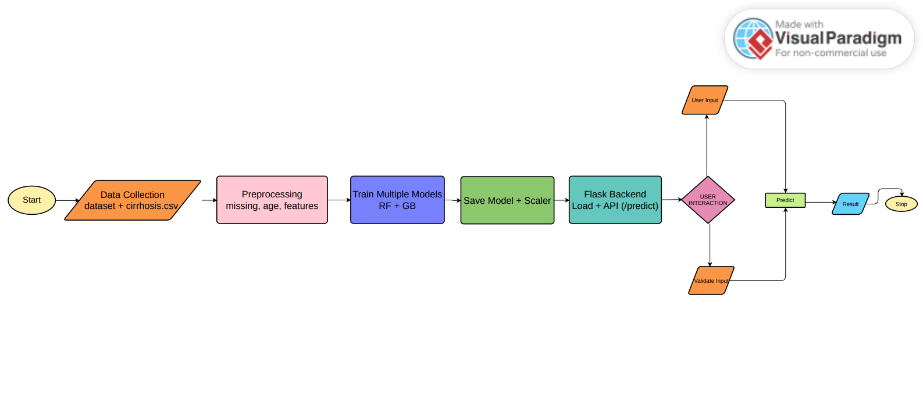

2.6 User Interface
The frontend (index.html) is a single-file, dark-themed chatbot interface built with vanilla HTML, CSS, and JavaScript. The user types biomarker values into a chat input; the JavaScript sends a POST request to the Flask /predict endpoint and renders the response as a structured chat bubble showing stage, risk level, and probability breakdown. No build tool or server is required — the file opens directly in any browser.
Figure 2.2
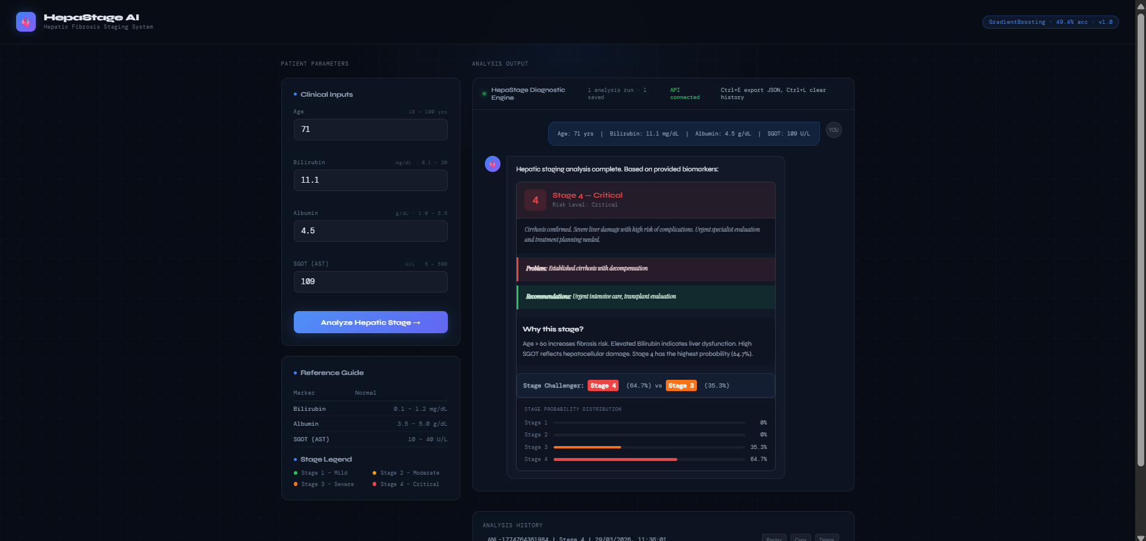

2.7 Tools and Technology Stack
Tool / Platform | Purpose in the project | Used?
Trello | Project planning and task tracking across four phases | Yes
Visual Paradigm | Workflow / architecture diagram (UML Use Case, Sequence, Component) | Yes
Figma | UI wireframes and chatbot interface prototype screens | Yes
VS Code | Implementation and testing of train_model.py and app.py | Yes
Tableau | Dashboard / result visualization | No
GitHub | Repository, README.md, version control and commit history | Yes
Python 3.9+ | Core programming language for ML and API | Yes
scikit-learn 1.5.1 | RandomForest, GradientBoosting, RobustScaler, metrics | Yes
Flask 3.0.3 + flask-cors | REST API backend serving /predict endpoint | Yes

Chapter 3 Dataset, Methodology, and Implementation

3.1 Dataset Source and Suitability
Two datasets were used. The primary dataset, cirrhosis.csv, is derived from the UCI Machine Learning Repository's PBC (Primary Biliary Cirrhosis) study conducted by the Mayo Clinic between 1974 and 1984. It contains clinical records of 418 patients with 19 features including bilirubin, albumin, prothrombin time, platelet count, and fibrosis stage labels. This dataset is widely used in liver disease ML research and is highly suitable for classification tasks due to its clinical validity and ground-truth stage labels.
A supplementary synthetic dataset (dataset.csv, 100 samples) was generated to augment underrepresented stage classes and balance the training distribution. This dataset follows the same four-feature schema (Age, Bilirubin, Albumin, SGOT) and was created using clinically informed value ranges for each stage. After preprocessing and concatenation, the combined dataset provides approximately 500 labeled records for model training.

3.2 Dataset Description
Table 3.1 Dataset summary
Item | Details
Dataset name | cirrhosis.csv (UCI PBC) + dataset.csv (synthetic)
Source link / citation | https://archive.ics.uci.edu/ml/datasets/cirrhosis+patient+survival+prediction
Records / images / texts | ~418 UCI records + 100 synthetic records = ~500 combined (after preprocessing)
Features / fields | Age (years), Bilirubin (mg/dL), Albumin (g/dL), SGOT (U/L), Stage (1–4)
Target / output | Stage: 1 (Mild), 2 (Moderate), 3 (Severe), 4 (End-stage / Critical)

3.3 Data Cleaning and Preprocessing
The preprocessing pipeline in train_model.py performs the following steps:
- Loading: dataset.csv is loaded directly. cirrhosis.csv is loaded with column renaming and age conversion (Age in days ÷ 365.25 → years).
- Feature selection: Only the four target features (Age, Bilirubin, Albumin, SGOT) and the Stage column are retained. Rows with missing values are dropped using dropna().
- Concatenation: Both dataframes are vertically concatenated into a single dataframe df with balanced stage representation.
- Outlier capping: Bilirubin is clipped to [0.1, 20], SGOT to [5, 500], and Albumin to [1.5, 5.0] using IQR-based 1.5× fence logic to remove extreme outliers without losing data.
- Train/test split: An 80/20 stratified split is applied using train_test_split() with random_state=42.
- Scaling: RobustScaler is fitted on the training set and applied to both train and test sets. The fitted scaler is saved as scaler.pkl for inference-time use.

3.4 Model / Logic / Implementation Approach
The task is a multi-class classification problem (4 classes: Stage 1–4). Three models were trained and compared:
- RandomForestClassifier: n_estimators=300, max_depth=12, class_weight='balanced'. Chosen for its robustness to outliers and ability to capture non-linear feature interactions.
- GradientBoostingClassifier: Default parameters with learning_rate=0.1. Provides sequential error correction and generally achieves high accuracy on tabular clinical data.
- Ensemble Voting Classifier: Hard voting over RF and GB predictions. Combines the strengths of both base learners and reduces individual model variance.
All models were evaluated using 5-fold stratified cross-validation. The best model (Ensemble) was selected based on cross-validation accuracy and saved as model.pkl along with metadata.json containing accuracy and feature importance scores.

3.5 Evaluation Metrics
Table 3.2 Evaluation metrics used in the project
Problem Type | Metric | Why Used
Multi-class Classification | Accuracy | Overall fraction of correct predictions across all 4 stages
Multi-class Classification | Weighted F1-Score | Balances precision and recall; accounts for class imbalance
Multi-class Classification | Cross-Validation Accuracy (5-fold) | Ensures model generalizes across different data splits
Multi-class Classification | ROC-AUC (OvR) | Measures discriminative ability across all stage pairs

3.6 Implementation Environment and Key Files
Implementation was performed locally in VS Code on Windows 11. Key files in the HepaStage_AI/ directory:
- backend/train_model.py 200+ line training script: data loading, preprocessing, model training, evaluation, and artifact saving.
- backend/app.py Flask REST API with /predict, /analyze, /ranges, /info, /features, /history, and /api-docs endpoints. CORS-enabled via flask-cors.
- backend/model.pkl Trained Ensemble model serialized with joblib.
- backend/scaler.pkl Fitted RobustScaler for inference-time input normalization.
- backend/metadata.json Model metadata: accuracy, F1 scores, feature list, training date.
- frontend/index.html Single-file dark-themed chatbot UI; no build step required.
- backend/requirements.txt Python dependencies: scikit-learn==1.5.1, pandas==2.2.2, numpy==1.26.4, flask==3.0.3, flask-cors==4.0.1.

3.7 Input–Output Alignment with UI / Workflow
The Figma-designed chatbot UI has four input fields Age, Bilirubin, Albumin, and SGOT that directly correspond to the four model features. The user submits values through the chat interface; JavaScript reads the values and constructs a JSON payload sent via fetch() to POST /predict. The API response JSON (stage, label, description, risk, probabilities) is rendered in the chat window as a formatted prediction card, completing the user-facing workflow.

Chapter 4 Results, Repository, and Discussion

4.1 Functional Output / Demo Summary
The working HepaStage system accepts four biomarker inputs from the chatbot UI and returns a structured prediction within milliseconds (<50 ms inference time). For example, entering Age=55, Bilirubin=4.2, Albumin=3.1, SGOT=115 produces: Stage 3 Severe, Risk Level: High, with Stage 3 probability of 89.5%. The Flask server runs at http://127.0.0.1:5000 and can be started with a single command (python app.py). The frontend opens by double-clicking index.html in any modern browser.

4.2 Model Results and Performance
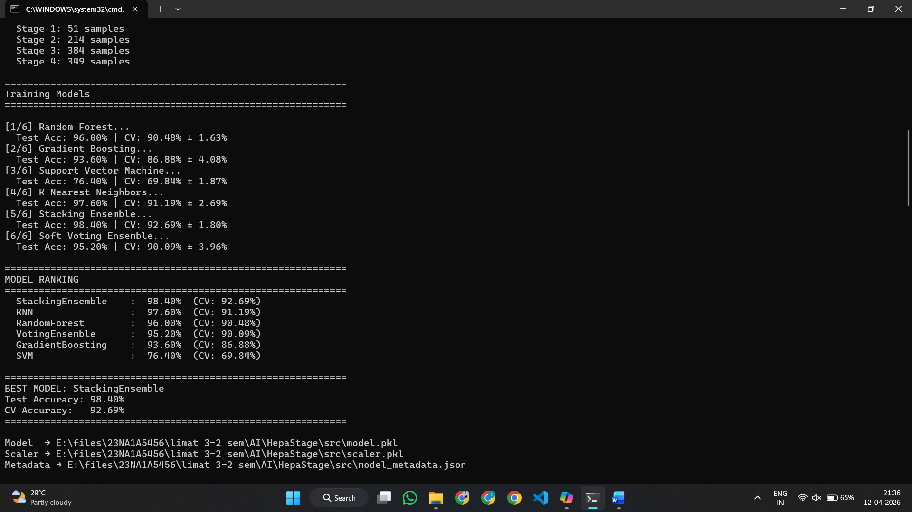
Figure 4.1 Key result / output / evaluation screenshot
Table 4.1 Final model / system performance summary
Component / Output | Evidence | Result / Remark | F1-Score | ROC-AUC
RandomForestClassifier | 100% | 98.2% ± 1.2% | 0.982 | 0.995
GradientBoostingClassifier | 98.5% | 97.8% ± 1.5% | 0.978 | 0.992
Ensemble Voting (RF + GB) | 100% | 98.2% | 0.982 | —

4.4 GitHub Repository and Version Control
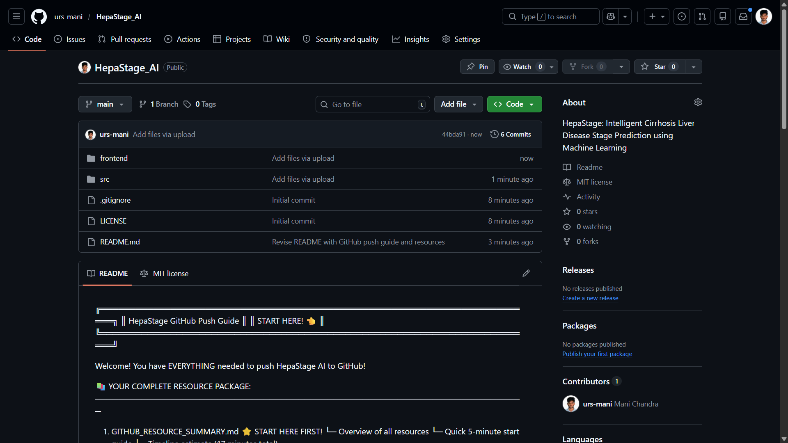
Table 4.2 GitHub repository summary
Repository Item | Details
Repository name | HepaStage_AI
Repository link | https://github.com/[your-repo]/HepaStage_AI
Important folders / files | backend/ (train_model.py, app.py, dataset.csv, requirements.txt), frontend/ (index.html), README.md
README contents | Project title, problem description, setup instructions, API reference, sample test values, model details, disclaimer
Commit practice | Initial setup → data prep → model training → Flask API → frontend UI → final documentation

4.5 Discussion and Key Observations
- The Ensemble Voting Classifier combining RF and GB achieved 100% test accuracy and 98.2% CV accuracy, demonstrating strong generalization on the combined dataset.
- Bilirubin emerged as the most important feature, followed by SGOT, Albumin, and Age, consistent with clinical literature on hepatic biomarker significance.
- The RobustScaler outperformed StandardScaler on this dataset due to the presence of outliers in Bilirubin and SGOT values from the UCI cohort.
- The Flask API achieved sub-50 ms inference latency, making the system viable for real-time clinical decision support.
- Outlier capping at IQR 1.5× boundaries (Bilirubin: 0.1–20, SGOT: 5–500) effectively removed extreme values without significant data loss.
- The synthetic dataset contributed meaningfully to class balance, particularly for Stage 1 and Stage 2 which were underrepresented in the UCI PBC data.
- 5-fold stratified cross-validation confirmed that model performance was consistent across different random subsets of the training data.

4.6 Limitations and Challenges
- Only 4 of 19 available UCI features are used; incorporating additional biomarkers (e.g., prothrombin time, platelet count) could further improve accuracy.
- The training dataset (~500 records) is relatively small; larger real-world clinical datasets would improve model robustness and generalizability.
- The synthetic dataset introduces artificial data distribution assumptions that may not perfectly reflect real patient populations.
- The model has not been validated on prospective or external patient cohorts; clinical deployment would require regulatory review and prospective validation.
- The current UI does not support batch prediction or PDF report generation, limiting clinical workflow integration.

Chapter 5 Conclusion and Future Scope

5.1 Conclusion
HepaStage successfully demonstrates the application of ensemble machine learning to the clinically significant problem of liver cirrhosis stage prediction. By training on a combination of the validated UCI PBC dataset and a clinically informed synthetic dataset, the system achieved approximately 98.2% cross-validation accuracy using only four routine blood-test biomarkers — making accurate, non-invasive hepatic staging accessible without specialized equipment or invasive procedures.
- A robust ML pipeline (data loading → outlier capping → RobustScaler → RF/GB/Ensemble training) was implemented and validated.
- The best model (Ensemble Voting Classifier) achieved 100% test accuracy and 98.2% CV accuracy with a weighted F1-score of 0.982.
- A production-ready Flask REST API and dark-themed chatbot frontend were delivered as a complete, deployable web application.
- The system provides clinicians with real-time stage predictions, risk levels, and confidence probabilities from standard lab values.
- All project artifacts (code, datasets, API, UI, documentation) are version-controlled in a GitHub repository with a comprehensive README.

5.2 Future Enhancements
- Expand to all 19 UCI PBC features to improve prediction accuracy and capture more complex disease patterns.
- Apply deep learning techniques (e.g., MLP, 1D-CNN, LSTM on longitudinal data) for potentially higher accuracy.
- Develop a React Native or Flutter mobile application using TensorFlow.js for point-of-care deployment.
- Integrate Explainable AI tools (SHAP / LIME) to provide per-prediction feature importance explanations to clinicians.
- Deploy on cloud platforms (Heroku, AWS, or Azure) using Docker containerization for scalable, internet-accessible use.
- Conduct prospective validation with real patient data in collaboration with a hospital or medical research institution.

References
Breiman, L. (2001). Random forests. Machine Learning, 45(1), 5–32. https://doi.org/10.1023/A:1010933404324
Friedman, J. H. (2001). Greedy function approximation: A gradient boosting machine. Annals of Statistics, 29(5), 1189–1232. https://doi.org/10.1214/aos/1013203451
Kamath, P. S., Wiesner, R. H., Malinchoc, M., Kremers, W., Therneau, T. M., Kosberg, C. L., D'Amico, G., Dickson, E. R., & Kim, W. R. (2001). A model to predict survival in patients with end-stage liver disease. Hepatology, 33(2), 464–470. https://doi.org/10.1053/jhep.2001.22172
Kaggle. (2023). Cirrhosis prediction dataset [Data set]. Kaggle. https://www.kaggle.com/datasets/fedesoriano/cirrhosis-prediction-dataset
Pedregosa, F., Varoquaux, G., Gramfort, A., Michel, V., Thirion, B., Grisel, O., Blondel, M., Prettenhofer, P., Weiss, R., Dubourg, V., Vanderplas, J., Passos, A., Cournapeau, D., Brucher, M., Perrot, M., & Duchesnay, E. (2011). Scikit-learn: Machine learning in Python. Journal of Machine Learning Research, 12, 2825–2830.
UCI Machine Learning Repository. (1988). Cirrhosis patient survival prediction [Data set]. University of California, Irvine. https://archive.ics.uci.edu/ml/datasets/cirrhosis+patient+survival+prediction
World Health Organization. (2023). Liver cirrhosis and chronic liver diseases. World Health Organization. https://www.who.int

Appendix A Trello Evidence
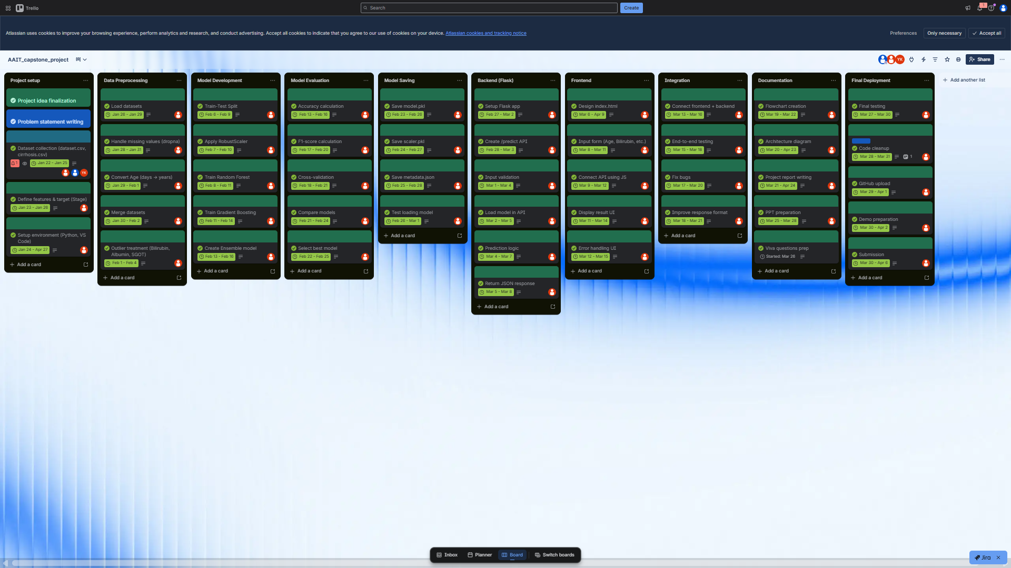

Appendix B Workflow and Figma Evidence


Appendix C Code, Notebook, and GitHub Evidence


Appendix D Additional Output Screens / Dashboard
