**Description**

This java executable file, AlgoScreen.jar is developed based on JDK 1.7, you need to have the same or higher version of JRE to run it. Log file will be generated at the folder you place the AlgoScreen.jar file.

The program consists of 3 parts.

1. Market Data Screen - Price depth up to 10 level for both Binance and Huobi
2. Algo Setting – the input parameter of the Algo.
3. Arbitrage Algo
   1. The Algo will fire order when trading condition meet, the earning of long and short for the same currency pair at 2 different exchange > transaction cost
   2. The Algo can be tested by lower the commission where the trading condition can meet easily
   3. The order fired will display in order book.

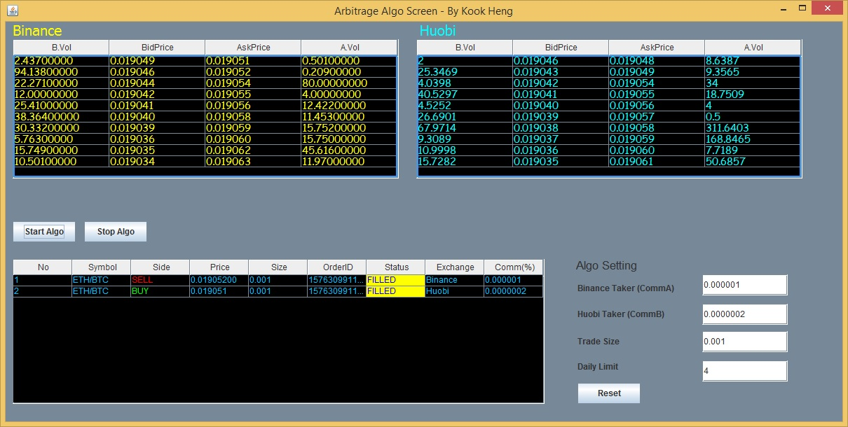

* After order fired, the Algo will stop. This is due to an UI update issue in order book which I haven’t resolved it yet. Let me know if this is crucial for this assessment, I will spend some time to fix this.

**Assumption / Limitation**

1. The Algo has not real order execution
2. The price and order only working for ETH/BTC pair.
3. The arbitrage Algo fire order based on the assumption the Algo is fast enough to hit the best bid or best ask on both exchanges. No exist strategy like scratching or cut lost if price move.
4. The Algo assumed to be executed at minimum quantity, no volume check on best price for both exchange.
5. Withdrawal fee for the traded currency at exchange are not included in the transaction cost of arbitrage.
6. The transaction cost is assumed based on the taker fee. There is not quoting mechanism in this Algo. It can reduce cost by using maker fee but it involve more complicated handling as exchange has restriction on number of quoting per min.