SHORT INTRODUCTION

METHODS & MATERIALS

This thesis consists of optimization, a longitudinal study of microbiota and sporobiota and additional cultivation of selected spore-forming bacteria from one individual’s ethanol-treated stool. First, we tested methods for isolation of bulk DNA from stool samples and optimized isolation of spore-forming bacteria’s DNA from stool samples. This study tracked the gut microbiota and sporobiota of nine healthy male individuals over six months using two DNA isolation methods: bulk and ethanol treated. DNA was sequenced using V3-V4 region of the 16S rRNA gene as well as shotgun metagenomic sequencing. Using this data, we noticed a reduction in microbial diversity and increase in sporulation frequency in individual who also went through antibiotic therapy mid-sampling. His samples were used for cultivation of Clostridium saudiense and molecular characterisation using whole genome sequencing.

2.1 LONGITUDINAL HUMAN STOOL COLLECTION
Stool samples used in this work were collected from nine healthy, non-related and non-cohabitating male participants, aged 25 – 43, with no gastrointestinal infections or surgeries within three months prior to the study. Antibiotic use before or during the study was not an exclusion criterion. At the onset, each participant completed a questionnaire on health status and history, diet, and living conditions (Supplement A, Supplement Table 1). Stool samples were collected in 14-day intervals and additionally at pre-determined events (dental visits, antibiotic treatment, travel, etc.) over a six-month period, with questionnaires filled out at each sample submission (Supplement A). The participants used sterile collection containers for sampling and delivered the samples to the laboratory within a few hours of collection. If immediate delivery was not possible, samples were stored at -20 °C until transport. Upon receipt, each sample was homogenized, divided into five aliquots (one 10 µl inoculation loop per aliquot), and stored at -80 °C. Ethical approval was obtained from the National Medical Ethics Committee of the Republic of Slovenia (0120-280/2022/6).

2.2 COMPARISON OF ISOLATION PROTOCOLS FOR BACTERIAL DNA FROM HUMAN STOOL SAMPLES
We compared four different DNA isolation protocols: QIAamp PowerFecal Pro DNA Kit, QIAamp Fast DNA Stool Mini Kit (Qiagen, Germany), NucleoSpin Soil Mini Kit (Macherey-Nagel, Germany) and one in-house protocol based on DNeasy Blood&Tissue kit (Qiagen, Germany) (Supplement Table 2). DNA was isolated in triplicates from three stool samples and negative control containing 250 µl nuclease-free water. The samples were handled according to the manufacturer’s instructions with the following modification: for FastDNA and DNeasy protocol additional mechanical lysis (half-and-half 0.1- and 0.5-mm zirconia beads) on MagnaLyser for 30 s at 7000 rpm was used. Final elution of DNA was in 100 µl of nuclease-free water. DNA concentration was measured with Quant-iT™ PicoGreen™ dsDNA Assay and dsDNA Reagents (Invitrogen™, US).

2.3 COMPARISON OF HEAT VS. ETHANOL SHOCK FOR ELIMINATION OF VEGETATIVE CELLS FROM STOOL SAMPLES
We compared different variations of ethanol and heat shock on stool samples to determine, which treatment is more effective for elimination of vegetative cells and later isolation of spore-forming bacteria from stool samples in culture and for DNA isolation from spores only.

2.3.1 Cultivation of spore-forming bacteria from human stool samples after ethanol or heat shock

There are two generally used treatments for elimination of vegetative cells from pure cultures of spore-forming bacteria, heat shock and ethanol shock with multiple variations (Setlow, 2014). We choose to test ethanol shock using 100% and 70% ethanol and heat shock performed at 80 °C for 30 or 60 min. Two stool samples were aliquoted and subjected to shock treatment. For ethanol shock, aliquots were resuspended in 1,5 ml of 70% or 100% ethanol and incubated for 24 h with vigorous shaking (1500 rpm) on thermomixer (Eppendorf, Germany) at room temperature (23 °C). For heat shock, stool aliquots were resuspended in 1,5 ml of 0.9% NaCl solution and heated for 30 or 60 min at 80 °C with vigorous shaking (1500 rpm) on thermomixer (Eppendorf, Germany). After the shock treatment samples were washed 3 times with distilled water. At the last washing step, each sample was separated in half. One half of the pellet was resuspended in 500 µl distilled water and second was resuspended in 500 µl 5% bile acids solution (Sigma-Aldrich, USA). The resuspended pellets were plated in whole on BHIS agar medium (1,5% agar) or added to liquid BHIS media. BHIS is composed of brain-heart infusion (BHI, Biolife, Italy) with 0.1% L-cysteine (Merck, USA) and 0.5% yeast extract (Biolife, Italy). Incubation took place in the anaerobic workstation (Whitley A35, Don Whitley Scientific, UK) at 37 °C for 14 days. On the 1st, 2nd, 5th, 7th, and 14th day colony forming unit (CFU) was counted on plates or 100 µl of liquid culture was plated confluently and CFU was counted the next day. On the 2nd, 5th, 7th, and 14th day two plates were swabbed in whole or 0,5 ml of liquid culture was used for DNA isolation. DNA was isolated using MasterPure™ Complete DNA and RNA Purification Kit (Lucigen, US) with a pre-step of bead-beating the sample in Cell Lysis Solution with 0,5 g of 0,5 mm silica beads. Bead-beating was performed on MagNA Lyser (Roche Diagnostics, Germany) for 70 s at 7000 rpm.

2.3.2 DNA isolation from bacterial spores in the human stool after ethanol or heat shock with EMA treatment
To obtain DNA from spores only, we compared the effectiveness of heat shock and ethanol shock to lyse vegetative cells from stool samples and additionally used ethidium bromide monoazide (EMA) to remove free DNA and DNA in damaged cells. EMA binds to free DNA, but can also enter damaged cells, where under the light signal EMA cleaves the double-stranded DNA, leaving it useless for PCR or sequencing. Additionally, we adjusted the bead-beating to minimize DNA shredding during the extraction process.
From previous analysis on cultivation of sporeformers we choose ethanol shock where stool aliquots were resuspended in 1,5 ml of 70% ethanol and heat shock was performed on samples heated to 80° C for 30 min. After the shock treatments samples were washed 3 times with nuclease-free water. We compared three illumination times for samples treated with EMA (2,5 ng/µl final concentration). After adding EMA, samples were incubated in dark for 5 min, followed by illumination on ice for 5, 10, or 15 min using 8000-lumen light source. The control represented an untreated stool sample and heat or ethanol shocked stool samples but only washed with nuclease-free water with no EMA treatment. DNA was isolated using MasterPure™ Complete DNA and RNA Purification Kit (Lucigen, US) with a pre-step of bead-beating the sample in Cell Lysis Solution with 0,5 g of 0,5 mm silica beads. Bead-beating was performed on MagNA Lyser (Roche Diagnostics, Germany) for 70 s at 7000 rpm.

DNA ISOLATION

2.4.1 DNA isolation of all bacterial DNA in stool sample
Bulk microbiota DNA was isolated using the PowerFecal Kit (Qiagen, Germany), following the manufacturer’s instructions, eluted in 100 µl nuclease-free water and stored at -80 °C. DNA concentration was measured using the Quant-iT™ PicoGreen™ dsDNA Assay (Thermo Fisher Scientific, USA).

2.4.2 DNA isolation from spores in the stool sample
One aliquot per stool sample in the longitudinal study was treated with 1,5 ml of 70% ethanol for 24 h with shaking (1500 rpm), then washed 3-times with nuclease-free water. EMA was added to 2,5 ng/µl concentration, then incubated for 5 min in the dark, followed by 10 min illumination with 8000-lumen light on ice and finally washed 3-times with nuclease-free water. DNA was isolated with MasterPure Complete DNA and RNA Purification Protocol (LGC Bioserach Technologies, UK), with added bead-beating (2 x 30 s at 7000 rpm, MagnaLyser, 0,5 mm zirconia beads) (Roche, Switzerland). Bead-beating duration was reduced from previous experiments to improve the DNA integrity. DNA was treated overnight with RNase (5 mg/ml). DNA concentration was measured using the Quant-iT™ PicoGreen™ dsDNA Assay and RNA concentration using the Qubit™ RNA High Sensitivity Assay Kit (both Thermo Fisher Scientific, USA). Fragmentation of DNA was assessed with gel electrophoresis. Protein contamination was calculated from absorbance ratio at 260 and 280 nm. DNA was stored at -80 °C.

DNA isolation from pure bacterial cultures
Genomic DNA from pure bacterial cultures was isolated using a QIAamp DNA Mini kit (QIAGEN, Germany) using one 10 µl inoculation loop of over-night culture. DNA was eluted in 60 µl of nuclease-free water. DNA concentration was measured with Quant-iT™ PicoGreen™ dsDNA Assay (Thermo Fisher Scientific, US) and stored at -20 °C.

Efficiency of DNA isolation from Clostridioides difficile spores using the PowerFecal protocol
Clostridioides difficile (strain VPI10463) was cultured from spore stock solution and plated confluently on three Columbia agar plates with 5% added horse blood (COH) plates (Biomérieux, France). After five days of anaerobic incubation at 37 °C, spores and cells were harvested and washed five times with ice-cold nuclease-free water. Washed spores were treated with EMA (2.5 ng/µl), sample was incubated for 5 minutes in the dark, followed by 10-minute exposure to 8000-lumen light with ice cooling. A fresh stool sample was homogenized and aliquoted (~100 mg) into PowerFecal bead-beating tubes. DNA was isolated from stool samples and from stool samples spiked with spores at various dilutions (non-diluted, 10-1, 10-3, and 10-4), in triplicates with PowerFecal Kit (Qiagen, Germany). The same spore dilutions were also plated on COH agar to determine CFU count.

2.4.4.1 Droplet digital PCR for absolute quantification of Clostridioides difficile
Droplet digital PCR (ddPCR) was performed using EvaGreen QX200 technology (Bio-Rad, USA) for the quantification of C. difficile, using C. difficile-specific primers targeting the 16S rRNA gene F(5’ CCATCCTGTACTGGCTCACCT-3’) and R(5’- TTGAGCGATTTACTTCGGTAAAGA-3’ (Rinttilä et al., 2004). The reaction volume was 25 µl, consisting of 2.5 µl of diluted DNA, 12.5 µl of 2x EvaGreen Supermix, 0.5 µl of each 10 µM primer, and 9 µl of nuclease-free water. Droplets were generated using the QX200 Droplet Generator, following the manufacturer’s instructions. The thermal cycling conditions for C. difficile 16S rRNA were enzyme activation at 95 °C for 5 minutes, followed by 40 cycles of denaturation at 95 °C for 30 seconds, annealing and elongation at 60 °C for 60 seconds, and signal stabilization at 4 °C for 5 minutes and 90 °C for 5 min.
Absolute quantification was performed using QuantaSoft software v7.4.1, with a minimum threshold of 10,000 droplets per sample. We calculated the copy number of target amplicon in each sample with Equation 1.
$c⋅\frac{V_{\text{reaction}}}{V_{\text{added DNA}}}⋅\frac{V_{\text{reaction}}}{V_{\text{used reaction}}}⋅\text{dilution factor}⋅\frac{c_{\text{original}}}{c_{\text{diluted}}}$ … (1)
Where c is concentration and V is volume. Efficiency of DNA isolation from spores was tested with Pearson correlation between CFU/ml and the copy number of the C. difficile 16S rRNA gene in the sample.

2.5 ABSOLUTE QUANTIFICATION OF THE 16S RRNA GENE IN BULK MICROBIOTA AND ETHANOL TREATED SAMPLES USING DROPLET DIGITAL PCR
Droplet digital PCR was performed using EvaGreen QX200 technology (Bio-Rad, USA) for the quantification of total bacterial load in samples for longitudinal study. ddPCR was conducted on all samples included in the longitudinal study, using universal primers targeting the V3-V4 regions of the 16S rRNA gene 341F (5'CCTACGGGNGGCWGCAG-3') and 806R (5'-GACTACHVGGGTATCTAATCC-3') (Klindworth et al., 2013). The reaction volume was 25 µl, consisting of 2.5 µl of diluted DNA, 12.5 µl of 2x EvaGreen Supermix, 0.5 µl of each 10 µM primer, and 9 µl of nuclease-free water. Droplets were generated using the QX200 Droplet Generator, following the manufacturer’s instructions. The thermal cycling conditions were enzyme activation at 95 °C for 3 minutes, followed by 40 cycles of denaturation at 95 °C for 30 seconds, annealing at 55 °C for 30 seconds, and elongation at 60 °C for 30 seconds, with a final elongation at 60 °C for 5 minutes and signal stabilization at 4 °C for 5 minutes and 90 °C for 5 minutes. Absolute quantification was performed using QuantaSoft software v7.4.1, with a minimum threshold of 10,000 droplets per sample. We calculated the copy number of target amplicon in each sample with Equation 1. Copy number of the 16S rRNA gene was multiplied by relative abundance of each OTU to determine their normalized abundance.

2.6 SEQUENCING

2.6.1 Amplicon sequencing of the 16S rRNA gene
Bacterial community structure was determined by sequencing the V3-V4 region of the 16S rRNA gene using 341F and 806R (Klindworth et al., 2013). Library preparation followed 16S Metagenomic Sequencing Library Preparation protocol (Illumina, USA) with Q5® High-Fidelity DNA Polymerase (New England Biolabs, USA) or KAPA HiFi HotStart ReadyMix (Kapa Biosystems, Massachusetts, USA), where specified (Supplementary Table 2). Sequencing was performed on the Illumina’s NextSeq platform (2x300 cycles) or where otherwise specified on the Illumina MiSeq platform with MiSeq Reagent kit V3 (2x300 cycle) (Supplementary Table 2).

Shotgun metagenomic sequencing
Shotgun metagenomic sequencing was performed on BGI DNBSEQ sequencing platform (at BGI, Hong Kong). Initial steps involved enzymatic tagmentation to fragment DNA (for microbiota samples, while for sporobiota the fragmentation was not necessary as the DNA was already fragmented), followed by selection of fragments sized between 200 and 400 base pairs using MGIEasy DNA Clean Beads (MGI, Hong Kong). Subsequently, 3’ ends underwent repair through adenylation, with adapters ligated to the DNA fragments. Amplification of DNA fragments occurred via PCR, followed by purification using MGIEasy DNA Clean Beads (MGI, Hong Kong). Cleaned PCR products were denatured, then circularized using a splint oligo sequence. The resulting single-strand circular DNA (ssCir DNA) was formatted as the final library. Any non-circularized DNA was digested, and library concentration was assessed, with libraries above 1 ng/µl selected for sequencing. Each library was further amplified using Phi29 DNA polymerase to generate DNA nanoballs (DNBs), each containing over 300 copies of a single molecular entity. These DNBs were loaded onto a patterned nanoarray, and paired end reads of 150 bases were generated.
Raw metagenomic reads were filtered and trimmed with program SOAPnuke (Chen et al., 2018). First reads containing 10% of uncertain bases (N bases), adapter sequences or low-quality bases (Q < 20) were removed, next we removed all reads that were more than 90% like host (in the reference genome GRCh38.p14) were removed.

2.6.3 Whole-genome sequencing using Illumina’s short-read and ONT long-read technology
Whole-genome short-read libraries were prepared using the NEBNext Ultra II FS DNA Library Prep Kit for Illumina (New England Biolabs, UK) and subjected to 2 x 150 bp paired-end sequencing on the NextSeq2000 platform (Illumina, USA). Selected isolates (2) with the highest number of reads and best assembly were also sequenced on the MinION platform (Oxford Nanopore Technologies - ONT, UK). In this case libraries were prepared using the Rapid Barcoding Kit 96 SQK-RBK110.96 (ONT, UK) and sequenced on R9.4 flow-cells (Supplement Table 2).

2.7 DATA ANALYSIS
All code used to carry out the analysis presented along with notes showing command runs is available at: https://github.com/ursamiklavcic/thesis, with sub-folders for each analysis.

Amplicon sequence analysis

Preprocessing
Sequenced reads were processed and binned in mothur v.1.48.0, according to the MiSeq standard operating procedure for Illumina paired-end reads (Schloss et al., 2009). Reads were processed using the following criteria: reads were not allowed any ambiguous bases and the maximum homopolymer length was set to 8 base pairs (bp); reads were aligned against the Silva reference alignment (Release 128); chimeras were identified using the UCHIME algorithm; the classification of reads was performed using the RDP training set v.9 with 0.80 bootstrap threshold value; sequences were clustered into operational taxonomic units (OTUs) at the 97% similarity cut-off (Cole et al., 2014; Edgar, 2016; Edgar et al., 2011; Pruesse et al., 2007). After quality filtering, depending on the depth of coverage OTUs with less than x-% of total number of reads were removed (Supplement Table 2), followed by rarefaction each sample to minimum number of reads after filtering in the study, rounded down to closest 1000 (Supplement Table 2). Samples with less reads than the minimum chosen were removed from the analysis. The following analysis and graphical representation were done in R v4.1.1, using packages: ‘tidyr’, ‘readr’, ‘strigr’, ‘tibble’, ‘dyplr’, ‘ggpubr’, ‘ggplot2’, ‘stringr’, ‘vegan’ (Oksanen et al., 2022; R: The R Project for Statistical Computing, n.d.; Wickham et al., 2019).

2.7.1.2 Analysis of sequences from comparison of DNA isolation protocols from human stool samples
Experiment included comparison of four DNA isolation protocols to evaluate their efficiency in DNA isolation from all bacterial phyla usually present in the human stool sample. The evaluation criteria included the total DNA yield, and the microbial community composition obtained with each protocol. Statistical comparison of DNA concentration obtained across the three biological replicates with three technical replicates was performed using paired t-test to determine significant differences between protocols. To assess the impact of isolation protocols on microbiome composition, we looked at the alpha, beta diversity and relative abundance of bacterial phyla, calculated across all replicates for each protocol. Differences in alpha diversity were evaluated using unpaired t-test and permutational analysis of variance (PERMANOVA) to assess significant differences in community composition based on isolation protocols.

2.7.1.3 Analysis of sequences from optimization of DNA isolation for spores from human stool sample after ethanol and heat shock
Experiment compared two treatments (70% ethanol shock and heat shock at 80 °C for 30 minutes) for lysing vegetative cells, followed by EMA treatment with illumination times of 5, 10 or 15 minutes. The evaluation criteria focused on removal efficiency of non-spore-forming bacteria assessing the known sporeformers from literature. Relative abundances of bacterial phyla were calculated across biological replicates for each treatment and compared to the untreated stool sample as well as to samples threated with heat and ethanol shock without EMA treatment.

2.7.1.4 Determination of ethanol resistant and ethanol non-resistant fraction in the longitudinal study
Individual OTU was determined as a member of ethanol resistant community, if the following criteria was met: 1) the OTU was present in both bulk microbiota sample and ethanol treated sample of the same stool sample and 2) was found at a higher relative abundance in the ethanol treated sample in at least 5% of the samples where criteria 1) was true. OTUs absent in all ethanol treated samples were considered ethanol non-resistant. OTUs with taxonomic assignment to phylum Bacillota were placed in a separate group. OTUs that were detected in the ethanol resistant community in less than 5% of the samples (determined uncertain) and OTUs detected only in ethanol treated samples (n = 141) were excluded from this analysis.

2.7.1.5 Bacterial diversity and community composition analysis
Community diversity of the ethanol-resistant and ethanol non-resistant community was calculated using the ‘vegan’ package in R (Oksanen et al., 2022; R: The R Project for Statistical Computing, n.d.). For alpha diversity we used Shannon index, that measures both the richness of a sample as well as evenness. While between sample diversity was assessed using Bray-Curtis dissimilarity and Jaccard distance, considering the number of OTUs and their relative abundance or presence and absence, respectively. Statistical difference for between and within-person beta diversity distances for all communities were assessed using the Kruskal-Wallis test. For correlation between time between samples and distance between the samples we used Pearson correlation. Composition of ethanol-resistant and ethanol non-resistant communities was analysed with differences in relative abundance, persistence and number of OTUs belonging to one or the other community.

2.7.1.6 Sporulation frequency calculation and analysis of host, time, and OTU-specific influences
Sporulation frequency analysis was conducted on a subset of OTUs meeting two criteria: 1) classification within ethanol-resistant Bacillota, and 2) detection in ≥80% of bulk microbiota and ≥80% ethanol-treated samples (to ensure robust temporal coverage). For each eligible OTU (i) sporulation frequency was defined as the ratio between the normalized abundance of OTU in the ethanol treated sample (e_{i}) and the normalized abundance of OTU in the bulk microbiota (m_{i}), i.e., sporulation frequency = e_{i}/mi. Here, the bulk microbiota includes sequences from both vegetative cells and ethanol-resistant forms, while the ethanol treated sample selectively enriches for spores and other ethanol-resistant cell forms. Sporulation frequency reflects the fraction of an OTU population in a sporulated state at a given time point of an individual host.
To assess whether the temporal order of sampling drives sporulation dynamics, we compared two scenarios for each host. First, where within-individual sporulation frequency was calculated for each OTU from chronologically ordered timepoints, and second, where time points were randomly shuffled prior to calculating the within-individual sporulation frequency for each OTU. Pearson correlation coefficients were then computed between ordered and reshuffled sporulation frequency values for each OTU-host pair to quantify the influence of temporal structure.
To characterize sporulation variability, we calculated the within-individual variance in sporulation frequency for each OTU and population-wide variance for this same OTU. Differences in the distribution of these variance values across hosts and OTUs were assessed using the Kruskal-Wallis test. To evaluate the degree of synchronization in sporulation dynamics across OTUs within individual hosts, we also computed pairwise Pearson correlation coefficients between sporulation frequencies of all OTUs within each individual.

2.7.2 Shotgun metagenomic sequence analysis

2.7.2.1 Bacterial, viral and fungal community analysis
Microbial composition was determined with MetaPhlAn (v4.2.2, database vJan25_202503) with default settings, also including the unclassified taxa estimation in the calculation of relative abundance (Blanco-Míguez et al., 2023). MetaPhlAn 4 profiles microbial communities from metagenomic shotgun sequencing data by mapping reads to a curated database of unique species-level marker genes derived from isolate genomes and metagenome-assembled genomes of bacteria, archaea, and eukaryotes. Alpha and beta diversity were calculated in R with the same calculations as for the amplicon sequencing on the single genome bin (SGB) and species-level data (See chapter ampSeq – diversity).
MetaPhlAn 4 will include identification of viral cluster sequences (both known and unknown), but at the time of analysis this feature was not yet available. For the analysis of viral community in the shotgun metagenomic samples we used geNomad (Camargo et al., 2024). geNomad is a tool that combines alignment-free classifies and gene-based classifier to improve classification performance of viral sequences. Viral sequences were analysed at the Class and Family level where possible, to explore abundance, diversity and persistence within and across individuals.

2.7.2.2 Gene based determination of sporulation ability
Sporulation ability was determined for all bacterial species detected in bulk microbiota and ethanol treated samples. Gene signature consisted of 66 conserved genes (Supplement Table 3) previously shown to be able to predict sporulation ability of bacterial species isolated from diverse environments with high accuracy (Browne et al., 2016, 2021). Reference genome for detected species were retrieved from the NCBI and species classification was performed using BLAST-based gene detection (e-value < 1e-5 and identity > 30%) (Camacho et al., 2009; Sayers et al., 2024). If a genome had more than 33 genes present with one of them also being the spo0A gene, species was classified as spore-forming. The method is confirmed by the distribution of the number of genes present in diverse set of genomes, with a clear break at 30 genes and the previous transmission electron microscopy of spores from species determined as spore-forming.

2.7.2.3 Determination of ethanol resistance
Ethanol resistance was determined for all bacterial species detected in bulk microbiota and ethanol treated samples. If a species was present in bulk microbiota and at least 10% of ethanol treated samples it was determined as probably having a ethanol-resistant cell form.

2.7.2.4 Antibiotic resistance gene monitoring
We used AMRfinder v , DB version, which finds antimicrobial resistance genes with the basic local alignment to known sequences (Feldgarden et al., 2019, 2021). AMRfinder reports exact BLAST matches over the full length of the reference protein or if there are not exact match, then matches with > 90% identity or with > 50% coverage of the protein are reported. Results were imported into R for visualisation and statistical analysis to report abundance, diversity, taxonomy of contigs and persistence of these genes through time within individual.

2.7.2.5 Analysis of retention and transition time of species in the human gut
Analysis included calculation on persistence of different species detected with MetaPhlAn in the human gut of each individual. We calculated correlation between the increase or decrease in diversity or abundance with reported events in individual’s life.

2.8 CULTIVATION AND MOLECULAR CHARACTERISATION OF SELECTED SPORE-FORMING BACTERIA FROM HUMAN STOOL SAMPLES

Isolation of selected spore-forming bacteria from ethanol treated stool samples
Analysing amplicon data from bulk microbiota and ethanol treated samples, we noticed a reduction in diversity and normalised abundance of bacteria during a period in individual H that coincided with antibiotic treatment (amoxicillin).
Ethanol treated stool samples from one time point before antibiotic treatment, during and after were serially diluted to 10⁻⁶. The undiluted sample and its 10-fold serial dilutions were plated on oxygen reduced Wilkins-Chalgren Anaerobe agar – WCA (Thermo Fisher Scientific, USA) with addition of bile acids (BA; Merck, USA), for 3 days at 37 °C in anaerobic workstation (Whitley A35 Workstation, Don Whitley Scientific, UK). WCAB was previously found to enable germination and sustain growth of the highest number of different spore-forming bacteria from stool (Dobovišek, 2021). After 3 days ~75 colonies from each sample were inoculated on fresh WCAB agar plates. Identification of isolates was performed with MALDI-TOF (Brucker, US). Based on the number of isolates recovered from all three timepoints we choose Clostridium saudiense for further investigation (Supplement Table 5). DNA was isolated from a single colony, confirmed to be C. saudiense by MALDI-TOF (Brucker, USA) and sequences as described in Chapter 3.6.3.
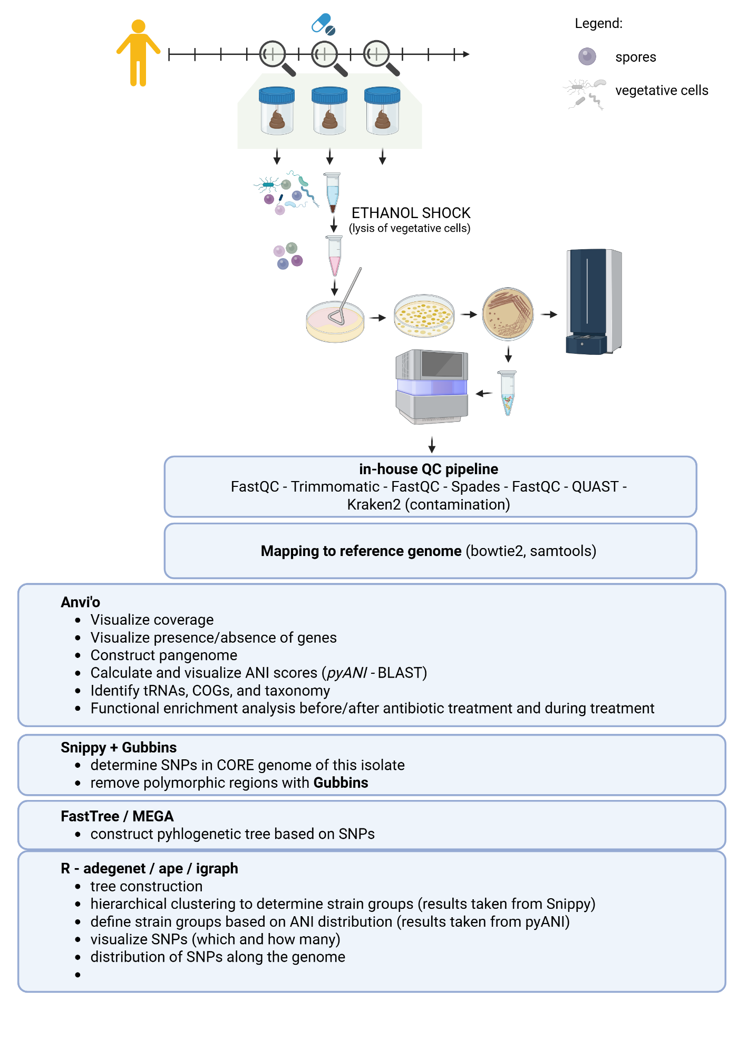
Figure 1. Workflow for isolation of spore-forming bacteria from ethanol treated stool samples.

2.8.2 Whole genome analysis

2.8.2.1 Preprocessing short-read sequences
We sequenced 44 isolates obtained from the ethanol treated stool samples of individual H determined as C. saudiense with MALDI-TOF. Short-read sequences were assessed for quality with fastqc v and trimmed with Trimmomatic v0.39, using the following settings: ILLUMINACLIP:NEBPE-PE.fa:2:30:10, LEADING:10, TRAILING:10, SLIDINGWINDOW:4:20, MINLEN:40 (Babraham Bioinformatics - FastQC A Quality Control Tool for High Throughput Sequence Data, n.d.; Bolger et al., 2014). The trimmed reads were assembled de novo into contigs using SPAdes v3.13.0 with the -careful option, while retaining all other settings at their default values (Prjibelski et al., 2020). The assembly was assessed with QUAST (Gurevich et al., 2013). Trimmed reads were mapped to the reference genome of Clostridium saudiense JCC and additionally to the hybrid assembly of one of our genomes using bowtie2 (Langmead & Salzberg, 2012).

2.8.2.2 Preprocessing long-read sequences
For long-read sequencing data, we used NanoFilt 2.8.0 (De Coster et al., 2018) to filter long-read sequences based on a Q score above 10 and a read length of at least 5000 bases. Hybrid assembly of Illumina and Nanopore reads was performed using Unicycler v0.5.1 (Wick et al., 2017). Phylogenetic trees, data, and networks were visualized using iTOL 7 (Letunic and Bork, 2007), R 4.4.1 (R Core Team, 2023) and Cytoscape 3.10.1 (Shannon et al., 2003). These genomes were later used as reference genome in the ANI and SNP analysis for C. saudiense.

2.8.2.3 Pangenome analysis
We assessed the completeness and contamination of each genome using samtools and pangenome was constructed in Anvi’o v8 (Delmont & Eren, 2018; Eren et al., 2021; Kiefl et al., 2023; Li et al., 2009). Than all genomes were annotated with prokka and pangenome constructed in roary for sanity check (Page et al., 2015; Seemann, 2014).

2.8.2.4 Average nucleotide identity (ANI) score
pyANI within Anvi’o was used to calculate ANI score between all isolates core genome – here determined as all genes present in all isolates (Pritchard et al., 2015). Based on ANI score we removed 2 genomes; one was another species (H005_94, Clostridium paraputrificium) and another was a mixture of two species (H005_126; C. saudiense and C. paraputrificium). These two sequences had lower MALDI-TOF score than recommended, but were nonetheless included in the sequencing, as MALDI-TOF has trouble distinguishing between the two species (as described in the MALDI-TOF manual). ANI pairwise comparisons of all isolates was used to determine the strain break for C. saudiense, from which we could define 4 strain groups and one singleton.

2.8.2.5 Determination of SNPs
We used snippy v4.6.0 to determine core SNPs (Seemann, 2014/2022). Core SNPs are defined as SNPs present in all isolated based on the reference genome. To remove loci with elevated densities of base substitutions, that could influence the number of SNPs between isolates, we used Gibbins v3.4.1 (Croucher et al., 2015). The filtered SNPs matrix served as input for construction of a neighbour-joining tree with MEGA v12. (Tamura et al., 2021).

2.8.2.6 Analysis of C. saudiense in shotgun metagenomic samples
We used a pipeline PStrain v1.0.3 to determine the number and frequency of C. saudiense strains in all metagenomic samples (Wang et al., 2021). PStrain is an optimization algorithm that profiles microbial strains from shotgun metagenomic sequencing data by iteratively inferring strain genotypes and abundances based on single nucleotide variant (SNV) frequency patterns. It uses both first-order and second-order genotype frequencies across marker genes from MetaPhlAn 4. We visualized strain frequency and relative abundance for individual at all timepoints.
To combine shotgun metagenomic data with whole-genome data, we concatenated reads from all isolates of one time point and ran them alongside metagenomic samples in PStrain pipeline. Results were imported into R for visualisation (Script PStrain.R).

RESULTS

3.1 DESCRIPTION AND COMPARISON OF THE TEMPORAL STABILITY OF THE GUT MICROBIOTA AND SPOROBIOTA IN HEALTHY INDIVIDUALS

3.1.1 Comparison of isolation protocols for bacterial DNA from human stool samples
The experiment included three stool samples and a negative control each isolated using four protocols in triplicate. Two criteria were used to select the best protocol: the highest DNA yield and ability to isolate all bacterial phyla known to reside in the human gut (Martino et al., 2022).
All four DNA isolation kits produced DNA concentrations sufficient for downstream molecular applications, with PowerFecal yielding approximately ten times higher concentration than the other protocols (Figure 1A). DNA concentration of negative controls was around 1 ng/µl, but the OTUs had on average of 2 and maximum 5 reads per OTU (Supplement Table 3). Community-based analysis showed differences among different DNA isolation kits in terms of community composition and occurrence of OTUs. DNeasy protocol showed significantly lower alpha diversity and density of clustering compared to other three protocols (Figure 1B, 1C). This was due to its inability to isolate bacteria from phylum Bacteroides in the same capacity as other protocols (Figure 1D). For isolation of DNA from human stool samples, we chose PowerFecal protocol due to speed of isolation procedure and highest DNA yield, while also considering the isolation of all major phyla in the human gut.
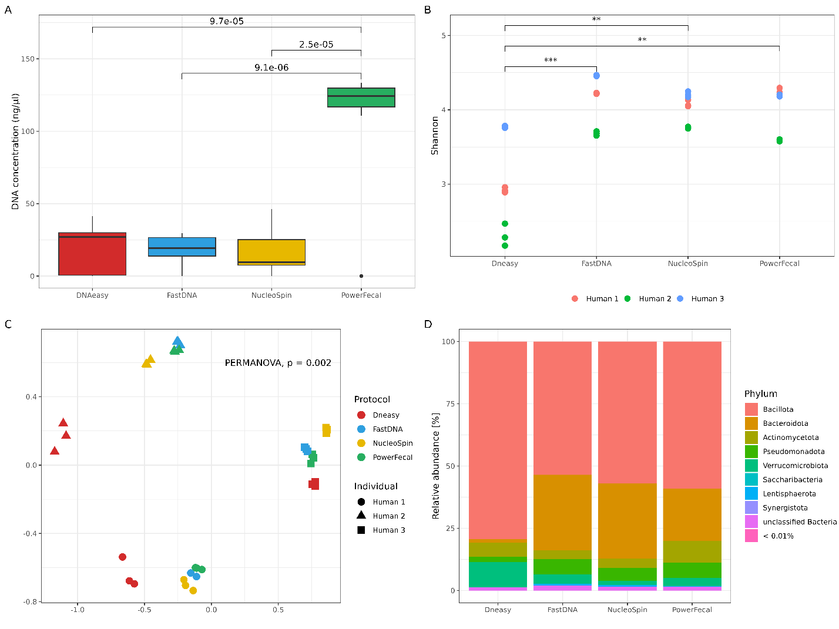
Figure 2. Comparison of DNA concentration, alpha and beta diversity and the relative abundance obtained with four different DNA isolation protocols. A) DNA concentrations [ng/µl] after isolation, measured with Quant-iT™ PicoGreen™ dsDNA Assay and dsDNA Reagents (Invitrogen™). p-values above connecting boxplots are result from paired t-test. B) Shannon index for alpha diversity, with t-test p-values denoted by asterisk (** < 0.01, *** < 0.001) for significantly different values. C) Non-metric multidimensional ordination based on Bray-Curtis distances, with PERMANOVA results for comparison of community structure between kits. D) Relative abundance across samples for each DNA isolation protocol, excluding phyla with relative abundance less than 0.01%. Legend: FastDNA: QIAamp Fast DNA Stool Mini Kit, NucleoSpin: NucleoSpin Soil Mini kit, PowerFecal: QIAamp PowerFecal Pro DNA Kit, DNAeasy: in-house protocol based on DNeasy Blood & Tissue protocol.

3.1.2 Comparison of ethanol or heat shock in elimination of vegetative cells from stool samples

3.1.2.1 Cultivation of spore forming bacteria from human gut after ethanol or heat shock
The experiment included two stool samples that were treated with two ethanol concentrations (70% and 100%) for 24 h or subjected to heat shock for 30 or 60 minutes at 80 °C. The goal was to evaluate the efficacy of ethanol or heat shocks in eliminating vegetative cells from stool samples to improve cultivation of spore-forming bacteria. Additionally, we tested the impact of adding bile acids and/or enrichment in liquid culture to enhance germination of spores. Over a 14-day anaerobic cultivation, we monitored colony-forming unit (CFU) and community structure based on 16S rRNA.
CFU was influenced by the addition of 5% bile acids solution both in enrichment media and on plates (Figure 2). When bile acids were added to enrichment media prior to plating, bacterial growth was inhibited after day 2 (CFU < 10), whereas enrichment without bile acids resulted in over 100 colonies after the same period (Figure 2, left). Conversely, on plates without prior enrichment, addition of bile acids accelerated germination and replication, yielding over 150 CFU on day 1, compared to similar CFU observed only after day 5 without bile acids (Figure 2, right).
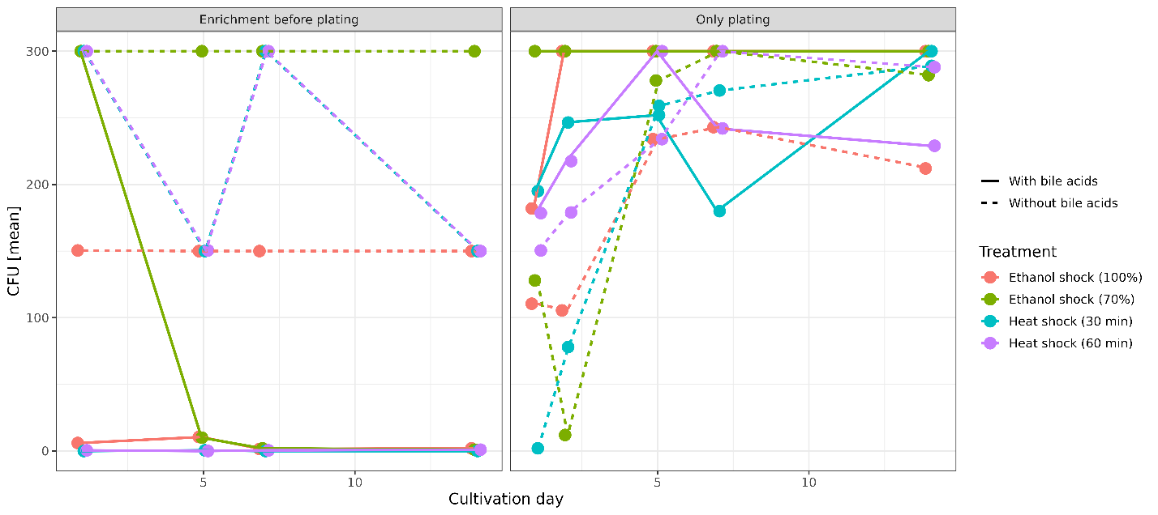
Figure 3. Colony-forming unit was influenced by addition of bile acids to the enrichment media and agar plates. Bacterial growth with and without enrichment step on BHIS, with and without the addition of bovine bile acids after two variations of ethanol concentration (100% or 70%) and heat shock at 80 °C (30 or 60 min) on days 1, 2, 5, 7, and 14.
More OTUs were detected in the enrichment cultures, especially with addition of BA than agar plates, both with and without addition of BA. This is contrary to the observed CFU, supported by a negative correlation between CFU and number of OTUs (Pearson correlation, p < 0.005). The composition of stool samples was that of healthy western individuals (45.3% Bacillota, 34.1% Bacteriodota, 3.6% Actinomycetota, 8.2% Pseudomonadota, 4% Verrucomicrobiota, 2.8% unclassified Bacteria and 1.4% other phyla). All treatments were able to some degree eliminate the non-spore-forming bacteria, but ethanol shock using 70% ethanol eliminated the greatest number of known non-sporeformers in the phyla Bacteriodota and Verrucomicrobiota (Figure 3). A reduction also happened in the phyla Pseudomonadota and Actinomycetota although some representatives withstood both ethanol and heat shocks (Figure 3).
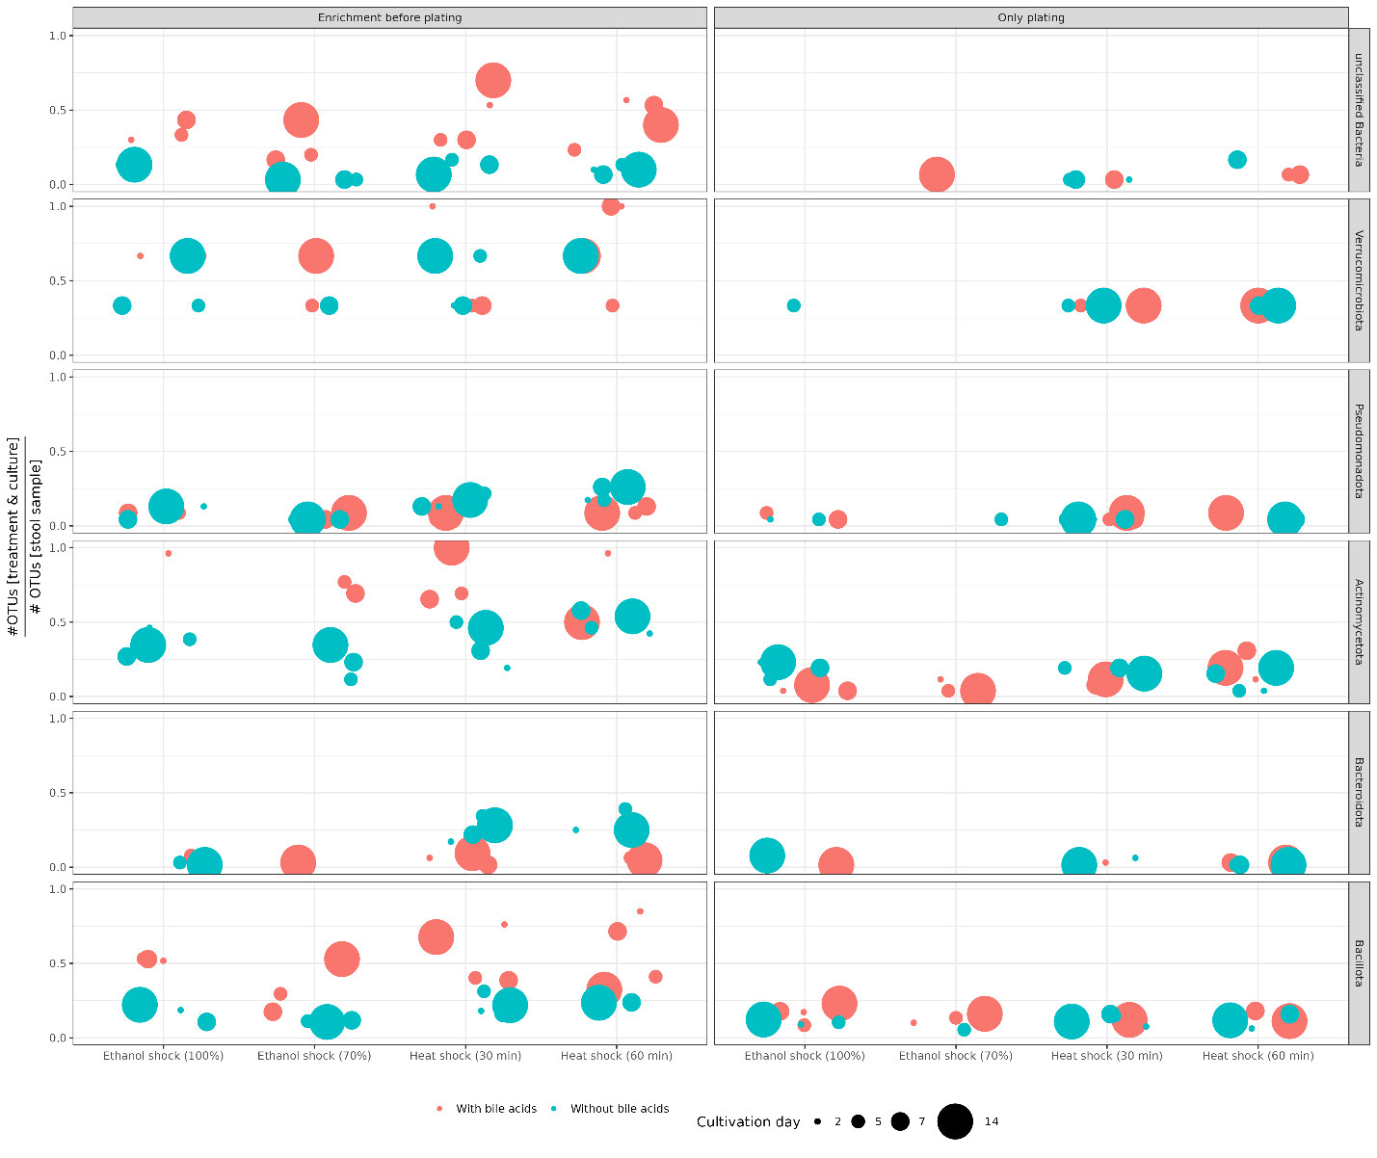
Figure 4. All treatments were able to some degree eliminate the non-spore-forming bacteria, but ethanol shock using 70% ethanol eliminated the greatest number of known non-sporeformers. Ratio between the number of OTUs in the original stool samples (n = 2) and the number of OTUs after heat/ethanol shock and cultivation/with prequal enrichment with and without bile acids on 2, 5, 7, and 14 days. Summed relative abundance for each treatment and cultivation media combination is available in Supplement Table 3

3.1.2.2 Optimization of pre-treatment for DNA isolation from spore-forming bacteria in stool samples
The experiment included two stool samples, treated in duplicates with 70% ethanol for 24 h and heat shock at 80 °C for 30 min, and subsequent removal of free DNA and DNA in lysed cells by using ethidium bromide monoazide (EMA treatment at different illumination times. Negative controls included a sample of water treated alongside stools (not sequenced, due to low DNA concentration), an untreated stool sample for reference of who was present in the original sample, and ethanol or heat shocked stools only washed with PCR-grade water with no addition of EMA. Results were analysed by comparing the community structure using amplicon sequencing (Supplement Table 2).
Both ethanol shock and heat shock treatments were able to enrich for OTUs belonging to phylum Bacillota and reduce the relative abundance of all other phyla in comparison to both the original stool sample (Non-treated) as well as stool samples treated with ethanol or heat shock but only washed with PCR-grade water, with no EMA treatment (Only-water) (Figure 4). The 15-min illumination of sample treated with EMA had the greatest effect on elimination of all bacteria not belonging to the spore-forming phyla, but the success rate of DNA isolation and subsequent sequencing was also low (5/16) in comparison to 5 min (14/16) or 10 min (8/16).
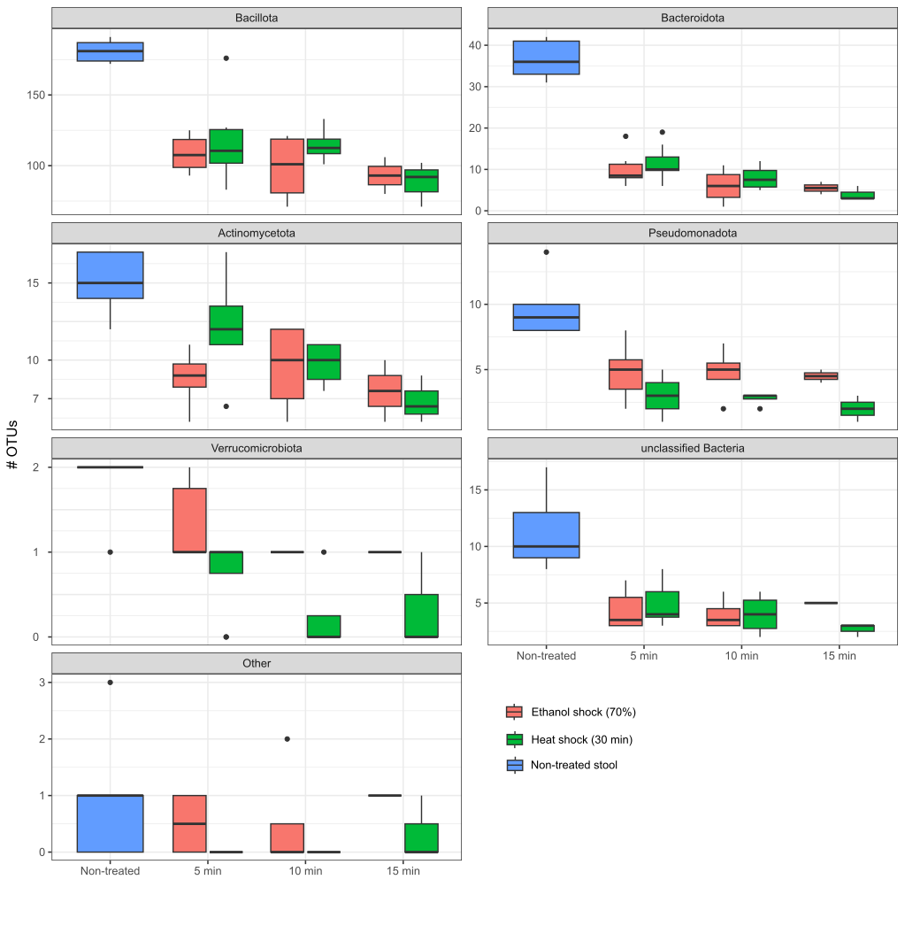
Figure 5. Removal of free DNA and DNA in lysed cells by EMA treatment after heat or ethanol shock. Relative abundance of OTUs in most abundant phyla in stool sample (non-treated), stool samples treated with ethanol or heat shock but washed with PCR-grade water (Only water) and stool samples treated with ethanol or heat shock, and EMA at different illumination times.

3.1.3 Isolation efficiency of Clostridioides difficile spores using the PowerFecal protocol
We used two different isolation protocols for isolation of DNA from bulk microbiota and ethanol treated samples. This decision was based on the fact PowerFecal has a spin-column to which to much DNA binds and we got insufficient DNA concentrations after ethanol shock and EMA treatment. To confirm that we isolated both vegetative cells and spores with bulk microbiota protocol, we added C. difficile spores to an otherwise C. difficile negative stool sample and measured the absolute amount of the C.difficile-specific 16S rRNA amplicon with ddPCR after isolation of DNA. The copy number of C. difficile-specific amplicon correlated to CFU count of spores after cultivation (Figure 5, Pearson’s correlation value = 0.73, p-value = 0.007).
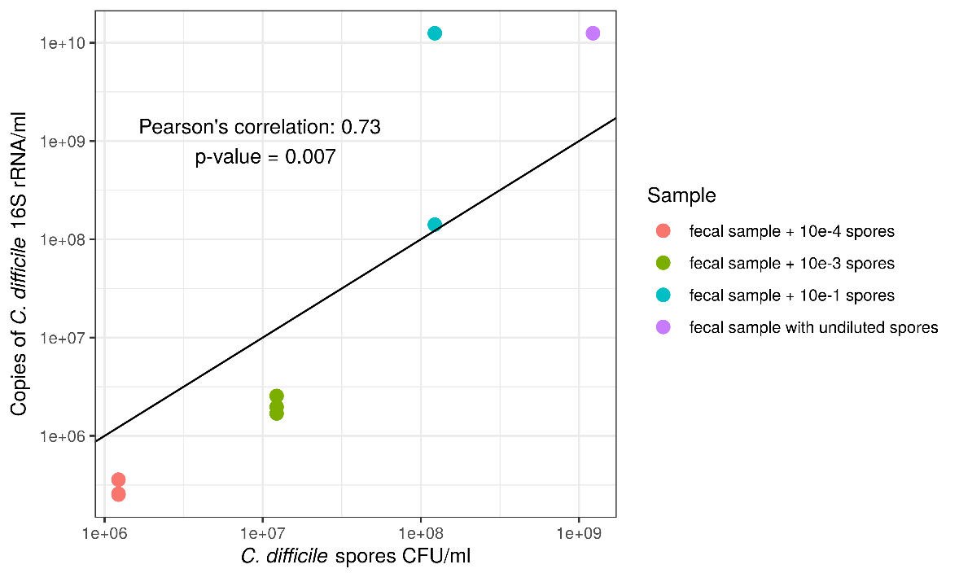
Figure 6. Efficiency of C. difficile spore isolation with PowerFecal protocol compared to C. difficile spore CFU count on COH agar plates.

3.1.4 Longitudinal study of individual’s gut microbiota and sporobiota
The experiment included nine healthy male participants who provided stool samples approximately every 14 days over six months, with additional samples collected during predefined events such as dental visits, antibiotic treatments, travel, stress (Table 3). Each participant contributed at least 12 samples. DNA was isolated using two protocols: bulk microbiota DNA isolation using the PowerFecal kit, and for the ethanol-treated samples, an aliquot underwent ethanol shock followed by EMA treatment to isolate DNA from spores and other ethanol-resistant cells. Microbial profiling was performed using both 16S rRNA gene amplicon sequencing (V3-V4 region) and shotgun metagenomic sequencing (Supplement Table 3).

Table 3. Basic information on participants in the study (additional information on every sample in Supplement Table 4).
Participant | Age | BMI | Living environment | Diet | Regular supplements | # samples
A | 34 | 23 | urban/flat | omnivore | omega3 | 13
B | 25 | 22 | urban/flat | omnivore | - | 12
C | 27 | 24 | urban/flat | omnivore | protein powder | 13
D | 37 | 24 | urban/flat | omnivore | - | 14
E | 28 | 23 | urban/flat | omnivore | - | 14
F | 27 | 33 | urban/flat | omnivore | - | 12
G | 27 | 26 | urban/house | omnivore | protein powder | 13
H | 43 | 29 | urban/house | omnivore | - | 14
I | 30 | 18 | urban/NA | lactose-free omnivore | Omega 3, vitamin D, complex B and Q10, probiotics ( | 12

3.1.4.1 Composition, abundance and diversity of ethanol-resistant and ethanol non-resistant bacterial community in stool
Out of 234 samples (117 of bulk microbiota and 117 of ethanol treated) we successfully sequenced 230 of them (Supplement Table 2). Negative control samples for both bulk microbiota and ethanol treated sample contained less than 1800 reads distributed into a 586 and 671 OTUs, respectively (average number of reads per OTU = 3). After quality filtering and rarefaction to 150 000 reads (Supplement Figure 1) we detected 2,431 OTUs in bulk microbiota samples, out of those 414 OTUs (17.0 %) were determined as part of the ethanol-resistant community and 1,934 (79.5%) as part of the ethanol non-resistant community. Eighty-three OTUs (3.4%) failed to meet the criteria (described in chapter 8.1.4.1.) and were designated as undetermined regarding ethanol resistance. An additional 141 OTUs were detected only in ethanol treated samples. These were all detected at low relative abundance and were considered highly probable sampling artifacts and therefore excluded from further analysis, following an example from a previous study (Kearney et al.). Compositional characteristics and temporal dynamics were subsequently analysed on the above defined ethanol-resistant and non-resistant communities obtained from a 6-month longitudinal sampling of nine healthy males.
Most ethanol-resistant representatives were found in the phylum Bacillota (n = 320), accounting for 77.5% of the total richness in the ethanol-resistant community (Figure 6A). Within the phylum Bacillota, 17.7% of all detected OTUs exhibited ethanol resistance, predominantly from the genera Clostridium (n = 76), unclassified Lachnospiraceae (n = 49), unclassified Ruminococcaceae (n = 42), unclassified Peptostreptococcaceae (n = 13), and Blautia (n = 12). The remaining ethanol-resistant community included representatives from Actinomycetota (n = 42, 11%), Pseudomonadota (n = 21, 5.5%), and unclassified Bacteria (n = 14, 3.7%). In these groups, the proportion of ethanol-resistant OTUs was higher than expected, with 36.2%, 40.4%, and 19.7%, respectively, exhibiting this trait (Figure 6B). Additionally, phyla with ten or fewer representatives collectively contributed 2.3% of the ethanol-resistant richness, most notably the biologically relevant genus Akkermansia. Ethanol treatment had the strongest elimination effect on the phylum Bacteroidota, with only 10 representatives remaining in the ethanol-resistant community, accounting for 0.5% of the total relative abundance.
We observed two notable characteristics distinguishing the ethanol-resistant community from the non-resistant community. Both were primarily driven by Bacillota OTUs due to their high abundance, though similar trends were also observed across other phyla. First, OTUs determined as ethanol-resistant exhibited significantly higher relative abundance within the gut microbiota compared to non-resistant OTUs (Wilcoxon rank-rum sum test, p < 0.001; Figure 6C). Second, ethanol-resistant OTUs were significantly more likely to be detected at more time points within an individual, particularly in more than 80% of samples collected over a six-month period, relative to non-resistant OTUs (Wilcoxon rank-sum test, p < 0.001; Figure 6D). These findings support the use of ethanol resistance as a proxy for identifying bacterial taxa employing dormancy mechanisms that contribute to long-term persistence in the human gut.
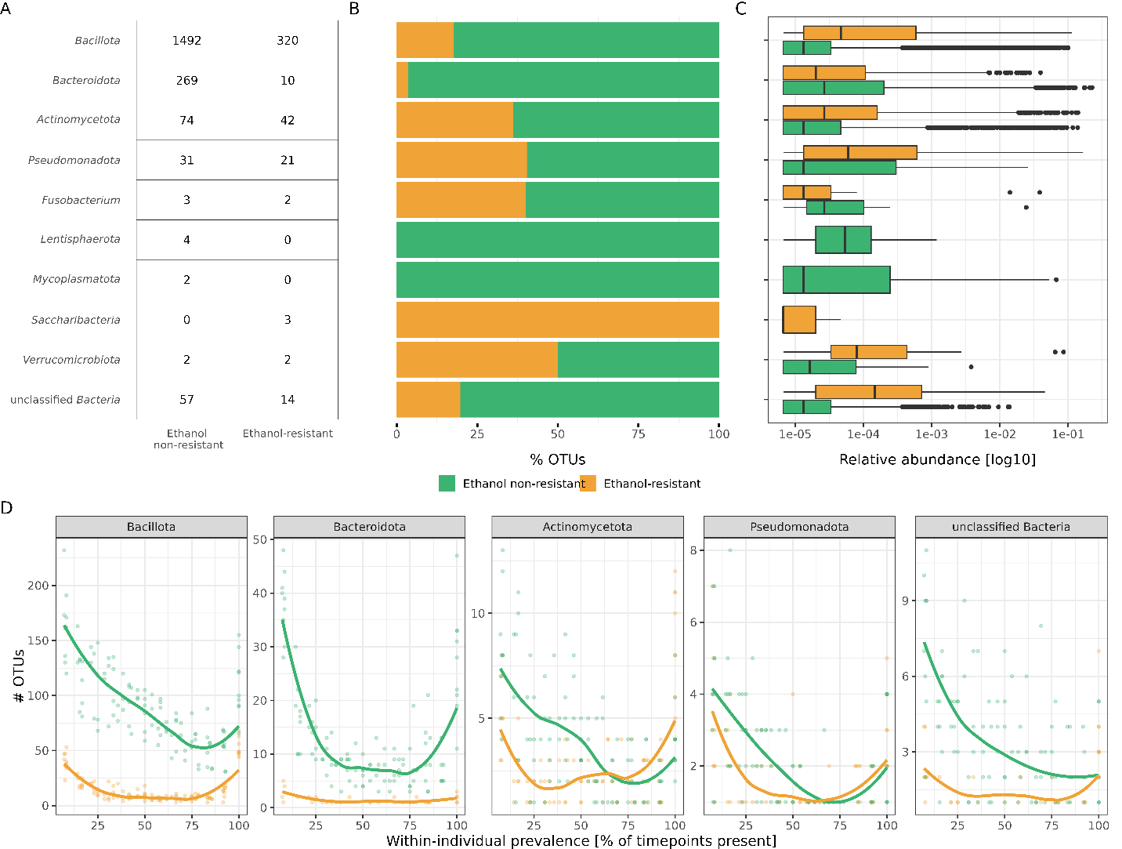
Figure 7. Characteristics of ethanol-resistant and ethanol non-resistant bacterial communities. A) Distributions of OTUs across phyla according to ethanol resistance. The number of OTUs identified in each phylum for the ethanol non-resistant and ethanol-resistant communities. B) Stacked bar plots depict relative proportions of ethanol-resistant and ethanol non-resistant OTUs within the respective phyla, color-coded based on their ethanol non-resistant (green) or ethanol-resistant (yellow) classification. B) Comparison of relative abundances in the gut microbiota between OTUs determined as part of the ethanol-resistant or ethanol non-resistant community per phyla. C) Within-individual prevalence of OTUs across the six-month observational period for the most prevalent phyla, shown as the percentage of OTUs detected at different numbers of time points. Thin lines represent individual participants, and bold lines indicate the cohort median.
For the purpose of statistical robustness and clarity in discussion, we further divided our dataset of ethanol-resistant and ethanol non-resistant communities into phylum Bacillota and other phyla (Figure 7). The ethanol-resistant communities exhibited significantly lower variability both between and within individuals compared to the non-resistant communities. This pattern was observed when implementing both unweighted (Jaccard distance, p < 0.001 for all comparisons; Figure 7A) and weighted beta diversity measures (Bray-Curtis, p < 0.001 for all comparisons; Supplement Figure 2). However, the lower within-individual variability observed in ethanol-resistant communities was significantly more pronounced in the phylum Bacillota compared to other phyla (Wilcoxon rank-sum test, p < 0.001; Figure 7A). In our study, we observed a modest but significant increase in temporal variability within ethanol-resistant Bacillota based on Jaccard distance (Pearson correlation, r = 0.19, p = 0.038, Figure 7B) and a borderline significant correlation when using Bray-Curtis dissimilarity (Pearson correlation, r = 0.169, p = 0.051, Supplement Figure 2). In contrast, no significant temporal changes were observed in other communities (Figure 7B).
Figure 8. Dynamics of ethanol-resistant and ethanol non-resistant taxa between and within individuals. A) Boxplots showing between-individual (left) and within-individual (right) variability in community composition for ethanol-resistant (yellow) and non-resistant (green) communities. Variability was assessed using the Jaccard distance, calculated separately for OTUs from the phylum Bacillota and OTUs from other phyla. Jaccard distances were derived from randomly subsampled communities (n = 24, iterations = 999), with the median distance used for visualization and statistical comparisons. Distributions were compared using the Wilcoxon rank-sum test. B) Community variability as measured by Jaccard distance plotted against the number of days between sampling time points. Data are presented separately for phylum Bacillota (solid line) and other phyla (dashed line) and color-coded according to ethanol resistance. The correlation between time interval and Jaccard distance was assessed using Pearson’s correlation test. Statistical significance is indicated as *** for p < 0.001.
Ethanol-resistant community exhibits greater OTU sharing among individuals, while ethanol non-resistant community suggests greater individual-specificity. As very stringent criteria were used to define OTU presence (at least 11 timepoints), which highlights persistent members of each community type and indicated that ethanol-resistance may promote transmission of widely shared and persistent OTUs.
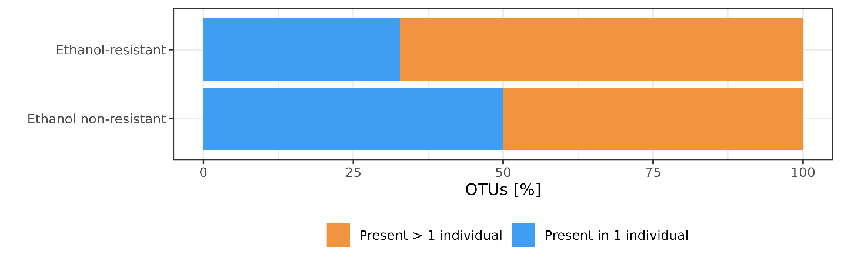
Figure 9. Transmission of OTUs between people based on their resistance to ethanol. Proportion of OTUs in ethanol-resistant and ethanol non-resistant community are present in a single individual or present in two or more individuals. This analysis was conducted on 865 OTUs determined present in an individual (90% of all timepoints). That reduced the number of OTUs present in the ethanol-resistant and non-ethanol resistant community to 192 and 673 OTUs, respectively.

Sporulation frequency of ethanol-resistant Bacillota in the human gut is host and time dependent
Sporulation frequency was calculated for OTUs determined as part of the ethanol-resistant fraction with taxonomic classification to the phylum Bacillota. The ratio between normalised abundance in bulk microbiota samples and normalised abundance in ethanol treated samples was calculated and termed sporulation frequency (see Chapter 8.1.4.3). This calculation is supported by a correlation of relative and/or normalised abundance of ethanol-resistant Bacillota between bulk microbiota and ethanol treated samples, despite different isolation protocols (Supplementary Figures 3 and 4).
The sporulation frequency for all OTUs within an individual increases or decreases simultaneously at a single time point in the majority of time points (Figure 9A). This indicates a dependency on the current state of the gut in each host. We investigated the correlation between the variation in sporulation frequency of each OTU at a single time point, normalised by the mean variation in sporulation frequency of this OTU across all days for an individual, and the same value with the day variable reshuffled. There was no correlation between the original and reshuffled data (Pearson’s correlation: 0.03, p = 0.74), confirming that the temporal order of sampling days is a key factor influencing the sporulation frequency of an OTU.
Variance in sporulation frequency of an OTU within an individual compared to variance in sporulation frequency of the same OTU in the whole population shows host specificity. This is evidenced by the ratio between the variance of OTU i in an individual and the variance of OTU i in the population, which falls below 1 in all but two individuals (Figure 9B). An exception was the increase in sporulation frequency in individual H, as opposed to population variance, which can be linked to antibiotic consumption between days 71 and 84 during the study. There was also a slight increase in individual C, linked to five days abroad in the second month of the study. Interestingly, in individual H this coincided with a decrease in alpha diversity, while in individual C there was an increase in alpha diversity. The Kruskal test shows significantly different variance in sporulation frequency of OTUs between individuals in our study (p = 1.7e-8), which strengthens our comparison as the population variance reflects highly different individuals. In contrast, comparison of the variance in sporulation frequency between different OTUs is not significantly different (Kruskal test, p = 0.96, Figure 9C). Further confirmation of the dependence of sporulation frequency on host and time, rather than OTU classification, is provided by positive Pearson’s correlations between sporulation frequencies of OTUs within an individual (Supplementary Figure 5).

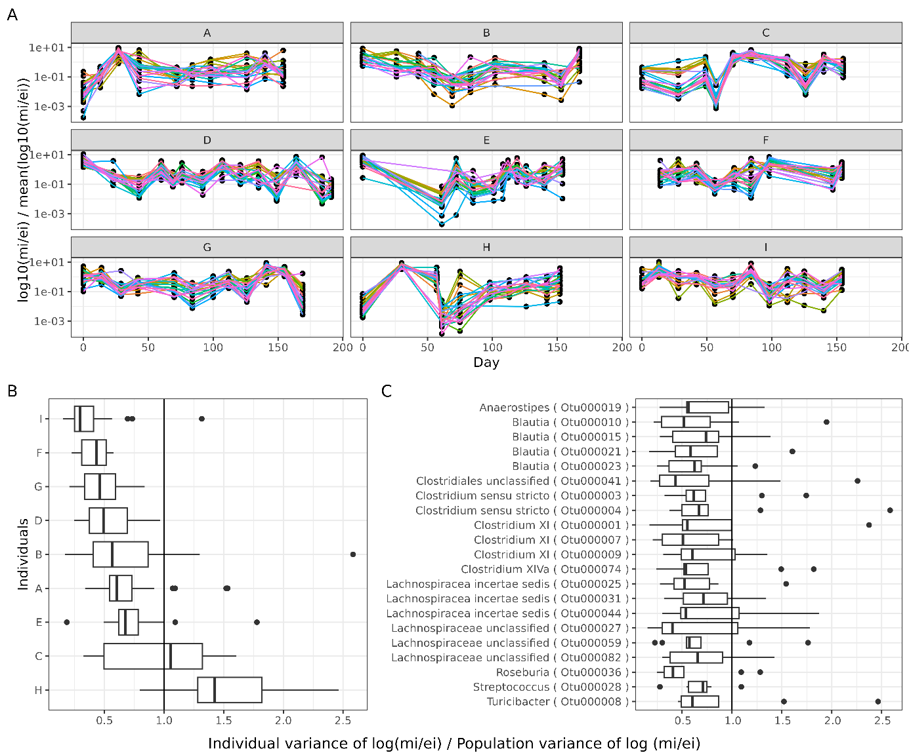
Figure 10. Sporulation frequency is more influenced by the individual and the specific time point of sampling than OTUs identity. Plot shows only highly prevalent OTUs belonging to ethanol resistant Bacillota fraction (present in > 80% of samples, n = 21). A) Sporulation frequency normalized by individuals mean sporulation frequency (m_{i} = normalized abundance of OTU i in bulk microbiota sample, e_{i} = normalized abundance of OTU i in ethanol resistant fraction). B) Ratio of sporulation frequency variance of OTU i in individual and in the population, plotted by individual and C) plotted by OTU.

Composition, abundance and diversity of microorganisms based on shotgun metagenomic sequencing
Out of 234 samples (117 of bulk microbiota and 117 of ethanol treated) we successfully sequenced 200 (116 of the bulk microbiota and 84 from the ethanol treated), removed reads of bad quality and human DNA (Supplement Table 3). Negative controls were not included in the shotgun metagenomic sequencing. There is a plethora of analysis one can do with shotgun metagenomic data, from assembling contigs and binning and manually curating bins into MAGs, to reference-based determination of bacteria, archaea, viruses and eukaryotes.
Based on sequence alignment and last-common ancestor (LCA) algorithm we were able to determine almost 97% of all contigs. 92% of contigs are determined bacterial origin, 3% belong to viral and around 1% to eukaryotes, while less than 0.4% belong to archaeal ancestry across all samples. While sequence alignment to a database of highly curated marker genes (MetaPhlAn 4) determined ~85% of all abundance across samples. Approaches differ by the reliability, as MetaPhlAn’s curated database has higher accuracy, but can miss taxa are not present in the database, while a non-curated database in the NCBI can report false determinations. Moving forward we decided to work with MetaPhlAn results.
Archaea were detected in 5/9 individuals in our cohort, where genus Methanobrevibacter is present in all five individuals, and Methanosphera were present in only two individuals (Figure 10). Both Methanobrevibacter smithii and Methanosphera stadmanae exhibit stable presence within individuals through time, despite M. stadmanae presenting in loser relative abundance.
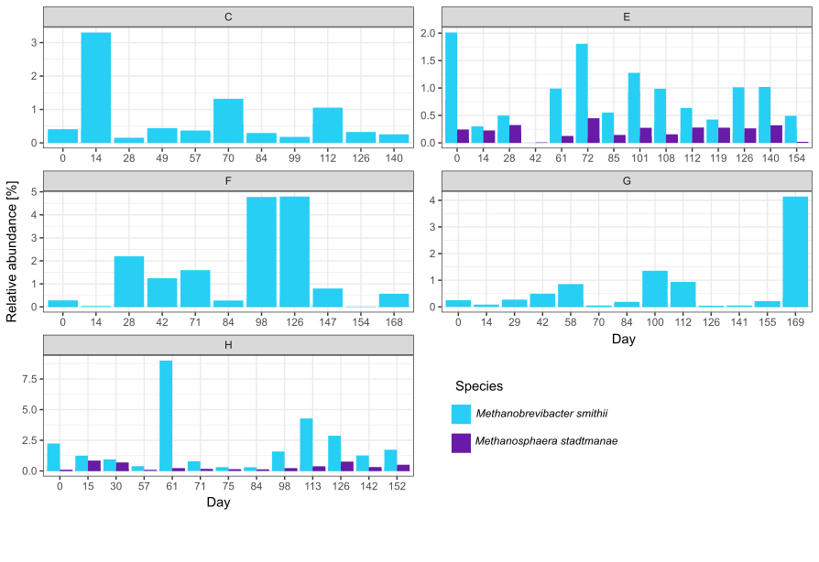
Figure 11. Abundance and persistence of archaea. Relative abundance of archaeal species detected with MetaPhlAn.

Eukaryotes were detected in 8/9 individuals in out cohort (Figure 11). Despite an omnivorus diet including bread, Saccharomyces cerevisiae was not consistently present, further confirming transience of this species in the human gut. In 4/9 individuals (C, D, E, H) we detected genus Blastocystis at low abundances (0.01 to 0.6% of all relative abundance).
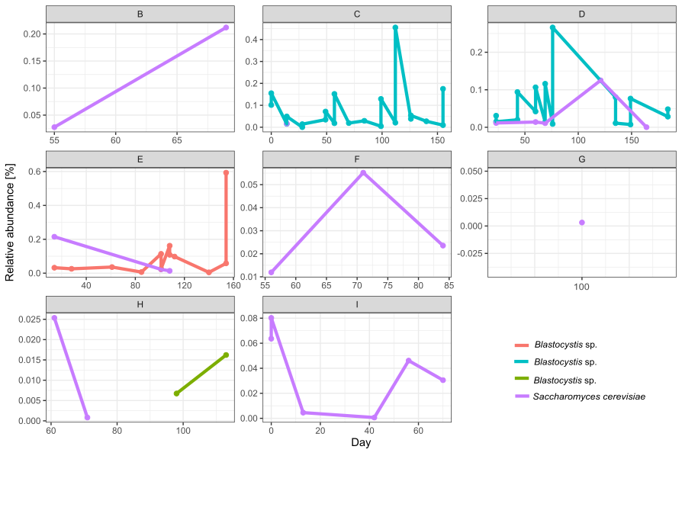
Figure 12. Abundance and persistence of eukaryotes. Relative abundance of eukaryotes detected with MetaPhlAn.

We detected both eukaryotic (Alsuviricetes, Arfiviricetes, Herviviricetes and Megavirictes) and bacterial viruses (Faserviricetes, Malgrandeviricetes and Caudoviricetes), and a family of viruses able to infect both eukaryotic and bacterial cells (Duplopiviricetes) in our bulk microbiota samples (Figure 12). Bacteriophages were present at ten-times the relative abundance than eukaryotic viruses, with Caudovirales exhibiting the greatest abundance. Viral communities in the human gut were individual-specific (Supplement Figure 6, NMDS of Bray-Curtis dissimilarity). Abundance of viruses was persistent through time and was not affected by extreme events or other metadata we gathered from subjects in out cohort.
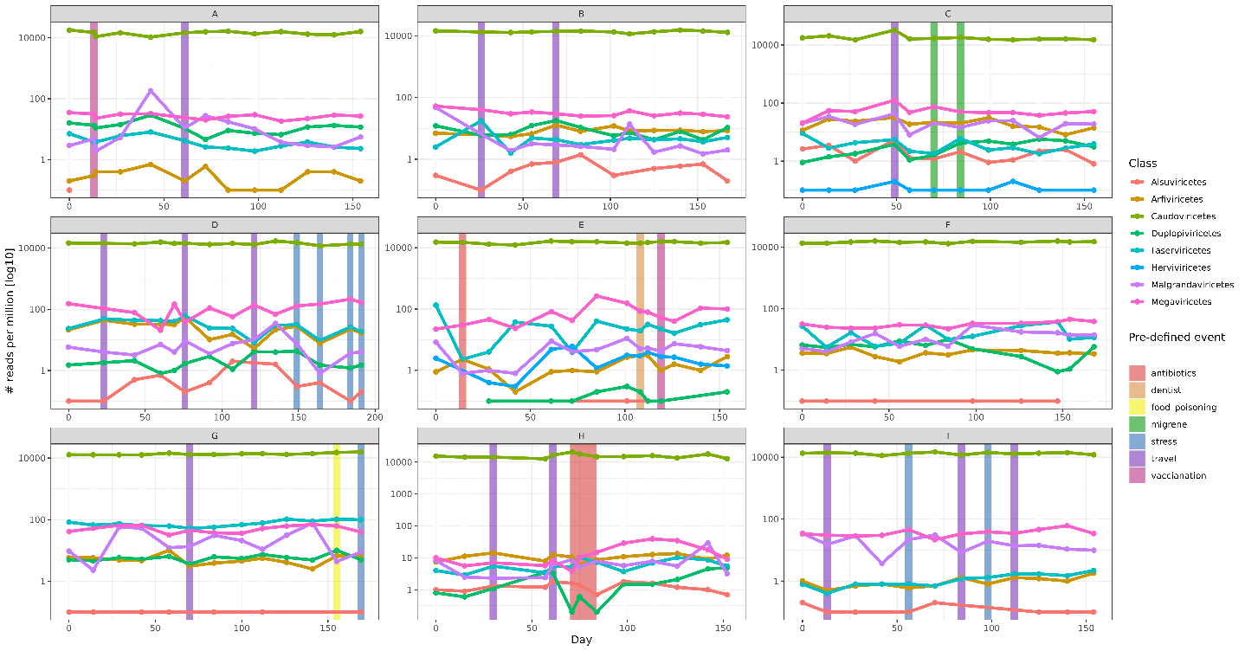
Figure 13. Viral sequences determined with geNomad.

We detected 1033 single-genome bins (SGBs) within domain Bacteria with MetaPhlAn. Out of those 527 have NCBI genome determination, others are determined only to phylum level, but their genome is more than 30% different than any other genome in the databases. The bulk microbiota samples are in accordance with amplicon sequences. In the ethanol treated samples we obtained much more species from phylum Bacteroidota than OTUs from the same phylum (Figure 13).
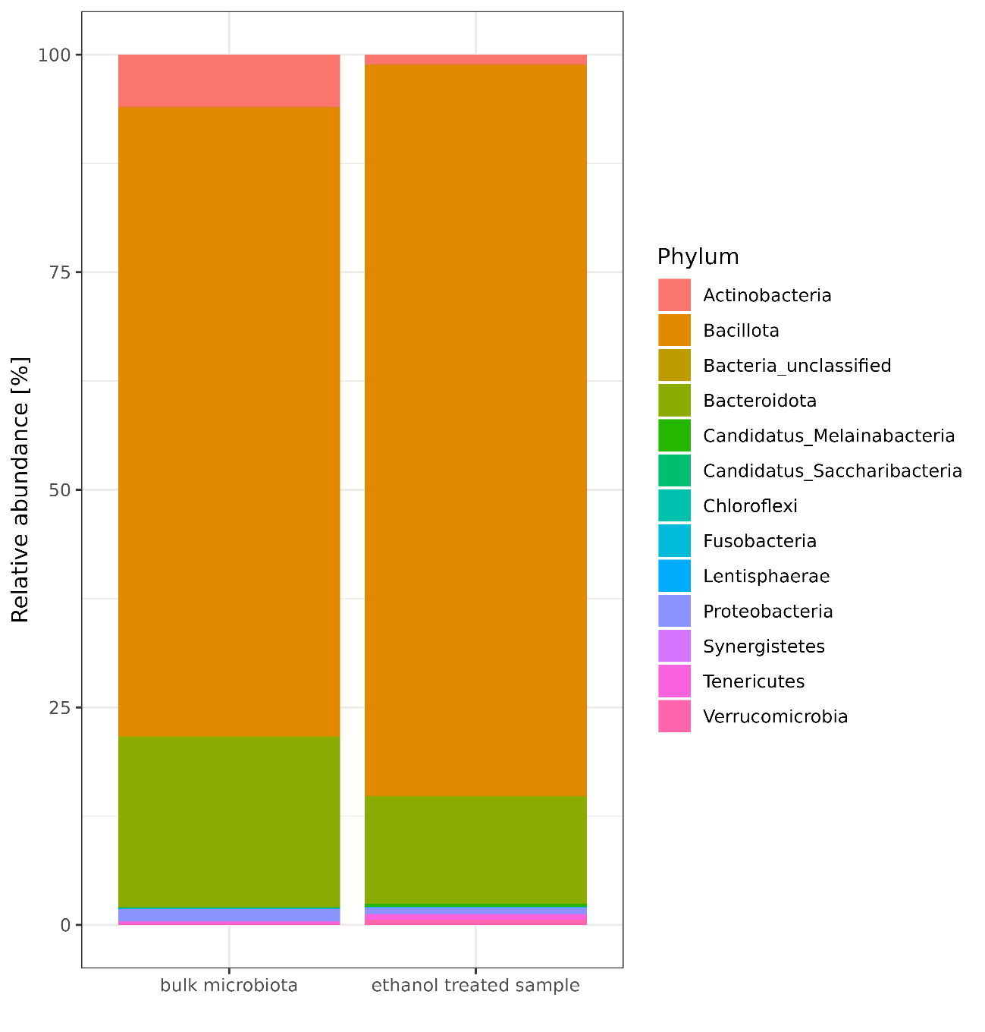
Figure 14. Relative abundance of bacterial phyla across individuals for the bulk microbiota samples and ethanol treated samples based on results from MetaPhlAn using shotgun metagenomic data.

Although we previously showed that ethanol-resistant Bacillota community is a good proxy for studying sporobiota, with metagenomic data we could determine sporulation ability based on the presence of sporulation genes, while ethanol treated samples provide us with information on ethanol resistance of a species thus information of active spore formation.
Spore-forming bacteria are present in the human gut at higher relative abundances and persist for longer periods of time within the gut of an individual (Wilcox test, p < 0.001) (Figure 14). This is true when comparing the sporeformers to all other bacteria in the human gut or to other Bacillota members.
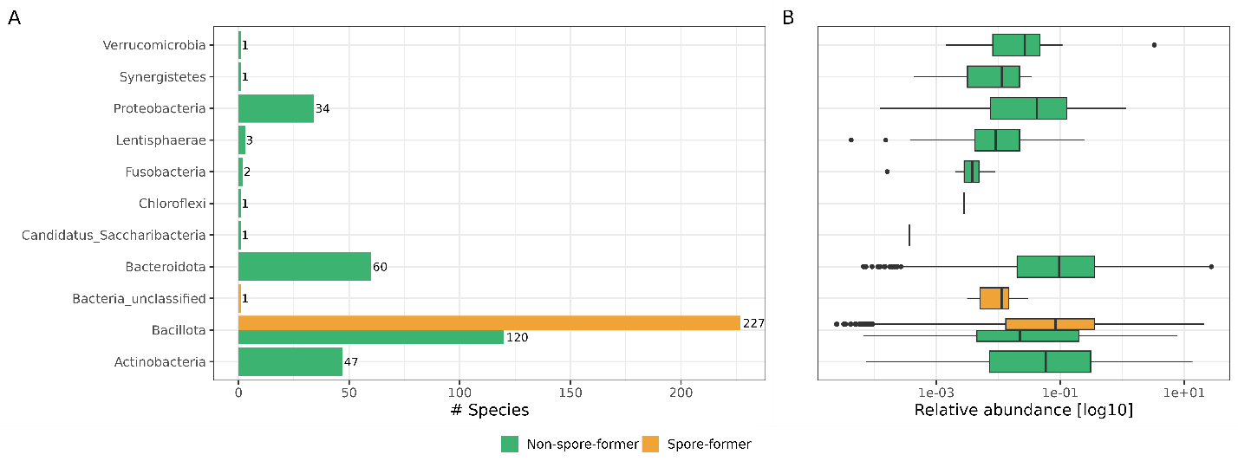
Figure 15. A) The number of species by phylum detected with MetaPhlAn and their relative abundances, separated by non-spore forming and spore-forming for the phyla, where spore-forming bacteria were detected.

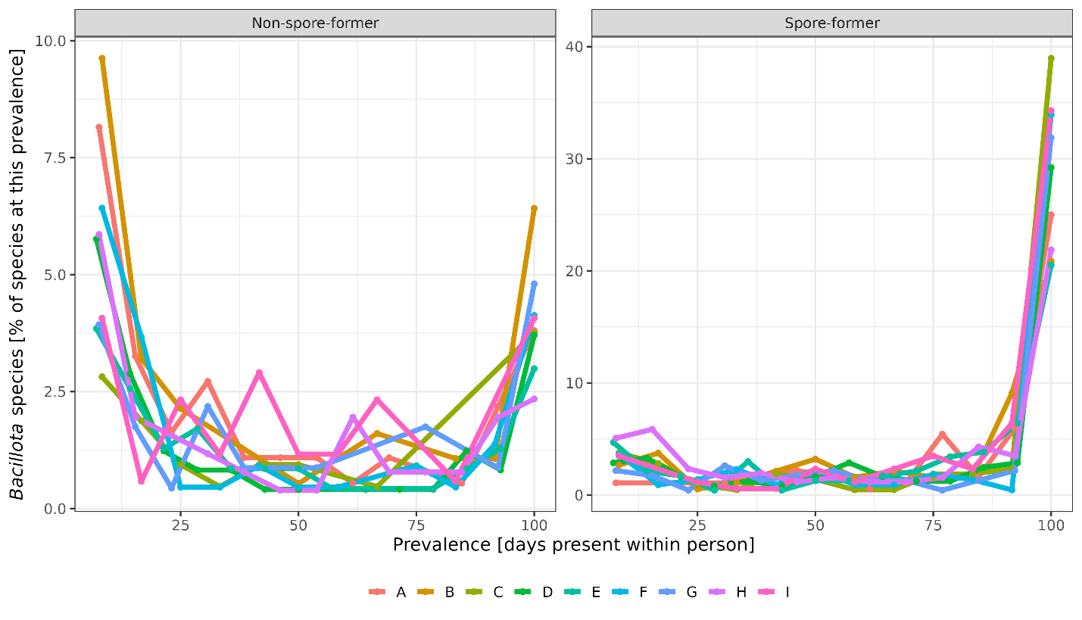
Figure 15. B) Prevalence within an individual for spore-forming and non-spore forming Bacillota species.

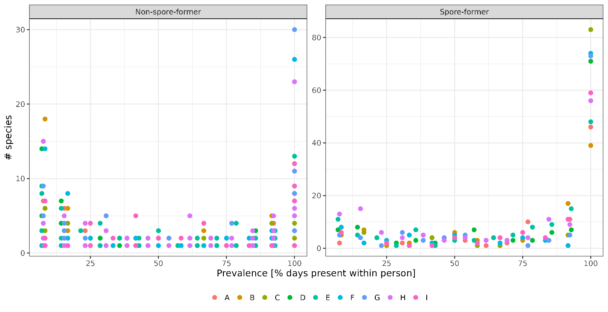Supplement Figure (I think) all species prevalence not only Bacillota!

Shannon diversity between spore/nonspore forming (yeloww/green)
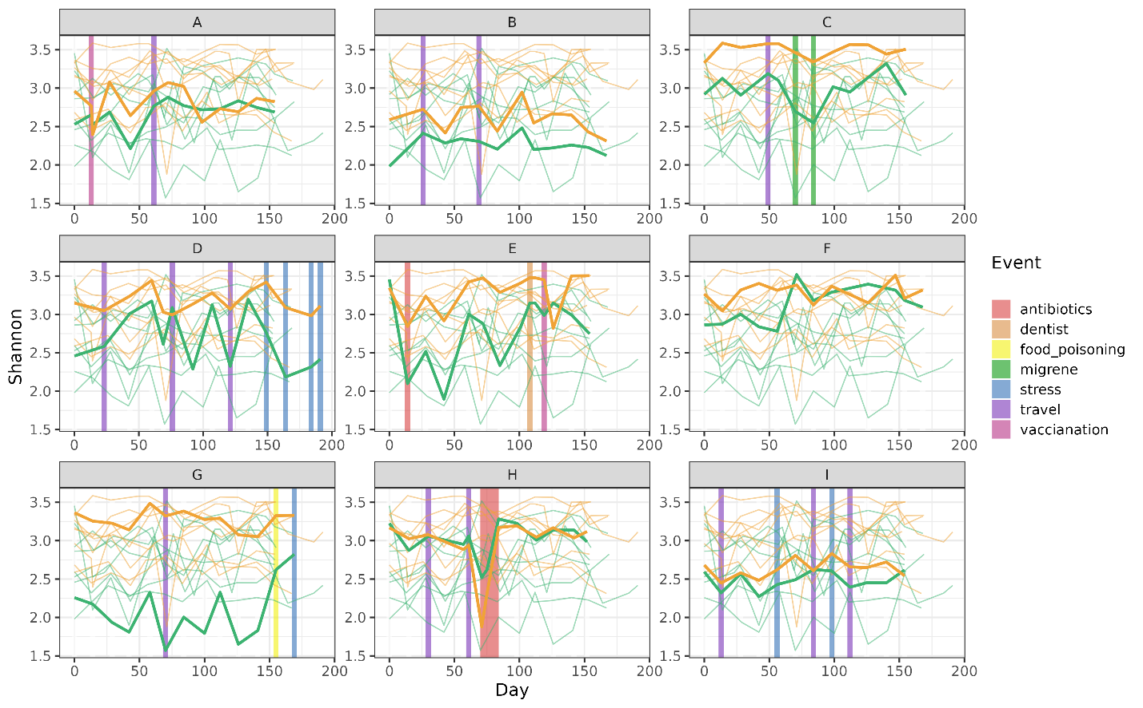
Sharing species (spore/ non-spore forming)
- Kakšno abundance predstavljajo sporegoenci v črevesju. (kakšen je procent bakterij v črevesju ki to zmorejo) in hkrati kakšno rela bund predtavljajo

INDIVIDUAL-SPECIFIC POPULATION GENETICS ANALYSIS ON THE ISOLATED SPORE-FORMING SPECIES

Cultivation of spore-forming species from ethanol shocked samples
Optimization of spore-forming species, looking at evolution of this species in time
We aim to optimize the growth conditions and to obtain strains of the same spore-forming species from different time points of an individual for whole-genome sequencing. With the genome comparison of a population of a species at different time points we will try to assess the retention/transition time and new acquisition of a spore-forming bacteria in the human gut. We will also be monitoring changes in the number of plasmids/phages in this species. This will be done in parallel with the analysis of metagenomic data.

Analysis of amplicon sequences, in particular the analysis of sporulation frequency revealed that individual H, who consumed amoxicillin, a broad-spectrum penicillin during the study had a significantly higher sporulation frequency for all OTUs in comparison to the res of our population. We also noticed we noticed a reduction in diversity and absolute abundance of bacteria during this period. We decided this is an interesting time period for deeper investigation into strain persistence and structure, as the consumption of AB has been shown multiple times to have an effect (REF).
In our preliminary testing for isolation of spore-formers in culture we used BHIS medium (See chapter xy), but for this we have chosen a growth medium that has proven successful in our lab in previous testing of cultivation spore-forming bacteria from the healthy human gut – WCAB (magisterij Urška Dobovišek). Samples were exposed to ethanol shock and plated onto WCAB medium for 3 days until ~70-100 colonies were selected. Replated colonies were determined with MALDI-TOF and due to the highest number (44) we selected Clostridium saudiense for sequencing. ANI score showed that 2 isolates were not pure/this species. One isolate was determined on the whole genome to be Clostridium paraputrificium, while another was a mixed isolate of C. paraputrificium and C. saudiense, they were excluded from the analysis. We determined strain break after pairwise comparisons of all genomes from C. saudiense to be at 99.8%, from this we defined 4 strain groups with one genome being an singleton. This grouping was also confirmed when we constructed the phylogenetic tree on SNPs in core genome using MEGA’s neighbor-joining tree (Figure)
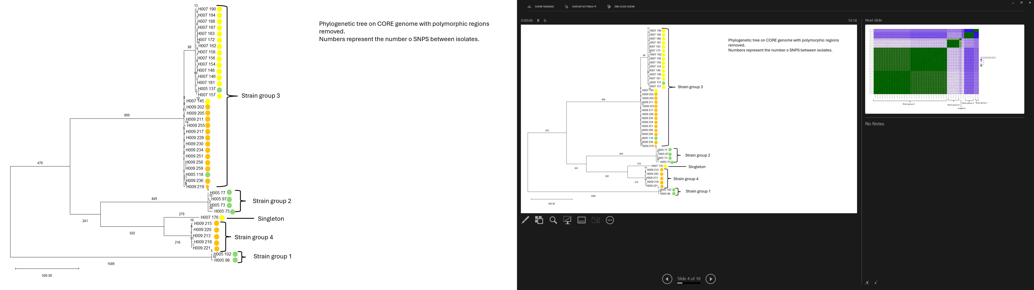
Figure 16. Neighbor-joining tree based on SNPs determined with SNIPPY, excluding polymorphic regions (Gibbons) in MEGA12. Dots besides isolate names represent the timepoint (green = 5, yellow = 7, orange = 9).
Using data from isolates we are able to show greater diversity before antibiotic consumption (AB), and a consequent reduction and difference in strain structure after AB. But interestingly this is not confirmed in the shotgun metagenomic data, where all four strains detected persist through all timepoints while the frequency of their abundances changes after antibiotic consumption, but interestingly starts at one timepoint prior to AB consumption, when the individual traveled out of Slovenia for more than 3 days. This is when we notice a reduction in the number of bacteria observed. Interestingly we notice that the relative abundance in bulk microbiota after these events for all four remains constant, but in ethanol treated samples strain 1 appears to be dominant, which means it was the one strain that produced more spores than other strains (Figure).
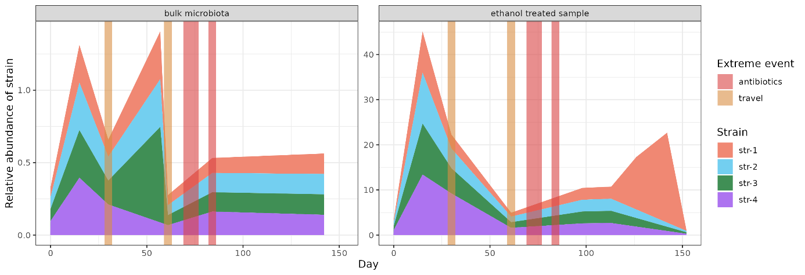
Figure 16. Results from PStrain determination of strains in the shotgun metagenomic samples. Vertical lines represent extreme events in this individual’s life.
Functional enrichment analysis showed 4 phage related functions to be more connected with the isolates in the genomes from antibiotic treatment timepoint as opposed to the isolates before and after antibiotic treatment.

MONITORING LONGITUDINAL CHANGES IN THE RESISTOME DEPENDING ON CHANGES IN THE INTESTINAL MICROBIOTA
Across the nine individuals in our cohort, we detected 111 antimicrobial resistance genes (ARGs) spanning 16 different classes and 5 different resistance mechanisms, as annotated by AMRfinder and CARD database (Figure 17). We also identified two stress response genes, gacL and qacEdelta1. The highest richness of ARGs was observed in aminoglycosides resistance genes, followed by glycopeptide, tetracycline and beta-lactams classes (Figure 17A). Diversity of ARGs per class did not correlate to the abundance of ARGs in a class. The most abundant ARGs confer resistance to tetracyclines, protein synthesis inhibitors (lincosamide, macrolide and streptogramin), and beta-lactaases that inactivate antibiotics (Figure 17B). Taxonomically, ARG diversity was highest for phylum Bacillota, followed by Bacteroidota, however, ARG abundance was greater in the phylum Bacteroidota, followed by Bacillota (Supplement Figure 6). Notably, clinically important carbapenemase genes prevalent in Slovenia (bla_{KPC}, bla_{NDM}, bla_{OXA48} or bla_{VIM}) and Acinetobacter-associated bla_{OXA23} and bla_{OXA24} were absent. The only clinically relevant ARG detected was bla_{CTX-M1}, found at very low abundance in a single individual (I) on a contig classified within the Enterobacteriaceae family (Supplementary Figure 7).

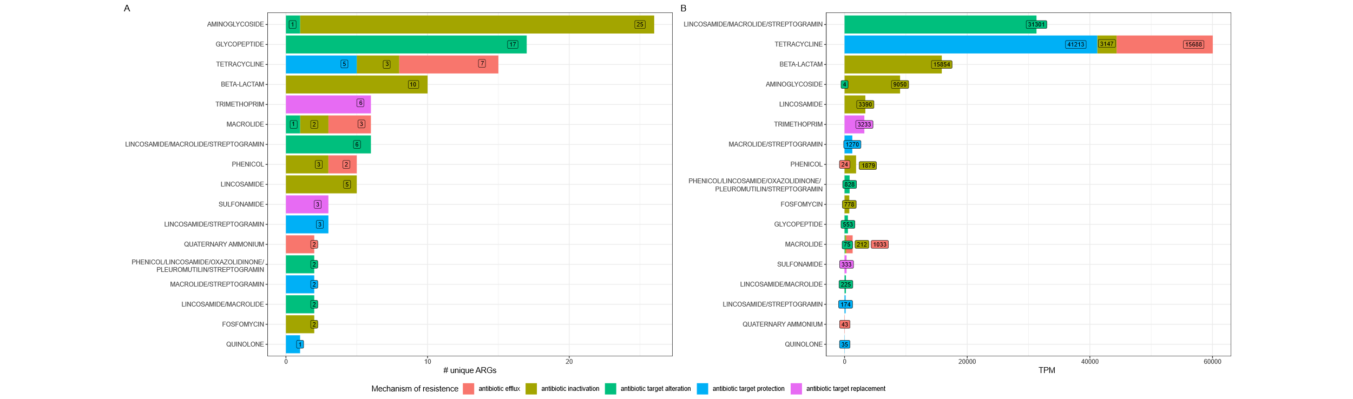
Figure 18. Diversity and abundance of antimicrobial resistance genes (ARGs) across all individuals gut microbiota in the cohort. A) Number of unique genes and B) number of mapped reads (TPM) to ARGs, coloured by mechanism of resistance based on CARD.

We detected from 81 to 101 unique ARGs per individual (Supplement Table 4), with anywhere from 32% to 63% (with an average of 36%) of ARGs consistently present over six months in an individual. Individuals that reported out-of-the-ordinary events did not have higher abundance or diversity of ARGs, neither did they have more persistent ARGs. In the six-month following we were unable to detect any true loss or gain of a new ARG within individual (Supplement Figure 8).
We observed no significant correlation between reported events and changes in abundance or diversity of ARGs beyond normal fluctuation within individuals through six months (Figure 18). The only dip in bacterial diversity that could be correlated to a change in lifestyle happened for individual H during antibiotic consumption (amoxicillin, day 78 to 84, Figure ADD chapter 1). And while other individuals also consumed antibiotics (E, day 10, doxycycline), travelled (A, B, C, D, G, H, I) and experienced periods of stress (D, I, G) etc. none of the before mentioned events influenced bacterial diversity on the abundance and diversity of ARGs. Overall, bacterial species diversity did not correlate with total ARG diversity or abundance. However, distinct ARG classes exhibited varying relationships with bacterial diversity: aminoglycoside, glycopeptide, and macrolide/streptogramin resistance genes positively correlated with bacterial diversity, whereas lincosamide, sulphonamide, trimethoprim, and some macrolide resistance genes correlated negatively (Supplement Figure 9).
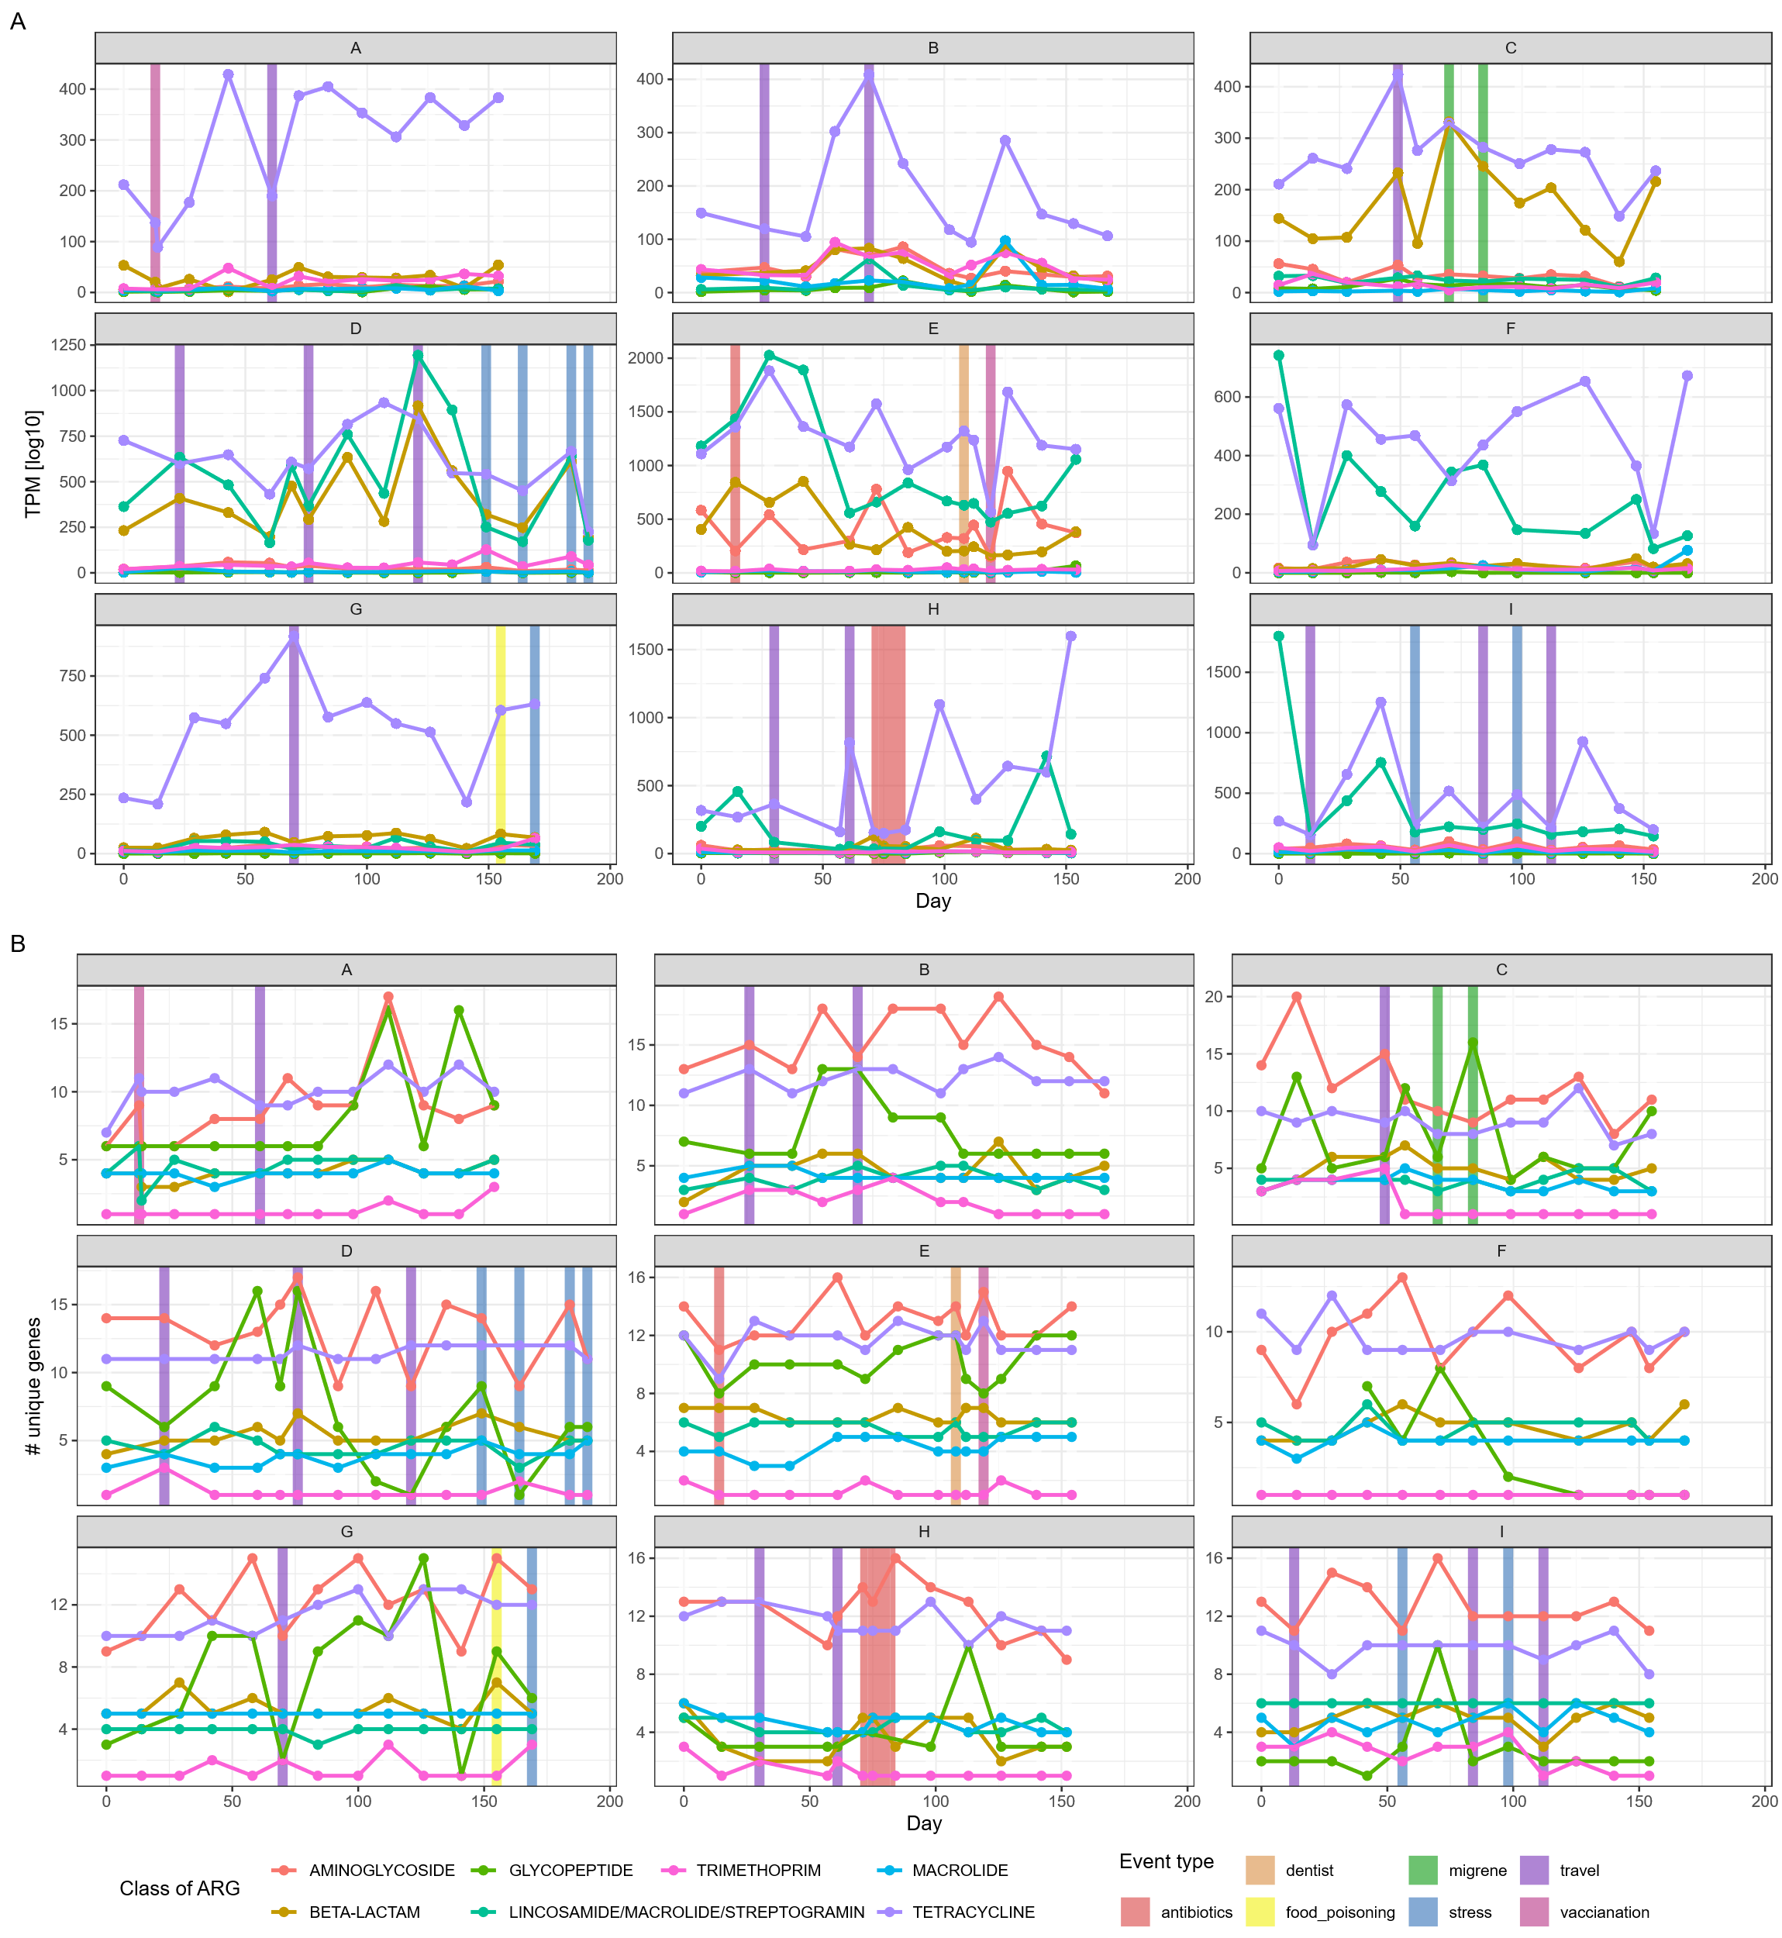
Figure 19. Abundance and diversity of classes of ARGs through time within each individual. Depicted are the classes with more than 5 unique ARGs. Depicted are the AGR classes with more than 5 unique resistance genes, which reduces the number of ARGs to 86, leaving 7 ARG classes. (all I have a picture available).

CONCLUSION

REFERENCES

