SUPPLEMENT
Supplement Table 1. Protocols DNA isolation from human stool samples.
Protocol | QIAamp Fast DNA Stool Mini Kit | NucleoSpin Soil Mini Kit | QIAamp PowerFecal Pro DNA Kit | in-house protocol based on DNeasy Blood and Tissue Kit
Manufacturer | QIAGEN | Macherey-Nagel | QIAGEN | QIAGEN
Cell lysis | Mechanical (bead-beating using MagnaLyser; 7000rpm, 70s) & heating the lysate at 95°C for 5min | Mechanical (bead-beating by vortexing; max speed, 5min) | Chemical (CD1 solution) & Mechanical (bead-beating by vortexing; max speed, 10min) | Chemical (ATL buffer) & Mechanical (bead-beating by MagnaLyser; 7000 rpm 70s)
Bead-beating tubes, beads and solutions | 2,0 ml nuclease-free tubes (Starstedt, DE) with 0.1 mm (0.25g) and 0.5 mm (0.25g) silica beads (Biospec Products, US) containing Inhibitex buffer | NucleoSpin Bead Tube Type A containing SL2 lysis buffer | PowerBead Pro Tubes (2ml) containing PowerBead and C1 solution | 2,0 ml nuclease-free tubes (Starstedt, DE) with 0.1 mm (0.25g) and 0.5 mm (0.25g) silica beads (Biospec Products, US) and ATL buffer

Supplementary Table 3. Details on sequencing projects in this thesis.
 | Comparison of isolation protocols | Optimization of protocol for spore DNA isolation from human stool samples | Longitudinal study |  | Longitudinal study
Sequencing platform | MiSeq | MiSeq | NextSeq |  | DNBSeq
Type of sequencing | Amplicon (V3-V4 region of the 16S rRNA gene) |  |  |  | Shotgun metagenomic sequencing bulk microbiota samples | Shotgun metagenomic sequencing of ethanol treated samples
Polymerase | KAPA HiFI | Q5 | Q5 |  | Phi29
Successfully sequenced | all | all | 234/6 removed including both negative controls |  | 116/116 | 116/85
Total number of reads | 3 258 569 | 4 000 965 | 62 793 747 |  | 5 700 000 000 | 4 600 000 000
Average number of reads per sample | 90515.8 | 25006.03 | 270662.7 |  | 49 000 000 | 55 000 000
Min / Max number of reads in a sample | 12542 / 153 530 | 3 / 85784 | 61388 / 884743 |  | 4e7 / 5e7 | 5e6 / 1e8
Number of reads per sample (rarefaction depth) | 50 000 | 10 000 | 150 000
OTUs with less than reads removed | 10 or less reads | 10 or less reads removed | 62 or less reads removed | Percentage of reads remaining after quality filtering (mean/min/max) | 98,5 / 88,8 / 99,3 | 51,2 / 22,9 / 98,3
 |  |  |  | Percentage of reads remaining after removal of human sequences (mean/min/max) | 98,5 / 88,8 / 99,3 | 50,5 / 22,3 / 98,3
SRA project number | PRJNA887005 | Data available upon request | PRJNA1124620

Supplementary Table 3. Sporulation signature genes.
Organism | Locus tag | Gene name | Weight
Bacillus subtilis 168 | BSU_15030 | spoVV | 0.95
Bacillus subtilis subsp. subtilis str. 168 | BSU_27970 | spoIVFB | 0.98
Bacillus subtilis 168 | BSU_40410 | walR | 0.91
Bacillus subtilis 168 | BSU_01690 | murR | 0.88
Bacillus subtilis 168 | BSU_13710 | ykvI | 0.92
Bacillus subtilis 168 | BSU_16700 | ylxY | 0.87
Clostridioides difficile 630 | CD630_RS18820 | spmB | 0.97
Clostridioides difficile 630 | CD630_RS18825 | spmA | 0.95
Clostridioides difficile 630 | CD630_RS19535 | noc | 0.90
Clostridioides difficile 630 | CD630_RS08555 | CD630_RS08555 | 0.83
Clostridioides difficile 630 | CD630_RS18610 | spoVT | 0.82
Clostridioides difficile 630 | CD630_RS14080 | spoIVA | 0.95
Clostridioides difficile 630 | CD630_RS15860 | dpsA | 0.76
Clostridioides difficile 630 | CD630_RS03565 | cotCB | 1
Clostridioides difficile 630 | CD630_RS06675 | spoIIIAG | 0.99
Clostridioides difficile 630 | CD630_RS06680 | spoIIIAH | 0.89
Clostridioides difficile 630 | CD630_RS06745 | bltD | 0.98
Clostridioides difficile 630 | CD630_RS00005 | dnaA | 0.84
Clostridioides difficile 630 | CD630_RS14145 | sigG | 0.88
Clostridioides difficile 630 | CD630_RS14150 | sigE | 0.88
Clostridioides difficile 630 | CD630_RS14155 | spoIIGA | 0.98
Clostridioides difficile 630 | CD630_RS14185 | ftsQ | 0.76
Clostridioides difficile 630 | CD630_RS14195 | spoVE | 0.88
Clostridioides difficile 630 | CD630_RS03425 | ytxC | 0.93
Clostridioides difficile 630 | CD630_RS04990 | CD630_RS04990 | 0.93
Clostridioides difficile 630 | CD630_RS11435 | CD630_RS11435 | 0.80
Clostridioides difficile 630 | CD630_RS07160 | dacF | 0.96
Clostridioides difficile 630 | CD630_RS01160 | yyaC | 0.83
Clostridioides difficile 630 | CD630_RS18960 | spoIIR | 0.84
Clostridioides difficile 630 | CD630_RS18975 | CD630_RS18975 | 0.96
Clostridioides difficile 630 | CD630_RS18985 | yabG | 0.85
Clostridioides difficile 630 | CD630_RS00585 | CD630_RS00585 | 0.95
Clostridioides difficile 630 | CD630_RS07380 | CD630_RS07380 | 0.82
Clostridioides difficile 630 | CD630_RS11130 | CD630_RS11130 | 0.83
Clostridioides difficile 630 | CD630_RS07320 | dapG | 0.91
Clostridioides difficile 630 | CD630_RS07325 | clp | 0.85
Clostridioides difficile 630 | CD630_RS13885 | CD630_RS13885 | 0.81
Clostridioides difficile 630 | CD630_RS06750 | spoIVB | 0.78
Clostridioides difficile 630 | CD630_RS06755 | spo0A | 0.99
Clostridioides difficile 630 | CD630_RS06810 | pdp | 0.92
Clostridioides difficile 630 | CD630_RS14045 | sepF | 0.87
Clostridioides difficile 630 | CD630_RS12080 | asrC | 0.82
Clostridioides difficile 630 | CD630_RS04450 | sigF | 0.83
Clostridioides difficile 630 | CD630_RS04460 | spoVAD | 0.80
Clostridioides difficile 630 | CD630_RS08895 | CD630_RS08895 | 0.98
Clostridioides difficile 630 | CD630_RS18585 | CD630_RS18585 | 0.94
Clostridioides difficile 630 | CD630_RS06075 | zupT | 0.79
Clostridioides difficile 630 | CD630_RS13130 | CD630_RS13130 | 0.82
Clostridioides difficile 630 | CD630_RS06645 | spoIIIAA | 1
Clostridioides difficile 630 | CD630_RS06650 | spoIIIAB | 0.96
Clostridioides difficile 630 | CD630_RS06655 | spoIIIAC | 0.86
Clostridioides difficile 630 | CD630_RS06660 | spoIIIAD | 0.83
Clostridioides difficile 630 | CD630_RS06665 | spoIIIAE | 0.96
Clostridioides difficile 630 | CD630_RS12285 | ytvl | 0.77
Clostridioides difficile 630 | CD630_RS09210 | trxB | 0.81
Clostridioides difficile 630 | CD630_RS13270 | spoIIP | 0.93
Clostridioides difficile 630 | CD630_RS13275 | gpr | 0.92
Clostridioides difficile 630 | CD630_RS00385 | CD630_RS00385 | 1
Clostridioides difficile 630 | CD630_RS16605 | abrB | 0.96
Clostridioides difficile 630 | CD630_RS13415 | CD630_RS13415 | 0.92
Clostridioides difficile 630 | CD630_RS00540 | rlmB | 0.97
Clostridioides difficile 630 | CD630_RS00550 | sigH | 0.94
Clostridium sp. | CSBG_02367 | CSBG_02367 | 0.79
Clostridioides difficile 630 | CD630_12300 | sigK | 0.91
Clostridioides difficile 630 | CD630_RS05845 | ytvl | 0.79
Clostridioides difficile 630 | CD630_RS11055 | Ytvl | 0.93

Supplement Table 5. Isolated species after ethanol shock from samples from individual H.

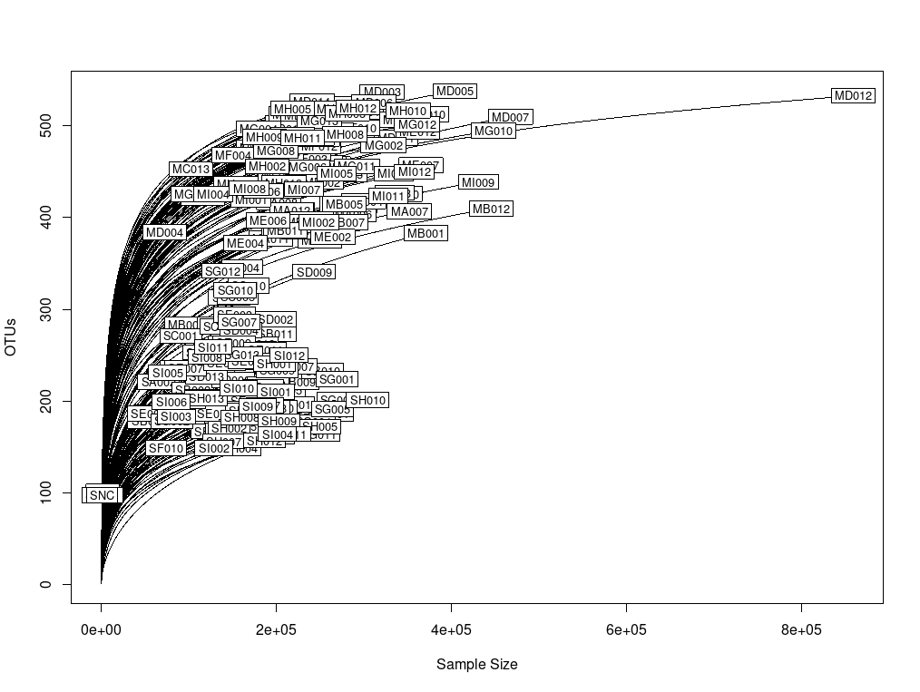
Supplement Figure 1. Rarefaction curve for all samples.

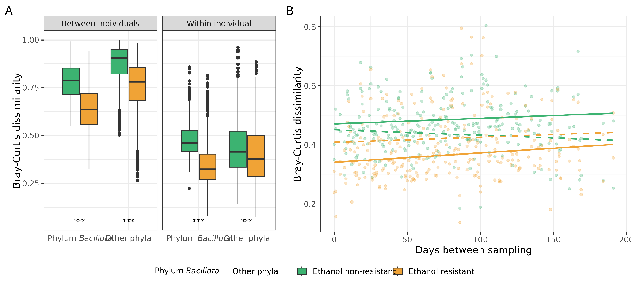
Supplement Figure 2: Dynamics of ethanol-resistant and ethanol non-resistant taxa between and within individuals. A) Boxplots showing between-individual (left) and within-individual (right) variability in community composition for ethanol-resistant (yellow) and non-resistant (green) communities. Variability was assessed using the Bray-Curtis dissimilarity, calculated separately for OTUs from the phylum Bacillota and OTUs from other phyla. Bray-Curtis dissimilarity was derived from randomly subsampled communities (n = 24, iterations = 999), with the median distance used for visualization and statistical comparisons. Distributions were compared using the Wilcoxon rank-sum test. B) Community variability as measured by Bray-Curtis dissimilarity plotted against the number of days between sampling time points. Data are presented separately for phylum Bacillota (solid line) and other phyla (dashed line) and color-coded according to ethanol resistance. The correlation between time interval and Jaccard distance was assessed using Pearson’s correlation test. Statistical significance is indicated as *** for p < 0.001.

Supplement Table 6: Wilcox rank sum test between all fractions inter and intra individuals.
Distance measure | Between fractions | p-value
 |  | Inter  individuals | Intra  individuals
Bray-Curtis | Ethanol resistant Bacillota & Ethanol non-resistant Bacillota | 0 | 7.7e-195
 | Ethanol resistant Bacillota & Other ethanol resistant taxa | 0 | 2e-19
 | Ethanol resistant Bacillota & Other ethanol non-resistant taxa | 0 | 1e-65
 | Other ethanol resistant taxa & Other ethanol non-resistant taxa | 0 | 2.2e-10
 | Other ethanol resistant taxa & Ethanol non-resistant Bacillota | 1e-20 | 1e-60
 | Other ethanol non-resistant taxa & Ethanol non-resistant taxa | 0 | 4e-31
Jaccard | Ethanol resistant Bacillota & Ethanol non-resistant Bacillota | 0 | 2e-197
 | Ethanol resistant Bacillota & Other ethanol resistant taxa | 0 | 1e-23
 | Ethanol resistant Bacillota & Other ethanol non-resistant taxa | 0 | 3e-61
 | Other ethanol resistant taxa & Other ethanol non-resistant taxa | 0 | 1e-6
 | Other ethanol resistant taxa & Ethanol non-resistant Bacillota | 0.01 | 1e-56
 | Other ethanol non-resistant taxa & Ethanol non-resistant taxa | 0 | 5e-38

Supplement Table 7. Pearson’s correlation values and p-values between median distance and time spans between an individual’s fractions. Significance is denoted as: * 0.05 – 0.01, **0.01 – 0.001 and *** < 0.001.
Distance measure | Fraction | Pearson's correlation | p-value
Bray-Curtis | Ethanol resistant Bacillota | 0.161 | 0.0625
 | Ethanol non-resistant Bacillota | 0.138 | 0.112
 | Other ethanol resistant taxa | 0.066 | 0.44
 | Other ethanol non-resistant taxa | -0.076 | 0.38
Jaccard | Ethanol resistant Bacillota | 0.179 | 0.038 *
 | Ethanol non-resistant Bacillota | 0.133 | 0.12
 | Other ethanol resistant taxa | 0.077 | 0.37
 | Other ethanol non-resistant taxa | -0.106 | 0.22

Ethanol shock is a known protocol for removal of vegetative cells as 70% ethanol damages the cell wall of all known bacteria in the human gut but does not damage spores and other ethanol resistant cell forms (Koransky et al., 1978). To obtain a normalized amount of each OTU in a sample, we measured the absolute amount of the 16S rRNA gene in each sample by performing digital droplet PCR with the same primers that were used for amplification of fragments later sequenced. Comparison of the relative abundance in the bulk microbiota sample and ethanol resistant sample of ethanol resistant OTUs revealed that these two quantities are, despite different isolation protocols positively correlated in ethanol resistant OTUs (Supplement Figure 3). The same holds true for normalized abundances (Supplement Figure 4). We could thus compare the proportion of active cells that are also creating endospores. The ratio gives us the information on the sporulation frequency of each OTU determined as endospore forming.
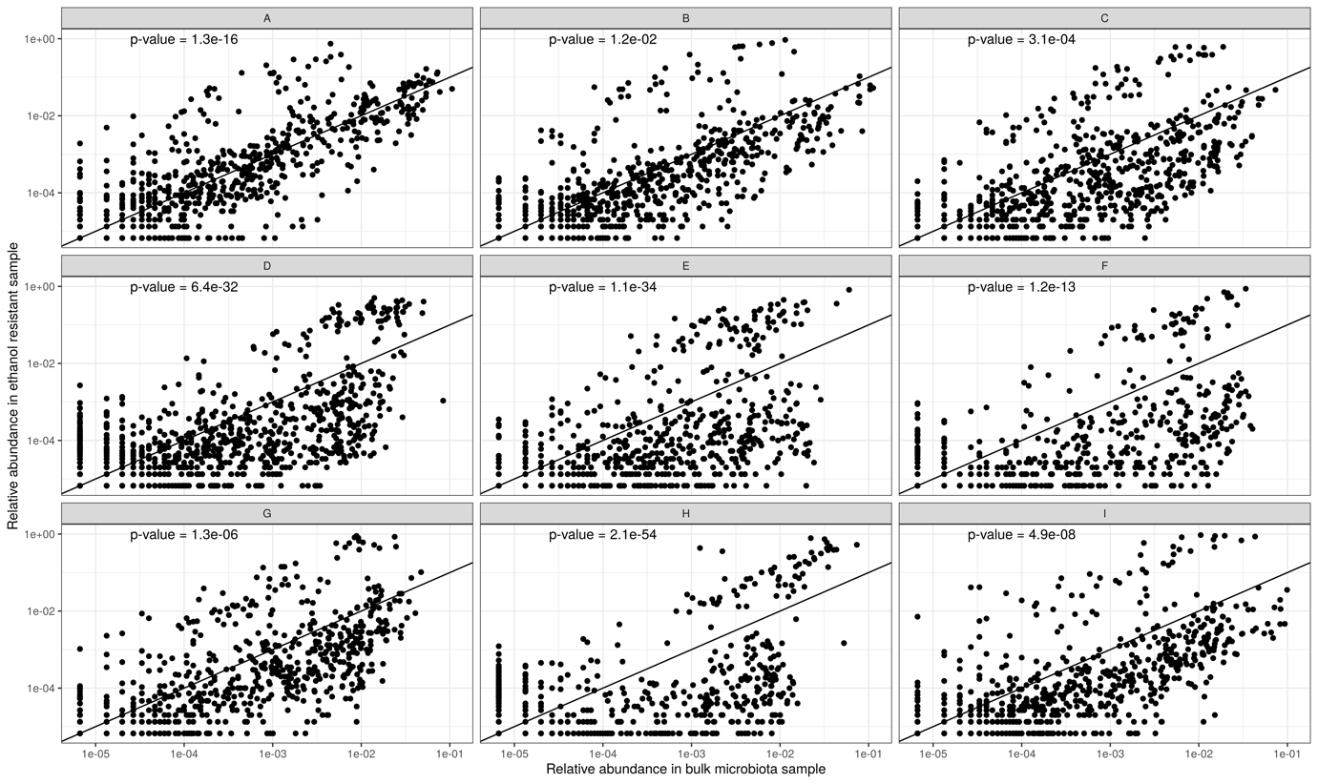
Supplement Figure 3. Relative abundance in ethanol resistant sample and relative abundance in microbiota sample are positively correlated (p-value for each individual Pearson’s correlation is plotted in the top left corner of the plot).
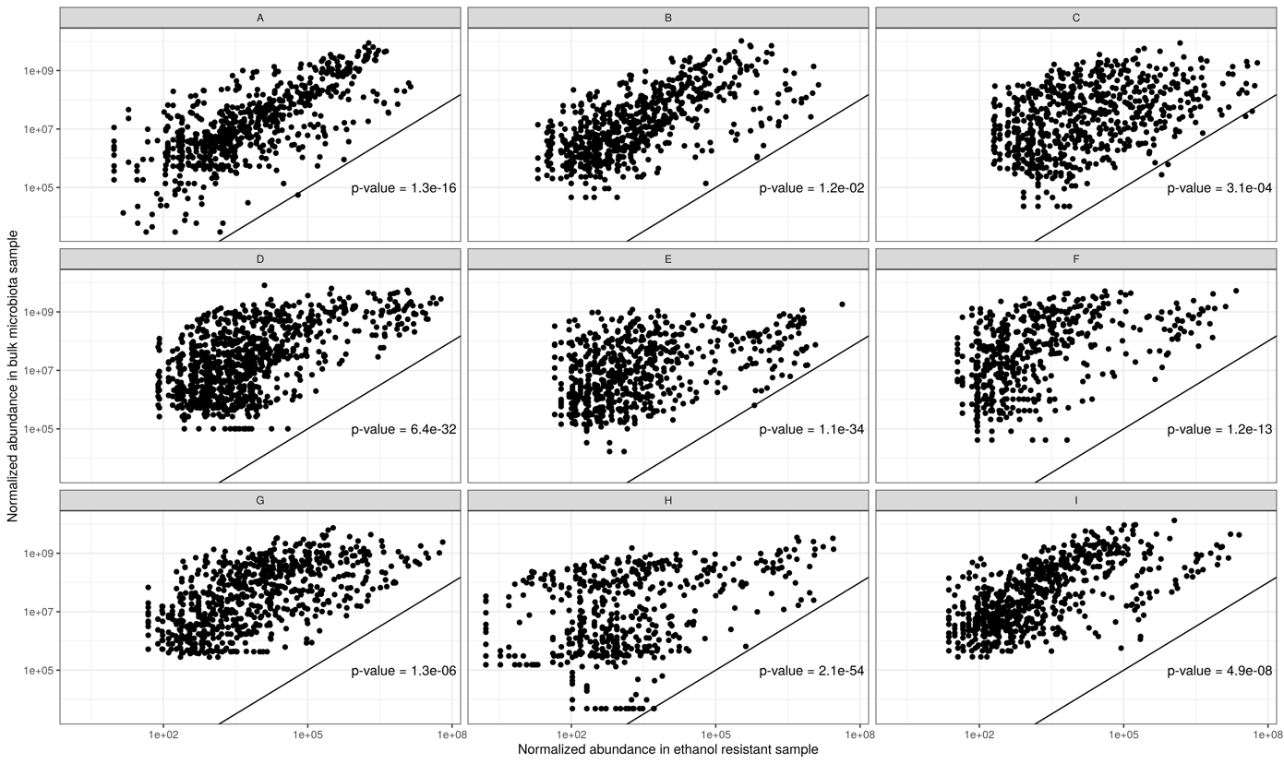
Supplement Figure 4. Normalized abundance in ethanol resistant sample and normalized abundance in microbiota sample are positively correlated (p-value for each individual Pearson’s correlation is plotted in the bottom right corner of the plot).
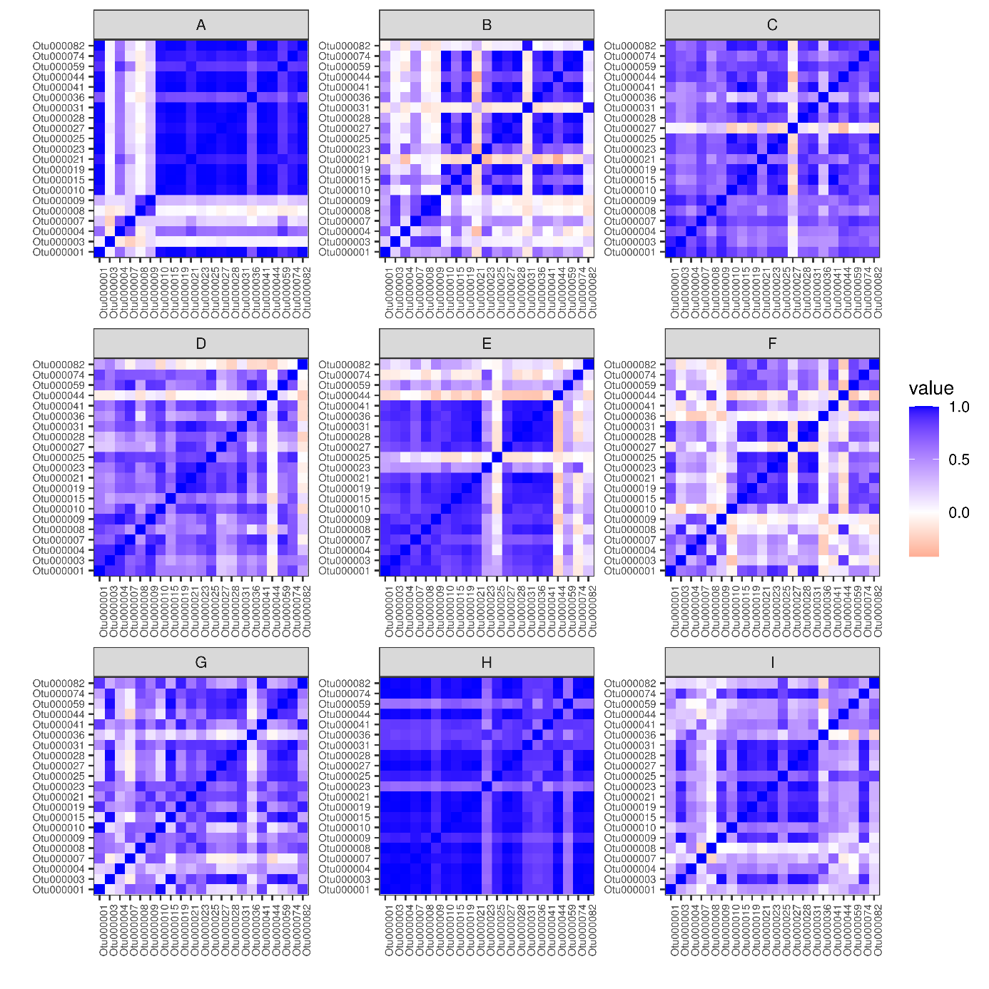
Supplement Figure 5. Correlation of sporulation frequency between OTUs within individuals. Mostly OTUs of an individual are correlated within an individual, which point to host specific sporulation frequency.
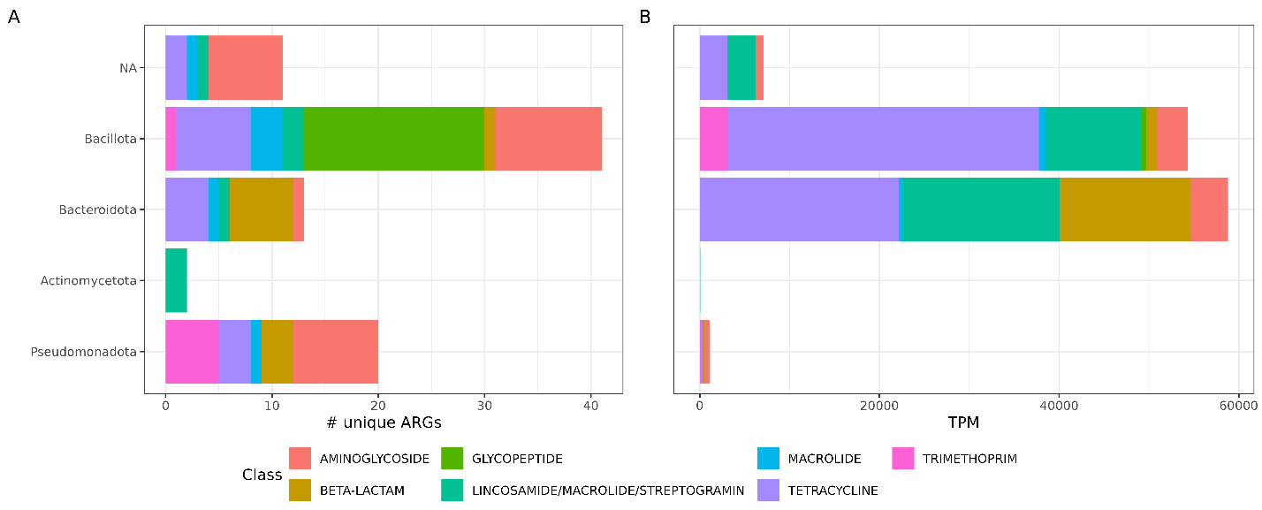
Supplement Figure 6. Taxonomy of ARGs, left the number of unique ARGs

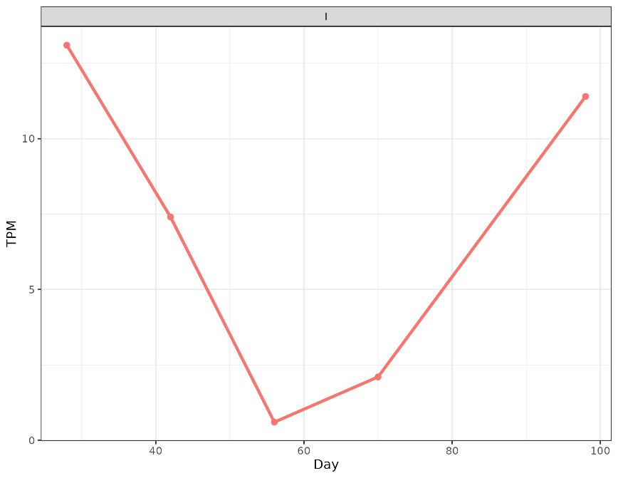
Supplement Figure 7. Abundance of CTX-M1 through time for individual I.

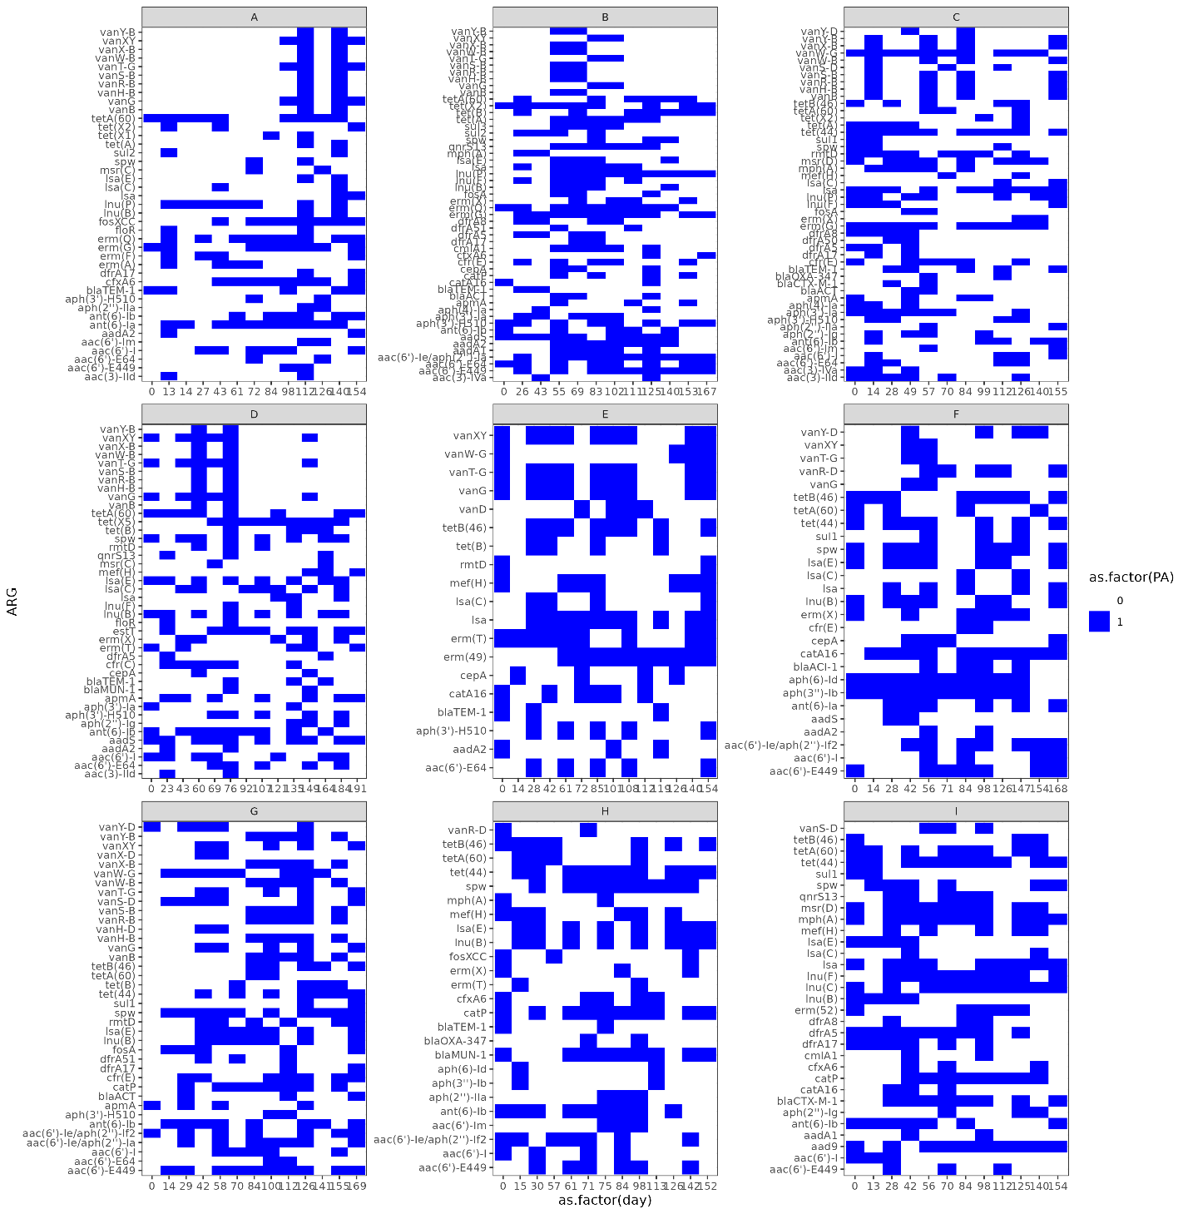
Supplement Figure 8. ARGs present more than once but less than 12 times.

Supplement Figure 9. Correlation between diversity of bacterial species in a sample and richness of class of ARGs.

