SUPPLEMENT A
Supplement Table 1
Supplement Table 2

SUPPLEMENT B
Questionnaires 1 and 2. Questionnaires at the onset of our study and the regular questionnaire completed at each sample submission. Questionnaires were in Slovene, translated for this thesis to English.
Questionnaire 1.

As part of the Longitudinal Stability of the Gut Microbiota study for the PhD degree of Urša Miklavčič, please fill in the questions below, as these questions, together with your samples, will give a comprehensive insight into the stability of your gut microbiota over a six-month period.
You are completing the questionnaire under your unique code so that we can protect your anonymity and confidentiality.
Thank you very much for your participation.

If you have any further questions, please contact me by e-mail: _________or by phone ________.
Ursa Miklavcic

Participants code:

PLEASE FILL IN!
Sex: M F Age (years): ____________
Height:_____ Weight: __________
Postal code: _________________

We will remind you a few days before the sample is submitted, so you have given your consent to the use of your personal data. Please provide us with your telephone number: ______________________ or email: _________________________.

Please answer the following questions below.

Eating habits:

No specifics
Vegi
Vegan
Gluten-free
Lactose-free
No-sugar
Paleo diet
Keto diet
Only fresh food
Other: _________________________

Do you have a medically confirmed allergy to:

Gluten
Lactose
Peanuts
Other nuts
Eggs
Cochineal
Other: ______________________
Do you take any supplements?
No
Yes, :
Omega 3
Vitamin D
Vitamin B12
Complex vitamins B
Vitamin C
Q10 complex
Other: __________________________

Physical activity
Occasionally (less than 1x per week)
Recreational 1x per week
Recreatinaly more than 1x per week
Active athlete
Regular smoker (several times a week)? No Yes

Did you take antibiotics in the last 3 months?
No
Yes, : ____________________
Don’t know

Have you ever had appendectomy in the past? No Yes

Have you ever had gallstone surgery in the past? No Yes

Have you had any other gastrointestinal surgery in the past? No Yes

Have you been hospitalized for more than two days in the last three months? No Yes

Have you had any gastrointestinal infections (vomiting and/or diarrhea) in the past 3 months? No Yes

Please mark the presence of any of the underlying gastrointestinal diseases (multiple answers are possible):
Irritable bowel syndrome (IBS)
Chron’s disease
Ulcerative colitis
Common/persistent non-specific gastrointestinal problems (e.g. flatulence, pain, cramps, wind, nausea, etc.)
Other: _____________________________

If you have ticked common/persistent non-specific problems which?
Bloating
Pain in the abdomen
Cramps
Gases
Sickness
Other: _____________________________
How would you assess your digestion?
Regular (daily most of the time)
Occasional problems with constipation (constipated maximum 2 days per week)
Major constipation problems (constipated more than 2 days a week)

How many people do you live with?
1
2
3 and more

I live in a:
house
apartment
do not want to disclose.

I live in rural or urban environment.

Thing you wish for us to know:

Questionnaire 2.
As part of the Longitudinal Stability of the Gut Microbiota study for the PhD degree of Urša Miklavčič, please fill in the questions below, as these questions, together with your samples, will give a comprehensive insight into the stability of your gut microbiota over a six-month period.
You are completing the questionnaire under your unique code so that we can protect your anonymity and confidentiality.
Thank you very much for your participation. If you have any further questions, please contact me by e-mail: _________or by phone ________.
Ursa Miklavcic

Date: Code:

The questions below refer to the past 14 days.

Eating habits:

No specifics
Vegi
Vegan
Gluten-free
Lactose-free
No-sugar
More sugar
1 to more days without food
Other: __________________
Did you take antibiotics?
No
Yes, which: _________________________, how many days ________________?

Did you take probiotics?
No
Yogurt with added probiotics
Other: ____________________________

Did you take prebiotics?
No
Yes, which ____________________________

Did you take any medication under supervision of your doctor?
No
Yes, which ____________________________

Did you take any supplements?
No
Yes, which ____________________________

How would you describe the levels of your stress  1 2 3 4 5 

Did any of the following events happen?
Moving house
Extreme physical activity (irregular from your baseline)
Travel abroad, where: ____________
Travel in Slovenia (more than 3 days)

Describe your level of activity in the past 14 days:
at least 30 min of moderate activity (walk, yoga, walking to work, playing with children, ..)
1-2x
2-3x
4x or more
Active (biking, fitness, hiking, …)
1-2x
2-3x
4x ali več

Did you visit the dentist?
No
Yes

Have you had an invasive body procedure (surgery or examination where your body has been interfered with, tattoo, piercing, etc.)?
No
Yes, what _________________

Have you been vaccinated in the past 14 days?
No
Yes, what vaccine ___________________?

Please, asses your stool, type ______________.

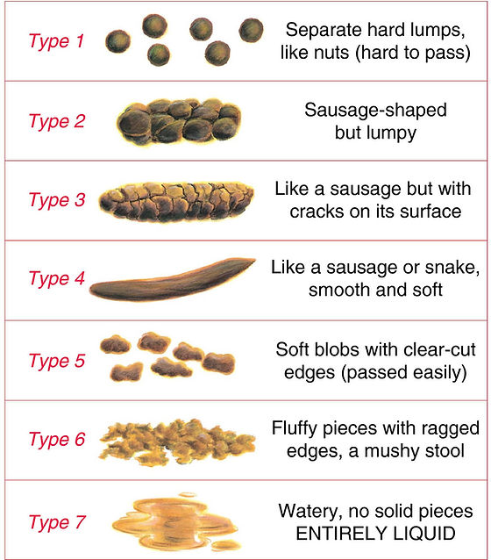

Supplement Table 1. General information on the participants. Questionnaires were filled out at each stool sample submission and events were reported for the previous 14 days, so we report the day of reporting and not necessary the day of event. For a more detailed account of each sample a metadata table is available in the GitHub repository under the folder `data/metadata.csv`.
 | Age | BMI | # samples obtained | Diet | Constant food supplements | Antibiotic consumption | Probiotics | Travel | Stress | Other reported events
A | 34 | 23 | 13 | omnivore | omega3 |  |  | Day 61: Croatia
B | 25 | 22 | 13 | omnivore | - |  | Day 26: Biotics strong | Day 26: Tanzania, Kenia; Day 69: Croatia
C | 27 | 24 | 13 | omnivore | protein powder |  |  | Day 49: UK |  | Migraines between days 70 to 84.
D | 37 | 24 | 14 | omnivore | probiotic yoghurt, protein powder |  |  | Day 23: Switzerland, Austria; Day 76: Netherlands | 149 to 191
E | 28 | 23 | 14 | omnivore | - | Day 6 to 14: doxycycline | Day 6 to 14, 72: linexForte, Omnibiotic Stress Repair, kefir
F | 27 | 33 | 12 | omnivore | - |  |  | Day 28: Croatia
G | 27 | 26 | 13 | omnivore | protein powder |  | Day 155: linexForte | Day 30: Croatia | 169 | Food poisoning on day 154
H | 43 | 29 | 13 | omnivore | - | Day 70 to 84: amoxicillin | Day 70 to 84: linexForte | Day 30: Croatia; Day 61: BIH
I | 30 | 18 | 12 | lactose-free omnivore | omega3, vitamin D, complex B.Q10, probiotics: Vivomox, EkoŠrknicl Unibiotic Strong

Supplement Table 2. Bacterial strains reported in the probiotics consumed by participants.
Probiotic (manufacturer) | Bacterial strains reported in the product
Biotics Strong (FutuNatura, EU) | Bifidobacterium longum, Lactobacillus plantarum, Lactobacillus reuteri, Lactobacillus acidophilus, Bifidobacterium lactis, Lactobacillus rhamnosus, Lactobacillus crispatus, Bifidobacterium bifidum, Lactobacillus casei, Lactobacillus paracasei, Bifidobacterium breve, Lactobacillus sporogenes, Lactobacillus gasseri, Lactobacillus lactis, Lactobacillus brevis, Lactobacillus salivarius, Lactobacillus bulgaricus, Bifidobacterium adolescentis, Streptococcus thermophilus
Linex Forte (Chr. Hansen, Denmark) | Lactobacillus acidophilus, LA-5, in Bifidobacterium animalis subsp. lactis, BB-12
OMNi-BiOTiC Stress Repair (OMNi-BiOTiC, Austria) | Lactobacillus casei W56, Lactococcus lactis W19, Lactobacillus acidophilus W22 , Bifidobacterium lactis W52, Lactobacillus paracasei W20, Lactobacillus plantarum W62, Bifidobacterium lactis W51, Bifidobacterium bifidum W23, Lactobacillus salivarius W24
Vivomixx (US) | Streptococcus thermophilus, Bifidobacterium breve, Bifidobacterium longum, Bifidobacterium infantis, Lactobacillus plantarum, Lactobacillus acidophilus, Lactobacillus paracasei, Lactobacillus dilbeckii subsp. Bulgaricus
EkoŠkrnicl Unibiotic Strong (BIO PAK Nutracevtika, Slovenia) | Lactobacillus acidophilus, Lactobacillus bulgaricus, Lactobacillus casei, Bificobacterium breve, Lactobacillus plantarum, Lactobacillus brevis, Lactobacillus paracasei, Lactobacillus rhamnosus, Bifidobacterium breve, Bifidobacterium lactis, Bifidobacterium longum, Lactococcus lactis, Streptococcus thermophilus, Lactobacillus reuteri, Lactobacillus salivarius, Lactobacillus helveticus

Supplement Table 3. Details on protocols for bulk DNA isolation from human stool samples.
Protocol | QIAamp Fast DNA Stool Mini Kit | NucleoSpin Soil Mini Kit | QIAamp PowerFecal Pro DNA Kit | in-house protocol based on DNeasy Blood and Tissue Kit
Manufacturer | QIAGEN | Macherey-Nagel | QIAGEN | QIAGEN
Cell lysis | Mechanical (bead-beating using MagnaLyser; 7000rpm, 70s) & heating the lysate at 95°C for 5min | Mechanical (bead-beating by vortexing; max speed, 5min) | Chemical (CD1 solution) & Mechanical (bead-beating by vortexing; max speed, 10min) | Chemical (ATL buffer) & Mechanical (bead-beating by MagnaLyser; 7000 rpm 70s)
Bead-beating tubes, beads and solutions | 2,0 ml nuclease-free tubes (Starstedt, DE) with 0.1 mm (0.25g) and 0.5 mm (0.25g) silica beads (Biospec Products, US) containing Inhibitex buffer | NucleoSpin Bead Tube Type A containing SL2 lysis buffer | PowerBead Pro Tubes (2ml) containing PowerBead and C1 solution | 2,0 ml nuclease-free tubes (Starstedt, DE) with 0.1 mm (0.25g) and 0.5 mm (0.25g) silica beads (Biospec Products, US) and ATL buffer

Supplement Text 1. Cultivation of spore-forming bacteria from human stool samples after ethanol or heat shock
We compared different variations of ethanol and heat shock on stool samples to determine, which treatment is more effective for elimination of vegetative cells and later isolation of spore-forming bacteria from stool samples and subsequent culturing. There are two generally used treatments for elimination of vegetative cells from pure cultures of spore-forming bacteria, heat shock and ethanol shock with multiple variations (Setlow, 2014). We choose to test ethanol shock using 100% and 70% ethanol and heat shock performed at 80 °C for 30 or 60 min. Two stool samples were aliquoted and subjected to shock treatment. For ethanol shock, aliquots were resuspended in 1,5 ml of 70% or 100% ethanol and incubated for 24 h with vigorous shaking (1500 rpm) on thermomixer (Eppendorf, Germany) at room temperature (23 °C). For heat shock, stool aliquots were resuspended in 1,5 ml of 0.9% NaCl solution and heated for 30 or 60 min at 80 °C with vigorous shaking (1500 rpm) on thermomixer (Eppendorf, Germany). After the shock treatment samples were washed 3 times with distilled water. At the last washing step, each sample was separated in half. One half of the pellet was resuspended in 500 µl distilled water and second was resuspended in 500 µl 5% bile acids solution (Sigma-Aldrich, USA). The resuspended pellets were plated in whole on BHIS agar medium (1,5% agar) or added to liquid BHIS media. BHIS is composed of brain-heart infusion (BHI, Biolife, Italy) with 0.1% L-cysteine (Merck, USA) and 0.5% yeast extract (Biolife, Italy). Incubation took place in the anaerobic workstation (Whitley A35, Don Whitley Scientific, UK) at 37 °C for 14 days. On the 1st, 2nd, 5th, 7th, and 14th day colony forming unit (CFU) was counted on plates or 100 µl of liquid culture was plated confluently and CFU was counted the next day. On the 2nd, 5th, 7th, and 14th day two plates were swabbed in whole or 0,5 ml of liquid culture was used for DNA isolation. DNA was isolated using MasterPure™ Complete DNA and RNA Purification Kit (Lucigen, US) with a pre-step of bead-beating the sample in Cell Lysis Solution with 0,5 g of 0,5 mm silica beads. Bead-beating was performed on MagNA Lyser (Roche Diagnostics, Germany) for 70 s at 7000 rpm.
The goal was to evaluate the efficacy of ethanol or heat shocks in eliminating vegetative cells from stool samples to improve cultivation of spore-forming bacteria. Additionally, we tested the impact of adding bile acids and/or enrichment in liquid culture to enhance germination of spores. Over a 14-day anaerobic cultivation, we monitored colony-forming unit (CFU) and community structure based on 16S rRNA.
CFU was influenced by the addition of 5% bile acids solution both in enrichment media and on plates (Supplement Figure 1). When bile acids were added to enrichment media prior to plating, bacterial growth was inhibited after day 2 (CFU < 10), whereas enrichment without bile acids resulted in over 100 colonies after the same period. Conversely, on plates without prior enrichment, addition of bile acids accelerated germination and replication, yielding over 150 CFU on day 1, compared to similar CFU observed only after day 5 without bile acids.
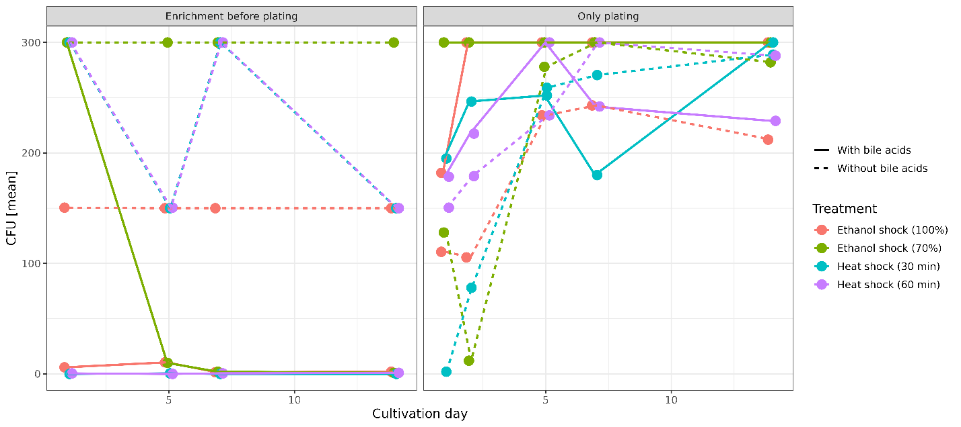
Supplement Figure 1. Colony-forming unit was influenced by addition of bile acids to the enrichment media and agar plates. Bacterial growth with and without enrichment step on BHIS, with and without the addition of bovine bile acids after two variations of ethanol concentration (100% or 70%) and heat shock at 80 °C (30 or 60 min) on days 1, 2, 5, 7, and 14.
More OTUs were detected in the enrichment cultures, especially with addition of BA than agar plates, both with and without addition of BA. This is contrary to the observed CFU, supported by a negative correlation between CFU and number of OTUs (Pearson correlation, p < 0.005). The composition of stool samples was that of healthy western individuals (45.3% Bacillota, 34.1% Bacteriodota, 3.6% Actinomycetota, 8.2% Pseudomonadota, 4% Verrucomicrobiota, 2.8% unclassified Bacteria and 1.4% other phyla). All treatments were able to some degree eliminate the non-spore-forming bacteria, but ethanol shock using 70% ethanol eliminated the greatest number of known non-sporeformers in the phyla Bacteriodota and Verrucomicrobiota (Supplement Figure 2). A reduction also happened in the phyla Pseudomonadota and Actinomycetota although some representatives withstood both ethanol and heat shocks.

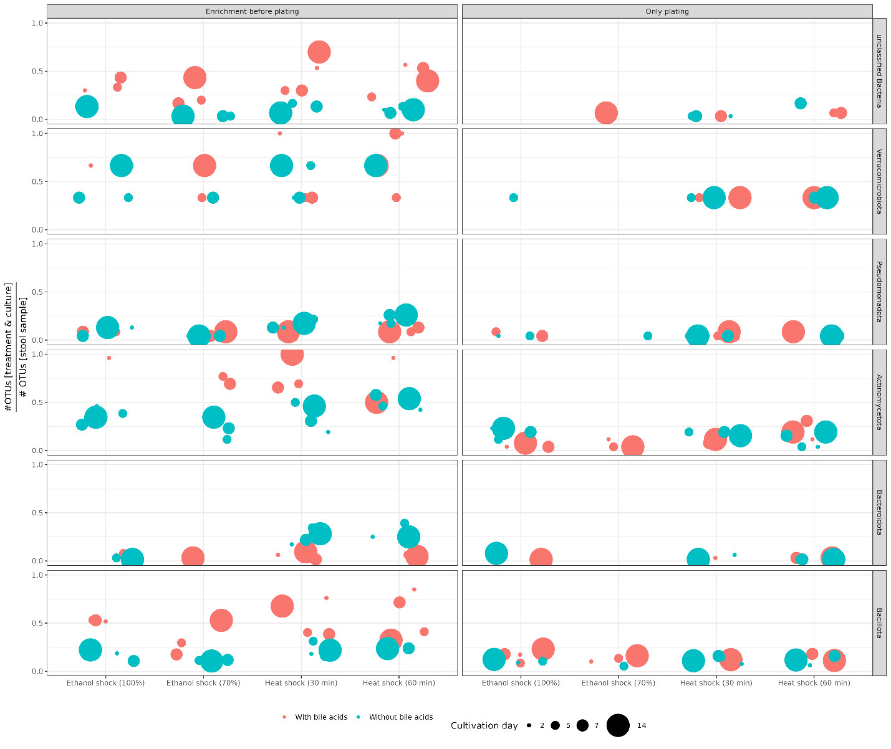
Supplement Figure 2. All treatments were able to some degree eliminate the non-spore-forming bacteria, but ethanol shock using 70% ethanol eliminated the greatest number of known non-sporeformers. Ratio between the number of OTUs in the original stool samples (n = 2) and the number of OTUs after heat/ethanol shock and cultivation/with prequal enrichment with and without bile acids on 2, 5, 7, and 14 days. Summed relative abundance for each treatment and cultivation media combination is available in Supplement Table 3

Supplementary Table 4. Details on sequencing experiments in this thesis.
Sequencing platform | Illumina MiSeq |  | Illumina NextSeq2000 |  | BGI DNBSeq | Illumina NextSeq2000 | Oxford Nanopore MinION
Experiment | Comparison of isolation protocols | Comparison of ethanol and heat shock in elimination of vegetative cells from stool samples and subsequent cultivation of sporeformers | Optimization of pre-treatment for DNA isolation from spore-forming bacteria in stool samples | Longitudinal study of gut microbiota and ethanol-treated stool samples |  | Population comparison of Clostridium saudiense
Type of sequencing | Amplicon sequencing (V3-V4 region of the 16S rRNA gene) |  |  |  | Shotgun metagenomic sequencing | Whole genome sequencing
Indexing | 16S Metagenomic Sequencing Library Preparation protocol |  |  |  | MGI Sequencing Prep Kit | NEBNext Ultra II FS DNA Library Prep Kit for Illumina | Rapid Barcoding Kit 24 SQK-RBK114.24
Polymerase | Kapa HiFi | Q5 |  |  | Phi29 | Q5 | Ligation
Number of samples/ successfully sequenced | 36/36 | 34/34 | 28/28 | 236/236 (117 of bulk microbiota and 117 of ethanol treated + 2 negative controls) | 201/234 (116 of the bulk microbiota and 85 from the ethanol treated) | 44/45 | 5/5
Negative control | Not sequenced due to low DNA concentration | Not included in experiment, control for experiment was untreated stool sample | Not sequenced due to low DNA concentration, controls were untreated stool sample and stool sample treated with ethanol and heat shock, but not EMA | Sequenced | Not sequenced | Sequenced | Not applicable
Read length | Paired-end 300 bp |  |  |  | Paired-end 150 bp |  | N50 6,04 kb
Mean number of reads per sample | 905 15 | 250 06 | 270 662 | 270 662 | 50 000 000 | 1 610 348 (details Table 5.) | 372,74 Mb (detalis Table 5.)
Filtering parameters | MiSeq SOP mothur, with rarefaction to: |  |  |  | Remove < 10% uncertain bases, Q > 20, more than 90% identity to host (GRCh38) | Trimmomatic ILLUMINACLIP:NEBPE-PE.fa:2:30:10, LEADING:10, TRAILING:10, SLIDINGWINDOW:4:20, MINLEN:40 | Q > 10, read length > 3000 bp
 | 50 000, remove OTUs < 10 reads | 10 000, remove OTUs < 10 reads | 10 000, remove OTUs < 10 reads | 150 000, remove OTUs < 62 reads
Project accession | PRJNA887005 | Data available upon request |  | PRJNA1124620 | Data available upon request

Supplementary Table 5. Details on quality control of whole genome sequencing of bacterial isolates with Illumina short-read and ONT long-read technology. Genomes marked with asterisk (*) were removed from analysis.
Genome | Illumina short-read QC |  |  | Nanopore long-read QC |  |  | # contigs
 | Read counts (after trimming) | Mapping rate (% reads mappes back to assembly) | Average coverage | Total bases unflitered (Mb) | Total bases after filtering (Mb) | N50 (after filtering)
H005_102 | 1284641 | 98,8 | 87 |  |  |  | 146
H005_118 | 1834523 | 99,0 | 129 | 466,2 | 257,1 | 5870 | 11
H005_126 * | 1202945 | 99,2 | 42 |  |  |  | 439
H005_137 | 1469188 | 98,9 | 99 |  |  |  | 123
H005_73 | 1429558 | 98,8 | 99 | 263,43 | 141,6 | 5358 | 15
H005_75 | 1509356 | 98,6 | 105 |  |  |  | 119
H005_77 | 1519024 | 98,7 | 107 |  |  |  | 117
H005_94 * | 1236201 | 99,3 | 91 |  |  |  | 71
H005_97 | 1419063 | 98,8 | 99 |  |  |  | 119
H005_98 | 1412733 | 99,1 | 97 | 501,26 | 333,5 | 6797 | 7
H007_145 | 1561483 | 98,6 | 106 |  |  |  | 145
H007_146 | 1485553 | 98,6 | 100 |  |  |  | 139
H007_148 | 1480170 | 98,8 | 100 |  |  |  | 133
H007_154 | 1423667 | 98,7 | 96 |  |  |  | 126
H007_156 | 1804629 | 98,5 | 121 |  |  |  | 130
H007_157 | 1606627 | 98,8 | 111 |  |  |  | 123
H007_158 | 1375079 | 99,0 | 95 |  |  |  | 129
H007_162 | 1308147 | 98,9 | 89 |  |  |  | 123
H007_172 | 1443359 | 98,5 | 99 |  |  |  | 136
H007_176 | 1685697 | 99,1 | 117 | 364,29 | 188,6 | 7355 | 6
H007_181 | 1268211 | 98,7 | 88 |  |  |  | 119
H007_183 | 1434111 | 98,5 | 98 |  |  |  | 130
H007_187 | 1897764 | 98,7 | 131 |  |  |  | 133
H007_188 | 1878395 | 98,9 | 122 |  |  |  | 127
H007_190 | 1663746 | 98,6 | 111 |  |  |  | 126
H007_194 | 1789766 | 98,7 | 116 |  |  |  | 136
H009_202 | 1683849 | 98,9 | 111 |  |  |  | 158
H009_205 | 1866064 | 98,7 | 120 |  |  |  | 162
H009_211 | 1505909 | 99,0 | 97 |  |  |  | 151
H009_213 | 1782794 | 99,0 | 126 |  |  |  | 128
H009_215 | 2161024 | 98,6 | 147 |  |  |  | 106
H009_217 | 1697678 | 98,7 | 116 |  |  |  | 149
H009_218 | 1774983 | 98,9 | 127 |  |  |  | 101
H009_219 | 1688393 | 99,1 | 116 |  |  |  | 149
H009_220 | 1391742 | 99,0 | 100 |  |  |  | 105
H009_221 | 1682869 | 98,8 | 120 | 268,51 | 109,9 | 5828 | 5
H009_228 | 1668854 | 98,8 | 115 |  |  |  | 143
H009_230 | 1987518 | 98,6 | 143 |  |  |  | 119
H009_234 | 1560947 | 98,8 | 111 |  |  |  | 130
H009_236 | 2001000 | 98,7 | 139 |  |  |  | 147
H009_251 | 1349494 | 98,8 | 94 |  |  |  | 149
H009_255 | 1908259 | 99,0 | 134 |  |  |  | 138
H009_256 | 1984918 | 97,3 | 119 |  |  |  | 524
H009_259 | 1735392 | 99,01 | 120 |  |  |  | 154

Supplement Text 2. Efficiency of DNA isolation from Clostridioides difficile spores using the PowerFecal protocol & sporulation frequency calculation support
Clostridioides difficile (strain VPI10463) was cultured from spore stock solution and plated confluently on three Columbia agar plates with 5% added horse blood (COH) plates (Biomérieux, France). After five days of anaerobic incubation at 37 °C, spores and cells were harvested and washed five times with ice-cold nuclease-free water. Washed spores were treated with EMA (2.5 ng/µl), sample was incubated for 5 minutes in the dark, followed by 10-minute exposure to 8000-lumen light with ice cooling. A fresh stool sample was homogenized and aliquoted (~100 mg) into PowerFecal bead-beating tubes. DNA was isolated from stool samples and from stool samples spiked with spores at various dilutions (non-diluted, 10-1, 10-3, and 10-4), in triplicates with PowerFecal Kit (Qiagen, Germany). The same spore dilutions were also plated on COH agar to determine CFU count.
Droplet digital PCR (ddPCR) was performed using EvaGreen QX200 technology (Bio-Rad, USA) for the quantification of C. difficile, using C. difficile-specific primers targeting the 16S rRNA gene F(5’ CCATCCTGTACTGGCTCACCT-3’) and R(5’- TTGAGCGATTTACTTCGGTAAAGA-3’ (Rinttilä et al., 2004). The reaction volume was 25 µl, consisting of 2.5 µl of diluted DNA, 12.5 µl of 2x EvaGreen Supermix, 0.5 µl of each 10 µM primer, and 9 µl of nuclease-free water. Droplets were generated using the QX200 Droplet Generator, following the manufacturer’s instructions. The thermal cycling conditions for C. difficile 16S rRNA were enzyme activation at 95 °C for 5 minutes, followed by 40 cycles of denaturation at 95 °C for 30 seconds, annealing and elongation at 60 °C for 60 seconds, and signal stabilization at 4 °C for 5 minutes and 90 °C for 5 min.
Absolute quantification was performed using QuantaSoft software v7.4.1, with a minimum threshold of 10,000 droplets per sample. We calculated the copy number of target amplicon in each sample with Equation 1. Efficiency of DNA isolation from spores was tested with Pearson correlation between CFU/ml and the copy number of the C. difficile 16S rRNA gene in the sample.
We used two different isolation protocols for isolation of DNA from bulk microbiota and ethanol treated samples. This decision was based on the fact PowerFecal has a spin-column to which to much DNA binds and we got insufficient DNA concentrations after ethanol shock and EMA treatment. To confirm that we isolated both vegetative cells and spores with bulk microbiota protocol, we added C. difficile spores to an otherwise C. difficile negative stool sample and measured the absolute amount of the C.difficile-specific 16S rRNA amplicon with ddPCR after isolation of DNA. The copy number of C. difficile-specific amplicon correlated to CFU count of spores after cultivation (Supplement Figure 3, Pearson’s correlation value = 0.73, p-value = 0.007).
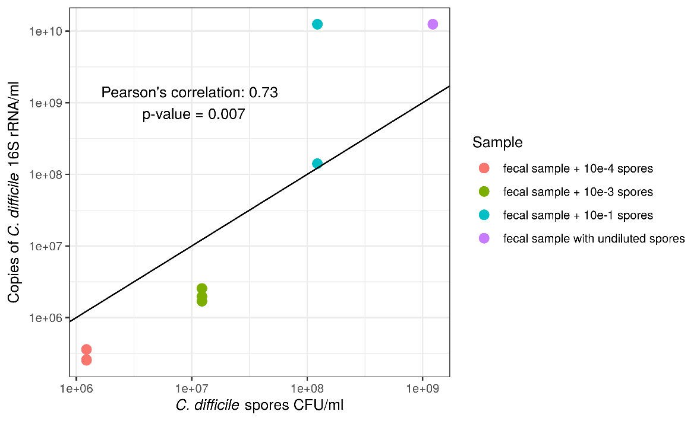
Figure 3. Efficiency of C. difficile spore isolation with PowerFecal protocol compared to C. difficile spore CFU count on COH agar plates.

To obtain a normalized amount of each OTU in a sample, we measured the absolute amount of the 16S rRNA gene in each sample by performing digital droplet PCR with the same primers that were used for amplification of fragments later sequenced. Comparison of the relative abundance in the bulk microbiota sample and ethanol resistant sample of ethanol resistant OTUs revealed that these two quantities are, despite different isolation protocols positively correlated in ethanol resistant OTUs (Supplement Figure 4). The same holds true for normalized abundances (Supplement Figure 5). We could thus compare the proportion of active cells that are also creating endospores. The ratio gives us the information on the sporulation frequency of each OTU determined as endospore forming.
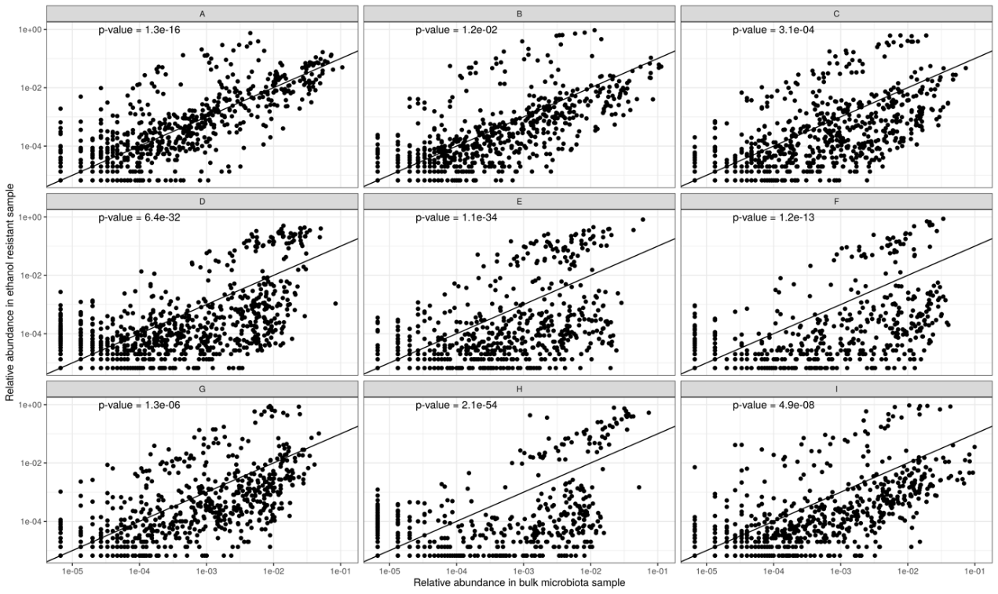
Supplement Figure 4. Relative abundance in ethanol resistant sample and relative abundance in microbiota sample is positively correlated (p-value for each individual Pearson’s correlation is plotted in the top left corner of the plot).
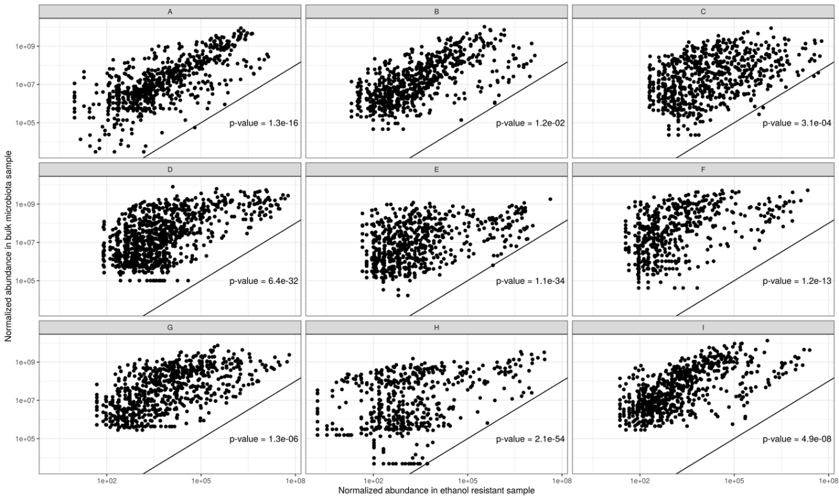
Supplement Figure 5. Normalized abundance in ethanol resistant sample and normalized abundance in microbiota sample is positively correlated (p-value for each individual Pearson’s correlation is plotted in the bottom right corner of the plot).
Supplement Table 6. Sporulation signature genes. Obtained from Browne et al., 2016.
Organism | Locus tag | Gene name
Bacillus subtilis 168 | BSU_15030 | spoVV
Bacillus subtilis subsp. subtilis str. 168 | BSU_27970 | spoIVFB
Bacillus subtilis 168 | BSU_40410 | walR
Bacillus subtilis 168 | BSU_01690 | murR
Bacillus subtilis 168 | BSU_13710 | ykvI
Bacillus subtilis 168 | BSU_16700 | ylxY
Clostridioides difficile 630 | CD630_RS18820 | spmB
Clostridioides difficile 630 | CD630_RS18825 | spmA
Clostridioides difficile 630 | CD630_RS19535 | noc
Clostridioides difficile 630 | CD630_RS08555 | CD630_RS08555
Clostridioides difficile 630 | CD630_RS18610 | spoVT
Clostridioides difficile 630 | CD630_RS14080 | spoIVA
Clostridioides difficile 630 | CD630_RS15860 | dpsA
Clostridioides difficile 630 | CD630_RS03565 | cotCB
Clostridioides difficile 630 | CD630_RS06675 | spoIIIAG
Clostridioides difficile 630 | CD630_RS06680 | spoIIIAH
Clostridioides difficile 630 | CD630_RS06745 | bltD
Clostridioides difficile 630 | CD630_RS00005 | dnaA
Clostridioides difficile 630 | CD630_RS14145 | sigG
Clostridioides difficile 630 | CD630_RS14150 | sigE
Clostridioides difficile 630 | CD630_RS14155 | spoIIGA
Clostridioides difficile 630 | CD630_RS14185 | ftsQ
Clostridioides difficile 630 | CD630_RS14195 | spoVE
Clostridioides difficile 630 | CD630_RS03425 | ytxC
Clostridioides difficile 630 | CD630_RS04990 | CD630_RS04990
Clostridioides difficile 630 | CD630_RS11435 | CD630_RS11435
Clostridioides difficile 630 | CD630_RS07160 | dacF
Clostridioides difficile 630 | CD630_RS01160 | yyaC
Clostridioides difficile 630 | CD630_RS18960 | spoIIR
Clostridioides difficile 630 | CD630_RS18975 | CD630_RS18975
Clostridioides difficile 630 | CD630_RS18985 | yabG
Clostridioides difficile 630 | CD630_RS00585 | CD630_RS00585
Clostridioides difficile 630 | CD630_RS07380 | CD630_RS07380
Clostridioides difficile 630 | CD630_RS11130 | CD630_RS11130
Clostridioides difficile 630 | CD630_RS07320 | dapG
Clostridioides difficile 630 | CD630_RS07325 | clp
Clostridioides difficile 630 | CD630_RS13885 | CD630_RS13885
Clostridioides difficile 630 | CD630_RS06750 | spoIVB
Clostridioides difficile 630 | CD630_RS06755 | spo0A
Clostridioides difficile 630 | CD630_RS06810 | pdp
Clostridioides difficile 630 | CD630_RS14045 | sepF
Clostridioides difficile 630 | CD630_RS12080 | asrC
Clostridioides difficile 630 | CD630_RS04450 | sigF
Clostridioides difficile 630 | CD630_RS04460 | spoVAD
Clostridioides difficile 630 | CD630_RS08895 | CD630_RS08895
Clostridioides difficile 630 | CD630_RS18585 | CD630_RS18585
Clostridioides difficile 630 | CD630_RS06075 | zupT
Clostridioides difficile 630 | CD630_RS13130 | CD630_RS13130
Clostridioides difficile 630 | CD630_RS06645 | spoIIIAA
Clostridioides difficile 630 | CD630_RS06650 | spoIIIAB
Clostridioides difficile 630 | CD630_RS06655 | spoIIIAC
Clostridioides difficile 630 | CD630_RS06660 | spoIIIAD
Clostridioides difficile 630 | CD630_RS06665 | spoIIIAE
Clostridioides difficile 630 | CD630_RS12285 | ytvl
Clostridioides difficile 630 | CD630_RS09210 | trxB
Clostridioides difficile 630 | CD630_RS13270 | spoIIP
Clostridioides difficile 630 | CD630_RS13275 | gpr
Clostridioides difficile 630 | CD630_RS00385 | CD630_RS00385
Clostridioides difficile 630 | CD630_RS16605 | abrB
Clostridioides difficile 630 | CD630_RS13415 | CD630_RS13415
Clostridioides difficile 630 | CD630_RS00540 | rlmB
Clostridioides difficile 630 | CD630_RS00550 | sigH
Clostridium sp. | CSBG_02367 | CSBG_02367
Clostridioides difficile 630 | CD630_12300 | sigK
Clostridioides difficile 630 | CD630_RS05845 | ytvl
Clostridioides difficile 630 | CD630_RS11055 | Ytvl

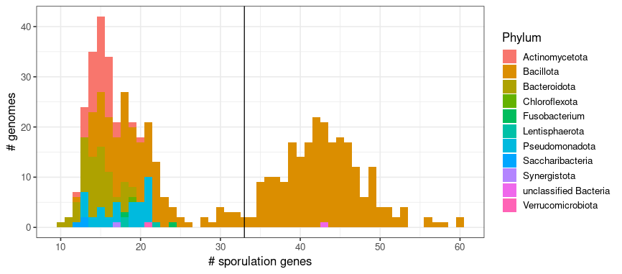
Supplement Figure 6. Number of sporulation genes per genome (x-axis) and the number of genomes (y-axis).
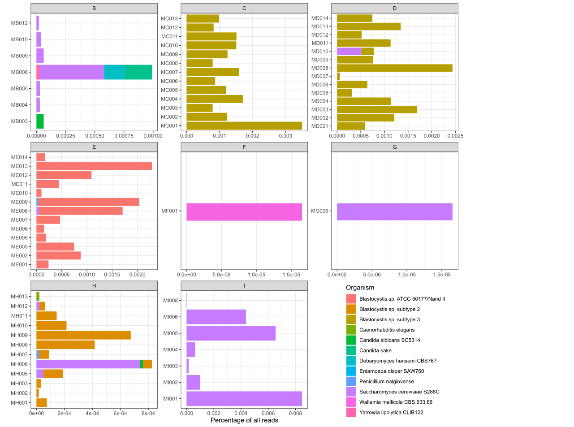
Supplementary Figure 7. Abundance of eukaryotic species as detected by EukDetect. On the x-axis the number represents the percentage of reads mapped to marker genes of a species vs. all reads in a sample, the y-axis represents each sample of an individual where eukaryotes were detected.
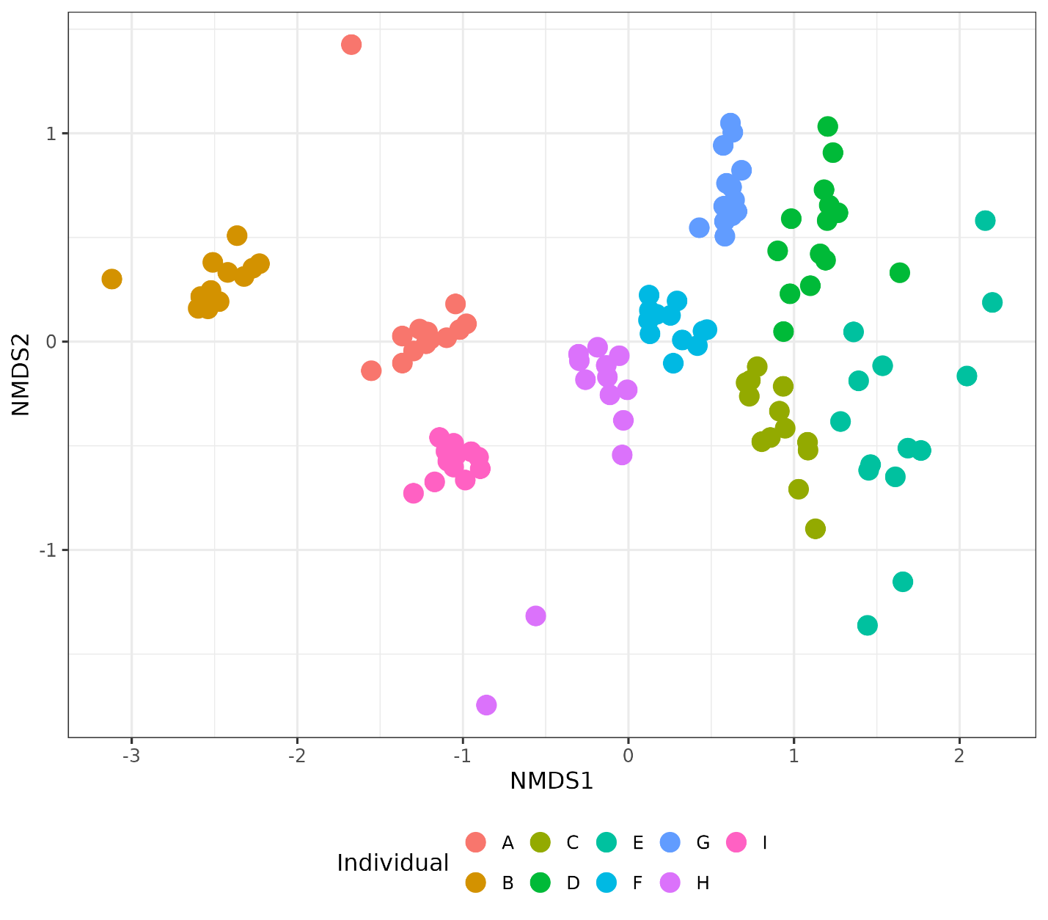
Supplement Figure 8. Beta diversity viral sequenced at family level.
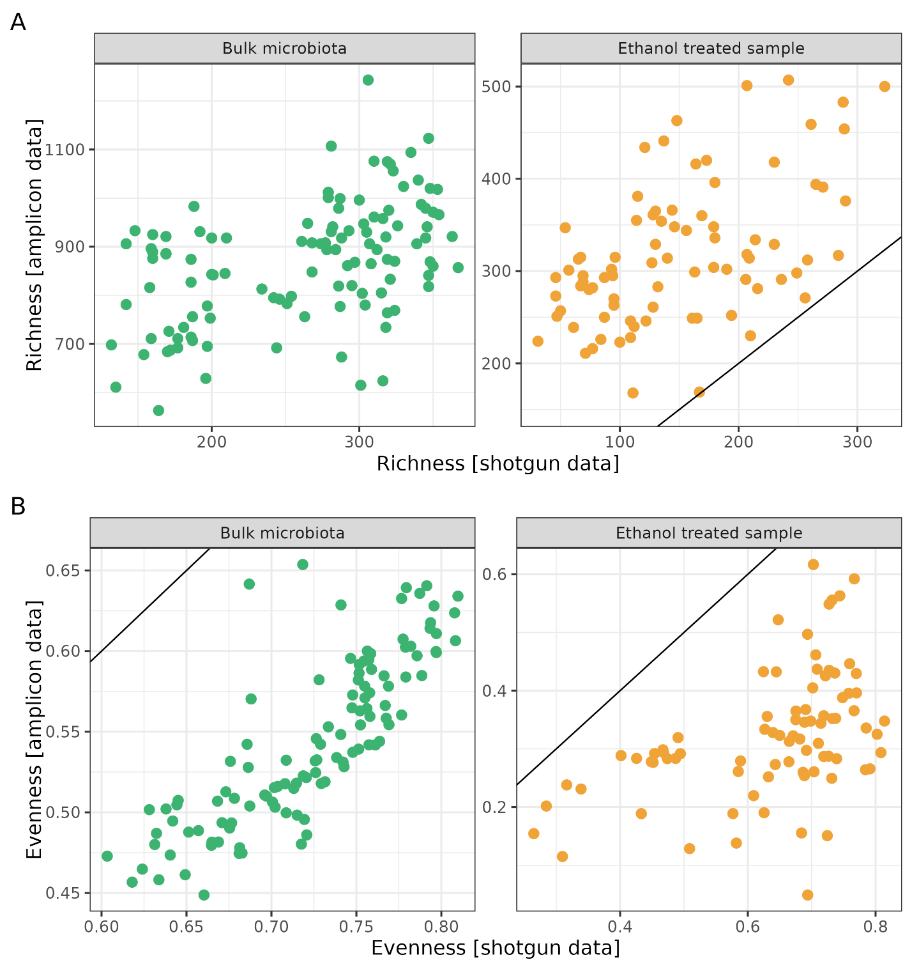
Supplement Figure 9. Richness and evenness comparison in each sample using amplicon sequencing (y-axis) and shotgun metagenomic sequencing (x-axis). The black line represents the identity function (x = y. If the points fell on the line, we could assume identical observations with both types of data.

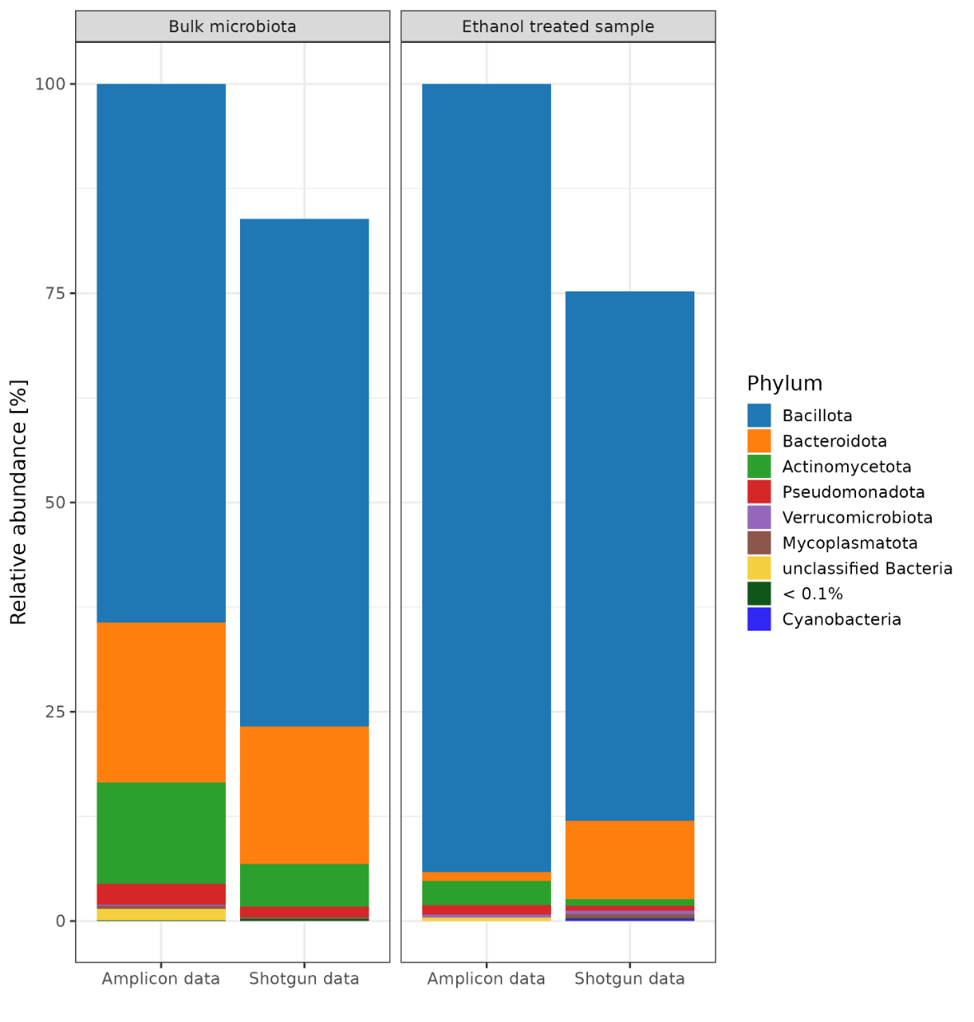
Supplement Figure 10. Relative abundance of bacterial phyla across samples for amplicon and shotgun metagenomic sequencing.

Supplement Text 3. Properties of OTUs detected only in ethanol treated samples
We removed 224 OTUs either because they were only found in ethanol treated samples (n = 114) or were undetermined (n = 83, See Methods). OTUs found only in ethanol treated samples are most likely a sampling error, as they were not found in untreated samples or were present in very low abundance and could only be detected once more dominant OTUs were removed via ethanol shock and EMA treatment. Their relative abundance in ethanol treated samples is unreliable, as we removed a lot of taxa with ethanol shock and EMA treatment, but are present at very low abundances from 0.000006 to 0.0009% of total abundance per sample (Supplement Figure 6). They are mostly from phylum Bacillota (n = 107), followed by OTUs from phylum Actinomycetota and Pseudomonadota (n = 10 and n = 9, respectively). Some 8 representatives are from the phylum Bacteroidota while less than 4 representatives each come from phyla Fucobacteria, Verrucomicrobiota and unclassified Bacteria.
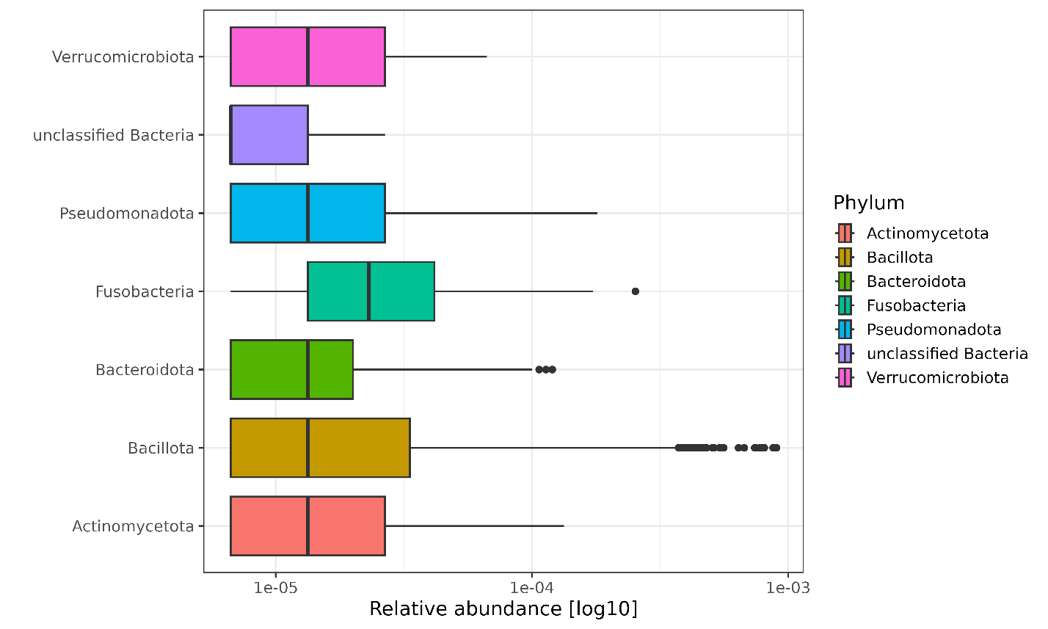
Supplement Figure 11. Relative abundance of OTUs detected only in ethanol treated samples divided per phylum.

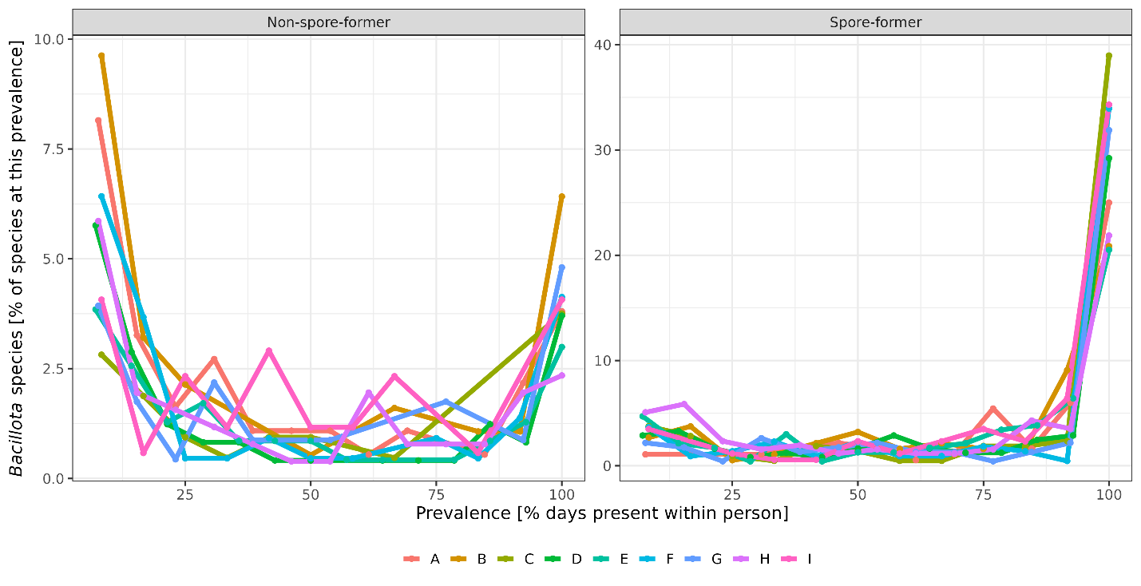
Supplement Figure 12. Persistence of spore-forming Bacillota species in the human gut based on shotgun metagenomic sequencing.

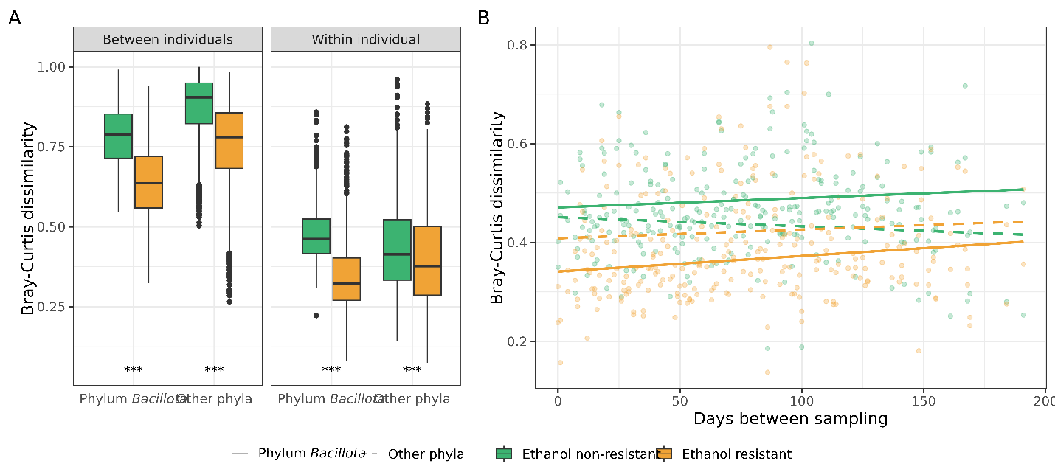
Supplement Figure 13. Dynamics of ethanol-resistant and ethanol non-resistant taxa between and within individuals. A) Boxplots showing between-individual (left) and within-individual (right) variability in community composition for ethanol-resistant (yellow) and non-resistant (green) communities. Variability was assessed using the Bray-Curtis dissimilarity, calculated separately for OTUs from the phylum Bacillota and OTUs from other phyla. Bray-Curtis dissimilarity was derived from randomly subsampled communities (n = 24, iterations = 999), with the median distance used for visualization and statistical comparisons. Distributions were compared using the Wilcoxon rank-sum test. B) Community variability as measured by Bray-Curtis dissimilarity plotted against the number of days between sampling time points. Data are presented separately for phylum Bacillota (solid line) and other phyla (dashed line) and color-coded according to ethanol resistance. The correlation between time interval and Jaccard distance was assessed using Pearson’s correlation test. Statistical significance is indicated as *** for p < 0.001.

Supplement Table 7. Wilcox rank sum test between all fractions inter- and intra-individuals.
Distance measure | Between fractions | p-value
 |  | Inter  individuals | Intra  individuals
Bray-Curtis | Ethanol resistant Bacillota & Ethanol non-resistant Bacillota | 0 | 7.7e-195
 | Ethanol resistant Bacillota & Other ethanol resistant taxa | 0 | 2e-19
 | Ethanol resistant Bacillota & Other ethanol non-resistant taxa | 0 | 1e-65
 | Other ethanol resistant taxa & Other ethanol non-resistant taxa | 0 | 2.2e-10
 | Other ethanol resistant taxa & Ethanol non-resistant Bacillota | 1e-20 | 1e-60
 | Other ethanol non-resistant taxa & Ethanol non-resistant taxa | 0 | 4e-31
Jaccard | Ethanol resistant Bacillota & Ethanol non-resistant Bacillota | 0 | 2e-197
 | Ethanol resistant Bacillota & Other ethanol resistant taxa | 0 | 1e-23
 | Ethanol resistant Bacillota & Other ethanol non-resistant taxa | 0 | 3e-61
 | Other ethanol resistant taxa & Other ethanol non-resistant taxa | 0 | 1e-6
 | Other ethanol resistant taxa & Ethanol non-resistant Bacillota | 0.01 | 1e-56
 | Other ethanol non-resistant taxa & Ethanol non-resistant taxa | 0 | 5e-38

Supplement Table 8. Pearson’s correlation values and p-values between median distance and time spans between an individual’s fractions. Significance is denoted as: * 0.05 – 0.01, **0.01 – 0.001 and *** < 0.001.
Distance measure | Fraction | Pearson's correlation | p-value
Bray-Curtis | Ethanol resistant Bacillota | 0.161 | 0.0625
 | Ethanol non-resistant Bacillota | 0.138 | 0.112
 | Other ethanol resistant taxa | 0.066 | 0.44
 | Other ethanol non-resistant taxa | -0.076 | 0.38
Jaccard | Ethanol resistant Bacillota | 0.179 | 0.038 *
 | Ethanol non-resistant Bacillota | 0.133 | 0.12
 | Other ethanol resistant taxa | 0.077 | 0.37
 | Other ethanol non-resistant taxa | -0.106 | 0.22

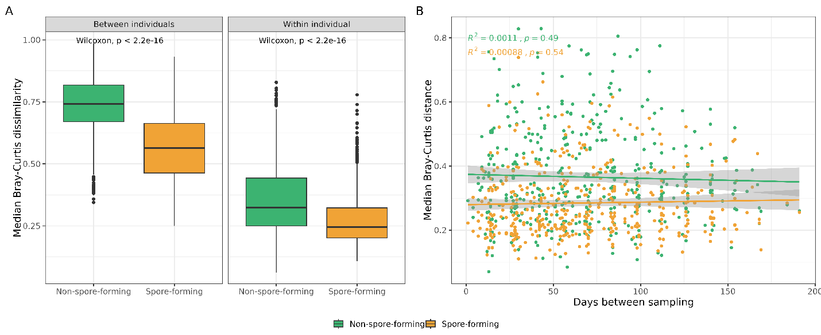
Supplement Figure 14. Dynamics of spore-forming and non-spore-forming bacteria between and within individuals. A) Boxplots showing between-individual (left) and within-individual (right) variability in community composition for spore-forming (yellow) and non-spore-forming (green) communities. Variability was assessed using the Bray-Curtis dissimilarity. Distributions were compared using the Wilcoxon rank-sum test. B) Community variability as measured by Bray-Curtis dissimilarity plotted against the number of days between sampling time points. The correlation between time interval and Bray-Curtis dissimilarity was assessed using Pearson’s correlation test. Statistical significance is indicated as *** for p < 0.001.

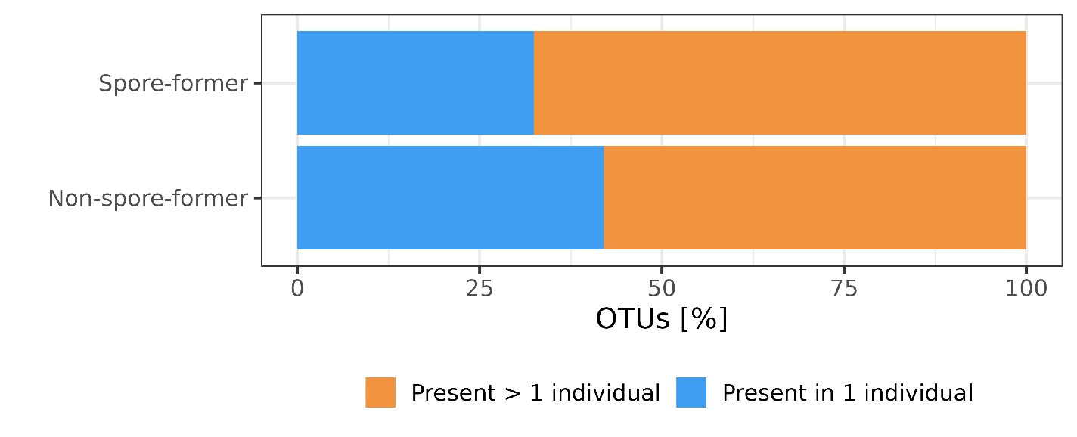
Supplement Figure 15. Sharing of spore-forming and non-spore-forming bacteria between people. This analysis was conducted on 527 SGBs with species level classification present in an individual (90% of all timepoints).
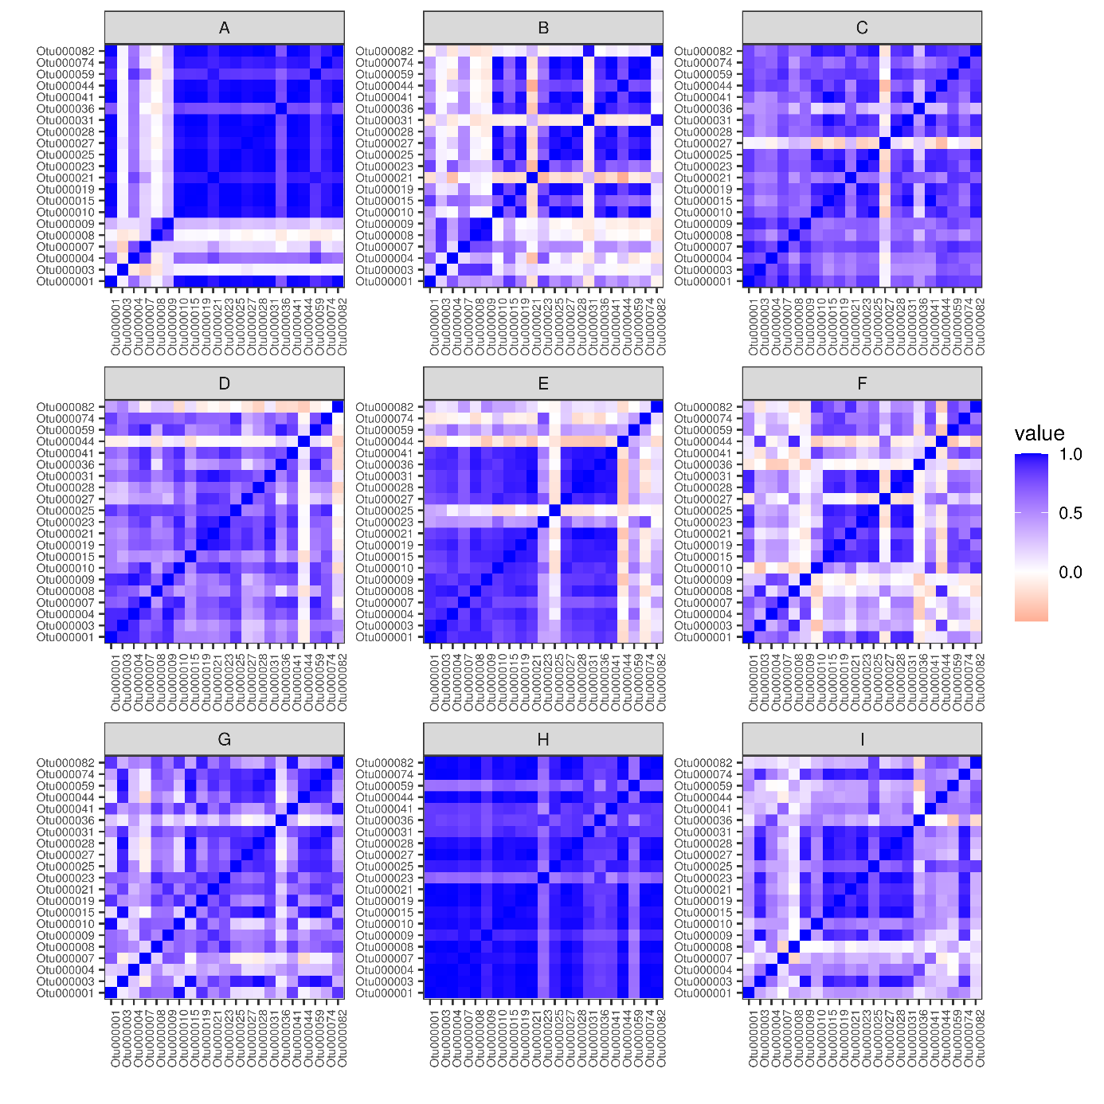
Supplement Figure 16. Correlation of sporulation frequency between OTUs within individuals. Mostly OTUs of an individual are correlated within an individual, which point to host specific sporulation frequency.

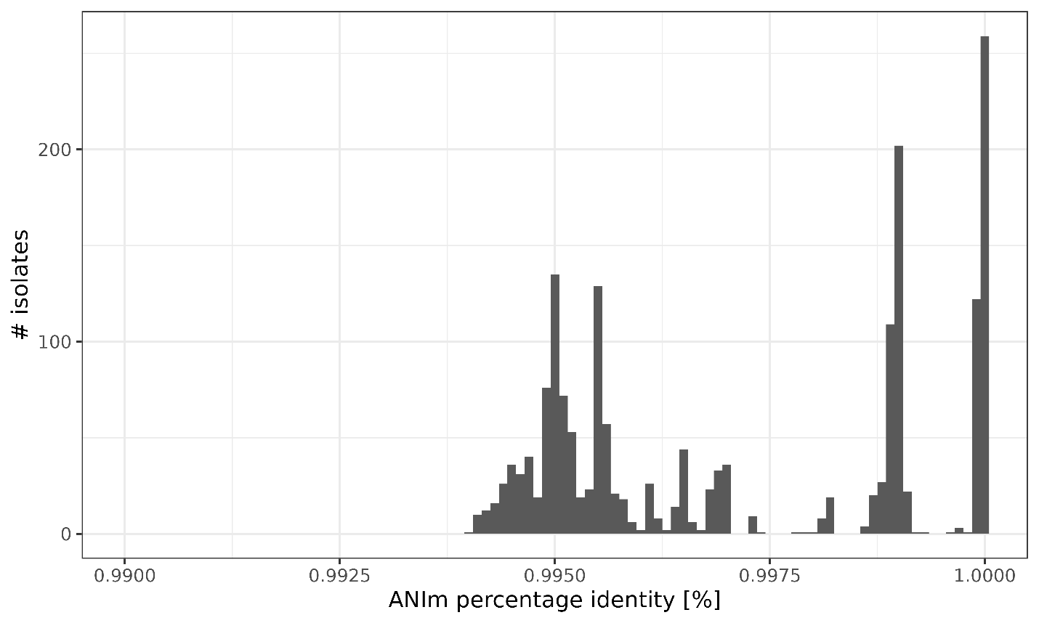
Supplement Figure 17. Pairwise average nucleotide identity comparison for all isolates determined as C. saudiense. Average nucleotide identity was calculated with pyANI-plus program utilizing the ANI mummer program.
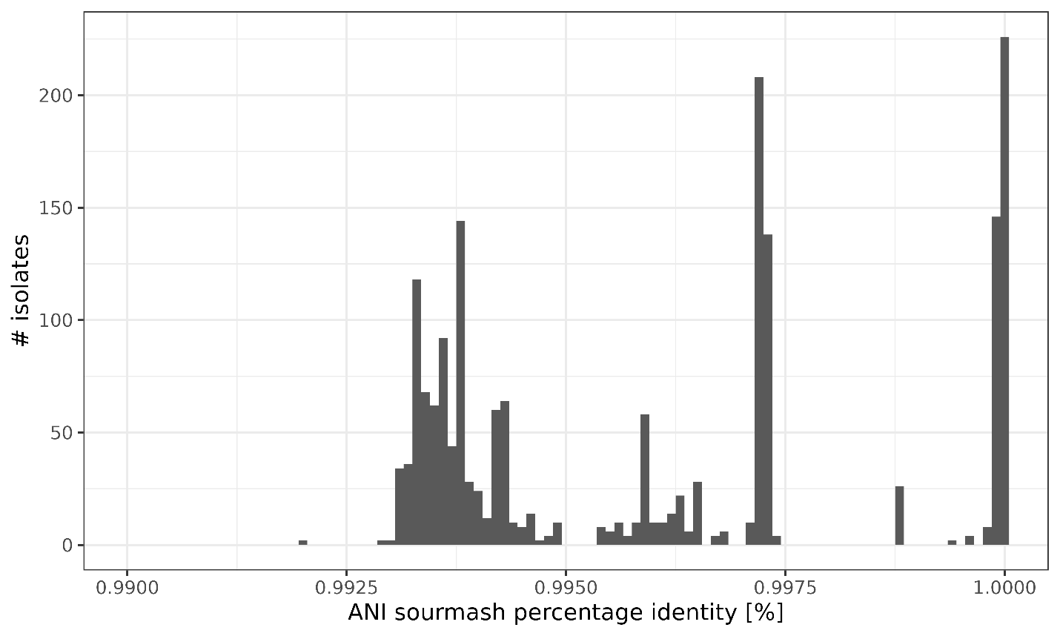
Supplement Figure 18. Pairwise average nucleotide identity comparison for all isolates determined as C. saudiense. Average nucleotide identity was calculated with pyANI-plus program utilizing the ANI sourmash program.

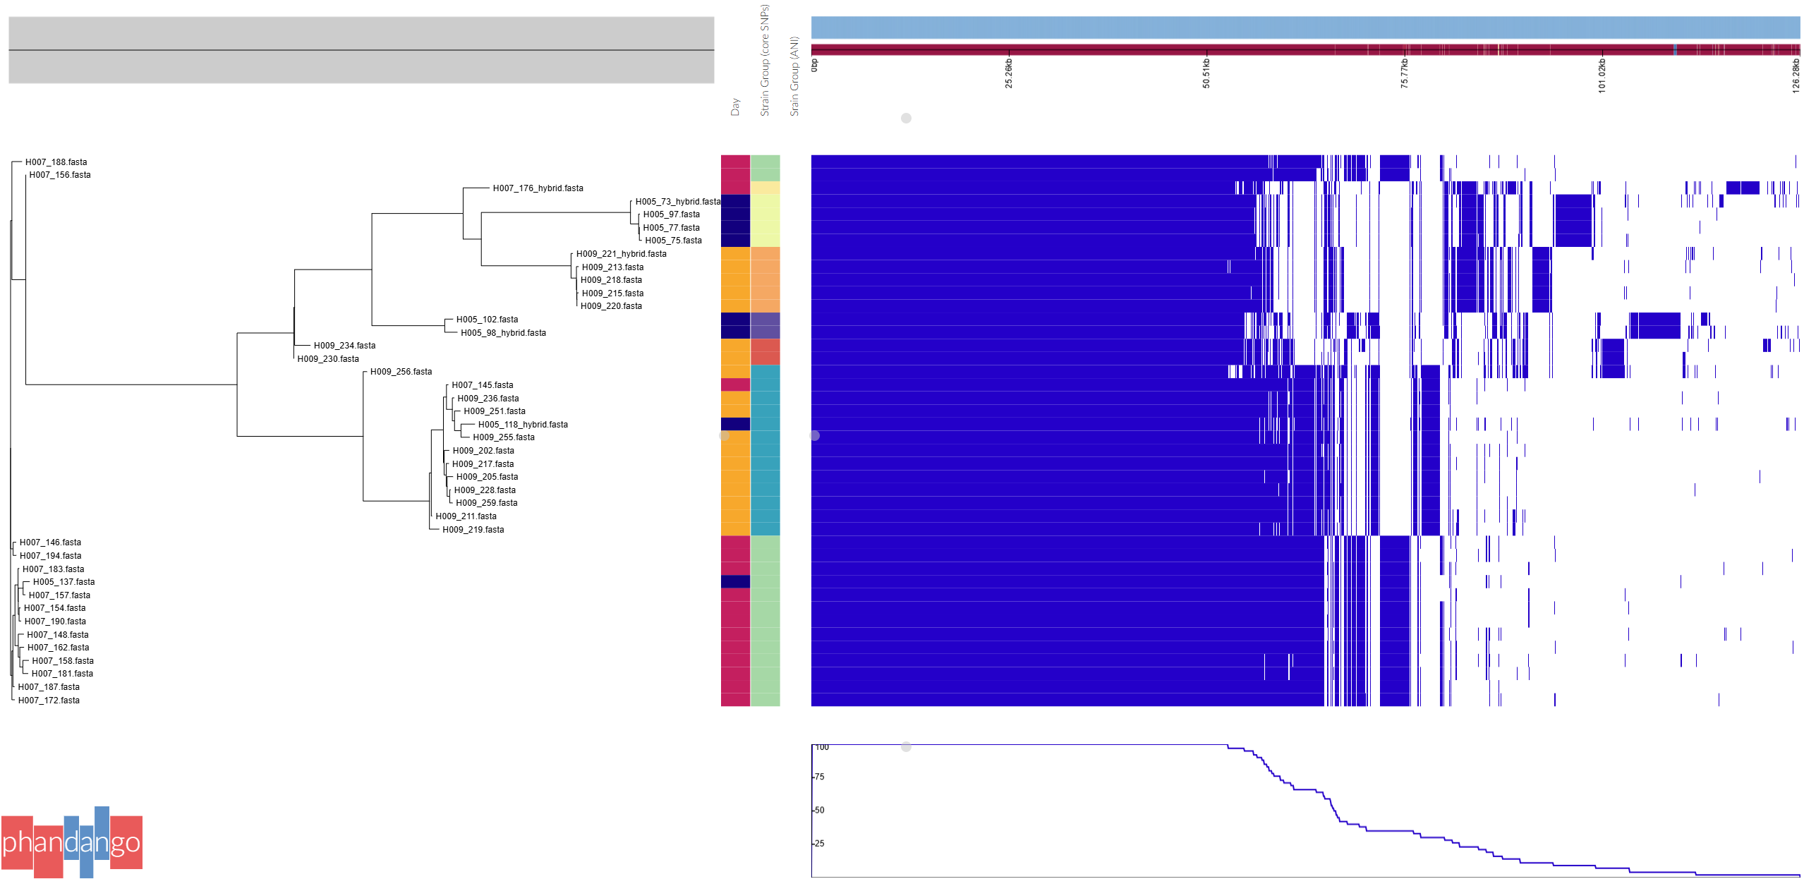
Supplement Figure 19. Phylogenetic tree based on accessory genes constructed with Roary and visualised with Phandango.

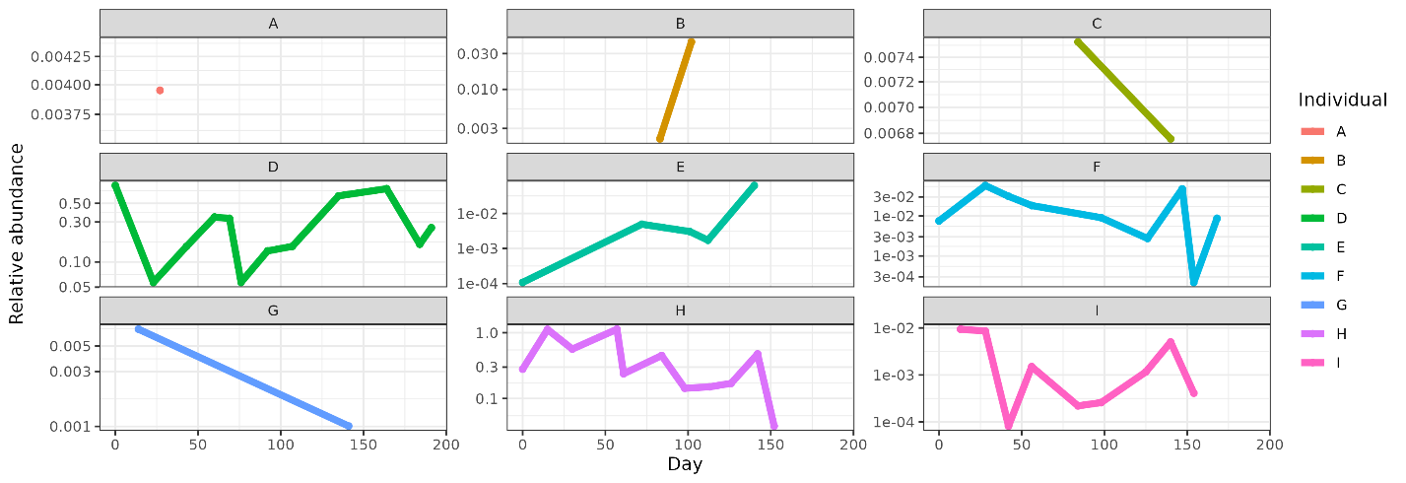
Supplement Figure 20. Abundance of C. saudiense in participants through time based on MetaPhlAn results.

Supplement Table 9. Strain-specific genes and their annotation. Hypothetic genes are not included in the table their number is visible in Table 2.
Strain | Gene | Annotation
1 | dapH_2 | 2,3,4,5-tetrahydropyridine-2,6-dicarboxylate N-acetyltransferase
1 | rpmJ | 50S ribosomal protein L36
1 | algA | Alginate biosynthesis protein AlgA
1 | group_1419 | Alpha-galactosidase AgaA
1 | group_2104 | Alpha-galactosidase AgaA
1 | group_705 | Anaerobic ribonucleoside-triphosphate reductase
1 | araC_1 | Arabinose operon regulatory protein
1 | bedA | Benzene 1,2-dioxygenase system ferredoxin--NAD(+) reductase subunit
1 | group_1547 | Chromosome partition protein Smc
1 | group_1627 | Cys-tRNA(Pro)/Cys-tRNA(Cys) deacylase YbaK
1 | group_1820 | Deoxyuridine 5'-triphosphate nucleotidohydrolase
1 | dnaG_3 | DNA primase
1 | hin_2 | DNA-invertase hin
1 | group_366 | Energy-dependent translational throttle protein EttA
1 | group_382 | Fatty acid ABC transporter ATP-binding/permease protein
1 | gmd | GDP-mannose 4,6-dehydratase
1 | hssR | Heme response regulator HssR
1 | group_1848 | HTH-type transcriptional activator BcrR
1 | group_2107 | HTH-type transcriptional activator RhaS
1 | cynR | HTH-type transcriptional regulator CynR
1 | gpx1_2 | Hydroperoxy fatty acid reductase gpx1
1 | group_1968 | Hydroperoxy fatty acid reductase gpx1
1 | group_322 | Ion-translocating oxidoreductase complex subunit B
1 | group_456 | IS1182 family transposase ISClbu1
1 | group_457 | IS1182 family transposase ISClbu1
1 | group_458 | IS1182 family transposase ISClbu1
1 | group_67 | IS1182 family transposase ISClbu1
1 | group_68 | IS1182 family transposase ISClbu1
1 | group_70 | IS1182 family transposase ISClbu1
1 | group_1460 | IS1595 family transposase ISCco3
1 | group_1503 | IS1595 family transposase ISClsp5
1 | group_283 | IS256 family transposase ISCbo4
1 | group_284 | IS256 family transposase ISCbo4
1 | group_285 | IS256 family transposase ISCbo4
1 | group_5368 | IS3 family transposase ISCb4
1 | group_5369 | IS3 family transposase ISCb4
1 | group_5370 | IS3 family transposase ISCb4
1 | group_5371 | IS3 family transposase ISCb4
1 | group_5373 | IS3 family transposase ISCb4
1 | group_5225 | IS30 family transposase IS658
1 | group_5228 | IS30 family transposase IS658
1 | group_5229 | IS30 family transposase IS658
1 | group_5230 | IS30 family transposase IS658
1 | group_5231 | IS30 family transposase IS658
1 | group_5232 | IS30 family transposase IS658
1 | group_205 | IS4 family transposase ISRel1
1 | group_206 | IS4 family transposase ISRel1
1 | group_207 | IS4 family transposase ISRel1
1 | group_208 | IS4 family transposase ISRel1
1 | group_209 | IS4 family transposase ISRel1
1 | group_210 | IS4 family transposase ISRel1
1 | group_4959 | IS6 family transposase ISClte3
1 | group_4960 | IS6 family transposase ISClte3
1 | group_4961 | IS6 family transposase ISClte3
1 | group_4962 | IS6 family transposase ISClte3
1 | group_4963 | IS6 family transposase ISClte3
1 | group_4964 | IS6 family transposase ISClte3
1 | group_4965 | IS6 family transposase ISClte3
1 | group_4966 | IS6 family transposase ISClte3
1 | group_4967 | IS6 family transposase ISClte3
1 | aplIM | Modification methylase AplI
1 | group_1630 | Modification methylase DpnIIA
1 | group_1945 | Modification methylase Eco57IB
1 | sbpA | Multiple sugar-binding periplasmic protein SbpA
1 | ohrR | Organic hydroperoxide resistance transcriptional regulator
1 | glmM_4 | Phosphoglucosamine mutase
1 | group_255 | Phosphoglucosamine mutase
1 | cph2 | Phytochrome-like protein cph2
1 | group_1616 | PTS system beta-glucoside-specific EIIBCA component
1 | group_1418 | PTS system trehalose-specific EIIBC component
1 | group_2105 | PTS system trehalose-specific EIIBC component
1 | pulA_2 | Pullulanase
1 | group_383 | putative ABC transporter ATP-binding protein
1 | group_652 | putative ABC transporter ATP-binding protein
1 | group_1689 | putative capsular polysaccharide biosynthesis protein YwqC
1 | epsF_6 | Putative glycosyltransferase EpsF
1 | group_1608 | Putative glycosyltransferase EpsF
1 | group_1702 | Putative glycosyltransferase EpsF
1 | group_1607 | putative glycosyltransferase EpsJ
1 | ywnA | Putative HTH-type transcriptional regulator YwnA
1 | yydK | putative HTH-type transcriptional regulator YydK
1 | group_538 | Pyridinium-3,5-bisthiocarboxylic acid mononucleotide nickel insertion protein
1 | sigE_2 | RNA polymerase sigma-35 factor
1 | cysE_2 | Serine acetyltransferase
1 | ssb_4 | Single-stranded DNA-binding protein
1 | group_1598 | Spore coat protein SA
1 | scrB_1 | Sucrose-6-phosphate hydrolase
1 | group_568 | Thermostable beta-glucosidase B
1 | trxA_3 | Thioredoxin
1 | trxB_3 | Thioredoxin reductase
1 | group_1462 | Tyrosine recombinase XerC
1 | group_2035 | Tyrosine recombinase XerC
1 | group_1573 | Tyrosine recombinase XerD
1 | group_1690 | Tyrosine-protein kinase YwqD
1 | group_1692 | UDP-glucose 6-dehydrogenase
1 | wecA_3 | UDP-N-acetylgalactosamine-undecaprenyl-phosphate N-acetylgalactosaminephosphotransferase
1 | group_1701 | UDP-N-acetylglucosamine--peptide N-acetylglucosaminyltransferase GtfA subunit
1 | group_1600 | Undecaprenyl-phosphate 4-deoxy-4-formamido-L-arabinose transferase
1 | group_1606 | Undecaprenyl-phosphate 4-deoxy-4-formamido-L-arabinose transferase
1 | xylG_1 | Xylose import ATP-binding protein XylG
1 | xylH | Xylose transport system permease protein XylH
3 | group_520 | Alkaline phosphatase synthesis sensor protein PhoR
3 | phoP_2 | Alkaline phosphatase synthesis transcriptional regulatory protein PhoP
3 | group_2977 | Alpha-galactosidase AgaA
3 | xylQ | Alpha-xylosidase XylQ
3 | group_3176 | Arginine transport system permease protein ArtQ
3 | group_2876 | ATP-dependent Clp protease proteolytic subunit
3 | group_3018 | ATP-dependent Clp protease proteolytic subunit
3 | group_3126 | Beta-galactosidase BoGH2A
3 | group_2974 | Beta-glucoside kinase
3 | nag3 | Beta-N-acetylglucosaminidase/beta-glucosidase
3 | yvdM | Beta-phosphoglucomutase
3 | ftsA | Cell division protein FtsA
3 | opuBA_1 | Choline transport ATP-binding protein OpuBA
3 | group_3034 | Chromosomal replication initiator protein DnaA
3 | group_2882 | Chromosome partition protein Smc
3 | group_3144 | Cytochrome b6-f complex iron-sulfur subunit
3 | group_2988 | DegV domain-containing protein
3 | group_3067 | D-inositol-3-phosphate glycosyltransferase
3 | dppB | Dipeptide transport system permease protein DppB
3 | polA_2 | DNA polymerase I
3 | group_3115 | Flagellar hook-associated protein 2
3 | flaD | Flagellin D
3 | pglH_1 | GalNAc-alpha-(1->4)-GalNAc-alpha-(1->3)-diNAcBac-PP-undecaprenol alpha-1,4-N-acetyl-D-galactosaminyltransferase
3 | pglH_2 | GalNAc-alpha-(1->4)-GalNAc-alpha-(1->3)-diNAcBac-PP-undecaprenol alpha-1,4-N-acetyl-D-galactosaminyltransferase
3 | glnQ | Glutamine transport ATP-binding protein GlnQ
3 | glnH_1 | Glutamine-binding periplasmic protein
3 | group_308 | Glutathione biosynthesis bifunctional protein GshAB
3 | hisS_2 | Histidine--tRNA ligase
3 | group_3128 | HTH-type transcriptional activator RhaS
3 | group_2973 | HTH-type transcriptional regulator GmuR
3 | group_76 | IS1182 family transposase ISClbu1
3 | group_77 | IS1182 family transposase ISClbu1
3 | group_79 | IS1182 family transposase ISClbu1
3 | group_80 | IS1182 family transposase ISClbu1
3 | group_81 | IS1182 family transposase ISClbu1
3 | group_82 | IS1182 family transposase ISClbu1
3 | group_83 | IS1182 family transposase ISClbu1
3 | group_84 | IS1182 family transposase ISClbu1
3 | group_85 | IS1182 family transposase ISClbu1
3 | group_2971 | IS1595 family transposase ISCco3
3 | group_290 | IS256 family transposase ISCbo4
3 | group_291 | IS256 family transposase ISCbo4
3 | group_292 | IS256 family transposase ISCbo4
3 | group_294 | IS256 family transposase ISCbo4
3 | group_2138 | IS3 family transposase ISBce13
3 | group_2139 | IS3 family transposase ISBce13
3 | group_2140 | IS3 family transposase ISBce13
3 | group_2141 | IS3 family transposase ISBce13
3 | group_2143 | IS3 family transposase ISBce13
3 | group_2144 | IS3 family transposase ISBce13
3 | group_2147 | IS3 family transposase ISBce13
3 | group_5214 | IS30 family transposase IS658
3 | group_5236 | IS30 family transposase IS658
3 | group_5237 | IS30 family transposase IS658
3 | group_5238 | IS30 family transposase IS658
3 | group_5239 | IS30 family transposase IS658
3 | group_153 | IS6 family transposase ISClte3
3 | group_154 | IS6 family transposase ISClte3
3 | group_155 | IS6 family transposase ISClte3
3 | group_156 | IS6 family transposase ISClte3
3 | group_157 | IS6 family transposase ISClte3
3 | group_158 | IS6 family transposase ISClte3
3 | group_4947 | IS6 family transposase ISClte3
3 | group_4950 | IS6 family transposase ISClte3
3 | group_4952 | IS6 family transposase ISClte3
3 | group_3129 | Isoprimeverose transporter
3 | group_656 | Ktr system potassium uptake protein A
3 | group_3168 | Macrolide export ATP-binding/permease protein MacB
3 | metH_1 | Methionine synthase
3 | group_3211 | N-acetylgalactosamine-N,N'-diacetylbacillosaminyl-diphospho-undecaprenol 4-alpha-N-acetylgalactosaminyltransferase
3 | group_3127 | Non-reducing end alpha-L-arabinofuranosidase BoGH43A
3 | expZ | Nucleotide-binding protein ExpZ
3 | group_2984 | Oligopeptide transport ATP-binding protein OppD
3 | oppC_2 | Oligopeptide transport system permease protein OppC
3 | blaI | Penicillinase repressor
3 | group_2990 | Peptidoglycan O-acetyltransferase
3 | epsE_2 | Putative glycosyltransferase EpsE
3 | group_3150 | Putative glycosyltransferase EpsF
3 | group_3091 | Putative type II secretion system protein F
3 | group_2976 | Regulator of RpoS
3 | rssB_3 | Regulator of RpoS
3 | group_3142 | Ribokinase
3 | group_3145 | Sensor histidine kinase RcsC
3 | group_3166 | Sensor histidine kinase RcsC
3 | group_3030 | Single-stranded DNA-binding protein
3 | cotSA | Spore coat protein SA
3 | tuaB | Teichuronic acid biosynthesis protein TuaB
3 | epsE_1 | Type II secretion system protein E
3 | group_3023 | Tyrosine recombinase XerC
3 | lpxD | UDP-3-O-(3-hydroxymyristoyl)glucosamine N-acyltransferase
3 | group_3198 | UDP-glucose 6-dehydrogenase
3 | arnC_4 | Undecaprenyl-phosphate 4-deoxy-4-formamido-L-arabinose transferase
3 | group_3061 | Undecaprenyl-phosphate 4-deoxy-4-formamido-L-arabinose transferase
3 | group_3154 | Undecaprenyl-phosphate 4-deoxy-4-formamido-L-arabinose transferase
3 | group_3210 | Undecaprenyl-phosphate 4-deoxy-4-formamido-L-arabinose transferase
3 | group_2983 | Vitamin B12 import ATP-binding protein BtuD
3 | group_3169 | Vitamin B12 import ATP-binding protein BtuD
4 | group_708 | 1,4-alpha-glucan branching enzyme GlgB
4 | group_3666 | 3'-5' exonuclease DinG
4 | group_3643 | Asparagine synthetase [glutamine-hydrolyzing] 1
4 | group_3590 | Cysteine desulfurase SufS
4 | mshA_5 | D-inositol-3-phosphate glycosyltransferase
4 | group_730 | dTDP-glucose 4,6-dehydratase
4 | rmlA_1 | Glucose-1-phosphate thymidylyltransferase
4 | glyE | Glycosyltransferase GlyE
4 | group_3669 | IS110 family transposase ISEnfa110
4 | group_3670 | IS110 family transposase ISEnfa110
4 | group_3671 | IS110 family transposase ISEnfa110
4 | group_3672 | IS110 family transposase ISEnfa110
4 | group_3673 | IS110 family transposase ISEnfa110
4 | group_3674 | IS110 family transposase ISEnfa110
4 | group_3675 | IS110 family transposase ISEnfa110
4 | group_3543 | IS1182 family transposase ISCbo5
4 | group_3678 | IS1182 family transposase ISClbu1
4 | group_3679 | IS1182 family transposase ISClbu1
4 | group_3680 | IS1182 family transposase ISClbu1
4 | group_61 | IS1182 family transposase ISClbu1
4 | group_62 | IS1182 family transposase ISClbu1
4 | group_65 | IS1182 family transposase ISClbu1
4 | group_6 | IS21 family transposase IS232
4 | group_281 | IS256 family transposase ISCbo4
4 | group_2146 | IS3 family transposase ISBce13
4 | group_5364 | IS3 family transposase ISCb4
4 | group_5367 | IS3 family transposase ISCb4
4 | group_178 | IS3 family transposase ISCpe6
4 | group_5217 | IS30 family transposase IS658
4 | group_141 | IS6 family transposase ISClte3
4 | group_146 | IS6 family transposase ISClte3
4 | group_4938 | IS6 family transposase ISClte3
4 | group_4940 | IS6 family transposase ISClte3
4 | group_4941 | IS6 family transposase ISClte3
4 | group_4943 | IS6 family transposase ISClte3
4 | group_3644 | Lipoprotein-releasing system ATP-binding protein LolD
4 | group_654 | PTS system EIIBC component
4 | group_3567 | Putative acetyltransferase
4 | yscN_2 | putative ATP synthase YscN
4 | group_3571 | Putative glycosyltransferase EpsF
4 | group_2927 | putative peptidase
4 | group_2928 | putative peptidase
4 | ypbG | putative protein YpbG
4 | group_3572 | Pyrophosphatase PpaX
4 | group_3626 | Single-stranded DNA-binding protein
4 | group_3662 | Sporulation initiation inhibitor protein Soj
4 | group_3637 | Undecaprenyl-phosphate 4-deoxy-4-formamido-L-arabinose transferase
5 | arnE | 4-amino-4-deoxy-L-arabinose-phosphoundecaprenol flippase subunit ArnE
5 | group_3433 | Alginate biosynthesis protein AlgA
5 | socA | Antitoxin SocA
5 | group_3345 | ATP-dependent Clp protease proteolytic subunit
5 | glmU_2 | Bifunctional protein GlmU
5 | rfbG | CDP-glucose 4,6-dehydratase
5 | group_3342 | Chromosome partition protein Smc
5 | group_3480 | Chromosome partition protein Smc
5 | group_3409 | D-inositol-3-phosphate glycosyltransferase
5 | group_3412 | D-inositol-3-phosphate glycosyltransferase
5 | group_3432 | D-inositol-3-phosphate glycosyltransferase
5 | rmlC | dTDP-4-dehydrorhamnose 3,5-epimerase
5 | rffG | dTDP-glucose 4,6-dehydratase 2
5 | glfT1 | Galactofuranosyltransferase GlfT1
5 | group_3407 | GDP-mannose 4,6-dehydratase
5 | rfbF | Glucose-1-phosphate cytidylyltransferase
5 | der_1 | GTPase Der
5 | era_1 | GTPase Era
5 | xre | HTH-type transcriptional regulator Xre
5 | group_3429 | IS1182 family transposase ISAco1
5 | group_3428 | IS1182 family transposase ISBsp4
5 | group_3427 | IS1182 family transposase ISCbo5
5 | group_455 | IS1182 family transposase ISClbu1
5 | group_10 | IS21 family transposase IS232
5 | group_9 | IS21 family transposase IS232
5 | group_3361 | IS256 family transposase ISCob1
5 | group_2131 | IS3 family transposase ISBce13
5 | group_2132 | IS3 family transposase ISBce13
5 | group_2133 | IS3 family transposase ISBce13
5 | group_2134 | IS3 family transposase ISBce13
5 | group_2135 | IS3 family transposase ISBce13
5 | group_2137 | IS3 family transposase ISBce13
5 | group_5218 | IS30 family transposase IS658
5 | group_5219 | IS30 family transposase IS658
5 | group_5220 | IS30 family transposase IS658
5 | group_5221 | IS30 family transposase IS658
5 | group_5222 | IS30 family transposase IS658
5 | group_148 | IS6 family transposase ISClte3
5 | group_149 | IS6 family transposase ISClte3
5 | group_150 | IS6 family transposase ISClte3
5 | group_4945 | IS6 family transposase ISClte3
5 | group_4953 | IS6 family transposase ISClte3
5 | group_4954 | IS6 family transposase ISClte3
5 | group_4955 | IS6 family transposase ISClte3
5 | group_4957 | IS6 family transposase ISClte3
5 | group_4958 | IS6 family transposase ISClte3
5 | group_3273 | Lon protease
5 | group_3406 | Mannose-1-phosphate guanylyltransferase RfbM
5 | manA | Mannose-6-phosphate isomerase ManA
5 | immA_2 | Metallopeptidase ImmA
5 | bshA | N-acetyl-alpha-D-glucosaminyl L-malate synthase
5 | group_3394 | N-acetylgalactosamine-N,N'-diacetylbacillosaminyl-diphospho-undecaprenol 4-alpha-N-acetylgalactosaminyltransferase
5 | wbbL | N-acetylglucosaminyl-diphospho-decaprenol L-rhamnosyltransferase
5 | tarA | N-acetylglucosaminyldiphosphoundecaprenol N-acetyl-beta-D-mannosaminyltransferase
5 | pgcA_3 | Phosphoglucomutase
5 | group_3404 | putative capsular polysaccharide biosynthesis protein YwqC
5 | group_3382 | Putative glycosyltransferase EpsD
5 | group_3396 | putative glycosyltransferase EpsJ
5 | rfbX | Putative O-antigen transporter
5 | recD | RecBCD enzyme subunit RecD
5 | mscS_3 | Small-conductance mechanosensitive channel
5 | group_3386 | Transmembrane protein EpsG
5 | pilT_2 | Twitching mobility protein
5 | group_184 | Tyrosine recombinase XerC
5 | group_3466 | Tyrosine recombinase XerC
5 | xerD_3 | Tyrosine recombinase XerD
5 | glf | UDP-galactopyranose mutase
5 | group_3405 | UDP-N-acetylgalactosamine-undecaprenyl-phosphate N-acetylgalactosaminephosphotransferase
5 | group_3437 | UDP-N-acetylgalactosamine-undecaprenyl-phosphate N-acetylgalactosaminephosphotransferase
5 | group_3391 | UDP-N-acetylglucosamine--peptide N-acetylglucosaminyltransferase GtfA subunit
5 | group_3393 | UDP-N-acetylglucosamine--peptide N-acetylglucosaminyltransferase GtfA subunit
5 | arnC | Undecaprenyl-phosphate 4-deoxy-4-formamido-L-arabinose transferase
2a | group_3852 | ATP-dependent Clp protease proteolytic subunit
2a | group_3865 | ATP-dependent RNA helicase DbpA
2a | smc_3 | Chromosome partition protein Smc
2a | mutL_1 | DNA mismatch repair protein MutL
2a | group_3875 | IS200/IS605 family transposase ISEfa4
2b | group_372 | Alpha-xylosidase
2b | clpA_2 | ATP-dependent Clp protease ATP-binding subunit ClpA
2b | bcrA_3 | Bacitracin transport ATP-binding protein BcrA
2b | uviB_1 | Bacteriocin UviB
2b | iscS_3 | Cysteine desulfurase IscS
2b | ybaK_1 | Cys-tRNA(Pro)/Cys-tRNA(Cys) deacylase YbaK
2b | group_310 | Glutathione biosynthesis bifunctional protein GshAB
2b | group_125 | Group II intron-encoded protein LtrA
2b | group_126 | Group II intron-encoded protein LtrA
2b | group_129 | Group II intron-encoded protein LtrA
2b | group_130 | Group II intron-encoded protein LtrA
2b | group_459 | IS1182 family transposase ISClbu1
2b | group_460 | IS1182 family transposase ISClbu1
2b | group_461 | IS1182 family transposase ISClbu1
2b | group_462 | IS1182 family transposase ISClbu1
2b | group_463 | IS1182 family transposase ISClbu1
2b | group_72 | IS1182 family transposase ISClbu1
2b | group_73 | IS1182 family transposase ISClbu1
2b | group_74 | IS1182 family transposase ISClbu1
2b | group_75 | IS1182 family transposase ISClbu1
2b | group_287 | IS256 family transposase ISCbo4
2b | group_288 | IS256 family transposase ISCbo4
2b | group_289 | IS256 family transposase ISCbo4
2b | group_5375 | IS3 family transposase ISCb4
2b | group_5376 | IS3 family transposase ISCb4
2b | group_5377 | IS3 family transposase ISCb4
2b | group_5378 | IS3 family transposase ISCb4
2b | group_5379 | IS3 family transposase ISCb4
2b | group_5380 | IS3 family transposase ISCb4
2b | group_5382 | IS3 family transposase ISCb4
2b | group_6155 | IS3 family transposase ISEnfa5
2b | group_6156 | IS3 family transposase ISEnfa5
2b | group_5211 | IS30 family transposase IS658
2b | group_5240 | IS30 family transposase IS658
2b | group_5241 | IS30 family transposase IS658
2b | group_5242 | IS30 family transposase IS658
2b | group_5243 | IS30 family transposase IS658
2b | group_5244 | IS30 family transposase IS658
2b | group_5245 | IS30 family transposase IS658
2b | group_5246 | IS30 family transposase IS658
2b | group_5247 | IS30 family transposase IS658
2b | group_5248 | IS30 family transposase IS658
2b | group_5249 | IS30 family transposase IS658
2b | group_96 | Putative formate dehydrogenase
2b | epsN_1 | Putative pyridoxal phosphate-dependent aminotransferase EpsN
2b | epsN_2 | Putative pyridoxal phosphate-dependent aminotransferase EpsN
2b | group_171 | Putative transposase InsK for insertion sequence element IS150
2b | group_703 | Putative xanthine dehydrogenase molybdenum-binding subunit XdhA
2b | group_2252 | Replicative DNA helicase
2b | bcgIA | Restriction enzyme BgcI subunit alpha
2b | group_6046 | Reverse rubrerythrin-1
2b | tnpR | Transposon gamma-delta resolvase
2b | group_2246 | Tyrosine recombinase XerC
2b | group_2260 | Tyrosine recombinase XerC
2b | xerH | Tyrosine recombinase XerH
2b | gtaB_5 | UTP--glucose-1-phosphate uridylyltransferase
2c | clpP_4 | ATP-dependent Clp protease proteolytic subunit
2c | group_2589 | ATP-dependent RNA helicase DbpA
2c | uviB_3 | Bacteriocin UviB
2c | group_659 | Calcium-transporting ATPase
2c | group_402 | Cardiolipin synthase
2c | group_2629 | Chromosomal replication initiator protein DnaA
2c | smc_8 | Chromosome partition protein Smc
2c | parA | Chromosome partitioning protein ParA
2c | cdr_2 | Coenzyme A disulfide reductase
2c | group_625 | Cyclic pyranopterin monophosphate synthase
2c | sufS_3 | Cysteine desulfurase SufS
2c | group_2792 | Extracellular matrix regulatory protein A
2c | gldA | Glycerol dehydrogenase
2c | group_127 | Group II intron-encoded protein LtrA
2c | hxlR_1 | HTH-type transcriptional activator HxlR
2c | group_2728 | IS1595 family transposase ISCpe8
2c | group_2729 | IS1595 family transposase ISDeul1
2c | group_278 | IS256 family transposase ISCbo4
2c | group_4968 | IS6 family transposase ISClte3
2c | dpnM | Modification methylase DpnIIA
2c | group_2709 | NADH oxidase
2c | group_336 | Negative regulator of SacY activity
2c | group_2607 | Nucleoid occlusion protein
2c | group_620 | putative CtpA-like serine protease
2c | group_2605 | Sporulation initiation inhibitor protein Soj
2c | aplIR | Type-2 restriction enzyme AplI
2c | xerC_4 | Tyrosine recombinase XerC
2c | xerC_5 | Tyrosine recombinase XerC
2c | xerC_6 | Tyrosine recombinase XerC

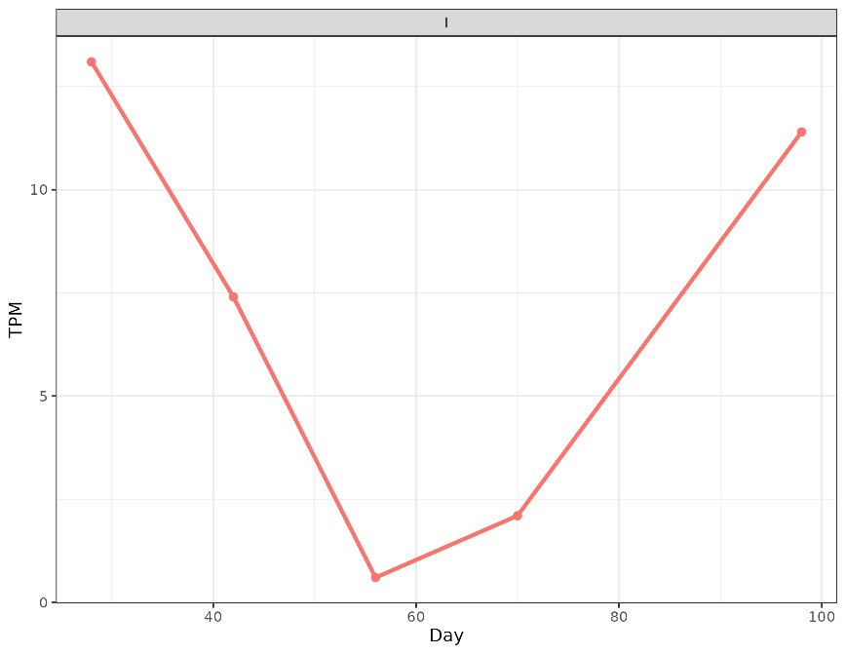
Supplement Figure 21. Abundance of CTX-M1 through time for individual I.

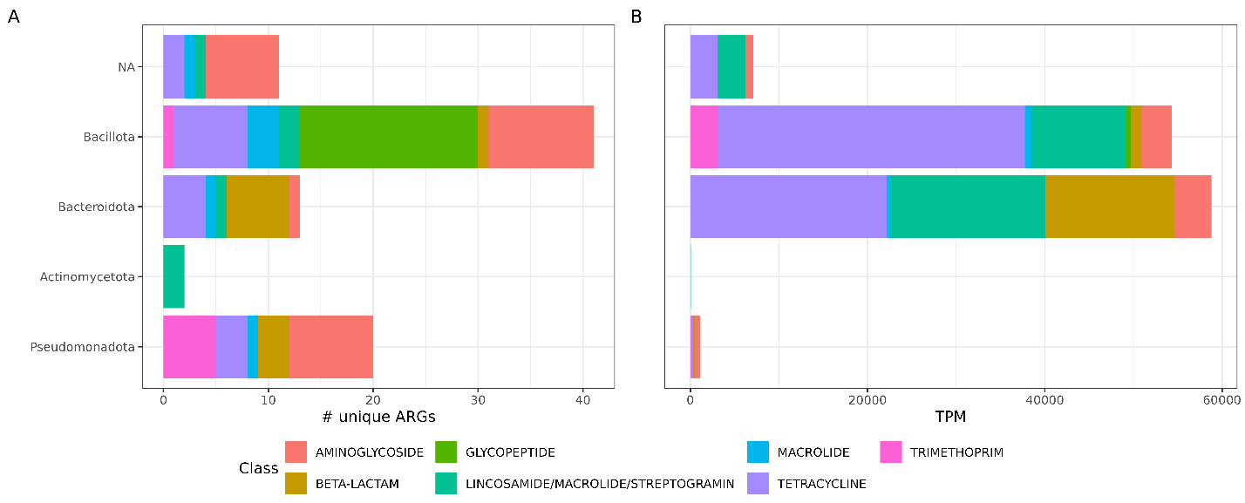
Supplement Figure 22. Taxonomy of ARGs, left the number of unique ARGs

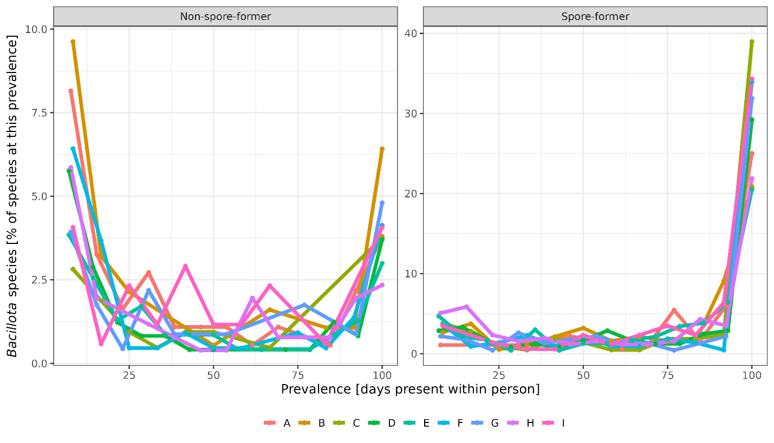
Supplement Figure 23. Persistence of spore-forming bacteria compared to non-spore-forming and the same comparison but only in phylum Bacillota.

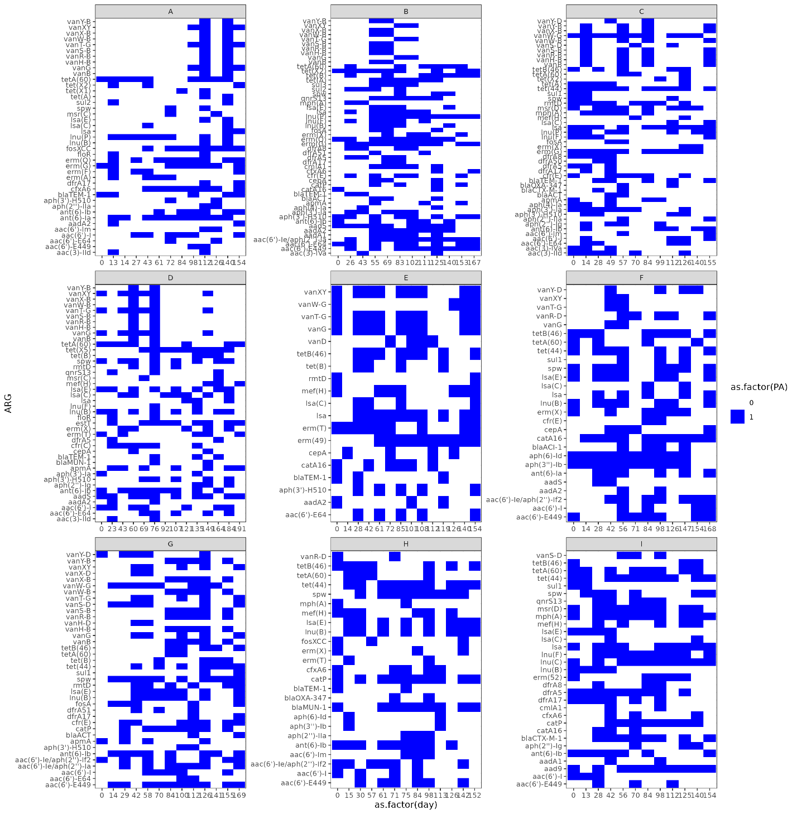
Supplement Figure 24. ARGs present more than once but less than 12 times.

Supplement Figure 25. Correlation between diversity of bacterial species in a sample and richness of class of ARGs.

