TABLE OF CONTENTS

1 INTRODUCTION – work in progress 4
1.1 RESEARCH GOALS 6
1.2 RESEARCH HYPOTHESIS 7
2 LITERATURE REVIEW 8
2.1 HUMAN GUT MICROBIOTA 8
2.1.1 Longitudinal studies of human gut microbiota 8
2.1.2 Stability of microbial communities 9
2.2 SPOROBIOTA OF THE HUMAN GUT 10
2.2.1 Culture-dependant and -independent analysis of sporobiota 11
2.3 CULTIVATION OF BACTERIA FROM THE HUMAN GUT 12
2.4 HUMAN GUT RESISTOME 13
3 METHODS AND MATERIALS 15
3.1 LONGITUDINAL STOOL SAMPLE COLLECTION 16
3.2 COMPARISON AND OPTIMIZATION OF PROTOCOLS FOR DNA ISOLATION 17
3.2.1 Comparison of isolation protocols for bacterial DNA from human stool samples 17
3.2.2 Optimization of removal of vegetative cells and their DNA from stool samples 17
3.3 DNA ISOLATION 18
3.3.1 DNA isolation from stool samples 18
3.3.2 DNA isolation from pure bacterial cultures 18
3.4 ABSOLUTE QUANTIFICATION OF THE 16S rRNA GENE IN UNTREATED AND ETHANOL TREATED SAMPLES USING DROPLET DIGITAL PCR 18
3.5 SEQUENCING OF MICROBIOTA, SPOROBIOTA, AND BACTERIAL ISOLATES 19
3.5.1 Amplicon sequencing of the 16S rRNA gene of microbiota and sporobiota 19
3.5.2 Shotgun metagenomic sequencing of microbiota and sporobiota 19
3.5.3 Whole-genome sequencing using Illumina short-read technology 20
3.5.4 Whole-genome sequencing using Oxford Nanopore Technologies long-read technology 20
3.6 DATA ANALYSIS 20
3.6.1 Amplicon data analysis 20
3.6.1.1 Preprocessing 20
3.6.1.2 Criteria for determination of ethanol resistant and ethanol non-resistant OTUs in the longitudinal study 21
3.6.1.3 Bacterial diversity and community composition analysis 21
3.6.1.4 Sporulation frequency calculation and analysis of host, time, and OTU-specific influences 21
3.6.2 Shotgun metagenomic data analysis 22
3.6.2.1 Preprocessing 22
3.6.2.2 Bacterial, eukaryotic, archaeal and viral community composition analysis 22
3.6.2.3 Gene-based determination of sporulation capacity for bacterial species 23
3.6.2.4 Determination of ethanol-resistant bacterial species 23
3.6.2.5 Antibiotic resistance gene analysis 23
3.7 CULTIVATION AND MOLECULAR CHARACTERISATION OF SELECTED SPORE-FORMING BACTERIA FROM HUMAN STOOL SAMPLES 24
3.7.1 Isolation of selected spore-forming bacteria from ethanol treated stool samples 24
3.7.2 Analysis of whole-genome sequencing reads 25
3.7.2.1 Preprocessing and assembly of short-read sequences 25
3.7.2.2 Average nucleotide identity (ANI) 25
3.7.2.3 SNP analysis 26
3.7.2.4 Preprocessing of long-read sequences and hybrid assembly 26
3.7.2.5 Pan-genome analysis, ANI score and SNP analysis with hybrid assemblies included 26
3.7.2.6 Analysis of C. saudiense in shotgun metagenomic samples 27
4 RESULTS 28
4.1 COMPARISON OF ISOLATION PROTOCOLS FOR BACTERIAL DNA FROM HUMAN STOOL SAMPLES 28
4.2 OPTIMIZATION OF PRE-TREATMENT FOR DNA ISOLATION FROM SPORES AND OTHER RESISTANT BACTERIA IN STOOL SAMPLES 30
4.3 DESCRIPTION AND COMPARISON OF THE TEMPORAL STABILITY OF THE GUT MICROBIOTA AND SPOROBIOTA IN HEALTHY INDIVIDUALS 32
4.3.1 Composition, abundance and diversity of human gut microbiota 32
4.3.2 Composition, abundance and diversity of ethanol-resistant bacterial community and sporobiota in the human gut 40
4.3.2.1 Ethanol-resistant community and sporobiota in amplicon data 40
4.3.2.2 Sporobiota in shotgun metagenomic data 41
4.3.3 Between and within-individual dynamics of spore-forming and non-spore-forming bacterial communities over time 43
4.3.4 Sporulation frequency of ethanol-resistant Bacillota in the human gut is host and time dependent 45
4.4 CULTIVATION AND MOLECULAR CHARACTERIZATION OF THE REPRESENTATIVE SPORE-FORMING SPECIES 48
4.4.1 Cultivation and sequencing of selected spore-forming species from ethanol treated stool samples 48
4.1.2 Average nucleotide identity, core SNPs analysis and pangenome construction 48
4.1.3 Shotgun metagenomic analysis of C. saudiense 51
4.1 LONGITUDINAL CHANGES IN THE RESISTOME DEPENDING ON CHANGES IN THE INTESTINAL MICROBIOTA 53
4.1.2 Overall diversity and abundance of antimicrobial resistance genes 53
4.1.3 Persistence of antimicrobial resistance genes in the human gut 54
5 DISCUSSION 57
5.1 COMPARISON OF TEMPORAL STABILITY OF THE GUT MICROBIOTA AND SPOROBIOTA IN HEALTHY INDIVIDUALS 57
5.1.1 Human gut microbiota 57
5.1.2 Human gut sporobiota 59
5.1.3 Between and within individual dynamics of spore-forming bacteria 60
5.1.4 Sporulation frequency is individual and time-specific 61
5.2 INDIVIDUAL-SPECIFIC POPULATION GENETIC ANALYSIS OF CULTURED SPORE-FORMING SPECIES 61
5.3 MONITORING LONGITUDINAL CHANGES IN THE GUT RESISTOME OF HEALTHY INDIVIDUALS 62
6 CONCLUSIONS 65
7 SUMMARY 65
8 POVZETEK (do 10% obsega angleškega dela doktorske naloge) 65
9 REFERENCES 66

INTRODUCTION – work in progress
The composition of the intestinal microbiota in the human gut is the result of constant immigration and competition between bacteria, viruses, archaea, and eukaryotes. Colonization begins at birth as infants acquire bacteria from their caretakers and environment (Martino et al., 2022). Successful colonization of commensal bacteria depends both on their capacity to spread between human hosts and their ability to establish and grow within an individual host. The likelihood of transmission increases with bacteria’s utilization of different life strategies (e.g. dormancy) and their prevalence, however high strain abundance within a host is not typically driven by transmission, but rather the bacterium’s ability to adapt and grow within a host (Valles-Colomer et al., 2023).
A high proportion of gut bacteria, at least 50%, possess the genetic capability for sporulation, suggesting that a considerable fraction of human gut microbiota harbour the capacity to survive conditions that are unfavourable for growth (Browne et al., 2016a). Sporulation is one of the most researched strategies for increasing survival time outside of the human gut as spore-forming bacteria are present in the most abundant phylum in human gut Bacillota (Egan et al., 2021; Galperin, 2013; Rajilić-Stojanović & de Vos, 2014). The ability of spore-forming bacteria to endure unfavourable conditions, such as oxygen, antibiotic treatment, inflammation, and other diseases, allows them to persist and potentially recolonize the gut following disruptions but also facilitates transmission between individuals (Swick et al., 2016; Tetz & Tetz, 2017). Other mechanisms hypothesized to increase transmission between human hosts include aerotoleration, and viable, but not-culturable state, where an increased survival ability is achieved through decreased metabolic activity and strengthened cell walls (Setlow, 2014).
While most research has focused on the pathogenic sporeformers related to food safety and intestinal infections, these strains constitute a miniscule fraction of the microbiota and far less is known about the ecological dynamics of commensal, spore-forming bacteria that are highly abundant within healthy individuals (Brown, 2000). Different studies have employed ethanol, heat shock or lysozyme treatment to separate vegetative cells from spores in stool samples. An advance in the isolation of ethanol resistant spore-forming bacteria was achieved with addition of bile acids to boost germination in the culture process (Browne et al., 2016a; Onizuka et al., 2021; Tanaka et al., 2020). More recently, culture-independent studies using either lysozyme treatment or ethanol shock to remove vegetative cells were used to investigate transmission of spore-forming bacteria between human hosts. In a cohort of healthy human adults, it was shown that lysozyme resistant OTUs are more frequently shared between individuals than other taxa (Kearney et al., 2018). While a comparison of infant-mother pairs showed that the majority of OTUs determined as spore-forming are acquired from environment rather than mother-to-child transmission (Avershina et al., 2020). Sporeformers are present in lower abundance in infant gut than adult’s, but despite this, they are the initial producers of butyrate, which was shown to protect the gut from intestinal diseases such as inflammatory bowel disease and colon cancer (Appert et al., 2020; Hodgkinson et al., 2023; Korpela et al., 2018; Nayfach et al., 2016).
A meta-metagenomic analysis of human gut microbiomes revealed that the loss of sporulation genes increases a bacterial species’ relative abundance in an individual, but decreases its overall prevalence in the broader population (Browne et al., 2021). At the level of cultured strains, the dynamics of three non-spore-forming and one spore-forming species have been tracked over time in human gut. The non-spore-forming strains of Bacteroides vulgatus and Bacteroides ovatus colonized an individual only once, while Escherichia coli exhibited a mix of strains that were persistent and those that were replaced over time. In contrast, the spore-forming bacterium Turicibacter sanguinis showed a pattern of strain replacement with each colonization attempt (Martinson et al., 2019; Poyet et al., 2019). Interestingly, evidence from a 24-day time series of an individuals’ 16S rRNA amplicon sequences showed a higher correlation between OTUs in the lysozyme resistant fraction than other OTUs in this person’s gut, supporting the hypothesis that spore-forming bacteria can establish a persistent community of dormant cells in an environment termed ‘seed bank’ (Kearney et al., 2018; Lennon & Jones, 2011).
ALI
The human gut microbiota has a significant impact on various aspects of an organism's health, making it a crucial target for developing diagnostics, prognostics, risk assessment, and targeted therapeutic methods for different diseases (Clemente et al., 2012). The community of microbes present in the human gut is complex and dynamic, making longitudinal studies an essential tool to investigate the stability or variability of an individual's gut microbiota over time.
Several longitudinal studies have been conducted on the gut microbiota. These studies included small (one or two) or large (hundreds) number of individuals, with two or more sampling points at different time intervals (days, weeks, months, years) within a specific geographical area. The standard method of analyzing gut bacteria is amplicon sequencing of the 16S rRNA gene. However, a few studies have explored the presence of fungi using targeted sequencing of the ITS region and the 18S rRNA gene, or even shotgun metagenomics. Still, bacterial fraction of gut microbiota is much better understood than that of fungi, other eukaryotes, or viruses (Martino et al., 2022).
At least 50% of the bacteria present in the human gut can form endospores (Browne et al., 2016). These endospore-forming bacteria, also known as sporobiota, can survive significant disturbances such as antibiotic treatments, inflammation, or diseases (Egan et al., 2021). Bacterial spores are the first colonizers of the gut microbiota following disruption such as antibiotic therapy or illness (Tetz & Tetz, 2017). Sporobiota plays a crucial role in the horizontal gene transfer of both commensal and pathogenic bacteria between different hosts and/or environments (Broaders et al., 2013). The spread of antimicrobial resistance has become an increasing concern, with horizontal gene transfer playing a particularly significant role in this phenomenon (McInnes et al., 2020). Traditional molecular methods for investigating gut microbiota are not suitable for researching spore-forming bacteria due to the hardy outer cortex of spores, which hinders DNA isolation (Setlow, 2007). Moreover, there is a sequencing bias as bacteria in the phylum Bacillota (Firmicutes) possess more rrn operons (on average 7.01 copies), making it difficult to ensure the reliability of targeted sequencing (Filippidou et al., 2015).

1.1 RESEARCH GOALS
Our research aims to optimize the isolation of DNA from spores in human stool samples and compare the metagenomic sequences of the sporobiota with that of microbiota over a period of 6 months in a small group of healthy male participants. We will look for correlations between changes in the gut microbiota and sporobiota with changes in the individual's lifestyle, which we will monitor using questionnaires. We will compare the results at the species level of taxonomy for bacteria, viruses (DNA bacteriophages and eucaryotic viruses), and fungi but also at the level of antibiotic resistance genes, by sequencing DNA from stool samples. We will also isolate chosen species from different time-points of an individual and use whole genome sequences to investigate population dynamics through time. According to goals presented below.

- Description and comparison of the temporal stability of the gut microbiota and sporobiota in healthy individuals.
We aim to describe the composition, diversity, and abundance of bacterial, viral, and fungal communities in the gut, including both commonly found colonizers and sporadically occurring species at different time points. We will monitor the community variations using metagenomic sequencing, targeted sequencing of the 16S rRNA gene and cultivation of specific spore-forming species. We will investigate how the individual’s time points will cluster (density of clustering) and what will be the distance between the points of samples from regular monitoring and samples from extreme events. As previous studies showed gut microbiota is relatively stable through time, but there are deviations from this equilibrium especially in the Bacillota phylum that includes most known spore-forming bacteria. We will compare the degree of clustering within and between microbiota and sporobiota samples of different individuals. We will analyse whether the longitudinal variation in the microbiota and sporobiota is similar or if one shows a greater variation than the other.
- Individual specific population genetics analysis on the isolated spore-forming species
We aim to optimize the growth conditions and to obtain strains of the same spore-forming species from different time points of an individual for whole-genome sequencing. With the genome comparison of a population of a species in different time points we will try to assess the retention/transition time and new acquisition of a spore-forming bacteria in the human gut. We will also be monitoring changes in the number of plasmids or bacteriophages in this species. This will be done in parallel with the analysis of metagenomic data.

- Monitoring longitudinal changes in the resistome depending on changes in the intestinal microbiota.
We aim to investigate the stability of antibiotic resistance genes present in the gut microbiota over time, which is also known as the gut resistome. We will assess the presence or absence and the abundance of specific antibiotic resistance genes to characterize the longitudinal stability of the resistome with metagenomic data as cultivation would only give us the results for cultivable bacteria and not overall antibiotic resistance genes, that we will get with metagenomic sequencing. Additionally, we will examine whether there is a correlation between changes observed in the gut microbiota and changes in the resistome.

RESEARCH HYPOTHESIS

- The gut sporobiota of an individual will be less stable than the gut microbiota.
- Gut sporobiota and microbiota will change during the extreme event in most volunteers.
- Increased presence of resistance genes will correlate with reduced diversity of the microbiota.

LITERATURE REVIEW

HUMAN GUT MICROBIOTA
The intestine is the most densely colonized microbial habitat of the human body, harbouring trillions of bacteria along with viruses, archaea and eukaryotes that collectively form the gut microbiota (Heidrich et al., 2025). Colonization begins at birth as infants acquire bacteria from their caretakers, siblings, and the surrounding environment (Martino et al., 2022). Successful colonization of commensal bacteria depends on both their capacity to spread across human hosts and their ability to establish and grow within an individual host. Community composition reflects a continuous balance between immigration, growth, competition and cooperation among these microorganisms, constrained by host physiology, lifestyle, and environment (Amato & Carmody, 2023).

Longitudinal studies of human gut microbiota
Longitudinal studies, in which microbiota is sampled repeatedly from the same individuals, provide the main empirical basis for understanding temporal dynamics and individuality in the human gut (Schlomann & Parthasarathy, 2019). Several longitudinal studies have been conducted on the gut microbiota. Cohorts have ranged from single‑subject dense time series to hundreds of participants, with sampling intervals from days to months or years, and typically focus on one geographical region. Most studies have profiled bacteria using 16S rRNA gene amplicon sequencing, but some have also characterized fungi by targeting the ITS region or 18S rRNA gene, and an increasing number now use shotgun metagenomics to capture strain‑level and functional dynamics, with some studies also including multi-omics approaches.
Early longitudinal studies relied on DGGE (denaturing gradient gel electrophoresis) or DNA microarrays (Duytschaever et al., 2011; Jalanka-Tuovinen et al., 2011; Rajilić-Stojanović et al., 2013). With the advancement of next‑generation sequencing, 16S rRNA amplicon sequencing rapidly became the dominant approach (Caporaso et al., 2011; Claesson et al., 2011; Clooney et al., 2021; Costello et al., 2009; David et al., 2014; Dubois et al., 2017; Faith et al., 2013; Flores et al., 2014; Fu et al., 2019; Hao et al., 2018; Hisada et al., 2015; Jayasinghe et al., 2017; Levy et al., 2020; Martínez et al., 2013; Martinson et al., 2019; Olsson et al., 2022; Turroni et al., 2017). These studies included populations ranging from one or two individuals to several hundred adults, typically male but sometimes female, with individuals aged between 18 and 50 years and a body mass index between 18.5 and 25. Sampling intervals ranged from daily or weekly to several months or even years apart. Densely sampled time series studies showed strong individual-specific and relatively persistent community structure despite day-to-day fluctuations (Caporaso et al., 2011). Studies in older adults (over 65 years of age) found a persistent individual gut microbiota over periods of three to six months at high taxonomic levels, but with certain taxa showing variability at the OTU level (Claesson et al., 2011; Fu et al., 2019). Other studies have found longitudinally persistent intestinal microbiota at the phylum or family level over periods ranging from a few months to several years or even decades (Faith et al., 2013; Jayasinghe et al., 2017).
However, the apparent stability at higher taxonomic levels changes when using shotgun metagenomic sequencing, which offers greater taxonomic resolution. Longitudinal studies using metagenomic sequencing have compared vertical transmission and early assembly of gut microbiota in the first year of life (Asnicar et al., 2017; Yassour et al., 2018), as well as strain and species persistence in healthy adults (Abu-Ali et al., 2018; Chen et al., 2021; Dapa et al., 2023; Jokela et al., 2023; Olsson et al., 2022; Wolff et al., 2023; Zhou et al., 2024), and microbiota dynamics in older individuals (Mehta et al., 2018). Studies using shotgun metagenomic sequencing have also compared healthy individuals with patients with chronic inflammatory bowel disease (Lloyd-Price et al., 2019), patients with irritable bowel syndrome (Mars et al., 2020), and patients with haematological diseases (Willmann et al., 2019). A few studies have focused exclusively on women, comparing healthy women with those who have frequent urinary tract infections (Hua et al., 2022) and women taking oral contraceptives (Worby et al., 2022). Cohorts in these studies ranged from 5 to more than 300 participants, followed for at least six months to a year, with sampling every few weeks to every few months. Metagenomic studies confirm that some species and strains can persist over long periods within individuals, whereas others show frequent replacement or large abundance shifts. Stable colonizers include many of the Bacteroides species, while representatives of the Bacillota phylum are among the more variable members of the gut community (Abu-Ali et al., 2018; Heidrich et al., 2025; Mehta et al., 2018). Longitudinal studies show that changes in species or strain persistence are shaped by the same host and environmental factors identified in cross-sectional studies, including diet, physical activity, medications and antibiotics, disease status, environment and host genetics (Thursby & Juge, 2017).
Longitudinal studies of cultured bacteria have provided insight into changes at the level of individual strains, using molecular approaches to assess changes over time. Two longitudinal studies investigated the stability of the intestinal microbiota at the level of individual bacterial species. In one study, PCR genotyping was used to compare the presence of different strains of Escherichia coli over time, revealing that some strains were consistently present while others varied (Martinson et al., 2019). In another study, the genomes of isolated strains of Bacteroides vulgatus and Bacteroides ovatus were analysed, showing that a single colonization event occurred, while the spore-forming bacterium Turicibacter sanguinis replaced previous strains with each colonization attempt (Poyet et al., 2019).

Stability of microbial communities
Most longitudinal studies aim to quantify an aspect of stability in the human gut community. Stability is an ambiguous term with many overlapping definitions (Grimm & Wissel, 1996). Here we focus on two key properties at the level of strains, species or OTUs depending on the method used: resilience and resistance, both of which can be explored using a definable value of persistence (Shade et al., 2012).
Resistance of a community is defined as insensitivity to the introduction of a new variable into the community, while resilience is defined as the rate of recovery after disturbance. Persistence, in turn, is a useful longitudinal metric that captures whether taxa remain detectable over time and thus integrates information about both resistance (limited initial change) and resilience (recovery after change) when inferred from longitudinal sequencing data of an environment (Lozupone et al., 2012). Disturbance can act either directly on the community or indirectly via changes in the host environment, in both cases, some community members may die out, enter dormancy, or change in relative abundance. Ecologists classify disturbances as short-term, long-term, or continuous events (Grimm & Wissel, 1996). Microbes have a short generation time, so disturbances can occur on the scale of minutes to days or can persist for years, these include changes in diet, disease, physical activity, moving, one-time overconsumption of alcohol, or traveling. A stable state of gut microbiota of all humans is still unknown due to variations in geographical regions, diet and genetics which influence the gut community (Lozupone et al., 2012). By repeatedly sampling individuals over time, we can follow factors that modulate the persistence of species or even strains and the dynamics of functions, providing essential context for interpreting microbiota dynamics when sampling is coupled with extensive metadata collection.

SPOROBIOTA OF THE HUMAN GUT
Sporobiota is defined as all spore-forming bacteria in a given environment (Tetz & Tetz, 2017). Evolutionary analyses indicate that sporulation originated once in the phylum Bacillota approximately 2.5 billion years ago (de Hoon et al., 2010). Spore formation and physiology has since diverged to great genetic diversity in many different species (Thomas, 2012). In the human gut, spore-formers are phylogenetically diverse but predominantly belong classes Clostridia and Bacilli including genera such as Ruminococcus, Blautia, Coprococcus, Eubacterium and Flavonifractor (Egan et al., 2021; Koopman et al., 2022). Many spore-forming species act as commensals and are central to a healthy gut microbiome. Key examples include members of the Clostridium clusters XI and XIVa (Clostridium leptum, Clostridium scindens, Clostridium innocuum), as well as Flavonifractor plautii and Ruminococcus bromii from the Ruminococcaceae family. Other prevalent species, such as Eubacterium rectale and Eubacterium elegans, also possess the genetic capability for sporulation (Egan et al., 2021).
The abundance of spore-forming bacteria is lower in infants than adults (Korpela et al., 2018; Nayfach et al., 2016), but despite this, they are the initial producers of butyrate, which was shown to protect the gut from intestinal diseases such as inflammatory bowel disease and colon cancer (Appert et al., 2020; Hodgkinson et al., 2023). Specifically, short chain fatty acids (SCFAs) generated by spore forming bacteria that break down dietary fibres, are linked to improved gut homeostasis, suppressed inflammatory responses, and epithelial barrier functioning (reviewed in Koopman et al., 2022). A high proportion of gut bacteria, at least 50 to 60% possess the genetic capability for sporulation, representing around 30% of all bacterial abundance in the adult human gut capable of survival in conditions that are unfavourable for growth (Browne et al., 2016b). The ability of spore-forming bacteria in the human gut to endure unfavourable conditions, such as oxygen, antibiotic treatment, inflammation, and other diseases, allows them to persist and potentially recolonize the gut following disruptions but also facilitates transmission between individuals (Swick et al., 2016). Other mechanisms hypothesized to increase transmission between human hosts include aero-toleration, and viable, but not-culturable state, where an increased survival ability is achieved through decreased metabolic activity and strengthened cell walls (Browne et al., 2017). The likelihood of transmission increases with bacteria’s utilization of different life-history strategies (e.g. dormancy) and their prevalence, however high strain abundance within a host is not typically driven by transmission, but rather the bacterium’s ability to adapt and grow within a host (Valles-Colomer et al., 2023).

Culture-dependant and -independent analysis of sporobiota
Until recently most research has focused on the pathogenic endospores related to food safety and intestinal infections (reviewed in Brown, 2000), but these species constitute a miniscule fraction of the microbiota and far less is known about the ecological dynamics of commensal, spore-forming bacteria that are highly abundant within healthy individuals. This is in-part due to the difficulty of isolating spores, which have proven to be one of the most resistant cell structures to live on Earth and space (Leggett at al., 2012, Horneck et al., 1994). Due to diverse evolutionary history bacterial spores can withstand many different environmental pressures such as heat, desiccation, radiation, oxidation or exposure to chemicals. Endospore producing bacteria have different mechanisms for defence from high temperature or prolonged emersion in high concentration of ethanol (Beaman et al., 1988; Thomas, 2012; Salvage et al., 2014; Tetz and Tetz, 2017).
Spores’ resistance to ethanol is enabled with detoxification trough external layers of spore coat (Henriques and Moran, 2007), reduced permeability and mobility of inner membrane (Cowan et al., 2004), and the protection of core content through a restriction of the macromolecule mobility in the coat. Outer spore coat layer is composed of more than 70 different proteins (Driks and Eichenberger, 2016) which are impermeable to alcohol that would denaturalize proteins and disable the cell metabolism and by disruption of membranes lead cell lysis. Spores resistant to heat shock (wet heat) have low core water content with high concentration of dipicolinic acid (DPA), Ca²⁺ ions and α/β-type small acid-soluble spore proteins (SASP) which protect DNA from damage (Jamroskovic, 2016). SASPs also enable DNA repair in spore outgrowth (Setlow, 2006). SASPs and DPA present up to 20% of spore core dry weight (Sunde et al., 2009). It has been observed that heat resistance develops late in the sporulation process, after calcium is incorporated and the cortex is formed or after DPA is synthesized (Bonsen, 1969).
Exposure to high temperatures or to ethanol are two main procedures used for selective enrichment of spores in both cultivation-dependant and independent approaches. This can either be heat shock at 80 °C or 60 °C for 60 min and ethanol shock with 70% (v/v) ethanol for at least 4 h at room temperature to kill vegetative cells, while leaving spores intact (Browne et al., 2016b; Fakhry et al., 2008; Setlow et al., 2017). These methods are followed by either culturing with added germinant, such as bile acids and amino acids, or DNA isolation and sequencing (Avershina et al., 2020; Browne et al., 2016b; Kearney et al., 2018; Koransky et al., 1978; Onizuka et al., 2021; Tanaka et al., 2020). An advance in the isolation of ethanol resistant spore-forming bacteria was achieved with addition of bile acids to boost germination in the culture process (Browne et al., 2016b; Onizuka et al., 2021; Tanaka et al., 2020). This procedure enabled isolation of new species from families which were previously been though as non-spore-forming such as Ruminococcus, Blautia, Coprococcus, Lachnospiraceae and Oscillospiraceae. These studies have vastly expanded our knowledge and shifted the view of spores from primarily soil-dwellers to prominent occupants of the human gut.
More recently, culture-independent studies used either lysozyme treatment or ethanol shock to selectively remove vegetative cells and profile the whole spore-forming community. In a cohort of healthy adults, lysozyme resistant operational taxonomic units (OTUs) were more frequently shared between individuals than other non-spore-forming taxa (Kearney et al., 2018). While a comparison of infant-mother pairs showed that the majority of OTUs determined as spore-forming are acquired from environment rather than mother-to-child transmission (Avershina et al., 2020). Transmission ability of spore-forming bacteria was further confirmed by comparison of metagenomic-assembled genomes from multiple human gut studies, where species with sporulation genes showed greater prevalence across the population but decreased in relative abundance within an individual (Browne et al., 2021). The only longitudinal study on sporobiota to date, shows evidence from a 24-day time series of 16S rRNA amplicon sequences from a single individual, which showed stronger correlation between OTUs in the lysozyme resistant fraction compared to other gut taxa (Kearney et al., 2018). These patterns support the “seed bank” hypothesis stating that spore-forming bacteria establish a persistent community of dormant cells in the human gut (Lennon & Jones, 2011).

CULTIVATION OF BACTERIA FROM THE HUMAN GUT
Cultivating bacteria from the human gut microbiome is challenging, as many exhibit stringent growth requirements, including extreme oxygen sensitivity, dependence on complex substrates (often produced by the host or other community members), narrow pH and redox conditions, and unidentified cofactors or growth factors (Tidjani Alou et al., 2020). Compounding these issues, slow-growing specialists are frequently outcompeted by fast-growing generalists under standard laboratory conditions (REF). Historically, culture-independent methods like 16S rRNA amplicon and shotgun metagenomics have dominated microbiome research, estimating over 70% of predicted species lacking cultured representatives (REF). However, cultivation retains critical importance for functional validation, as metagenomic inferences alone cannot reliably predict phenotypes such as growth characteristics, metabolic outputs, antibiotic resistance, host interactions, or syntrophic behaviours (Abellan-Schneyder et al., 2021; Lagier et al., 2018). Shotgun metagenomics excels at species-level profiling but struggles with strain resolution, particularly for low-abundance taxa. It requires high coverage ( > 20x) and dominant strains to reconstruct metagenome-assembled genomes (MAGs), yet non-dominant subpopulations often evade detection due to allelic variation or chimeric assemblies (Garud et al., 2019; Garud & Pollard, 2020; Nayfach et al., 2016; Poyet et al., 2019; Valles-Colomer et al., 2023).
Culturomics addresses these hurdles through high-throughput, targeted strategies such as tailoring media (e.g. mucin, bile acids, specific fibres), using antioxidants, extending incubation times, employing pre-enrichment or elimination steps and increasingly using metagenome-guided media design to target difficult genera a large fraction of “uncultured” diversity (Afouda et al., 2020; Browne et al., 2016b; Huang et al., 2023; Onizuka et al., 2021; Song et al., 2024; Tanaka et al., 2020; Tidjani Alou et al., 2020). Once isolates are obtained, whole genome sequencing enables precise characterization of high-quality reference genomes which facilitate accurate binning of metagenomic reads, gene function validation through knockouts or expression studies, and development of live biotherapeutics, probiotics, and synthetic consortia. Cultured strains are vital for testing antibiotic susceptibility, as metagenomic predictions overlook phenotypic resistance mechanisms, and for elucidating interspecies interactions like cross-feeding (Lagier et al., 2018).
Tu sva se pogovarjali o tabeli najbolj pogostih bakterijskih vrst v črevesni mikrobioti (po relativni zastopanosti v Evropski populaciji? v moji popoulaciji?). Če grem z shotgun podatki, je veliko vrst, ki niti nimajo določenega imena ker še niso bile kultivirane (CAGxzy ..), njihovi pomembnosti (fukcionalna pomembnost ali zgolj zanimiv podatek iz članka ko je ta vrsta bila opisana?, spet problem veliko the ‘vrst’ je zaenkrat na nivoju MAGov) in statusu kultivacije.

HUMAN GUT RESISTOME
The human gut resistome comprises all genes in the intestinal microbiota that can confer resistance to antimicrobial agents, whether they reside in a pathogen, opportunistic pathobionts or commensal bacteria (Wuethrich et al., 2021). So of the many bacterial species that carry antimicrobial resistance genes (ARGs) are vancomycin-resistant enterococci (VRE), methicillin-resistant staphylococci (MRSA), pseudomonas and Acinetobacter resistant to carbapenems, and especially multiple-resistant enterobacteria including E. coli and Klebsiella spp. with extended-spectrum beta-lactamases or carbapenems, Salmonella spp. and Shigella spp. resistant to quinolones (Anthony et al., 2021).
ARGs in the gut resistome can be intrinsic, encoded in core genomes, or acquired through horizontal gene transfer via plasmids, transposons and integrative elements. They cover resistance to all major antibiotic classes, through mechanisms such as reduced uptake and efflux, target modification, target protection or bypass, and antibiotic inactivation. Metagenomic surveys show that resistance to tetracyclines, bacitracin and glycopeptides (e.g. vancomycin) is particularly common in healthy individuals across multiple countries, with many ARGs traced to dominant commensal phyla such as Bacillota and Bacteroidetes (Lee et al., 2023). Country-specific analyses indicate that ARG abundance and diversity correlate with national antibiotic consumption patterns (Xia et al., 2019). Antibiotic exposure strongly reshapes both the microbiota and the resistome. Short antibiotic courses typically reduce microbial diversity, create ecological bottlenecks and select for resistant and tolerant taxa, which get an opportunity to expand and elevate the gut ARG pool. Experimental and human longitudinal studies show that antibiotic treatment often increases the rate of horizontal gene transfer events and the abundance of mobile ARGs, sometimes with long-lasting effects on resistome composition even after apparent taxonomic recovery (Peng et al., 2025). Across the lifespan, the gut resistome generally expands with age and cumulative antibiotic exposure, with elderly individuals and patients with chronic, antibiotic-treated diseases often harbouring higher loads and broader repertoires of ARGs (Ho et al., 2020).
Methodologically, most human gut resistome studies rely on shotgun metagenomics combined with bioinformatic pipelines that map reads or assembled contigs to curated ARG databases or machine learning algorithms that recognize ARG signatures on contigs (Ho et al., 2020). But reliable detection of low-abundance ARGs requires relatively high sequencing depth and different tools and databases vary in sensitivity and precision (Aldea et al., 2025). Longitudinal metagenomic studies, though still fewer than cross-sectional ones, reveal that individual resistome are dynamic yet person-specific, with ARG loads and compositions fluctuating over time but often tracking clinical events, antibiotic courses and microbiota shifts (Li et al., 2023).

METHODS AND MATERIALS

Work for this thesis encompasses four parts, as depicted in Figure 1. The first part included optimisation, firstly testing four protocols for bulk DNA isolation from stool samples and secondly optimising the isolation of spore-forming bacterial DNA from stool by selectively removing vegetative cells. The second part was gathering the stool sample collection, from nine healthy male participants over a six-month period. Each sample was processed using two DNA isolation methods: bulk and ethanol-treated. In the third part we profiled microbial DNA with two sequencing approaches, amplicon sequencing targeting the V3-V4 region of the 16S rRNA gene and shotgun metagenomic sequencing. The analysis included characterisation and comparison of ethanol-resistant, non-ethanol-resistant, and spore-forming fractions of the human gut microbiota. In a separate analysis we investigated human gut resistome over time. The fourth part of this thesis included isolation of spore-forming representatives from a single selected donor. Stool samples from this participant were used for the cultivation of Clostridium saudiense and molecular characterisation by whole genome sequencing.
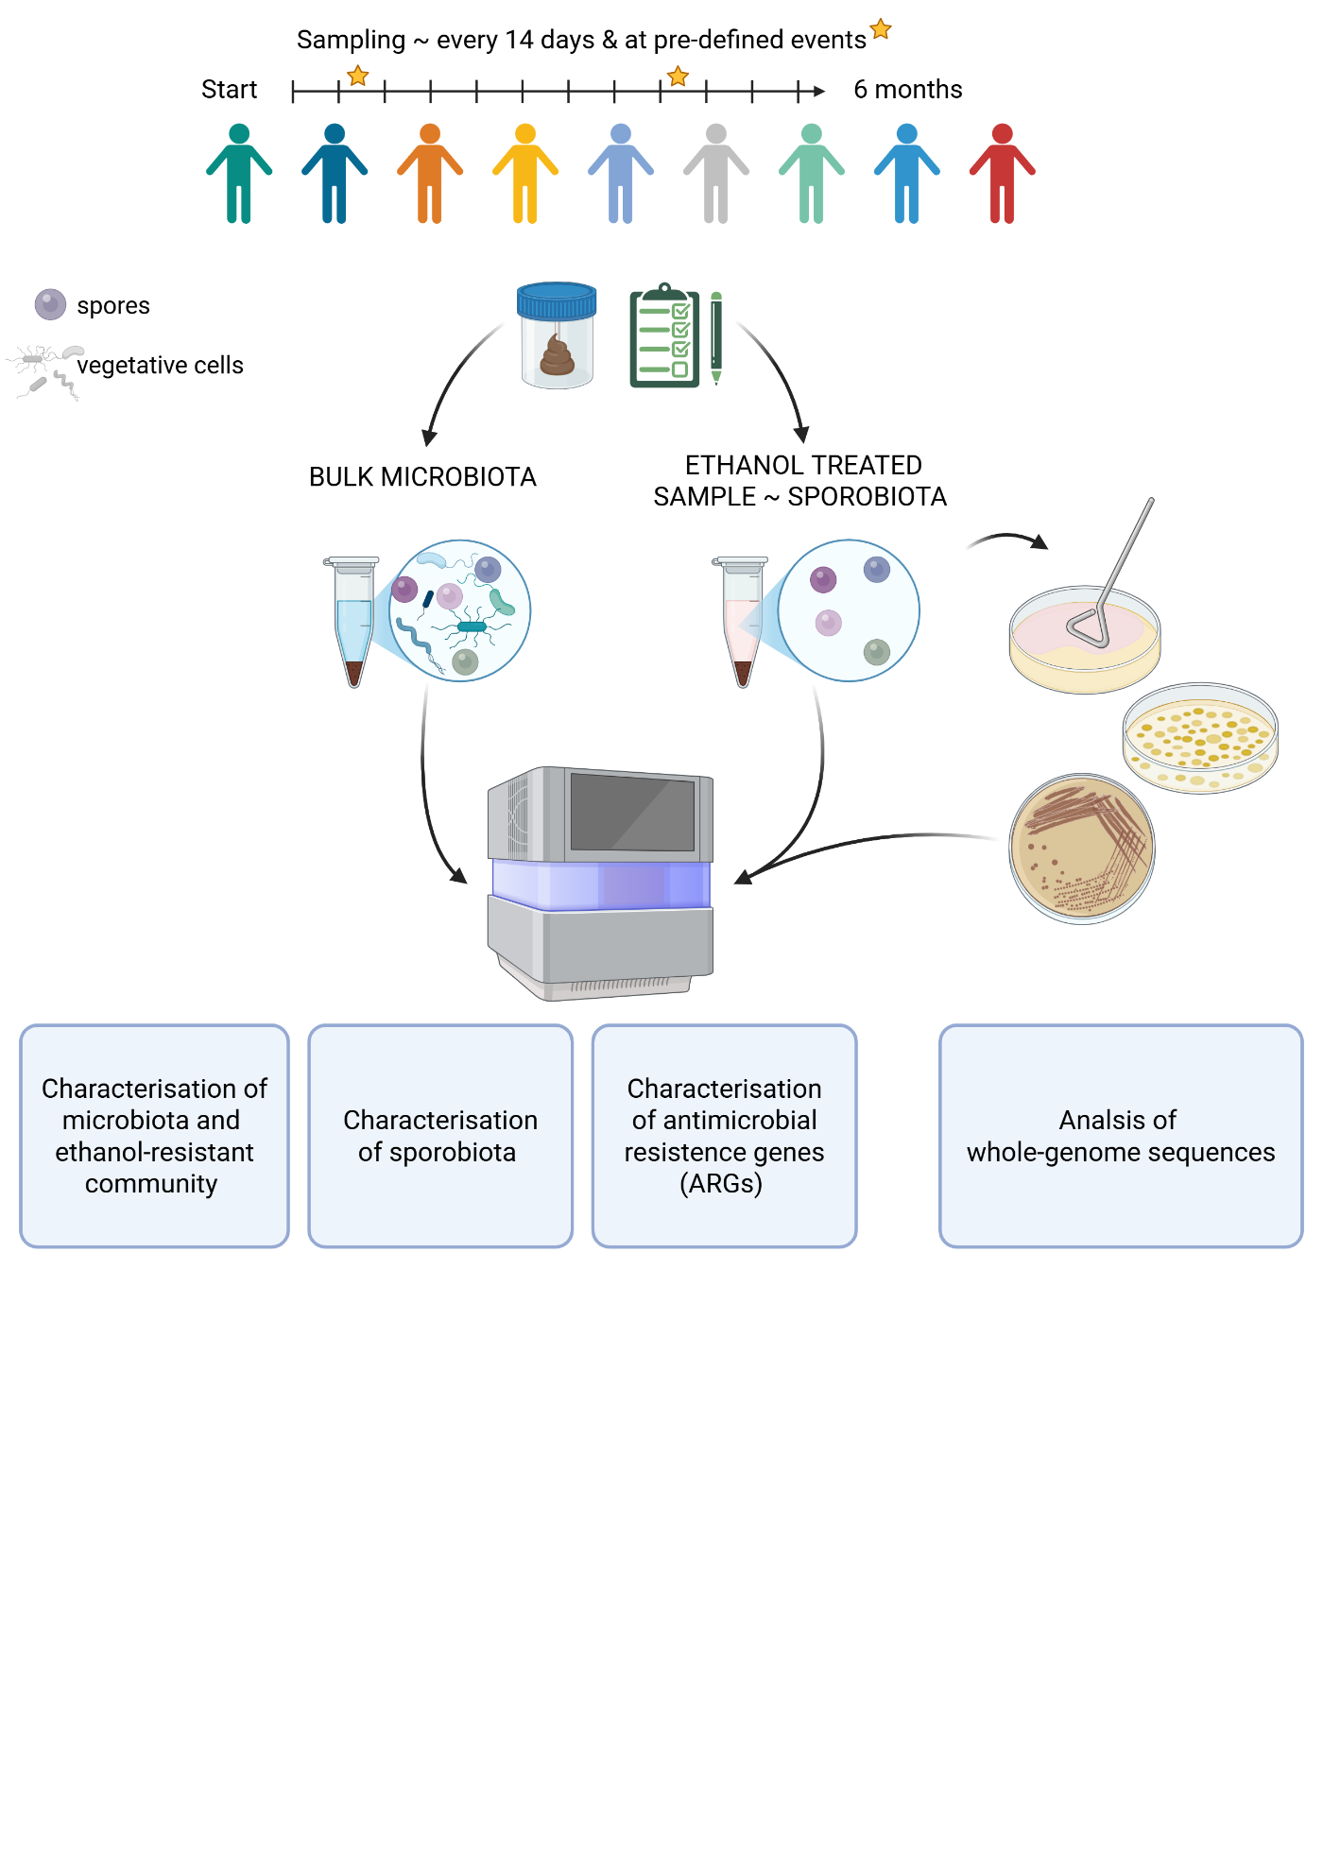
Figure 1. Longitudinal study design for characterisation of gut microbiota and sporobiota in stool samples from healthy male individuals. Created in BioRender.

LONGITUDINAL STOOL SAMPLE COLLECTION
Stool samples for this study were collected from nine healthy, unrelated, non-cohabiting male participants aged 25–43, with no gastrointestinal infections or surgeries in the three months preceding the study (Supplement Table 1, 2).
Stool samples and corresponding questionnaires were collected at 14-day intervals for six months and additionally at pre-determined events: dental hygiene visits, vaccination, minor operative procedures, hospitalisation, single episodes of excessive alcohol consumption, diarrhoea, food poisoning, antibiotic treatment, or travel. A questionnaire is presented in Supplement B and included data on health status and history, diet, and living conditions and nature of pre-defined events. Participants used sterile collection containers and delivered the samples to the laboratory within a few hours of collection. If immediate delivery was not possible, samples were stored at -20 °C until transport. Upon receipt, each sample was homogenized, divided into five aliquots (one 10 µl inoculation loop per aliquot), and stored at -80 °C.
Ethical approval was obtained from the National Medical Ethics Committee of the Republic of Slovenia (0120-280/2022/6).

COMPARISON AND OPTIMIZATION OF PROTOCOLS FOR DNA ISOLATION

Comparison of isolation protocols for bacterial DNA from human stool samples
We compared four DNA isolation protocols: QIAamp PowerFecal Pro DNA Kit (Qiagen, Germany), QIAamp Fast DNA Stool Mini Kit (Qiagen, Germany), NucleoSpin Soil Mini Kit (Macherey-Nagel, Germany), and an in-house protocol based on the DNeasy Blood & Tissue Kit (Qiagen, Germany) (Supplement Table 3). DNA was isolated in triplicate from three stool samples and a negative control containing 250 µl nuclease-free water. Samples were processed according to the manufacturer’s instructions, with the following modification: for the FastDNA and DNeasy protocols, additional mechanical lysis was performed using a mixture of 0.1 mm and 0.5 mm zirconia beads in equal parts on a MagnaLyser for 30 seconds at 7000 rpm. DNA was eluted in 100 µl nuclease-free water. DNA concentration was measured using the Quant-iT™ PicoGreen™ dsDNA Assay and dsDNA Reagents (Invitrogen™, US).

Optimization of removal of vegetative cells and their DNA from stool samples
To obtain DNA from spores and other resistant cell forms we compared heat and ethanol shock treatments of stool samples. Additionally, we used ethidium bromide monoazide (EMA) to remove free DNA and DNA from damaged (vegetative) cells. EMA binds to free DNA and can enter damaged cells, where, under light exposure, it cleaves double-stranded DNA, rendering it unsuitable for PCR or sequencing. To minimise DNA fragmentation during extraction, we also optimised the bead-beating procedure.
Two stool aliquots were each resuspended in duplicates 1.5 ml of 70% ethanol for 24 hours or subjected to heat shock at 80 °C for 30 minutes, based on previous cultivation experiments with spore-forming bacteria (Supplement text 1). After treatment, samples were washed three times with nuclease-free water. For EMA treatment, samples were incubated with 2.5 ng/µl EMA in the dark for 5 minutes, then illuminated on ice for 5, 10, or 15 minutes using an 8000-lumen light source. Controls included untreated stool samples and heat- or ethanol-shocked samples washed only with water but without EMA treatment, as EMA-efficiency controls. DNA was isolated using the MasterPure™ Complete DNA and RNA Purification Kit (Lucigen, USA). Prior to isolation, samples underwent bead-beating in Cell Lysis Solution with 0.5 g of 0.5 mm silica beads using a MagNA Lyser (Roche Diagnostics, Germany) at 7000 rpm. Bead-beating was performed for 70 seconds for the initial comparison and subsequently optimised to two cycles of 30 seconds at 7000 rpm to reduce DNA shearing. DNA quality was assessed by gel electrophoresis for fragmentation and by the absorbance ratio at 260/280 to estimate protein contamination.
Ethanol shock combined with EMA treatment (10-minute illumination) and the optimised bead-beating protocol was selected for sporobiota isolation of all samples. Isolated DNA was stored at -80 °C until further use.

DNA ISOLATION

DNA isolation from stool samples
DNA from untreated stool samples was isolated from an entire aliquot (one full 10 µl inoculation loop of stool) using the PowerFecal Kit (Qiagen, Germany) according to the manufacturer’s instructions, eluted in 100 µl nuclease-free water, and stored at -80 °C. DNA concentration was measured using the Quant-iT™ PicoGreen™ dsDNA Assay (Thermo Fisher Scientific, USA).

DNA isolation from pure bacterial cultures
Genomic DNA from pure bacterial cultures was isolated using a QIAamp DNA Mini Kit (Qiagen, Germany) with one full 10 µl inoculation loop of overnight culture. DNA was eluted in 50 µl nuclease-free water and stored at -20 °C. DNA concentration was measured with the Quant-iT™ PicoGreen™ dsDNA Assay (Thermo Fisher Scientific, USA).

ABSOLUTE QUANTIFICATION OF THE 16S rRNA GENE IN UNTREATED AND ETHANOL TREATED SAMPLES USING DROPLET DIGITAL PCR
Droplet digital PCR (ddPCR) was performed using EvaGreen QX200 technology (Bio-Rad, USA) to quantify the total bacterial load. ddPCR was conducted on all samples included in the longitudinal study, using universal primers targeting the V3-V4 regions of the 16S rRNA gene: 341F (5'-CCTACGGGNGGCWGCAG-3') and 806R (5'-GACTACHVGGGTATCTAATCC-3') (Klindworth et al., 2013). The reaction volume was 25 µl, comprising 2.5 µl of diluted DNA, 12.5 µl of 2 × EvaGreen Supermix, 0.5 µl of each 10 µM primer, and 9 µl of nuclease-free water. Droplets were generated using the QX200 Droplet Generator, following the manufacturer’s instructions.
The thermal cycling conditions were enzyme activation at 95 °C for 3 minutes, 40 cycles of denaturation at 95 °C for 30 seconds, annealing at 55 °C for 30 seconds, and elongation at 60 °C for 30 seconds, followed by a final elongation at 60 °C for 5 minutes and signal stabilisation at 4 °C for 5 minutes and 90 °C for 5 minutes. Absolute quantification was performed using QuantaSoft software v7.4.1, with a minimum threshold of 10,000 droplets per sample. The copy number of the target amplicon in each sample was calculated using Equation 1.
$c⋅\frac{V_{\text{reaction}}}{V_{\text{added DNA}}}⋅\frac{V_{\text{reaction}}}{V_{\text{used reaction}}}⋅\text{dilution factor}⋅\frac{c_{\text{original}}}{c_{\text{diluted}}}$ … (1)
Where c is concentration and V is volume. The copy number of the 16S rRNA gene was multiplied by the relative abundance of each OTU to determine their normalised abundance.

SEQUENCING OF MICROBIOTA, SPOROBIOTA, AND BACTERIAL ISOLATES

Amplicon sequencing of the 16S rRNA gene of microbiota and sporobiota
Bacterial community structure was determined by sequencing the V3-V4 region of the 16S rRNA gene using the same primers as for the ddPCR, 341F and 806R (Klindworth et al., 2013). Library preparation followed the 16S Metagenomic Sequencing Library Preparation protocol (Illumina, USA) with Q5® High-Fidelity DNA Polymerase (New England Biolabs, USA) or KAPA HiFi HotStart ReadyMix (Kapa Biosystems, Massachusetts, USA), as specified in Supplement Table 4. Sequencing was performed on Illumina’s NextSeq platform (2 × 300 cycles) or, where specified, on the Illumina MiSeq platform with the MiSeq Reagent Kit V3 (2 × 300 cycles).

Shotgun metagenomic sequencing of microbiota and sporobiota
Shotgun metagenomic sequencing was outsourced and performed on the BGI DNBSeq sequencing platform (BGI, Hong Kong). The initial steps involved enzymatic tagmentation to fragment DNA for microbiota samples, while for sporobiota samples, fragmentation was unnecessary as the DNA was already fragmented. Fragments between 200 and 400 base pairs were selected using MGIEasy DNA Clean Beads (MGI, Hong Kong). The 3’ ends were then repaired by adenylation, and adapters were ligated to the DNA fragments. DNA fragments were amplified by PCR and purified using MGIEasy DNA Clean Beads (MGI, Hong Kong). The purified PCR products were denatured and circularised using a splint oligo sequence. The resulting single-stranded circular DNA (ssCir DNA) constituted the final library. Any non-circularised DNA was digested, and library concentration was measured, libraries with concentrations above 1 ng/µl were selected for sequencing. Each library was further amplified using Phi29 DNA polymerase to generate DNA nanoballs (DNBs), each containing over 300 copies of a single molecular entity. These DNBs were loaded onto a patterned nanoarray and paired-end reads of 150 bases were generated.

Whole-genome sequencing using Illumina short-read technology
Libraries for whole-genome sequencing of individual strains were prepared using the NEBNext Ultra II FS DNA Library Prep Kit for Illumina (New England Biolabs, UK) according to the manufacturer’s instructions (Supplement Table 4, 5). Libraries were sequenced using 2 × 150 bp paired-end reads on the NextSeq2000 platform (Illumina, USA).

3.5.4 Whole-genome sequencing using Oxford Nanopore Technologies long-read technology
Within Clostridium saudiense analysis five selected isolates, representing each strain group based on ANI score and core SNPs, were chosen based on containing the highest number of reads and lowest number of contigs. Libraries were prepared using the Rapid Barcoding Kit 24 SQK-RBK114.24 (Oxford Nanopore Technologies – ONT, UK) and sequenced on R10.4.1 flow cells for 48 hours (Supplement Table 4, 5) on MinION platform (ONT, UK).

DATA ANALYSIS
All code used to carry out the analysis presented along with notes showing command runs is available at: https://github.com/ursamiklavcic/PhD, with sub-folders for each type of analysis.

Amplicon data analysis

Preprocessing
Sequenced reads were processed and binned in mothur v.1.48.0, following the MiSeq standard operating procedure for Illumina paired-end reads (Schloss et al., 2009). Reads were processed using the following criteria: no ambiguous bases were allowed and the maximum homopolymer length was set to 8 base pairs (bp), reads were then aligned against the Silva reference alignment (Release 128), chimeras were identified using the UCHIME algorithm, reads were classified using the RDP training set v.9 with a bootstrap threshold value of 0.80. Sequences were clustered into operational taxonomic units (OTUs) at a 97% similarity cut-off (Cole et al., 2014; Edgar, 2016; Edgar et al., 2011; Pruesse et al., 2007). After quality filtering, depending on the depth of coverage OTUs with fewer than a specified number of reads were removed. Each sample was rarefied to the minimum number of reads after filtering, rounded down to the nearest 1000 based on sequencing experiment (Supplement Table 4). Samples with fewer reads than the chosen minimum were removed from the analysis. Analysis and graphical representations of the experiments were performed in R v4.1.1 using the following packages: ‘dplyr’, ‘tidyr’, ‘tibble’, ‘stringr’, ‘readr’, ‘scales’, ‘ggplot2’, ‘ggpubr’, ‘vegan’, ‘glue’, ‘lubridate’, ‘purrr’, ‘readxl’, ‘forcats’, ‘ggnewscale’, and ‘renv’, with versions available in the thesis.renv environment (Ggplot2 Based Publication Ready Plots, n.d.; Project Environments, n.d.; R: The R Project for Statistical Computing, n.d.; Read Excel Files, n.d.; Scale Functions for Visualization, n.d.; tidyverse, 2016/2025; Oksanen, n.d.-a, n.d.-b; Oksanen et al., 2022; Wickham et al., 2019).

Criteria for determination of ethanol resistant and ethanol non-resistant OTUs in the longitudinal study
An individual OTU was determined as a member of the ethanol-resistant community if it met the following criteria: 1) the OTU was present in both the untreated and ethanol treated sample from the same stool sample, and 2) it was found at a higher relative abundance in the ethanol-treated sample in at least 5% of samples where criterion 1) was met. OTUs absent from all ethanol-treated samples were considered ethanol non-resistant.
OTUs detected in the ethanol-resistant community in less than 5% of the samples (determined uncertain, n = 83), and OTUs detected only in ethanol-treated samples (n = 141), were excluded from further analysis.

Bacterial diversity and community composition analysis
Community diversity of the ethanol-resistant and ethanol non-resistant communities was calculated using functions from the R package ‘vegan’. For alpha diversity, we used the Shannon index, which measures both the richness and evenness of a sample. Between-sample diversity was assessed using Bray-Curtis dissimilarity and Jaccard distance, considering the number of OTUs and their relative abundance or presence and absence, respectively. Statistical differences in between- and within-person beta diversity distances for all communities were assessed using the Kruskal-Wallis test. For the correlation between time between samples and distance between samples, we used Pearson correlation. The composition of ethanol-resistant and ethanol non-resistant communities was analysed by comparing differences in relative abundance, persistence (number of samples per person in which an OTU was detected), and the number of OTUs belonging to each community.

Sporulation frequency calculation and analysis of host, time, and OTU-specific influences
Sporulation frequency analysis was performed on a subset of OTUs that met two criteria: 1) classification within ethanol-resistant community and belonging to the phylum Bacillota, and 2) detection in at least 80% of both untreated and ethanol treated samples (to ensure robust temporal coverage). For each eligible OTU (i), sporulation frequency was defined as the ratio of the normalised abundance of the OTU in the ethanol-treated sample (e_{i}) to its normalised abundance in the untreated sample (m_{i}), i.e., sporulation frequency = e_{i}/m_{i}. This calculation is supported by a correlation between the relative and/or normalised abundance of ethanol-resistant Bacillota between untreated and ethanol treated samples, despite different isolation protocols (Supplement Text 2). Sporulation frequency thus reflects the fraction of an OTU population in a sporulated state at a given time point in a given host.
To assess whether the temporal order of sampling influences sporulation dynamics, we compared two scenarios for each host. First, within-individual sporulation frequency was calculated for each OTU from chronologically ordered time points and second, time points were randomly shuffled before calculating within-individual sporulation frequency for each OTU. Pearson correlation coefficients were then computed between ordered and reshuffled sporulation frequency values for each OTU-host pair to quantify the influence of temporal structure.
To characterise sporulation variability, we calculated the within-individual variance in sporulation frequency for each OTU and the population-wide variance for the same OTU. Differences in the distribution of these variance values across hosts and OTUs were assessed using the Kruskal–Wallis test. To evaluate the degree of synchronisation in sporulation dynamics across OTUs within individual hosts, we also computed pairwise Pearson correlation coefficients between sporulation frequencies of all OTUs within each individual.

Shotgun metagenomic data analysis

Preprocessing
Raw metagenomic reads were filtered and trimmed using the SOAPnuke programme (Chen et al., 2018). Reads containing 10% or more of uncertain bases, adapter sequences, or low-quality bases (Q < 20) were removed. All reads with more than 90% identity to host DNA using the reference genome GRCh38.p14, were also removed.

Bacterial, eukaryotic, archaeal and viral community composition analysis
Microbial composition was determined using DIAMOND and the last common ancestor (LCA) algorithm in the SqueezeMeta pipeline, and using MetaPhlAn v4.2.2, database vJan25_202503, with default settings, but the calculation of relative abundance also included unclassified taxa (Aho et al., 1973; Blanco-Míguez et al., 2023a; Buchfink et al., 2021; Tamames & Puente-Sánchez, 2019). These are two distinct approaches, each with its own advantages and disadvantages. The first approach requires read assembly and gene prediction on each contig. The taxonomy of each gene is determined by the most common taxon among the top 10 BLAST hits. Additional contig regions without gene predictions are analysed with blastx using the non-redundant NCBI database (Camacho et al., 2009). Taxonomic classification is then determined by consensus among the top hits using the LCA algorithm.
MetaPhlAn profiles microbial communities by mapping reads to a curated database of unique species-level marker genes derived from single-genome bins (SGBs) from isolate genomes and metagenome-assembled genomes of bacteria, archaea, and eukaryotes.
For the analysis of viral communities in the shotgun metagenomic samples, we used geNomad (Camargo et al., 2024). geNomad combines alignment-free and gene-based classifiers to improve the classification performance of viral sequences. Viral sequences were analysed at the class and family levels where possible, to explore abundance, diversity, and persistence within and across individuals.
Alpha and beta diversity, composition, and other graphical representations were calculated using functions in the R package ‘vegan’ at the SGB level for bacterial, archaeal, and eukaryotic data, and at the family and class levels for viral sequences.

Gene-based determination of sporulation capacity for bacterial species
Sporulation capacity was determined for all bacterial species detected in untreated and ethanol treated samples where the single-genome bin also had an NCBI species-level classification. The gene signature comprised 66 conserved genes (Supplement Table 6) previously shown to predict the sporulation capacity of bacterial species isolated from diverse environments with high accuracy (Browne et al., 2016a, 2021). Reference genomes for detected species were retrieved from the NCBI, based on representative genomes from GTDB. For each species, gene presence was assessed using BLAST-based gene detection (e-value < 1 × 10⁻⁵ and identity > 30%) (Camacho et al., 2009; Sayers et al., 2024). If a genome had more than 33 genes present, including the spo0A gene, the species was classified as spore-forming. The method is supported by the distribution of the number of genes present in a diverse set of genomes, with a clear break at 30 genes (Supplement Figure 6), and by previous transmission electron microscopy of spores from species determined as spore-forming (Browne et al., 2021).

Determination of ethanol-resistant bacterial species
Ethanol resistance was determined for all bacterial species detected in untreated and ethanol treated samples using the same criteria as for the OTUs (see Chapter 3.6.1.4).

Antibiotic resistance gene analysis
We used AMRfinder v4.0.3, db2025-07-16.1, which identifies antimicrobial resistance genes using basic local alignment to known sequences (Feldgarden et al., 2019, 2021). AMRfinder reports exact BLAST matches over the full length of the reference protein or, if there is no exact match, reports match with greater than 90% identity or with greater than 50% coverage of the protein. Results were imported into R for visualisation and statistical analysis to report abundance, diversity, taxonomy, and persistence of these genes over time within individuals.

CULTIVATION AND MOLECULAR CHARACTERISATION OF SELECTED SPORE-FORMING BACTERIA FROM HUMAN STOOL SAMPLES

Isolation of selected spore-forming bacteria from ethanol treated stool samples
Individual H was selected for this analysis. Based on amplicon data from untreated and ethanol treated samples, we observed a reduction in diversity and normalised abundance of bacteria during a period in individual H that coincided with antibiotic use (amoxicillin). Stool samples from one month before, during and after antibiotic use were used for isolation of spore-forming bacteria.
To isolate selected spore-forming bacteria we treated stool samples with ethanol shock. Ethanol shock included 24 h incubation of stool at ambient temperature (23 °C) with 70% ethanol with mixing. Samples were then serially diluted to 10⁻⁵, 100 μl of undiluted sample and its 10-fold serial dilutions were plated on oxygen-reduced Wilkins-Chalgren Anaerobe agar (WCA; Thermo Fisher Scientific, USA) with the addition of bile acids (BA; Merck, USA), and incubated for 2 days at 37 °C in an anaerobic workstation (Whitley A35 Workstation, Don Whitley Scientific, UK). WCAB has previously been shown to enable germination and sustain the growth of the highest number of different spore-forming bacteria from human stool samples (Dobovišek, 2021). After 2 days, approximately 60 colonies from each sample were picked and subcultured on WCAB. Identification of isolates was performed on overnight cultures using MALDI-TOF MS (Bruker, USA). DNA was isolated from a single colony overnight culture and sequenced as described in chapters 3.5.3 and 3.5.4 (Supplement Table 5).
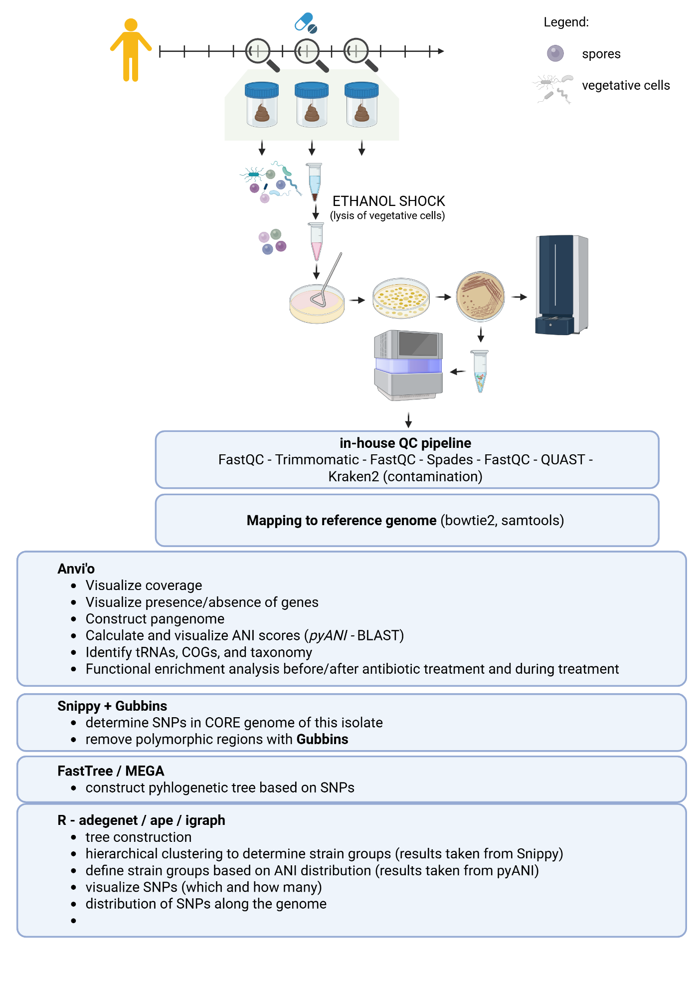
Figure 2. Workflow for isolation of selected spore-forming bacteria from ethanol treated stool samples and subsequent whole-genome sequencing. This figure was designed in BioRender.

Analysis of whole-genome sequencing reads

Preprocessing and assembly of short-read sequences
Sequencing was performed as described in chapter 3.5.3. The quality of Illumina short-read sequences was assessed with FastQC v0.12.1 and trimmed using Trimmomatic v0.39 using the following settings: ILLUMINACLIP:NEBPE-PE.fa:2:30:10, LEADING:10, TRAILING:10, SLIDINGWINDOW:4:20, MINLEN:40 (Babraham Bioinformatics - FastQC A Quality Control Tool for High Throughput Sequence Data, n.d.; Bolger et al., 2014). The trimmed reads were assembled de novo into contigs using SPAdes v3.13.0 with the --careful option, retaining all other settings at their default values (Prjibelski et al., 2020). The assembly was assessed with QUAST (Gurevich et al., 2013).
Trimmed short reads were mapped to a reference genome from NCBI (NCBI RefSeq assembly GCF_000577815.1) using bowtie2 with the --sensitive flag (Langmead & Salzberg, 2012). Samtools was then used to sort and index the SAM files (Li et al., 2009). Coverage was calculated using genomeCoverageBed within BEDtools for each individual genome and for the combined coverage of all genomes (Quinlan AR and Hall IM, 2010. BEDTools: A Flexible Suite of Utilities for Comparing Genomic Features. Bioinformatics. 26, 6, Pp. 841–842. - Google Search, n.d.).

Average nucleotide identity (ANI)
pyANI-plus was used to calculate pairwise ANIb, ANIm, and sourmash scores with default parameters between the core genomes of all sequenced isolates. Core genomes is here defined as genes present in all genomes analysed (Pritchard et al., 2015). Pairwise ANI scores were plotted in R. To delineate strain boundaries, a strain break determined by histogram of all ANI pairwise scores. Strain break was then applied to filter the results, retaining only genome pairs that exceeded the defined identity cut-off. An undirected graph was constructed from the filtered genome pairs using the `igraph` R package (Antonov et al., 2023; Igraph – Network Analysis Software, n.d.). Each genome was represented as a node and each qualifying pairwise relationship as an edge. Connected components within the graph were identified, corresponding to discrete strain groups. Each genome was assigned to a strain group based on its graph membership.

SNP analysis
To confirm strain groups obtained from ANI scores, we determined core SNPs using Snippy v4.6.0 (Seemann, 2014/2022). Core genome is here defined as all sites in a genome present in all genomes. We used the NCBI RefSeq assembly GCF_000577815.1 as the reference genome. To remove loci with elevated densities of base substitutions that could affect the number of SNPs between isolates, we used Gubbins v3.4.1 (Croucher et al., 2015). The filtered SNP matrix was used to construct a neighbour-joining tree in Gubbins, which we visualised in MEGA v12 (Tamura et al., 2021). Coloured squares for easier inspection of the tree were added in InkScape.

Preprocessing of long-read sequences and hybrid assembly
Five isolates were additionally sequenced on an ONT MinION platform as described in chapter 3.5.4. The quality of long-reads was assessed with NanoPlot v1.43.0 and NanoStat v1.6.0, and reads were filtered with NanoFilt v2.8.0 using a minimum Q-score of 10 and a minimum read length of 3000 bases (De Coster et al., 2018; De Coster & Rademakers, 2023). Hybrid assemblies were constructed with flye v2.9.6 using trimmed short-read sequences and filtered long-read sequences with default settings(Kolmogorov et al., 2019).

Pan-genome analysis, ANI score and SNP analysis with hybrid assemblies included
All genome assemblies were annotated with Prokka v1.14.6 prior to pan-genome construction (Seemann, 2014). The pan-genome was inferred with Roary v3.11.2 and visualised with Phandango, including metadata on the sampling day for each stool sample (Hadfield et al., 2018; Page et al., 2015). To account for the improved assemblies of five genomes, the analyses in chapters 3.7.2.2 and 3.7.2.3 were repeated with hybrid assemblies, using the hybrid assembly of genome H005_98 as the reference. In addition, reads from all genomes were mapped to the annotated H005_98 hybrid assembly with breseq v0.39.0 to detect and annotate genetic differences (Deatherage & Barrick, 2014).

Analysis of C. saudiense in shotgun metagenomic samples
StrainPhlAn v4.1.1 was used to identify the dominant C. saudiense strain in each metagenomic sample from participant H and to construct a dendrogram based on average site substitutions between samples (Blanco-Míguez et al., 2023a). This approach characterises only variation in the most abundant strain per sample. StrainPhlAn, an extension of MetaPhlAn, reconstructs the dominant strain of a target species in given samples. It aligns all reads to species-specific marker genes and generates a multiple sequence alignment, which is then used by PhyloPhlAn to build a phylogenetic tree.
To integrate isolate and metagenomic data, strain-specific genes were defined for each strain that was determined by pairwise ANI, core SNPs, and accessory-gene content. Shotgun metagenomic reads from all stool samples of participants H and A were mapped to these strain-specific genes with bowtie2 using the --very-sensitive flag (Langmead & Salzberg, 2012). Participant A served as a negative control for this approach, as C. saudiense was detected at very low abundance in only one of his 12 samples. We normalised the number of reads mapped to each gene by gene length and, for each strain, by the number of genes detected for that strain.

RESULTS

COMPARISON OF ISOLATION PROTOCOLS FOR BACTERIAL DNA FROM HUMAN STOOL SAMPLES
Four DNA isolation protocols were compared using three stool samples and a negative control, each processed in triplicate. Amplicon sequencing of the V3-V4 region of the 16S rRNA gene was performed to assess the efficiency of each protocol (Supplement Table 3). Selection of the best protocol was based on two criteria: the highest DNA yield and the ability to recover all bacterial phyla known to reside in the human gut (Martino et al., 2022).
All four DNA isolation kits produced DNA concentrations sufficient for downstream molecular applications, with the PowerFecal kit yielding approximately ten times higher DNA concentrations than the other protocols (paired t-test, p < 0.001; Figure 3A). The DNA concentration of negative controls was approximately 1 ng/µl, with OTUs averaging between 2 and 5 reads per control. Microbial community composition was significantly influenced by the DNA isolation protocol, explaining 19% of variation (PERMANOVA, p = 0.005; Figure 3B). The DNeasy protocol yielded significantly lower alpha diversity compared to the other three protocols (paired t-test, p < 0.005; Figure 3C), largely due to its reduced efficiency in isolating bacteria from phylum Bacteroides (Figure 3D). The remaining three isolation protocols all produced distinct communities, which however did not significantly differ in alpha diversity metrics. Consequently, the PowerFecal protocol was selected for subsequent analysis because it provided the highest DNA yield and comprehensive bacterial recovery.
These findings are consistent with published evaluations reporting that the PowerFecal kit provides high DNA yields, efficient lysis particularly of Gram-positive bacteria, and recovery of high-quality DNA suitable for microbiome studies (Gall-David et al., 2023).
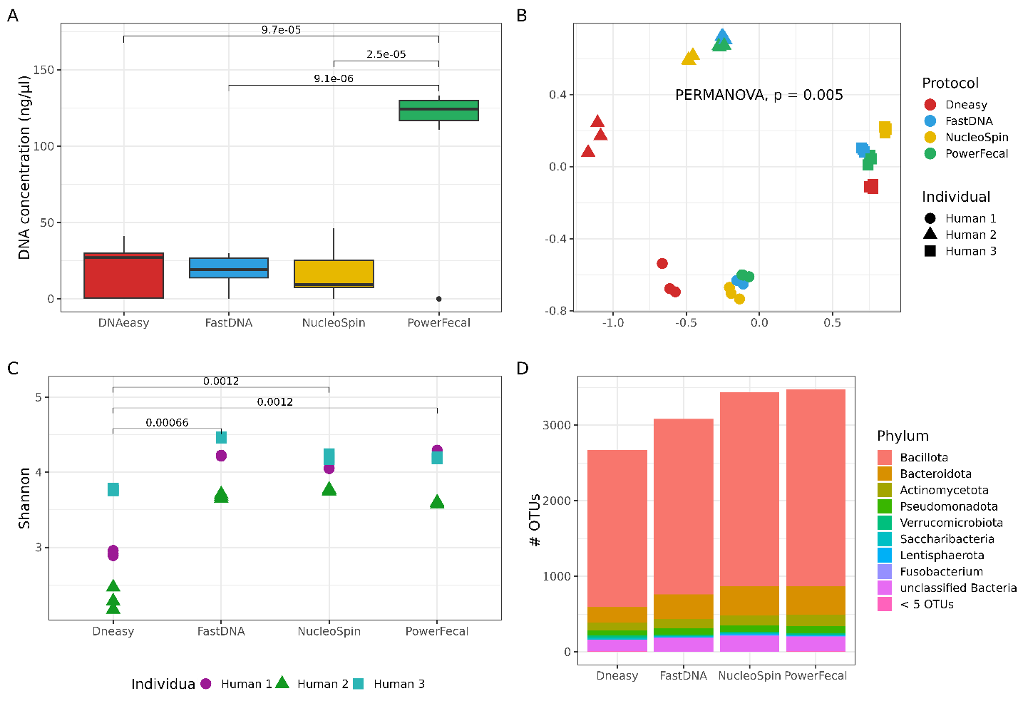
Figure 3. Comparison of DNA concentration, alpha and beta diversity, and the number of unique OTUs from three human stool samples using four different DNA isolation protocols. A) DNA concentrations [ng/µl] after isolation, measured with the Quant-iT™ PicoGreen™ dsDNA Assay and dsDNA Reagents (Invitrogen™, USA), with p-values above the connecting boxplots from paired t-tests. B) Non-metric multidimensional scaling (NMDS) ordination based on Bray–Curtis distances, with permutational multivariate analysis of variance used to assess differences between kits (PERMANOVA). C) Shannon index for alpha diversity, with p-values above the connecting boxplots from paired t-tests. D) Number of unique OTUs in each bacterial phylum across samples for each DNA isolation protocol, concatenating phyla with fewer than 5 OTUs into one group (< 5 OTUs). Legend: FastDNA: QIAamp Fast DNA Stool Mini Kit; NucleoSpin: NucleoSpin Soil Mini Kit, PowerFecal: QIAamp PowerFecal Pro DNA Kit; DNAeasy: in-house protocol based on the DNeasy Blood & Tissue protocol.

OPTIMIZATION OF PRE-TREATMENT FOR DNA ISOLATION FROM SPORES AND OTHER RESISTANT BACTERIA IN STOOL SAMPLES
The experiment included two stool samples, each treated in duplicate with either ethanol shock using 70% ethanol for 24 hours or heat shock at 80 °C for 30 minutes (selected based on previous experiments, see Supplement Text 1). Free DNA and DNA in lysed cells were subsequently removed by ethidium bromide monoazide (EMA) treatment with illumination times of 5, 10, or 15 minutes. Negative controls included a water sample treated alongside the stool samples, which was not sequenced due to low DNA concentration. Additional controls comprised an untreated stool sample, used to assess the fraction of the community removed by shocks, and ethanol- and heat-shocked samples washed only with nuclease-free water (without EMA), as EMA-efficiency controls.
Removal efficiency of non-spore-forming bacteria was evaluated using amplicon sequencing, focusing on taxa known to form spores according to the literature (Figure 4). Number of unique OTUs for each of the most abundant bacterial phyla were calculated across biological replicates for each treatment and compared with the untreated stool sample and the EMA-efficiency controls. Both ethanol shock and heat shock enriched for OTUs belonging to the phylum Bacillota and reduced the number of OTUs from other phyla compared to the original stool sample and EMA-efficiency controls. The 15-minute EMA illumination resulted in the strongest depletion of non-spore-forming phyla but had a low success rate of DNA isolation. Only 5 out of 16 samples had DNA of sufficient concentration and quality for sequencing, compared to 5 minutes (14/16) and 10 minutes (8/16).
For isolation of DNA from spores in human stool samples, ethanol shock combined with EMA treatment and 10-minute illumination was selected as the optimal compromise between selectivity and sequencing success rate.
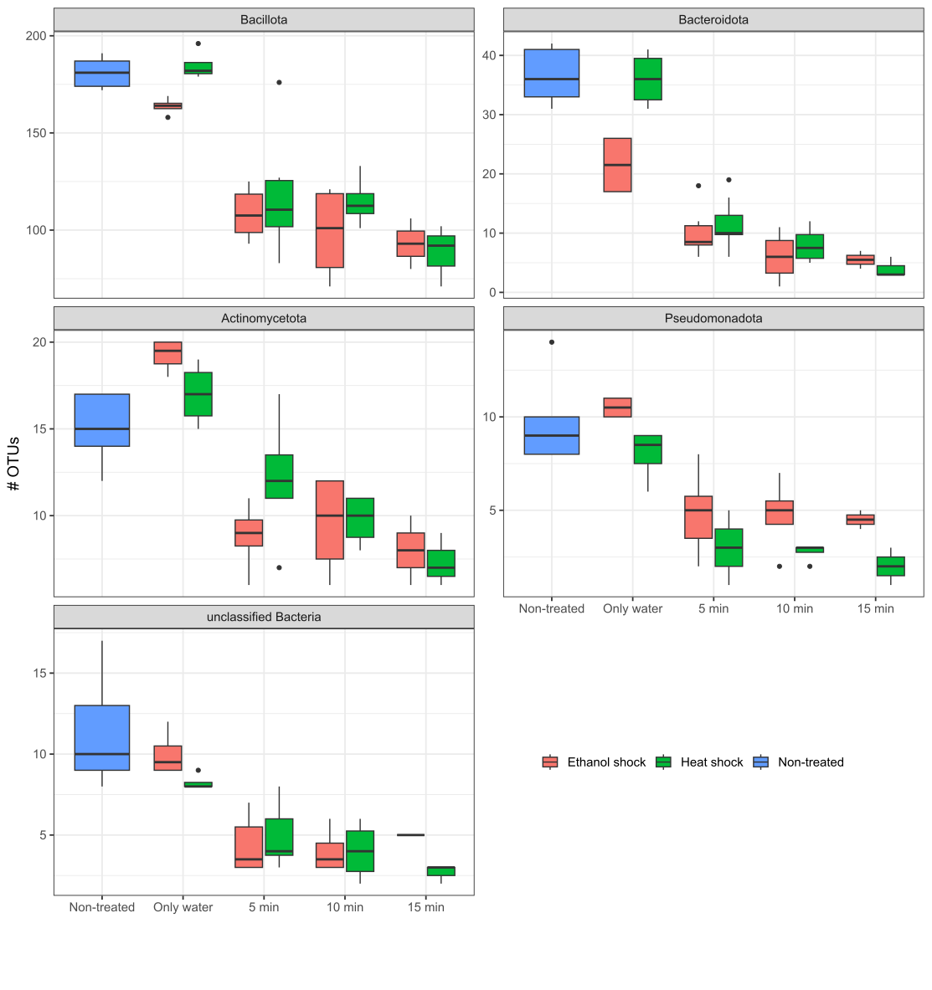
Figure 4. Efficiency of lysis and subsequent removal of free DNA and DNA in lysed cells by EMA treatment after heat or ethanol shock. Each plot represents one of the most abundant phyla in stool samples. Number of OTUs is represented on the y-axis. The boxplots are colour-coded by non-treated stool (blue), stool samples treated with ethanol shock (red), or heat shock (green), with different illumination times after EMA treatment (only water, 5 min, 10 min, and 15 min).

DESCRIPTION AND COMPARISON OF THE TEMPORAL STABILITY OF THE GUT MICROBIOTA AND SPOROBIOTA IN HEALTHY INDIVIDUALS

Composition, abundance and diversity of human gut microbiota
We obtained at least 12 stool samples from each participant over a six-month period (Supplement Table 1). The population consisted of healthy adult males, with a BMI between 18 and 33. All except one individual followed an omnivorous diet (participant I followed a lactose-free omnivorous diet). All participants reported regular digestion, with Bristol stool types ranging from 2 to 4. The use of regular food supplements varies, including omega-3 (A, I), protein powder (C, D, G), and probiotic yoghurt (D). Only participant I consistently consumed probiotics (Vivomox, EkoŠkrnicl Unibiotic Strong). Others reported probiotic supplementation overlapping with antibiotic use, travel, or food poisoning. Participants E and H consumed antibiotics during the study – doxycycline and amoxicillin, respectively. Participants reported only travel longer than three days outside their country of residence. Most reported visits were to other European countries: Croatia (A, B, F, G, H), the UK (C), Switzerland and the Netherlands (D). However, one individual also travelled to Tanzania and Kenya (B).
DNA was isolated from untreated stool samples and from ethanol treated samples. Of all 234 samples (117 untreated and 117 ethanol treated samples), we successfully sequenced 201 samples using shotgun metagenomic sequencing (116 untreated and 85 ethanol treated samples) and all 234 samples using amplicon sequencing (Supplement Table 4). The two sequencing approaches provided complementary results. Amplicon sequencing offers greater depth but lower taxonomic resolution, while shotgun metagenomic sequencing, despite its high sequencing depth, is less sensitive to low-abundance organisms but allows both functional and taxonomic profiling (Clooney et al., 2016; Jovel et al., 2016).
In the shotgun data, based on sequence alignment and the last common ancestor (LCA) algorithm we determined the taxonomy of approximately 97% of contigs. Nearly 92% of contigs were of bacterial origin, 3% were viral, and around 1% were fungi and other eukaryotes, while less than 0.4% were of archaeal ancestry across all samples (Figure 5A). For a more reliable analysis we determined the taxonomy using MetaPhlAn, which aligns reads to a database of highly curated marker genes (Figure 5B). These two approaches differ in reliability, MetaPhlAn’s curated database has higher accuracy but can miss taxa not present in the database, while a non-curated database such as NCBI can report false positive determinations.
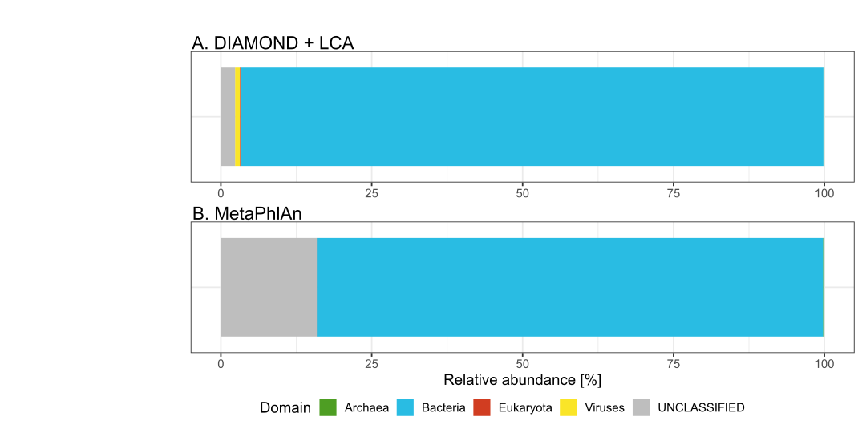
Figure 5. Presence of archaea, bacteria, eukaryotes, and viruses in shotgun metagenomes across all untreatedsamples using two different classification approaches. A) Determination at the contig level (DIAMOND + LCA) and B) at the read level (MetaPhlAn) of all microorganisms present in the gut microbiota of all participants. MetaPhlAn does not detect viral sequences.

We decided to use MetaPhlAn results due to their higher reliability. Archaea were detected in 5 out of 9 individuals in our cohort. The genus Methanobrevibacter was present in all five individuals, while Methanosphera were found in only two (Figure 6). Methanobrevibacter smithii exhibited oscillatory abundance within participants over time, while Methanosphera stadmanae was present at a lower relative abundance in a more equal abundance through time. Their abundance changes could not be connected to selected events from participants questionnaires.

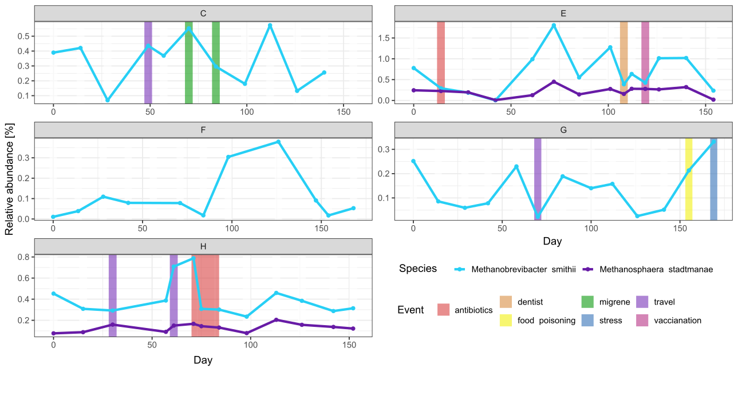
Figure 6. Relative abundance and persistence of archaeal species in participants gut microbiota. Species were determined using MetaPhlAn. Each plot depicts one participant (labelled with capital letters A to I), with days on the x-axis indicating when the stool samples were collected. Vertical coloured lines indicate out-of-the-ordinary events reported by participants in their questionnaires.

Eukaryotes were detected in 8 out of 9 individuals in our cohort, but not persistently throughout the study duration as detected by MetaPhlAn (Figure 7). In 7 out of 9 individuals (B, C, D, E, F, G, H, I), we detected fungal species Saccharomyces cerevisiae but not consistently though out the study and in 4 out of 9 individuals (C, D, E, H), we detected the genus Blastocystis at low abundances (0.01 to 0.6% of total relative abundance).
For better detection of eukaryotes especially fungi, we additionally used EukDetect (Supplementary Figure 7). Results from this tool could not be compared to results from MetaPhlAn, as EukDetect only reports number of reads mapped to marker genes of each species and not relative abundance.
With EukDetect Blastocystis sp. was still the most abundant eukaryotic species detected, but we also detected some other species from phylum Ascomycetota such as Penicillium nalgiovense, Candida albicans, Candida sake, Debaryomyces hansenii, and Yarrowia lipolytica besides Saccharomyces cerevisiae. We also detected two fungal species outside Ascomycetota phylum namely Wallemia mellicola and Entamoeba dispar but with only 2 and 3 reads mapping to their marker genes, respectively. The same number of reads was observed for the roundworm Caenorhabditis elegans in one sample of participant H.
The most abundant fungal species was still Saccharomyces cerevisiae, followed by Debaryomyces hansenii also from the Saccharomycetaceae family, although the difference between them is 10-fold. All other fungal species represented less than 0.0001 % of reads in all samples combined.
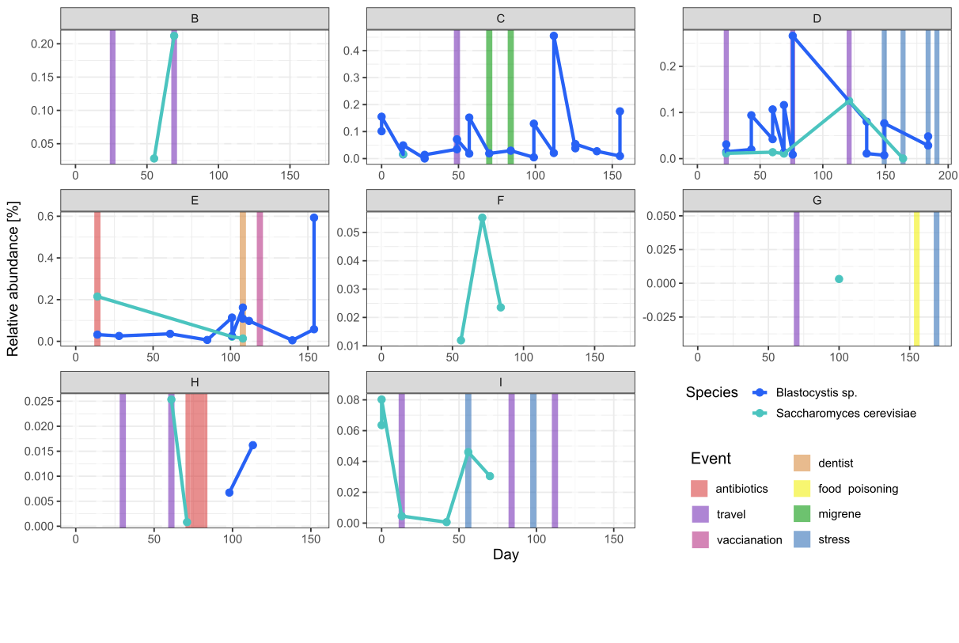
Figure 7. Relative abundance and persistence of eukaryotic species in participants gut microbiota. Species were identified using MetaPhlAn. Each plot depicts a participant (labelled with capital letters A to I), with days on the x-axis indicating when the stool samples were collected. Vertical coloured lines indicate out-of-the-ordinary events reported by participants in their questionnaires.
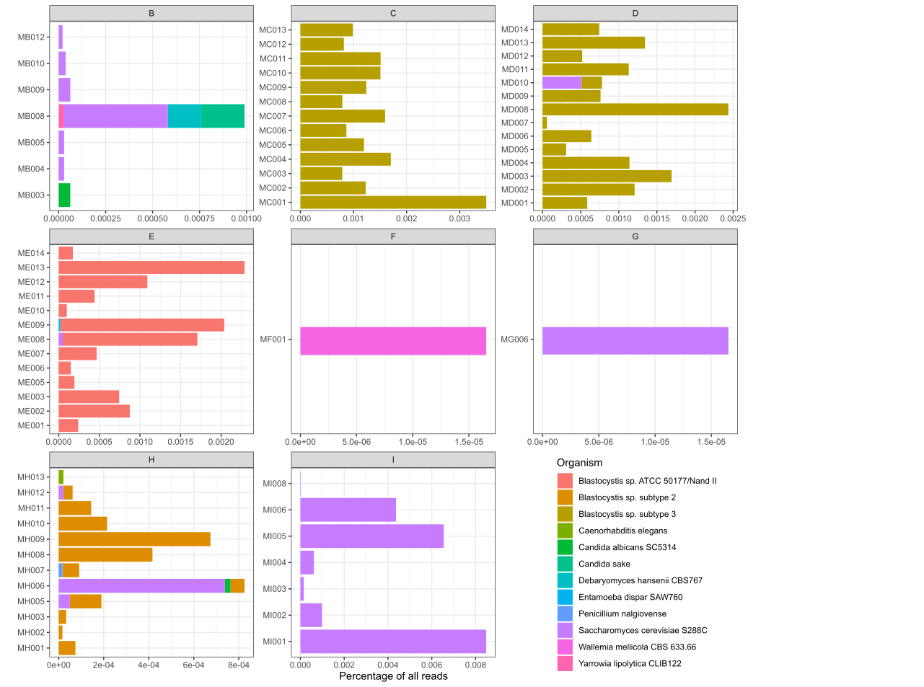
Alternative Figure 7. Abundance of eukaryotic species as detected by EukDetect. On the x-axis the number represents the percentage of reads mapped to marker genes of a species vs. all reads in a sample, the y-axis represents each sample of an individual where eukaryotes were detected.

In microbiota samples we detected both eukaryotic (Alsuviricetes, Arfiviricetes, Herviviricetes and Megavirictes) and bacterial viruses (Faserviricetes, Malgrandeviricetes, and Caudoviricetes), as well as a family of viruses able to infect both eukaryotic and bacterial cells (Duplopiviricetes) (Figure 8). Bacteriophages were present at ten times the relative abundance of eukaryotic viruses. Caudovirales showed the highest abundance among all groups. Viral communities in the human gut were individual-specific (Supplement Figure 8). The abundance of viruses was persistent over time and was not affected by extreme events or other metadata we collected from participants in our cohort.
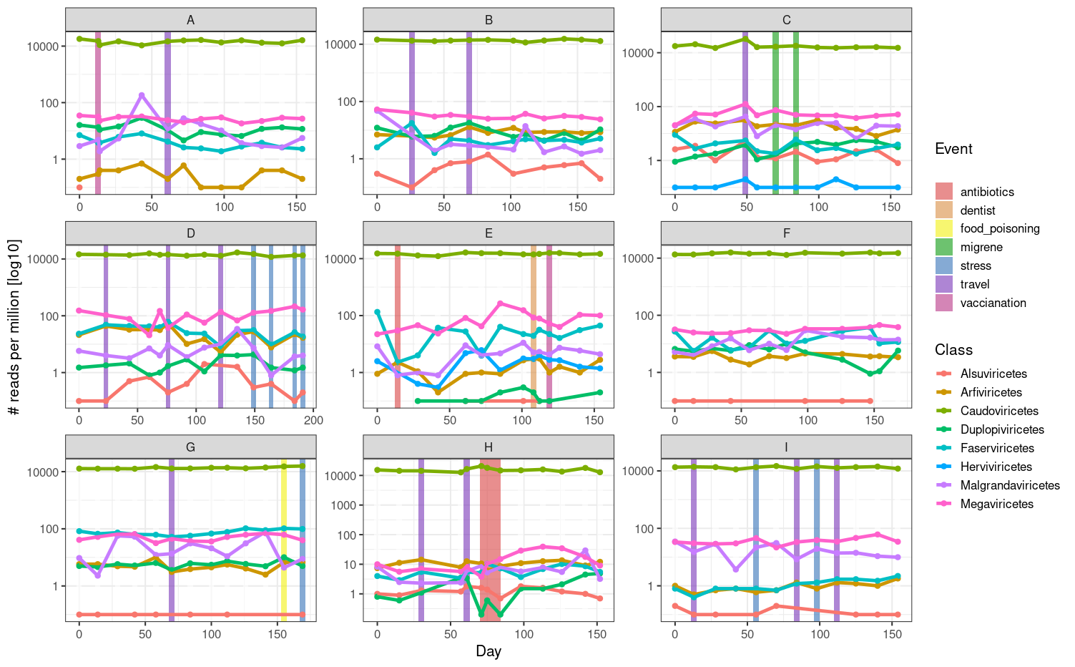
Figure 8. Log-scaled reads per million of viral classes in participants' gut microbiota. Viral sequences were identified using geNomad. Each plot depicts one participant (labelled with capital letters A to I), with days on the x-axis indicating when stool samples were collected. Vertical coloured lines indicate out-of-the-ordinary events reported by participants in their questionnaires.

Using MetaPhlAn we detected marker genes for 1033 bacterial single-genome bins (SGBs) across all shotgun metagenomic samples. Of these, 527 were assigned to a named NCBI species, while the remainder (n = 506) were classified only at the phylum or family level. In amplicon data, 2572 OTUs were detected across all samples. The number of detected bacterial genera differs between the two approaches (Figure 9). Amplicon sequencing detected more genera than shotgun sequencing in untreated stool samples. In ethanol treated samples, this difference was smaller, suggesting shotgun metagenomic sequencing more readily detects low-abundance organisms in less diverse samples but is less effective in high diversity samples despite the deep sequencing.
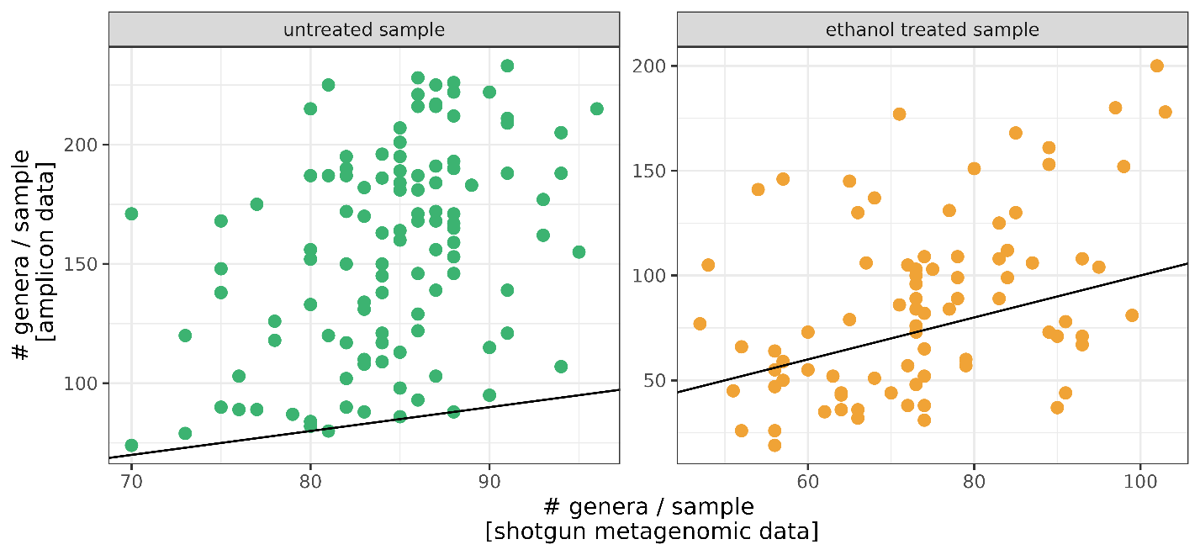
Figure 9. Number of bacterial genera detected in each sample (point) using amplicon sequencing (y-axis) and shotgun metagenomic sequencing (x-axis). The black line represents the identity function (x = y). If the points fell on the line, we could assume identical observations with both types of data.
Although the observed number of genera did not match between the two sequencing approaches for untreated stool samples, we observed similar distinct temporal patterns across the nine participants (A–I) when comparing the Shannon index based on OTUs or SBGs (Figure 10). The Shannon index calculated from SGB-level data is consistently higher due to the greater evenness in the shotgun metagenomic data and not due to richness (Supplement Figure 9). Longitudinal trajectories varied substantially between individuals, with some participants maintaining relatively monotonic trajectories (A, B, C, F), and others experiencing large shifts (D, E, G, H). Only the shift in participant H could be linked to antibiotic use during the study. Other shifts did not correlate with predetermined events collected in metadata.
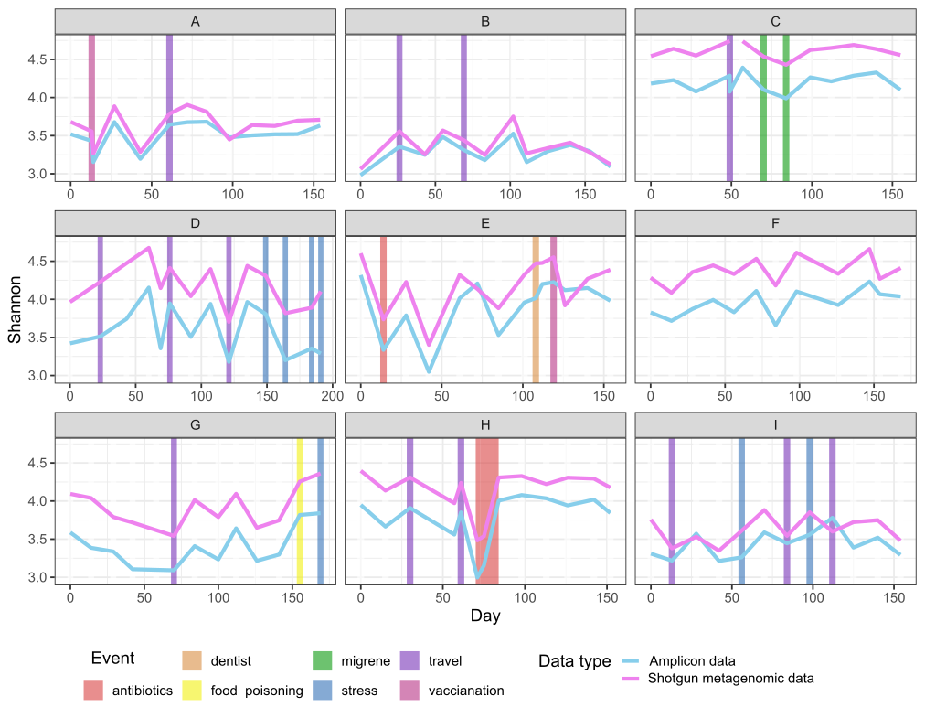
Figure 10. Alpha diversity based on Shannon index for untreated stool samples based on OTUs (blue) and SGB-level (violet). Each plot depicts one participant (labelled with capital letters A to I), with days on the x-axis indicating when stool samples were collected. Vertical coloured lines indicate out-of-the-ordinary events reported by participants in their questionnaires.
Beta diversity NMDS ordination based on Bray-Curtis dissimilarity showed strong participant-specific clustering for both OTUs (Figure 11A) and SGB-level profiling of shotgun metagenomic data (Figure 11B). Samples from the same participant clustered together despite temporal variations (homogeneity of multivariate dispersions, ANOVA p < 0.005). The separation between participants was maintained across both sequencing methods, indicating robust inter-individual differences independent of sequencing or analytical approach.
Amplicon and shotgun sequencing produced broadly consistent phylum-level profiles, with Bacillota dominating all sample types (Supplement Figure 10). In untreated stool samples, amplicon data showed a higher relative abundance of Bacteroidota and Actinomycetota phylum, whereas shotgun data were more strongly dominated by Bacillota. In ethanol treated samples, both methods showed an even stronger enrichment of Bacillota and a marked depletion of other phyla, consistent with selective retention of ethanol‑resistant taxa.

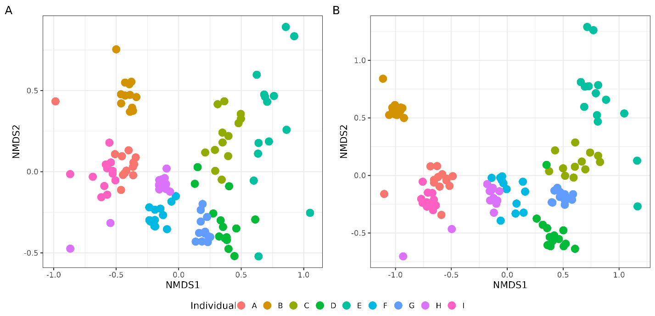
Figure 11. Non-metric multidimensional scaling (NMDS) based on Bray-Curtis dissimilarity calculated from relative values of OTUs (A) and SGBs (B). Colours indicate participants. NMDS ordination based on Bray-Curtis dissimilarity calculated from viral sequence classification obtained with geNomad is available as Supplement Figure 8.

Composition, abundance and diversity of ethanol-resistant bacterial community and sporobiota in the human gut
First, we present results from amplicon data, in which we analysed compositional characteristics and temporal dynamics the ethanol-resistant community of the human microbiota and further divided it into sporobiota, and other ethanol-resistant bacteria based on taxonomic classification. Later we present results from shotgun metagenomic data, where sporulation capacity was defined by the number of sporulation genes present in a genome.

4.3.2.1 Ethanol-resistant community and sporobiota in amplicon data
We obtained 2,431 OTUs across the untreated samples, of which 414 (17.0 %) were determined as part of the ethanol-resistant community and 1,934 (79.5%) as part of the ethanol non-resistant community (see Materials and methods chapter 3.6.1.2). Eighty-three OTUs (3.4%) failed to meet the criteria and were designated as undetermined regarding ethanol resistance. An additional 141 OTUs were detected only in ethanol treated samples. These were all present at low relative abundance and were considered highly probable sampling artifacts and therefore excluded from further analysis (Supplement Text 3), following the example of a previous study (Kearney et al., 2018).
Most ethanol-resistant representatives were found in the phylum Bacillota (n = 320), accounting for 77.5% of the total richness in the ethanol-resistant community (Figure 12A). Within Bacillota, 17.7% of all detected OTUs exhibited ethanol resistance, predominantly from the genera Clostridium (n = 76), unclassified Lachnospiraceae (n = 49), unclassified Ruminococcaceae (n = 42), unclassified Peptostreptococcaceae (n = 13), and Blautia (n = 12). The remaining ethanol-resistant community included representatives from Actinomycetota (n = 42, 11%), Pseudomonadota (n = 21, 5.5%), and unclassified Bacteria (n = 14, 3.7%). In these groups, the proportion of ethanol-resistant OTUs was higher than expected, with 36.2%, 40.4%, and 19.7%, respectively, exhibiting this trait (Figure 12B). Additionally, phyla with ten or fewer representatives collectively contributed 2.3% of the ethanol-resistant richness, most notably the biologically relevant genus Akkermansia. Ethanol treatment had the strongest elimination effect on the phylum Bacteroidota, with only 10 representatives remaining in the ethanol-resistant community, accounting for 0.5% of the total relative abundance.
We observed two notable characteristics distinguishing the ethanol-resistant community from the non-resistant community. Both were primarily driven by Bacillota OTUs due to their high abundance, although similar trends were also observed across other phyla. First, OTUs determined as ethanol-resistant exhibited significantly higher relative abundance within the gut microbiota compared to non-resistant OTUs (Wilcoxon rank sum test, p < 0.001; Figure 12C). Second, ethanol-resistant OTUs were significantly more likely to be detected at more time points within an individual, particularly in more than 80% of samples collected over a six-month period, compared to non-resistant OTUs (Wilcoxon rank-sum test, p < 0.001; Figure 12D).

4.3.2.2 Sporobiota in shotgun metagenomic data
In the previous chapter, we showed that the ethanol-resistant Bacillota community serves as a good proxy for studying the sporobiota when using amplicon sequencing data (determination is described in Chapter 3.6.1.2). Using shotgun metagenomic data we could determine sporulation capacity based on presence of sporulation genes (described in Chapter 3.6.2.3) and with the ethanol treated samples we obtained information on actual sporulation (presence of spores) by species in a given environment.

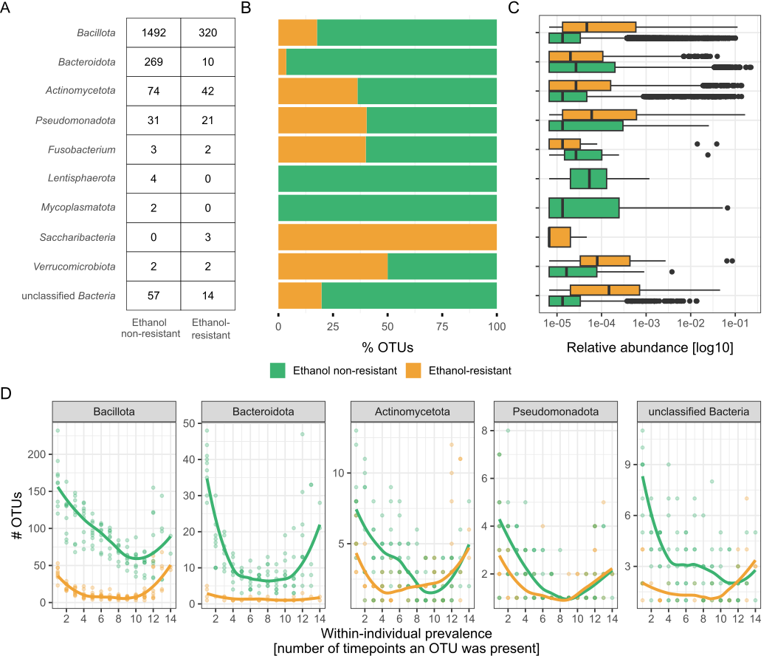
Figure 12. Characteristics of ethanol-resistant and ethanol non-resistant bacterial communities based on amplicon data. A) Distribution of OTUs across phyla according to ethanol resistance. The number of OTUs identified in each phylum for the ethanol non-resistant and ethanol-resistant communities. B) Stacked bar plots show the relative proportions of ethanol-resistant and ethanol non-resistant OTUs within each phylum, colour-coded as ethanol non-resistant (green) or ethanol-resistant (yellow). C) Comparison of relative abundances in the gut microbiota between OTUs determined as part of the ethanol-resistant or ethanol non-resistant community per phylum. D) Within-individual prevalence of OTUs across the six-month observational period for the most prevalent phyla, shown as the number of OTUs detected at different percentage of time points. Points represent one OTU per individual, and lines represent the cohort median.

For the 527 single-genome bins (SGBs) classified at species level, reference genomes were downloaded from GTDB and screened for the 66 genes associated with sporulation (Supplement Table 6). Species carrying at least 33 of these genes were classified as spore-forming, resulting in 235 spore-forming and 292 non-spore-forming species (Supplement Figure 6). The remaining 506 SGBs could not be assessed because no genomes are available in GTDB or anywhere else and were therefore excluded from further analysis. Subsequent analysis focused on SGBs with species-level classifications.
In our dataset we found that around 50% of human gut bacteria have sporulation capacity based on sporulation gene presence (Supplement Figure 6). However, we found that only about 32% of spore-formers could be detected in the ethanol-resistant community, indicating they were forming spores at the time of our sampling. Spore-forming bacteria represent approximately 40% of the total relative abundance within individual untreated stool sample, although this varies greatly between participants (SD = 13%).
Spore-formers defined by gene presence, are present at higher relative abundances and persist for longer periods within an individual (Wilcoxon test, p < 0.001; Figure 13 and Supplement Figure 12). This remains true when comparing the spore-formers to all other bacteria in the human gut or to other Bacillota members.
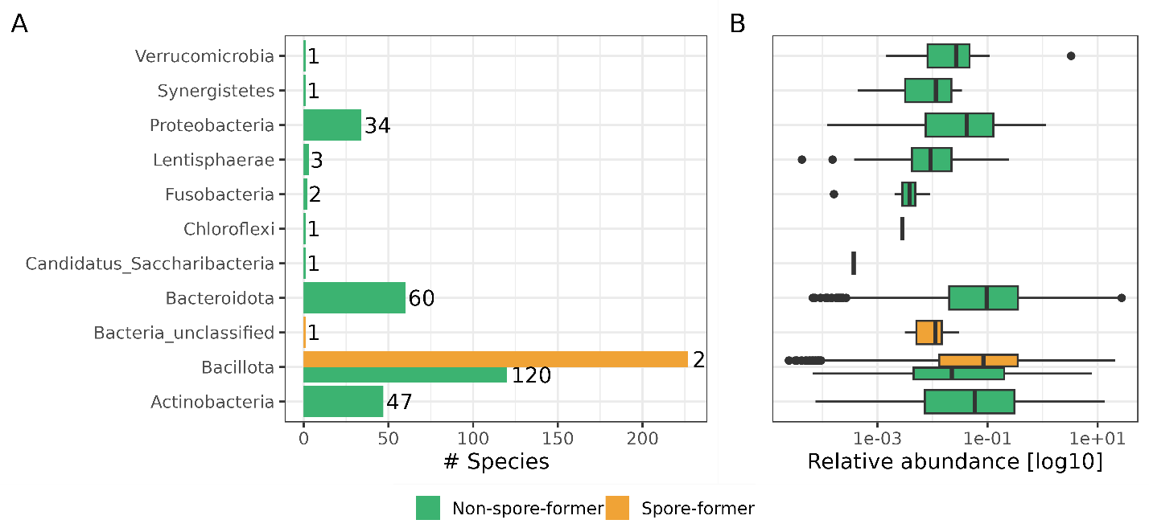
Figure 13. Characteristics of spore-forming (yellow) and non-spore-forming (green) bacteria in shotgun metagenomic data. A) Distribution of species across phyla according to spore-forming ability. B) Boxplots represent relative abundance of all species within a phylum separated by non-spore forming and spore-forming for the phyla, where spore-forming bacteria were detected.

Between and within-individual dynamics of spore-forming and non-spore-forming bacterial communities over time
For statistical robustness and clarity in discussion, we further divided our amplicon dataset of ethanol-resistant and ethanol non-resistant communities into the spore-forming phylum Bacillota and other phyla (Figure 14). The ethanol-resistant communities showed significantly lower variability both between and within individuals compared to the non-resistant communities. This pattern was observed when implementing both unweighted (Jaccard distance, p < 0.001 for all comparisons; Figure 14A) and unweighted beta diversity measures (Bray-Curtis, p < 0.001 for all comparisons, Supplement Figure 13A, Supplement Table 7). However, the lower within-individual variability in ethanol-resistant communities was significantly more pronounced in the phylum Bacillota compared to other phyla (Wilcoxon rank-sum test, p < 0.001; Figure 14A). This also hold true for spore-forming bacteria detected in shotgun metagenomic samples (Supplement Figure 14A).
In our study, we observed a modest but significant increase in temporal variability within ethanol-resistant Bacillota based on Jaccard distance (Pearson correlation, r = 0.19, p = 0.038, Figure 14B) and a borderline significant correlation using Bray-Curtis dissimilarity (Pearson correlation, r = 0.169, p = 0.051, Supplement Figure 13B, Supplement Table 8). In contrast, no significant temporal changes were observed in other communities (Figure 14B). This temporal trend could not be observed for spore-forming bacteria detected in shotgun metagenomic samples (Supplement Figure 14B).
Figure 14. Dynamics of ethanol-resistant and ethanol non-resistant taxa between and within individuals in amplicon data. A) Boxplots showing between-individual (left) and within-individual (right) variability in community composition for ethanol-resistant (yellow) and non-resistant (green) communities. Variability was assessed using the Jaccard distance, calculated separately for OTUs from the phylum Bacillota and OTUs from other phyla. Jaccard distances were derived from randomly subsampled communities (n = 24, iterations = 999), with the median distance used for visualization and statistical comparisons. Distributions were compared using the Wilcoxon rank-sum test. B) Community variability as measured by Jaccard distance plotted against the number of days between sampling time points. Data are presented separately for phylum Bacillota (solid line) and other phyla (dashed line) and color-coded according to ethanol resistance. The correlation between time interval and Jaccard distance was assessed using Pearson’s correlation test. Statistical significance is indicated as *** for p < 0.001.
Both spore-forming community and the ethanol-resistant community exhibits greater species/OTU sharing among unrelated and non-cohabitating individuals, while non-spore-forming and ethanol non-resistant community suggests greater individual-specificity (Figure 15, Supplement Figure 15).
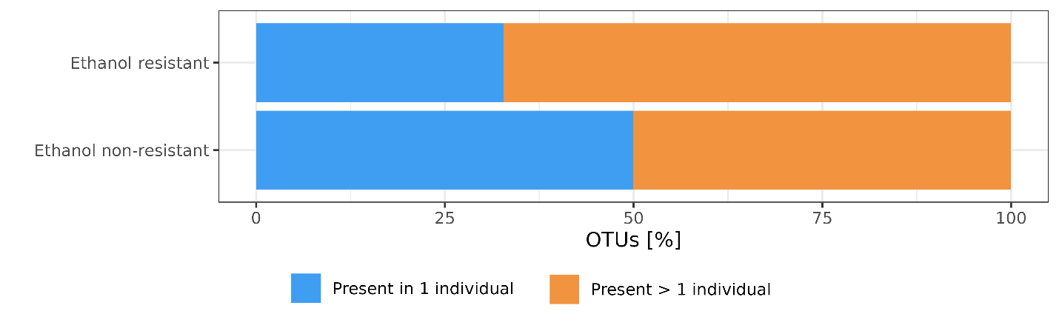
Figure 15. Sharing of OTUs between people based on their resistance to ethanol. Proportion of OTUs in ethanol-resistant and ethanol non-resistant community are present in a single individual or present in two or more individuals. This analysis was conducted on 865 OTUs determined present in an individual (90% of all timepoints). That reduced the number of OTUs present in the ethanol-resistant and non-ethanol resistant community to 192 and 673 OTUs, respectively.

Sporulation frequency of ethanol-resistant Bacillota in the human gut is host and time dependent
Sporulation frequency was calculated for OTUs determined as part of the ethanol-resistant community with taxonomic classification to the phylum Bacillota. For each OTU, the ratio of normalised abundance in untreated samples (including sequences from both vegetative cells and ethanol-resistant forms) samples to normalised abundance in ethanol treated samples (enriched for spores and other ethanol-resistant cell forms) was defined as the sporulation frequency (Supplement Text 2). Sporulation frequency thus reflects the fraction of an OTU population in a sporulated state at a given time point in a given host.
The sporulation frequency for all OTUs within an individual increases or decreases simultaneously at a single time point in the majority of time points (Figure 16A). This indicates a dependency on the current state of the gut in each host. We examined the correlation between the variation in sporulation frequency of each OTU at a single time point, normalised by the mean variation in sporulation frequency of that OTU across all days for an individual, and the same value with the day variable reshuffled. There was no correlation between the original and reshuffled data (Pearson’s correlation: 0.03, p = 0.74), confirming that the temporal order of sampling days is a key factor influencing the sporulation frequency of an OTU.
Variance in sporulation frequency of an OTU within an individual, compared to the variance in sporulation frequency of the same OTU across the whole population, indicates host specificity. This is demonstrated by the ratio between the variance of OTU i in an individual and the variance of OTU i in the population, which falls below 1 in all but two individuals (Figure 16C). An exception was the increased sporulation frequency in individual H, relative to the population variance, which can be attributed to antibiotic consumption between days 71 and 84 of the study. There was also a slight increase in individual C, associated with five days spent abroad in the second month of the study. Notably, in individual H this coincided with a decrease in alpha diversity, while in individual C there was an increase in alpha diversity. The Kruskal test shows significantly different variance in sporulation frequency of OTUs between individuals in our study (p = 1.7 × 10⁻⁸), which strengthens our comparison, as the population variance reflects highly diverse individuals. In contrast, comparison of the variance in sporulation frequency between different OTUs is not significantly different (Kruskal test, p = 0.96, Figure 16B). Further confirmation of the dependence of sporulation frequency on host and time, rather than OTU classification, is provided by positive Pearson correlations between sporulation frequencies of OTUs within an individual (Supplement Figure 16).
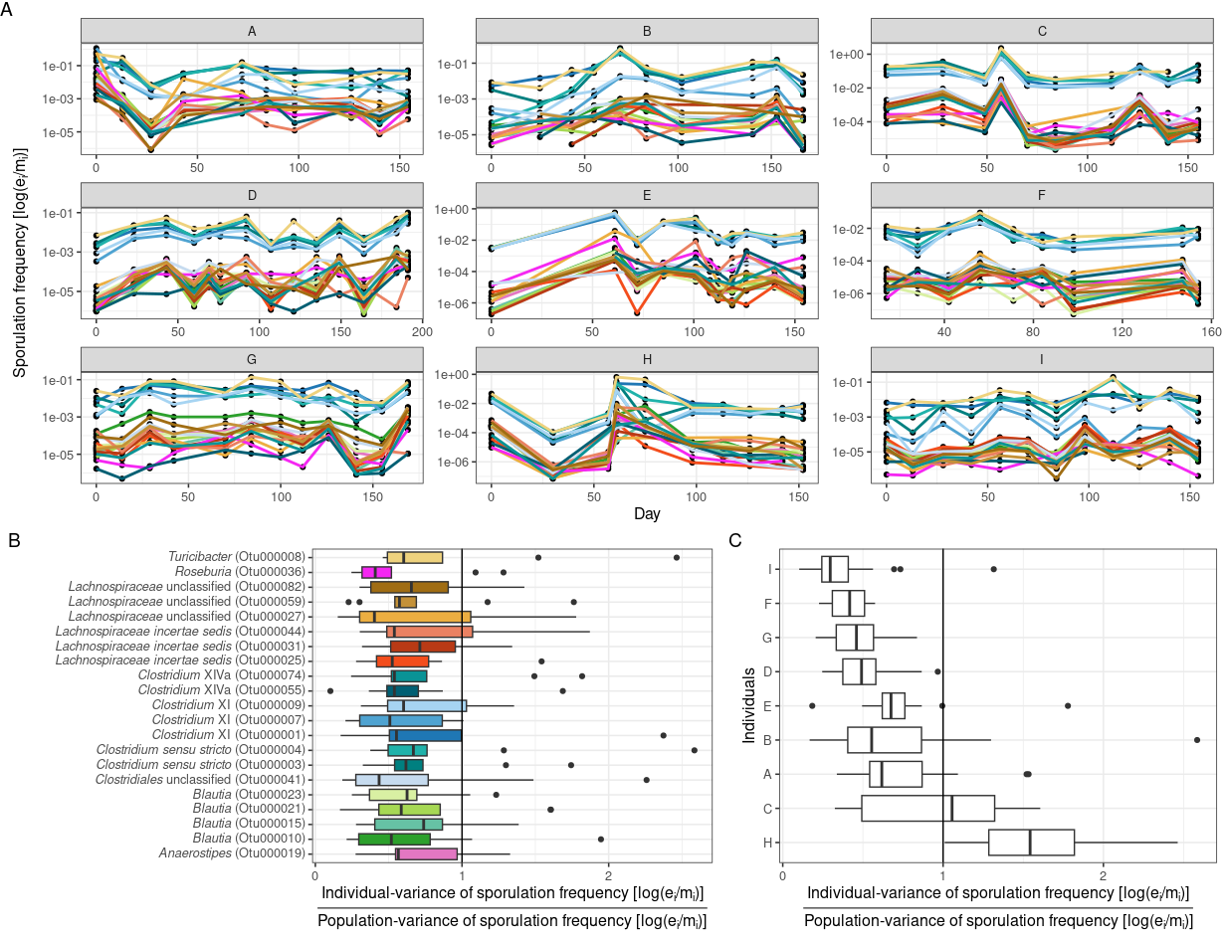
Figure 16. Influence of individual, time or OTU identity on sporulation frequency. The analysis includes only highly prevalent OTUs belonging to ethanol-resistant Bacillota (present in > 80% of samples, n = 22). A) Sporulation frequency of each OTU over the study duration, shown separately for each participant. Sporulation frequency was calculated as a ratio of normalized OTU abundance and ethanol-treated samples (e_{i}) and untreated samples (m_{i}), and log10-transformed for visualisation purposes. B) Ratio of within-individual to population-level variance in sporulation frequency, plotted by OTU. C) Ratio of within-individual to population-level variance in sporulation frequency, plotted by study participant. The vertical line (x = 1) indicates where within-individual (OTU or participant) variance equals the population-wide variance.

CULTIVATION AND MOLECULAR CHARACTERIZATION OF THE REPRESENTATIVE SPORE-FORMING SPECIES
This analysis was done on three stool samples of a single participant. Participant H consumed amoxicillin, a broad-spectrum penicillin, midway through the study from day 70 to 84. During this period bacterial diversity and normalised abundance decreased, and sporulation frequency across OTUs was significantly higher than in other participants. This made participant H an informative case for investigating strain dynamics of selected spore-forming species. Spore-forming bacteria were isolated from three time points: one month before, during, and one month after antibiotic use.

Cultivation and sequencing of selected spore-forming species from ethanol treated stool samples
Pre-, mid- and post-antibiotic stool samples of participant H (H005, H007, H009 respectively) were exposed to ethanol shock and after cultivation approximately 60 colonies per sample were picked and re-streaked onto fresh media to obtain pure isolates. The identification of obtained isolates is shown in Table 1.
Due to the highest number of isolates obtained we selected Clostridium saudiense for whole-genome sequencing (Table 1). In total, 44 C. saudiense genomes were sequenced (Supplement Table 5), as second re-streaking was not successful in remaining 43 isolates. We obtained 8, 16, and 18 genomes from the pre-, mid- and post-antibiotic samples, respectively.
Table 1. Number of obtained isolates after picking and first re-streaking. Species of isolate was determined with MALDI-TOF MS. H005, H007 and H009 are samples from time point pre-, mid- and post-antibiotic use of participant H. Some colonies were lost during the second re-streaking step, due to not growing, which accounts for the unequal numbers to the sequencing experiment.
Detected species | All samples | Before antibiotic H005 | During antibiotic  H007 | After antibiotic  H009
Clostridium paraputrificum | 24 | 23 | 0 | 1
Intestinibacter bartletti | 11 | 4 | 2 | 5
Clostridium saudiense | 87 | 19 | 42 | 26
No organism identification possible | 20 | 7 | 7 | 6
No growth after first re-streaking | 0 | 4 | 19 | 25

4.1.2 Average nucleotide identity, core SNPs analysis and pangenome construction
We first determined pairwise average nucleotide identity (ANI) between all obtained isolates (Figure 17). We observed two genomes with ANI scores below 95%. One was identified as Clostridium paraputrificium, while the other was a mixed isolate of C. paraputrificium and C. saudiense. These were excluded from the analysis.
We determined the strain break after pairwise comparisons of all C. saudiense genomes to be 99.98%. Using a similarity network analysis based on pairwise ANI scores, we identified four strain groups, with one genome determined a singleton. These ANI‑defined groups were confirmed by a neighbour‑joining tree built from core genome SNPs.
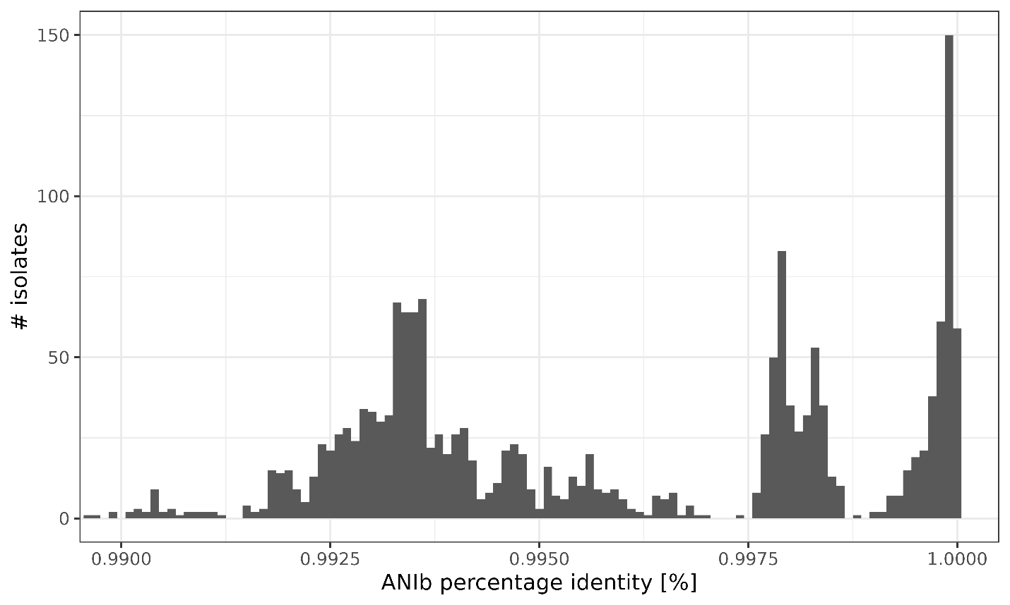
Figure 17. Pairwise average nucleotide identity comparison for all isolate genomes determined as C. saudiense. Average nucleotide identity was calculated with pyANI-plus program utilizing the ANI blast program, but also ANIm and sourmash (Supplement Figure 17, 18).
From each of the five strain groups, one representative genome with high coverage and fewest contigs was selected and re‑sequenced on an Oxford Nanopore MinION to obtain long reads (Supplement Table 5). SNP analysis was repeated using genome H009_221 as the reference, as it had the fewest contigs. The resulting phylogenetic tree based on SNPs in the core genome resolved six strains and a singleton (Figure 18). A phylogeny based on core genes confirmed this grouping and so did the accessory genes (Supplement Figure 19).
Strains1, 2a, 3, and 4 were detected at only one of the three time points, whereas strain 2c was present before and during, but not after antibiotic treatment. Only strain 2b was observed at all three time points.
No new bacteriophages or other mobile genetic elements were acquired during the 60‑day interval between the first and last sample in none of the strains.
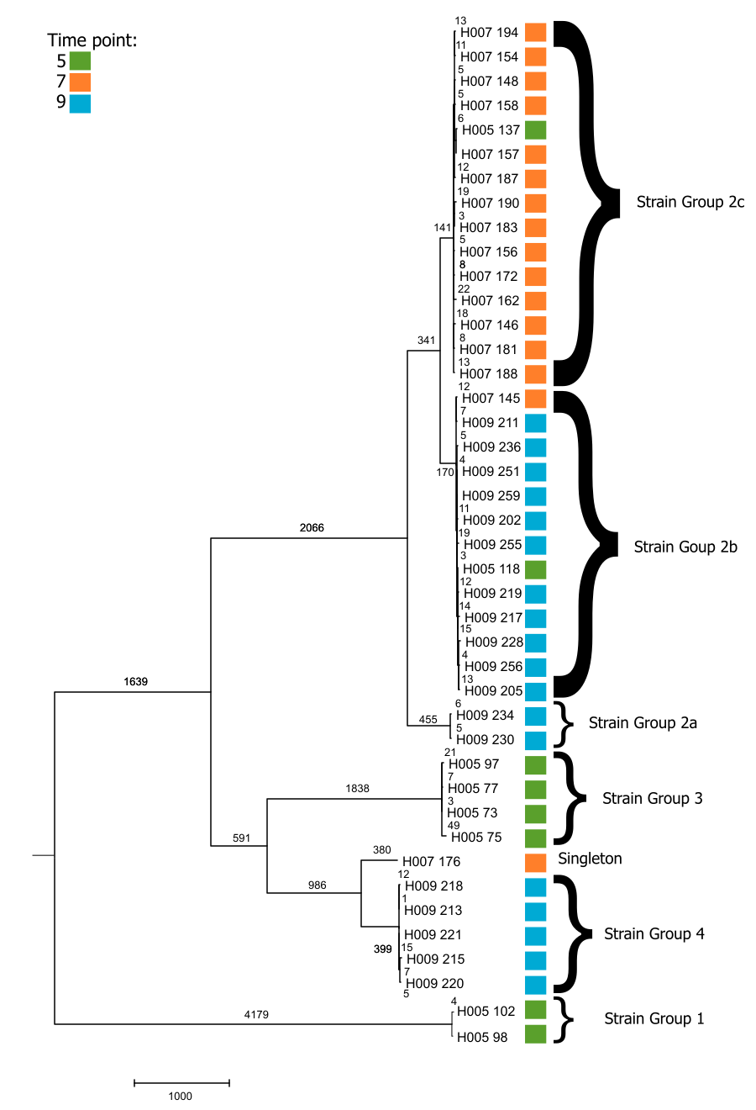
Figure 18. Phylogenetic tree constructed with neighbour-joining algorithm based on core genome SNPs. Coloured squares represent time point from which the isolate was obtained.

Shotgun metagenomic analysis of C. saudiense
To link the isolate-based findings with metagenomic data, we used StrainPhlAn to characterise the within-species diversity of the C. saudiense population in all shotgun metagenomic samples from individual H (Figure 19). The resulting dendrogram of samples revealed two main C. saudiense clusters, which did not segregate according to antibiotic exposure or time, but rather randomly.
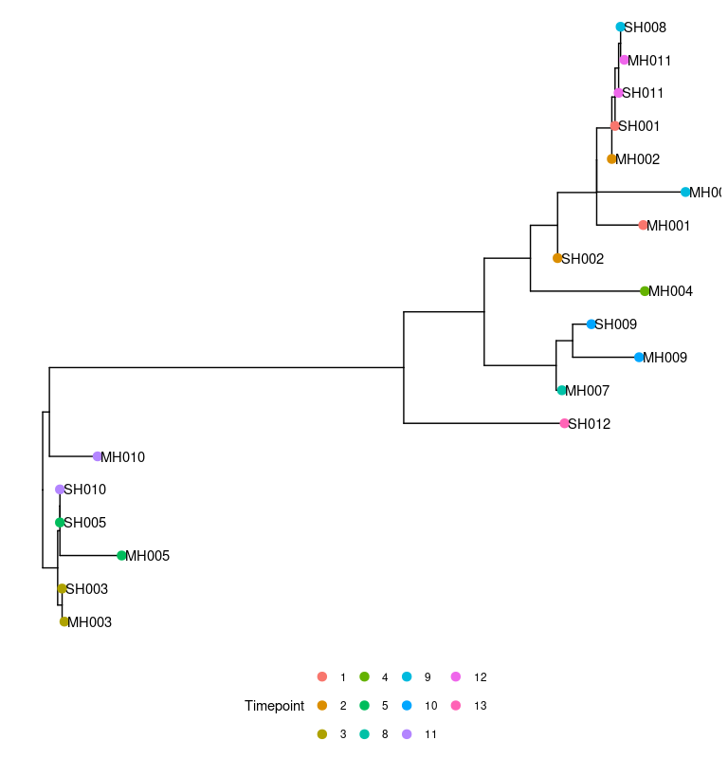
Figure 19. Dendrogram of stool samples of participant H based on C. saudiense marker-gene alignment inferred with StrainPhlAn. Colours represent sampling time point. Sample IDs encode experimental conditions: the first letter indicates the DNA isolation protocol (S for ethanol treated samples and M for untreated stool samples), the second letter denotes the participant (H), and the number indicates the sampling time point.
StrainPhlAn profiles only the dominant strain of a species in given shotgun metagenomic samples and quantifies divergence from the dominant genotype for all samples, but it does not resolve the full strain structure when multiple strains co-occur at similar abundances. To obtain a more detailed view of C. saudiense strain structure, strain-specific genes were identified from our isolate genomes (Table 2, Supplement Table 9). Shotgun metagenomic reads from all samples of participants A and H were mapped to these markers. Participant A served as a negative control, because C. saudiense was detected at low abundance in only one of his 12 samples (Supplement Figure 20). As expected, reads from participant A covered genes at much lower numbers than reads of participant H (only 8 genes had higher coverage in A than in H of the 85 genes detected in both participants).
Table 2. Number of strain-specific genes for each isolate. A detailed table with gene names is available as Supplement Table 9.
Strain | 1 | 2a | 2b | 2c | 3 | 4 | 5
# genomes | 2 | 2 | 13 | 15 | 4 | 5 | 1
# unique genes | 464 | 59 | 244 | 286 | 328 | 174 | 258
# hypothetical proteins | 363 | 54 | 188 | 257 | 231 | 127 | 186
# other genes | 101 | 5 | 56 | 29 | 97 | 47 | 72
# genes detected in participant H | 380 | 46 | 48 | 199 | 222 | 110 | 195
# genes detected in participant A | 24 | 2 | 8 | 16 | 16 | 15 | 5
# genes detected in participant A and H | 24 | 2 | 8 | 16 | 16 | 15 | 4
# genes used in final analysis | 356 | 44 | 40 | 183 | 206 | 95 | 190

Read counts were normalised by gene length and for each strain by the number of genes analysed. This strain-specific mapping showed that, in contrast to the culture-based data, all defined C. saudiense strains persisted throughout the sampling period in participant H (Figure 20). The only exceptions were samples collected between antibiotic use, when C. saudiense abundance dropped below the detection limit. This method enabled tracking of defined strains over time in shotgun metagenomic samples, but only for strains not represented in the isolate genomes.

Figure 20. Persistence of isolated strains over time in participant H, based on shotgun metagenomic read mapping to strain-specific genes. The number of reads mapped to each gene was normalised by gene length. Subsequently, all counts for each strain were summed and divided by the number of genes observed for each strain. Ethanol treated samples were not sequenced as successfully as untreated samples, points on the plot indicate which timepoints are included in the analysis.

LONGITUDINAL CHANGES IN THE RESISTOME DEPENDING ON CHANGES IN THE INTESTINAL MICROBIOTA

Overall diversity and abundance of antimicrobial resistance genes
Across the nine individuals in our cohort during six months’ time, we detected 111 antimicrobial resistance genes (ARGs) spanning 16 classes and 5 resistance mechanisms, as annotated by AMRfinder and the CARD database (Figure 21). We also identified two stress response genes, gacL and qacEdelta1. Notably, clinically important carbapenem genes prevalent in Slovenia (bla_{KPC}, bla_{NDM}, bla_{OXA48} or bla_{VIM}) and Acinetobacter-associated bla_{OXA23} and bla_{OXA24} were absent. The only clinically relevant ARG detected was bla_{CTX-M1}, found at very low abundance in a single individual (I) on a contig classified within the Enterobacteriaceae family (Supplement Figure 21).
The highest richness of ARGs was observed in aminoglycoside resistance genes, followed by glycopeptide, tetracycline, and beta-lactam classes (Figure 21A). The diversity of ARGs per class did not correlate with the abundance of ARGs in the class. The most abundant ARGs confer resistance to tetracyclines, protein synthesis inhibitors (lincosamide, macrolide, and streptogramin), and beta-lactamases that inactivate antibiotics (Figure 21B).
Taxonomically, ARG diversity was highest for phylum Bacillota, followed by Bacteroidota, however, ARG abundance was greater in Bacteroidota, followed by Bacillota (Supplement Figure 22).
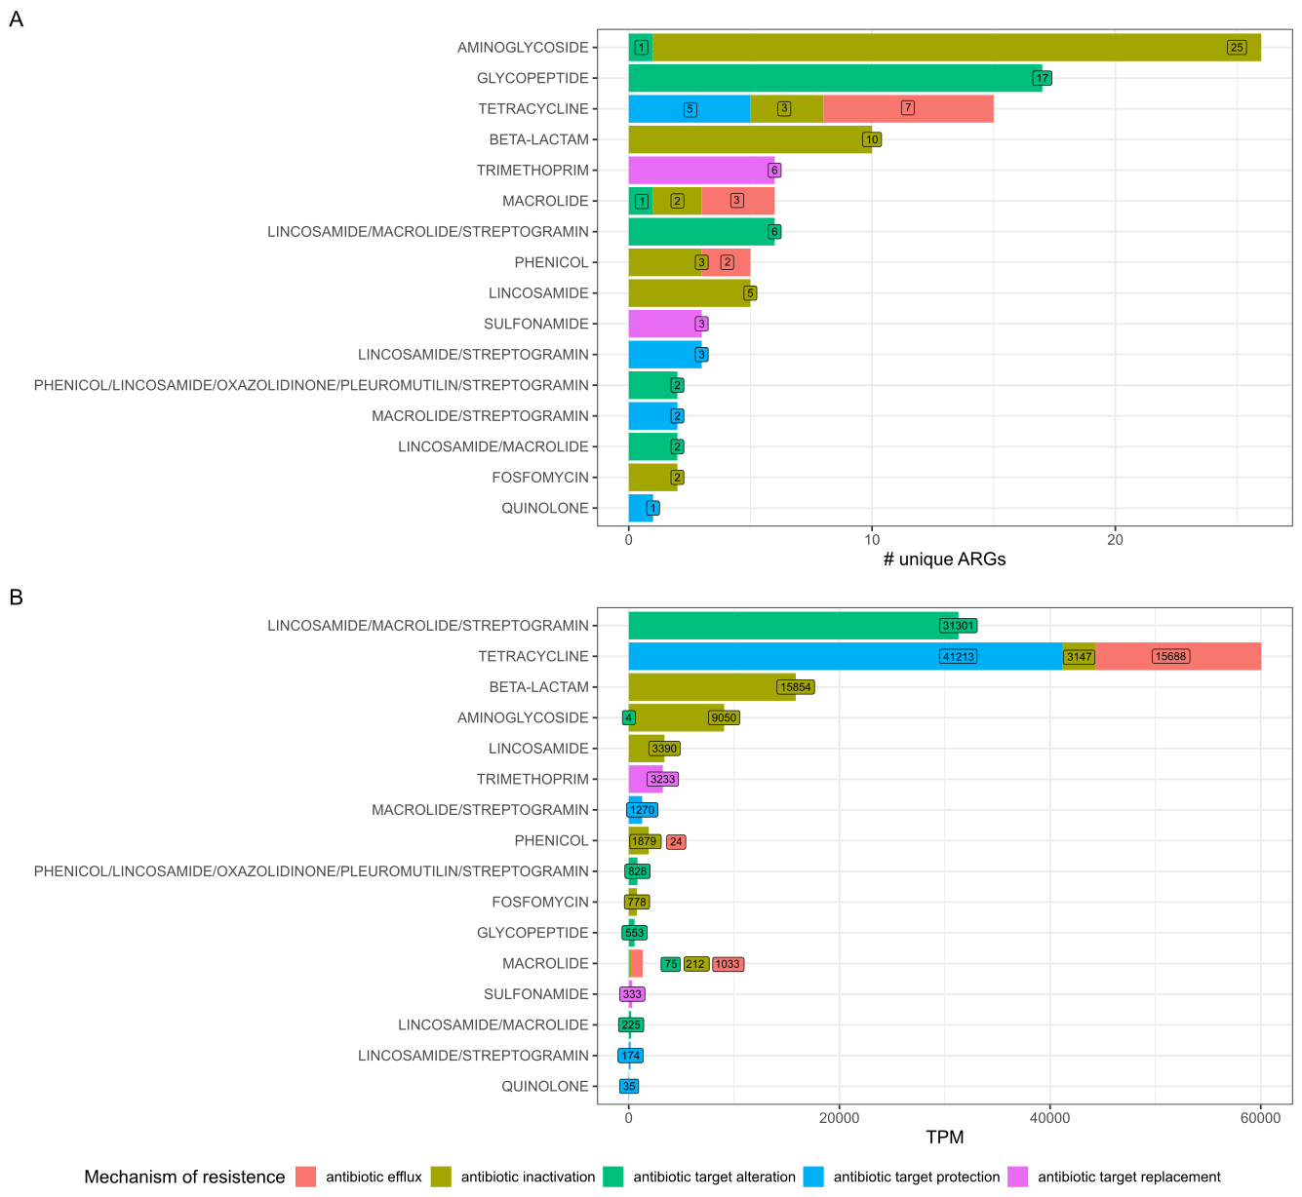
Figure 21. Diversity and abundance of antimicrobial resistance genes (ARGs) across all individuals untreated samples. A) Number of unique ARGs and B) number of mapped reads per million (TPM) to ARGs, coloured by mechanism of resistance based on CARD.

Persistence of antimicrobial resistance genes in the human gut
We detected between 81 and 101 unique ARGs per individual, with 32% to 63% (average 36%) ARGs out of all ARGs per individual being consistently present over six months in each participant (Supplement Figure 23). Individuals who reported pre-defined events did not have higher abundance or diversity of ARGs, nor did they have more persistent ARGs. In the six months study interval, we did not detect any true loss or gain of a new ARG within individuals (Supplement Figure 24).
We observed no significant correlation between reported events and changes in the abundance or diversity of ARGs beyond normal fluctuations within individuals over six months (Figure 22). The only decrease in bacterial diversity that could be correlated with a lifestyle change occurred in individual H during antibiotic consumption (amoxicillin, days 70 to 84, Figure 10). Although other individuals also consumed antibiotics (E, day 10, doxycycline), travelled (A, B, C, D, G, H, I), or experienced periods of stress (D, I, G), none of these events influenced bacterial diversity or the abundance and diversity of ARGs. Overall, bacterial species diversity did not correlate with total ARG diversity or abundance. However, distinct ARG classes exhibited varying relationships with bacterial diversity: aminoglycoside, glycopeptide, and macrolide/streptogramin resistance genes correlated positively with bacterial diversity, whereas lincosamide, sulphonamide, trimethoprim, and some macrolide resistance genes correlated negatively (Supplement Figure 25).
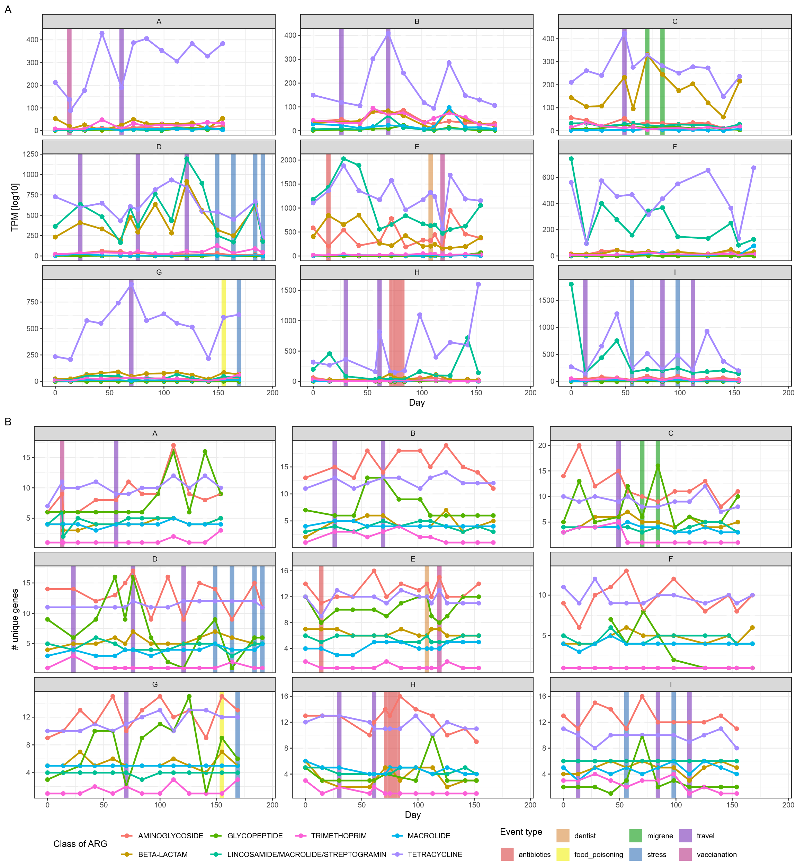
Figure 22. Abundance and diversity of ARG classes over time within each participant. Shown are the classes with more than five unique ARGs, reducing the number of ARGs to 86 and leaving 7 ARG classes. In figure 22A the y-axis represents log10-transformed reads per million (TPM), while in the figure 22B the y-axis represents the number of unique ARGs detected. Each plot depicts one participant (labelled with capital letters A to I), with days on the x-axis indicating when stool samples were collected. Vertical coloured lines indicate out-of-the-ordinary events reported by participants in their questionnaires.

DISCUSSION

COMPARISON OF TEMPORAL STABILITY OF THE GUT MICROBIOTA AND SPOROBIOTA IN HEALTHY INDIVIDUALS
In a longitudinally sampled cohort of nine healthy participants, we analysed gut microbiota and sporobiota communities using amplicon and shotgun metagenomic sequencing. Although the human gut microbiota is well researched, our study is the first to combine longitudinal investigation of gut microbiota with ethanol-treated stool samples and sporobiota in more than one individual, and the first to sequence the sporobiota community of the gut microbiota using shotgun metagenomic sequencing.

Human gut microbiota
Gut microbiota is dominated by bacterial representatives, primarily from the phyla Bacillota and Bacteroidota, while other phyla such as Pseudomonadota, Actinomycetota and Verrucomicrobiota are present at lower relative abundance as determined by amplicon and shotgun metagenomic sequencing, was consistent with previous research on Slovenian and European populations (Falony et al., 2016; Mahnic & Rupnik, 2018). Comparison of genera indicates that the gut microbiota was not sequenced deeply enough with shotgun metagenomic sequencing, however, alpha and beta diversity are comparable between the two analysis types for both the microbiota and ethanol-treated samples, where shotgun metagenomic sequencing was sufficiently deep. Temporal composition was influenced by previously reported life events such as antibiotic consumption and travel, but other predefined events reported by participants had no effect on the gut microbiota (Vandeputte et al., 2021). One possible explanation for this is the time scale of our sampling, as bacterial generation time ranges from hours to a day, while our sampling occurred every 14 days; thus, we were unable to observe large ecological shifts due to only approximately 180 generations. Although we collected a large amount of metadata at each sampling time point, our study is too small (in terms of the number of identical changes across the whole study), and changes were too sporadic within and between individuals to be, with the exception of antibiotic consumption, statistically significantly linked to changes in the alpha or beta diversity of individuals over time.
Methanobrevibacter smithii was detected in more than half of participants at low relative abundances, while Methanosphaera stadtmanae was detected in only two participants. Although Mbb. smithii has been reported at higher prevalence in the general population, its relative abundance here is consistent with previous research (Hoegenauer et al., 2022; Moissl-Eichinger et al., 2018).
Despite the previously reported high prevalence of Saccharomyces cerevisiae, we did not detect this species in all participants, and when detected, it was not persistent over time (REF). Blastocystis sp. showed higher prevalence in the population and persisted for longer periods within individuals (REF). Despite deep sequencing of the microbiota, comparison at the genus level with amplicon data shows that we did not detect all microorganisms present in the sample, so we cannot truly discuss the absence of a species, but rather that they may be below the detection limit (REF).
(Nash et al., 2017) ITS detects more species than shotgun metagenomic sequencing! Also,
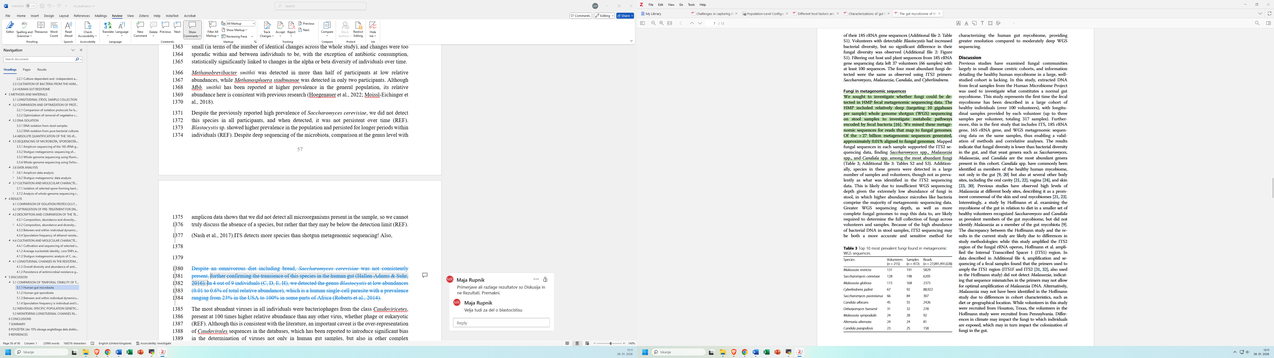

The most abundant viruses in all individuals were bacteriophages from the class Caudoviricetes, present at 100 times higher relative abundance than any other virus, whether phage or eukaryotic (REF). Although this is consistent with the literature, an important caveat is the over-representation of Caudovirales sequences in the databases, which has been reported to introduce significant bias in the determination of viruses not only in human gut samples, but also in other complex environments (REF).

5.1.2 Human gut sporobiota
The ethanol-resistant community was dominated by bacteria from the phylum Bacillota, mainly the genera Clostridium, unclassified Lachnospiraceae, unclassified Ruminococcaceae, unclassified Peptostreptococcaceae, and Blautia. There were also representatives from the phyla Actinomycetota, Pseudomonadota, and unclassified Bacteria. The high abundance of ethanol-resistant representatives within Bacillota was expected due to the widespread ability to sporulate in this phylum (Egan et al., 2021). Most Bacillota representatives identified as ethanol-resistant in this study belong to genera in which sporulation has previously been confirmed through the detection of sporulation-associated gene clusters or in vitro sporulation induction (Browne et al., 2021; Galperin et al., 2022; Koopman et al., 2022). In contrast, ethanol-resistant representatives and the mechanisms underlying their resistance are poorly described in other phyla. Previous studies have reported the detection of Actinomycetota representatives in ethanol- or lysozyme-treated samples (Avershina et al., 2020; Browne et al., 2016b; Kearney et al., 2018). While exospore formation has been described in the families Actinomycetaceae and Streptomycetaceae, the mechanisms underlying ethanol resistance in other Actinomycetota families remain unclear. In our data, Actinomycetaceae accounted for only 0.4% of the relative abundance within the ethanol-resistant community, while Streptomycetaceae were not detected. Members of the phylum Pseudomonadota, also commonly detected in the ethanol-resistant community, have previously been reported to adopt various dormant life strategies, such as persistence and the viable but non-culturable state (Li et al., 2014).
A limitation of 16S rRNA amplicon sequencing was addressed by simultaneous shotgun metagenomic sequencing, which provided information beyond taxonomic classification and allowed us to determine sporulation capability based on the presence of the minimal necessary genes required for sporulation. Here, we observed that true spore-formers are present only in the phylum Bacillota or as some unclassified Bacteria (Browne et al., 2021).
In general, we observed two notable characteristics distinguishing the ethanol-resistant community from the non-resistant community. Both were primarily driven by Bacillota OTUs due to their high abundance, although similar trends were also observed across other phyla. First, OTUs determined as ethanol-resistant showed significantly higher relative abundance within the gut microbiota compared to non-resistant OTUs and were significantly more likely to be detected at more time points within an individual, particularly in more than 80% of samples collected over a six-month period, relative to non-resistant OTUs. These findings support the use of ethanol resistance as a proxy for identifying bacterial taxa that employ dormancy mechanisms contributing to long-term persistence in the human gut. Further confirmation of their higher relative abundance and persistence also comes from species determined spore-forming based on the presence of genes necessary for sporulation in shotgun metagenomic data.

Between and within individual dynamics of spore-forming bacteria
Both in amplicon data where we looked at inter- and intra-individual dynamics of ethanol-resistant Bacillota and in shotgun metagenomic data, looking at gene-based determined spore-forming bacteria, we observed a significantly lower variability within individual than between individuals. Our observation aligns with prior findings showing that lysozyme resistant taxa tend to have higher population-level prevalence and lower within-individual variability than non-resistant communities (Kearney et al., 2018). Moreover, a comparative genomic analysis has shown that bacterial species with more sporulation genes are significantly more prevalent in human populations, at least partially explaining the lower between-individual variability observed in this study (Browne et al., 2021).
Spore persistence within the human gut was previously assessed using in vitro and murine gut models that have shown C. difficile spores bind to biofilms and consequently evade washout (Normington et al., 2021; Soavelomandroso et al., 2017). Their ability to persist is further supported by recurring infections with the same strain (Figueroa et al., 2012). However, similar mechanisms of spore persistence have not been demonstrated for other species beyond in vitro biofilm formations (Donelli et al., 2012). Although we noticed a significant increase in temporal variability within ethanol-resistant Bacillota community based on Jaccard distance, this correlation was not present when using Bray-Curtis dissimilarity and even using species obtained from shotgun metagenomic data. Our findings provide additional experimental evidence that spore formation in phylum Bacillota contributes to increased transmission between individuals, but we saw no proof of long-term (6 months) persistence within the host. The same can be true for ethanol-resistant non-Bacillota representatives, which appear to play a prominent role in facilitating transmission, with a lesser impact on within-host persistence.
Density of clustering for everyone is individual dependant, so based on their changes in the life. But still ethanol-resistant especially ethanol-resistant Bacillota - the sporobiota of the gut community is more similar to itself in time than other ethanol-resistant or ethanol non-resistant communities.
Limitation of our study but also our next step is to assess whether temporal changes in taxa detection reflected strain replacement or the coexistence of multiple strains (Poyet et al., 2019). This distinction is particularly relevant given previous reports of high strain-level retention in the gut over short time scales and limited strain sharing between individuals (Wolff et al., 2023).

5.1.4 Sporulation frequency is individual and time-specific
The ethanol-resistant Bacillota OTUs present in at least 80% of all samples exhibited individual-specific and highly synchronized, temporal fluctuations in sporulation frequency across taxonomically distinct taxa. Furthermore, the within-individual variance in sporulation frequency for an OTU was significantly lower than the population-wide variance. Together, these results suggest that host-specific gut environments have a greater impact on sporulation frequency than OTU identity. Our observations align with previous studies demonstrating that external stimuli, such as dietary or environmental changes, impact the gut microbiota in a host specific manner (Zeevi et al., 2015). Additionally, our results suggest that the sporulation frequency of ethanol-resistant Bacillota varies between individuals and fluctuates over time within an individual but remains synchronized across different taxa within the same host. In vitro studies have shown that sporulation and germination in individual bacterial species can be triggered by environmental stress, metabolic depression, inter-bacterial signaling, or viral threats (Hutchison et al., 2014; Koopman et al., 2022; Ramos-Silva et al., 2019). Identifying specific in vivo signals driving sporulation and germination was beyond the scope of this study. Nevertheless, our findings suggest that the spore-forming community in the human gut responds collectively to shared, yet unidentified, environmental, or physiological signals, rather than to intrinsic signals from individual species.

5.2 INDIVIDUAL-SPECIFIC POPULATION GENETIC ANALYSIS OF CULTURED SPORE-FORMING SPECIES
From three stool samples collected from participant H, we isolated 87 strains of Clostridium saudiense, a spore-forming species only recently cultured (Angelakis et al., 2014). Spore-forming bacteria are characteristically slow-growing, with using a rich medium (WCAB) and short incubation time (48 hours) we selectively enriched for species capable of rapid germination and vegetative proliferation (Kapinusova et al., 2023; Setlow, 2003). Of these, 42 strains were successfully sequenced, substantially expanding the genomic diversity of C. saudiense. The number of sequenced strains is half of the number of isolated strains, as there are some unknown factors why the bacteria were unable to grow past the second re-streaking (Lagier et al., 2018). Prior to this study, public databases (ENA and SRA, accessed 15.1.2026) contained only 38 draft genomes of C. saudiense. These are mostly isolates from adult (n = 33) and infant (n = 2) human stool samples (n = 33), and one each from chicken caecum, cattle stool sample and one metagenome-assembled genome (MAG) from human gut dataset.
Clostridium saudiense is a poorly studied bacterial species, first isolated in Marseille in 2014, from the stool of an obese Saudi individual (Angelakis et al., 2014). Currently 38 non-complete genomes are available on NCBI.
Pairwise average nucleotide identity (ANI) analysis across all newly obtained genomes revealed a strain delineation threshold at 99.98% identity, yielding four strain groups and one singleton. Complementary single nucleotide polymorphism (SNP) profiling and pangenome assessment of accessory genes refined this to six distinct strain groups and one singleton. This represents the highest strain diversity reported for any single bacterial species within an individual human gut, exceeding the typical range of 1–3 strains per species documented across prior cultivation studies (Chen-Liaw et al., 2025; Poyet et al., 2019; Van Rossum et al., 2020).
To contextualize these cultured strains, we compared them against shotgun metagenomic data from all 12 samples from participant H. Cultivation following ethanol shock enabled cultivation of dormant spores, whereas metagenomics samples captured the total population of both vegetative cells and spores, provided sufficient abundance. Strain resolution from metagenomic data is constrained by sequencing depth, requiring high coverage across the whole of genome (x20) for reliable SNP calling (Nayfach et al., 2016; Poyet et al., 2019). We first applied StrainPhlAn, a marker-gene based tool, which reconstructs the dominant strain in all given samples and its divergence across samples (Blanco-Míguez et al., 2023b). This revealed that the temporal shifts were unrelated to antibiotic consumption, but rather to underestimated diversity, as minority strains fall below detection limit, despite C. saudiense comprising around 1% relative abundance per sample.
To overcome limitations of StarinPhlAn, we developed a gene-based strain-specific mapping approach. For each cultured strain we determined unique marker genes and mapped to it reads from metagenomic samples with high specificity. This strain-specific mapping strategy is conceptually similar to StrainPhlAn, in that it also relies on species- and strain-informative marker genes and read alignment to infer strain presence and dynamics. The added value of the new approach is that the marker set is derived directly from the isolated C. saudiense strains in this study, allowing explicit tracking of these genomes across time, and enabling the detection of minority strains that may be missed when only the dominant strain is reconstructed. A limitation is that this method can only follow strains for which isolate genomes (and thus marker genes) are available. Strains present in the community but not successfully isolated, or highly divergent from the cultured genomes, may be underrepresented or completely overlooked.
This method unmasked subdominant strains, demonstrating that antibiotic perturbation in participant H drove C. saudiense below detection in bulk metagenomes but spared spores in the ethanol-resistant fraction—enabling post-treatment recolonization. Alternative tools (e.g., ConStrains, Strainer, MIDAS) failed here due to absent reference genomes or insufficient coverage for this low-to-moderate abundance species (REF).

5.3 MONITORING LONGITUDINAL CHANGES IN THE GUT RESISTOME OF HEALTHY INDIVIDUALS
Human gut resistome is at the individual level shaped by age, sex, co-morbidities, microbiota composition, living conditions and daily life exposure (Ho et al., 2020). In this study we detected between 81 to 101 unique ARGs per individual, with 32% to 63% of ARGs consistently present over six months of our study. Despite using the most up-to-date and comprehensive database AMRfinder and a strict identity threshold (> 90% identity) there could still be both false positive ARGs detected as well as ARGs that are not present in the database and were therefore missed (Feldgarden et al., 2019, 2021). Comparison with other European studies of human gut resistome reveal that the highly abundant tetracycline resistance in our cohort is also highly persistent in other studies (Boolchandani et al., 2022; Li et al., 2023; Sinha et al., 2018; Willmann et al., 2019). As this is the first study of human gut resistome of Slovenian population, we could not compare the whole resistome, but there are information on the clinically important resistance genes present in nosocomial infections, rivers and wastewaters (Maric et al., 2025; Slovenia, n.d.). Notably, clinically important carbapenem and beta-lactam genes prevalent in Slovenia were absent in the gut of our healthy participants, with exception of bla_{CTX-M1} found at very low abundance in a single individual (I).
The highest abundance of ARGs was detected in phylum Bacteroidota, followed closely by Bacillota, with minor contributions of Pseudomonadota and Actinomycetota, contrary to other studies reporting Pseudomonadota specifically Escherichia coli as the largest contributor of ARG abundance in the human gut, followed by Bacteroidota (Li et al., 2023; Sinha et al., 2018). Limitation of this study is detection of ARGs on contigs and not in bins, where depending on the quality of assembly taxonomic classification could have been improved and had higher resolution (Ho et al., 2020).
Both individuals (E, H) that consumed antibiotics during the study had higher abundance, but not diversity of ARGs than individuals that had not consumed antibiotics during or 3 months prior to the study, which is in accordance with previous studies (Malin et al., 2023; Rampelli et al., 2015; Willmann et al., 2019).
Limitations of this analysis include known limitations of using only sequence data to analyse presence and persistence or antimicrobial resistance genes in the human gut; these include high sequence similarity, but unknown phenotype or expression levels and non-complete databases. Despite that we show that human gut resistome of a limited Slovenian cohort is similar to that of other European individuals and mostly comprises of resistance genes present in gut commensals.
ARG hypothesis testing Our hypothesis states that when microbial diversity will be reduced, there will be an increase in the presence of antimicrobial resistance genes. Reduced microbial diversity simplifies the ecosystem, removing barriers to the proliferation and genetic exchange of resistant bacteria, while at the same time creating new ecological niches for resistant bacteria left behind to thrive in.
This hypothesis can be tested in different ways as out dataset is longitudinal but also includes multiple individuals (we have a population, although small).
There is no correlation between either richness or Shannon’s diversity index (based on SGBs or OTUs) to the number of unique ARGs or to the number of reads mapped (TPM) to ARGs, this holds true whether we look at all ARGs together or if we separate them by the class of antibiotics towards which they have an effect. The correlations are driven by individuals higher diversity which drives higher diversity of ARGs, while within an individual a reduced or increased diversity did not influence the diversity of ARGs.
Stability of ARGs over time
Stability can be understood in many ways (see Chapter: A brain dump on stability). Here we have decided to investigate persistence of ARGs within an individual through time coupled with their occupancy (relative abundance). We are aware of the limitation of sequencing as an imperfect method that does not enable to say for sure that something is truly missing or just so rare that we have missed it with our depth of sequencing. But for the reason being we will say that our sequencing was as good as possible, we will not say that something is gone missing but is under the level of detection. A third of ARGs have been detected at all time points (28.6 %). We were unable to detect any loss or gain of a new ARG within an individual, even in individuals that had perturbations (AB or travel).

CONCLUSIONS

SUMMARY

POVZETEK (do 10% obsega angleškega dela doktorske naloge)

REFERENCES
Abellan-Schneyder, I., Matchado, M. S., Reitmeier, S., Sommer, A., Sewald, Z., Baumbach, J., List, M., & Neuhaus, K. (2021). Primer, Pipelines, Parameters: Issues in 16S rRNA Gene Sequencing. mSphere, 6(1), e01202-20. https://doi.org/10.1128/mSphere.01202-20
Abu-Ali, G. S., Mehta, R. S., Lloyd-Price, J., Mallick, H., Branck, T., Ivey, K. L., Drew, D. A., DuLong, C., Rimm, E., Izard, J., Chan, A. T., & Huttenhower, C. (2018). Metatranscriptome of human faecal microbial communities in a cohort of adult men. Nature Microbiology, 3(3), Article 3. https://doi.org/10.1038/s41564-017-0084-4
Afouda, P., Hocquart, M., Pham, T.-P.-T., Kuete, E., Ngom, I. I., Dione, N., Valles, C., Bellali, S., Lagier, J.-C., Dubourg, G., & Raoult, D. (2020). Alcohol pretreatment of stools effect on culturomics. Scientific Reports, 10(1), 5190. https://doi.org/10.1038/s41598-020-62068-x
Aho, A. V., Hopcroft, J. E., & Ullman, J. D. (1973). On finding lowest common ancestors in trees. Proceedings of the Fifth Annual ACM Symposium on Theory of Computing, STOC ’73, 253–265. https://doi.org/10.1145/800125.804056
Aldea, A. C., Diguṭă, F. C., Presacan, O., Voaideṣ, C., Toma, R. C., & Matei, F. (2025). Detecting antibiotic resistance: Classical, molecular, advanced bioengineering, and AI-enhanced approaches. Frontiers in Microbiology, 16. https://doi.org/10.3389/fmicb.2025.1673343
Angelakis, E., Bibi, F., Ramasamy, D., Azhar, E. I., Jiman-Fatani, A. A., Aboushoushah, S. M., Lagier, J.-C., Robert, C., Caputo, A., Yasir, M., Fournier, P.-E., & Raoult, D. (2014). Non-contiguous finished genome sequence and description of Clostridium saudii sp. Nov. Standards in Genomic Sciences, 9(1), 8. https://doi.org/10.1186/1944-3277-9-8
Anthony, W. E., Burnham, C.-A. D., Dantas, G., & Kwon, J. H. (2021). The Gut Microbiome as a Reservoir for Antimicrobial Resistance. The Journal of Infectious Diseases, 223(12 Suppl 2), S209–S213. https://doi.org/10.1093/infdis/jiaa497
Antonov, M., Csárdi, G., Horvát, S., Müller, K., Nepusz, T., Noom, D., Salmon, M., Traag, V., Welles, B. F., & Zanini, F. (2023). Igraph enables fast and robust network analysis across programming languages (arXiv:2311.10260). arXiv. https://doi.org/10.48550/arXiv.2311.10260
Appert, O., Garcia, A. R., Frei, R., Roduit, C., Constancias, F., Neuzil-Bunesova, V., Ferstl, R., Zhang, J., Akdis, C., Lauener, R., Lacroix, C., & Schwab, C. (2020). Initial butyrate producers during infant gut microbiota development are endospore formers. Environmental Microbiology, 22(9), 3909–3921. https://doi.org/10.1111/1462-2920.15167
Asnicar, F., Manara, S., Zolfo, M., Truong, D. T., Scholz, M., Armanini, F., Ferretti, P., Gorfer, V., Pedrotti, A., Tett, A., & Segata, N. (2017). Studying Vertical Microbiome Transmission from Mothers to Infants by Strain-Level Metagenomic Profiling. mSystems, 2(1), e00164-16. https://doi.org/10.1128/mSystems.00164-16
Avershina, E., Larsen, M. G., Aspholm, M., Lindback, T., Storrø, O., Øien, T., Johnsen, R., & Rudi, K. (2020). Culture dependent and independent analyses suggest a low level of sharing of endospore-forming species between mothers and their children. Scientific Reports, 10(1), 1832. https://doi.org/10.1038/s41598-020-58858-y
Babraham Bioinformatics—FastQC A Quality Control tool for High Throughput Sequence Data. (n.d.). Retrieved February 22, 2023, from https://www.bioinformatics.babraham.ac.uk/projects/fastqc/
Blanco-Míguez, A., Beghini, F., Cumbo, F., McIver, L. J., Thompson, K. N., Zolfo, M., Manghi, P., Dubois, L., Huang, K. D., Thomas, A. M., Nickols, W. A., Piccinno, G., Piperni, E., Punčochář, M., Valles-Colomer, M., Tett, A., Giordano, F., Davies, R., Wolf, J., … Segata, N. (2023a). Extending and improving metagenomic taxonomic profiling with uncharacterized species using MetaPhlAn 4. Nature Biotechnology, 41(11), 1633–1644. https://doi.org/10.1038/s41587-023-01688-w
Blanco-Míguez, A., Beghini, F., Cumbo, F., McIver, L. J., Thompson, K. N., Zolfo, M., Manghi, P., Dubois, L., Huang, K. D., Thomas, A. M., Nickols, W. A., Piccinno, G., Piperni, E., Punčochář, M., Valles-Colomer, M., Tett, A., Giordano, F., Davies, R., Wolf, J., … Segata, N. (2023b). Extending and improving metagenomic taxonomic profiling with uncharacterized species using MetaPhlAn 4. Nature Biotechnology, 1–12. https://doi.org/10.1038/s41587-023-01688-w
Bolger, A. M., Lohse, M., & Usadel, B. (2014). Trimmomatic: A flexible trimmer for Illumina sequence data. Bioinformatics, 30(15), 2114–2120. https://doi.org/10.1093/bioinformatics/btu170
Boolchandani, M., Blake, K. S., Tilley, D. H., Cabada, M. M., Schwartz, D. J., Patel, S., Morales, M. L., Meza, R., Soto, G., Isidean, S. D., Porter, C. K., Simons, M. P., & Dantas, G. (2022). Impact of international travel and diarrhea on gut microbiome and resistome dynamics. Nature Communications, 13(1), Article 1. https://doi.org/10.1038/s41467-022-34862-w
Brown, K. L. (2000). Control of bacterial spores. British Medical Bulletin, 56(1), 158–171. https://doi.org/10.1258/0007142001902860
Browne, H. P., Almeida, A., Kumar, N., Vervier, K., Adoum, A. T., Viciani, E., Dawson, N. J. R., Forster, S. C., Cormie, C., Goulding, D., & Lawley, T. D. (2021). Host adaptation in gut Firmicutes is associated with sporulation loss and altered transmission cycle. Genome Biology, 22(1), 204. https://doi.org/10.1186/s13059-021-02428-6
Browne, H. P., Forster, S. C., Anonye, B. O., Kumar, N., Neville, B. A., Stares, M. D., Goulding, D., & Lawley, T. D. (2016a). Culturing of ‘unculturable’ human microbiota reveals novel taxa and extensive sporulation. Nature, 533(7604), 543–546. https://doi.org/10.1038/nature17645
Browne, H. P., Forster, S. C., Anonye, B. O., Kumar, N., Neville, B. A., Stares, M. D., Goulding, D., & Lawley, T. D. (2016b). Culturing of ‘unculturable’ human microbiota reveals novel taxa and extensive sporulation. Nature, 533(7604), 543–546. https://doi.org/10.1038/nature17645
Browne, H. P., Neville, B. A., Forster, S. C., & Lawley, T. D. (2017). Transmission of the gut microbiota: Spreading of health. Nature Reviews Microbiology, 15(9), 531–543. https://doi.org/10.1038/nrmicro.2017.50
Buchfink, B., Reuter, K., & Drost, H.-G. (2021). Sensitive protein alignments at tree-of-life scale using DIAMOND. Nature Methods, 18(4), 366–368. https://doi.org/10.1038/s41592-021-01101-x
Camacho, C., Coulouris, G., Avagyan, V., Ma, N., Papadopoulos, J., Bealer, K., & Madden, T. L. (2009). BLAST+: Architecture and applications. BMC Bioinformatics, 10, 421. https://doi.org/10.1186/1471-2105-10-421
Camargo, A. P., Roux, S., Schulz, F., Babinski, M., Xu, Y., Hu, B., Chain, P. S. G., Nayfach, S., & Kyrpides, N. C. (2024). Identification of mobile genetic elements with geNomad. Nature Biotechnology, 42(8), 1303–1312. https://doi.org/10.1038/s41587-023-01953-y
Caporaso, J. G., Lauber, C. L., Costello, E. K., Berg-Lyons, D., Gonzalez, A., Stombaugh, J., Knights, D., Gajer, P., Ravel, J., Fierer, N., Gordon, J. I., & Knight, R. (2011). Moving pictures of the human microbiome. Genome Biology, 12(5), R50. https://doi.org/10.1186/gb-2011-12-5-r50
Chen, L., Wang, D., Garmaeva, S., Kurilshikov, A., Vich Vila, A., Gacesa, R., Sinha, T., Segal, E., Weersma, R. K., Wijmenga, C., Zhernakova, A., & Fu, J. (2021). The long-term genetic stability and individual specificity of the human gut microbiome. Cell, 184(9), 2302-2315.e12. https://doi.org/10.1016/j.cell.2021.03.024
Chen, Yuxin, Chen, Yongsheng, Shi, C., Huang, Z., Zhang, Y., Li, S., Li, Y., Ye, J., Yu, C., Li, Z., Zhang, X., Wang, J., Yang, H., Fang, L., & Chen, Q. (2018). SOAPnuke: A MapReduce acceleration-supported software for integrated quality control and preprocessing of high-throughput sequencing data. GigaScience, 7(1), gix120. https://doi.org/10.1093/gigascience/gix120
Chen-Liaw, A., Aggarwala, V., Mogno, I., Haifer, C., Li, Z., Eggers, J., Helmus, D., Hart, A., Wehkamp, J., Lamousé-Smith, E. S. N., Kerby, R. L., Rey, F. E., Colombel, J. F., Kamm, M. A., Olle, B., Norman, J. M., Menon, R., Watson, A. R., Crossette, E., … Faith, J. J. (2025). Gut microbiota strain richness is species specific and affects engraftment. Nature, 637(8045), 422–429. https://doi.org/10.1038/s41586-024-08242-x
Claesson, M. J., Cusack, S., O’Sullivan, O., Greene-Diniz, R., de Weerd, H., Flannery, E., Marchesi, J. R., Falush, D., Dinan, T., Fitzgerald, G., Stanton, C., van Sinderen, D., O’Connor, M., Harnedy, N., O’Connor, K., Henry, C., O’Mahony, D., Fitzgerald, A. P., Shanahan, F., … O’Toole, P. W. (2011). Composition, variability, and temporal stability of the intestinal microbiota of the elderly. Proceedings of the National Academy of Sciences, 108(supplement_1), 4586–4591. (world). https://doi.org/10.1073/pnas.1000097107
Clooney, A. G., Eckenberger, J., Laserna-Mendieta, E., Sexton, K. A., Bernstein, M. T., Vagianos, K., Sargent, M., Ryan, F. J., Moran, C., Sheehan, D., Sleator, R. D., Targownik, L. E., Bernstein, C. N., Shanahan, F., & Claesson, M. J. (2021). Ranking microbiome variance in inflammatory bowel disease: A large longitudinal intercontinental study. Gut, 70(3), 499–510. https://doi.org/10.1136/gutjnl-2020-321106
Clooney, A. G., Fouhy, F., Sleator, R. D., O’ Driscoll, A., Stanton, C., Cotter, P. D., & Claesson, M. J. (2016). Comparing Apples and Oranges?: Next Generation Sequencing and Its Impact on Microbiome Analysis. PloS One, 11(2), e0148028. https://doi.org/10.1371/journal.pone.0148028
Cole, J. R., Wang, Q., Fish, J. A., Chai, B., McGarrell, D. M., Sun, Y., Brown, C. T., Porras-Alfaro, A., Kuske, C. R., & Tiedje, J. M. (2014). Ribosomal Database Project: Data and tools for high throughput rRNA analysis. Nucleic Acids Research, 42(Database issue), D633–D642. https://doi.org/10.1093/nar/gkt1244
Costello, E. K., Lauber, C. L., Hamady, M., Fierer, N., Gordon, J. I., & Knight, R. (2009). Bacterial Community Variation in Human Body Habitats Across Space and Time. Science, 326(5960), 1694–1697. https://doi.org/10.1126/science.1177486
Croucher, N. J., Page, A. J., Connor, T. R., Delaney, A. J., Keane, J. A., Bentley, S. D., Parkhill, J., & Harris, S. R. (2015). Rapid phylogenetic analysis of large samples of recombinant bacterial whole genome sequences using Gubbins. Nucleic Acids Research, 43(3), e15. https://doi.org/10.1093/nar/gku1196
Dapa, T., Wong, D. P., Vasquez, K. S., Xavier, K. B., Huang, K. C., & Good, B. H. (2023). Within-host evolution of the gut microbiome. Current Opinion in Microbiology, 71, 102258. https://doi.org/10.1016/j.mib.2022.102258
David, L. A., Materna, A. C., Friedman, J., Campos-Baptista, M. I., Blackburn, M. C., Perrotta, A., Erdman, S. E., & Alm, E. J. (2014). Host lifestyle affects human microbiota on daily timescales. Genome Biology, 15(7), R89. https://doi.org/10.1186/gb-2014-15-7-r89
De Coster, W., D’Hert, S., Schultz, D. T., Cruts, M., & Van Broeckhoven, C. (2018). NanoPack: Visualizing and processing long-read sequencing data. Bioinformatics, 34(15), 2666–2669. https://doi.org/10.1093/bioinformatics/bty149
De Coster, W., & Rademakers, R. (2023). NanoPack2: Population-scale evaluation of long-read sequencing data. Bioinformatics, 39(5), btad311. https://doi.org/10.1093/bioinformatics/btad311
Deatherage, D. E., & Barrick, J. E. (2014). Identification of mutations in laboratory evolved microbes from next-generation sequencing data using breseq. Methods in Molecular Biology (Clifton, N.J.), 1151, 165–188. https://doi.org/10.1007/978-1-4939-0554-6_12
Dobovišek, U. (2021). Optimizacija metod za osamitev sporogenih bakterij iz fecesa človeka [Thesis, Univerza v Ljubljani, Biotehniška fakulteta]. https://repozitorij.uni-lj.si/IzpisGradiva.php?id=131236
Donelli, G., Vuotto, C., Cardines, R., & Mastrantonio, P. (2012). Biofilm-growing intestinal anaerobic bacteria. FEMS Immunology and Medical Microbiology, 65(2), 318–325. https://doi.org/10.1111/j.1574-695X.2012.00962.x
Dubois, G., Girard, C., Lapointe, F.-J., & Shapiro, B. J. (2017). The Inuit gut microbiome is dynamic over time and shaped by traditional foods. Microbiome, 5(1), 151. https://doi.org/10.1186/s40168-017-0370-7
Duytschaever, G., Huys, G., Bekaert, M., Boulanger, L., De Boeck, K., & Vandamme, P. (2011). Cross-sectional and longitudinal comparisons of the predominant fecal microbiota compositions of a group of pediatric patients with cystic fibrosis and their healthy siblings. Applied and Environmental Microbiology, 77(22), 8015–8024. https://doi.org/10.1128/AEM.05933-11
Edgar, R. C. (2016). UCHIME2: Improved chimera prediction for amplicon sequencing (p. 074252). bioRxiv. https://doi.org/10.1101/074252
Edgar, R. C., Haas, B. J., Clemente, J. C., Quince, C., & Knight, R. (2011). UCHIME improves sensitivity and speed of chimera detection. Bioinformatics, 27(16), 2194–2200. https://doi.org/10.1093/bioinformatics/btr381
Egan, M., Dempsey, E., Ryan, C. A., Ross, R. P., & Stanton, C. (2021). The Sporobiota of the Human Gut. Gut Microbes, 13(1), 1863134. https://doi.org/10.1080/19490976.2020.1863134
Faith, J. J., Guruge, J. L., Charbonneau, M., Subramanian, S., Seedorf, H., Goodman, A. L., Clemente, J. C., Knight, R., Heath, A. C., Leibel, R. L., Rosenbaum, M., & Gordon, J. I. (2013). The long-term stability of the human gut microbiota. Science (New York, N.Y.), 341(6141), 1237439. https://doi.org/10.1126/science.1237439
Fakhry, S., Sorrentini, I., Ricca, E., De Felice, M., & Baccigalupi, L. (2008). Characterization of spore forming Bacilli isolated from the human gastrointestinal tract. Journal of Applied Microbiology, 105(6), 2178–2186. https://doi.org/10.1111/j.1365-2672.2008.03934.x
Feldgarden, M., Brover, V., Gonzalez-Escalona, N., Frye, J. G., Haendiges, J., Haft, D. H., Hoffmann, M., Pettengill, J. B., Prasad, A. B., Tillman, G. E., Tyson, G. H., & Klimke, W. (2021). AMRFinderPlus and the Reference Gene Catalog facilitate examination of the genomic links among antimicrobial resistance, stress response, and virulence. Scientific Reports, 11(1), 12728. https://doi.org/10.1038/s41598-021-91456-0
Feldgarden, M., Brover, V., Haft, D. H., Prasad, A. B., Slotta, D. J., Tolstoy, I., Tyson, G. H., Zhao, S., Hsu, C.-H., McDermott, P. F., Tadesse, D. A., Morales, C., Simmons, M., Tillman, G., Wasilenko, J., Folster, J. P., & Klimke, W. (2019). Validating the AMRFinder Tool and Resistance Gene Database by Using Antimicrobial Resistance Genotype-Phenotype Correlations in a Collection of Isolates. Antimicrobial Agents and Chemotherapy, 63(11), e00483-19. https://doi.org/10.1128/AAC.00483-19
Figueroa, I., Johnson, S., Sambol, S. P., Goldstein, E. J. C., Citron, D. M., & Gerding, D. N. (2012). Relapse versus reinfection: Recurrent Clostridium difficile infection following treatment with fidaxomicin or vancomycin. Clinical Infectious Diseases: An Official Publication of the Infectious Diseases Society of America, 55 Suppl 2(Suppl 2), S104-109. https://doi.org/10.1093/cid/cis357
Flores, G. E., Caporaso, J. G., Henley, J. B., Rideout, J. R., Domogala, D., Chase, J., Leff, J. W., Vázquez-Baeza, Y., Gonzalez, A., Knight, R., Dunn, R. R., & Fierer, N. (2014). Temporal variability is a personalized feature of the human microbiome. Genome Biology, 15(12), 531. https://doi.org/10.1186/s13059-014-0531-y
Fu, B. C., Randolph, T. W., Lim, U., Monroe, K. R., Cheng, I., Wilkens, L. R., Le Marchand, L., Lampe, J. W., & Hullar, M. A. J. (2019). Temporal Variability and Stability of the Fecal Microbiome: The Multiethnic Cohort Study. Cancer Epidemiology, Biomarkers & Prevention: A Publication of the American Association for Cancer Research, Cosponsored by the American Society of Preventive Oncology, 28(1), 154–162. https://doi.org/10.1158/1055-9965.EPI-18-0348
Gall-David, S. L., Boudry, G., & Buffet-Bataillon, S. (2023). Comparison of Four DNA Extraction Kits Efficiency for 16SrDNA Microbiota Profiling of Diverse Human Samples. Future Science OA, 9(1), FSO837. https://doi.org/10.2144/fsoa-2022-0072
Galperin, M. Y. (2013). Genome Diversity of Spore-Forming Firmicutes. Microbiology Spectrum, 1(2), TBS-0015-2012. https://doi.org/10.1128/microbiolspectrum.TBS-0015-2012
Galperin, M. Y., Yutin, N., Wolf, Y. I., Vera Alvarez, R., & Koonin, E. V. (2022). Conservation and Evolution of the Sporulation Gene Set in Diverse Members of the Firmicutes. Journal of Bacteriology, 204(6), e00079-22. https://doi.org/10.1128/jb.00079-22
Garud, N. R., Good, B. H., Hallatschek, O., & Pollard, K. S. (2019). Evolutionary dynamics of bacteria in the gut microbiome within and across hosts. PLOS Biology, 17(1), e3000102. https://doi.org/10.1371/journal.pbio.3000102
Garud, N. R., & Pollard, K. S. (2020). Population Genetics in the Human Microbiome. Trends in Genetics, 36(1), 53–67. https://doi.org/10.1016/j.tig.2019.10.010
Ggplot2 Based Publication Ready Plots. (n.d.). Retrieved November 7, 2025, from https://rpkgs.datanovia.com/ggpubr/
Grimm, V., & Wissel, C. (1996). Babel, or The Ecological Stability Discussions: An Inventory and Analysis of Terminology and A Guide for Avoiding Confusion. Oecologia, 109, 323–334. https://doi.org/10.1007/s004420050090
Gurevich, A., Saveliev, V., Vyahhi, N., & Tesler, G. (2013). QUAST: Quality assessment tool for genome assemblies. Bioinformatics, 29(8), 1072–1075. https://doi.org/10.1093/bioinformatics/btt086
Hadfield, J., Croucher, N. J., Goater, R. J., Abudahab, K., Aanensen, D. M., & Harris, S. R. (2018). Phandango: An interactive viewer for bacterial population genomics. Bioinformatics, 34(2), 292–293. https://doi.org/10.1093/bioinformatics/btx610
Hao, Z., Li, L., Fu, Y., & Liu, H. (2018). The influence of bioregenerative life-support system dietary structure and lifestyle on the gut microbiota: A 105-day ground-based space simulation in Lunar Palace 1. Environmental Microbiology, 20(10), 3643–3656. https://doi.org/10.1111/1462-2920.14358
Heidrich, V., Valles-Colomer, M., & Segata, N. (2025). Human microbiome acquisition and transmission. Nature Reviews Microbiology, 23(9), 568–584. https://doi.org/10.1038/s41579-025-01166-x
Hisada, T., Endoh, K., & Kuriki, K. (2015). Inter- and intra-individual variations in seasonal and daily stabilities of the human gut microbiota in Japanese. Archives of Microbiology, 197(7), 919–934. https://doi.org/10.1007/s00203-015-1125-0
Ho, J., Yeoh, Y. K., Barua, N., Chen, Z., Lui, G., Wong, S. H., Yang, X., Chan, M. C., Chan, P. K., Hawkey, P. M., & Ip, M. (2020). Systematic review of human gut resistome studies revealed variable definitions and approaches. Gut Microbes, 12(1), 1700755. https://doi.org/10.1080/19490976.2019.1700755
Hodgkinson, K., El Abbar, F., Dobranowski, P., Manoogian, J., Butcher, J., Figeys, D., Mack, D., & Stintzi, A. (2023). Butyrate’s role in human health and the current progress towards its clinical application to treat gastrointestinal disease. Clinical Nutrition, 42(2), 61–75. https://doi.org/10.1016/j.clnu.2022.10.024
Hua, X., Cao, Y., Morgan, D. M., Miller, K., Chin, S. M., Bellavance, D., & Khalili, H. 2022. (n.d.). Longitudinal analysis of the impact of oral contraceptive use on the gut microbiome. Journal of Medical Microbiology, 71(4), 001512. https://doi.org/10.1099/jmm.0.001512
Huang, Y., Sheth, R. U., Zhao, S., Cohen, L. A., Dabaghi, K., Moody, T., Sun, Y., Ricaurte, D., Richardson, M., Velez-Cortes, F., Blazejewski, T., Kaufman, A., Ronda, C., & Wang, H. H. (2023). High-throughput microbial culturomics using automation and machine learning. Nature Biotechnology, 41(10), 1424–1433. https://doi.org/10.1038/s41587-023-01674-2
Hutchison, E. A., Miller, D. A., & Angert, E. R. (2014). Sporulation in Bacteria: Beyond the Standard Model. Microbiology Spectrum. (Washington, DC). https://doi.org/10.1128/microbiolspec.TBS-0013-2012
Igraph – Network analysis software. (n.d.). Igraph – the Network Analysis Package. Retrieved November 26, 2025, from https://igraph.org/
Jalanka-Tuovinen, J., Salonen, A., Nikkilä, J., Immonen, O., Kekkonen, R., Lahti, L., Palva, A., & de Vos, W. M. (2011). Intestinal microbiota in healthy adults: Temporal analysis reveals individual and common core and relation to intestinal symptoms. PloS One, 6(7), e23035. https://doi.org/10.1371/journal.pone.0023035
Jayasinghe, T. N., Hilton, C., Tsai, P., Apple, B., Shepherd, P., Cutfield, W. S., & O’Sullivan, J. M. (2017). Long-term stability in the gut microbiome over 46 years in the life of Billy Apple®. Human Microbiome Journal, 5–6, 7–10. https://doi.org/10.1016/j.humic.2017.09.001
Jokela, R., Ponsero, A. J., Dikareva, E., Wei, X., Kolho, K.-L., Korpela, K., De Vos, W. M., & Salonen, A. (2023). Sources of gut microbiota variation in a large longitudinal Finnish infant cohort. eBioMedicine, 94, 104695. https://doi.org/10.1016/j.ebiom.2023.104695
Jovel, J., Patterson, J., Wang, W., Hotte, N., O’Keefe, S., Mitchel, T., Perry, T., Kao, D., Mason, A. L., Madsen, K. L., & Wong, G. K.-S. (2016). Characterization of the Gut Microbiome Using 16S or Shotgun Metagenomics. Frontiers in Microbiology, 7, 459. https://doi.org/10.3389/fmicb.2016.00459
Kapinusova, G., Lopez Marin, M. A., & Uhlik, O. (2023). Reaching unreachables: Obstacles and successes of microbial cultivation and their reasons. Frontiers in Microbiology, 14, 1089630. https://doi.org/10.3389/fmicb.2023.1089630
Kearney, S. M., Gibbons, S. M., Poyet, M., Gurry, T., Bullock, K., Allegretti, J. R., Clish, C. B., & Alm, E. J. (2018). Endospores and other lysis-resistant bacteria comprise a widely shared core community within the human microbiota. The ISME Journal, 12(10), 2403–2416. https://doi.org/10.1038/s41396-018-0192-z
Klindworth, A., Pruesse, E., Schweer, T., Peplies, J., Quast, C., Horn, M., & Glöckner, F. O. (2013). Evaluation of general 16S ribosomal RNA gene PCR primers for classical and next-generation sequencing-based diversity studies. Nucleic Acids Research, 41(1), e1. https://doi.org/10.1093/nar/gks808
Kolmogorov, M., Yuan, J., Lin, Y., & Pevzner, P. A. (2019). Assembly of long, error-prone reads using repeat graphs. Nature Biotechnology, 37(5), 540–546. https://doi.org/10.1038/s41587-019-0072-8
Koopman, N., Remijas, L., Seppen, J., Setlow, P., & Brul, S. (2022). Mechanisms and Applications of Bacterial Sporulation and Germination in the Intestine. International Journal of Molecular Sciences, 23(6), 3405. https://doi.org/10.3390/ijms23063405
Koransky, J. R., Allen, S. D., & Dowell, V. R. (1978). Use of ethanol for selective isolation of sporeforming microorganisms. Applied and Environmental Microbiology, 35(4), 762–765. https://doi.org/10.1128/aem.35.4.762-765.1978
Korpela, K., Costea, P., Coelho, L. P., Kandels-Lewis, S., Willemsen, G., Boomsma, D. I., Segata, N., & Bork, P. (2018). Selective maternal seeding and environment shape the human gut microbiome. Genome Research, 28(4), 561–568. https://doi.org/10.1101/gr.233940.117
Lagier, J.-C., Dubourg, G., Million, M., Cadoret, F., Bilen, M., Fenollar, F., Levasseur, A., Rolain, J.-M., Fournier, P.-E., & Raoult, D. (2018). Culturing the human microbiota and culturomics. Nature Reviews Microbiology, 16(9), 540–550. https://doi.org/10.1038/s41579-018-0041-0
Langmead, B., & Salzberg, S. L. (2012). Fast gapped-read alignment with Bowtie 2. Nature Methods, 9(4), 357–359. https://doi.org/10.1038/nmeth.1923
Lee, K., Raguideau, S., Sirén, K., Asnicar, F., Cumbo, F., Hildebrand, F., Segata, N., Cha, C.-J., & Quince, C. (2023). Population-level impacts of antibiotic usage on the human gut microbiome. Nature Communications, 14(1), 1191. https://doi.org/10.1038/s41467-023-36633-7
Lennon, J. T., & Jones, S. E. (2011). Microbial seed banks: The ecological and evolutionary implications of dormancy. Nature Reviews Microbiology, 9(2), 119–130. https://doi.org/10.1038/nrmicro2504
Levy, R., Magis, A. T., Earls, J. C., Manor, O., Wilmanski, T., Lovejoy, J., Gibbons, S. M., Omenn, G. S., Hood, L., & Price, N. D. (2020). Longitudinal analysis reveals transition barriers between dominant ecological states in the gut microbiome. Proceedings of the National Academy of Sciences of the United States of America, 117(24), 13839–13845. https://doi.org/10.1073/pnas.1922498117
Li, H., Handsaker, B., Wysoker, A., Fennell, T., Ruan, J., Homer, N., Marth, G., Abecasis, G., Durbin, R., & 1000 Genome Project Data Processing Subgroup. (2009). The Sequence Alignment/Map format and SAMtools. Bioinformatics, 25(16), 2078–2079. https://doi.org/10.1093/bioinformatics/btp352
Li, L., Mendis, N., Trigui, H., Oliver, J. D., & Faucher, S. P. (2014). The importance of the viable but non-culturable state in human bacterial pathogens. Frontiers in Microbiology, 5. https://doi.org/10.3389/fmicb.2014.00258
Li, X., Brejnrod, A., Thorsen, J., Zachariasen, T., Trivedi, U., Russel, J., Vestergaard, G. A., Stokholm, J., Rasmussen, M. A., & Sørensen, S. J. (2023). Differential responses of the gut microbiome and resistome to antibiotic exposures in infants and adults. Nature Communications, 14(1), 8526. https://doi.org/10.1038/s41467-023-44289-6
Lloyd-Price, J., Arze, C., Ananthakrishnan, A. N., Schirmer, M., Avila-Pacheco, J., Poon, T. W., Andrews, E., Ajami, N. J., Bonham, K. S., Brislawn, C. J., Casero, D., Courtney, H., Gonzalez, A., Graeber, T. G., Hall, A. B., Lake, K., Landers, C. J., Mallick, H., Plichta, D. R., … Huttenhower, C. (2019). Multi-omics of the gut microbial ecosystem in inflammatory bowel diseases. Nature, 569(7758), Article 7758. https://doi.org/10.1038/s41586-019-1237-9
Lozupone, C. A., Stombaugh, J. I., Gordon, J. I., Jansson, J. K., & Knight, R. (2012). Diversity, stability and resilience of the human gut microbiota. Nature, 489(7415), Article 7415. https://doi.org/10.1038/nature11550
Malin, J. J., von Wintersdorff, C. J. H., Penders, J., Savelkoul, P. H. M., & Wolffs, P. F. G. (2023). Longitudinal fluctuations of common antimicrobial resistance genes in the gut microbiomes of healthy Dutch individuals. International Journal of Antimicrobial Agents, 61(3), 106716. https://doi.org/10.1016/j.ijantimicag.2023.106716
Maric, L., Janezic, S., Coia, C. W., Roer, L., & Rupnik, M. (2025). Limited clonality but widespread plasmid sharing of ESBL-producing E. coli between humans and the environment of northeastern Slovenia. Current Research in Microbial Sciences, 9, 100408. https://doi.org/10.1016/j.crmicr.2025.100408
Mars, R. A. T., Yang, Y., Ward, T., Houtti, M., Priya, S., Lekatz, H. R., Tang, X., Sun, Z., Kalari, K. R., Korem, T., Bhattarai, Y., Zheng, T., Bar, N., Frost, G., Johnson, A. J., van Treuren, W., Han, S., Ordog, T., Grover, M., … Kashyap, P. C. (2020). Longitudinal Multi-omics Reveals Subset-Specific Mechanisms Underlying Irritable Bowel Syndrome. Cell, 182(6), 1460-1473.e17. https://doi.org/10.1016/j.cell.2020.08.007
Martínez, I., Muller, C. E., & Walter, J. (2013). Long-Term Temporal Analysis of the Human Fecal Microbiota Revealed a Stable Core of Dominant Bacterial Species. PLOS ONE, 8(7), e69621. https://doi.org/10.1371/journal.pone.0069621
Martino, C., Dilmore, A. H., Burcham, Z. M., Metcalf, J. L., Jeste, D., & Knight, R. (2022). Microbiota succession throughout life from the cradle to the grave. Nature Reviews Microbiology, 1–14. https://doi.org/10.1038/s41579-022-00768-z
Martinson, J. N. V., Pinkham, N. V., Peters, G. W., Cho, H., Heng, J., Rauch, M., Broadaway, S. C., & Walk, S. T. (2019). Rethinking gut microbiome residency and the Enterobacteriaceae in healthy human adults. The ISME Journal, 13(9), Article 9. https://doi.org/10.1038/s41396-019-0435-7
Mehta, R. S., Abu-Ali, G. S., Drew, D. A., Lloyd-Price, J., Subramanian, A., Lochhead, P., Joshi, A. D., Ivey, K. L., Khalili, H., Brown, G. T., DuLong, C., Song, M., Nguyen, L. H., Mallick, H., Rimm, E. B., Izard, J., Huttenhower, C., & Chan, A. T. (2018). Stability of the human faecal microbiome in a cohort of adult men. Nature Microbiology, 3(3), Article 3. https://doi.org/10.1038/s41564-017-0096-0
Nash, A. K., Auchtung, T. A., Wong, M. C., Smith, D. P., Gesell, J. R., Ross, M. C., Stewart, C. J., Metcalf, G. A., Muzny, D. M., Gibbs, R. A., Ajami, N. J., & Petrosino, J. F. (2017). The gut mycobiome of the Human Microbiome Project healthy cohort. Microbiome, 5(1), 153. https://doi.org/10.1186/s40168-017-0373-4
Nayfach, S., Rodriguez-Mueller, B., Garud, N., & Pollard, K. S. (2016). An integrated metagenomics pipeline for strain profiling reveals novel patterns of bacterial transmission and biogeography. Genome Research, 26(11), 1612–1625. https://doi.org/10.1101/gr.201863.115
Normington, C., Moura, I. B., Bryant, J. A., Ewin, D. J., Clark, E. V., Kettle, M. J., Harris, H. C., Spittal, W., Davis, G., Henn, M. R., Ford, C. B., Wilcox, M. H., & Buckley, A. M. (2021). Biofilms harbour Clostridioides difficile, serving as a reservoir for recurrent infection. Npj Biofilms and Microbiomes, 7(1), 1–10. https://doi.org/10.1038/s41522-021-00184-w
Oksanen, J. (n.d.-a). Multivariate Analysis of Ecological Communities in R: vegan tutorial. 43.
Oksanen, J. (n.d.-b). Vegan: An introduction to ordination. 12.
Oksanen, J., Blanchet, F. G., Friendly, M., Kindt, R., Legendre, P., McGlinn, D., Minchin, P. R., O’Hara, R. B., Simpson, G. L., & Solymos, P. (2022). vegan: Community Ecology Package. R package version 2.5–7. 2020.
Olsson, L. M., Boulund, F., Nilsson, S., Khan, M. T., Gummesson, A., Fagerberg, L., Engstrand, L., Perkins, R., Uhlén, M., Bergström, G., Tremaroli, V., & Bäckhed, F. (2022). Dynamics of the normal gut microbiota: A longitudinal one-year population study in Sweden. Cell Host & Microbe, 30(5), 726-739.e3. https://doi.org/10.1016/j.chom.2022.03.002
Onizuka, S., Tanaka, M., Mishima, R., & Nakayama, J. (2021). Cultivation of Spore-Forming Gut Microbes Using a Combination of Bile Acids and Amino Acids. Microorganisms, 9(8), 1651. https://doi.org/10.3390/microorganisms9081651
Page, A. J., Cummins, C. A., Hunt, M., Wong, V. K., Reuter, S., Holden, M. T. G., Fookes, M., Falush, D., Keane, J. A., & Parkhill, J. (2015). Roary: Rapid large-scale prokaryote pan genome analysis. Bioinformatics (Oxford, England), 31(22), 3691–3693. https://doi.org/10.1093/bioinformatics/btv421
Peng, H., Andreu-Sanchez, S., Ruiz-Moreno, A. J., Fernández-Pato, A., Wu, J., Gacesa, R., Zhernakova, A., Wang, D., & Fu, J. (2025). Longitudinal gut microbiota tracking reveals the dynamics of horizontal gene transfer. Nature Communications, 16(1), 11543. https://doi.org/10.1038/s41467-025-66612-z
Poyet, M., Groussin, M., Gibbons, S. M., Avila-Pacheco, J., Jiang, X., Kearney, S. M., Perrotta, A. R., Berdy, B., Zhao, S., Lieberman, T. D., Swanson, P. K., Smith, M., Roesemann, S., Alexander, J. E., Rich, S. A., Livny, J., Vlamakis, H., Clish, C., Bullock, K., … Alm, E. J. (2019). A library of human gut bacterial isolates paired with longitudinal multiomics data enables mechanistic microbiome research. Nature Medicine, 25(9), 1442–1452. https://doi.org/10.1038/s41591-019-0559-3
Pritchard, L., Glover, R. H., Humphris, S., Elphinstone, J. G., & Toth, I. K. (2015). Genomics and taxonomy in diagnostics for food security: Soft-rotting enterobacterial plant pathogens. Analytical Methods, 8(1), 12–24. https://doi.org/10.1039/C5AY02550H
Prjibelski, A., Antipov, D., Meleshko, D., Lapidus, A., & Korobeynikov, A. (2020). Using SPAdes De Novo Assembler. Current Protocols in Bioinformatics, 70(1), e102. https://doi.org/10.1002/cpbi.102
Project Environments. (n.d.). Retrieved November 7, 2025, from https://rstudio.github.io/renv/
Pruesse, E., Quast, C., Knittel, K., Fuchs, B. M., Ludwig, W., Peplies, J., & Glöckner, F. O. (2007). SILVA: A comprehensive online resource for quality checked and aligned ribosomal RNA sequence data compatible with ARB. Nucleic Acids Research, 35(21), 7188–7196. https://doi.org/10.1093/nar/gkm864
Quinlan AR and Hall IM, 2010. BEDTools: A flexible suite of utilities for comparing genomic features. Bioinformatics. 26, 6, pp. 841–842. - Google Search. (n.d.). Retrieved November 10, 2025, from https://www.google.com/search?q=Quinlan+AR+and+Hall+IM%2C+2010.+BEDTools%3A+a+flexible+suite+of+utilities+for+comparing+genomic+features.+Bioinformatics.+26%2C+6%2C+pp.+841%E2%80%93842.&oq=Quinlan+AR+and+Hall+IM%2C+2010.+BEDTools%3A+a+flexible+suite+of+utilities+for+comparing+genomic+features.+Bioinformatics.+26%2C+6%2C+pp.+841%E2%80%93842.&gs_lcrp=EgZjaHJvbWUyBggAEEUYOTIGCAEQLhhA0gEHNTQyajBqNKgCALACAQ&sourceid=chrome&ie=UTF-8
R: The R Project for Statistical Computing. (n.d.). Retrieved October 21, 2025, from https://www.r-project.org/
Rajilić-Stojanović, M., & de Vos, W. M. (2014). The first 1000 cultured species of the human gastrointestinal microbiota. FEMS Microbiology Reviews, 38(5), 996–1047. https://doi.org/10.1111/1574-6976.12075
Rajilić-Stojanović, M., Heilig, H. G. H. J., Tims, S., Zoetendal, E. G., & de Vos, W. M. (2013). Long-term monitoring of the human intestinal microbiota composition. Environmental Microbiology, 15(4), 1146–1159. https://doi.org/10.1111/1462-2920.12023
Ramos-Silva, P., Serrano, M., & Henriques, A. O. (2019). From Root to Tips: Sporulation Evolution and Specialization in Bacillus subtilis and the Intestinal Pathogen Clostridioides difficile. Molecular Biology and Evolution, 36(12), 2714–2736. https://doi.org/10.1093/molbev/msz175
Rampelli, S., Schnorr, S. L., Consolandi, C., Turroni, S., Severgnini, M., Peano, C., Brigidi, P., Crittenden, A. N., Henry, A. G., & Candela, M. (2015). Metagenome Sequencing of the Hadza Hunter-Gatherer Gut Microbiota. Current Biology, 25(13), 1682–1693. https://doi.org/10.1016/j.cub.2015.04.055
Read Excel Files. (n.d.). Retrieved November 7, 2025, from https://readxl.tidyverse.org/
Sayers, E. W., Beck, J., Bolton, E. E., Brister, J. R., Chan, J., Connor, R., Feldgarden, M., Fine, A. M., Funk, K., Hoffman, J., Kannan, S., Kelly, C., Klimke, W., Kim, S., Lathrop, S., Marchler-Bauer, A., Murphy, T. D., O’Sullivan, C., Schmieder, E., … Pruitt, K. D. (2024). Database resources of the National Center for Biotechnology Information in 2025. Nucleic Acids Research, 53(D1), D20–D29. https://doi.org/10.1093/nar/gkae979
Scale Functions for Visualization. (n.d.). Retrieved November 7, 2025, from https://scales.r-lib.org/
Schlomann, B. H., & Parthasarathy, R. (2019). Timescales of gut microbiome dynamics. Current Opinion in Microbiology, Microbiota, 50, 56–63. https://doi.org/10.1016/j.mib.2019.09.011
Schloss, P. D., Westcott, S. L., Ryabin, T., Hall, J. R., Hartmann, M., Hollister, E. B., Lesniewski, R. A., Oakley, B. B., Parks, D. H., Robinson, C. J., Sahl, J. W., Stres, B., Thallinger, G. G., Van Horn, D. J., & Weber, C. F. (2009). Introducing mothur: Open-source, platform-independent, community-supported software for describing and comparing microbial communities. Applied and Environmental Microbiology, 75(23), 7537–7541. https://doi.org/10.1128/AEM.01541-09
Seemann, T. (2014). Prokka: Rapid prokaryotic genome annotation. Bioinformatics, 30(14), 2068–2069. https://doi.org/10.1093/bioinformatics/btu153
Seemann, T. (2022). Snippy [Perl]. https://github.com/tseemann/snippy (Original work published 2014)
Setlow, P. (2003). Spore germination. Current Opinion in Microbiology, 6(6), 550–556. https://doi.org/10.1016/j.mib.2003.10.001
Setlow, P. (2014). Spore Resistance Properties. Microbiology Spectrum, 2(5), 10.1128/microbiolspec.tbs-0003–2012. https://doi.org/10.1128/microbiolspec.tbs-0003-2012
Setlow, P., Wang, S., & Li, Y.-Q. (2017). Germination of Spores of the Orders Bacillales and Clostridiales. Annual Review of Microbiology, 71, 459–477. https://doi.org/10.1146/annurev-micro-090816-093558
Shade, A., Peter, H., Allison, S. D., Baho, D., Berga, M., Buergmann, H., Huber, D. H., Langenheder, S., Lennon, J. T., Martiny, J. B., Matulich, K. L., Schmidt, T. M., & Handelsman, J. (2012). Fundamentals of Microbial Community Resistance and Resilience. Frontiers in Microbiology, 3. https://doi.org/10.3389/fmicb.2012.00417
Sinha, T., Vich Vila, A., Garmaeva, S., Jankipersadsing, S. A., Imhann, F., Collij, V., Bonder, M. J., Jiang, X., Gurry, T., Alm, E. J., D’Amato, M., Weersma, R. K., Scherjon, S., Wijmenga, C., Fu, J., Kurilshikov, A., & Zhernakova, A. (2018). Analysis of 1135 gut metagenomes identifies sex-specific resistome profiles. Gut Microbes, 10(3), 358–366. https://doi.org/10.1080/19490976.2018.1528822
Slovenia: National One Health strategy for the management of microbial resistance 2019-2024 (Slovenian). (n.d.). Retrieved January 19, 2026, from https://www.who.int/publications/m/item/slovenia-national-one-health-strategy-for-the-management-of-microbial-resistance-2019-2024
Soavelomandroso, A. P., Gaudin, F., Hoys, S., Nicolas, V., Vedantam, G., Janoir, C., & Bouttier, S. (2017). Biofilm Structures in a Mono-Associated Mouse Model of Clostridium difficile Infection. Frontiers in Microbiology, 8, 2086. https://doi.org/10.3389/fmicb.2017.02086
Song, H. S., Kim, Y. B., Kim, J. Y., Roh, S. W., & Whon, T. W. (2024). Advances in Culturomics Research on the Human Gut Microbiome: Optimizing Medium Composition and Culture Techniques for Enhanced Microbial Discovery. 34(4), 757–764. https://doi.org/10.4014/jmb.2311.11024
Swick, M. C., Koehler, T. M., & Driks, A. (2016). Surviving Between Hosts: Sporulation and Transmission. Microbiology Spectrum, 4(4), 10.1128/microbiolspec.VMBF-0029–2015. https://doi.org/10.1128/microbiolspec.VMBF-0029-2015
Tamames, J., & Puente-Sánchez, F. (2019). SqueezeMeta, A Highly Portable, Fully Automatic Metagenomic Analysis Pipeline. Frontiers in Microbiology, 9. https://doi.org/10.3389/fmicb.2018.03349
Tamura, K., Stecher, G., & Kumar, S. (2021). MEGA11: Molecular Evolutionary Genetics Analysis Version 11. Molecular Biology and Evolution, 38(7), 3022–3027. https://doi.org/10.1093/molbev/msab120
Tanaka, M., Onizuka, S., Mishima, R., & Nakayama, J. (2020). Cultural isolation of spore-forming bacteria in human feces using bile acids. Scientific Reports, 10, 15041. https://doi.org/10.1038/s41598-020-71883-1
Tetz, G., & Tetz, V. (2017). Introducing the sporobiota and sporobiome. Gut Pathogens, 9(1), 38. https://doi.org/10.1186/s13099-017-0187-8
Thursby, E., & Juge, N. (2017). Introduction to the human gut microbiota. Biochemical Journal, 474(11), 1823–1836. https://doi.org/10.1042/BCJ20160510
Tidjani Alou, M., Naud, S., Khelaifia, S., Bonnet, M., Lagier, J.-C., & Raoult, D. (2020). State of the Art in the Culture of the Human Microbiota: New Interests and Strategies. Clinical Microbiology Reviews, 34(1), 10.1128/cmr.00129-19. https://doi.org/10.1128/cmr.00129-19
tidyverse. (2025). Tidyverse/glue [R]. https://github.com/tidyverse/glue (Original work published 2016)
Turroni, S., Rampelli, S., Biagi, E., Consolandi, C., Severgnini, M., Peano, C., Quercia, S., Soverini, M., Carbonero, F. G., Bianconi, G., Rettberg, P., Canganella, F., Brigidi, P., & Candela, M. (2017). Temporal dynamics of the gut microbiota in people sharing a confined environment, a 520-day ground-based space simulation, MARS500. Microbiome, 5(1), 39. https://doi.org/10.1186/s40168-017-0256-8
Valles-Colomer, M., Blanco-Míguez, A., Manghi, P., Asnicar, F., Dubois, L., Golzato, D., Armanini, F., Cumbo, F., Huang, K. D., Manara, S., Masetti, G., Pinto, F., Piperni, E., Punčochář, M., Ricci, L., Zolfo, M., Farrant, O., Goncalves, A., Selma-Royo, M., … Segata, N. (2023). The person-to-person transmission landscape of the gut and oral microbiomes. Nature, 614(7946), Article 7946. https://doi.org/10.1038/s41586-022-05620-1
Van Rossum, T., Ferretti, P., Maistrenko, O. M., & Bork, P. (2020). Diversity within species: Interpreting strains in microbiomes. Nature Reviews Microbiology, 18(9), 491–506. https://doi.org/10.1038/s41579-020-0368-1
Wickham, H., Averick, M., Bryan, J., Chang, W., McGowan, L., François, R., Grolemund, G., Hayes, A., Henry, L., Hester, J., Kuhn, M., Pedersen, T., Miller, E., Bache, S., Müller, K., Ooms, J., Robinson, D., Seidel, D., Spinu, V., … Yutani, H. (2019). Welcome to the Tidyverse. Journal of Open Source Software, 4(43), 1686. https://doi.org/10.21105/joss.01686
Willmann, M., Vehreschild, M. J. G. T., Biehl, L. M., Vogel, W., Dörfel, D., Hamprecht, A., Seifert, H., Autenrieth, I. B., & Peter, S. (2019). Distinct impact of antibiotics on the gut microbiome and resistome: A longitudinal multicenter cohort study. BMC Biology, 17(1), 76. https://doi.org/10.1186/s12915-019-0692-y
Wolff, R., Shoemaker, W., & Garud, N. (2023). Ecological Stability Emerges at the Level of Strains in the Human Gut Microbiome. mBio, 14(2), e02502-22. https://doi.org/10.1128/mbio.02502-22
Worby, C. J., Schreiber, H. L., Straub, T. J., van Dijk, L. R., Bronson, R. A., Olson, B. S., Pinkner, J. S., Obernuefemann, C. L. P., Muñoz, V. L., Paharik, A. E., Azimzadeh, P. N., Walker, B. J., Desjardins, C. A., Chou, W.-C., Bergeron, K., Chapman, S. B., Klim, A., Manson, A. L., Hannan, T. J., … Earl, A. M. (2022). Longitudinal multi-omics analyses link gut microbiome dysbiosis with recurrent urinary tract infections in women. Nature Microbiology, 7(5), Article 5. https://doi.org/10.1038/s41564-022-01107-x
Wuethrich, I., W. Pelzer, B., Khodamoradi, Y., & Vehreschild, M. J. G. T. (2021). The role of the human gut microbiota in colonization and infection with multidrug-resistant bacteria. Gut Microbes, 13(1), 1911279. https://doi.org/10.1080/19490976.2021.1911279
Xia, Y., Zhu, Y., Li, Q., & Lu, J. (2019). Human gut resistome can be country-specific. PeerJ, 7, e6389. https://doi.org/10.7717/peerj.6389
Yassour, M., Jason, E., Hogstrom, L. J., Arthur, T. D., Tripathi, S., Siljander, H., Selvenius, J., Oikarinen, S., Hyöty, H., Virtanen, S. M., Ilonen, J., Ferretti, P., Pasolli, E., Tett, A., Asnicar, F., Segata, N., Vlamakis, H., Lander, E. S., Huttenhower, C., … Xavier, R. J. (2018). Strain-Level Analysis of Mother-to-Child Bacterial Transmission during the First Few Months of Life. Cell Host & Microbe, 24(1), 146-154.e4. https://doi.org/10.1016/j.chom.2018.06.007
Zeevi, D., Korem, T., Zmora, N., Israeli, D., Rothschild, D., Weinberger, A., Ben-Yacov, O., Lador, D., Avnit-Sagi, T., Lotan-Pompan, M., Suez, J., Mahdi, J. A., Matot, E., Malka, G., Kosower, N., Rein, M., Zilberman-Schapira, G., Dohnalová, L., Pevsner-Fischer, M., … Segal, E. (2015). Personalized Nutrition by Prediction of Glycemic Responses. Cell, 163(5), 1079–1094. https://doi.org/10.1016/j.cell.2015.11.001
Zhou, X., Shen, X., Johnson, J. S., Spakowicz, D. J., Agnello, M., Zhou, W., Avina, M., Honkala, A., Chleilat, F., Chen, S. J., Cha, K., Leopold, S., Zhu, C., Chen, L., Lyu, L., Hornburg, D., Wu, S., Zhang, X., Jiang, C., … Snyder, Michael P. (2024). Longitudinal profiling of the microbiome at four body sites reveals core stability and individualized dynamics during health and disease. Cell Host & Microbe, 32(4), 506-526.e9. https://doi.org/10.1016/j.chom.2024.02.012

