INTRODUCTION PRESENTING THE RESEARCH PROBLEM, GOALS AND HYPOTHESIS
RESEARCH PROBLEM

Hypothesis
- The gut sporobiota of an individual will be less stable than the gut microbiota.

We do not have any serious perturbations a too small cohort to talk about stability. To talk about persistence nobody has good enough methodology. And so the hypothesis can be disregarded at the start. But nobody mentioned this or even gave this a second look/thought.
- Gut sporobiota and microbiota will change during the extreme event in most volunteers.

- Increased presence of resistance genes will correlate with reduced diversity of the microbiota.

Research goals
- Description and comparison of the temporal stability of the gut microbiota and sporobiota in healthy individuals.
- Individual specific population genetics analysis on the isolated spore-forming species.
- Monitoring longitudinal changes in the resistome depending on changes in the intestinal microbiota.

REVIEW OF PREVIOUS RESEARCH

Human gut microbiota + longitudinal studies
- Most researched microbial community (host associated or otherwise in the world)
- Comprised of bacteria, viruses and eukaryotes. Although eukaryotes are mostly there because of food consumption.
- Constant competition and cooperation. Stability intermezzo

Human gut microbiota is one of the most research host related microbial communities. While most focus has been on bacterial communities with the advancement and especially lowering the price of shotgun metagenomic sequencing viral and fungal communities are coming to the forefront of research. Between the representatives of the human gut microbiota there is constant competition and cooperation for the best usage of limited resources available. Though the human intestinal tract is filled with food to think about abundance would be anthropocentric, with short germination times of bacteria, fungi and viruses can presume the gut to be a very dynamic environment. Food arrives every so often and not in constant intervals, bacteria thus must be able to survive during this starving times. There is also peristaltic to think about, where bacteria are constantly pushed out of the gut, so constant reproduction is necessary for long-time survival within an individual, while dissemination of itself is only possible with different life-strategies such as sporulation, aeroterolation, viable but not culturable state etc.
Viral population in the gut are comprised of eukayotic viruses and bacteriophages (present 1(bacteria):10 (phage)) as in every other environment, where we can find bacteria.
Nekatere študije se osredotočajo tudi na gleve ( vendar je za le te dokazano da se v črevesju pojavljajo sporadično in niso stalno prisotne (Mahnic et al. 2018)
Črevesna mikrobiota skozi čas - kaj vem ?
- Raziskave amplikonskega sekvenciranja kažejo na izjemno ohranjenost taksonomskih skupin (deblo, red skozi čas) od 1 meseca, do več mesecev in let. 1 študija (Billy Apple) tudi na taksonomsko ohranjenost skozi 46 let.
- Raziskave metagenomsko sekvenciranje pa kažejo da ja višji taksonomski nivoji se ohrnajajo skozi daljša časovna obdobja, medtem ko vrste/sevi se odvisno od vrste bakterije kar zamenjujejo oz. Mutirajo za v človeka pomembnem času.
Comparison of isolation protocols for human stool DNA isolation
Biological and technical biases are introduced into microbiome studies of humans and animals. They include, but are not limited to the diet, lifestyle, sampling time (Bibbò et al., n.d.), nucleic acid isolation techniques, choice of primers (Chen et al., 2019), sequencing and analysis (Abellan-Schneyder et al., 2021). To evaluate three different DNA isolation protocols on a variety of animal faecal samples, we compared DNA yield, alpha and beta diversity as well as taxonomy, abundance, and proportion of shared and differentially abundant zero-radius operational taxonomic units (ZOTUs).

Studies of sporobiota / other resistant bacteria in the human gut
How to define sporobiota?

Human gut sporobiota + longitudinal (mention Kearney)
- Mention ethanol/temperature shock

Culture dependent studies

Culture-independent studies
- Persistence of bacteria within a human gut is dependent on their prevalence and ability to withstand changes in the human intestine
Comparison between heat and ethanol shock for isolation of anaerobe spore-forming bacteria from human gut
Bacterial spores are resistant cell structures, that can withstand many different environmental pressures such as heat, desiccation, radiation, oxidation or exposure to chemicals. As such they are often involved in food spoilage, food poisoning and human disease or as bioweapon in case of Bacillus anthracis (Setlow, 2014). Evolutionary analyses of sporulation genes revealed that this developmental process evolved once in the phylum Bacillota (previously Firmicutes) approximately 2.5 billion years ago (de Hoon et al., 2010). Spore formation and physiology has since diverged to great genetic diversity in many different species, this makes them differently resistant to stressors (Thomas, 2012).
Endospore producing bacteria have different mechanisms for defence from high temperature or prolonged emersion in high concentration of ethanol (Beaman et al., 1988; Thomas, 2012; Salvage et al., 2014; Tetz and Tetz, 2017). Spores resistance to ethanol is enabled with detoxification trough external layers of spore coat (Henriques and Moran, 2007), reduced permeability and mobility of inner membrane (Cowan et al., 2004), and the protection of core content through a restriction of the macromolecules mobility in the coat. Outer spore coat layer is composed of more than 70 different proteins (Driks and Eichenberger, 2016) which are impermeable to alcohol that would denaturalize proteins and disable the cell metabolism and by disruption of membranes lead cell lysis. Spores resistant to heat shock (wet heat) have low core water content with high concentration of dipicolinic acid (DPA), Ca²⁺ ions and α/β-type small acid-soluble spore proteins (SASP) which protect DNA from damage (Jamroskovic, 2016). SASPs also enable DNA repair in spore outgrowth (Setlow, 2006). SASPs and DPA present up to 20% of spore core dry weight (Sunde et al., 2009). It has been observed that heat resistance develops late in the sporulation process, after calcium is incorporated and the cortex is formed or after DPA is synthesized (Bonsen, 1969).
As most studied spore-formers are at best a nuisance for humans we have tried to find many different approaches to destroy them with heat, radiation or alcohol. But they have proved to be one of the most resistant structures to live on Earth and space (Leggett at al., 2012, Horneck et al., 1994). Exposure to high temperatures or to ethanol are two main procedures used for selective enrichment of spores. In this study, we aimed to compare spore selection approach from faeces: Which, heat or ethanol shock, with and without enrichment step, with and without addition of bile acids works better for isolating spore-forming bacteria from faeces.
In the past sporogenic bacteria were seen as “transient” species in the gut. However, new data confirms 50-70% of gut microbiota to be composed of spore-forming bacteria (Egan, 2021). Obligate anaerobic gut microbes are dependent on sporulation for transfer between individuals and environments as their vegetative cells would not survive in aerobic environment (Swick, 2016).

Human gut resistome + longitudinal studies on human gut resistome
Antibiotics allowed mankind to reach the population levels we see today, but with the discovery of first antibiotics. Antimicrobial resistance is a natural occurrence, but with our use of antibiotics in both animal production and human health care, humans have created a high threshold natural selection for bacteria and the spread of antimicrobial resistance genes. Antibiotic resistance can be intrinsic for a specific species due to lack of target or can be acquired through horizontal gene transfer or mutations. Antimicrobial resistance genes can be found on both on the genome or on plasmids. There are four main classes of antibiotics based on their mechanism of action: a) inhibitors of cell wall, b) inhibitors of protein synthesis, c) inhibitors of nucleic acids synthesis and d) inhibitors of cell membrane. And corresponding to this there are five major classes of antimicrobial resistance genes based on their mechanism: a) prevention of cellular uptake or efflux, b) target modification, c) target overproduction or enzymatic bypass and target mimicry.
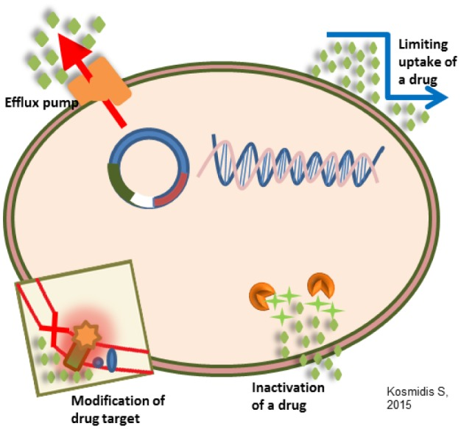
Figure. General antimicrobial resistance mechanisms.

Difference between amplicon and shotgun metagenomic sequencing

Studies on stability / persistence / seed bank? As an additional chapter or just mention it in between the microbiota chapter
Stability is an ambiguous term than should not be a definition, but rather an overarching term than includes RESISTANCE, RESISTANCE, ELASTICITY, CONSTANCY and PERSISTENCE. In other words, these 5 terms, can be summed up in 3 definitions:
- ‘staying essentially unchanged’,
- ‘returning to the reference state (or dynamic) after temporary disturbance’ and
- ‘persistence through time of an ecological system’.
Note the difference between properties 1. and 3. “Staying essentially unchanged” refers to a certain reference state or dynamics, which may be an equilibrium, or oscillations, or irregular but limited fluctuations. “Persistence through time”, on the other hand, does not refer to any particular dynamic but only to the question whether a system persists as an identifiable entity (Grimm & Wissel, 1996).
Stability includes RESISTANCE (insensitivity to disturbance) and RESILIENCE (the rate of recovery after disturbance). Disturbance alters the community or the environment in which community resides, members of a community may die or have altered relative abundance because of disturbance. Disturbances are often classified as pulses (short term event) or presses (long-term or continuous) depending on their duration. These timeframes are dependent on the generation time of the community of interest. In microbial communities’ generation time is not long, so presses or pulses can be on scale of minutes to days or even years. Press disturbance in the human gut could be change of diet, disease, moving to a new place, while pulse disturbance in the human gut are more like one time over-consumption of alcohol, short holiday, etc.
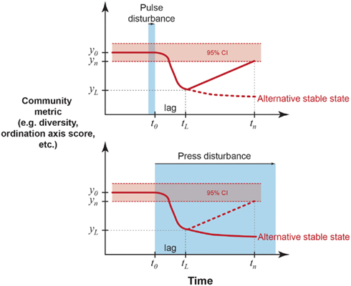 (Lozupone et al., 2012)
The landscape of stable states or “regimes” for the human gut is still unknown. Samples obtained over time from the same individual are more like one another compared to those obtained from other individuals, suggesting that each person has a relatively distinct, stable community. This temporal stability can be related to the concept that stable equilibrium states exist for the microbiota, in which disturbances, stochasticity, and temporal dynamics of individual microbes produce change yet the community is still drawn to a central attractor. But Zaoli et al. showed this is not the case as on the timescale of years human gut microbiota can alter between alternative stable states (Zaoli & Grilli, 2021).

Strain diversity and inference of stability

Diversity
Diversity can be described on the level of individual sample by the evenness of the distribution of OTUs, the number of observed OTUs and with all the derivatives that consider evenness and relative abundance or presence of OTUs in the samples like Shannon and Simpsons diversity indexes. Highest diversity of bacterial OTUs was present in microbiota as we did not remove anything from this community, while sporobiota has much lower diversity. Phylogenetic diversity (Faith’s index) also showed higher diversity in microbiota than ethanol resistant fraction. Bacillota is a paraphyletic phylum, consisting many of monophyletic classes. Most notable are the aerobic Bacilli and anaerobic Clostridia, which are polyphyletic, but both can form endospores.
(https://archive.ph/20121209051705/http://ijs.sgmjournals.org/cgi/pmidlookup?view=long&pmid=15143038
As we showed that Shannon’s diversity in the least skewed because of different sampling depths, we will use this index in the explanation of results. Shannon’s diversity index - is related to the concept of uncertainty. If for example, a community has very low diversity, we can be certain of the identity of an organism we might choose by random (high certainty or low uncertainty). If a community is highly diverse and we choose an organism by random, we have a greater uncertainty of which species we will choose (low certainty or high uncertainty), where p is the proportion of individual species i and S is species richness. Equation 1: $H=-\sum_{i=1}^{S}{p_{i}}*\ln{p_{i}}$. The value H ranges from 0 to H_{max} is different in each community and depends on species richness. If practically all abundance is concentrated to one type, and the other types are very rare (even if there are many of them), Shannon entropy approaches 0. When there is only one type in the dataset, Shannon entropy exactly equals 0 (there is no uncertainty in predicting the type of the next randomly chosen entity).

