- Description and comparison of the temporal stability of the gut microbiota and sporobiota in healthy individuals.

  - Comparison of isolation protocols for bulk bacterial DNA from human stool samples
The experiment included three stool samples and a negative control isolated with four protocols in triplicates. There were two criteria for selection of the best protocol: having the highest yield and being able to isolate all bacterial phyla known to reside inside human gut (REF Cradle to Grave).
All four DNA isolation kits yielded DNA concentrations sufficient for downstream molecular applications, with PowerFecal producing DNA concentrations approximately ten times higher than the other protocols (Figure 1A). Similar observation on good performance of PowerFecal protocol was reported previously for human samples (doi:10.1186/s12866-020-01894-5). DNA concentration of negative controls was around 1 ng/µl, but the OTUs had on average 2 reads (max 5), which implies contamination during the library preparation step. Details on sequencing, quality control and OTU clustering (Supplementary Table 2). Community-based analysis showed differences among different DNA isolation kits in terms of community composition and occurrence of OTUs. Dneasy protocol showed significantly lower alpha diversity and density of clustering compared to other three protocols (Figure 1B, 1C). This is due to Dneasy protocol not being able to isolate Bacteroides in the same amount as the other protocols (Figure 1D). These results highlight the importance of using the same DNA isolation protocol in a single study, especially when analysing gut microbiome data with low sequencing depths (REF). For isolation of DNA from human stool samples, we chose PowerFecal protocol because of ease of isolation protocol and highest DNA yield, but taking into account the isolation of all major phyla in the human gut.
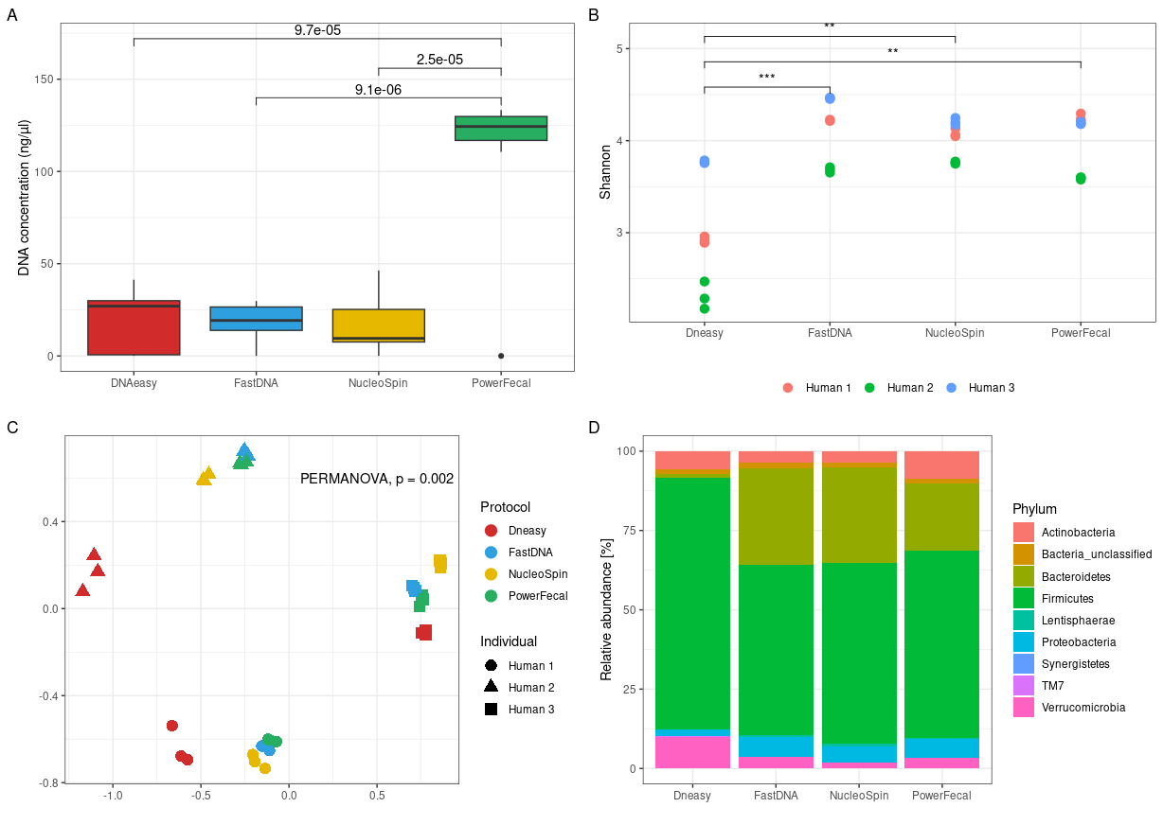
Figure 1. Comparison of DNA concentration, alpha and beta diversity and the relative abundance of phyla obtained with four different DNA isolation protocols. A) DNA concentrations [ng/µl] after isolation, measured with Quant-iT™ PicoGreen™ dsDNA Assay and dsDNA Reagents (Invitrogen™). p-values above connecting boxplots are result from paired t-test. B) Shannon index for alpha diversity, with t-test p-values denoted by asterix (** < 0.01, *** < 0.001) for significantly different values. C) Non-metric multidimensional ordination based on Bray-Curtis distances, with PERMANOVA results for comparison of community structure between kits. D) Relative abundance across samples for each DNA isolation protocol, excluding phyla with relative abundance less than 0.01%. Legend: FastDNA: QIAamp Fast DNA Stool Mini Kit, NucleoSpin: NucleoSpin Soil Mini kit, PowerFecal: QIAamp PowerFecal Pro DNA Kit, DNAeasy: in-house protocol based on DNeasy Blood & Tissue protocol.

  - Effectiveness of ethanol or heat shock in elimination of vegetative cells from stool samples
    - Cultivation of spore forming bacteria from human gut after ethanol or heat shock
The experiment included two stool samples that were treated with two variations of ethanol (70% and 100% ethanol for 24 h) and heat shock (30 or 60 min at 80 °C). The goal was to test the efficiency of ethanol or heat shock at elimination of vegetative cells from stool samples for subsequent cultivation of spore-fromign bacteria. Additionally, we tried the addition of bile acids and enrichment in liquid culture for better germination of spore-forming bacteria. We investigated this by colony-forming units (CFU) count and community structure based on 16S rRNA sequences over the span of 14 days of cultivation in anaerobic chamber at 37 °C.
The number of colony-forming units (CFU) was influenced by the addition of 5% bile acids solution in the final step of washing. Only a small number of bacteria were able to grow on plates after enrichment in the liquid medium with added BA (CFU < 10), while more than 100 colonies were observed after enrichment in liquid medium without BA (Figure 1, left). As time progressed bacteria in the enrichment cultures used all the resources available and we were not able to grow any bacteria on plates. Indicating we were sampling a dead community. The opposite was observed on plates, where the addition of BA in the final step of washing resulted in immediate high CFU (> 150 CFU on day 1), as opposed to slower growth on plates without BA (> 10 CFU only after day 5) (Figure 2, right).
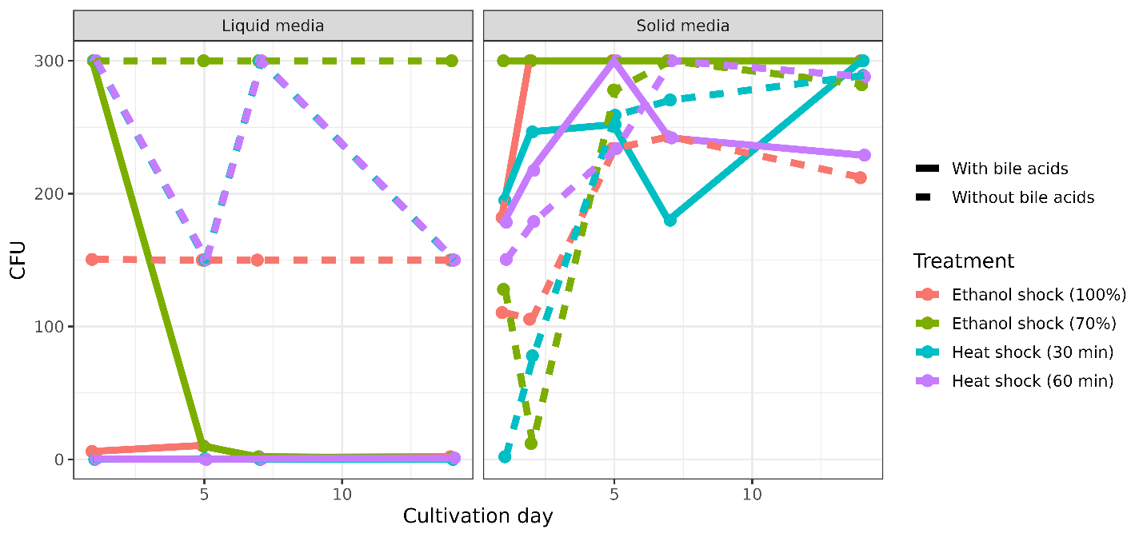
Figure 2. Bacterial growth on BHIS (with/without BA) after heat and ethanol shock. Growth of bacteria on agar plates with or without beforehand enrichment in liquid media; with and without addition of bile acids after heat shock (80 °C for 30/60 min with constant shaking) and ethanol shock (100/70% ethanol for 24 h with constant shaking) from day 1, 2, 5, 7, and 14.
Amplicon sequencing of swapped plates and enrichment cultures gave us information as to who was eliminated, and which taxa were subsequently enriched. Liquid culture supported growth of more bacteria, especially with addition of BA than agar plates, both with or without addition of BA. This is contrary to the observed CFU, supported by a negative correlation between CFU and number of OTUs (Pearson correlation, p < 0.005).
The composition of stool samples was that of healthy western individuals (45.3% Bacillota, 34.1% Bacteriodota, 3.6% Actinomycetota, 8.2% Pseudomonadota, 4% Verrucomicrobiota, 2.8% unclassified Bacteria and 1.4% other phyla). All treatments and subsequent cultivation reduced the diversity of bacteria regardless of the phylum. But ethanol shock using 70% ethanol was the most successful in eliminating known non-spore-forming bacteria (Figure 3).
All treatments were able to some degree eliminate the non-spore-forming bacteria, but ethanol shock using 70% ethanol eliminated the greatest number of known non-sporeformers in the phyla Bacteriodota and Verrucomicrobiota (Figure 3). A reduction also happened in the phyla Pseudomonadota and Actinomycetota although some representatives have the ability to withstand ethanol shock (Figure 3) (REF).
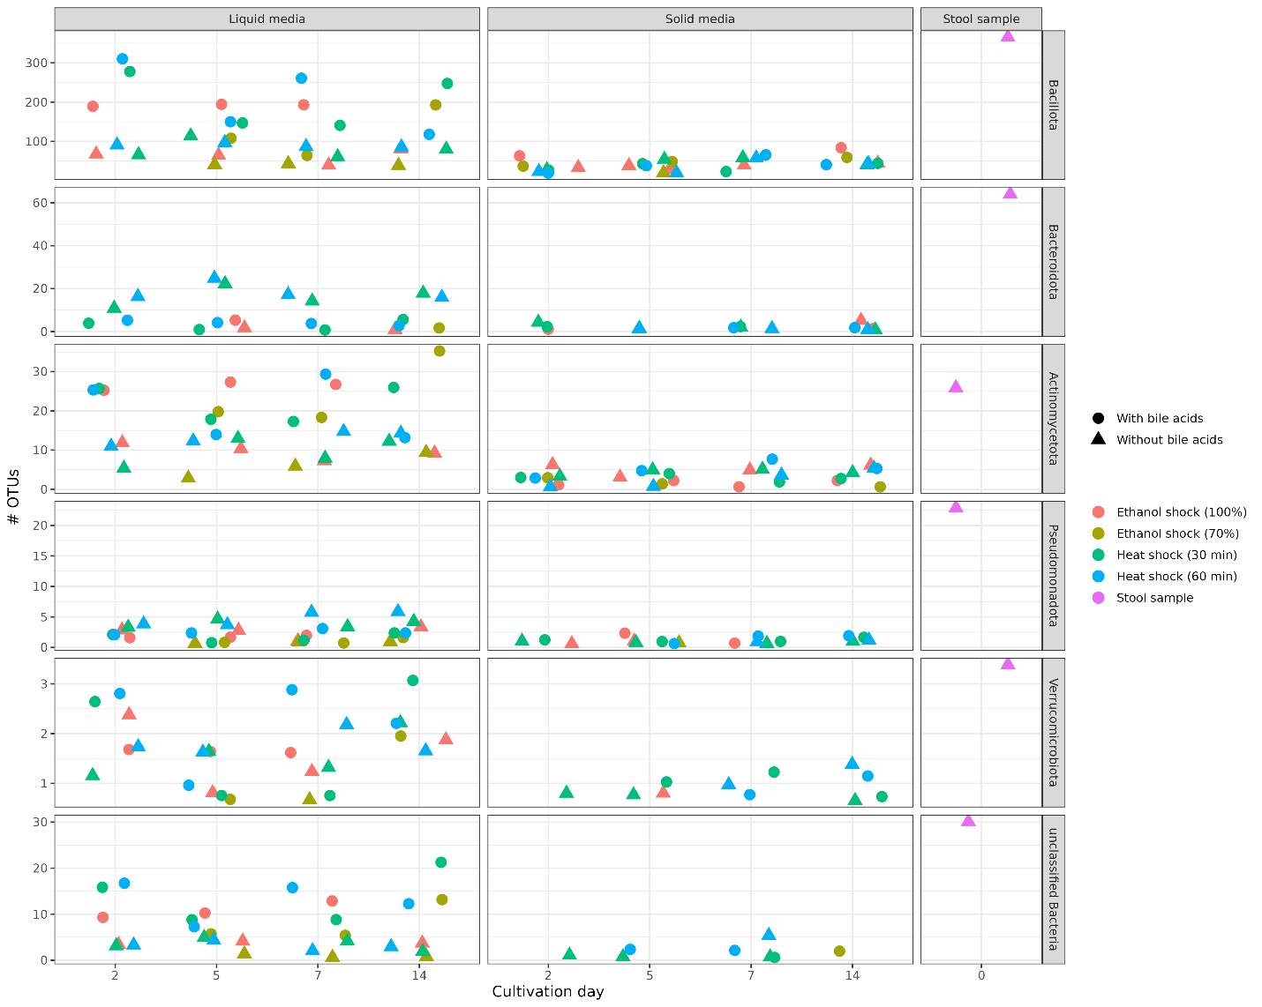
Figure 3. Number of OTUs belonging to each phylum in the original stool samples (n = 2) and cultivation on solid/liquid medium with and without bile acids on 2, 5, 7, and 14 days.

    - Optimization of pre-treatment for DNA isolation from spore-forming bacteria in stool samples
The experiment included two stool samples, treated in duplicates with 70% ethanol for 24 h and heat shock at 80 °C for 30 min. The goal was to test the efficiency of ethanol or heat shock at lysis of vegetative cells and subsequent removal of their DNA from stool samples using ethidium bromide monoazide (EMA) with different illumination times. Negative controls included a sample of water treated alongside stools (not sequenced, due to low DNA concentration), an untreated stool sample, and ethanol or heat shocked stools only washed with PCR-grade water with no addition of EMA. Results were analysed by comparing the community structure using amplicon sequencing (Supplement Table 2).
Both ethanol shock and heat shock treatments were able to enrich for OTUs belonging to phylum Bacillota and reduce the relative abundance of all other phyla in comparison to both the original stool sample (Non-treated) as well as stool samples treated with ethanol or heat shock but only washed with PCR-grade water, with no EMA treatment (Only-water) (Figure 4). The 15-min illumination of sample treated with EMA had the greatest effect on elimination of all bacteria not belonging to the spore-forming phyla, but the success rate of DNA isolation and subsequent sequencing was also low (5/16) in comparison to 5 min (14/16) or 10 min (8/16).
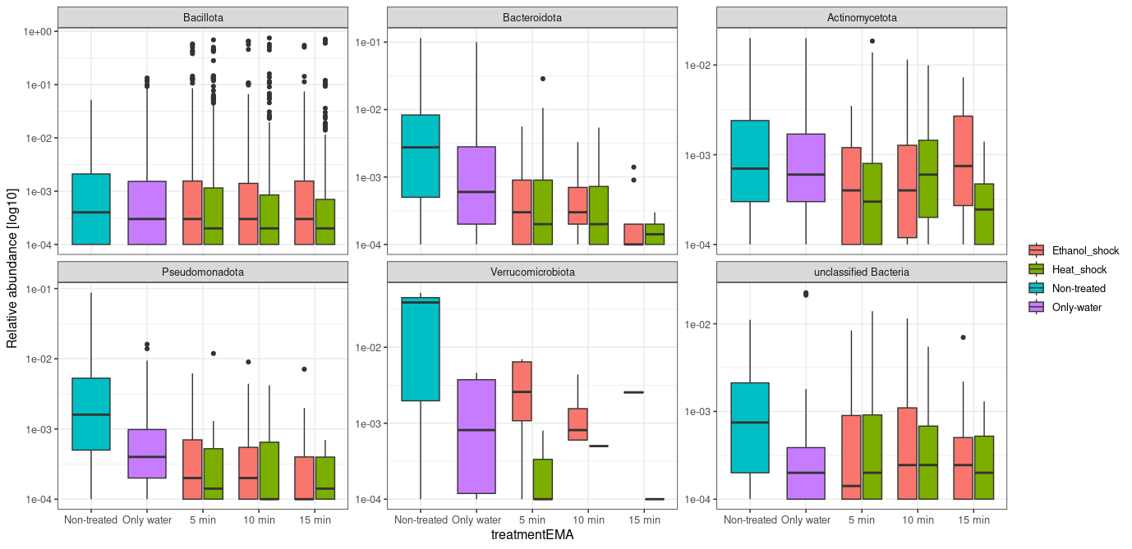
Figure 4. Efficiency of enrichment for spore-forming bacteria in the stool sample. Relative abundance of OTUs in most abundant phyla in stool sample (Non-treated), stool samples treated with ethanol or heat shock, but washed with PCR-grade water (Only water) and stool samples treated with ethanol or heat shock, and EMA at different illumination times.

  - Longitudinal study of individual’s gut microbiota and sporobiota
The experiment included nine healthy male individuals whose stools was sampled approx. every 14 days for 6 months and at some pre-defined events (dentist, antibiotic therapy, travel, etc.). We collected a minimum of 12 samples per person. We isolated the ethanol resistant fraction of gut microbiota and the bulk microbiota DNA and sequenced it with both amplicon sequencing as well as shotgun metagenomic sequencing.
    - Composition and abundance of ethanol-resistant and ethanol non-resistant bacterial community in stool based on amplicon sequencing
Out of 234 (117 of bulk microbiota and 117 of ethanol treated) samples we successfully sequenced 230 of them (Supplement Table 2). Negative control samples for both bulk microbiota and ethanol treated sample contained less than 1800 reads distributed into a 586 and 671 OTUs, respectively (average number of reads per OTU x). After quality filtering and rarefaction (Supplement Figure 1) we detected 2,431 OTUs in bulk microbiota samples, out of those 414 OTUs (17.0 %) were determined as part of the ethanol-resistant community and 1,934 (79.5%) as part of the ethanol non-resistant community. Eighty-three OTUs (3.4%) failed to meet the criteria (described in the Methods & Materials xy) and were designated as undetermined regarding ethanol resistance. An additional 141 OTUs were detected only in ethanol treated samples. These were all detected at low relative abundance and were considered highly probable sampling artifacts and therefore excluded from further analysis, following an example from a previous study (Kearney et al.). Compositional characteristics and temporal dynamics were subsequently analysed on the above defined ethanol-resistant and non-resistant communities obtained from a 6-month longitudinal sampling of nine healthy males.
The majority of ethanol-resistant representatives were found in the phylum Bacillota (n = 320), accounting for 77.5% of the total richness in the ethanol-resistant community (Figure 5A). Within the phylum Bacillota, 17.7% of all detected OTUs exhibited ethanol resistance, predominantly from the genera Clostridium (n = 76), unclassified Lachnospiraceae (n = 49), unclassified Ruminococcaceae (n = 42), unclassified Peptostreptococcaceae (n = 13), and Blautia (n = 12). The remaining ethanol-resistant community included representatives from Actinomycetota (n = 42, 11%), Pseudomonadota (n = 21, 5.5%), and unclassified Bacteria (n = 14, 3.7%). In these groups, the proportion of ethanol-resistant OTUs was higher than expected, with 36.2%, 40.4%, and 19.7%, respectively, exhibiting this trait. Additionally, phyla with ten or fewer representatives collectively contributed 2.3% of the ethanol-resistant richness, most notably the biologically relevant genus Akkermansia. Ethanol treatment had the strongest elimination effect on the phylum Bacteroidota, with only 10 representatives remaining in the ethanol-resistant community, accounting for 0.5% of the total relative abundance.
We observed two notable characteristics distinguishing the ethanol-resistant community from the non-resistant community. Both were primarily driven by Bacillota OTUs due to their high abundance, though similar trends were also observed across other phyla. First, OTUs determined as ethanol-resistant exhibited significantly higher relative abundance within the gut microbiota compared to non-resistant OTUs (Wilcoxon rank-rum sum test, p < 0.001; Figure 5B). Second, ethanol-resistant OTUs were significantly more likely to be detected at more time points within an individual, particularly in more than 80% of samples collected over a six-month period, relative to non-resistant OTUs (Wilcoxon rank-sum test, p < 0.001; Figure 5D). These findings support the use of ethanol resistance as a proxy for identifying bacterial taxa employing dormancy mechanisms that contribute to long-term persistence in the human gut.

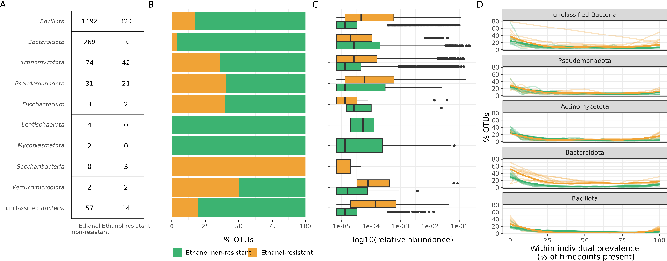

Figure 5. Characteristics of ethanol-resistant and ethanol non-resistant bacterial communities. A) Distributions of OTUs across phyla according to ethanol resistance. The table (left) shows the number of OTUs identified in each phylum for the ethanol non-resistant and ethanol-resistant communities, while the stacked bar plots (right) depict their relative proportions within the respective phyla, color-coded based on their ethanol non-resistant (green) or ethanol-resistant (yellow) classification. B) Comparison of relative abundances in the gut microbiota between OTUs determined as part of the ethanol-resistant or ethanol non-resistant community. C) Within-individual prevalence of OTUs across the six-month observational period, shown as the percentage of OTUs detected at different numbers of time points. Thin lines represent individual participants, and bold lines indicate the cohort median.

    - Diversity of ethanol-resistant and ethanol non-resistant bacterial community in stool based on amplicon sequencing

Is there a correlation between the diversity of ethanol resistant and ethanol non-resistant communities?

Figure 6. Shannon’s diversity index for ethanol-resistant and ethanol non-resistant community of each individual timepoints.
For the purpose of statistical robustness and clarity in discussion, we further divided our dataset of ethanol-resistant and etahanol non-resistant communities into phylum Bacillota and other phyla (Figure 7). The ethanol-resistant communities exhibited significantly lower variability both between and within individuals compared to the non-resistant communities. This pattern was observed when implementing both unweighted (Jaccard distance, p < 0.001 for all comparisons; Figure 7A) and weighted beta diversity measures (Bray-Curtis, p < 0.001 for all comparisons; Supplement Figure 2). However, the lower within-individual variability observed in ethanol-resistant communities was significantly more pronounced in the phylum Bacillota compared to other phyla (Wilcoxon rank-sum test, p < 0.001; Figure 7A). In our study, we observed a modest but significant increase in temporal variability within ethanol-resistant Bacillota based on Jaccard distance (Pearson correlation, r = 0.19, p = 0.038, Figure 7B) and a borderline significant correlation when using Bray-Curtis dissimilarity (Pearson correlation, r = 0.169, p = 0.051, Supplement Figure 2). In contrast, no significant temporal changes were observed in other communities (Figure 7B).
Figure 7. Dynamics of ethanol-resistant and ethanol non-resistant taxa between and within individuals. A) Boxplots showing between-individual (left) and within-individual (right) variability in community composition for ethanol-resistant (yellow) and non-resistant (green) communities. Variability was assessed using the Jaccard distance, calculated separately for OTUs from the phylum Bacillota and OTUs from other phyla. Jaccard distances were derived from randomly subsampled communities (n = 24, iterations = 999), with the median distance used for visualization and statistical comparisons. Distributions were compared using the Wilcoxon rank-sum test. B) Community variability as measured by Jaccard distance plotted against the number of days between sampling time points. Data are presented separately for phylum Bacillota (solid line) and other phyla (dashed line) and color-coded according to ethanol resistance. The correlation between time interval and Jaccard distance was assessed using Pearson’s correlation test. Statistical significance is indicated as *** for p < 0.001.

    - Longitudinal variability of ethanol-resistant and ethanol non-resistant community
Some individuals are more dispersed and some cluster closer together, this is dependent on the rate of changes in their gut microbiota - to figure out what effect this we would have to record much more metadata than we did, as these are all healthy individuals aged 26 - 46, with no other problems than occasional gas and bloating in individual I.

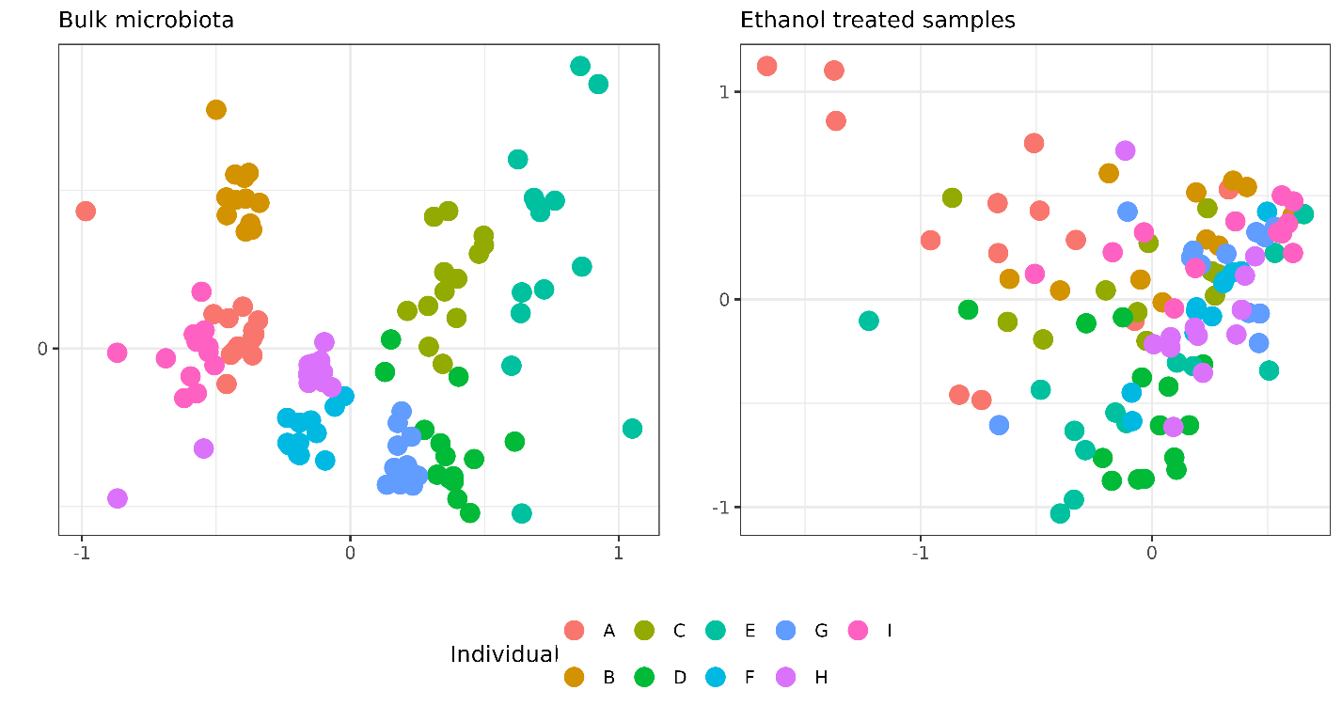
Figure: NMDS ethanol treated samples and bulk microbiota samples.
We can than observe that ethanol resistant fraction is more individually dispersed than microbiota for all beta diversity measures Bray-Curtis, Jaccard (Figure below).

Normalization is it necessary/logical – normalization by individual = we can compare different individuals OR normalization across individuals (what does that bring me, as values are distances already).
But when we are comparing distances of multiple individuals between microbiota and ethanol resistant fraction to show weather one or the other is more dispersed we have to somehow normalize this data. We decided on min-max normalization. This method involves scaling the distances within each cluster to a [0, 1] range based on the maximum and minimum distances observed within each cluster. This approach ensures that all normalized distances are directly comparable across clusters, irrespective of their original scales or densities (Equation 1).
$$noralized value=\frac{a-\min\left(a\right)}{\max\left(a\right)-min⁡(a)}$$
Where a is the distance between two samples. Normalizeation Bray and Jaccard (Z-score and min/max)
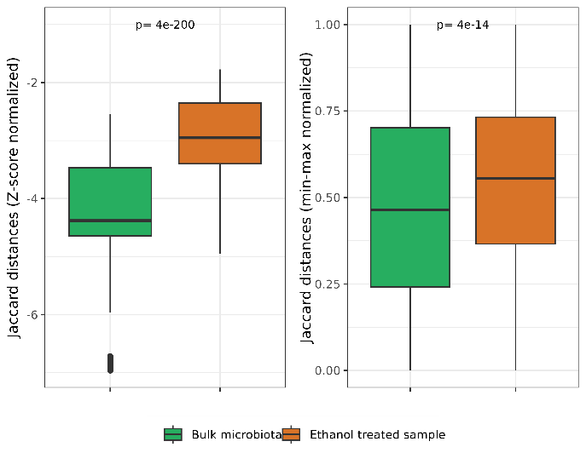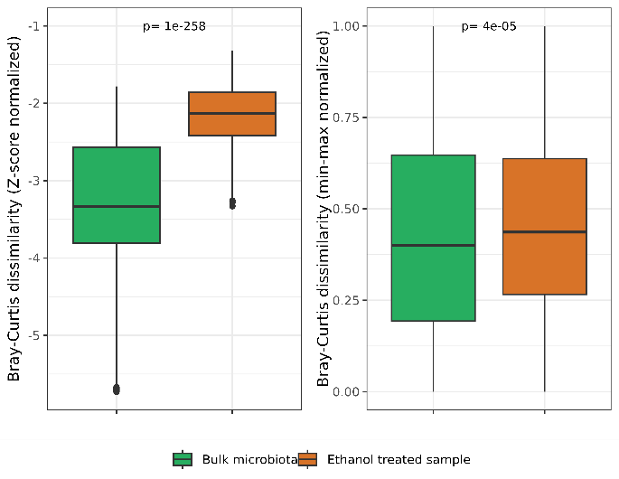
Figure:
This hypothesis can also be confirmed looking at the number of OTUs present in only one individual and two or more. Ethanol resistant fraction has a larger number of OTUs present in two individuals or more, as most of the OTUs in microbiota that are present in 2 individuals or more are actually a part of the ethanol resistant fraction (brighter color area) (Figure 14). Here we have to take into account that our study only had 9 individuals and that for an OTU to be present in individual we counted any individual present in more than 2 time points.
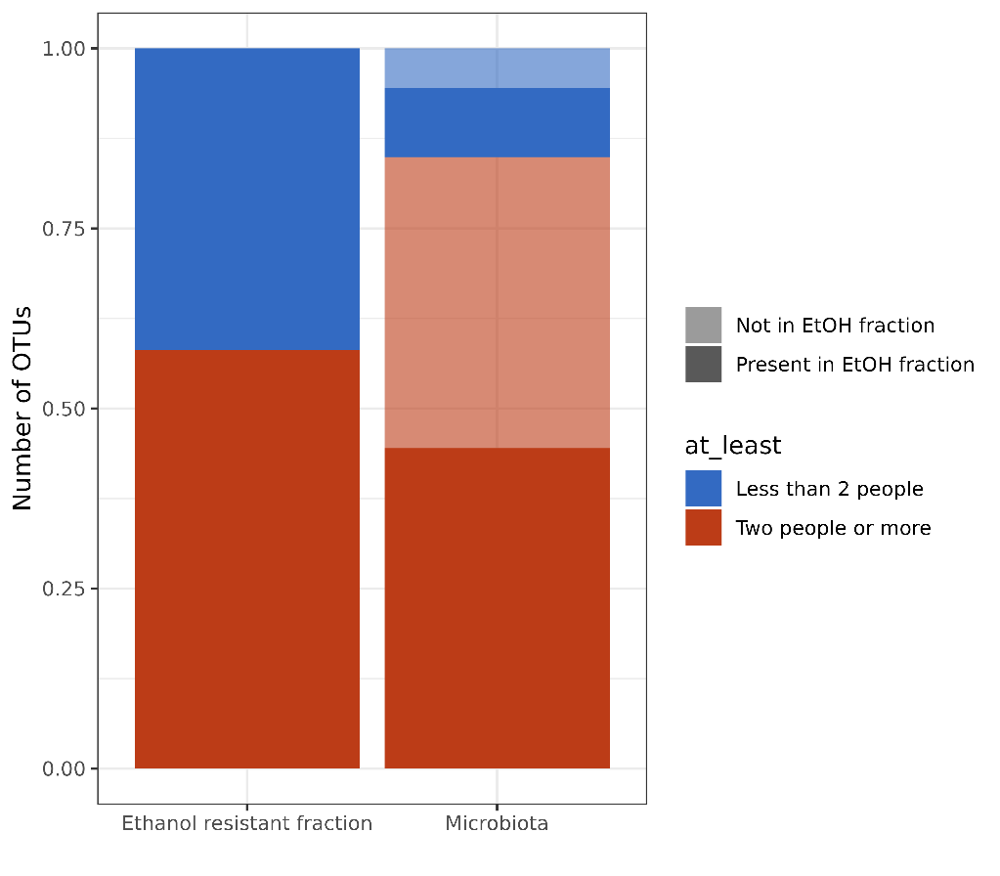
Figure 14: Presence of OTUs in only one individual and two and more individuals, while also accounting for OTUs that are part of ethanol resistant fraction as well as microbiota fraction. BUT is this what I want?
Seen from the Figure 14, all of OTUs that are present in the ethanol treated sample are also a part of the bulk microbiota samples. Quite a lot, to avoid mistakes made when comparing fraction within a bulk microbiota. We decided to separate the OTUs into ethanol resistant fraction and ethanol non-resistant fraction (See Methods).

Transition to ethanol resistant and ethanol non-resistant fractions within bulk microbiota
Sestava/zastopanost/diveritetea vzorcev, nato povem kako sem se oločila ločit ethanol resistant / non-resistant in opišem to sestavo,zastopanost, diverziteto in dalje beta diverzitetene razlike.
Definitition of sporobiota/ethanol resistant Bacillota:
We defined ethanol resistant and ethanol non-resistant fractions in bulk microbiota communities of stool samples from nine healthy male individuals sampled every 14 days across 6 months. Out of 2574 OTUs detected in our study, we determined 415 OTUs as part of the ethanol resistant fraction and 1935 as part of the ethanol non-resistant fraction (See Methods; Data analysis). We removed 224 OTUs either because they were only found in ethanol treated samples (n = 114) or were undetermined (n = 83, See Methods). OTUs found only in ethanol treated samples are most likely a sampling error, as they were not found in bulk microbiota sample. Besides this their abundance in ethanol treated samples is unreliable, as we removed a lot of taxa with ethanol shock and EMA treatment. The removed OTUs belong to Bacillota and Bacteroidota genera.
The highest richness of ethanol resistant representatives was found in phylum Bacillota (n = 320), representing 77.5% of all abundance within ethanol resistant fraction, followed by Actinomycetota (n = 42, 11%) and Pseudomonadota (n = 21, 5.5%) and unclassified Bacteria (n = 14, 3.7%), other phyla had 10 or less representatives that were classified as part of the ethanol resistant fraction and presented less than 3% of abundance in ethanol resistant fraction (Figure 1). In the ethanol non-resistant fraction Bacillota (n = 1492) and Bacteroidota (n = 269) represent more than 80% of total relative abundance (47% and 36% respectively). Actinomycetota (n = 74) present 14% while Pseudomonadota (n = 31) only 3.7%, other phyla present less than 2% (Figure 1).
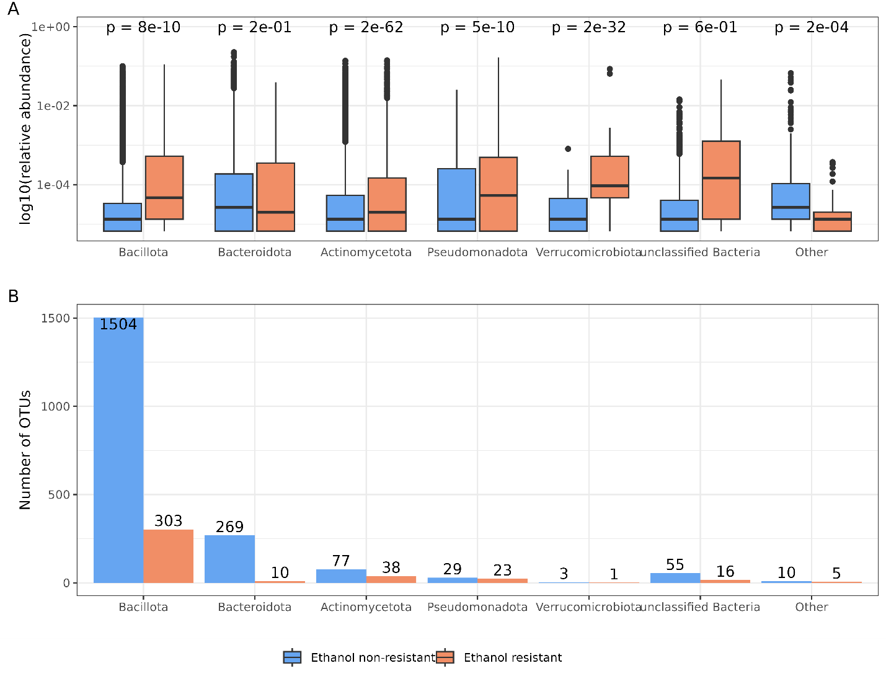
Figure 1. Ethanol resistant fraction is dominated by OTUs classified as Bacillota. The number of OTUs presented separately for most abundant phyla and color coded as ethanol resistant (yellow) or ethanol non-resistant fraction (green).
Ethanol resistant Bacillota are a shared component of the gut microbiota between individuals and form a persistent community within individual that shows directed change in six-months’ time
Within the ethanol resistant fraction, we defined two communities. The first included representatives from phylum Bacillota, known endospore-forming bacteria (n = 320) and the second included other taxa determined as ethanol resistant in this study (n= 95), for which the mechanisms of ethanol resistance are poorly understood. The same grouping into Bacillota and other taxa was made for ethanol non-resistant taxa.
Using beta diversity measures, we observed that ethanol resistant Bacillota exhibit significantly lower inter-individual variability (Wilcox, p < 0.001) compared to ethanol non-resistant Bacillota (Figure 2A, Supplement Figure 1, Supplement Table 1). Other ethanol resistant taxa also show significantly lower inter-individual variability in comparison to ethanol non-resistant counterpart however, the effect is notably smaller (Wilcox, p < 0.001, Figure 2A, Supplement Figure 1, Supplement Table 1). Despite almost negligible variability in individuals gut microbiota in six-months’ time and an expectedly lower variability when compared to inter-individual variability for all fractions. We observed comparable outcomes in the ethanol resistant fractions. Reduced variability was observed in case of ethanol resistant Bacillota fraction (Wilcox, p < 0.001) and for non-Bacillota taxa. But the effect was much smaller compared to inter individual differences between fractions (Wilcox, p < 0.001, Figure 2A, Supplement Figure 1, Supplement Table 1), as the ethanol resistant taxa exhibit greater variation than ethanol non-resistant taxa.
Differences between time points are not added to the elapsed time between samples in the six-months for ethanol non-resistant fractions. Pearson’s correlation never exceeded 0.2 and was nonsignificant (Figure 2B, Supplement Figure 1, Supplement Table 2), except for ethanol resistant Bacillota fraction that exhibit a weak correlation between time and the Jaccard distance between samples (R = 0.19, p = 0.025, Figure 2B), and a border-line significance with Bray-Curtis dissimilarity (R = 0.169, p = 0.051, Supplement Figure 1). Which implies directed change, an acquisition of new OTUs in the ethanol resistant Bacillota as opposed to more random processes in communities of ethanol non-resistant Bacillota and other taxa in individual’s gut.
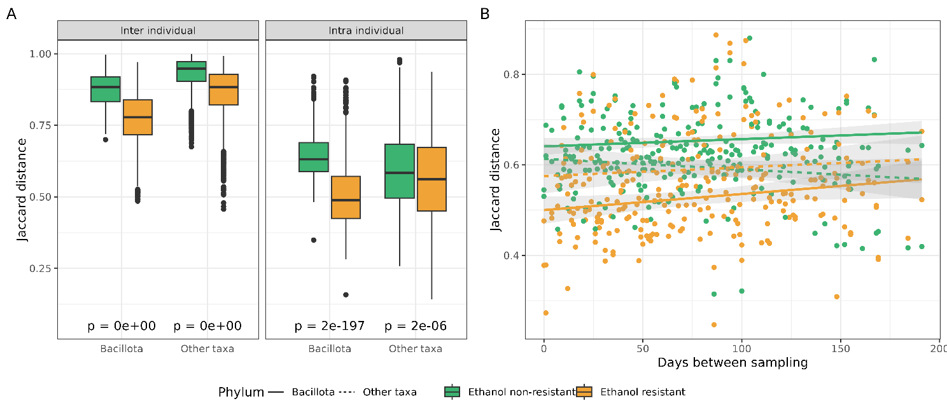
Figure 2. Ethanol resistant bacterial fractions of the human gut microbiota are more commonly shared between individuals and form a persistent community, with directed acquisition of new OTUs within an individual. Jaccard distance was calculated from randomly subsampled communities (n = 24, iterations = 999) and the median value was taken for graphical representation and used in Wilcoxon ranked sum tests. A) Comparison of cluster density for ethanol resistant and ethanol non-resistant Bacillota and other ethanol resistant and ethanol non-resistant taxa inter- and intra- individual. B) Comparison of median value of Jaccard distances between different time spans of individual for ethanol resistant and ethanol non-resistant Bacillota and other ethanol resistant and ethanol non-resistant taxa.
Isolation efficiency of Clostridioides difficile spores using the PowerFecal protocol
For isolation of DNA from ethanol and EMA treated samples we used MasterPure protocol, while for bulk microbiota samples we used PowerFecal. This decision was based on the fact PowerFecal has a spin-column to which to much DNA binds and we got insufficient DNA concentrations. But we wanted to know whether PowerFecal protocol was able to isolate DNA from spores or only vegetative cells.
To confirm that we isolated both vegetative cells and spores with bulk microbiota protocol, we added C. difficile spores to an otherwise C. difficile negative stool sample and measured the absolute amount of the C.difficile-specific 16S rRNA amplicon with ddPCR after isolation of DNA. The copy number of C. difficile-specific amplicon was correlated to CFU count of spores after cultivation (Figure 6, Pearson’s correlation value = 0.73, p-value = 0.007).
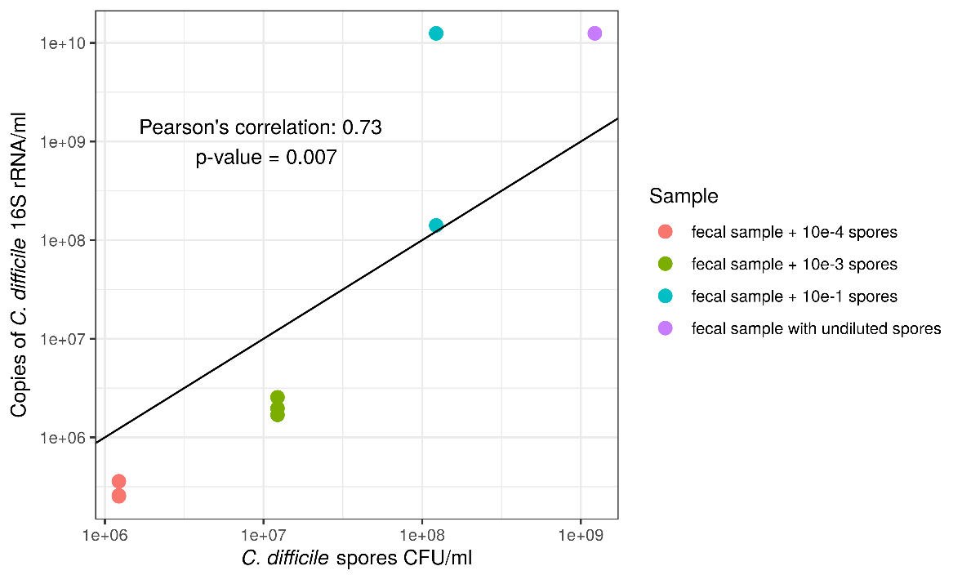
Figure 6. Efficiency of C. difficile spore isolation with PowerFecal protocol compared to C. difficile spore CFU count on COH agar plates.

Stability
I have shown than in the span of 6 months in 9 individuals that we samples the OTUs we receovered from bulk microbiota either they be part of the ethanol resistant or ethanol non-resistant fraction are stable. There are no alternative stable states or large transitions. Even though two of participants consumed antibiotics during the study (E, H) there is no proof of instability.
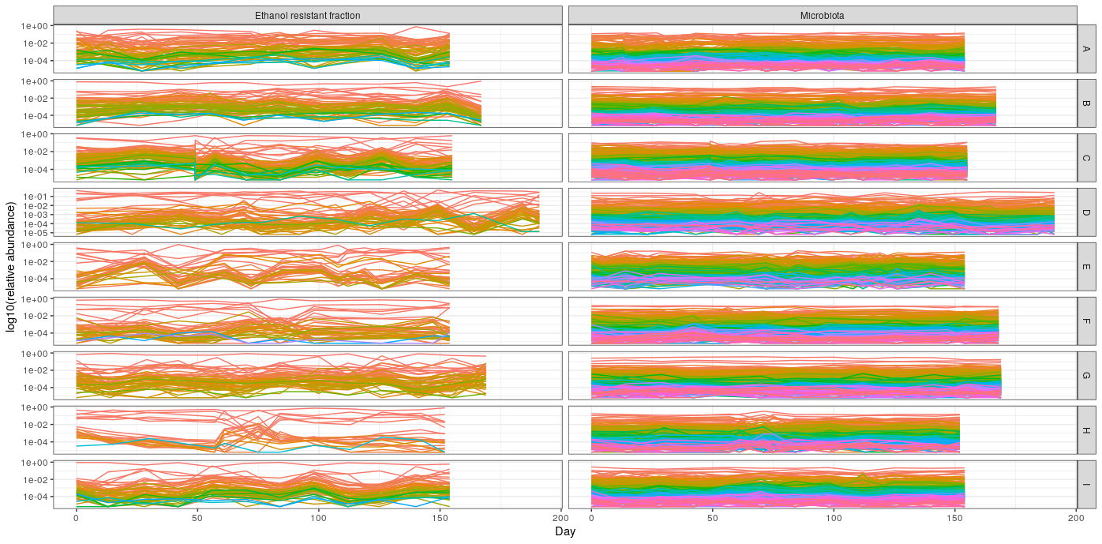
Figure: Relative abundance of each OTU through time for each individual. There is no indication for alternative stable states, as even individuals E and H, that consumed AB there is the return to the same as before in relative abundance of all observed OTUs.
By different definitions of stability this community on the level of OTUs is stable, as the return to previous after disturbance such as antibiotic treatment and travel (individuals A, B, C, D) is either not even visible in the observation of relative abundance or they have return to ‘previous state’ quickly after the disturbance (H). One possible explanation for this could also be the time scale of our sampling, as bacterial generation time is on the scale from hours to a day, while our sampling took place every 14 weeks. So, we were able to observe larger ecological changes that did not occur, as opposed to smaller changes in hour to hour.

Sporulation frequency of ethanol resistant Bacillota in the human gut is host and time dependent
Sporulation frequency was calculated for OTUs determined as part of the ethanol resistant fraction with taxonomic classification to the phylum Bacillota. The ratio between normalized abundance in bulk microbiota samples and normalized abundance in ethanol treated samples was calculated and termed sporulation frequency (See Methods). The calculation is supported by a correlation of relative and/or normalized abundance of the ethanol resistant Bacillota between the bulk microbiota and ethanol treated samples, despite different isolation protocols (Supplement Text 2, Supplement Figure 3, 4).
The sporulation frequency for all OTUs within an individual increases or decreases simultaneously at a single time point in majority of the time points (Figure 3A). This indicates a dependency on the current state of gut in each host. We investigated the correlation between the variation of sporulation frequency of each OTU at a single time point normalized with mean variation in sporulation frequency of this OTU across all days of an individual, with the same value, but reshuffling the day variable. There was no correlation between the original and reshuffled data (Pearson’s correlation: 0.03, p = 0.74), confirming that the temporal order of sampling days is a key factor influencing sporulation frequency of an OTU.
Variance in sporulation frequency of an OTU within an individual compared to variance in sporulation frequency of the same OUT in the whole population shows host-specificity. This is evidenced by the ratio between variance of OTU i in an individual and the variance of OTU i in population which falls below 1 in all but two individuals (Figure 3B). An exception was the increase in sporulation frequency in individual H, as opposed to population variance which can be linked to antibiotic consumption between day 71 and 84 during the duration of the study. And a slight increase in individual C, linked to 5 days abroad in the second month of the study. Interestingly in the individual H this coincides with decrease in alpha diversity, while in individual C there was an increase in alpha diversity. Kruskal test shows significantly different variance of sporulation frequency of OTUs between individuals in our study (p = 1.7e-8), which strengthens our comparison as the population variance reflects highly different individuals. While comparison of the variance in sporulation frequency between different OTUs is not significantly different (Kruskal test, p = 0.96, Figure 3C). Another confirmation of dependance of sporulation frequency to host and time and not OUT classification are also positive Pearson’s correlations between sporulation frequency of OTUs within an individual (Supplement Figure 5).

The reliability of this measure is supported by a strong correlation between relative and/or normalized abundance of OTU in both sample types, despite different isolation protocols.

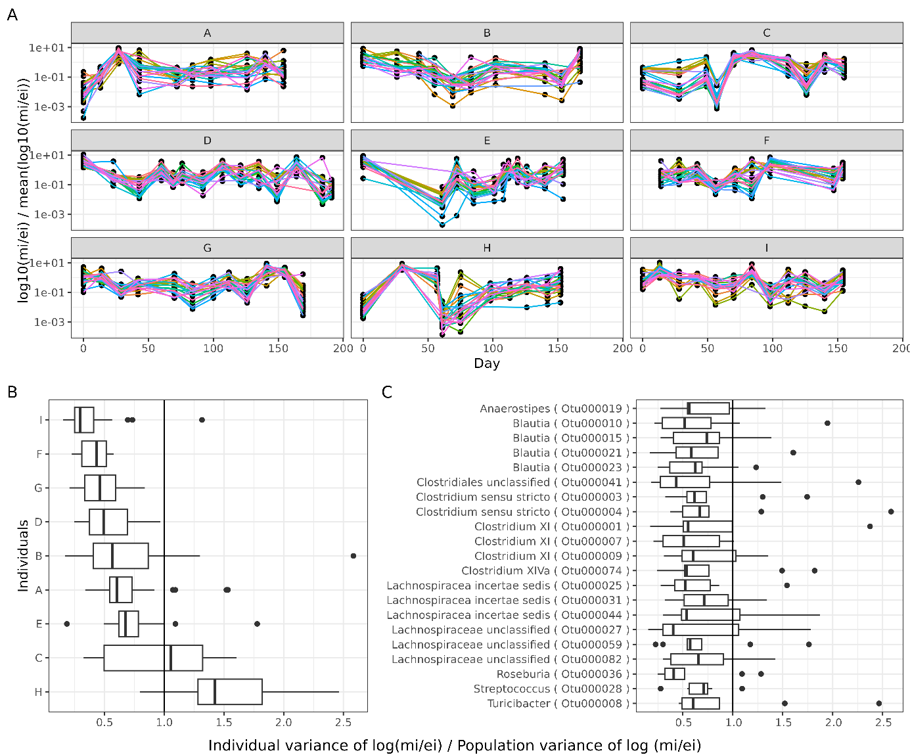
Figure 3. Sporulation frequency is more influenced by the individual and the specific time point of sampling than OTUs identity. Plot shows only highly prevalent OTUs belonging to ethanol resistant Bacillota fraction (present in > 90% of samples, n = 21). A) Sporulation frequency normalized by individuals mean sporulation frequency (m_{i} = normalized abundance of OTU i in bulk microbiota sample, e_{i} = normalized abundance of OTU i in ethanol resistant fraction). B) Ratio of sporulation frequency variance of OTU i in individual and in the population, plotted by individual and C) plotted by OTU.
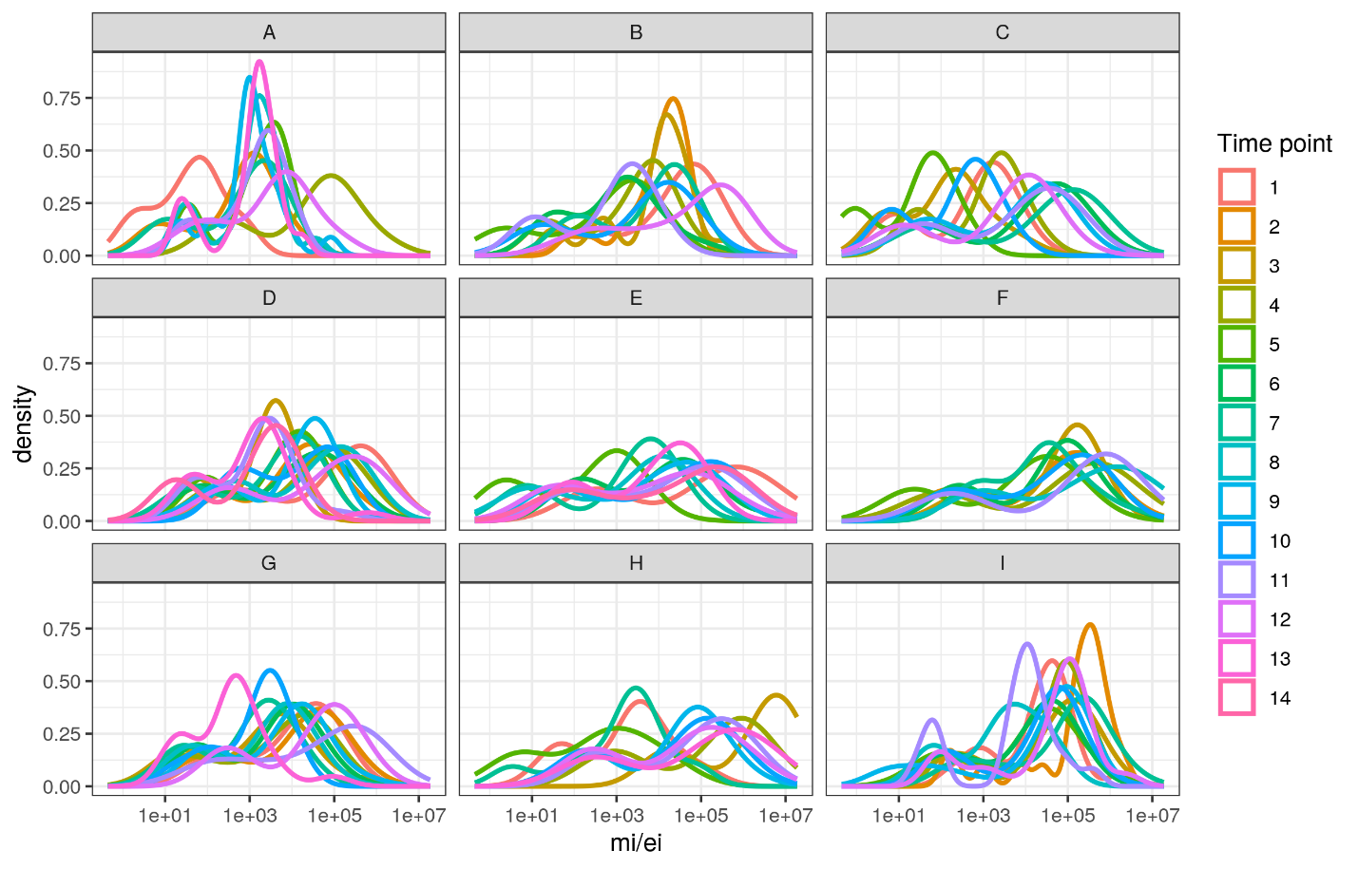

Results from this:
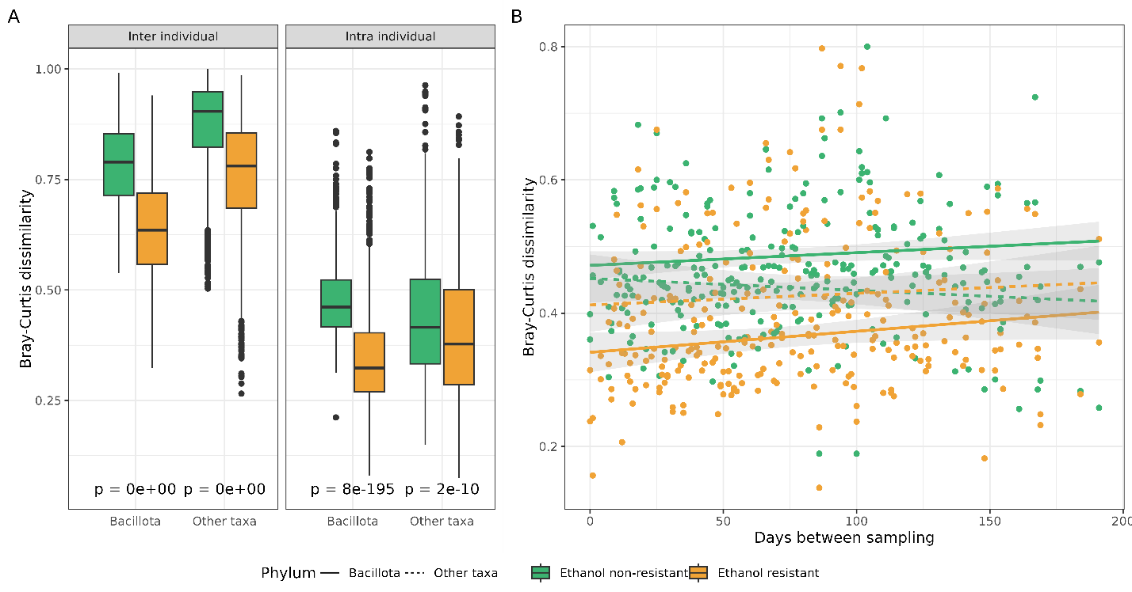
Supplement Table 1: Wilcox rank sum test between all fractions inter and intra individuals.
Distance measure | Between fractions | p-value
 |  | Inter  individuals | Intra  individuals
Bray-Curtis | Ethanol resistant Bacillota & Ethanol non-resistant Bacillota | 0 | 7.7e-195
 | Ethanol resistant Bacillota & Other ethanol resistant taxa | 0 | 2e-19
 | Ethanol resistant Bacillota & Other ethanol non-resistant taxa | 0 | 1e-65
 | Other ethanol resistant taxa & Other ethanol non-resistant taxa | 0 | 2.2e-10
 | Other ethanol resistant taxa & Ethanol non-resistant Bacillota | 1e-20 | 1e-60
 | Other ethanol non-resistant taxa & Ethanol non-resistant taxa | 0 | 4e-31
Jaccard | Ethanol resistant Bacillota & Ethanol non-resistant Bacillota | 0 | 2e-197
 | Ethanol resistant Bacillota & Other ethanol resistant taxa | 0 | 1e-23
 | Ethanol resistant Bacillota & Other ethanol non-resistant taxa | 0 | 3e-61
 | Other ethanol resistant taxa & Other ethanol non-resistant taxa | 0 | 1e-6
 | Other ethanol resistant taxa & Ethanol non-resistant Bacillota | 0.01 | 1e-56
 | Other ethanol non-resistant taxa & Ethanol non-resistant taxa | 0 | 5e-38

Supplement Table 2: Pearson’s correlation values and p-values between median distance and time spans between an individual’s fractions. Significance is denoted as: * 0.05 – 0.01, **0.01 – 0.001 and *** < 0.001.
Distance measure | Fraction | Pearson's correlation | p-value
Bray-Curtis | Ethanol resistant Bacillota | 0.161 | 0.0625
 | Ethanol non-resistant Bacillota | 0.138 | 0.112
 | Other ethanol resistant taxa | 0.066 | 0.44
 | Other ethanol non-resistant taxa | -0.076 | 0.38
Jaccard | Ethanol resistant Bacillota | 0.179 | 0.038 *
 | Ethanol non-resistant Bacillota | 0.133 | 0.12
 | Other ethanol resistant taxa | 0.077 | 0.37
 | Other ethanol non-resistant taxa | -0.106 | 0.22

Additional sporulation frequency:
Ethanol shock is a known protocol for removal of vegetative cells as 70% ethanol damages the cell wall of all known bacteria in the human gut but does not damage spores and other ethanol resistant cell forms (Koransky et al., 1978). To obtain a normalized amount of each OTU in a sample, we measured the absolute amount of the 16S rRNA gene in each sample by performing digital droplet PCR with the same primers that were used for amplification of fragments later sequenced. Comparison of the relative abundance in the bulk microbiota sample and ethanol resistant sample of ethanol resistant OTUs revealed that these two quantities are, despite different isolation protocols positively correlated in ethanol resistant OTUs (Supplement Figure 3). The same holds true for normalized abundances (Supplement Figure 4). We could thus compare the proportion of active cells that are also creating endospores. The ratio gives us the information on the sporulation frequency of each OTU determined as endospore forming.
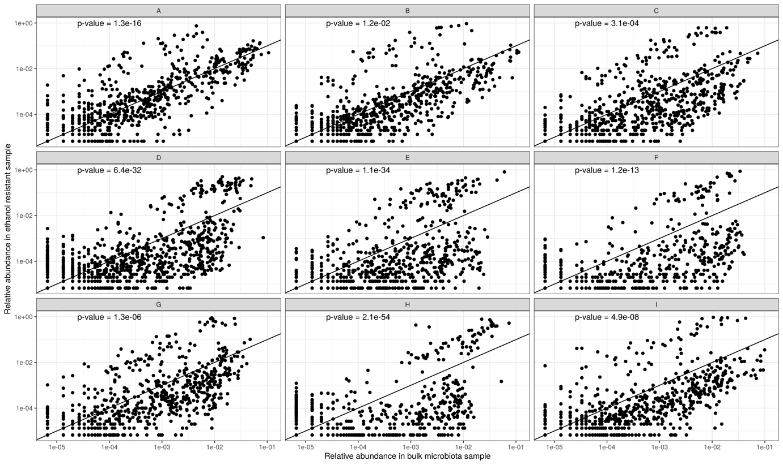
Supplement Figure 3: Relative abundance in ethanol resistant sample and relative abundance in microbiota sample are positively correlated (p-value for each individual Pearson’s correlation is plotted in the top left corner of the plot).
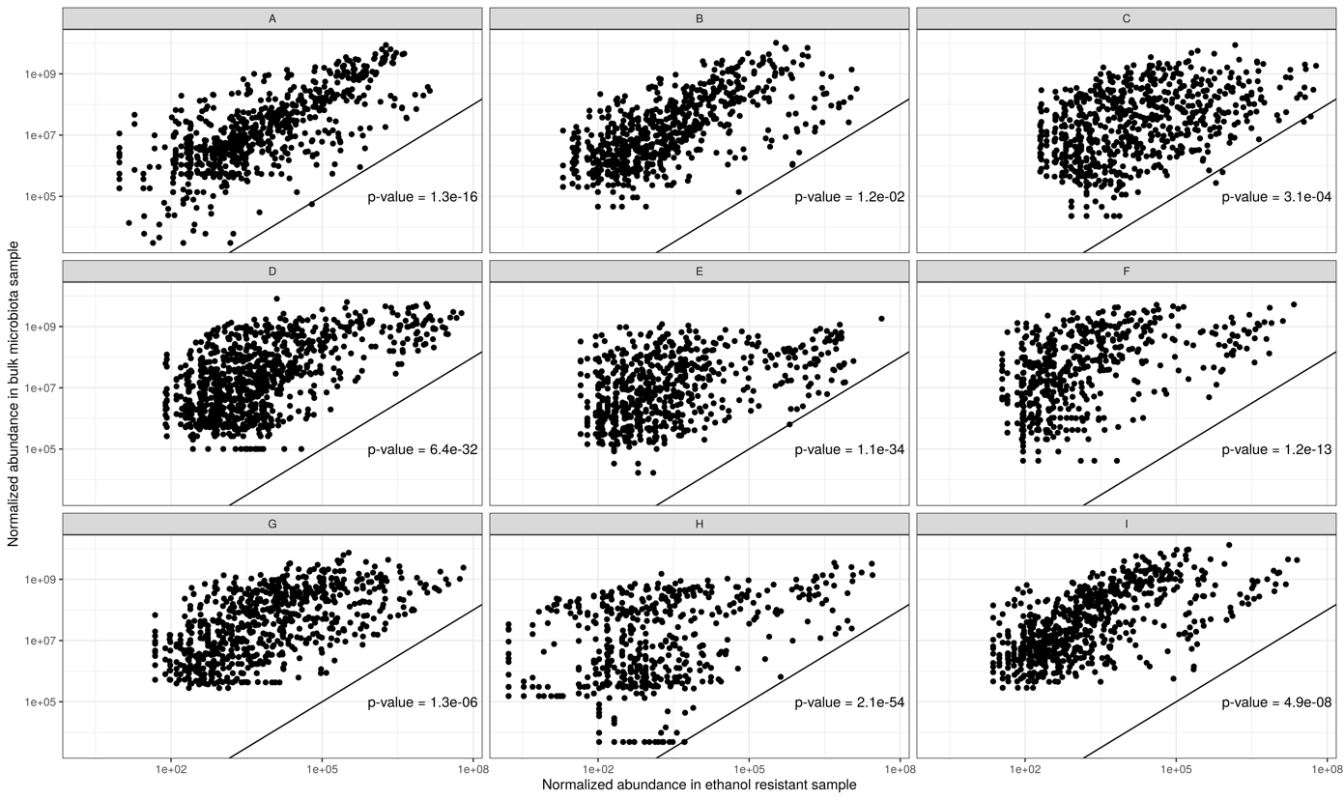
Supplement Figure 4: Normalized abundance in ethanol resistant sample and normalized abundance in microbiota sample are positively correlated (p-value for each individual Pearson’s correlation is plotted in the bottom right corner of the plot).
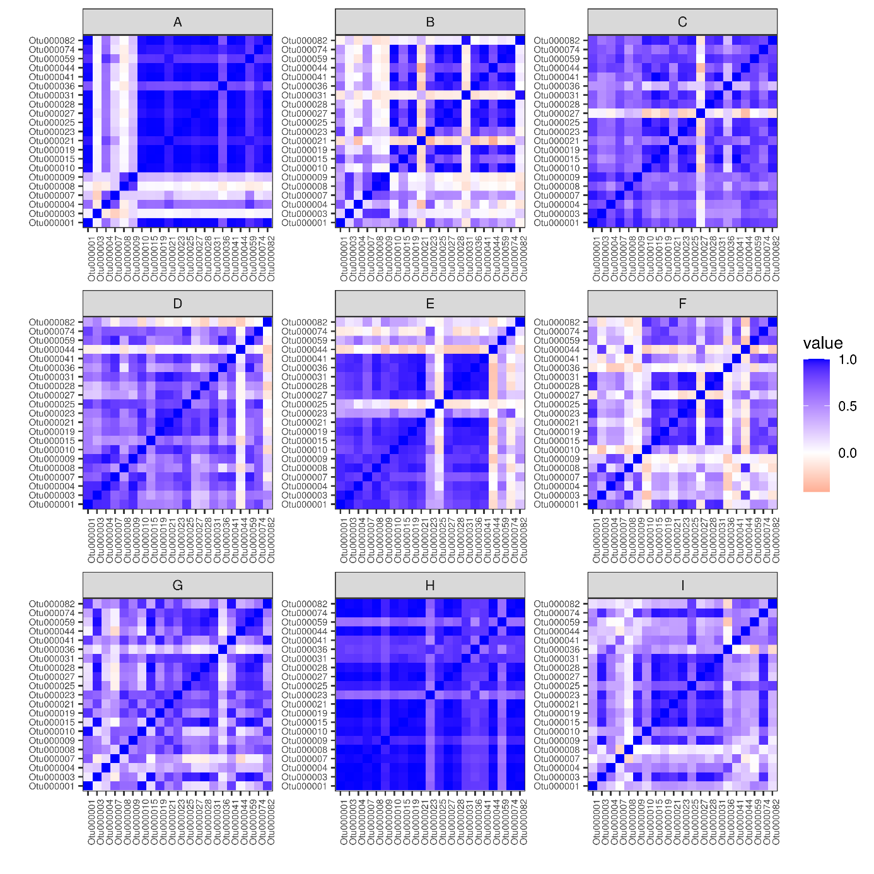
Supplement Figure 5: Correlation of sporulation frequency between OTUs within individuals. Mostly OTUs of an individual are correlated within an individual, which point to host specific sporulation frequency.

Hypothesis: SPOROBIOTA is less stable than MICROBIOTA
Goals in disposition:
Composition & abundance of gut microbiota and sporobiota bacteria
Diversity of microbiota and sporobiota (alpha, beta) bacteria
Density of clustering of individuals
Density of clustering of extreme events
Degree of clustering between and within individuals for microbiota and sporobiota
Longitudinal variation of sporobiota and microbiota
Hypothesis 2: Gut sporobiota and microbiota will change during the extreme event in most volunteers.
Goals:
what will be the distance between the points of samples from regular monitoring and samples from extreme events
CHECK for correlations in changes between alpha and travel and alpha and AB consumption!
Although we followed a large number of metadata at each time point of sampling, our study is too small (in terms of number of same changes in the whole study) and also changes were to sporadic by individual and between individuals so could not be (with exception of antibiotic consumption) statistically significant linked to changes in the alpha diversity of individuals through time.

Cultivation of spore-forming species from ethanol shocked samples
Goals:
Optimization of spore-forming species, looking at evolution of this species in time
We aim to optimize the growth conditions and to obtain strains of the same spore-forming species from different time points of an individual for whole-genome sequencing. With the genome comparison of a population of a species at different time points we will try to assess the retention/transition time and new acquisition of a spore-forming bacteria in the human gut. We will also be monitoring changes in the number of plasmids/phages in this species. This will be done in parallel with the analysis of metagenomic data.

Analysis of amplicon sequences, in particular the analysis of sporulation frequency revealed that individual H, who consumed amoxicillin, a broad-spectrum penicillin during the study had a significantly higher sporulation frequency for all OTUs in comparison to the res of our population. We also noticed we noticed a reduction in diversity and absolute abundance of bacteria during this period. We decided this is an interesting time period for deeper investigation into strain persistence and structure, as the consumption of AB has been shown multiple times to have an effect (REF).
In our preliminary testing for isolation of spore-formers in culture we used BHIS medium (See chapter xy), but for this we have chosen a growth medium that has proven successful in our lab in previous testing of cultivation spore-forming bacteria from the healthy human gut – WCAB ( magisterij Urška Dobovišek). Samples were exposed to ethanol shock and plated onto WCAB medium for 3 days until ~70-100 colonies were selected. Replated colonies were determined with MALDI-TOF and due to the highest number (44) we selected Clostridium saudiense for sequencing. ANI score showed that 2 isolates were not pure/this species. One isolate was determined on the whole genome to be Clostridium paraputrificium, while another was a mixed isolate of C. paraputrificium and C. saudiense, they were excluded from the analysis. We determined strain break after pairwise comparisons of all genomes from C. saudiense to be at 99.8%, from this we defined 4 strain groups with one genome being an singleton. This grouping was also confirmed when we constructed the phylogenetic tree on SNPs in core genome using MEGA’s neighbor-joining tree (Figure)
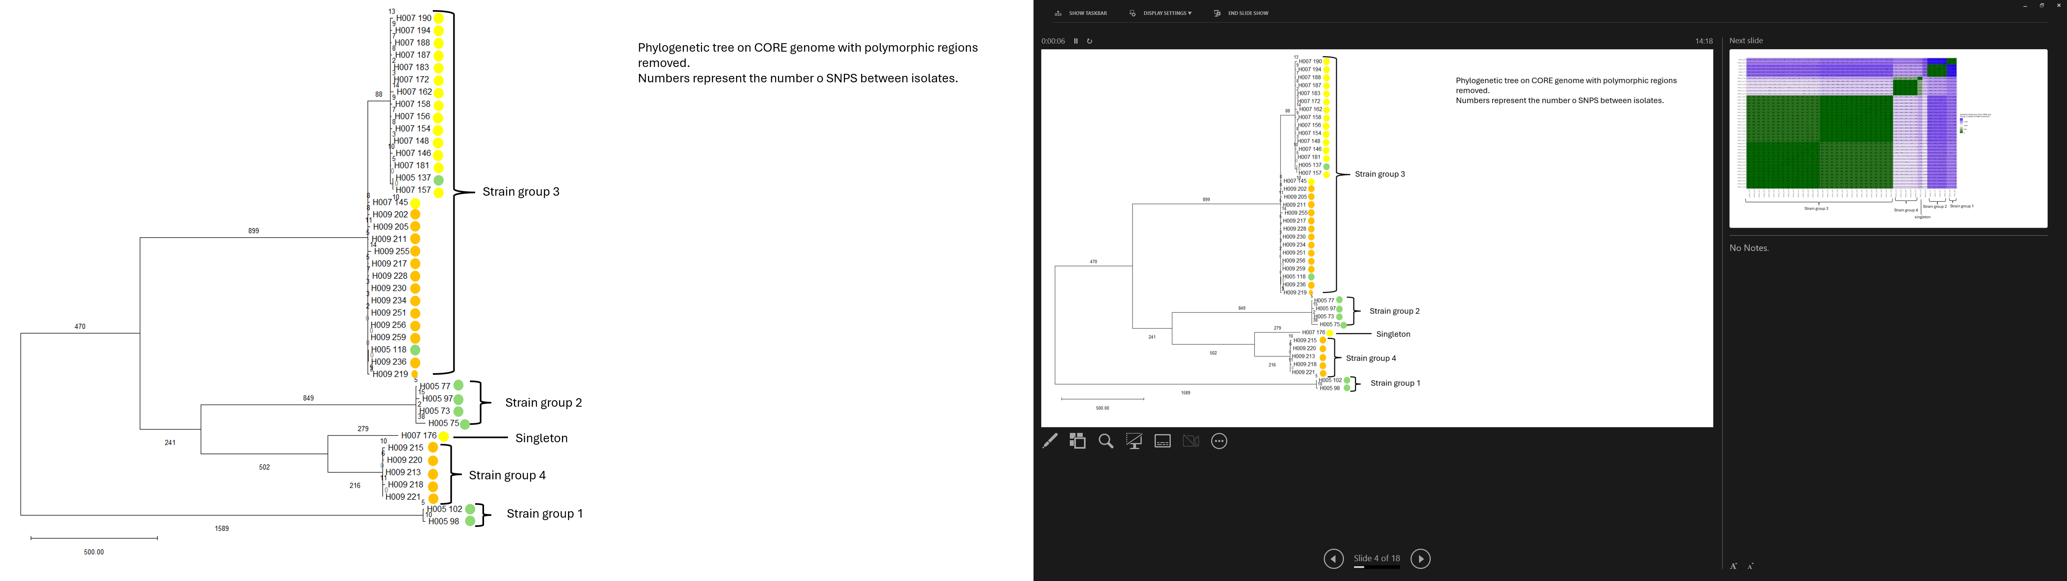
Figure. Neighbor-joining tree based on SNPs determined with SNIPPY, excluding polymorphic regions (Gibbons) in MEGA12. Dots besides isolate names represent the timepoint (green = 5, yellow = 7, orange = 9).
Using data from isolates we are able to show greater diversity before antibiotic consumption (AB), and a consequent reduction and difference in strain structure after AB. But interestingly this is not confirmed in the shotgun metagenomic data, where all four strains detected persist through all timepoints while the frequency of their abundances changes after antibiotic consumption, but interestingly starts at one timepoint prior to AB consumption, when the individual traveled out of Slovenia for more than 3 days. This is when we notice a reduction in the number of bacteria observed. Interestingly we notice that the relative abundance in bulk microbiota after these events for all four remains constant, but in ethanol treated samples strain 1 appears to be dominant, which means it was the one strain that produced more spores than other strains (Figure).
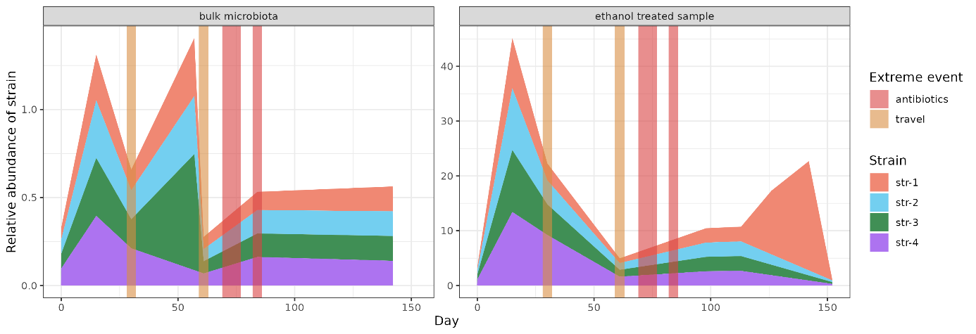
Figure. Results from PStrain determination of strains in the shotgun metagenomic samples. Vertical lines represent extreme events in this individuals life.
Functional enrichment analysis showed 4 phage related functions to be more connected with the isolates in the genomes from antibiotic treatment timepoint as opposed to the isolates before and after antibiotic treatment.

Shotgun metagenomic sequencing
Shotgun metagenomic data enabled us investigation beyond taxonomy (functions) and at a finer scale (species and strain diversity). Human gut microbiota is composed of bacteria, eukaryots (protozoa and fungi) and viruses. As it has been confirmed before bacteria are the most abundant microorganisms in the human stool samples and human intestine. Bacteria represent ~92% of all assembled contigs, while program MetaPhlan determined there are about ~ 84% of bacterial representatives within the reads we obtained. MetaPhlan is a reference-based program whose databases only contain bacterial, eukaryotic and archaeal references, so the Viruses could not be determined. While each contig was determined using DIAMOND and LCA algorithm (described in Methods: algorithms section).
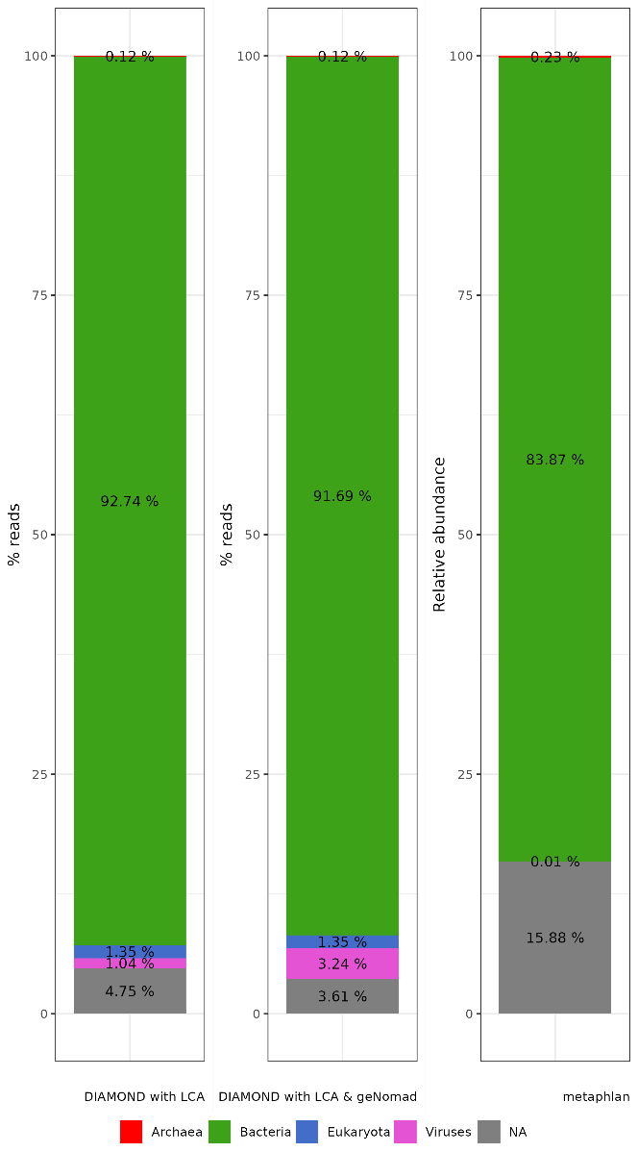
Figure: Abundance of each kingdom (relative abundance or the % of reads) across all individuals with SQM, SQM+geNomad and metahlan.
Archaea
We were able to detect six archaeal genera Methanimicroccus, Methnobacterium, Methanobrevibacter, Methnocorpuscuium, Methanosarcina and Methanosphera. We were only able to detect 2 species Methanobrevibacter smithii and Methanosphera stadmanae. Methnobrevibacter smithii is the most represented archaea in our data set across all individuals. Methanobrevibacter is the most abundant taxa in the human gut, this is also true for individuals in our cohort.
Interestingly individual D is colonized with completely different archaea than other individuals (D lived in America and Netherlands 1 year before the study, while other individuals lived in Slovenia/EU their whole life and spent only short periods abroad (less than 3 months).
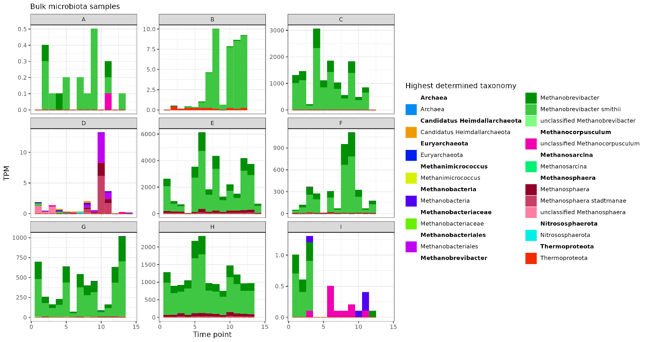
Viruses

Antimicrobial resistance genes analysis (resistome analysis)
Hypothesis: Increased presence of resistance genes will correlate with reduced diversity of the microbiota.
Goals: Monitoring longitudinal changes in the resistome depending on changes in the intestinal microbiota.
Describe number/which ARGs in the study
PA analysis on Slovenians most clinically important genes
Correlation analysis between alpha diversity and resistome
Correlation between taxonomic beta diversity and ARGs beta diversity? How?
Stability of antibiotic resistance genes present in the gut microbiota over time
presence or absence and the abundance of specific antibiotic resistance genes to characterize the longitudinal stability of the resistome with metagenomic data
examine whether there is a correlation between changes observed in the gut microbiota and changes in the resistome.
Synthetic shotgun metagenomic datasets (mixture of isolate whole genomes) was assessed multiple times for the detection of ARGs in the dataset. Whether this be agricultural samples (https://pmc.ncbi.nlm.nih.gov/articles/PMC10799530/#Sec22) or fecal samples etc. they have proved that for a reliable detection of ture ARGs coverage has to be exceptionally high, which in most shotgun metagenomic studies is not. Here we do not have phenotypic data for the stool samples, for which we provide ARG profiles, but e have used 3 different programs for detection of ARGs and also used the program hAMRonization
For this chapter we only analyzed the bulk microbiota samples.
We used two programs for detection of antimicrobial resistance genes, we could have used even as there are endless array of options. We decided to test a machine learning vs. alignment approach. We went with default options but for the purpose of this quick comparison we
Resistome of the dataset
We also investigated VirSorter2 and VirFinder but ultimately decided for geNomad as it is fast and highly cited tool. Our goal was just a broad overview of viral representatives within our dataset, so we didn’t compare multiple tools as it was not in the scope of this study.

To predict antimicrobial resistance genes (ARGs) we used a deep neural network program called deepARG. deepARG predicted 23 different classes of microbial resistance and 351 unique antimicrobial resistance genes. We used ana semi-strict identity cut-off of 80%80% identity which reduces the number of unique genes down to 133 and only 16 predicted classes (90% identity cutoff, 125 ARGs within 15 classes). With this filtering we removed 4 classes: fusidic acid, mupirocin, nucleoside, pleuromutilinm polyamine peptide, rifamycin and triclosan. The number of ARGs determined and the type of ARG determined with deepARG is in accordance with another program used AMRfinder, that searches for genes using a hash system using blastx. nucleoside. deepARG is known to be worse at predicting ARGs with low number of examples in the learning database. With filtering less than 80% identity ARGs we removed the ones that could be false positives while still leaving some plausible ARGs.
AMRfinder (90% identity, as is default for the program), we obtain 126 ARGs in 20 different classes. We checked for inconsistencies between these two programs, we looked how many genes were found by one program and not the other, if they found the same gene on the same contigs and what were the discrepancies. We filtered results from deepARG so that only 90% identity and higher remained.
Table. Differentially determined genes on the same contigs by programs deepARG and AMRfinder.
AMRfinder | deepARG
cfxA3 | cfxA2
Tet(B) | Tet(B)
vanX | vanY
Sat4 | APH(3‘‘‘)-III
Lnu(F) | linG
blaCTX-M-1 | Only CTX-M
cepA | classA
qacEdelta1 & sul1 | Only sull
Ant(6)-Ia | AADE

highest number of different genes were present in class multidrug. These genes are not specific for a certain antibiotic but rather contain mostly genes for pumps, transmembrane proteins and. Other classes with many different genes are MLS, tetracycline and aminoglycoside and beta-lactam is in the 6th place (Figure 1, left). This does not correlate with the number of reads mapped to these genes (TPM) (Figure 1, right), as tetracyclines are the most represented class of antimicrobial resistance if we look at the normalized number of reads mapped to this genes, following are beta-lactams and MLS. 5th place (Figure 1, left). This somewhat correlates with the number of reads mapped to these genes (Figure 1, right). As MLS has the highest amount of reads mapped to

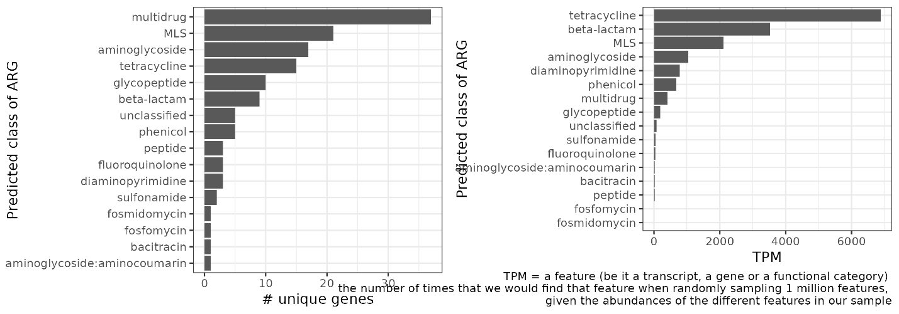
Figure 1. Number of unique genes found in each antimicrobial resistance class (left) and the reads per million of mapped reads normalized by the gene length (TPM) to these classes of ARGs across the dataset of bulk microbiota (right).
We manually assigned mechanism of resistance to each ARG from the CARD database. Interestingly the highest number of unique genes can be found for efflux (so pumps etc.) but looking at the normalized number of reads (TPM) the highest number of genes fall into the group of antibiotic target alteration. This is not influenced by the representation of antibiotic efflux being better represented in the CARD database as we could determine mechanism of resistance for all genes.
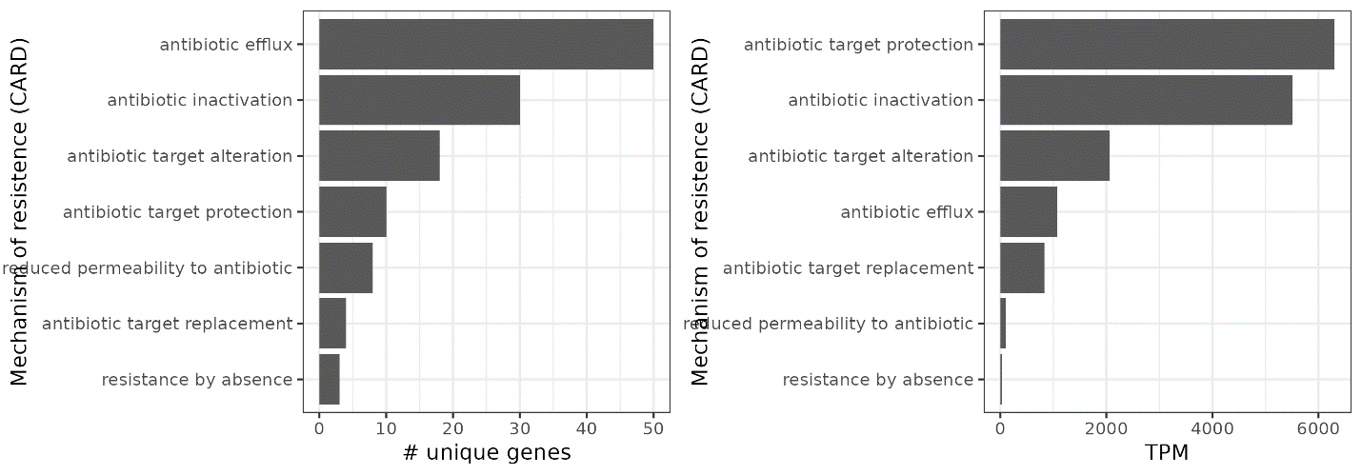
Figure 2. Number of unique genes found in each antimicrobial resistance class (left) and the reads per million of mapped reads normalized by the gene length (TPM) for each mechanism of antimicrobial resistance.
To see which bacteria harbor the most ARGs used the classification of contigs on which ARGs we found with DIAMOND homology searches and using the LCA algorithm to assign taxa within the SqueezeMeta pipeline. We determined that the highest number of different ARG is present in the phylum Bacillota, followed by unclassified Bacteria and Bacteriodota and then Pseudomonadota. While within Bacillota and unclassified Bacteria the most represented class od ARGs is tetracycline, Bacteriodota harbours the highest number of ARGs in class beta-lactam (Figure 3).
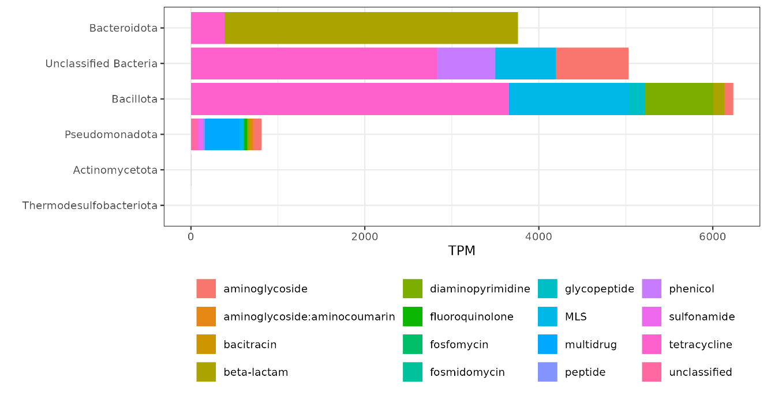
Figure 3. Taxonomic determination of contigs upon which an ARG was found.
We checked the dataset for most clinically important and common antimicrobial genes in Slovenia. And found that in our dataset of 9 health individuals, the most common beta-lactams that are causing most problems in the nosocomial infections, such as bla_{KPC}, bla_{NDM}, bla_{OXA48} or bla_{VIM} which cause carbapenems resistance and bla _{OXA23}, bla_{OXA24} which are present in Acinetobacter baumanii are not present. We found one ORF that was predicted to be CTX-M1 present in only one individual (I), at very low abundance (up to 0.8 TPM).
Hypothesis testing
Our hypothesis states that when microbial diversity will be reduced, there will be an increase in the presence of antimicrobial resistance genes. Reduced microbial diversity simplifies the ecosystem, removing barriers to the proliferation and genetic exchange of resistant bacteria, while at the same time creating new ecological niches for resistant bacteria left behind to thrive in.
This hypothesis can be tested in different ways as out dataset is longitudinal but also includes multiple individuals (we have a population, although small).
On the level of individual (no statistics possible, as there are not enough perturbations)
Is there an increase of reads mapped to ARGs within an individual after a perturbation and consequent lower diversity (AB consumption, travel)?
Is there an increase in the number of unique ARGs within an individual after a perturbation and consequent lower diversity (AB consumption, travel)?
On the level of population
Is there a correlation between the diversity of a sample and number of unique ARGs?
Is there a correlation between the diversity of a samples number of reads mapped to ARGs?
Two individuals within our population consumed antibiotics doxycycline and amoxicillin, E and H, respectively, while individuals A, B, C, and D traveled abroad during the study. Only antibiotic consumption had an influence on microbial diversity (Figure alpha diversity chapter..), but non of the irregular event in any of the individuals could be statistically tested for effect on either the number of unique ARGs or the amount of reads mapped to this ARGs within time points of special notice (Figure 4).
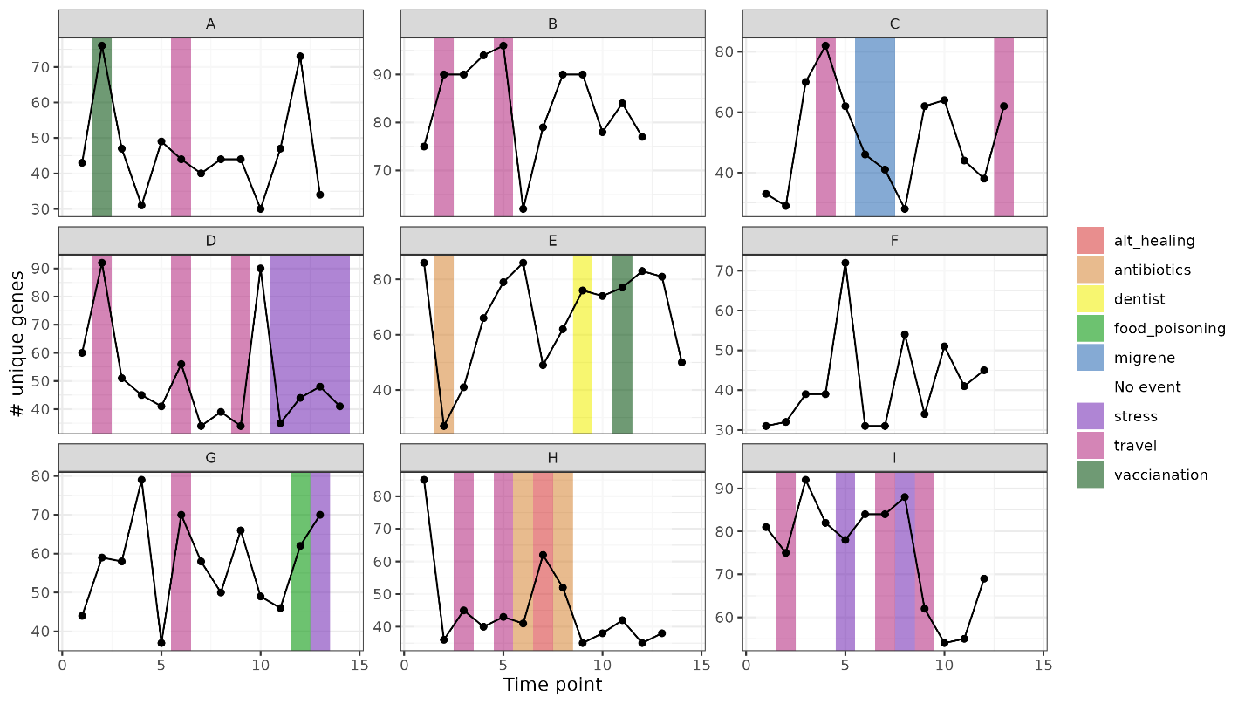
Figure 4. The number of unique antimicrobial resistance genes plotted for each individual at each time point, the background of each point is colored by the event happening in the previous 14 days, white indicates no event happening.
We notice an increase in the number of reads mapped to ARGs in class beta-lactam during antibiotic consumption, but this is not the only increase as individual D also had quite turbulent dynamic of ARGs in class beta-lactam, but did not consume antibiotics. The individual traveled during the study, but the increases/decreases do not correlate with the time of travel, while other individuals that traveled had no increase/decrease of beta-lactams during the study period. While most of the ARG classes show a stable number of unique genes through the study the number of unique ARGs in class MLS changes drastically, this could be due to ? While the number of reads mapped to different ARG classes change more drastically for some (tetracycline, beta-lactam, phenicol) than others and differ between individuals.
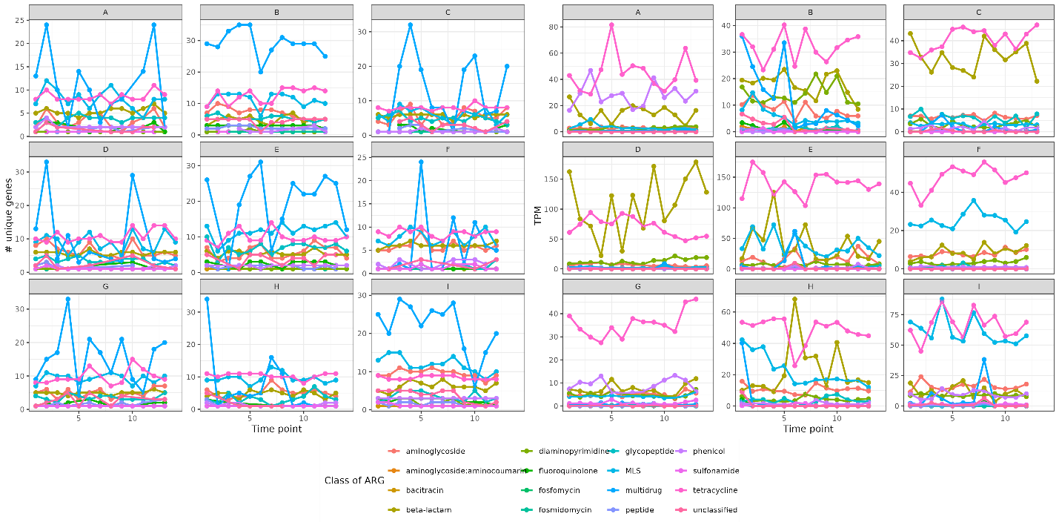
Figure 2. Number of unique genes in ARG classes (left) and of mapped reads per million of reads (TPM) for each ARG within a predicted class of ARGs (right) through time within individual.

The third hypothesis could also be looked at on the level of population not only individual through time. The reason we choose Shannon’s diversity index was because of previous analysis on rarefaction influence on alpha diversity measures, where our type of analysis did not affect Shannon’s diversity index. When looking at overall correlation between Shannon’s diversity index calculated based on OTUs and the number of unique antimicrobial resistance genes in a sample there is a statistically significant (p < 0.05) positive correlation for the classes tetracycline, phenicol, peptide, glycopeptide, beta-lactam and aminoglycoside, but for the class fluoroquinolone there is a statistically significant negative correlation between the number of unique ARGs and Shannon’s diversity. But these correlations do not persist when comparing the number of reads mapped to ARGs (so the number of copies of ARGs). They are different to above correlations. In case of correlations between Shannon diversity and number of mapped reads statistically significant positive correlation is present in the case of aminoglycoside, fosfomycin, gycopeptide, multidrug, mupirocin, nucleoside, phenicol, pleuromutilin, polyamine peptid, suflonamid, tetracycline and statistically significant negative correlation for the classes of beta-lactams, fluoroquinolone, fosmidomycin and triclosan. The correlation is not on the level of individual, but rather samples with higher diversity also possess higher number of antimicrobial resistance genes for some bacterial classes while others do not have correlations.
Correlations between richness of OTUs and ARGs for each person’s time point in both bulk microbiota and ethanol treated samples. There is no correlation between the number of OTUs and the number of ARGs, except in individual H (p = 0.005).
We also checked how beta diversity calculated on OTUs correlates with that calculated on the abundance of ARGs in our samples. There is no correlation between the Bray-Curtis dissimilarity calculated on OTUs and ARGs.
Stability of ARGs over time
Stability can be understood in many ways (see Chapter: A brain dump on stability). Here we have decided to investigate persistence of ARGs within an individual through time coupled with their occupancy (relative abundance). We are aware of the limitation of sequencing as an imperfect method that does not enable to say for sure that something is truly missing or just so rare that we have missed it with our depth of sequencing. But for the reason being we will say that our sequencing was as good as possible, we will not say that something is gone missing but is under the level of detection. A third of ARGs have been detected at all time points (28.6 %). We were unable to detect any loss or gain of a new ARG within an individual, even in individuals that had perturbations (AB or travel).

SUPPLEMENT TO RESULTS
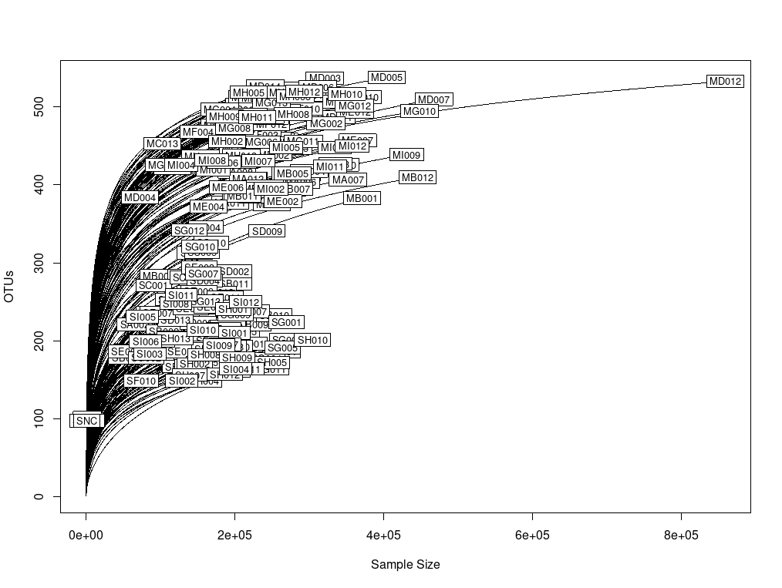
Supplement Figure 1. Rarefaction curve for all samples.

