UNIVERSITY OF LJUBLJANA
BIOTECHNICAL FACULTY

Urša MIKLAVČIČ

LONGITUDINAL STABILITY OF HUMAN GUT MICROBIOTA AND SPOROBIOTA
IN HEALTHY VOLUNTEERS

DOCTORAL DISSERTATION

Ljubljana, 2026
UNIVERSITY OF LJUBLJANA
BIOTECHNICAL FACULTY

Urša MIKLAVČIČ

LONGITUDINAL STABILITY OF HUMAN GUT
MICROBIOTA AND SPOROBIOTA IN HEALTHY VOLUNTEERS

DOCTORAL DISSERTATION

LONGITUDINALNA STABILNOST ČLOVEŠKE ČREVESNE MIKROBIOTE IN SPOROBIOTE PRI ZDRAVIH PROSTOVOLJCIH

DOKTORSKA DISERTACIJA

Ljubljana, 2026

Based on the Statute of the University of Ljubljana and the decision of the Biotechnical Faculty senate, as well as the decision of the Commission for Doctoral Studies of the University of Ljubljana adopted on [date] it has been confirmed that the candidate meets the requirements for pursuing a PhD in the interdisciplinary doctoral programme in Biosciences, scientific field Microbiology. Asst. Prof. dr. Sandra Janežič is appointed as supervisor and Prof. dr. Maja Rupnik as co-supervisor.

Supervisor: Asst. Prof. dr. Sandra Janežič

Co-advisor: Prof. dr. Maja Rupnik

Evaluation and Defence Committee:

President: Prof. dr. Gorazd Avguštin
University of Ljubljana, Biotechnical Faculty, Department of Microbiology, Biotechnology

Member: dr. Denis Kutnjak
National Institute of Biology, Department of Biotechnology and System Biology

Member: Prof. dr. David Berry
University of Vienna, Centre for Microbiology and Environmental Systems Science, Department of Microbiology and Ecosystem Science, Division of Microbial Ecology

Urša MIKLAVČIČ

KEY WORDS DOCUMENTATION

ND Dd
DC UDC … [specified by library]
CX human gut, microbiota, sporobiota, longitudinal analysis, stability, metagenomic sequencing, amplicon sequencing, sporulation frequency, Clostridium saudiense
AU MIKLAVČIČ, Urša
AA JANEŽIČ, Sandra (supervisor), RUPNIK, Maja (co-advisor)
PP SI-1000 Ljubljana, Jamnikarjeva 101
PB University of Ljubljana, Biotechnical Faculty, Interdisciplinary Doctoral Programme in Biosciences, scientific field Microbiology
PY 2026
TI LONGITUDINAL STABILITY OF HUMAN GUT MICROBIOTA AND SPOROBIOTA IN HEALTHY VOLUNTEERS
DT Doctoral dissertation
NO [enter the number of pages of the Roman and Arabic pagination (separated by a
comma), the number of tables, figures, annexes and references
Example: IV, 45 p., 2 tab., 3 fig., 2 ann., 15 ref.]
LA en
AL en/sl
AB [abstract in English]

KLJUČNA DOKUMENTACIJSKA INFORMACIJA

ŠD Dd
DK UDK … [specified by library]
KG človeško črevo, mikrobiota, sporobiota, longitudinalna analiza, stabilnost, metagenomsko sekvenciranje, amplikonsko sekvenciranje, sporulacijska frekvenca, Clostridium saudiense
AV magistrica molekulske in funkcionalne biologije Urša Miklavčič
SA JANEŽIČ, Sandra (mentor/mentorica), RUPNIK, Maja (somentor/somentorica)
KZ SI-1000 Ljubljana, Jamnikarjeva 101
ZA Univerza v Ljubljani, Biotehniška fakulteta, Interdisciplinarni doktorski študijski program Bioznanosti, znanstveno področje Mikrobiologija
LI 2026
IN LONGITUDINALNA STABILNOST ČLOVEŠKE ČREVESNE MIKROBIOTE IN SPOROBIOTE PRI ZDRAVIH PROSTOVOLJCIH
TD Doktorska disertacija
OP [enter the number of pages of the Roman and Arabic pagination (separated by a
comma), the number of tables, figures, annexes and references
Example: IV, 45 str., 2 pregl., 3 sl., 2 pril., 15 vir.]
IJ en
JI en/sl
AI [abstract in Slovene]

TABLE OF CONTENTS

KEY WORDS DOCUMENTATION III
KLJUČNA DOKUMENTACIJSKA INFORMACIJA IV
TABLE OF CONTENTS V
LIST OF TABLES VI
LIST OF FIGURES VII
LIST OF ANNEXES VIII
ABBREVIATIONS AND SYMBOLS IX
1 INTRODUCTION 1
2 LITERATURE REVIEW 2
2.1 TITLE OF SUB-SECTION 2
2.1.1 Title of further sub-section 2
2.1.1.1 Title of further sub-section 2
3 MATERIAL AND METHODS 4
4 RESULTS 5
4 DISCUSSION 6
5 CONCLUSIONS 7
6 SUMMARY (Povzetek) 8
6.1 SUMMARY 8
6.2 povzetek 8
8 REFERENCES 9
ACKNOWLEDGEMENTS 1
ANNEXES 2

LIST OF TABLES

Table 1: Daily intake of selenium in the edible portion (100 g) of various meat products (Petrič, 2010) 3

LIST OF FIGURES

Figure 1: Figure title (Bartol, 2005) 3

LIST OF ANNEXES

Annex A: [The title of the annex (without page number)]

ABBREVIATIONS AND SYMBOLS

[The page (if any) should be titled in capital letters ABBREVIATIONS AND SYMBOLS and centre aligned. Symbols and abbreviations are explained in a list on this page (or further pages). Commonly known symbols (e.g. standard units of measure) are not explained. Also explain on this page abbreviations that you have formed yourself and that are used throughout the following text. Also explain the abbreviation in brackets in the text itself when first used.]

INTRODUCTION

LITERATURE REVIEW

TITLE OF SUB-SECTION

Title of further sub-section

Title of further sub-section

[For in-text citations, the principle of listing last names and years applies. If there are two authors, both last names are listed and separated by the word “and”. If there are more authors, the first is given and then “et al.” is added. When you use a publication of an author as the source of a longer cited text, indicate at the beginning of such a text what will apply to that author.

Examples of citing in the text:

- one author
… (Vidrih, 2009). or … Vidrih (2009) believes that …

- two authors
… (Abram and Simčič, 2000). or … Abram and Simčič (2000) state that the …

- three or more authors
… (Korošec et al., 2006). or … Korošec et al. (2006) claim that …

- anonymous work (authors are not indicated)
... we used the formulas (Manual ..., 2017).
... the plant protection product must not be used (Prohibition Policy ..., 2005).
... The Animal Protection Act (2007) specifies ...
... complied with the international standards (ISO 7144, 2000; ISO 7160, 2004)

- if multiple works by the same author are cited from the same year
... in subsequent measurements (MacFarland, 2017a, 2017b), the results are …

- if we cite sources by the same author published in different years
… in subsequent measurements (MacFarland, 2017, 2019), the results are ...

Examples of designing tables and figures:

According to the standard, the uniform term “figure” is intended for images, drawings and photographs, as well as graphic images (charts). The titles of tables are written above the tables and the titles of figures below them. Both are numbered separately and consecutively.

When tables or figures are taken from other sources, the information about them is given in brackets right after the title of the table or figure. The source from which the tables or figures are taken are indicated in the References section, in accordance with the reference listing instructions.

A common design of tables and figures is recommended (example Table 1, Figure 1). The columns and rows are not separated unnecessarily by drawn borders.

Table 1: Daily intake of selenium in the edible portion (100 g) of various meat products (Petrič, 2010)
Type of meat product | Selenium content in the edible por-  tion (μg/100 g) | Selenium content in the edible portion according to the daily intake 50 μg/day (%)
Cooked prosciutto | 6,8 | 13,6
Classic hot dog | 3,4 | 6,8
Karst prosciutto | 13,2 | 26,5

If the table is longer than one page, write “Continuation” at the bottom of the first page and
“Continuation of Table 1” at the top left of the next page. Then enter the line with the table
header again on the next page, at the beginning of the continuation.

Each figure and table must be fully described (units given, abbreviations explained), so that no reading of other text is necessary for understanding.

Figure

Figure 1: Figure title (Bartol, 2005)]

MATERIAL AND METHODS

[In the sections MATERIAL, RESULTS, DISSCUSSION, CONCLUSIONS and SUMMARY the writing style should be unified.]

RESULTS

DISCUSSION

CONCLUSIONS

SUMMARY (Povzetek)

[The main results are presented only in the text, without tables and figures. Summarize all elements of the IMRAD structure, but without specifically titled sections.]

SUMMARY

povzetek

[Obligatory summary in Slovenian, at least 8 pages long.]

REFERENCES

[The final numbered section References contains a list of cited sources. The references are arranged alphabetically and chronologically (the older ones first) by the first author or title (for
references without known authors). For multi-line references, the subsequent lines are indented
to approximately below the third letter of the first line. When citing web resources (URL), we
recommend an active link.

Important:
- All cited references must be in primary (full) form.
- We list all the works we have referred to in our text. The works we have not referred to are not included in this list.
- Titles of English works (title of article, title of book, title of chapter) are indicated with lowercase letters, unless a grammatical rule requires the use of a capital letter (e.g. Molecular ecology and not Molecular Ecology). Journal titles are capitalized, e.g., Journal of Molecular Ecology.
- When the year of publication of the document or record is not given, we write n.y. (no year) when citing in the text itself, but we do not write this in the section References.
- We write the names of all authors (and not “et al.” as in text).

Examples of citing most common types of sources in the section REFERENCES:
Articles:
Bartol T. 2007. Pregled in analiza izbranih podatkovnih zbirk ter predmetnih oznak za področje lesarskih znanosti in tehnologije. Zbornik gozdarstva in lesarstva, 83: 3–14
Blasco E., Gonzalez-Olabarria J. R., Rodriguez-Veiga P., Pukkala T., Kolehmainen O., Palahi M. 2009. Predicting scenic beauty of forest stands in Catalonia (North-east Spain). Journal of Forestry Research, 20, 1: 73–78
Strašek Smrdel K., Avšič T. 2021. The detection of Anaplasma phagocytophilum and Babesia vulpes in spleen samples of red fox (Vulpes vulpes) in Slovenia. Slovenian Veterinary Research, 58, 3: 103–109, https://doi.org/10.26873/SVR-1206-2020
Knight A., Satchell L. 2021. Vegan versus meat-based pet foods: owner-reported palatability behaviours and implications for canine and feline welfare. PLoS ONE, 16, 6: e0253292, https://doi.org/10.1371/journal.pone.0253292
An example of an article when the year and issue are not yet known (online first):
Yadav A., Kumar N., Upadhyay A., Anurag P., Anurang K. R. 2021. Edible packaging for fruit processing waste: a comprehensive review. Food Reviews International, https://doi.org/10.1080/87559129.2021.1940198
Scientific and professional books (monographs) in full:
Bush T. 2003. Theories of educational leadership and management. 3rd ed. London, Sage Publications
Glumac R. 2017. Comparative analysis of stakeholders' expectations from the agri-environmental programme in Slovenia and Croatia: doctoral dissertation. Ljubljana, Biotechnical Faculty
Šiško M. 2022. Mikropropagacija koščičarjev. Maribor, Univerzitetna založba Univerze v Mariboru, https://doi.org/10.18690/um.fkbv.8.2022
Chapters in books with editor:
Leštan D. 1996. Načrtovanje eksperimentalnega preučevanja bioprocesov. V: Biotehnologija: osnovna znanja. Raspor P. (ed.). Ljubljana, Bia: 397–409
Richards E., Fearon A. M. 2003. Butter: the product and its manufacture. V: Encyclopedia of food sciences and nutrition. 2nd ed. Caballero B., Trugo L. C., Finglas P. M. (eds.). Amsterdam, Academic Press: 718–726, https://doi.org/10.1016/B0-12-227055-X/00138-3
Poklar Ulrih N., Prislan I., Cigić B. 2019. Coumaric and cinnamic acids in food. V: Handbook of dietary phytochemicals. Xiao J., Sarker S., Asakawa Y. (eds.). Singapore, Springer: 1–40, https://doi.org/10.1007/978-981-13-1745-3_24-1
Other internet sources:
Jennings L. 2020. Antibiotics: the good, the bad and the ugly. Washington University in St. Louis, Institute for Public Health, https://publichealth.wustl.edu/antibiotics-the-good-the-bad-and-the-ugly/ (15 Feb. 2022)
SURS. 2022. Kazalniki ekološkega kmetijstva, Slovenija, letno. Ljubljana, Statistični urad RS, https://pxweb.stat.si/SiStatData/pxweb/sl/Data/-/3268606S.PX (17 Jan. 2023)
Berkshire breed page. British Pig Association, https://britishpigs.org.uk/berkshire (15 Dec. 2022)
When citing online databases, check on the website if there is a recommended citation and adjust the order of the citation elements (e.g. https://support.nlm.nih.gov/knowledgebase/‌article/‌‌‌KA-03391/en-us).]

ACKNOWLEDGEMENTS

[Acknowledgements and annexes are not numbered by page.

At its 7th session on 27 May 2013, the Senate of the Biotechnical Faculty decided that the indication of the logo of the co-financier should be indicated in doctoral dissertations in the section Acknowledgements.]

ANNEXES
ANNEX A
Participant questionaries

ANNEX A1. Questionnaire submitted at the beginning of the study with instructions for participants on how to submit their samples. The original version was in Slovene and was translated into English for purposes of this study.

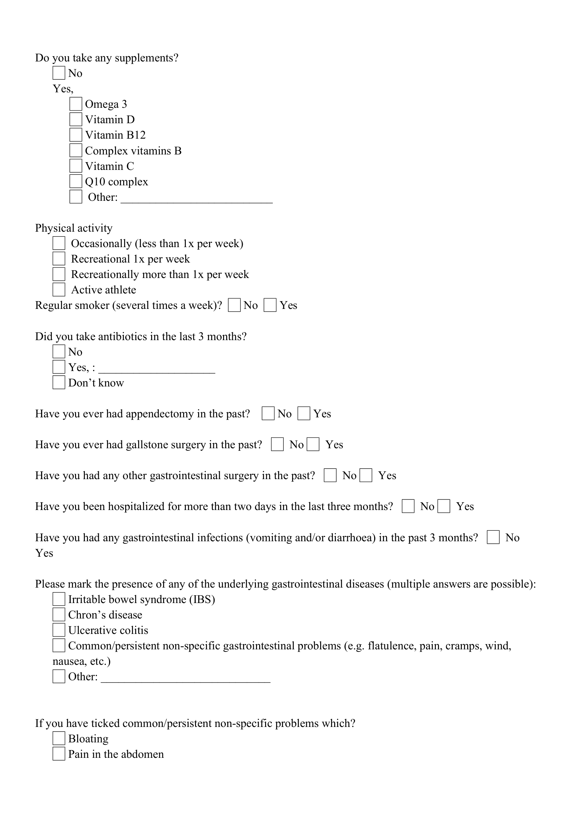
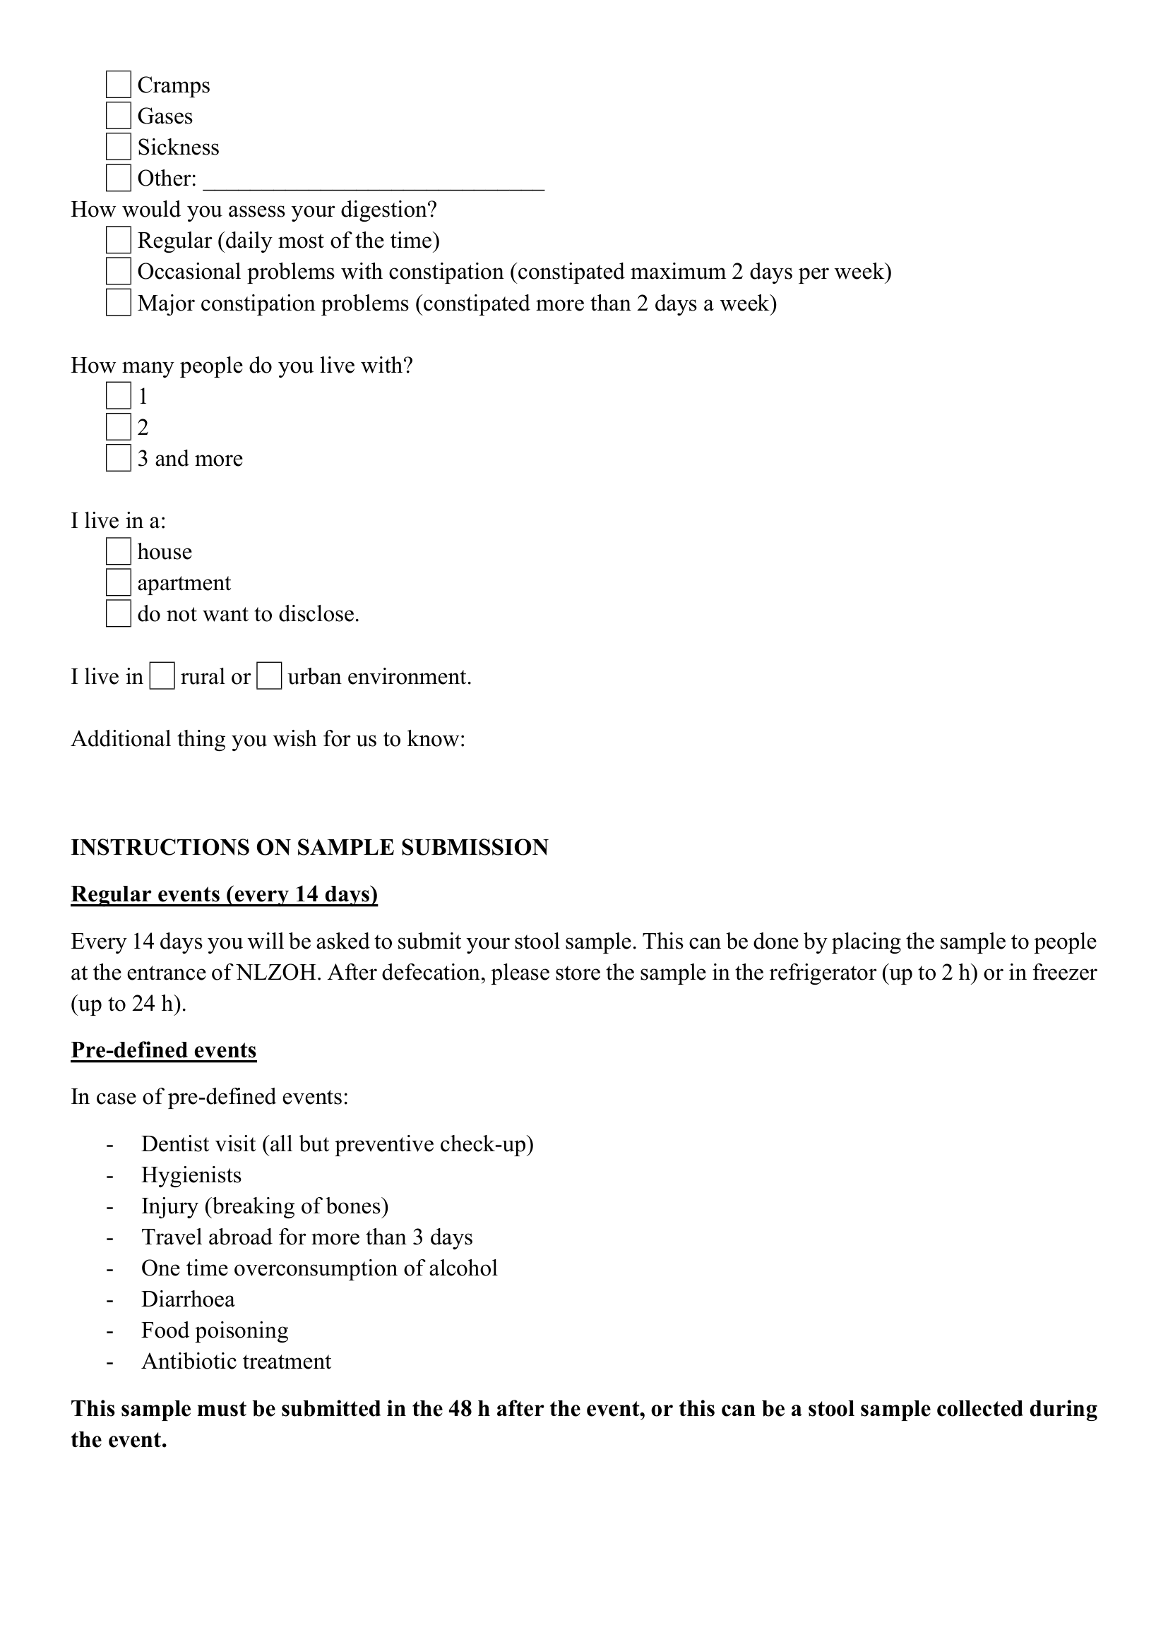

ANNEX A2. Questionnaire submitted at each regular (every 14 days) submission of stool sample. The original version was in Slovene and was translated into English for purposes of this study.

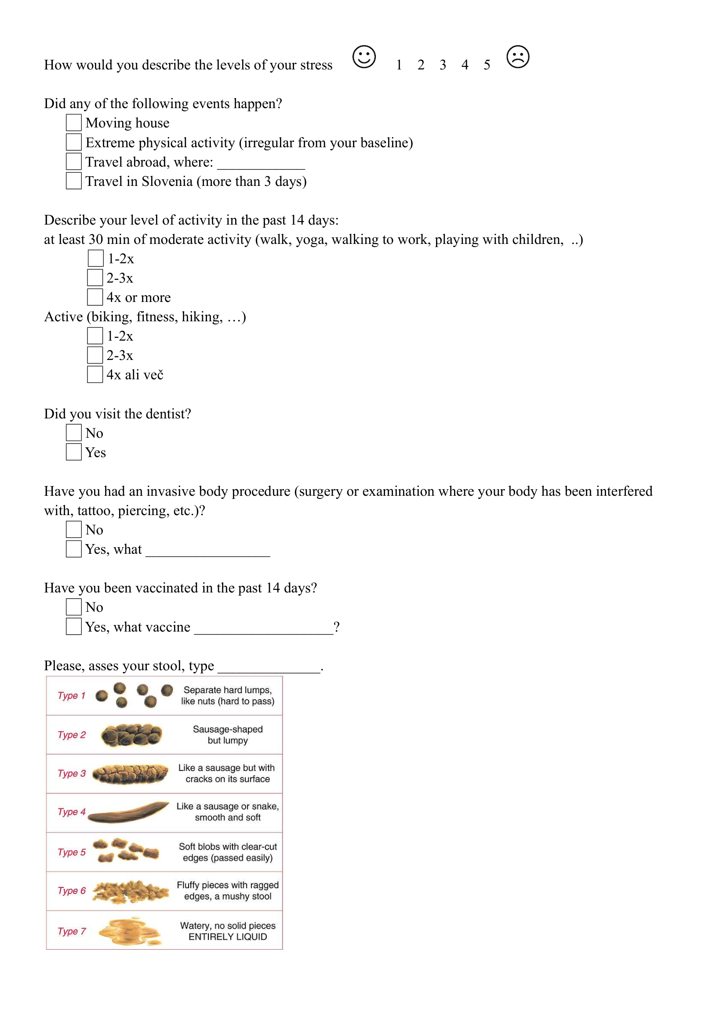
ANNEX A3. Questionnaire submitted with pre-defined events submission of stool sample. The original version was in Slovene and was translated into English for purposes of this study. 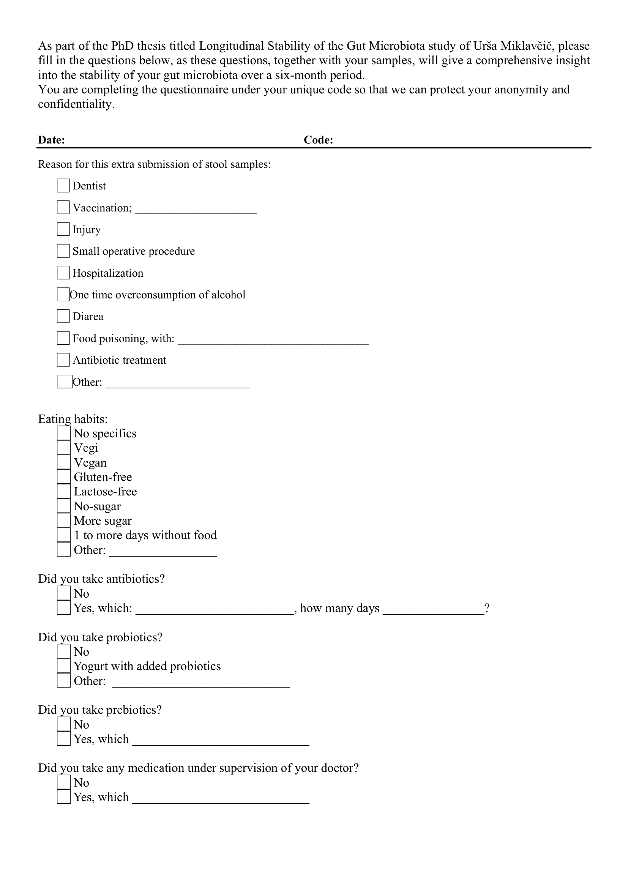
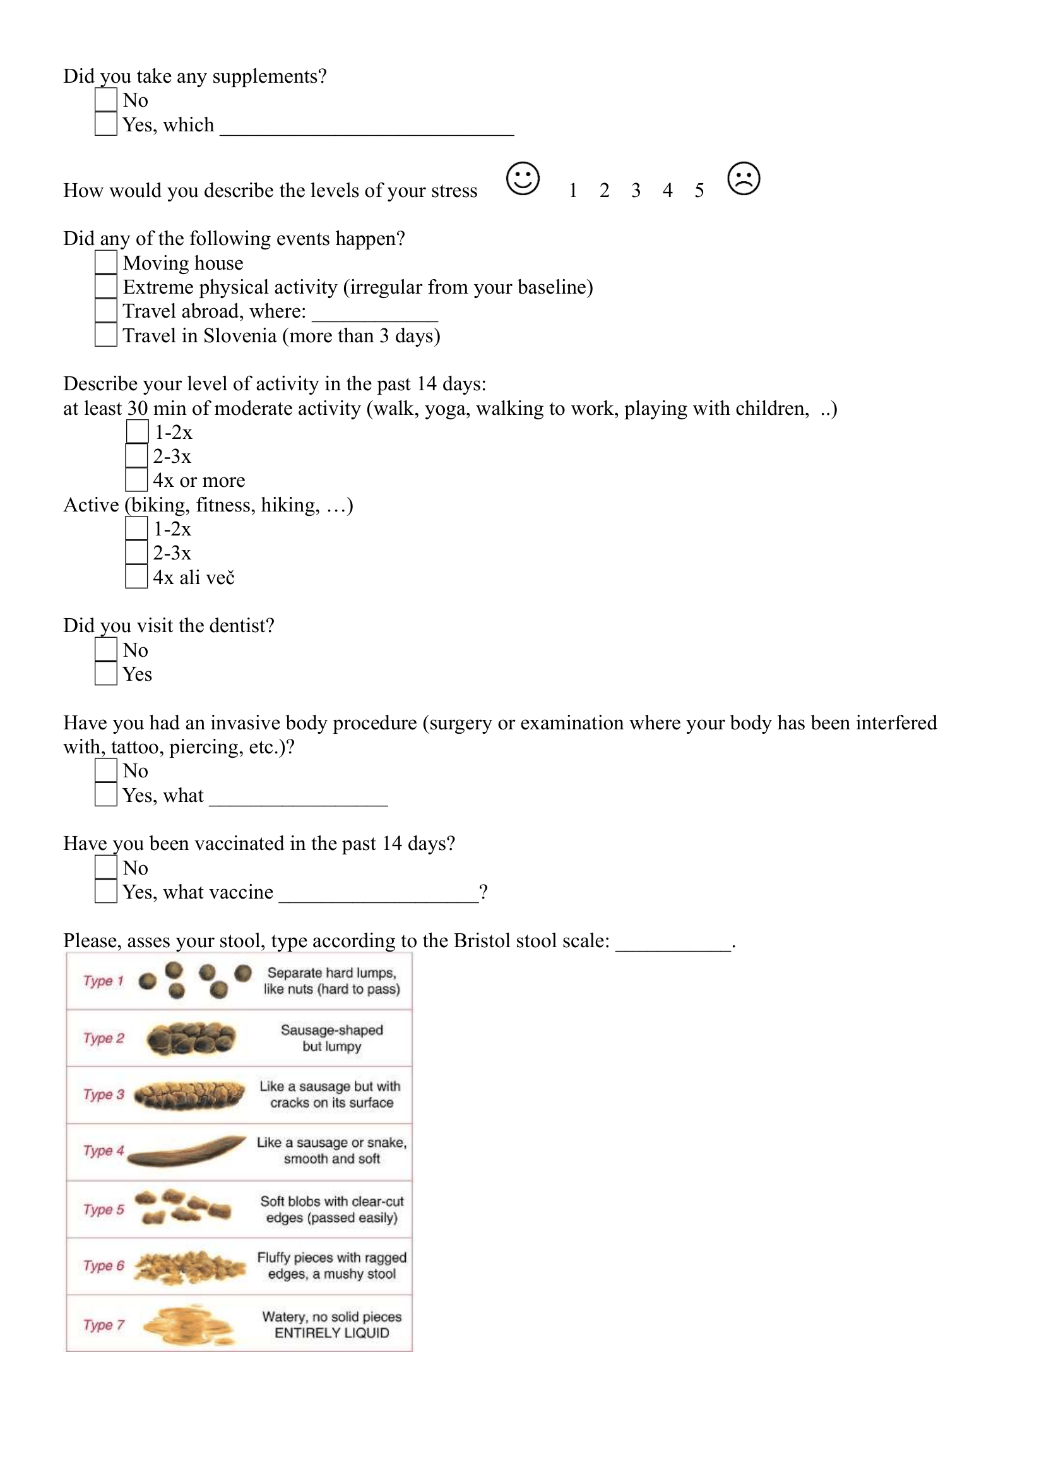

ANNEX B
General information from participants collected with questionnaires

Table 2. General information on the participants. Questionnaires were filled out at each stool sample submission and events were reported for the previous 14 days, so we report the day of reporting and not necessary the day of event. For a more detailed account of each sample a metadata table is available in the GitHub repository under the folder `data/metadata.csv`.
Participant | Age | BMI | Diet | Constant food supplements | Antibiotic consumption | Probiotics | Travel | Stress | Other reported events
A | 34 | 23 | omnivore | omega 3 |  |  | Day 61: Croatia
B | 25 | 22 | omnivore | - |  | Day 26: Biotics strong | Day 26: Tanzania, Kenia; Day 69: Croatia
C | 27 | 24 | omnivore | protein powder |  |  | Day 49: UK |  | Migraines between days 70 to 84.
D | 37 | 24 | omnivore | probiotic yoghurt, protein powder |  |  | Day 23: Switzerland, Austria; Day 76: Netherlands | Day 149 to 191
E | 28 | 23 | omnivore | - | Day 6 to 14: doxycycline | Day 6 to 14, 72: linexForte, Omnibiotic Stress Repair, kefir
F | 27 | 33 | omnivore | - |  |  | Day 28: Croatia
G | 27 | 26 | omnivore | protein powder |  | Day 155: linexForte | Day 30: Croatia | Day 169 | Food poisoning on day 154
H | 43 | 29 | omnivore | - | Day 70 to 84: amoxicillin | Day 70 to 84: linexForte | Day 30: Croatia; Day 61: BIH
I | 30 | 18 | lactose-free omnivore | Omega 3, vitamin D, complex B.Q10, probiotics: Vivomox, EkoŠrknicl Unibiotic Strong

Table 3. Bacterial strains reported in the probiotics consumed by participants.
Probiotic (manufacturer) | Bacterial strains
Biotics Strong (FutuNatura, EU) | Bifidobacterium longum, Lactobacillus plantarum, Lactobacillus reuteri, Lactobacillus acidophilus, Bifidobacterium lactis, Lactobacillus rhamnosus, Lactobacillus crispatus, Bifidobacterium bifidum, Lactobacillus casei, Lactobacillus paracasei, Bifidobacterium breve, Lactobacillus sporogenes, Lactobacillus gasseri, Lactobacillus lactis, Lactobacillus brevis, Lactobacillus salivarius, Lactobacillus bulgaricus, Bifidobacterium adolescentis, Streptococcus thermophilus,
Linex Forte (Chr. Hansen, Denmark) | Lactobacillus acidophilus LA-5, and Bifidobacterium animalis subsp. lactis BB-12
Omnibiotic Stress Repair (OMNi-BiOTiC, Austria) | Lactobacillus casei W56, Lactococcus lactis W19, Lactobacillus acidophilus W22 , Bifidobacterium lactis W52, Lactobacillus paracasei W20, Lactobacillus plantarum W62, Bifidobacterium lactis W51, Bifidobacterium bifidum W23, Lactobacillus salivarius W24
Vivomixx (US) | Streptococcus thermophilus, Bifidobacterium breve, Bifidobacterium longum, Bifidobacterium infantis, Lactobacillus plantarum, Lactobacillus acidophilus, Lactobacillus paracasei, Lactobacillus dilbeckii subsp. Bulgaricus
EkoŠkrnicl Unibiotic Strong (BIO PAK Nutracevtika, Slovenia) | Lactobacillus acidophilus, Lactobacillus bulgaricus, Lactobacillus casei, Bificobacterium breve, Lactobacillus plantarum, Lactobacillus brevis, Lactobacillus paracasei, Lactobacillus rhamnosus, Bifidobacterium breve, Bifidobacterium lactis, Bifidobacterium longum, Lactococcus lactis, Streptococcus thermophilus, Lactobacillus reuteri, Lactobacillus salivarius, Lactobacillus helveticus

Table 4. Details on protocols for bulk DNA isolation from human stool samples.
Protocol | QIAamp Fast DNA Stool Mini Kit | NucleoSpin Soil Mini Kit | QIAamp PowerFecal Pro DNA Kit | in-house protocol based on DNeasy Blood and Tissue Kit
Manufacturer | QIAGEN | Macherey-Nagel | QIAGEN | QIAGEN
Cell lysis | Mechanical (bead-beating using MagnaLyser; 7000rpm, 70s) & heating the lysate at 95 °C for 5 min | Mechanical (bead-beating by vortexing; max speed, 5 min) | Chemical (CD1 solution) & Mechanical (bead-beating by vortexing; max speed, 10 min) | Chemical (ATL buffer) & Mechanical (bead-beating by MagnaLyser; 7000 rpm 70 s)
Bead-beating tubes, beads and solutions | 2,0 ml nuclease-free tubes (Starstedt, DE) with 0.1 mm (0.25 g) and 0.5 mm (0.25g) silica beads (Biospec Products, US) containing Inhibitex buffer | NucleoSpin Bead Tube Type A containing SL2 lysis buffer | PowerBead Pro Tubes (2 ml) containing PowerBead and C1 solution | 2,0 ml nuclease-free tubes (Starstedt, DE) with 0.1 mm (0.25 g) and 0.5 mm (0.25 g) silica beads (Biospec Products, US) and ATL buffer

ANNEX C
Cultivation of spore-forming bacteria from human stool samples after ethanol or heat shock
We compared different variations of ethanol and heat shock on stool samples to determine, which treatment is more effective for elimination of vegetative cells and later isolation of spore-forming bacteria from stool samples and subsequent culturing. There are two generally used treatments for elimination of vegetative cells from pure cultures of spore-forming bacteria, heat shock and ethanol shock with multiple variations (Setlow, 2014). We choose to test ethanol shock using 100% and 70% ethanol and heat shock performed at 80 °C for 30 or 60 min. Two stool samples were aliquoted and subjected to shock treatment. For ethanol shock, aliquots were resuspended in 1,5 ml of 70% or 100% ethanol and incubated for 24 h with vigorous shaking (1500 rpm) on thermomixer (Eppendorf, Germany) at room temperature (23 °C). For heat shock, stool aliquots were resuspended in 1,5 ml of 0.9% NaCl solution and heated for 30 or 60 min at 80 °C with vigorous shaking (1500 rpm) on thermomixer (Eppendorf, Germany). After the shock treatment samples were washed 3 times with distilled water. At the last washing step, each sample was separated in half. One half of the pellet was resuspended in 500 µl distilled water and second was resuspended in 500 µl 5% bile acids solution (Sigma-Aldrich, USA). The resuspended pellets were plated in whole on BHIS agar medium (1,5% agar) or added to liquid BHIS media. BHIS is composed of brain-heart infusion (BHI, Biolife, Italy) with 0.1% L-cysteine (Merck, USA) and 0.5% yeast extract (Biolife, Italy). Incubation took place in the anaerobic workstation (Whitley A35, Don Whitley Scientific, UK) at 37 °C for 14 days. On the 1st, 2nd, 5th, 7th, and 14th day colony forming unit (CFU) was counted on plates or 100 µl of liquid culture was plated confluently and CFU was counted the next day. On the 2nd, 5th, 7th, and 14th day two plates were swabbed in whole or 0,5 ml of liquid culture was used for DNA isolation. DNA was isolated using MasterPure™ Complete DNA and RNA Purification Kit (Lucigen, US) with a pre-step of bead-beating the sample in Cell Lysis Solution with 0,5 g of 0,5 mm silica beads. Bead-beating was performed on MagNA Lyser (Roche Diagnostics, Germany) for 70 s at 7000 rpm.
The goal was to evaluate the efficacy of ethanol or heat shocks in eliminating vegetative cells from stool samples to improve cultivation of spore-forming bacteria. Additionally, we tested the impact of adding bile acids and/or enrichment in liquid culture to enhance germination of spores. Over a 14-day anaerobic cultivation, we monitored colony-forming unit (CFU) and community structure based on 16S rRNA.
CFU was influenced by the addition of 5% bile acids solution both in enrichment media and on plates (Figure 18). When bile acids were added to enrichment media prior to plating, bacterial growth was inhibited after day 2 (CFU < 10), whereas enrichment without bile acids resulted in over 100 colonies after the same period. Conversely, on plates without prior enrichment, addition of bile acids accelerated germination and replication, yielding over 150 CFU on day 1, compared to similar CFU observed only after day 5 without bile acids.
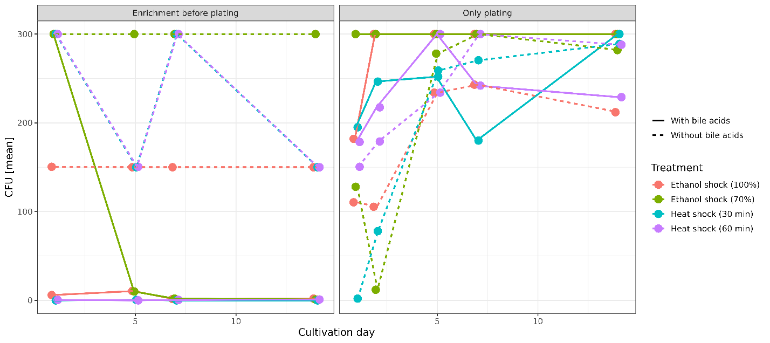
Figure 18. Colony-forming unit was influenced by addition of bile acids to the enrichment media and agar plates. Bacterial growth with and without enrichment step on BHIS, with and without the addition of bovine bile acids after two variations of ethanol concentration (100% or 70%) and heat shock at 80 °C (30 or 60 min) on days 1, 2, 5, 7, and 14.
More OTUs were detected in the enrichment cultures, especially with addition of BA than agar plates, both with and without addition of BA. This is contrary to the observed CFU, supported by a negative correlation between CFU and number of OTUs (Pearson correlation, p < 0.005). The composition of stool samples was that of healthy western individuals (45.3% Bacillota, 34.1% Bacteriodota, 3.6% Actinomycetota, 8.2% Pseudomonadota, 4% Verrucomicrobiota, 2.8% unclassified Bacteria and 1.4% other phyla). All treatments were able to some degree eliminate the non-spore-forming bacteria, but ethanol shock using 70% ethanol eliminated the greatest number of known non-sporeformers in the phyla Bacteriodota and Verrucomicrobiota (Figure 19). A reduction also happened in the phyla Pseudomonadota and Actinomycetota although some representatives withstood both ethanol and heat shocks.

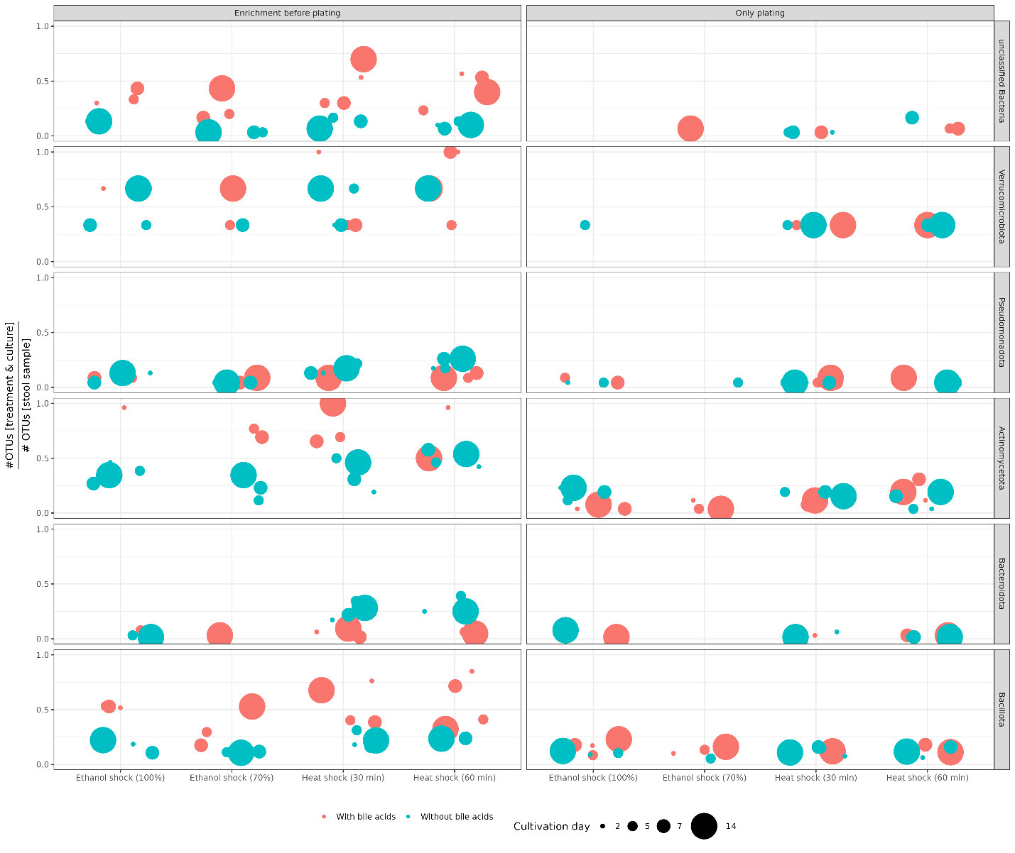
Figure 19. All treatments were able to eliminate the non-spore-forming bacteria to some degree, but ethanol shock using 70% ethanol eliminated the greatest number of known non-sporeformers. Ratio between the number of OTUs in the original stool samples (n = 2) and the number of OTUs after heat/ethanol shock and cultivation/with prequal enrichment with and without bile acids on 2, 5, 7, and 14 days.

ANNEX D
Details on sequencing experiments

Table 5. Details on sequencing experiments in this dissertation.
Sequencing platform | Illumina MiSeq |  |  | Illumina NextSeq2000 | BGI DNBSeq | Illumina NextSeq2000 | Oxford Nanopore MinION
Experiment | Comparison of isolation protocols | Comparison of ethanol and heat shock in elimination of vegetative cells from stool samples and subsequent cultivation of sporeformers | Optimization of pre-treatment for DNA isolation from spore-forming bacteria in stool samples | Longitudinal study of gut microbiota and ethanol treated stool samples |  | Population comparison of Clostridium saudiense
Type of sequencing | Amplicon sequencing (V3-V4 region of the 16S rRNA gene) |  |  |  | Shotgun metagenomic sequencing | Whole genome sequencing
Indexing | 16S Metagenomic Sequencing Library Preparation protocol |  |  |  | MGI Sequencing Prep Kit | NEBNext Ultra II FS DNA Library Prep Kit for Illumina | Rapid Barcoding Kit 24 SQK-RBK114.24
Polymerase | Kapa HiFi | Q5 |  |  | Phi29 | Q5 | Ligation
Number of samples/ sucessfully seqenced | 36/36 | 34/34 | 28/28 | 236/236 (117 of bulk microbiota and 117 of ethanol treated + 2 negative controls ) | 201/234 (116 of the bulk microbiota and 85 from the ethanol treated) | 44/45 | 5/5
Negative control | Not sequenced due to low DNA concetration | Not included in experiment, control for experiment was untreated stool sample | Not sequenced due to low DNA concentration. Controls were untreated stool sample and stool sample treated with ethanol and heat shock, but not EMA | Sequenced | Not sequenced | Sequenced | Not applicable
Read length | Paired-end 300 bp |  |  |  | Paired-end 150 bp |  | N50 6,04 kb
Mean number of reads per sample | 905 15 | 250 06 | 270 662 | 270 662 | 50 000 000 | 1 610 348 (details Table 5.) | 372,74 Mb (detalis Table 5.)
Filtering parameters | MiSeq SOP mothur, with rarefaction to: |  |  |  | Remove < 10% uncertain bases, Q > 20, more than 90% identity to host (GRCh38) | Trimmomatic ILLUMINACLIP:NEBPE-PE.fa:2:30:10, LEADING:10, TRAILING:10, SLIDINGWINDOW:4:20, MINLEN:40 | Q > 10, read length > 3000 bp
 | 50 000, remove OTUs < 10 reads | 10 000, remove OTUs < 10 reads | 10 000, remove OTUs < 10 reads | 150 000, remove OTUs < 62 reads
Project accession | PRJNA887005 | Data available upon request |  | PRJNA1124620 |  | PRJNA1428727

Table 6. Details on quality control of whole genome sequencing of bacterial isolates with Illumina short-read and ONT long-read technology. Genomes marked with asterisk (*) were removed from analysis.
Genome | Illumina short-read QC |  |  | Nanopore long-read QC
 | Read counts (after trimming) | Mapping rate (% reads mappes back to assembly) | Average coverage | Total bases unflitered (Mb) | Total bases after filtering (Mb) | N50 (after filtering) | # contigs
H005_102 | 1284641 | 98,8 | 87 |  |  |  | 146
H005_118 | 1834523 | 99,0 | 129 | 466,2 | 257,1 | 5870 | 11
H005_126 | 1202945 | 99,2 | 42
H005_137 | 1469188 | 98,9 | 99 |  |  |  | 123
H005_73 | 1429558 | 98,8 | 99 | 263,43 | 141,6 | 5358 | 15
H005_75 | 1509356 | 98,6 | 105 |  |  |  | 119
H005_77 | 1519024 | 98,7 | 107 |  |  |  | 117
H005_94 | 1236201 | 99,3 | 91 |  |  |  | 71
H005_97 | 1419063 | 98,8 | 99
H005_98 | 1412733 | 99,1 | 97 | 501,26 | 333,5 | 6797 | 7
H007_145 | 1561483 | 98,6 | 106 |  |  |  | 145
H007_146 | 1485553 | 98,6 | 100 |  |  |  | 139
H007_148 | 1480170 | 98,8 | 100 |  |  |  | 133
H007_154 | 1423667 | 98,7 | 96 |  |  |  | 126
H007_156 | 1804629 | 98,5 | 121 |  |  |  | 130
H007_157 | 1606627 | 98,8 | 111 |  |  |  | 123
H007_158 | 1375079 | 99,0 | 95 |  |  |  | 129
H007_162 | 1308147 | 98,9 | 89 |  |  |  | 123
H007_172 | 1443359 | 98,5 | 99 |  |  |  | 136
H007_176 | 1685697 | 99,1 | 117 | 364,29 | 188,6 | 7355 | 6
H007_181 | 1268211 | 98,7 | 88 |  |  |  | 119
H007_183 | 1434111 | 98,5 | 98 |  |  |  | 130
H007_187 | 1897764 | 98,7 | 131 |  |  |  | 133
H007_188 | 1878395 | 98,9 | 122 |  |  |  | 127
H007_190 | 1663746 | 98,6 | 111 |  |  |  | 126
H007_194 | 1789766 | 98,7 | 116 |  |  |  | 136
H009_202 | 1683849 | 98,9 | 111 |  |  |  | 158
H009_205 | 1866064 | 98,7 | 120 |  |  |  | 162
H009_211 | 1505909 | 99,0 | 97 |  |  |  | 151
H009_213 | 1782794 | 99,0 | 126 |  |  |  | 128
H009_215 | 2161024 | 98,6 | 147 |  |  |  | 106
H009_217 | 1697678 | 98,7 | 116 |  |  |  | 149
H009_218 | 1774983 | 98,9 | 127 |  |  |  | 101
H009_219 | 1688393 | 99,1 | 116 |  |  |  | 149
H009_220 | 1391742 | 99,0 | 100 |  |  |  | 105
H009_221 | 1682869 | 98,8 | 120 | 268,51 | 109,9 | 5828 | 5
H009_228 | 1668854 | 98,8 | 115 |  |  |  | 143
H009_230 | 1987518 | 98,6 | 143 |  |  |  | 119
H009_234 | 1560947 | 98,8 | 111 |  |  |  | 130
H009_236 | 2001000 | 98,7 | 139 |  |  |  | 147
H009_251 | 1349494 | 98,8 | 94 |  |  |  | 149
H009_255 | 1908259 | 99,0 | 134 |  |  |  | 138
H009_256 | 1984918 | 97,3 | 119 |  |  |  | 524
H009_259 | 1735392 | 99,01 | 120 |  |  |  | 154

ANNEX E
Properties of OTUs and species excluded from analysis due to being found only in ethanol treated samples or undetermined in the ethanol-resistant community analysis

From the analysis of ethanol-resistant community in the 16S AS data, we removed 229 OTUs either because they were only found in ethanol treated samples (n = 152) or were undetermined (n = 77), as shown in Table 7. OTUs found only in ethanol treated samples are most likely a sampling error, as they were not found in untreated samples or were present in very low abundance and could only be detected once more dominant OTUs were removed via ethanol shock and EMA treatment. Their relative abundance in ethanol treated samples is unreliable, as we removed a lot of taxa with ethanol shock and EMA treatment, but are present at very low abundances from 0.000006 to 0.0009% of total abundance per sample (Figure 20). They are mostly from phylum Bacillota (n = 107), followed by OTUs from phylum Actinomycetota and Pseudomonadota (n = 10 and n = 9, respectively). Some 8 representatives are from the phylum Bacteroidota while less than 4 representatives each come from phyla Fucobacteria, Verrucomicrobiota and unclassified Bacteria.

From the analysis of ethanol-resistant community in the metagenomic data, we removed 273 species either because they were detected only in ethanol treated samples (n = 110) or were undetermined (n = 163), as shown in Table 7. Again, the species detected in ethanol treated samples only have unreliable relative abundance due to removal of other species, as well as also ethanol treated samples were not sequenced successfully due to low DNA concentration. Species detected in ethanol treated samples only were manly from phylum Bacillota (n = 81), followed by Actiinomycetota (n = 18), Pseudomonadota (n = 6), Saccharibacteria (n = 3), and one from each Mycoplasmatota and Bacteroidota.

Table 7. Number of taxa detected in different samples and communities based on our criteria.
 | 16S amplicon data (OTUs) | Metagenomic data (species)
All samples (untreated + ethanol treated) | 2572 | 1027
Untreated samples | 2420 | 915
Ethanol treated samples | 152 | 110
Ethanol resistant community | 441 | 253
Non ethanol-resistant community | 1932 | 501
Undetermined | 77 | 163
Sporeforming |  | 236
Non sporeforming |  | 292
Sporulation could not be determined |  | 500

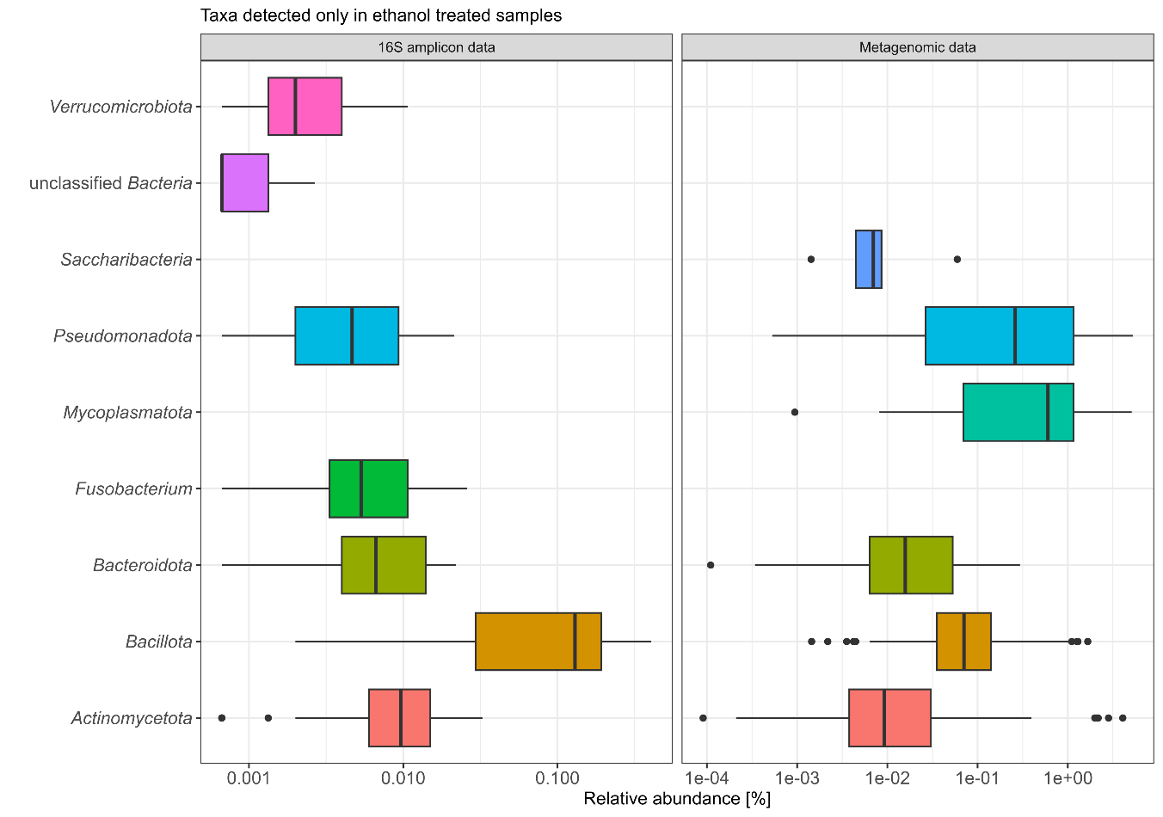
Figure 20. Relative abundance of OTUs and species detected only in ethanol treated samples divided per phylum.
Undetermined OTUs represent 23.1% of total relative abundance across all samples, most of this OTUs belong to phylum Bacillota (n = 72), followed by Actinomycetota (n = 6), and Bacteroidota, Fusobacterium and Pseudomonadota with one representative each, two OTUs are unclassified Bacteria.
Undetermined species represent 13.7% of total relative abundance across all samples, most of this species belong to phylum Bacillota (n = 135), Bacteroidota (n = 10), Actinomycetota (n = 6), and Pseudomonadota (n = 6). Other phyla have less than 3 representatives each.
ANNEX F
Efficiency of DNA isolation from Clostridioides difficile spores using the PowerFecal protocol and support for sporulation frequency calculation

Clostridioides difficile (strain VPI10463) was cultured from spore stock solution and plated confluently on three Columbia agar plates with 5% added horse blood (COH) plates (Biomérieux, France). After five days of anaerobic incubation at 37 °C, spores and cells were harvested and washed five times with ice-cold nuclease-free water. Washed spores were treated with EMA (2.5 ng/µl), sample was incubated for 5 minutes in the dark, followed by 10-minute exposure to 8000-lumen light with ice cooling. A fresh stool sample was homogenized and aliquoted (~100 mg) into PowerFecal bead-beating tubes. DNA was isolated from stool samples and from stool samples spiked with spores at various dilutions (non-diluted, 10⁻¹, 10⁻³, and 10⁻⁴), in triplicates with PowerFecal Kit (Qiagen, Germany). The same spore dilutions were also plated on COH agar to determine CFU count.
Droplet digital PCR (ddPCR) was performed using EvaGreen QX200 technology (Bio-Rad, USA) for the quantification of C. difficile, using C. difficile-specific primers targeting the 16S rRNA gene F(5’ CCATCCTGTACTGGCTCACCT-3’) and R(5’- TTGAGCGATTTACTTCGGTAAAGA-3’ (Rinttilä et al., 2004). The reaction volume was 25 µl, consisting of 2.5 µl of diluted DNA, 12.5 µl of 2x EvaGreen Supermix, 0.5 µl of each 10 µM primer, and 9 µl of nuclease-free water. Droplets were generated using the QX200 Droplet Generator, following the manufacturer’s instructions. The thermal cycling conditions for C. difficile 16S rRNA were enzyme activation at 95 °C for 5 minutes, followed by 40 cycles of denaturation at 95 °C for 30 seconds, annealing and elongation at 60 °C for 60 seconds, and signal stabilization at 4 °C for 5 minutes and 90 °C for 5 min.
Absolute quantification was performed using QuantaSoft software v7.4.1, with a minimum threshold of 10,000 droplets per sample. We calculated the copy number of target amplicon in each sample with Equation 1. Efficiency of DNA isolation from spores was tested with Pearson correlation between CFU/ml and the copy number of the C. difficile 16S rRNA gene in the sample.
We used two different isolation protocols for isolation of DNA from bulk microbiota and ethanol treated samples. This decision was based on the fact PowerFecal has a spin-column to which to much DNA binds and we got insufficient DNA concentrations after ethanol shock and EMA treatment. To confirm that we isolated both vegetative cells and spores with bulk microbiota protocol, we added C. difficile spores to an otherwise C. difficile negative stool sample and measured the absolute amount of the C.difficile-specific 16S rRNA amplicon with ddPCR after isolation of DNA. The copy number of C. difficile-specific amplicon correlated to CFU count of spores after cultivation (Figure 21, Pearson’s correlation value = 0.73, p-value = 0.007).
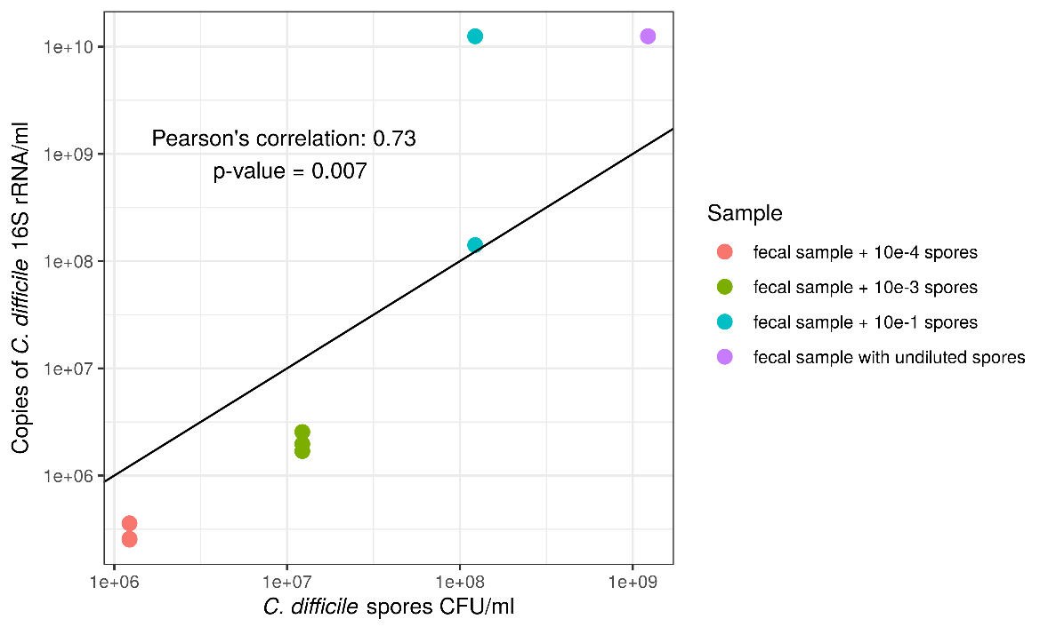
Figure 21. Efficiency of C. difficile spore isolation with PowerFecal protocol compared to C. difficile spore CFU count on COH agar plates.

To obtain a normalized amount of each OTU in a sample, we measured the absolute amount of the 16S rRNA gene in each sample by performing digital droplet PCR with the same primers that were used for amplification of fragments later sequenced. Comparison of the relative abundance of OTUs in the untreated and ethanol treated samples revealed that these two quantities are, despite different isolation protocols positively correlated for OTUs in the ethanol resistant community (Figure 22). The same holds true for normalized abundances (Figure 23). We could thus compare the proportion of active cells that are also creating endospores. The ratio gives us information on the sporulation frequency of each OTU determined as endospore forming.
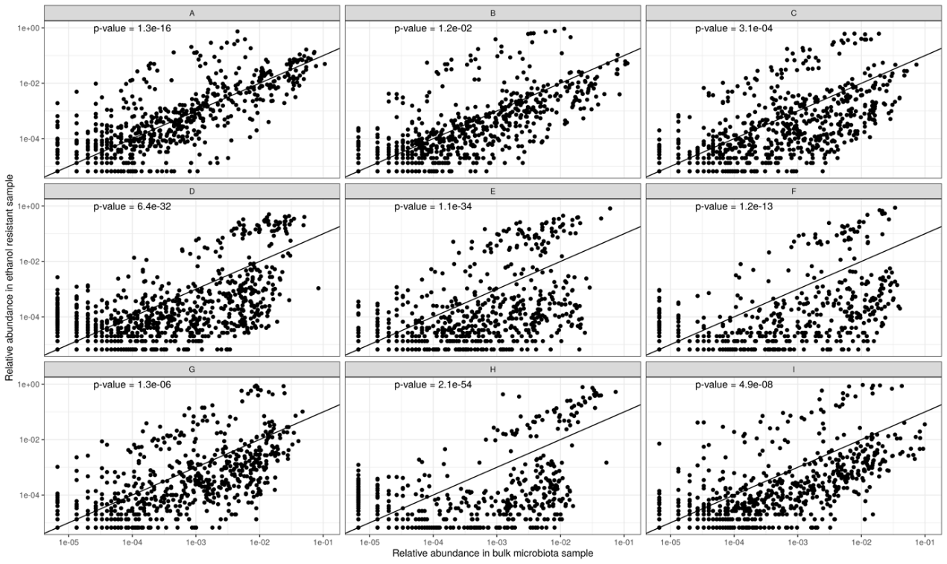
Figure 22. Relative abundance in ethanol treated sample and relative abundance in untreated sample is positively correlated. P-value for each individual Pearson’s correlation is plotted in the top left corner of the plot).

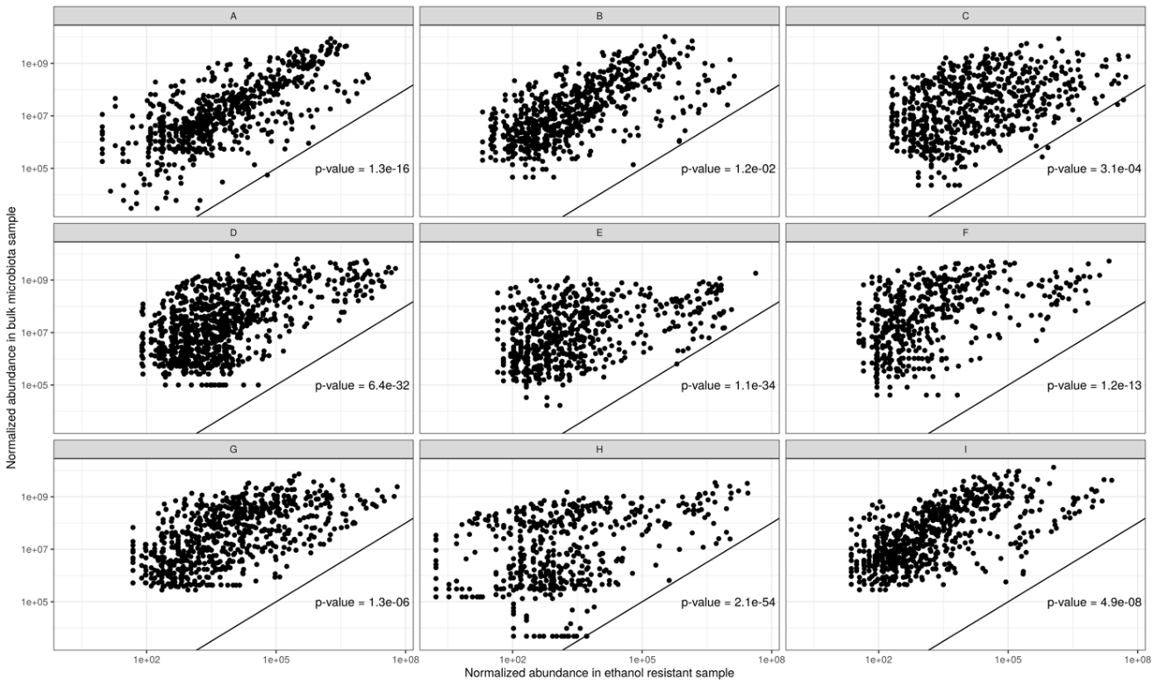
Figure 23. Normalized abundance in ethanol treated sample and normalized abundance in untreated sample is positively correlated. P-value for each individual Pearson’s correlation is plotted in the bottom right corner of the plot).
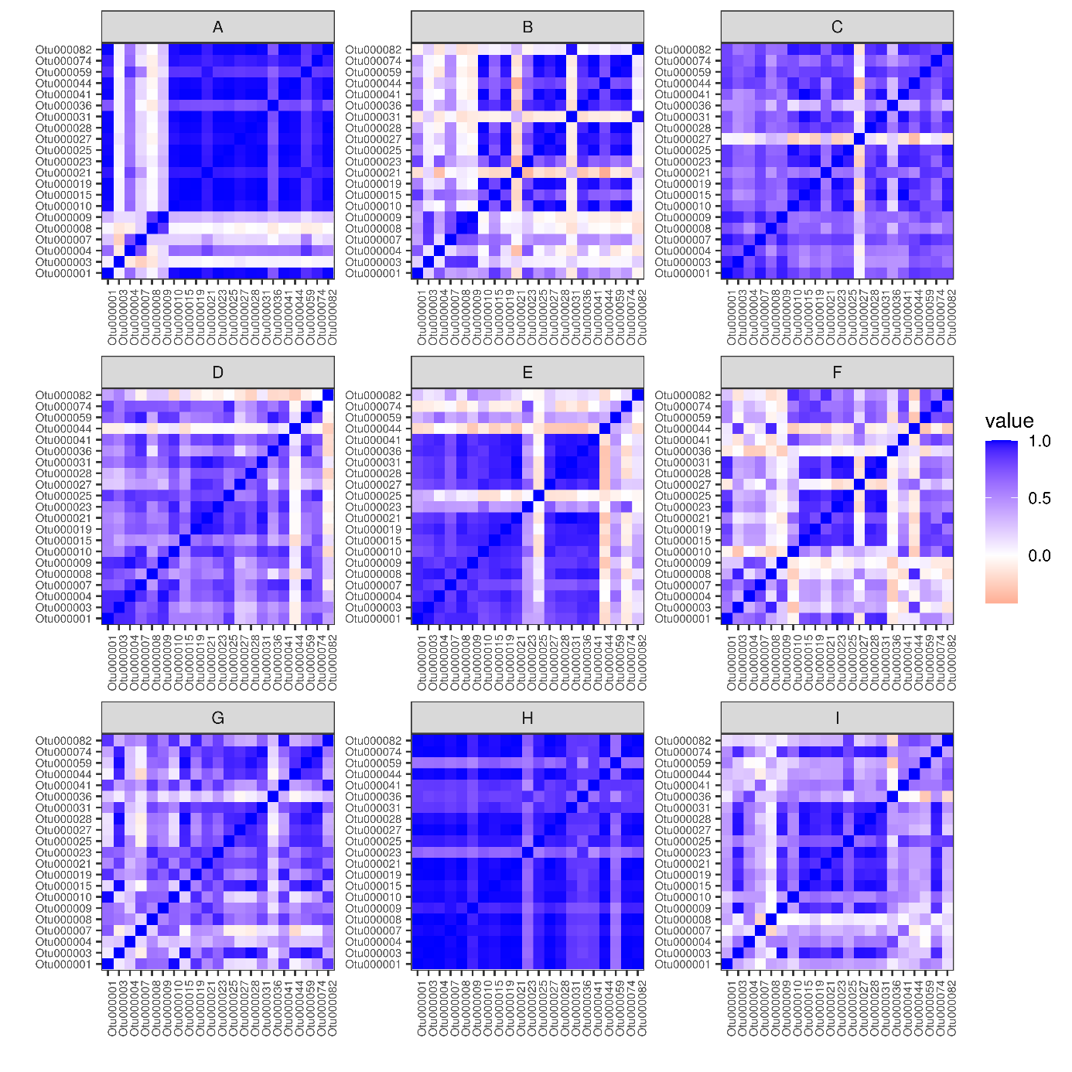
Figure 24. Correlation of sporulation frequency between OTUs within individuals. Mostly OTUs of an individual are correlated within an individual, which point to host specific sporulation frequency.

ANNEX G
Sporulation ability of bacterial species based on presence of sporulation-associated genes

Table 8. Sporulation signature genes (Browne et al., 2017).
Organism | Locus tag | Gene name
Bacillus subtilis 168 | BSU_15030 | spoVV
Bacillus subtilis subsp. subtilis str. 168 | BSU_27970 | spoIVFB
Bacillus subtilis 168 | BSU_40410 | walR
Bacillus subtilis 168 | BSU_01690 | murR
Bacillus subtilis 168 | BSU_13710 | ykvI
Bacillus subtilis 168 | BSU_16700 | ylxY
Clostridioides difficile 630 | CD630_RS18820 | spmB
Clostridioides difficile 630 | CD630_RS18825 | spmA
Clostridioides difficile 630 | CD630_RS19535 | noc
Clostridioides difficile 630 | CD630_RS08555 | CD630_RS08555
Clostridioides difficile 630 | CD630_RS18610 | spoVT
Clostridioides difficile 630 | CD630_RS14080 | spoIVA
Clostridioides difficile 630 | CD630_RS15860 | dpsA
Clostridioides difficile 630 | CD630_RS03565 | cotCB
Clostridioides difficile 630 | CD630_RS06675 | spoIIIAG
Clostridioides difficile 630 | CD630_RS06680 | spoIIIAH
Clostridioides difficile 630 | CD630_RS06745 | bltD
Clostridioides difficile 630 | CD630_RS00005 | dnaA
Clostridioides difficile 630 | CD630_RS14145 | sigG
Clostridioides difficile 630 | CD630_RS14150 | sigE
Clostridioides difficile 630 | CD630_RS14155 | spoIIGA
Clostridioides difficile 630 | CD630_RS14185 | ftsQ
Clostridioides difficile 630 | CD630_RS14195 | spoVE
Clostridioides difficile 630 | CD630_RS03425 | ytxC
Clostridioides difficile 630 | CD630_RS04990 | CD630_RS04990
Clostridioides difficile 630 | CD630_RS11435 | CD630_RS11435
Clostridioides difficile 630 | CD630_RS07160 | dacF
Clostridioides difficile 630 | CD630_RS01160 | yyaC
Clostridioides difficile 630 | CD630_RS18960 | spoIIR
Clostridioides difficile 630 | CD630_RS18975 | CD630_RS18975
Clostridioides difficile 630 | CD630_RS18985 | yabG
Clostridioides difficile 630 | CD630_RS00585 | CD630_RS00585
Clostridioides difficile 630 | CD630_RS07380 | CD630_RS07380
Clostridioides difficile 630 | CD630_RS11130 | CD630_RS11130
Clostridioides difficile 630 | CD630_RS07320 | dapG
Clostridioides difficile 630 | CD630_RS07325 | clp
Clostridioides difficile 630 | CD630_RS13885 | CD630_RS13885
Clostridioides difficile 630 | CD630_RS06750 | spoIVB
Clostridioides difficile 630 | CD630_RS06755 | spo0A
Clostridioides difficile 630 | CD630_RS06810 | pdp
Clostridioides difficile 630 | CD630_RS14045 | sepF
Clostridioides difficile 630 | CD630_RS12080 | asrC
Clostridioides difficile 630 | CD630_RS04450 | sigF
Clostridioides difficile 630 | CD630_RS04460 | spoVAD
Clostridioides difficile 630 | CD630_RS08895 | CD630_RS08895
Clostridioides difficile 630 | CD630_RS18585 | CD630_RS18585
Clostridioides difficile 630 | CD630_RS06075 | zupT
Clostridioides difficile 630 | CD630_RS13130 | CD630_RS13130
Clostridioides difficile 630 | CD630_RS06645 | spoIIIAA
Clostridioides difficile 630 | CD630_RS06650 | spoIIIAB
Clostridioides difficile 630 | CD630_RS06655 | spoIIIAC
Clostridioides difficile 630 | CD630_RS06660 | spoIIIAD
Clostridioides difficile 630 | CD630_RS06665 | spoIIIAE
Clostridioides difficile 630 | CD630_RS12285 | ytvl
Clostridioides difficile 630 | CD630_RS09210 | trxB
Clostridioides difficile 630 | CD630_RS13270 | spoIIP
Clostridioides difficile 630 | CD630_RS13275 | gpr
Clostridioides difficile 630 | CD630_RS00385 | CD630_RS00385
Clostridioides difficile 630 | CD630_RS16605 | abrB
Clostridioides difficile 630 | CD630_RS13415 | CD630_RS13415
Clostridioides difficile 630 | CD630_RS00540 | rlmB
Clostridioides difficile 630 | CD630_RS00550 | sigH
Clostridium sp. | CSBG_02367 | CSBG_02367
Clostridioides difficile 630 | CD630_12300 | sigK

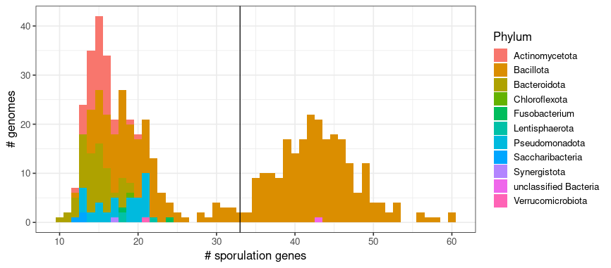
Figure 25. Number of sporulation genes per genome (x-axis) and the number of genomes (y-axis). All species determined to be spore-forming belong to phylum Bacillota, with exception of bacterium 210917-SL.2.15, which does not have a phylum level taxonomy determination. This species was removed from analysis as its representative genome low-completeness (78,97) although also low-contamination score (0.67) MAG.
Figure 26. Presence of the genes for determination of sporulation ability across ethanol-resistant and ethanol non-resistant bacterial species.
ANNEX H
Comparison of 16S amplicon and metagenomic sequencing

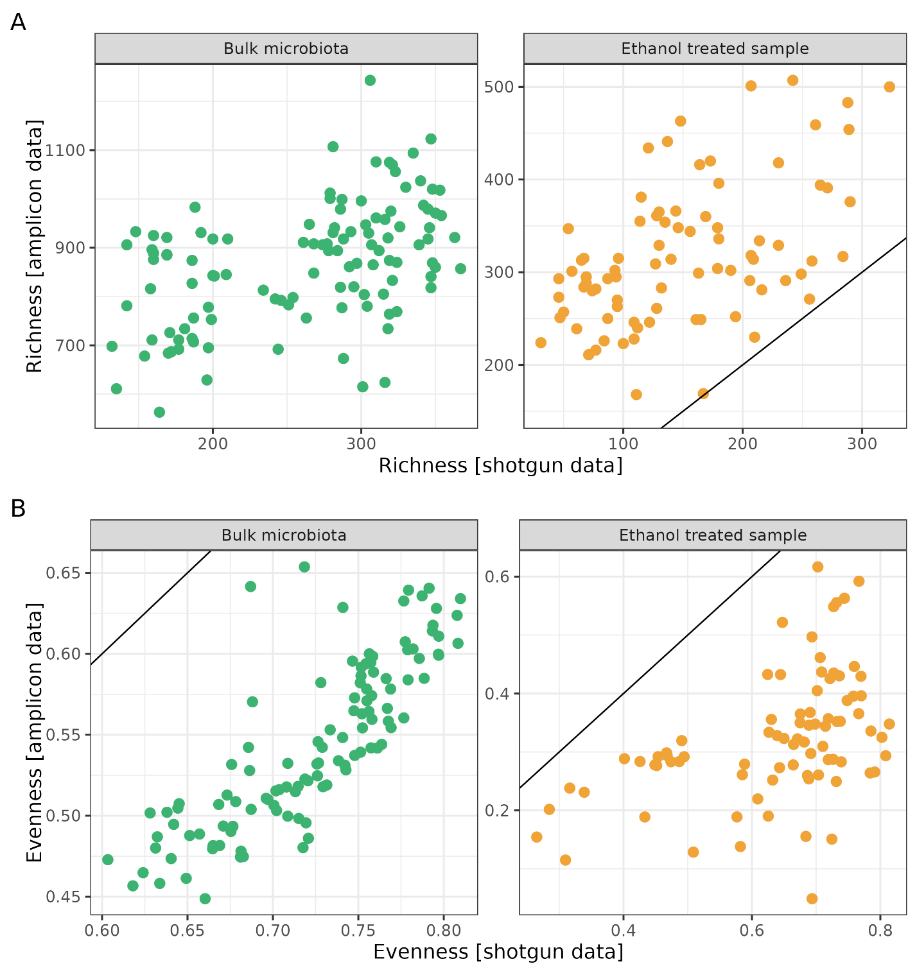
Figure 27. Richness and evenness comparison in each sample using amplicon sequencing (y-axis) and shotgun metagenomic sequencing (x-axis). The black line represents the identity function (x = y. If the points fell on the line, we could assume identical observations with both types of data.

Table 9. Collected metadata correlation to Shannon diversity index calculated based on OTU-level data (16S amplicon) and species-level data (metagenomics).
 | 16S amplicon data |  | Metagenomic data
Variable | r² | p-value | r² | p-value
Age | 0.0884 | 0.011 | 0.1341 | 0.001
Height | 0.2728 | 0.001 | 0.3010 | 0.001
Weight | 0.2106 | 0.001 | 0.2571 | 0.001
General level of activity | 0.0050 | 0.804 | 0.0524 | 0.083
Number of household members | 0.0692 | 0.029 | 0.0332 | 0.195
Stress | 0.1314 | 0.003 | 0.1133 | 0.009
Bristool stool scale | 0.0201 | 0.337 | 0.0109 | 0.584
Moderately active in the past 14 days | 0.0499 | 0.087 | 0.0731 | 0.025
Very active in the past 14 days | 0.0542 | 0.075 | 0.1015 | 0.004
Sample type (regular/predefined event) | 0.0114 | 0.299 | 0.0108 | 0.296
Diet | 0 | 1 | 0 | 1
Food supplements | 0.6483 | 0.001 | 0.7698 | 0.001
Regularity of digestion | 0 | 1 | 0 | 1
House/flat/etc. | 0.0014 | 0.779 | 0.0178 | 0.171
Urban/rural environment | 0 | 1 | 0 | 1
Diet in the past 14 days | 0.0951 | 0.395 | 0.0554 | 0.715
Antibiotics | 0.0097 | 0.339 | 0.0024 | 0.703
Probiotics | 0.0835 | 0.008 | 0.0568 | 0.014
Prebiotics | 0.4373 | 0.001 | 0.4990 | 0.001
Mediacation | 0.0095 | 0.349 | 0.0087 | 0.367
Visits to the dentist | 0.0237 | 0.298 | 0.0298 | 0.206
Vaccination | 0.0405 | 0.169 | 0.0208 | 0.304

ANNEX I
Abundance of OTUs and species in ethanol resistant community vs non ethanol-resistant community and species determined to be spore-forming vs non-spore-forming
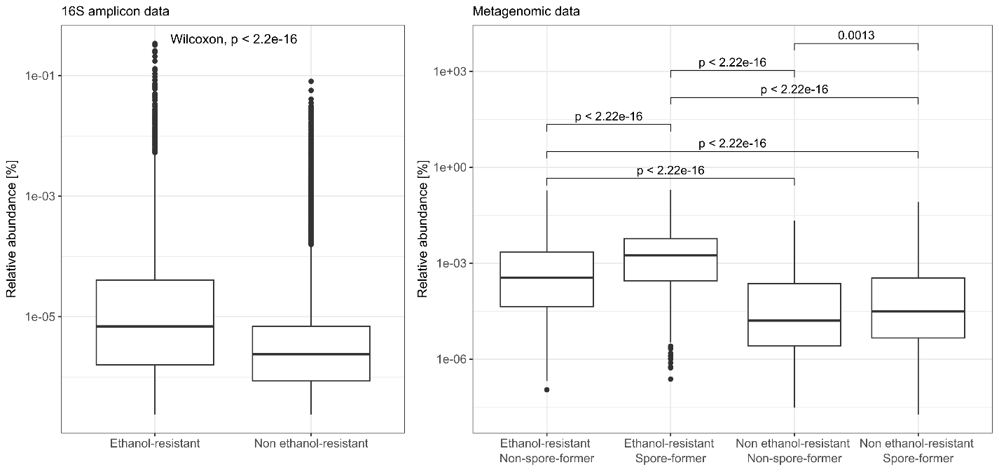
Figure 28. Relative abundance of ethanol-resistant vs non ethanol-resistant OTUs and all combinations of ethanol-resistant and spore-forming species. P-values are written only for the statistically significant comparisons (p < 0.05) using Wilcox rank-sum test to test whether relative abundance of ethanol resistant OTUs is significantly different than non ethanol-resistant OTUs. For species all groups are also compared with Wilcox rank-sum test, with added Benjamini-Hochberg correction for multiple comparisons.

ANNEX J
Clinically important antimicrobial resistance genes detected in our dataset

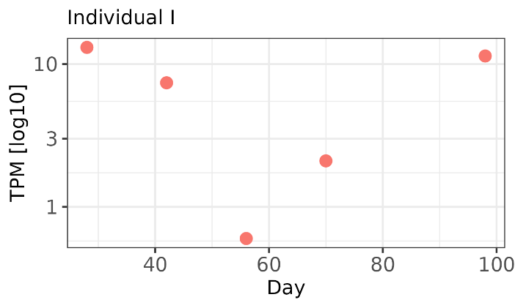
Figure 29. Abundance of bla_{CTX-M1} through time for individual I. TPM – transcripts per million, here calculated as the number of reads mapped to this gene, normalized by gene length (bp).

ANNEX K
Additional analysis of Clostridium saudiense genomes
ANNEX K1. Gut microbiota abundance and diversity of individual H through time
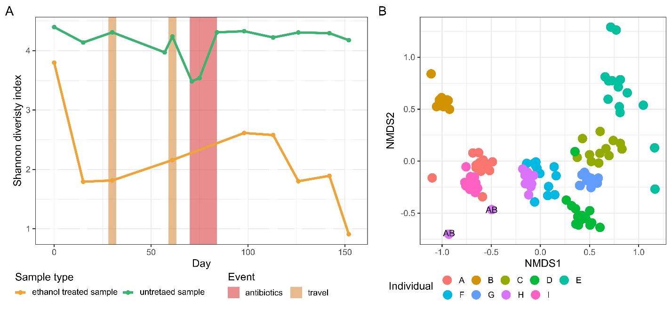
Figure 30. Alpha (Shannon’s diversity index) and beta (Bray-Curtis dissimilarity) diversity of participant H. A) Shannon diversity of untreated and ethanol treated samples, and B) NMDS based on Bray-Curtis dissimilarity both calculated from species-level relative abundance data obtained from MetaPhlAn. Samples from individual H sampled during antibiotic use are marked with as ‘AB’. Ethanol-treated samples from timepoints before and during antibiotic treatment had low DNA concentrations and did not sequence successfully.

ANNEX K2. C. saudiense strain determination using ANI and pangenome analysis. 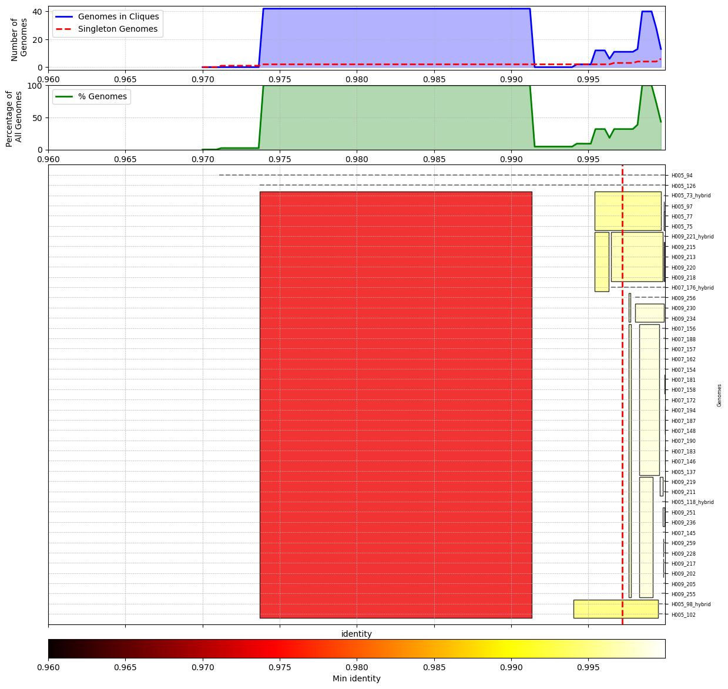
Figure 31. Pairwise average nucleotide identity comparison for all obtained genomes. Average nucleotide identity was calculated with pyANI-plus program utilizing the ANI blast program. Red dotted line represents strain break at 99.72% determining 5 strain groups.
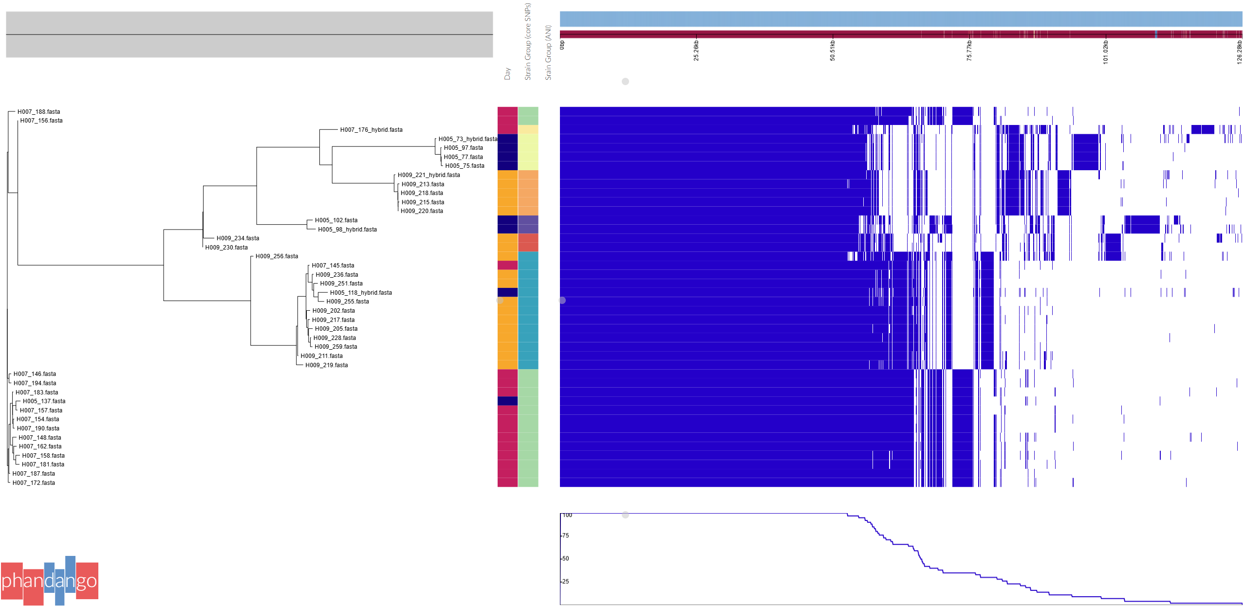
Figure 32. Phylogenetic tree based on accessory genes constructed with Roary and visualised with Phandango.
ANNEX K3. Analysis of mobile genetic elements in isolates of C. saudiense.
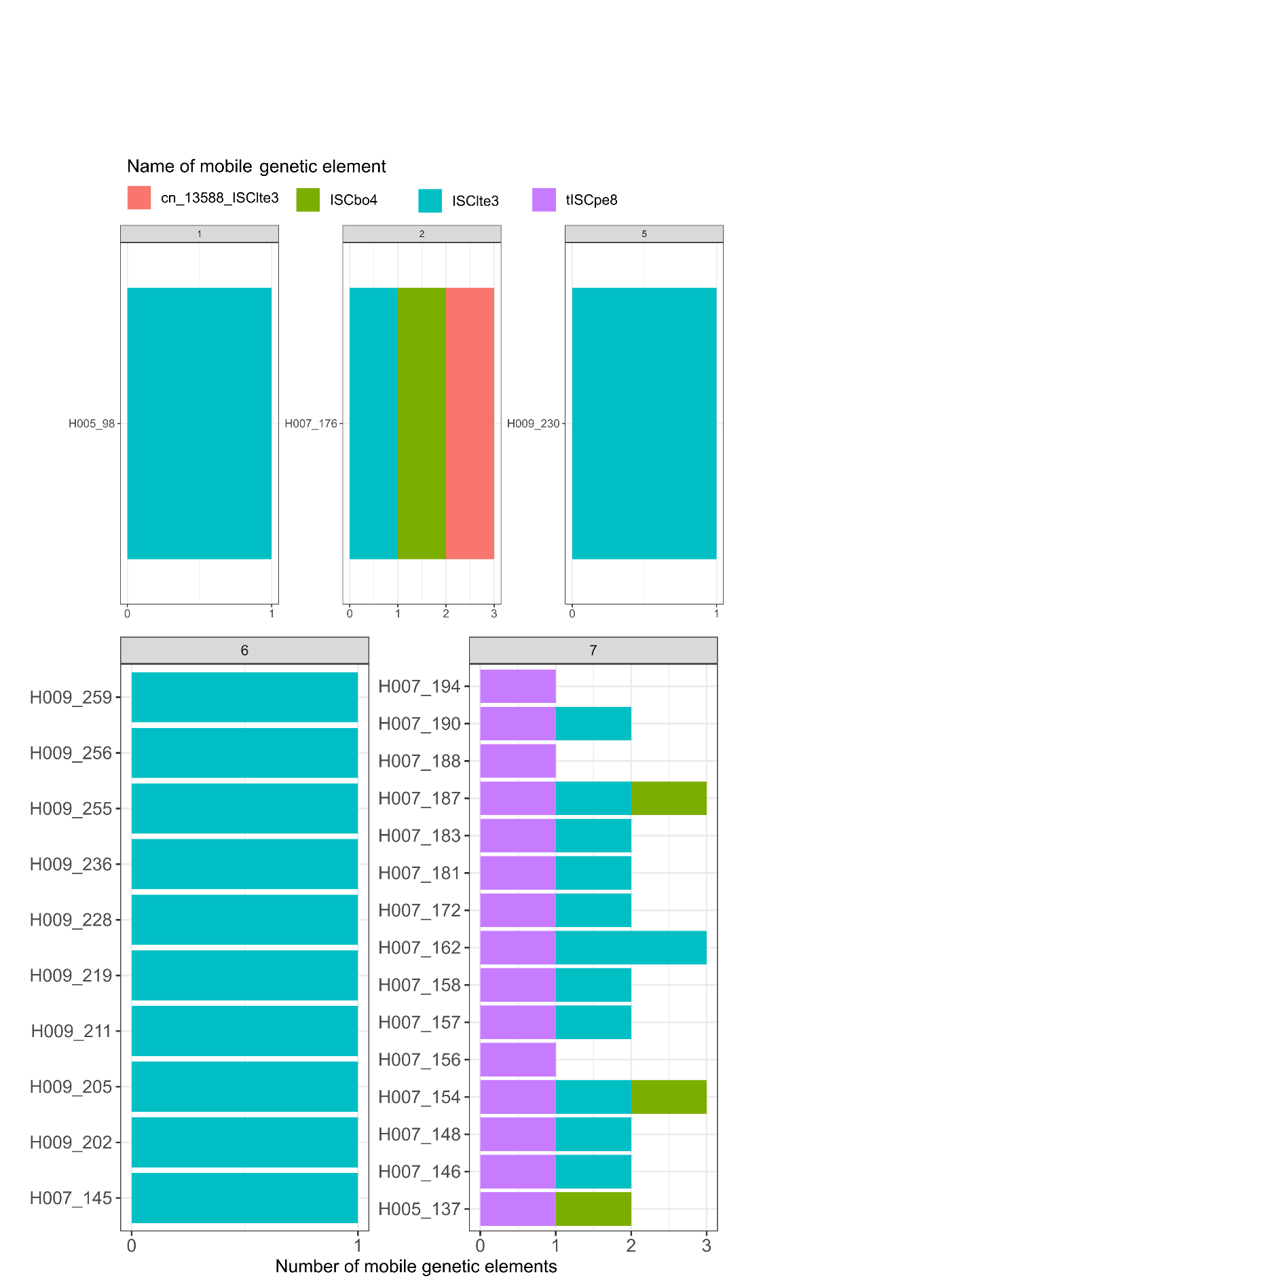
Figure 33. Detection of mobile genetic elements using MobileElementFinder for each genome. Panels represent strains determined by SNP and core genome analysis. This MGEs are insertion sequences from other Clostridium species, only ISCpe8 also contains an ORF that is determined to be O- lacosamide nucleotidyltransferase.

ANNEX K4. C. saudiense in metagenomic dataset.
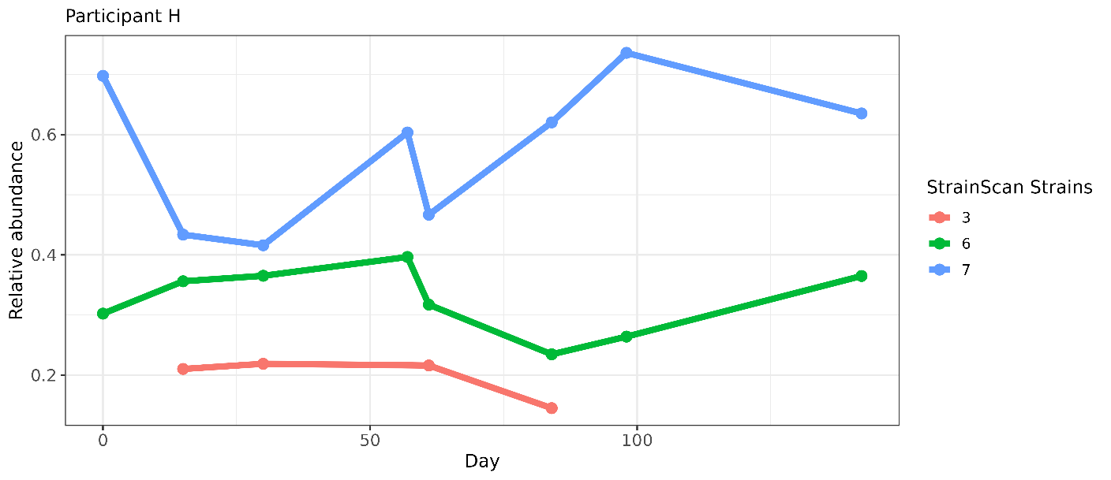
Figure 38. Results from StrainScan detection of determined strains in the metagenomic samples of individual H.
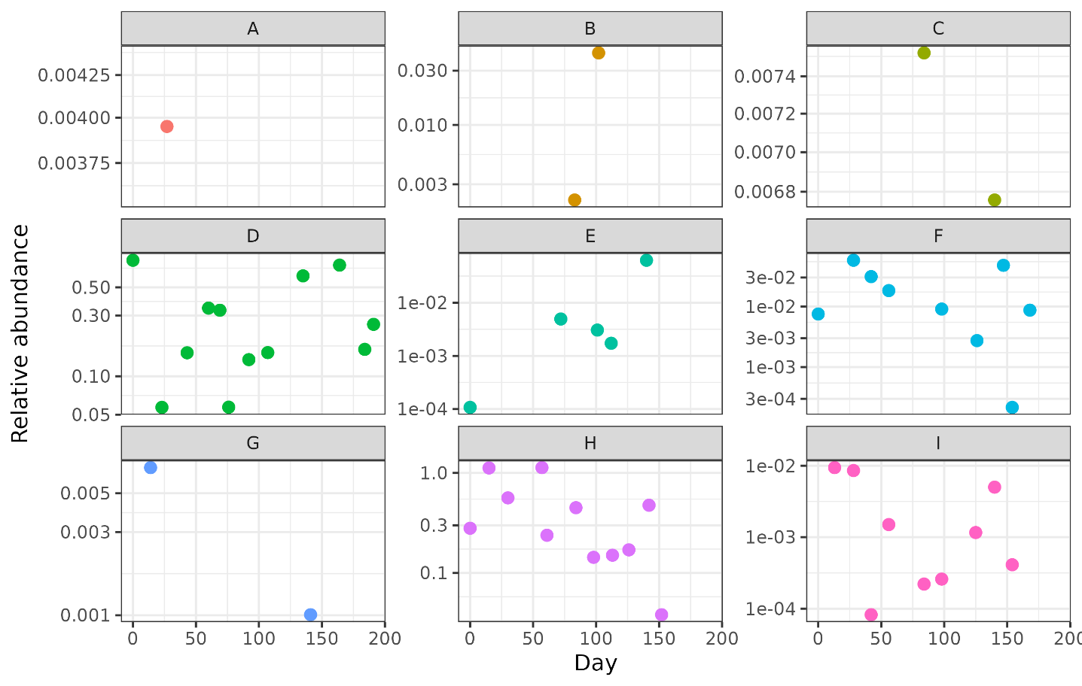
Figure 34. Abundance of C. saudiense in all participants through time based on MetaPhlAn results.
ANNEX K5. Strain-specific genes determined through pan-genome analysis.

Table 10. Strain-specific genes and their annotation. Hypothetic genes are not included in the table their number is visible in Table 11.
Strain | Gene | Annotation
1 | dapH_2 | 2,3,4,5-tetrahydropyridine-2,6-dicarboxylate N-acetyltransferase
1 | rpmJ | 50S ribosomal protein L36
1 | algA | Alginate biosynthesis protein AlgA
1 | group_1419 | Alpha-galactosidase AgaA
1 | group_2104 | Alpha-galactosidase AgaA
1 | group_705 | Anaerobic ribonucleoside-triphosphate reductase
1 | araC_1 | Arabinose operon regulatory protein
1 | bedA | Benzene 1,2-dioxygenase system ferredoxin--NAD(+) reductase subunit
1 | group_1547 | Chromosome partition protein Smc
1 | group_1627 | Cys-tRNA(Pro)/Cys-tRNA(Cys) deacylase YbaK
1 | group_1820 | Deoxyuridine 5'-triphosphate nucleotidohydrolase
1 | dnaG_3 | DNA primase
1 | hin_2 | DNA-invertase hin
1 | group_366 | Energy-dependent translational throttle protein EttA
1 | group_382 | Fatty acid ABC transporter ATP-binding/permease protein
1 | gmd | GDP-mannose 4,6-dehydratase
1 | hssR | Heme response regulator HssR
1 | group_1848 | HTH-type transcriptional activator BcrR
1 | group_2107 | HTH-type transcriptional activator RhaS
1 | cynR | HTH-type transcriptional regulator CynR
1 | gpx1_2 | Hydroperoxy fatty acid reductase gpx1
1 | group_1968 | Hydroperoxy fatty acid reductase gpx1
1 | group_322 | Ion-translocating oxidoreductase complex subunit B
1 | group_456 | IS1182 family transposase ISClbu1
1 | group_457 | IS1182 family transposase ISClbu1
1 | group_458 | IS1182 family transposase ISClbu1
1 | group_67 | IS1182 family transposase ISClbu1
1 | group_68 | IS1182 family transposase ISClbu1
1 | group_70 | IS1182 family transposase ISClbu1
1 | group_1460 | IS1595 family transposase ISCco3
1 | group_1503 | IS1595 family transposase ISClsp5
1 | group_283 | IS256 family transposase ISCbo4
1 | group_284 | IS256 family transposase ISCbo4
1 | group_285 | IS256 family transposase ISCbo4
1 | group_5368 | IS3 family transposase ISCb4
1 | group_5369 | IS3 family transposase ISCb4
1 | group_5370 | IS3 family transposase ISCb4
1 | group_5371 | IS3 family transposase ISCb4
1 | group_5373 | IS3 family transposase ISCb4
1 | group_5225 | IS30 family transposase IS658
1 | group_5228 | IS30 family transposase IS658
1 | group_5229 | IS30 family transposase IS658
1 | group_5230 | IS30 family transposase IS658
1 | group_5231 | IS30 family transposase IS658
1 | group_5232 | IS30 family transposase IS658
1 | group_205 | IS4 family transposase ISRel1
1 | group_206 | IS4 family transposase ISRel1
1 | group_207 | IS4 family transposase ISRel1
1 | group_208 | IS4 family transposase ISRel1
1 | group_209 | IS4 family transposase ISRel1
1 | group_210 | IS4 family transposase ISRel1
1 | group_4959 | IS6 family transposase ISClte3
1 | group_4960 | IS6 family transposase ISClte3
1 | group_4961 | IS6 family transposase ISClte3
1 | group_4962 | IS6 family transposase ISClte3
1 | group_4963 | IS6 family transposase ISClte3
1 | group_4964 | IS6 family transposase ISClte3
1 | group_4965 | IS6 family transposase ISClte3
1 | group_4966 | IS6 family transposase ISClte3
1 | group_4967 | IS6 family transposase ISClte3
1 | aplIM | Modification methylase AplI
1 | group_1630 | Modification methylase DpnIIA
1 | group_1945 | Modification methylase Eco57IB
1 | sbpA | Multiple sugar-binding periplasmic protein SbpA
1 | ohrR | Organic hydroperoxide resistance transcriptional regulator
1 | glmM_4 | Phosphoglucosamine mutase
1 | group_255 | Phosphoglucosamine mutase
1 | cph2 | Phytochrome-like protein cph2
1 | group_1616 | PTS system beta-glucoside-specific EIIBCA component
1 | group_1418 | PTS system trehalose-specific EIIBC component
1 | group_2105 | PTS system trehalose-specific EIIBC component
1 | pulA_2 | Pullulanase
1 | group_383 | putative ABC transporter ATP-binding protein
1 | group_652 | putative ABC transporter ATP-binding protein
1 | group_1689 | putative capsular polysaccharide biosynthesis protein YwqC
1 | epsF_6 | Putative glycosyltransferase EpsF
1 | group_1608 | Putative glycosyltransferase EpsF
1 | group_1702 | Putative glycosyltransferase EpsF
1 | group_1607 | putative glycosyltransferase EpsJ
1 | ywnA | Putative HTH-type transcriptional regulator YwnA
1 | yydK | putative HTH-type transcriptional regulator YydK
1 | group_538 | Pyridinium-3,5-bisthiocarboxylic acid mononucleotide nickel insertion protein
1 | sigE_2 | RNA polymerase sigma-35 factor
1 | cysE_2 | Serine acetyltransferase
1 | ssb_4 | Single-stranded DNA-binding protein
1 | group_1598 | Spore coat protein SA
1 | scrB_1 | Sucrose-6-phosphate hydrolase
1 | group_568 | Thermostable beta-glucosidase B
1 | trxA_3 | Thioredoxin
1 | trxB_3 | Thioredoxin reductase
1 | group_1462 | Tyrosine recombinase XerC
1 | group_2035 | Tyrosine recombinase XerC
1 | group_1573 | Tyrosine recombinase XerD
1 | group_1690 | Tyrosine-protein kinase YwqD
1 | group_1692 | UDP-glucose 6-dehydrogenase
1 | wecA_3 | UDP-N-acetylgalactosamine-undecaprenyl-phosphate N-acetylgalactosaminephosphotransferase
1 | group_1701 | UDP-N-acetylglucosamine--peptide N-acetylglucosaminyltransferase GtfA subunit
1 | group_1600 | Undecaprenyl-phosphate 4-deoxy-4-formamido-L-arabinose transferase
1 | group_1606 | Undecaprenyl-phosphate 4-deoxy-4-formamido-L-arabinose transferase
1 | xylG_1 | Xylose import ATP-binding protein XylG
1 | xylH | Xylose transport system permease protein XylH
3 | group_520 | Alkaline phosphatase synthesis sensor protein PhoR
3 | phoP_2 | Alkaline phosphatase synthesis transcriptional regulatory protein PhoP
3 | group_2977 | Alpha-galactosidase AgaA
3 | xylQ | Alpha-xylosidase XylQ
3 | group_3176 | Arginine transport system permease protein ArtQ
3 | group_2876 | ATP-dependent Clp protease proteolytic subunit
3 | group_3018 | ATP-dependent Clp protease proteolytic subunit
3 | group_3126 | Beta-galactosidase BoGH2A
3 | group_2974 | Beta-glucoside kinase
3 | nag3 | Beta-N-acetylglucosaminidase/beta-glucosidase
3 | yvdM | Beta-phosphoglucomutase
3 | ftsA | Cell division protein FtsA
3 | opuBA_1 | Choline transport ATP-binding protein OpuBA
3 | group_3034 | Chromosomal replication initiator protein DnaA
3 | group_2882 | Chromosome partition protein Smc
3 | group_3144 | Cytochrome b6-f complex iron-sulfur subunit
3 | group_2988 | DegV domain-containing protein
3 | group_3067 | D-inositol-3-phosphate glycosyltransferase
3 | dppB | Dipeptide transport system permease protein DppB
3 | polA_2 | DNA polymerase I
3 | group_3115 | Flagellar hook-associated protein 2
3 | flaD | Flagellin D
3 | pglH_1 | GalNAc-alpha-(1->4)-GalNAc-alpha-(1->3)-diNAcBac-PP-undecaprenol alpha-1,4-N-acetyl-D-galactosaminyltransferase
3 | pglH_2 | GalNAc-alpha-(1->4)-GalNAc-alpha-(1->3)-diNAcBac-PP-undecaprenol alpha-1,4-N-acetyl-D-galactosaminyltransferase
3 | glnQ | Glutamine transport ATP-binding protein GlnQ
3 | glnH_1 | Glutamine-binding periplasmic protein
3 | group_308 | Glutathione biosynthesis bifunctional protein GshAB
3 | hisS_2 | Histidine--tRNA ligase
3 | group_3128 | HTH-type transcriptional activator RhaS
3 | group_2973 | HTH-type transcriptional regulator GmuR
3 | group_76 | IS1182 family transposase ISClbu1
3 | group_77 | IS1182 family transposase ISClbu1
3 | group_79 | IS1182 family transposase ISClbu1
3 | group_80 | IS1182 family transposase ISClbu1
3 | group_81 | IS1182 family transposase ISClbu1
3 | group_82 | IS1182 family transposase ISClbu1
3 | group_83 | IS1182 family transposase ISClbu1
3 | group_84 | IS1182 family transposase ISClbu1
3 | group_85 | IS1182 family transposase ISClbu1
3 | group_2971 | IS1595 family transposase ISCco3
3 | group_290 | IS256 family transposase ISCbo4
3 | group_291 | IS256 family transposase ISCbo4
3 | group_292 | IS256 family transposase ISCbo4
3 | group_294 | IS256 family transposase ISCbo4
3 | group_2138 | IS3 family transposase ISBce13
3 | group_2139 | IS3 family transposase ISBce13
3 | group_2140 | IS3 family transposase ISBce13
3 | group_2141 | IS3 family transposase ISBce13
3 | group_2143 | IS3 family transposase ISBce13
3 | group_2144 | IS3 family transposase ISBce13
3 | group_2147 | IS3 family transposase ISBce13
3 | group_5214 | IS30 family transposase IS658
3 | group_5236 | IS30 family transposase IS658
3 | group_5237 | IS30 family transposase IS658
3 | group_5238 | IS30 family transposase IS658
3 | group_5239 | IS30 family transposase IS658
3 | group_153 | IS6 family transposase ISClte3
3 | group_154 | IS6 family transposase ISClte3
3 | group_155 | IS6 family transposase ISClte3
3 | group_156 | IS6 family transposase ISClte3
3 | group_157 | IS6 family transposase ISClte3
3 | group_158 | IS6 family transposase ISClte3
3 | group_4947 | IS6 family transposase ISClte3
3 | group_4950 | IS6 family transposase ISClte3
3 | group_4952 | IS6 family transposase ISClte3
3 | group_3129 | Isoprimeverose transporter
3 | group_656 | Ktr system potassium uptake protein A
3 | group_3168 | Macrolide export ATP-binding/permease protein MacB
3 | metH_1 | Methionine synthase
3 | group_3211 | N-acetylgalactosamine-N,N'-diacetylbacillosaminyl-diphospho-undecaprenol 4-alpha-N-acetylgalactosaminyltransferase
3 | group_3127 | Non-reducing end alpha-L-arabinofuranosidase BoGH43A
3 | expZ | Nucleotide-binding protein ExpZ
3 | group_2984 | Oligopeptide transport ATP-binding protein OppD
3 | oppC_2 | Oligopeptide transport system permease protein OppC
3 | blaI | Penicillinase repressor
3 | group_2990 | Peptidoglycan O-acetyltransferase
3 | epsE_2 | Putative glycosyltransferase EpsE
3 | group_3150 | Putative glycosyltransferase EpsF
3 | group_3091 | Putative type II secretion system protein F
3 | group_2976 | Regulator of RpoS
3 | rssB_3 | Regulator of RpoS
3 | group_3142 | Ribokinase
3 | group_3145 | Sensor histidine kinase RcsC
3 | group_3166 | Sensor histidine kinase RcsC
3 | group_3030 | Single-stranded DNA-binding protein
3 | cotSA | Spore coat protein SA
3 | tuaB | Teichuronic acid biosynthesis protein TuaB
3 | epsE_1 | Type II secretion system protein E
3 | group_3023 | Tyrosine recombinase XerC
3 | lpxD | UDP-3-O-(3-hydroxymyristoyl)glucosamine N-acyltransferase
3 | group_3198 | UDP-glucose 6-dehydrogenase
3 | arnC_4 | Undecaprenyl-phosphate 4-deoxy-4-formamido-L-arabinose transferase
3 | group_3061 | Undecaprenyl-phosphate 4-deoxy-4-formamido-L-arabinose transferase
3 | group_3154 | Undecaprenyl-phosphate 4-deoxy-4-formamido-L-arabinose transferase
3 | group_3210 | Undecaprenyl-phosphate 4-deoxy-4-formamido-L-arabinose transferase
3 | group_2983 | Vitamin B12 import ATP-binding protein BtuD
3 | group_3169 | Vitamin B12 import ATP-binding protein BtuD
4 | group_708 | 1,4-alpha-glucan branching enzyme GlgB
4 | group_3666 | 3'-5' exonuclease DinG
4 | group_3643 | Asparagine synthetase [glutamine-hydrolyzing] 1
4 | group_3590 | Cysteine desulfurase SufS
4 | mshA_5 | D-inositol-3-phosphate glycosyltransferase
4 | group_730 | dTDP-glucose 4,6-dehydratase
4 | rmlA_1 | Glucose-1-phosphate thymidylyltransferase
4 | glyE | Glycosyltransferase GlyE
4 | group_3669 | IS110 family transposase ISEnfa110
4 | group_3670 | IS110 family transposase ISEnfa110
4 | group_3671 | IS110 family transposase ISEnfa110
4 | group_3672 | IS110 family transposase ISEnfa110
4 | group_3673 | IS110 family transposase ISEnfa110
4 | group_3674 | IS110 family transposase ISEnfa110
4 | group_3675 | IS110 family transposase ISEnfa110
4 | group_3543 | IS1182 family transposase ISCbo5
4 | group_3678 | IS1182 family transposase ISClbu1
4 | group_3679 | IS1182 family transposase ISClbu1
4 | group_3680 | IS1182 family transposase ISClbu1
4 | group_61 | IS1182 family transposase ISClbu1
4 | group_62 | IS1182 family transposase ISClbu1
4 | group_65 | IS1182 family transposase ISClbu1
4 | group_6 | IS21 family transposase IS232
4 | group_281 | IS256 family transposase ISCbo4
4 | group_2146 | IS3 family transposase ISBce13
4 | group_5364 | IS3 family transposase ISCb4
4 | group_5367 | IS3 family transposase ISCb4
4 | group_178 | IS3 family transposase ISCpe6
4 | group_5217 | IS30 family transposase IS658
4 | group_141 | IS6 family transposase ISClte3
4 | group_146 | IS6 family transposase ISClte3
4 | group_4938 | IS6 family transposase ISClte3
4 | group_4940 | IS6 family transposase ISClte3
4 | group_4941 | IS6 family transposase ISClte3
4 | group_4943 | IS6 family transposase ISClte3
4 | group_3644 | Lipoprotein-releasing system ATP-binding protein LolD
4 | group_654 | PTS system EIIBC component
4 | group_3567 | Putative acetyltransferase
4 | yscN_2 | putative ATP synthase YscN
4 | group_3571 | Putative glycosyltransferase EpsF
4 | group_2927 | putative peptidase
4 | group_2928 | putative peptidase
4 | ypbG | putative protein YpbG
4 | group_3572 | Pyrophosphatase PpaX
4 | group_3626 | Single-stranded DNA-binding protein
4 | group_3662 | Sporulation initiation inhibitor protein Soj
4 | group_3637 | Undecaprenyl-phosphate 4-deoxy-4-formamido-L-arabinose transferase
5 | arnE | 4-amino-4-deoxy-L-arabinose-phosphoundecaprenol flippase subunit ArnE
5 | group_3433 | Alginate biosynthesis protein AlgA
5 | socA | Antitoxin SocA
5 | group_3345 | ATP-dependent Clp protease proteolytic subunit
5 | glmU_2 | Bifunctional protein GlmU
5 | rfbG | CDP-glucose 4,6-dehydratase
5 | group_3342 | Chromosome partition protein Smc
5 | group_3480 | Chromosome partition protein Smc
5 | group_3409 | D-inositol-3-phosphate glycosyltransferase
5 | group_3412 | D-inositol-3-phosphate glycosyltransferase
5 | group_3432 | D-inositol-3-phosphate glycosyltransferase
5 | rmlC | dTDP-4-dehydrorhamnose 3,5-epimerase
5 | rffG | dTDP-glucose 4,6-dehydratase 2
5 | glfT1 | Galactofuranosyltransferase GlfT1
5 | group_3407 | GDP-mannose 4,6-dehydratase
5 | rfbF | Glucose-1-phosphate cytidylyltransferase
5 | der_1 | GTPase Der
5 | era_1 | GTPase Era
5 | xre | HTH-type transcriptional regulator Xre
5 | group_3429 | IS1182 family transposase ISAco1
5 | group_3428 | IS1182 family transposase ISBsp4
5 | group_3427 | IS1182 family transposase ISCbo5
5 | group_455 | IS1182 family transposase ISClbu1
5 | group_10 | IS21 family transposase IS232
5 | group_9 | IS21 family transposase IS232
5 | group_3361 | IS256 family transposase ISCob1
5 | group_2131 | IS3 family transposase ISBce13
5 | group_2132 | IS3 family transposase ISBce13
5 | group_2133 | IS3 family transposase ISBce13
5 | group_2134 | IS3 family transposase ISBce13
5 | group_2135 | IS3 family transposase ISBce13
5 | group_2137 | IS3 family transposase ISBce13
5 | group_5218 | IS30 family transposase IS658
5 | group_5219 | IS30 family transposase IS658
5 | group_5220 | IS30 family transposase IS658
5 | group_5221 | IS30 family transposase IS658
5 | group_5222 | IS30 family transposase IS658
5 | group_148 | IS6 family transposase ISClte3
5 | group_149 | IS6 family transposase ISClte3
5 | group_150 | IS6 family transposase ISClte3
5 | group_4945 | IS6 family transposase ISClte3
5 | group_4953 | IS6 family transposase ISClte3
5 | group_4954 | IS6 family transposase ISClte3
5 | group_4955 | IS6 family transposase ISClte3
5 | group_4957 | IS6 family transposase ISClte3
5 | group_4958 | IS6 family transposase ISClte3
5 | group_3273 | Lon protease
5 | group_3406 | Mannose-1-phosphate guanylyltransferase RfbM
5 | manA | Mannose-6-phosphate isomerase ManA
5 | immA_2 | Metallopeptidase ImmA
5 | bshA | N-acetyl-alpha-D-glucosaminyl L-malate synthase
5 | group_3394 | N-acetylgalactosamine-N,N'-diacetylbacillosaminyl-diphospho-undecaprenol 4-alpha-N-acetylgalactosaminyltransferase
5 | wbbL | N-acetylglucosaminyl-diphospho-decaprenol L-rhamnosyltransferase
5 | tarA | N-acetylglucosaminyldiphosphoundecaprenol N-acetyl-beta-D-mannosaminyltransferase
5 | pgcA_3 | Phosphoglucomutase
5 | group_3404 | putative capsular polysaccharide biosynthesis protein YwqC
5 | group_3382 | Putative glycosyltransferase EpsD
5 | group_3396 | putative glycosyltransferase EpsJ
5 | rfbX | Putative O-antigen transporter
5 | recD | RecBCD enzyme subunit RecD
5 | mscS_3 | Small-conductance mechanosensitive channel
5 | group_3386 | Transmembrane protein EpsG
5 | pilT_2 | Twitching mobility protein
5 | group_184 | Tyrosine recombinase XerC
5 | group_3466 | Tyrosine recombinase XerC
5 | xerD_3 | Tyrosine recombinase XerD
5 | glf | UDP-galactopyranose mutase
5 | group_3405 | UDP-N-acetylgalactosamine-undecaprenyl-phosphate N-acetylgalactosaminephosphotransferase
5 | group_3437 | UDP-N-acetylgalactosamine-undecaprenyl-phosphate N-acetylgalactosaminephosphotransferase
5 | group_3391 | UDP-N-acetylglucosamine--peptide N-acetylglucosaminyltransferase GtfA subunit
5 | group_3393 | UDP-N-acetylglucosamine--peptide N-acetylglucosaminyltransferase GtfA subunit
5 | arnC | Undecaprenyl-phosphate 4-deoxy-4-formamido-L-arabinose transferase
2a | group_3852 | ATP-dependent Clp protease proteolytic subunit
2a | group_3865 | ATP-dependent RNA helicase DbpA
2a | smc_3 | Chromosome partition protein Smc
2a | mutL_1 | DNA mismatch repair protein MutL
2a | group_3875 | IS200/IS605 family transposase ISEfa4
2b | group_372 | Alpha-xylosidase
2b | clpA_2 | ATP-dependent Clp protease ATP-binding subunit ClpA
2b | bcrA_3 | Bacitracin transport ATP-binding protein BcrA
2b | uviB_1 | Bacteriocin UviB
2b | iscS_3 | Cysteine desulfurase IscS
2b | ybaK_1 | Cys-tRNA(Pro)/Cys-tRNA(Cys) deacylase YbaK
2b | group_310 | Glutathione biosynthesis bifunctional protein GshAB
2b | group_125 | Group II intron-encoded protein LtrA
2b | group_126 | Group II intron-encoded protein LtrA
2b | group_129 | Group II intron-encoded protein LtrA
2b | group_130 | Group II intron-encoded protein LtrA
2b | group_459 | IS1182 family transposase ISClbu1
2b | group_460 | IS1182 family transposase ISClbu1
2b | group_461 | IS1182 family transposase ISClbu1
2b | group_462 | IS1182 family transposase ISClbu1
2b | group_463 | IS1182 family transposase ISClbu1
2b | group_72 | IS1182 family transposase ISClbu1
2b | group_73 | IS1182 family transposase ISClbu1
2b | group_74 | IS1182 family transposase ISClbu1
2b | group_75 | IS1182 family transposase ISClbu1
2b | group_287 | IS256 family transposase ISCbo4
2b | group_288 | IS256 family transposase ISCbo4
2b | group_289 | IS256 family transposase ISCbo4
2b | group_5375 | IS3 family transposase ISCb4
2b | group_5376 | IS3 family transposase ISCb4
2b | group_5377 | IS3 family transposase ISCb4
2b | group_5378 | IS3 family transposase ISCb4
2b | group_5379 | IS3 family transposase ISCb4
2b | group_5380 | IS3 family transposase ISCb4
2b | group_5382 | IS3 family transposase ISCb4
2b | group_6155 | IS3 family transposase ISEnfa5
2b | group_6156 | IS3 family transposase ISEnfa5
2b | group_5211 | IS30 family transposase IS658
2b | group_5240 | IS30 family transposase IS658
2b | group_5241 | IS30 family transposase IS658
2b | group_5242 | IS30 family transposase IS658
2b | group_5243 | IS30 family transposase IS658
2b | group_5244 | IS30 family transposase IS658
2b | group_5245 | IS30 family transposase IS658
2b | group_5246 | IS30 family transposase IS658
2b | group_5247 | IS30 family transposase IS658
2b | group_5248 | IS30 family transposase IS658
2b | group_5249 | IS30 family transposase IS658
2b | group_96 | Putative formate dehydrogenase
2b | epsN_1 | Putative pyridoxal phosphate-dependent aminotransferase EpsN
2b | epsN_2 | Putative pyridoxal phosphate-dependent aminotransferase EpsN
2b | group_171 | Putative transposase InsK for insertion sequence element IS150
2b | group_703 | Putative xanthine dehydrogenase molybdenum-binding subunit XdhA
2b | group_2252 | Replicative DNA helicase
2b | bcgIA | Restriction enzyme BgcI subunit alpha
2b | group_6046 | Reverse rubrerythrin-1
2b | tnpR | Transposon gamma-delta resolvase
2b | group_2246 | Tyrosine recombinase XerC
2b | group_2260 | Tyrosine recombinase XerC
2b | xerH | Tyrosine recombinase XerH
2b | gtaB_5 | UTP--glucose-1-phosphate uridylyltransferase
2c | clpP_4 | ATP-dependent Clp protease proteolytic subunit
2c | group_2589 | ATP-dependent RNA helicase DbpA
2c | uviB_3 | Bacteriocin UviB
2c | group_659 | Calcium-transporting ATPase
2c | group_402 | Cardiolipin synthase
2c | group_2629 | Chromosomal replication initiator protein DnaA
2c | smc_8 | Chromosome partition protein Smc
2c | parA | Chromosome partitioning protein ParA
2c | cdr_2 | Coenzyme A disulfide reductase
2c | group_625 | Cyclic pyranopterin monophosphate synthase
2c | sufS_3 | Cysteine desulfurase SufS
2c | group_2792 | Extracellular matrix regulatory protein A
2c | gldA | Glycerol dehydrogenase
2c | group_127 | Group II intron-encoded protein LtrA
2c | hxlR_1 | HTH-type transcriptional activator HxlR
2c | group_2728 | IS1595 family transposase ISCpe8
2c | group_2729 | IS1595 family transposase ISDeul1
2c | group_278 | IS256 family transposase ISCbo4
2c | group_4968 | IS6 family transposase ISClte3
2c | dpnM | Modification methylase DpnIIA
2c | group_2709 | NADH oxidase
2c | group_336 | Negative regulator of SacY activity
2c | group_2607 | Nucleoid occlusion protein
2c | group_620 | putative CtpA-like serine protease
2c | group_2605 | Sporulation initiation inhibitor protein Soj
2c | aplIR | Type-2 restriction enzyme AplI
2c | xerC_4 | Tyrosine recombinase XerC
2c | xerC_5 | Tyrosine recombinase XerC
2c | xerC_6 | Tyrosine recombinase XerC

Table 11. Number of strain-specific genes for each strain.
Strain | 1 | 5 | 7 | 6 | 3 | 4 | 2
# genomes | 2 | 2 | 13 | 15 | 4 | 5 | 1
# unique genes | 464 | 59 | 244 | 286 | 328 | 174 | 258
# hypothetical proteins | 363 | 54 | 188 | 257 | 231 | 127 | 186
# other genes | 101 | 5 | 56 | 29 | 97 | 47 | 72
# genes detected in participant H | 380 | 46 | 48 | 199 | 222 | 110 | 195
# genes detected in participant A | 24 | 2 | 8 | 16 | 16 | 15 | 5
# genes detected in participant A&H | 24 | 2 | 8 | 16 | 16 | 15 | 4
# genes used in final analysis | 356 | 44 | 40 | 183 | 206 | 95 | 190

ANNEX K4. In vitro assay of C. saudiense susceptibility to amoxicillin.
Table 12. Minimal inhibitory concentration (MIC) of amoxicillin on C. saudiense strains.
Strain | Isolate | MIC
1 | H005_98 | 0.047
2 | H007_176 | 0.064
3 | H005_73 | 0.094
4 | H009_221 | 0.094
5 | H009_230 | 0.094
6 | H005_118 | 0.064
7 | H007_194 | 0.094

ANNEX L
Framework analysis of composition, abundance and diversity of microbes other than bacteria in the untreated stool samples

ANNEX L1. Human gut virome
The human gut virome is highly diverse and stable, forming a resilient community that influences host health. Each person has a highly individual gut virome, which remains consistent over time even when bacterial populations fluctuate (Chica Cardenas et al., 2026). The viral community includes bacteriophages, both free-living and prophages, eukaryotic viruses, archaeal viruses, and even virus-like entities such as obelisks (Zheludev et al., 2024). The concentration of viral particles in the human gut is estimated to range from 109 to 1010 virus-like particles per gram of stool sample (Hoyles et al., 2014). The gut viral community is primarily composed of DNA bacteriophages, such as dsDNA phages from the order Caudovirales and ssDNA phages from the Microviridae and Inoviridae families. Despite significant advances in viral metagenomics in recent years, most phage sequences recovered from the gut virome remain unclassified as ‘viral dark matter’. Eukaryotic viruses are less abundant than bacteriophages representing around 2% of the total relative abundance in the human gut. These include ssDNA Circoviridae, dsDNA Herpesviridae and RNA viruses from families such as Picobirnaviridae, Alphaflexiviridae, Bromoviridae, Luteoviridae, and Virgaviridae (Garmaeva et al., 2021; Wylie et al., 2014). The gut eukaryotic virome is highly variable between individuals and is entirely driven by host-intrinsic factors. The least abundant viruses in the human gut are archaeal viruses. Severely understudied, they represent only 0.7 % of the total abundance in the human gut (Z. Feng et al., 2025). These are mostly viruses infecting methanogenic archaea, exhibiting high genetic diversity with unique adaptations to the gut environment (Medvedeva et al., 2023).

Using GeNomad program we detected both eukaryotic (Alsuviricetes, Arfiviricetes, Duplopiviricetes, Herviviricetes and Megavirictes) and bacterial viruses (Faserviricetes, Malgrandeviricetes, and Caudoviricetes) (Figure 35) (Camargo et al., 2024). Bacteriophages were present at ten times the relative abundance of eukaryotic viruses. Caudovirales showed the highest abundance among all groups. Viral communities in the human gut were individual-specific (Supplement Figure 10). The abundance of viral classes was persistent over time and was not affected by pre-defined events, except in individual H during antibiotic treatment. Although this is probably due to observing data at high taxonomical level (class instead of family or viral OTUs).

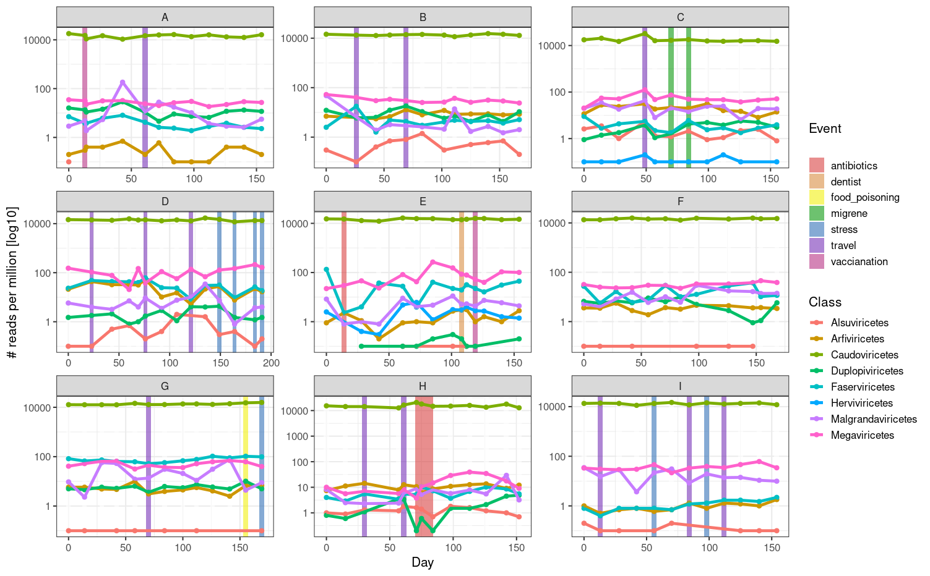
Figure 35. Log-scaled reads per million of viral classes in participants' gut microbiota. Viral sequences were identified using geNomad. Each plot depicts one participant (labelled with capital letters A to I), with days on the x-axis indicating when stool samples were collected. Vertical coloured lines indicate out-of-the-ordinary events reported by participants in their questionnaires.

ANNEX L2. Human gut archaeome
Archaeal diversity and abundance are linked to geographical location, ethnicity, diet, and age of individual. Archaea represent around 1% of the total abundance in the human gut. Most gut archaea are methanogens, which metabolise mainly H₂ and CO₂ to produce methane, released in both breath and gas (Hoegenauer et al., 2022). The wide diversity of archaea in the human gut includes lineages such as Methanobacteriales, Methanomassiliicoccales, Methanomicrobiales, Methanosarcinales, Halobacteriales, Thaumarchaeota (Nitrososphaeria) and members of the DPANN clade (Borrel et al., 2020; Koskinen et al., 2017).
Archaea were detected in 5 out of 9 individuals in our cohort using MetaPhlAn. The genus Methanobrevibacter was present in all five individuals, while Methanosphera were found in only two (Figure 36). Methanobrevibacter smithii exhibited oscillatory abundance within participants over time, while Methanosphera stadmanae was present at a lower relative abundance in a more equal abundance through time. Their abundance changes could not be connected to selected events from participants questionnaires.

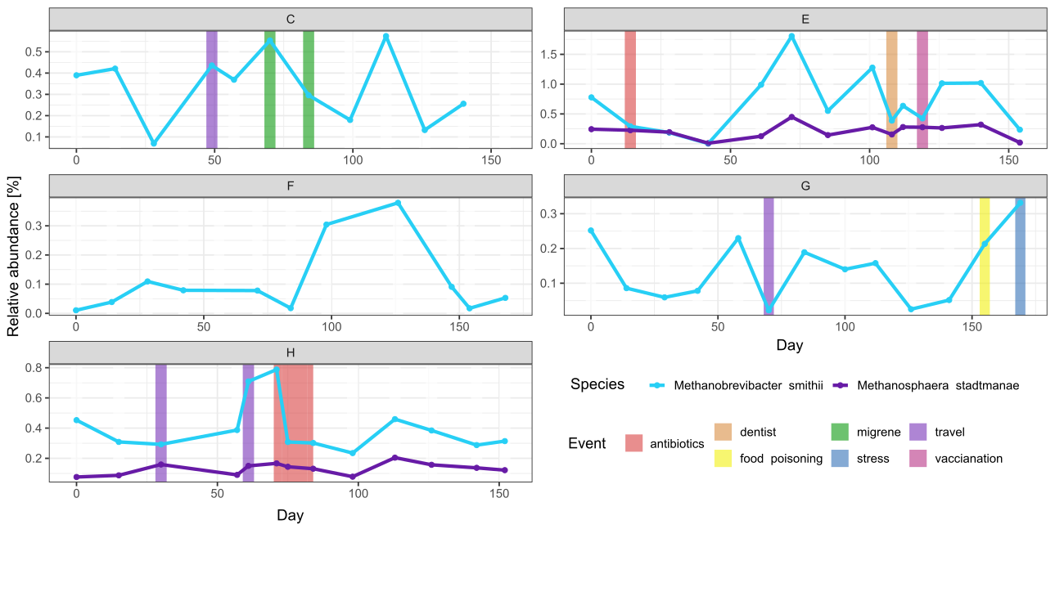
Figure 36. Relative abundance and persistence of archaeal species in participants gut microbiota. Species were determined using MetaPhlAn. Each plot depicts one participant (labelled with capital letters A to I), with days on the x-axis indicating when the stool samples were collected. Vertical coloured lines indicate out-of-the-ordinary events reported by participants in their questionnaires.

ANNEX L3. Human gut mycobiome and protozoa
The human gut mycobiome constitutes a very low biomass, approximately 0.1% of the total relative abundance, but is a dynamic component influencing many bacterial interactions, immunity, and disease through metabolites and immune modulation (Nash et al., 2017; Sun et al., 2021). The predominant fungal groups within the gut mycobiome belong primarily to the phylum Ascomycota, followed by Zygomycota and Basidiomycota (Mohammadi et al., 2025). Common genera include Candida, Cryptococcus, Malassezia, Aspergillus, Saccharomyces, Galactomyces, Trichosporon and Cladosporium. The mycobiome is influenced by diet, body weight, age, gender, exposure to antimicrobial and antifungal treatment, and other environmental factors (Mohammadi et al., 2025).
Protozoa represent even less, ranging from 0.01 to 0.1% of the total relative abundance. Protozoa are present in most stool samples, represented mainly by two dominant species, Entamoeba and Blastocystis, with the latter being the most prevalent protozoan in industrialized populations (Aykur et al., 2024).

Eukaryotes were detected using EukDetect program, as program MetaPhlAn only detected 2 eukaryotic species (Blastocystis sp. and Saccharomyces cerevisiae). Using EukDetect Blastocystis sp. was the most abundant eukaryotic species detected (Figure 37). Besides this monocellular eukaryote we also detected an amoeba Entamoeba dispar and roundworm Caenorhabditis elegans in one sample of participant H. The most abundant fungal species was Saccharomyces cerevisiae, followed by Debaryomyces hansenii also from the Saccharomycetaceae family, the difference between their abundance being 10-fold (Figure 37). All other fungal species represented less than 0.0001 % of reads in all samples combined and were mainly from the phylum Ascomycetota such as Penicillium nalgiovense, Candida albicans, Candida sake, Yarrowia lipolytica and Saccharomyces cerevisiae (Figure 37). We also detected one fungal species outside Ascomycetota phylum Wallemia mellicola.

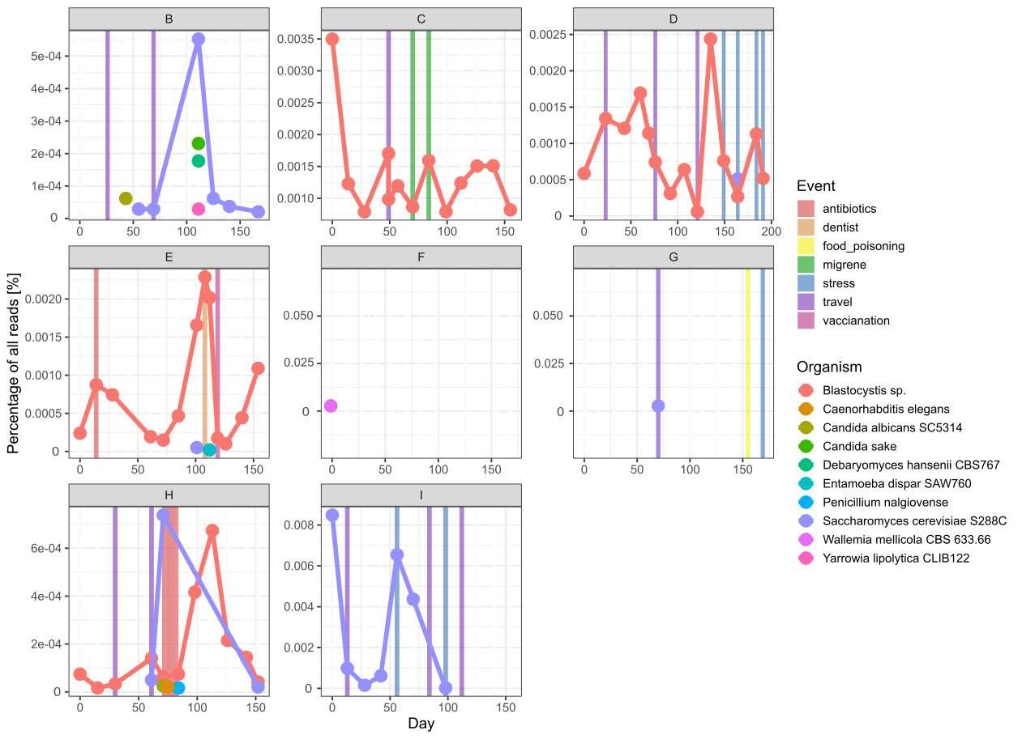
Figure 37. Abundance of eukaryotic species as detected by EukDetect. On the x-axis the number represents the percentage of reads mapped to marker genes of a species vs. all reads in a sample, the y-axis represents each sample of an individual where eukaryotes were detected. Each plot depicts a participant (labelled with capital letters A to I), with days on the x-axis indicating when the stool samples were collected. Vertical coloured lines indicate out-of-the-ordinary events reported by participants in their questionnaires.

