INTRODUCTION
Transmission of gut bacteria between individuals and their colonization within an individual depends on survival in intermittent environments and their prevalence (Martino et al., 2022; Valles-Colomer et al., 2023). Sporulation is one of the most researched strategies for increasing survival time outside of the human gut as spore-forming bacteria are present in the most abundant phylum in human gut Bacillota (Egan et al., 2021; Galperin, 2013; Rajilić-Stojanović and de Vos, 2014). At least 50% of gut bacteria possess the genetic ability for sporulation (Browne et al., 2016a), giving them the ability to endure unfavourable conditions, such as oxygen, antibiotic treatment, inflammation, and other diseases. This allows them to persist and potentially recolonize the gut following disruptions but also facilitates transmission between individuals (Swick et al., 2016; Tetz and Tetz, 2017). Other mechanisms hypothesized to increase transmission between human hosts include aerotolerance, and viable-but-not-culturable state, where an increased survival ability is achieved through decreased metabolic activity and strengthened cell walls (Peter Setlow, 2014).
To investigate transmission of spore-forming bacteria between human hosts in a culture-independent manner, studies used either lysozyme treatment or ethanol shock to remove vegetative cells from stool samples (Avershina et al., 2020; Kearney et al., 2018). In a cohort of healthy human adults, it was shown that lysozyme resistant OTUs (operational taxonomic units) are more frequently shared between individuals than other taxa (Kearney et al., 2018). While a comparison of infant-mother pairs showed that the majority of OTUs determined as spore-forming are acquired from environment rather than mother-to-child transmission (Avershina et al., 2020). Analysis of metagenomes derived from the human gut revealed that the sporulation ability increases its prevalence in a broader population, but decreases bacterial species relative abundance in an individual (Browne et al., 2021).
Analysis at the level of cultured strains from Escherichia coli obtained from human stools across ~1.5 years revealed persistence of a mix of strains and some replacements over time (Martinson et al., 2019). The same was not true for other non-spore-forming species, namely Bacteroides vulgatus and Bacteroides ovatus where only one-time colonization events were observed. In contrast, the spore-forming bacterium Turicibacter sanguinis showed a pattern of serial colonisations by multiple distantly related strains (Poyet et al., 2019).
Gut microbiota is also an important reservoir of antibiotic-resistant bacteria and antibiotic resistance genes (ARGs) (X. Li et al., 2023). Especially important are non-spore-forming gram negative bacteria, although other groups must not be overlooked. Antimicrobial resistance genes in the human gut resistome can be encoded in core genome, or acquired through horizontal gene transfer via plasmids, transposons and integrative elements (Wuethrich et al., 2021). Metagenomic surveys show that in silico determined resistance to tetracyclines, bacitracin and glycopeptides (e.g. vancomycin) is particularly common in healthy individuals, with many ARGs traced to dominant commensal phyla such as Bacillota and Bacteroidetes (Lee et al., 2023). Country-specific analyses indicate that ARG abundance and diversity correlate with national antibiotic consumption patterns (Xia et al., 2019).

RESEARCH GOALS
The main goal was to investigate the whole community of spore-forming bacteria (sporobiota) in the human gut through extended period of time in multiple individuals using both culture-independent and to some extend culture-dependant methods. This study was set out to be exploratory with an aim of extending the knowledge of sporobiota. To achieve this, we set ourselves three research goals:
Goal 1. Description and comparison of the temporal stability of the gut microbiota and sporobiota in healthy individuals.
Goal 2. Individual-specific population genetics analysis on the isolated spore-forming species.
Goal 3. Monitoring longitudinal changes in the resistome depending on changes in the intestinal microbiota.

RESEARCH HYPOTHESES
We set three hypotheses:
Hypothesis 1. The gut sporobiota of an individual will be less stable than the gut microbiota.
Previous work on lysozyme-resistant community in the human gut assessed stability in a single individual over 24-days and suggested this community is less variable than the rest of the microbiota, at the level of OTUs. In contrast, longitudinal shotgun metagenomic studies reported members from the phylum Bacilllota, which include many spore-forming bacteria tend to fluctuate more over time than non-spore-forming species. In addition, cultivation‑based studies have documented replacement events for spore‑forming taxa such as T. sanguinis, whereas non‑spore‑formers like B. vulgatus and B. ovatus persisted, pointing to a potentially more dynamic lifestyle of spore formers in the gut ecosystem. We formulated this hypothesis before coming across the ‘seed bank’ hypothesis, which predicts that dormant forms such as endospores can increase persistence by buffering populations against environmental fluctuations. Based on this, we initially expected spores to enhance the transmission and therefore the sporobiota to show lower within host stability than the rest of microbiota.
Contrary to our expectation, this hypothesis was not confirmed. When we defined stability as persistence of taxa within an individual, we observed that spore-forming bacteria, especially those also present in the ethanol-resistant community, persist for longer than other non-spore-forming or ethanol non-resistant bacteria within an individual.
Hypothesis 2. Gut sporobiota and microbiota will change during the extreme event in most volunteers.
Short‑term perturbations such as antibiotics, gastrointestinal infections, or major dietary shifts are known to affect gut microbial community structure, often causing transient reductions in diversity and shifts in composition, with partial or full recovery over time. Because spore formation and other dormant states can enable survival under adverse conditions, we hypothesized that extreme events would particularly reshape the sporobiota, either by enriching dormant forms that survive the disturbance or by altering their relative contribution as the community returns toward its pre‑event state.
Due to lack of extreme events reported in the six-months sampling period we cannot reject or confirm the second hypothesis with statistically significant results. However, observational evidence does suggest a change in community composition during antibiotic consumption, which is later returned to a previous state. Other self-reported events such as travel outside of country of residence, stress, migraines or visits to the dentist did not significantly affect the relative abundance of gut bacteria in our dataset.
Hypothesis 3. Increased presence of resistance genes will correlate with reduced diversity of the microbiota.
A large proportion do resistance genes found in gut microbiota are associated with non-selective efflux pumps or changed porins. Both mechanisms can also support better adaptation to changing environmental conditions. Also, it has been described previously that antibiotic exposure can reduce microbial diversity in human gut and select for resistant taxa, leading to communities with higher carriage of ARGs but lower taxonomic diversity. We therefore expected that individuals or time points with a higher number or diversity of ARGs would exhibit reduced microbiota diversity, reflecting past selection and competitive advantages of resistant strains.
However, our data did not support this hypothesis, as no significant association was observed between bacterial diversity and ARG diversity over time. Instead, we identified class-specific relationships between bacterial diversity and abundance of ARGs. A negative association was observed between bacterial diversity and abundance of ARGs in MLS class, and a positive association for the macrolide and trimethoprim classes. These findings suggest that reductions in bacterial abundance may selectively influence certain resistance classes, rather than driving a broad increase in resistome diversity.

LITERATURE REVIEW

HUMAN GUT MICROBIOTA
The intestine is the most densely colonized microbial habitat of the human body, harbouring trillions of bacteria along with viruses, archaea and eukaryotes that collectively form the gut microbiota (Heidrich et al., 2025). Colonization begins at birth as infants acquire microbes from their caretakers, siblings, and the surrounding environment (Martino et al., 2022). Community composition reflects a continuous balance between immigration, growth, competition and cooperation among these microorganisms, constrained by host physiology, lifestyle, and environment (Amato and Carmody, 2023).

Longitudinal studies of bacterial communities in the human gut
Longitudinal studies, in which microbiota is repeatedly sampled from the same individuals, provide the main empirical basis for understanding temporal dynamics and individuality in the human gut (Schlomann and Parthasarathy, 2019). Several longitudinal studies have been conducted on the gut microbiota and will be summarized below. Cohorts have ranged from single‑subject dense time series to hundreds of participants, with sampling intervals from days to months or even years. Most studies have profiled bacteria using 16S rRNA gene amplicon sequencing, but some have also characterized fungi by targeting the ITS region or 18S rRNA gene. An increasing number now use shotgun metagenomics to capture strain-level and functional dynamics, with some studies also including multi-omics’ approaches. Studies focusing on viruses use specialised DNA or RNA isolation methods or enrichment prior to sequencing.

Culture-independent longitudinal studies of human gut bacteria
Early longitudinal studies relied on DGGE (denaturing gradient gel electrophoresis) or DNA microarrays (Duytschaever et al., 2011; Jalanka-Tuovinen et al., 2011; Rajilić-Stojanović et al., 2013). With the advancement of next‑generation sequencing, 16S rRNA amplicon sequencing rapidly became the dominant approach (Caporaso et al., 2011; Claesson et al., 2011; Clooney et al., 2021; Costello et al., 2009; David et al., 2014; Dubois et al., 2017; Faith et al., 2013; Flores et al., 2014; Fu et al., 2019; Hao et al., 2018; Hisada et al., 2015; Jayasinghe et al., 2017; Levy et al., 2020; Martínez et al., 2013; Martinson et al., 2019; Olsson et al., 2022; Turroni et al., 2017). These studies included populations ranging from one or two individuals to several hundred adults, typically male but sometimes female, with individuals aged between 18 and 50 years and a body mass index between 18.5 and 25. Sampling intervals ranged from daily or weekly to several months or even years apart. Densely sampled time series studies showed strong individual-specific and relatively persistent community structure despite day-to-day fluctuations (Caporaso et al., 2011). Studies in older adults (over 65 years of age) found a persistent individual gut microbiota over periods of three to six months at high taxonomic levels, but with certain taxa showing variability at the OTU level (Claesson et al., 2011; Fu et al., 2019). Other studies have found longitudinally persistent intestinal microbiota at the phylum or family level over periods ranging from a few months to several years or even decades (Faith et al., 2013; Jayasinghe et al., 2017).
However, the apparent stability at higher taxonomic levels changes when using shotgun metagenomic sequencing, which offers greater taxonomic resolution. Longitudinal studies using metagenomic sequencing have compared vertical transmission and early assembly of gut microbiota in the first year of life (Asnicar et al., 2017; Yassour et al., 2018), as well as strain and species persistence in healthy adults (Abu-Ali et al., 2018; L. Chen et al., 2021; Dapa et al., 2023; Jokela et al., 2023; Olsson et al., 2022; Wolff et al., 2023; Zhou et al., 2024), and microbiota dynamics in older individuals (Mehta et al., 2018). Showing that changes in species or strain persistence are shaped by the same environmental and host factors identified in cross-sectional studies, including diet, physical activity, medications and antibiotics, stress and host genetics.
Studies using shotgun metagenomic sequencing have also compared healthy individuals patients with irritable bowel syndrome (Mars et al., 2020), and patients with haematological diseases (Willmann et al., 2019), and other chronic conditions such as metabolic liver disease, diabetes and impaired pancreatic function (Frost et al., 2021). All showing that human gut microbiota of diseased individuals is less stable in time than that of healthy individuals. A few studies have focused exclusively on women, comparing healthy women with those who have frequent urinary tract infections (Hua et al., 2022) and women taking oral contraceptives (Worby et al., 2022), showing acute perturbations such as exocrine hormones also influence gut microbiota at functional level, but not taxonomical. Other acute perturbations, such as antibiotic treatment and bowel cleansing have also been shown to change gut microbiota at both taxonomical and functional level, but that it is able to recover in a matter of weeks to a month (Baldanzi et al., 2026; Fukuyama et al., 2017; Raymond et al., 2016; D. J. Schwartz et al., 2020).
Cohorts in studies mentioned above ranged from 5 to more than 300 participants, followed for at least six months to a year, with sampling every few weeks to every few months. Metagenomic studies confirm that some species and strains can persist over long periods within individuals, whereas others show frequent replacement or large abundance shifts. Stable colonizers include many of the Bacteroides species, while representatives of the Bacillota phylum are among the more variable members of the gut community (Heidrich et al., 2025).

Culture-dependant longitudinal studies of human gut bacteria
Longitudinal studies of cultured bacteria from various environments have shown a modest rate of mutation within host for Klebsiella pneumoniae (Mathers et al., 2015), Streptococcus aureus (Young et al., 2012) or Clostridioides difficile (Didelot et al., 2012; Duchêne et al., 2016; Eyre et al., 2013). But cultivation studies using more than one time point stool samples from the same individual are scarce, but crucial to provide insight into changes at the level of individual strains, by using molecular approaches to assess changes over time. To our knowledge only two longitudinal studies investigated the stability of the intestinal microbiota at the level of individual bacterial species. In one study, PCR genotyping was used to compare the presence of different strains of Escherichia coli over time, revealing that some strains were consistently present while others varied (Martinson et al., 2019). In another study, the genomes of isolated strains of Bacteroides vulgatus and Bacteroides ovatus were analysed, showing that a single colonization event occurred, while the spore-forming bacterium Turicibacter sanguinis replaced previous strains with each colonization attempt (Poyet et al., 2019).

Stability of microbial communities
Most longitudinal studies aim to quantify an aspect of stability in the human gut community. Stability is an ambiguous term with many overlapping definitions (Grimm and Wissel, 1996). Here we focus on two key properties at the level of strains, species or OTUs depending on the method used: resilience and resistance, both of which can be explored using a definable value of persistence (Shade et al., 2012).
Resistance of a community is defined as insensitivity to the introduction of a new variable into the community, while resilience is defined as the rate of recovery after disturbance (Grimm and Wissel, 1996). Persistence, in turn, is a useful longitudinal metric that captures whether taxa remain detectable over time and thus integrates information about both resistance (limited initial change) and resilience (recovery after change) when inferred from longitudinal sequencing data of an environment (Lozupone et al., 2012). Disturbance can act either directly on the community or indirectly via changes in the host environment, in both cases, some community members may die out, enter dormancy, or change in relative abundance.
Ecologists classify disturbances as short-term, long-term, or continuous events (Grimm and Wissel, 1996). Microbes have a short generation time, so disturbances can occur on the scale of minutes to days or can persist for years. In the human gut these are changes in diet, disease, physical activity, moving, one-time overconsumption of alcohol, or traveling (Martino et al., 2022).
A stable state of gut microbiota of all humans is still unknown due to variations in geographical regions, diet and genetics (Lozupone et al., 2012). By repeatedly sampling individuals over time, we can follow factors that modulate the persistence of species or even strains and the dynamics of functions, providing essential context for interpreting microbiota dynamics when sampling is coupled with extensive metadata collection.

HUMAN GUT SPOROBIOTA
Sporobiota is defined as all spore-forming bacteria in a given environment (Tetz and Tetz, 2017). Evolutionary analyses indicate that sporulation originated once in the phylum Bacillota approximately 2.5 billion years ago (de Hoon et al., 2010). Spore formation and physiology have since diverged to great genetic diversity in many different species (Browne et al., 2021; Thomas, 2012).
In the human gut, spore-formers are phylogenetically diverse but predominantly belong to classes Clostridia and Bacilli including genera such as Clostridium, Ruminococcus, Blautia, Coprococcus, Eubacterium and Flavonifractor (Egan et al., 2021; Koopman et al., 2022). Many spore-forming species act as commensals and are central to a healthy gut microbiome. Key examples include members of the Clostridium clusters XI and XIVa (Clostridium leptum, Clostridium scindens, Clostridium innocuum), as well as Flavonifractor plautii and Ruminococcus bromii from the Ruminococcaceae family. Other prevalent species, such as Eubacterium rectale and Eubacterium elegans, also possess the genetic capability for sporulation (Egan et al., 2021).
The abundance of spore-forming bacteria is lower in infants than adults (Korpela et al., 2018; Nayfach et al., 2016), but despite this, they are the initial producers of butyrate, which was shown to protect the gut from intestinal diseases such as inflammatory bowel disease and colon cancer (Appert et al., 2020; Hodgkinson et al., 2023). Specifically, short chain fatty acids (SCFAs) are generated by spore-forming bacteria dietary fibre metabolism, so spore-formers are thus linked to improved gut homeostasis, suppressed inflammatory responses, and epithelial barrier functioning (Koopman et al., 2022).
A high proportion of gut bacteria, at least 50% possess the genetic ability for sporulation, representing around 30% of all bacterial abundance in the adult human gut capable of survival in conditions that are unfavourable for growth (Browne et al., 2016a). The ability of spore-forming bacteria in the human gut to endure unfavourable conditions, such as oxygen, antibiotic treatment, inflammation, and other diseases, allows them to persist and potentially recolonize the gut following disruptions but also facilitates transmission between individuals (Swick et al., 2016). Other mechanisms hypothesized to increase transmission between human hosts include aero-toleration, and viable, but not-culturable state, where an increased survival ability is achieved through decreased metabolic activity and strengthened cell walls (Browne et al., 2017). The likelihood of transmission increases with bacteria’s utilization of different life-history strategies (e.g. dormancy) and their prevalence, however high strain abundance within a host is not typically driven by transmission, but rather the bacterium’s ability to adapt and grow within a host (Valles-Colomer et al., 2023).

Culture-dependant and -independent analysis of sporobiota
Until recently, most research has focused on the pathogenic endospores related to food safety and intestinal infections (reviewed in Brown, 2000), but these species constitute only a minuscule fraction of the gut microbiota, and far less is known about the ecological dynamics of commensal, spore-forming bacteria that are highly abundant in healthy individuals. This is partly due to the difficulty of isolating DNA from spores, which have proven to be among the most resistant cell structures to survive on Earth and in space (Horneck et al., 1994; Leggett et al., 2012). Due to their diverse evolutionary history, bacterial spores can withstand many different environmental pressures such as heat, desiccation, radiation, oxidation, or exposure to chemicals. Endospore-producing bacteria have different mechanisms for defence against high temperatures or prolonged immersion in high concentrations of ethanol (Beaman et al., 1988; Salvage et al., 2014; Tetz and Tetz, 2017; Thomas, 2012).
Spore resistance to ethanol is enabled by detoxification through the external layers of the spore coat, reduced permeability and mobility of the inner membrane, and protection of the core content through restriction of the macromolecule mobility in the coat (Beaman et al., 1988; Henriques and Moran, 2007). The outer spore coat layer is composed of more than 70 different proteins, which are impermeable to alcohol that would otherwise denature proteins and lead to cell lysis by disrupting membranes (Driks and Eichenberger, 2016).
Spore resistance to wet heat shock is enabled by low core water content, a high concentration of dipicolinic acid, Ca²⁺ ions and α/β-type small acid-soluble spore proteins (SASP), which protect DNA from damage and enable its repair (Jamroskovic et al., 2016; P. Setlow, 2006). SASPs and dipicolinic acids constitute up to 20% of the spore core dry weight (Sunde et al., 2009). It has been observed that heat resistance develops late in the sporulation process, after calcium is incorporated and the cortex is formed, or after dipicolinic acid is synthesized (Bonsen et al., 1969).
In sporobiota analysis exposure to high temperatures or to ethanol are two main procedures used for selective enrichment of spores in both cultivation-dependant and -independent analytical approaches. This can either be heat shock at 80 °C or 60 °C for 60 min and ethanol shock with 70% (v/v) ethanol for at least 4 h at room temperature to kill vegetative cells, while leaving spores intact (Browne et al., 2016a; Fakhry et al., 2008; Peter Setlow et al., 2017). Shocks are followed by either culturing the bacteria with added germinant, such as bile acids and amino acids, or DNA isolation and sequencing (Avershina et al., 2020; Browne et al., 2016a; Kearney et al., 2018; Koransky et al., 1978; Onizuka et al., 2021; Tanaka et al., 2020).
An advance in the cultivation of ethanol-resistant spore-forming bacteria was achieved with addition of bile acids to boost germination in the culture process (Browne et al., 2016a; Onizuka et al., 2021; Tanaka et al., 2020). This procedure enabled isolation of new species from families which were previously been though as non-spore-forming such as Ruminococcus, Blautia, Coprococcus, Lachnospiraceae and Oscillospiraceae. These studies have vastly expanded our knowledge and shifted the view of spores from primarily soil-dwellers to prominent occupants of the human gut.
Culture-independent studies used either lysozyme treatment or ethanol shock to selectively remove vegetative cells and profile the whole spore-forming community. In a cohort of healthy adults, lysozyme resistant operational taxonomic units (OTUs) were more frequently shared between individuals than other non-spore-forming taxa (Kearney et al., 2018). While a comparison of infant-mother pairs showed that the majority of OTUs determined as spore-forming are acquired from environment rather than mother-to-child transmission (Avershina et al., 2020).
Transmission ability of spore-forming bacteria was further confirmed by comparison of metagenomic-assembled genomes from multiple human gut studies, where species with sporulation genes showed greater prevalence across the population but decreased in relative abundance within an individual (Browne et al., 2021).
The only longitudinal study on sporobiota to date, shows evidence from a 24-day time series of 16S rRNA amplicon sequences from a single individual, which showed stronger correlation between OTUs in the lysozyme resistant fraction compared to other gut taxa (Kearney et al., 2018). These patterns support the “seed bank” hypothesis stating that spore-forming bacteria establish a persistent community of dormant cells in the human gut (Lennon and Jones, 2011).

CULTIVATION OF BACTERIA FROM THE HUMAN GUT
Cultivating bacteria from the human gut microbiome is challenging, as many have stringent growth requirements, including extreme oxygen sensitivity, dependence on complex substrates (often produced by the host or other community members), narrow pH and redox ranges, and unidentified cofactors or growth factors (Tidjani Alou et al., 2020). These challenges are compounded by the fact that slow-growing specialists are often outcompeted by fast-growing generalists under standard laboratory conditions (Lagier et al., 2018).
Historically, culture-independent methods such as 16S rRNA amplicon sequencing and shotgun metagenomics have dominated microbiome research, with estimates suggesting that over 70% of predicted species lack cultured representatives (Browne et al., 2016a). However, cultivation remains critically important for functional validation, as metagenomic inferences alone cannot reliably predict phenotypes such as growth characteristics, metabolic outputs, antibiotic resistance, host interactions, or syntrophic behaviours (Abellan-Schneyder et al., 2021; Lagier et al., 2018).
Shotgun metagenomics excels at species-level profiling but struggles with strain resolution, particularly for low-abundance taxa. It requires high coverage (> 20x) and dominant strains to reconstruct metagenome-assembled genomes (MAGs), yet non-dominant subpopulations often evade detection due to allelic variation or chimeric assemblies (Garud and Pollard, 2020; Garud et al., 2019; Nayfach et al., 2016; Poyet et al., 2019; Valles-Colomer et al., 2023).
Culturomics addresses these hurdles through high-throughput, targeted strategies such as tailoring media (e.g. mucin, bile acids, specific fibres), using antioxidants, extending incubation times, employing pre-enrichment or elimination steps, and increasingly using metagenome-guided media design to target difficult genera and a large fraction of ‘uncultured’ diversity (Afouda et al., 2020; Browne et al., 2016a; Huang et al., 2023; Onizuka et al., 2021; Song et al., 2024; Tanaka et al., 2020; Tidjani Alou et al., 2020). Once isolates are obtained, whole genome sequencing enables precise characterization of high-quality reference genomes. Once a high-quality reference is obtained it also facilitates more accurate binning of metagenomic reads, gene function validation through knockouts or expression studies, and development of live biotherapeutics, probiotics, and synthetic consortia. Cultured strains are vital for testing antibiotic susceptibility, as metagenomic predictions overlook phenotypic resistance mechanisms, and for elucidating interspecies interactions such as cross-feeding (Lagier et al., 2018).

HUMAN GUT RESISTOME
The human gut resistome comprises all genes in the intestinal microbiota that can confer resistance to antimicrobial agents, whether they reside in pathogens, opportunistic pathobionts or commensal bacteria (Wuethrich et al., 2021). Antimicrobial resistance genes (ARGs) in the gut resistome can be intrinsic, encoded in core genomes, or acquired through horizontal gene transfer via plasmids, transposons and integrative elements. They confer resistance to all major antibiotic classes, through mechanisms such as reduced uptake and efflux, target modification, target protection or bypass, and antibiotic inactivation.
Metagenomic surveys show that resistance to tetracyclines, bacitracin and glycopeptides (e.g. vancomycin) is particularly common in healthy individuals across multiple countries, with many ARGs traced to dominant commensal phyla such as Bacillota and Bacteroidetes (Lee et al., 2023). Country specific analyses indicate that ARG abundance and diversity correlate with national antibiotic consumption patterns (Xia et al., 2019).
Antibiotic exposure strongly reshapes both the microbiota and the resistome. Short antibiotic courses typically reduce microbial diversity, create ecological bottlenecks and select for resistant and tolerant taxa, which then can expand and increase the gut resistome. Experimental and human longitudinal studies show that antibiotic treatment often increases the rate of horizontal gene transfer events and the abundance of mobile ARGs, sometimes with long-lasting effects on resistome composition even after apparent taxonomic recovery (Peng et al., 2025). Across the lifespan, the gut resistome generally expands with age and cumulative antibiotic exposure, with elderly individuals and patients with chronic, antibiotic treated diseases often harbouring higher loads and broader repertoires of ARGs (Ho et al., 2020).
Methodologically, most human gut resistome studies rely on shotgun metagenomics combined with bioinformatic pipelines that map reads or assembled contigs to curated ARG databases or machine learning algorithms that recognize ARG signatures on contigs (Ho et al., 2020). However, reliable detection of low abundance ARGs requires relatively high sequencing depth, and different tools and databases vary in sensitivity and precision (Aldea et al., 2025). Longitudinal metagenomic studies, though still fewer than cross-sectional ones, reveal that individual resistome is dynamic yet person-specific, with ARG loads and compositions fluctuating over time but often tracking clinical events, antibiotic courses and microbiota shifts (X. Li et al., 2023).

METHODS AND MATERIALS
Work for this thesis encompasses tasks illustrated in Figure 1.
Prior to the main study, protocols for DNA isolation from spores were optimised. This involved testing four protocols for DNA isolation from stool samples and optimisation of a protocol specifically targeting DNA from spores in stool samples, through selective removal of vegetative cells.
In the main study stool samples were collected from nine healthy male participants every 14 days over six months. Along with each sample participants completed a questionnaire about their lifestyle, including diet, exercise, stress level, supplement and antibiotic use. Each stool sample was processed using two DNA isolation methods: untreated (obtaining all DNA from stool samples) and ethanol-EMA (ethidium monoazide amide) treated (obtaining DNA from spores and other ethanol-resistant cell forms).
Microbial DNA was profiled using two sequencing approaches, amplicon sequencing targeting the V3-V4 region of the 16S rRNA gene and shotgun metagenomic sequencing. Comparing ethanol treated and untreated samples enabled us to distinguish ethanol-resistant from ethanol non-resistant microbial communities based on taxon presence and abundance criteria. Additionally, in metagenomic dataset spore-forming species were determined based on presence of at least 33 out of 66 genes associated with sporulation, as described by Browne et al., 2016.
The third part focused on isolation of spore-forming representatives from a single selected donor (participant H). We cultivated spore-forming bacteria from three ethanol treated stool samples and selected Clostridium saudiense for further characterisation by whole-genome sequencing, using both short- and long-read technologies.
The fourth part examined longitudinal changes in the human gut resistome using untreated stool samples from all participants using AMRfinder and CARD database.
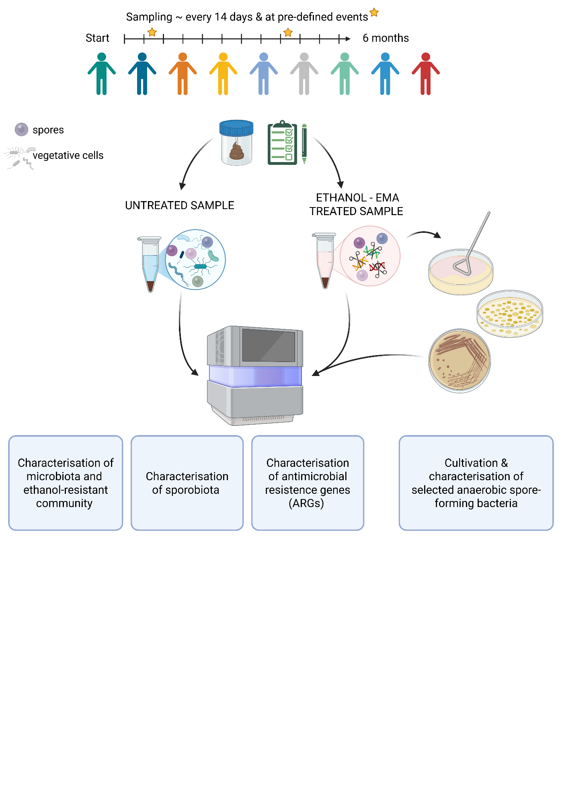
Figure 1. Longitudinal study design for characterisation of gut microbiota and sporobiota in stool samples from healthy male individuals. Created in BioRender.

LONGITUDINAL STOOL SAMPLE COLLECTION
Stool samples for this study were collected from nine healthy, unrelated, non-cohabiting male participants aged 25–43, with no gastrointestinal infections or surgeries in the three months preceding the study (Annex B). Individuals A, C, D are co-workers, with A and D also sharing an office. Additionally, individuals E and F also work in the same building.
Stool samples and corresponding questionnaires were collected at 14-day intervals for six months and additionally at pre-determined events: dentist or dental hygiene visits, vaccination, minor operative procedures, hospitalisation, single episodes of excessive alcohol consumption, diarrhoea, food poisoning, antibiotic treatment or travel. Questionnaires presented in Annex A included gathering information on health status and history, diet, and living conditions and nature of pre-defined events. Participants used sterile collection containers and delivered the samples to the laboratory within a few hours of collection. If immediate delivery was not possible, samples were stored at -20 °C until transport. Upon receipt, each sample was homogenized, divided into five aliquots (one 10 µl inoculation loop per aliquot), and stored at -80 °C.
Ethical approval was obtained from the National Medical Ethics Committee of the Republic of Slovenia (0120-280/2022/6).

COMPARISON AND OPTIMIZATION OF PROTOCOLS FOR DNA ISOLATION

Comparison of isolation protocols for bacterial DNA from human stool samples
We compared four DNA isolation protocols: QIAamp PowerFecal Pro DNA Kit (Qiagen, Germany), QIAamp Fast DNA Stool Mini Kit (Qiagen, Germany), NucleoSpin Soil Mini Kit (Macherey-Nagel, Germany), and an in-house protocol based on the DNeasy Blood & Tissue Kit (Qiagen, Germany) (Annex B). DNA was isolated in triplicate from three stool samples and a negative control containing 250 µl nuclease-free water. Samples were processed according to the manufacturer’s instructions, with the following modification: for the FastDNA and DNeasy protocols, additional mechanical lysis was performed using a mixture of 0.1 mm and 0.5 mm zirconia beads in equal parts on a MagnaLyser for 30 seconds at 7000 rpm. DNA was eluted in 100 µl nuclease-free water. DNA concentration was measured using the Quant-iT™ PicoGreen™ dsDNA Assay and dsDNA Reagents (Invitrogen™, USA).

Optimization of removal of vegetative cells and their DNA from stool samples
To obtain DNA from spores and other resistant cell forms we compared heat and ethanol shock treatments on stool samples. Additionally, we used ethidium bromide monoazide (EMA) to remove free DNA and DNA from damaged (vegetative) cells. EMA binds to free DNA and can enter damaged cells, where, under light exposure, it cleaves double-stranded DNA, rendering it unsuitable for PCR or sequencing. To minimise DNA fragmentation during extraction, we also optimised the bead-beating procedure.
Two stool aliquots in duplicates were each resuspended in 1.5 ml of 70% ethanol for 24 hours or subjected to heat shock at 80 °C for 30 minutes, based on our previous cultivation projects with spore-forming bacteria (Annex C). After treatment, samples were washed three times with nuclease-free water. For EMA treatment, samples were incubated with 2.5 ng/µl EMA in the dark for 5 minutes, then illuminated on ice for 5, 10, or 15 minutes using an 8000-lumen light source. Controls included untreated stool samples and heat- or ethanol-shocked samples washed only with water but without EMA treatment, as EMA-efficiency controls. DNA was isolated using the MasterPure™ Complete DNA and RNA Purification Kit (Lucigen, USA). Prior to isolation, samples underwent bead-beating in Cell Lysis Solution with 0.5 g of 0.5 mm silica beads using a MagNA Lyser (Roche Diagnostics, Germany) at 7000 rpm. Bead-beating was performed for 70 seconds for the initial comparison and subsequently optimised to two cycles of 30 seconds at 7000 rpm to reduce DNA shearing. DNA quality was assessed by gel electrophoresis for fragmentation and by the absorbance ratio at 260/280 to estimate protein contamination. DNA concentration was measured using the Quant-iT™ PicoGreen™ dsDNA Assay (Thermo Fisher Scientific, USA).
Ethanol shock combined with EMA treatment (10-minute illumination) and the optimised bead-beating protocol (2 x 30 s at 7000 rpm) was selected for isolation of ethanol treated samples from the longitudinal cohort. Isolated DNA was stored at -80 °C until further use.

DNA ISOLATION

DNA isolation from stool samples
DNA from untreated stool samples was isolated from an entire aliquot (one full 10 µl inoculation loop of stool) using the PowerFecal Kit (Qiagen, Germany) according to the manufacturer’s instructions, eluted in 100 µl nuclease-free water, and stored at -80 °C. DNA concentration was measured using the Quant-iT™ PicoGreen™ dsDNA Assay (Thermo Fisher Scientific, USA).

DNA isolation from pure bacterial cultures
Genomic DNA from pure bacterial cultures was isolated using a QIAamp DNA Mini Kit (Qiagen, Germany) with one full 10 µl inoculation loop of overnight culture. DNA was eluted in 50 µl nuclease-free water and stored at -20 °C. DNA concentration was measured with the Quant-iT™ PicoGreen™ dsDNA Assay (Thermo Fisher Scientific, USA).

ABSOLUTE QUANTIFICATION OF THE 16S rRNA GENE IN UNTREATED AND ETHANOL TREATED SAMPLES USING DROPLET DIGITAL PCR
Droplet digital PCR (ddPCR) was performed using EvaGreen QX200 technology (Bio-Rad, USA) to quantify the total bacterial load. ddPCR was conducted on all samples included in the longitudinal study, using universal primers targeting the V3-V4 regions of the 16S rRNA gene: 341F (5'-CCTACGGGNGGCWGCAG-3') and 806R (5'-GACTACHVGGGTATCTAATCC-3') (Klindworth et al., 2013). The reaction volume was 25 µl, comprising 2.5 µl of diluted DNA, 12.5 µl of 2 × EvaGreen Supermix, 0.5 µl of each 10 µM primer, and 9 µl of nuclease-free water. Droplets were generated using the QX200 Droplet Generator, following the manufacturer’s instructions.
The thermal cycling conditions were enzyme activation at 95 °C for 3 minutes, 40 cycles of denaturation at 95 °C for 30 seconds, annealing at 55 °C for 30 seconds, and elongation at 60 °C for 30 seconds, followed by a final elongation at 60 °C for 5 minutes and signal stabilisation at 4 °C for 5 minutes and 90 °C for 5 minutes. Absolute quantification was performed using QuantaSoft software v7.4.1, with a minimum threshold of 10,000 droplets per sample. The copy number of the target amplicon in each sample was calculated using Equation 1.
$c⋅\frac{V_{\text{reaction}}}{V_{\text{added DNA}}}⋅\frac{V_{\text{reaction}}}{V_{\text{used reaction}}}⋅\text{dilution factor}⋅\frac{c_{\text{original}}}{c_{\text{diluted}}}$ … (1)
Where c is concentration and V is volume. The copy number of the 16S rRNA gene was multiplied by the relative abundance of each OTU to determine their normalised abundance.

SEQUENCING OF DNA FROM ETHANOL TREATED AND UNTREATED STOOL SAMPLES, AND BACTERIAL ISOLATES

Amplicon sequencing of the 16S rRNA gene of ethanol treated and untreated stool samples
Bacterial community structure was determined by sequencing the V3-V4 region of the 16S rRNA gene using the same primers as for the ddPCR, 341F and 806R (Klindworth et al., 2013). Library preparation followed the 16S Metagenomic Sequencing Library Preparation protocol (Illumina, USA) with Q5® High-Fidelity DNA Polymerase (New England Biolabs, USA) or KAPA HiFi HotStart ReadyMix (Kapa Biosystems, Massachusetts, USA), as specified in Annex D. Sequencing was performed on Illumina’s NextSeq platform (2 × 300 bp) or, where specified, on the Illumina MiSeq platform with the MiSeq Reagent Kit V3 (2 × 300 bp).

Shotgun metagenomic sequencing of ethanol treated and untreated stool samples
Shotgun metagenomic sequencing was outsourced and performed on the BGI DNBSeq sequencing platform (BGI, Hong Kong). The initial steps involved enzymatic fragmentation of DNA from the untreated samples, while for ethanol treated samples, fragmentation was unnecessary as the DNA was already fragmented. Fragments between 200 and 400 base pairs were selected using MGIEasy DNA Clean Beads (MGI, Hong Kong). The 3’ ends were then repaired by adenylation, and adapters were ligated to the DNA fragments. DNA fragments were amplified by PCR and purified using MGIEasy DNA Clean Beads (MGI, Hong Kong). The purified PCR products were denatured and circularised using a splint oligo sequence. The resulting single-stranded circular DNA (ssCir DNA) constituted the final library. Any non-circularised DNA was digested, and library concentration was measured, libraries with concentrations above 1 ng/µl were selected for sequencing. Each library was further amplified using Phi29 DNA polymerase to generate DNA nanoballs (DNBs), each containing over 300 copies of a single molecular entity. These DNBs were loaded onto a patterned nanoarray where paired-end reads of 150 bases were generated.

Whole-genome sequencing using Illumina short-read technology
Libraries for whole-genome sequencing of individual strains were prepared using the NEBNext Ultra II FS DNA Library Prep Kit for Illumina (New England Biolabs, UK) according to the manufacturer’s instructions. Libraries were sequenced using 2 × 150 bp paired-end reads on the NextSeq2000 platform (Illumina, USA).

3.5.4 Whole-genome sequencing using Oxford Nanopore Technologies long-read technology
Within Clostridium saudiense analysis five selected isolates, representing each strain group based on ANI score, were chosen based on containing the highest number of reads and lowest number of contigs. Libraries were prepared using the Rapid Barcoding Kit 24 SQK-RBK114.24 (Oxford Nanopore Technologies – ONT, UK) and sequenced on R10.4.1 flow cells for 48 hours on MinION platform (ONT, UK).

DATA ANALYSIS
All code and tables obtained after preprocessing steps to carry out the analysis presented along with notes showing command runs is available at: https://github.com/ursamiklavcic/PhD, with sub-folders for each type of analysis.

16S amplicon (16S AS) data analysis

Preprocessing
Sequenced reads were processed and binned in mothur v.1.48.0, following the MiSeq standard operating procedure for Illumina paired-end reads (Schloss et al., 2009). Reads were processed using the following criteria: no ambiguous bases were allowed and the maximum homopolymer length was set to 8 base pairs, reads were then aligned against the Silva reference alignment (Release 138), chimeras were identified using the UCHIME algorithm, reads were classified using the RDP training set v.9 with a bootstrap threshold value of 0.80. Sequences were clustered into operational taxonomic units (OTUs) at a 97% similarity cut-off (Cole et al., 2014; Edgar, 2016; Edgar et al., 2011; Pruesse et al., 2007). OTUs were used instead of ASVs as binned quality scores outputted from NextSeq2500 are not yet compatible with ‘dada2’ pipeline. After quality filtering, depending on the depth of coverage OTUs with fewer than a specified number of reads were removed. Each sample was rarefied to the minimum number of reads after filtering, rounded down to the nearest 1000 based on sequencing experiment (Annex D). Samples with fewer reads than the chosen minimum were removed from the analysis. Analysis and graphical representations of the experiments were performed in R v4.4.1 using the following packages: ‘dplyr’, ‘tidyr’, ‘tibble’, ‘stringr’, ‘readr’, ‘scales’, ‘ggplot2’, ‘ggpubr’, ‘vegan’, ‘glue’, ‘lubridate’, ‘purrr’, ‘readxl’, ‘forcats’, ‘ggnewscale’, and ‘renv’, with versions available in the thesis.renv environment (ggplot2 Based Publication Ready Plots, n.d.; Project Environments, n.d.; R: The R Project for Statistical Computing, n.d.; Read Excel Files, n.d.; Scale Functions for Visualization, n.d.; tidyverse/glue, December 23, 2016/2025; Jari Oksanen, n.d.a, n.d.b; JARI Oksanen et al., 2022; Wickham et al., 2019).

Criteria for determination of ethanol-resistant and ethanol non-resistant OTUs in the longitudinal study
An individual OTU was determined as a member of the ethanol-resistant community if it met the following criteria: 1) the OTU was present in both the untreated and ethanol treated sample from the same stool sample, and 2) it was found at a higher relative abundance in the ethanol treated sample in at least 5% of samples where criterion 1) was met. OTUs absent from all ethanol treated samples were considered ethanol non-resistant.
OTUs detected in the ethanol-resistant community in less than 5% of the samples (determined uncertain, n = 83), and OTUs detected only in ethanol-treated samples (n = 141), were excluded from further analysis (Annex E).

Bacterial diversity and community composition analysis
Community diversity of the ethanol-resistant and ethanol non-resistant communities was calculated using functions from the R package ‘vegan’.
For alpha diversity, we used richness and evenness separately, as well as the Shannon diversity index, which measures both the richness and evenness of a sample. Temporal changes in alpha diversity for each participant were compared between 16S amplicon and metagenomic data for untreated and ethanol-treated samples using repeated-measures correlation analysis implemented in the ‘rmcorr’ R package (Bakdash and Marusich, 2017).
Between-sample diversity was assessed using Bray-Curtis dissimilarity and Jaccard distance, considering the number of OTUs and their relative abundance or presence and absence, respectively. Unequal group sizes in the beta diversity analysis were addressed using bootstrapping (subsample size = 104, 99 permutations). Procrustes analysis was used to assess concordance between NMDS ordinations based on Bray–Curtis dissimilarity calculated from OTU- and species-level data (Peres-Neto and Jackson, 2001). Jaccard distance was compared between individuals and within individuals, accounting for participant-specific clustering using PERMANOVA from R package ‘vegan’.
The composition of ethanol-resistant and ethanol non-resistant communities was analysed by comparing differences in relative abundance, persistence (number of samples per person in which an OTU was detected), and the number of OTUs belonging to each community, using Wilcox rank-sum test.

Sporulation frequency calculation and analysis of host, time, and OTU-specific influences
Sporulation frequency analysis was performed on a subset of OTUs that met two criteria: 1) classification within ethanol-resistant Bacillota, and 2) detection in at least 80% of both untreated and ethanol treated samples (to ensure robust temporal coverage). For each eligible OTU (i), sporulation frequency was defined as the ratio e_{i}/m_{i} , where e_{i} is the normalised abundance of the OTU in the ethanol treated sample and m_{i} is normalised abundance in the untreated sample. The untreated samples include sequences from both vegetative cells and ethanol-resistant forms, while the ethanol treated sample selectively enriches for spores (Annex F). Sporulation frequency thus reflects the fraction of an OTU population in a sporulated state at a given time point in an individual host. The reliability of this measure is supported by a strong correlation between the relative and/or normalised abundances of the OTU in both sample types, despite different isolation protocols (Annex F).
To assess whether the temporal order of sampling influences sporulation dynamics, we compared two scenarios for each host. First, within-individual sporulation frequency was calculated for each OTU from chronologically ordered time points; second, time points were randomly shuffled prior to calculating the within-individual sporulation frequency for each OTU. Pearson correlation coefficients were then computed between ordered and reshuffled sporulation frequency values for each OTU-host pair to quantify the influence of temporal structure.
To characterise sporulation variability, we calculated the within-individual variance in sporulation frequency for each OTU and the population-wide variance for the same OTU. Differences in the distribution of these variance values across hosts and OTUs were assessed using the Kruskal–Wallis test. To evaluate the degree of synchronisation in sporulation dynamics across OTUs within individual hosts, we also computed pairwise Spearman correlation coefficients between sporulation frequencies of all OTUs within each individual and compared these with linear mixed models to remove the intra-individual effect.

Shotgun metagenomic data analysis

Preprocessing
Raw metagenomic reads were filtered and trimmed using the SOAPnuke programme (Y. Chen et al., 2018). Reads containing 10% or more of uncertain bases, adapter sequences, or low-quality bases (Q < 20) were removed. All reads with more than 90% identity to host DNA using the reference genome GRCh38.p14, were also removed.

Bacterial community composition analysis
Bacterial composition was determined using MetaPhlAn v4.2.2, database vJan25_202503, with default settings, but the calculation of relative abundance also included unclassified taxa (Blanco-Míguez et al., 2023a). MetaPhlAn profiles microbial communities by mapping reads to a curated database of unique species-level marker genes derived from single-genome bins (SGBs) from isolate genomes and metagenome-assembled genomes of bacteria, archaea and eukaryotes. Alpha and beta diversity, composition, and other graphical representations were calculated using functions in the R package ‘vegan’ at the level of bacterial species. Analysis of other microbes was not part of this dissertation.

Gene-based determination of sporulation ability for bacterial species
Sporulation ability was determined for all bacterial species detected in untreated and ethanol treated samples where the species also had an NCBI species-level classification. The gene signature comprised 66 conserved genes (Annex G) previously shown to predict the sporulation ability of bacterial species isolated from diverse environment with high accuracy (Browne et al., 2016b, 2021). Reference genomes (the representative genome for each species based on GTDB) for detected species were retrieved from the NCBI Genome database. For each species, gene presence was assessed using BLAST-based gene detection (e-value < 1 × 10⁻⁵ and identity > 30%) (Camacho et al., 2009; Sayers et al., 2024). If a genome had more than 33 genes present, the species was classified as spore-forming. The method is supported by the distribution of the number of genes present in a diverse set of genomes, with a clear break at 30 genes (Annex G), and by previous transmission electron microscopy of spores from species determined as spore-forming (Browne et al., 2021).

Determination of ethanol-resistant bacterial species
Ethanol resistance was determined for all bacterial species detected in untreated and ethanol treated samples using the same criteria as for the OTUs (see Chapter 2.6.1.2). Species detected in the ethanol-resistant community in less than 5% of the samples (determined uncertain, n = 163), and species detected only in ethanol-treated samples (n = 110), were excluded from further analysis (Annex E).

Analysis of antibiotic resistance gene in untreated stool samples
We used AMRfinder v4.0.3, db2025-07-16.1, which identifies antimicrobial resistance genes using basic local alignment to known sequences (Feldgarden et al., 2019, 2021). AMRfinder reports exact BLAST matches over the full length of the reference protein or, if there is no exact match, reports match with greater than 90% identity or with greater than 50% coverage of the protein. Results were imported into R for visualisation and statistical analysis to report abundance, diversity, taxonomy, and persistence of these genes over time within individuals. Linear mixed-effect models were used to assess the association between diversity and abundance of ARGs to bacterial abundance based on species-level data. Individuals were always added as a random effect.

CULTIVATION AND MOLECULAR CHARACTERISATION OF SELECTED SPORE-FORMING BACTERIA FROM HUMAN STOOL SAMPLES

Isolation of selected spore-forming bacteria from ethanol treated stool samples
Stool samples from individual H were selected for this analysis. Based on amplicon data from untreated and ethanol treated samples, we observed a reduction in diversity and normalised abundance of bacteria during a period in individual H that coincided with antibiotic treatment (amoxicillin). Stool samples from one month before, during and after antibiotic use were used for isolation of spore-forming bacteria.
To isolate selected spore-forming bacteria, we treated stool samples with 70% ethanol for 24 hours at room temperature (23 °C) with shaking. Samples were serially diluted to 10⁻⁵, and 100 μl of undiluted sample and its 10-fold serial dilutions were plated on oxygen-reduced WCAB (Wilkins-Chalgren Anaerobe agar (Thermo Fisher Scientific, USA) with the addition of bile acids (5% w/v; Merck, USA) and incubated for 2 days at 37 °C in an anaerobic workstation (Whitley A35 Workstation, Don Whitley Scientific, UK). WCAB has in our previous experiments been shown to enable germination and sustain the growth of the highest number of different spore-forming bacteria from human stool samples (Dobovišek, 2021). After 2 days, approximately 60 colonies from each sample were picked and sub-cultured on fresh WCAB. Identification of colonies was performed on overnight cultures with a commercial MALDI-TOF MS identification system (Bruker, USA). Based on the number of isolates we chose C. saudiense for further investigation. We froze selected isolates in oxygen-reduced 20% glycerol with WCAB medium at -80 °C until further use. DNA was isolated from a single colony overnight culture and sequenced as described in chapters 3.5.3 and 3.5.4 (Annex D).

Analysis of whole-genome sequences

Preprocessing and assembly of short-read sequences
Sequencing was performed as described in chapter 3.5.3. The quality of Illumina short-read sequences was assessed with FastQC v0.12.1 and trimmed using Trimmomatic v0.39 using the following settings: ILLUMINACLIP:NEBPE-PE.fa:2:30:10, LEADING:10, TRAILING:10, SLIDINGWINDOW:4:20, MINLEN:40 (Babraham Bioinformatics - FastQC A Quality Control tool for High Throughput Sequence Data, n.d.; Bolger et al., 2014). The trimmed reads were assembled de novo into contigs using SPAdes v3.13.0 with the --careful option, retaining all other settings at their default values (Prjibelski et al., 2020). The assembly was assessed with QUAST (Gurevich et al., 2013).
Trimmed short reads were mapped to a reference genome from NCBI (NCBI RefSeq assembly GCF_000577815.1) using bowtie2 with the --sensitive flag (Langmead and Salzberg, 2012). Samtools was then used to sort and index the SAM files (H. Li et al., 2009). Coverage was calculated using genomeCoverageBed within BEDtools for each individual genome and for the combined coverage of all genomes (Quinlan and Hall, 2010).

Preprocessing of long-read sequences and hybrid assembly
Five isolates were additionally sequenced on an ONT MinION platform as described in chapter 3.5.4. The quality of long-reads was assessed with NanoPlot v1.43.0 and NanoStat v1.6.0, and reads were filtered with NanoFilt v2.8.0 using a minimum Q-score of 10 and a minimum read length of 3000 bases (De Coster and Rademakers, 2023; De Coster et al., 2018). Hybrid assemblies were constructed with flye v2.9.6 using trimmed short-read sequences and filtered long-read sequences with default settings (Kolmogorov et al., 2019).

Average nucleotide identity (ANI)
pyANI-plus was used to calculate pairwise ANI blast scores with default parameters between the core genomes of all sequenced isolates. Core genome is here defined as genes present in all genomes analysed (Pritchard et al., 2015). To delineate strain boundaries, a strain break was determined by plotting ANI pairwise scores on a histogram in R. The strain break was then applied to filter the results, retaining only genome pairs that exceeded the defined identity cutoff. An undirected graph was constructed from the filtered genome pairs using the `igraph` R package (Antonov et al., 2023). Each genome was represented as a node and each qualifying pairwise relationship as an edge. Connected components within the graph were identified, corresponding to discrete strain groups. Each genome was assigned to a strain group based on its graph membership. Alternatively, we also used pyANI-plus ‘classify’ with strain break at 99.72% to confirm the network determination of strain groups (Annex K2).

Single-nucleotide polymorphism (SNP) analysis
SNPs in core genome were determined using Snippy v4.6.0 (Seemann, May 15, 2014/2022). We used the hybrid assembly of genome H009_98 as the reference genome. Gubbins v3.4.1 was used to remove recombinant loci (Croucher et al., 2015). The filtered SNP matrix was used to construct a neighbour-joining tree in Gubbins, which we visualised in MEGA v12 (Tamura et al., 2021).

Pangenome analysis
All genome assemblies were annotated with Prokka v1.14.6 prior to pangenome construction (Seemann, 2014). The pangenome was inferred with Roary v3.11.2 and visualised with Phandango, including metadata on the sampling day for each stool sample (Hadfield et al., 2018; Page et al., 2015).

Determination of mobile genetic elements and antimicrobial resistance genes in assembled genomes
All genome assemblies were checked for presence of mobile genetic elements using MobileElementFinder and geNomad, with default settings (Camargo et al., 2024; Johansson et al., 2021). Viral and plasmid sequences detected by geNomad were clustered at 90% identity and 80% coverage using MMseqs2, to compare detection of plasmids and viral sequences across our genomes (Steinegger and Söding, 2017).
We used AMRfinder v4.0.3, db2025-07-16.1, which identifies antimicrobial resistance genes using basic local alignment to known sequences (Feldgarden et al., 2019, 2021). AMRfinder reports exact BLAST matches over the full length of the reference protein or, if there is no exact match, it reports matches with more than 90% identity or more than 50% coverage of the protein.

In vitro determination of amoxicillin resistance of C. saudiense strains
Amoxicillin susceptibility of each strain was determined by the minimum inhibitory concentration (MIC) method using amoxicillin E-test strips (bioMérieux, France). Isolates H005_73, H005_98, H005_118, H007_176, H007_194, H009_221, and H009_230 were cultured from frozen stock solutions on Columbia agar plates with 5% added horse blood (COH; bioMérieux, France). Fresh overnight cultures were suspended in 2 ml of 0.9% NaCl solution and adjusted to turbidity equivalent to 1 McFarland standard. The suspensions were inoculated confluently onto oxygen-reduced COH plates, after which amoxicillin E-test strips were applied. MIC values were determined after overnight incubation.

Determination of C. saudiense strains in metagenomic data
Using two published tools and a novel approach using similar mindset, we compared the determination of strain structure of C. saudiense in shotgun metagenomic samples from participant H.
We first used StrainPhlAn v4.1.1 to identify the dominant C. saudiense strain in the samples from participant H and to construct a dendrogram based on average site substitutions between samples (Blanco-Míguez et al., 2023b). This approach reconstructs only the dominant strain of a target species. It aligns all reads to species-specific marker genes and generates a multiple sequence alignment, which is then used by PhyloPhlAn to build a phylogenetic tree.
To connect the whole-genome dataset with the shotgun metagenomic dataset, we also used StrainScan v1.0.14 (Liao et al., 2023). StrainScan determines strain structure based on hierarchical clustering of assembled genomes of a species and finds strain-specific k-mers, to which it maps short reads from metagenomic samples to determine the strain structure of each sample.
In the third, novel approach we identified strain-specific genes for each strain determined by core SNPs and core-gene content. Next we mapped metagenomic reads from all stool samples of participants H and A to these strain-specific genes using bowtie2 with the --very-sensitive flag (Langmead and Salzberg, 2012). Participant A served as a negative control for this approach. We normalized the number of reads mapped to each gene, by gene length (bp) and, for each strain, by the number of genes detected for that strain, and visualized the results in R.

RESULTS

COMPARISON OF ISOLATION PROTOCOLS FOR BACTERIAL DNA FROM HUMAN STOOL SAMPLES
Four DNA isolation protocols for isolation of DNA from untreated stool samples were compared using three stool samples and a negative control, each processed in triplicate. Amplicon sequencing of the V3-V4 region of the 16S rRNA gene was performed to assess the efficiency of each protocol (Annex D). Selection of the best protocol was based on two criteria: the highest DNA yield and the ability to recover all bacterial phyla known to reside in the human gut (Martino et al., 2022).
All four DNA isolation kits produced DNA concentrations sufficient for downstream molecular applications, with the PowerFecal kit yielding approximately ten times higher DNA concentrations than the other protocols (paired t-test, p < 0.001; Figure 2A). The DNA concentration of negative controls was approximately 1 ng/µl, with OTUs averaging between 2 and 5 reads per control. Microbial community composition was significantly influenced by the DNA isolation protocol, explaining 19% of variation (PERMANOVA, p = 0.005; Figure 2B). The DNeasy protocol yielded significantly lower alpha diversity compared to the other three protocols (paired t-test, p < 0.005; Figure 2C), largely due to its reduced efficiency in isolating bacteria from phylum Bacteroidota (Figure 2D). The remaining three isolation protocols all produced distinct communities, which however did not significantly differ in alpha diversity metrics. Consequently, the PowerFecal protocol was selected for subsequent analysis because it provided the highest DNA yield and comprehensive bacterial recovery.
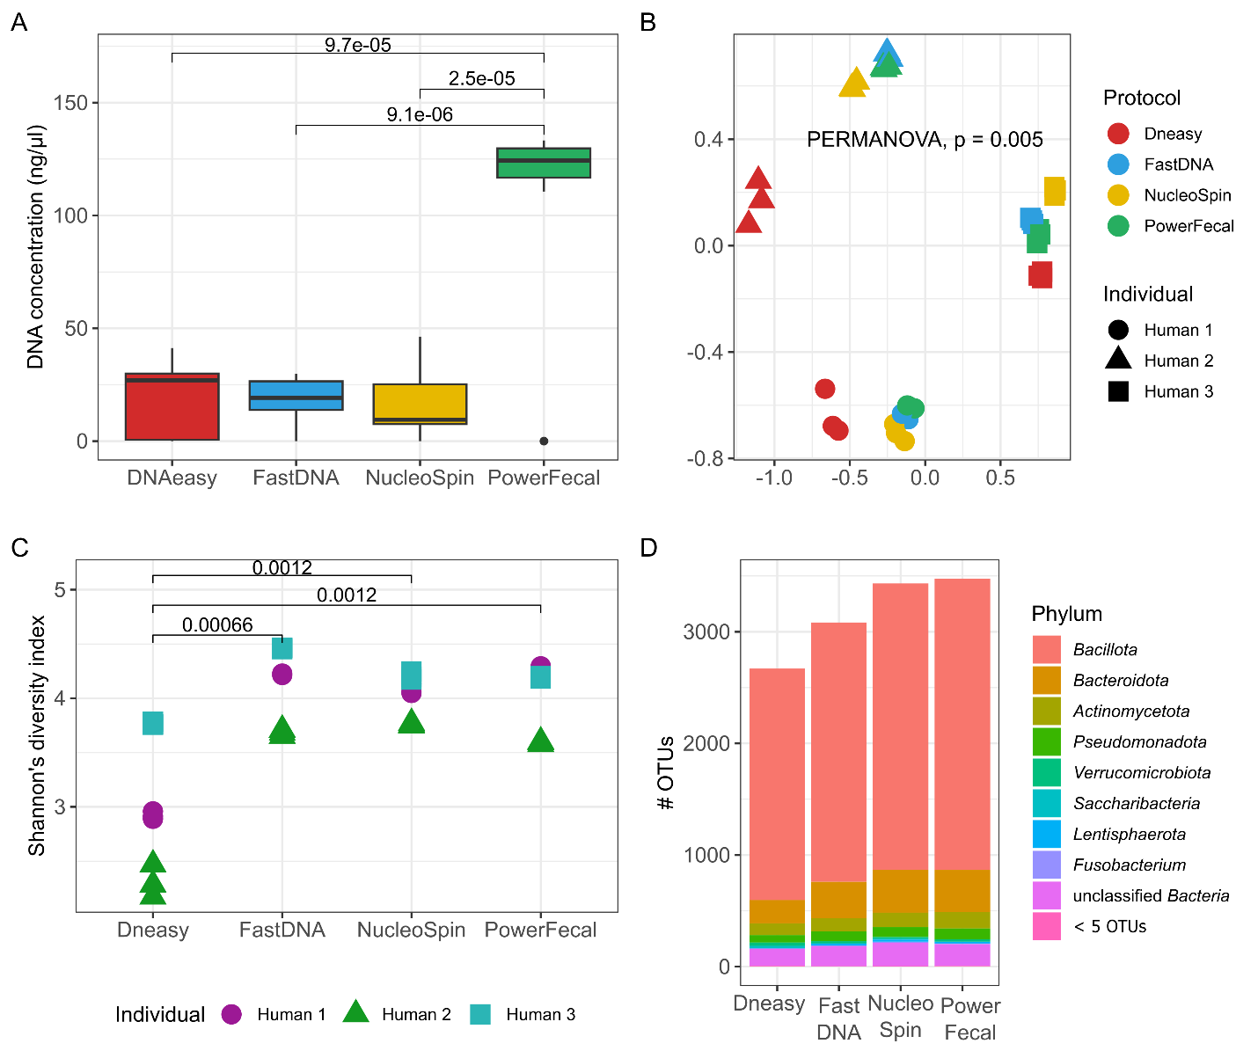
Figure 2. Comparison of DNA concentration, alpha and beta diversity, and the number of unique OTUs recovered from three human stool samples using four different DNA isolation protocols. A) DNA concentrations [ng/µl] after isolation, measured with the Quant-iT™ PicoGreen™ dsDNA Assay and dsDNA Reagents (Invitrogen™, USA), with p-values above the connecting boxplots from paired t-tests. B) Non-metric multidimensional scaling (NMDS) ordination based on Bray–Curtis distances, with permutational multivariate analysis of variance used to assess differences between protocols (PERMANOVA). C) Shannon’s diversity index, with p-values above the connecting boxplots from paired t-tests. D) Number of unique OTUs in each bacterial phylum across samples for each DNA isolation protocol, concatenating phyla with fewer than 5 OTUs into one group (< 5 OTUs). Legend: FastDNA: QIAamp Fast DNA Stool Mini Kit; NucleoSpin: NucleoSpin Soil Mini Kit, PowerFecal: QIAamp PowerFecal Pro DNA Kit; DNAeasy: in-house protocol based on the DNeasy Blood & Tissue protocol.

OPTIMIZATION OF REMOVAL OF VEGETATIVE CELLS AND THEIR DNA FROM STOOL SAMPLES
The experiment included two stool samples, each treated in duplicate with either ethanol shock using 70% ethanol for 24 hours or heat shock at 80 °C for 30 minutes (selected based on previous experiments, see Annex C). Free DNA and DNA in damaged cells from either ethanol or heat shock, were subsequently removed by ethidium bromide monoazide (EMA) treatment with illumination times of 5, 10, or 15 minutes. Negative controls included a water sample treated alongside the stool samples, which was not sequenced due to low DNA concentration. Additional controls comprised an untreated stool sample, used to assess the fraction of the community removed by shock, or/and ethanol- and heat-shocked samples washed only with nuclease-free water (without EMA), as EMA-efficiency controls.
Removal efficiency of non-spore-forming bacteria was evaluated using amplicon sequencing, focusing on taxa known to form spores according to the literature (Figure 3). Number of unique OTUs for each of the most abundant bacterial phyla were calculated across biological replicates for each treatment and compared with the untreated stool sample and the EMA-efficiency controls. Both ethanol shock and heat shock enriched for OTUs belonging to the phylum Bacillota and reduced the number of OTUs from other phyla compared to the original stool sample and EMA-efficiency controls. The 15-minute EMA illumination resulted in the strongest depletion of non-spore-forming phyla but had a low success rate of DNA isolation. Only 5 out of 16 samples had DNA of sufficient concentration and quality for sequencing, compared to 5 minutes (14/16) and 10 minutes (8/16).
For isolation of DNA from spores in human stool samples, ethanol shock combined with EMA treatment and 10-minute illumination was selected as the optimal compromise between selectivity and sequencing success rate.
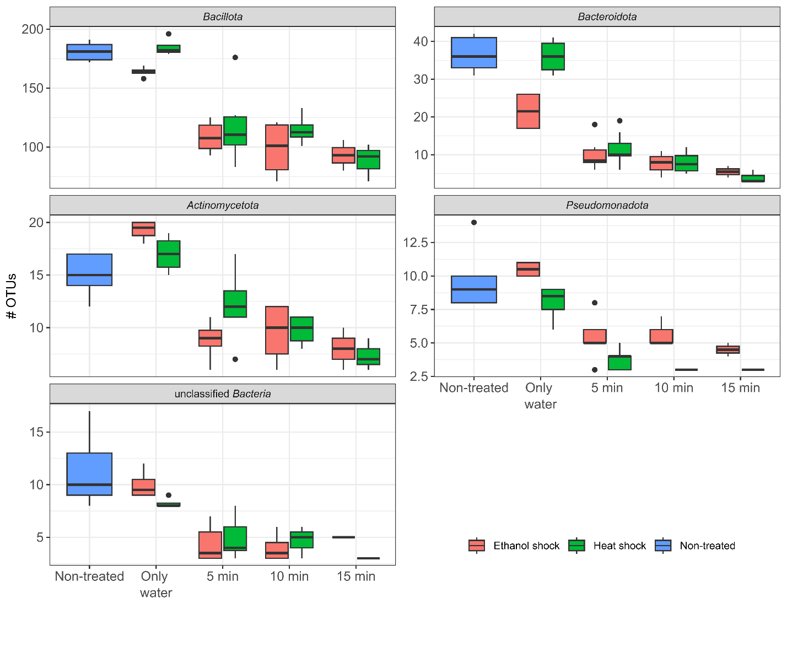
Figure 3. Efficiency of lysis and subsequent removal of free DNA and DNA in lysed cells by EMA treatment after heat or ethanol shock. Each plot represents one of the most abundant phyla in stool samples. Number of OTUs is represented on the y-axis. The boxplots are colour-coded by non-treated stool (blue), stool samples treated with ethanol shock (red), or heat shock (green), with different illumination times after EMA treatment (only water, 5 min, 10 min, and 15 min).

DESCRIPTION AND COMPARISON OF THE TEMPORAL STABILITY OF THE GUT MICROBIOTA AND SPOROBIOTA IN HEALTHY INDIVIDUALS
The population consisted of nine healthy adult males (anonymized with letters A to I), with a BMI between 18 and 33. All except one individual followed an omnivorous diet (participant I followed a lactose-free omnivorous diet). All participants reported regular digestion, with Bristol stool types ranging from 2 to 4. The use of regular food supplements varies, including omega-3 (A, I), protein powder (C, D, G), and probiotic yoghurt (D). Only participant I consistently consumed probiotics (Vivomox, EkoŠkrnicl Unibiotic Strong) (Annex B). Others reported probiotic supplementation overlapping with antibiotic use, travel, or food poisoning. Participants E and H consumed antibiotics during the study, doxycycline and amoxicillin, respectively. Participants reported only travel longer than three days outside their country of residence. Most reported visits were to other European countries: Croatia (A, B, F, G, H), the UK (C), Switzerland and the Netherlands (D). However, one individual (B) also travelled to Tanzania and Kenya during the study (Annex B).

Comparison of 16S amplicon and metagenomic sequencing approaches and general characterises of microbiota in our dataset
We obtained at least 12 stool samples (ranging 12 to 14) from each participant over a six-month period, obtaining 117 samples all together. DNA was isolated from untreated and ethanol treated stool samples. Of all 234 samples (117 untreated and 117 ethanol treated samples) we successfully sequenced 201 samples using metagenomic sequencing and 230 samples using 16S amplicon sequencing (16S AS).
Using MetaPhlAn4.1 we detected marker genes for 1027 bacterial species across all metagenomic samples. Of these, 527 were assigned to a named NCBI species, while the remainder (n = 500) were classified at higher taxonomic level. In 16S AS data, 2572 OTUs were detected across all samples. The combined use of 16S AS and metagenomic sequencing enabled comprehensive analysis of both community composition and longitudinal dynamics, with the 16S AS approach providing higher sensitivity for low-abundance taxa and metagenomic data supporting improved taxonomic resolution and inference of sporulation ability (Annex H).
Community richness and evenness for both OTU-level (16S AS) and species-level (metagenomic) data revealed highly synchronized and stable within-individual temporal patterns (Figure 4, repeated-measures correlation p < 0.001 for both). Antibiotic treatment in both participant E and H could be linked to reduced bacterial diversity. Many individuals travelled during the study, not all events could be connected to a change in bacterial diversity, as sometimes it led to increase in bacterial richness (A) and a reduction in evenness (D). The number of reported pre-defined events was too small for significant correlations and are thus reported as observational.
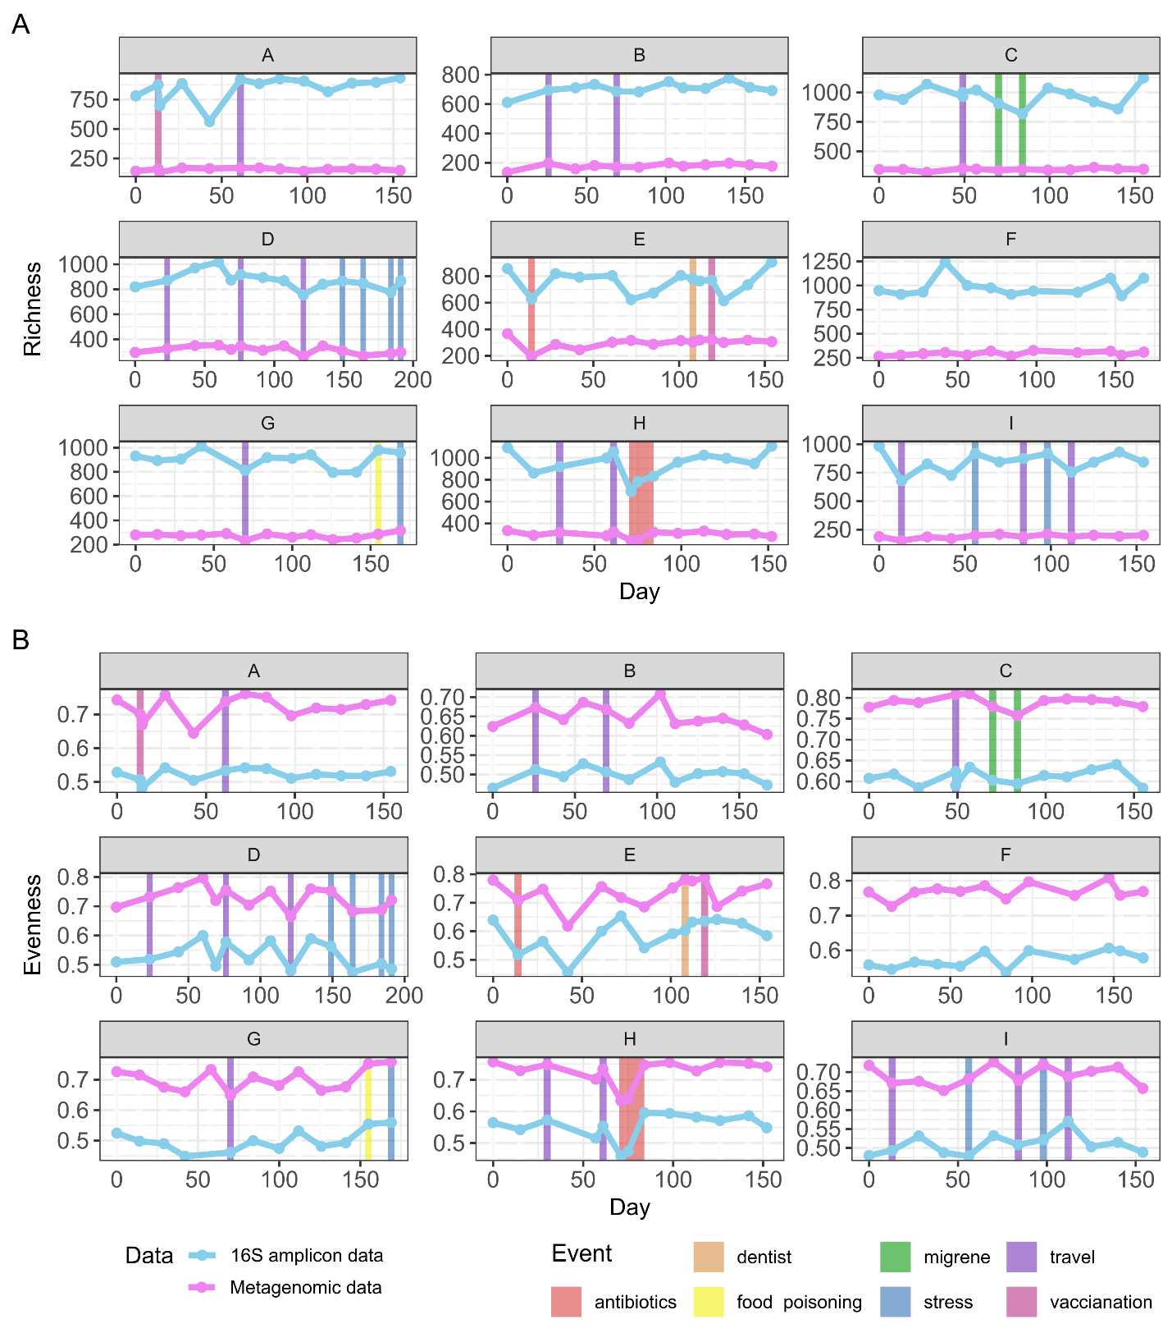
Figure 4. Richness and evenness based on OTU- (16S AS) and species-level (metagenomic) data for untreated samples. Richness and evenness estimated from 16S AS data were positively associated with those derived from metagenomic data across individuals. Linear mixed-effects models with participant included as a random intercept; richness p < 0.001; evenness p < 0.001. No significant effect of time was observed for richness (p = 0.77) or evenness (p = 0.79).
In both, 16S AS and metagenomic data, 73.0% and 73.5% of variation, respectively was explained by participant identity (Figure 5, PERMANOVA, 999 permutations, p = 0.001 for both data types). Comparison of environmental fitting of metadata onto the NMDS ordination based on OTU- or species-level data identified several individual-related variables significantly associated with microbial community structure. The strongest predictor of microbiome composition was food supplements when taken as a group (vitamins, omega 3, pro- and pre-biotics all together), while lower but consistent predictors across both data types were also height, weight, age, stress and consumption of pre- and probiotics (Annex H). Seasonality had no effect on microbiota composition.
Spatial separation in NMDS ordination space was maintained between the two sequencing methods, indicating a robust individual-specific microbiome signatures (Figure 5, symmetric Procrustes analysis, r = 0.94, 999 permutations, p = 0.001).
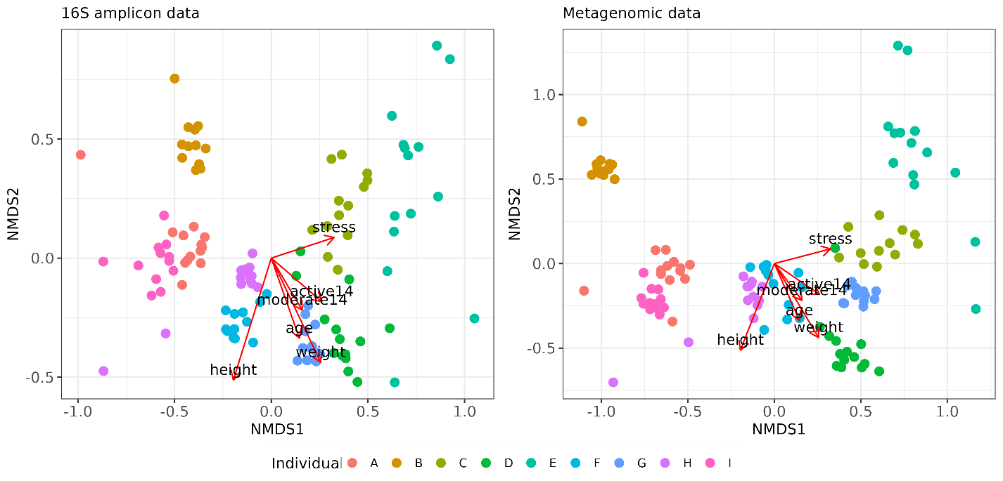
Figure 5. Beta diversity of untreated stool samples based on 16S amplicon (left) and metagenomic data (right). NMDS ordinations based on Bray-Curtis dissimilarity of untreated samples derived from 16S amplicon (OTU-level) and metagenomic (species-level) relative abundances. Colours indicate participants.
16S AS and metagenomic sequencing produced broadly consistent phylum-level profiles, with Bacillota dominating all sample types (Figure 6). In untreated stool samples, 16S AS data showed a higher relative abundance of Bacteroidota and Actinomycetota phylum, whereas metagenomic data were more strongly dominated by Bacillota. In ethanol treated samples, both methods showed an even stronger enrichment of Bacillota and a marked depletion of other phyla, consistent with selective retention of ethanol‑resistant taxa.
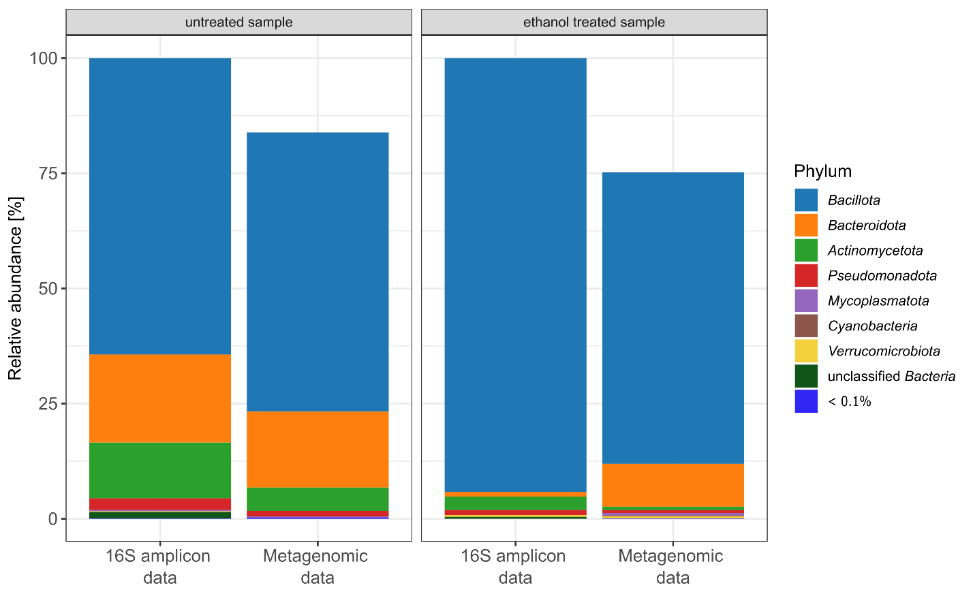
Figure 6. Relative abundance of bacterial phyla across samples for 16S AS and metagenomic data in ethanol treated and untreated samples.

At lower taxonomical levels the comparison is made more complicated due to MetaPhlAn naming for example genera, which are not in line with generally accepted nomenclature. In metagenomic data in untreated samples we see that the top ten genera (from most abundant to least) are Faecalibacterium, Alistipes, Bacteroides, Oscillibacter, two genera from phylum Bacillota, Bifidobacterium, Wujia and another two genera from Bacillota. While in 16S AS data the top ten most abundant genera are Bacteroides, Lachnospiraceae, Collinsela, unclassidied Ruminococcaceae, Prevotella, Ruminococcus, Dialister, Erysipelotrichaceae incerta sedis, Coprococcus and Clostridioides.

Composition, abundance and diversity of ethanol-resistant bacterial community and sporobiota in our dataset
First, we present results from 16S AS data, in which we analysed compositional characteristics and temporal dynamics in the ethanol-resistant community of the human microbiota. Ethanol-resistant taxa were determined based on presence and abundance criteria in the ethanol treated samples (see Chapter 3.6.1.2). Second, we present metagenomic data where the same criteria were used for determination of ethanol resistance at the level of presence and abundance of each species (see Chapter 3.6.2.4). Additionally, in metagenomic data we could also determine sporulation ability based on presence of sporulation-associated genes (see Chapter 3.6.2.5).
With 16S AS we detected a total of 2420 OTUs in untreated stool samples. Of these, 411 OTUs (17.0%) met the criteria for ethanol resistance, 1932 OTUs (79.8%) were determined as ethanol non-resistant, and 77 OTUs (3.2%) were designated as undetermined (Figure 7A). The 152 OTUs detected only in ethanol treated samples are described in Annex E. Most ethanol-resistant representatives in the 16S AS were found in the phylum Bacillota (n = 315), accounting for 77.5% of the total richness in the ethanol-resistant community (Figure 7A). Within Bacillota, 17.7% of all detected OTUs exhibited ethanol resistance, predominantly from the genera Clostridium (n = 75), unclassified Lachnospiraceae (n = 47), unclassified Ruminococcaceae (n = 42), unclassified Peptostreptococcaceae (n = 13), and Blautia (n = 12). The remaining ethanol-resistant community included representatives from Actinomycetota (n = 41, 11%), Pseudomonadota (n = 23, 5.5%), and unclassified Bacteria (n = 14, 3.7%). In these groups, the proportion of ethanol-resistant OTUs was 36.6%, 39.6%, and 20.8%, respectively, exhibiting this trait. Additionally, phyla with fewer than ten representatives collectively contributed 2.3% of the ethanol-resistant richness, most notably the biologically relevant genus Akkermansia. Ethanol treatment had the strongest elimination effect on the phylum Bacteroidota, with only 9 representatives remaining in the ethanol-resistant community, accounting for 0.5% of the total relative abundance. Ethanol-resistant taxa exhibited higher relative abundance, primarily driven by Bacillota OTUs due to their high abundance, although similar trends were also observed in phylum Actinomycetota and for unclassified Bacteria (Annex I).
In metagenomic data, a total of 917 species were detected in untreated stool samples, of these 253 (27.6%) met criteria for ethanol resistance, 501 (54.7%) were determined as ethanol non-resistant and 163 (17.8%) did not meet the criteria and were designated as undetermined (Figure 7A). The properties of the 110 species detected only in ethanol treated samples are described in Annex E. The ethanol-resistant community was dominated by members of the phylum Bacillota, 81.8% of all ethanol-resistant taxa in untreated samples. In contrast, the number of ethanol-resistant taxa was notably lower in remaining phyla (Figure 7A). Fractions of ethanol-resistant taxa showed consistency across different phyla between the two sequencing approaches (Figure 7A, mean difference 0.6 %, paired t-test, p = 0.96).
Using metagenomic data we could also determine sporulation ability based on presence of sporulation genes - sporobiota. Including this information besides the ethanol resistance determined based on presence and abundance criteria in the ethanol treated samples, we obtained information on actual sporulation (presence of spores) of a species in a given gut environment.
A total of 527 species were assigned a known NCBI species name with available genome sequence in the entire set of 203 stool samples, enabling inference of sporulation ability based on the presence of a predefined set of sporulation genes (Figure 7B). The remaining species (n = 388) could not be assigned to a species-level name and were excluded from further analysis. The unassigned species represented around 22.8% of total relative abundance, predominantly comprising Bacillota (17.8%) and Bacteroidota (3.3%), while other phyla contributed less than 0.6% of total relative abundance per sample. Assembly-based reconstruction of metagenome-assembled genomes (MAGs) produced only 64 high-quality MAGs (completion > 90%, contamination < 10%), thereby preventing genome-resolved analyses.
We identified 236 spore-forming species in the phylum Bacillota, and 292 non-spore-forming species distributed across Bacillota (n = 134) and other phyla (n = 158). Spore-formers defined by gene presence, the true sporobiota, are present at higher relative abundance (Annex I). This remains true when comparing the spore-formers to all other bacteria in the human gut or to other Bacillota members.
Among Bacillota, ethanol-resistant taxa were significantly enriched in spore-forming species relative to ethanol-non-resistant taxa (Figure 7B, Fisher’s exact test, two-sided p = 0.034). However, ethanol resistance was not restricted to spore-forming taxa, as a notable number of ethanol-resistant representatives were classified as non-spore-forming, indicating that mechanisms other than sporulation likely also contribute to ethanol tolerance in these bacteria. Conversely, several spore-forming taxa (54%) were not detected in the ethanol-resistant fraction, despite occurring at relative abundances comparable to those of ethanol-resistant taxa (Annex I). Moreover, the presence or absence of sporulation-associated genes did not predict ethanol resistance status, either within the spore-forming or the non-spore-forming communities (Annex G). In metagenomic data we detected only about 32% of spore-forming species (of all species defined based on sporulation genes) in the ethanol-resistant community, indicating they were forming spores at the time of our sampling.
Together, these findings indicate that although ethanol resistance is associated with sporulation ability, it is not determined by sporulation gene content alone. Integrating ethanol-resistance profiles with inferred sporulation ability therefore enabled us to distinguish taxa capable of sporulation from those most likely present in spore form at the time of sampling, that is, members of the active sporobiota.

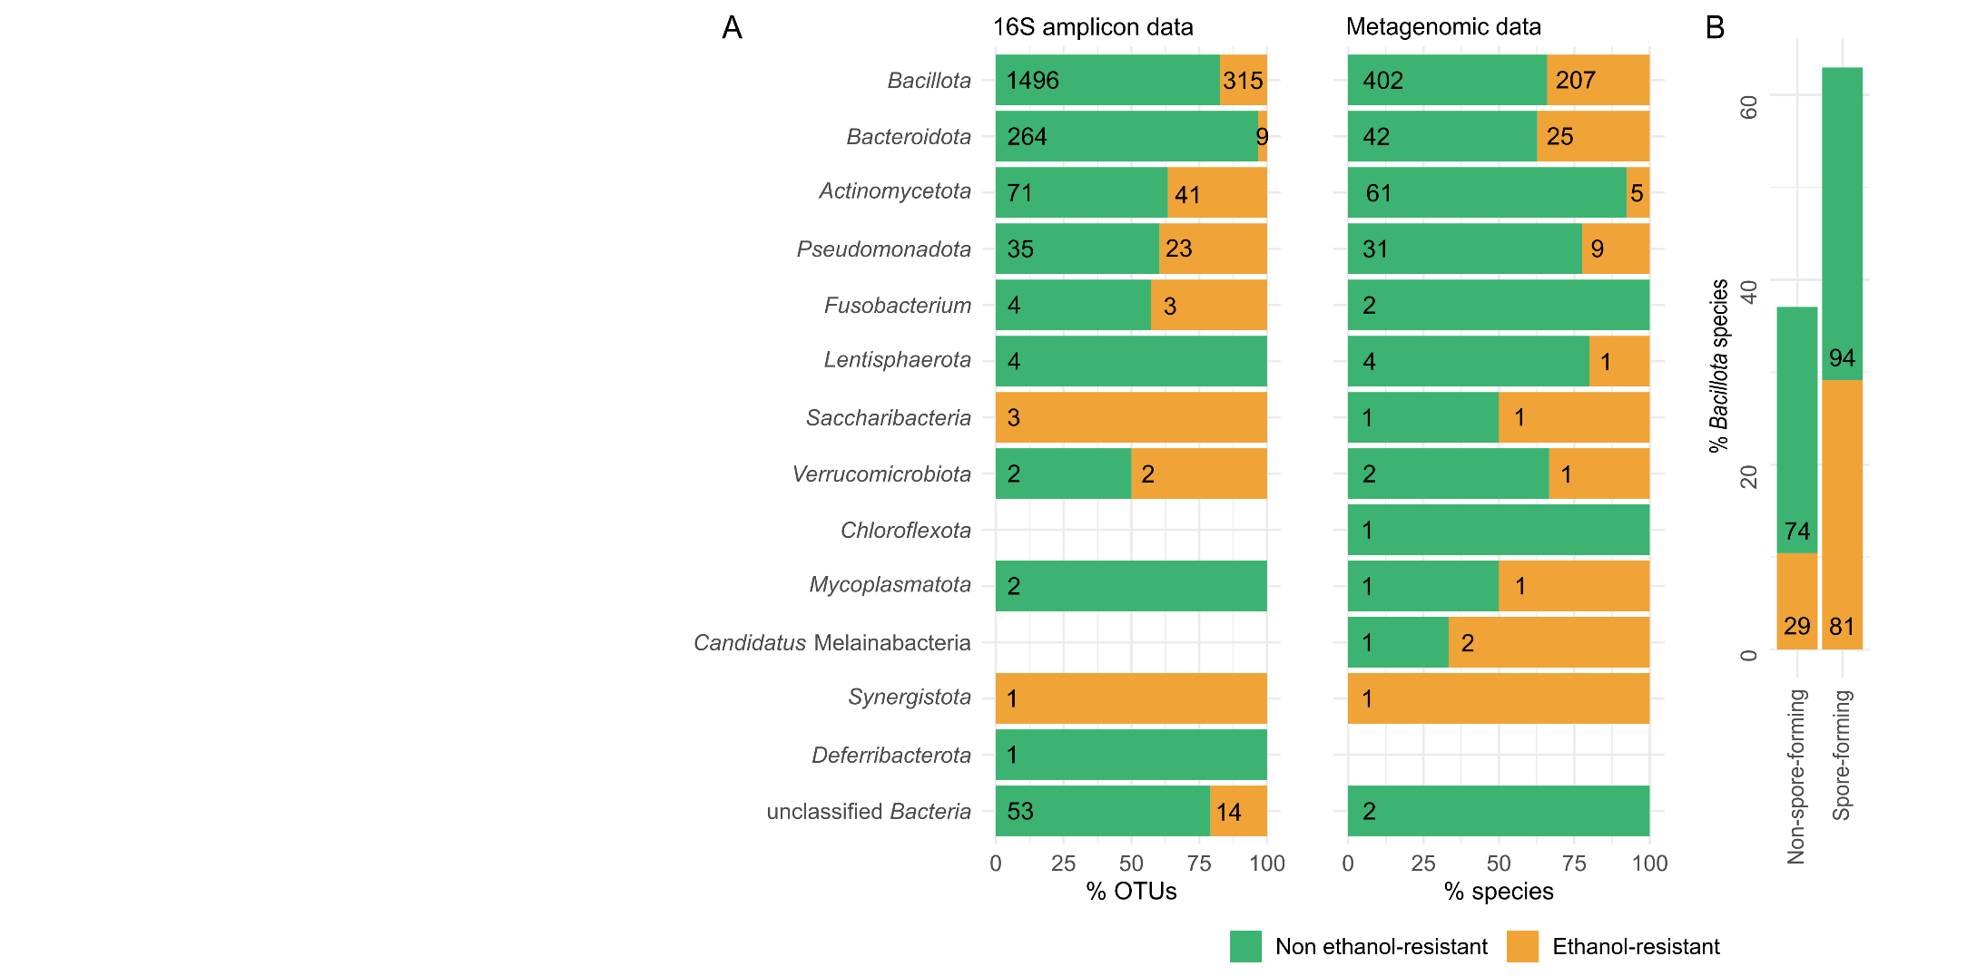
Figure 7. Characteristics of ethanol-resistant and ethanol non-resistant bacterial communities and sporobiota in 16S amplicon and metagenomic data. A) Distributions of OTUs (left) and species (right) across phyla according to ethanol resistance. Stacked bar plots show the relative proportions of ethanol-resistant and ethanol non-resistant taxa within each phylum. The numbers at the beginning of each coloured bar segment indicate the number of taxa per phylum in the ethanol-resistant and ethanol non-resistant communities. B) Distribution of ethanol-resistant species across spore- and non-spore-forming bacteria, shown for the phylum Bacillota (the only phylum containing spore-forming taxa).

Between- and within-individual dynamics of ethanol-resistant community and sporobiota
Ethanol-resistant OTUs and species exhibited greater sharing across participants and enhanced temporal stability within individual over the six months. This pattern was especially pronounced among ethanol-resistant spore-forming species.
Ethanol-resistant communities demonstrated significantly lower variability both between and within individuals compared to the non-resistant communities (16S AS, Jaccard distance, PERMANOVA with permutations constrained within participant, p = 0.001 for between- and within-individual comparisons; Figure 8A). The reduced within-individual variability of ethanol-resistant communities was particularly evident within the phylum Bacillota compared with other bacterial phyla. Reduced between-individual variability of ethanol-resistant communities was observed both in Bacillota and across other phyla. A similar pattern was observed when comparing spore-forming and non-spore-forming species, as between and within individual Jaccard distances were significantly lower for spore-forming bacteria than non-spore-forming (metagenomic data, PERMANOVA with permutations constrained within participant, p = 0.001 for between and within individuals; Figure 8D).
Resistance to ethanol was the key factor for species- and OTU-level overlap across individuals in our cohort (Figure 8B, E; n=9). This effect was most pronounced among ethanol-resistant spore-forming species (Figure 8E, Fisher’s exact test, all pairwise Benjamini-Hochberg-adjusted p < 0.001, Figure 8B).
We next quantified temporal trends of within-individual persistence by exploring number of timepoints a taxon was detected across six months sampling period within each individual. At the OTU-level, a significantly larger fraction of ethanol-resistant OTUs remained present throughout the six months compared to ethanol non-resistant taxa (Figure 8C, Wilcox rank-sum test, p < 0.001). An even more pronounced pattern was observed at the species-level, where ethanol-resistant spore-forming species were the most persistent within individual, being detected at approximately 92% of sampling time points on average, compared to approximately 72% time points for ethanol non-resistant, non-spore-formers (Figure 8E, pairwise Wilcoxon rank sum tests all pairwise Benjamini–Hochberg adjusted p < 0.05). These results indicate that ethanol resistance particularly in combination with sporulation ability is associated with an increased fraction of highly persistent taxa within individual.

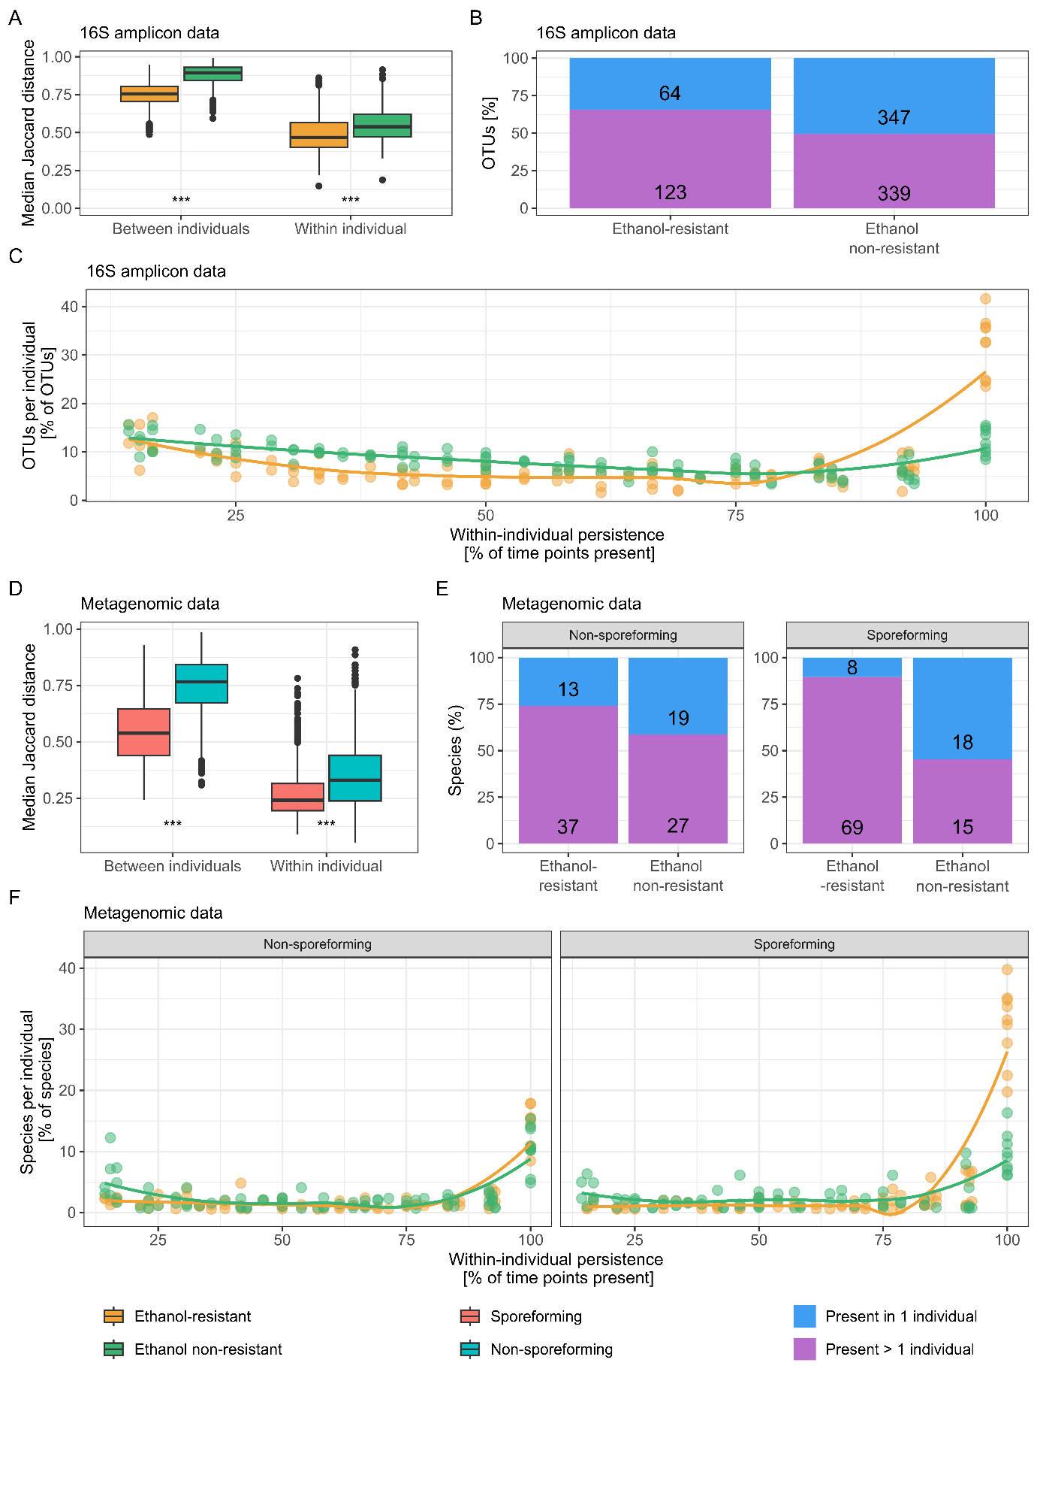
Figure 8. Dynamics of ethanol-resistant and ethanol non-resistant community and sporobiota between and within individuals. A) Boxplots showing between- and within-individual variability in community composition for ethanol-resistant and non-resistant communities in the 16S AS dataset and B) for spore-forming and non-spore-forming communities in the metagenomic dataset. Variability was assessed using Jaccard distance, calculated separately for each community. Jaccard distances was derived from randomly subsampled communities, with the median distance used for visualisation and statistical comparisons. Distributions were compared using a PERMANOVA. B) and E) stacked bar plots show the number of taxa present in only 1 individual vs more than 1 individual, based on their ethanol-resistance and spore-forming ability. In this analysis only highly persistent taxa were included (present in more than 90% of time-points per individual; 206 species and 873 OTUs). C) and F) Persistence of taxa within individuals. Persistence was calculated for each taxon in each participant, excluding taxa detected at only one time point. Lines represent the median percentage of taxa across participants detected at a given percentage of sampled time points. Colours indicate classification as ethanol-resistant or ethanol-non-resistant, and line type indicates sporulation ability. Statistical significance is indicated as *** for p < 0.001.

Sporulation frequency of ethanol-resistant Bacillota is host and time dependent in our dataset of healthy human gut samples
Sporulation frequency was calculated for OTUs determined as part of the ethanol-resistant community with taxonomic classification to the phylum Bacillota. For each OTU, the ratio of normalised abundance in untreated samples (including sequences from both vegetative cells and ethanol-resistant forms) to normalised abundance in ethanol treated samples (enriched for spores and other ethanol-resistant cell forms) was defined as the sporulation frequency (Annex F). Sporulation frequency thus reflects the fraction of an OTU population in a sporulated state at a given time point in a given host.
The sporulation frequency for all OTUs within an individual increases or decreases simultaneously at a single time point in the majority of time points (Figure 9A). This indicates a dependency on the current state of the gut in each host. We examined the correlation between the variation in sporulation frequency of each OTU at a single time point, normalised by the mean variation in sporulation frequency of that OTU across all days for an individual, and the same value with the day variable reshuffled. There was no correlation between the original and reshuffled data (Pearson’s correlation: 0.03, p = 0.74), confirming that the temporal order of sampling days is a key factor influencing the sporulation frequency of an OTU.
Variance in sporulation frequency of an OTU within an individual, compared to the variance in sporulation frequency of the same OTU across the whole population indicates host specificity. This is demonstrated by the ratio between the variance of OTU i in an individual and the variance of OTU i in the population, which falls below 1 in all but two individuals (Figure 9C). An exception was the increased sporulation frequency in individual H, relative to the population variance, which can be attributed to antibiotic consumption between days 71 and 84 of the study. There was also a slight increase in individual C, associated with five days spent abroad in the second month of the study. Notably, in individual H this coincided with a decrease in alpha diversity, while in individual C there was an increase in alpha diversity.
The Kruskal test shows significantly different variance in sporulation frequency of OTUs between individuals in our study (p = 1.7 × 10⁻⁸), which strengthens our comparison, as the population variance reflects highly diverse individuals. In contrast, comparison of the variance in sporulation frequency between different OTUs is not significantly different (Kruskal test, p = 0.96, Figure 9B). Further confirmation of the dependence of sporulation frequency on host and time, rather than OTU classification, is provided by positive Pearson correlations between sporulation frequencies of OTUs within an individual (Annex F).
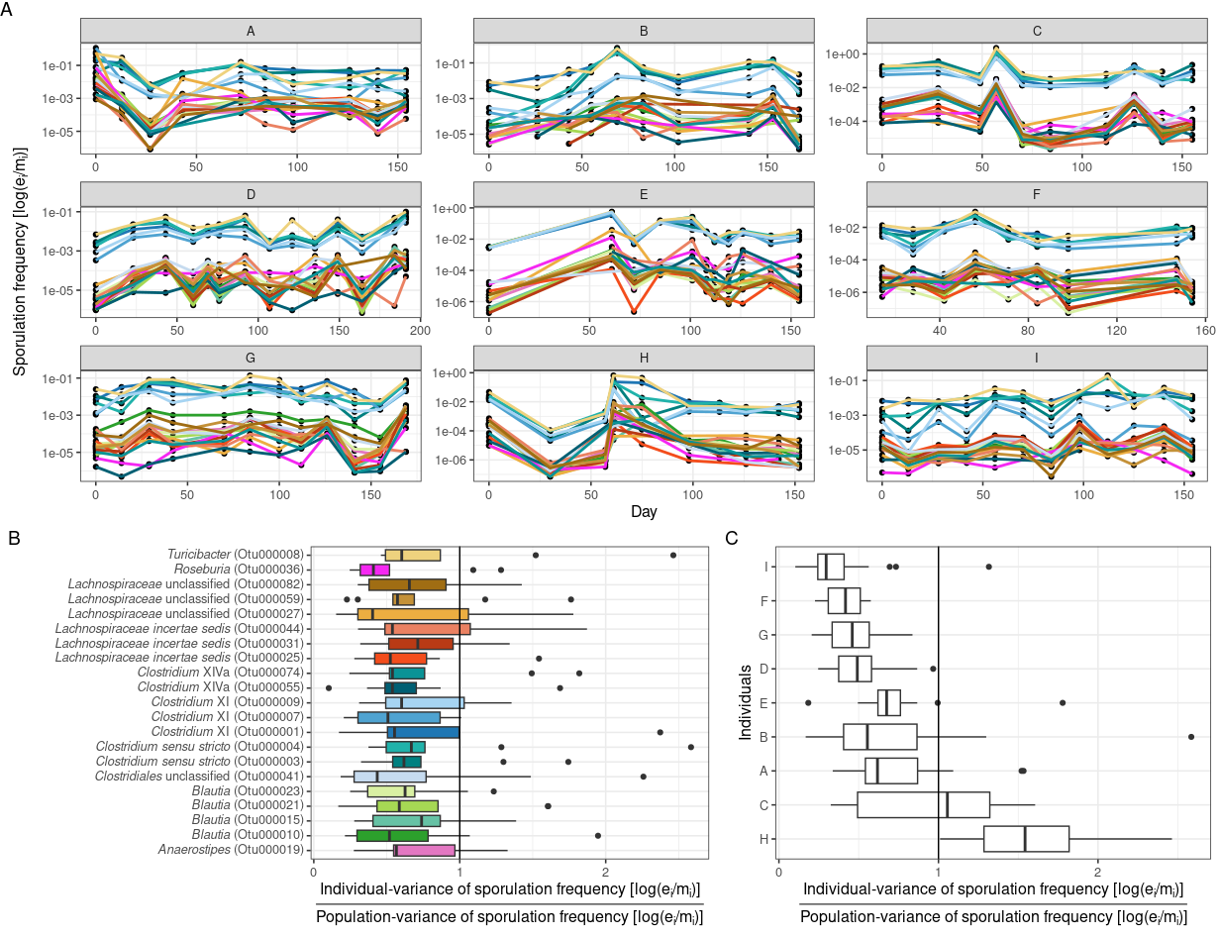
Figure 9. Influence of individual, time or OTU identity on sporulation frequency. The analysis includes only highly prevalent OTUs belonging to ethanol-resistant Bacillota (present in > 80% of samples, n = 22). A) Sporulation frequency of each OTU over the study duration, shown separately for each participant. Sporulation frequency was calculated as a ratio of normalized OTU abundance and ethanol-treated samples (e_{i}) and untreated samples (m_{i}), and log10-transformed for visualisation purposes. B) Ratio of within-individual to population-level variance in sporulation frequency, plotted by OTU. C) Ratio of within-individual to population-level variance in sporulation frequency, plotted by study participant. The vertical line (x = 1) indicates where within-individual (OTU or participant) variance equals the population-wide variance.

LONGITUDINAL CHANGES IN THE RESISTOME DEPENDING ON CHANGES IN THE INTESTINAL MICROBIOTA

Overall diversity and abundance of antimicrobial resistance genes
Across the nine individuals in our cohort during six months and in total of 116 untreated samples, we detected 111 antimicrobial resistance genes (ARGs) spanning 16 classes and 5 resistance mechanisms, as annotated by AMRfinder and the CARD database (Figure 14). We also identified two stress response genes, gacL and qacEdelta1. Notably, clinically important carbapenem genes prevalent in Slovenia (bla_{KPC}, bla_{NDM}, bla_{OXA-48} or bla_{VIM}) and Acinetobacter-associated bla_{OXA-23} and bla_{OXA-24} were absent. The only clinically relevant ARG detected was bla_{CTX-M1}, found at very low abundance in a single individual (I) on a contig classified within the Enterobacteriaceae family (Annex J).
The highest richness of ARGs was observed in aminoglycoside resistance genes, followed by glycopeptide, tetracycline, and beta-lactam classes (Figure 10A). The diversity of ARGs per class did not correlate with the abundance of ARGs in the class. The most abundant ARGs confer resistance to tetracyclines, protein synthesis inhibitors (lincosamide, macrolide, and streptogramin), and beta-lactamases that inactivate antibiotics (Figure 10B).
Taxonomically, ARG diversity was highest for phylum Bacillota, followed by Pseudomonadota and Bacteroidota, and similarly, ARG abundance was highest for phylum Bacillota but greater in Bacteroidota, than Pseudomonadota (Figure 11).

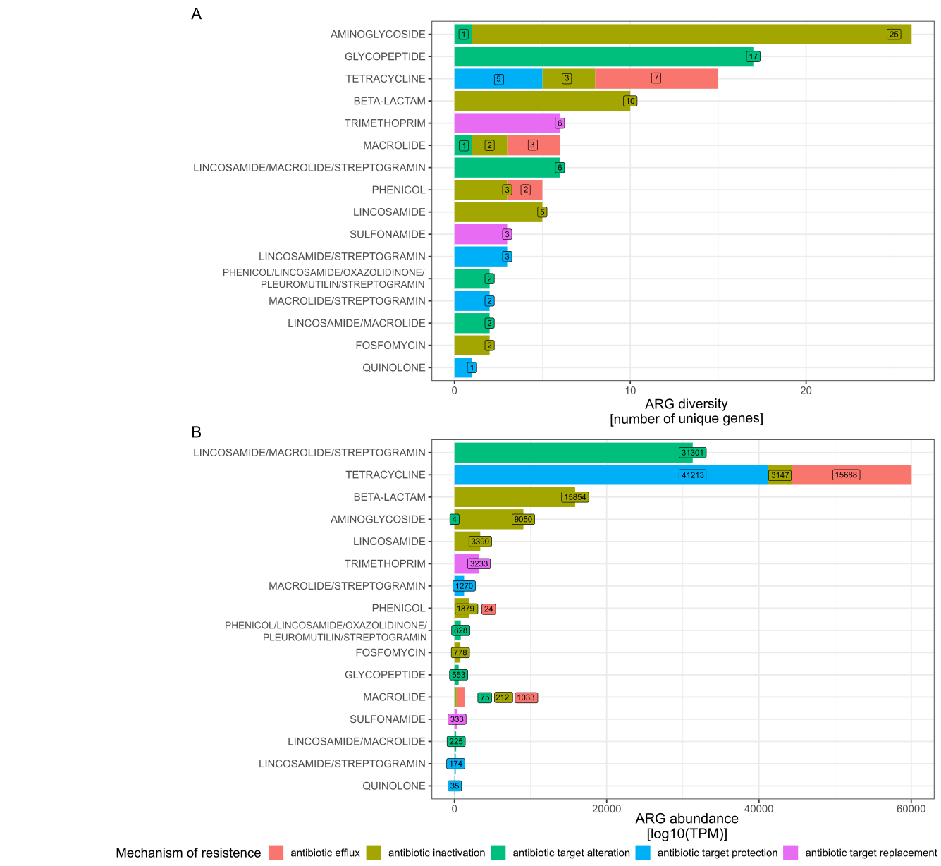
Figure 10. Diversity and abundance of antimicrobial resistance genes (ARGs) across all individuals untreated samples. A) Number of unique ARGs and B) number of mapped reads per million (TPM) to ARGs, coloured by mechanism of resistance based on CARD.

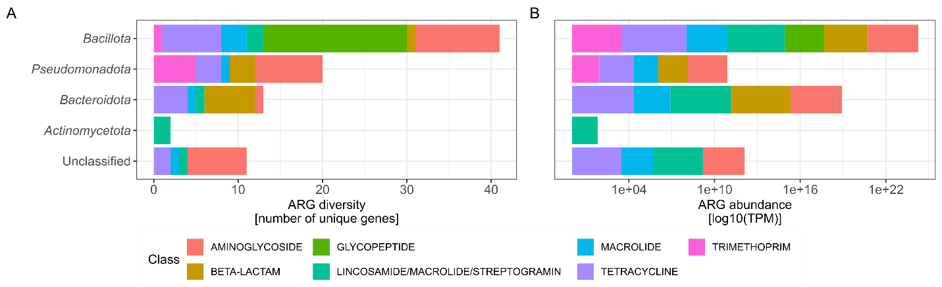
Figure 11. Diversity and abundance of ARGs based on the taxonomical classification of contig on which the ARG was detected. A) Number of unique ARGs and B) number of mapped reads per million (TPM) detected on contigs classified as stated on y-axis. Coloured by class of ARG.

Persistence of antimicrobial resistance genes in the human gut in our cohort
We detected between 81 and 101 unique ARGs per individual, of which 39% to 66% (average 49%) were consistently present over six months. Overall, individual characteristics and reported life events had limited influence on diversity and abundance of ARGs (Figure 12). To assess these effects, we fitted a linear mixed-effects models including age, height, weight, living conditions (urban/rural, flat/house, number of household members), dietary changes, supplement and medication consumption, and vaccination, stress level, physical activity and other reported life events such as travel, as well as Bristol stool scale scores.
For ARG diversity (Figure 12A), only a small number of variables showed statistically significant associations. Body weight was negatively associated with ARG richness (estimate = -0.034, p = 0.022). Supplement consumption was associated with increased ARG richness (estimate = 1.14, p = 0.03) but individual supplement category (omega 3, proteins, vitamin B12, Q-complex, pre- and pro-biotics) showed significant effect. The random effect of individual explained negligible variance, indicating minimal between individual differences after accounting for covariates.
For ARG abundance (Figure 12B), most variables were not significantly associated (all p > 0.05), including predefined events such as illness or antibiotic treatment. Only vaccination was associated with a modest decrease in ARG abundance (estimate = -61.5, p = 0.031). However, this effect should be interpreted cautiously given the large number of predictors tested. Substantial variability was observed both between individuals (SD ~ 142) and within individuals over time (SD ~ 162), suggesting ARG abundance is highly variable and not well explained by the reported variables. This contrasts with the diversity model, where minimal between individual variance was observed.

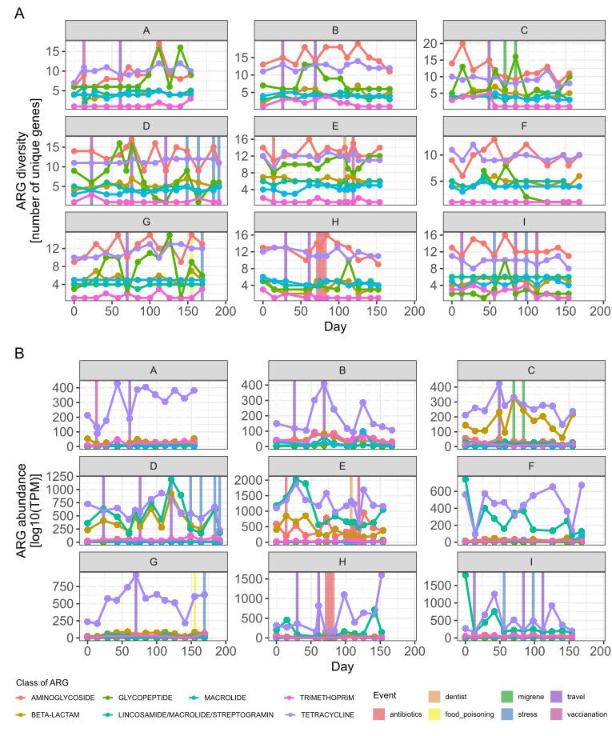
Figure 12. Stable ARG abundance and diversity over time within each participant. Shown are the classes with more than five unique ARGs, reducing the number of ARGs to 86 and leaving 7 ARG classes. Each plot depicts one participant (labelled with capital letters A to I), with days on the x-axis indicating when stool samples were collected. Vertical coloured lines indicate out-of-the-ordinary events reported by participants in their questionnaires.

Bacterial diversity (Shannon diversity index) showed no consistent association with ARG diversity across samples, after accounting for repeated measures and ARG class structure (Figure 13A). We observed substantial differences in baseline richness between ARG classes.
When looking into ARG abundance (log10-transformed TPM), a different pattern emerged (Figure 13B). Although no overall association between Shannon diversity and ARG abundance was detected, significant class-dependent interactions were observed. Specifically, the relationship between bacterial diversity and ARG abundance varied in both magnitude and direction across ARG classes, with some classes exhibiting positive associations (lincosamide/macrolide/ streptogramin) and others negative associations (macrolide and trimethoprim) with increasing Shannon diversity.
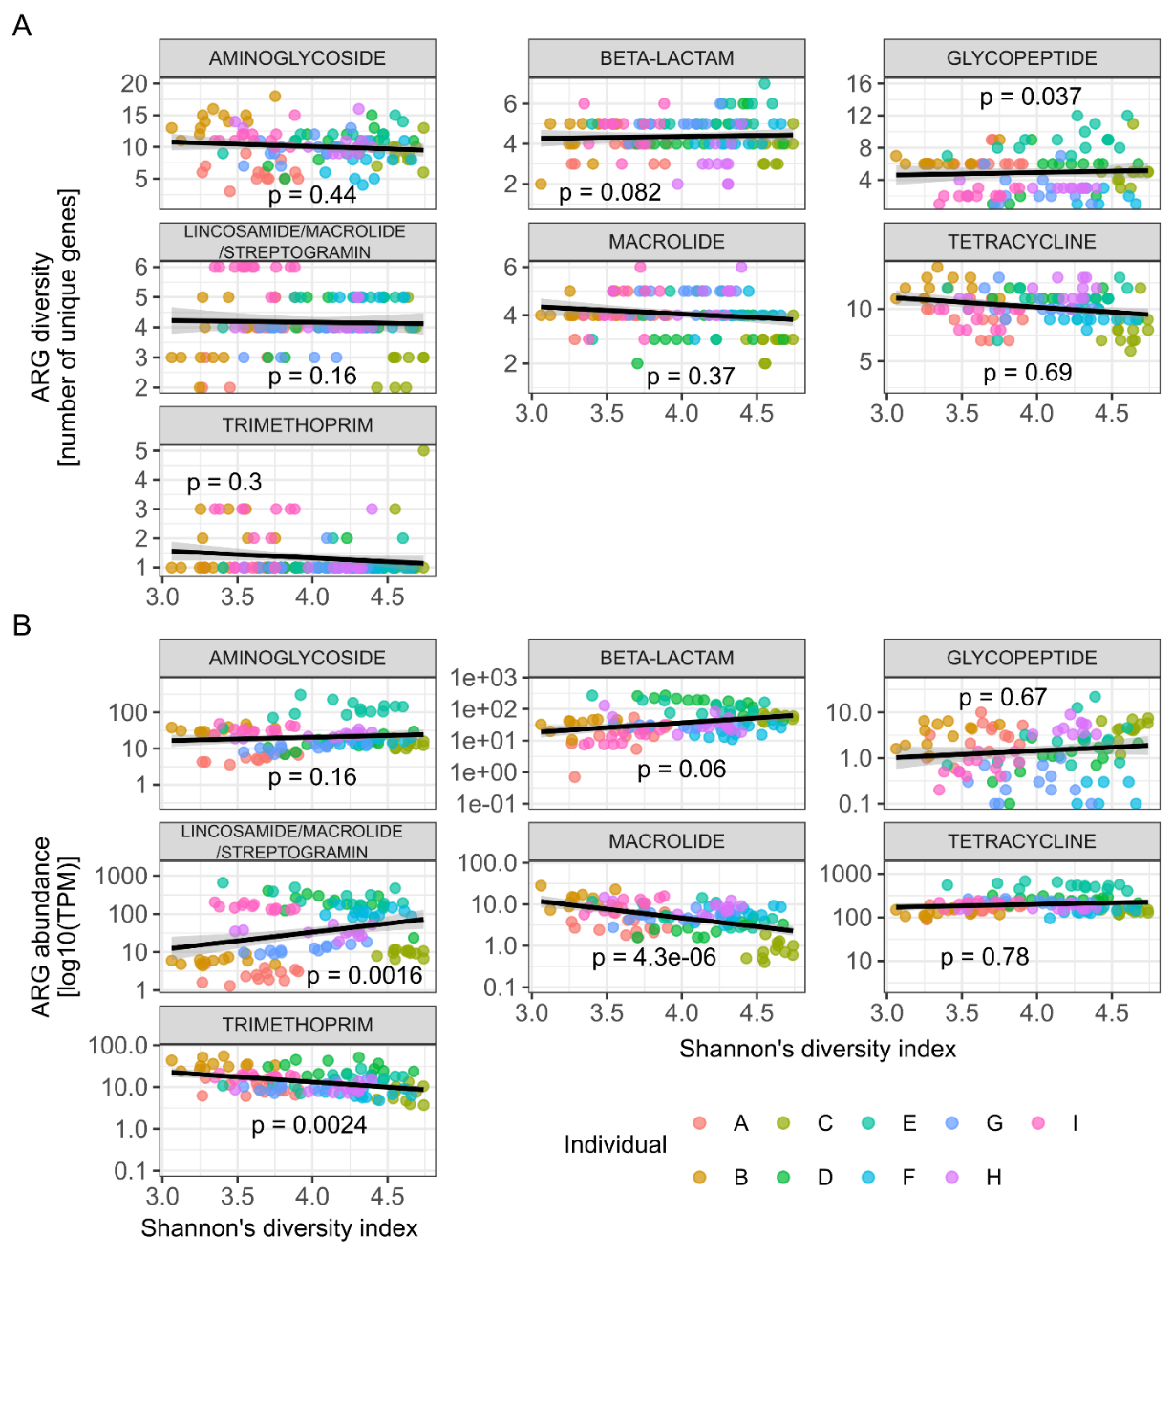
Figure 13. Relationship between bacterial diversity and ARG abundance and diversity vary by ARG class. Only ARG classes with more than 5 unique ARGs are included, reducing the number of ARGs to 86 across 7 classes. Each panel shows the association between Shannon diversity (calculated from species-level abundance data) and either A) ARG diversity (number of unique ARGs) or B) ARG abundance (log-transformed TPM) for a given ARG class. Lines represent linear association, with p values from linear mixed-effects models with individual included as a random effect and ARG class and time as fixed values.

CULTIVATION AND MOLECULAR CHARACTERIZATION OF THE REPRESENTATIVE SPORE-FORMING SPECIES
This analysis was done on three stool samples of a single participant. Participant H consumed amoxicillin, a broad-spectrum penicillin, midway through the study from day 70 to 84. During this period bacterial diversity and normalised abundance decreased, and sporulation frequency across taxa was significantly higher than in other participants (Annex K1). This made participant H an informative case for investigating strain dynamics of selected spore-forming species. Spore-forming bacteria were isolated from three time points: one month before, during, and one month after antibiotic use.

Cultivation and whole-genome sequencing of selected spore-forming species from ethanol treated stool samples
Pre-, mid- and post-antibiotic stool samples of participant H (H005, H007, H009 respectively) were exposed to ethanol shock. Due to the highest number of isolates obtained we selected Clostridium saudiense for whole-genome sequencing (Table 1). All together 87 C. saudiense isolates were cultivated. Some C. saudiense isolates were lost during the second re-streaking step, which accounts for the unequal numbers to the sequencing experiment. In total, 44 genomes were sequenced (Annex D), as second re-streaking was not successful in remaining 43 isolates.
Table 1. Number of obtained isolates after picking and first re-streaking. Species of isolate was determined with MALDI-TOF MS. H005, H007 and H009 are samples from time point pre-, mid- and post-antibiotic use of participant H. Some colonies were lost during the second re-streaking step, due to not growing, which accounts for the unequal numbers to the sequencing experiment.
Detected species | All samples | Before antibiotic H005 | During antibiotic H007 | After antibiotic H009
Clostridium paraputrificum | 24 | 23 | 0 | 1
Intestinibacter bartletti | 11 | 4 | 2 | 5
Clostridium saudiense | 87 | 19 | 42 | 26
No organism identification possible | 20 | 7 | 7 | 6
No growth after first re-streaking | 0 | 4 | 19 | 25
Total | 142 | 57 | 70 | 63

Pairwise average nucleotide identity (ANI) was calculated between all 44 genomes (Annex K2). Two genomes with ANI values below 95% were excluded from further analysis, one identified as Clostridium paraputrificium (H005_126) and one mixed isolate containing both C. paraputrificium and C. saudiense (H005_94). The remaining 42 genomes represented C. saudiense isolates: 8 from pre-, 16 from the mid-, and 18 from post-antibiotic samples.
Genome sizes ranged from 3.7 to 4.4 Mbp, with an average GC content of 28.04% (SD = 0.05). Compared with published C. saudiense genomes (average 3.6 Mbp, 27.93% GC), our assemblies were slightly larger but notably less fragmented. The core genome of our genomes comprised 2,657 genes shared across all isolates. When genomes from NCBI were included, the number of core genes decreased to 1,581 genes. On average, each genome from our isolates contained 3,644 genes (range = 3,434 – 3,992), including on average 987 accessory genes (range = 777 – 1,265).

Core genome structure and strain definition
Pairwise ANI comparisons indicated a strain break at 99.72% identity (Figure 14A, blue line). Applying the pyANI‑plus ‘classify’ command, we identified five distinct C. saudiense strain groups, one of which contained a single genome. Genome coverage expectantly correlates to ANI (Figure 14B, Spearman rho = 0.92, p < 0.001).

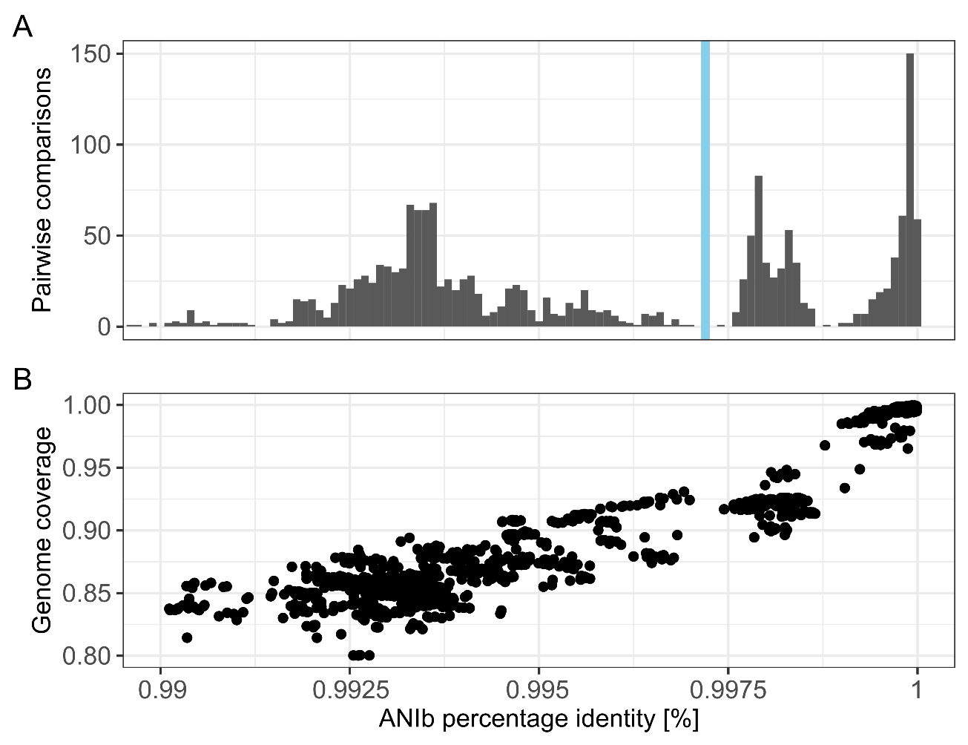
Figure 14. Pairwise average nucleotide identity (ANI) and genome coverage comparisons for 42 C. saudiense genomes. A) Pairwise comparisons, with the blue line representing strain break at 99.72% ANI value. B) Genome coverage expectantly correlates to ANI (Spearman rho = 0.92, p < 0.001). Both genome coverage and ANI were calculated with pyANI-plus program utilizing the ANI blast program.

From each of the five strain groups determined by ANIb analysis, one representative genome with the highest coverage and lowest number contigs was selected for resequencing using Oxford Nanopore MinION platform. Hybrid assemblies combining short and long read were then generated to improve completeness and accuracy. Genome H005_98 was used as the reference genome for single nucleotide polymorphism (SNP) analysis across the core genome. The resulting phylogenetic tree based on core genome SNPs resolved seven distinct C. saudiense strains, including one singleton (Figure 15). This grouping was consistent with phylogenies derived from core gene alignments and with accessory gene distributions in the pangenome (Annex K2). Strain detection patterns varied across time points. Strains 1, 2 (the singleton), 3, 4, and 5 appeared at only one of the three sampling points, while strain 7 was observed at two points before and during antibiotic use. Only strain 6 was detected at all three sampling points.
Strains differed in presence of mobile genetic elements (MGEs) among themselves but not through time. Depending on the tool used we detected variable numbers of MGEs per strain. MobileElementFinder detected three distinct insertion sequences and one composite transposon in strains 1, 2, 5, 6, and 7. Insertion sequence ISClte3 was detected in all strains, while ISCbo4 was detected only in strain 2 and three genomes from strain 7. Additionally, we could detect tISCpe8 in all genomes from strain 7, which also carried a lacosamide nucleotidyltransferase, while the transposon was detected only in a genome from strain 2 (Annex K3). While using geNomad we detected 64 possible plasmid sequences and 33 viral sequences (> 95% confidence). Notably, no new bacteriophages or other mobile genetic elements were detected in any strain over the 60‑day interval between the first and last sample. As strains differed markedly in accessory genes, we could use strain-specific marker genes in later detection of C. saudiense strains in metagenomic data.

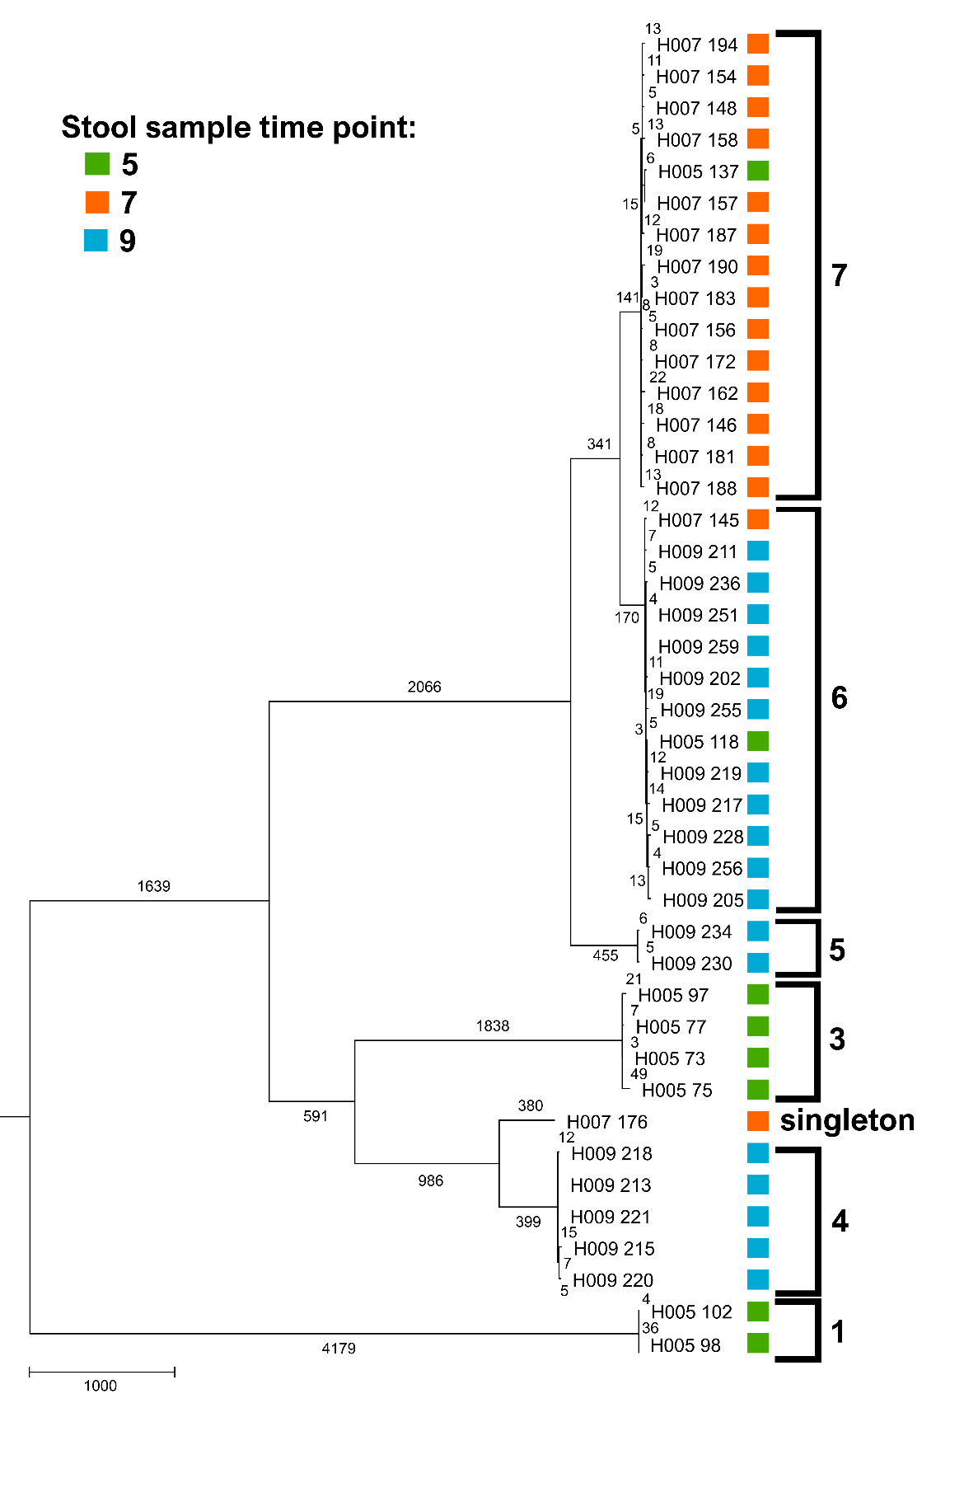
Figure 15. Phylogenetic tree constructed with neighbour-joining algorithm based on core genome SNPs. Coloured squares represent time point from which the isolate was obtained, reference was genome H009_221 obtained from stool sample collected at timepoint 9 (after AB). Number on the phylogenetic tree represent the number of SNPs between each genome.

Strain persistence revealed in metagenomic data
Stool samples from individual H were also analysed using shotgun metagenomic sequencing. To link isolate-based observations with metagenomic data, we applied two established tools StrainPhlAn and StrainScan (Blanco-Míguez et al., 2023b; Liao et al., 2023), alongside a newly developed approach, enabling analysis of C. saudiense strain dynamics over the six months.
StrainPhlAn profiled the dominant strain of C. saudiense in metagenomic samples and quantified genetic divergence from this major genotype for all time points. However, it is not in its ability to resolve complete strain structures when multiple strains co-occur at similar abundances. The resulting dendrogram of samples revealed two main C. saudiense clusters, which did not correspond to sampling time, antibiotic exposure or travel (Figure 16).

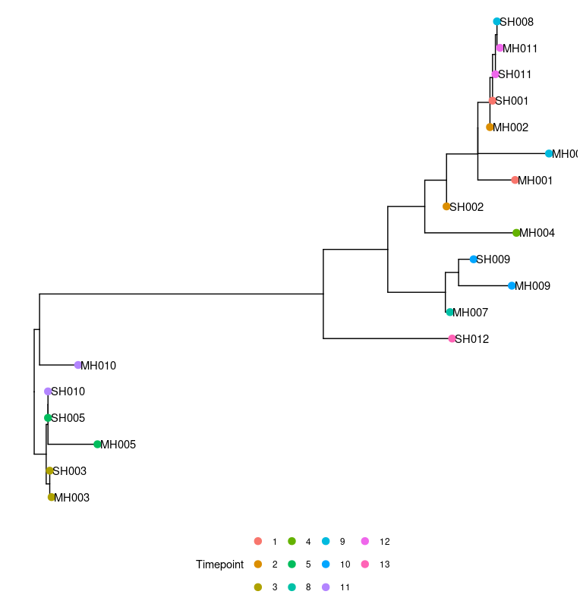
Figure 16. Dendrogram of stool samples of participant H based on C. saudiense marker-gene alignment inferred with StrainPhlAn. Colours represent sampling time point. Sample IDs encode experimental conditions: the first letter indicates the DNA isolation protocol (S for ethanol treated samples and M for untreated stool samples), the second letter denotes the participant (H), and the number indicates the sampling time point.
We next applied StrainScan, which infers strain structure using strain-specific k-mers derived from assembled genomes to estimate relative abundance in metagenomic samples. This method predicted eight C. saudiense strains from whole-genome data. Comparison between StrainScan determined strains and strains we determined using SNPs and pangenome analysis revealed, that determination was similar. It determined the same membership of isolates to each strain, with exception of genome H009_256, which was excluded from our determined strain 6 in the StrainScan analysis. Next, StrainScan detected of only strains 3, 6 and 7. Strain 6 and 7 were detected from day 0 to 143, while strain 3 was detected only from day 15 to 84, due to low coverage of diagnostic k-mers (Annex K4).
Because these tools provided only partial resolution, we developed a complementary mapping‑based approach to examine C. saudiense strain composition in greater detail. Shotgun metagenomic reads from all samples of participants A and H were mapped to strain‑specific marker genes identified in the pangenome analysis (Annex K5). Participant A served as negative control, as C. saudiense was detected at very low abundance in only one of his twelve samples (Annex K4). As expected, reads from participant A covered far fewer strain‑specific genes than those from participant H. Only eight genes showed higher coverage in participant A among the 85 genes detected in both individuals.
Mapped read counts were normalized by gene length, and for each strain, by the total number of genes included in the analysis. This strain-specific mapping showed that, unlike culture-based data, all defined C. saudiense strains persisted throughout the six months in participant H (Figure 17). This is not in accordance with cultured strains, where only strain 6 could be detected through the whole study (Figure 17). The only exception to this persistence were mid-antibiotic samples, when C. saudiense abundance dropped below the detection limit (untreated samples, Figure 17 – left). This approach thus enabled longitudinal tracking of defined strains in metagenomic data, but only for strains represented in the isolate genomes.

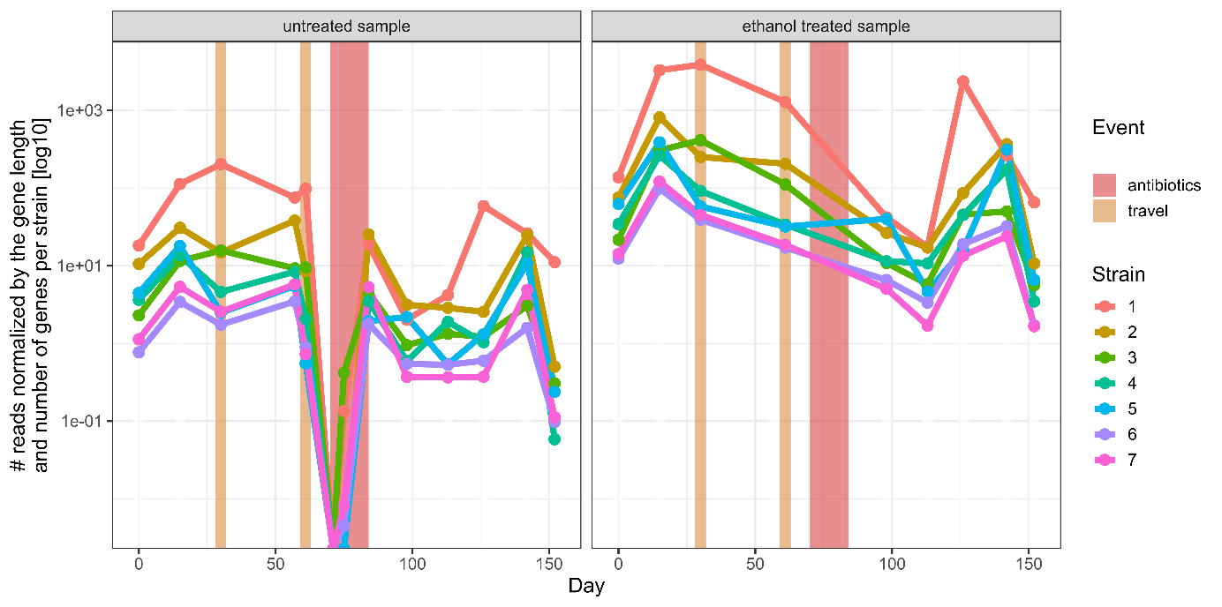
Figure 17. Persistence of isolated strains over time in participant H, based on shotgun metagenomic read mapping to strain-specific genes. The y-axis represents log10 transformed number of reads mapped to each gene normalised by gene length (bp) and subsequently, all counts for each strain were summed and divided by the number of genes observed for each strain. Ethanol treated samples were not sequenced as successfully as untreated samples, points on the plot indicate which timepoints are included in the analysis. Ethanol treated samples were not sequenced as successfully as untreated samples (only 9/13 samples, missing are days: 57, 71, 75, 84), points on the plot indicate which timepoints are included in the analysis.

DISCUSSION
This study focused on a longitudinally sampled cohort of nine healthy male participants, analysing the gut microbiota and ethanol-resistant and/or spore-forming communities. We employed 16S rRNA amplicon sequencing, shotgun metagenomic sequencing, and cultivation of selected spore-forming species from ethanol treated stool samples with subsequent molecular characterisation through whole-genome sequencing.

DESCRIPTION AND COMPARISON OF TEMPORAL STABILITY OF THE GUT MICROBIOTA AND SPOROBIOTA IN HEALTHY INDIVIDUALS (GOAL 1)
Comparison of 16S amplicon and metagenomic sequencing revealed highly synchronised within-individual patters both in terms of richness and evenness, as well as conserved spatial separation of beta diversity in NMDS ordination space. Among the collected metadata, only physical characteristics (age, height, weight), activity level and stress level were associated with variation in microbiota composition, which could be due to small cohort size or sporadic changes both within and between individuals. The changes we observed are in correlation with previous studies, as they have also identified antibiotic treatment, diet, geographical location, gender as important determinants of gut microbiota composition (Dethlefsen et al., 2008; Hisada et al., 2015; Mahnic and Rupnik, 2018; Martino et al., 2022; Olsson et al., 2022; Rampelli et al., 2015; Thursby and Juge, 2017). The limited influence of metadata in our study could also be explained by the sampling time scale. Given that bacterial generation time ranges from hours to approximately one day, our 14-day sampling intervals for six months captured only ~160 – 200 generations, which may be insufficient to observe major ecological shifts (Zaoli and Grilli, 2021). The overall gut microbiota composition was consistent with previous research of European and Slovenian populations (Falony et al., 2016; Mahnic and Rupnik, 2018). Communities were dominated by bacterial representatives, primarily from the phyla Bacillota and Bacteroidota, while other phyla such as Pseudomonadota, Actinomycetota and, Verrucomicrobiota were present at lower relative abundance as determined by 16S amplicon and metagenomic sequencing. Most abundant genera present in untreated samples depend on the sequencing and even more so on classification methods used. But the most abundant genera in our cohort coincide with Western human gut microbiota composition (Proctor et al., 2019).
Ethanol and EMA treatment depleted known non-spore-forming taxa, although a subset of non-spore-forming bacteria remained detectable after treatment. Ethanol treatment likely enriched for endospores and other dormant or stress‑tolerant cell states. Because this operational definition of sporobiota is imperfect, we also inferred sporulation ability using a gene-based approach. Within Bacillota, our data showed that ethanol resistance is concentrated in genera characterised as spore-forming, based on both sporulation gene clusters and previous in vitro induction, thereby extending prior experimental work to a natural human cohort (Browne et al., 2021; Galperin et al., 2022; Koopman et al., 2022). The high abundance of ethanol-resistant representatives within Bacillota was expected due to the widespread ability to sporulate in this phylum (Egan et al., 2021). But the combined approach of ethanol-EMA treatment and gene-based sporulation determination revealed a substantial group of Bacillota representatives with gene-defined sporulation ability that did not confer ethanol resistance, indicating that the presence of sporulation genes alone does not guarantee spore formation under all conditions. This is not unexpected, as sporulation and germination signals differ markedly even between well-studied model organisms such as Bacillus subtilis and C. difficile (Peter Setlow, 2019). It is therefore plausible that many gut bacteria with the genetic sporulation ability either do not sporulate in the healthy human gut or do so only transiently, consistent with recent observations (Machado et al., 2025).
Ethanol-resistant taxa outside Bacillota were rare in our study and the mechanisms underlying their resistance remain poorly characterised. Although exospore formation has been described in Actinomycetaceae and Streptomycetaceae, these families contributed minimally to the ethanol-resistant community in our cohort, with five Actinomycetaceae species detected and no Streptomycetaceae recovered from ethanol-treated samples. This is consistent with previous studies in which these groups were reported in ethanol- or lysozyme-treated communities (Avershina et al., 2020; Browne et al., 2016a; Kearney et al., 2018). Members of the phylum Pseudomonadota (nine species detected in the ethanol-resistant community), were also previously confirmed in the ethanol-resistant community and have been reported to adopt various dormant life strategies, including non-spore persistence and the viable but non-culturable state (L. Li et al., 2014). Together, these observations indicate that ethanol resistance may serve as a proxy for a broader spectrum of dormant or stress-tolerant cell states, including but not limited to endospores (Avershina et al., 2020; Browne et al., 2016a).
In our cohort, ethanol-resistant spore-forming species were both more prevalent among individuals and more persistent within individuals over six months, corroborating comparative genomic predictions that sporulation ability is associated with higher population-level prevalence (Browne et al., 2021) and aligning with experimental findings from lysozyme treated communities (Kearney et al., 2018). Experimental evidence from in vitro and murine gut models has shown that C. difficile spores can bind to biofilms and consequently evade washout, thereby sustaining recurrent infection (Figueroa et al., 2012; Normington et al., 2021; Soavelomandroso et al., 2017), but similar mechanisms of spore persistence have not been demonstrated for other species beyond in vitro biofilm formation (Donelli et al., 2012). Within this context, our longitudinal findings show that ethanol-resistant and particularly spore-forming Bacillota behave as a gut “seed bank”, persisting over months (Jones and Lennon, 2010). In contrast non-spore-forming taxa exhibited higher within-individual turnover and were less likely to be shared within our cohort.
Surprisingly, ethanol-resistant taxa outside Bacillota also showed a higher degree of between-host sharing, while having minimal effect on long-term persistence within the host. This suggests that alternative dormancy or stress-response mechanisms in these lineages preferentially support transmission within the population rather than long-term colonisation. A limitation of our study was that we did not assess whether temporal changes in taxa detection reflect strain replacement or the coexistence of multiple strains (Poyet et al., 2019). This distinction is particularly relevant given previous reports of high strain-level retention in the gut over short time scales and limited strain sharing between individuals (Wolff et al., 2023).
One of the key findings of our study is that the highly abundant and persistent ethanol-resistant Bacillota community respond to the same gut environmental signals, resulting in synchronised sporulation across diverse genera within the same host. These fluctuations were not conserved across hosts, suggesting that sporulation in the human gut is governed primarily by host specific environmental and physiological conditions rather than by taxon specific mechanisms. This interpretation is consistent with previous reports showing highly individualised microbial responses to diet and lifestyle factors (Zeevi et al., 2015). In line with in vitro studies, potential triggers for sporulation include environmental stress, metabolic depression, cell signalling, or viral threats (Hutchison et al., 2014; Koopman et al., 2022; Ramos-Silva et al., 2019). In addition to host derived cues, phage–host interactions may also influence sporulation decisions, as phages carrying sporulation-related genes have been described in spore-forming Bacillota, providing another potential layer of regulation of the sporobiota (D. A. Schwartz et al., 2022). Although the specific in vivo signals governing sporulation and germination remain unresolved, our findings suggest that spore-forming gut bacteria respond collectively to shared, host-specific environmental or physiological cues rather than acting solely through species-specific regulation.

MONITORING LONGITUDINAL CHANGES IN THE GUT RESISTOME OF HEALTHY INDIVIDUALS (GOAL 3)
Across the cohort, we detected between 81 and 101 unique antimicrobial resistance genes (ARGs) per individual, of which on average 49% were consistently present over six months. This is in agreement with a description of a diverse and temporally stable multi-class resistome in human gut (Ho et al., 2020). Due to different methodology we cannot compare this exact number of ARGs per individual but can confirm it is in the order of magnitude other studies report (Feng et al., 2018; Ho et al., 2020; Hu et al., 2014; Qiu et al., 2020). Despite antibiotic treatment during the study (individuals E, H) they did not have more abundant or diverse resistome than other individuals overall but had higher ARG abundance in the month after antibiotic treatment. This finding is consistent with previous studies showing that antibiotic treatment tends to expand the abundance of existing resistance genes rather than introduce substantial new diversity (Malin et al., 2023; Rampelli et al., 2015; Willmann et al., 2019). Despite using the comprehensive AMRfinder database with a stringent identity threshold (> 90%), both false positives and false negatives remain possible. Some detected ARGs may represent misannotations, while others may be absent from current databases and therefore undetected (Feldgarden et al., 2019, 2021).
Comparison with other European cohort studies shows that the high abundance and persistence of tetracycline resistance genes observed in our dataset is consistent with broader population-level trends (Boolchandani et al., 2022; X. Li et al., 2023; Sinha et al., 2018; Willmann et al., 2019). As this is the first study of the human gut resistome in the Slovenian population, comprehensive comparisons are limited. However, there is information on clinically important resistance genes present in nosocomial infections, rivers, and wastewaters (Maric et al., 2025; Slovenia: National One Health strategy for the management of microbial resistance 2019-2024 (Slovenian), n.d.). Notably, clinically important carbapenem and beta-lactam genes prevalent in Slovenia were absent in the gut of our healthy participants, except for the beta-lactamase gene bla_{CTX-M1}, found at very low abundance in a single individual (I), interestingly this individual does not possess the most abundant or diverse resistome. This gene is present in around ~10% of bacterial isolates from human origin in Slovenia (Matos, 2024).
ARGs were most abundant in the phylum Bacillota, followed by Bacteriodata, and Pseudomonadota, in contrast to other studies, which report Pseudomonadota, specifically Escherichia coli, as the largest contributor to ARG abundance in the human gut, followed by members of the phylum Bacteroidota (X. Li et al., 2023; Sinha et al., 2018). A substantial number of ARGs were present on contigs without taxonomic classification, which could be improved if bins and not contigs would be used for detection of ARGs, but this depends on assembly quality (Ho et al., 2020).
Reduced microbial diversity has been proposed to facilitate the proliferation and horizontal transfer of resistance genes by simplifying community structure and opening ecological niches for resistant taxa (Willmann et al., 2019). In our study, we hypothesised that lower bacterial diversity would correlate with increased ARG diversity. However, our data did not support this hypothesis, as no significant association was observed between bacterial diversity and ARG diversity over time. Instead, we identified class-specific relationships between bacterial diversity and abundance of ARGs. A positive association was observed between bacterial diversity and abundance of ARGs in MLS class, and a negative association for the macrolide and trimethoprim classes. These findings suggest that reductions in bacterial abundance may selectively influence certain resistance classes, rather than driving a broad increase in resistome diversity or abundance.

INDIVIDUAL-SPECIFIC POPULATION ANALYSIS ON THE ISOLATED SPORE-FORMING SPECIES (GOAL 2)
Integrating whole-genome sequencing of cultured isolates with metagenomic sequencing of stool samples enabled tracking of bacterial strains using both culture-dependent and culture-independent approaches.
Cultivation of gut microbes remains inherently biased due to selective growth conditions (Tidjani Alou et al., 2020). Spore-forming bacteria are typically slow-growing, therefore the use of nutrient-rich medium (WCAB) and short incubation period (48 hours) likely selected for species capable of rapid germination and vegetative growth (Kapinusova et al., 2023; Peter Setlow, 2019). Substantial proportion of isolates was also not growing after subcultures, a phenomenon that may be due to unknown factors in secondary re-streaking and already observed earlier (Lagier et al., 2018). Despite this, our dataset of 42 new sequenced strains substantially expands the genomic diversity and improves quality of C. saudiense genomes, which previously comprised 31 isolate draft genomes and 7 metagenome-assembled genomes (MAGs) from public databases (accessed April 15, 2026). Previously published isolate genomes were obtained from adult (n = 28) and infant (n = 2) human stool samples (n = 31), and one from a cattle stool sample, while the seven MAGs were obtained from human gut metagenomes.
Clostridium saudiense is a poorly studied bacterial species, first isolated in Marseille, France in 2014, from the stool of an obese Saudi individual (Angelakis et al., 2014). Using several tools, we identified seven distinct strains and revealed extensive within-host diversity. This level of diversity exceeds the commonly reported strain richness of 1 to 4 strains per species in the human gut (Chen-Liaw et al., 2025; Poyet et al., 2019; Van Rossum et al., 2020), highlighting substantial intra-species heterogeneity within a single host. We have also detected this bacterium in eight of nine individuals included in our cohort indicating that species is common member of gut microbiota, but present in very low abundance (< 0.1% relative abundance).
Only one isolated strain was detected in all three stool samples (spanning 3 months), others were either detected at two time points (strain 7) or at only one time point (strains 1, 2, 3, 4, and 5). To expand strain tracking beyond cultivation time points, we integrated isolated genomes with longitudinal metagenomic data spanning six months. Strain-resolved metagenomics is possible for high-abundance taxa with sufficient coverage (typically > 20x), with non-dominant subpopulations often evading detection due to allelic variation or chimeric assemblies (Garud and Pollard, 2020; Garud et al., 2019; Nayfach et al., 2016; Poyet et al., 2019; Valles-Colomer et al., 2023).
We first applied StrainPhlAn, which revealed that the temporal shifts were unrelated to antibiotic consumption, but rather to underestimated diversity, as minority strains fall below detection limit, despite C. saudiense comprising from 0.1 to 1% relative abundance per sample (Blanco-Míguez et al., 2023b). Low detection limit was also a problem when using StrainScan, which could only determine three out of the eight strains it determined from our isolate genomes (Liao et al., 2023).
To overcome limitations of established tools, we developed a strain-specific, gene-based mapping approach. Unique marker genes were identified for each cultured strain and used to map metagenomic reads at high specificity (100% identity). While conceptually similar to existing tools, such as StrainPhlAn, this approach leverages isolate-derived, strain-specific markers, enabling precise longitudinal tracking of known strains and improved detection of subdominant populations. With our approach we could detect a fall in detection during antibiotic treatment. All strains are sensitive to amoxicillin, which was checked both in vitro and in silico, so we know this persistence was due to spore persistence through antibiotic treatment. The added value of the new approach is that the marker set is derived directly from the isolated C. saudiense strains in this study, allowing explicit tracking of these genomes across time, and enabling the detection of minority strains that may be missed when only the dominant strain is reconstructed. However, this strategy is inherently constrained to strains represented in the isolate collection, potentially overlooking uncultured or highly divergent lineages.
Using this approach, we demonstrate that antibiotic treatment reduced C. saudiense below metagenomic detection thresholds but likely sparing spores, facilitating subsequent recolonization. These findings support a model in which spore formation contributes to the resilience and long-term persistence of gut commensals under antibiotic stress such as ‘seed bank’ hypothesis.

CONCLUSIONS
- The human gut microbiota in healthy male individuals was highly stable over time, with strong within individual consistency and clear between individual differences.
- The gut sporobiota could be studied through ethanol treated samples but was improved by the combination of gene-based determination of sporulation ability. With the caveat that sporulation ability did not always translate into ethanol resistance indicating that gene presence alone was not sufficient. The combination of both methods provided a sporobiota determination that could be trusted.
- Ethanol-resistant taxa were more likely observed across distinct individuals and showed less community variability than ethanol non-resistant taxa.
- Ethanol-resistant spore-forming species were the most persistent members of the gut community while also being detected in multiple individuals, showing higher cohort prevalence than non-spore-forming bacteria.
- Sporulation dynamics were host-specific and time-dependant, suggesting regulation by shared, host-derived environmental or physiological cues, rather than taxon-specific mechanisms.
- The human gut resistome was diverse with approximately half of ARGs persisting over six months.
- Antibiotic exposure increased short-term ARG abundance but not diversity in the short-term or overall, supporting the idea that antibiotics amplified existing resistance rather than introducing new ARGs.
- The resistome in this cohort was dominated by tetracycline resistance genes, consistent with other European populations, while clinically critical resistance genes were largely absent.
- No association was observed between bacterial diversity and ARG diversity, contradicting the initial hypothesis. Instead, class-specific relationships existed, where changes in bacterial diversity influenced only certain ARG classes (MLS, macrolide and trimethoprim) rather than overall resistome.

- Integrating culture-based whole-genome sequencing with metagenomics enabled strain-level tracking of spore-forming bacteria, revealing substantial within-host diversity (seven distinct strains of Clostridium saudiense) that exceeded typical gut strain richness.
- Antibiotic treatment likely reduced vegetative cells of C. saudiense below detection while preserving spores, which recolonized this individuals gut after antibiotiv treatment, shown both by persisting cultivated strains and in metagenomic data.

SUMMARY

SUMMARY
The human gut is the most densely populated microbial habitat of the human body. Colonization begins at birth and depends substantially on microbes’ ability to spread between human hosts and environmental reservoirs, but also to establish and grow within each individual. Approximately half of gut bacterial species carry the genes for sporulation, enabling survival of unfavourable growth conditions. Sporulation is among the most researched survival strategies for increasing time outside the human gut, as spore-forming bacteria are present in the most abundant phylum in human gut Bacillota (sporobiota). Other mechanisms hypothesized to increase transmission between human hosts include aerotolerance, and viable, but not-culturable state, where an increased survival ability is achieved through decreased metabolic activity and strengthened cell walls. To study transmission of spore-forming bacteria in a culture-independent manner, previous studies used either lysozyme treatment or ethanol shock to remove vegetative cells from stool samples. In a cohort of healthy human adults, lysozyme resistant OTUs were more frequently shared between individuals than other taxa. While a comparison of infant-mother pairs showed that the majority of OTUs determined as ethanol-resistant are acquired from environment rather than mother-to-child transmission. A meta-analysis of human gut metagenomes revealed that the sporulation ability increases a species prevalence across the population but reduces its relative abundance within a given host.
The aim of this thesis was to explore the stability of human gut sporobiota and microbiota within and between unrelated individuals across six months. We recruited nine healthy male individuals who provided stool samples and detailed questionnaires about their lifestyle and health status every 14 days for half a year. From each stool sample, DNA was isolated using two protocols: untreated and ethanol-EMA treated. Treatment with 70% ethanol damaged vegetative cells, and ethidium monoazide bromide (EMA) removed free DNA and DNA in damaged cells, leaving spores and other ethanol-resistant bacteria. All samples were analysed using 16S rRNA gene amplicon and shotgun metagenomic sequencing, yielding OUT- and species-level relative abundances. We further quantified 16S rRNA gene copy number using droplet digital PCR using the same primers as for amplicon sequencing, allowing us to calculate normalized abundances of each taxon. By applying presence and abundance criteria to taxa detected in both untreated and ethanol treated aliquots, we identified members of the ethanol-resistant community. Using metagenomic data, we also determined which species carried enough sporulation-associated genes to be considered capable of sporulation. In this way, we could distinguish ethanol-resistant taxa, gene-defined spore-formers, and a subset of spore-forming species that were actively present in a spore form at the time of sampling.
Community richness and evenness, calculated at the OTU-level from 16S amplicon data and at the species-level from metagenomes, showed highly synchronised temporal patterns within individuals. These patterns were consistent across both sequencing approaches and were accompanied by clear spatial separation of samples in the NMDS ordinations based on Bray-Curtis dissimilarity. Among all recorded metadata only food supplements and basic physical characteristics showed detectable associations with community structure, and even these could reflect between-individual differences rather than true drivers, given the small cohort size. This concordance between methods justified using both 16S amplicon and metagenomic data in subsequent discussion of results. Overall gut microbiota composition matched previous reports from European and Slovenian populations. Bacterial representatives dominated, particularly phyla Bacillota and Bacteroidota, while Pseudomonadota, Actinomycetota and, Verrucomicrobiota occurred at lower relative abundance in both datasets. At lower taxonomical levels the comparison is made more complicated due to MetaPhlAn naming for example genera, which are not in line with generally accepted nomenclature. In metagenomic data in untreated samples we see that the top ten genera (from most abundant to least) are Faecalibacterium, Alistipes, Bacteroides, Oscillibacter, two genera from phylum Bacillota, Bifidobacterium, Wujia and another two genera from Bacillota. While in 16S AS data the top ten most abundant genera are Bacteroides, Lachnospiraceae, Collinsela, unclassidied Ruminococcaceae, Prevotella, Ruminococcus, Dialister, Erysipelotrichaceae incerta sedis, Coprococcus and Clostridioides.
Ethanol and EMA treatment depleted known non-spore-forming taxa, but a fraction of non-spore-forming taxa also remained detectable. Ethanol treatment therefore enriched for endospores and other dormant or stress‑tolerant cell forms rather than only for spores. Because this operational definition of sporobiota (ethanol resistant fraction) is imperfect, we complemented it with a gene-based approach. Combining ethanol–EMA treatment with gene‑based detection of sporulation genes in metagenomes revealed a substantial group of Bacillota species that carried sporulation-associated genes yet were not ethanol-resistant under our conditions. This indicated that sporulation ability alone does not guarantee spore formation under all conditions. Ethanol-resistant taxa outside Bacillota were rare in our study and the mechanisms underlying their resistance remain poorly characterised. Although exospore formation is known in Actinomycetaceae and Streptomycetaceae, these families contributed minimally to the ethanol-resistant community in our cohort, with five Actinomycetaceae species detected and no Streptomycetaceae recovered from ethanol-treated samples. This is consistent with previous studies in which these groups were reported in ethanol- or lysozyme-treated communities. Members of Pseudomonadota (nine species detected in the ethanol-resistant community) have previously been found in the ethanol-resistant community and are known to adopt dormant life strategies such as non-spore persistence and the viable but non-culturable state. Together, these observations indicate that ethanol resistance may serve as a proxy for a broader spectrum of dormant or stress-tolerant cell states, including but not limited to endospores.
Within our cohort, ethanol-resistant spore-forming species were both more prevalent across individuals and more persistent within individuals over six months. This supports comparative genomic predictions linking sporulation ability to higher population-level prevalence and matches experimental findings from lysozyme treated communities. Within this context, our longitudinal findings show that ethanol-resistant and particularly spore-forming Bacillota behave as a gut “seed bank”, persisting over months even as other taxa fluctuate. In contrast non-spore-forming bacterial taxa showed greater within-individual turnover and were less likely to be shared within our cohort. Ethanol-resistant taxa outside Bacillota tended to be more widely shared between individuals, yet they contributed little to long-term persistence within the host. This pattern suggests that alternative dormancy or stress-response mechanisms in these lineages preferentially support transmission within the population rather than long-term colonisation.
We calculated sporulation frequency for the highly abundant and persistent ethanol-resistant Bacillota OTUs as the ration of normalized abundance in ethanol treated samples to that in untreated samples, effectively estimating the fraction of spores among all cells of that OTU. One of the key findings is that gut spore-formers appear to respond to the same environmental signals within a host, resulting in synchronised sporulation across diverse genera. These temporal fluctuations were not conserved across hosts, suggesting that sporulation dynamics are governed primarily by host specific environmental and physiological conditions rather than by fixed, taxon specific mechanisms.
Metagenomic data also enabled characterisation of antimicrobial resistance genes and their relationship with bacterial diversity. Each individual harboured between 81 and 101 unique antimicrobial resistance genes (ARGs), of which on average about half were consistently present across six months, indicating diverse but temporally stable multi-class resistome in healthy adults. The high abundance and persistence of tetracycline resistance genes are consistent with reports from European populations, but do not correspond to the most used antibiotics in Slovenia. Clinical surveillance in Slovenia has documented important carbapenem and beta‑lactam resistance genes in hospital settings, rivers and wastewaters, but these determinants were absent from the gut of our healthy participants, except for bla_{CTX-M1} detected at very low abundance in a single individual. We hypothesised that lower bacterial diversity would correlate with increased ARG diversity, the data did not support this. No significant association was observed between bacterial diversity and ARG diversity over time. Instead, any relationships appeared to be class‑specific and subtle, rather than a simple inverse link between diversity and resistance.
In addition to culture‑independent profiling, we cultivated spore‑forming bacteria from three ethanol‑treated samples of a single participant (H) who received antibiotics during the study. This individual was particularly informative for examining persistence of spore‑formers across antibiotic exposure. Using short incubation time and a rich medium, we selected for fast-germinating, fast-growing species Clostridum saudiense. Short-read whole-genome sequencing of all 42 isolates and additional long-read sequencing of selected five representatives, yielded 42 draft genomes and substantially expanded the known genetic diversity of this species. Previously, C. saudiense was represented by 31 isolate draft genomes and 7 metagenome-assembled genomes (MAGs). The earlier isolates derived mostly from adult human stool, with a few from infants and one from cattle, and the MAGs came from human gut metagenomes.
Core‑genome SNP and pangenome analyses identified seven distinct strains in our C. saudiense isolate set, expanding the strain richness previously determined in other culturomics studies from human gut, where only 1 – 4 strains per species were estimated or detected. Through cultivation, these strains were detected at one (five strains), two (one strain) or all three (one strain) of the time points sampled from participant H. Because cultivation inherently favours certain phenotypes and conditions, we extended strain tracking by integrating these genomes with longitudinal metagenomic data over six months. Ethanol treatment plus cultivation allowed recovery of germinated spores, while metagenomics captured DNA from both vegetative and spore‑associated cells when their abundance and coverage were sufficient. With this combined approach we observed a drop in metagenomic detectability of C. saudiense during antibiotic treatment, but continuous presence of all seven strains across the entire sampling period. C. saudiense was detected also in metagenomic samples in all other participants.
Amoxicillin susceptibility of these strains was confirmed both in vitro and in silico. A key advantage of our strain-tracking strategy is that marker genes are derived directly from the isolated C. saudiense genomes, allowing explicit longitudinal tracking of these specific lineages and improved detection of minority strains that might be missed if only dominant strain were reconstructed. However, this strategy is inherently constrained to strains represented in the isolate collection, potentially overlooking uncultured or highly divergent lineages. Nonetheless, the data support the view that antibiotic treatment pushed C. saudiense below detection in metagenomic data without eradicating spores, enabling later recolonisation.
Taken together, our community‑ and strain‑level findings, using both culture‑independent and culture‑dependent methods, support a model in which spore formation underpins resilience and long‑term persistence of gut commensals under antibiotic stress and during stable periods. These results are consistent with the ‘seed bank’ hypothesis, in which spore‑forming taxa maintain a persistent, dormant reservoir that stabilises the microbiota over time and likely enhances their chances of transmission between individuals.

POVZETEK
Človeško črevo je najbolj gosto poseljen mikrobni habitat človeškega telesa in premore izjemno raznoliko združbo mikroorganizmov, ki pomembno vplivajo na presnovo, razvoj imunskega sistema in kolonizacijsko rezistenco. Mikrobna kolonizacija črevesja se začne ob rojstvu novorojenčka in je odvisna tako od uspešnega prenosa mikroorganizmov med gostitelji in okoljem, kot tudi njihove sposobnosti prilagajanja in razmnoževanja v spreminjajočih se razmerah črevesnega ekosistema.
Približno polovica bakterijskih vrst, ki naseljujejo človeško črevo premore gene povezane s sposobnostjo sporulacije. Sporogene bakterije v človeškem črevesju so prisotne v najbolj številčnem deblu Bacillota, v rodovih kot so Clostridium, Bacillus, Paenibacillus, Geobacillus, Ruminococcus, Balutia, Roseburia, Anaerostripes, Eubacterium, Turicibacter Peptoclostridium, Clostridioised in še nekaj drugih, kjer še ni za vse vrste dokazana sporulacijska sporobnost (npr. Faecalibacterium). Sporulacija črevesnim bakterijam omogoča preživetje neugodnih okolijskih razmer, kot so prisotnost kisika, pomankanje hranil, vnetna stanja gostitelja ter izpostalvjenost različnim zdravilom ali antibiotikom. Bakterijska spora predstavlja metabolno skoraj neaktivno strukturo z izjemno odporno večplastno ovojnico, ki omogoča dolgotrajno preživetje in učinkovito širjenje med gostitelji. Združba sporogenih bakterij v določenem okolju se imenuje sporobiota. Poleg sporulacije bakterije uporabljajo tudi druge strategije preživetja v vmesnih aerobnih rezervoarjih, med katere sodita aerotoleranca in tako imenovano 'viable but non-culturable' (VBNC) stanje, pri katerem bakterije preživijo v stanju zmanjšane presnovne aktivnosti in okrepljene celične stene.
Proučevanje sporogenih bakterij je oteženo zaradi njihove slabe germinacije v laboratorijskih pogojih in posledično pomankanje sporogenih vrst v kulturi. Hkrati, pa je otežena tudi izolacija DNA sporogenih bakterij zaradi izjemne odpornosti spor na običajne protokole izolacije DNA. Izolacijo sporogenih bakterij so izboljšali z dodatkom žolčnih kislin v gojišča in predhodnim etanolnim ali toplotnim šokom, kar je uničilo vegetativne celice in tako omogočilo germinacijo in rast sporogenim bakterijam iz okolijskih vzorcev. Dalje so študije, ki so se želele izogniti gojitvenim metodam za preučevanje prenosa sporogenih bakterij med ljudmi odločile za uporabo lizocima ali etanolnega šoka, s katerima so poškodovali vegetativne celice iz vzorcev blata in dalje z DNAazami ali etidijevim monoazid bromidom (EMA) odstranili prosto DNA in DNA v poškodovanih celicah. Iz preostalega tretiranega vzorca so lahko izolirali DNA s protokoli prilagojenimi za poškodovanje spore, kar je vključevalo mehansko poškodbo spore. Ti protokoli so seveda približek prave sporobiote, saj vedno obstajajo tudi druge bakterije, ki zaradi svojih inertnih lastnosti preživijo določen šok.
V kohorti zdravih odraslih oseb so pokazali, da OTU-ji prisotni v lizocim-odpornemu delu človeške črevesne mikrobiote kažejo manjšo variabilnost med ljudmi, kot OTU-ji, ki niso bili zaznani v lizocim-odporni frakciji. Medtem ko je študija prenosa sporogenih bakterij med mamami ter njihovimi novorojenci pokazala, da je večina OTU-jev prisotnih v etanol-odporni frakciji črevesne mikrobiote dojenčkov pridobljena iz okolja, in ne preko vertikalnega prenosa med mamo in otrokom. Dalje je analiza metagenomov pridobljenih iz človeškega blata pa je pokazala, da so genomi, ki premorejo gene za sporulacijo širše prisotni v populaciji, med tem ko je njihova relativna zastopanost pri posamezniku manjša. Vse to nakazuje na uspešno širjenje sporogenih bakterij v populaciji, vendar pa je malo znanega o njihovi persistenci znotraj posameznika. Longitudinalne študije človeške črevesne mikrobiote so do sedaj pokazale, da so tisti bolj vztrajni predstavniki po navadi iz rodov Bacteroides in ne sporogenih rodov. Vendar pa je že omenjena študija, v kateri so preiskovali lizocim-odporno frakcijo bakterij v človeškem črevesju pokazala na podlagi vzorcev enega posameznika, da se je v 24. dneh lizocim-odporna frakcija OTU-jev spremenila manj kot pa preostanek črevesne mikrobiote.
Medtem so longitudinalne študije kjer so uporabljene gojitvene metode za pridobitev več sevov posamezne vrste črevesnih bakterij zelo omejene. Longitudinalne analize gojenih sevov bakterije Escherichia coli iz človeškega blata skozi približno leto in pol so pokazale dolgotrajno prisotnost mešanice sevov ter postopne zamenjave določenih linij skozi čas. Nasprotno pa so pri vrstah Bacteroides vulgatus in Bacteroides ovatus, opazili zgolj enkratne kolonizacijske dogodke brez kasnejšega nadomeščanja sevov. Medtem ko je bilo za sporogeno vrsto Turicibacter sanguinis, pokazano zaporedno koloniziranje s več med seboj oddaljenimi sevi, kar nakazuje pomembno vlogo spor pri prenosu med gostitelji in dolgoročnem preživetju v okolju.
Namen sledeče doktorske naloge je bil raziskati stabilnost črevesne sporobiote in mikrobiote med nesorodnimi posamezniki in znotraj posameznika v šestmesečnem obdobju na nivoju OTU-jev, bakterijskih vrst pridobljenih iz metagenomov in celo kultivacije posameznih sporogenih vrst. V raziskavi je sodelovalo devet zdravih moških, ki so vsakih 14 dni v obdobju pol leta oddajali vzorce blata in izpolnjevali podrobne vprašalnike o svojem življenju in zdravstvenem stanju. Iz vsakega vzorca blata smo izolirali DNA z dvema protokoloma: brez obdelave in po obdelavi z etanolom in EMA. Obdelava z 70% etanolom je poškodovala vegetativne celice, EMA pa je s kovalentno vezavo na DNA po svetlobni aktivaciji omogočila odstranitev proste DNA in DNA v poškodovanih celicah. V etanol tretiranem vzorci smo tako obogatili predvsem spore in druge etanol‑rezistentne oblike bakterijskih celic. Vse vzorce smo analizirali z 16S rRNA amplikonskim sekvenciranjem in celokupnim metagenomskim sekvenciranjem.
Surove sekvence amplikonskega sekvenciranja smo obdelali v programu mothur, v katerem smo pridobili operacijske taksonomske enote (OTU) ter njihove relativne zastopanosti v posameznem vzorcu. OTU-je smo klasificirali s podatkovno bazo RDP, s katero smo jim doložili taksonomsko pripadnost. Dalje smo kvantificirali število kopij gena za 16S rRNA z digitalnim PCR v kapljicah (ddPCR), pri čemer smo uporabili enak nabor začetnih oligonukleotidov kot pri amplikonskem sekvenciranju, in tako izračunali normalizirano zastopanost posameznega OTU-ja.
Iz surovih sekvenc metagenomskega sekvenciranja smo najprej odstranili vse sekvence humanega izvora, za zagotovitev anonimnosti naših podatkov. Dalje smo uporabili program MetaPhlAn, s katerim smo z mapiranjem surovih odčitkov pridobili relativne zastopanosti posameznih bakterijskih, evkariontskih in arhejskih vrst. Za nadaljnjo analizo smo uporabili zgolj podatke o bakterijskih vrstah, saj smo le te lahko primerjali s podatki amplikonskega sekvenciranja.
Vsak takson (OTU ali bakterijsko vrsto), ki smo ga zaznali v parnih neobdelanih in etanol-tretiranih vzorcih blata po sekvenciranju smo prerazporedili dve združbi: v na etanolni šok odporno združbo ali neodporno združbo. Taksone smo v ti dve združbi razporedili na podlagi kriterijev prisotnosti in relativne zastopanosti. Takson je moral biti 1) prisoten v obeh parnih vzorcih in 2) prisoten v etanol-tretiranem vzorcu v višji relativni zastopanosti, v vsaj 5% vseh vzorcev, kjer je bil zaznan. Dalje smo na podlagi metagenomskih podatkov pridobili genome zaznanih bakterijskih vrst. S setom že objavljenih genov povezanih s sporulacijo smo določili sporulacijsko sposobnost vsaki posamični vrsti. To smo naredili tako, da smo v vsakem genomu poiskali (z visoko identiteto) gene za sporulacijo, če je posamična vrsta premogla vsaj polovico (33 od 66) genov za sporulacijo, smo jo označili kot sposobno sporulacije. Ker program MetaPhlAn nima usklajene taksonomije z NCBI podatkovno bazo, smo morali 500 genomov od skupno 1027 zaznanih izpustiti iz nadaljnje analize sporulacijske sposobnosti. Ti genomi so predstavljali ~20% relativne zastopanosti v vseh vzorcih.
Na ta način smo razlikovali med etanol-odporno združbo črevesne mikrobiote in sporobioto, torej bakterijskimi vrstami, ki so imele dovoljšne število genov povezanih s sporulacijo in smo jih hkrati zaznali v etanol odporni združbi črevesne mikrobiote. To nam je omogočilo raziskovanje bakterijske združbe, ki ne samo da ima sposobnost sporulacije vendar je v danem trenutku bila v obliki spore, kar potrjuje njena izolacija njene DNA iz etanol tretiranega vzorca blata.
Bogastvo in enakomernost bakterijske združbe, izračunani na ravni OTU iz 16S amplikonskih podatkov ter na ravni vrst iz metagenomskih podatkov, sta pokazali izrazito usklajene časovne vzorce znotraj posameznikov. Ti vzorci so bili skladni med obema pristopoma sekvenciranja in so se odražali tudi v jasni ločitvi vzorcev v NMDS‑ordinaciji na podlagi Bray–Curtis različnosti. Med vsemi zbranimi metapodatki sta bila s strukturo skupnosti najtesneje povezana le vnos prehranskih dopolnil in osnovne fizične lastnosti posameznikov, kot so telesna masa, višina, pri čemer so lahko te povezave zaradi majhnega vzorca posameznikov v naši študiji tudi odraz razlik med posamezniki in ne neposrednih vzročnih dejavnikov. Skladnost v rezultatih alfa in beta diverzitete med metodama sekvenciranja je v nadaljnjih analizah utemeljila skupno interpretacijo rezultatov tako 16S amplikonskih, kot tudi metagenomskih podatkov.
Celotna sestava črevesne mikrobiote je bila primerljiva s prejšnjimi raziskavami evropskih in slovenskih populacij. V črevesni mikrobioti posameznikov naše kohorte so prevladovale bakterije, zlasti debli Bacillota in Bacteroidota, medtem ko so bili predstavniki debel Pseudomonadota, Actinomycetota in Verrucomicrobiota prisotni v nižjih relativnih abundancah. V metagenomskih podatkih neobdelanih vzorcev opažamo, da je deset najpogostejših rodov (od najbolj do najmanj zastopanega): Faecalibacterium, Alistipes, Bacteroides, Oscillibacter, dva rodova iz debla Bacillota, Bifidobacterium, Wujia ter še dva dodatna rodova iz debla Bacillota. Medtem pa so v podatkih amplikonskega sekvenciranja deset najpogostejših rodov: Bacteroides, Lachnospiraceae, Collinsella, neklasificirani predstavniki družine Ruminococcaceae, Prevotella, Ruminococcus, Dialister, Erysipelotrichaceae incerta sedis, Coprococcus in Clostridioides.
Tretiranje vzorcev blata z etanolnim šokom in EMA je obogatilo znane sporogene bakterije iz debla Bacillota, vendar smo zaznali tudi druge nesporogene bakterije, zato sklepamo da je etanolni šok sicer obogatil spore, vendar smo ohranili tudi druge neaktivne ali na stres odporne oblike celic. Ker je takšna definicija sporobiote nepopolna, smo jo dopolnili s določitvijo prisotnosti genov povezanih s sporulacijo v vsaki posamezni vrsti, kot opisano zgoraj. S kombinacijo teh dveh pristopov smo zaznali tudi del bakterijskih vrst iz debla Bacillota, ki imajo genetsko osnovo za sporulacijo, vendar niso bile prisotne v etanol odporni združbi. To kaže, da sama prisotnost genov poveznih s sporulacijo še ne zagotavlja tvorbe spor v danem okolju ali času. Taksoni v etanol odporni združbi, ki pripadajo drugim deblom so bili v naši študiji redki. Ko smo raziskovali potencialne mehanizme odpornosti so le ti slabo pojasnjeni. Čeprav je tvorba eksospor opisana pri družinah Actinomycetaceae in Streptomycetaceae, sta ti družini v naši etanol odporni združbi predstavljali majhen delež. Zaznali smo pet vrst Actinomycetaceae, predstavnikov Streptomycetaceae pa v etanolno odporni združbi nismo zaznali. To se sklada s prejšnjimi študijami, v katerih so te skupine bakterij redko prisotne v lizocim ali etanol odpornih združbah. Člani debla Pseudomonadota, med katerimi smo v etanol odporni združbi zaznali devet vrst, so bili v etanolno obdelanih skupnostih opisani že prej in so znani po različnih oblikah dormance, npr. po vztrajnostnih celicah (ang. 'persister cells') in VBNC stanju. Ti rezultati nakazujejo, da odpornost proti etanolu deluje kot približek širšemu spektru dormantnih in stresno odpornih celičnih stanj, med katerimi spore predstavljajo le en del.
V naši kohorti so bile sporogene bakterije, ki so bile zaznane tudi v etanol odporni združbi pogostejše zaznane med več posamezniki in hkrati bile prisotne v več časovnih točkah znotraj črevesja enega posameznika, kot bakterije, brez sporulacijske sposobnosti ali, ki niso bile zaznane v etanol odporni združbi. S tem smo podprli primerjalne analize genomov, ki bakterije s sporulacijsko sposobnost povezujejo z višjo prevalenco v populaciji, hkrati pa ti rezultati tudi dobro sovpadajo z eksperimentalnimi ugotovitvami lizocim odpornih združb. V tem okviru naši longitudinalni podatki kažejo, da se etanol‑rezistentne, zlasti pa sporogene bakterije debla Bacillota v črevesju obnašajo kot 'semenska banka' ('seed bank'), ki v obliki spor ali drugih odpornih oblik vztraja v okolju več mesecev, medtem ko se ostali taksoni bolj spreminjajo.
Bakterije brez sporulacijske sposobnosti so bile znotraj posameznika bolj variabilne, so si jih posamezniki v naši kohorti redkeje delili. Vendar pa so bili taksoni v etanol odporni združbi izven debla Bacillota prav tako pogosteje zastopani pri več posameznikih, a so le malo prispevali k dolgotrajni prisotnosti znotraj posameznega gostitelja. Tak vzorec nakazuje, da alternativni mehanizmi dormance ali odziva na stres v teh vrstah bolj podpirajo prenos na ravni populacije kot pa stabilno dolgotrajno kolonizacijo pri posamezniku.
Frekvenco sporulacije smo izračunali za najbolj številčne in dolgotrajno prisotne OTU-je v etanol odporni združbi iz debla Bacillota, kot razmerje med normalizirano zastopanostjo v etanolno obdelanem vzorcu in normalizirano abundanco v neobdelanem vzorcu. To razmerje predstavlja oceno deleža spor med vsemi celicami in sporami danega OTU-ja. Ena ključnih ugotovitev je, da se sporogene bakterije v črevesju očitno odzivajo na skupne okolijske signale znotraj istega gostitelja. Spremembe v frekvenci sporulacije so bile časovno usklajene med raznolikimi rodovi znotraj posameznika. Vendar pa ti časovni vzorci pa niso bili ohranjeni med različnimi posamezniki, kar kaže, da dinamiko sporulacije v črevesju primarno določajo gostitelju specifične okolijske in fiziološke razmere (npr. prehrana, imunski status, uporaba zdravil), ne pa rigidni, taksonu lastni programi.
Poleg analiz celotne združbe črevesne mikrobiote in etanolno odporne združbe ter bakterij s sposobnostjo sporulacije na nivoju genov, smo izolirali tudi sporogeno bakterijsko vrsto Clostridum saudiense v čisti kulturi. Izbrali smo tri vzorce blata posameznika H, le ta je bil izbran saj je med študijo prejel antibiotike (amoksicilin, zaradi s študijo nepovezanih zdravstvenih težav). V tem času smo pri analizi normalizirane zastopanosti opazili upad bakterijskega bremena in hkrati opazili, da je variabilnost sporulacijske frekvence tega posameznika višja od povprečne. Ti vzorci so se nam zato zdel informativen primer obstojnosti sporogene vrste preko antibiotične terapije.
Izbrali smo tri vzorce, ki smo jih šokirali z etanolom, ti so vključevali vzorec en mesec pred zaužitjem antibiotika, med terapijo in en mesec po antibiotični terapiji. Z uporabo kratkega inkubacijskega časa in bogatega gojišča smo selekcionirali bakterijske vrste, ki so sposobne hitre germinacije in razmnoževanja. Ker smo v največjem številu izolirali bakterijo C. saudiense je bila le ta izbrana za nadaljnjo molekularno analizo. S sekvenciranjem celotnega genoma na podlagi kratkih odčitkov smo analizirali vseh 42 izoliranih sevov, dodatno pa smo izbranih 5 sevov sekvencirali še z metodo dolgih odčitkov. Pridobili smo 42 kvalitetnih osnutkov genomov C. saudiense in tako pomembno razširili znano gensko raznolikost te vrste, saj so bili predhodno objavljeni genomi slabše kvalitete in sestavljeni iz več kot 60 v večini primerov več kot 100 sosesk (ang. 'contigs'). Pred našo študijo je bilo v javnih podatkovnih bazah objavljenih 31 genomov izolatov in 7 metagenomsko sestavljenih genomov (MAG) C. saudiense. Večina predhodnih izolatov je bila pridobljena iz blata odraslih ljudi, nekaj iz blata dojenčkov in eden iz blata goveda, MAG-i pa so izvirali iz metagenomov človeškega črevesja.
Analiza SNP-ov v jedrnem genomu in analiza pangenoma sta razkrili sedem genetsko ločenih sevov v našem naboru izolatov, kar presega ocenjeno število raznolikih sevov posamezne vrste v človeškem črevesju. Z gojitvenimi metodami, smo te seve zaznali v eni (pet sevov), dveh (en sev) ali vseh treh (en sev) časovnih točkah, pri katerih smo gojili z etanolom šokirano blato. Ker gojitvene metode favorizirajo določene fenotipe, smo sledenje sevom razširili tako, da smo izolirane genome vključili v longitudinalno metagenomsko analizo šestmesečnega obdobja.
Gojenje etanol šokiranih vzorcev blata je omogočilo izolacijo germiniranih spor, medtem ko je metagenomika zajela DNA tako vegetativnih celic kot spor, kadar je bila njihova zastopanost in pokritost zadostna. S tem kombiniranim pristopom smo zaznali padec v zaznavnosti C. saudiense v metagenomskih vzorcih med antibiotičnim zdravljenjem, vendar stalno prisotnost vseh sedmih sevov skozi celotno obdobje vzorčenja. Občutljivost sevov na amoksicilin smo potrdili tako in vitro kot in silico s programom AMRfinder. Ključna prednost našega pristopa sledenja sevom je, da so uporabljeni sevno-specifični geni neposredno iz genomov izoliranih sevov C. saudiense, kar omogoča natančno longitudinalno sledenje tem specifičnim linijam in boljše zaznavanje manjšinskih sevov, ki bi pri rekonstrukciji le dominantnega seva ostali spregledani. Strategija pa je po naravi omejena na seve, ki jih uspemo izolirati, in lahko spregleda nekultivirane ali zelo divergentne linije. Kljub temu podatki podpirajo interpretacijo, da je antibiotično zdravljenje C. saudiense potisnilo pod prag zaznave v metagenomskih podatkih, ne da bi izničilo spore, kar je omogočilo naknadno ponovno razrast vseh sevov.
Naše ugotovitve na ravni celotne skupnosti in posamezne vrste, z uporabo od gojitve neodvisnih in odvisnih metod, podpirajo model, v katerem sporulacija prispeva k odpornosti (resilience) in dolgotrajni vztrajnosti črevesnih komenzalov tako v obdobjih antibiotičnega stresa kot v stabilnih razmerah. Rezultati so skladni s hipotezo 'semenske banke', po kateri sporogene bakterije vzdržujejo trajen, mirujoč rezervoar genetske raznolikosti, ki stabilizira mikrobioto skozi čas in hkrati poveča njihove možnosti za prenos med posamezniki.

Črevesna mikrobiota predstavlja tudi pomemben rezervoar bakterij odpornih proti antibiotikom ter genov za protimikrobno odpornost (ARG; angl. antimicrobial resistance genes). Posebej pomembne so po Gramu negativne bakterije, čeprav tudi drugih skupin ne gre zanemariti. Geni za odpornost so lahko zapisani v jedrnem genomu bakterij ali pa se med mikroorganizmi širijo preko horizontalnega prenosa genov s pomočjo plazmidov, transpozonov in drugih integrativnih mobilnih elementov. Metagenomske raziskave kažejo, da so pri zdravih posameznikih posebej pogosti geni povezani z odpornostjo proti tetraciklinom in glikopeptidnim antibiotikom, kot je vankomicin. Velik delež teh genov izvira iz dominantnih komenzalnih bakterij debel Bacillota in Bacteroidetes. Poleg tega so študije pokazale povezavo med raznolikostjo in številčnostjo genov za odpornost ter nacionalnimi vzorci uporabe antibiotikov, kar kaže na pomemben vpliv človeške uporabe antibiotikov na oblikovanje črevesnega rezistoma. Sporogene bakterije imajo pri tem potencialno pomembno vlogo, saj lahko zaradi odpornosti spor preživijo antibiotično zdravljenje, se uspešno širijo med posamezniki in služijo kot dolgoročni rezervoarji genov za odpornost.
Metagenomski podatki naše raziskave so omogočili tudi karakterizacijo genov za protimikrobno odpornost in njihovo povezavo z bakterijsko bogatostjo. Pri posameznikih smo zaznali med 81 in 101 različnih genov za protimikrobno odpornost (ARGs), od katerih je bilo v povprečju približno polovica prisotnih skozi celotno šestmesečno obdobje. To kaže, da zdravi odrasli v črevesju gostijo raznoliko in časovno razmeroma stabilen nabor genov za protimikrobno odpornost. Najvišje zastopani geni za odpornost proti antibiotikom so bili tisti v razredu tetraciklinov, kar sicer sovpada s poročili iz drugih evropskih držav, vendar pa le ti antibiotiki niso med najbolj predpisanimi in zaužitimi v Sloveniji. Nadzor večkratno odpornih bakterij v Sloveniji je pokazal prisotnost pomembnih genov za karbapenemaze in betalaktamaze v bolnišničnem okolju ter v rekah in odpadnih vodah, vendar teh genov v črevesju naših zdravih udeležencev nismo zaznali, z izjemo gena bla_{CTX‑M1} v zelo nizki abundanci pri enem posamezniku (I). Ta gen prevladuje v približno 10% humanih izolatov slovenske populacije.
Domnevali smo, da bo nižja bakterijska raznolikost povezana z večjo raznolikostjo ARG, a podatki te hipoteze niso podprli saj med celokupno bakterijsko raznolikostjo in raznolikostjo ARG skozi čas nismo našli pomembne povezanosti. Morebitne povezave so bile med bakterijsko raznolikostjo in številčnostjo ARG vendar zgolj za posamezne razrede antibiotikov.
Če povzamemo in zaključimo so rezultati naše raziskave pokazali, da je bila črevesna mikrobiota zdravih moških posameznikov skozi čas izjemno stabilna, pri čemer so bile razlike med vzorci istega posameznika bistveno manjše kot razlike med posamezniki. To potrjuje koncept individualno specifičnega mikrobioma, za katerega je značilna dolgotrajna prisotnost določenih bakterijskih združb in sevov.
Raziskava je pokazala, da je bilo sporobioto mogoče učinkovito preučevati z uporabo vzorcev, obdelanih z etanolom, saj je etanolni šok omogočil selektivno odstranitev vegetativnih celic in obogatitev sporogenih bakterij. Določanje sporobiote je bilo dodatno izboljšano s kombinacijo eksperimentalnega pristopa in bioinformatske analize genov, povezanih s sporulacijo. Prisotnost sporulacijskih genov sama po sebi ni vedno napovedovala odpornosti na etanol, kar kaže, da zgolj genetski potencial za sporulacijo ni nujno povezan z dejansko tvorbo odpornih spor v danih pogojih. Kombinacija obeh metod je zato omogočila bolj zanesljivo določitev sporobiote in zmanjšala možnost napačne interpretacije rezultatov.
S tem setom podatkov smo pokazali, da so bili etanolno odporni taksoni pogosteje prisotni pri več različnih posameznikih in so kazali manjšo variabilnost združbe v primerjavi z bakterijami, ki se niso pojavile v etanolno odporni združbi. Vendar pa so bile sporogene bakterije tiste, ki so izkazovale večjo sposobnost širjenja med gostitelji in dolgoročnega vztrajanja v posameznikovem črevesju. Posebej pomembna ugotovitev raziskave je bila, da so bile etanolno odporne sporogene vrste najbolj persistentni člani črevesne mikrobiote. Te bakterije niso bile le dolgoročno prisotne pri posameznih gostiteljih, temveč so bile zaznane tudi pri večjem številu posameznikov znotraj kohorte, kar kaže na njihovo večjo prevalenco v primerjavi z nesporogenimi bakterijami. Takšna sposobnost dolgotrajnega preživetja in prenosa je verjetno povezana z odpornostjo spor proti zunanjim dejavnikom, kot so prisotnost kisika, temperaturne spremembe, pomanjkanje hranil in izpostavljenost antibiotikom.
Dinamika sporulacije se je izkazala kot gostiteljsko specifična in časovno odvisna, kar nakazuje, da sporulacijo uravnavajo skupni fiziološki ali okolijski dejavniki gostitelja in ne zgolj taksonomsko specifični mehanizmi posameznih bakterij. To pomeni, da lahko spremembe v prehrani, imunskem odzivu, vnetnih procesih ali drugih fizioloških pogojih vplivajo na aktivacijo sporulacijskih poti pri različnih bakterijskih vrstah hkrati.
Poleg preučevanja sporobiote smo analizirali tudi črevesni rezistom in pokazali, da je bila skupnost genov za protimikrobno odpornost izredno raznolika, pri čemer je približno polovica zaznanih genov za odpornost vztrajala skozi obdobje šestih mesecev. To kaže, da je črevesna mikrobiota pomemben dolgoročni rezervoar genov za odpornost proti antibiotikom tudi pri zdravih posameznikih brez aktivne okužbe, kar sovpada z že objavljenimi raziskovami.
Izpostavljenost antibiotikom je povzročila kratkoročno povečanje številčnosti genov za odpornost, ni pa vplivala na njihovo kratkoročno ali dolgoročno raznolikost. Takšni rezultati podpirajo hipotezo, da antibiotično zdravljenje predvsem poveča delež že prisotnih odpornih bakterij in njihovih genov, namesto da bi v mikrobioto vnašalo nove gene za odpornost. Rezistom preiskovane kohorte je bil izrazito dominiran z geni za odpornost proti tetraciklinom, kar je skladno z rezultati drugih evropskih populacij in verjetno odraža dolgoletno uporabo tetraciklinskih antibiotikov v humani in veterinarski medicini. Po drugi strani pa so bili klinično posebej problematični geni za odpornost, povezani z odpornostjo proti karbapenemom ali betalaktamom, večinoma odsotni, kar kaže na relativno nizko breme kritične protimikrobne odpornosti v preučevani populaciji.
Pri analizi povezave med bakterijsko raznolikostjo in raznolikostjo rezistoma raziskava ni potrdila začetne hipoteze, da manjša mikrobna raznolikost vodi v večjo raznolikost genov za odpornost. Namesto splošne povezave so bile opažene predvsem specifične povezave med določenimi skupinami bakterij in številčnostjo posameznih razredov genov za odpornost. Spremembe bakterijske raznolikosti so tako vplivale predvsem na gene povezane z odpornostjo proti MLS-antibiotikom, makrolidom in trimetoprimu, medtem ko na celoten rezistom niso imele enotnega vpliva.
Pomemben del raziskave je predstavljala tudi integracija gojitvenih metod s sekvenciranjem celotnih genomov in metagenomskimi analizami, kar je omogočilo sledenje izolirani sporogeni bakterij C. saudiense na ravni sevov. Takšen pristop je razkril izjemno visoko raznolikost te vrste znotraj enega gostitelja, saj smo zaznali sedem različnih sevov, kar presega običajno opaženo raznolikost sevov v človeškem črevesju. Rezultati nakazujejo, da lahko sporogene bakterije vzdržujejo kompleksne populacijske strukture znotraj istega.
Zdravljenje z antibiotiki je verjetno zmanjšalo število vegetativnih celic C. saudiense pod mejo zaznave, medtem ko so spore preživele zdravljenje in omogočile ponovno kolonizacijo črevesja po prenehanju terapije. Ti rezultati podpirajo hipotezo t. i. 'seed bank' hipoteze, po kateri sporogene bakterije tvorijo stabilen rezervoar dormantnih oblik, ki omogoča dolgoročno obstojnost komenzalov v črevesju in njihovo ponovno vzpostavitev po porušenju ravnovesja mikrobiote. Sporulacija zato ne predstavlja zgolj mehanizma preživetja posameznih bakterij, temveč pomembno ekološko strategijo, ki omogoča stabilnost črevesnega ekosistema, prenos bakterij med gostitelji ter dolgoročno ohranjanje funkcionalne in genetske pestrosti črevesne mikrobiote.

REFERENCES
Abellan-Schneyder I., Matchado M. S., Reitmeier S., Sommer A., Sewald Z., Baumbach J., List M., Neuhaus K. 2021. Primer, Pipelines, Parameters: Issues in 16S rRNA Gene Sequencing. mSphere, 6, 1: e01202-20, https://doi.org/10.1128/mSphere.01202-20
Abu-Ali G. S., Mehta R. S., Lloyd-Price J., Mallick H., Branck T., Ivey K. L., Drew D. A., DuLong C., Rimm E., Izard J., Chan A. T., Huttenhower C. 2018. Metatranscriptome of human faecal microbial communities in a cohort of adult men. Nature Microbiology, 3, 3: 356–366, https://doi.org/10.1038/s41564-017-0084-4
Afouda P., Hocquart M., Pham T.-P.-T., Kuete E., Ngom I. I., Dione N., Valles C., Bellali S., Lagier J.-C., Dubourg G., Raoult D. 2020. Alcohol pretreatment of stools effect on culturomics. Scientific Reports, 10, 1: 5190, https://doi.org/10.1038/s41598-020-62068-x
Aldea A. C., Diguṭă F. C., Presacan O., Voaideṣ C., Toma R. C., Matei F. 2025. Detecting antibiotic resistance: classical, molecular, advanced bioengineering, and AI-enhanced approaches. Frontiers in Microbiology, 16, https://doi.org/10.3389/fmicb.2025.1673343
Amato K. R., Carmody R. N. 2023. Gut Microbial Intersections with Human Ecology and Evolution. Annual Review of Anthropology, 52, Volume 52, 2023: 295–311, https://doi.org/10.1146/annurev-anthro-052721-085122
Angelakis E., Bibi F., Ramasamy D., Azhar E. I., Jiman-Fatani A. A., Aboushoushah S. M., Lagier J.-C., Robert C., Caputo A., Yasir M., Fournier P.-E., Raoult D. 2014. Non-contiguous finished genome sequence and description of Clostridium saudii sp. nov. Standards in Genomic Sciences, 9, 1: 8, https://doi.org/10.1186/1944-3277-9-8
Antonov M., Csárdi G., Horvát S., Müller K., Nepusz T., Noom D., Salmon M., Traag V., Welles B. F., Zanini F. 2023. . arXiv, https://doi.org/10.48550/arXiv.2311.10260
Appert O., Garcia A. R., Frei R., Roduit C., Constancias F., Neuzil-Bunesova V., Ferstl R., Zhang J., Akdis C., Lauener R., Lacroix C., Schwab C. 2020. Initial butyrate producers during infant gut microbiota development are endospore formers. Environmental Microbiology, 22, 9: 3909–3921, https://doi.org/10.1111/1462-2920.15167
Asnicar F., Manara S., Zolfo M., Truong D. T., Scholz M., Armanini F., Ferretti P., Gorfer V., Pedrotti A., Tett A., Segata N. 2017. Studying Vertical Microbiome Transmission from Mothers to Infants by Strain-Level Metagenomic Profiling. mSystems, 2, 1: e00164-16, https://doi.org/10.1128/mSystems.00164-16
Avershina E., Larsen M. G., Aspholm M., Lindback T., Storrø O., Øien T., Johnsen R., Rudi K. 2020. Culture dependent and independent analyses suggest a low level of sharing of endospore-forming species between mothers and their children. Scientific Reports, 10, 1: 1832, https://doi.org/10.1038/s41598-020-58858-y
Babraham Bioinformatics - FastQC A Quality Control tool for High Throughput Sequence Data. https://www.bioinformatics.babraham.ac.uk/projects/fastqc/ (Feb. 22, 2023)
Bakdash J. Z., Marusich L. R. 2017. Repeated Measures Correlation. Frontiers in Psychology, 8, https://doi.org/10.3389/fpsyg.2017.00456
Baldanzi G., Larsson A., Sayols-Baixeras S., Dekkers K. F., Hammar U., Nguyen D., Graells T., Ahmad S., Gazolla Volpiano C., Meric G., Järhult J. D., Tängdén T., Ludvigsson J. F., Lind L., Sundström J., Michaëlsson K., Ärnlöv J., Kennedy B., Orho-Melander M., Fall T. 2026. Antibiotic use and gut microbiome composition links from individual-level prescription data of 14,979 individuals. Nature Medicine, 1–11, https://doi.org/10.1038/s41591-026-04284-y
Beaman T. C., Pankratz H. S., Gerhardt P. 1988. Heat shock affects permeability and resistance of Bacillus stearothermophilus spores. APPL. ENVIRON. MICROBIOL., 54: 6
Blanco-Míguez A., Beghini F., Cumbo F., McIver L. J., Thompson K. N., Zolfo M., Manghi P., Dubois L., Huang K. D., Thomas A. M., Nickols W. A., Piccinno G., Piperni E., Punčochář M., Valles-Colomer M., Tett A., Giordano F., Davies R., Wolf J., Berry S. E., Spector T. D., Franzosa E. A., Pasolli E., Asnicar F., Huttenhower C., Segata N. 2023a. Extending and improving metagenomic taxonomic profiling with uncharacterized species using MetaPhlAn 4. Nature Biotechnology, 41, 11: 1633–1644, https://doi.org/10.1038/s41587-023-01688-w
Blanco-Míguez A., Beghini F., Cumbo F., McIver L. J., Thompson K. N., Zolfo M., Manghi P., Dubois L., Huang K. D., Thomas A. M., Nickols W. A., Piccinno G., Piperni E., Punčochář M., Valles-Colomer M., Tett A., Giordano F., Davies R., Wolf J., Berry S. E., Spector T. D., Franzosa E. A., Pasolli E., Asnicar F., Huttenhower C., Segata N. 2023b. Extending and improving metagenomic taxonomic profiling with uncharacterized species using MetaPhlAn 4. Nature Biotechnology, 1–12, https://doi.org/10.1038/s41587-023-01688-w
Bolger A. M., Lohse M., Usadel B. 2014. Trimmomatic: a flexible trimmer for Illumina sequence data. Bioinformatics, 30, 15: 2114–2120, https://doi.org/10.1093/bioinformatics/btu170
Bonsen P. P. M., Spudich J. A., Nelson D. L., Kornberg A. 1969. Biochemical Studies of Bacterial Sporulation and Germination XII. A Sulfonic Acid as a Major Sulfur Compound of Bacillus subtilis Spores. Journal of Bacteriology, 98, 1: 62–68
Boolchandani M., Blake K. S., Tilley D. H., Cabada M. M., Schwartz D. J., Patel S., Morales M. L., Meza R., Soto G., Isidean S. D., Porter C. K., Simons M. P., Dantas G. 2022. Impact of international travel and diarrhea on gut microbiome and resistome dynamics. Nature Communications, 13, 1: 7485, https://doi.org/10.1038/s41467-022-34862-w
Brown K. L. 2000. Control of bacterial spores. British Medical Bulletin, 56, 1: 158–171, https://doi.org/10.1258/0007142001902860
Browne H. P., Almeida A., Kumar N., Vervier K., Adoum A. T., Viciani E., Dawson N. J. R., Forster S. C., Cormie C., Goulding D., Lawley T. D. 2021. Host adaptation in gut Firmicutes is associated with sporulation loss and altered transmission cycle. Genome Biology, 22, 1: 204, https://doi.org/10.1186/s13059-021-02428-6
Browne H. P., Forster S. C., Anonye B. O., Kumar N., Neville B. A., Stares M. D., Goulding D., Lawley T. D. 2016a. Culturing of ‘unculturable’ human microbiota reveals novel taxa and extensive sporulation. Nature, 533, 7604: 543–546, https://doi.org/10.1038/nature17645
Browne H. P., Forster S. C., Anonye B. O., Kumar N., Neville B. A., Stares M. D., Goulding D., Lawley T. D. 2016b. Culturing of ‘unculturable’ human microbiota reveals novel taxa and extensive sporulation. Nature, 533, 7604: 543–546, https://doi.org/10.1038/nature17645
Browne H. P., Neville B. A., Forster S. C., Lawley T. D. 2017. Transmission of the gut microbiota: spreading of health. Nature Reviews Microbiology, 15, 9: 531–543, https://doi.org/10.1038/nrmicro.2017.50
Camacho C., Coulouris G., Avagyan V., Ma N., Papadopoulos J., Bealer K., Madden T. L. 2009. BLAST+: architecture and applications. BMC Bioinformatics, 10: 421, https://doi.org/10.1186/1471-2105-10-421
Camargo A. P., Roux S., Schulz F., Babinski M., Xu Y., Hu B., Chain P. S. G., Nayfach S., Kyrpides N. C. 2024. Identification of mobile genetic elements with geNomad. Nature Biotechnology, 42, 8: 1303–1312, https://doi.org/10.1038/s41587-023-01953-y
Caporaso J. G., Lauber C. L., Costello E. K., Berg-Lyons D., Gonzalez A., Stombaugh J., Knights D., Gajer P., Ravel J., Fierer N., Gordon J. I., Knight R. 2011. Moving pictures of the human microbiome. Genome Biology, 12, 5: R50, https://doi.org/10.1186/gb-2011-12-5-r50
Chen L., Wang D., Garmaeva S., Kurilshikov A., Vich Vila A., Gacesa R., Sinha T., Segal E., Weersma R. K., Wijmenga C., Zhernakova A., Fu J. 2021. The long-term genetic stability and individual specificity of the human gut microbiome. Cell, 184, 9: 2302-2315.e12, https://doi.org/10.1016/j.cell.2021.03.024
Chen Y., Chen Y., Shi C., Huang Z., Zhang Y., Li S., Li Y., Ye J., Yu C., Li Z., Zhang X., Wang J., Yang H., Fang L., Chen Q. 2018. SOAPnuke: a MapReduce acceleration-supported software for integrated quality control and preprocessing of high-throughput sequencing data. GigaScience, 7, 1: gix120, https://doi.org/10.1093/gigascience/gix120
Chen-Liaw A., Aggarwala V., Mogno I., Haifer C., Li Z., Eggers J., Helmus D., Hart A., Wehkamp J., Lamousé-Smith E. S. N., Kerby R. L., Rey F. E., Colombel J. F., Kamm M. A., Olle B., Norman J. M., Menon R., Watson A. R., Crossette E., Terveer E. M., Keller J. J., Borody T. J., Grinspan A., Paramsothy S., Kaakoush N. O., Dubinsky M. C., Faith J. J. 2025. Gut microbiota strain richness is species specific and affects engraftment. Nature, 637, 8045: 422–429, https://doi.org/10.1038/s41586-024-08242-x
Claesson M. J., Cusack S., O’Sullivan O., Greene-Diniz R., de Weerd H., Flannery E., Marchesi J. R., Falush D., Dinan T., Fitzgerald G., Stanton C., van Sinderen D., O’Connor M., Harnedy N., O’Connor K., Henry C., O’Mahony D., Fitzgerald A. P., Shanahan F., Twomey C., Hill C., Ross R. P., O’Toole P. W. 2011. Composition, variability, and temporal stability of the intestinal microbiota of the elderly. Proceedings of the National Academy of Sciences, 108, supplement_1: 4586–4591, https://doi.org/10.1073/pnas.1000097107
Clooney A. G., Eckenberger J., Laserna-Mendieta E., Sexton K. A., Bernstein M. T., Vagianos K., Sargent M., Ryan F. J., Moran C., Sheehan D., Sleator R. D., Targownik L. E., Bernstein C. N., Shanahan F., Claesson M. J. 2021. Ranking microbiome variance in inflammatory bowel disease: a large longitudinal intercontinental study. Gut, 70, 3: 499–510, https://doi.org/10.1136/gutjnl-2020-321106
Cole J. R., Wang Q., Fish J. A., Chai B., McGarrell D. M., Sun Y., Brown C. T., Porras-Alfaro A., Kuske C. R., Tiedje J. M. 2014. Ribosomal Database Project: data and tools for high throughput rRNA analysis. Nucleic Acids Research, 42, Database issue: D633–D642, https://doi.org/10.1093/nar/gkt1244
Costello E. K., Lauber C. L., Hamady M., Fierer N., Gordon J. I., Knight R. 2009. Bacterial Community Variation in Human Body Habitats Across Space and Time. Science, 326, 5960: 1694–1697, https://doi.org/10.1126/science.1177486
Croucher N. J., Page A. J., Connor T. R., Delaney A. J., Keane J. A., Bentley S. D., Parkhill J., Harris S. R. 2015. Rapid phylogenetic analysis of large samples of recombinant bacterial whole genome sequences using Gubbins. Nucleic Acids Research, 43, 3: e15, https://doi.org/10.1093/nar/gku1196
Dapa T., Wong D. P., Vasquez K. S., Xavier K. B., Huang K. C., Good B. H. 2023. Within-host evolution of the gut microbiome. Current Opinion in Microbiology, 71: 102258, https://doi.org/10.1016/j.mib.2022.102258
David L. A., Materna A. C., Friedman J., Campos-Baptista M. I., Blackburn M. C., Perrotta A., Erdman S. E., Alm E. J. 2014. Host lifestyle affects human microbiota on daily timescales. Genome Biology, 15, 7: R89, https://doi.org/10.1186/gb-2014-15-7-r89
De Coster W., D’Hert S., Schultz D. T., Cruts M., Van Broeckhoven C. 2018. NanoPack: visualizing and processing long-read sequencing data. Bioinformatics, 34, 15: 2666–2669, https://doi.org/10.1093/bioinformatics/bty149
De Coster W., Rademakers R. 2023. NanoPack2: population-scale evaluation of long-read sequencing data. Bioinformatics, 39, 5: btad311, https://doi.org/10.1093/bioinformatics/btad311
de Hoon M. J., Eichenberger P., Vitkup D. 2010. Hierarchical evolution of the bacterial sporulation network. Current Biology : CB, 20, 17: R735–R745, https://doi.org/10.1016/j.cub.2010.06.031
Dethlefsen L., Huse S., Sogin M. L., Relman D. A. 2008. The Pervasive Effects of an Antibiotic on the Human Gut Microbiota, as Revealed by Deep 16S rRNA Sequencing. PLOS Biology, 6, 11: e280, https://doi.org/10.1371/journal.pbio.0060280
Didelot X., Eyre D. W., Cule M., Ip C. L., Ansari M. A., Griffiths D., Vaughan A., O’Connor L., Golubchik T., Batty E. M., Piazza P., Wilson D. J., Bowden R., Donnelly P. J., Dingle K. E., Wilcox M., Walker A. S., Crook D. W., A Peto T. E., Harding R. M. 2012. Microevolutionary analysis of Clostridium difficile genomes to investigate transmission. Genome Biology, 13, 12: R118, https://doi.org/10.1186/gb-2012-13-12-r118
Dobovišek U. 2021. Optimizacija metod za osamitev sporogenih bakterij iz fecesa človeka. Univerza v Ljubljani, Biotehniška fakulteta
Donelli G., Vuotto C., Cardines R., Mastrantonio P. 2012. Biofilm-growing intestinal anaerobic bacteria. FEMS Immunology and Medical Microbiology, 65, 2: 318–325, https://doi.org/10.1111/j.1574-695X.2012.00962.x
Driks A., Eichenberger P. 2016. The Spore Coat. Microbiology Spectrum, 4, 2: 4.2.03, https://doi.org/10.1128/microbiolspec.TBS-0023-2016
Dubois G., Girard C., Lapointe F.-J., Shapiro B. J. 2017. The Inuit gut microbiome is dynamic over time and shaped by traditional foods. Microbiome, 5, 1: 151, https://doi.org/10.1186/s40168-017-0370-7
Duchêne S., Holt K. E., Weill F.-X., Le Hello S., Hawkey J., Edwards D. J., Fourment M., Holmes E. C. 2016. Genome-scale rates of evolutionary change in bacteria. Microbial Genomics, 2, 11: e000094, https://doi.org/10.1099/mgen.0.000094
Duytschaever G., Huys G., Bekaert M., Boulanger L., De Boeck K., Vandamme P. 2011. Cross-sectional and longitudinal comparisons of the predominant fecal microbiota compositions of a group of pediatric patients with cystic fibrosis and their healthy siblings. Applied and Environmental Microbiology, 77, 22: 8015–8024, https://doi.org/10.1128/AEM.05933-11
Edgar R. C. 2016. . bioRxiv, https://doi.org/10.1101/074252
Edgar R. C., Haas B. J., Clemente J. C., Quince C., Knight R. 2011. UCHIME improves sensitivity and speed of chimera detection. Bioinformatics, 27, 16: 2194–2200, https://doi.org/10.1093/bioinformatics/btr381
Egan M., Dempsey E., Ryan C. A., Ross R. P., Stanton C. 2021. The Sporobiota of the Human Gut. Gut Microbes, 13, 1: 1863134, https://doi.org/10.1080/19490976.2020.1863134
Eyre D. W., Cule M. L., Wilson D. J., Griffiths D., Vaughan A., O’Connor L., Ip C. L. C., Golubchik T., Batty E. M., Finney J. M., Wyllie D. H., Didelot X., Piazza P., Bowden R., Dingle K. E., Harding R. M., Crook D. W., Wilcox M. H., Peto T. E. A., Walker A. S. 2013. Diverse Sources of C. difficile Infection Identified on Whole-Genome Sequencing. The New England Journal of Medicine, 369, 13: 10.1056/NEJMoa1216064, https://doi.org/10.1056/NEJMoa1216064
Faith J. J., Guruge J. L., Charbonneau M., Subramanian S., Seedorf H., Goodman A. L., Clemente J. C., Knight R., Heath A. C., Leibel R. L., Rosenbaum M., Gordon J. I. 2013. The long-term stability of the human gut microbiota. Science (New York, N.Y.), 341, 6141: 1237439, https://doi.org/10.1126/science.1237439
Fakhry S., Sorrentini I., Ricca E., De Felice M., Baccigalupi L. 2008. Characterization of spore forming Bacilli isolated from the human gastrointestinal tract. Journal of Applied Microbiology, 105, 6: 2178–2186, https://doi.org/10.1111/j.1365-2672.2008.03934.x
Falony G., Joossens M., Vieira-Silva S., Wang J., Darzi Y., Faust K., Kurilshikov A., Bonder M. J., Valles-Colomer M., Vandeputte D., Tito R. Y., Chaffron S., Rymenans L., Verspecht C., De Sutter L., Lima-Mendez G., D’hoe K., Jonckheere K., Homola D., Garcia R., Tigchelaar E. F., Eeckhaudt L., Fu J., Henckaerts L., Zhernakova A., Wijmenga C., Raes J. 2016. Population-level analysis of gut microbiome variation. Science, 352, 6285: 560–564, https://doi.org/10.1126/science.aad3503
Feldgarden M., Brover V., Gonzalez-Escalona N., Frye J. G., Haendiges J., Haft D. H., Hoffmann M., Pettengill J. B., Prasad A. B., Tillman G. E., Tyson G. H., Klimke W. 2021. AMRFinderPlus and the Reference Gene Catalog facilitate examination of the genomic links among antimicrobial resistance, stress response, and virulence. Scientific Reports, 11, 1: 12728, https://doi.org/10.1038/s41598-021-91456-0
Feldgarden M., Brover V., Haft D. H., Prasad A. B., Slotta D. J., Tolstoy I., Tyson G. H., Zhao S., Hsu C.-H., McDermott P. F., Tadesse D. A., Morales C., Simmons M., Tillman G., Wasilenko J., Folster J. P., Klimke W. 2019. Validating the AMRFinder Tool and Resistance Gene Database by Using Antimicrobial Resistance Genotype-Phenotype Correlations in a Collection of Isolates. Antimicrobial Agents and Chemotherapy, 63, 11: e00483-19, https://doi.org/10.1128/AAC.00483-19
Feng J., Li B., Jiang X., Yang Y., Wells G. F., Zhang T., Li X. 2018. Antibiotic resistome in a large-scale healthy human gut microbiota deciphered by metagenomic and network analyses. Environmental Microbiology, 20, 1: 355–368, https://doi.org/10.1111/1462-2920.14009
Figueroa I., Johnson S., Sambol S. P., Goldstein E. J. C., Citron D. M., Gerding D. N. 2012. Relapse versus reinfection: recurrent Clostridium difficile infection following treatment with fidaxomicin or vancomycin. Clinical Infectious Diseases: An Official Publication of the Infectious Diseases Society of America, 55 Suppl 2, Suppl 2: S104-109, https://doi.org/10.1093/cid/cis357
Flores G. E., Caporaso J. G., Henley J. B., Rideout J. R., Domogala D., Chase J., Leff J. W., Vázquez-Baeza Y., Gonzalez A., Knight R., Dunn R. R., Fierer N. 2014. Temporal variability is a personalized feature of the human microbiome. Genome Biology, 15, 12: 531, https://doi.org/10.1186/s13059-014-0531-y
Frost F., Kacprowski T., Rühlemann M., Pietzner M., Bang C., Franke A., Nauck M., Völker U., Völzke H., Dörr M., Baumbach J., Sendler M., Schulz C., Mayerle J., Weiss F. U., Homuth G., Lerch M. M. 2021. Long-term instability of the intestinal microbiome is associated with metabolic liver disease, low microbiota diversity, diabetes mellitus and impaired exocrine pancreatic function. Gut, 70, 3: 522–530, https://doi.org/10.1136/gutjnl-2020-322753
Fu B. C., Randolph T. W., Lim U., Monroe K. R., Cheng I., Wilkens L. R., Le Marchand L., Lampe J. W., Hullar M. A. J. 2019. Temporal Variability and Stability of the Fecal Microbiome: The Multiethnic Cohort Study. Cancer Epidemiology, Biomarkers & Prevention: A Publication of the American Association for Cancer Research, Cosponsored by the American Society of Preventive Oncology, 28, 1: 154–162, https://doi.org/10.1158/1055-9965.EPI-18-0348
Fukuyama J., Rumker L., Sankaran K., Jeganathan P., Dethlefsen L., Relman D. A., Holmes S. P. 2017. Multidomain analyses of a longitudinal human microbiome intestinal cleanout perturbation experiment. PLOS Computational Biology, 13, 8: e1005706, https://doi.org/10.1371/journal.pcbi.1005706
Galperin M. Y. 2013. Genome Diversity of Spore-Forming Firmicutes. Microbiology Spectrum, 1, 2: TBS-0015-2012, https://doi.org/10.1128/microbiolspectrum.TBS-0015-2012
Galperin M. Y., Yutin N., Wolf Y. I., Vera Alvarez R., Koonin E. V. 2022. Conservation and Evolution of the Sporulation Gene Set in Diverse Members of the Firmicutes. Journal of Bacteriology, 204, 6: e00079-22, https://doi.org/10.1128/jb.00079-22
Garud N. R., Good B. H., Hallatschek O., Pollard K. S. 2019. Evolutionary dynamics of bacteria in the gut microbiome within and across hosts. PLOS Biology, 17, 1: e3000102, https://doi.org/10.1371/journal.pbio.3000102
Garud N. R., Pollard K. S. 2020. Population Genetics in the Human Microbiome. Trends in Genetics, 36, 1: 53–67, https://doi.org/10.1016/j.tig.2019.10.010
ggplot2 Based Publication Ready Plots. https://rpkgs.datanovia.com/ggpubr/ (Nov. 7, 2025)
Grimm V., Wissel C. 1996. Babel, or The Ecological Stability Discussions: An Inventory and Analysis of Terminology and A Guide for Avoiding Confusion. Oecologia, 109: 323–334, https://doi.org/10.1007/s004420050090
Gurevich A., Saveliev V., Vyahhi N., Tesler G. 2013. QUAST: quality assessment tool for genome assemblies. Bioinformatics, 29, 8: 1072–1075, https://doi.org/10.1093/bioinformatics/btt086
Hadfield J., Croucher N. J., Goater R. J., Abudahab K., Aanensen D. M., Harris S. R. 2018. Phandango: an interactive viewer for bacterial population genomics. Bioinformatics, 34, 2: 292–293, https://doi.org/10.1093/bioinformatics/btx610
Hao Z., Li L., Fu Y., Liu H. 2018. The influence of bioregenerative life-support system dietary structure and lifestyle on the gut microbiota: a 105-day ground-based space simulation in Lunar Palace 1. Environmental Microbiology, 20, 10: 3643–3656, https://doi.org/10.1111/1462-2920.14358
Heidrich V., Valles-Colomer M., Segata N. 2025. Human microbiome acquisition and transmission. Nature Reviews Microbiology, 23, 9: 568–584, https://doi.org/10.1038/s41579-025-01166-x
Henriques A. O., Moran C. P. Jr. 2007. Structure, Assembly, and Function of the Spore Surface Layers. Annual Review of Microbiology, 61, 1: 555–588, https://doi.org/10.1146/annurev.micro.61.080706.093224
Hisada T., Endoh K., Kuriki K. 2015. Inter- and intra-individual variations in seasonal and daily stabilities of the human gut microbiota in Japanese. Archives of Microbiology, 197, 7: 919–934, https://doi.org/10.1007/s00203-015-1125-0
Ho J., Yeoh Y. K., Barua N., Chen Z., Lui G., Wong S. H., Yang X., Chan M. C., Chan P. K., Hawkey P. M., Ip M. 2020. Systematic review of human gut resistome studies revealed variable definitions and approaches. Gut Microbes, 12, 1: 1700755, https://doi.org/10.1080/19490976.2019.1700755
Hodgkinson K., El Abbar F., Dobranowski P., Manoogian J., Butcher J., Figeys D., Mack D., Stintzi A. 2023. Butyrate’s role in human health and the current progress towards its clinical application to treat gastrointestinal disease. Clinical Nutrition, 42, 2: 61–75, https://doi.org/10.1016/j.clnu.2022.10.024
Horneck G., Bücker H., Reitz G. 1994. Long-term survival of bacterial spores in space. Advances in Space Research, 14, 10: 41–45, https://doi.org/10.1016/0273-1177(94)90448-0
Hu Y., Yang X., Lu N., Zhu B. 2014. The abundance of antibiotic resistance genes in human guts has correlation to the consumption of antibiotics in animal. Gut Microbes, 5, 2: 245–249, https://doi.org/10.4161/gmic.27916
Hua X., Cao Y., Morgan D. M., Miller K., Chin S. M., Bellavance D., Khalili H. 2022. Longitudinal analysis of the impact of oral contraceptive use on the gut microbiome. Journal of Medical Microbiology, 71, 4: 001512, https://doi.org/10.1099/jmm.0.001512
Huang Y., Sheth R. U., Zhao S., Cohen L. A., Dabaghi K., Moody T., Sun Y., Ricaurte D., Richardson M., Velez-Cortes F., Blazejewski T., Kaufman A., Ronda C., Wang H. H. 2023. High-throughput microbial culturomics using automation and machine learning. Nature Biotechnology, 41, 10: 1424–1433, https://doi.org/10.1038/s41587-023-01674-2
Hutchison E. A., Miller D. A., Angert E. R. 2014. Sporulation in Bacteria: Beyond the Standard Model. Microbiology Spectrum, https://doi.org/10.1128/microbiolspec.TBS-0013-2012
Jalanka-Tuovinen J., Salonen A., Nikkilä J., Immonen O., Kekkonen R., Lahti L., Palva A., de Vos W. M. 2011. Intestinal microbiota in healthy adults: temporal analysis reveals individual and common core and relation to intestinal symptoms. PloS One, 6, 7: e23035, https://doi.org/10.1371/journal.pone.0023035
Jamroskovic J., Chromikova Z., List C., Bartova B., Barak I., Bernier-Latmani R. 2016. Variability in DPA and Calcium Content in the Spores of Clostridium Species. Frontiers in Microbiology, 7
Jayasinghe T. N., Hilton C., Tsai P., Apple B., Shepherd P., Cutfield W. S., O’Sullivan J. M. 2017. Long-term stability in the gut microbiome over 46 years in the life of Billy Apple®. Human Microbiome Journal, 5–6: 7–10, https://doi.org/10.1016/j.humic.2017.09.001
Johansson M. H. K., Bortolaia V., Tansirichaiya S., Aarestrup F. M., Roberts A. P., Petersen T. N. 2021. Detection of mobile genetic elements associated with antibiotic resistance in Salmonella enterica using a newly developed web tool: MobileElementFinder. The Journal of Antimicrobial Chemotherapy, 76, 1: 101–109, https://doi.org/10.1093/jac/dkaa390
Jokela R., Ponsero A. J., Dikareva E., Wei X., Kolho K.-L., Korpela K., De Vos W. M., Salonen A. 2023. Sources of gut microbiota variation in a large longitudinal Finnish infant cohort. eBioMedicine, 94: 104695, https://doi.org/10.1016/j.ebiom.2023.104695
Jones S. E., Lennon J. T. 2010. Dormancy contributes to the maintenance of microbial diversity. Proceedings of the National Academy of Sciences of the United States of America, 107, 13: 5881–5886, https://doi.org/10.1073/pnas.0912765107
Kapinusova G., Lopez Marin M. A., Uhlik O. 2023. Reaching unreachables: Obstacles and successes of microbial cultivation and their reasons. Frontiers in Microbiology, 14: 1089630, https://doi.org/10.3389/fmicb.2023.1089630
Kearney S. M., Gibbons S. M., Poyet M., Gurry T., Bullock K., Allegretti J. R., Clish C. B., Alm E. J. 2018. Endospores and other lysis-resistant bacteria comprise a widely shared core community within the human microbiota. The ISME Journal, 12, 10: 2403–2416, https://doi.org/10.1038/s41396-018-0192-z
Klindworth A., Pruesse E., Schweer T., Peplies J., Quast C., Horn M., Glöckner F. O. 2013. Evaluation of general 16S ribosomal RNA gene PCR primers for classical and next-generation sequencing-based diversity studies. Nucleic Acids Research, 41, 1: e1, https://doi.org/10.1093/nar/gks808
Kolmogorov M., Yuan J., Lin Y., Pevzner P. A. 2019. Assembly of long, error-prone reads using repeat graphs. Nature Biotechnology, 37, 5: 540–546, https://doi.org/10.1038/s41587-019-0072-8
Koopman N., Remijas L., Seppen J., Setlow P., Brul S. 2022. Mechanisms and Applications of Bacterial Sporulation and Germination in the Intestine. International Journal of Molecular Sciences, 23, 6: 3405, https://doi.org/10.3390/ijms23063405
Koransky J. R., Allen S. D., Dowell V. R. 1978. Use of ethanol for selective isolation of sporeforming microorganisms. Applied and Environmental Microbiology, 35, 4: 762–765, https://doi.org/10.1128/aem.35.4.762-765.1978
Korpela K., Costea P., Coelho L. P., Kandels-Lewis S., Willemsen G., Boomsma D. I., Segata N., Bork P. 2018. Selective maternal seeding and environment shape the human gut microbiome. Genome Research, 28, 4: 561–568, https://doi.org/10.1101/gr.233940.117
Lagier J.-C., Dubourg G., Million M., Cadoret F., Bilen M., Fenollar F., Levasseur A., Rolain J.-M., Fournier P.-E., Raoult D. 2018. Culturing the human microbiota and culturomics. Nature Reviews Microbiology, 16, 9: 540–550, https://doi.org/10.1038/s41579-018-0041-0
Langmead B., Salzberg S. L. 2012. Fast gapped-read alignment with Bowtie 2. Nature Methods, 9, 4: 357–359, https://doi.org/10.1038/nmeth.1923
Lee K., Raguideau S., Sirén K., Asnicar F., Cumbo F., Hildebrand F., Segata N., Cha C.-J., Quince C. 2023. Population-level impacts of antibiotic usage on the human gut microbiome. Nature Communications, 14, 1: 1191, https://doi.org/10.1038/s41467-023-36633-7
Leggett M. j., McDonnell G., Denyer S. p., Setlow P., Maillard J.-Y. 2012. Bacterial spore structures and their protective role in biocide resistance. Journal of Applied Microbiology, 113, 3: 485–498, https://doi.org/10.1111/j.1365-2672.2012.05336.x
Lennon J. T., Jones S. E. 2011. Microbial seed banks: the ecological and evolutionary implications of dormancy. Nature Reviews Microbiology, 9, 2: 119–130, https://doi.org/10.1038/nrmicro2504
Levy R., Magis A. T., Earls J. C., Manor O., Wilmanski T., Lovejoy J., Gibbons S. M., Omenn G. S., Hood L., Price N. D. 2020. Longitudinal analysis reveals transition barriers between dominant ecological states in the gut microbiome. Proceedings of the National Academy of Sciences of the United States of America, 117, 24: 13839–13845, https://doi.org/10.1073/pnas.1922498117
Li H., Handsaker B., Wysoker A., Fennell T., Ruan J., Homer N., Marth G., Abecasis G., Durbin R., 1000 Genome Project Data Processing Subgroup. 2009. The Sequence Alignment/Map format and SAMtools. Bioinformatics, 25, 16: 2078–2079, https://doi.org/10.1093/bioinformatics/btp352
Li L., Mendis N., Trigui H., Oliver J. D., Faucher S. P. 2014. The importance of the viable but non-culturable state in human bacterial pathogens. Frontiers in Microbiology, 5, https://doi.org/10.3389/fmicb.2014.00258
Li X., Brejnrod A., Thorsen J., Zachariasen T., Trivedi U., Russel J., Vestergaard G. A., Stokholm J., Rasmussen M. A., Sørensen S. J. 2023. Differential responses of the gut microbiome and resistome to antibiotic exposures in infants and adults. Nature Communications, 14, 1: 8526, https://doi.org/10.1038/s41467-023-44289-6
Liao H., Ji Y., Sun Y. 2023. High-resolution strain-level microbiome composition analysis from short reads. Microbiome, 11, 1: 183, https://doi.org/10.1186/s40168-023-01615-w
Lozupone C. A., Stombaugh J. I., Gordon J. I., Jansson J. K., Knight R. 2012. Diversity, stability and resilience of the human gut microbiota. Nature, 489, 7415: 220–230, https://doi.org/10.1038/nature11550
Machado D. T., Brustolini O. J. B., Corrêa E. dos S., Vasconcelos A. T. R. 2025. Prediction of sporulating Firmicutes from uncultured gut microbiota using SpoMAG, an ensemble learning tool. PeerJ, 13: e20232, https://doi.org/10.7717/peerj.20232
Mahnic A., Rupnik M. 2018. Different host factors are associated with patterns in bacterial and fungal gut microbiota in Slovenian healthy cohort. PLoS ONE, 13, 12: e0209209, https://doi.org/10.1371/journal.pone.0209209
Malin J. J., von Wintersdorff C. J. H., Penders J., Savelkoul P. H. M., Wolffs P. F. G. 2023. Longitudinal fluctuations of common antimicrobial resistance genes in the gut microbiomes of healthy Dutch individuals. International Journal of Antimicrobial Agents, 61, 3: 106716, https://doi.org/10.1016/j.ijantimicag.2023.106716
Maric L., Janezic S., Coia C. W., Roer L., Rupnik M. 2025. Limited clonality but widespread plasmid sharing of ESBL-producing E. coli between humans and the environment of northeastern Slovenia. Current Research in Microbial Sciences, 9: 100408, https://doi.org/10.1016/j.crmicr.2025.100408
Mars R. A. T., Yang Y., Ward T., Houtti M., Priya S., Lekatz H. R., Tang X., Sun Z., Kalari K. R., Korem T., Bhattarai Y., Zheng T., Bar N., Frost G., Johnson A. J., van Treuren W., Han S., Ordog T., Grover M., Sonnenburg J., D’Amato M., Camilleri M., Elinav E., Segal E., Blekhman R., Farrugia G., Swann J. R., Knights D., Kashyap P. C. 2020. Longitudinal Multi-omics Reveals Subset-Specific Mechanisms Underlying Irritable Bowel Syndrome. Cell, 182, 6: 1460-1473.e17, https://doi.org/10.1016/j.cell.2020.08.007
Martínez I., Muller C. E., Walter J. 2013. Long-Term Temporal Analysis of the Human Fecal Microbiota Revealed a Stable Core of Dominant Bacterial Species. PLOS ONE, 8, 7: e69621, https://doi.org/10.1371/journal.pone.0069621
Martino C., Dilmore A. H., Burcham Z. M., Metcalf J. L., Jeste D., Knight R. 2022. Microbiota succession throughout life from the cradle to the grave. Nature Reviews Microbiology, 1–14, https://doi.org/10.1038/s41579-022-00768-z
Martinson J. N. V., Pinkham N. V., Peters G. W., Cho H., Heng J., Rauch M., Broadaway S. C., Walk S. T. 2019. Rethinking gut microbiome residency and the Enterobacteriaceae in healthy human adults. The ISME Journal, 13, 9: 2306–2318, https://doi.org/10.1038/s41396-019-0435-7
Mathers A. J., Stoesser N., Sheppard A. E., Pankhurst L., Giess A., Yeh A. J., Didelot X., Turner S. D., Sebra R., Kasarskis A., Peto T., Crook D., Sifri C. D. 2015. Klebsiella pneumoniae Carbapenemase (KPC)-Producing K. pneumoniae at a Single Institution: Insights into Endemicity from Whole-Genome Sequencing. Antimicrobial Agents and Chemotherapy, 59, 3: 1656–1663, https://doi.org/10.1128/aac.04292-14
Matos T. 2024. 14. Baničevi dnevi. knjige. Sekcija za mikrobiologijo in bolnišnične okužbe SZD
Mehta R. S., Abu-Ali G. S., Drew D. A., Lloyd-Price J., Subramanian A., Lochhead P., Joshi A. D., Ivey K. L., Khalili H., Brown G. T., DuLong C., Song M., Nguyen L. H., Mallick H., Rimm E. B., Izard J., Huttenhower C., Chan A. T. 2018. Stability of the human faecal microbiome in a cohort of adult men. Nature Microbiology, 3, 3: 347–355, https://doi.org/10.1038/s41564-017-0096-0
Nayfach S., Rodriguez-Mueller B., Garud N., Pollard K. S. 2016. An integrated metagenomics pipeline for strain profiling reveals novel patterns of bacterial transmission and biogeography. Genome Research, 26, 11: 1612–1625, https://doi.org/10.1101/gr.201863.115
Normington C., Moura I. B., Bryant J. A., Ewin D. J., Clark E. V., Kettle M. J., Harris H. C., Spittal W., Davis G., Henn M. R., Ford C. B., Wilcox M. H., Buckley A. M. 2021. Biofilms harbour Clostridioides difficile, serving as a reservoir for recurrent infection. Npj Biofilms and Microbiomes, 7, 1: 1–10, https://doi.org/10.1038/s41522-021-00184-w
Oksanen Jari. a. Multivariate Analysis of Ecological Communities in R: vegan tutorial., 43
Oksanen Jari. b. Vegan: an introduction to ordination., 12
Oksanen JARI, Blanchet F. G., Friendly M., Kindt R., Legendre P., McGlinn D., Minchin P. R., O’Hara R. B., Simpson G. L., Solymos P. 2022. vegan: Community Ecology Package. R package version 2.5–7. 2020.
Olsson L. M., Boulund F., Nilsson S., Khan M. T., Gummesson A., Fagerberg L., Engstrand L., Perkins R., Uhlén M., Bergström G., Tremaroli V., Bäckhed F. 2022. Dynamics of the normal gut microbiota: A longitudinal one-year population study in Sweden. Cell Host & Microbe, 30, 5: 726-739.e3, https://doi.org/10.1016/j.chom.2022.03.002
Onizuka S., Tanaka M., Mishima R., Nakayama J. 2021. Cultivation of Spore-Forming Gut Microbes Using a Combination of Bile Acids and Amino Acids. Microorganisms, 9, 8: 1651, https://doi.org/10.3390/microorganisms9081651
Page A. J., Cummins C. A., Hunt M., Wong V. K., Reuter S., Holden M. T. G., Fookes M., Falush D., Keane J. A., Parkhill J. 2015. Roary: rapid large-scale prokaryote pan genome analysis. Bioinformatics (Oxford, England), 31, 22: 3691–3693, https://doi.org/10.1093/bioinformatics/btv421
Peng H., Andreu-Sanchez S., Ruiz-Moreno A. J., Fernández-Pato A., Wu J., Gacesa R., Zhernakova A., Wang D., Fu J. 2025. Longitudinal gut microbiota tracking reveals the dynamics of horizontal gene transfer. Nature Communications, 16, 1: 11543, https://doi.org/10.1038/s41467-025-66612-z
Peres-Neto P. R., Jackson D. A. 2001. How well do multivariate data sets match? The advantages of a Procrustean superimposition approach over the Mantel test. Oecologia, 129, 2: 169–178, https://doi.org/10.1007/s004420100720
Poyet M., Groussin M., Gibbons S. M., Avila-Pacheco J., Jiang X., Kearney S. M., Perrotta A. R., Berdy B., Zhao S., Lieberman T. D., Swanson P. K., Smith M., Roesemann S., Alexander J. E., Rich S. A., Livny J., Vlamakis H., Clish C., Bullock K., Deik A., Scott J., Pierce K. A., Xavier R. J., Alm E. J. 2019. A library of human gut bacterial isolates paired with longitudinal multiomics data enables mechanistic microbiome research. Nature Medicine, 25, 9: 1442–1452, https://doi.org/10.1038/s41591-019-0559-3
Pritchard L., Glover R. H., Humphris S., Elphinstone J. G., Toth I. K. 2015. Genomics and taxonomy in diagnostics for food security: soft-rotting enterobacterial plant pathogens. Analytical Methods, 8, 1: 12–24, https://doi.org/10.1039/C5AY02550H
Prjibelski A., Antipov D., Meleshko D., Lapidus A., Korobeynikov A. 2020. Using SPAdes De Novo Assembler. Current Protocols in Bioinformatics, 70, 1: e102, https://doi.org/10.1002/cpbi.102
Proctor L. M., Creasy H. H., Fettweis J. M., Lloyd-Price J., Mahurkar A., Zhou W., Buck G. A., Snyder M. P., Strauss J. F., Weinstock G. M., White O., Huttenhower C., The Integrative HMP (iHMP) Research Network Consortium. 2019. The Integrative Human Microbiome Project. Nature, 569, 7758: 641–648, https://doi.org/10.1038/s41586-019-1238-8
Project Environments. https://rstudio.github.io/renv/ (Nov. 7, 2025)
Pruesse E., Quast C., Knittel K., Fuchs B. M., Ludwig W., Peplies J., Glöckner F. O. 2007. SILVA: a comprehensive online resource for quality checked and aligned ribosomal RNA sequence data compatible with ARB. Nucleic Acids Research, 35, 21: 7188–7196, https://doi.org/10.1093/nar/gkm864
Qiu Q., Wang J., Yan Y., Roy B., Chen Y., Shang X., Dou T., Han L. 2020. Metagenomic Analysis Reveals the Distribution of Antibiotic Resistance Genes in a Large-Scale Population of Healthy Individuals and Patients With Varied Diseases. Frontiers in Molecular Biosciences, 7: 590018, https://doi.org/10.3389/fmolb.2020.590018
Quinlan A. R., Hall I. M. 2010. BEDTools: a flexible suite of utilities for comparing genomic features. Bioinformatics, 26, 6: 841–842, https://doi.org/10.1093/bioinformatics/btq033
R: The R Project for Statistical Computing. https://www.r-project.org/ (Oct. 21, 2025)
Rajilić-Stojanović M., de Vos W. M. 2014. The first 1000 cultured species of the human gastrointestinal microbiota. FEMS Microbiology Reviews, 38, 5: 996–1047, https://doi.org/10.1111/1574-6976.12075
Rajilić-Stojanović M., Heilig H. G. H. J., Tims S., Zoetendal E. G., de Vos W. M. 2013. Long-term monitoring of the human intestinal microbiota composition. Environmental Microbiology, 15, 4: 1146–1159, https://doi.org/10.1111/1462-2920.12023
Ramos-Silva P., Serrano M., Henriques A. O. 2019. From Root to Tips: Sporulation Evolution and Specialization in Bacillus subtilis and the Intestinal Pathogen Clostridioides difficile. Molecular Biology and Evolution, 36, 12: 2714–2736, https://doi.org/10.1093/molbev/msz175
Rampelli S., Schnorr S. L., Consolandi C., Turroni S., Severgnini M., Peano C., Brigidi P., Crittenden A. N., Henry A. G., Candela M. 2015. Metagenome Sequencing of the Hadza Hunter-Gatherer Gut Microbiota. Current Biology, 25, 13: 1682–1693, https://doi.org/10.1016/j.cub.2015.04.055
Raymond F., Ouameur A. A., Déraspe M., Iqbal N., Gingras H., Dridi B., Leprohon P., Plante P.-L., Giroux R., Bérubé È., Frenette J., Boudreau D. K., Simard J.-L., Chabot I., Domingo M.-C., Trottier S., Boissinot M., Huletsky A., Roy P. H., Ouellette M., Bergeron M. G., Corbeil J. 2016. The initial state of the human gut microbiome determines its reshaping by antibiotics. The ISME Journal, 10, 3: 707–720, https://doi.org/10.1038/ismej.2015.148
Read Excel Files. https://readxl.tidyverse.org/ (Nov. 7, 2025)
Salvage R., Hull C. M., Kelly D. E., Kelly S. L. 2014. Use of 70% alcohol for the routine removal of microbial hard surface bioburden in life science cleanrooms. Future Microbiology, 9, 10: 1123–1130, https://doi.org/10.2217/fmb.14.73
Sayers E. W., Beck J., Bolton E. E., Brister J. R., Chan J., Connor R., Feldgarden M., Fine A. M., Funk K., Hoffman J., Kannan S., Kelly C., Klimke W., Kim S., Lathrop S., Marchler-Bauer A., Murphy T. D., O’Sullivan C., Schmieder E., Skripchenko Y., Stine A., Thibaud-Nissen F., Wang J., Ye J., Zellers E., Schneider V. A., Pruitt K. D. 2024. Database resources of the National Center for Biotechnology Information in 2025. Nucleic Acids Research, 53, D1: D20–D29, https://doi.org/10.1093/nar/gkae979
Scale Functions for Visualization. https://scales.r-lib.org/ (Nov. 7, 2025)
Schlomann B. H., Parthasarathy R. 2019. Timescales of gut microbiome dynamics. Current Opinion in Microbiology, 50: 56–63, https://doi.org/10.1016/j.mib.2019.09.011
Schloss P. D., Westcott S. L., Ryabin T., Hall J. R., Hartmann M., Hollister E. B., Lesniewski R. A., Oakley B. B., Parks D. H., Robinson C. J., Sahl J. W., Stres B., Thallinger G. G., Van Horn D. J., Weber C. F. 2009. Introducing mothur: open-source, platform-independent, community-supported software for describing and comparing microbial communities. Applied and Environmental Microbiology, 75, 23: 7537–7541, https://doi.org/10.1128/AEM.01541-09
Schwartz D. A., Lehmkuhl B. K., Lennon J. T. 2022. Phage-Encoded Sigma Factors Alter Bacterial Dormancy. mSphere, 0, 0: e00297-22, https://doi.org/10.1128/msphere.00297-22
Schwartz D. J., Langdon A. E., Dantas G. 2020. Understanding the impact of antibiotic perturbation on the human microbiome. Genome Medicine, 12: 82, https://doi.org/10.1186/s13073-020-00782-x
Seemann T. 2014. Prokka: rapid prokaryotic genome annotation. Bioinformatics, 30, 14: 2068–2069, https://doi.org/10.1093/bioinformatics/btu153
Seemann T. 2022. Snippy. Perl https://github.com/tseemann/snippy (Nov. 18, 2022) (Original work published May 15, 2014)
Setlow P. 2006. Spores of Bacillus subtilis: their resistance to and killing by radiation, heat and chemicals. Journal of Applied Microbiology, 101, 3: 514–525, https://doi.org/10.1111/j.1365-2672.2005.02736.x
Setlow Peter. 2014. Spore Resistance Properties. Microbiology Spectrum, 2, 5: 10.1128/microbiolspec.tbs-0003–2012, https://doi.org/10.1128/microbiolspec.tbs-0003-2012
Setlow Peter. 2019. Observations on research with spores of Bacillales and Clostridiales species. Journal of Applied Microbiology, 126, 2: 348–358, https://doi.org/10.1111/jam.14067
Setlow Peter, Wang S., Li Y.-Q. 2017. Germination of Spores of the Orders Bacillales and Clostridiales. Annual Review of Microbiology, 71: 459–477, https://doi.org/10.1146/annurev-micro-090816-093558
Shade A., Peter H., Allison S. D., Baho D., Berga M., Buergmann H., Huber D. H., Langenheder S., Lennon J. T., Martiny J. B., Matulich K. L., Schmidt T. M., Handelsman J. 2012. Fundamentals of Microbial Community Resistance and Resilience. Frontiers in Microbiology, 3, https://doi.org/10.3389/fmicb.2012.00417
Sinha T., Vich Vila A., Garmaeva S., Jankipersadsing S. A., Imhann F., Collij V., Bonder M. J., Jiang X., Gurry T., Alm E. J., D’Amato M., Weersma R. K., Scherjon S., Wijmenga C., Fu J., Kurilshikov A., Zhernakova A. 2018. Analysis of 1135 gut metagenomes identifies sex-specific resistome profiles. Gut Microbes, 10, 3: 358–366, https://doi.org/10.1080/19490976.2018.1528822
Slovenia: National One Health strategy for the management of microbial resistance 2019-2024 (Slovenian). https://www.who.int/publications/m/item/slovenia-national-one-health-strategy-for-the-management-of-microbial-resistance-2019-2024 (Jan. 19, 2026)
Soavelomandroso A. P., Gaudin F., Hoys S., Nicolas V., Vedantam G., Janoir C., Bouttier S. 2017. Biofilm Structures in a Mono-Associated Mouse Model of Clostridium difficile Infection. Frontiers in Microbiology, 8: 2086, https://doi.org/10.3389/fmicb.2017.02086
Song H. S., Kim Y. B., Kim J. Y., Roh S. W., Whon T. W. 2024. Advances in Culturomics Research on the Human Gut Microbiome: Optimizing Medium Composition and Culture Techniques for Enhanced Microbial Discovery., 34, 4: 757–764, https://doi.org/10.4014/jmb.2311.11024
Steinegger M., Söding J. 2017. MMseqs2 enables sensitive protein sequence searching for the analysis of massive data sets. Nature Biotechnology, 35, 11: 1026–1028, https://doi.org/10.1038/nbt.3988
Sunde E. P., Setlow P., Hederstedt L., Halle B. 2009. The physical state of water in bacterial spores. Proceedings of the National Academy of Sciences, 106, 46: 19334–19339, https://doi.org/10.1073/pnas.0908712106
Swick M. C., Koehler T. M., Driks A. 2016. Surviving Between Hosts: Sporulation and Transmission. Microbiology Spectrum, 4, 4: 10.1128/microbiolspec.VMBF-0029–2015, https://doi.org/10.1128/microbiolspec.VMBF-0029-2015
Tamura K., Stecher G., Kumar S. 2021. MEGA11: Molecular Evolutionary Genetics Analysis Version 11. Molecular Biology and Evolution, 38, 7: 3022–3027, https://doi.org/10.1093/molbev/msab120
Tanaka M., Onizuka S., Mishima R., Nakayama J. 2020. Cultural isolation of spore-forming bacteria in human feces using bile acids. Scientific Reports, 10: 15041, https://doi.org/10.1038/s41598-020-71883-1
Tetz G., Tetz V. 2017. Introducing the sporobiota and sporobiome. Gut Pathogens, 9, 1: 38, https://doi.org/10.1186/s13099-017-0187-8
Thomas P. 2012. Long-term survival of Bacillus spores in alcohol and identification of 90% ethanol as relatively more spori/bactericidal. Current Microbiology, 64, 2: 130–139, https://doi.org/10.1007/s00284-011-0040-0
Thursby E., Juge N. 2017. Introduction to the human gut microbiota. Biochemical Journal, 474, 11: 1823–1836, https://doi.org/10.1042/BCJ20160510
Tidjani Alou M., Naud S., Khelaifia S., Bonnet M., Lagier J.-C., Raoult D. 2020. State of the Art in the Culture of the Human Microbiota: New Interests and Strategies. Clinical Microbiology Reviews, 34, 1: 10.1128/cmr.00129-19, https://doi.org/10.1128/cmr.00129-19
tidyverse/glue. 2025. . R, tidyverse https://github.com/tidyverse/glue (Nov. 7, 2025) (Original work published December 23, 2016)
Turroni S., Rampelli S., Biagi E., Consolandi C., Severgnini M., Peano C., Quercia S., Soverini M., Carbonero F. G., Bianconi G., Rettberg P., Canganella F., Brigidi P., Candela M. 2017. Temporal dynamics of the gut microbiota in people sharing a confined environment, a 520-day ground-based space simulation, MARS500. Microbiome, 5, 1: 39, https://doi.org/10.1186/s40168-017-0256-8
Valles-Colomer M., Blanco-Míguez A., Manghi P., Asnicar F., Dubois L., Golzato D., Armanini F., Cumbo F., Huang K. D., Manara S., Masetti G., Pinto F., Piperni E., Punčochář M., Ricci L., Zolfo M., Farrant O., Goncalves A., Selma-Royo M., Binetti A. G., Becerra J. E., Han B., Lusingu J., Amuasi J., Amoroso L., Visconti A., Steves C. M., Falchi M., Filosi M., Tett A., Last A., Xu Q., Qin N., Qin H., May J., Eibach D., Corrias M. V., Ponzoni M., Pasolli E., Spector T. D., Domenici E., Collado M. C., Segata N. 2023. The person-to-person transmission landscape of the gut and oral microbiomes. Nature, 614, 7946: 125–135, https://doi.org/10.1038/s41586-022-05620-1
Van Rossum T., Ferretti P., Maistrenko O. M., Bork P. 2020. Diversity within species: interpreting strains in microbiomes. Nature Reviews Microbiology, 18, 9: 491–506, https://doi.org/10.1038/s41579-020-0368-1
Wickham H., Averick M., Bryan J., Chang W., McGowan L., François R., Grolemund G., Hayes A., Henry L., Hester J., Kuhn M., Pedersen T., Miller E., Bache S., Müller K., Ooms J., Robinson D., Seidel D., Spinu V., Takahashi K., Vaughan D., Wilke C., Woo K., Yutani H. 2019. Welcome to the Tidyverse. Journal of Open Source Software, 4, 43: 1686, https://doi.org/10.21105/joss.01686
Willmann M., Vehreschild M. J. G. T., Biehl L. M., Vogel W., Dörfel D., Hamprecht A., Seifert H., Autenrieth I. B., Peter S. 2019. Distinct impact of antibiotics on the gut microbiome and resistome: a longitudinal multicenter cohort study. BMC Biology, 17, 1: 76, https://doi.org/10.1186/s12915-019-0692-y
Wolff R., Shoemaker W., Garud N. 2023. Ecological Stability Emerges at the Level of Strains in the Human Gut Microbiome. mBio, 14, 2: e02502-22, https://doi.org/10.1128/mbio.02502-22
Worby C. J., Schreiber H. L., Straub T. J., van Dijk L. R., Bronson R. A., Olson B. S., Pinkner J. S., Obernuefemann C. L. P., Muñoz V. L., Paharik A. E., Azimzadeh P. N., Walker B. J., Desjardins C. A., Chou W.-C., Bergeron K., Chapman S. B., Klim A., Manson A. L., Hannan T. J., Hooton T. M., Kau A. L., Lai H. H., Dodson K. W., Hultgren S. J., Earl A. M. 2022. Longitudinal multi-omics analyses link gut microbiome dysbiosis with recurrent urinary tract infections in women. Nature Microbiology, 7, 5: 630–639, https://doi.org/10.1038/s41564-022-01107-x
Wuethrich I., W. Pelzer B., Khodamoradi Y., Vehreschild M. J. G. T. 2021. The role of the human gut microbiota in colonization and infection with multidrug-resistant bacteria. Gut Microbes, 13, 1: 1911279, https://doi.org/10.1080/19490976.2021.1911279
Xia Y., Zhu Y., Li Q., Lu J. 2019. Human gut resistome can be country-specific. PeerJ, 7: e6389, https://doi.org/10.7717/peerj.6389
Yassour M., Jason E., Hogstrom L. J., Arthur T. D., Tripathi S., Siljander H., Selvenius J., Oikarinen S., Hyöty H., Virtanen S. M., Ilonen J., Ferretti P., Pasolli E., Tett A., Asnicar F., Segata N., Vlamakis H., Lander E. S., Huttenhower C., Knip M., Xavier R. J. 2018. Strain-Level Analysis of Mother-to-Child Bacterial Transmission during the First Few Months of Life. Cell Host & Microbe, 24, 1: 146-154.e4, https://doi.org/10.1016/j.chom.2018.06.007
Young B. C., Golubchik T., Batty E. M., Fung R., Larner-Svensson H., Votintseva A. A., Miller R. R., Godwin H., Knox K., Everitt R. G., Iqbal Z., Rimmer A. J., Cule M., Ip C. L. C., Didelot X., Harding R. M., Donnelly P., Peto T. E., Crook D. W., Bowden R., Wilson D. J. 2012. Evolutionary dynamics of Staphylococcus aureus during progression from carriage to disease. Proceedings of the National Academy of Sciences, 109, 12: 4550–4555, https://doi.org/10.1073/pnas.1113219109
Zaoli S., Grilli J. 2021. A macroecological description of alternative stable states reproduces intra- and inter-host variability of gut microbiome. Science Advances, 7, 43: eabj2882, https://doi.org/10.1126/sciadv.abj2882
Zeevi D., Korem T., Zmora N., Israeli D., Rothschild D., Weinberger A., Ben-Yacov O., Lador D., Avnit-Sagi T., Lotan-Pompan M., Suez J., Mahdi J. A., Matot E., Malka G., Kosower N., Rein M., Zilberman-Schapira G., Dohnalová L., Pevsner-Fischer M., Bikovsky R., Halpern Z., Elinav E., Segal E. 2015. Personalized Nutrition by Prediction of Glycemic Responses. Cell, 163, 5: 1079–1094, https://doi.org/10.1016/j.cell.2015.11.001
Zhou X., Shen X., Johnson J. S., Spakowicz D. J., Agnello M., Zhou W., Avina M., Honkala A., Chleilat F., Chen S. J., Cha K., Leopold S., Zhu C., Chen L., Lyu L., Hornburg D., Wu S., Zhang X., Jiang C., Jiang L., Jiang L., Jian R., Brooks A. W., Wang M., Contrepois K., Gao P., Rose S. M. S.-F., Tran T. D. B., Nguyen H., Celli A., Hong B.-Y., Bautista E. J., Dorsett Y., Kavathas P. B., Zhou Y., Sodergren E., Weinstock G. M., Snyder M. P. 2024. Longitudinal profiling of the microbiome at four body sites reveals core stability and individualized dynamics during health and disease. Cell Host & Microbe, 32, 4: 506-526.e9, https://doi.org/10.1016/j.chom.2024.02.012

