AIM: Create a simple cloud software application for Flight Reservation System using any Cloud Service Provider to demonstrate SaaS include the necessary fields such as one way, round trip, From, to, Departure, Departure, Travelers & Class, Fare Type, International and Domestic Flights etc

Step 1: create application ixigo and create passenger details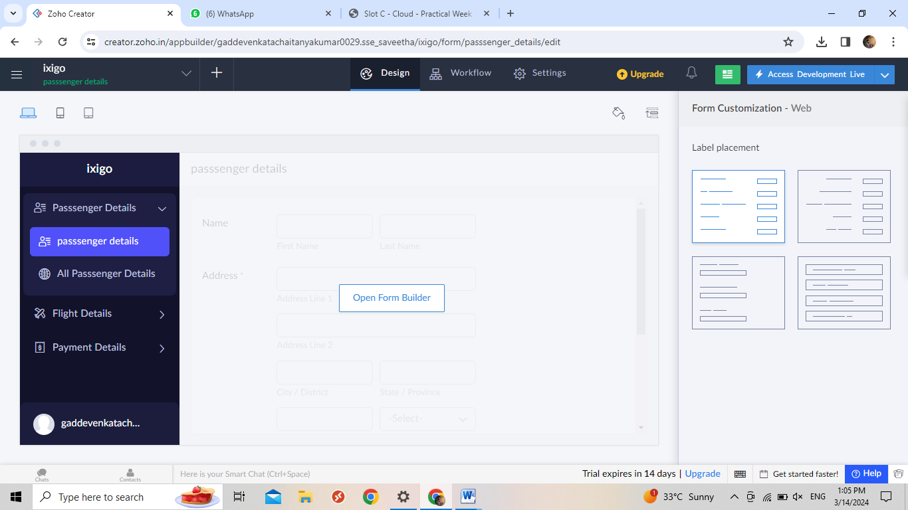

Step 2:create flight details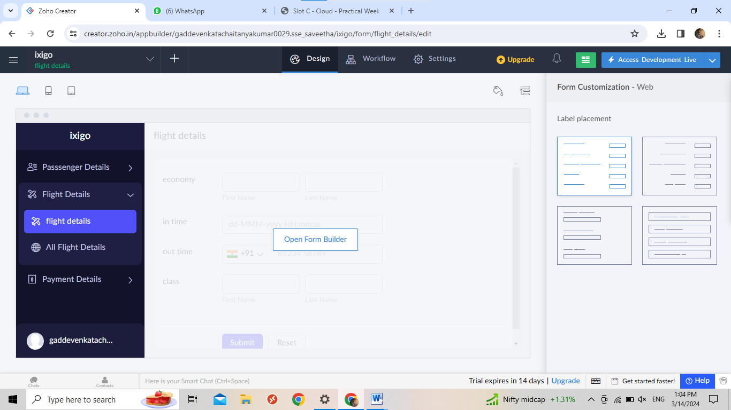

Step 3:create payment details