Dynamic music influence network analysis model

**1Data Pre-processing**

Because of the large amount of data in influence_data data set , if we use all the data to build the network, information in network is too complex to analyze and the network diagram is not easy to watch.So we selected portions of data according to the principles as follows:

1. We selected the data at three representative points in time(according to follower_active_start), namely 1940,1970,2000, to build a dynamic network to show the development and change of the influence relationship between artists over time.

2. We choose partial influencers with the most followers and partial followers learning from the most influencers to build nodes.

**2The whole network**

**插入三张图片1940,1970,2000**

**2.1The conceptual structure of the influence network**

As shown in the figure？, the nodes in the network represent the influencer and the followers. Because the influence is from one influencer to follower, the link is directed.The size of a node circle and the gradation of color depends on its out-degree of nodes, and the larger the out-degree of nodes, the larger the circle,the deeper the color, indicating that the influencer influenced more artists.The label of node is influencer_id and follower_id.

**2.2 Network properties and indicators--Analysis from macro level**

**2.2.1** **Degree Centrality**

? represents the in-degree of node I, which is used to calculate the number of the directed link from node other g-1 j nodes (i≠j) to i nodes and indicates the extent to which the artist is influenced.Out-degree is the other way around.Degree Centrality of certain node is formulated by: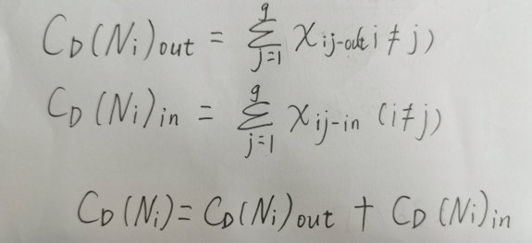

**2.2.2quantify** musical influence

The music influence of an artist can be measured by the number of musicians he influences and the duration of influence.Meanwhile, if an artist is able to influence artists outside the genre,it means that his music is very influential,so we give different weights to followers inside and outside the genre.Denoted the weight as ui.（麻烦打一下，i做下标）Considering that the influence will continue to spread and create a cumulative effect, we use an [exponential](C:/Windows.old/Users/86180/AppData/Local/youdao/dict/Application/8.9.6.0/resultui/html/index.html" \l "/javascript:;) [function](C:/Windows.old/Users/86180/AppData/Local/youdao/dict/Application/8.9.6.0/resultui/html/index.html" \l "/javascript:;) to depict that as the number of followers increases, the speed of music influence grows faster and faster.Denote ‘musical influence’ as MI, ‘musical influence’ of artist i is formulated by:

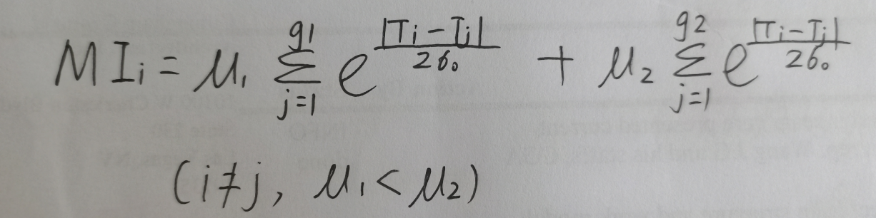

where g1 represents the number of followers within a genre, g2 represents the number of followers outside the genre,Ti(下标）represents influencer active start year, Tj(下标)represents follower active start year. σ is a tunable parameter, determining the robustness of our model, the bigger the more robust.

**4.2.3The subnetwork——Analysis from micro level**

We choose the data in 1970 as an example to analyse the subnetwork.

We analyze subnetworks within and across genres respectively.

（1）Analysis within the genre

**（圆点）Cohesive Subgroup analysis（加大加粗）**

We use The cohesive subgroup analysis to subset a subnetworks. Some nodes in a network are so closely related that they combine into a subgroup that is called cohesive subgroup.The nodes within the cohesive subgroup are closely connected with and greatly influenced each other. Implemented by Ucinet software, we got some cohesive subgroups and we chose a cohesive subgroup with nodes represent the artists in one genre as shown in figure ?.

**圆点Music influence in genre**

Within the genre, MI-in is formulated by: 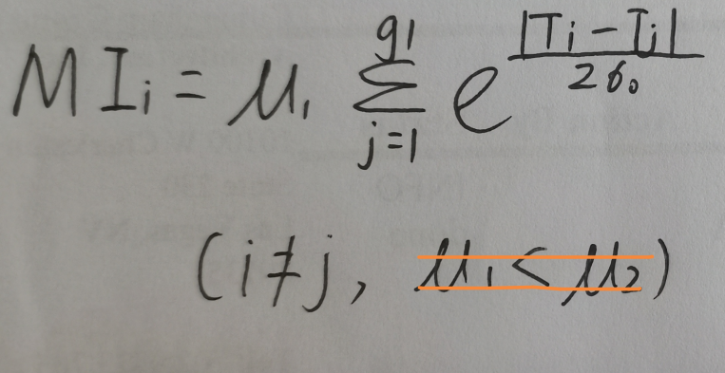

MI-in reveals the inheritance of the musical characteristics and styles of the genre.

As shown in figure?,The darker the color, the larger the radius of the node represent the artist who made a major contribution to the development of the genre and influenced many artists. They were the “musical godfathers”of the genre. In influence_data, some influencers are also followers, the position of influencer and follower change dynamically.

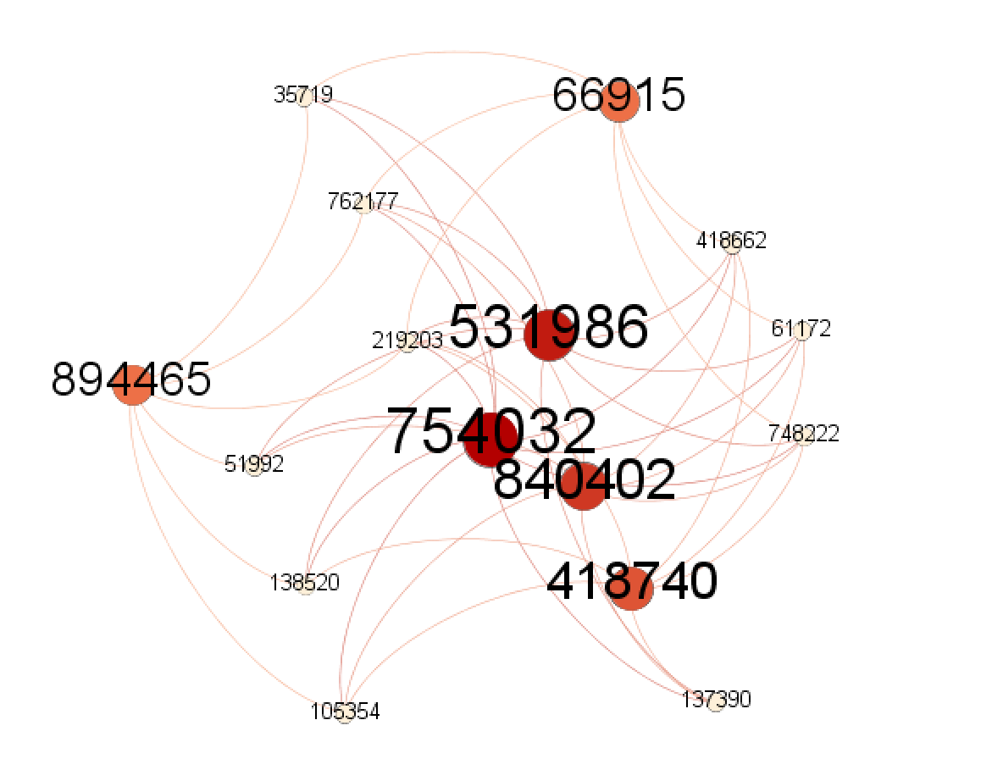

**（2）Analysis among the genres**

**圆点The core-periphery analysis(加粗）**

We use the core-periphery analysis to subset a subnetworks.According to the importance and degree of affinity of nodes, the nodes in the network are divided into core nodes and edge nodes so as to simplify the complex network and focus on the key structure of the network. Through the core-periphery analysis, we got a subnetwork with nodes that represent artists from various genre. Implemented by Ucinet software, the results are as follows:

Core artists’id :608701,549797,816890,414251,276085

Periphery artists’id :198532,287350,217641,224294,198532,207735,187478,240865

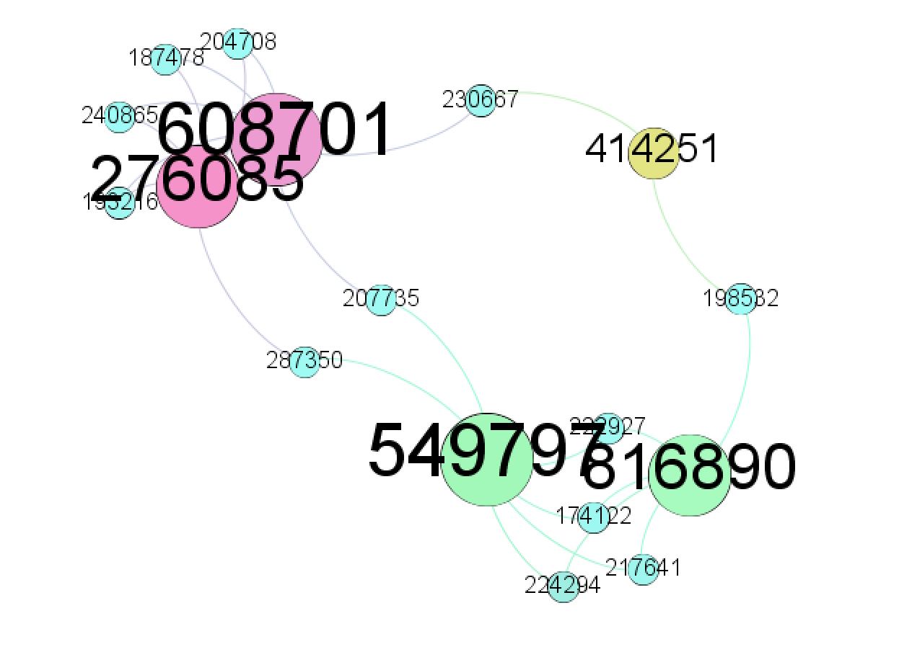

**圆点Between centrality**

Between centrality is an indicator of the importance of a node in terms of the number of shortest paths through a node

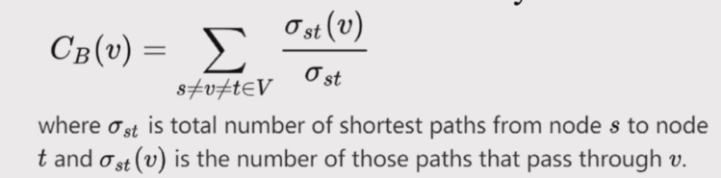

把这个公式敲出来，下面的小字变成正文。

Here, the higher the between centrality of a node is, the higher the connection role the artist plays in the process of music's influence In the process of transmission. These artists with the high between centrality connects different kinds of music and promotes the integration of music.

**圆点Music influence among genres**

Among genres,MI-out is formulated by:

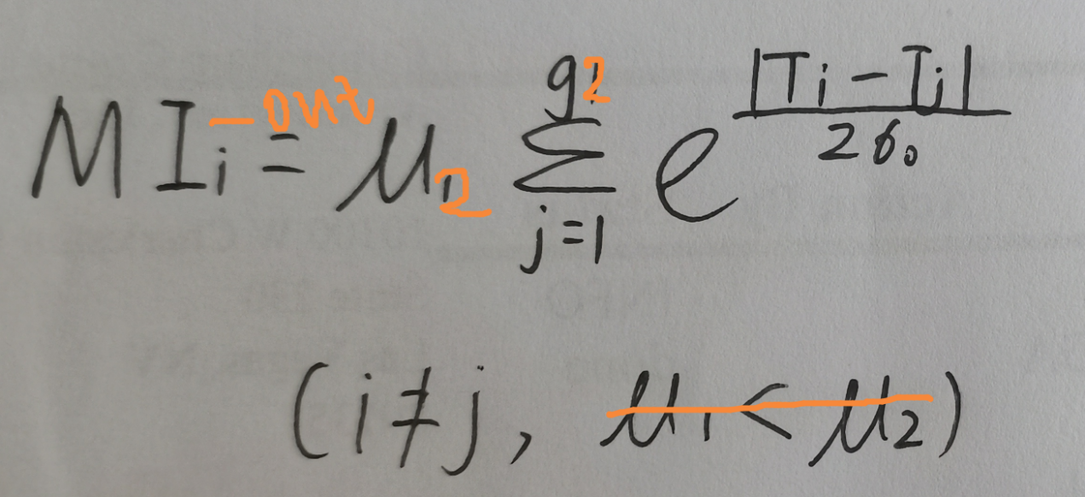

reveals the mutual communication of genres, which is the collision and integration of different types of music.

As shown in figure?,the different color represents different genre.

We can know that the followers are all from Rock/Pop genre, but they are influenced by artists from different genres such as Country,R&B,Blues,Vocal,Folk music and so on.To clarify the influence among different genres,we drew a radar map(figure?) and used the following example.The artists with the highest out-degree that indicates influence, Hank Williams(id:549797) and Johnny Cash(id:816890),are Country musicians.This shows that in the process of development Rock music has been influenced by Country heavily. Lyric rock is a branch of rock which is influenced by country music a lot and became the fusion of country style and rock music.One of the most famous artists in Lyric Rock genre is Don Henley(id:184091)in The Eagles.