实验报告

1.

select room_id,room_name,hotel_id from hotel natural join room_type;

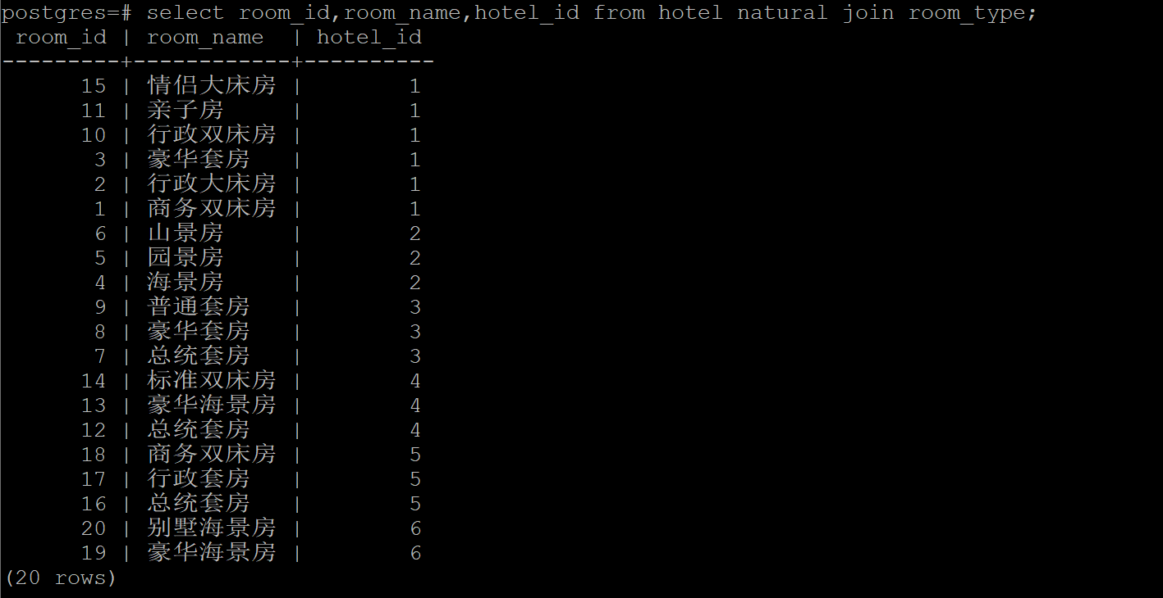

2.

select hotel_name,hotel_id from hotel where hotel_name like '%希尔顿%';

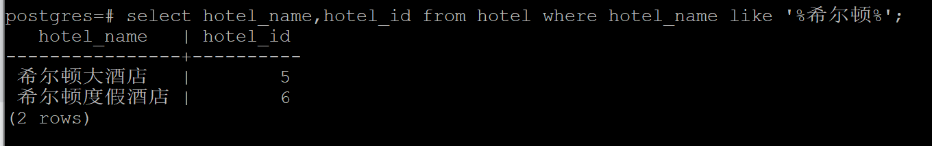

3.

Select order_id,hotel_id,room_id,(leave_date-create_date) livingtime from hotel_order natural join hotel where payment>10000;

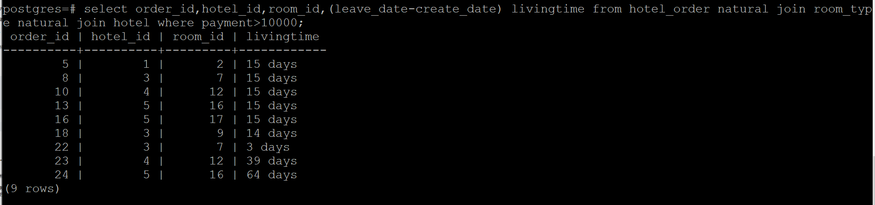

4.

select distinct R1.room_id,room_name,order_id,price from room_info R1,hotel_order R2,room_type R3 where R1.room_id=R2.room_id and R2.room_id=R3.room_id and R1.date=R2.start_date order by R1.room_id;

（假设连续多天的订单都是按照开房当天的房价支付的）

所有房型的订单情况，订单里一定要有所有房型！即时该房型没有出现在订单中

Room_type left join hotel_order left join room_info where

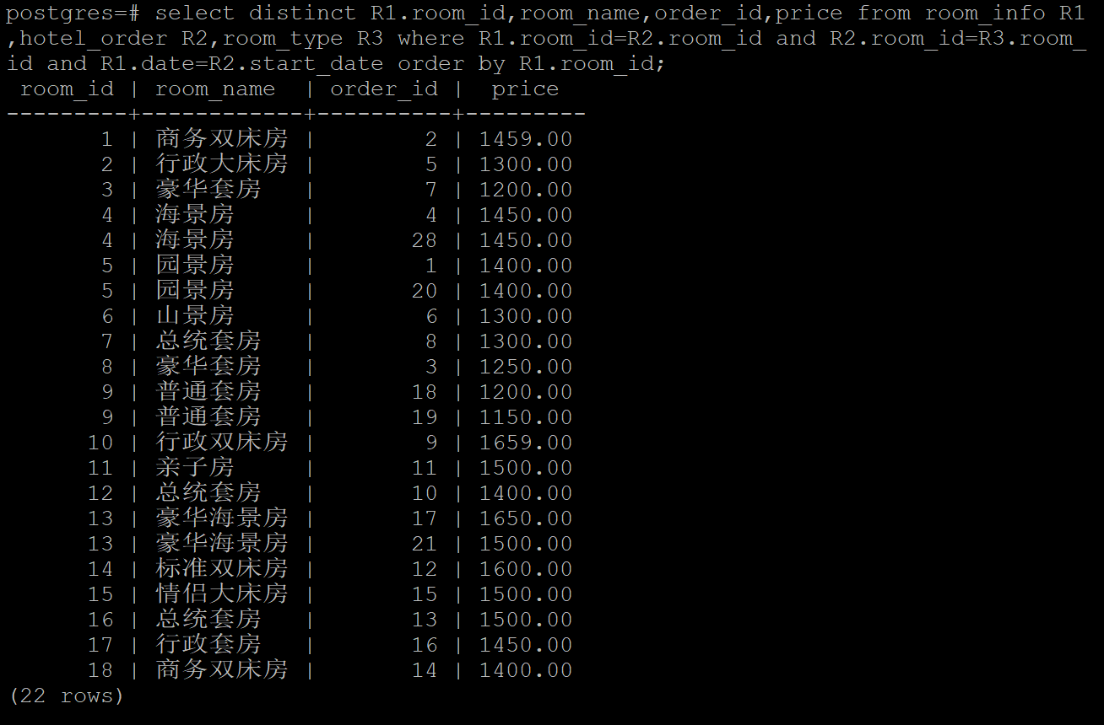

更正：select R1.room_id,room_name,order_id,payment from (room_type R1 left outer join hotel_order R2 on R1.room_id=R2.room_id) order by R1.room_id;

联系上下文，说的是订单情况，这个价格指的应该是订单的payment吧

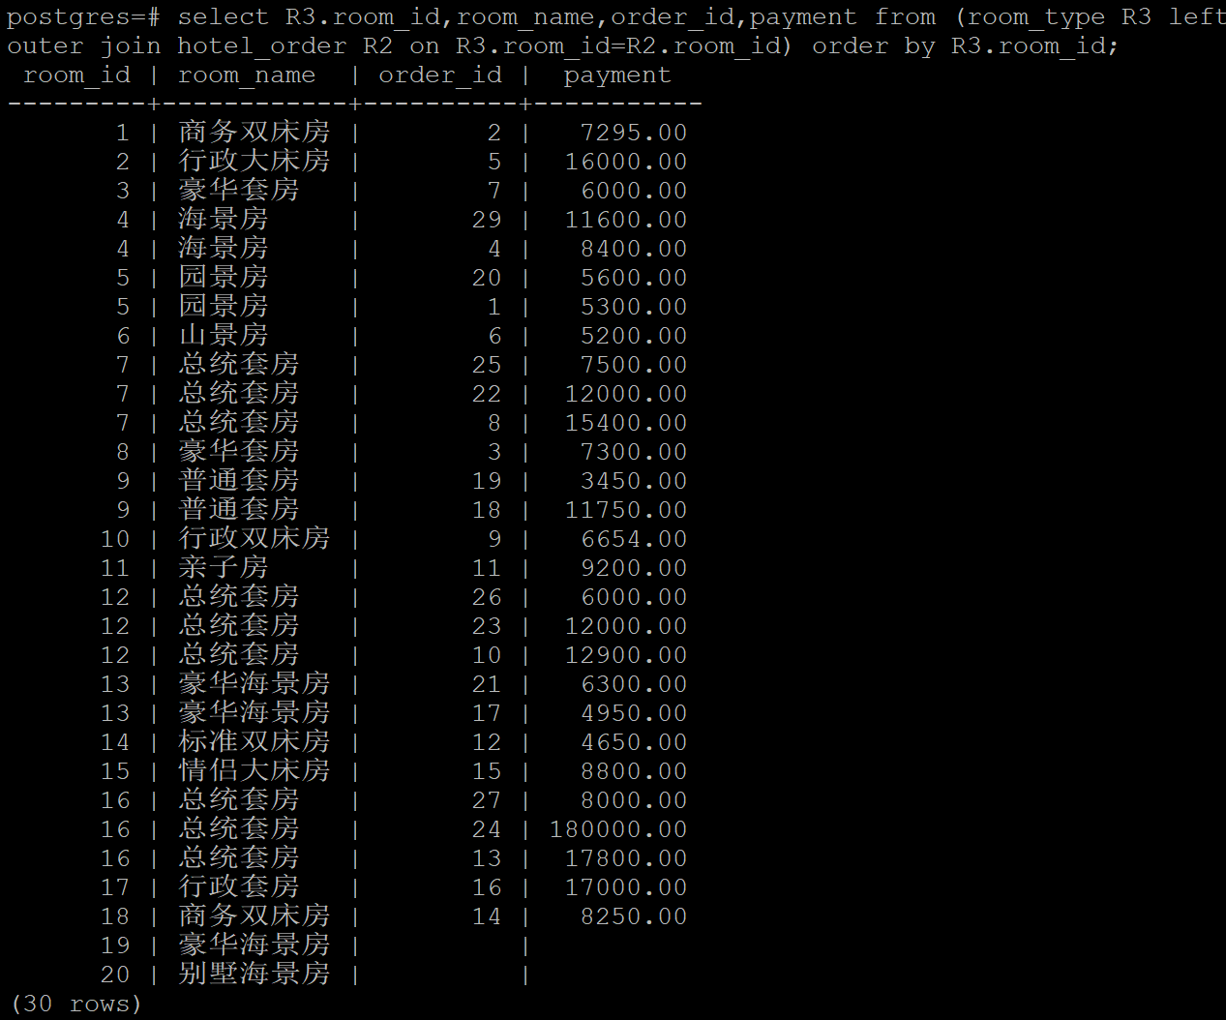

5.

create view 启悦 as select * from hotel_order natural join room_type natural join hotel where hotel_name='启悦酒店';

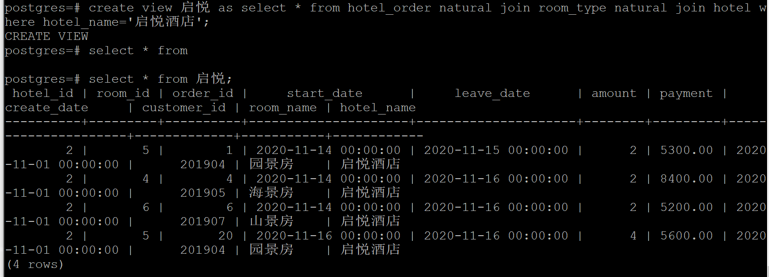

6.

create index orderpayment on hotel_order(payment DESC);



7.

所有酒店

Right outer join hotel where hotel.room_id=room_type.room_id

select hotel_id,avg(price) from room_info natural join room_type natural join hotel where date like '%2020-11-14%' group by hotel_id order by avg ASC;

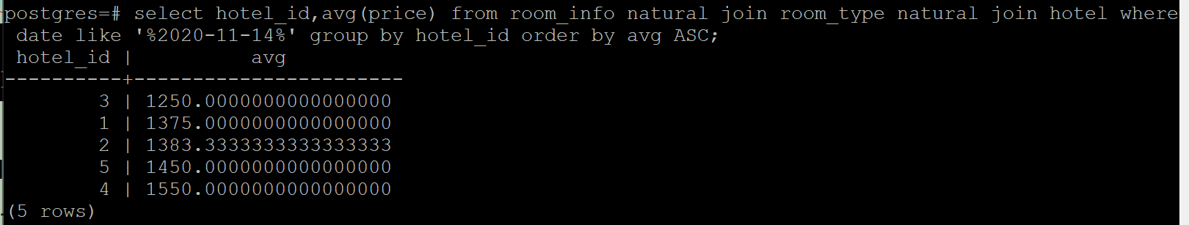

8.

select hotel_name,room_name,amount from hotel natural join room_type natural join hotel_order where hotel_name='希尔顿大酒店' and start_date<='2020-11-14' and leave_date>='2020-11-14';

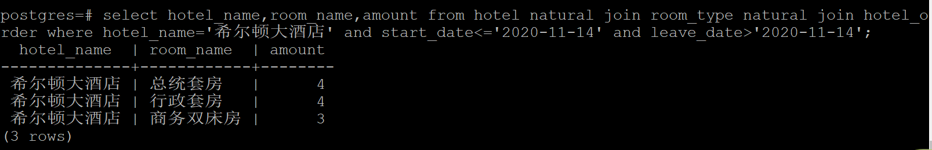

9.

select distinct r1.uID,uName from customer,rating r1, rating r2 where customer.uid=r1.uid and r1.uid=r2.uid and r1.rid>r2.rid;

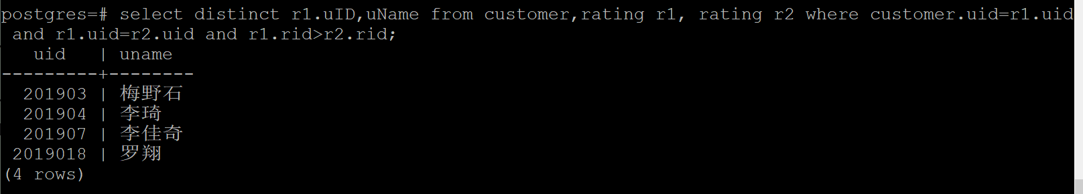

10.

先创建两个视图便于查询：

create view hotel_info as select * from room_type where room_name='总统套房';

create view custom_info as select * from rating natural join customer natural join hotel_order natural join room_type where room_name='总统套房';

select distinct uname from custom_info R1 where not exists (select * from hotel_info S where S.room_id not in (select R2.room_id from custom_info R2 where R2.uname=R1.uname));

视图：



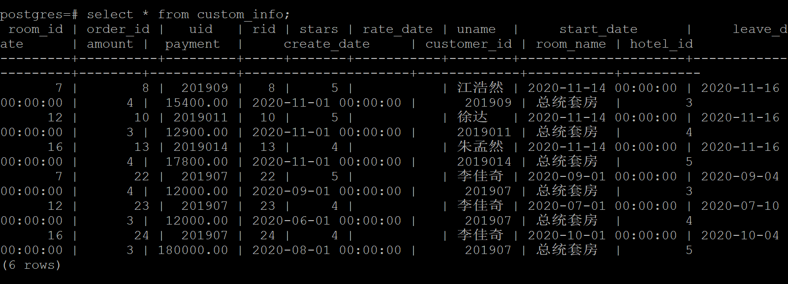



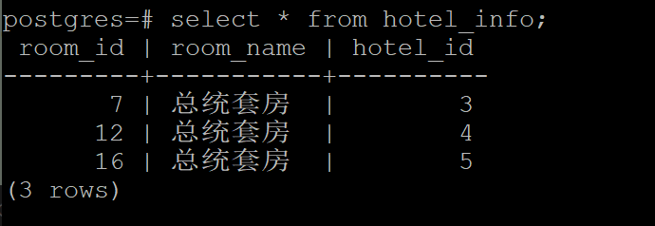

运行结果：

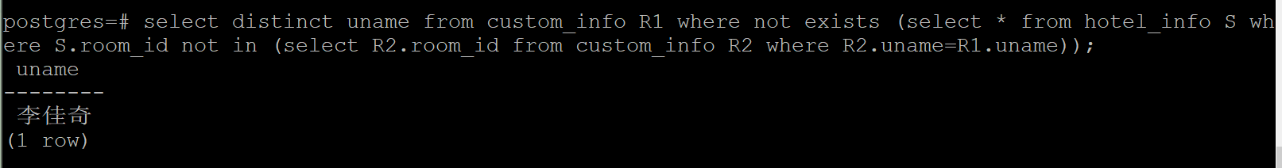

11.

select hotel_name,room_name,avg from hotel natural join room_type natural join (select room_id,avg(price) from room_info where (date='2020-11-14' or date='2020-11-15' or date='2020-11-16') and room_id in (select room_id from room_info where room_id in (select room_id from room_info where remain>=4 and date='2020-11-14') and room_id in (select room_id from room_info where remain>=4 and date='2020-11-15') and room_id in (select room_id from room_info where remain>=4 and date='2020-11-16')) group by room_id);

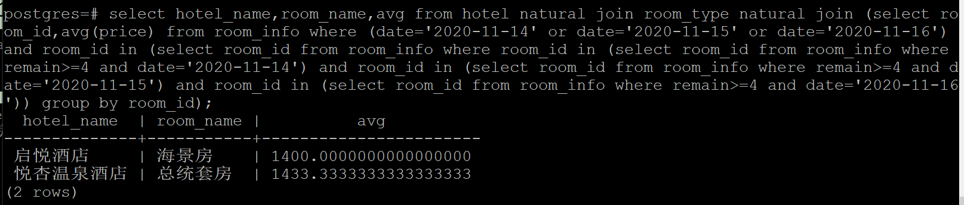

12.

根据上一题的结果可知，能预订的房间有room_id=4或12

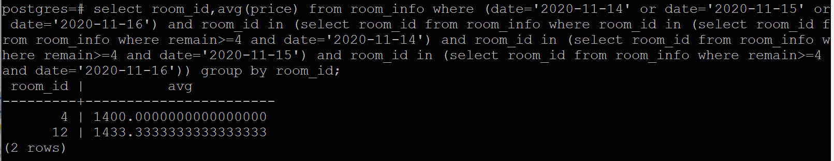

若订单为预订11月14号-15号4号海景房（room_id=4）4间，客户uid是201908，产生的订单号order_id是29

更新房间信息：

update room_info set remain=remain-4 where room_id in (select room_id from room_type where room_id=4) and (date='2020-11-14' or date='2020-11-15');

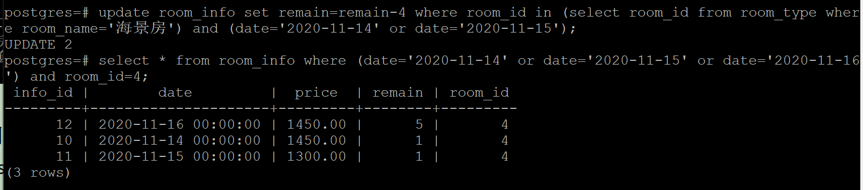

更新前后的数据对比：

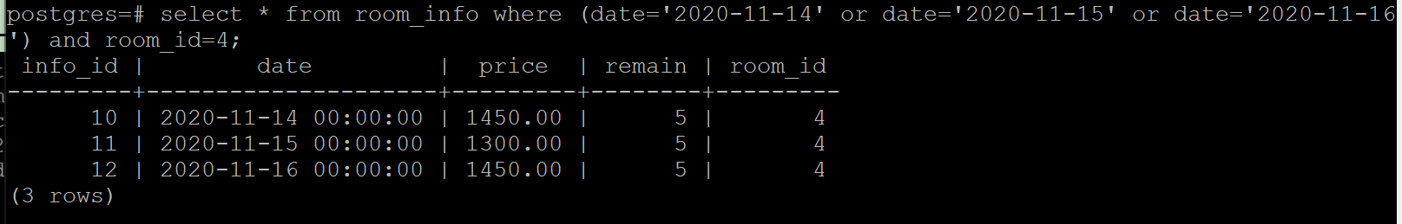

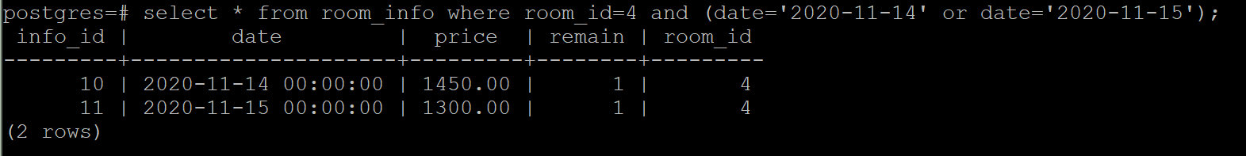

插入一条订单信息：

insert into hotel_order values (29,4,'2020-11-14','2020-11-15',4,(select price from room_info where date='2020-11-14' and room_id=4)*2*4,(select distinct create_date from hotel_order where room_id=4) ,'201908');

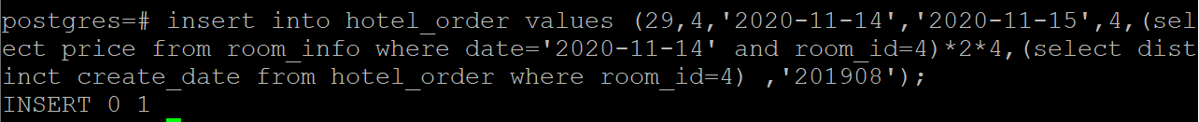

插入的数据：

