Talentra
Technical Design Document: AI resume screening tool and client shortlist portal
GitHub repository: https://github.com/urumb/talentra-ai-recruitment
Live app: not deployed. The app runs locally in a few commands and a free-tier deployment recipe is in deployment.md; it has not been tried on a host. Demo logins are in deployment.md.
Brief chosen: #1 (Company A, Noida staffing firm). Role: Software Engineering candidate, core build slice.

1. What was built
Recruiters create a requisition, extract or hand-write an editable scorecard, bulk-upload up to 500 CVs (PDF or DOCX), and get a ranked list in which every criterion shows the exact line quoted from the CV. Candidates move through a pipeline from Sourced to Joined. Clients see only candidates submitted to their organization, with identity and contact details withheld, and can shortlist, reject with a reason, or propose interview slots. A delivery head sees a weekly comparison of AI ranks and recruiter choices. Consent, a deletion workflow and a who-viewed-what audit log cover the DPDP constraints.
Brief "core build" item | Where it lives
JD scorecard | Requisitions screen: AI extraction from the JD, then editable criteria and weights (must total 100)
Bulk CV upload and parsing | Uploads screen: batch history, per-document status, errors, retry; Duplicates screen
Ranked list with evidence | Candidates screen and candidate drawer (evidence, original CV, client feedback, access history)
Client shortlist portal | Client portal (phone-first): shortlist, reject with reason, propose interview slots
Pipeline | Pipeline screen: Sourced to Joined, filterable per requisition
Optional depth delivered | Consent record, deletion workflow, access audit, weekly fairness view (Privacy and Monitoring screens)

2. Assumptions (labelled)
Only the problem statement was used as source. Everything below that it does not say is an assumption.
# | Assumption
A1 | The cost figures (₹1.57 crore a year, 300 requisitions a month, 120 CVs each, 3 minutes per CV) are the client's and were not re-derived or measured. The 60% screening-time target is not measured by this build; see section 9.
A2 | The brief names no client companies, so the demo uses two invented client organizations (Acme Systems, Globex Corp). A requisition's client must match a client user's organization; that match is the isolation key.
A3 | Candidate names, roles, skills, experience and notice days for CND-91022, CND-91047 and CND-91088 come from the brief. Their emails, phones, CTC and CV wording are invented. Every other sample person is fictional (example.com emails, 90000001xx phones).
A4 | CTC is read as lakh per annum (LPA) and the expected CTC is preferred over the current one. Experience counts only when the CV phrases it as experience (so "lived in Pune for 10 years" is ignored).
A5 | "Immediate joiner" means a 0-day notice period. A month of notice is treated as 30 days.
A6 | A candidate belongs to one requisition. The same person applying to two requisitions is out of scope; the second CV is flagged as a duplicate.
A7 | CVs are in English. Duplicate means the same email, the same phone number or a byte-identical file.
A8 | A "recruiter opened the CV" means they previewed the stored original (or, if no file is stored, opened the profile). That is the gate before submission to a client.
A9 | Client contact details stay masked throughout. The brief does not say when a client may see them, so the build never reveals them; releasing them after interview confirmation is a next step.
A10 | Everything runs on free tools: open-source libraries, Tesseract OCR, and a free-tier LLM through any OpenAI-compatible endpoint.

3. Architecture and why
Part | Choice | Why
Frontend | Next.js 15 (React, TypeScript), plain CSS | One responsive app for recruiter, client and delivery-head views. No UI library: fewer dependencies and a deliberately minimal look.
Backend | FastAPI + SQLAlchemy 2, Pydantic validation | Typed request validation, automatic OpenAPI docs at /docs, fast to test with an in-process client.
Database | PostgreSQL (Docker); SQLite for local runs and tests | Relational data with strict ownership rules. The same SQLAlchemy models run on both.
Document processing | PyMuPDF, python-docx, Tesseract (pytesseract) | All free. Text PDFs and DOCX are read directly, and Tesseract OCR runs only when a PDF has no text layer.
Background work | In-process bounded thread pool (PROCESS_WORKERS), recovered on restart | A queue server is extra infrastructure for a 7-day, single-host build. Uploads return immediately; each document is processed in isolation.
Auth | JWT (8 h), PBKDF2-SHA256 password hashes, role checks on every route | Roles RECRUITER, CLIENT, DELIVERY_HEAD. Client queries are filtered by organization on the server.
AI | LLM for JD extraction only; CV scoring is deterministic rules | Section 6 explains why scoring is deliberately not an LLM.

Request flow: browser → FastAPI (auth, validation, role check) → SQLAlchemy → database. Uploads are saved to a private upload directory, then handed to the worker pool.

4. Data model
Table | Key fields | Notes
users | id, email, role, org, password_hash | org is the client-isolation key
requisitions | id, title, client, location, description, scorecard (JSON) | Scorecard criteria: label, type, weight, values/min/max
candidates | id, requisition_id, name, email (unique), phone, experience, skills, notice_days, raw_text, score, confidence, stage, evidence (JSON), consent, deleted_at | Missing facts are NULL, never 0. raw_text keeps form-feed page breaks so quotes carry page numbers
batches / resumes | batch_id, filename, path, sha256, status, error, candidate_id | Status: queued, processing, completed, failed, duplicate, resolved_duplicate, deleted. For a duplicate, candidate_id points to the match
submissions | candidate_id, client_org | The only way a client can see a candidate
client_reviews | candidate_id, client_org, action, reason, slots | Shortlist, reject (reason required), interview (slots)
deletion_requests | candidate_id, requested_by, status, resolved_at | Requested, Completed or Declined
audits | actor_id, action, target, created_at | Profile views, CV previews, consent, submissions, client actions, deletions

Relationships: requisition 1—n candidates; requisition 1—n batches; batch 1—n resumes; candidate 1—n submissions and client_reviews; candidate 1—n deletion_requests.

5. Main flows
- Screening flow. Recruiter selects a requisition and uploads CVs → server validates type, size and file signature → each accepted file is queued → a worker parses it, extracts fields, checks for duplicates, scores it against the saved scorecard, and stores a candidate at stage Sourced → the Uploads screen polls and shows total / completed / processing / failed / duplicate with per-file errors and Retry.
- Review and submit. Recruiter opens a candidate, reads the evidence, opens the original CV, records consent, then submits to the client. Submit is refused unless consent is Granted and the CV was opened.
- Client flow. Client signs in → sees only submissions for their organization, masked → shortlists, rejects with a reason, or proposes up to five slots → the stage changes immediately in the recruiter pipeline and the feedback appears in the candidate drawer.
- Scorecard edit. Saving a scorecard re-scores all existing candidates of that requisition, so ranking always matches the saved scorecard.
- Deletion. Request → recruiter completes it → name, text, contacts, skills and evidence are erased, the CV file is deleted from disk, client access and feedback are removed, and the audit trail keeps the fact of deletion.

6. How the AI part works

6.1 JD intake (LLM)
The server sends the JD to any OpenAI-compatible chat endpoint (free tiers work) with a JSON-only prompt that forbids inventing requirements. The reply is validated against the scorecard schema (types, weight range). If weights do not total 100 they are scaled and the user sees a warning. The result only pre-fills the form; a person edits and saves it. The endpoint is configured by three environment variables and works with free providers such as Groq. If no key is configured the API returns a clear "not configured" error and the scorecard can be built by hand. Provider errors, timeouts and invalid output return an error message and never fill the form with guesses. Supported criteria: skills, experience, notice, CTC, location, education.

6.2 Parsing CVs in bulk (the hard part)
- PDF text is read page by page; DOCX paragraphs and table cells are both read (many CVs are tables).
- A PDF with almost no text is treated as a scan: pages are rendered and read by Tesseract OCR, limited to 20 pages. If Tesseract is missing, that document fails with a plain message and a Retry button.
- Fields (email, phone, experience, notice, CTC, skills, name) come from rules. A field that cannot be found stays unknown instead of being guessed. The name is accepted only when the first line looks like a name.
- Every document is processed independently: a corrupt, password-protected, empty or oversized file fails alone with its own error and the batch continues. Unfinished documents are re-queued after a restart.

6.3 Scoring with evidence (deterministic)
score = sum over criteria of weight × ratio. Ratio is the share of required skills found, years against the minimum (capped at 1), notice or CTC within the limit (1 or 0), or location/education found. Each criterion stores status (matched, partial, not met, not found, unknown), the points, a verbatim quote from the CV, the source file and page. The same CV and scorecard always give the same score.
Why not an LLM for scoring: an LLM score cannot be reproduced or audited line by line. A reproducible, quoted score is what lets Company A show clients that candidates are treated fairly (DPDP and client scrutiny). The cost is that keyword matching misses synonyms, which is listed under limits.

6.4 When the AI is wrong or unsure
Brief requirement | Implementation
Never reject automatically | No code path changes a candidate's stage based on score. Rejection happens only by a recruiter, or by a client with a reason.
Every score shows evidence | Each criterion shows a quote, file and page, or says it was not stated. Unknown facts earn 0 points but are labelled unknown and are never treated as failures.
Recruiter must open the CV before submitting | The server refuses the submit call until the original CV was previewed by that recruiter (HTTP 409), and the button explains why it is disabled.
Name, gender, age, photo and marital status hidden from scoring | The scorer reads only the CV text for the scorecard criteria and extracted skills, experience, notice and CTC. A unit test confirms that changing name, age, gender and marital status does not change the score.
Low scorers stay searchable | The candidate list shows everyone; search never filters by score. Sample CVs include a deliberately poor match.
Weekly sample for the delivery head | Monitoring screen (delivery-head and recruiter roles): per week and requisition, sample size, overlap with the AI top-K, mean AI rank of selected candidates, average scores of selected versus not selected, and the ranking differences. Candidates appear as pseudonymous references.

The monitoring view says on screen that it does not prove the AI is unbiased. No protected attributes are collected, so group-level disparity cannot be measured, and a sample under 30 is flagged as anecdotal.

7. Security and privacy
- Access control. JWT on every route; recruiter-only, client-only and delivery-head routes enforced server-side. Clients only ever receive candidates linked through their own organization's submissions, and a client action on someone else's candidate returns 404.
- Masking. Clients get a reference like "Candidate D91022", no name, email or phone, and emails and phone numbers inside quoted evidence are masked.
- Consent. Recorded per candidate. Submission requires Granted; withdrawing consent hides the candidate from the client at once.
- Deletion. Erases personal data and the stored CV file, and records the event in the audit log.
- Audit. Who viewed a profile or CV, changed consent, submitted, or acted as a client, and when.
- Inputs and uploads. Pydantic validation, scorecard weights checked, PDF/DOCX type, size (10 MB default) and file signature checked, filenames never used as paths.
- Secrets. Nothing secret is committed; configuration comes from environment variables listed in deployment.md. With APP_ENV=production the API refuses a weak JWT secret. Failed logins are throttled per email.

8. UI and design decisions
The client asked for minimal design with a restrained palette. One navy and indigo palette on warm off-white, one typeface, status colours used only for meaning (green matched, amber partial or duplicate, red failed), and no decoration. Recruiters scan many profiles, so each row gives the score as a ring (a single neutral hue, so a low score never looks like a verdict), the top skills and the stage; the evidence opens in a side panel without losing the list. The panel always shows one next step in the order the server enforces: open the CV, record consent, submit. Navigation is grouped (Workspace, Review, Compliance) with counts on the items that need attention, the overview lists what needs doing today, destructive actions use a confirmation dialog, and the sign-in page offers one-click demo accounts so a reviewer can see every role in seconds.
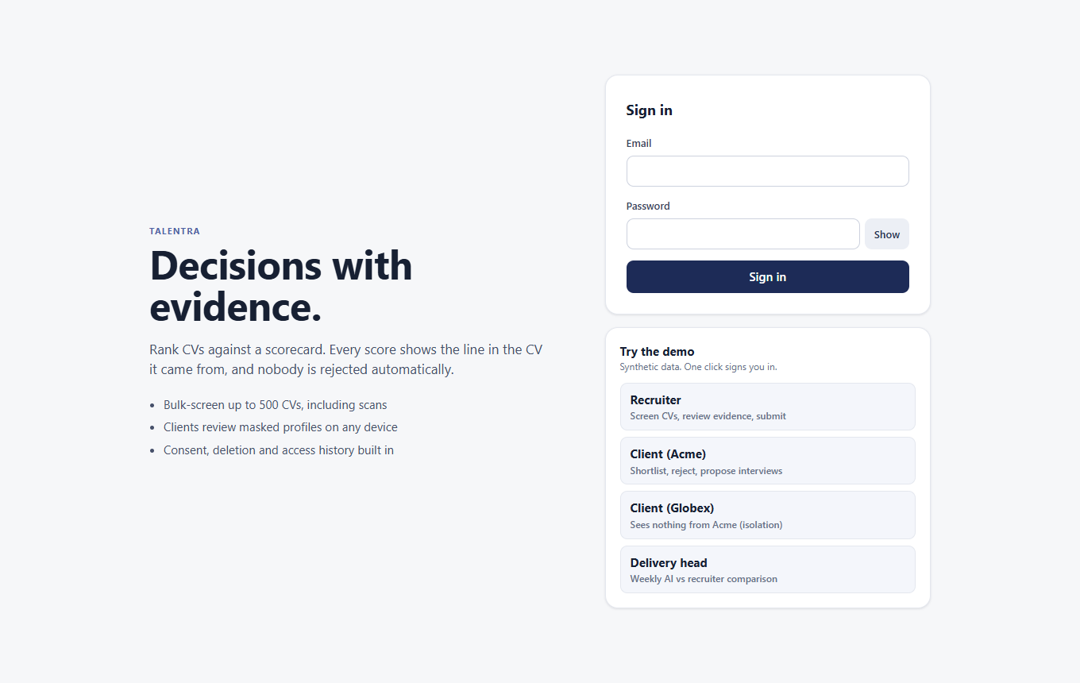
Sign-in with one-click demo accounts (shown only when demo data is enabled)
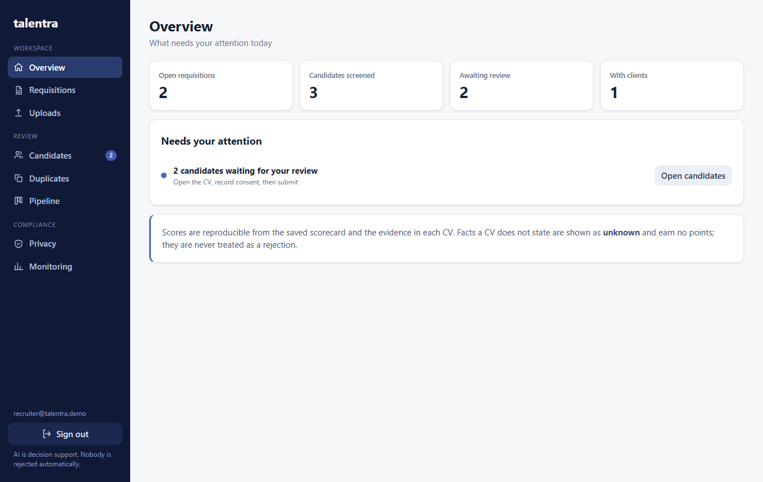
Overview: counts, then a "Needs your attention" list with one button per task
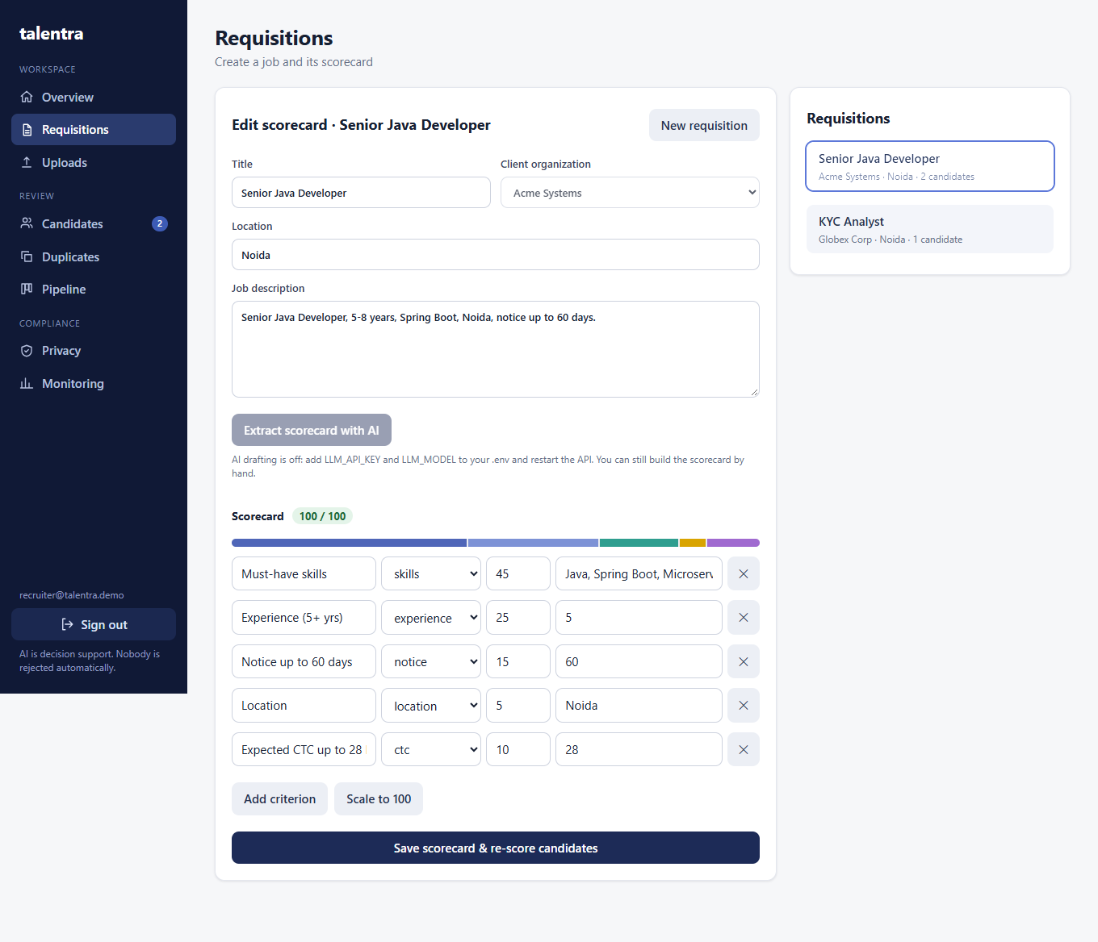
Scorecard: AI-extracted or hand-built criteria; the weight bar and total show 100 before saving is allowed
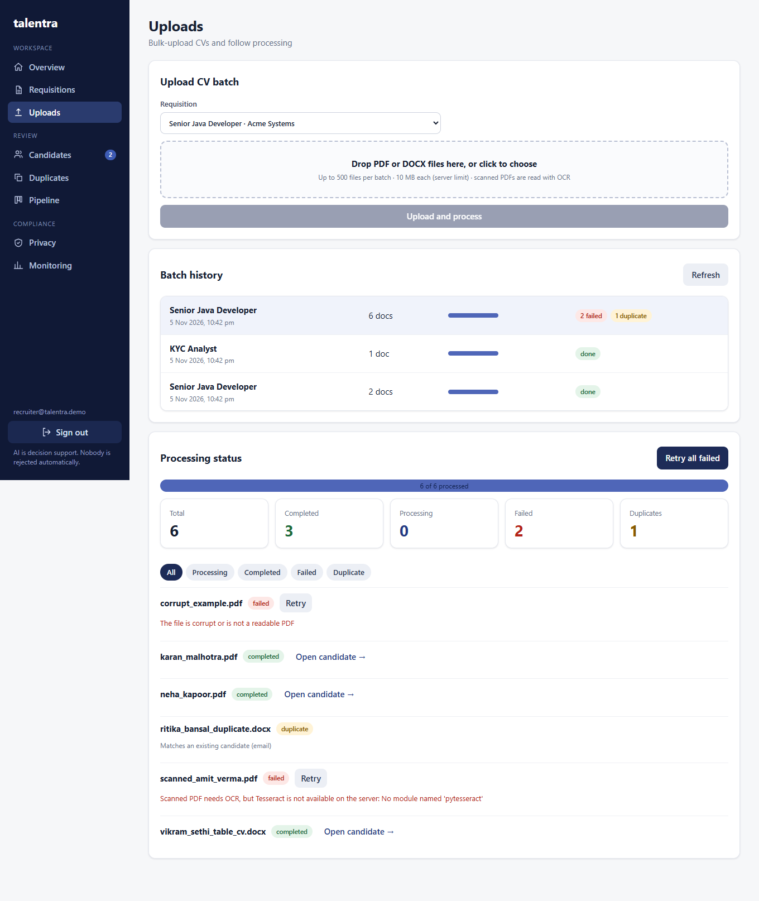
Bulk upload: batch history, progress, totals, per-file errors and Retry (the scanned PDF failed here only because Tesseract was not installed on the capture machine)
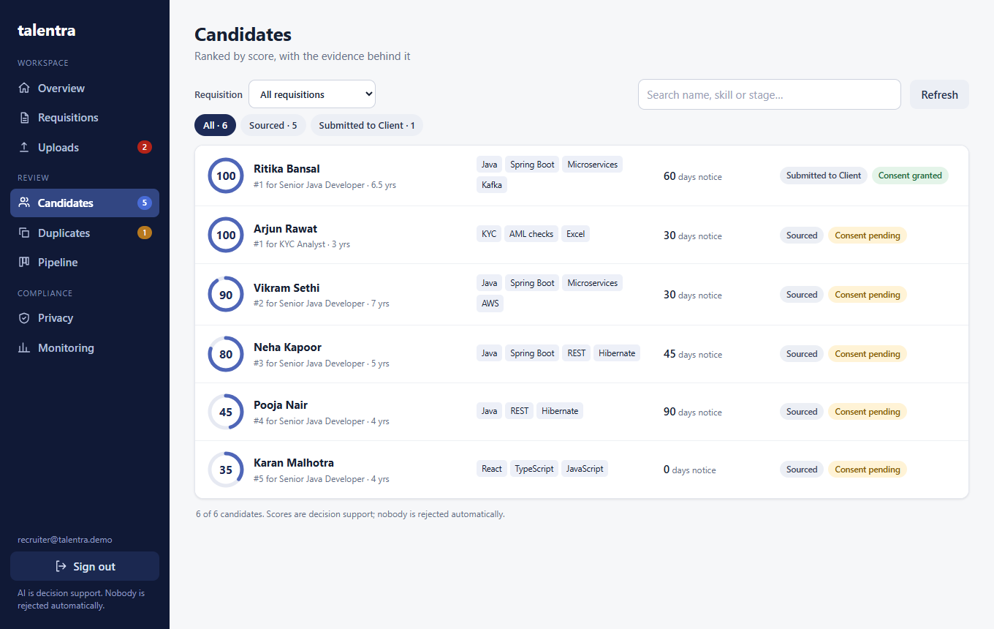
Ranked list: score first, skills, notice and stage; search never hides low scorers
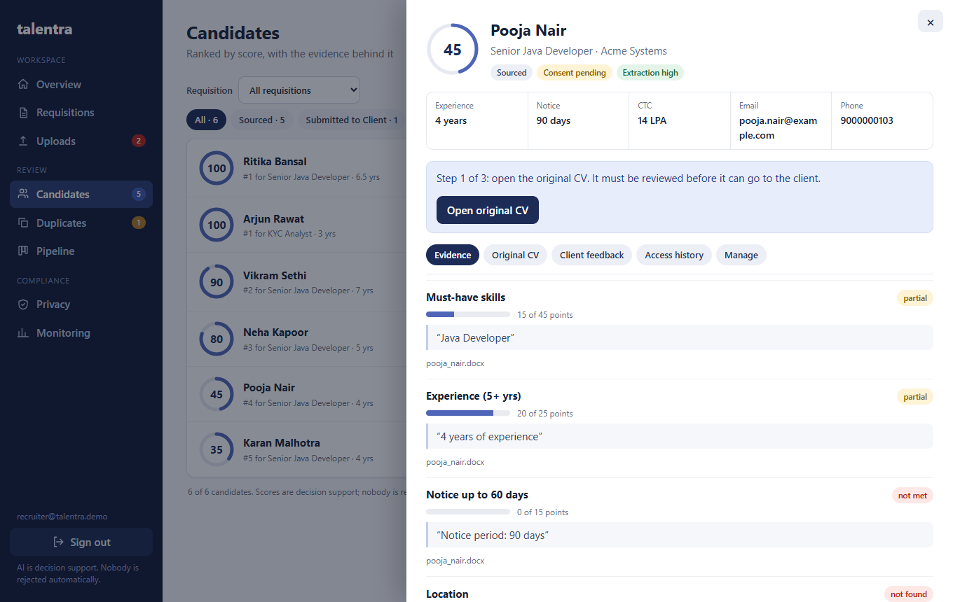
Candidate panel: score, key facts, a guided next step (open CV, record consent, submit) and quoted evidence per criterion
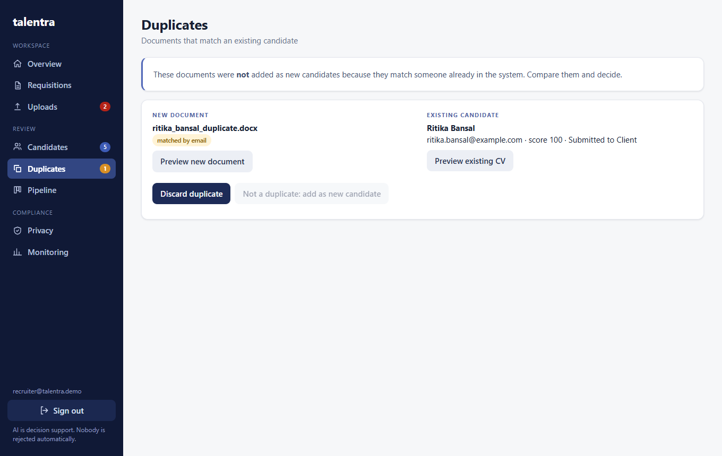
Duplicate review: new document beside the existing candidate, with discard or keep-both
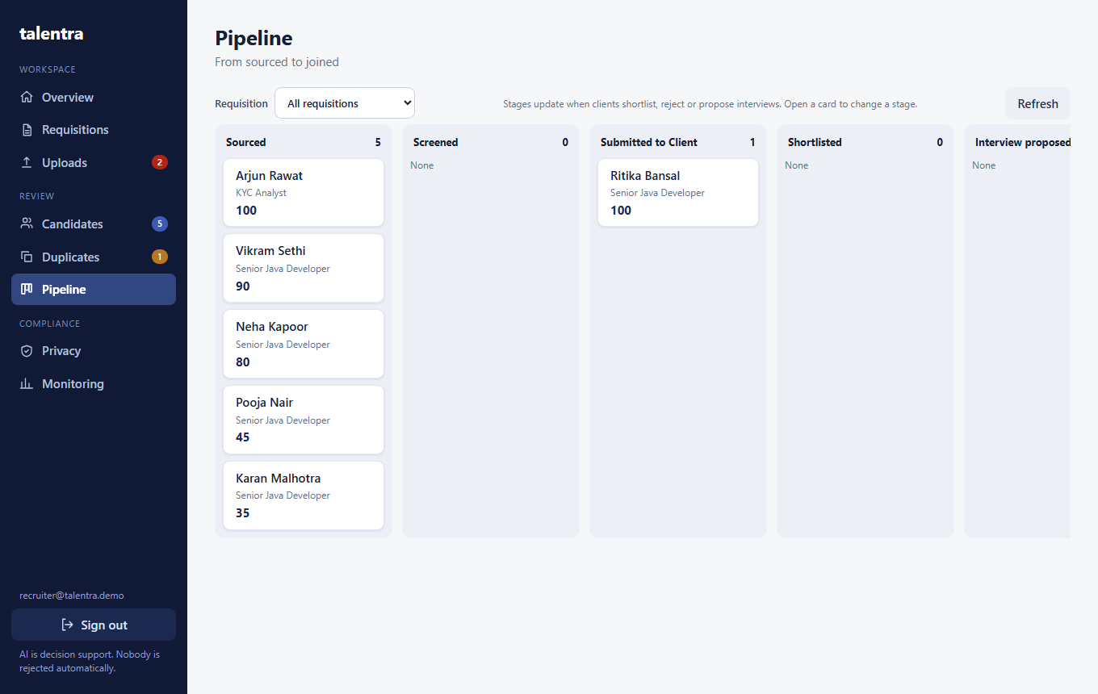
Pipeline from Sourced to Joined, filterable per requisition
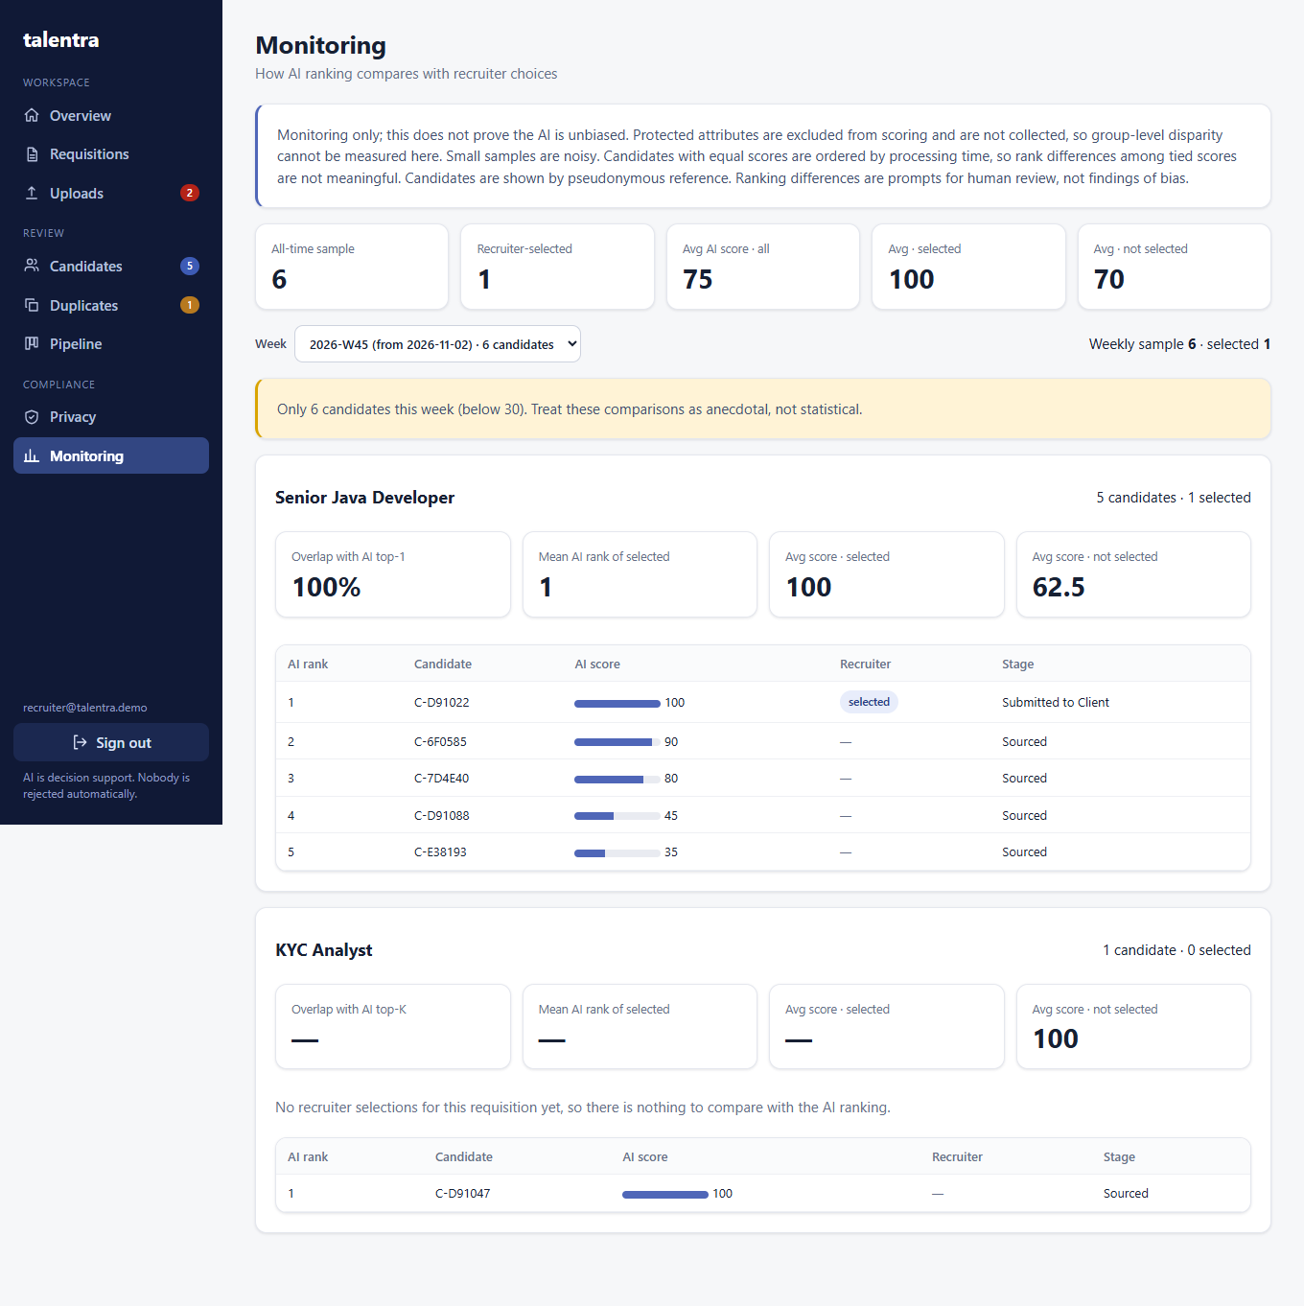
Weekly AI-versus-recruiter comparison with the sample-size warning
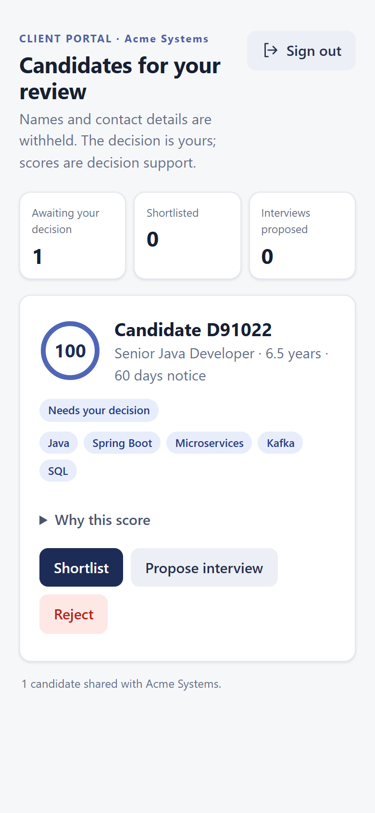
Client portal on a phone: masked candidate, score, "why this score", and three clear actions
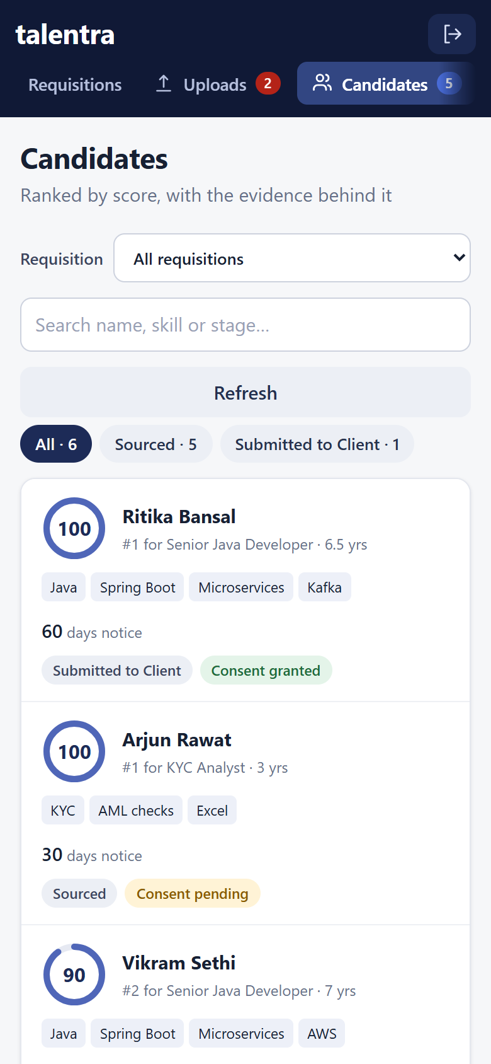
Recruiter workspace on a phone: scrolling tab bar, search, filter chips and one card per candidate
Loading spinners, empty states with a hint, and error states with a Retry button exist on every data screen. The layout collapses to a scrollable top bar on phones with no horizontal overflow (checked at 375 px).

9. Testing and what was verified
33 automated tests (pytest, in-process API, mocked LLM and a mocked OCR engine) cover: authentication and role limits; JD extraction success, weight scaling, invalid output and provider failure; mixed bulk batches where corrupt, empty, fake and unsupported files fail alone; scoring evidence with real page numbers; unknown versus failed; retry; the OCR path; duplicate detection and resolution; document access control; client isolation, masking, shortlist/reject/interview persistence; consent gating and the open-CV gate; deletion removing data and files; scorecard re-scoring; the fairness report; CTC parsing; and that the brief's three sample candidates are seeded and scored from their generated CVs. The frontend builds with type-checking, and the main flows were also driven in a real browser against the running app. Two things were also run by hand with real components: a Groq extraction, and a scanned (image-only) PDF through real Tesseract 5.4, which was read correctly (name, email, 8 years, 30-day notice, CTC) and scored 85. Before Tesseract was installed, the same file failed with a clear per-document message.
Not verified, stated plainly:
- Automated tests mock the LLM. A real call to Groq (model openai/gpt-oss-120b) was run once by hand and returned a valid five-criterion scorecard; the result quality was not evaluated across many JDs.
- Batch size: a synthetic 500-file batch (about 450 valid PDF/DOCX, 49 corrupt, one scanned PDF) was run against the Docker backend with PostgreSQL. All 500 were accepted in about 1 second and processed in about 4 seconds with 4 workers; every corrupt file failed alone with its own message and the scan was read by OCR. This used tiny one-page files, so real multi-page CVs will be slower.
- Docker: the backend image builds and runs against PostgreSQL with Tesseract 5.5 inside (verified). The frontend image could not be built on the test machine because its network intercepts HTTPS to registry.npmjs.org, so it was verified only with npm run build and a local run. The Dockerfile accepts an NPM_REGISTRY build argument for such networks.
- The success metrics (60% less screening time, 48-hour shortlists, 45% to 60% acceptance) are not measured; the audit log timestamps (uploads, submissions, client actions) are the starting data for measuring them.

10. What was cut, limits, and next steps
- Cut: job-board integration, video, background checks (out of scope in the brief); email notifications and real calendar booking; client-visible contact release after interview; multiple requisitions per candidate; CTC and notice as editable fields on the candidate.
- Known limits: extraction is rule-based, so unusual layouts or synonyms (for example "J2EE" for Java) give unknown or a lower score; the in-process worker pool suits one server and the 4-second figure above is for tiny files; the schema is created on startup without migrations; CVs are stored unencrypted on disk; tokens last 8 hours with no revocation; the sample names are fictional and extraction of names from arbitrary CVs is conservative; OCR can misread characters (a bullet in one scanned quote came out as a replacement symbol) and was tried on one synthetic scan only.
- Next: a synonym and skills taxonomy; an LLM-assisted extraction pass that must still quote the CV and is checked against the text; a durable queue; Alembic migrations; encrypted storage and malware scanning; releasing contacts after interview confirmation; measuring the success metrics from audit timestamps.

