1. Replicate the below image. Make sure they responsive for all screen devices.

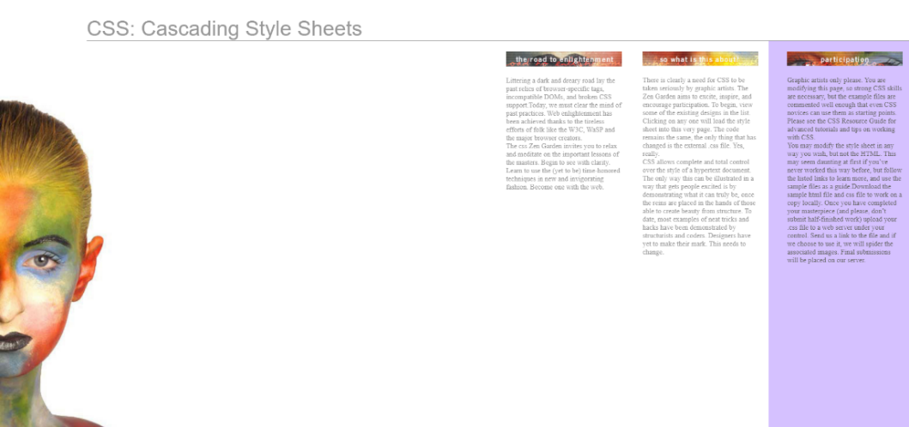

1. Replicate the below image. Make sure they responsive for all screen devices. Take images from google for mobile.

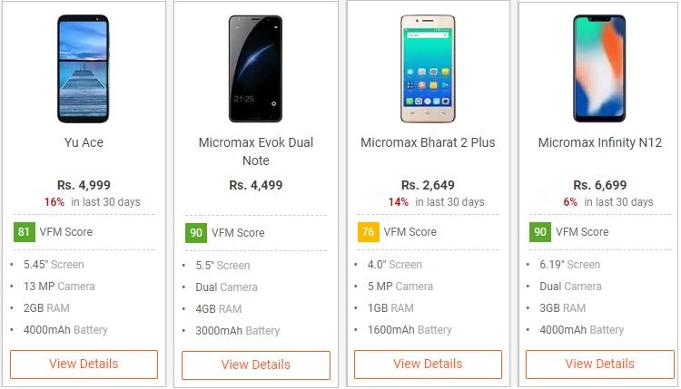

Till width: 1400px make it responsive.