LLM Proxy — Development Design Document
Project: DigitalOceanTest / llm-proxy
Stack: Java 21, Spring Boot 3.4
Author: Engineering Team
Status: Implemented
Version: 1.0

1. Problem Statement
Teams operating LLM-backed APIs need a safe way to evaluate alternative models (candidate) without risking customer experience on the production model (primary). Directly routing customer traffic to an unproven model introduces latency, quality, and availability risk.
We require a production-ready proxy that serves all customer traffic through a trusted primary DigitalOcean Serverless Inference endpoint while asynchronously mirroring the same requests to a candidate model, comparing outputs with deterministic rules, and exposing real-time observability so operators can decide when a candidate is ready for promotion.

2. Goals
- Expose POST /v1/chat that forwards payloads to primary DO Serverless Inference and returns immediately.
- Asynchronously route identical payloads to a candidate model on a decoupled background thread pool.
- Ensure candidate latency, errors, timeouts, or queue saturation never delay or alter the primary HTTP response.
- Compare primary vs candidate outputs using deterministic heuristics (valid JSON + exact action match).
- Expose GET /metrics with total requests, shadow errors/timeouts, dropped shadow tasks, and exact match rate.
- Bound memory footprint under burst via bounded thread pool, bounded queue, load shedding, and capped comparison history.
- Provide mock mode for local development and CI without live API keys.
- Run automated tests and GitHub Actions CI on every push.

3. Non-Goals
- Streaming chat completions (explicitly rejected with HTTP 400).
- Semantic similarity or LLM-as-judge comparison (non-deterministic scoring).
- Persistent trace storage or SQLite mismatch audit trail (discussed as future work).
- Runtime PUT /config shadow mirror percentage throttle (discussed as future work).
- Customer-facing exposure of candidate responses or A/B routing at request time.
- Multi-region deployment, autoscaling, or Kubernetes manifests in v1.
- Authentication/authorization on public endpoints in v1 (recommended before production).

4. Approach
We implemented a three-layer Spring Boot service: (1) HTTP API layer, (2) synchronous primary path on the request thread, and (3) decoupled shadow evaluation pool. The primary path is strictly sequential: validate → call primary LlmClient → return ChatCompletionResponse. Shadow work is fire-and-forget via BoundedShadowExecutor after primary success.
Comparison runs only after candidate response arrives. Metrics are aggregated in-memory with atomic counters and a ring-buffer deque for recent comparison records. Under overload, shadow tasks are dropped (never queued unboundedly, never executed on HTTP threads).

5. Architecture

5.1 Layer Map
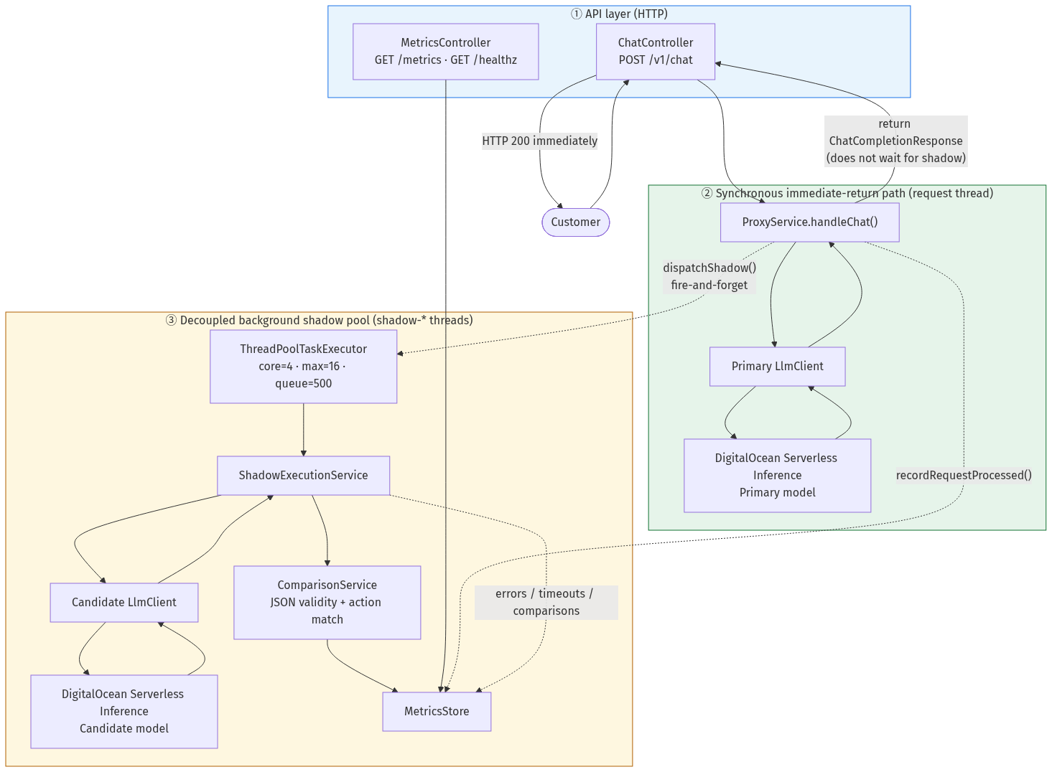
Layer | Components | Thread | Customer Impact
API | ChatController, MetricsController | HTTP worker | Entry/exit for all traffic
Sync path | ProxyService → primary LlmClient → DO Inference | HTTP thread | Blocks only on primary
Shadow pool | BoundedShadowExecutor → ShadowExecutionService → candidate → ComparisonService | shadow-* threads | Fully decoupled; failures invisible to customer

5.2 Component Responsibilities
Component | Responsibility
ChatController | POST /v1/chat — counts requests, delegates to ProxyService
MetricsController | GET /metrics, GET /healthz
ProxyService | Primary orchestration; schedules shadow after primary success
LlmClient (primary/candidate) | HTTP to DO /v1/chat/completions; mock or live mode
BoundedShadowExecutor | Bounded thread pool + queue; load shedding
ShadowExecutionService | Candidate call, comparison, metrics recording
ComparisonService | JSON validity + action field exact match
MetricsStore | Counters, ring buffer, ObservabilitySummary
AppProperties | Configuration from application.yml / .env

6. Sequence Diagram
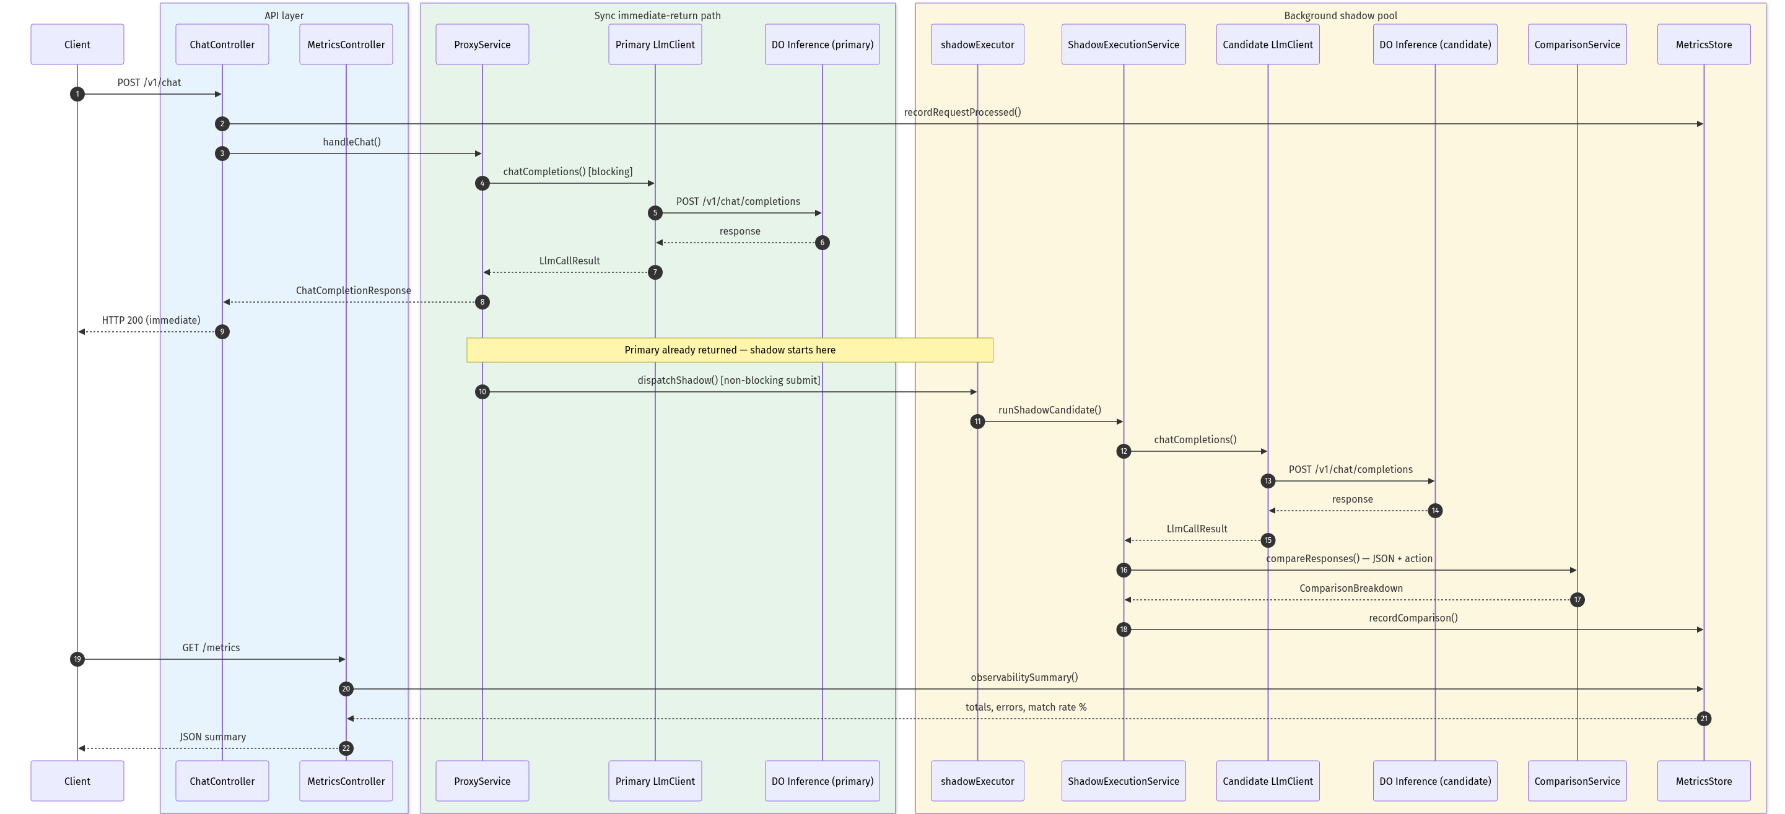
Key invariant: steps 1–8 (primary path) complete before the customer receives HTTP 200. Shadow steps 9–16 run concurrently and never block step 8.

7. API Design
Method | Path | Description
POST | /v1/chat | OpenAI-compatible chat proxy (primary path)
GET | /metrics | Real-time observability JSON summary
GET | /healthz | Liveness probe
GET | /actuator/prometheus | Optional Prometheus scrape

7.1 Metrics Response Fields
Field | Meaning
total_requests_processed | All /v1/chat requests received
shadow_errors_or_timeouts | Candidate failures (customer unaffected)
shadow_tasks_dropped | Shadow evaluations shed when pool saturated
exact_match_rate_percent | % comparisons with matching action field
total_comparisons | Completed shadow evaluations
action_exact_matches | Count of exact action matches
pending_shadow_executions | Shadow jobs in flight

8. Comparison Heuristics
- Parse primary and candidate message content as JSON objects (supports markdown ```json fences).
- Extract the action string field from each payload.
- action_exact_match = both valid JSON AND primary.action equals candidate.action (exact string equality).
- exact_match_rate_percent = action_exact_matches / total_comparisons × 100.

9. Data Structures & Algorithms
Structure / Algorithm | Usage | Complexity / Bound
ThreadPoolExecutor + ArrayBlockingQueue | Shadow task scheduling | O(1) submit; bounded queue
ArrayDeque ring buffer | Comparison history in MetricsStore | O(1) append; evict oldest when > max
AtomicLong / AtomicInteger | Hot counters (requests, drops, pending) | Lock-free increments
Jackson readTree + regex fence strip | JSON parsing in ComparisonService | O(n) on payload size
SHA-256 (mock mode) | Deterministic mock LLM responses | O(n) on input length
Deep copy via Jackson convertValue | Isolate shadow request copy | O(n); only on shadow thread

10. Configuration
Variable | Default | Purpose
MOCK_LLM | true (tests) | Local mocks vs live DO Inference
LLM_TIMEOUT_SECONDS | 60 | Upstream DO HTTP response timeout
SHADOW_CORE_POOL_SIZE | 4 | Minimum shadow worker threads
SHADOW_MAX_POOL_SIZE | 16 | Maximum parallel shadow executions
SHADOW_QUEUE_CAPACITY | 500 | Max queued shadow tasks before shedding
MAX_COMPARISON_RECORDS | 1000 | Ring buffer size for comparison history
PRIMARY_LLM_MODEL | llama3.3-70b-instruct | Primary model ID
CANDIDATE_LLM_MODEL | llama3-8b-instruct | Candidate model ID

11. Trade-offs & Design Decisions
Decision | Chosen | Alternative | Rationale
Shadow start timing | After primary returns | Parallel with primary | Avoid 2× API cost on primary failure; simpler lifecycle
Overload policy | Drop shadow tasks | Block or CallerRuns | Never impact customer latency or HTTP threads
Comparison method | Deterministic JSON/action | Semantic / LLM judge | Reproducible, testable, explainable
Metrics storage | In-memory aggregates | Database | Fast, simple; sufficient for live SLA view
Language | Java 21 / Spring Boot | Python FastAPI (initial) | Production thread pools, typing, ecosystem
Primary/candidate clients | Two @Qualifier beans | Single client with param | Clear separation, independent config
Mock mode | Built into LlmClient | External stub server | Zero-deps local dev and CI

12. Memory Footprint Under Load
Worst-case shadow memory is approximately O(SHADOW_QUEUE_CAPACITY + SHADOW_MAX_POOL_SIZE + MAX_COMPARISON_RECORDS). Primary footprint scales with concurrent HTTP connections only — not with shadow backlog.
- Pre-check capacity before shadow submit; reject handler as safety net.
- Lazy request deep-copy inside shadow runnable (shed tasks allocate nothing).
- DiscardPolicy semantics — dropped tasks are not retained in memory.
- Comparison deque evicts oldest entries beyond MAX_COMPARISON_RECORDS.

13. Testing & CI
- Unit: BoundedShadowExecutorTest, MetricsStoreTest, ComparisonServiceTest, ShadowExecutionServiceTest
- Integration: ProxyIntegrationTest, ShadowLoadSheddingIntegrationTest (20-request burst)
- GitHub Actions: Java 21, ./mvnw test, MOCK_LLM=true on push/PR to main

14. Future Enhancements
- PUT /config for runtime shadow_mirror_percent (0–100) throttle.
- SQLite persistent traces for mismatched payloads (debug / visualization).
- Parallel primary + candidate start for faster comparisons (at higher API cost).
- Auth on admin endpoints; rate limiting on /v1/chat.
- Streaming support with shadow on completed non-stream responses.

15. References
- DigitalOcean Serverless Inference: https://cloud.digitalocean.com/model-studio/serverless-inference
- DO Inference API: https://docs.digitalocean.com/products/inference/reference/api/serverless-inference/
- Repository README and docs/diagrams/ in DigitalOceanTest project

