**Computer Vision -TA2**

Name: Urvashi Bisen

Roll No: 20

Batch: B2

**1)SIFT (Scale Invariant Feature Transform)**

**Code and output:**

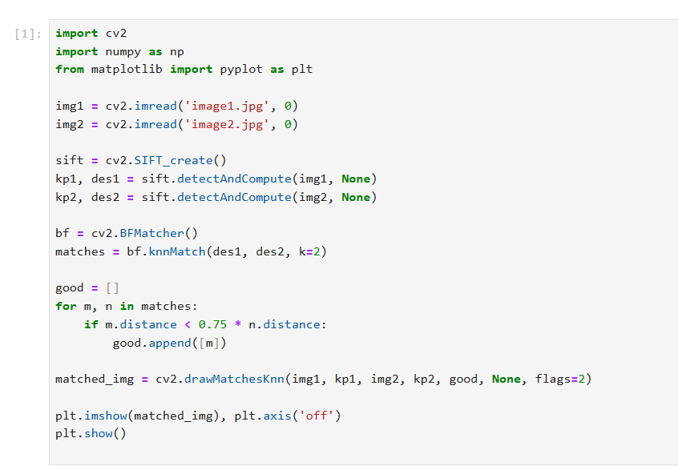

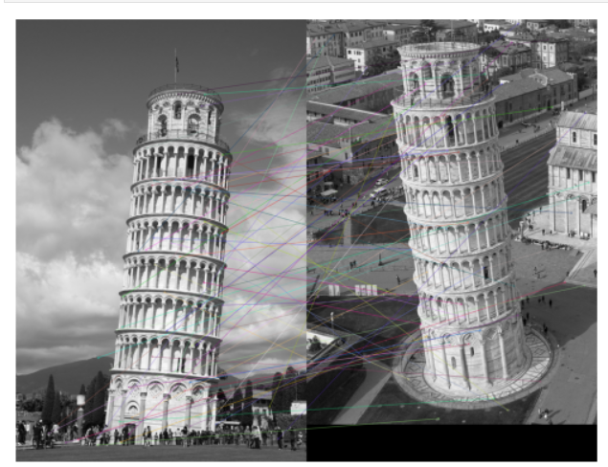

**2)Harris Corner Detection**

**Code and output:**

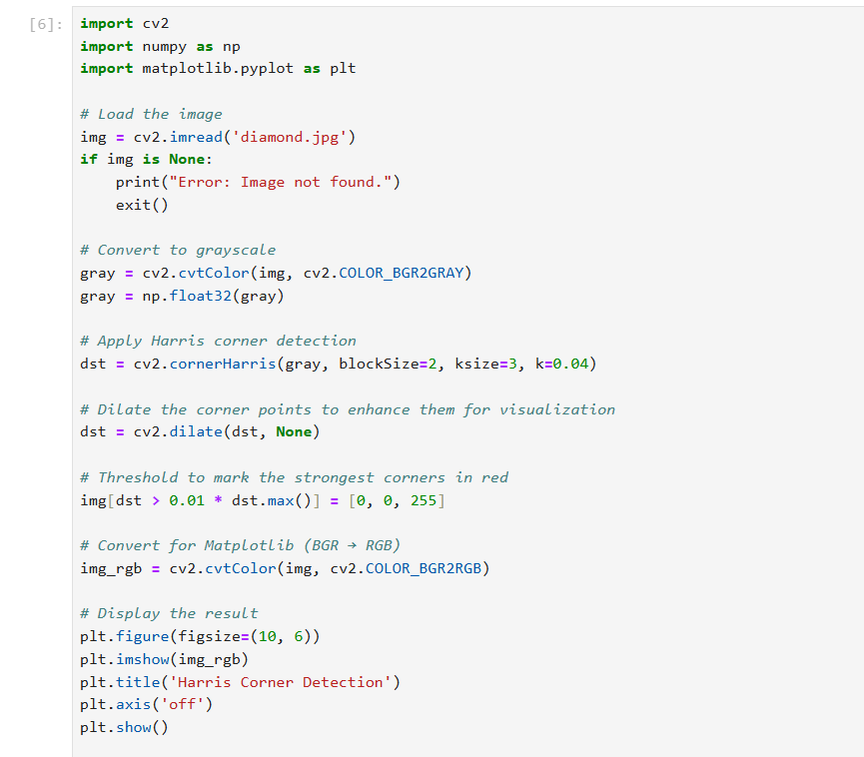

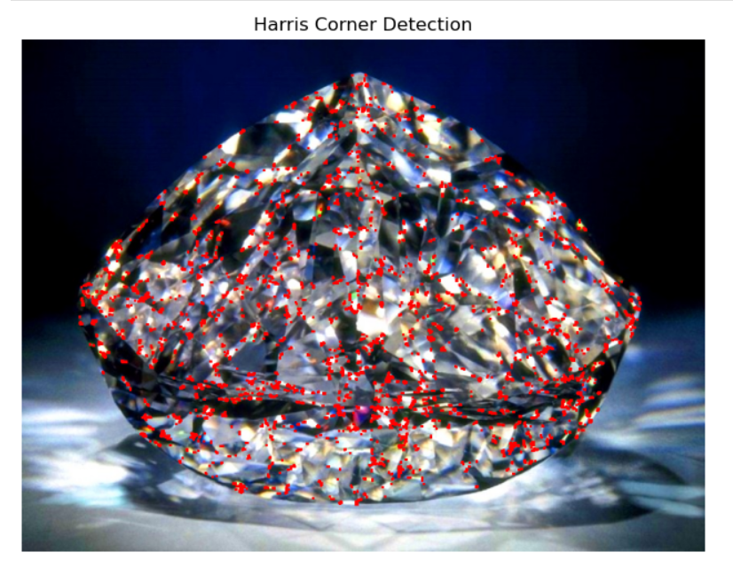

**3)Shi-Tomasi Corner Detection**

**Code and output:**

