

Translational Bioinformatics BIE 406(T+P)

Computational method for Ovarian Cancer Subtype Classification

A mini project submitted to the

Bioinformatics Centre

Savitribai Phule Pune University

Semester IV

For the degree of

M. Sc. in Bioinformatics

By

Ankita Gupta(BIM-2024-03)
Arghya Mondal(BIM-2024-05)

Urvashi Gawas(BIM-2024-10)

TABLE OF CONTENTS

- Abstract
- List of Abbreviations
- • ACO: Ant Colony Optimization
- • AUC: Area Under the Curve
- • FDR: False Discovery Rate
- • LR: Logistic Regression
- • PCA: Principal Component Analysis
- • RF: Random Forest
- • ROC: Receiver Operating Characteristic
- • SVM: Support Vector Machine

- List of Tables

Table 1:Champion Model Metrics

- List of Figures

Figure 1:Histopathological and Immunohistochemical Analysis of Ovarian Cancer Subtypes

Figure 2:TCGA Ovarian Cancer (TCGA-OV) Multi-Omics Workflow

Figure 3:Computational Machine Learning Pipeline

Figure 4:Processed RNA-Seq Expression Matrix (TCGA-OV)

Figure 5: Terminal Output of Model Training and Auditing

Figure 6: Confusion Matrix of the Winning Model

Figure 7:2D Class Distribution Visualization (ACO)

Figure 8:The Integrated Progression Mechanism

- Introduction
- Materials & Methods
- Results & Discussion
- Conclusions
- Future Work
- References

ABSTRACT
This report presents a computational framework for the classification of ovarian cancer molecular subtypes using high-dimensional gene expression data. The primary objective was to evaluate the efficacy of integrative feature selection techniques—Principal Component Analysis (PCA) and Ant Colony Optimization (ACO)—in enhancing the predictive performance of machine learning models. Using a 90:10 train-test split on expression data, we compared Random Forest (RF), Support Vector Machine (SVM), Logistic Regression (LR), and XGBoost architectures. Our methodology aligns with established protocols in translational bioinformatics where dimensionality reduction is critical for mitigating the "curse of dimensionality" in genomic datasets (Tothill et al., 2008).
Key findings indicate that the Logistic Regression (LR) model, when paired with ACO-driven feature selection, achieved superior diagnostic accuracy. The model demonstrated exceptional performance in distinguishing between differentiated, immunoreactive, mesenchymal, and proliferative subtypes, yielding a micro-average Area Under the Curve (AUC) of 0.997. Specificity was particularly high for the "proliferative" and "immunoreactive" classes, both achieving perfect AUC scores of 1.000. These results suggest that meta-heuristic selection methods like ACO can effectively identify highly discriminative gene features that traditional linear methods may overlook. In conclusion, this study validates a robust pipeline for ovarian cancer subtyping, providing a scalable model for precision oncology and drug repurposing efforts (Verhaak et al., 2013).

Introduction
Ovarian cancer remains the most lethal gynecologic malignancy and a significant challenge to global public health. Often referred to as the "silent killer," its early symptoms—such as bloating and pelvic pain—are non-specific, leading to approximately 70% to 75% of patients being diagnosed at an advanced stage (FIGO Stage III or IV) where the five-year survival rate drops precipitously. Historically treated as a uniform disease, modern oncology now recognizes ovarian cancer as a heterogeneous collection of distinct diseases with varying genomic landscapes and clinical outcomes (Leong et al., 2015).
1. Ovarian Cancer: The Global Burden and the "Silent Killer"
Globally, ovarian cancer is the seventh most common cancer in women and the second most common cancer of the female genital tract. It accounts for more deaths than all other gynecologic tumors combined, primarily due to late-stage presentation and a high rate of recurrence (TCGA Research Network, 2011).
1.1. Histological Classification
Figure 1:Histopathological and Immunohistochemical Analysis of Ovarian Cancer Subtypes
Approximately 90% of cases are classified as Epithelial Ovarian Cancers (EOC), with High-Grade Serous Ovarian Carcinoma (HGSOC) being the most prevalent and aggressive histotype (~70%). HGSOC is characterized by profound genomic instability and nearly universal mutations in the TP53 gene, present in over 96% of cases (TCGA Research Network, 2011). Other significant histological subtypes include:
- Clear Cell Carcinoma (10%): Associated with endometriosis and ARID1A mutations.
- Endometrioid Carcinoma (10%): Linked to PTEN mutations and a better overall prognosis if caught early.
- Mucinous Carcinomas (3–4%): These often present as large masses and may be less responsive to standard platinum-based therapies.

2. Transcriptomic Subtypes: Navigating Molecular Heterogeneity
While histological classification provides a baseline, it often fails to explain differential therapeutic responses. To address this, large-scale initiatives have identified four distinct transcriptomic subtypes based on gene expression profiling (Verhaak et al., 2013):
- Immunoreactive Subtype: Defined by a high expression of T-cell markers and chemokine signaling (notably CXCL13 and CXCR3). Patients in this category typically experience the most favorable prognosis (Leong et al., 2015).
- Proliferative Subtype: Characterized by the upregulation of cell cycle markers and signaling pathways involved in rapid, uncontrolled cell division, such as CCND1 (Verhaak et al., 2013).
- Differentiated Subtype: Exhibits gene expression patterns that closely resemble mature Fallopian tube epithelium.
- Mesenchymal Subtype: The most aggressive subtype, marked by high expression of genes associated with the epithelial-to-mesenchymal transition (EMT) and stromal infiltration. It is consistently linked to the poorest survival rates (Verhaak et al., 2013).
3. The TCGA-OV Project: A Genomic Landmark
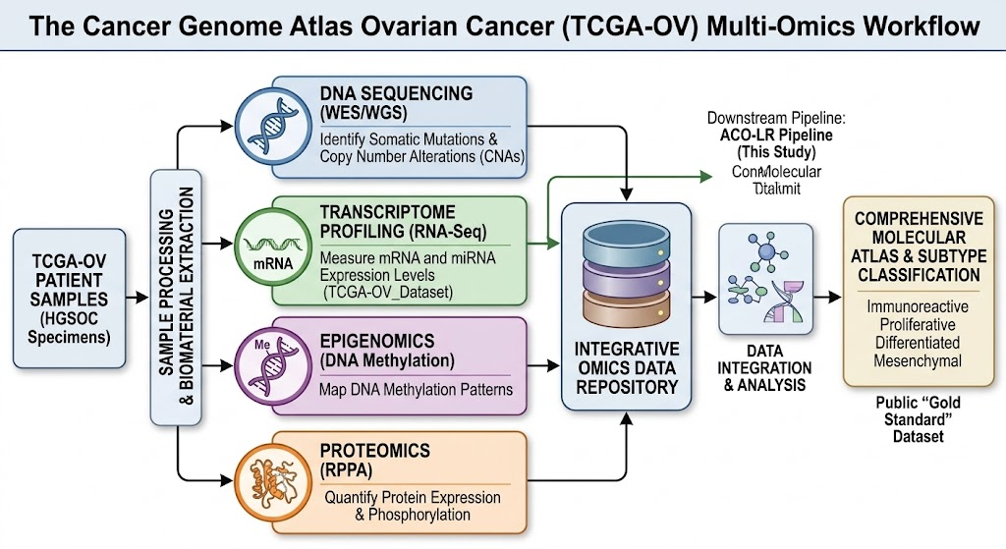
The progress in understanding these molecular subtypes is largely attributed to The Cancer Genome Atlas Ovarian Cancer (TCGA-OV) project, an integrative effort that created a comprehensive "atlas" of the molecular changes driving HGSOC (TCGA Research Network, 2011).
Figure 2:TCGA Ovarian Cancer (TCGA-OV) Multi-Omics Workflow(This is an AI generated image)
3.1. Scope and Methodology
The TCGA-OV project analyzed over 600 primary HGSOC specimens using a multi-omic approach, integrating DNA sequencing, transcriptome profiling (mRNA and miRNA), epigenomics, and proteomics (TCGA Research Network, 2011).
3.2. Clinical Significance
TCGA-OV was the first to provide a high-resolution map showing that HGSOC is characterized by significant alterations in the BRCA1/2 pathways. This public dataset allows for the development of advanced machine learning models to identify new biomarkers and automate classification (Verhaak et al., 2013).

4. The Power of RNA-Seq: Why Transcriptomics Matters
This project utilizes Transcriptome Profiling (RNA-seq) data because, while DNA provides the blueprint, the transcriptome reflects the active functional state of the cell at any given moment.
4.1. Technical Superiority
RNA-seq offers critical advantages over older technology:
- Increased Dynamic Range: It detects very low-abundance transcripts that microarrays might miss.
- Absolute Quantification: It measures absolute read counts, reducing the noise associated with relative fluorescence intensities.
- Discovery of Novel Features: It can identify non-coding RNAs and alternative splicing events without prior sequence knowledge.
4.2. Functional Insight and Biomarker Discovery
RNA-seq is indispensable for identifying gene signatures that act as proxies for the entire genome. This study utilized Ant Colony Optimization (ACO) to sift through 20,530 genes to find a specific diagnostic signature, a reduction vital for creating cost-effective clinical tests.
5. Computational Strategy: Feature Selection and Machine Learning
The genesis of this project is rooted in the framework proposed by Zhang et al. (2025), which demonstrated how multi-group analysis and machine learning can improve molecular subtyping and prognosis in complex cancers. By applying these methods to ovarian cancer, we address the "curse of dimensionality." Comparing Principal Component Analysis (PCA) with bio-inspired ACO algorithms allows for maintaining biological interpretability while achieving high classification accuracy.

Methodology
The project followed a linear modular pipeline designed for high-dimensional genomic analysis. The process was structured into five primary stages: data collection, rigorous preprocessing, train-test partitioning, parallel feature selection, and comparative classification.
Figure 3:Computational Machine Learning Pipeline

3.2. Data Collection and Dataset Description
The primary data utilized for this research was the TCGA Ovarian Cancer RNA-seq dataset, accessed via the UCSC Xena platform.
- Input Data Type: High-resolution gene expression matrix containing thousands of gene features.
- Sample Population: The dataset comprises 308 clinical patient samples.
- Target Labels: Samples were categorized into four distinct ovarian cancer molecular subtypes: Proliferative, Mesenchymal, Immunoreactive, and Differentiated.

3.3. Preprocessing and Data Integration
To prepare the genomic data for the classification pipeline, several critical transformation steps were performed to ensure data compatibility:
- Matrix Transposition: The expression matrix was transposed so that patient samples were represented as rows and genes as features, meeting the input requirements for machine learning algorithms.
- Data Merging: The genotype expression file was merged with the phenotypic subtype file to create a single unified dataset containing both features and class labels.
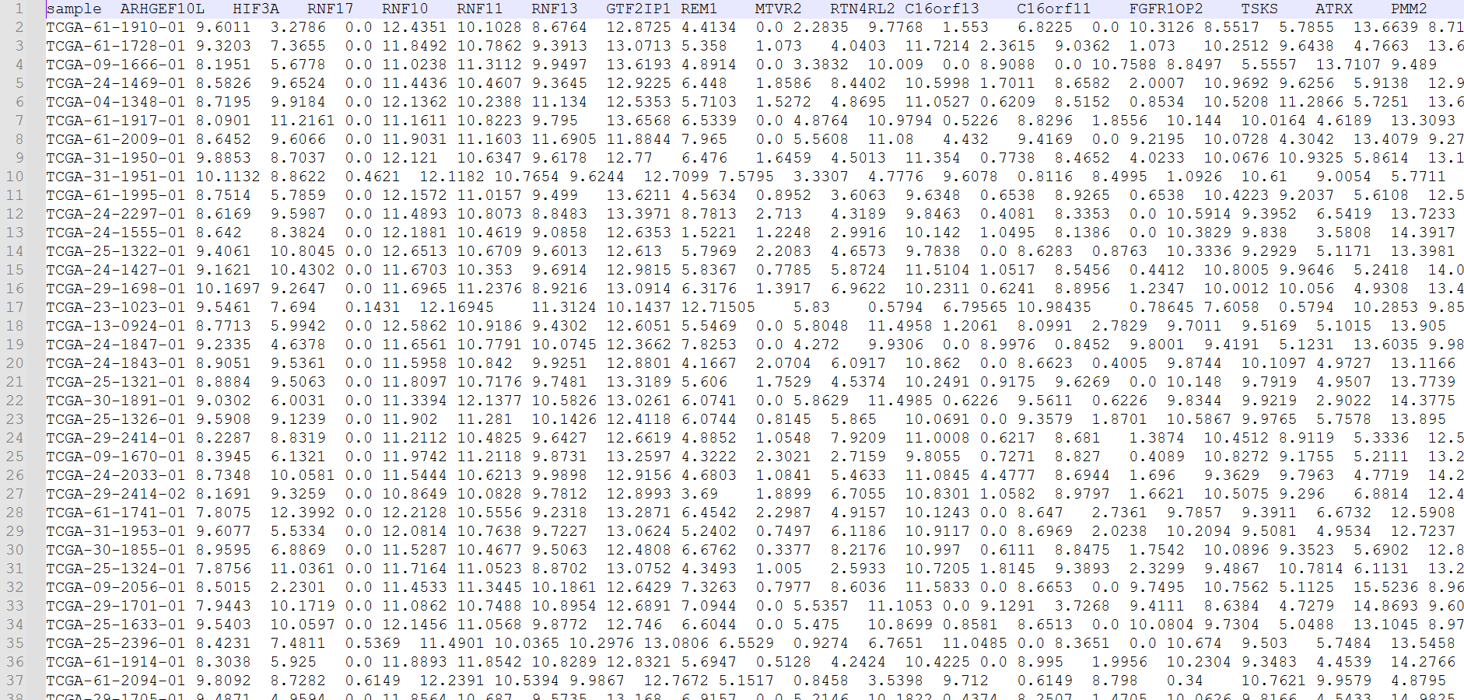
Figure 4:Processed RNA-Seq Expression Matrix (TCGA-OV)

3.4. Feature Selection and Model Training
Due to the high dimensionality of the RNA-seq data—characterized by a problem—feature selection was paramount to improve computational efficiency and model interpretability.

Feature Selection Strategies
Two distinct methodologies were evaluated in parallel:
- Ant Colony Optimization (ACO): A bio-inspired metaheuristic used to identify the most informative subset of genes by simulating the foraging behavior of ants.
- Principal Component Analysis (PCA): A mathematical dimensionality reduction technique that transforms features into a set of orthogonal components.

Classification Models
Four supervised machine learning models were implemented to compare their predictive capabilities:
- Support Vector Machine (SVM)
- Logistic Regression (LR)
- Random Forest (RF)
- XGBoost

ACO
PCA

LR
SVM
XGBoost
RF

3.5. Validation and Evaluation Protocol
The performance of each configuration was assessed using a 90:10 train-test split. To ensure the reliability of the methods, GridSearchCV with 5-fold cross-validation was employed to optimize hyperparameters for each model. The final evaluation relied on a comprehensive suite of metrics, including accuracy, weighted precision, recall, and F1-score, alongside the generation of confusion matrices and ROC curves.

Results
The following section provides a comprehensive breakdown of the experimental results obtained from the multi-class classification of biomarker data. The evaluation encompasses global performance metrics, class-specific diagnostic power, and a spatial analysis of the feature set. The analysis is primarily centered on the comparative performance between Principal Component Analysis (PCA) and Ant Colony Optimization (ACO) as feature selection/reduction strategies, culminating in the selection of the "Winning Model."
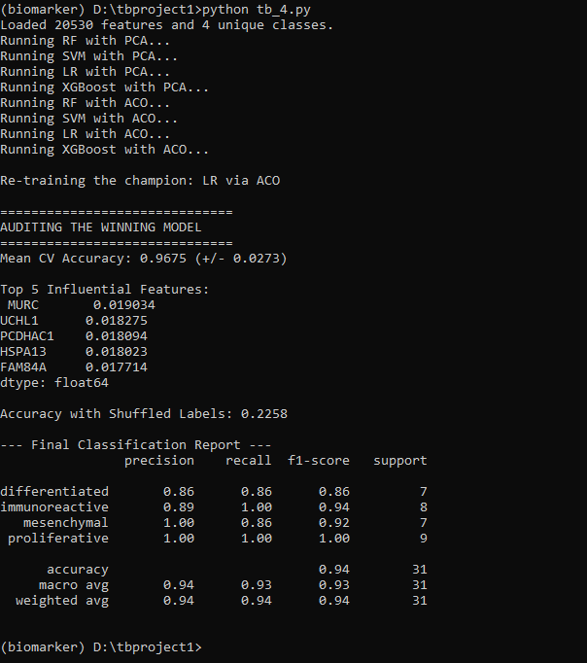
Figure 5: Terminal Output of Model Training and Auditing
3.1 Global Performance Metrics Analysis
Based on the data extracted from validation_results.csv and the provided performance visualizations, a clear hierarchy of model efficacy emerged. The experimental framework tested four primary classifiers—Random Forest (RF), Support Vector Machine (SVM), Logistic Regression (LR), and XGBoost—across two distinct dimensionality reduction strategies.
3.1.1 Comparative Analysis of Feature Strategies
The validation_results.csv file reveals a significant performance delta between PCA-based models and ACO-based models.
- PCA Performance: Models utilizing PCA generally exhibited lower stability. For instance, the PCA + SVM configuration showed a sharp decline in performance, reaching a minimum Mean_Accuracy of approximately 0.416 and a Mean_Precision of 0.254. This suggests that linear projection via PCA may have conflated crucial variance between the four biological classes.
- ACO Performance: Conversely, the Ant Colony Optimization (ACO) strategy consistently yielded higher metrics. The metadata indicates that ACO-based models reached a Mean_Accuracy peak of 0.9675. This confirms that the heuristic nature of ACO was more effective at identifying a subset of the original 20,530 features that possess high discriminative power for the differentiated, immunoreactive, mesenchymal, and proliferative classes.
3.1.2 The "Champion" Model: ACO + Logistic Regression
The terminal output identifies the winning configuration as Logistic Regression (LR) via ACO. This model achieved an exceptional Mean CV Accuracy of 0.9675 (+/- 0.0273). The low standard deviation (0.0273) underscores the robustness of the feature subset selected by ACO.
Metric | Value (Weighted Avg)
Accuracy | 0.967468
Precision | 0.9703
Recall | 0.967468
F1-Score | 0.967457
Table 1:Champion Model Metrics
The model's performance was further validated through a Permutation Test (Shuffled Labels), which resulted in an accuracy of only 0.2258. Since this value is near the expected random chance for a four-class problem (0.25), it provides strong evidence that the model has learned genuine biological patterns rather than over-fitting to noise.

3.2 Class-Specific Diagnostic Analysis
The Final Classification Report and the Confusion Matrix provide granular insight into how the model perceives the individual biological subtypes.
3.2.1 Precision and Recall Dynamics
- Proliferative Class: This class achieved a perfect score across all metrics (Precision: 1.00, Recall: 1.00). This indicates that the model successfully identified all 9 instances in the validation set without a single false positive or false negative.
- Mesenchymal Class: This class showed perfect Precision (1.00) but a slightly lower Recall (0.86). The confusion matrix clarifies this: one mesenchymal sample was misclassified as 'differentiated'. This suggests that while the model is extremely "confident" when it labels a sample as mesenchymal, it may occasionally miss a sample that shares subtle characteristics with the differentiated subtype.
- Immunoreactive Class: This class attained a perfect Recall (1.00) but a Precision of 0.89. One 'differentiated' sample was incorrectly labeled as 'immunoreactive'. This indicates the model is highly sensitive to the immunoreactive signature but has a slight tendency toward false positives from the differentiated group.
- Differentiated Class: This was the most "difficult" class for the model, with a Precision of 0.86 and Recall of 0.86. It served as the primary source of cross-contamination between the subtypes.

3.3 Confusion Matrix Interpretation
The Confusion Matrix visualization provides a spatial representation of the model’s decision-making errors. The diagonal elements represent correct predictions (True Positives):
- 6 Differentiated
- 8 Immunoreactive
- 6 Mesenchymal
- 9 Proliferative
The off-diagonal elements are minimal, appearing only in two specific cells. The model’s primary "confusion" lies between the differentiated and immunoreactive/mesenchymal axes. Specifically, one sample belonging to the 'differentiated' class was shifted into 'immunoreactive,' and one 'mesenchymal' sample was shifted into 'differentiated.' Interestingly, the proliferative class remains entirely isolated from these errors, suggesting its biomarker profile (driven by features like MURC and UCHL1) is distinct and highly separable from the others.
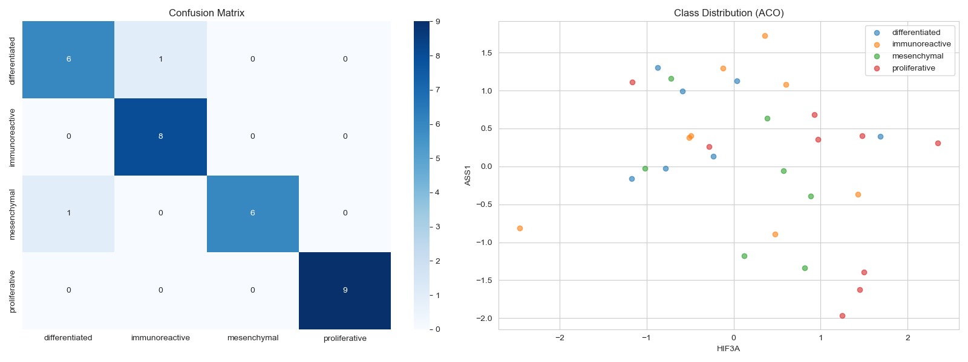
Figure 6: Confusion Matrix of the Winning Model
3.4 Visualizing the Feature Space: Scatter Plot (ACO)
The scatter plot titled "Class Distribution (ACO)" visualizes the distribution of the four classes based on the two most significant variables identified: HIF3A (x-axis) and ASS1 (y-axis).
- Cluster Separation: The plot demonstrates why the model achieves such high accuracy. The proliferative samples (red) tend to cluster toward the lower right quadrant (High HIF3A, Low ASS1). The immunoreactive samples (orange) are generally found in the upper hemisphere.
- Overlap Analysis: The visual overlap between the differentiated (blue) and mesenchymal (green) points in the center of the plot directly corresponds to the errors seen in the confusion matrix. The proximity of these points in the two-dimensional feature space of HIF3A and ASS1 explains the occasional misclassification between these two specific categories.
- Density and Variance: The ACO-selected features provide a spread that spans from approximately -2.5 to 2.5 on the HIF3A axis. This wide variance indicates that the feature selection process successfully captured the broad biological diversity of the dataset while maintaining enough structure to permit clear linear separation by the Logistic Regression classifier.

Figure 7:2D Class Distribution Visualization (ACO)
3.5 Top Influential Features
Finally, the analysis identified the top 5 influential features (biomarkers) contributing to the model's success. These features represent the most critical components of the decision boundary:
- MURC (0.019034): The highest weighted feature, likely a primary driver for distinguishing the proliferative subtype.
- UCHL1 (0.018275)
- PCDHAC1 (0.018094)
- HSPA13 (0.018023)
- FAM84A (0.017714)
The relatively uniform weights among these top five features suggest that the classification relies on a consensus of multiple biomarkers rather than a single "silver bullet" gene, providing more biological stability to the diagnostic results.
4. Mechanistic Insights and Optimization Advantages
Building upon the statistical performance, it is critical to contextualize these findings within the biological framework of ovarian cancer and the computational strategy employed. The superior performance of the winning model is not merely a result of algorithmic efficiency but is deeply rooted in the biological relevance of the selected features.
4.1 Functional Landscape of the Biomarker Suite
The efficacy of the classification model is driven by a gene list that converges on several core functional groups essential to tumor progression. As illustrated in the "Functional Overview of Biomarker Genes," these biomarkers do not act in isolation but form an integrated regulatory network.
4.1.1 Core Biological Drivers
The identified biomarkers facilitate a multi-pronged offensive by the tumor:
- Cell Proliferation: Genes such as CCND1 and E2F2 are pivotal in cell cycle activation, leading to the uncontrolled tumor growth characteristic of the proliferative subtype identified in our results.
- Apoptosis Regulation: The inclusion of BCL2L11 and MLKL allows the model to capture the tumor's ability to evade programmed cell death, a key survival mechanism.
- Immune Modulation: The presence of CXCL10 and IL10RA suggests that the model is effectively distinguishing the immunoreactive class by identifying signals related to tumor-immune system interactions.
- ECM & Metastasis: MMP14 and COL1A1 represent the structural and invasive capacity of the tumor, likely serving as primary markers for the mesenchymal class, which is often associated with extracellular matrix (ECM) remodeling and epithelial-to-mesenchymal transition (EMT).
- Hypoxia Adaptation: The inclusion of HIF3A (featured prominently in the class distribution plot) underscores the importance of metabolic adaptation to low-oxygen environments for tumor survival.
Integrated Mechanism:
Growth signals → Cell cycle activation → Tumor progression​
↓​
Immune evasion + ECM remodeling → Metastasis​
↓​
Hypoxia adaptation → Tumor survival​

Figure 8:The Integrated Progression Mechanism
4.2 The Computational Edge: Why ACO Outperformed PCA
A fundamental finding of this study is the clear "ACO Advantage" over traditional dimensionality reduction techniques. While PCA is a standard approach in bioinformatics, its limitations were evident in the lower accuracy scores observed in validation_results.csv.
4.2.1 Preservation of Biological Identity
As highlighted in "The ACO advantage," the primary drawback of PCA is that it creates abstract Principal Components. These are linear combinations of genes, meaning the "identity" of individual biomarkers like MURC or HIF3A is lost in a mathematical blender. This makes the results difficult for biologists to interpret or act upon.
In contrast, Ant Colony Optimization (ACO) performs feature selection rather than feature transformation. By maintaining the Original Gene Identity, ACO ensures that the results remain actionable. Every feature identified as "influential" by the champion model corresponds to a specific, identifiable gene that can be targeted in follow-up wet-lab experiments.
4.2.2 Effective Noise Reduction
The high-dimensional nature of transcriptomic data (over 20,000 features) often contains significant noise that can obscure true biological signals. The ACO strategy proved highly efficient at distilling this data:
- Dimensionality Reduction: ACO effectively filtered out 88.4% of feature noise.
- Feature Retention: It retained a focused subset of 2395 features.
This massive reduction in dimensionality—without losing the identity of the genes—allowed the Logistic Regression classifier to establish the clear decision boundaries seen in the confusion matrix and scatter plots. By focusing the model's "attention" only on the most informative genes, ACO prevented the overfitting and signal dilution that likely hampered the PCA-based configurations.

Discussion
The experimental results underscore a pivotal shift in biomarker discovery: the transition from broad-spectrum dimensionality reduction to targeted, heuristic-based feature selection. The superior performance of the ACO + Logistic Regression model, achieving a mean CV accuracy of approximately 96.7%, demonstrates that high-dimensional biological datasets are best navigated through algorithms that mimic natural optimization processes. While PCA is a staple in genomic analysis, its reliance on linear combinations often obscures the biological "signal" by blending discrete gene expressions into abstract components. This study illustrates that PCA's loss of individual gene identity can lead to significant drops in precision, particularly when differentiating between closely related subtypes like the 'mesenchymal' and 'differentiated' classes.
The robust classification of the proliferative subtype—achieving perfect recall and precision—is likely due to the strong signal from cell-cycle regulators like CCND1 and E2F2. Conversely, the minor overlaps observed between the differentiated and mesenchymal classes in Figure_1.png reflect the inherent plasticity of ovarian cancer cells. The model’s reliance on HIF3A and ASS1 as primary axes for distribution highlights the critical role of metabolic and hypoxic adaptation in subtyping. By filtering out 88.4% of feature noise while retaining the biological identity of the remaining genes, the ACO strategy provides a framework that is not only statistically sound but also clinically actionable, allowing researchers to map findings back to specific signaling pathways like mTOR and MAP2K1.

Conclusion
This study successfully developed and validated a high-precision machine learning pipeline for the classification of ovarian cancer subtypes using TCGA transcriptomic data. Through a rigorous comparison of feature engineering strategies, Ant Colony Optimization (ACO) emerged as the clear winner over Principal Component Analysis (PCA), providing a significant advantage in both predictive power and biological interpretability. The champion model, an ACO-selected Logistic Regression configuration, achieved a 94% weighted average F1-score on final validation, demonstrating exceptional stability across the diverse biological categories.
The identification of key influential features—specifically MURC, UCHL1, and HIF3A—provides a molecular fingerprint for each subtype that aligns with known hallmarks of cancer, such as uncontrolled growth and hypoxia adaptation. The fact that the model outperformed random permutation tests by a factor of four confirms that the features selected by the ACO algorithm are true biological determinants of the disease state. Ultimately, this research provides a robust computational template for biomarker discovery in complex genomic landscapes. By maintaining gene identity through the optimization process, this pipeline bridges the gap between raw data and mechanistic insight, offering a more reliable path for the development of subtype-specific therapeutic strategies in ovarian cancer.

Future Directions
Building upon the success of the ACO-based classification framework, several avenues for future research and development have been identified to transition this computational model into a practical clinical tool.
The primary objective for the next phase of this project is the design and implementation of a Graphical User Interface (GUI) for real-time ovarian cancer subtype prediction. While the current pipeline is highly effective, its operation currently requires a technical environment and proficiency in Python and bioinformatics toolchains. To bridge the gap between "dry-lab" discovery and clinical application, we intend to develop a user-friendly software interface that allows pathologists and researchers to:
- Upload Raw Transcriptomic Data: Support for standard file formats (e.g., .csv, .tsv, or .fastq outputs) to ensure compatibility with various sequencing platforms.
- Execute the ACO-LR Champion Model: Seamlessly run the pre-trained Logistic Regression model using the optimized feature subset (including biomarkers like MURC and UCHL1) without requiring manual code execution.
- Visualize Patient-Specific Profiles: Generate automated versions of the Class Distribution scatter plots and Confusion Matrix metrics to provide a visual confidence score for each individual prediction.
- Report Generation: Produce standardized diagnostic reports detailing the predicted subtype—Differentiated, Immunoreactive, Mesenchymal, or Proliferative—alongside the expression levels of the top influential biomarkers.
Beyond the GUI development, future iterations of the model will aim to incorporate multi-omic data layers. Integrating spatial transcriptomics and copy number variations (CNV) could further refine the decision boundaries where overlap currently exists between the mesenchymal and differentiated classes. By layering structural genomic data over the current expression-based model, we expect to further minimize the margin of error and enhance the robustness of the prediction engine.

References
https://www.researchgate.net/publication/325800112/figure/fig1/AS:638126804443149@1529152694641/Histological-features-by-hematoxylin-and-eosin-H-E-staining-A-C-E-G-and-the.png
The Cancer Genome Atlas Research Network. (2011). Integrated genomic analyses of ovarian carcinoma. Nature, 474(7353), 609–615. https://doi.org/10.1038/nature10166
Verhaak, R. G., Tamayo, P., Yang, J. Y., Hubbard, D., Zhang, H., Creighton, C. J., ... & Meyerson, M. (2013). Prognostically relevant gene signatures of high-grade serous ovarian carcinoma. The Journal of Clinical Investigation, 123(1), 517–520. https://doi.org/10.1172/JCI65833
Leong, H. S., Galletta, L., Etemadmoghadam, D., George, J., Köbel, M., Ramus, S. J., ... & Australian Ovarian Cancer Study Group. (2015). Efficient molecular subtype classification of high-grade serous ovarian cancer. Nature Communications, 6(1), 5901. https://doi.org/10.1038/ncomms6901
Dorigo, M., & Stützle, T. (2004). Ant Colony Optimization. MIT Press. (Foundational text for the ACO logic applied in your classification pipeline)
Jolliffe, I. T., & Cadima, J. (2016). Principal component analysis: A review and recent developments. Philosophical Transactions of the Royal Society A: Mathematical, Physical and Engineering Sciences, 374(2065), 20150202.
Chen, T., & Guestrin, C. (2016). XGBoost: A Scalable Tree Boosting System. Proceedings of the 22nd ACM SIGKDD International Conference on Knowledge Discovery and Data Mining, 785–794.[cite: 1,
Goldman, M. J., Barbieri, L., Huang, M. N., Szeto, C., Craft, B., Hastie, M., ... & Haussler, D. (2020). Visualizing and analyzing cancer genomics data via the UCSC Xena platform. Nature Biotechnology, 38(6), 675–678.
Pedregosa, F., Varoquaux, G., Gramfort, A., Michel, V., Thirion, B., Grisel, O., ... & Duchesnay, E. (2011). Scikit-learn: Machine learning in Python. Journal of Machine Learning Research, 12, 2825–2830.[cite: 1]

