Power BI report

- Below graph depicts the status of flights owned by particular airlines

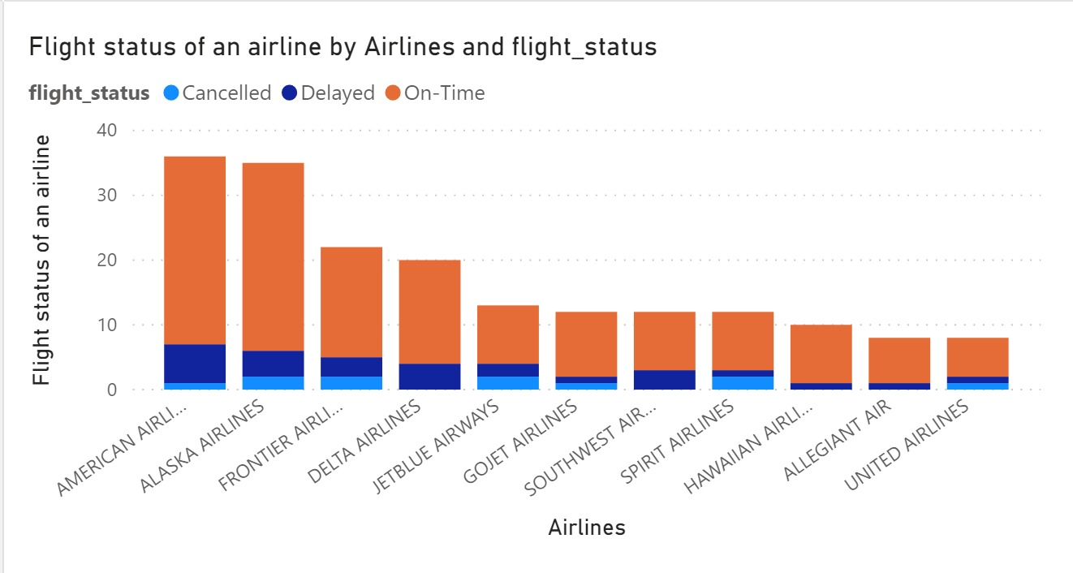

- Below graph shows the popular layover locations with the number of flights having layover there.

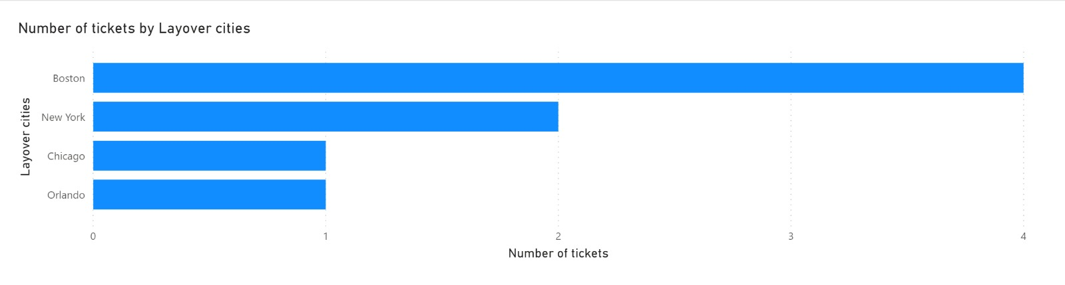

- Below graph depicts number of flights scheduled from a particular location.
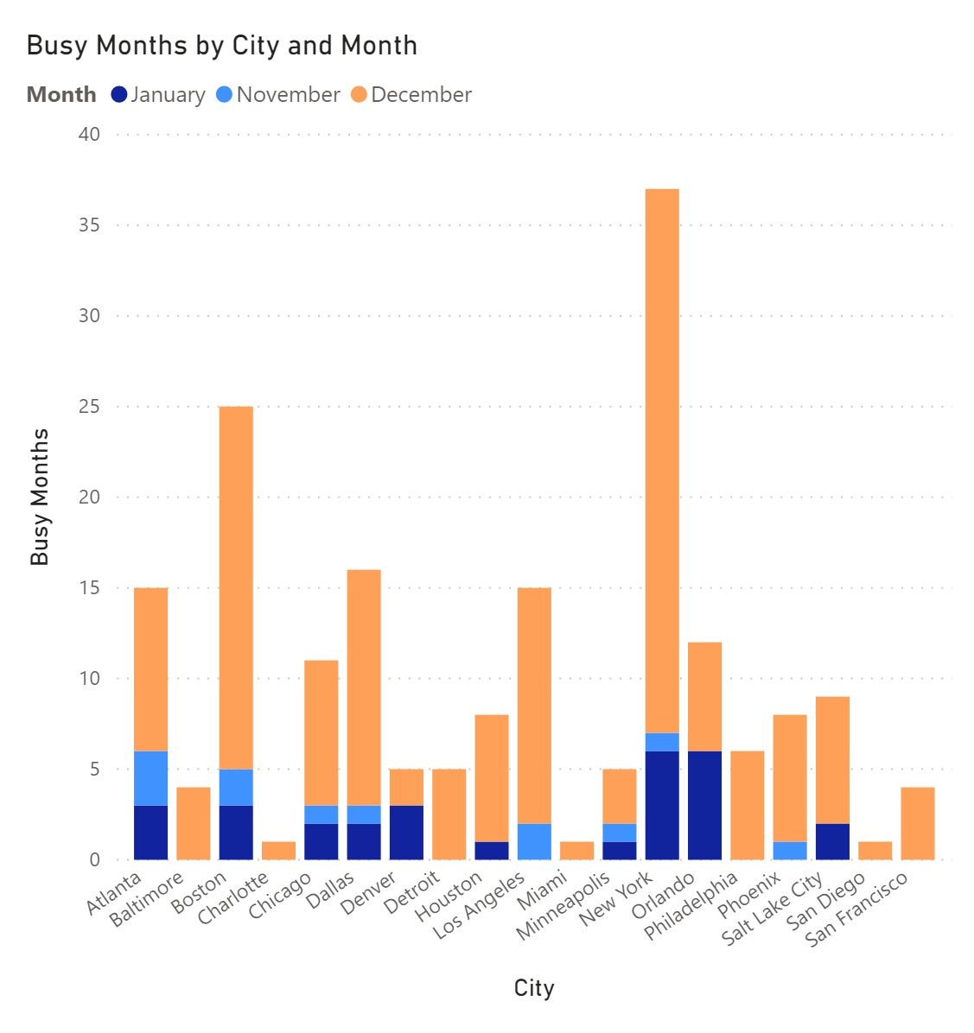
- Below graph depicts the locations with most number of bookings.
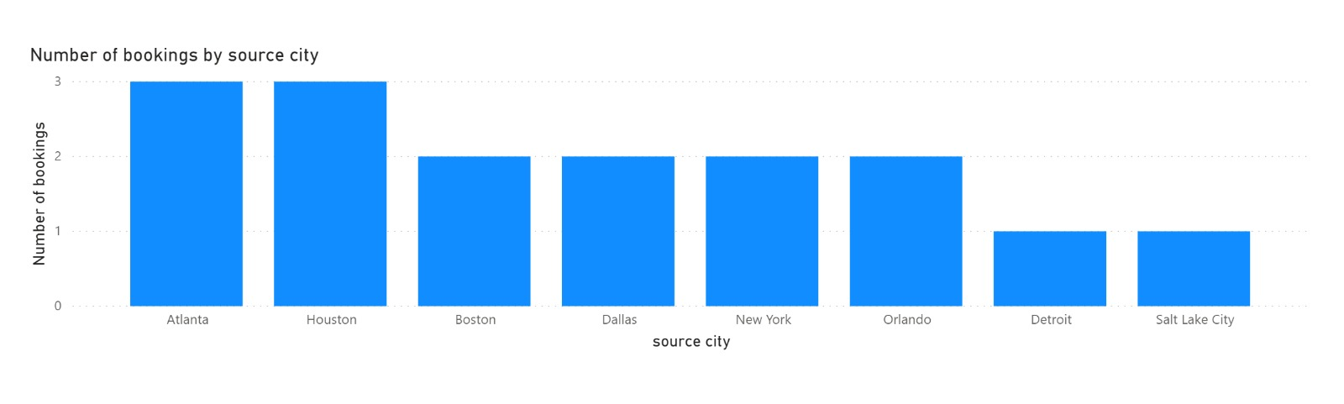
3. Below Pie chart depicts the class preference of a passenger while booking a ticket
