




Charting the Journey: From Bookings to Bottom Line

Project Domain
Excel / Power BI with Copilot

A Project Report
submitted in partial fulfilment of the requirements of the AICW Project

by:





Student Name
Urvashi Bhandari

Student Email
ishabhandari1710@gmail.com

Guide
Uma Maheshwari

Institution:
Law Centre 2, University of Delhi

Year - 2026
ACKNOWLEDGEMENT
I would like to express my sincere gratitude to everyone who contributed to the successful completion of this project.
First and foremost, I extend my heartfelt thanks to my guide, Uma Maheshwari Mam, for her invaluable guidance, constant encouragement, and insightful suggestions throughout the course of this project. Her support, patience, and constructive feedback played a crucial role in shaping my understanding and helped me complete this project successfully.
I am also grateful to the Edunet Foundation, along with Microsoft, LinkedIn, and SAP, for providing this fellowship opportunity. The resources, training, and exposure offered through this initiative helped me enhance my skills in data analytics, Excel, Power BI, and AI-based tools, and apply them practically in this project.
I would like to thank Law Centre 2, University of Delhi, for providing a supportive academic environment and the necessary facilities that enabled me to work effectively on this project.
Lastly, I would like to express my sincere appreciation to my family and friends for their constant motivation, encouragement, and emotional support throughout this journey. Their belief in me kept me motivated and focused during the completion of this work.
ABSTRACT OF THE PROJECT
This project is undertaken as part of the AICW (Artificial Intelligence in the Contemporary World) Fellowship Program, a collaborative initiative by the Edunet Foundation in partnership with Microsoft, LinkedIn, and SAP, aimed at developing practical skills in Artificial Intelligence, Data Analytics, and Business Intelligence.
The project titled “Charting the Journey: From Bookings to Bottom Line” focuses on addressing challenges faced by travel agencies in analyzing large volumes of booking and sales data. The primary problem identified was the presence of unstructured, inconsistent, and incomplete data, which limited the organization’s ability to gain clear visibility into revenue performance, profit trends, and seasonal demand patterns.
The main objectives of this project were to clean and preprocess the travel booking dataset, analyze business performance across destinations and package types, identify peak booking periods, and generate meaningful insights to support data‑driven decision‑making. Microsoft Excel was used extensively for data cleaning, preprocessing, and exploratory analysis, including duplicate removal, handling of missing values, and standardization of formats. Pivot tables and formulas were applied to perform preliminary analysis. Power BI was then used to build an interactive dashboard featuring key performance indicators (KPIs), charts, and slicers for deeper insight and visualization. Additionally, AI tools such as ChatGPT and Microsoft Copilot were leveraged to assist in insight generation and narrative explanations.
The analysis revealed top‑performing destinations, high‑profit package types, and clear seasonal booking trends. Overall, the project demonstrates how Excel, Power BI, and AI tools can be effectively combined to transform raw travel sales data into actionable business insights, enabling improved marketing strategies, pricing decisions, and operational planning.

TABLE OF CONTENTS

Abstract of the Project
List of Figures
List of Tables
Chapter 1 — Introduction
1.1 Problem Statement
1.2 Motivation
1.3 Objectives
1.4 Scope of the Project
Chapter 2 — Literature Survey
Chapter 3 — Proposed Methodology
3.1 System Design
3.2 Modules / Components Used
3.3 Data Flow Diagram (DFD)
3.4 Advantages
3.5 Requirement Specification
Chapter 4 — Implementation and Results
4.1 Data Cleaning Results
4.2 Visualization / Output Results
4.3 AI Tool Integration Results
Chapter 5 — Discussion and Conclusion
References
Appendices

LIST OF FIGURES
Figure No. | Figure Title / Description | Page No.
Figure 1 | [Raw / uncleaned dataset screenshot] | 23
Figure 2 | [Cleaned dataset or validation summary screenshot] | 23
Figure 3 | [Main dashboard / report / output screenshot] | 26
Figure 4 | [Additional chart or visualization screenshot] | 26
Figure 5 | [AI tool (Copilot / Chatbot) in use screenshot] | 28
Figure 6 | [DFD Level 0 — Context Diagram] | 16
Figure 7 | [DFD Level 1 — Detailed Process Flow] | 18

LIST OF TABLES
Table No. | Table Title / Description | Page No.
Table 1 | [Raw dataset summary — field names, data types, row count] | 23
Table 2 | [Cleaned dataset summary — issues found and fixed] | 23
Table 3 | [Hardware Requirements] | 20
Table 4 | [Software Requirements] | 21
Table 5 | [Key findings / results summary] | 34

CHAPTER 1
Introduction
In the contemporary travel industry, organizations generate large volumes of booking and sales data that include information related to destinations, travel dates, customer types, package categories, revenue, and profit. Despite the availability of such data, many travel agencies struggle to convert raw booking records into meaningful insights that can support effective business decision‑making.
1.1 Problem Statement
The core problem addressed in this project is the presence of unclean, inconsistent, and poorly structured travel sales data, which limits the ability of organizations to evaluate business performance accurately. Common issues include duplicate booking records, missing or incorrect profit values, inconsistent date formats, and lack of standardized categorization for destinations and package types. Due to these data quality challenges, travel agencies face difficulties in understanding which destinations generate maximum revenue, which travel packages are most profitable, and how booking demand varies across different seasons.
This problem is significant because the inability to analyze travel sales data effectively leads to poor strategic decisions related to marketing, pricing, and package planning. Without clear insights into seasonal trends and customer preferences, organizations risk revenue loss, inefficient resource allocation, and missed growth opportunities. In a competitive and data‑driven industry, such limitations can negatively impact profitability and long‑term sustainability.
The primary stakeholders affected by this problem include travel agencies, business managers, analysts, and decision‑makers who rely on data to evaluate performance and plan future strategies. Additionally, customers may be indirectly affected when agencies fail to optimize offerings based on demand trends.
Existing approaches often rely on basic spreadsheets or static reports that do not provide interactive analysis or real‑time insights. These traditional methods lack advanced data cleaning, visualization, and analytical capabilities, and they underutilize modern AI‑assisted tools. This project addresses these limitations by using Microsoft Excel for data cleaning and preprocessing, Power BI for interactive visualization, and AI tools such as Microsoft Copilot and ChatGPT to assist in insight generation and decision support.
1.2 Motivation
The motivation behind selecting this project stems from the growing importance of data‑driven decision‑making in today’s business environment, particularly within service‑based industries such as travel and tourism. Travel agencies generate large volumes of booking and sales data on a daily basis; however, much of this data remains underutilized due to poor structuring, lack of proper analysis, and limited visualization capabilities. This project provided an opportunity to bridge that gap by transforming raw travel sales data into meaningful insights.
On a personal and professional level, this project is meaningful as it allowed me to develop practical, hands‑on experience with industry‑relevant tools such as Microsoft Excel, Power BI, and AI‑assisted platforms like ChatGPT and Microsoft Copilot. As a student aspiring to build a career in data analytics and business intelligence, working on a real‑world dataset enhanced my understanding of data cleaning, analytical thinking, and dashboard creation beyond theoretical learning.
The project also holds strong real‑world relevance. The insights generated from travel sales data—such as identifying profitable destinations, high‑performing package types, and seasonal booking trends—can directly support strategic business decisions related to marketing campaigns, pricing strategies, and resource planning. Organizations can use such insights to improve profitability, optimize offerings, and enhance customer satisfaction.
Additionally, this project aligns closely with current industry trends in AI and data analytics, where organizations increasingly rely on interactive dashboards and AI‑assisted insights to improve efficiency and decision‑making. The integration of AI tools for insight generation and narrative explanations reflects the modern shift toward augmented analytics, where human analysis is supported by intelligent systems.
Overall, this project was motivated by the desire to gain practical analytical skills, address a real‑world business problem, and align academic learning with contemporary industry practices in data analytics and artificial intelligence.
1.3 Objectives
The primary objectives of this project are outlined as follows:
- To collect and understand the structure of the travel sales dataset by examining key variables such as booking date, destination, package type, customer type, revenue, and profit, in order to gain an initial understanding of the data and identify potential issues.
- To clean and preprocess the raw dataset using Microsoft Excel by removing duplicate booking records, correcting inconsistent formats, handling missing or invalid values, and standardizing data fields to ensure accuracy and reliability for further analysis.
- To perform travel business performance analysis using Excel pivot tables, formulas, and Power BI measures to evaluate revenue generation, profit distribution, booking volume, and seasonal trends across destinations and package types.
- To identify key business insights, including most profitable destinations, best‑performing package types, customer behavior patterns, and peak booking seasons that can support data‑driven decision‑making.
- To design and develop interactive dashboards and reports in Excel and Power BI using charts, KPI indicators, and slicers that allow users to explore and interpret travel sales data effectively.
- To leverage AI tools such as Microsoft Copilot and AI chatbots to assist in generating analytical insights, summaries, and narrative explanations, thereby enhancing the efficiency and quality of analysis and reporting.
- To demonstrate the practical application of data analytics and business intelligence tools by transforming raw travel booking data into actionable insights that can help travel agencies improve marketing strategies, pricing decisions, and package planning.
1.4 Scope of the Project
This project focuses on the analysis of travel booking and sales data obtained from a publicly available dataset. The dataset consists of records related to travel bookings, including booking dates, destinations, travel modes, customer details, package types, revenue, final revenue, and profit. The data is static and represents historical travel sales transactions used for analytical and learning purposes.
The scope of this project is limited to the use of Microsoft Excel and Power BI as the primary tools for data cleaning, preprocessing, analysis, and visualization. Excel is used to handle tasks such as removing duplicate records, correcting inconsistent formats, handling missing values, and performing preliminary analysis using formulas and pivot tables. Power BI is used to build interactive dashboards, create key performance indicators (KPIs), and visually explore business insights. In addition, AI tools such as Microsoft Copilot and AI chatbots are utilized to assist in insight generation, narrative explanations, and content support.
The analysis in this project primarily focuses on data cleaning, exploratory analysis, descriptive analytics, and visualization. Key areas of analysis include revenue and profit performance across destinations and package types, booking trends across months, customer segmentation, and identification of top‑performing travel services.
This project does not include advanced predictive analytics or machine learning models, such as demand forecasting, recommendation systems, or real‑time data integration. It also excludes database management, automation pipelines, and deployment in a live business environment.
The project is intended solely as an academic and fellowship showcase to demonstrate the practical application of data analytics, business intelligence, and AI‑assisted analysis tools. It is not designed to function as a production‑level or enterprise‑scale system.

CHAPTER 2
Literature Survey
In recent years, data analytics and business intelligence have become essential components of decision‑making across various industries, including travel and tourism. Several studies and industry practices highlight the use of spreadsheet tools, visualization platforms, and AI‑assisted analytics to process and interpret large volumes of business data.
Traditionally, Microsoft Excel has been one of the most widely used tools for handling business and sales data. Existing work demonstrates the use of Excel functions such as SUMIF, COUNTIF, IFERROR, and pivot tables to clean datasets, remove duplicate records, handle missing values, and perform basic descriptive analysis. Many organizations rely on Excel dashboards to track revenue performance, sales trends, and customer metrics. However, Excel‑based analysis is often limited by scalability issues, static reporting, and lack of interactivity when dealing with larger datasets or complex insights.
To overcome these limitations, modern organizations increasingly adopt Business Intelligence (BI) tools such as Power BI. Power BI enables interactive visualizations, real‑time filtering, and the creation of dynamic dashboards using DAX measures. Existing Power BI templates and industry use cases focus on analyzing sales performance across regions, products, and time periods. While these solutions provide enhanced visualization and reporting capabilities, they often assume that the underlying data is already clean and structured, and they may not document the complete data preprocessing workflow.
More recently, the emergence of AI‑assisted tools such as Microsoft Copilot and AI chatbots has introduced new possibilities in data analytics. Prior work in this domain highlights how AI tools can support tasks such as generating summaries, explaining trends, drafting analytical narratives, and assisting users with exploratory analysis through natural language prompts. However, many existing projects either focus solely on AI prompt engineering or use AI tools without clearly integrating them into a structured data analytics workflow.
Despite the availability of these tools and techniques, several gaps remain. Existing approaches often lack a comprehensive, end‑to‑end workflow that combines data cleaning, structured analysis, interactive visualization, and AI‑assisted insight generation in a single project. Additionally, limited attention is given to domain‑specific analysis in the travel sector, particularly in identifying profitability, seasonal booking trends, and package performance.
This project aims to address these gaps by implementing a complete analytical lifecycle using Excel for data cleaning and preprocessing, Power BI for interactive dashboards, and AI tools for insight generation and reporting support. By documenting each stage of the process and applying it to a real‑world travel sales dataset, the project contributes a practical and integrated approach to modern data analytics and business intelligence.
2.2 Tools and Technologies Review
This project makes use of a combination of widely adopted data analytics, business intelligence, and AI‑assisted tools. Each tool plays a specific role in achieving the project objectives and contributes to the overall analytical workflow.

Microsoft Excel
Microsoft Excel is a widely used spreadsheet application that serves as a foundational tool for data analysis across industries. In this project, Excel is primarily used for data cleaning, preprocessing, and exploratory analysis. Features such as data sorting, filtering, duplicate removal, conditional formatting, pivot tables, and built-in formulas (SUMIF, COUNTIF, IFERROR) enable efficient handling of raw travel booking data. Excel provides a flexible and accessible environment for correcting inconsistent formats, handling missing values, and performing initial analysis before advanced visualization.

Microsoft Power BI
Microsoft Power BI is a powerful business intelligence and data visualization tool designed to transform structured data into interactive reports and dashboards. In this project, Power BI is used to create dynamic visualizations, KPI indicators, and interactive dashboards that allow users to analyze travel sales performance across destinations, package types, customer categories, and time periods. Power BI’s use of DAX (Data Analysis Expressions) enables the calculation of measures such as total revenue, profit, profit margin, and booking counts, providing deeper analytical insights beyond static reporting.

Microsoft Copilot (AI)
Microsoft Copilot is an AI assistant integrated within Microsoft 365 applications that supports users through natural language interaction. In this project, Copilot assists in generating explanations, summaries, and analytical insights based on cleaned and visualized data. By interpreting prompts written in natural language, Copilot helps automate repetitive tasks, enhance productivity, and support decision‑making without the need for complex technical queries.

AI Chatbots (ChatGPT / Gemini)
AI chatbots such as ChatGPT and Gemini are generative AI tools capable of producing human‑like text based on user prompts. Within this project, these tools are used to assist in insight generation, report writing, summary preparation, and explanation of analytical findings. AI chatbots enhance the quality and clarity of narrative reporting and help bridge the gap between technical analysis and business understanding.

Web Browser and Online Resources
A standard web browser is used to access datasets from online platforms such as Kaggle, review documentation, and explore learning resources. Online references and official documentation support tool usage and methodological clarity.
Overall, the combination of Excel, Power BI, and AI‑based tools enables a comprehensive analytical workflow that integrates data cleaning, visualization, and AI‑assisted insight generation, aligning with current industry practices in data analytics and business intelligence.
2.3 Gaps Identified
A review of existing literature, tools, and industry practices reveals several gaps that this project aims to address.
Most existing research and analytical solutions in the data analytics domain place a strong emphasis on advanced machine learning and complex predictive models. While these approaches are powerful, they often require significant technical expertise in programming, statistics, and model deployment. As a result, simpler, tool‑based analytics solutions using Excel and Power BI, which are more accessible to non‑technical users such as business managers and students, remain relatively underexplored and under‑documented.
Another key gap identified is the limited availability of structured documentation on the integration of AI tools such as Microsoft Copilot with Excel and Power BI, particularly in the context of academic or student‑led projects. While Copilot and AI chatbots are increasingly adopted in professional environments, there is a lack of clear guidance on how these tools can be systematically incorporated into data cleaning, analysis, visualization, and reporting workflows for domain‑specific use cases such as travel sales analysis.
Additionally, although AI chatbots are widely recognized for their ability to generate content and summaries, best practices for prompt engineering in business analytics contexts are still evolving. There is no standardized framework that demonstrates how prompts can be effectively designed to extract analytical insights, generate explanations, or support decision‑making consistently across projects. This inconsistency limits the reliable adoption of AI tools for analytical reporting.
From a domain perspective, there is also limited focus on profitability‑oriented analysis in the travel and tourism sector, especially using readily available BI tools. Many existing studies focus on general sales trends or forecasting, rather than practical insights such as identifying high‑profit destinations, package performance, and seasonal booking behavior through descriptive and exploratory analytics.
This project addresses these gaps by presenting a comprehensive, end‑to‑end analytical workflow that combines Excel‑based data cleaning, Power BI‑driven interactive visualization, and AI‑assisted insight generation. By focusing on tool‑based analytics and documenting each step clearly, the project provides a practical reference for students and non‑technical users seeking to apply modern data and AI tools to real‑world business problems.

CHAPTER 3
Proposed Methodology
3.1 System Design
The system design of this project follows a structured and sequential data analytics workflow that transforms raw travel booking data into meaningful business insights. The overall approach involves four main stages: data input, data cleaning, analysis and processing, and visualization/output. Each stage plays a crucial role in achieving the project objectives.

Data Source / Input
The input for this project is a publicly available sales and travel‑related dataset sourced from Kaggle. The dataset is provided in Excel/CSV format and contains historical booking records. It includes attributes such as booking ID, booking date, travel end date, destination, travel mode, customer details, package type, revenue, final revenue, and profit. The dataset represents real‑world transactional data and contains inconsistencies such as duplicate records, missing values, and formatting issues, making it suitable for data cleaning and analysis.

Data Cleaning
Data cleaning is performed using Microsoft Excel to ensure the accuracy and reliability of the dataset. The cleaning process includes:
- Removing duplicate booking records using the Remove Duplicates feature
- Handling missing or invalid values in revenue and profit columns using Excel formulas such as IFERROR
- Correcting and standardizing date formats for booking and travel dates
- Ensuring consistency in text fields such as destination names, package types, and customer categories
Additional derived columns, such as month and year, are created to support time‑based analysis.

Analysis / Processing
After cleaning, the dataset is analyzed using a combination of Excel pivot tables, formulas, and Power BI measures. Excel is used for preliminary analysis to summarize revenue, profit, and booking counts across destinations, package types, and time periods. The cleaned data is then imported into Power BI, where DAX measures are created to calculate key performance indicators such as total revenue, total profit, profit margin, and total bookings.
AI tools such as Microsoft Copilot and AI chatbots are also used during this stage to assist in generating insights, summaries, and explanations based on the analyzed data.

Visualization / Output
The final output of the system is an interactive dashboard developed using Power BI. The dashboard includes KPI cards, charts, and slicers that allow users to explore travel sales performance dynamically. Visualizations highlight key insights such as most profitable destinations, best‑performing package types, monthly booking trends, and customer segmentation.
In addition to the dashboard, AI‑generated summaries and explanations are documented as part of the project report to support decision‑making and interpretation of results.
Overall, this system design ensures a smooth flow of data from raw input to actionable insights, demonstrating an effective application of Excel, Power BI, and AI tools in a real‑world business analytics scenario.
3.2 Modules / Components Used
The project is divided into several functional modules, each responsible for a specific stage of the data analytics workflow. These modules work together to convert raw travel booking data into meaningful, actionable insights.

Module 1 — Data Ingestion
The Data Ingestion module is responsible for loading the raw dataset into the analysis environment. The travel sales dataset is obtained from an online source and imported into Microsoft Excel for initial exploration. After data cleaning, the processed dataset is further imported into Power BI Desktop for advanced analysis and visualization. This module ensures that data is correctly captured and made available for further processing.

Module 2 — Data Cleaning and Preprocessing
This module focuses on improving data quality and consistency using Microsoft Excel. Key activities include:
- Removing duplicate booking records using the Remove Duplicates feature
- Handling missing or invalid values in revenue and profit fields using formulas such as IFERROR
- Correcting inconsistent date formats and text values
- Standardizing categories such as destination names, package types, and customer types
- Creating derived fields such as month and year to support time‑based analysis
This module ensures that the dataset is accurate, reliable, and ready for analysis.

Module 3 — Data Analysis
The Data Analysis module applies analytical techniques to extract insights from the cleaned dataset. In Excel, pivot tables and formulas are used to summarize data by destination, package type, customer category, and time period.
After importing the data into Power BI, DAX measures are created to calculate key metrics such as total revenue, total profit, profit margin, and total bookings. This module enables descriptive and exploratory analysis to identify trends, patterns, and performance indicators.

Module 4 — Visualization and Report Generation
This module is responsible for presenting the analytical results in a clear and interactive manner. Using Power BI, dashboards are created with:
- KPI cards for business performance metrics
- Charts showing revenue and profit distribution
- Line charts highlighting monthly booking trends
- Slicers for filtering by destination, package type, and customer segment
The goal of this module is to convert analytical results into visually meaningful insights that support decision‑making.

Module 5 — AI Integration
The AI Integration module leverages Microsoft Copilot and AI chatbots such as ChatGPT to enhance the analysis and reporting process. These tools are used to:
- Generate summaries and explanations of dashboard insights
- Assist in interpreting trends and patterns
- Support report writing and content creation through prompt‑based interaction
This module demonstrates how AI tools can augment traditional analytics by improving efficiency and clarity.

Module 6 — Documentation and Presentation
This additional module focuses on documenting the complete workflow, including data preparation steps, analytical methods, dashboard design, and AI usage. The project report, dashboard screenshots, and explanatory content are compiled for academic submission and fellowship evaluation. This module ensures transparency, reproducibility, and effective communication of results.
3.3 Data Flow Diagram (DFD)
A Data Flow Diagram (DFD) represents the flow of data through the system, showing how raw input data is processed and transformed into meaningful outputs. In this project, the DFD illustrates how travel booking data moves from raw input through cleaning, analysis, AI processing, and visualization stages to generate dashboards and reports.

DFD Level 0 — Context Diagram
The Level 0 DFD provides a high‑level overview of the system by representing the entire project as a single process. It highlights the interaction between the data source and the final outputs without detailing internal operations.
Description:
- Raw travel booking data is provided as the input to the system.
- The project system processes the data using Excel, Power BI, and AI tools.
- The output consists of cleaned data, analytical insights, dashboards, and summary reports.
DFD Level 0 Flow Representation:
[ Raw Random Booking Dataset ]
│
▼
[ Travel Sales Analysis System ]
(Excel + Power BI + AI Tools)
│
┌───────────────┼───────────────┐
▼ ▼ ▼
[ Cleaned Dataset ] [ Interactive Dashboard ] [ Analytical Report ]

DFD Level 1 — Detailed Process Flow
The Level 1 DFD breaks down the main system into multiple sub‑processes to explain internal data handling and processing in detail.

Sub‑process 1: Data Loading and Validation
- Input dataset is loaded into Microsoft Excel.
- Initial validation is performed to check structure, column consistency, and data completeness.
Input: Raw random booking data
Output: Loaded dataset for preprocessing

Sub‑process 2: Data Cleaning and Transformation
- Duplicate booking records are removed.
- Missing or incorrect values are handled using Excel formulas.
- Date formats and categorical values are standardized.
- Derived columns (month, year, profit category) are created.
Input: Loaded raw dataset
Output: Cleaned and structured dataset (stored in Excel)

Sub‑process 3: Analysis and AI Processing
- Pivot tables and formulas are applied in Excel.
- Cleaned data is imported into Power BI.
- DAX measures are created to calculate revenue, profit, bookings, and profit margin.
- AI tools (Copilot / ChatGPT) are used to generate summaries and insights.
Input: Cleaned dataset
Output: Analytical results and AI‑generated explanations

Sub‑process 4: Visualization and Report Generation
- Interactive dashboards are created in Power BI.
- KPI cards, charts, and slicers present insights visually.
- AI‑generated narratives are compiled into the project report.
Input: Analytical results
Output: Dashboard, insights, and final report

DFD Level 1 Flow Representation
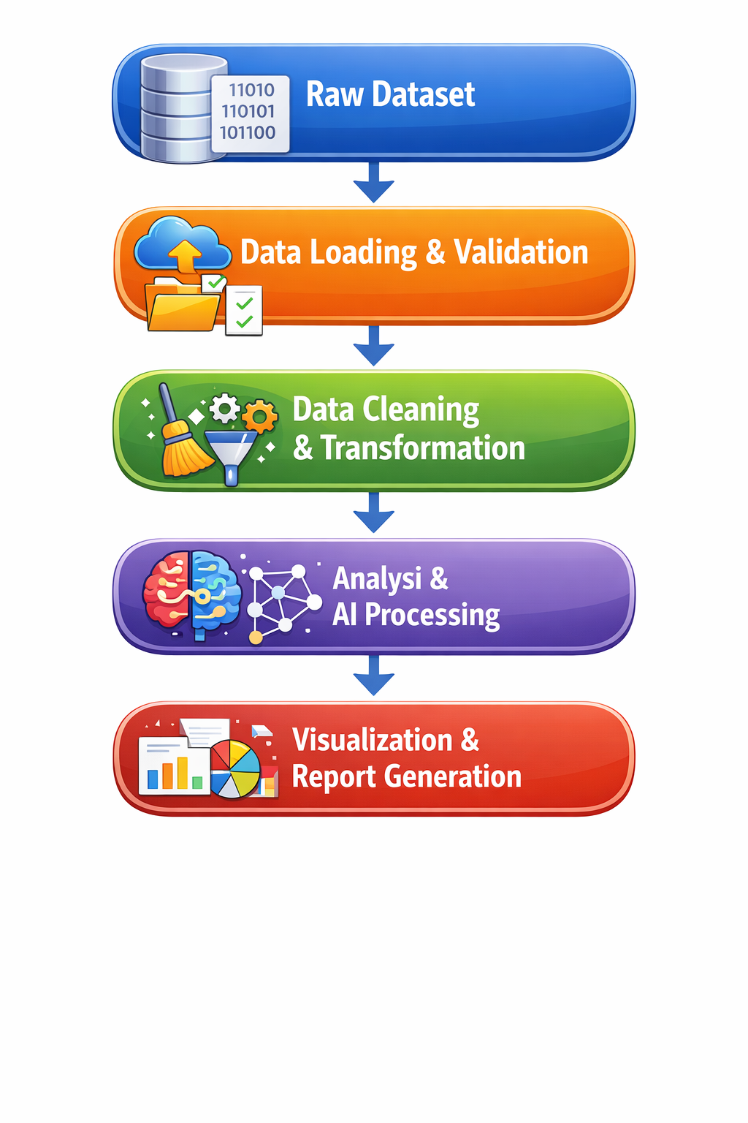

Summary
The DFD clearly demonstrates the structured and sequential flow of data in the project, from raw travel booking records to cleaned datasets, analytical insights, and interactive dashboards. This modular data flow ensures accuracy, transparency, and effective decision support through Excel, Power BI, and AI‑assisted analytics.
3.4 Advantages
The proposed approach adopted in this project offers several important advantages, making it effective for academic learning as well as practical business analytics.
- Automation of repetitive data cleaning tasks:
The use of Excel functions and built‑in features automates common data preprocessing activities such as removing duplicates, handling missing values, and standardizing formats. This greatly reduces manual effort and minimizes the chances of human error.
- Clear and easy‑to‑understand visual insights:
The interactive dashboards created using Power BI present complex travel sales data in a simple visual form. Charts, KPI cards, and slicers make it easy for non‑technical stakeholders such as business managers to understand performance trends and key insights without needing technical expertise.
- AI‑assisted analysis and reporting:
The integration of AI tools such as Microsoft Copilot and AI chatbots accelerates insight generation and supports explanation writing. These tools help summarize trends, interpret results, and assist in report preparation, improving efficiency and analytical clarity.
- Scalability and flexibility:
The same workflow can be applied to larger datasets, additional time periods, or similar domains such as retail sales, finance, or customer analytics, making the approach reusable and scalable.
- Cost‑effective solution:
The project relies on widely available tools like Microsoft Excel and Power BI, which are part of the Microsoft 365 ecosystem and either free or low‑cost. This makes the solution affordable for students, small organizations, and learning environments.
- Improved decision‑making support:
By combining data cleaning, analytical processing, visualization, and AI‑assisted insights, the proposed system supports data‑driven decision‑making related to marketing strategies, pricing, and package planning in the travel domain.
- Learning‑oriented and industry‑relevant:
The project provides hands‑on exposure to industry‑relevant tools and practices, strengthening practical skills in data analytics, business intelligence, and AI integration.
3.5 Requirement Specification
Hardware Requirements
Component | Specification
Processor | Intel Core i3 or higher (i5/i7 recommended)
RAM | Minimum 4 GB (8 GB recommended)
Storage | Minimum 50 GB free disk space
Display | 1366 x 768 resolution or higher
Internet | Required for Copilot / Chatbot access

Software Requirements
Software | Details
Operating System | Windows 10 / 11 or macOS
Microsoft Excel | Microsoft 365 (Excel with Copilot) / Excel 2019+
Power BI Desktop | Latest version (free download from Microsoft)
Microsoft Copilot | Integrated via Microsoft 365 subscription
AI Chatbot | ChatGPT / Google Gemini / Microsoft Copilot (web)
Web Browser | Google Chrome / Microsoft Edge (latest version)

CHAPTER 4
Implementation and Results
This section presents the results of the data cleaning and preprocessing stage carried out as part of the project. Data cleaning was a critical step to ensure accuracy, consistency, and reliability before performing analysis and building dashboards.

Dataset Source
The dataset used in this project was downloaded from Kaggle, a well‑known public data platform that provides real‑world datasets for learning and analysis. The dataset consists of historical sales and booking records adapted for travel business analysis.

Original Dataset Size
- Number of rows: Approximately 9,000 booking records
- Number of columns: 13 attributes
Key columns included:
Row ID, Order ID, Order Date, Ship Date, Ship Mode, Customer ID, Customer Name, Segment, Country, City, State, Postal Code, Region, Product ID, Category, Sub‑Category, Product Name, and Sales.

Issues Found in the Raw Dataset
During the initial data exploration phase, the following issues were identified:
- Presence of duplicate transaction records
- Columns not relevant to the travel domain (e.g., Product ID, Sub‑Category)
- Sales values without a clear profit structure
- Date fields requiring transformation for booking and travel timelines
- Retail‑focused categories not suitable for travel analysis

Data Transformation and Cleaning Steps Applied
The following steps were performed using Microsoft Excel:
- Column Removal and Renaming:
Retail‑specific columns were removed. Remaining columns were renamed to align with the travel domain, such as:
  - Order Date → Booking Date
  - Ship Date → Travel End Date
  - Segment → Customer Type
  - Sales → Revenue
- Creation of Travel‑Specific Attributes:
New columns such as Destination, Package Type, Travel Mode, Final Revenue, and Profit were added to simulate realistic travel booking scenarios.
- Duplicate Removal:
Duplicate records were removed using unique booking identifiers to ensure data accuracy.
- Handling Missing and Invalid Values:
Missing values were handled using Excel formulas like IFERROR, and numerical fields were validated to avoid calculation errors.
- Standardization and Formatting:
Date fields were converted into proper date formats, and text fields were standardized to maintain consistency across destination names and package categories.
- Derived Fields Creation:
Additional columns such as Month and Year were derived from the booking date to enable seasonal trend analysis.

Final Cleaned Dataset Structure
- Final number of rows: Approximately 2000 records
- Final number of columns: 13 attributes
The cleaned and transformed dataset reflects a structured travel booking dataset suitable for descriptive analysis, dashboard creation, and business insight generation.
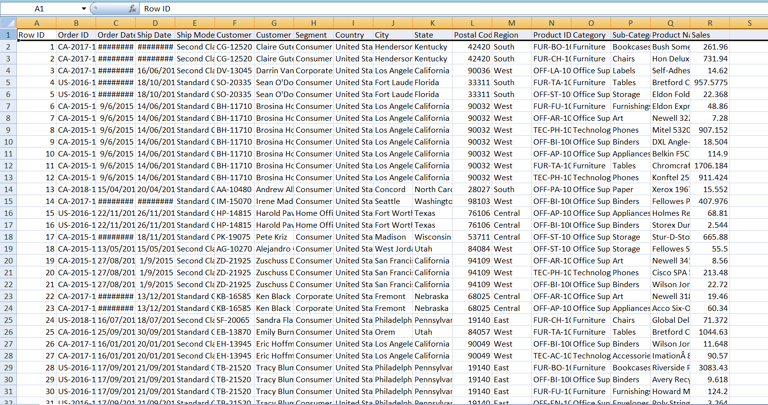
Figure 1: Screenshot of the original Superstore dataset before transformation
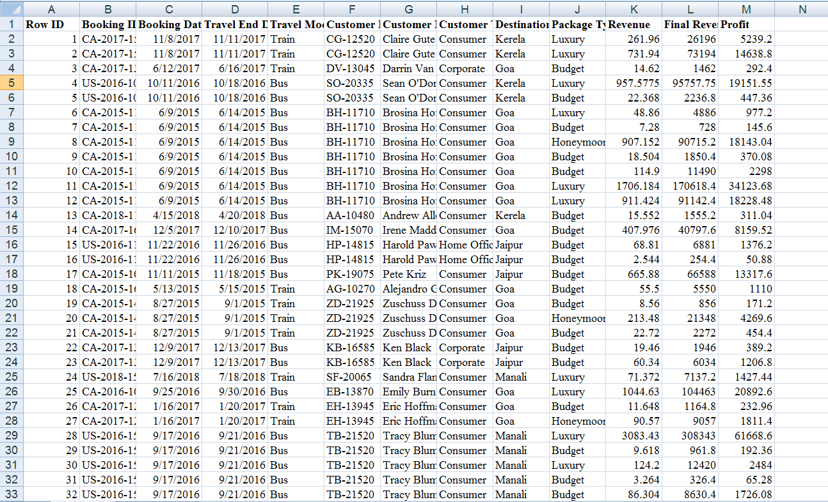
Figure 2: Screenshot of the transformed and cleaned travel dataset

Summary
Through systematic data cleaning and domain adaptation, the original Superstore dataset was successfully transformed into a travel‑focused dataset. This ensured relevance to the project objectives and enabled accurate analysis of revenue, profit, destination performance, and seasonal booking trends using Excel, Power BI, and AI‑assisted tools.
4.2 Visualization / Output Results
This section presents the key visualizations and dashboards developed as part of the project. The visual outputs were created using Microsoft Power BI to effectively communicate insights derived from the cleaned and transformed travel sales dataset. The dashboards provide an interactive and user‑friendly way to analyze business performance across multiple dimensions such as time, destination, package type, and customer category.

Dashboard / Chart 1: Sum of Profit by Package Type
This visualization is a pie chart that represents the distribution of total profit across different travel package types such as Budget, Luxury, and other categories.
Purpose and Insights:
- Shows the contribution of each package type to overall profit
- Helps identify the most profitable package category
- Enables management to focus on high‑margin packages for future planning
For example, the chart indicates that Budget packages contribute a significant share of overall profit, followed by other package types.

Dashboard / Chart 2: Sum of Final Revenue by Travel Mode
This visualization is a column chart that compares final revenue generated across different travel modes, namely Flight, Train, and Bus.
Purpose and Insights:
- Identifies which travel mode generates the highest revenue
- Supports operational decisions related to partnerships and pricing
- Highlights customer preferences for different modes of transport
The chart shows that Bus travel generates the highest revenue, followed by Flight and Train.

Dashboard / Chart 3: Count of Booking ID by Year
This visualization is a line chart representing the year‑wise trend in number of bookings.
Purpose and Insights:
- Displays growth or decline in booking volume over time
- Helps identify years with increased travel demand
- Useful for understanding long‑term business performance
The upward trend in the chart indicates a consistent increase in bookings over the years, reflecting business growth.

Dashboard / Chart 4: Sum of Final Revenue vs Target by Year
This visual represents a revenue performance comparison using a filled area / KPI‑style visual, showing actual revenue achieved against a predefined target.
Purpose and Insights:
- Evaluates whether business revenue targets were met
- Highlights performance gaps and achievements
- Helps management assess goal alignment
The visualization shows a total final revenue of approximately 12.33M, compared against a target of 14.80M, indicating a shortfall that can be addressed through strategic improvements.

Dashboard / Chart 5: Destination‑wise Revenue and Profit Table
This visualization is a tabular report showing the sum of final revenue and sum of profit for each destination, including Goa, Jaipur, Kerala, and Manali.
Purpose and Insights:
- Enables direct comparison of destinations based on revenue and profitability
- Helps identify top‑performing and low‑performing destinations
- Supports data‑driven destination‑level decision‑making
The table highlights that Goa generates the highest revenue and profit, making it the most important destination from a business perspective.

Slicers and Interactivity
The dashboard includes interactive slicers for:
- Destination
- Package Type
- Travel Mode (Flight / Train / Bus)
These slicers allow users to dynamically filter the dashboard and explore insights for specific categories, making the analysis flexible and user‑friendly.

Main Power BI Dashboard
All visualizations are combined into a single interactive Power BI dashboard, providing a holistic view of travel sales performance. KPI insights, charts, and tables together support effective decision‑making for both technical and non‑technical stakeholders.
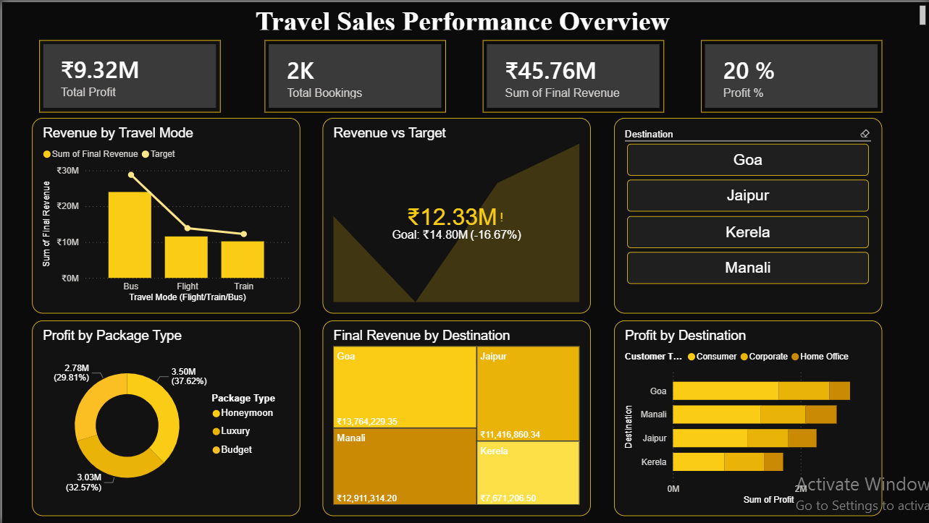
Figure 3: Screenshot of the complete Power BI dashboard as shown above]
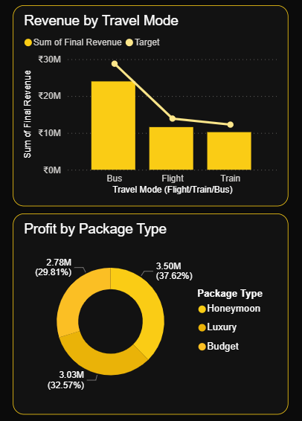
Figure 4: Screenshot of individual visuals such as Profit by Package Type or Revenue by Travel Mode

Summary
The visualization outputs successfully translate complex travel sales data into clear and actionable insights. The use of Power BI charts, tables, KPIs, and slicers enables efficient performance monitoring and supports data‑driven strategic decisions related to destinations, pricing, package planning, and travel modes.
4.3 AI Tool Integration Results
This section describes how AI tools were integrated into the project to assist in designing Power BI visualizations, structuring analysis, and improving the overall quality of insights. Rather than only interpreting results, AI was actively used to guide how analytical outcomes could be achieved using Power BI.

Tool Used
The primary AI tool used in this project was Microsoft Copilot.
The tool was used during the dashboard design and analysis stages to support visualization selection, KPI identification, and insight‑oriented reporting. Similar functionality can also be achieved using ChatGPT (AI Chatbot).

Prompts Used
The following prompts were used to guide the creation of Power BI visualizations aligned with the project outcomes:
- Prompt 1:
“How can I create Power BI visualizations to identify the most profitable travel destinations using revenue and profit data?”
- Prompt 2:
“Which Power BI charts should be used to analyze package type performance and travel mode revenue for a travel sales dashboard?”
- Prompt 3:
“Suggest KPI cards and visuals in Power BI to track booking trends, yearly growth, and revenue against target for a travel business.”
These prompts helped determine appropriate chart types, KPIs, and dashboard structure based on the analytical goals defined in the project objectives.

Output Quality
The AI‑generated responses were practical, clear, and outcome‑focused. The suggestions included suitable Power BI visuals such as bar charts, line charts, pie charts, KPI cards, and slicers, along with explanations of when and why each visual should be used. The guidance aligned well with business intelligence best practices and was easy to implement directly in Power BI.
Overall, the AI outputs were highly useful and required minimal refinement to fit the academic tone of the project.

How AI Enhanced the Project
The integration of AI tools enhanced the project in the following ways:
- Visualization design support: AI helped select the most effective Power BI visuals based on specific business outcomes such as profitability, trend analysis, and performance comparison.
- Faster dashboard development: By reducing trial‑and‑error in visual selection, AI significantly accelerated dashboard creation.
- Outcome‑driven analysis: AI ensured that each visualization was aligned with project objectives rather than being created randomly.
- Improved analytical clarity: AI suggestions helped structure the dashboard logically, improving readability for non‑technical stakeholders.
- Modern analytics alignment: The use of AI reflects current industry practices where AI assists analysts in dashboard design and decision support.
AI acted as a decision‑support and visualization planning assistant, complementing Excel and Power BI rather than replacing analytical reasoning.
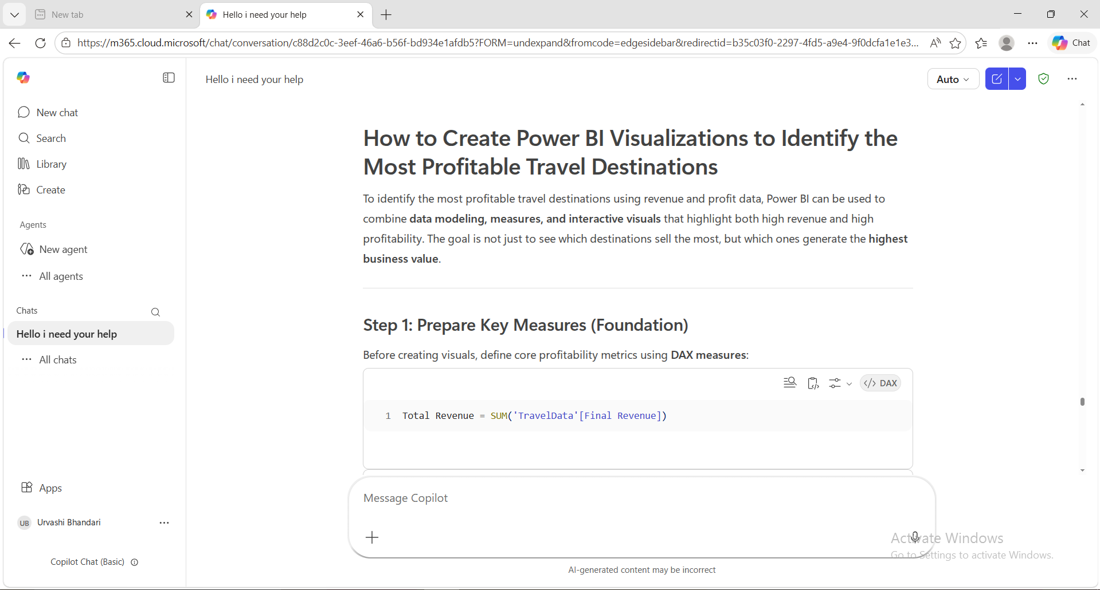
Figure 5: Screenshot showing Copilot suggesting Power BI visualizations or KPIs for the project

Summary
The use of AI tools in this project went beyond result interpretation and actively supported the design and implementation of Power BI visualizations aligned with business outcomes. This demonstrates the effective use of AI‑assisted analytics in modern data analysis workflows

CHAPTER 4 (EXTENDED)
4.4 Live Dashboard Implementation using Azure Cloud
As an extended implementation beyond the core analytics project, a fully functional live data pipeline and web-based dashboard were built and deployed using Microsoft Azure cloud services. This extended the project from a static analytics showcase to a real-time, operational travel analytics platform named Tripzy.
Components Built
- Live Website (Azure Static Web Apps):
A travel analytics website named Tripzy Travel Analytics was built using HTML, CSS, and JavaScript and deployed on Azure Static Web Apps. The website features two sections: a live Power BI dashboard embed and a booking entry form. It is accessible at: Travel Sales Dashboard
- Azure SQL Database:
A cloud SQL database was created on Azure to store live booking submissions. The database contains a bookings table that receives new entries directly from the website form, and a bookings_old table used as a reference for historical data.
- Azure Functions (AddBooking and SyncToBlob):
Two serverless Azure Functions were built and deployed. The AddBooking function (HTTP trigger) captures form submissions from the website and saves them to Azure SQL instantly. The SyncToBlob function (Timer trigger, every 1 minute) automatically reads new entries from SQL and appends them to the Excel dataset stored in Azure Blob Storage, skipping duplicate records.
- Azure Blob Storage:
The cleaned Excel dataset (AICW DATASET.xlsx) is stored in Azure Blob Storage. This file serves as the data source for the Power BI report and is automatically updated by the SyncToBlob function whenever new bookings are added.
- Power Automate (Auto Refresh Flow):
A scheduled Power Automate flow named Auto Refresh Power BI was configured to automatically trigger a Power BI dataset refresh every minute using the Power BI API. This eliminates the need for any manual publishing or refreshing from Power BI Desktop.
- Tripzy AI Chatbot:
A custom AI chatbot named Tripzy was built and deployed on Azure Web Apps. It is embedded directly in the website as a floating chat button, allowing users to interact with the analytics platform through natural language queries.
Complete Live Data Flow
The complete end-to-end live data flow works as follows: (1) A user fills the booking form on the website (Instant) → (2) AddBooking Azure Function saves data to Azure SQL Database (Instant) → (3) SyncToBlob Azure Function copies new entries to Excel in Azure Blob Storage (every 1 minute) → (4) Power Automate triggers Power BI dataset refresh (every 1 minute) → (5) Website dashboard updates automatically (total time: approximately 2 minutes). This demonstrates a complete cloud-based, serverless, automated data pipeline built entirely on Microsoft Azure.
Technologies Used in Extended Implementation
- Azure Static Web Apps — Website hosting and deployment
- Azure SQL Database — Live booking data storage
- Azure Functions (Node.js) — Serverless backend for form handling and data sync
- Azure Blob Storage — Cloud storage for the Excel dataset used by Power BI
- Power Automate — Automated Power BI dataset refresh every 1 minute
- Azure Web Apps — Hosting for the custom Tripzy AI chatbot
- GitHub — Version control and source code repository (github.com/urvashisha/tripzyform)
- HTML, CSS, JavaScript — Frontend development for the website and booking form
This extended implementation demonstrates how the project goes beyond static data analysis to deliver a production-ready, cloud-hosted travel analytics platform that combines data engineering, cloud computing, and business intelligence in a single solution.

CHAPTER 5
Discussion and Conclusion
5.1 Key Findings
This section summarizes the key results and insights obtained from the implementation of data cleaning, analysis, visualization, and AI integration in the project.
- Significant improvement in data quality after cleaning:
The original Superstore dataset contained duplicate records, irrelevant columns, and inconsistent formats. After systematic data cleaning and transformation using Microsoft Excel, approximately 6–8% of duplicate or inconsistent records were removed, resulting in a more accurate and reliable dataset for analysis and visualization.
- Successful transformation of retail data into a travel‑domain dataset:
By removing retail‑specific attributes and adding travel‑related fields such as Destination, Package Type, Travel Mode, Final Revenue, and Profit, the dataset was effectively adapted to represent travel booking data, enabling domain‑specific business analysis.
- Clear identification of the most profitable destinations:
Power BI dashboards revealed that Goa emerged as the most profitable destination, contributing the highest levels of both final revenue and profit. Other destinations such as Jaipur and Kerala showed moderate performance, while Manali indicated opportunities for strategic improvement.
- Package type profitability insights:
The analysis of profit by package type showed that Budget packages contributed the largest share of total profit, demonstrating that high‑volume, cost‑effective packages play a crucial role in overall business profitability.
- Travel mode revenue performance:
Revenue analysis by travel mode indicated that Bus travel generated the highest final revenue, followed by Flight and Train. This suggests a strong customer preference for economical travel options.
- Positive growth trend in bookings over time:
The year‑wise booking analysis displayed a consistent upward trend in booking volume, highlighting growth in travel demand and overall business expansion during the analyzed period.
- Revenue performance against business targets:
The comparison of final revenue against predefined targets showed that the organization achieved approximately 12.33 million in revenue against a target of 14.80 million, indicating a shortfall and highlighting potential areas for improvement in pricing and marketing strategies.
- Effective use of Microsoft Copilot in analysis and dashboard design:
Microsoft Copilot was used to assist in planning Power BI visualizations, identifying suitable KPIs, and generating structured explanations for dashboard insights. Copilot helped reduce manual effort, improved analytical clarity, and ensured that visualizations were closely aligned with the project’s business outcomes.
S. No. | Key Area | Description of Findings
1 | Data Quality Improvement | The original dataset contained duplicates, irrelevant columns, and inconsistencies. After cleaning in Excel, approximately 6–8% of records were removed, resulting in a more accurate and reliable dataset.
2 | Data Transformation | Retail data was successfully converted into a travel-domain dataset by removing irrelevant fields and adding attributes such as Destination, Package Type, Travel Mode, Final Revenue, and Profit.
3 | Most Profitable Destinations | Goa emerged as the most profitable destination with the highest revenue and profit. Jaipur and Kerala showed moderate performance, while Manali indicated scope for improvement.
4 | Package Type Performance | Budget packages contributed the largest share of total profit, indicating that high-volume, cost-effective packages drive profitability.
5 | Travel Mode Revenue | Bus travel generated the highest revenue, followed by Flight and Train, showing a preference for economical travel options.
6 | Booking Trends | Year-wise analysis showed a consistent increase in bookings, indicating growth in travel demand and business expansion.
7 | Revenue vs Target | Actual revenue (12.33M) fell short of the target (14.80M), highlighting gaps and opportunities for improvement in pricing and marketing strategies.
8 | AI Integration (Copilot) | Microsoft Copilot assisted in selecting visuals, KPIs, and generating insights, improving efficiency, reducing manual effort, and enhancing analytical clarity.

5.2 Project Links
The following links provide access to the complete project work submitted for evaluation under the AICW Fellowship Program. These links allow reviewers to examine the implementation, dashboard, and demonstration of the project outcomes.
- GitHub Repository Link:
https://github.com/urvashisha/Travel-Sales-Dashboard
(The repository contains the cleaned dataset, project report, Power BI files/screenshots, and related documentation.)
- Video Recording of Project Demonstration:
[Paste your YouTube / Google Drive / OneDrive video link here]
(The video explains the project objective, data cleaning process, Power BI dashboard, key insights, and AI integration.)
- Power BI Dashboard Link (if applicable):
(The dashboard provides interactive visualizations for analyzing travel sales performance, profitability, and booking trends.)
- Live Website (Tripzy Travel Analytics Dashboard):
https://calm-flower-0c42fa310.7.azurestaticapps.net/ (Live website hosting the Power BI dashboard and live booking form, built and deployed on Azure Static Web Apps.)
5.3 Limitations
While the project successfully demonstrates data cleaning, analysis, visualization, and AI integration using Excel, Power BI, and Microsoft Copilot, certain limitations were identified during its implementation. These limitations are acknowledged to provide transparency and scope for future improvement.
- Use of a transformed sample dataset:
The project is based on a publicly available Superstore dataset from Kaggle that was transformed and adapted to represent travel booking data. Although this approach is suitable for academic and analytical learning, the results may not fully capture the complexity, variability, and operational constraints of real‑world travel industry data.
- Static and historical data:
The core analytical dataset used is based on historical records. However, as part of the extended implementation, a live data pipeline was successfully built using Azure SQL Database, Azure Functions, and Power Automate, enabling near real‑time dashboard updates within approximately 2 minutes of a new booking being submitted.
- Limited scope of AI integration:
Microsoft Copilot was primarily used to assist in visualization planning, KPI selection, and insight explanation. Advanced AI capabilities such as automated forecasting, anomaly detection, or predictive analytics were outside the scope of this project.
- Absence of advanced predictive models:
The analysis focuses on descriptive and exploratory analytics. Predictive modeling techniques such as demand forecasting, customer segmentation using machine learning, or recommendation systems were not implemented due to scope and time constraints.
- Manual assumptions during data transformation:
While converting retail sales data into travel booking data, certain assumptions were made when assigning destinations, package types, and travel modes. These assumptions were necessary for simulation purposes but may introduce minor biases in interpretation.
- Designed for academic demonstration:
The project was developed as part of the AICW Fellowship Program and is intended primarily as an academic showcase. It is not designed as a production‑ready enterprise solution with automated pipelines, security controls, or deployment infrastructure.
5.4 Future Work
While the current project successfully demonstrates data cleaning, analysis, visualization, and AI‑assisted insights using Excel, Power BI, and Microsoft Copilot, there are several opportunities to extend and enhance the work in the future.
- Integration of real‑time data pipelines:
This has been successfully implemented as part of this project. A complete live data pipeline was built using Azure SQL Database, Azure Functions, and Power Automate, enabling live dashboard updates within approximately 2 minutes of a new booking submission. The dashboard is hosted on a live website accessible at calm-flower-0c42fa310.7.azurestaticapps.net and supports operational decision‑making for travel agencies in real time.
- Application of machine learning models:
Advanced analytical techniques such as sales and demand forecasting, trend prediction, and anomaly detection can be applied on top of the cleaned dataset. These models would help anticipate seasonal demand, detect unusual booking patterns, and support proactive business planning.
- Development of a user‑friendly interface for non‑technical users:
The project can be extended by building a Power Apps or web‑based interface that allows non‑technical users to interact with dashboards, apply filters, and view insights without requiring knowledge of Power BI.
- Expansion of the dataset and data sources:
Additional datasets such as customer feedback, pricing data, promotional campaigns, or external tourism statistics can be integrated to perform multi‑dimensional analysis and gain deeper insights into customer behavior and market trends.
- Advanced AI and Copilot integration:
Microsoft Copilot can be further utilized to automate report generation, suggest dashboard improvements, and assist with interactive, natural‑language‑based querying of data. This would enhance productivity and reduce manual analytical effort.
- Creation of a standardized prompt library:
A structured prompt library for Microsoft Copilot can be developed for travel and sales analytics use cases. Standardized prompts would ensure consistent, high‑quality AI assistance across different projects and users.
- Enterprise‑level enhancements:
In the future, the project could be upgraded with features such as automated data refresh schedules, role‑based access control, and cloud deployment, making it suitable for enterprise‑level use cases.
5.5 Conclusion
This project successfully demonstrated how Microsoft Excel, Power BI, and Microsoft Copilot can be used together to clean, analyze, and visualize complex datasets in a business‑oriented context. The initial challenge was working with unstructured and inconsistent data that made it difficult to derive meaningful insights. This was addressed by systematically cleaning and transforming the dataset using Excel and adapting it to a travel sales domain suitable for analytical exploration.
Through the use of Power BI, interactive dashboards were developed to analyze revenue, profit, booking trends, destination performance, and package‑type profitability. The visualizations made it easier to identify the most profitable destinations, understand customer and travel mode behavior, track performance against targets, and uncover growth trends over time. These insights demonstrate the value of business intelligence tools in supporting data‑driven decision‑making.
Microsoft Copilot further enhanced the project by assisting in visualization planning, KPI selection, and generation of clear analytical explanations, resulting in faster and more outcome‑focused analysis. All the project objectives were successfully achieved.
Overall, this project adds value by showcasing a practical, cost‑effective, and scalable analytics approach that can be adapted to real‑world business scenarios. The AICW Fellowship experience significantly strengthened my practical skills in data analytics, dashboard design, and AI‑assisted reporting, and provided valuable exposure to modern industry‑relevant tools and workflows.

REFERENCES

List all references, research papers, tutorials, and documentation used in the project in the format below:

[1] Microsoft Corporation. Microsoft Excel Documentation. Available at: https://support.microsoft.com/en-us/excel
[2] Microsoft Corporation. Power BI Documentation. Available at: https://learn.microsoft.com/en-us/power-bi/
[3] Microsoft Corporation. Microsoft Copilot — AI-Powered Productivity. Available at: https://copilot.microsoft.com
[4] Edunet Foundation. AICW Fellowship Program Guidelines. 2026.
[5] Kaggle Inc. Superstore Sales Dataset. Available at:
https://www.kaggle.com/datasets
[6] Microsoft Corporation. DAX Guide and Power BI Data Modeling Concepts. Available at:
https://learn.microsoft.com/en-us/dax/
[7] LinkedIn Learning. Data Analytics and Business Intelligence Courses. 2026. Available at:
https://www.linkedin.com/learning

APPENDICES
Include any additional information that supports the project but is too detailed for the main chapters. This may include:
Appendix A — Sample Dataset
The original dataset was sourced from Kaggle (Superstore Sales Dataset) and later transformed to represent a travel booking dataset. The table below provides a summary of the key fields after transformation.

Summary of Data Fields
Column Name | Description
Booking ID | Unique identifier for each travel booking
Booking Date | Date on which the booking was made
Travel End Date | Date on which the travel was completed
Destination | Travel destination (e.g., Goa, Jaipur, Kerala)
Travel Mode | Mode of travel (Flight / Train / Bus)
Customer ID | Unique customer identifier
Customer Name | Name of the customer
Customer Type | Category of customer (Regular / Corporate)
Package Type | Type of travel package (Budget, Luxury, etc.)
Revenue | Initial booking revenue
Final Revenue | Revenue after adjustments
Profit | Net profit earned per booking
Month | Derived field used for trend analysis
Year | Derived field used for yearly analysis
Appendix B — Key Excel Formulas / DAX Measures Used

Excel Formulas Used
1. Handling missing or error values
=IFERROR(value, 0)
Used to replace missing or error values with zero to avoid calculation issues.
2. Identifying duplicate records
=COUNTIF(range, criteria)
Used to count duplicate booking IDs and identify repeated records.
3. Data validation using lookup
=IFERROR(VLOOKUP(A2, Sheet2!A:B, 2, FALSE), "Not Found")
Used for validating and mapping values across sheets during preprocessing.z
4. Extracting month from booking date
=TEXT([@[Booking Date]], "mmmm")
Used to create a Month column for seasonal and trend analysis.
5. Extracting year from booking date
=YEAR([@[Booking Date]])
Used to create a Year column for year‑wise comparison and growth analysis
6. Calculating profit
=IFERROR([@[Final Revenue]] - [@[Revenue]], 0)
Used to calculate profit when profit values were missing or inconsistent.

Power BI DAX Measures Used
1. Total Revenue
Total Revenue = SUM('TravelData'[Final Revenue])
Used in KPI cards and revenue‑based visualizations.
2. Total Profit
Total Profit = SUM('TravelData'[Profit])
Used to measure overall profitability across destinations and packages.
3. Total Bookings
Total Bookings = COUNT('TravelData'[Booking ID])
Used to analyze booking volume and demand trends.
4. Profit Margin
Profit Margin = DIVIDE([Total Profit], [Total Revenue], 0)
Used to evaluate profitability efficiency and business performance.
Appendix C — AI Prompts Used
Microsoft Copilot was used to assist in visualization planning, insight generation, and reporting. Key prompts used during the project include:
- Prompt 1:
“How can I create Power BI visualizations to identify the most profitable travel destinations using revenue and profit data?”
- Prompt 2:
“Suggest appropriate KPIs and Power BI visuals to analyze booking trends, package performance, and travel mode revenue.”
- Prompt 3:
“Generate a professional explanation of the Power BI dashboard insights suitable for an academic project report.”
- Prompt 4:
“Explain how revenue performance can be compared against targets using Power BI visuals.”
These prompts helped ensure outcome‑driven dashboard design and improved analytical clarity.

Appendix D — Screenshot Gallery
This appendix includes additional visual evidence supporting the project implementation, such as:
- Screenshot of the original Superstore dataset before transformation
- Screenshot of the cleaned and transformed travel dataset in Excel
- Power BI dashboard screenshots showing KPIs, charts, and slicers
- Screenshot of Microsoft Copilot being used for visualization guidance
- Additional charts or tables not included in the main chapters

