PYTHON3 FOR VLSI

1. Reserved Keywords

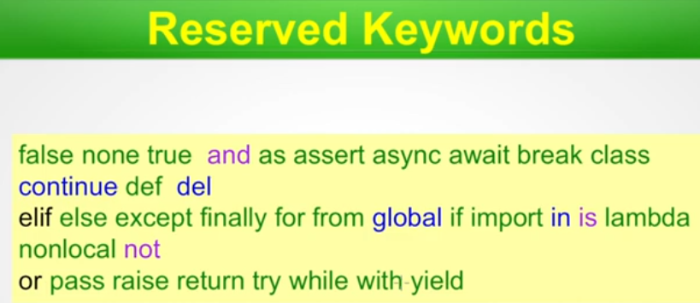

2.

