1. **Sprint Planning**

Number of developer: 1

Sprint duration: 3 weeks

* 1. **Task Detail**
     1. Requirement Document & Flowchart – 2 Story points / Estimated 2 days
     2. Create Entities Teacher, Student, Subject, Academic Class – 2 story point / Estimated 2 day
     3. Create DAO for all Entities – 1 story point / Estimated 1 day
     4. Create DAO Implementation for all Entities– 4 story point / Estimated 3 days
     5. Create Service File for all entities and also create Service Implementation file for all the entities – 2 Story point/Estimated 2 days.
     6. Create Homepage, Login page JSP file and also create controller for that and service file as well as service file Implementation, too. – 2 story points / Estimated 2 Days
     7. Create Add Subject & Delete Subject & Display Subject JSP file, Create Servlet (controller) for them – 2 story point / Estimated 2 days
     8. Create Add Teacher & Delete Teacher JSP file, Create Servlet (controller) for them-1 Story point/Estimated 1 Day.
     9. Create Add Student & Delete Student JSP file. Create Servlet (controller) for them – 1 Story point/Estimated 1 Day.
     10. Create Add Academic class & Delete Academic class JSP file. Create Servlet (controller) for them.- 1 Story point/Estimated 1 Day.
     11. Testing – 2 Story Point/Estimated 2 days.
     12. Release Announcement – 1 story point / Estimated 1 hour

1. **Flow of the project**

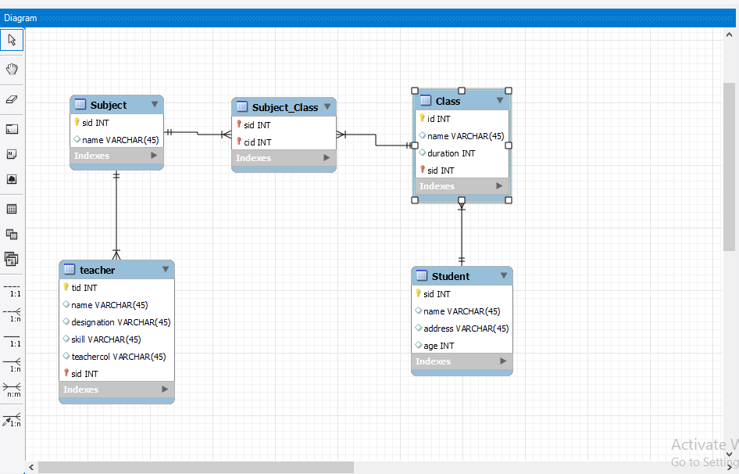

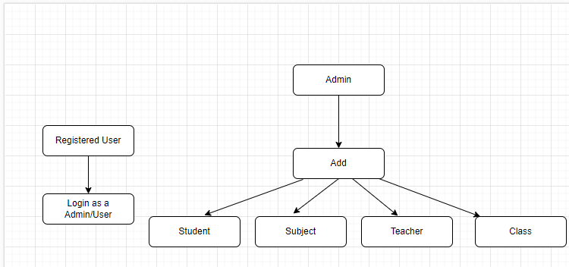

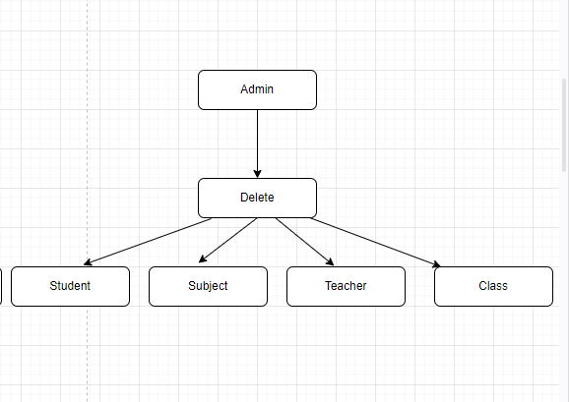

1. **How the project works:**

In this project we can login as Admin or User. Admin can add and delete student, subject, class and teacher.

* **Registration Form:**

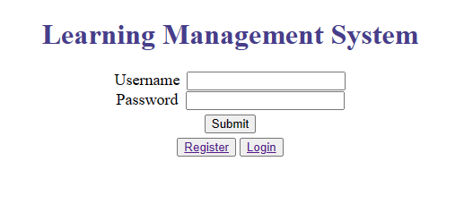

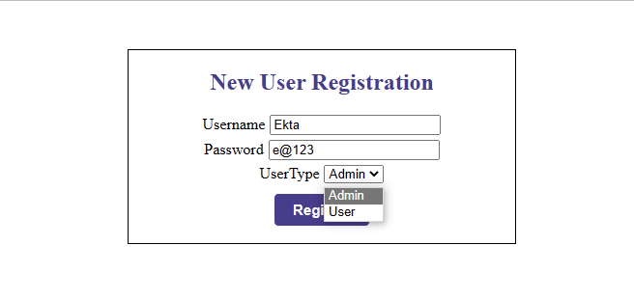

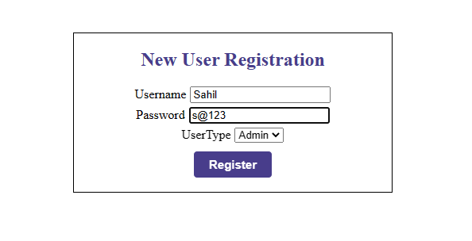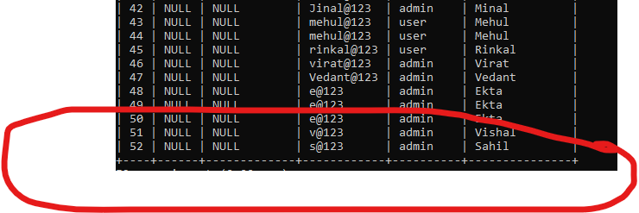

* **Login Form:**

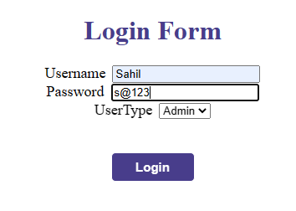



* **Homepage:**

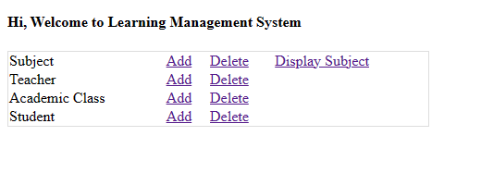

* **Add Teacher:**

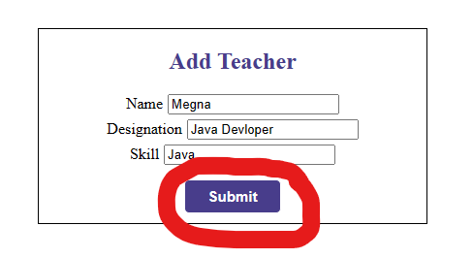

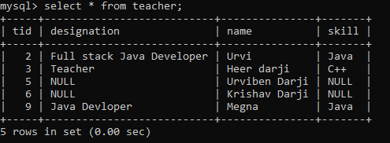

* **Delete Teacher:**

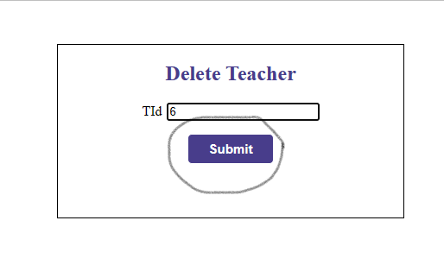

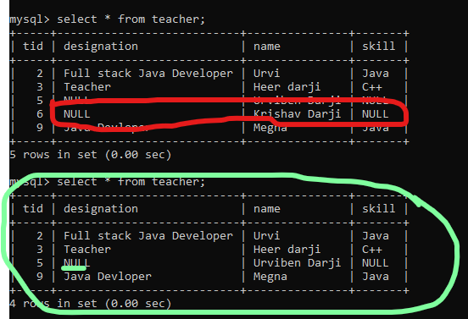

* **Add Subject:**

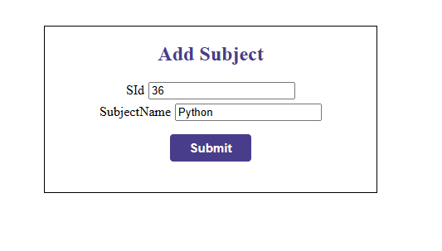

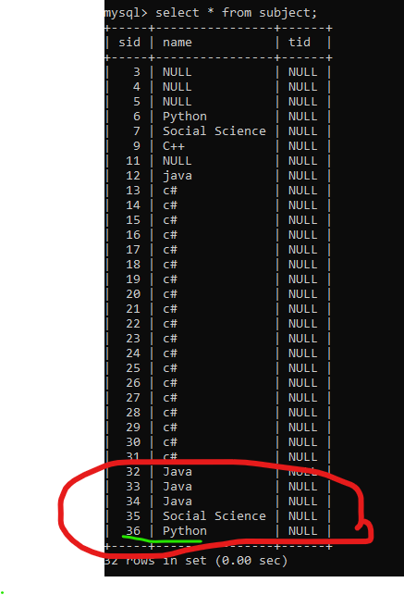

* **Delete Subject:**

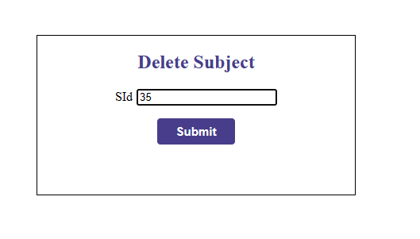

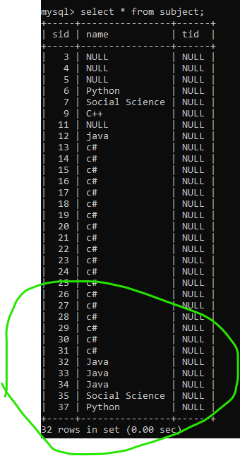

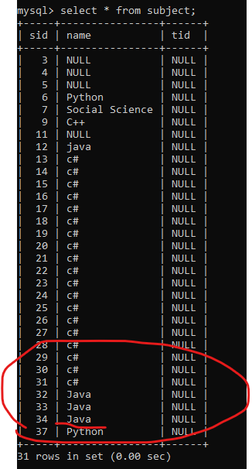

* **Display Subject:**

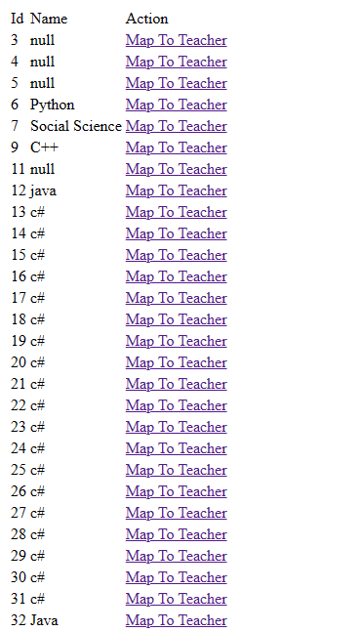

* **Add Student**

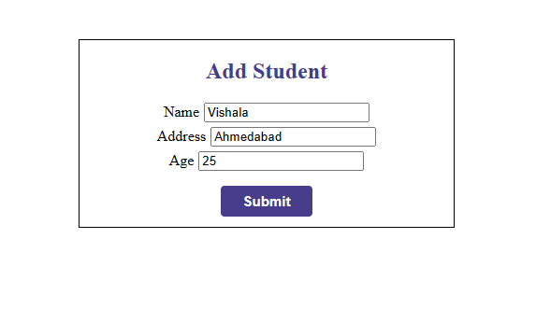

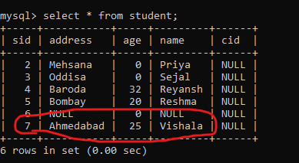

* **Delete Student**

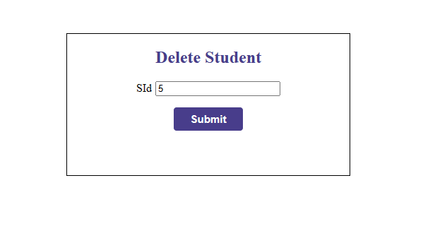

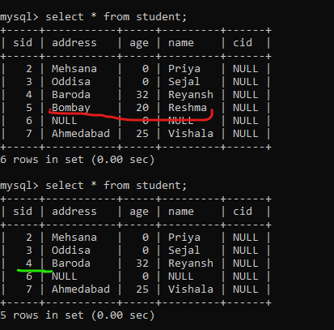

* **Add Academic class**

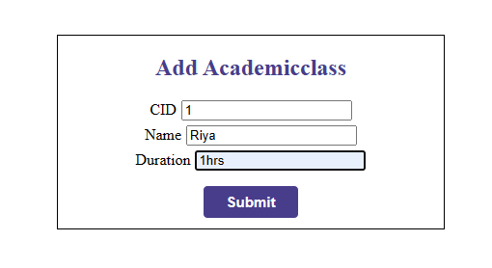

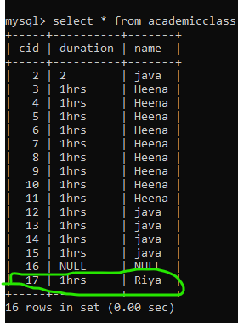

* **Delete Academic Class:**

