1. **Sprint Planning**

Number of developer: 1

Sprint duration: 2 weeks

* 1. **Task Detail**
     1. Requirement Document & Flowchart – 2 Story points / Estimated 2 days
     2. Create a class for choice menu – 1 story point / Estimated 1 day
     3. Create a class for file operations – 1 story point / Estimated 1 day
     4. Create class for getter and setter for id and filename – 1 story point / Estimated 1 hour
     5. Create a class for basic file operation Add File , Delete File , Display list of the File , Search File and Exit – 5 story points / Estimated 5 Days
     6. Testing – 1 story point / Estimated 1 day
     7. Release Announcement – 1 story point / Estimated 1 hour

1. **Flow of the project**

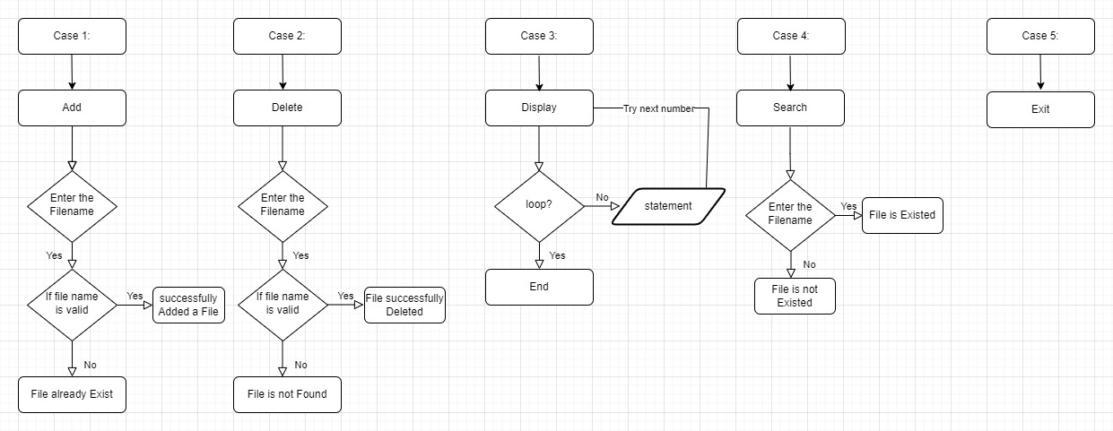

1. **Basic Operation of the File**

In this project LockedMe.com there are different types of the File operation.

For Example: Create and Add File, Delete File, Display File List, Search File and Exit.

**3.1 Choise Menu**

When we compile this application get the choice menu. You can see this in below screenshot.

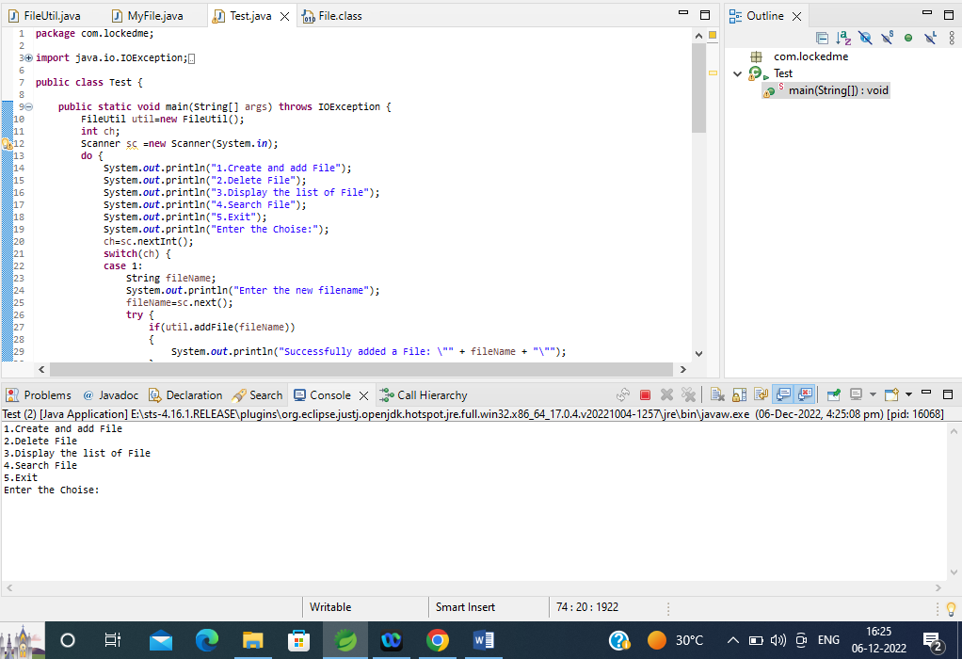

**Screenshot 3.1: Choise Menu**

**3.2 Add File**

Step 1: Enter the Choise.

Step 2: Enter the Filename.

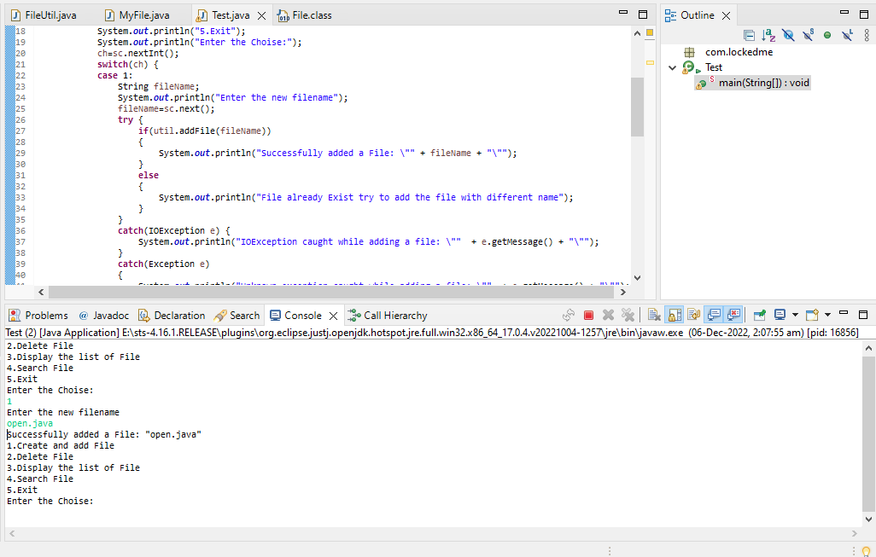

**Screenshot 3.2: Add File**

**3.2.1 File Already Exist**

If you enter the filename that already exist in the directory then get the message:

“File already Exist try to add the file with different name.”

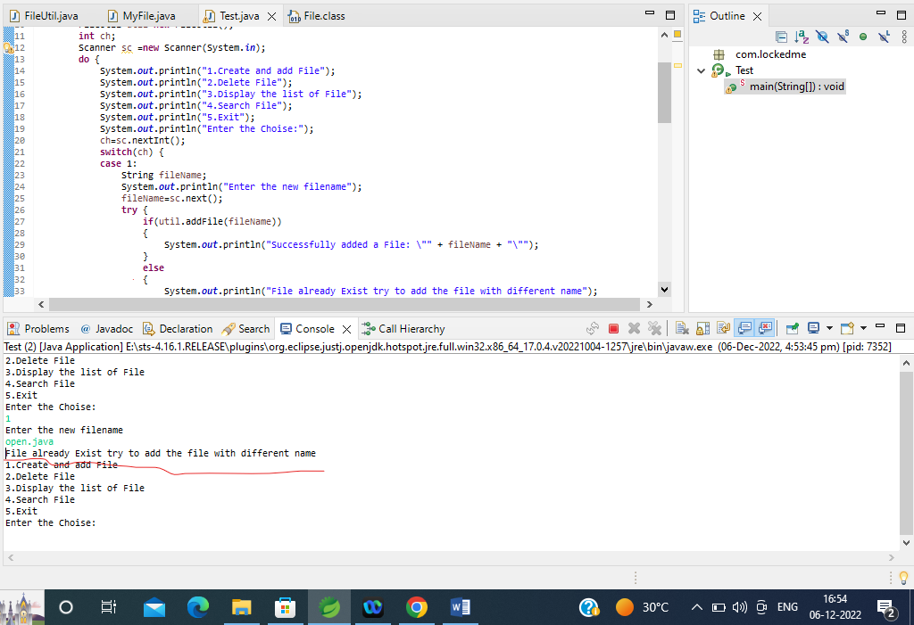

**Screenshot 3.2.1 File already Exist**

**3.2.2 IOException Caught If Path is Incorrect:**

If the path is incorrect in the function addFile () then IOException throws the exception message.

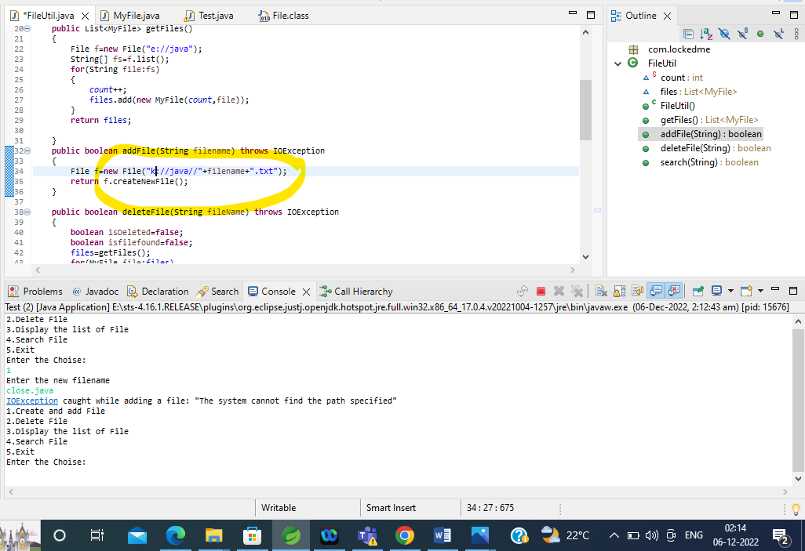

**Screenshot 3.2.2 IOException throws Exception**

**3.3 Delete File**

Step1: Enter the choise

Step2: Enter the Filename.

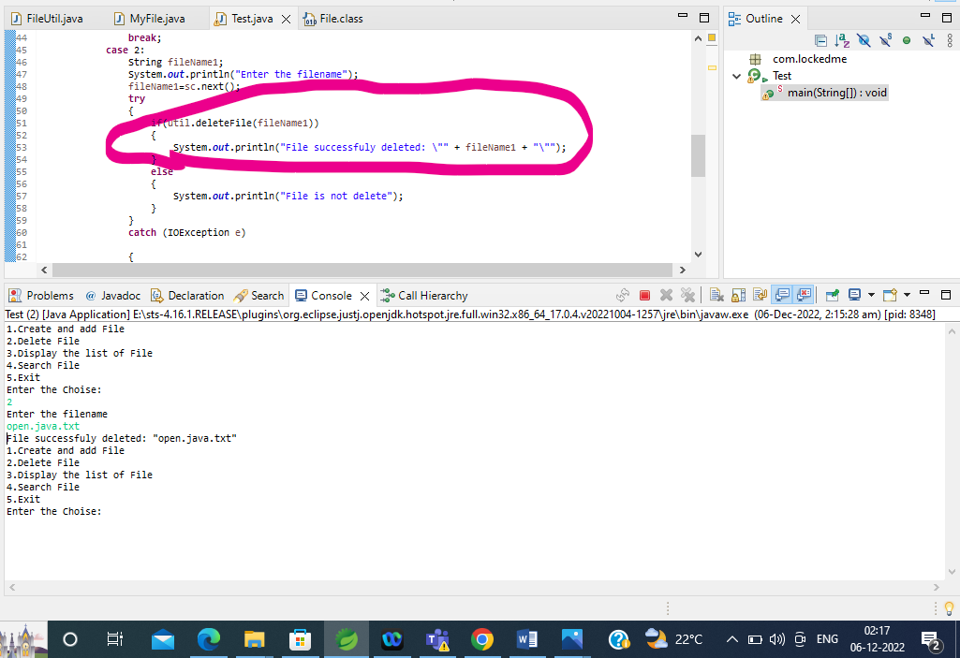

**Screenshot 3.3 File Successfully Deleted**

**3.3.1 If File Not Found (FNF)**

Step 1: Enter the Choise.

Step 2: Enter the Filename.

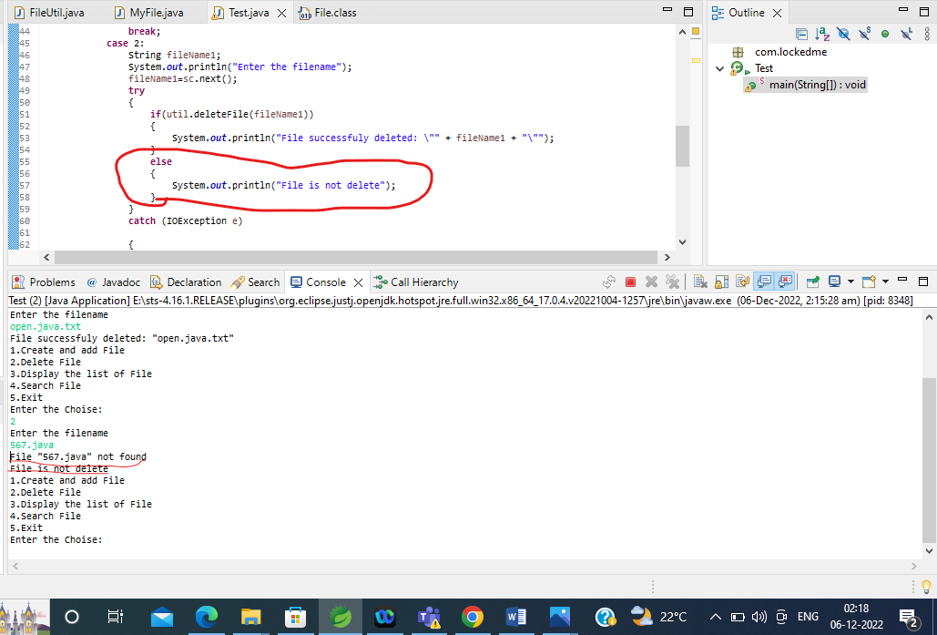

**Screenshot 3.3.1 File Not Found (FNF)**

**3.4 Display the list of File**

Step 1: Enter the Choise.

Step 2: Get the list of the File.

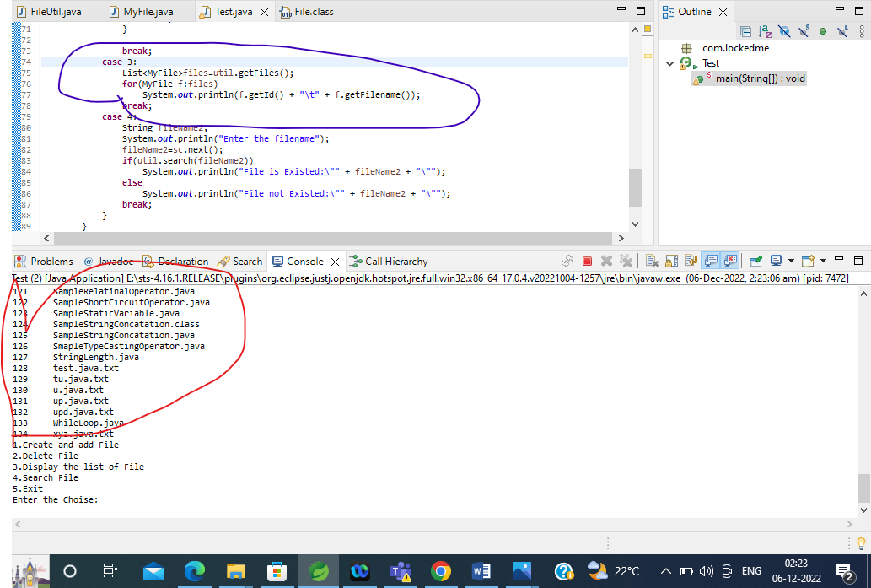

**Screenshot 3.4 Display List of the File**

**3.5 Search File**

Step 1: Enter the Choise.

Step 2: Enter the Filename.

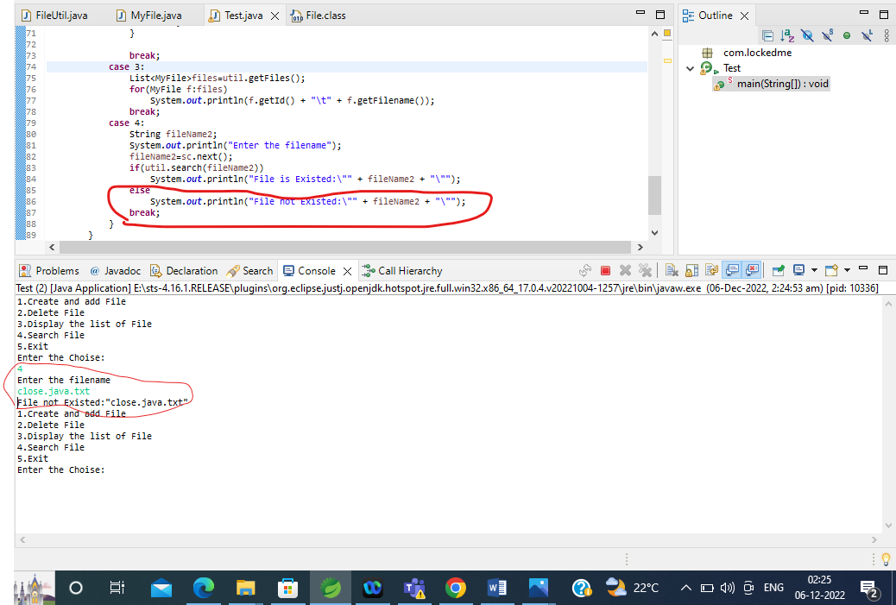

**Screenshot 3.5 Search File (File not Existed)**

**3.5.1 If File Existed**

Step 1: Enter the Choise.

Step 2: Enter the Filename.

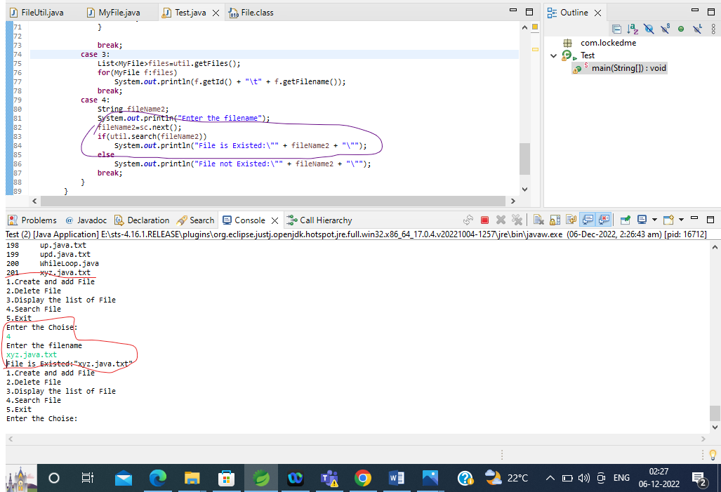

**Screenshot 3.5.1 Search File (File is Existed)**