Submitted by- Urvi Dixit
Date-1st October 2026
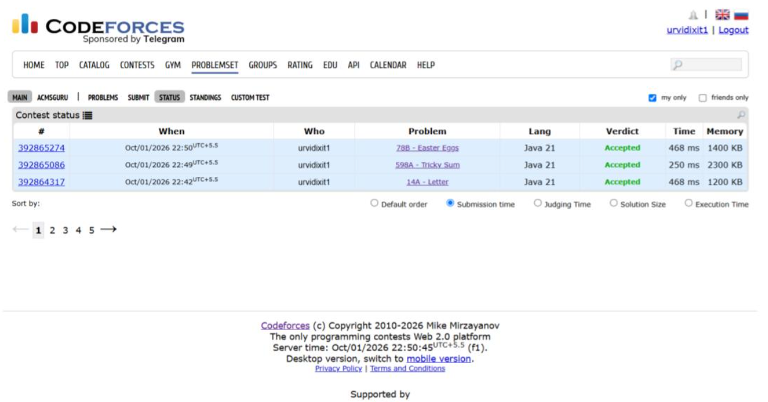
Date – 2nd October 2026
