**Explain the DDL (Data Definition Language), DML (Data Manipulation Language) and DCL (Data Control Language) statements in SQL.**

* **DDL**: The Data Definition Language is a set of SQL queries that are used to specify the database and schema structure, such as CREATE, ALTER, TRUNCATE, DROP, and RENAME.
* **DCL**: The Data Control Language is a set of SQL instructions that are used to control user access to the database. It includes operations like GRANT and REVOKE.
* **DML**: Data Manipulation Language is used to manage data using SQL queries such as SELECT, INSERT, DELETE, and UPDATE.

**Difference between Declaration and definition of a variable and function in C**

>If we merely want to declare variables and not define them, i.e. we don't want to allocate memory space, we can use the following declaration:

extern int x;

Only the information about the variable is sent in this example, and no memory is allocated. The above information informs the compiler that variable is declared now, but memory for it will be defined later, either in the same file or in a separate file.

**What is a Kernel in OS?**

**List the differences between Echo and Print in PHP.**

The functions of echo and print are nearly identical. Both are used to display info on the screen.

The differences are minor:

* Echo returns nothing, whereas print returns 1 and can be used in expressions.
* While echo can take many parameters, print only takes one.
* Because echo does not return a value, it is faster than print.

We obtain a syntax error if we try to pass multiple parameters into print

**What is the Man-in-the-Middle Attack in context to Cyber Security?**

A man-in-the-middle attack is a cyber threat (a form of eavesdropping assault) in which a cybercriminal wiretaps a conversation or data transmission involving two people. When a cybercriminal joins a two-way chat, they appear to be authentic participants, giving them the ability to gather sensitive information and respond in a number of ways. The main purpose of this type of attack is to gain access to personal information about our enterprise or consumers. A cybercriminal could, for example, intercept data flowing between the target device and the network on an unprotected Wi-Fi network.

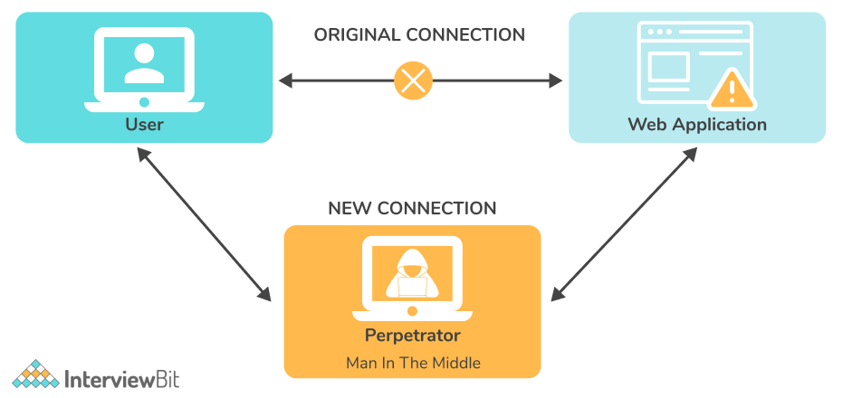

As we can understand from the image, a man-in-the-middle attack is a form of eavesdropping attack in which an attacker intercepts a conversation or data transfer in progress. The attackers pose as both genuine participants after inserting themselves in the "middle" of the transfer. This allows an attacker to intercept data and information from both parties while also providing malicious links or other information to both genuine participants in a way that may not be detected until it is too late.

**24. Discuss honeypots in context to Cyber Security.**

Honeypots are **attack targets** put up to study how different attackers try to exploit vulnerabilities. Honeypot is a **spoof computer system** that keeps track of **all user transactions, interactions, and behaviours**. The same idea, which is extensively utilised in academic settings, can be employed by private companies and governments to assess their risks.

Production Honeypots and research Honeypots are the two types of Honeypots available.

* **Production Honeypot:** Its purpose is to collect **genuine data** in order for the **administrator to access vulnerabilities**. To improve security, they're usually installed inside **production networks**.
* **Research Honeypot:** It is employed by educational institutions and organisations for the sole aim of examining the black-hat community's **reasons and strategies** for targeting various networks.

Logical Questions

DSA/ Programming Questions

After JEE Mains, some students got admission into an engineering college. Now there is a class consisting of such n students, and the HOD came to say it is time to select the class monitor. But He never gets all of them at one time. So he brought a register, every time he gets someone with less rank than the previous time he cut the name and wrote the name of the student and the rank.  
For a given number of ranks he gets each time, you have to predict how many names are cut in the list.

**Constraints:**  
Number of Visiting<=10^9  
ranks <=10000

**Input Format:**  
Number of Visiting N in their first line  
N space separated ranks the HOD gets each time

**Output Format:**  
Number of ranks cut in the list

**Sample Input:**  
6  
4 3 7 2 6 1

|  |
| --- |
| n=int(input("size= "))#kitne numbers pehle lene hai  a=[] #empty list  for i in range(n):      a.append(int(input("Enter student rank"))) #enter input  m=a[0]  c=0  for i in range(1,n): #so 1st no. not compared to itself      if(i<m):          c+=1 #increment c with every rank lower than 4  print(c) |

Q2)

**Problem Statement :**

Every decimal number can be changed into its binary form. Suppose your computer has it’s own CoronaVirus, that eats binary digits from the right side of a number. Suppose a virus has 6 spikes, it will eat up 6 LSB binary digits in your numbers.  
You will have a bunch of numbers, and your machine will have a virus with n spikes, you have to calculate what will be the final situation of the final numbers.

**Input Format:**  
First line, a single Integer N  
Second line N space separated integers of the bunch of values as array V  
Third line a single integer n, the number of spikes in Corona for Computer

**Output Format:**  
Single N space separated integers denoting the final situation with the array v.

**Sample Input:**  
5 //how much input to give  
1 2 3 4 5 //actual input  
2 //no. of spikes

**Output:**  
0 0 0 1 1

**Explanation:**  
5 is 101 in binary, when you cut the last two binary digits, its 1.

|  |
| --- |
| n=int(input("length of array=\n"))  a=[]  for i in range(n):      a.append(int(input("element=\n")))  c=int(input("no. of spikes=\n"))  for i in range(n):      print(bin(a[i]//pow(2,c))) |

**Question 3 : Help of Prepsters**

**Problem Statement :**

Arnab has given me a challenge. I have to calculate the number of numbers which are less than a certain value n, and have exactly k set bits in its binary form. As you are a Prepster like me, help me write a code that will take input for n and k and give the expected output.

**Constraints :**  
1<=n<=10000  
1<=k<=10  
**Input Format :**  
First line containing n and k space separated  
**Output Format :**  
Number of numbers present in a single line

**Sample Input:**  
7 2  
**Sample Output:**  
3  
**Explanation:**  
11,110,101 -> These three numbers.

|  |
| --- |
| n=int(input("enter number= "))  k=int(input("enter number of set bits= "))  c=0  for i in range(n):      b=0 #re initialise for every number      temp=i      while i>0:          d=i%2            if d==1:              b+=1          i=i//2      if b==k:                  c+=1                  #check for every number                  print(temp)    print(c) |

**Question 4: Momentum LinkedList**

**Problem Statement :**

Ratul made a linked list, a list made of n nodes, where every node has two variables, the velocity and the mass of a particle.  
Since all the particles have the velocity in the same direction, find the total momentum of the entity made by the particles from the linked list.

**Constraints :**  
1<=n<=10000  
1<=m,v<=100  
**Input format:**  
First line containing n, number of nodes  
Then n lines containing the mass and the velocity space separated.  
**Output Format:**  
Single integer denoting the momentum

**Sample Input:**  
4  
1 3  
2 4  
2 3  
4 5

**Sample Output:**  
37

|  |
| --- |
| n=int(input("enter size=\n"))  M=0  for i in range(n):      m,v=eval(input("Enter mass")),eval(input("Enter velocity"))      M+=m*v  print("Total=",M) |

**Question 5: Lazy String**

**Problem Statement :**

Anish is the laziest person you can ever see. He is tasked to write the name of the winner in a game where two people take part. And he just writes the longest common subsequence over there, so that with minimum change or no backspace he can edit the name to the winner’s name.  
For two given names, you have to predict what Anish will write in his computer before the start of the name. If there are more than two longest subsequences possible, write the one with less lexicographic value.  
Input Format:  
Two lines including two strings of name(All with capital letters)

**Output Format:**  
A single line with the lexicographically smallest possible longest common subsequence.

**Sample Input:**  
ABCD  
BACD  
**Sample Output:**  
ABC  
**Explanation:**  
ABC, ACD and BCD these are the two possible biggest substring

|  |
| --- |
| s1=input("enter string 1=\n")  s2=input("enter string 2=\n")  s1,s2=s1.upper(),s2.upper()  s3=''  print(s1,s2)  if(len(s1)>len(s2)):      m=len(s1)  else:      m=len(s2)  for i in range(m-1):      for j in range(m-1):          if(s1[i]==s2[j]):              s3+=s1[i]  print(s3) |

Project Explanations

MARKETPLACE  
VOTING SYSTEM

GFG DSA Sums