Pillar 2 — Operations: Geographic Contagion of Delays
AMS 597 Statistical Computing
2026-04-20
Table of Contents

Question: Which U.S. airports act as systemic super-spreaders — propagating delays to the next aircraft leg rather than absorbing them?
Pipeline: EDA → Tail-Number Metrics → K-Means (K=3) → Geographic Map → Network Map

Setup
library(arrow); library(tidyverse); library(scales)
library(factoextra); library(cluster)
library(ggrepel); library(gridExtra)
library(nycflights13); library(maps)
library(igraph); library(ggraph); library(patchwork)
theme_set(theme_bw(base_size = 12))
theme_update(panel.grid.minor = element_blank(),
plot.title = element_text(face = "bold", size = 13),
plot.subtitle = element_text(color = "grey40", size = 11))
CLUSTER_COLS <- c("Outbreak Hub" = "#d62728", "Average" = "#ff7f0e", "Resilient" = "#2ca02c")
ROUTE_COLS <- c("High-Delay" = "#d62728", "Moderate" = "#ff7f0e", "Low-Delay" = "#2ca02c")
TIME_ORDER <- c("Morning", "Afternoon", "Evening", "Night")
CHARTS <- file.path("..", "charts", "pillar2")
dir.create(CHARTS, showWarnings = FALSE, recursive = TRUE)
save_chart <- function(name, w = 13, h = 5)
ggsave(file.path(CHARTS, name), width = w, height = h, dpi = 150, bg = "white")
df <- read_parquet(file.path("..", "data", "cleaned_flight_data_2024.parquet")) |>
filter(Carrier_Type != "ULCC") |>
mutate(Time_Block = as.character(Time_Block),
Carrier_Type = as.character(Carrier_Type),
FlightDate = as.Date(FlightDate))
cat(sprintf("Total flights : %s\n", format(nrow(df), big.mark = ",")))
## Total flights : 3,159,061
cat(sprintf("Tail numbers : %s\n", format(n_distinct(df$Tail_Number), big.mark = ",")))
## Tail numbers : 5,528
cat(sprintf("Origin airports: %d\n", n_distinct(df$Origin)))
## Origin airports: 322

Stage 1 — Route Clustering
Cluster every OD route by its delay signature to show delays are structured, not random.
route_data <- df |>
group_by(Origin, Dest) |>
summarise(avg_dep_delay = mean(DepDelay, na.rm = TRUE),
avg_arr_delay = mean(ArrDelay, na.rm = TRUE),
avg_taxi_out = mean(TaxiOut, na.rm = TRUE),
flight_count = n(),
.groups = "drop") |>
filter(flight_count >= 20, avg_dep_delay < 200, avg_arr_delay < 200)
route_scaled <- route_data |>
select(avg_dep_delay, avg_arr_delay, avg_taxi_out) |>
scale()
set.seed(42)
km_route <- kmeans(route_scaled, centers = 3, nstart = 50)
rank_dep <- rank(km_route$centers[, 1])
route_data <- route_data |>
mutate(route_cluster = factor(
setNames(case_when(rank_dep == 3 ~ "High-Delay",
rank_dep == 1 ~ "Low-Delay",
TRUE ~ "Moderate"),
seq_len(3))[as.character(km_route$cluster)],
levels = c("High-Delay", "Moderate", "Low-Delay")))
cat("Route cluster sizes:\n"); print(table(route_data$route_cluster))
## Route cluster sizes:
##
## High-Delay Moderate Low-Delay
## 1048 1461 2638
ggplot(route_data, aes(avg_dep_delay, avg_arr_delay, colour = route_cluster)) +
geom_point(alpha = 0.5, size = 1.2) +
scale_colour_manual(values = ROUTE_COLS, name = "Route cluster") +
labs(title = "Route Clusters by Delay Signature",
subtitle = "Each point = one OD route",
x = "Avg Departure Delay (min)", y = "Avg Arrival Delay (min)")
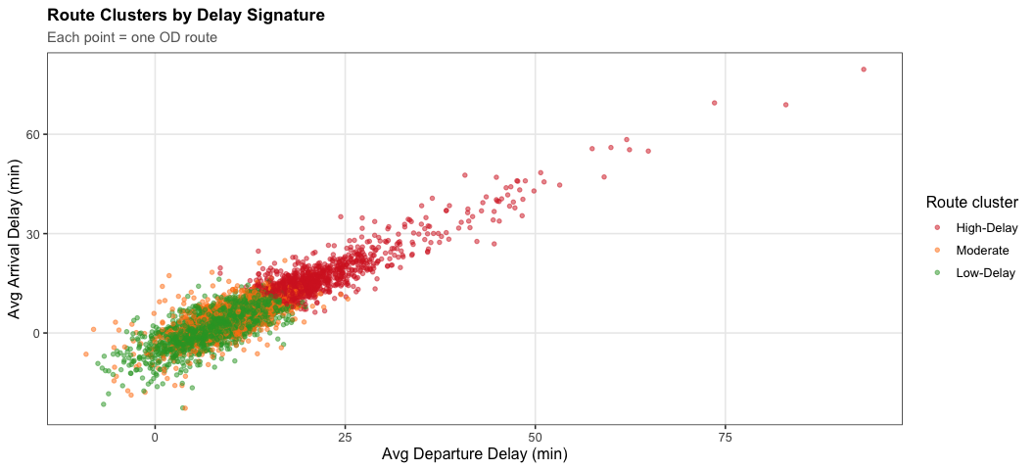
save_chart("p2_route_clusters.png", w = 11, h = 5)

Stage 2 — System Cascade
cascade <- df |>
filter(Time_Block %in% TIME_ORDER) |>
mutate(Time_Block = factor(Time_Block, levels = TIME_ORDER)) |>
group_by(Time_Block) |>
summarise(mean_delay = mean(DepDelay, na.rm = TRUE),
pct_delayed = mean(DepDelay > 15, na.rm = TRUE) * 100,
.groups = "drop")
mu <- mean(df$DepDelay, na.rm = TRUE)
p1 <- ggplot(cascade, aes(Time_Block, mean_delay, fill = Time_Block)) +
geom_col(alpha = 0.85, width = 0.6, show.legend = FALSE) +
geom_text(aes(label = sprintf("%.1f min", mean_delay)), vjust = -0.4, fontface = "bold", size = 4) +
geom_hline(yintercept = mu, color = "forestgreen", linetype = "dashed") +
annotate("text", x = 4.45, y = mu + 0.3, label = sprintf("Mean: %.1f min", mu),
hjust = 1, size = 3.3, color = "forestgreen") +
scale_fill_brewer(palette = "Blues") +
scale_y_continuous(expand = expansion(mult = c(0, 0.15))) +
labs(title = "Avg Departure Delay by Time Block", x = NULL, y = "Avg DepDelay (min)")
p2 <- ggplot(cascade, aes(Time_Block, pct_delayed, fill = Time_Block)) +
geom_col(alpha = 0.85, width = 0.6, show.legend = FALSE) +
geom_text(aes(label = sprintf("%.1f%%", pct_delayed)), vjust = -0.4, fontface = "bold", size = 4) +
scale_fill_brewer(palette = "Oranges") +
scale_y_continuous(expand = expansion(mult = c(0, 0.15))) +
labs(title = "% Flights Delayed (>15 min) by Time Block", x = NULL, y = "% Delayed")
grid.arrange(p1, p2, ncol = 2)
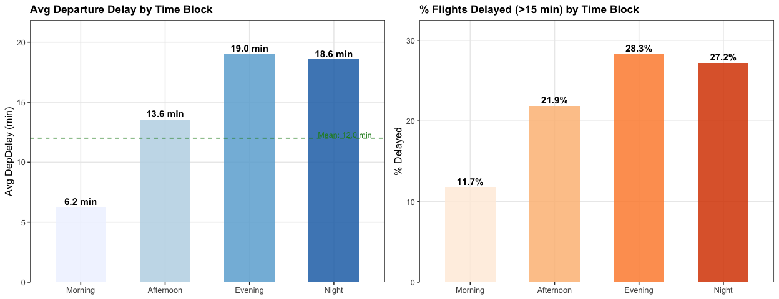
save_chart("p2_cascade.png")

Stage 3 — Tail-Number Contagion Metrics
For each airport, track consecutive legs on the same aircraft to compute:
- Transmission Rate — % of delayed arrivals that produce a delayed next departure
- Propagation Slope — lm slope of next_DepDelay ~ ArrDelay
- Propagation Factor — mean(next_DepDelay − ArrDelay); positive = amplifies, negative = absorbs
fit_slope <- function(arr, dep) {
ok <- !is.na(arr) & !is.na(dep)
if (sum(ok) < 10) return(NA_real_)
coef(lm(dep[ok] ~ arr[ok]))[2]
}
hhmm_to_min <- function(t) (t %/% 100L) * 60L + (t %% 100L)
turnarounds <- df |>
filter(!is.na(Tail_Number), Tail_Number != "Unknown", Tail_Number != "") |>
arrange(Tail_Number, FlightDate, CRSDepTime) |>
group_by(Tail_Number) |>
mutate(next_Origin = lead(Origin),
next_DepDelay = lead(DepDelay),
next_CRSDepTime = lead(CRSDepTime)) |>
ungroup() |>
filter(Dest == next_Origin, !is.na(ArrDelay), !is.na(next_DepDelay)) |>
mutate(arr_min = hhmm_to_min(CRSArrTime) + ArrDelay,
dep_next_min = hhmm_to_min(next_CRSDepTime) + next_DepDelay,
dep_next_min = if_else(dep_next_min < arr_min, dep_next_min + 1440L, dep_next_min),
turnaround_min = dep_next_min - arr_min) |>
filter(turnaround_min >= 0, turnaround_min <= 480)
tx_stats <- turnarounds |>
group_by(Origin = Dest) |>
summarise(n_turnarounds = n(),
n_exposed = sum(ArrDelay > 15, na.rm = TRUE),
n_infected = sum(ArrDelay > 15 & next_DepDelay > 15, na.rm = TRUE),
transmission_rate = n_infected / pmax(n_exposed, 1),
prop_slope = fit_slope(ArrDelay, next_DepDelay),
propagation_factor = mean(next_DepDelay - ArrDelay, na.rm = TRUE),
avg_turnaround = median(turnaround_min, na.rm = TRUE),
.groups = "drop") |>
filter(n_exposed >= 30)
cat(sprintf("Turnaround events : %s\n", format(nrow(turnarounds), big.mark = ",")))
## Turnaround events : 2,591,228
cat(sprintf("Airports (≥30 exp): %d\n", nrow(tx_stats)))
## Airports (≥30 exp): 300
# Validate route clustering: do aircraft off High-Delay routes have higher transmission rates?
bridge <- turnarounds |>
left_join(route_data |> select(Origin, Dest, route_cluster), by = c("Origin", "Dest")) |>
filter(!is.na(route_cluster)) |>
group_by(route_cluster) |>
summarise(n_exposed = sum(ArrDelay > 15, na.rm = TRUE),
n_infected = sum(ArrDelay > 15 & next_DepDelay > 15, na.rm = TRUE),
tx_rate = n_infected / pmax(n_exposed, 1),
.groups = "drop")
cat("Transmission rate by inbound route cluster:\n")
## Transmission rate by inbound route cluster:
bridge |> mutate(tx_rate = percent(tx_rate, 0.1)) |> print()
## # A tibble: 3 × 4
## route_cluster n_exposed n_infected tx_rate
## <fct> <int> <int> <chr>
## 1 High-Delay 111731 65501 58.6%
## 2 Moderate 164092 96292 58.7%
## 3 Low-Delay 212354 132900 62.6%
label_df <- tx_stats |>
filter(transmission_rate > quantile(transmission_rate, 0.88, na.rm = TRUE) |
avg_turnaround < quantile(avg_turnaround, 0.10, na.rm = TRUE) |
propagation_factor > quantile(propagation_factor, 0.90, na.rm = TRUE))
ggplot(tx_stats, aes(x = avg_turnaround, y = transmission_rate, colour = propagation_factor)) +
geom_point(aes(size = n_turnarounds), alpha = 0.75) +
geom_smooth(method = "loess", formula = "y ~ x", se = TRUE,
colour = "grey30", fill = "grey80", linewidth = 1, show.legend = FALSE) +
geom_text_repel(data = label_df, aes(label = Origin),
size = 3.2, fontface = "bold", box.padding = 0.4,
max.overlaps = 20, show.legend = FALSE) +
scale_colour_gradient2(low = "#2166ac", mid = "gold", high = "#d62728", midpoint = 0,
name = "Propagation factor\n(+ amplifies / − absorbs)") +
scale_y_continuous(labels = percent_format()) +
scale_size_continuous(name = "Turnarounds", labels = comma, range = c(1.5, 9)) +
labs(title = "Transmission Rate vs Turnaround Time",
subtitle = "Colour = Propagation Factor | Size = turnaround volume | LOESS trend",
x = "Median Turnaround Time (min)", y = "Transmission Rate")
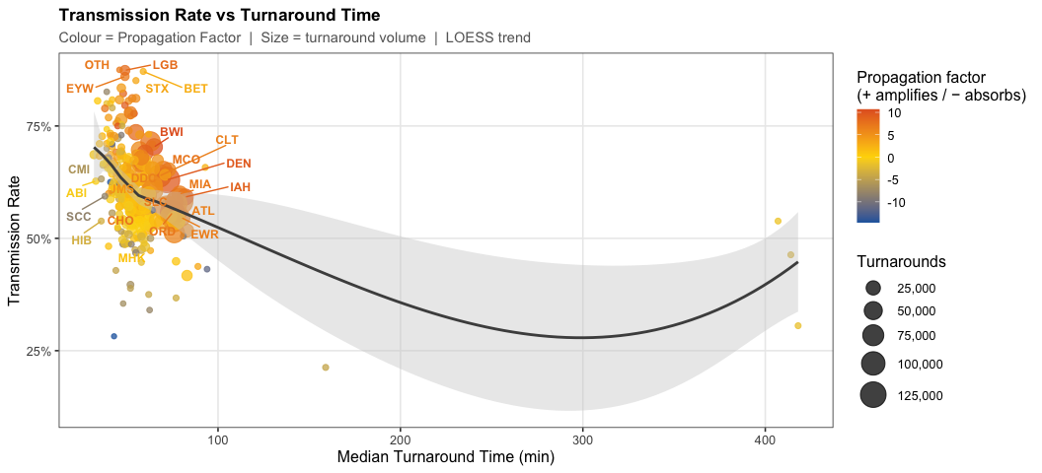
save_chart("p2_transmission.png", w = 11, h = 5)

Stage 4 — Airport Clustering
base_stats <- df |>
group_by(Origin) |>
summarise(n_flights = n(), .groups = "drop") |>
filter(n_flights >= 200)
airport_feats <- tx_stats |>
inner_join(base_stats, by = "Origin") |>
mutate(log_volume = log(n_flights))
FEAT_COLS <- c("transmission_rate", "prop_slope", "propagation_factor",
"avg_turnaround", "log_volume")
feat_mat <- airport_feats |> select(all_of(FEAT_COLS)) |> drop_na()
feat_scaled <- feat_mat |> scale()
rownames(feat_scaled) <- airport_feats$Origin[complete.cases(airport_feats[, FEAT_COLS])]
cat(sprintf("Airports in matrix: %d\n", nrow(feat_mat)))
## Airports in matrix: 295
set.seed(42)
p_e <- fviz_nbclust(feat_scaled, kmeans, method = "wss", k.max = 8, linecolor = "#1f77b4") +
labs(title = "Elbow — WSS", x = "K", y = "Within-cluster SS") +
theme(plot.title = element_text(face = "bold"))
p_s <- fviz_nbclust(feat_scaled, kmeans, method = "silhouette", k.max = 8, linecolor = "#d62728") +
labs(title = "Silhouette Width", x = "K", y = "Avg silhouette") +
theme(plot.title = element_text(face = "bold"))
p_e + p_s
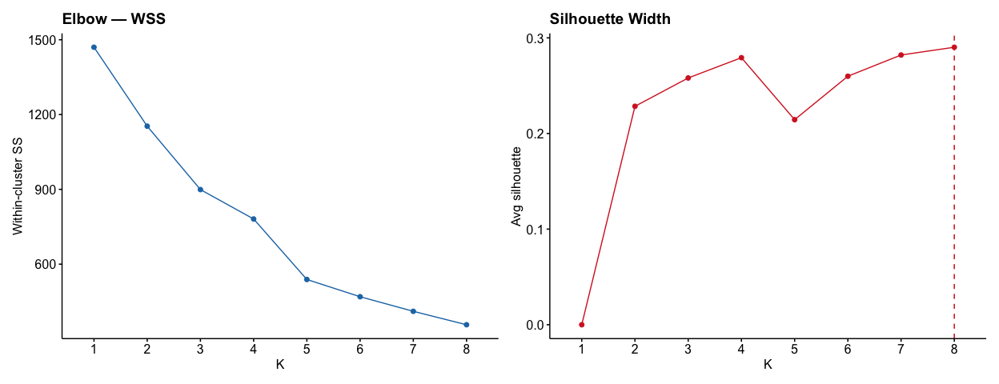
save_chart("p2_kselect.png", w = 12, h = 5)
K_CHOSEN <- 3
set.seed(42)
km <- kmeans(feat_scaled, centers = K_CHOSEN, nstart = 50, iter.max = 300)
tx_idx <- which(colnames(feat_scaled) == "transmission_rate")
rank_tx <- rank(km$centers[, tx_idx])
label_map <- setNames(case_when(rank_tx == K_CHOSEN ~ "Outbreak Hub",
rank_tx == 1 ~ "Resilient",
TRUE ~ "Average"),
seq_len(K_CHOSEN))
airport_feats <- airport_feats |>
filter(Origin %in% rownames(feat_scaled)) |>
mutate(cluster = factor(label_map[as.character(km$cluster)], levels = names(CLUSTER_COLS)))
cat("Cluster sizes:\n"); print(table(airport_feats$cluster))
## Cluster sizes:
##
## Outbreak Hub Average Resilient
## 113 179 3
FEAT_LABELS <- c(transmission_rate = "Transmission rate",
prop_slope = "Propagation slope",
propagation_factor = "Propagation factor",
avg_turnaround = "Avg turnaround (min)",
log_volume = "Log volume")
profile <- airport_feats |>
select(cluster, all_of(FEAT_COLS)) |>
group_by(cluster) |>
summarise(across(everything(), \(x) mean(x, na.rm = TRUE)), .groups = "drop") |>
pivot_longer(-cluster, names_to = "feature", values_to = "raw_mean") |>
group_by(feature) |> mutate(z = as.numeric(scale(raw_mean))) |> ungroup() |>
mutate(feature = factor(FEAT_LABELS[feature], levels = FEAT_LABELS))
ggplot(profile, aes(feature, cluster, fill = z)) +
geom_tile(color = "white", lwd = 0.7) +
geom_text(aes(label = sprintf("%.2f", raw_mean)), size = 3.5, fontface = "bold",
color = ifelse(abs(profile$z) > 1.0, "white", "grey20")) +
scale_fill_gradient2(low = "#2166ac", mid = "white", high = "#d73027",
midpoint = 0, name = "z-score") +
scale_x_discrete(guide = guide_axis(angle = 25)) +
scale_y_discrete(limits = rev(names(CLUSTER_COLS))) +
labs(title = "Cluster Profile Heatmap",
subtitle = "Red = high, Blue = low | values = cluster means",
x = NULL, y = NULL) +
theme(panel.grid = element_blank())
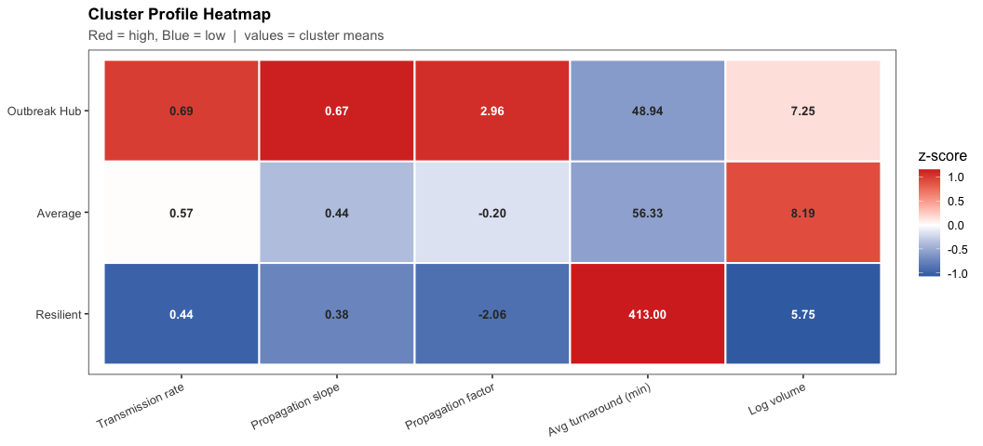
save_chart("p2_cluster_profile.png", w = 11, h = 5)

Stage 5 — Geographic Contagion Zones
coords <- nycflights13::airports |>
select(faa, lat, lon) |>
filter(lon >= -130, lon <= -65, lat >= 20, lat <= 55)
map_df <- airport_feats |>
left_join(coords, by = c("Origin" = "faa")) |>
filter(!is.na(lat), !is.na(lon))
ggplot() +
geom_polygon(data = map_data("state"), aes(long, lat, group = group),
fill = "grey94", color = "white", lwd = 0.3) +
geom_point(data = map_df |> arrange(n_flights),
aes(lon, lat, color = cluster, size = n_flights, alpha = transmission_rate)) +
geom_text_repel(
data = map_df |> group_by(cluster) |> slice_max(n_flights, n = 4, with_ties = FALSE) |> ungroup(),
aes(lon, lat, label = Origin, color = cluster),
size = 3.2, fontface = "bold", box.padding = 0.4, max.overlaps = 40, show.legend = FALSE
) +
coord_fixed(1.3, xlim = c(-125, -65), ylim = c(24, 50)) +
scale_color_manual(values = CLUSTER_COLS, name = "Cluster") +
scale_size_continuous(name = "Total flights", labels = comma, range = c(2, 12)) +
scale_alpha_continuous(name = "Transmission rate", labels = percent_format(), range = c(0.35, 1)) +
labs(title = "U.S. Geographic Contagion Zones",
subtitle = "Red = Outbreak Hub | Orange = Average | Green = Resilient | Size = flight volume",
x = NULL, y = NULL) +
theme(axis.text = element_blank(), axis.ticks = element_blank(),
panel.border = element_blank(), panel.grid = element_blank())
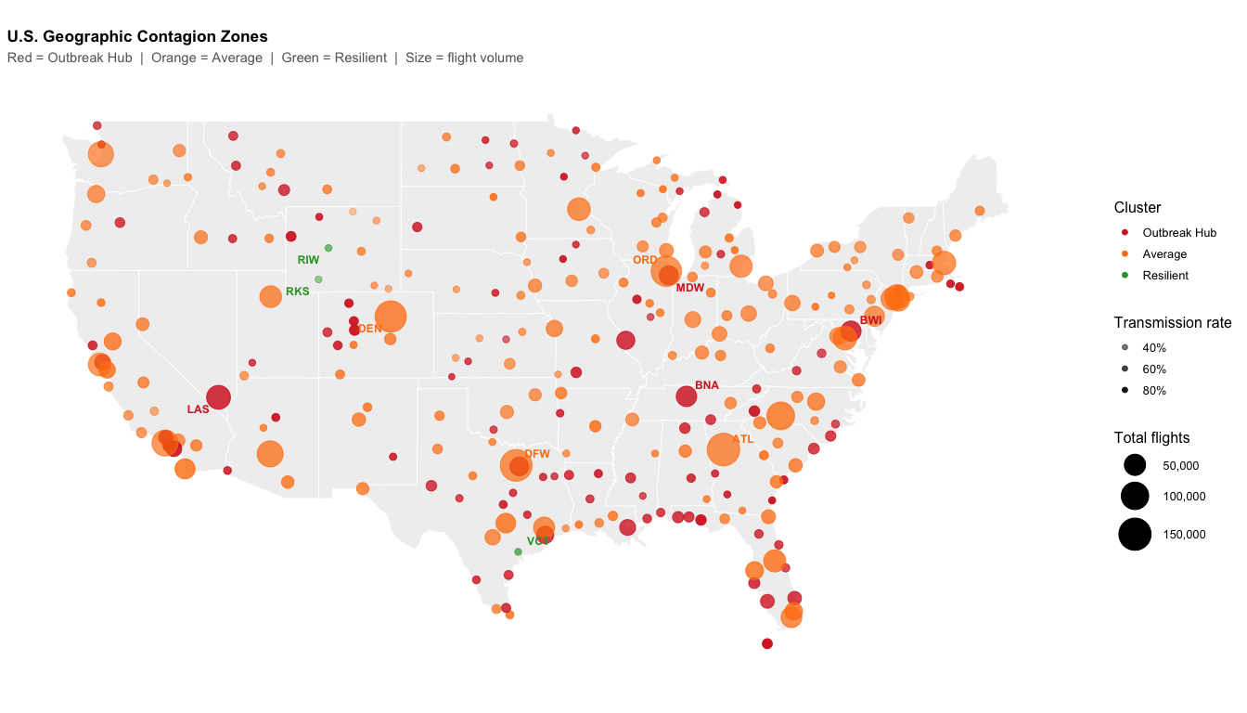
save_chart("p2_geo_map.png", w = 14, h = 8)

Stage 6 — Network Contagion Map
clust_lookup <- airport_feats |> select(Origin, cluster)
cluster_edges <- df |>
inner_join(clust_lookup, by = "Origin") |>
inner_join(clust_lookup |> rename(Dest = Origin, dest_cluster = cluster), by = "Dest") |>
filter(!is.na(cluster), !is.na(dest_cluster),
as.character(cluster) != as.character(dest_cluster)) |>
group_by(from = as.character(cluster), to = as.character(dest_cluster)) |>
summarise(n_flights = n(), avg_dep_delay = mean(DepDelay, na.rm = TRUE), .groups = "drop")
cluster_nodes <- airport_feats |>
group_by(name = as.character(cluster)) |>
summarise(n_airports = n(),
avg_tx_rate = mean(transmission_rate, na.rm = TRUE),
avg_pf = mean(propagation_factor, na.rm = TRUE),
.groups = "drop")
g <- graph_from_data_frame(cluster_edges, vertices = cluster_nodes, directed = TRUE)
V(g)$label <- paste0(V(g)$name, "\n", V(g)$n_airports, " airports",
"\nTx: ", percent(V(g)$avg_tx_rate, 0.1),
" PF: ", round(V(g)$avg_pf, 1), " min")
ggraph(g, layout = "circle") +
geom_edge_arc(aes(width = n_flights, color = avg_dep_delay),
strength = 0.25, alpha = 0.85,
arrow = arrow(length = unit(4, "mm"), type = "closed"),
end_cap = circle(14, "mm")) +
geom_node_point(aes(size = avg_tx_rate),
color = CLUSTER_COLS[match(V(g)$name, names(CLUSTER_COLS))], alpha = 0.9) +
geom_node_label(aes(label = label), size = 3.5, fontface = "bold",
fill = "white", color = CLUSTER_COLS[match(V(g)$name, names(CLUSTER_COLS))],
label.size = 0.4, repel = TRUE) +
scale_edge_color_gradient(low = "gold", high = "#d62728", name = "Avg DepDelay (min)") +
scale_edge_width_continuous(name = "Flight volume", labels = comma, range = c(0.8, 4)) +
scale_size_continuous(name = "Avg transmission rate", labels = percent_format(), range = c(8, 20)) +
labs(title = "Delay Contagion Network — Inter-Cluster Flow",
subtitle = "Arrow width = flight volume | Arrow colour = avg DepDelay | Node size = transmission rate") +
theme_graph(base_size = 12) +
theme(plot.title = element_text(face = "bold", size = 13),
plot.subtitle = element_text(color = "grey40", size = 11))
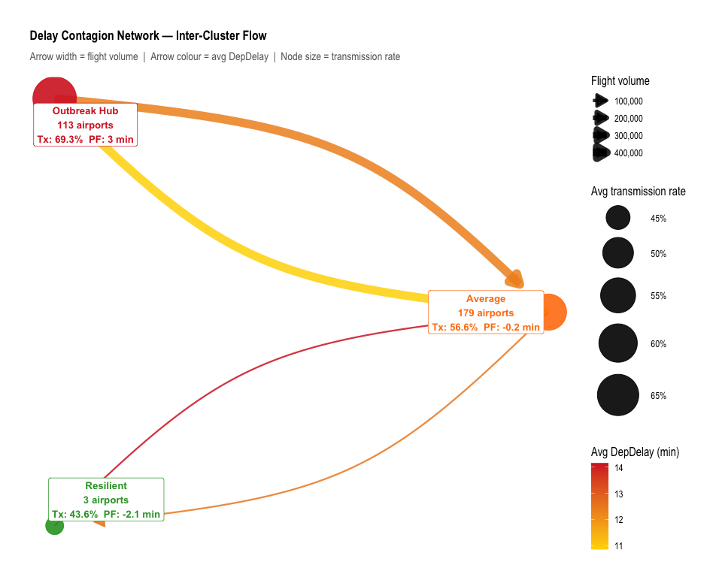
save_chart("p2_network.png", w = 10, h = 8)

Summary
top_tx <- airport_feats |> slice_max(transmission_rate, n = 1)
cat("PILLAR 2 — RESULTS SUMMARY\n")
## PILLAR 2 — RESULTS SUMMARY
cat(sprintf("Airports analysed : %d (≥200 flights, ≥30 exposures)\n", nrow(airport_feats)))
## Airports analysed : 295 (≥200 flights, ≥30 exposures)
cat(sprintf("Turnaround events : %s\n", format(nrow(turnarounds), big.mark = ",")))
## Turnaround events : 2,591,228
cat(sprintf("K-Means K : %d\n\n", K_CHOSEN))
## K-Means K : 3
cat(sprintf("Top super-spreader: %s (Tx=%.1f%% Slope=%.3f PF=%.1f min)\n\n",
top_tx$Origin, top_tx$transmission_rate * 100,
top_tx$prop_slope, top_tx$propagation_factor))
## Top super-spreader: LGB (Tx=87.4% Slope=0.822 PF=8.2 min)
airport_feats |>
group_by(cluster) |>
summarise(n = n(),
avg_tx_rate = percent(mean(transmission_rate, na.rm = TRUE), 0.1),
avg_slope = round(mean(prop_slope, na.rm = TRUE), 3),
avg_pf = round(mean(propagation_factor, na.rm = TRUE), 2),
avg_turnover = round(mean(avg_turnaround, na.rm = TRUE), 1),
.groups = "drop") |>
print()
## # A tibble: 3 × 6
## cluster n avg_tx_rate avg_slope avg_pf avg_turnover
## <fct> <int> <chr> <dbl> <dbl> <dbl>
## 1 Outbreak Hub 113 69.3% 0.668 2.96 48.9
## 2 Average 179 56.6% 0.439 -0.2 56.3
## 3 Resilient 3 43.6% 0.384 -2.06 413

