Pillar 3 — Strategy: Corporate Favoritism & The Regional Penalty
  - After controlling for hub congestion, do regional carriers pay a structural taxi-out penalty?
AMS 597 Statistical Computing
2026-04-21
Table of Contents

Question: Accounting for the baseline congestion of each hub airport, what is the true isolated impact of carrier type (Mainline vs. Regional) on taxi-out time?
Pipeline: EDA → OLS Baseline → Mixed-Effects Model → Fixed Effects Comparison → Congestion Ranking → Favoritism Test

Setup
library(arrow); library(tidyverse); library(scales)
library(lme4); library(lmerTest)
library(ggrepel); library(gridExtra)
theme_set(theme_bw(base_size = 12))
theme_update(panel.grid.minor = element_blank(),
plot.title = element_text(face = "bold", size = 13),
plot.subtitle = element_text(color = "grey40", size = 11))
PALETTE <- c(Mainline = "#1f77b4", Regional = "#ff7f0e")
TIME_ORDER <- c("Morning", "Afternoon", "Evening", "Night")
CHARTS <- file.path("..", "charts", "pillar3")
dir.create(CHARTS, showWarnings = FALSE, recursive = TRUE)
save_chart <- function(name, w = 13, h = 5)
ggsave(file.path(CHARTS, name), width = w, height = h, dpi = 150, bg = "white")
df <- read_parquet(file.path("..", "data", "cleaned_flight_data_2024.parquet")) |>
filter(Carrier_Type != "ULCC") |>
mutate(Time_Block = factor(as.character(Time_Block), levels = TIME_ORDER),
Carrier_Type = factor(as.character(Carrier_Type), levels = c("Mainline", "Regional")),
DayOfWeek = factor(DayOfWeek))
cat(sprintf("Total flights : %s\n", format(nrow(df), big.mark = ",")))
## Total flights : 3,159,061
cat(sprintf("Origins : %d\n", n_distinct(df$Origin)))
## Origins : 322
cat(sprintf("Carrier types : %s\n", paste(levels(df$Carrier_Type), collapse = ", ")))
## Carrier types : Mainline, Regional

Stage 1 — EDA
Raw taxi-out distributions and the gap by time block — before any modelling.
cap99 <- quantile(df$TaxiOut, 0.99, na.rm = TRUE)
df_plot <- df |> filter(TaxiOut <= cap99, !is.na(TaxiOut))
taxi_summary <- df |>
filter(!is.na(TaxiOut)) |>
group_by(Carrier_Type) |>
summarise(mean = mean(TaxiOut),
se = sd(TaxiOut) / sqrt(n()),
lower = mean - 1.96 * se,
upper = mean + 1.96 * se,
.groups = "drop")
p1 <- ggplot(df_plot, aes(TaxiOut, fill = Carrier_Type)) +
geom_histogram(bins = 50, alpha = 0.7, position = "identity") +
scale_fill_manual(values = PALETTE, name = NULL) +
scale_y_continuous(labels = comma) +
labs(title = "TaxiOut Distribution by Carrier Type",
subtitle = "Capped at 99th percentile",
x = "TaxiOut (min)", y = "Count")
p2 <- ggplot(taxi_summary, aes(Carrier_Type, mean, fill = Carrier_Type)) +
geom_col(alpha = 0.85, width = 0.5, show.legend = FALSE) +
geom_errorbar(aes(ymin = lower, ymax = upper), width = 0.15, lwd = 0.8) +
geom_text(aes(label = sprintf("%.2f min", mean)),
vjust = -0.8, fontface = "bold", size = 4) +
scale_fill_manual(values = PALETTE) +
scale_y_continuous(expand = expansion(mult = c(0, 0.15))) +
labs(title = "Mean TaxiOut by Carrier (95% CI)",
subtitle = "Raw gap — not yet controlling for airport congestion",
x = NULL, y = "Avg TaxiOut (min)")
grid.arrange(p1, p2, ncol = 2)
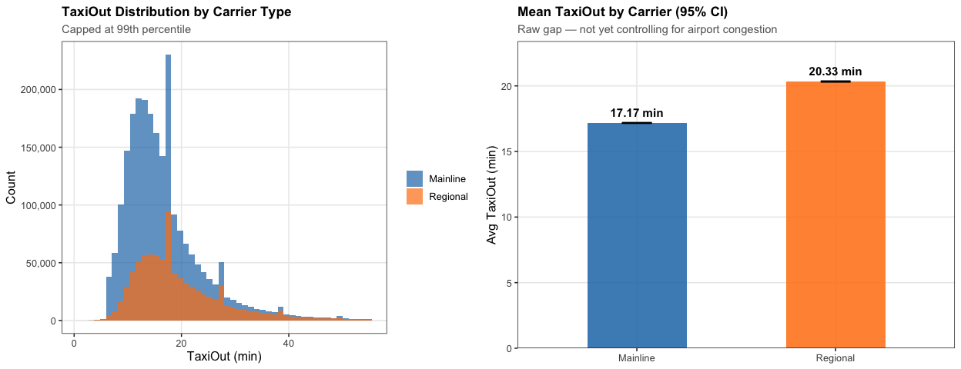
save_chart("p3_taxiout_dist.png")
cat("Raw TaxiOut by carrier:\n")
## Raw TaxiOut by carrier:
taxi_summary |> mutate(across(where(is.double), \(x) round(x, 3))) |> print()
## # A tibble: 2 × 5
## Carrier_Type mean se lower upper
## <fct> <dbl> <dbl> <dbl> <dbl>
## 1 Mainline 17.2 0.006 17.2 17.2
## 2 Regional 20.3 0.012 20.3 20.4
tb_summary <- df |>
filter(!is.na(TaxiOut), !is.na(Time_Block)) |>
group_by(Time_Block, Carrier_Type) |>
summarise(mean_taxi = mean(TaxiOut), .groups = "drop")
ggplot(tb_summary, aes(Time_Block, mean_taxi, colour = Carrier_Type, group = Carrier_Type)) +
geom_line(lwd = 1.2) +
geom_point(size = 3) +
geom_text(aes(label = sprintf("%.1f", mean_taxi)),
vjust = -0.8, size = 3.2, fontface = "bold", show.legend = FALSE) +
scale_colour_manual(values = PALETTE, name = NULL) +
scale_y_continuous(expand = expansion(mult = c(0.05, 0.15))) +
labs(title = "Avg TaxiOut by Time Block × Carrier",
subtitle = "Does the regional penalty persist across all time blocks?",
x = NULL, y = "Avg TaxiOut (min)")
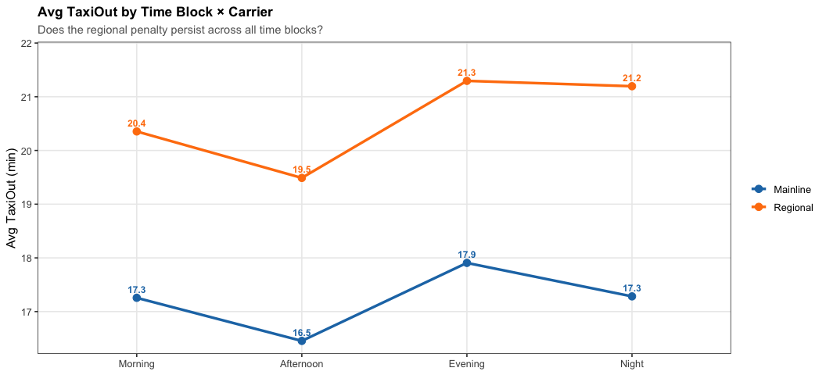
save_chart("p3_taxiout_timeblock.png", w = 11, h = 5)

Stage 2 — OLS Baseline
Simple regression with no airport control — establishes the raw regional penalty before accounting for where flights depart.
df_filtered <- df |> filter(!is.na(TaxiOut), !is.na(Time_Block), !is.na(Distance))
set.seed(42)
df_model <- slice_sample(df_filtered, n = min(200000, nrow(df_filtered)))
# Mainline share per airport — used in Stage 6 favoritism test
mainline_share <- df |>
group_by(Origin) |>
summarise(mainline_share = mean(Carrier_Type == "Mainline", na.rm = TRUE),
.groups = "drop")
df_model <- df_model |> left_join(mainline_share, by = "Origin")
ols <- lm(TaxiOut ~ Carrier_Type + Time_Block + Distance + DayOfWeek, data = df_model)
cat("OLS — Raw Regional Penalty:\n")
## OLS — Raw Regional Penalty:
broom::tidy(ols) |>
filter(str_detect(term, "Carrier|Intercept")) |>
mutate(across(where(is.double), \(x) round(x, 4))) |>
print()
## # A tibble: 2 × 5
## term estimate std.error statistic p.value
## <chr> <dbl> <dbl> <dbl> <dbl>
## 1 (Intercept) 15.5 0.0709 219. 0
## 2 Carrier_TypeRegional 4.07 0.0515 79.1 0

Stage 3 — Mixed-Effects Model
(1 | Origin) gives every airport its own baseline taxi-out time, stripping out congestion differences before estimating the carrier effect.
lmer_fit <- lmer(TaxiOut ~ Carrier_Type + Time_Block + Distance + (1 | Origin),
data = df_model, REML = TRUE)
cat("Mixed-Effects — True Regional Penalty:\n")
## Mixed-Effects — True Regional Penalty:
broom.mixed::tidy(lmer_fit, effects = "fixed") |>
filter(str_detect(term, "Carrier|Intercept")) |>
mutate(across(where(is.double), \(x) round(x, 4))) |>
print()
## # A tibble: 2 × 7
## effect term estimate std.error statistic df p.value
## <chr> <chr> <dbl> <dbl> <dbl> <dbl> <dbl>
## 1 fixed (Intercept) 14.0 0.177 79.1 348. 0
## 2 fixed Carrier_TypeRegional 3.49 0.054 64.7 189035. 0

Stage 4 — Fixed Effects Comparison
Side-by-side: how much does the regional penalty shrink once airport congestion is controlled?
ols_fe <- broom::tidy(ols, conf.int = TRUE) |> mutate(model = "OLS")
lmer_fe <- broom.mixed::tidy(lmer_fit, effects = "fixed", conf.int = TRUE) |>
mutate(model = "Mixed-Effects")
fe_combined <- bind_rows(ols_fe, lmer_fe) |>
filter(str_detect(term, "Carrier|Time_Block")) |>
mutate(term = str_remove(term, "Carrier_Type|Time_Block"),
term = if_else(term == "", "Regional", term))
ggplot(fe_combined, aes(estimate, reorder(term, estimate), colour = model, shape = model)) +
geom_vline(xintercept = 0, linetype = "dashed", color = "grey50") +
geom_errorbar(aes(xmin = conf.low, xmax = conf.high),
orientation = "y", width = 0.25, lwd = 0.8,
position = position_dodge(0.5)) +
geom_point(size = 3, position = position_dodge(0.5)) +
scale_colour_manual(values = c(OLS = "#1f77b4", "Mixed-Effects" = "#d62728"), name = NULL) +
scale_shape_manual(values = c(OLS = 16, "Mixed-Effects" = 17), name = NULL) +
labs(title = "Fixed Effects: OLS vs Mixed-Effects",
subtitle = "Shrinkage in the Regional coefficient = portion explained by airport congestion",
x = "Coefficient (minutes of TaxiOut)", y = NULL) +
theme(legend.position = "bottom")
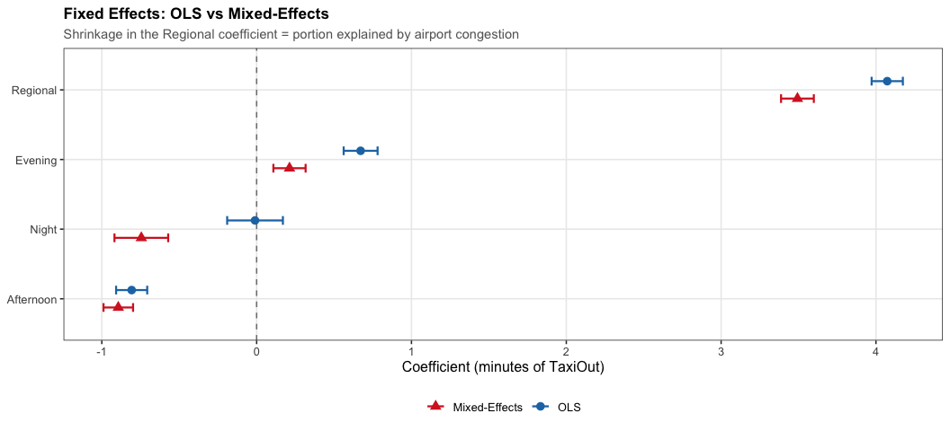
save_chart("p3_fixed_effects.png", w = 11, h = 5)
cat("\nRegional penalty — before vs after airport control:\n")
##
## Regional penalty — before vs after airport control:
bind_rows(
ols_fe |> filter(term == "Carrier_TypeRegional") |> select(model, estimate, conf.low, conf.high),
lmer_fe |> filter(term == "Carrier_TypeRegional") |> select(model, estimate, conf.low, conf.high)
) |> mutate(across(where(is.double), \(x) round(x, 3))) |> print()
## # A tibble: 2 × 4
## model estimate conf.low conf.high
## <chr> <dbl> <dbl> <dbl>
## 1 OLS 4.07 3.97 4.17
## 2 Mixed-Effects 3.49 3.39 3.60

Stage 5 — Airport Congestion Ranking
Which airports impose the most baseline congestion on all carriers, regardless of carrier type?
re <- ranef(lmer_fit)$Origin |>
rownames_to_column("Origin") |>
rename(intercept = `(Intercept)`) |>
arrange(desc(intercept))
re_plot <- bind_rows(slice_head(re, n = 15), slice_tail(re, n = 15)) |>
mutate(Origin = fct_reorder(Origin, intercept),
direction = if_else(intercept > 0, "Above average", "Below average"))
ggplot(re_plot, aes(intercept, Origin, fill = direction)) +
geom_col(alpha = 0.85) +
geom_vline(xintercept = 0, lwd = 0.6) +
geom_text(aes(label = sprintf("%+.1f", intercept),
hjust = if_else(intercept > 0, -0.15, 1.15)),
size = 3.2, fontface = "bold") +
scale_fill_manual(values = c("Above average" = "#d62728", "Below average" = "#2ca02c"),
name = NULL) +
scale_x_continuous(expand = expansion(mult = c(0.15, 0.15))) +
labs(title = "Airport Random Intercepts — Baseline Congestion",
subtitle = "Top 15 most congested vs bottom 15 least congested",
x = "Minutes above/below grand mean TaxiOut", y = NULL) +
theme(legend.position = "top")
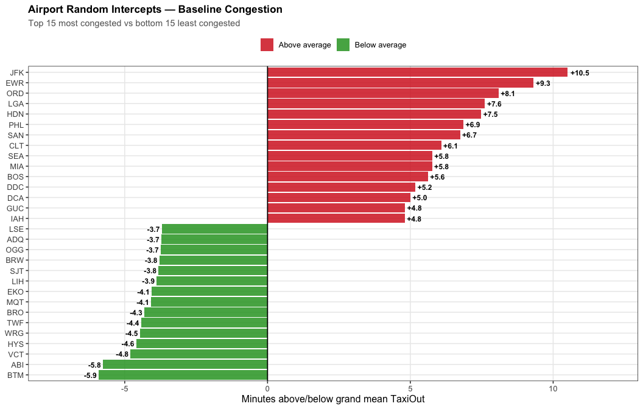
save_chart("p3_random_effects.png", w = 11, h = 7)
cat("\nTop-10 most congested airports:\n")
##
## Top-10 most congested airports:
re |> slice_head(n = 10) |> mutate(intercept = round(intercept, 3)) |> print()
## Origin intercept
## 1 JFK 10.512
## 2 EWR 9.319
## 3 ORD 8.088
## 4 LGA 7.612
## 5 HDN 7.477
## 6 PHL 6.860
## 7 SAN 6.741
## 8 CLT 6.082
## 9 SEA 5.765
## 10 MIA 5.764

Stage 6 — Favoritism Test
The mixed-effects model proves a gap, not favoritism. This test checks whether the regional penalty gets worse specifically at airports where mainline carriers dominate — the signature of active prioritization.
lmer_interact <- lmer(
TaxiOut ~ Carrier_Type * mainline_share + Time_Block + Distance + (1 | Origin),
data = df_model, REML = TRUE
)
## Warning: Some predictor variables are on very different scales: consider rescaling.
## You may also use (g)lmerControl(autoscale = TRUE) to improve numerical stability.
## Warning: Some predictor variables are on very different scales: consider rescaling.
## You may also use (g)lmerControl(autoscale = TRUE) to improve numerical stability.
cat("Interaction: Carrier_Type × Mainline Share:\n")
## Interaction: Carrier_Type × Mainline Share:
broom.mixed::tidy(lmer_interact, effects = "fixed", conf.int = TRUE) |>
filter(str_detect(term, "Carrier|mainline")) |>
mutate(across(where(is.double), \(x) round(x, 4))) |>
print()
## # A tibble: 3 × 9
## effect term estimate std.error statistic df p.value conf.low conf.high
## <chr> <chr> <dbl> <dbl> <dbl> <dbl> <dbl> <dbl> <dbl>
## 1 fixed Carrier… 2.94 0.232 12.7 1.09e5 0 2.49 3.39
## 2 fixed mainlin… 0.357 0.519 0.689 5.59e2 0.491 -0.662 1.38
## 3 fixed Carrier… 0.840 0.334 2.51 1.03e5 0.012 0.185 1.50
# Airport-level gap: Regional minus Mainline avg TaxiOut, at shared airports
airport_gap <- df |>
filter(!is.na(TaxiOut)) |>
group_by(Origin, Carrier_Type) |>
summarise(mean_taxi = mean(TaxiOut, na.rm = TRUE), .groups = "drop") |>
pivot_wider(names_from = Carrier_Type, values_from = mean_taxi) |>
filter(!is.na(Mainline), !is.na(Regional)) |>
mutate(gap = Regional - Mainline) |>
left_join(mainline_share, by = "Origin")
ggplot(airport_gap, aes(mainline_share, gap)) +
geom_hline(yintercept = 0, linetype = "dashed", color = "grey50") +
geom_point(alpha = 0.6, color = "#1f77b4", size = 2) +
geom_smooth(method = "lm", formula = "y ~ x", se = TRUE,
color = "#d62728", fill = "#d62728", alpha = 0.15, lwd = 1.2) +
geom_text_repel(
data = airport_gap |> filter(gap > quantile(gap, 0.92) | mainline_share > 0.90),
aes(label = Origin), size = 3.2, fontface = "bold",
box.padding = 0.4, max.overlaps = 15
) +
scale_x_continuous(labels = percent_format()) +
labs(title = "Regional Taxi-Out Penalty vs Mainline Hub Dominance",
subtitle = "Upward slope = penalty grows where mainline carriers dominate",
x = "Mainline share of flights at airport", y = "Regional − Mainline TaxiOut gap (min)")
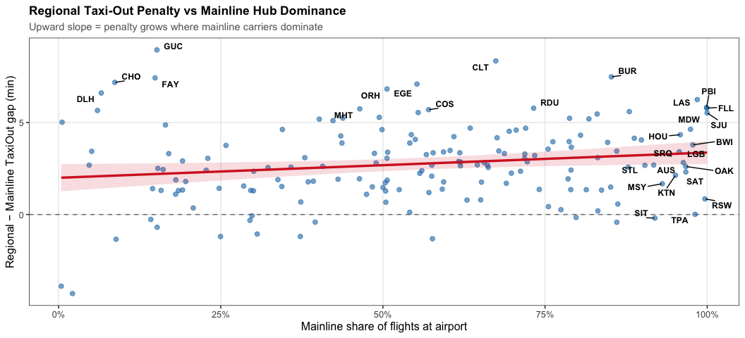
save_chart("p3_favoritism.png", w = 11, h = 5)
cat(sprintf("\nCorrelation (gap ~ mainline_share): r = %.3f\n",
cor(airport_gap$gap, airport_gap$mainline_share, use = "complete.obs")))
##
## Correlation (gap ~ mainline_share): r = 0.172

Summary
re_ols <- broom::tidy(ols) |> filter(term == "Carrier_TypeRegional")
re_lmer <- broom.mixed::tidy(lmer_fit, effects = "fixed") |>
filter(term == "Carrier_TypeRegional")
re_interact <- broom.mixed::tidy(lmer_interact, effects = "fixed") |>
filter(term == "Carrier_TypeRegional:mainline_share")
cat("PILLAR 3 — RESULTS SUMMARY\n")
## PILLAR 3 — RESULTS SUMMARY
cat(sprintf("Flights in model : %s\n", format(nrow(df_model), big.mark = ",")))
## Flights in model : 200,000
cat(sprintf("Airports (random eff) : %d\n", n_distinct(df_model$Origin)))
## Airports (random eff) : 321
cat(sprintf("\nRaw regional penalty : +%.3f min (OLS)\n", re_ols$estimate))
##
## Raw regional penalty : +4.073 min (OLS)
cat(sprintf("True regional penalty : +%.3f min (mixed-effects)\n", re_lmer$estimate))
## True regional penalty : +3.493 min (mixed-effects)
cat(sprintf("Explained by airports : %.1f%%\n",
(1 - re_lmer$estimate / re_ols$estimate) * 100))
## Explained by airports : 14.2%
cat(sprintf("\nFavoritism interaction: %.4f (p = %.4f)\n",
re_interact$estimate, re_interact$p.value))
##
## Favoritism interaction: 0.8402 (p = 0.0120)
cat(sprintf("Interpretation : %s\n",
if (re_interact$p.value < 0.05 & re_interact$estimate > 0)
"SIGNIFICANT — penalty grows at mainline-dominated hubs"
else if (re_interact$p.value < 0.05 & re_interact$estimate < 0)
"SIGNIFICANT — penalty shrinks at mainline-dominated hubs"
else "NOT SIGNIFICANT — penalty is uniform across hub types"))
## Interpretation : SIGNIFICANT — penalty grows at mainline-dominated hubs
cat(sprintf("\nICC (airport variance) : %.1f%% of total TaxiOut variance\n",
as.data.frame(VarCorr(lmer_fit))$vcov[1] /
sum(as.data.frame(VarCorr(lmer_fit))$vcov) * 100))
##
## ICC (airport variance) : 8.8% of total TaxiOut variance

