CS 303 – Data Structures

Dr. Mohammed Kuhail

Project 2A

Nathaniel Barnett – Adam Bergman – Urvish Shah

University of Missouri – Kansas City

UML DIAGRAM  
  
  
  
  
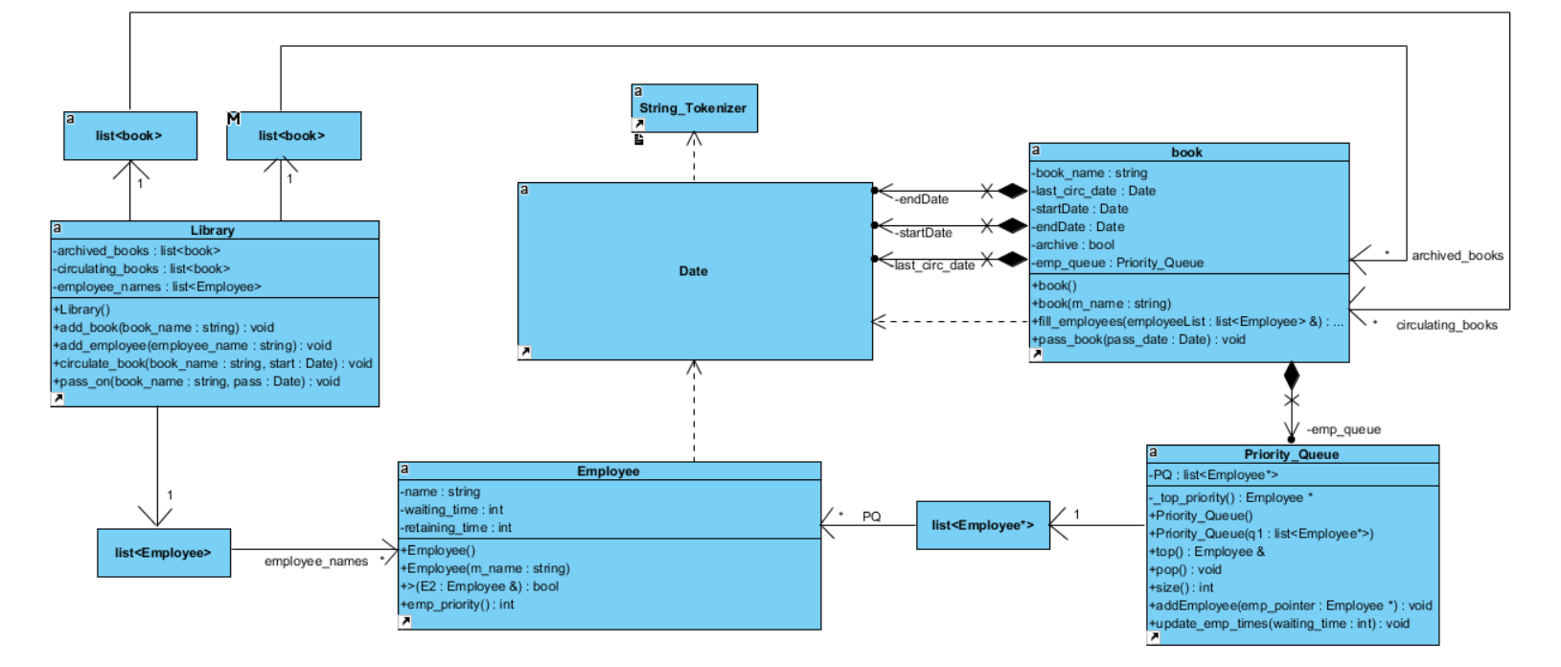

**BIG-O:**  
  
**Priority Queue class:**  
  
Employee* _top_priority();  
  
- O(n)  
  
void update_emp_times(int waiting_time);  
  
- O(n)  
  
**Book class:**  
void fill_employees(list<Employee>& employeeList);  
  
- O(n)  
  
  
  
  
  
  
  
  
  
  
  
  
  
  
References:  
  
  
<http://stackoverflow.com/questions/19535644/how-to-use-the-priority-queue-stl-for-objects>