**How to Run Test Cases in Selenium Grid**

* **To run the test cases on Selenium Grid, you need to download and install JDK, Eclipse, Selenium WebDriver, TestNG and related browsers in respective nodes.**

**What is Selenium Grid?**

* Selenium Grid allows you to run your tests on different machines against different browsers in parallel. That is, running multiple tests at the same time against different machines running different browsers and operating systems. Essentially, Selenium Grid supports distributed test execution. It allows for running your tests in a distributed test execution environment.

**What is a hub?**

* A hub is the central point that receives test requests and distributes them to the right nodes. The distribution is done on a capabilities basis, meaning a test requiring a set of capabilities will only be distributed to nodes offering that set or subset of capabilities.
* There should only be one hub in a grid. The hub is launched only on a single machine, the machine containing the hub is where the tests will be run, but you will see the browser being automated on the node.

**What is a node?**

* Nodes are the Selenium instances that will execute the tests that you loaded on the hub. There can be one or more nodes in a grid. Nodes can be launched on multiple machines with different platforms and browsers. The machines running the nodes need not be the same platform as that of the hub.

**In this documentation, you will see how to run the test cases on a grid. Here are 1 hub and 2 nodes.**

|  |  |  |  |  |  |
| --- | --- | --- | --- | --- | --- |
| **Machine Name** | **VM** | **OS cong.** | **ID** | **Password** | **Browser[version]** |
| Hub | IST00263 | WIN 8 | AVWORLD\seleniumgrid | AutomateThis | ----- |
| Node | IST00266 | WIN 8.1 | AVWORLD\seleniumgrid | AutomateThis | Chrome [47.0] |
| Node | IST00405 | WIN 10 | AVWORLD\seleniumgrid | AutomateThis | Firefox [34.0] |
| Node Future | Your machine | Win 8.1 |  |  | Internet explorer [11] |
| Node  Future | Vcenter (<http://vcenter.esri.com>) | OSX-10.10 | AVWORLD\seleniumgrid | AutomateThis | Safari [8.0] |

To run the test case on the grid follow below procedure:

**1). Start Hub [IST00263]**

**Go to Remote Desktop Connection 🡪 Enter VM #, fill out the name and password and run the VM [HUB].**

On your desktop, you will find a ‘Start hub’ icon which is the batch file for the hub. Double click the icon to start the Hub.

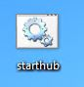

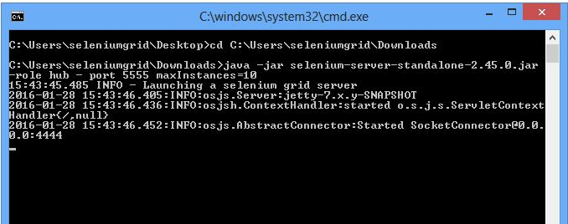

Don’t close the command prompt, just minimize it; otherwise node will not connect to the hub.

When you launch the Selenium Standalone Server in Hub role, it starts accepting to nodes and Selenium tests on port 4444. If you browse to [**http://localhost:4444/grid/console**](http://localhost:4444/grid/console)on the Hub machine, it will display the following information in the browser. It means hub is started.

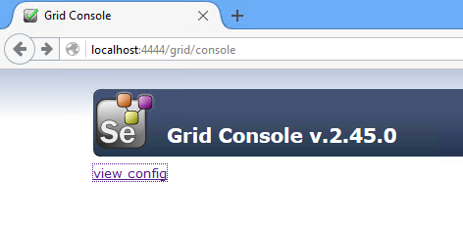

Now, click the ‘view config’ link. It displays the configuration details of the Hub. (As shown in the below figure)

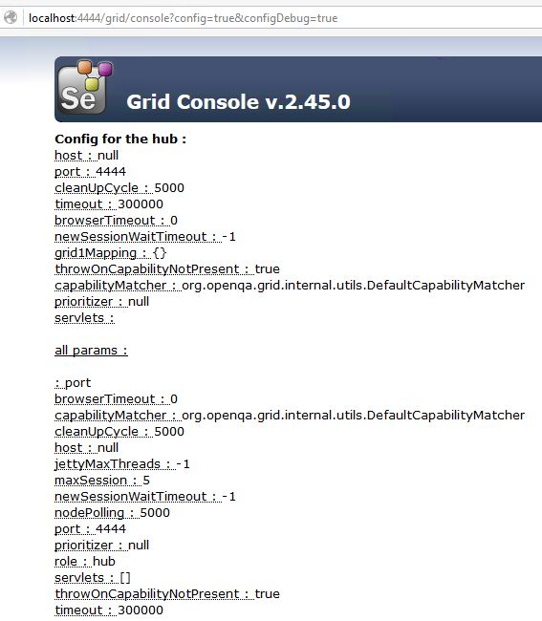

By default the Hub provides 5 sessions on the server.

**2). Adding Node to Selenium Hub**

**In order to run the test cases on different environments we need to connect them to the hub.**

After starting the hub, add the node to the Selenium hub to run the test cases on different environments. The grid gives the order to the node for the steps. And then the test cases will start performing.

Below are the details of the node for the respective browser:

If you want to run your tests in Chrome 🡪 use node # IST00266

If you want to run your tests in Firefox 🡪 use node # IST00405

* **Add Node #IST00266 (For Chrome):**

On your local machine, connect to Remote Desktop Connection 🡪 Enter VM # [IST00266], fill out name and password and run the VM [NODE].

Now, you will find a ‘node.bat’ icon on your desktop. Double click the icon to open or start the node.

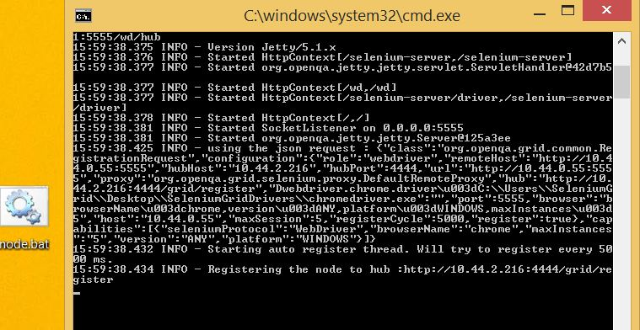

You will see a command prompt opened. Minimize it (please make sure that the node is connected to the hub).

Go to the Selenium Grid web interface and refresh the page. You should see something as below figure.

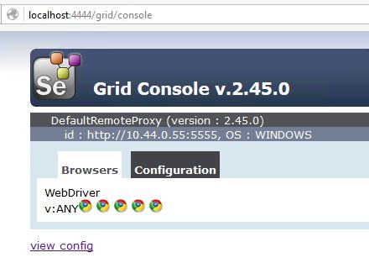

Here you can see a Chrome driver, as it is configured to Chrome driver in IST00066.

* **Add Node #IST00405 (For Firefox):**

Similarly now connect 2nd node [IST00405 for Firefox]. Go back to your local machine

On your machine connect to Remote Desktop Connection 🡪 Enter VM # [IST405], fill out name and password and start the VM [NODE].

You will find a ‘node.bat’ icon your desktop. Double click the icon to open or start the node. You should see something as below figure.

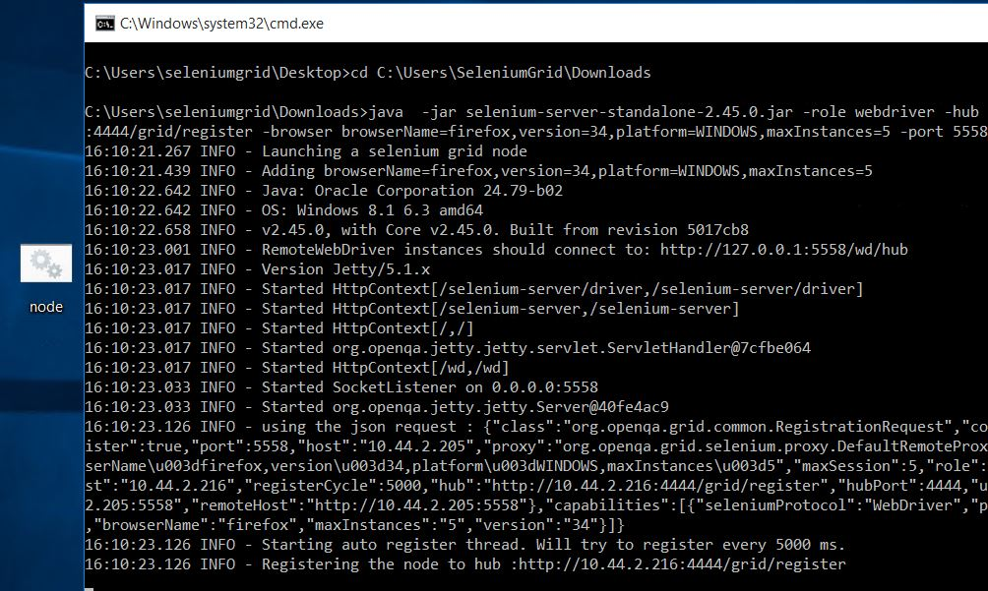

Then**,** go back to the hub and check whether both the nodes are connected. If you didn’t find it, just refresh the page or URL. If you see below screenshot, you are successfully done with the Selenium Grid connection between hub and node**.**

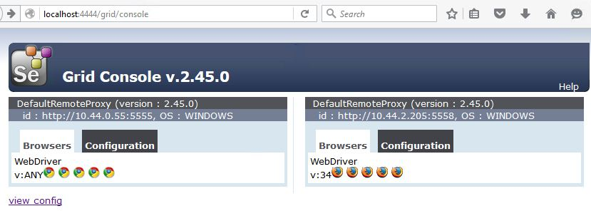

**3). How to Get Test Case and How to Run**

Open hub on your desktop and start ‘Eclipse Java Mars’. Go to Project. Once you open Eclipse you will get the below view with a list of projects.

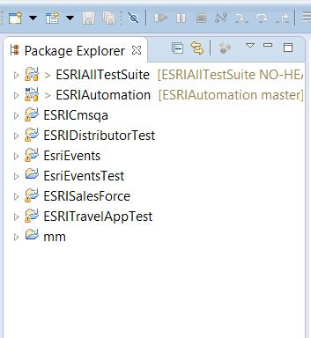

Select your related project and double click it. For the test case you need to double-click the **Project (**ESRICmsqa**)** -🡪 click **src** folder🡪-click the **Package (**com.esri.cmsqa.test**)**

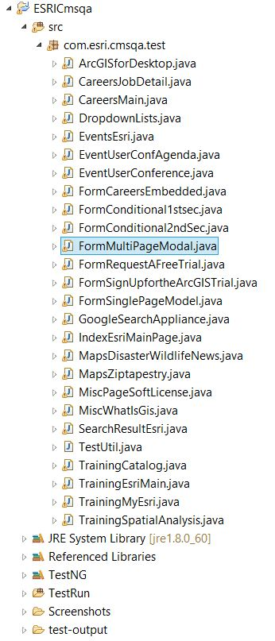

Once you open the Package, you will find all the test cases. Select the related test case and double click to open it (as shown in the below figure).

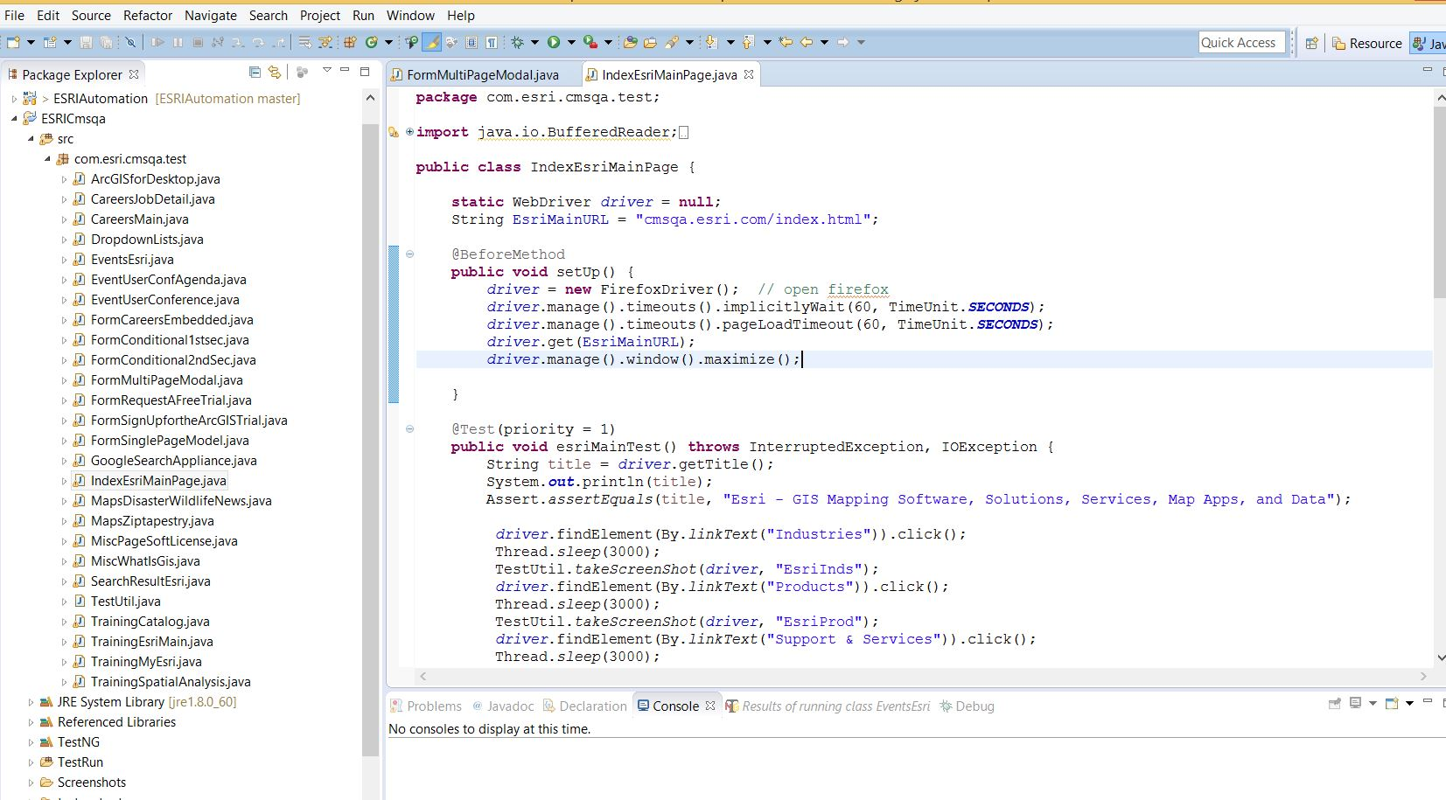

**To Run the Test Case Follow the Below Option:**

To run the entire test automation suite:

Go to **Project** – Open **Test Run folder** (where testng.xml file is present) -🡪right-click it – click **Run As,** then click **TestNG Suite**.

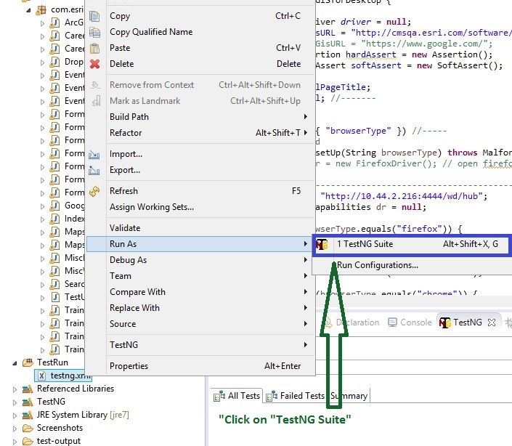

It will start running all the test Java files one by one.

**4). How to Get Report:**

To get the Report, wait until all test cases are completed. TestNG will give you an HTML report.

Console: you will get simple report.

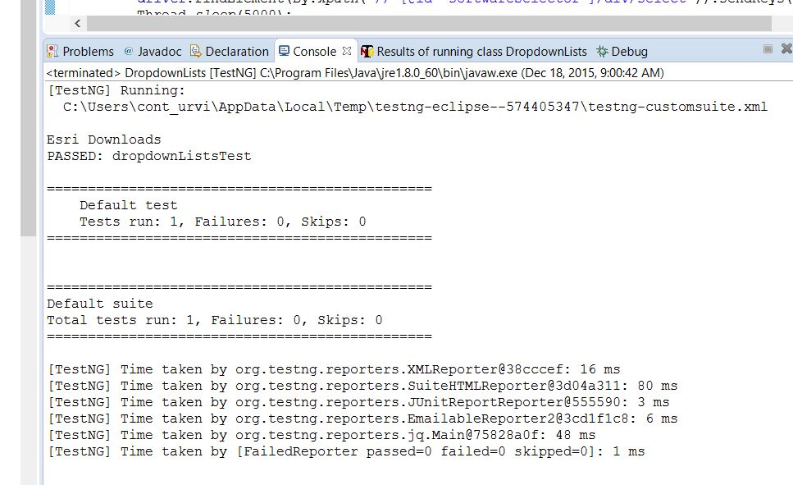

Result of test case: in this section you will get some more details about your test.

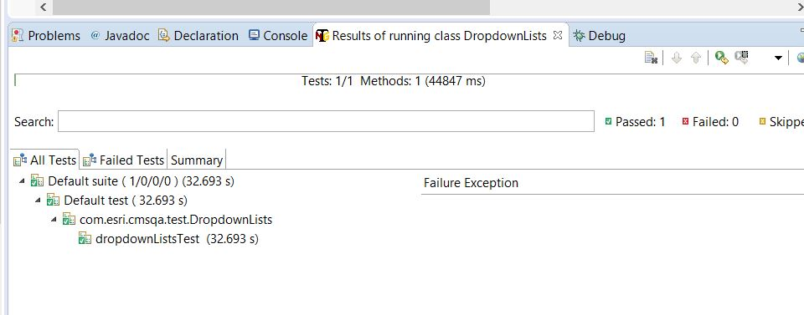

For HTML report, once test cases are completed just right-click **project name**🡪 **Refresh** 🡪double-click **test-output folder** 🡪 click **index.html**

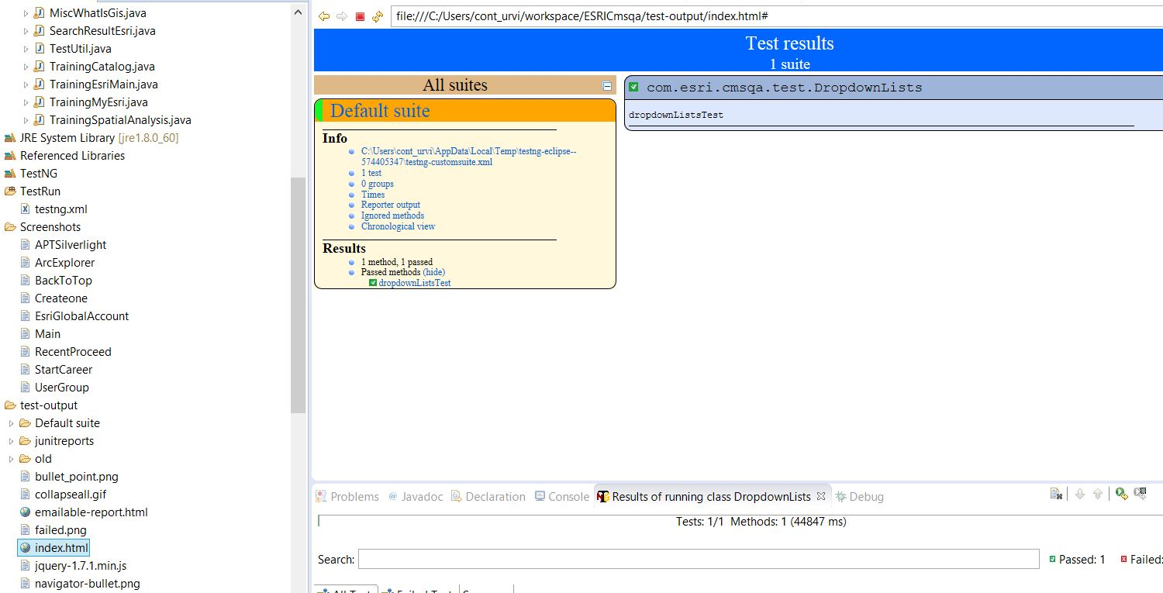

Or get a path of the **index.html file**. Copy and paste it in Firefox (or any browser).