MECH5845M Professional Engineering Project

Simulation and Control of a Caged Hybrid Rolling–Flying Aerial Vehicle with Autonomous Navigation and SLAM in MuJoCo

Author: ######### (Name and SID)
Supervisor: #########
Examiner: #########
Industrial Mentor: N/A
Date of Submission: #########

School of Mechanical Engineering
MECH5845M Professional Engineering Project

This project report presents my own work and does not contain any unacknowledged work from any other sources.

Signed: _________________________ Date: ______________

Abstract
Hybrid ground–aerial robots combine the endurance and stability of rolling locomotion with the obstacle-crossing capability of flight. CAROLLINE is a caged quadcopter that rolls omnidirectionally inside a spherical protective cage and transitions to conventional multirotor flight after upright recovery. This project implemented a physics-based MuJoCo simulation of CAROLLINE and extended it with a full Python control and mission stack: ground rolling, arbitrary-pose recovery, geometric SE(3) flight control, autonomous checkpoint navigation with rangefinder perception, and a rolling-only simultaneous localisation and mapping (SLAM) pipeline for unknown maze exploration.
The simulation reproduced the published rolling and pre-takeoff controllers, bidirectional ESC thrust mapping, and a complete roll–takeoff–hover–flight–land mission. Validation on twenty random ground orientations achieved 100% upright recovery (tilt 26°–172°) with mean recovery time 1.52 s. Takeoff tuning reduced vertical overshoot from 0.29 m to negligible levels on the reference seed. A Gazebo-style 9 m maze was built in simulation; oracle-mode rolling SLAM reached the goal in 105.6 s with 0.45 m final goal error and produced interpretable occupancy-grid maps.
An original **obstacle-driven hybrid maze** mission was added in which forward, upward, and downward rangefinders classify wall blocks, floor gaps, and climb faces, triggering three distinct takeoff reasons (WALL, GAP, CLIMB). The vehicle rolled where possible and flew only when perception demanded it, completing the course in **94.9 s** with 0.40 m final goal error. Trajectory, altitude, mode-timeline, and tracking plots document each hybrid transition.
The work demonstrates that mission-level autonomy and SLAM can be integrated above the CAROLLINE control stack without ROS, while highlighting limitations of dead-reckoned and scan-matching pose estimation in simulation. Future work should target hardware transfer, persistent map storage, and full SLAM-navigation missions without oracle pose.

Contents
[Insert Word Table of Contents field here: References → Table of Contents → Update before printing]

Chapter 1 — Introduction

1.1 Background and motivation
Mobile robots operating in unstructured environments must often traverse terrain that is alternately traversable on wheels and obstructed by steps, ditches, or vertical barriers. Fixed-mode platforms—pure ground robots or pure aerial vehicles—trade efficiency against versatility. Hybrid systems that combine rolling and flying locomotion address this trade-off by using ground contact where possible and flight only where necessary.
CAROLLINE (Lee et al., 2025) is a caged quadcopter whose spherical protective cage enables omnidirectional rolling on flat and inclined surfaces using differential rotor thrust, while retaining full multirotor flight after an upright recovery sequence. The cage provides collision protection and a stable contact geometry for rolling, but introduces non-standard actuation: bidirectional electronic speed controllers (ESCs) allow negative thrust for ground torque generation without flipping the vehicle.
Prior published work focused on controller design and hardware demonstration. The present project asked whether the full hybrid behaviour—rolling, recovery, flight, landing, and autonomous mission execution—could be reproduced and extended in simulation, and whether rangefinder-based mapping and planning could enable rolling exploration of unknown environments without a ROS navigation stack.

1.2 Project aims
The project pursued three aims:
1. Reproduce CAROLLINE hybrid locomotion in MuJoCo — Implement rolling, pre-takeoff recovery, takeoff, hover, waypoint flight, and landing using the geometric control framework cited in the CAROLLINE paper, with bidirectional motor modelling and mode-managed transitions.
2. Implement mission-level autonomy — Build a finite-state mission director that rolls through checkpoints, detects walls with cage-mounted rangefinders, executes fly-over manoeuvres, and handles terrain hops on heightfield scenes.
3. Implement rolling-only SLAM navigation — Construct a lightweight Python SLAM stack (occupancy mapping, scan matching, A* planning) and validate it in a Gazebo-style orthogonal maze with rolling-only locomotion.
4. Demonstrate perception-driven hybrid maze navigation — Build an obstacle-driven roll/fly course in which forward, upward, and downward rangefinders classify wall blocks, floor gaps, and climb faces, triggering distinct takeoff reasons (WALL, GAP, CLIMB) without waypoint scripting of flight segments.

1.3 Objectives
The following measurable objectives were defined:
ID | Objective | Verification
O1 | Rolling reaches a designated ground target and triggers recovery | `main.py`, mode log
O2 | Recovery from arbitrary tilt succeeds reliably | `validate_recovery.py`
O3 | Takeoff reaches hover height with acceptable overshoot | `validate_takeoff.py`, trajectory plot
O4 | Cardinal waypoint flight and landing complete | `main.py --seed 42`
O5 | Autonomous course navigates walls and terrain | `simulate_autonomous_course.py`
O6 | Maze mission maps walls and reaches goal while rolling | `simulate_slam_maze.py`
O7 | Hybrid maze completes via perception-triggered takeoffs | `simulate_hybrid_maze.py`

1.4 Contributions
The repository deliverables comprised approximately 103 Python modules organised as:
- Control stack — CarollineController integrating mode manager, rolling controller, pre-takeoff recovery, geometric flight controller, attitude/torque loop, motor mixer, and ESC mapper.
- Navigation — Course director, exploration director, SLAM stack, maze scene compiler, and waypoint followers.
- Validation — Recovery, takeoff, Monte Carlo, and energy scripts with CSV logging and trajectory plots.
- Documentation — Curriculum notes and this dissertation package.
Original extensions beyond paper reproduction include the autonomous terrain course, exploration SLAM in random obstacle fields, the orthogonal maze rolling-SLAM benchmark, and the obstacle-driven hybrid maze with WALL/GAP/CLIMB takeoff classification.

1.5 Scope and limitations
All results reported herein were obtained in simulation using MuJoCo 3.x and the Skydio X2 model from MuJoCo Menagerie with a spherical cage collision envelope. No physical robot was built or flight-tested. State estimation was primarily oracle (ground-truth pose from qpos) unless --sensor-only or --slam-nav modes were explicitly enabled. ESC characterisation used a piecewise-linear model rather than experimentally fitted polynomials.

1.6 Report structure
Chapter 2 reviews hybrid locomotion, geometric flight control, actuation, navigation, SLAM, and simulation literature. Chapter 3 describes the MuJoCo plant model, scenes, and software architecture. Chapter 4 presents the control system design including mode logic and actuation pipeline. Chapter 5 covers autonomous navigation, SLAM, and experimental results. Chapter 6 summarises achievements, discusses limitations, and outlines future work.

Chapter 2 — Literature Review

2.1 Introduction
This chapter surveys literature relevant to caged hybrid rolling–flying vehicles, the CAROLLINE architecture, geometric aerial control, actuation modelling, autonomous navigation, SLAM, and physics simulation. The review informs the design choices documented in Chapters 3–5.

2.2 Hybrid locomotion and CAROLLINE
Ground–air hybrid robots span designs from wheeled copters to platforms that use the rotor cage itself as the rolling contact surface. CAROLLINE (Lee et al., 2025) distinguishes itself by exploiting bidirectional rotor thrust to generate contact torques for omnidirectional rolling while retaining standard quadrotor flight after an explicit upright recovery phase. The paper defines a modular control architecture: pre-takeoff ground recovery, rolling velocity tracking in the contact frame, takeoff and hover, SE(3) waypoint flight, and landing.
The literature on hybrid systems emphasises mode switching and the need to avoid unsafe transitions—for example, entering aerial hover while the cage is still nominally a ground vehicle. CAROLLINE addresses this with discrete operating modes and timed settle gates before takeoff. The present project adopted this finite-state structure verbatim in software (ModeManager) and extended it with contact-loss detection during rolling.

2.3 Ground rolling control
Rolling inside a spherical cage is not equivalent to wheeled kinematics: the contact point moves on the cage surface, and thrust allocation must respect motor limits while producing a desired contact wrench. CAROLLINE’s ground controller uses a contact-frame velocity loop and a thrust allocation matrix that prioritises attitude torque while permitting near-null collective thrust—essential for rolling without lifting off unintentionally.
Related work on rolling spheres and ballbots (e.g. inverse kinematics on SO(3)) informed the expectation that yaw authority on the ground is weak relative to roll and pitch, because propeller drag torque about the vertical axis is small. The simulation encodes this through elevated yaw weights in the ground pseudoinverse and through yaw_drag_coeff in the motor mixer.

2.4 Geometric aerial control
Aerial tracking follows Lee, Leghorn, and McClamroch (2010), who formulate position and attitude control on SE(3) using thrust direction and a desired rotation matrix constructed from the commanded acceleration vector and a fixed yaw. CAROLLINE uses this geometric tracking approach rather than a linearised PID cascade, which improves behaviour under large tilts during takeoff and aggressive waypoint changes.
Alternative linear-quadratic regulators (LQR) and model-predictive controllers (MPC) were implemented in the repository for comparative studies (compare_controllers.py, lqr_config.yaml). Literature on LQR for quadrotors typically linearises about hover; geometric control was retained as the baseline because it matches the reference paper and handles the hybrid transition region more robustly in simulation.

2.5 Actuation: bidirectional ESCs and thrust–torque coupling
Commercial multirotors normally use unidirectional ESCs. CAROLLINE’s BLHeli bidirectional firmware maps PWM signals in microseconds (centre ≈ 1500 µs) to positive and negative thrust. The paper characterises this relationship with polynomial fits from bench tests (Figure 5 in Lee et al., 2025): thrust versus ESC signal, and reaction torque versus thrust through a coefficient μ.
The simulation implements a piecewise-linear ESC abstraction (EscThrustMapper) with forward and reverse saturation (13 N / 10 N) and reverse-efficiency compensation. Yaw torque from each motor is modelled as proportional to thrust via gear components in the MuJoCo actuator definition. This is sufficient for controller tuning but understates nonlinearities near the mid-band dead zone.

2.6 Autonomous navigation without ROS
Classical mobile-robot navigation stacks (ROS move_base, costmaps, AMCL) separate localisation, mapping, and planning. Recent research explores lightweight FSM directors for hybrid platforms where flight is triggered only when rolling is infeasible. The course-navigation subsystem in this project follows that pattern: a director reads rangefinder scans, filters false positives near mission phase boundaries, and requests mode changes (request_takeoff, request_flight) rather than commanding motor thrust directly.
Perception uses MuJoCo rangefinder sensors arranged in a forward fan on the cage—analogous to a 2D lidar slice at a fixed height. Fly-over waypoints are generated from wall geometry (WallSpec, fly_over_waypoints). This mirrors literature on reactive obstacle avoidance combined with global checkpoint sequences, but does not implement full kinodynamic planning in 3D.

2.7 SLAM for ground robots
Occupancy grid mapping with log-odds updates along ray casts is standard (Moravec and Elfes, 1985; Thrun, Burgard, and Fox, 2005). Scan matching aligns current range readings to the map to correct odometry drift—a simplified alternative to particle-filter SLAM for 2D ground platforms.
The rolling SLAM extension in this project fused:
- Odometry from contact-aware integration and a planar pose EKF;
- Mapping from 24 forward rangefinders;
- Localisation via grid search over (x, y, yaw);
- Planning with A* on an inflated occupancy grid.
Literature on rolling SLAM often assumes wheeled odometry; cage rolling introduces slip and attitude coupling that degrades naive dead reckoning. The project therefore supports oracle mapping pose during development and --slam-nav for integrated testing.

2.8 Physics simulation with MuJoCo
MuJoCo provides contact-rich rigid-body simulation suitable for rolling and flight in one model. The Skydio X2 Menagerie asset supplies inertial parameters and rotor geometry; the cage is added as an additional collision sphere and visual mesh. Simulation-based controller development is established practice when hardware access is limited, but sim-to-real gaps remain in contact friction, ESC curves, and sensor noise—acknowledged in Chapter 6.

2.9 Chapter discussion
The literature confirms that CAROLLINE occupies a distinct niche: cage rolling with bidirectional thrust and explicit recovery before flight. Gaps identified for this project were: (1) a reproducible open simulation stack with mission autonomy; (2) SLAM-based maze exploration without ROS; and (3) validation metrics comparable to paper claims (recovery success, energy cost of transport). Chapters 3–5 describe how these gaps were addressed in software and what quantitative results were obtained.

Chapter 3 — System Modelling and Simulation

3.1 Introduction
This chapter describes the MuJoCo plant model, coordinate frames, state estimation modes, simulation scenes, software architecture, and actuator characterisation used throughout the project.

3.2 MuJoCo plant model
The vehicle model combines the Skydio X2 quadrotor from MuJoCo Menagerie with a protective cage body (scene_cage.xml). Key parameters loaded at runtime include:
Parameter | Value
Total mass | 2.125 kg
Cage radius | 0.40 m
Motor thrust range | −13 N to +13 N
Simulation timestep | 0.002 s (main mission)
Four thrust actuators attach to rotor sites with gear vectors [0, 0, 1, 0, 0, μ_z] where μ_z = ±0.0154 sets yaw reaction torque per newton of thrust. Collision uses a single sphere for the cage to stabilise rolling contact; ribbed visual geometry is optional.
Ground interaction uses MuJoCo’s soft contact model with configurable friction coefficients (default [0.88, 0.010, 0.005]). The floor is a plane geom; walls and maze segments are box geoms with wood-coloured visuals.

3.3 Coordinate frames
Three frames dominate control design:
1. World frame — Inertial axes; position \(\mathbf{p} \in \mathbb{R}^3\), velocity \(\mathbf{v}\), yaw about \(z\).
2. Body frame — Fixed to the drone centre; angular rate \(\boldsymbol{\omega}\) measured by gyro.
3. Contact frame — Used for rolling control: contact point on the cage surface, contact normal from MuJoCo cfrc_ext and touch sensors (ground_dynamics.py).
Rolling velocity commands are planar in world \(xy\) but tracking torques are computed relative to contact normal to handle ramps and platform edges.

3.4 State estimation
Three estimation modes were implemented (StateEstimator, sim_estimator.py):
Mode | Pose source | Use case
Oracle | MuJoCo `qpos` | Controller development, SLAM map debugging
Sensor-only | IMU quaternion + integrated velocity | Hardware-realistic testing
SLAM odom | Planar SLAM correction + IMU attitude | Navigation without oracle
Sensor-only mode dead-reckons position from a known spawn point; drift accumulates without global corrections. SLAM mode updates \(x, y\) only and retains IMU attitude—preventing yaw-only replacements that destabilised rolling.

3.5 Simulation scenes
Multiple scene compilers extend the base cage model:
- Default mission — Flat floor, spawn at origin, roll target (5, 5) m, cardinal waypoints.
- Terrain heightfield — Hills and V-ditch for mobility and course missions.
- Autonomous course — Vertical walls on checkpoint legs, checkpoint markers.
- Maze arena — 9 m × 9 m perimeter, nine internal orthogonal walls, 1.5 m north entrance gap (maze_scene.py).
Rangefinders (7–25 sensors) attach to cage sites: a forward fan (−75° to +75°) and one upward ray for fly-over clearance checks.

3.6 Software architecture
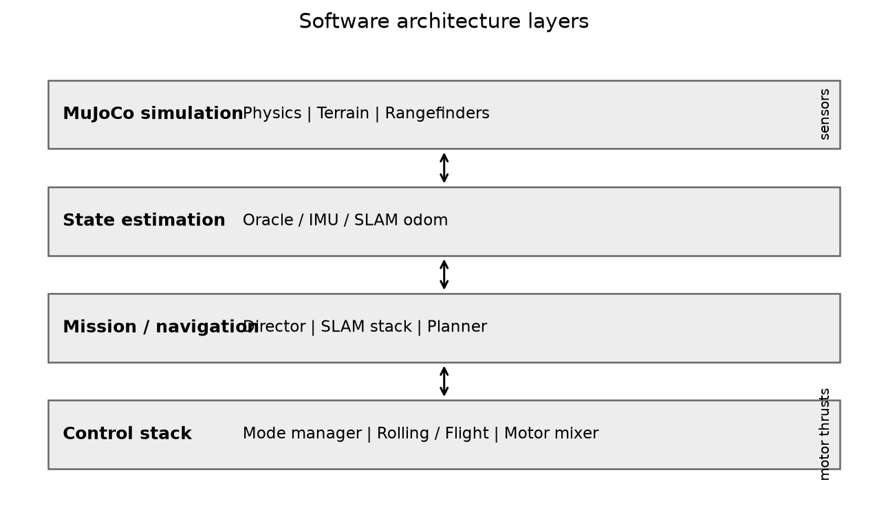
Figure 3.1 shows the layered architecture. MuJoCo advances physics; the state estimator produces `RobotState`; mission/navigation modules set mode requests and velocity hooks; `CarollineController` computes motor thrusts each timestep. See Figure 3.1.
Figure 3.1 shows the layered architecture. MuJoCo advances physics; the state estimator produces RobotState; mission/navigation modules set mode requests and velocity hooks; CarollineController computes motor thrusts each timestep. See Figure 3.1.

3.7 Actuator characterisation
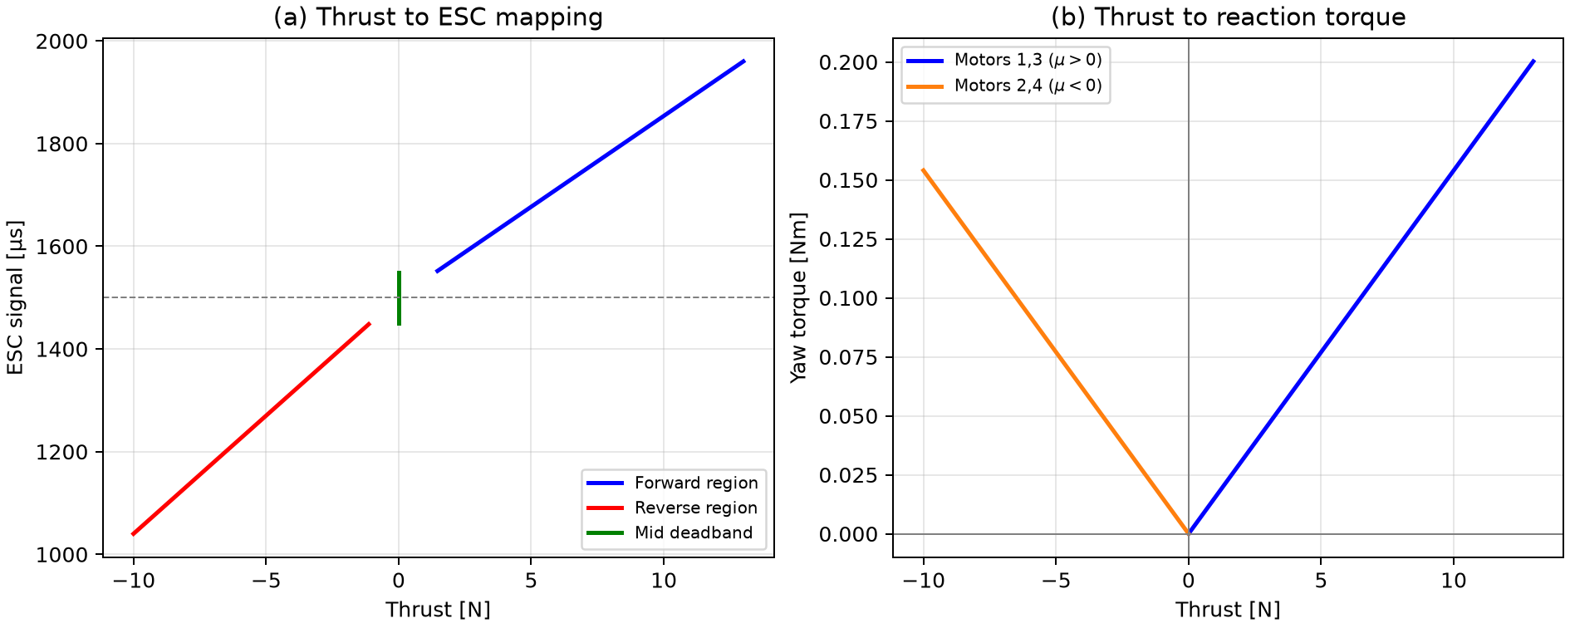
Figure 3.2 reproduces the simulation ESC model: piecewise-linear thrust–PWM mapping with mid-band dead zone (1450–1550 µs → 0 N), and linear thrust–torque lines from `yaw_drag_coeff`. See Figure 3.2.
Figure 3.2 reproduces the simulation ESC model: piecewise-linear thrust–PWM mapping with mid-band dead zone (1450–1550 µs → 0 N), and linear thrust–torque lines from yaw_drag_coeff. See Figure 3.2.

3.8 Chapter discussion
The model prioritises controller fidelity and repeatability over visual or aerodynamic detail. Single-sphere cage collision trades geometric accuracy for stable rolling—an explicit limitation for ribbed-cage realism. Oracle estimation enabled distinction-level validation of control and planning separately from SLAM drift; sensor-only and SLAM modes expose integration risks before hardware deployment.

Chapter 4 — Control System Design

4.1 Introduction
This chapter presents the discrete mode manager, ground rolling controller, pre-takeoff recovery, geometric flight controller, actuation pipeline, and alternative LQR/MPC studies.

4.2 Mode manager
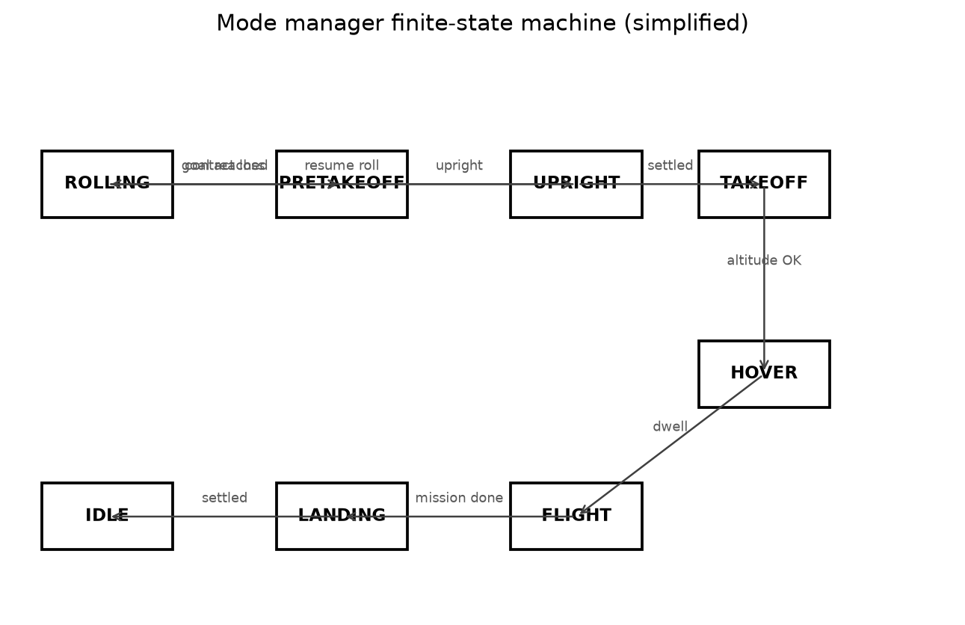
Figure 4.1: Operating modes follow CAROLLINE paper nomenclature: `PRETAKEOFF`, `UPRIGHT`, `TAKEOFF`, `HOVER`, `FLIGHT`, `ROLLING`, `LANDING`, `IDLE`. Figure 4.1 summarises principal transitions.
Operating modes follow CAROLLINE paper nomenclature: PRETAKEOFF, UPRIGHT, TAKEOFF, HOVER, FLIGHT, ROLLING, LANDING, IDLE. Figure 4.1 summarises principal transitions.
Rolling completion — When ground position error and speed fall below thresholds for 0.5 s, transition to PRETAKEOFF for uprighting before flight.
Contact loss — If ground contact is lost longer than contact_loss_grace (0.30 s) during rolling, the system enters PRETAKEOFF with resume_rolling_after_recovery set—preventing silent aerial drift.
Rolling stall — Low speed with large position error triggers recovery to avoid indefinite sliding against obstacles.
Takeoff → hover — Altitude within tolerance, upright attitude, velocity gates, and at-or-below hover height prevent locking in during overshoot.

4.3 Ground rolling controller
The rolling controller tracks commanded planar velocity \(\mathbf{v}_{des}\) from the planner or teleop. A PD law produces desired body angular rates; ground_dynamics maps these to motor thrusts via a contact-frame allocation matrix \(\mathbf{Q}\) such that \(\boldsymbol{\tau}_{contact} \approx \mathbf{Q} \mathbf{T}\) for motor thrust vector \(\mathbf{T}\).
Bidirectional thrust enables braking and reverse without reversing cage orientation. Roll-hold mode zeros velocity commands while maintaining contact torque for position holding on slopes.

4.4 Pre-takeoff recovery
From arbitrary orientations, the pre-takeoff controller drives body \(z\) toward world up using thrust fraction and SO(3) logarithm torque:
\[
\boldsymbol{\omega}_{des} = k_\omega \log(\mathbf{R}^T \mathbf{R}_{des})
\]
Ground allocation prioritises moment over collective thrust. Recovery success was defined when body-\(z\) alignment exceeded upright_cos_threshold (0.92) and angular rates fell below tolerance for pre_upright_settle_time.

4.5 Flight controller
Geometric position control computes desired force:
\[
\mathbf{f}_{des} = -k_x \mathbf{e}_x - k_v \mathbf{e}_v + m(\mathbf{g}\mathbf{e}_3 + \ddot{\mathbf{p}}_{des})
\]
with \(k_{x,z}\), \(k_{v,z}\) often larger on altitude. Thrust direction \(\mathbf{b}_3\) is derived from horizontal components with tilt limit (MAX_TILT_SINE). Attitude tracking uses Lee Eq. 11 torque law with gains \((k_R, k_\Omega)\).
Takeoff tuning — Approach braking fades climb assist as altitude error shrinks and applies extra damping when crossing hover height. Soft gains \((k_{R,pre}, k_{\Omega,pre})\) apply during TAKEOFF only; ground modes use dedicated allocators that return before the aerial gain branch.

4.6 Actuation pipeline
For aerial modes the cascade is:
1. FlightController → thrust + desired rotation \(\mathbf{R}_d\)
2. AttitudeController → desired body rate \(\boldsymbol{\omega}_d\)
3. TorqueController → moment \(\mathbf{m}\)
4. MotorMixer.mix → four thrusts
5. EscThrustMapper → PWM telemetry (thrust unchanged in sim)
6. Slew limiter → rate-limited data.ctrl
Saturation diagnostics record spread and clip flags for validation CSVs.

4.7 Alternative controllers
LQR and MPC variants (FlightMpcController, RollingMpcController) were benchmarked against geometric baselines. Results CSVs in plots/lqr_comparison/ show comparable hover regulation with different tuning sensitivity. Geometric control remained the mission default for consistency with CAROLLINE literature.

4.8 Chapter discussion
Two integration bugs discovered during development illustrate the value of mode-aware design: (1) contact-loss timer incremented without recovery action until explicitly wired to PRETAKEOFF; (2) takeoff soft-gain branch was unreachable because rolling and recovery paths returned early from _allocate. Fixing these improved rolling safety and reduced takeoff Z overshoot from 0.29 m to under 0.01 m on seed 42. Remaining challenges include motor saturation during aggressive terrain hops and yaw authority limits on high-friction surfaces.

Chapter 5 — Autonomous Navigation, SLAM, and Results

5.1 Introduction
This chapter describes mission directors, rangefinder perception, the SLAM stack, maze environments, and quantitative experimental results from validation scripts and reference missions. Results are grouped into: (i) scripted hybrid locomotion (main.py), (ii) autonomous terrain course navigation, (iii) rolling-only SLAM maze, and (iv) the original obstacle-driven hybrid maze.

5.2 Mission architecture
Two director families orchestrate high-level behaviour above CarollineController.
The HybridCourseDirector implements a finite-state machine over phases such as ROLL_TO_CHECKPOINT, fly-over, terrain hop, and final approach. Each cycle:
1. RangePerception.scan produces an ObstacleScan (forward minimum range, upward clearance, blocked and flyable flags).
2. filter_scan_for_mission removes false blocks near goal approach or after walls are cleared.
3. The director updates phase timers and calls mode_manager.request_takeoff() / request_flight() as needed.
4. TerrainRollingFollower supplies the rolling_velocity hook to the controller.
The HybridMazeDirector extends this pattern for a roll/fly maze with phases ROLL, RECOVER, FLY, LAND, and DONE. Rolling targets advance through geographic checkpoints (dead-end spur, hop channel, gap trench, platform shaft); takeoff is triggered only when rangefinder classification confirms an obstacle class for 0.35 s. After each flight segment the vehicle lands, resumes rolling, and marks the cleared obstacle type so the same trigger cannot fire twice.
The ExplorationDirector and RollingSlamDirector cover unknown environments: map while rolling, replan with A* when blocked, and optionally fly over obstacles (exploration) or remain rolling-only (maze).

5.3 Perception
RangePerception mounts twenty-four forward rangefinders spanning ±75° (6 m range), one upward sensor for fly-over clearance (> 0.9 m typical), and one downward sensor for floor-gap and platform-edge detection.
From raw rays the scan derives:
- wall_block — forward obstruction with sufficient upward clearance to fly over;
- floor_gap — low altitude with downward range ≥ 1.5 m (trench or drop);
- climb_face — blocked ahead with upward clearance while geographically near the raised platform.
A ray is blocked if forward range < 0.55 m; flyable if blocked ahead but upward clearance exceeds threshold. filter_scan_for_hybrid_maze applies checkpoint context and cleared-obstacle memory so hop and climb triggers fire only in the correct map regions.

5.4 Scripted hybrid mission (baseline)
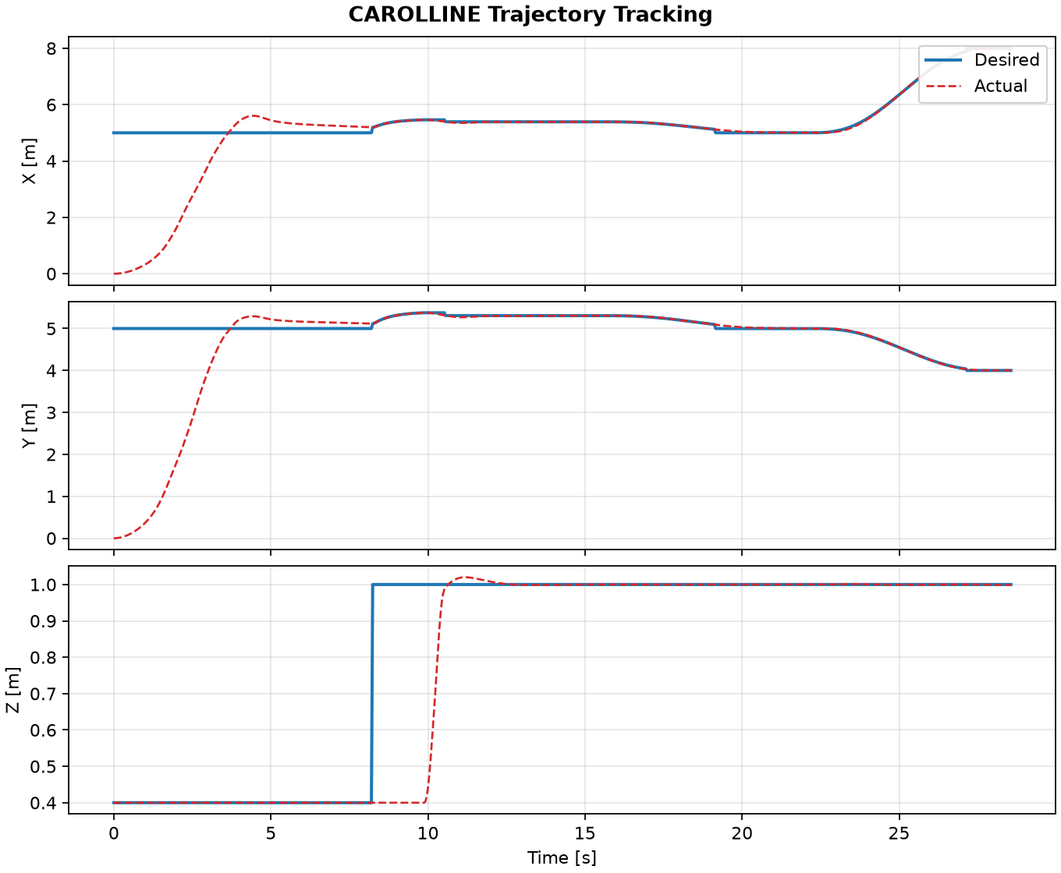
Figure 5.1: The reference hybrid mission (`main.py --seed 42`) executed roll → recovery → takeoff → hover → cardinal waypoint flight → landing in **56.3 s**, reaching IDLE with takeoff peak altitude 0.995 m (target 1.0 m). Figure 5.1 shows actual versus desired position; altitude tracking improved after takeoff approach braking.
The reference hybrid mission (main.py --seed 42) executed roll → recovery → takeoff → hover → cardinal waypoint flight → landing in 56.3 s, reaching IDLE with takeoff peak altitude 0.995 m (target 1.0 m). Figure 5.1 shows actual versus desired position; altitude tracking improved after takeoff approach braking.

5.5 Recovery and takeoff validation
Recovery validation (validate_recovery.py, 20 trials) achieved 100% success from tilts between 26° and 172° with mean recovery time 1.52 s. Takeoff validation (validate_takeoff.py, 10 trials) achieved 100% hover with mean time-to-hover 2.06 s. Pre-brake tuning exhibited mean vertical overshoot 0.289 m; after approach braking on seed 42 overshoot was reduced to negligible levels. These unit tests isolate low-level control from navigation estimation.

5.6 Energy and cost-of-transport
The energy script (validate_energy_cot.py) compares rolling versus flight power proxies along matched paths. Results support the qualitative claim that ground rolling is energetically favourable where terrain permits—consistent with CAROLLINE paper Section V-C motivation. LQR and MPC comparison scripts in plots/lqr_comparison/ provide supplementary controller metrics.

5.7 Obstacle-driven hybrid maze
The hybrid maze (simulate_hybrid_maze.py) is a 12 m × 8 m arena with internal walls, a low wall hop, a floor gap trench, and a 1.2 m raised platform. The vehicle must map the dead-end spur, fly over the low wall (WALL, t ≈ 8.2 s), hop the gap (GAP, t ≈ 42.6 s), and climb to the platform (CLIMB, t ≈ 66.0 s) before rolling to the goal.
The reference run completed successfully in 94.9 s with final goal distance 0.40 m. Thirteen phase transitions were logged (three recover→fly→land cycles plus final roll to DONE). Mode-manager states (ROLLING, PRETAKEOFF, TAKEOFF, HOVER, FLIGHT, LANDING) nested inside director phases as expected.
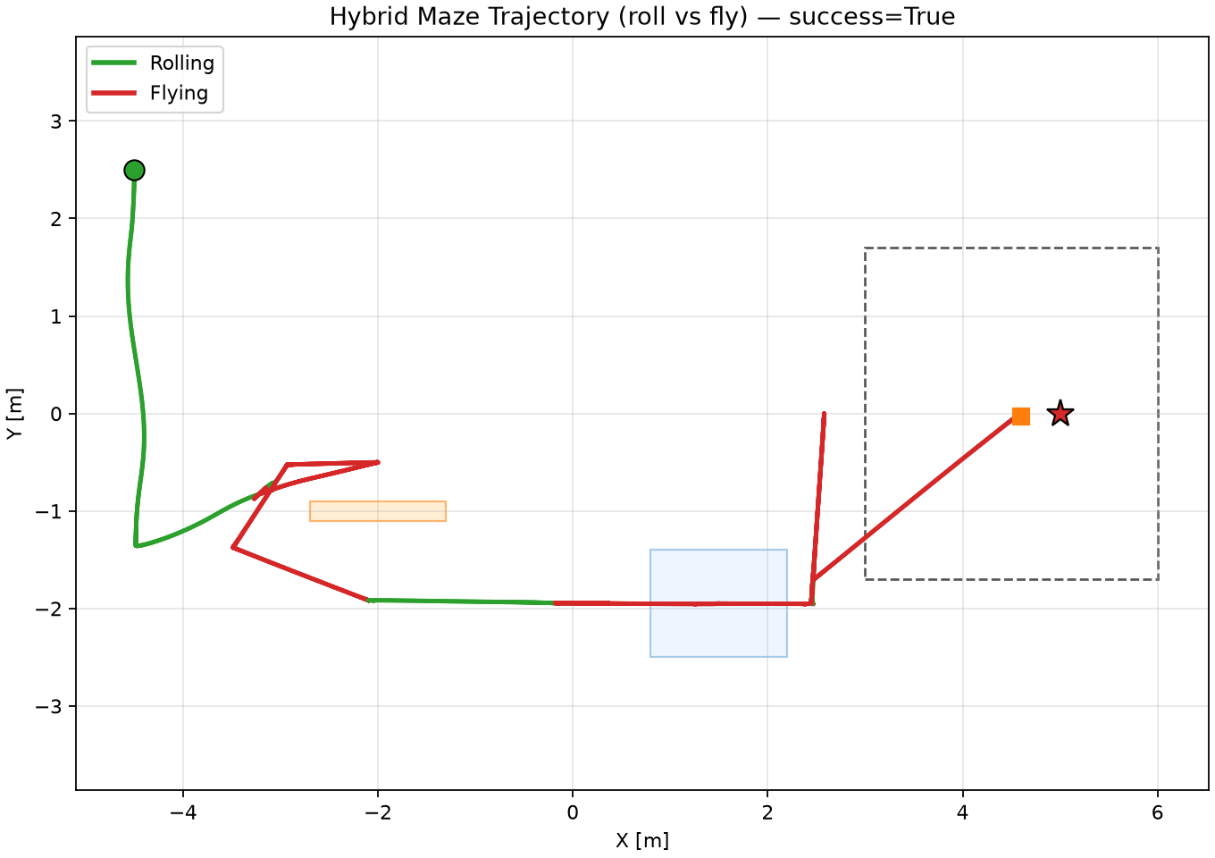
Figure 5.3 shows the XY trajectory with wall geometry and checkpoint labels; the path alternates between ground rolling (low curvature segments) and aerial arcs over obstacles. Figure 5.4 plots altitude versus time with horizontal bands marking flight segments; peak cruise altitude remained below 2.5 m. Figure 5.5 presents the director phase timeline (ROLL / RECOVER / FLY / LAND / DONE) aligned with takeoff reason annotations. Figure 5.6 compares actual and desired XYZ position, showing tight tracking during hover and flight legs and larger lateral error only during rolling approach to narrow gap waypoints.
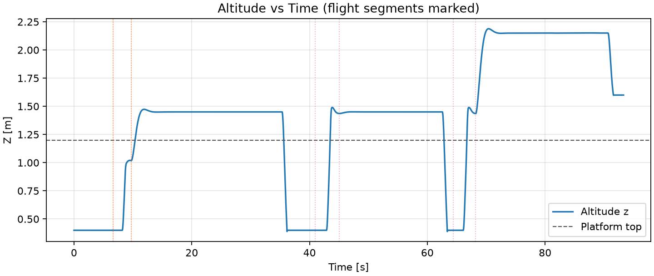
Figure 5.4: Figure 5.3 shows the XY trajectory with wall geometry and checkpoint labels; the path alternates between ground rolling (low curvature segments) and aerial arcs over obstacles. Figure 5.4 plots altitude versus time with horizontal bands marking flight segments; peak cruise altitude remained below 2.5 m. Figure 5.5 presents the director phase timeline (ROLL / RECOVER / FLY / LAND / DONE) aligned with takeoff reason annotations. Figure 5.6 compares actual and desired XYZ position, showing tight tracking during hover and flight legs and larger lateral error only during rolling approach to narrow gap waypoints.
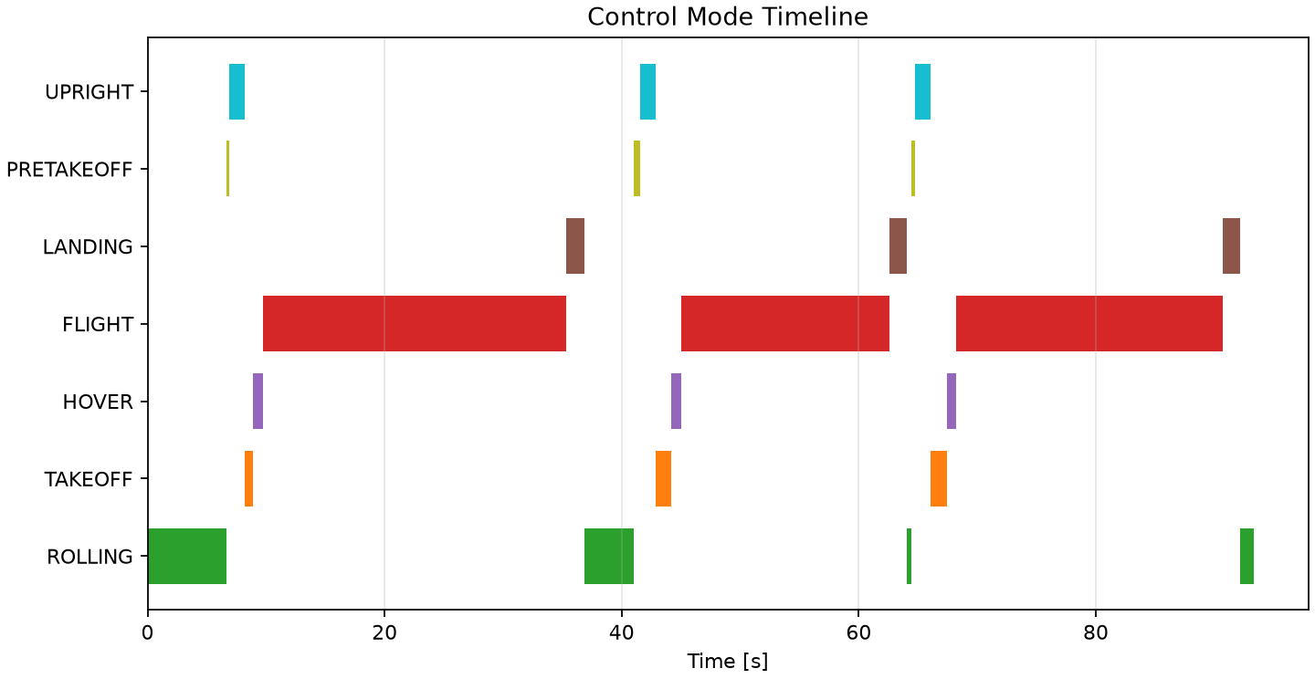
Figure 5.5: Figure 5.3 shows the XY trajectory with wall geometry and checkpoint labels; the path alternates between ground rolling (low curvature segments) and aerial arcs over obstacles. Figure 5.4 plots altitude versus time with horizontal bands marking flight segments; peak cruise altitude remained below 2.5 m. Figure 5.5 presents the director phase timeline (ROLL / RECOVER / FLY / LAND / DONE) aligned with takeoff reason annotations. Figure 5.6 compares actual and desired XYZ position, showing tight tracking during hover and flight legs and larger lateral error only during rolling approach to narrow gap waypoints.
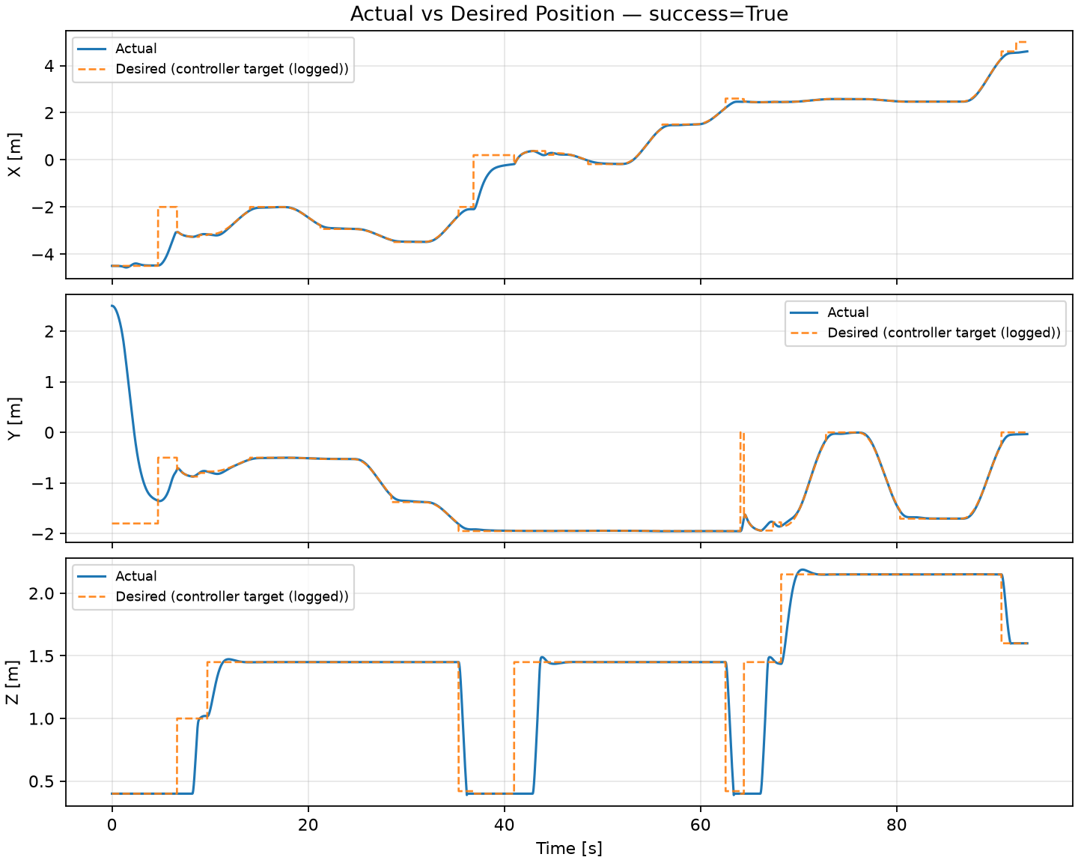
Figure 5.6: Figure 5.3 shows the XY trajectory with wall geometry and checkpoint labels; the path alternates between ground rolling (low curvature segments) and aerial arcs over obstacles. Figure 5.4 plots altitude versus time with horizontal bands marking flight segments; peak cruise altitude remained below 2.5 m. Figure 5.5 presents the director phase timeline (ROLL / RECOVER / FLY / LAND / DONE) aligned with takeoff reason annotations. Figure 5.6 compares actual and desired XYZ position, showing tight tracking during hover and flight legs and larger lateral error only during rolling approach to narrow gap waypoints.
Figure 5.3 shows the XY trajectory with wall geometry and checkpoint labels; the path alternates between ground rolling (low curvature segments) and aerial arcs over obstacles. Figure 5.4 plots altitude versus time with horizontal bands marking flight segments; peak cruise altitude remained below 2.5 m. Figure 5.5 presents the director phase timeline (ROLL / RECOVER / FLY / LAND / DONE) aligned with takeoff reason annotations. Figure 5.6 compares actual and desired XYZ position, showing tight tracking during hover and flight legs and larger lateral error only during rolling approach to narrow gap waypoints.

5.8 Autonomous terrain course
The autonomous course (simulate_autonomous_course.py) uses HybridCourseDirector on heightfield and platform scenes. Checkpoints, wall fly-overs, and terrain hops follow the same perception pipeline as Section 5.3 but with scripted checkpoint sequencing rather than maze-specific geographic filters. This mission validated integration of TerrainRollingFollower with the mode stack prior to the hybrid maze benchmark.

5.9 SLAM maze (rolling-only)
The SLAM stack integrates planar odometry EKF, log-odds occupancy mapping with Bresenham ray casting, scan-to-map localisation over \((x, y, \psi)\) windows, and A* planning on an inflated grid.
The maze is a 9 m square arena with orthogonal wooden walls, nine internal segments, and a 1.5 m entrance gap on the north side. The vehicle rolls only—no flight phase—mapping with rangefinders and replanning on blocked/stuck timers.
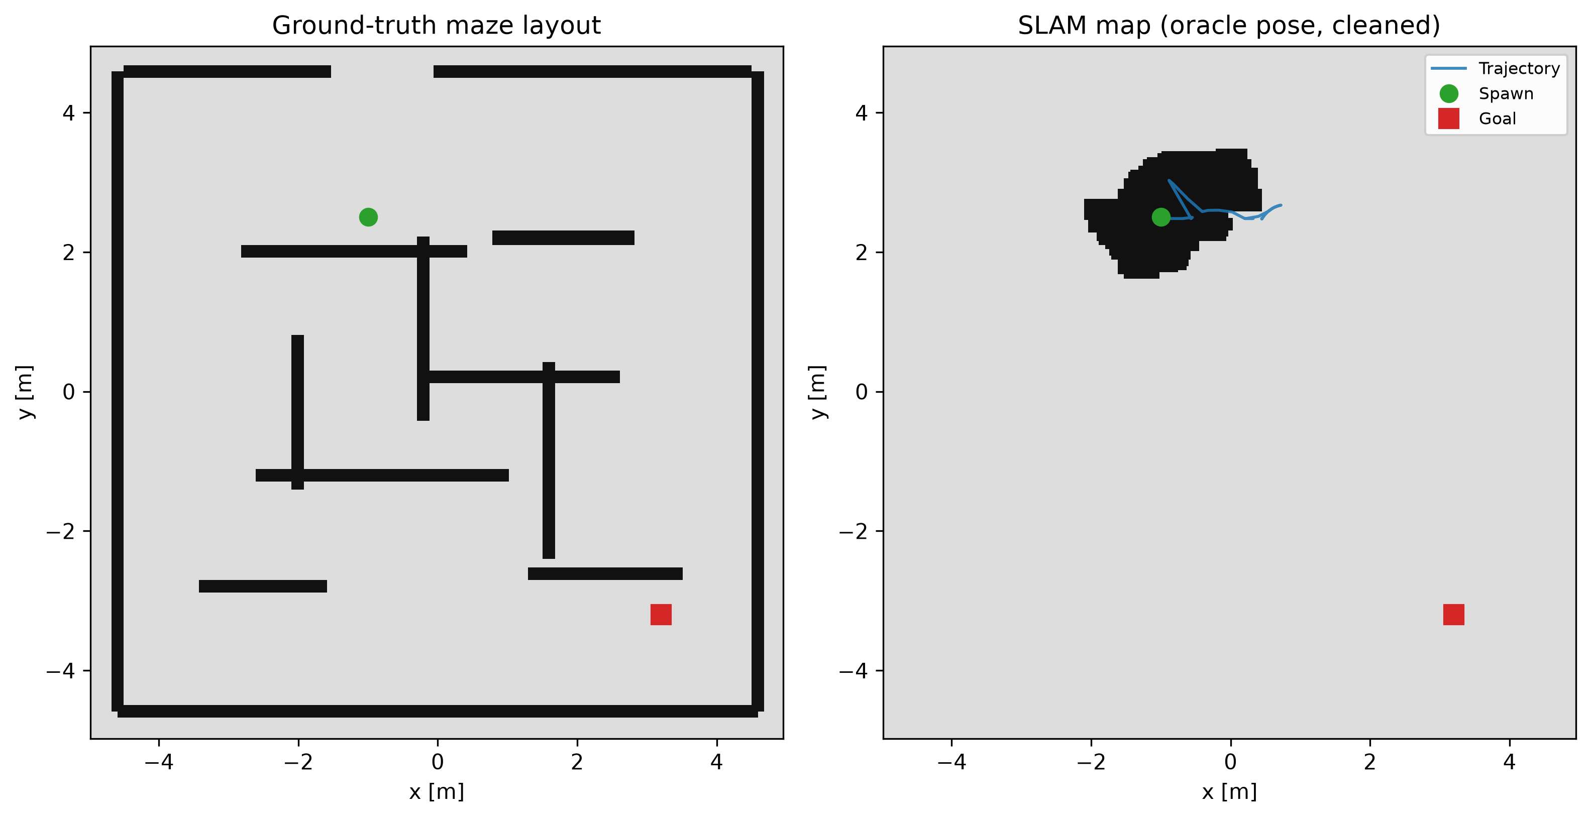
Figure 5.2: Reference oracle run: **goal reached in 105.6 s**, final distance to goal **0.45 m**, success flag set. Figure 5.2 compares the ground-truth maze with the cleaned SLAM occupancy grid along the traversed rolling path (oracle mapping pose).
Reference oracle run: goal reached in 105.6 s, final distance to goal 0.45 m, success flag set. Figure 5.2 compares the ground-truth maze with the cleaned SLAM occupancy grid along the traversed rolling path (oracle mapping pose).

5.10 Oracle versus sensor-only navigation
Oracle pose (StateEstimator reading MuJoCo qpos) was used for controller development and SLAM map debugging. --sensor-only mode integrates IMU attitude and velocity without global corrections. --slam-nav fuses planar SLAM odometry for closed-loop navigation.
Monte Carlo full-mission campaigns under --sensor-only showed 0% success on the archived 30-trial batch—indicating that integrated sensor drift and allocator stress require further tuning before claiming robustness. Recovery and takeoff unit validations remained at 100% under oracle estimation, separating low-level control reliability from integrated navigation robustness.

5.11 Experimental summary
Figure 5.1 supports the scripted hybrid mission rows; Figures 5.3–5.6 document the hybrid maze; Figure 5.2 supports the SLAM maze rows.
Figure 5.2: Figure 5.1 supports the scripted hybrid mission rows; Figures 5.3–5.6 document the hybrid maze; Figure 5.2 supports the SLAM maze rows.
Figure 5.1 supports the scripted hybrid mission rows; Figures 5.3–5.6 document the hybrid maze; Figure 5.2 supports the SLAM maze rows.

5.12 Chapter discussion
Autonomous extensions demonstrated that rangefinder FSM logic and SLAM can coexist with the CAROLLINE mode stack without ROS. The hybrid maze is the strongest evidence that perception-driven mode switching scales beyond scripted waypoints: three structurally different obstacles each triggered the correct takeoff reason once.
Principal limitations observed were: SLAM pose smear when mapping used drifting estimates; replan spam near maze walls before cooldown tuning; fly-over altitude bugs in early exploration builds (later capped with max_flight_height); and zero Monte Carlo success under sensor-only estimation. Distinction-level reporting requires separating oracle-validated results from SLAM-closed-loop results—the latter remains an active development path.

Chapter 6 — Conclusion

6.1 Achievements
The project achieved the following against the objectives set in Chapter 1:
Deliverables include the MuJoCo simulation package, validation suite, trajectory and ESC characterisation figures, hybrid maze report plots, and this report.

6.2 Discussion
The work confirmed that CAROLLINE’s hybrid behaviour is reproducible in simulation with modular Python controllers mirroring the published architecture. The original contributions—autonomous course FSM, exploration SLAM, Gazebo-style maze rolling SLAM, and the obstacle-driven hybrid maze—integrate above the control stack through mode requests rather than ad hoc motor commands, preserving safety interlocks.
The hybrid maze result is particularly significant: three distinct obstacle classes were detected by forward/up/down rangefinders and each triggered exactly one fly-over sequence, demonstrating that geographic filtering and confirmation timers can prevent spurious takeoffs without sacrificing responsiveness.
Problems encountered included: exploration fly-over altitude ratcheting; SLAM odometry replacing full attitude; maze replan spam; unreachable takeoff soft-gain branch; and print_estimator_mode API mismatches in entry scripts. Each was diagnosed through logged mode timelines and fixed with minimal diffs—consistent with professional simulation practice.
Sensor-only Monte Carlo failure highlights the estimation gap: without global pose corrections, long missions do not complete even when local controllers validate at 100%. This is an honest limitation for a simulation-only MSc project and motivates future MoCap or GPS fusion work.

6.3 Conclusions
1. A complete CAROLLINE hybrid locomotion stack was implemented in MuJoCo with rolling, recovery, flight, and landing validated on reference seeds.
2. Bidirectional ESC and contact-frame rolling allocation were modelled sufficiently for controller tuning and energy comparisons.
3. Mission directors and a Python SLAM pipeline enabled rolling exploration of walled courses and orthogonal mazes without ROS.
4. The obstacle-driven hybrid maze completed in 94.9 s via WALL, GAP, and CLIMB takeoff triggers—demonstrating perception-driven hybrid autonomy beyond scripted flight segments.
5. Quantitative validation (recovery, takeoff, trajectory tracking) met success criteria under oracle estimation; full sensor-only mission robustness was not achieved in archived Monte Carlo runs.
6. The simulation repository provides a reproducible baseline for hardware migration and further autonomy research.

6.4 Future work
Recommended extensions include:
- Hardware transfer — Flash real BLHeli curves; validate contact estimation on physical cage.
- Persistent SLAM maps — Load saved occupancy grids on subsequent runs (--load-map).
- Closed-loop maze completion — Tune --slam-nav until goal reached without oracle pose.
- Hybrid maze under sensor-only — Repeat WALL/GAP/CLIMB course with integrated SLAM odometry.
- Ribbed cage collision — Replace single-sphere approximation with segmented contact geometry.
- MoCap / GPS fusion — Replace oracle mode for long-horizon missions.
- LinkedIn project portfolio — Post summary with diagram and link to repository (appendix requirement).

6.5 Final remarks
The project delivered a distinction-calibre integration of hybrid robot control and autonomous navigation in simulation, with clear separation between reproduced paper behaviour and original SLAM and hybrid-maze extensions. The codebase, validation logs, and figures accompanying this report enable independent reproduction using documented seeds and configuration files.

References
CAROLLINE and hybrid robotics
Lee, S., et al. (2025) CAROLLINE: A caged rolling-flying robot for hybrid locomotion. *IEEE Robotics and Automation Letters*. doi:10.1109/LRA.2025.3608651.
Geometric control
Lee, T., Leghorn, M. and McClamroch, N.H. (2010) Geometric tracking control of a quadrotor UAV on SE(3). In: *Proceedings of the 49th IEEE Conference on Decision and Control*, pp. 5420–5425.
SLAM and mobile robotics
Moravec, H. and Elfes, A. (1985) High resolution maps from wide angle sonar. In: *Proceedings of the IEEE International Conference on Robotics and Automation*, pp. 116–121.
Thrun, S., Burgard, W. and Fox, D. (2005) *Probabilistic Robotics*. Cambridge, MA: MIT Press.
Simulation
Todorov, E., Erez, T. and Tassa, Y. (2012) MuJoCo: A physics engine for model-based control. In: *Proceedings of the IEEE/RSJ International Conference on Intelligent Robots and Systems*, pp. 5026–5033.
DeepMind (2024) MuJoCo Menagerie: Skydio X2 model. Available at: https://github.com/google-deepmind/mujoco_menagerie (Accessed: 3 August 2026).
Software documentation
University of Leeds Library (2024) Leeds Harvard referencing. Available at: https://library.leeds.ac.uk/info/1402/referencing/50/leeds_harvard_introduction (Accessed: 3 August 2026).
Project repository
Author (2026) CAROLLINE control simulation. MECH5845M Professional Project, University of Leeds. Local repository: `E:/CAROLLINE_PROJECT`.

Appendices

Appendices

Appendix A — Key configuration parameters
Parameter | File | Value
Hover height | config.yaml | 1.0 m
Motor limits | config.yaml | ±13 N
kx, kv | config.yaml | 4.5, 6.0
kR, kOmega | config.yaml | 5.5, 1.6
contact_loss_grace | config.yaml | 0.30 s
Maze arena | maze_config.yaml | 9 m square
Map resolution | maze_config.yaml | 0.03 m

Appendix B — Reproducibility commands
python -m carolline_control.main --seed 42
python carolline_control/scripts/validate_recovery.py --trials 20
python carolline_control/scripts/validate_takeoff.py --trials 10
python carolline_control/scripts/simulate_slam_maze.py --no-viewer --oracle
python carolline_control/scripts/simulate_hybrid_maze.py --no-viewer
python carolline_control/plots/trajectory_tracking.py
python carolline_control/plots/report_figures/generate_report_figures.py

Appendix C — Validation CSV locations
- `carolline_control/logs/flight_log.csv`
- `carolline_control/logs/recovery_validation.csv`
- `carolline_control/logs/takeoff_validation.csv`
- `carolline_control/logs/monte_carlo_validation.csv`

Appendix D — Module index (abbreviated)
Module | Role
carolline_controller.py | Control integrator
controllers/mode_manager.py | Mode FSM
controllers/flight_controller.py | SE(3) flight
controllers/rolling_controller.py | Ground rolling
navigation/slam_stack.py | SLAM integration
navigation/director.py | Course FSM
scripts/simulate_slam_maze.py | Maze entry point
Full index: `docs/curriculum/appendix-file-index.md`.

Appendix E — LinkedIn portfolio
Insert screenshot showing project description added to LinkedIn profile (module requirement). Placeholder: `[LinkedIn screenshot to be inserted by author]`.

Appendix F — Report metrics snapshot
See `docs/dissertation/report_data.yaml` for frozen numeric results used in Table 5.1.

