Twitter Analytics Dashboard
Power BI Project Report

Project Overview
This project works through a Twitter/social-media engagement dataset of 1,181 tweets in Power BI. The data includes impressions, engagements, likes, retweets, replies, URL clicks, hashtag clicks, profile clicks, media views and engagements, app opens, and a timestamp for every tweet. It's split into six tasks, each looking at the data from a different angle — content type, time of day, day of the week, month, and individual tweet performance.
For each task, I've written out what was asked, how I built it in Power BI (the columns, DAX measures and visuals involved), a screenshot of the finished page, and what the numbers actually showed once everything was put together.

Task 1: Tweet Interaction Breakdown by Content Category
What this task asked for
Group tweets into five content categories — Media, Link, Hashtag, Mixed Content, or Plain Text — based on what's actually in each tweet, then compare URL Clicks, Profile Clicks and Hashtag Clicks across those groups, and work out which category is best for traffic, profile discovery, and hashtag visibility.
How I built it
- The tweet text in this dataset is placeholder text, so it doesn't actually contain real links or media tags. I worked around that by using the engagement columns as a stand-in: if a tweet has media views or media engagements, it has media; if it has URL clicks, it has a link; if it has hashtag clicks, it has a hashtag.
- Any tweet with more than one of those present gets tagged Mixed Content, so it isn't counted twice.
- Built a summary table with Total Clicks, Click-Through Rate, and a classification (Traffic Driven, Profile Interest, Discovery Driven, or Mixed Interaction) depending on which click type makes up more than half the total. Categories with a below-median CTR also get flagged Low Click Efficiency.
- The main visual is a clustered bar chart comparing the three click types across all five categories, with recommendation cards underneath.
Dashboard
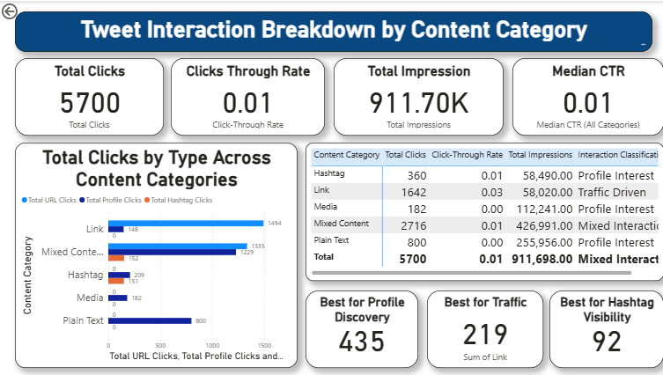

What the data showed
- Link tweets bring in the most URL clicks (1,494), so that's the category to use if the goal is traffic.
- Mixed Content tweets get the most Profile Clicks (1,229) and Hashtag Clicks (152) — best pick for profile discovery and hashtag visibility.

Task 2: Engagement Rate Comparison
What this task asked for
Compare how tweets that led to an app open performed against tweets that didn't, but only for tweets posted on a weekday between 9 AM and 5 PM, and classify each one as High App Impact, App Interest–Low Engagement, High Organic Reach, or Low Performance.
How I built it
- Along the way I found a data issue: a chunk of timestamps were missing their leading digit (an earlier fixed-width split had shifted single-digit months by one character), which I traced back and fixed before pulling out the hour and weekday.
- Built a business-hours flag and a group column splitting tweets by whether App Opens was above zero, then compared each tweet's Engagement Rate and Impressions against the filtered averages to assign the four categories.
Dashboard
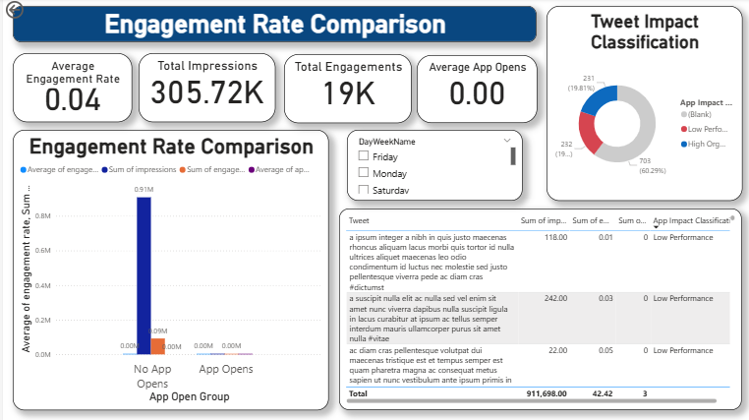
What the data showed
- It turns out none of the tweets with App Opens above zero were posted inside that weekday business-hours window — everything that drove app opens happened outside 9-to-5.
- That's a scheduling gap worth acting on: content that leads to app opens isn't currently going out during standard business hours.

Task 3: Media Interaction by Day of the Week
What this task asked for
Chart Media Views and Media Engagement Rate by weekday for the most recent complete quarter in the data, classify each day relative to the weekday average, flag any interaction spikes, and say which days are worth prioritising for media posts.
How I built it
- Worked out the latest complete quarter with a DAX measure that checks the data's most recent date against each quarter's end date — came out to Q3 2020.
- Classified each day as Strong Media Day, High Reach–Low Interaction, Niche High-Quality Day, or Weak Media Day, and flagged any day where engagements ran 20% or more above the weekday average as an Interaction Spike.
- Weekdays are sorted in calendar order (Monday through Sunday) rather than alphabetically, using a custom sort column.
- Q3 2020 only had media-tagged tweets on two of the seven weekdays, so I added a second, all-time chart alongside it for a fuller picture.
Dashboard
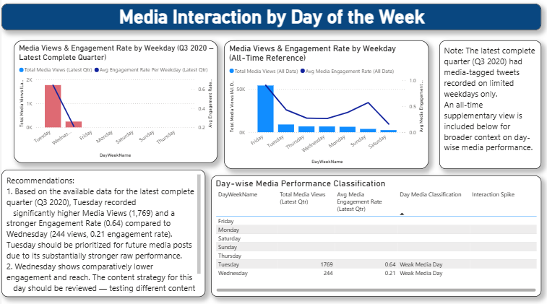
What the data showed
- Of the two days with media activity in Q3 2020, Tuesday came out well ahead — 1,769 views and a 0.64 engagement rate, versus Wednesday's 244 views and 0.21.

Task 4: Replies, Retweets and Likes Comparison
What this task asked for
Compare total Replies, Retweets and Likes by month for tweets posted between June and August 2020, leaving out tweets with no interactions at all, and classify each tweet by whichever interaction type dominates it — plus explain how audience behaviour shifted across the three months.
How I built it
- Worked out each tweet's share of Replies, Retweets and Likes, then classified it: Balanced Interaction if the gap between the highest and lowest share was 10 points or less, otherwise whichever type had the largest share.
- Tweets with total interactions below the median (within the filtered June–August, non-zero group) get a separate Low Interaction tag.
- Chart is a clustered column chart by month, with a donut showing how many tweets fall into each classification.
Dashboard
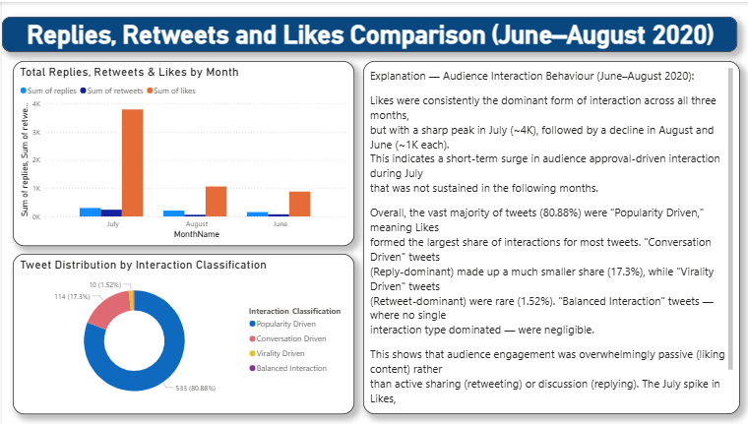

What the data showed
- Likes spiked hard in July, close to 4K, then dropped back to around 1K in both June and August — a short burst rather than a lasting trend.
- About 81% of tweets are Popularity Driven (Likes lead), 17% are Conversation Driven, and only 1.5% are Virality Driven — most of the engagement here is people liking, not sharing or replying.

Task 5: Monthly Engagement Rate Trend
What this task asked for
Build a monthly line chart comparing the average Engagement Rate of tweets with media against tweets without, using a real Date table with year and content-type filters, classify each month, and flag two consecutive months of decline.
How I built it
- Built a dedicated Date table with CALENDAR() and linked it to the main table, so the report has a proper time dimension to filter and sort by rather than relying on text columns.
- Set up Media and Non-Media Engagement Rate measures, plus month-over-month and two-months-back comparisons to catch a consecutive drop.
- Each month gets classified as Media Dominant, Non-Media Dominant, Balanced, or Engagement Decline Alert — the decline alert overrides the usual classification when it's triggered.
- Added Year and Content Type slicers, and the tooltip carries Tweet Count, Impressions, both Engagement Rates, and the month-over-month change.
Dashboard
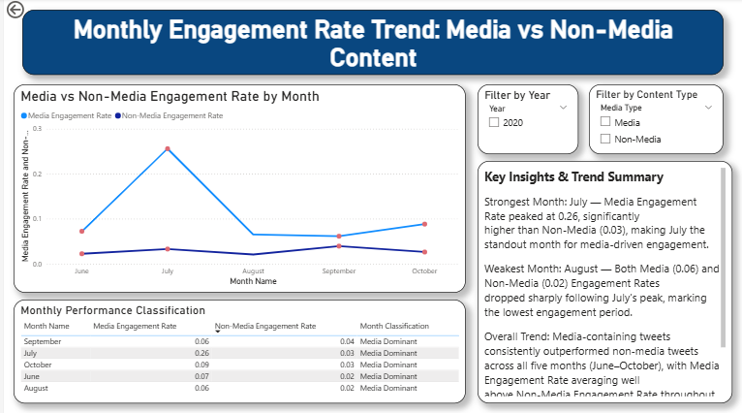.
What the data showed
- July was clearly the strongest month — Media Engagement Rate hit 0.26 against Non-Media's 0.03.
- August was the weakest, with both rates dropping sharply right after July's peak.
- Media beat Non-Media every single month from June through October, so every month lands as Media Dominant.

Task 6: Top 10 Tweets by Engagement
What this task asked for
Rank the top 10 weekday tweets by Total Engagements (Likes plus Retweets plus Replies), classify each by its dominant interaction type against the dataset averages, and explain why the top three did well.
How I built it
- Reused the Reply, Retweet and Like share columns from Task 4 to build the classification here — checking for Reply-dominance first, since that's how the task is worded, then Like-dominance with an above-average engagement rate, then retweet share against the dataset average, with a fallback for high-volume, low-efficiency tweets.
- Chart is filtered to weekdays only, sorted by Total Engagements, and capped to the top 10.
- Bars are coloured by classification, and the tooltip shows Impressions and Engagement Rate.
Dashboard
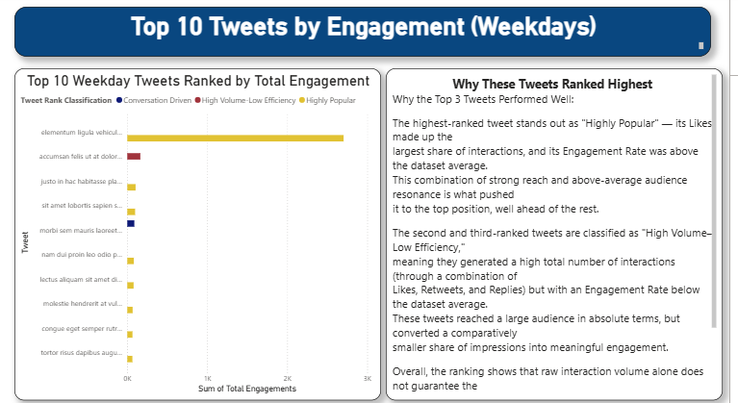
What the data showed
- The top tweet is Highly Popular — Likes make up most of its interactions and its Engagement Rate is above average, so it's not just reach, it's resonance too.
- The next two are High Volume–Low Efficiency: plenty of total interactions, but an Engagement Rate below average — a reminder that volume and quality aren't the same thing.

