COIMBATORE INSTITUTE OF TECHNOLOGY
(Government Aided Autonomous Institution Affiliated to Anna University)

23IT723 - DEVOPS LABORATORY
PROJECT
LASTZONE – ONLINE TOURNAMENT PLATFORM


OCTOBER 2026

Submitted by

2303717620521014 DHARANIDHARAN V

COIMBATORE INSTITUTE OF TECHNOLOGY
(Government Aided Autonomous Institution Affiliated to Anna University)
BONAFIDE CERTIFICATE

Certified that this project report titled “LASTZONE – ONLINE TOURNAMENT PLATFORM” is the bonafide work of 2303717620521014- DHARANIDHARAN V completed during the academic year 2025-2026-Semester VII for the project presentation of 23IT723 - DEVOPS LABORATORY under our supervision.

Certified that the candidate was examined by using the project work examination.

Review Members:
- Dr.M.Sangeetha
- Dr.E.Arul

23IT723 – DEVOPS LABORATORY
FINAL MINI PROJECT – EVALUATION SCHEME
Final Mini Project Assessment
The final mini project shall require students to integrate the major DevOps practices covered in the laboratory. The project should demonstrate practical implementation of version control, collaborative development, Continuous Integration, containerization and/or automated configuration/provisioning, with proper execution evidence.
S.No. | Evaluation Component | Key Verification Points | Marks
1 | Problem Definition & Project Planning | Problem statement, objectives, requirements, scope, module identification, technology selection and workflow planning. | 10
2 | Git Repository & Version Control | Repository creation, meaningful commits, README, .gitignore, remote repository, push/pull/fetch operations and commit history. | 15
3 | Branching, Merging & Collaboration | Feature branches, parallel development, merging, conflict handling, branch organization and collaborative workflow. | 10
4 | Application Development & Build | Working application/source code, project structure, dependency management, build configuration and successful execution. | 15
5 | Jenkins Continuous Integration | Jenkins configuration, source-code integration, automated checkout, build job/pipeline, build execution and console verification. | 15
6 | Docker / Containerization | Dockerfile, image creation, container execution, port/configuration handling, application deployment and container verification. | 10
7 | Automation / Configuration Management | Ansible/Chef/Puppet/SaltStack or equivalent automation where applicable; repeatable configuration/provisioning and successful execution. | 5
8 | Testing & Verification | Functional testing, build verification, error identification, test evidence and corrective action. | 5
9 | Documentation & Technical Presentation | Architecture/workflow diagram, commands/configuration, screenshots, results, troubleshooting, conclusion and repository details. | 5
10 | Final Demonstration & Viva-Voce | Live demonstration, explanation of implementation, troubleshooting responses and technical understanding. | 10
TOTAL |  |  | 100

Recommended Mark Distribution within the Final Demonstration
For uniform evaluation, the examiner may use the following internal split for the implementation and demonstration components.
Assessment Area | Marks | Awarded Marks | Remarks
Working implementation and correctness | 30
DevOps tool integration and automation | 20
Version control and collaborative workflow | 15
Build / deployment / container verification | 15
Testing and troubleshooting | 5
Documentation and technical presentation | 5
Live demonstration and viva-voce | 10
TOTAL | 100
Minimum Evidence to be Submitted
- Project repository URL and project README.
- Git commit history and branch/merge evidence.
- Jenkins job/pipeline configuration and successful build evidence.
- Dockerfile, image and running container evidence where Docker is used.
- Automation/configuration scripts where applicable.
- Application execution and testing evidence.
- Architecture/workflow diagram.
- Short technical report containing implementation steps, results and troubleshooting.
- Live demonstration of the complete DevOps workflow.
Evaluation Guidelines
- Marks shall be awarded primarily for a working implementation and demonstrable output.
- Copied source code without functional understanding shall not receive full marks.
- Screenshots may support the evaluation, but critical components should be demonstrated live wherever possible.
- Students should use meaningful repository names, branch names and commit messages.
- If a component is not applicable to the selected project, the student shall obtain faculty approval and demonstrate an equivalent DevOps automation component.
- The final viva shall focus on the student's own implementation, commands used, tool configuration and troubleshooting.
Faculty Evaluation Record
Student Name | DHARNIDHARAN V | Register No. | 2303717620521014
Project Title | LastZone – Online Tournament Platform | Date
Final Mark
Faculty Evaluator I |  | Signature
Faculty Evaluator II | / 100 | Signature

TABLE OF CONTENTS
S. NO. | CONTENT | PAGE NO.
1 | INTRODUCTION | 05
2 | OBJECTIVES | 05
3 | ABSTRACT | 06
4 | TECHOLOGY STACK | 06
5 | SYSTEM ARCHITECTURE | 07
6 | MODULE 1 —USER INTERFACE & zombie survival tournament gameplay | 08
7 | MODULE 2 — Spring Boot 3.3.5 BACKEND & score and run management | 09
8 | MODULE 3 — PostgreSQL 16 DATABASE MANAGEMENT | 10
9 | MODULE 4 — GIT & GITHUB SOURCE CONTROL | 11
10 | MODULE 5 — DOCKER CONTAINERIZATION | 12
11 | MODULE 6 — JENKINS CI/CD PIPELINE | 14
12 | MODULE 7 — AUTOMATED TESTING | 15

13 | MODULE 8 — ANSIBLE DEPLOYMENT | 17w
14 | MODULE 9 — PERSISTENT STORAGE | 18
15 | MODULE 10 — ADMIN & score and run management | 19
16 | MODULE 11 — CI/CD INTEGRATION | 20
17 | MODULE 12 — APPLICATION & DEPLOYMENT VERIFICATION | 21
18 | RESULTS AND OUTPUT | 23
19 | COMMANDS USED | 23
20 | ADVANTAGES | 28
21 | LIMITATIONS | 28
22 | FUTURE ENHANCEMENTS | 29
23 | CONCLUSION | 29

1. INTRODUCTION

The LASTZONE – ONLINE TOURNAMENT PLATFORM is a web-based zombie survival tournament gameplay and management system developed to simplify the process of ordering food in a tournament environment. The system allows users to browse available leaderboard entrys, search for dishes, select leaderboard entrys, add them to a cart, and place orders through a digital interface. An leaderboard dashboard is also provided to view and manage placed orders.The application is developed using HTML, CSS, JavaScript, Java 21, Spring Boot 3.3.5, and PostgreSQL 16, with Spring Boot 3.3.5 handling backend operations and PostgreSQL 16 storing order information. The project also incorporates DevOps practices to automate the development, testing, and deployment process. Git and GitHub are used for source code management, while Jenkins automates the CI/CD pipeline. Docker provides application containerization, Spring Boot Test + MockMvc (JUnit 5) performs automated testing, and Ansible automates deployment and container configuration. A Docker Volume is used to provide persistent storage for the PostgreSQL 16 database.The project combines a functional zombie survival tournament gameplay system with DevOps automation to provide a structured and reliable approach to application development and deployment.

2.OBJECTIVES
- To develop a digital zombie survival tournament gameplay system that enables users to browse, search, select leaderboard entrys, add them to a cart, and place orders conveniently.
- To implement an leaderboard dashboard for viewing placed orders and maintaining order information using PostgreSQL 16.
- To organize order data systematically and provide quick access to stored order details through the leaderboard dashboard.
- To implement DevOps practices throughout the application development and deployment process using Git, GitHub, and Jenkins.
- To automate the CI/CD workflow using Jenkins for building, testing, and deploying the application.
- To containerize the application using Docker to provide a consistent and portable execution environment.
- To integrate Spring Boot Test + MockMvc (JUnit 5) for automated testing to verify application functionality and reduce errors before deployment.
- To automate application deployment and container configuration using Ansible.
- To implement Docker Volume for persistent storage of the PostgreSQL 16 database and ensure that order information is retained even when the application container is recreated.

3. ABSTRACT

The LASTZONE – ONLINE TOURNAMENT PLATFORM is a web-based zombie survival tournament gameplay and management system designed to simplify the process of ordering food in a tournament environment. Traditional tournament operations may involve long queues, manual order processing, difficulty in managing multiple orders, and challenges in maintaining order records. The proposed system provides a digital platform where users can browse available leaderboard entrys, search for dishes, select leaderboard entrys, add them to a cart, and place orders conveniently. An administrative dashboard is also provided for viewing and managing placed orders. The application is developed using HTML, CSS, JavaScript, Java 21, Spring Boot 3.3.5, and PostgreSQL 16, with Spring Boot 3.3.5 handling backend operations and PostgreSQL 16 storing order information. The project also implements DevOps practices to automate the software development, testing, and deployment process. Git and GitHub are used for version control and source code management, while Jenkins automates the CI/CD pipeline. Docker is used to containerize the application and provide a consistent execution environment, Spring Boot Test + MockMvc (JUnit 5) performs automated testing, and Ansible automates application deployment and container configuration. A Docker Volume named lastzone_postgres_data is used to provide persistent storage for the PostgreSQL 16 database, ensuring that stored order information is retained even when the application container is recreated. The complete workflow follows GitHub → Jenkins → Docker Build → Spring Boot Test + MockMvc (JUnit 5) → Ansible → Docker Container → Spring Boot 3.3.5 → PostgreSQL 16, demonstrating the integration of a functional web application with modern DevOps practices and persistent data management.

4.TECHNOLOGY STACK

Technology | Version | Purpose
Java (OpenJDK) | 21 LTS | Backend programming language
Spring Boot | 3.3.5 | REST API backend framework
React + TypeScript | 18 / TS 5.x | Frontend web framework
Vite | 5.x | Build tool & dev server
PostgreSQL | 16-alpine | Production relational database
Unity WebGL | 2022.3 LTS | 3D game engine (396 MB)
Nginx | 1.25-alpine | Web server & reverse proxy
Docker | 27.x | Container runtime
Docker Compose | v2.x | Service orchestration
Jenkins | 2.462 LTS | CI/CD pipeline automation
Ansible | Core 2.17 | Infrastructure-as-code
Caddy | 2.x | HTTPS reverse proxy
JWT + BCrypt | jjwt 0.11 | Authentication & security

5.SYSTEM ARCHITECTURE
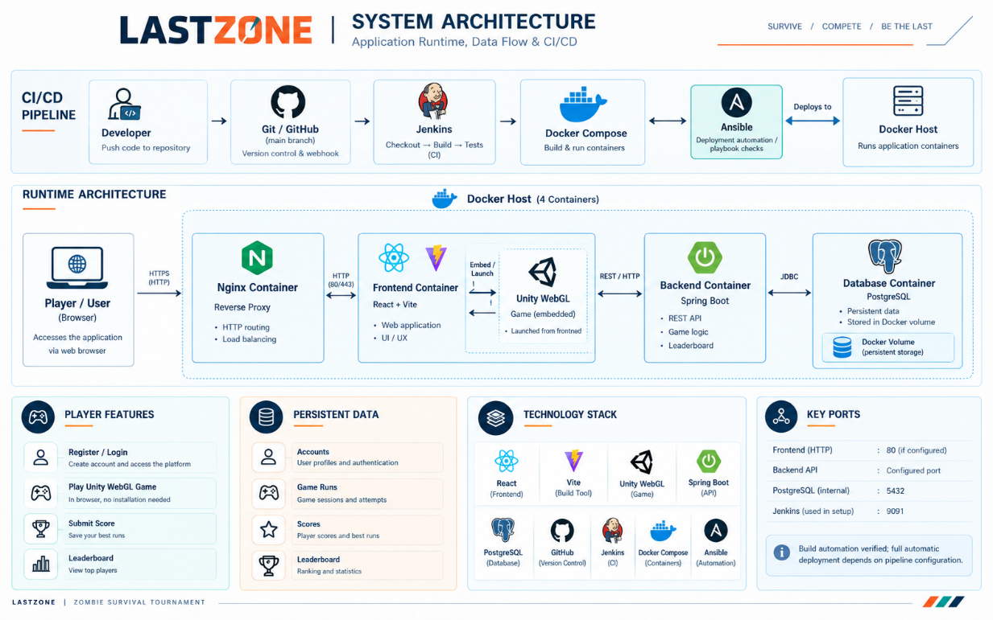
- Development: Developer creates and updates the LASTZONE – ONLINE TOURNAMENT PLATFORM application.
- Source Code Management: The application source code and configuration files are maintained using Git.
- GitHub Repository: The updated code is pushed to the GitHub repository for centralized source code management.
- Jenkins Trigger: Jenkins retrieves the latest source code from the GitHub repository and starts the CI/CD pipeline.
- Docker Build: Jenkins builds the application into a Docker image containing the Spring Boot 3.3.5 application and required dependencies.
- Automated Testing: Jenkins runs Spring Boot Test + MockMvc (JUnit 5) to verify the application before deployment.
- Deployment Automation: After successful testing, Jenkins invokes Ansible to automate the deployment process.
- Container Configuration: Ansible creates and configures the Docker container with the required image, port mapping, restart policy, and volume configuration.
- Application Execution: The Docker container runs the Spring Boot 3.3.5 backend, HTML/CSS/JavaScript frontend, and PostgreSQL 16 database.
- User Interaction: Students can browse leaderboard entrys, search for dishes, add items to the cart, and place orders through the application.
- Admin Management: The leaderboard dashboard allows administrators to view and monitor the placed order information stored in the database.
MODULE 1 — USER INTERFACE & zombie survival tournament gameplay
This module provides the user-facing interface of the LASTZONE – ONLINE TOURNAMENT PLATFORM application. It is designed to make food browsing and ordering simple and convenient for students.
Main Features
- Displays available leaderboard entrys with relevant details.
- Provides a search option to find leaderboard entrys quickly.
- Organizes leaderboard entrys into different categories.
- Allows users to select individual leaderboard entrys.
- Allows selected items to be added to the game run session.
- Provides cart management for selected leaderboard entrys.
- Displays the selected items and order details before confirmation.
- Allows users to place the final order.
- Provides order confirmation after successful submission.
- Provides a simple and user-friendly interface for accessing tournament services.
- Uses responsive interface elements for better usability.
- Connects the user interface with the Spring Boot 3.3.5 backend for processing requests.
Technologies: HTML, CSS, JavaScript. 
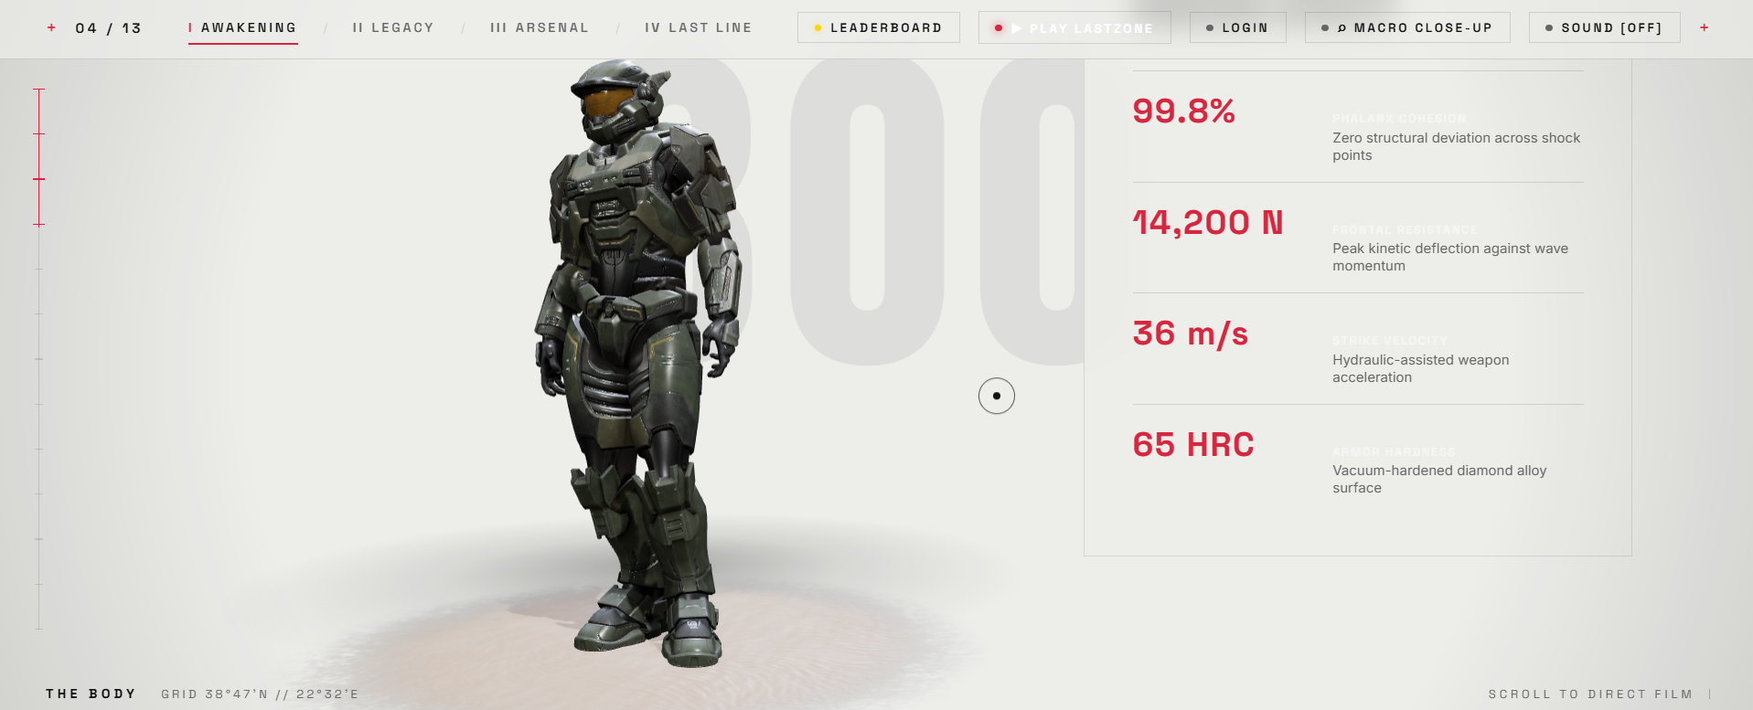
Figure 7.1: LASTZONE – ONLINE TOURNAMENT PLATFORM Home Page

Figure 7.2: Food Selection and game run session

MODULE 2 — Spring Boot 3.3.5 BACKEND & score and run management
This module handles the application logic and acts as the communication layer between the frontend and the PostgreSQL 16 database. Spring Boot 3.3.5 processes user requests and manages the complete order submission process.
Main Functions
- Receives requests from the frontend.
- Processes food selection requests.
- Handles cart and order processing.
- Processes order submissions.
- Generates and manages order information.
- Communicates with the PostgreSQL 16 database.
- Stores submitted order information.
- Retrieves stored order information.
- Handles requests related to the leaderboard dashboard.
- Connects the frontend interface with backend services.
- Processes application routes and requests.
- Runs the Spring Boot 3.3.5 application inside the Docker container.
- Provides the backend services required by the LASTZONE – ONLINE TOURNAMENT PLATFORM application.
Technology: Java 21 with Spring Boot 3.3.5.
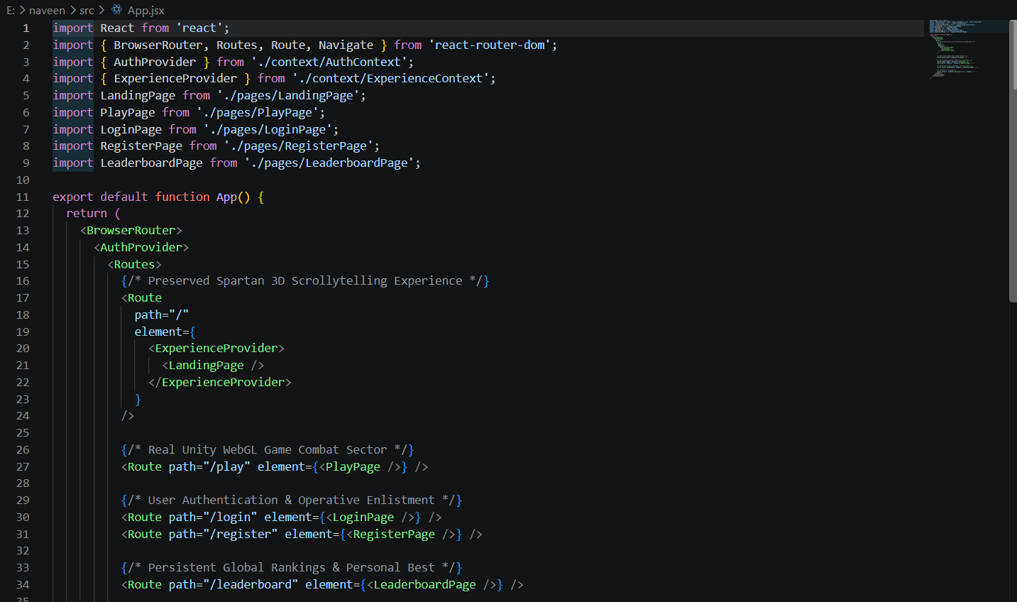
Figure 7.3: Spring Boot 3.3.5 Backend Implementation

MODULE 3 — PostgreSQL 16 DATABASE MANAGEMENT
This module manages the storage and retrieval of order information using PostgreSQL 16. The database provides persistent application data that can be accessed by the Spring Boot 3.3.5 backend.
Main Functions
- Stores placed orders.
- Maintains order records.
- Stores order-related information.
- Provides database access to the Spring Boot 3.3.5 backend.
- Allows stored orders to be retrieved.
- Makes stored orders available to the leaderboard dashboard.
- Maintains the lastzonedb database file.
- Stores the database under the application data directory.
- Works with the Docker Volume for persistent storage.
- Provides structured storage for order information.
- Maintains order data even when the application container is recreated, through the configured Docker Volume.

Database Location
data/lastzonedb
Inside the Docker container:
/app/data/lastzonedb
Technology: PostgreSQL 16.
MODULE 4 — GIT & GITHUB SOURCE CONTROL
This module manages the source code and maintains the development history of the LASTZONE – ONLINE TOURNAMENT PLATFORM project. Git is used locally for version control, while GitHub provides the remote repository.
Main Functions
- Initializes the project as a Git repository.
- Tracks changes made to project files.
- Creates commits for project updates.
- Maintains the history of project development.
- Allows changes to be reviewed through Git history.
- Pushes project code to GitHub.
- Provides a centralized remote repository.
- Allows Jenkins to retrieve the latest source code.
- Maintains the important project files in one repository.
- Supports integration between source control and the Jenkins pipeline.
- Helps maintain different versions of the project.

Main Project Files
app.py
Dockerfile
Jenkinsfile
test_app.py
requirements.txt
.gitignore
Technologies: Git and GitHub.
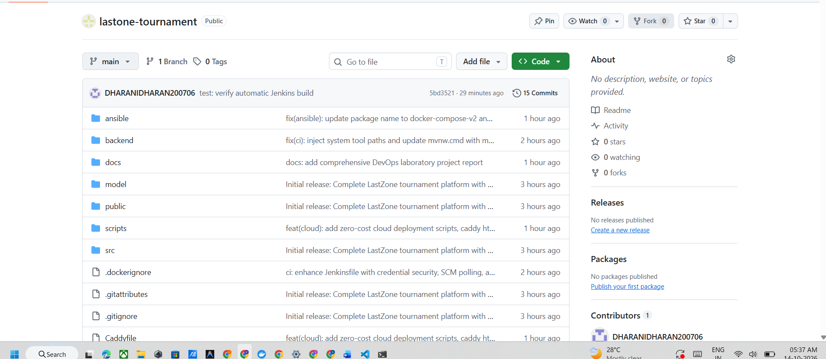
Figure 7.5: LASTZONE – ONLINE TOURNAMENT PLATFORM GitHub Repository

MODULE 5 — DOCKER CONTAINERIZATION
Docker is used to package and run the LASTZONE – ONLINE TOURNAMENT PLATFORM application in an isolated and consistent environment. The application and its required dependencies are packaged into a Docker image.
Main Functions
- Creates a Docker image from the application.
- Packages the application and required dependencies.
- Provides an isolated execution environment.
- Creates the application container from the Docker image.
- Runs the Spring Boot 3.3.5 application inside the container.
- Provides port mapping for application access.
- Provides a consistent environment for testing and deployment.
- Allows the application to run independently of the host environment.
- Works with Jenkins for automated image creation.
- Works with Ansible for automated deployment.
- Provides a repeatable application deployment environment.
Docker Configuration
Docker Image:
lastzone-ci
Docker Container:
lastzone-ansible
Port Mapping:
5001 → 5000
The application can be accessed through:
http://localhost:5001
Technology: Docker.
Docker Flow
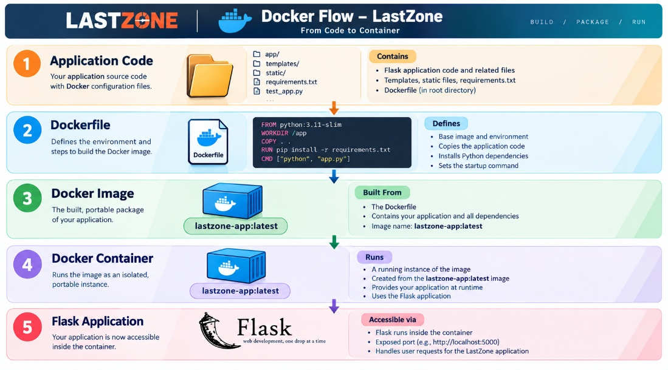
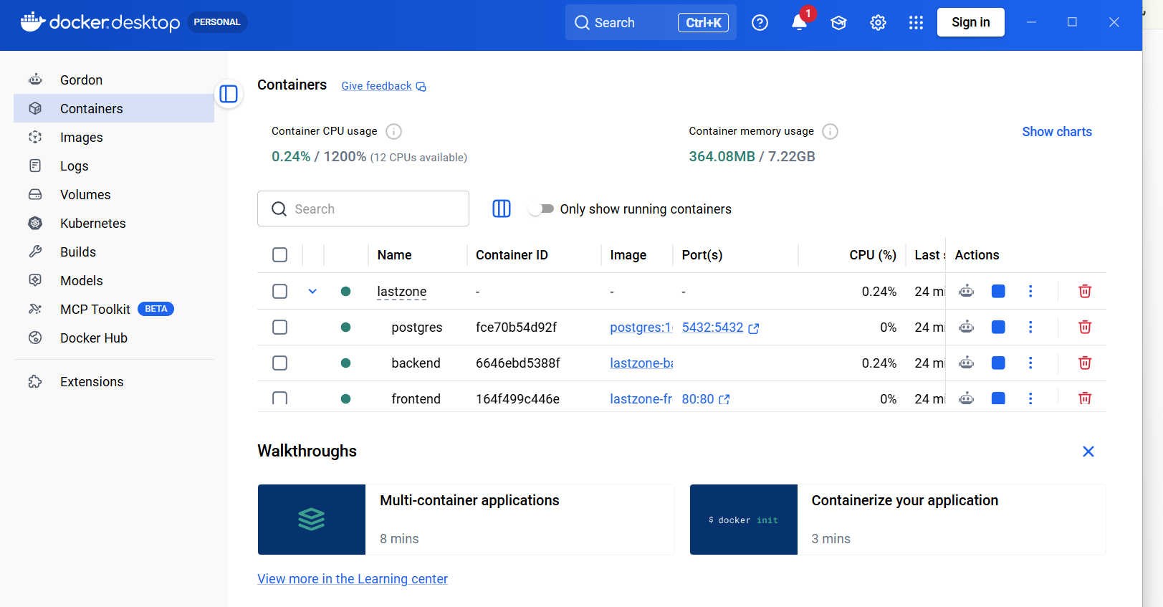
Figure 7.6: LASTZONE – ONLINE TOURNAMENT PLATFORM Docker Image

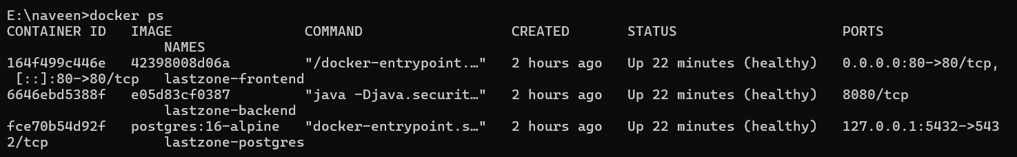
Figure 7.7: Running LASTZONE – ONLINE TOURNAMENT PLATFORM Docker Container
MODULE 6 — JENKINS CI/CD PIPELINE
Jenkins is used to automate the Continuous Integration and Continuous Deployment process. It connects the source code repository with the application build, testing, and deployment stages.
Main Functions
- Retrieves the latest source code from GitHub.
- Checks out the required project version.
- Builds the Docker image.
- Executes automated tests.
- Provides a sequence of automated pipeline stages.
- Prevents later stages from proceeding when an earlier stage fails.
- Invokes the Ansible playbook after successful testing.
- Provides pipeline execution logs.
- Reports pipeline success or failure.
- Automates the overall CI/CD process.
- Reduces repetitive manual build and deployment activities.
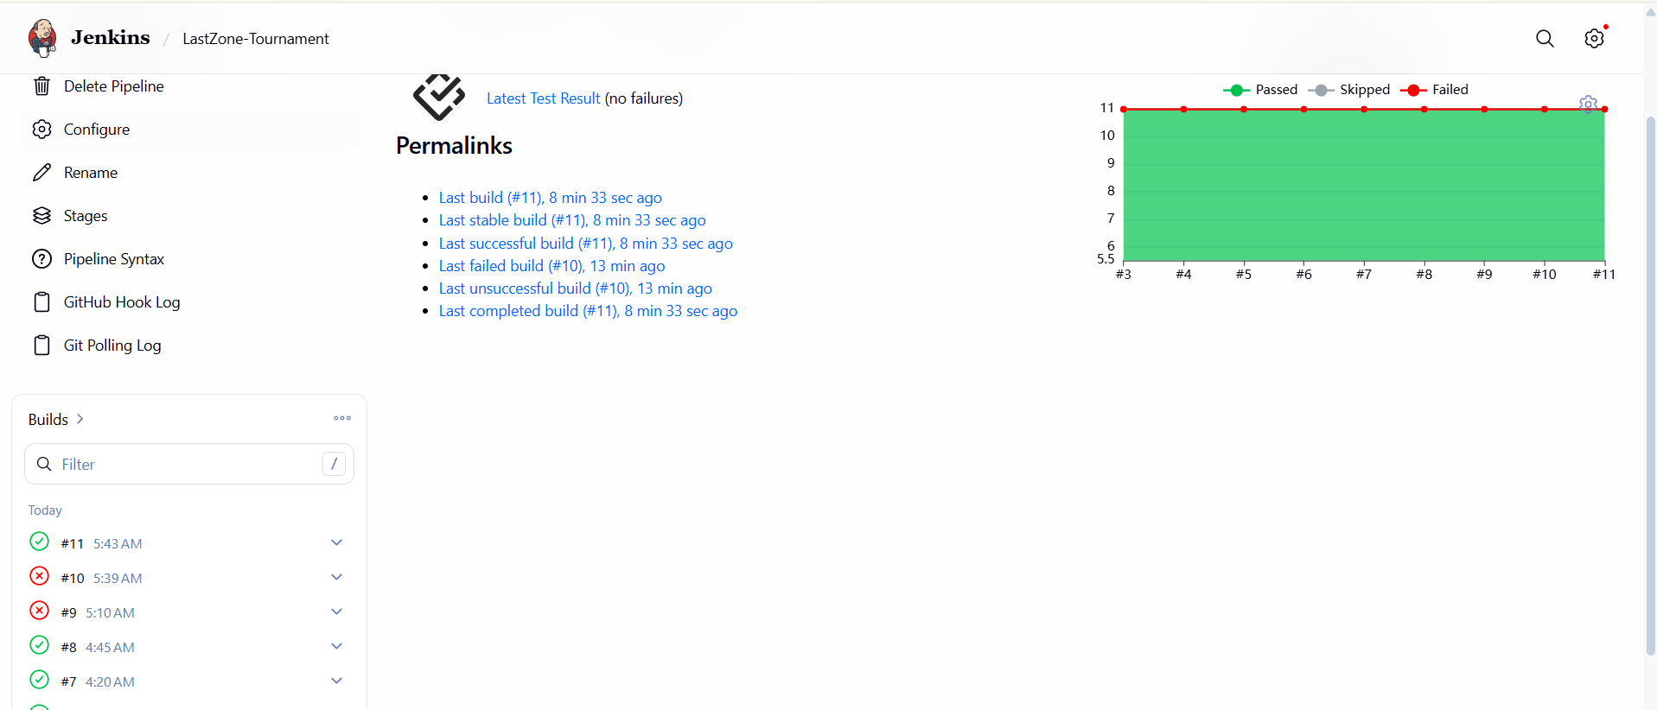
Figure 7.8: Jenkins CI/CD Pipeline
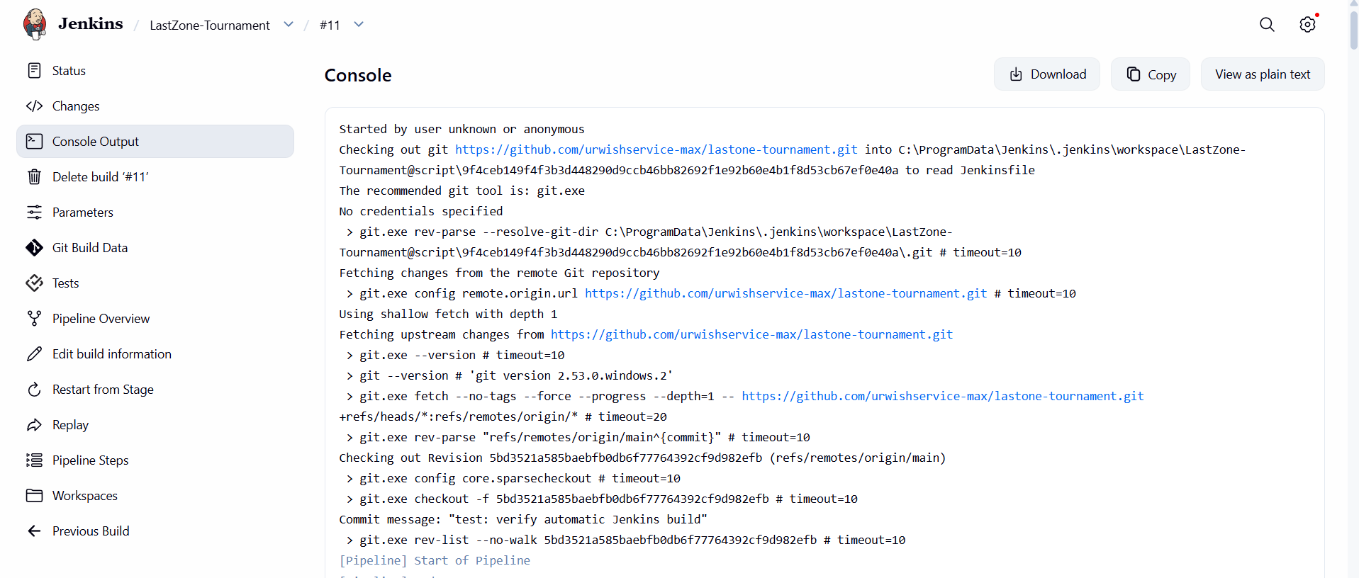
Figure 7.9: Successful Jenkins Pipeline Execution

MODULE 7 — AUTOMATED TESTING
This module validates the application automatically before deployment. Spring Boot Test + MockMvc (JUnit 5) is integrated into the Jenkins pipeline so that the application is tested before the deployment stage.
Main Functions
- Uses Spring Boot Test + MockMvc (JUnit 5) for automated testing.
- Maintains the test file test_app.py.
- Executes the test inside the Docker image.
- Verifies the configured application test.
- Provides automated test execution.
- Prevents deployment from continuing when an earlier pipeline stage fails.
- Displays test results in Jenkins.
- Integrates testing directly into the CI/CD workflow.
- Reduces the need for repeated manual testing.
- Helps identify application issues before deployment.
Test File
test_app.py
Test Command
Java 21 -m Spring Boot Test + MockMvc (JUnit 5) test_app.py
Test Result
collected 1 item
test_app.py . [100%]
1 passed
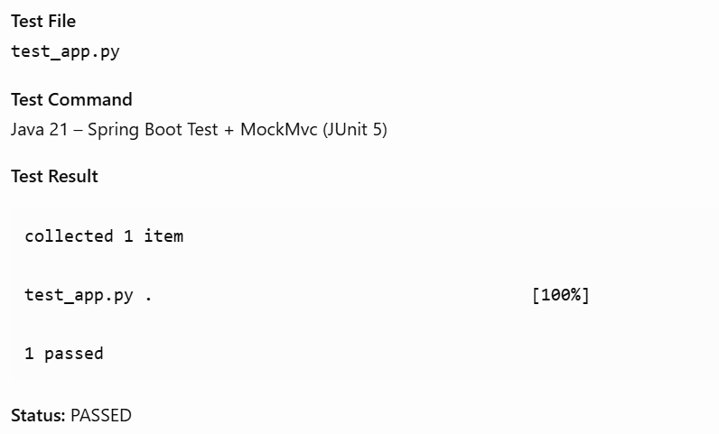
Figure 7.10: Successful Automated Test Execution

MODULE 8 — ANSIBLE DEPLOYMENT
Ansible is used to automate the deployment and configuration of the LASTZONE – ONLINE TOURNAMENT PLATFORM Docker container. The deployment configuration is defined in the Ansible playbook.
Main Functions
- Executes the deployment playbook.
- Specifies the Docker container name.
- Specifies the Docker image.
- Configures application port mapping.
- Configures persistent volume mounting.
- Defines the container state.
- Defines the restart policy.
- Uses Docker to apply the specified configuration.
- Automates container deployment.
- Allows deployment to be triggered through Jenkins.
- Provides a repeatable deployment configuration.
Deployment Configuration
name: lastzone-ansible
image: lastzone-ci
published_ports:
- "5001:8080"
volumes:
- "lastzone_postgres_data:/app/data"
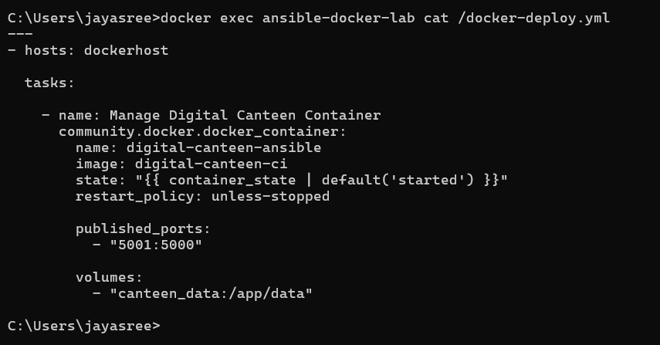
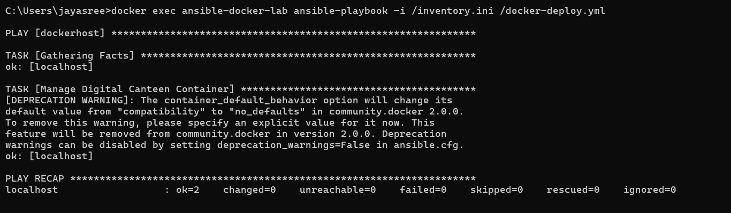
Figure 7.11: Ansible Deployment Playbook
MODULE 9 — PERSISTENT STORAGE
This module ensures that database information remains available even when the application container is recreated. Docker Volume is used to separate persistent application data from the container lifecycle.
Main Functions
- Creates persistent storage for application data.
- Uses the Docker Volume lastzone_postgres_data.
- Mounts the volume to /app/data.
- Stores the PostgreSQL 16 database in the mounted directory.
- Separates persistent data from the container lifecycle.
- Allows the database to remain available after container recreation.
- Preserves stored order information.
- Provides persistent storage for the PostgreSQL 16 database.
- Allows the application container to be recreated without losing stored order data.
Storage Configuration
lastzone_postgres_data:/app/data
Storage Flow
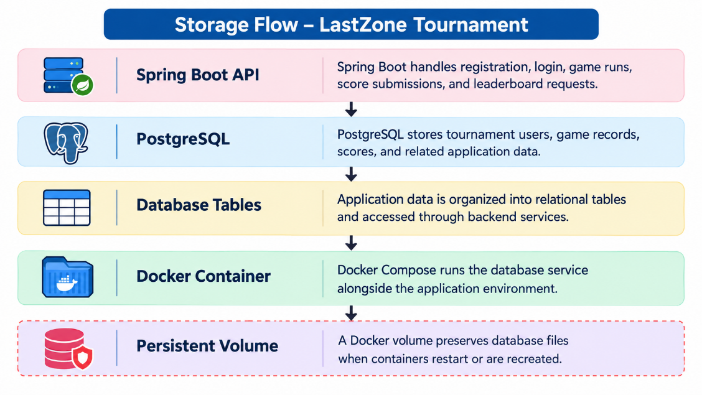

Figure 7.12: tournament Data Docker Volume

MODULE 10 — ADMIN & score and run management
This module provides access to the orders placed by users. The Spring Boot 3.3.5 backend stores the order information in PostgreSQL 16, while the leaderboard dashboard provides access to the stored records.
Main Functions
- Receives orders placed by users.
- Processes order information through Spring Boot 3.3.5.
- Stores order information in PostgreSQL 16.
- Generates an order ID.
- Makes stored orders available to the administrator.
- Provides access to order information through the leaderboard dashboard.
- Allows the administrator to view stored orders.
- Connects the application workflow with database records.
- Provides a centralized view of placed orders.

leaderboard dashboard
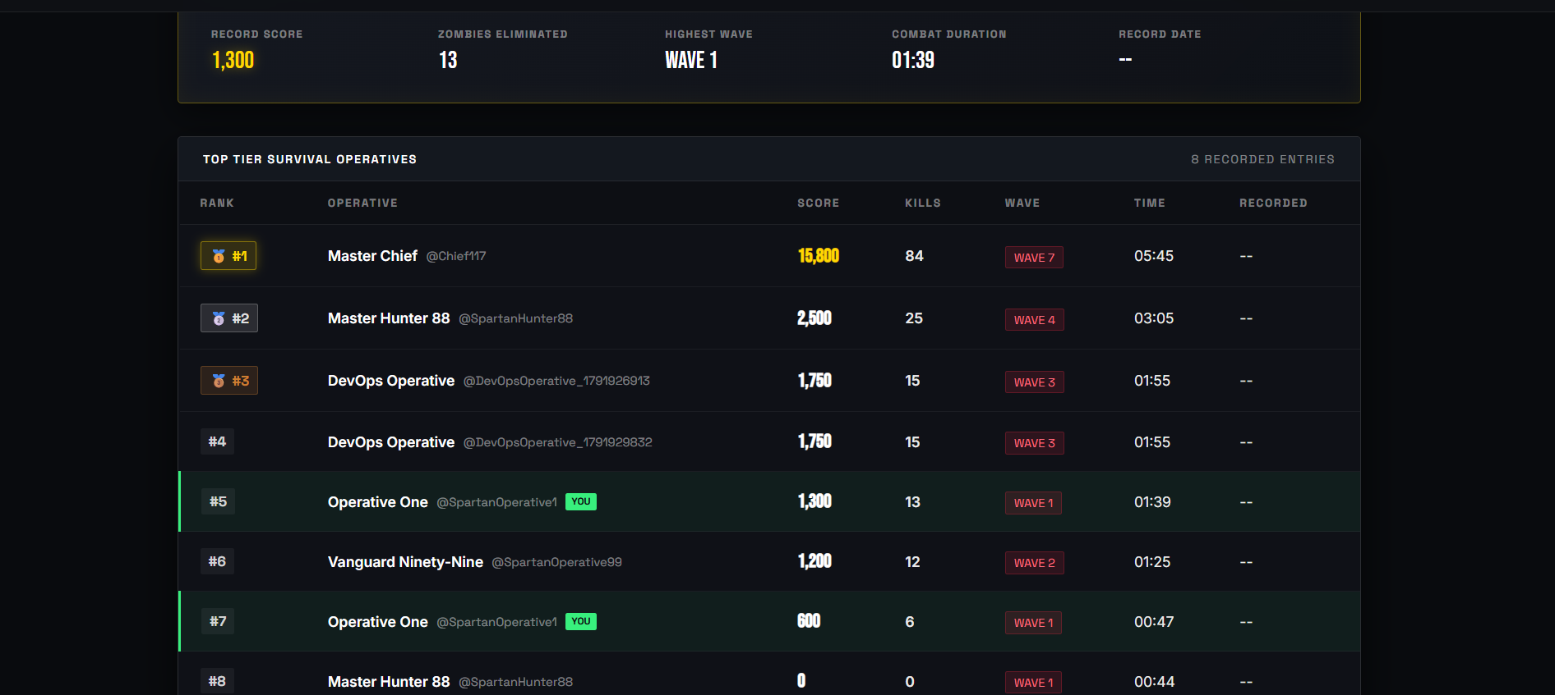
Figure 7.13: LASTZONE – ONLINE TOURNAMENT PLATFORM leaderboard dashboard

MODULE 11 — CI/CD INTEGRATION
This module integrates the different DevOps tools into a single automated workflow. GitHub, Jenkins, Docker, Spring Boot Test + MockMvc (JUnit 5), and Ansible work together to automate the build, testing, and deployment process.
Main Functions
- Integrates GitHub with Jenkins.
- Retrieves the latest project code.
- Checks out the required project version.
- Builds the Docker image automatically.
- Runs Spring Boot Test + MockMvc (JUnit 5) automatically.
- Triggers Ansible deployment after successful testing.
- Creates and manages the Docker container.
- Provides a repeatable deployment process.
- Produces execution results for each pipeline stage.
- Reduces repetitive manual deployment activities.
- Connects source control, testing, containerization, and deployment into one workflow.
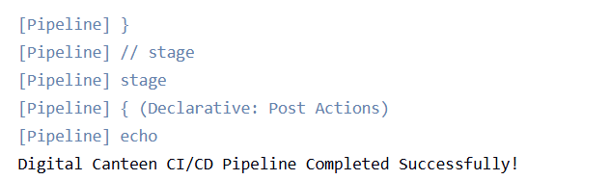
Figure 7.14: Complete CI/CD Pipeline Execution

MODULE 12 — APPLICATION & DEPLOYMENT VERIFICATION
This module verifies that the complete LASTZONE – ONLINE TOURNAMENT PLATFORM system is functioning correctly after deployment. Verification is performed across the application, Docker container, database, storage, Ansible deployment, and Jenkins pipeline.
Verification Activities
- Checking the running Docker container.
- Checking the application port.
- Opening the LASTZONE – ONLINE TOURNAMENT PLATFORM application.
- Browsing available leaderboard entrys.
- Placing a food order.
- Checking the generated order information.
- Checking the leaderboard dashboard.
- Checking stored PostgreSQL 16 orders.
- Checking the Docker Volume.
- Checking Ansible execution.
- Checking Jenkins pipeline results.
- Confirming successful application deployment.
- Verifying that order data remains available after container recreation.
Important Outputs
Docker Build → SUCCESS
Spring Boot Test + MockMvc (JUnit 5) → 1 PASSED
Ansible → failed=0
Pipeline → SUCCESS
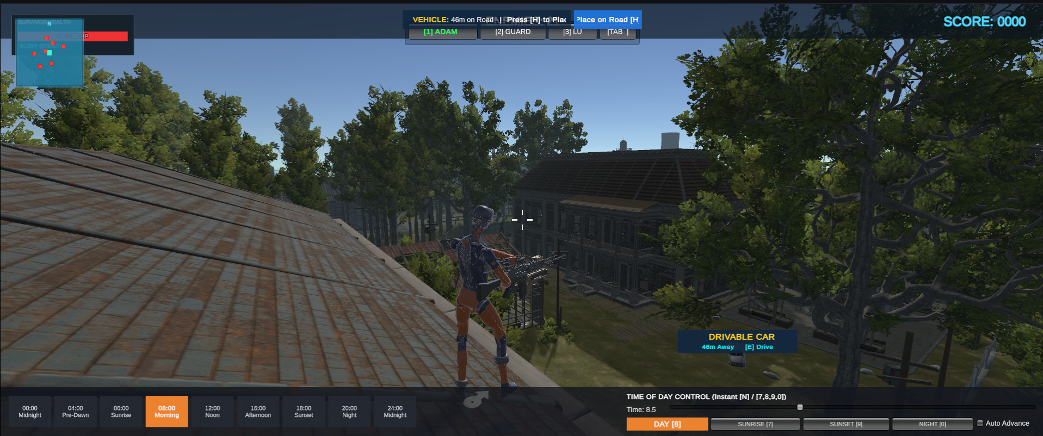
Figure 7.15: Successfully Deployed LASTZONE – ONLINE TOURNAMENT PLATFORM Application
19. RESULTS AND OUTPUT
The implemented LASTZONE – ONLINE TOURNAMENT PLATFORM successfully demonstrates the integration of web application development with DevOps tools. The implemented system provides the following features:
- Digital tournament interface for users.
- User registration and login functionality.
- Game run session management.
- Score submission and validation.
- Leaderboard dashboard.
- Spring Boot 3.3.5 backend API.
- PostgreSQL 16 database integration.
- Docker containerization using Docker Compose.
- Automated backend testing using Spring Boot Test and MockMvc with JUnit 5.
- Jenkins CI/CD pipeline for automated building and testing.
- Ansible playbook for deployment automation.
- Persistent database storage using Docker volumes.
- Git and GitHub integration for source code management.
- API verification for registration, login, game runs, score submission, duplicate submission rejection, and leaderboard operations.
The automated API verification completed successfully in the earlier test run, including duplicate submission rejection with HTTP 409. The Jenkins pipeline has also demonstrated successful execution of the automated tests and application build stages. Deployment stages depend on the Docker Engine being operational.
COMMANDS USED
1. Docker Environment
Check running containers:
docker ps
Check all containers:
docker ps -a
List available Docker images:
docker images
Check Docker version and engine status:
docker version
docker info
Start the Ansible container:
docker start ansible-docker-lab
Start Jenkins:
docker start jenkins
2. Jenkins Commands
Jenkins was accessed using:
http://localhost:8080/job/LastZone-Tournament/
Check the Jenkins container:
docker ps -a
Check Jenkins port mappings:
docker port jenkins
Check Jenkins logs:
docker logs jenkins
Verify Docker access from Jenkins, if the Docker socket is available:
docker exec jenkins docker info
The Jenkins pipeline retrieves the latest source code from GitHub and performs the configured build, test, and deployment stages.
3. Docker Image Build
Build the LastZone Docker image:
docker build -t lastzone-ci .
The Jenkins pipeline also builds the application images using the project's Docker configuration.
The image name lastzone-ci is used for the command shown above; the actual image names used by Docker Compose depend on the project configuration.
4. Automated Testing
The backend automated tests use Spring Boot Test, MockMvc, and JUnit 5.
Run the backend tests from the backend directory:
cd backend
mvn test
Package the backend application:
mvn clean package
The Jenkins pipeline executes the configured automated tests before proceeding to later stages.
Previously recorded test result: 11 tests passed in the earlier test run.
The test count should be checked against the latest Jenkins console output before including it as the final result in the report.
5. API Verification
The project includes an API end-to-end verification script.
Run the verification script from the project root:
.\scripts\verify-api-e2e.ps1 -port 80
The script verifies the configured API workflow, including:
- User registration.
- User login.
- Game run operations.
- Score submission.
- Duplicate submission rejection.
- Leaderboard retrieval.
The earlier recorded execution completed successfully.
6. Ansible Deployment
Start the Ansible container:
docker start ansible-docker-lab
Run the Ansible playbook manually:
docker exec ansible-docker-lab ansible-playbook -i /inventory.ini /docker-deploy.yml
View the Ansible playbook:
docker exec ansible-docker-lab cat /docker-deploy.yml
The Ansible configuration is used to automate the configured deployment tasks. A successful syntax check or dry run alone does not confirm that a complete deployment has occurred.
7. Docker Container Verification
Check running containers:
docker ps
Check all containers:
docker ps -a
View container logs:
docker logs CONTAINER_NAME
Check port mappings:
docker port CONTAINER_NAME
The exact deployed container name and port mapping should be taken from the current Docker Compose configuration and container output.
8. PostgreSQL 16 Database Commands
List Docker volumes:
docker volume ls
Inspect the configured PostgreSQL volume:
docker volume inspect lastzone_postgres_data
Check the database service:
docker compose ps -a
View PostgreSQL container logs:
docker compose logs postgres
Open the PostgreSQL command-line interface, if the service and credentials match the project configuration:
docker compose exec postgres psql -U POSTGRES_USER -d POSTGRES_DB
Replace POSTGRES_USER and POSTGRES_DB with the actual values configured in the project's environment or Compose file.
Inside psql, list database tables:
\dt
Inspect the available tables and their columns before running queries. The actual database schema must be used for any score, game-session, user, or leaderboard query.
9. Docker Volume and Persistent Storage Verification
List available volumes:
docker volume ls
Inspect the configured volume:
docker volume inspect lastzone_postgres_data
Inspect the Compose volume configuration:
docker compose config --volumes
Check the configured database service:
docker compose ps -a
A configured persistent volume allows database data to survive ordinary container recreation when the volume is correctly mounted. The actual volume name and mount point must be verified from the project's Compose configuration.
10. Git and GitHub Commands
Check the current Git status:
git status
Check the current branch:
git branch
View configured remotes:
git remote -v
View recent commits:
git log --oneline -5
Stage a specific project file:
git add index.html
Commit changes:
git commit -m "Update LastZone tournament platform"
Push the current branch:
git push origin main
The project repository is:
https://github.com/urwishservice-max/lastone-tournament
Git commands should be executed from the project directory. Stage only the files intended for the commit, and preserve local database files and other untracked data.
11. Main Commands for the Report
The following commands are the most important for demonstrating the project's DevOps implementation:
docker version
docker ps -a
docker images
docker compose ps -a
docker compose config --volumes
docker volume ls
docker volume inspect lastzone_postgres_data
Backend testing:
cd backend
mvn test
mvn clean package
API verification:
.\scripts\verify-api-e2e.ps1 -port 80
Ansible deployment:
docker exec ansible-docker-lab ansible-playbook -i /inventory.ini /docker-deploy.yml
GitHub integration:
git status
git log --oneline -5
git push origin main
21. ADVANTAGES
- Provides a dedicated online tournament platform with a web-based user interface.
- Supports user registration and login.
- Enables game-session management and score submission.
- Provides a leaderboard for displaying tournament scores.
- Uses PostgreSQL 16 for structured application data storage.
- Uses Docker to provide a consistent application environment.
- Automates application building and testing through Jenkins.
- Integrates Git and GitHub for version control.
- Uses Spring Boot Test, MockMvc, and JUnit 5 for backend testing.
- Demonstrates deployment automation using Ansible.
- Supports persistent database storage through Docker volumes when correctly configured.
- Reduces repetitive manual work in the application build and deployment workflow.
22. LIMITATIONS
- The current deployment is demonstrated in a local Docker environment.
- The application depends on the availability and correct configuration of the Docker Engine.
- The database requires correct PostgreSQL connection settings and persistent-volume configuration.
- Real-time multiplayer functionality should not be claimed unless it has been implemented and tested.
- Advanced monitoring and centralized logging are not confirmed as implemented.
- Cloud deployment is not part of the currently demonstrated workflow.
- Deployment success depends on the successful completion of the Jenkins pipeline and Ansible tasks.
- The application's performance under a large number of simultaneous users has not been established through load testing.
23. CONCLUSION
The LASTZONE – ONLINE TOURNAMENT PLATFORM demonstrates the integration of modern web development technologies with DevOps practices. The application uses React, Vite, and TypeScript for the frontend and Spring Boot 3.3.5 for backend operations. PostgreSQL 16 provides database storage for application information, while Docker and Docker Compose provide a containerized execution environment.
The project integrates Git and GitHub for source code management and Jenkins for automating the application build and testing process. Spring Boot Test, MockMvc, and JUnit 5 are used to verify backend functionality. The API verification script checks important application operations, including registration, login, game sessions, score submission, duplicate submission rejection, and leaderboard retrieval. Ansible is incorporated to demonstrate deployment automation through a playbook.
Docker volume configuration is used to support persistent PostgreSQL storage, helping preserve database information across ordinary container recreation when the volume is correctly mounted. Together, these components demonstrate how application development, automated testing, containerization, version control, and deployment automation can be combined in a single project.
Overall, the project provides practical experience in developing and managing a web-based tournament platform and demonstrates a DevOps workflow involving GitHub, Jenkins, Docker, Spring Boot, PostgreSQL, automated testing, and Ansible.

24. FUTURE ENHANCEMENTS
The system can be extended with the following improvements:
- Real-time multiplayer tournament support.
- Multiple tournament creation and management.
- Improved leaderboard filtering and ranking.
- Enhanced authentication and role-based access control.
- Real-time score and tournament updates.
- Email or WhatsApp notifications for tournament events.
- Cloud deployment for wider accessibility.
- Application monitoring and centralized logging.
- Automated performance and load testing.
- Improved database backup and recovery procedures.
- Security improvements for credentials, API access, and deployment permissions.
- More comprehensive end-to-end testing.
- Improved Jenkins pipeline error handling and automatic recovery.
- Automated deployment verification after each successful build.

