**Q1:** 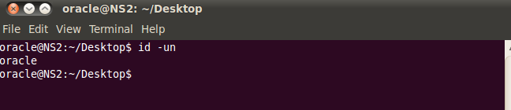

**Q2:**

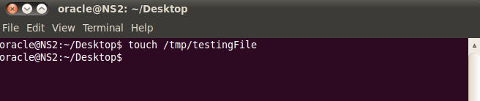

**Q3:**

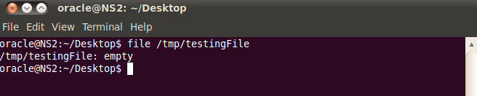

**Q4:**

rmdir can only be used to remove an empty directory. It won't work for non-empty directories and files. rm removes both files and non-empty directories.

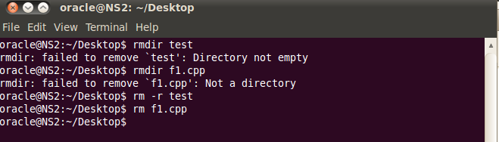

**Q5:**

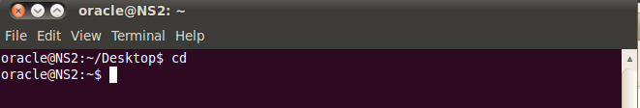

**Q6:**



**Q7:**

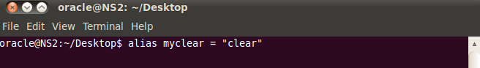

**Q8 a)** cls: command not found

**b)** mkdir: cannot create directory `d1': File exists

**Q1:**

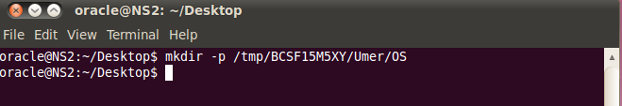

**Q2:**

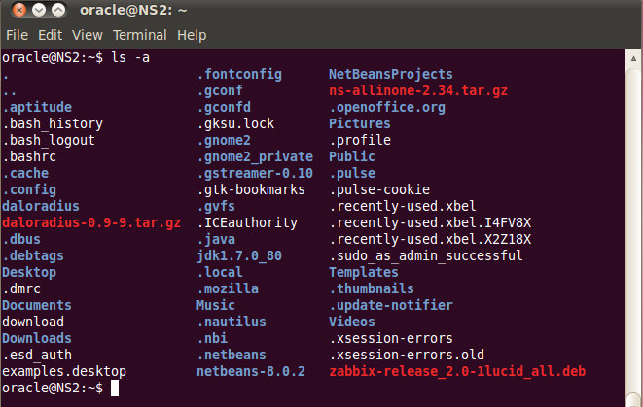

**Q3:**

1. rmdir –p BCSF15M5XY/Umer/OS
2. rm –r BCSF15M5XY

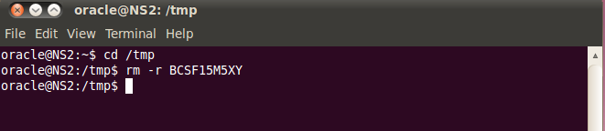

**Q4:**

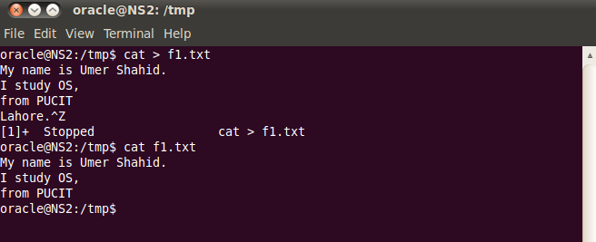

**Q5:**

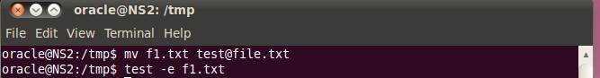

**Q6:**

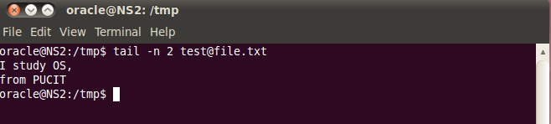

**Q7:**

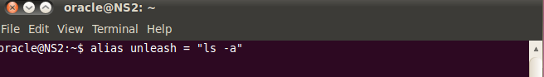

**Q8:**

man [command_name]

**Q9:**

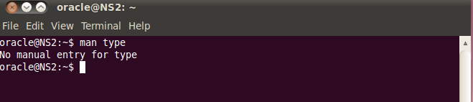

**Q10:**

rm –r [directory_name]

**Q1:**

mkdir dilawar/reports

**Q2:**

mkdir/home/oracle/Desktop/abdul

**Q3:**

mkdir ../ ../ abdul/file1

**Q4:**

mkdir -p ../staff/arif

mkdir ../staff/rauf

**Q5:**

touch arif/file2

touch rauf/file3

**Q6:**

cp -r arif ../abdul

cp -r rauf ../abdul

**Q7:**

mkdir ../dilawar/newdir

cp -r ../staff ../dilawar/newdir

**Q8:**

rm -r ../../staff

**Q9:**

mv file2 refile2