WORKFLOW AUTOMATION — THEORY REPORT
DMN-Driven Auto-Approval: Employee Leave Request Process
Name: Utsav Saxena
Register Number: RA2411056010221
Section: AO2
Tool Used: Camunda Modeler (Camunda 8 / Zeebe engine)
GitHub Repository: https://github.com/us9250-svg/BPMN_Process_Modeling.git

This report answers the four theory questions for the assignment on DMN-based auto-approval logic within a BPMN process. The corresponding BPMN process model and DMN decision requirements diagram have been built and simulated in Camunda Modeler, and are uploaded to the GitHub repository linked above. Screenshots of the working models are included in this report as figures.

1. BPMN 2.0 Process Model (Camunda 8 / Zeebe)

Process Description
An employee submits a leave request. The system validates the request and computes the number of leave days requested along with the employee's available balance. This data is passed into a Business Rule Task, which invokes a DMN decision to determine whether the request can be auto-approved, must be auto-rejected, or needs manager review. Depending on the outcome, the process either updates the leave balance and notifies the employee directly, or routes the request to a manager for a human decision before doing the same. The process always ends with an employee notification, so every path terminates in a definite outcome.

Elements Used
- 1 Start Event — Leave Request Submitted.
- Service Task — Validate Leave Request (computes numberOfDays and availableBalance).
- Business Rule Task — Evaluate Approval Route (invokes the DMN decision).
- Exclusive Gateway — Approval Decision? (routes on AUTO_APPROVE / AUTO_REJECT / MANUAL_REVIEW).
- User Task — Manager Review (human-in-the-loop step, only reached on MANUAL_REVIEW).
- Exclusive Gateway — Manager Decision? (routes on Approved / Rejected).
- 2 Merging Exclusive Gateways — converge the auto-approved/manager-approved paths, and the auto-rejected/manager-rejected paths, so downstream tasks are not duplicated.
- Service Task — Update Leave Balance.
- Service Task — Notify Employee: Approved.
- Service Task — Notify Employee: Rejected.
- 2 End Events — Leave Approved, Leave Rejected.

Gateway Logic
- Approval Decision? — AUTO_APPROVE: goes straight to balance update and approval notice. AUTO_REJECT: goes straight to rejection notice. MANUAL_REVIEW: routed to the manager.
- Manager Decision? — Approved: merges back into the same balance-update/approval-notice path as an auto-approval. Rejected: merges back into the same rejection-notice path as an auto-rejection.
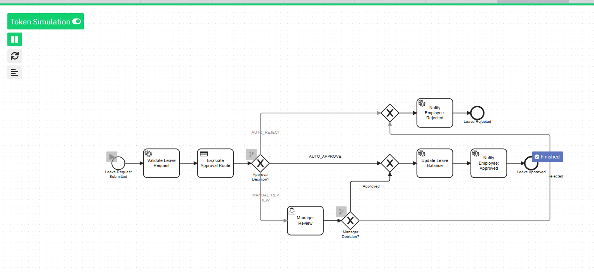
Figure 1: Leave Approval BPMN process with Business Rule Task, gateways, and merged end paths, executed via Token Simulation in Camunda Modeler.

2. DMN Decision Table for Auto-Approval Logic
The auto-approval logic is modelled as a Decision Requirements Diagram (DRD) containing two linked decision tables, invoked as a single decision from the Business Rule Task.

Decision 1 — Check Leave Balance Sufficiency
Hit Policy: UNIQUE. Purpose: a generic, reusable check for whether the employee has enough balance for the requested days.
Input: numberOfDays | Input: availableBalance | Output: balanceSufficient
— | >= numberOfDays | true
— | < numberOfDays | false

Decision 2 — Determine Approval Route
Hit Policy: FIRST. Purpose: combines leave type, day count, and the balance-sufficiency result from Decision 1 to pick a routing outcome.
Leave Type | Number of Days | Balance Sufficient | Approval Decision | Approval Reason
— | — | false | AUTO_REJECT | Insufficient leave balance
UNPAID | — | true | MANUAL_REVIEW | Unpaid leave requires manager approval
SICK | <= 3 | true | AUTO_APPROVE | Sick leave within auto-approval threshold
ANNUAL | <= 5 | true | AUTO_APPROVE | Annual leave within auto-approval threshold
PARENTAL | <= 5 | true | AUTO_APPROVE | Parental leave within auto-approval threshold
— | — | true | MANUAL_REVIEW | Exceeds auto-approval threshold, requires manager review
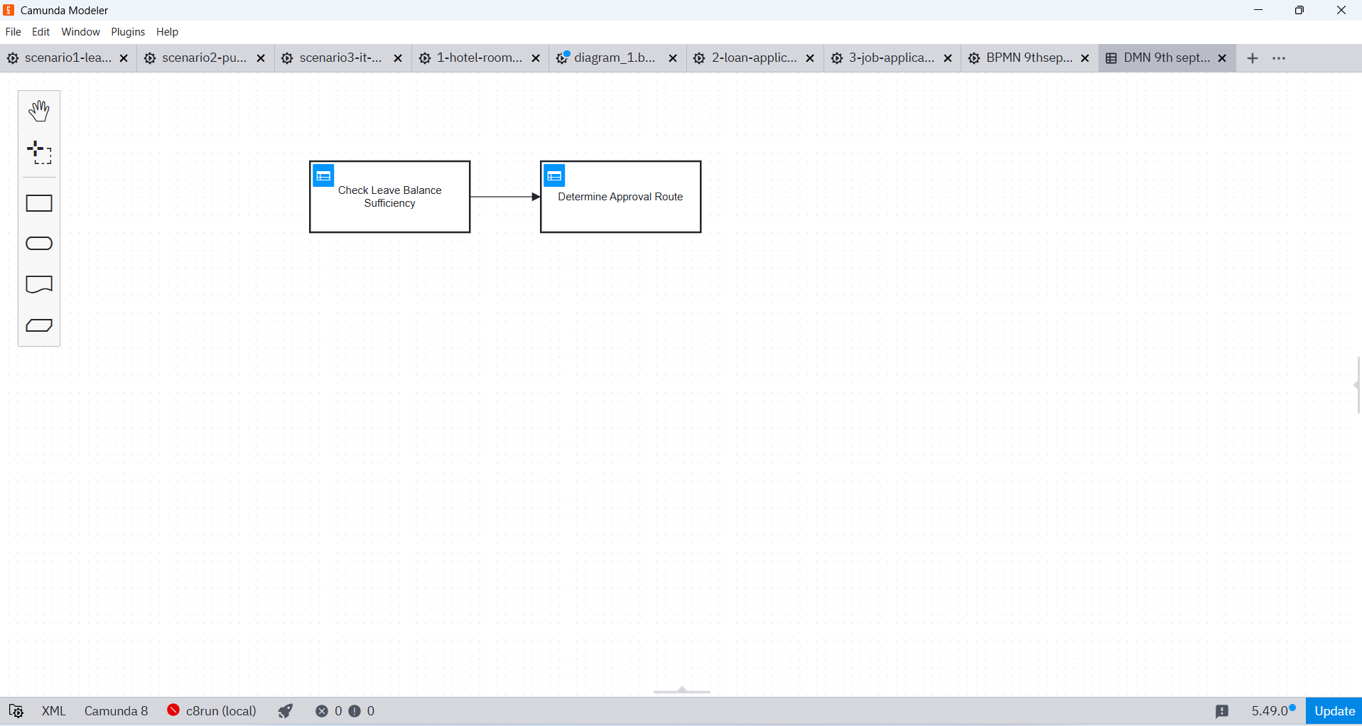
Figure 2: DMN Decision Requirements Diagram (DRD) showing 'Check Leave Balance Sufficiency' feeding into 'Determine Approval Route', modelled in Camunda Modeler.

3. Service Tasks vs. User Tasks, and Data Passed Between Them
Elements were classified as Service Tasks when the work is deterministic, rule-based, or a system update with no judgement required, and as a User Task only where a human decision genuinely adds value beyond what the DMN rules can resolve.
Element | Type | Justification | Input Variables | Output Variables
Validate Leave Request | Service Task | Deterministic data lookup/calculation | employeeId, leaveType, startDate, endDate | numberOfDays, availableBalance
Evaluate Approval Route | Business Rule Task | Pure decision logic, delegated to DMN | leaveType, numberOfDays, availableBalance | approvalDecision, approvalReason
Manager Review | User Task | Human judgement needed only when rules cannot auto-decide | employeeId, leaveType, numberOfDays, approvalReason | managerDecision, managerComment
Update Leave Balance | Service Task | System-of-record update, fully automatable | employeeId, numberOfDays | updatedBalance
Notify Employee (Approved/Rejected) | Service Task | Sending a notification requires no discretion | employeeId, notificationType, approvalReason | — (fire-and-forget)
The dividing line used throughout: if the outcome can be fully determined from existing data by applying a fixed rule, it is automated (Service Task or Business Rule Task). If the outcome depends on discretion, context, or an exception the rules do not cover, it is escalated to a human via a User Task — in this process, that is limited strictly to the Manager Review step.

4. Justification: Single Table vs. Multiple Hit-Policy Tables
This design uses two linked decision tables in one DRD rather than a single combined table, for the following reasons:
- Separation of concerns: 'Is the balance sufficient?' is a generic, reusable check that other processes (e.g., leave cancellation or leave transfer) could call independently. Folding it into the approval-routing table would duplicate that logic wherever it is needed elsewhere.
- Hit policy fit: the balance check is a clean binary UNIQUE-hit decision, whereas approval routing benefits from a FIRST/PRIORITY-style hit policy so that hard blockers (e.g., insufficient balance) can be ordered ahead of soft threshold rules (e.g., leave-type day limits). Combining both concerns under one hit policy would force awkward, repeated conditions in every row.
- Maintainability: HR/business analysts will change auto-approval thresholds (e.g., raising the annual-leave limit from 5 to 7 days) far more often than they will change how balance sufficiency itself is computed. Splitting the tables keeps each change isolated to the table it actually concerns.
- No added orchestration cost: because Decision 2 declares Decision 1 as a required decision in the DRD, the DMN engine evaluates Decision 1 automatically whenever Decision 2 is called. The BPMN process still only needs a single Business Rule Task — the two-table split is invisible to the process model and adds no extra steps at runtime.
A single combined table was considered but rejected, since it would mix a reusable, low-churn calculation with a frequently-changing policy decision — increasing the risk of accidental errors whenever thresholds are updated. Splitting further into three or more tables was also considered unnecessary for this scope, since the natural seam in the logic is exactly two decisions: eligibility (balance) and routing (policy).

All BPMN and DMN model files, along with the Token Simulation screenshots referenced above, are available in the GitHub repository linked at the top of this report.

