Untwist
Camelina population structure analysis;
with the goal to assess how well the European germplasm is represented by the Untwist lines

1. Material and Methods:

1.1 Sequencing :

With the goal to assess how well the European germplasm is represented by the Untwist lines we assessed genetic relatedness and diversity of 223 Camelina accessions.
Of these the respective whole genome re-sequencing data for 169 accessions was generated by Li et., al. 2021 and is publicly available in the NCBI database (under accessions SRP215681-220853; 241487–241525). Additional information on these accessions is provided in Supplementary Table S2 (Li et., al. 2021). The remaining 54 accessions were sequenced using paired end short read sequencing.

The resulting high-quality paired end reads were trimmed with trimmomatic (Bolger et., al. 2014) and then mapped, i.e. aligned to the Camelina sativa L. reference genome (downloaded from NCBI under Bioproject: PRJA264159). Aligment of sequencing reads was done with the bwa software in version 0.7.17 (Li, 2013). Using the alignments genomic variants were identified. This variant calling was done with the GATK software tool in version 4.1.4.0 (Poplin et., al. 2017).
1.2 Filtering of genomic variants:
Genomic variants include insertions, deletions, reversions, and single nucleotide polymorphisms. To answer the question how well the Untwist lines sample the diversity of European germplasm, we carried out a population structure analysis. To obtain unbiased and high confidence results, we filtered the genomic variants obtained from sequencing and variant calling (section 1.1).
Filtering was implemented in a bioinformatics pipeline. In the first step, we used bcftools in version 1.9 to only retain single nucleotide polymorphisms (SNPs), that are bi-allelic. Of these we retained only those that have less than 10% of the genotypes with missing data, and have read quality score of at least 20, and have a minor allele frequency of at least 0.05, and have at least three sequencing reads aligned to the respective genomic position. Subsequently, we filtered out the retained genomic positions or sites that had an acceptable rate of heterocygosity below or equal to 50 %. For this we used vcffilterjs from the jvarkit package in version 2021.10.13. Finally, we filtered out sites correlated due to linkage disequilibrium, during which we discarded sites that were within a genomic distance of ten kilo-bases and had a correlation coefficient of 0.9 or higher. This step was carried out with bcftools version 1.9.
1.3 population structure analysis
In order to infer the genetic diversity and population structure of the Camelina UNTWIST panel (54 accessions) in the context of the analyzed public accessions (169 accessions)
we assessed pairwise genetic distances for all pairs of Camelina accessions using Identity by State distance measures. This was calculated with the PLINK program in version 1.9 (Purcel et al. 2007). These IBS-distances (plink parameter “1-IBS”) was used to carry out hierarchical clustering (Hartigan 1975) in R (hclust).
Subsequently, to infer each accession’s genome’s fractional composition in terms of how much of a genome belongs to which subpopulation, we used ADMIXTURE (Alexander et al. 2009). We ran ADMIXTURE multiple times testing different values for the assumed number of subpopulation parameter, taken from 3,4,…,6. To infer the best performing number of subpopulations we examined the cross-validation error (CVE) reported by ADMIXTURE, choosing the parameter value with the lowest CVE. To visualize the results of ADMIXTURE we generated barplots where each accession is represented by a single bar sub-divided into colored sections. Each of these colored sections represents the fraction of a genome coming from ancestry belonging to the subpopulation represented by that particular color. We aligned these barplots with the dendrogram generated by the hierarchical clustering analysis on the IBS distances (see results). Plotting was done in R (version 4.2.3; R Core Team 2023).
Finally, we carried out a principal component analysis using the top 20 principal components of the variance-standardized relationship matrix (plink; v1.9). For each accession we thus obtained its respective coordinates in the principal component vector space, of which the first two were used for scatter-plots (see results). Subsequently, k-means clustering was carried out on the accession coordinates in the 20 dimensional principal component space (Hartigan and Wong, 1979). In this, to identify the ideal number parameter k different numbers for this parameter were tried, taken from 3,4,…,10. The best performing value was inferred by visual inspection of the Silhouette plot (Lengyel and Botta-Dukát 2019). k-means clustering was done in R (version 4.2.3; R Core Team 2023).
1.4 Code availability
All code used to carry out these analyses and a detailed description of the procedures is hosted on GitHub (github.com/usadellab/untwist). All plots are stored there, too. These files are also stored in the supplemental archive “Untwist_Population_Structure_Analysis.zip”.
2. Results:
In this study, we analyzed the genotypic dataset of 223 Camelina accessions to decipher the genetic diversity of Camelina Untwist accessions and assess how well the Untwist Camelina lines sample the genomic diversity of the European germplasm. To this end, we first identified single nucleotide polymorphisms (SNPs) by aligning sequencing reads to the reference genome. Next, these SNPs were filtered to retain those with high confidence and quality (see methods), which generated a SNP variant matrix of 340,696 high confidence SNPs (“genotype dataset”).
To further hone in on genetic diversity and reveal the underlying population structure in more detail, we carried out a principal component analysis on the top 20 principal components (PC) of the variance-standardized relationship matrix. We thus obtained the PC coordinates of each analyzed Camelina accession, which we plotted in supplemental figure one.
To elucidate the pairwise genomic likeliness in detail we carried out hierarchical clustering based on Identity-By-State distances (see methods). We aligned the resulting dendrogram (tree) with the results from an ADMIXTURE population genetics analysis. In this analysis accessions are grouped by their genomic relatedness in order to infer which fractions of their genomes, based on SNP data, belong to which ancestral population. The advantage here being, that an accession is not necessarily entirely assigned to one or another population (cluster) but fractions of its genome are. Thus, admixture between populations can be inferred and visualized. This analysis was carried out by the ADMIXTURE software (see methods) and revealed best performance for nine assumed subpopulations. To carry out an admixture analysis the user needs to specify the number of assumed ancestral populations. ADMIXTURE carries out a cross-validation assay to infer the respective error bias imposed by assuming the respective number of ancestral populations. By comparison of this cross validation error with runs using different numbers of ancestral populations the best fitting number of populations is found as the one producing the lowest cross-validation-error (CVE). Here, we found nine populations to be optimal (CVE = 0.47). Find the visualized admixture results in supplemental figure two.
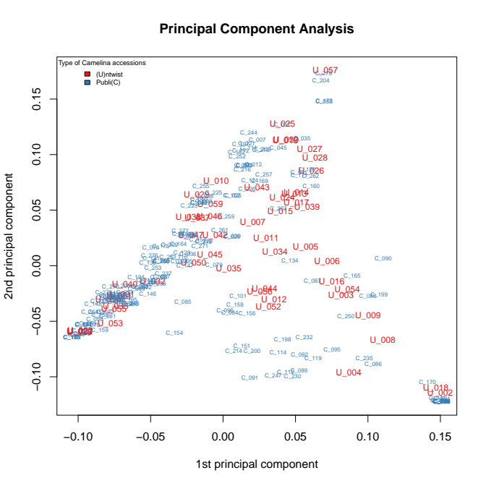
Supplemental figure one: Scatterplot visualizing the results of the principal component analysis of 223 Camelina lines. The first two principal components (PCs) are shows (x- and y-axis) that explain most of the observed genomic variation. Public Camelina lines are plotted in blue and are abbreviated with a “C_” prefix followed by their accession number. Untwist accessions are plotted in red and are abbreviated with a “U_” prefix followed by their respective accession numbers. The plot shows that the Untwist lines sample the genomic diversity space well according to the first two PCs.
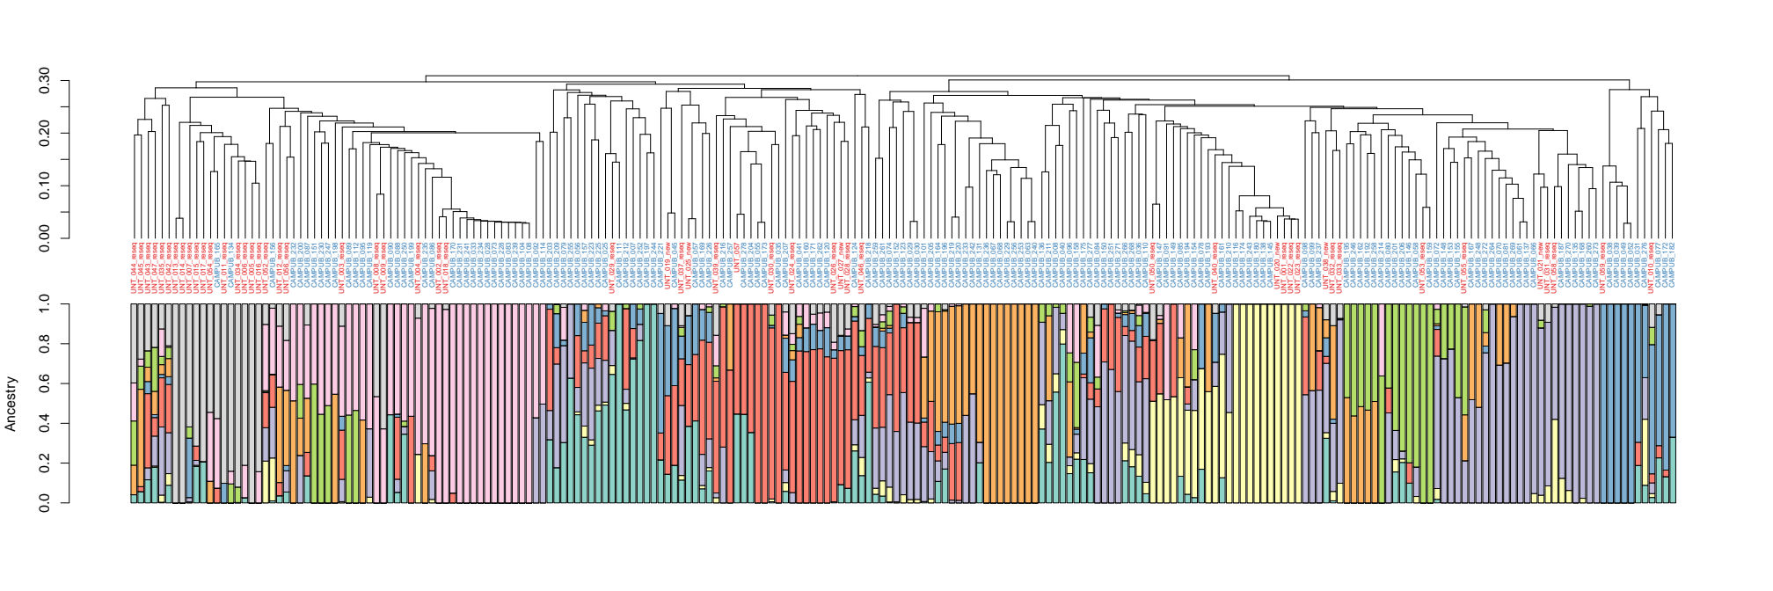
Supplemental figure two: Results of the hierarchical clustering (hclust) and admixture population genetics analysis. On top the dendrogram is shows that hclust produced based on Identity-By-State (IBS) distances (see methods). Public Camelina lines are represented by their accession identifier as blue dendrogram leaves, and Untwist accessions are shown as red dendrogram leaves. Aligned with the hierarchical clustering result is a barplot visualizing inferred genomic admixture for each respective Camelina accession. Nine ancestral sub-populations are represented by the nine different colors in the barplot. Colored sections in the bars represent the proportion of the respective accession’s genome being inherited from the ancestral population identified by the respective color. The aligned plots confirm each other and show that (i) the genomic variability of European Camelina germplasm is sampled well by the Untwist lines and (ii) that this is a result produced by the independent clustering, admixture analyses, and principal component analyses (see supplemental figure one).
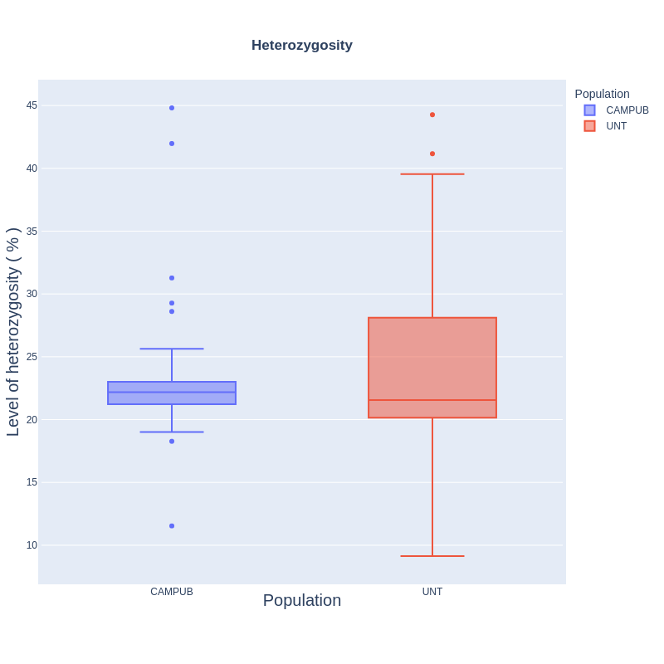Figure : Percentage of heterozygosity in Camelina public (169) and Untwist (54) accessions across 2,306,926 genome wide SNP positions . The blue boxplot to the left represent public accessions, wheras the orange boxplot to the right, describe the the heterozygosity of Untwist population.

3. Discussion
We carried out population genetics analyses to answer the question how well the European Camelina sativa germplasm is represented by the Untwist lines. In order to increase confidence in the results three independent analyses were carried out and their outcome compared. A principal component analysis, hierarchical clustering of Identity-By-State (IBS) distances, and an admixture analysis confirmed that the genomic variation of European Camelina accessions is captured well by the Untwist lines. Importantly the results of the three analyses confirm each other. Thus, we conclude that the European Camelina germplasm has been sampled well within Untwist breeding.

References:

Li, H., Hu, X., Lovell, J. T., Grabowski, P. P., Mamidi, S., Chen, C., ... & Lu, C. (2021). Genetic dissection of natural variation in oilseed traits of camelina by whole‐genome resequencing and QTL mapping. The plant genome, 14(2), e20110.

Bolger, A. M., Lohse, M., & Usadel, B. (2014). Trimmomatic: a flexible trimmer for Illumina sequence data. Bioinformatics, 30(15), 2114-2120.
Li, H. (2013). Aligning sequence reads, clone sequences and assembly contigs with BWA-MEM. arXiv preprint arXiv:1303.3997.

Poplin, R., Ruano-Rubio, V., DePristo, M. A., Fennell, T. J., Carneiro, M. O., Van der Auwera, G. A., ... & Banks, E. (2017). Scaling accurate genetic variant discovery to tens of thousands of samples. BioRxiv, 201178.

Haleem, A., Klees, S., Schmitt, A. O., & Gültas, M. (2022). Deciphering Pleiotropic Signatures of Regulatory SNPs in Zea mays L. Using Multi-Omics Data and Machine Learning Algorithms. International Journal of Molecular Sciences, 23(9), 5121.

Xu, J., Chen, G., Hermanson, P. J., Xu, Q., Sun, C., Chen, W., ... & Li, Q. (2019). Population-level analysis reveals the widespread occurrence and phenotypic consequence of DNA methylation variation not tagged by genetic variation in maize. Genome biology, 20, 1-16.

Li, H., Peng, Z., Yang, X., Wang, W., Fu, J., Wang, J., ... & Yan, J. (2013). Genome-wide association study dissects the genetic architecture of oil biosynthesis in maize kernels. Nature genetics, 45(1), 43-50.

Norman, A., Taylor, J., Edwards, J., & Kuchel, H. (2018). Optimising genomic selection in wheat: effect of marker density, population size and population structure on prediction accuracy. G3: Genes, Genomes, Genetics, 8(9), 2889-2899.
Miles, A., Io, B. P., Murillo, R., Ralph, P., Harding, N., Pisupati, R., ... & Millar, T. (2021). Cggh/Scikit-Allel: V1. 3.3 (version v1. 3.3). Zenodo.

Ng, A. (2012). Clustering with the k-means algorithm. Machine Learning, 1-2.
Pedregosa, F., Varoquaux, G., Gramfort, A., Michel, V., Thirion, B., Grisel, O., ... & Duchesnay, E. (2011). Scikit-learn: Machine learning in Python. the Journal of machine Learning research, 12, 2825-2830.
Inc., P. T. (2015). Collaborative data science. Montreal, QC: Plotly Technologies Inc. Retrieved from https://plot.ly
Purcell, S. et al. PLINK: A Tool Set for Whole-Genome Association and Population-Based Linkage Analyses. The American Journal of Human Genetics 81, 559–575 (2007).

Hartigan, J. A. and Wong, M. A. (1979). Algorithm AS 136: A K-means clustering algorithm. Applied Statistics, 28, 100-108.

R Core Team (2023). R: A language and environment for statistical computing. R Foundation for Statistical Computing, Vienna, Austria. URL https://www.R-project.org/.
Hartigan, J.A. (1975). Clustering Algorithms. New York: Wiley.

D.H. Alexander, J. Novembre, and K. Lange. Fast model-based estimation of ancestry in unrelated individuals. Genome Research, 19:1655–1664, 2009.

Lengyel, A. & Botta-Dukát, Z. Silhouette width using generalized mean—A flexible method for assessing clustering efficiency. Ecology and Evolution 9, 13231–13243 (2019).
Supplementary Figure 1:
Figure 1: Percentage of heterozygosity in Camelina public (169) and Untwist (54) accessions across 2,306,926 genome wide SNP positions . The blue boxplot to the left represent public accessions, wheras the orange boxplot to the right, describe the the heterozygosity of Untwist population.

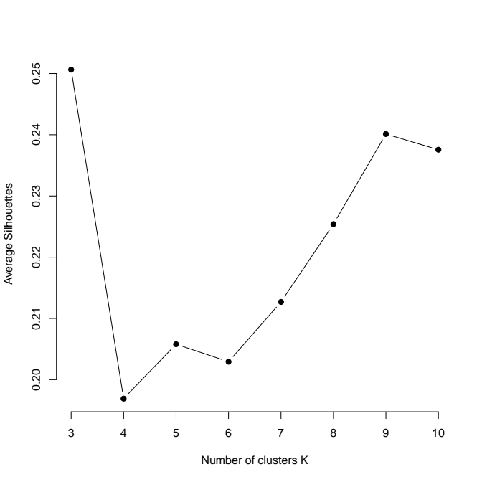
Figure 2: Silhouette values plotted for different tried numbers of clusters in k-means clustering. Good performance (high average silhouette values) are achieved at k=3 and k=9.

A)
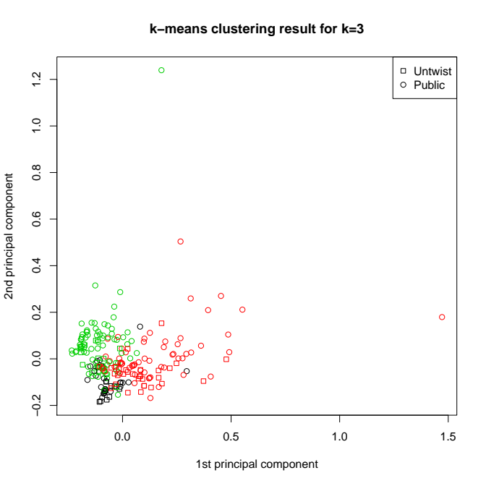
B)
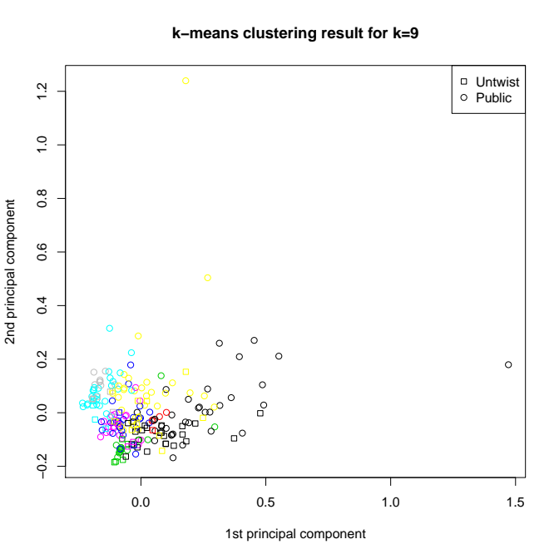
Figure 3: Scatter-plots using the two first principal component coordinates generated for each analyzed Camelina accession (see methods). The color indicates which population the respective accession belongs to and the sign represents whether the accession is already published (“Public”, circle), or has been sequenced within this research project (“Untwist”, square). Plot A shows the results for k=3 assumed clusters, and plot B the results for k=9 assumed clusters. Both plots show that the public and “Untwist” accessions intermingle well with the “Public” accessions. Two Public outliers are visible in the top and right extremes.
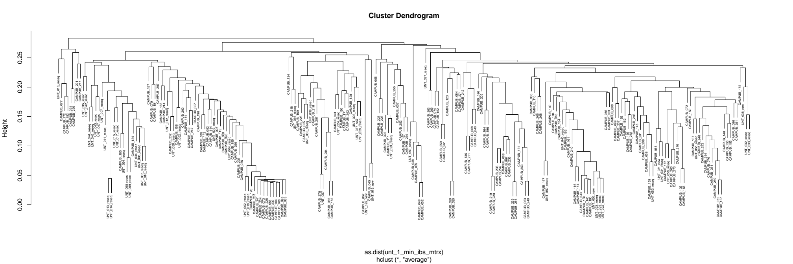
Figure 4: Dendrogram showing the result of hierarchical clustering based on Identity By State (IBS) distances. The plot confirms the results obtained by the principal component analysis, i.e. that the public and “Untwist” accessions intermingle well with each other. - Untwist accessions are those sequenced within the context of this research project.
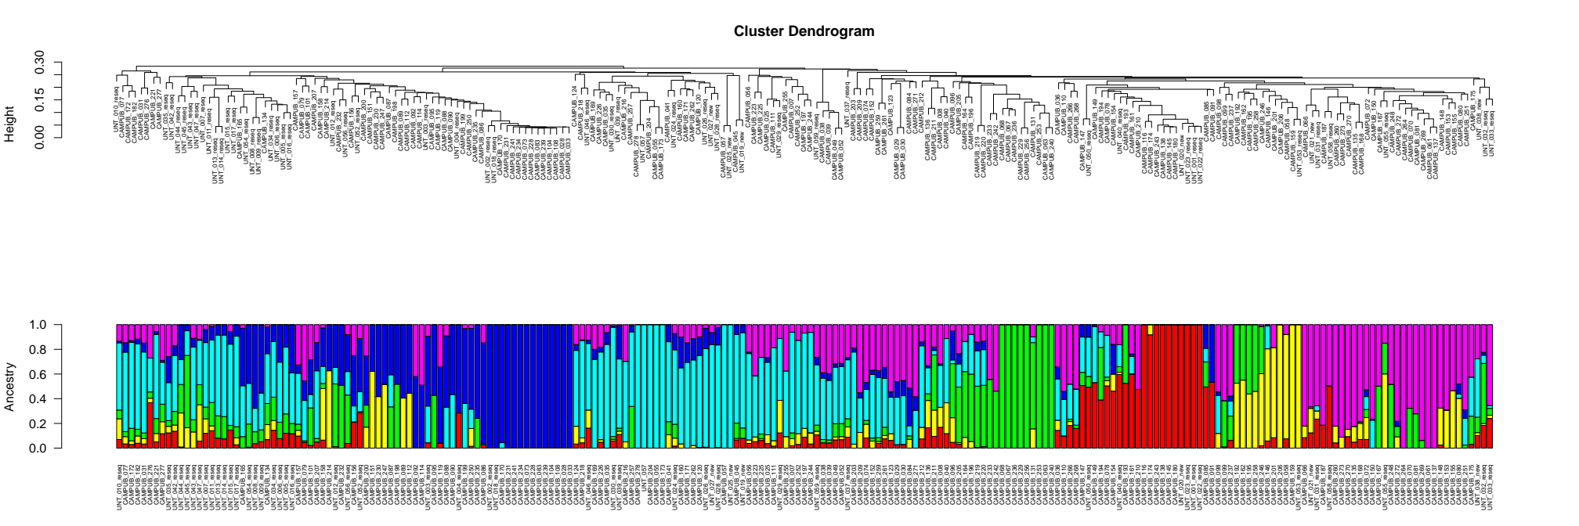
Figure 5: Aligned hierarchical clustering dendrogram (figure 4) and admixture plot for six assumed subpopulations. The analysis highlights a high grade of admixture between the subpopulations. Only very few lines entirely belong to a single population (dark blue, turquoise, bright green, bright red, and violet bars). The majority of accessions have ancestry stemming from multiple populations.

Supplementary Table 1: Percent heterozygosity of individual accessions in Camelina public (169) and Untwist (54) accessions across 2,306,926 genome wide SNP positions.

Index | Heterozygosity | Accession | Population
1 | 25.316 | CAMPUB_007 | CAMPUB
2 | 22.48 | CAMPUB_008 | CAMPUB
3 | 24.948 | CAMPUB_025 | CAMPUB
4 | 20.388 | CAMPUB_028 | CAMPUB
5 | 22.299 | CAMPUB_029 | CAMPUB
6 | 21.427 | CAMPUB_030 | CAMPUB
7 | 19.091 | CAMPUB_031 | CAMPUB
8 | 21.033 | CAMPUB_033 | CAMPUB
9 | 20.389 | CAMPUB_035 | CAMPUB
10 | 21.848 | CAMPUB_036 | CAMPUB
11 | 21.791 | CAMPUB_038 | CAMPUB
12 | 21.661 | CAMPUB_039 | CAMPUB
13 | 19.018 | CAMPUB_040 | CAMPUB
14 | 20.323 | CAMPUB_041 | CAMPUB
15 | 19.378 | CAMPUB_045 | CAMPUB
16 | 21.619 | CAMPUB_049 | CAMPUB
17 | 21.187 | CAMPUB_052 | CAMPUB
18 | 19.589 | CAMPUB_055 | CAMPUB
19 | 20.404 | CAMPUB_056 | CAMPUB
20 | 11.536 | CAMPUB_057 | CAMPUB
21 | 22.08 | CAMPUB_058 | CAMPUB
22 | 22.379 | CAMPUB_061 | CAMPUB
23 | 22.668 | CAMPUB_063 | CAMPUB
24 | 23.395 | CAMPUB_066 | CAMPUB
25 | 21.27 | CAMPUB_067 | CAMPUB
26 | 22.326 | CAMPUB_068 | CAMPUB
27 | 22.992 | CAMPUB_070 | CAMPUB
28 | 23.241 | CAMPUB_072 | CAMPUB
29 | 20.623 | CAMPUB_073 | CAMPUB
30 | 23.074 | CAMPUB_074 | CAMPUB
31 | 19.55 | CAMPUB_077 | CAMPUB
32 | 44.811 | CAMPUB_078 | CAMPUB
33 | 21.732 | CAMPUB_079 | CAMPUB
34 | 23.129 | CAMPUB_080 | CAMPUB
35 | 22.755 | CAMPUB_081 | CAMPUB
36 | 21.048 | CAMPUB_083 | CAMPUB
37 | 22.989 | CAMPUB_084 | CAMPUB
38 | 23.452 | CAMPUB_085 | CAMPUB
39 | 21.492 | CAMPUB_086 | CAMPUB
40 | 22.455 | CAMPUB_087 | CAMPUB
41 | 21.689 | CAMPUB_088 | CAMPUB
42 | 21.451 | CAMPUB_089 | CAMPUB
43 | 19.809 | CAMPUB_090 | CAMPUB
44 | 21.476 | CAMPUB_091 | CAMPUB
45 | 22.17 | CAMPUB_092 | CAMPUB
46 | 21.242 | CAMPUB_095 | CAMPUB
47 | 20.858 | CAMPUB_096 | CAMPUB
48 | 22.428 | CAMPUB_098 | CAMPUB
49 | 21.637 | CAMPUB_099 | CAMPUB
50 | 21.055 | CAMPUB_101 | CAMPUB
51 | 20.582 | CAMPUB_104 | CAMPUB
52 | 20.576 | CAMPUB_108 | CAMPUB
53 | 22.179 | CAMPUB_110 | CAMPUB
54 | 21.609 | CAMPUB_111 | CAMPUB
55 | 22.715 | CAMPUB_112 | CAMPUB
56 | 22.19 | CAMPUB_114 | CAMPUB
57 | 23.048 | CAMPUB_116 | CAMPUB
58 | 22.544 | CAMPUB_119 | CAMPUB
59 | 19.894 | CAMPUB_120 | CAMPUB
60 | 22.793 | CAMPUB_123 | CAMPUB
61 | 22.388 | CAMPUB_124 | CAMPUB
62 | 24.066 | CAMPUB_131 | CAMPUB
63 | 21.451 | CAMPUB_134 | CAMPUB
64 | 23.363 | CAMPUB_135 | CAMPUB
65 | 20.805 | CAMPUB_136 | CAMPUB
66 | 23.694 | CAMPUB_137 | CAMPUB
67 | 21.77 | CAMPUB_138 | CAMPUB
68 | 22.789 | CAMPUB_145 | CAMPUB
69 | 22.896 | CAMPUB_146 | CAMPUB
70 | 22.766 | CAMPUB_147 | CAMPUB
71 | 23.529 | CAMPUB_148 | CAMPUB
72 | 22.567 | CAMPUB_149 | CAMPUB
73 | 22.447 | CAMPUB_150 | CAMPUB
74 | 22.601 | CAMPUB_151 | CAMPUB
75 | 21.691 | CAMPUB_152 | CAMPUB
76 | 24.446 | CAMPUB_153 | CAMPUB
77 | 22.559 | CAMPUB_154 | CAMPUB
78 | 23.714 | CAMPUB_155 | CAMPUB
79 | 21.287 | CAMPUB_156 | CAMPUB
80 | 19.53 | CAMPUB_157 | CAMPUB
81 | 21.19 | CAMPUB_158 | CAMPUB
82 | 21.722 | CAMPUB_159 | CAMPUB
83 | 21.383 | CAMPUB_160 | CAMPUB
84 | 21.916 | CAMPUB_161 | CAMPUB
85 | 22.638 | CAMPUB_162 | CAMPUB
86 | 22.278 | CAMPUB_164 | CAMPUB
87 | 22.7 | CAMPUB_165 | CAMPUB
88 | 23.408 | CAMPUB_167 | CAMPUB
89 | 24.122 | CAMPUB_168 | CAMPUB
90 | 19.364 | CAMPUB_169 | CAMPUB
91 | 23.535 | CAMPUB_170 | CAMPUB
92 | 21.963 | CAMPUB_171 | CAMPUB
93 | 19.034 | CAMPUB_172 | CAMPUB
94 | 19.956 | CAMPUB_173 | CAMPUB
95 | 21.573 | CAMPUB_174 | CAMPUB
96 | 21.344 | CAMPUB_175 | CAMPUB
97 | 22.633 | CAMPUB_180 | CAMPUB
98 | 19.446 | CAMPUB_182 | CAMPUB
99 | 23.385 | CAMPUB_187 | CAMPUB
100 | 23.072 | CAMPUB_192 | CAMPUB
101 | 23.142 | CAMPUB_193 | CAMPUB
102 | 28.607 | CAMPUB_194 | CAMPUB
103 | 22.376 | CAMPUB_195 | CAMPUB
104 | 20.141 | CAMPUB_196 | CAMPUB
105 | 20.845 | CAMPUB_197 | CAMPUB
106 | 20.919 | CAMPUB_198 | CAMPUB
107 | 20.457 | CAMPUB_199 | CAMPUB
108 | 22.992 | CAMPUB_200 | CAMPUB
109 | 23.045 | CAMPUB_201 | CAMPUB
110 | 29.274 | CAMPUB_203 | CAMPUB
111 | 20.43 | CAMPUB_204 | CAMPUB
112 | 22.023 | CAMPUB_205 | CAMPUB
113 | 22.729 | CAMPUB_206 | CAMPUB
114 | 19.633 | CAMPUB_207 | CAMPUB
115 | 22.42 | CAMPUB_209 | CAMPUB
116 | 23.031 | CAMPUB_210 | CAMPUB
117 | 21.443 | CAMPUB_211 | CAMPUB
118 | 31.274 | CAMPUB_212 | CAMPUB
119 | 22.477 | CAMPUB_214 | CAMPUB
120 | 21.62 | CAMPUB_216 | CAMPUB
121 | 21.175 | CAMPUB_218 | CAMPUB
122 | 22.578 | CAMPUB_219 | CAMPUB
123 | 22.315 | CAMPUB_220 | CAMPUB
124 | 21.594 | CAMPUB_221 | CAMPUB
125 | 41.973 | CAMPUB_223 | CAMPUB
126 | 23.742 | CAMPUB_225 | CAMPUB
127 | 18.27 | CAMPUB_226 | CAMPUB
128 | 20.426 | CAMPUB_228 | CAMPUB
129 | 23.132 | CAMPUB_229 | CAMPUB
130 | 22.21 | CAMPUB_230 | CAMPUB
131 | 21.264 | CAMPUB_231 | CAMPUB
132 | 21.225 | CAMPUB_232 | CAMPUB
133 | 23.598 | CAMPUB_233 | CAMPUB
134 | 20.767 | CAMPUB_234 | CAMPUB
135 | 21.411 | CAMPUB_235 | CAMPUB
136 | 21.016 | CAMPUB_236 | CAMPUB
137 | 25.629 | CAMPUB_237 | CAMPUB
138 | 21.541 | CAMPUB_239 | CAMPUB
139 | 22.52 | CAMPUB_240 | CAMPUB
140 | 22.014 | CAMPUB_241 | CAMPUB
141 | 22.749 | CAMPUB_242 | CAMPUB
142 | 24.335 | CAMPUB_243 | CAMPUB
143 | 20.98 | CAMPUB_244 | CAMPUB
144 | 23.3 | CAMPUB_246 | CAMPUB
145 | 22.012 | CAMPUB_247 | CAMPUB
146 | 24.234 | CAMPUB_248 | CAMPUB
147 | 21.243 | CAMPUB_250 | CAMPUB
148 | 23.169 | CAMPUB_251 | CAMPUB
149 | 21.083 | CAMPUB_252 | CAMPUB
150 | 22.486 | CAMPUB_253 | CAMPUB
151 | 21.988 | CAMPUB_255 | CAMPUB
152 | 22.78 | CAMPUB_256 | CAMPUB
153 | 20.561 | CAMPUB_257 | CAMPUB
154 | 21.658 | CAMPUB_258 | CAMPUB
155 | 22.476 | CAMPUB_259 | CAMPUB
156 | 23.147 | CAMPUB_260 | CAMPUB
157 | 22.057 | CAMPUB_261 | CAMPUB
158 | 22.283 | CAMPUB_262 | CAMPUB
159 | 24.851 | CAMPUB_264 | CAMPUB
160 | 23.101 | CAMPUB_266 | CAMPUB
161 | 22.569 | CAMPUB_268 | CAMPUB
162 | 24.714 | CAMPUB_269 | CAMPUB
163 | 24.054 | CAMPUB_270 | CAMPUB
164 | 21.896 | CAMPUB_271 | CAMPUB
165 | 23.676 | CAMPUB_272 | CAMPUB
166 | 23.429 | CAMPUB_273 | CAMPUB
167 | 22.98 | CAMPUB_276 | CAMPUB
168 | 22.131 | CAMPUB_277 | CAMPUB
169 | 20.231 | CAMPUB_278 | CAMPUB
170 | 21.448 | UNT_001_reseq | UNT
171 | 20.383 | UNT_002_reseq | UNT
172 | 20.313 | UNT_003_reseq | UNT
173 | 22.428 | UNT_004_reseq | UNT
174 | 19.368 | UNT_005_reseq | UNT
175 | 26.261 | UNT_006_reseq | UNT
176 | 29.619 | UNT_007_reseq | UNT
177 | 20.881 | UNT_008_reseq | UNT
178 | 20.19 | UNT_009_reseq | UNT
179 | 22.486 | UNT_010_reseq | UNT
180 | 20.924 | UNT_011_reseq | UNT
181 | 44.268 | UNT_012_reseq | UNT
182 | 20.724 | UNT_013_reseq | UNT
183 | 20.546 | UNT_014_reseq | UNT
184 | 20.153 | UNT_015_reseq | UNT
185 | 20.872 | UNT_016_reseq | UNT
186 | 19.02 | UNT_017_reseq | UNT
187 | 20.888 | UNT_018_reseq | UNT
188 | 13.272 | UNT_019_new | UNT
189 | 16.284 | UNT_020_new | UNT
190 | 15.744 | UNT_021_new | UNT
191 | 21.664 | UNT_022_reseq | UNT
192 | 21.96 | UNT_023_reseq | UNT
193 | 23.908 | UNT_024_reseq | UNT
194 | 9.133 | UNT_025_new | UNT
195 | 17.928 | UNT_026_reseq | UNT
196 | 19.183 | UNT_027_new | UNT
197 | 18.48 | UNT_028_reseq | UNT
198 | 19.968 | UNT_029_reseq | UNT
199 | 17.882 | UNT_030_reseq | UNT
200 | 22.618 | UNT_031_reseq | UNT
201 | 32.262 | UNT_032_reseq | UNT
202 | 21.883 | UNT_033_reseq | UNT
203 | 29.835 | UNT_034_reseq | UNT
204 | 33.447 | UNT_035_reseq | UNT
205 | 19.817 | UNT_037_reseq | UNT
206 | 30.161 | UNT_038_new | UNT
207 | 22.957 | UNT_039_reseq | UNT
208 | 30.301 | UNT_040_reseq | UNT
209 | 23.135 | UNT_042_reseq | UNT
210 | 41.161 | UNT_043_reseq | UNT
211 | 27.945 | UNT_044_reseq | UNT
212 | 32.137 | UNT_045_reseq | UNT
213 | 20.081 | UNT_046_reseq | UNT
214 | 39.545 | UNT_047_reseq | UNT
215 | 21.159 | UNT_050_reseq | UNT
216 | 23.114 | UNT_052_reseq | UNT
217 | 22.955 | UNT_053_reseq | UNT
218 | 28.53 | UNT_054_reseq | UNT
219 | 35.953 | UNT_055_reseq | UNT
220 | 32.925 | UNT_056_reseq | UNT
221 | 21.248 | UNT_057 | UNT
222 | 28.104 | UNT_058_reseq | UNT
223 | 20.237 | UNT_059_reseq | UNT

Table S. List of the 222 genome-resequenced C. sativa accessions
this table is taken from Li et., al. 2021.

Accession number | Accession name | Other name | Biological status | Country of origin
CS001 | Suneson | MT5 | Cultivar | United States
CS002 | Licalla |  | Advanced/improved cultivar | Germany
CS003 | Kirgizskij | CAM 7 | Advanced/improved cultivar | Kyrgyzstan
CS004 | Sortandinskij | CAM 8 | Advanced/improved cultivar | Former Soviet Union
CS007 | OmskijMestnyj | CAM 25 | Mutant | Former Soviet Union
CS008 | Czestochowska | CAM 28 | Advanced/improved cultivar | Poland
CS009 | Volynskaja1 | CAM 29 | Advanced/improved cultivar | Ukraine
CS010* | ZarjaSocializma2 | CAM 30 | Advanced/improved cultivar | Former Soviet Union
CS011* | CAM31 | CAM 31 | Traditional cultivar/landrace | Poland
CS013 | Bronowska1 | CAM 33 | Advanced/improved cultivar | Poland
CS015 | Ukrajinskij | CAM 35 | Advanced/improved cultivar | Former Soviet Union
CS016 | Wroclawska | CAM 36 | Advanced/improved cultivar | Poland
CS018 | CAM38 | CAM 38 | Traditional cultivar/landrace | Austria
CS019 | CAM39 | CAM 39 | Traditional cultivar/landrace | Austria
CS020 | Lindo | CAM 40 | Advanced/improved cultivar | Germany
CS022 | Ukrajinskaja | CAM 45 | Advanced/improved cultivar | Former Soviet Union
CS023 | CAM49 | CAM 49 |  | Poland
CS024 | CAM52 | CAM 52 | NA | Slovenia
CS025 | CAM55 | CAM 55 | NA | Austria
CS026 | OmskijMestnyi2 | CAM 56 | Mutant | Former Soviet Union
CS027 | Kirgizskij2 | CAM 57 | Advanced/improved cultivar | Former Soviet Union
CS028 | CAM58 | CAM 58 | Wild | Germany
CS030 | Boha1 | CAM 61 | Advanced/improved cultivar | Denmark
CS031 | CAME1 | CAM 63 | Advanced/improved cultivar | Swedenden
CS033 | CAM66 | CAM 66 | Advanced/improved cultivar | Germany
CS034 | Hoga1 | CAM 67 | Advanced/improved cultivar | Denmark
CS035 | Svalof | CAM 68 | Advanced/improved cultivar | Sweden
CS036 | CAM70 | CAM 70 | Wild | Germany
CS037 | Vniimk | CAM 72 | Advanced/improved cultivar | Former Soviet Union
CS038 | Kirkizska | CAM 73 | Advanced/improved cultivar | Former Soviet Union
CS039 | Czenstochwska1 | CAM 74 | Advanced/improved cultivar | Czech Republic
CS040* | Auslese2 | CAM 77 | Breeder's line | Former Soviet Union
CS041 | Auslese1 | CAM 78 | Breeder's line | Former Soviet Union
CS042 | PRFGL47 | CAM 79 | Breeding/research material | Germany
CS043 | PRFGL36 | CAM 80 | Breeding/research material | Germany
CS044 | PRFGL40 | CAM 81 | Breeding/research material | Germany
CS046 | PRFGL75 | CAM 83 | Breeding/research material | Germany
CS047 | PRFGL42 | CAM 84 | Breeding/research material | Germany
CS048 | PRFGL45 | CAM 85 | Breeding/research material | Germany
CS049 | PRFGL57 | CAM 86 | Breeding/research material | Germany
CS050 | PRFGL49 | CAM 87 | Breeding/research material | Germany
CS051 | PRFGL39 | CAM 88 | Breeding/research material | Germany
CS052 | PRFGL72 | CAM 89 | Breeding/research material | Germany
CS053 | PRFGL54 | CAM 90 | Breeding/research material | Germany
CS054 | PRFGL69 | CAM 91 | Breeding/research material | Germany
CS055 | PRFGL59 | CAM 92 | Breeding/research material | Germany
CS056 | PRFGL21 | CAM 95 | Breeding/research material | Germany
CS057 | PRFGL20 | CAM 96 | Breeding/research material | Germany
CS058 | PRFGL19 | CAM 98 | Breeding/research material | Germany
CS059 | PRFGL10 | CAM 99 | Breeding/research material | Germany
CS060 | PRFGL16 | CAM 101 | Breeding/research material | Germany
CS062 | PRFGL34 | CAM 104 | Breeding/research material | Germany
CS063 | Bronowska2 | CAM 108 | Breeding/research material | Poland
CS064 | Volynskaja2 | CAM 110 | Advanced/improved cultivar | Poland
CS065 | Omskaja | CAM 111 | Advanced/improved cultivar | Former Soviet Union
CS066 | PRFGL23 | CAM 112 | Breeding/research material | Germany
CS067 | PRFGL28 | CAM 114 | Breeding/research material | Germany
CS068 | CAM116 | CAM 116 | Wild | Belgium
CS069 | PRFGL27 | CAM 119 | Breeding/research material | Germany
CS070 | WroclawskaAMCSA70 | CAM 120 | Advanced/improved cultivar | Poland
CS071 | Czenstochwska2 | CAM 123 | Advanced/improved cultivar | Czech Republic
CS072 | PRFGL22 | CAM 124 | Breeding/research material | Germany
CS073 | PRFGL32 | CAM 131 | Breeding/research material | Germany
CS074 | CalenaAMCSA74 | CAM 134 | Advanced/improved cultivar | Germany
CS075 | CAM135 | CAM 135 | Wild | Germany
CS076 | Sortadinskij | CAM 136 | Advanced/improved cultivar | Poland
CS077 | CAM137 | CAM 137 | Wild | Denmark
CS078 | CAM138 | CAM 138 | Wild | NA
CS079 | CAM145 | CAM 145 | Wild | Germany
CS080 | STAMM13X14A | CAM 146 | Breeder's line | Germany
CS081 | STAMM09X13 | CAM 147 | Breeder's line | Germany
CS082 | CAM148 | CAM 148 | Wild | Bulgaria
CS083 | STAMM11X15 | CAM 149 | Breeder's line | Germany
CS084 | STAMM09X14 | CAM 150 | Breeder's line | Germany
CS085 | STAMM07X13B | CAM 151 | Breeder's line | Germany
CS086 | STAMM09X11 | CAM 152 | Breeder's line | Germany
CS087 | STAMM08X14 | CAM 153 | Breeder's line | Germany
CS088 | STAMM12X13 | CAM 154 | Breeder's line | Germany
CS089 | STAMM08X13 | CAM 155 | Breeder's line | Germany
CS090 | STAMM09X15 | CAM 156 | Breeder's line | Germany
CS091 | STAMM10X12 | CAM 157 | Breeder's line | Germany
CS092 | STAMM10X13 | CAM 158 | Breeder's line | Germany
CS093 | STAMM13X15 | CAM 159 | Breeder's line | Germany
CS094 | STAMM13X14B | CAM 160 | Breeder's line | Germany
CS095 | STAMM10X15 | CAM 161 | Breeder's line | Germany
CS096 | STAMM06X13B | CAM 162 | Breeder's line | Germany
CS098 | STAMM06X10A | CAM 164 | Breeder's line | Germany
CS099 | STAMM04X05 | CAM 165 | Breeder's line | Germany
CS101 | STAMM06X14C | CAM 167 | Breeder's line | Germany
CS102 | CAM168 | CAM 168 | Wild | NA
CS103 | Vnttmk17 | CAM 169 | Breeding/research material | Former Soviet Union
CS104 | CAM170 | CAM 170 | Wild | Poland
CS105 | Guillemeteau | CAM 171 | Advanced/improved cultivar | NA
CS106* | Zarjasocialisma1 | CAM 172 | Advanced/improved cultivar | Former Soviet Union
CS107 | Irkutskajamestnaja | CAM 173 | Traditional cultivar/landrace | Former Soviet Union
CS108 | Voronezskij3491 | CAM 174 | Advanced/improved cultivar | NA
CS109 | CAM175 | CAM 175 | Wild | Sweden
CS110 | Bavaria | CAM 180 | advanced/improved cultivar | Germany
CS111 | CAM182 | CAM 182 | Breeding/research material | NA
CS112 | CAM187 | CAM 187 | Wild | Spain
CS114 | STAMM06X13A | CAM 192 | Breeder's line | Germany
CS115 | STAMM06X15B | CAM 193 | Breeder's line | Germany
CS116 | STAMM06X15A | CAM 194 | Breeder's line | Germany
CS117 | STAMM06X08C | CAM 195 | Breeder's line | Germany
CS118 | STAMM06X10B | CAM 196 | Breeder's line | Germany
CS119 | STAMM02X12A | CAM 197 | Breeder's line | Germany
CS120 | STAMM06X07B | CAM 198 | Breeder's line | Germany
CS121 | STAMM07X11A | CAM 199 | Breeder's line | Germany
CS122 | STAMM06X08A | CAM 200 | Breeder's line | Germany
CS123 | STAMM03X13 | CAM 201 | Breeder's line | Germany
CS125 | STAMM02X11C | CAM 203 | Breeder's line | Germany
CS126 | STAMM01X13 | CAM 204 | Breeder's line | Germany
CS127 | STAMM06X09 | CAM 205 | Breeder's line | Germany
CS128 | STAMM05X11 | CAM 206 | Breeder's line | Germany
CS129 | STAMM02X09 | CAM 207 | Breeder's line | Germany
CS131 | STAMM01X08 | CAM 209 | Breeder's line | Germany
CS132 | STAMM14X15 | CAM 210 | Breeder's line | Germany
CS133 | STAMM06X12B | CAM 211 | Breeder's line | Germany
CS134 | STAMM02X11A | CAM 212 | Breeder's line | Germany
CS136 | STAMM04X13 | CAM 214 | Breeder's line | Germany
CS137 | CAM216 | CAM 216 | Traditional cultivar/landrace | Former Soviet Union
CS138 | CAM218 | CAM 218 | Traditional cultivar/landrace | Former Soviet Union
CS139 | CAM219 | CAM 219 | Traditional cultivar/landrace | Former Soviet Union
CS140 | CAME2 | CAM 220 | Traditional cultivar/landrace | Sweden
CS141 | Voronezskij3392 | CAM 221 | Advanced/improved cultivar | Former Soviet Union
CS142 | Borow1 | CAM 223 | Advanced/improved cultivar | Poland
CS143 | Krajova | CAM 225 | Advanced/improved cultivar | NA
CS144 | Vnjjmk17 | CAM 226 | Breeding/research material | Former Soviet Union
CS145 | PRFGL81 | CAM 228 | Breeding/research material | Germany
CS146 | PRFGL96 | CAM 229 | Breeding/research material | Poland
CS147 | PRFGL88 | CAM 230 | Breeding/research material | Germany
CS148 | PRFGL77 | CAM 231 | Breeding/research material | Germany
CS149 | PRFGL85 | CAM 232 | Breeding/research material | Germany
CS150 | PRFGL95 | CAM 233 | Breeding/research material | Germany
CS151 | PRFGL76 | CAM 234 | Breeding/research material | Germany
CS152 | PRFGL87 | CAM 235 | Breeding/research material | Germany
CS153 | PRFGL91 | CAM 236 | Breeding/research material | NA
CS154 | PRFGL82 | CAM 237 | Breeding/research material | Germany
CS155 | PRFGL80 | CAM 239 | Breeding/research material | Germany
CS156 | PRFGL94 | CAM 240 | Breeding/research material | Germany
CS157 | PRFGL78 | CAM 241 | Breeding/research material | Germany
CS158 | PRFGL92 | CAM 242 | Breeding/research material | Germany
CS159 | CAM243 | CAM 243 |  | Germany
CS160 | STAMM02X12B | CAM 244 | Wild | Former Soviet Union
CS162 | STAMM06X08B | CAM 246 | Breeder's line | Germany
CS163 | STAMM07X13A | CAM 247 | Breeder's line | Germany
CS164 | STAMM06X14A | CAM 248 | Breeder's line | Germany
CS165 | STAMM03X07 | CAM 250 | Breeder's line | Germany
CS166 | STAMM05X14A | CAM 251 | Breeder's line | Germany
CS167 | STAMM02X10B | CAM 252 | Breeder's line | Germany
CS168 | STAMM06X14B | CAM 253 | Breeder's line | Germany
CS170 | STAMM02X08B | CAM 255 | Breeder's line | Germany
CS171 | STAMM05X14C | CAM 256 | Breeder's line | Germany
CS172 | STAMM06X11B | CAM 257 | Breeder's line | Germany
CS173 | STAMM06X13C | CAM 258 | Breeder's line | Germany
CS174 | CAM259 | CAM 259 | Wild | Bulgaria
CS175 | CAM260 | CAM 260 | Wild | Bulgaria
CS176 | CAM261 | CAM 261 | Wild | Bulgaria
CS177 | CAM262 | CAM 262 | Wild | Romania
CS178 | CAM264 | CAM 264 | Wild | Bulgaria
CS179 | CAM266 | CAM 266 | Wild | Former Soviet Union
CS180 | CAM268 | CAM 268 | Wild | Bulgaria
CS181 | CAM269 | CAM 269 | Wild | Great Britain
CS182 | CAM270 | CAM 270 | Wild | Czech Republic
CS183 | STAMM05X14D | CAM 271 | Breeder's line | Germany
CS184 | CAM272 | CAM 272 | Wild | Belgium
CS185 | CAM273 | CAM 273 | Wild | Sweden
CS188 | CAM276 | CAM 276 | Wild | Bulgaria
CS189 | Calinka | CAM 277 | NA | Germany
CS190 | STAMM02X11B | CAM 278 | Breeder's line | Germany
CS191 | GE201101 | Ames 31231 | Wild | Georgia
CS192 | GE201105 | Ames 31232 | Wild | Georgia
CS193 | Vniimk17 | PI 258366 | Early variety | Former Soviet Union
CS194 | Voronezh349 | PI 258367 | Early variety | Former Soviet Union
CS195 | No401 | PI 304268 | Breeding line | Sweden
CS196 | No402 | PI 304269 | Breeding line | Sweden
CS199 | Borow2 | PI 311735 | donated/collected seed | Poland
CS200* | Przybrodzka | PI 311736 | donated/collected seed | Poland
CS201 | 163207372 | PI 597833 | donated/collected seed | Denmark
CS202 | CR47665 | PI 633192 | donated/collected seed | Germany
CS203 | CR49294a | PI 633193 | donated/collected seed | Germany
CS204 | GiessenNr3 | PI 633194 | donated/collected seed | Germany
CS206 | CAME3 | PI 650140 | donated/collected seed | Germany
CS207 | NU52279 | PI 650141 | donated/collected seed | United States
CS208 | CS163 | PI 650142 | donated/collected seed | Denmark
CS209* | CSCroo | PI 650143 | donated/collected seed | Germany
CS210 | Boha2 | PI 650144 | donated/collected seed | Denmark
CS211 | BRSCHW28347 | PI 650145 | donated/collected seed | Germany
CS212 | BRSCHW30021 | PI 650146 | donated/collected seed | Sweden
CS213 | CAME4 | PI 650147 | donated/collected seed | Sweden
CS214 | Giessen3 | PI 650148 | donated/collected seed | Germany
CS215 | Giessen4 | PI 650149 | donated/collected seed | Germany
CS216 | Hoga2 | PI 650150 | donated/collected seed | Denmark
CS217 | SvalofAMCSA217 | PI 650151 | donated/collected seed | Sweden
CS218 | CPSCAM23 | PI 650152 | donated/collected seed | Germany
CS219 | CPSCAM10 | PI 650153 | donated/collected seed | Former Soviet Union
CS220 | CSSCAM25 | PI 650154 | donated/collected seed | Former Soviet Union
CS221* | CSSCAM27 | PI 650155 | donated/collected seed | Poland
CS222 | CSSCAM29 | PI 650156 | donated/collected seed | Former Soviet Union
CS223 | CSSCAM30 | PI 650157 | donated/collected seed | Former Soviet Union
CS224* | CSSCAM31 | PI 650158 | donated/collected seed | Poland
CS225 | CSSCAM33 | PI 650159 | donated/collected seed | Poland
CS226 | CSSCAM34 | PI 650160 | donated/collected seed | Former Soviet Union
CS227 | CSSCAM35 | PI 650161 | donated/collected seed | Former Soviet Union
CS228 | CSSCAM36 | PI 650162 | donated/collected seed | Poland
CS229 | CSSCAM37 | PI 650163 | donated/collected seed | Former Soviet Union
CS230 | CSSCAM38 | PI 650164 | donated/collected seed | Austria
CS231 | CSSCAM7 | PI 650165 | donated/collected seed | Former Soviet Union
CS232 | CSSCAM8 | PI 650166 | donated/collected seed | Former Soviet Union
CS233 | Seminum144 | PI 650167 | donated/collected seed | Poland
CS234* | NE20061 | PI 650168 | Advanced/improved cultivar | United States
CS235 | AMES29309 | PI 652885 | donated/collected seed | Slovenia
CS236 | AMES29310 | PI 652886 | donated/collected seed | Slovenia
CS245 | MT1 |  | Breeder's line | United States
CS246 | Blaine Creek | MT3 | Breeder's line | United States
CS248 | Celine |  | Advanced/improved cultivar | France
CS249 | Cheyenne |  | Advanced/improved cultivar | United States
CS250 | Ligena |  | Advanced/improved cultivar | Germany
CS251 | Prytzh | MT102 | Big seed variety | Ukraine
CS252 | MT148 |  | Breeder's line | United States
CS253 | MT229 |  | Breeder's line | United States
CS254 | MT402 |  | Breeder's line | United States

* Indicates accessions that didn’t bolt in both years of field trial. They are potential winter types that requires vernalization to flower.

