Orientation to RStudio, Github, Git, and R

General considerations

Because learning how to use these tools can be intimidating, we’ll begin by focusing on just what you need to know as we progress through the semester. The approach used in this tutorial is to have you get some hands-on experience with github and RStudio and how these two resources can be “glued together” with the version control features of Git. This tutorial assumes that you have already installed these tools on your computer.

1. Run through the “hello-world” tutorial at <https://guides.github.com/activities/hello-world/>. This 10-minute read will get you started with the basics of github. When you complete this tutorial, you will have created your first repository (usually shortened to “repo”).
2. Connect RStudio to your hello-world repo.
   1. Open RStudio.
   2. From the main menu: Tools|Git/SVN.
   3. Ensure that “enable version control…” is checked.
   4. Git executable field should point to the location of the git.exe file on your computer. The default location is C:/Program Files/Git/bin/git.exe, but it may be different if you changed the location when installing Git.
   5. Click the “Create RSA Key…” Button. When this completes, click “Close.”
   6. Click “view public key.”
   7. Copy the public key to the clipboard.
   8. Go to github and log in.
   9. Open your github account settings.
   10. Go to “SSH and GPG keys.”
   11. Title your new SSH key something that identifies how it is used, for example “RStudio-key”
   12. Paste the public key, which should still be in your clipboard, into the Key field, and add it. Github will verify your identity by asking for your github password.
   13. Return to RStudio and click “Apply” and “OK.” RStudio will restart.
   14. From the main menu: File | New Project.
   15. Click “Version Control” from the New Project dialog.
   16. Click Git to clone your repo.
   17. Enter the url for your repo.
   18. Enter a name for the directory where you want the local version of your repo to reside.
   19. Browse to the existing directory that you want to house the directory for your repo.
   20. Click “Create Project.” RStudio will restart open to your project.
3. Use RStudio to make changes to the README.md file in your Hello-world repo.
   1. In RStudio with your project opened, open the “Files” tab. This tab will appear at the top of one of the panes in RStudio.   
      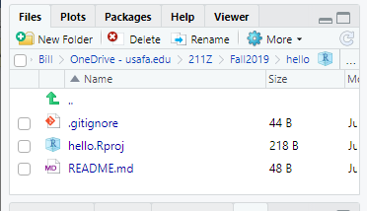
   2. Click on the README.md file. It will open in the source pane.
   3. In the source pane, edit the content of the file, and click the disk icon at the top of the source editor. This operation saves the changed file to your local repo, but not on github.
4. Upload you’re your edited changes to the github repo.
   1. Click on the Git tab in the Environment pane  
      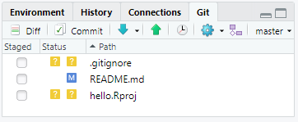
   2. Check the box in the “Staged” column next to “README.md; then click “Commit.” A new dialog will open that will look kind of like this:  
      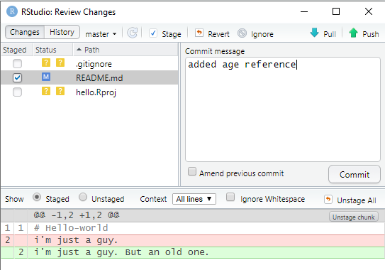  
      Take a minute to study this dialog box. Note the following:
      1. The changes will be made to the master branch.
      2. The file we’re updating is checked as Staged
      3. The differences in the two versions are shown at bottom of the file.
      4. There’s a field for entering a Commit message.
   3. About the Commit message: You should always write something that explains the change. It need not be long. For instance, you might in this case write something as simple as “added age reference.”
   4. Click the “Commit” button below the commit message field.
   5. Close the confirming commit dialog.
   6. Click the “Push” button.
   7. Open your online repo at github and confirm that your new version is online.
5. While you’re at github, check out the history of the changes made to your file.
   1. In the code tab, click on README.md
   2. Click the “History” button that appears just above the text of your file.
   3. Explore on your own what the various links associated with the versions do.