DESIGN AND IMPLEMENTATION OF AN AGRICULTURAL EXTENSION SERVICE SYSTEM

SALEEM ISHAQ

201212039

DR PREMA KIRUBAKARAN

Faculty of computing, Department of software Engineering

JANUARY, 2024

**ABSTRACT**

This concept presents the Agricultural Extension Service System, a cutting-edge digital platform designed to transform the relationship between farmers and agricultural professionals (administrators). The system uses technology to close the knowledge gap between experts and practitioners in the dynamic world of modern agriculture. This helps to empower farmers, promote sustainable farming methods, and advance the agricultural industry as a whole. There are two main interfaces in the system: one for farmers and one for specialists in agriculture. After registering, farmers are granted access to a customised dashboard that offers them a plethora of information on market trends, crop management, animal care, and real-time insights along with weather forecasts. The platform facilitates user engagement by means of forums, inquiry submissions, and the establishment of a cooperative community of farmers.

**TABLE OF CONTENTS**

**CHAPTER ONE………………………………………………….………….1**

1. **Background of the Study……………………………………………..1**
   1. **Statement of the Problem…………………………………………….2**
   2. **Significance of the Study……………………………………………..3**
   3. **Aim and Objectives……………………………………...…………...4**
   4. **Scope and Limitation of the Study…………………………………..5**
   5. **Organization of the Study……………………………………………5**
   6. **Definition of Operational Terms…………………………………….5**

**CHAPTER TWO…………………………………………………………..6**

1. **General Information*………………………………………………..6***
   1. **Related Works………………………………………………………8**
   2. **Summary of the Review…………………………………………….9**

**CHAPTER THREE………………………………………………………13**

1. **System Analysis…………………………………………………….13**
   * 1. **Analysis of the Existing System……………………………13**

**3.1.2 Limitation of the Existing System…………………………..14**

**3.1.3 Justification for the New System……………………………14**

**3.1.4 Description of the New System………………………………15**

**3.2 Design of the Proposed System……………………………………….15**

**3.2.1 Data Model…………………………………………………….16**

**3.2.2 Functional Requirement (*Use Case Diagram*)………………17**

**3.2.3 System Architecture *(Deployment Diagram)…………………18***

**3.2.4 Software Structure *(Class Diagram)………………………….18***

**3.2.5 Workflow of Use Cases (*Activity Diagram*)…………………..19**

**References…………………………………………………………………..20**

**LIST OF FIGURES**

Figure 2.1: Summary of Review

Figure 3.1: Data Model using ER Diagram

Figure 3.2: Use Case Diagram Showing Functional Requirements

Figure 3.3: System Architecture using Deployment Diagram

Figure 3.4: Class Diagram showing the Software Structure

Figure 3.5: Workflow of the System using an Activity Diagram

**CHAPTER ONE**

* 1. **Background of study**

Agricultural Extension is a service or system which assists farm people, through educational procedures, in improving farming methods and techniques, increasing production efficiency and income, bettering their levels of living, and lifting the social and educational standards of rural life. It is the set of organizations that facilitate and support people engaged in agricultural activities to solve problems and to obtain information, skills, and technologies to improve their livelihoods and well-being.

Since the mid-1970s, Agricultural Development Programmes (ADPs) located in each of the 36 states and the Federal Capital Territory of Nigeria have dominated agricultural extension activities, with funding provided by World Bank loans (Adebayo and Idowu, 2000). Agricultural extension organisations help farmers increase the productivity of their crop and animal output and, therefore, their incomes from both farming and non-farm sources by offering them guidance, information, and other forms of support. They play a crucial role in carrying out the plans and initiatives of governments for rural development. However, because ADPs deliver poor quality services, during the past 25 years, a range of governmental, private, and nonprofit organisations with different goals have supplied extension services. For instance, public sector organisations strive to accomplish national policy objectives; commercial entities, on the other hand, are driven by profit-making concerns and aim to meet plant and market capacity as well as high

1

quality standards in the raw materials that reach their processing plants. The majority of

the volunteer sector is made up of nongovernmental organisations (NGOs), most of which have farm families' wellbeing as their primary concern. All of these organisations, albeit having different aims and strategies, strive to accomplish their goals through information sharing that will impact the choices and behaviours of numerous rural farm households (Adebayo, 2004).

Agricultural Extension is a bridge between technology farmers and technology developers. The role of bridge can applies to both formal and informal setting. Approaches can be either direct or indirect through education procedures that improve farming practices or methods and techniques aiming increased production efficiency and income generation, better living condition, and lift the social and educational standards in rural life (Isubikalu, 2007).

In addition, FAO (2003) defines agricultural extension is a non-formal educational function applies to any institution that disseminates information and advice with the intention of promoting knowledge, attitudes, skills and aspirations, although the term extension tends to be associated with agriculture and rural development. Extension is multidisciplinary. It combines education methodologies, communication and group techniques in promoting agriculture

* 1. **Statement of the problem**

Numerous issues the industry faces prevent it from reaching its full potential. Low production, inadequate marketing and distribution infrastructures, limited financing availability, shoddy extension services, and inadequate databases are a few of the

2

obstacles. Its efficacy may be constrained by its difficulties with antiquated

techniques. Research and actual farming practices differ from one another. It can be challenging for extension agents to satisfy the requirements of all farmers when they have a lot of territory to cover and little resources, particularly in rural regions. Not to mention, it might take some time to convince farmers to use new methods. It's a complicated problem that has a significant influence on agriculture's expansion and sustainability, particularly in cities like Abuja. These are some of the problems in details;

* Limited access to technology: Even though technology is becoming more and more important in today's agriculture, many farmers still struggle to acquire and implement the necessary agricultural technologies, especially in rural and underdeveloped areas. The system's influence is limited as the digital divide widens gaps in production and knowledge.
* Insufficient Training and Education: Adopting contemporary and sustainable agricultural techniques requires ongoing education. But the system has trouble giving farmers access to continuing education and training, which makes it difficult for them to stay up to date with agricultural innovations.
* Climate Change Impacts: Farmers face several issues as a result of climate change and the growing unpredictability of weather patterns. To reduce risks and prepare for changing conditions, the agricultural service system must include resilient methods and timely information on climate-smart agriculture to farmers.
  1. **Significance of the study**

Agricultural extension service system significantly contributes to offering technical guidance, providing information, helping farmers determine their problems, unifying

3

farmers into farmers’ groups, and exposing them to new technology and teaching them the best farming and management practice.

* 1. **Aims and Objectives**

The aim of this system is to provide a comprehensive and efficient solution for agricultural extension service system, with a focus on improving effectiveness, streamlining processes, enhancing communication, and ensuring regulatory compliance.

Objectives;

* Engage in research that would provide relevant and appropriate solutions to most development problems and improve agricultural productivity in general.
* Help farmer organizations, community based organizations etc. to train the interested individuals in skills needed for economic empowerment.
* Provide a centralized platform for managing all aspects of agric extension service, including client interactions, in sights on common farming problems , treatment plans, and reporting.

4

* 1. **Scope and limitation of the study**

This system's scope is extensive, encompassing a variety of services and activities designed to assist farmers, improve agricultural output, and encourage sustainable farming methods. Here are some limitations of this project:

* Places without internet connections will not be able to use the system due to it being a web application and can only be accessed with an active internet connection.
* Human resources shortages:
  1. **Organization of the study**

This study is divided into numerous chapters which includes, Introduction, Literature review, System design and analysis, development, Implementation, and finally evaluation.

* 1. **Definition of operational terms**
* Agricultural extension service system(AESS): This is known as the entire set of organizations that facilitate and support people engaged in agricultural activities to solve problems and to obtain information, skills, and technologies to improve their livelihoods and well-being
* Farmers: These are individuals who are engaged in agriculture, raising living organisms for raw food or materials

5

**CHAPTER TWO**

A literature review is a top priority in any academic research, as it provides examination of existing works and knowledge on the topic at hand. The chapter below talks about existing works and how this system aims to improve it.

**2.1 General Information**

An effective agricultural extension service site should have a range of features and content in order to provide farmers with helpful support and information. A typical agricultural extension service system should acquire the following crucial information:

* User-friendly interface: Just like any good system now a days, having a site that is clean and easy to navigate and has a friendly user interface is a top priority.
* Crop and livestock information: This feature covers numerous crop and livestock information, addressing topics like cultivation practices, pest management, disease prevention, and breeding techniques.
* Weather information: This feature provides farmers with weather conditions ahead so that they can plan activities and make decisions.

6

* Discussion forums: This feature provides a platform in which farmers can interact, ask questions, and share experiences. It is mainly a platform for knowledge sharing.
* Collaboration with experts: This feature allows to collaborate with experts and higher institutions to gain more information an accuracy.
* Feedback mechanism: This feature generates a feedback mechanism which allows users to provide input, ask questions, or report any complaints. Also a reliable feedback system is crucial for continuous improvements.
* Up-to-date information: This feature always updates the site so that farmers can have the latest agricultural information, practices, and policy changes to ensure that farmers to accurate information.
* Training materials: This feature provides video tutorials, downloadable guides, and webinars that can help increase the skills and knowledge of farmers
* Interactive tools: This helps to increase user engagement and offer helpful advice, such as decision support systems, crop calculators, and pest identification guides.
* Government policies and support: This gives specifics regarding relevant government policies, aid plans, and agricultural projects. Align the website with official campaigns to ensure its support and relevance.

7

* Data security measures: This ensures strong data security procedures in place to guarantee user privacy and security. Farmers should have no trouble giving the information required for tailored support.

**2.2 Related works**

* West and central African Council for Agricultural Research and Development(CORAF/WECARD): The goal of this sub-regional body is to advance agricultural research and development in West and Central Africa. It collaborates with national research systems to address challenges in agriculture, foster innovation, and improve farming methods. The system shows great performance when it comes to it's research focus as it emphasizes agricultural research, adding to the growth and diffusion of cutting-edge technology, It also has a good regional coordination as it facilitates coordination within national research systems, encouraging a coordinated strategy to deal with agricultural concerns.

Contrarily, there were limited extension services so therefore the linkage with extension services were weak and there was not a reliable way of research findings reaching a farmer.

* West African Network of Farmers Association(ROPPA): This network unites farmers' associations from nations throughout West Africa. It pushes for laws that assist smallholder farmers, encourage teamwork, and advance sustainable farming in the area. The system’s advocacy is top notch as it represent the interests of farmers and influencing policies and it also enables cooperation and information sharing amongst

8

* West African farmer organizations. As good of a system it is, it lacks resource limitations which may impair the full implantation of advocacy and support programs. It also hard to assure the inclusion of farmer groups.
* The Songhai Center: With locations throughout many West African nations, the Songhai Centre is an integrated agricultural development facility. With the goal of empowering farmers economically, it offers training in agribusiness, entrepreneurship, and sustainable agricultural methods. The study shows great strength in aspects of integrated approach covering training, agribusiness, and sustainable practices. It focuses on entrepreneurship, empowering farmers to view farming as a business and investment. Study also shows that it’s ability to grow activities and secure funds are mostly what determine its viability.
* Niger Basin Authority(NBA): This is an international body that deals with rural development, agriculture, and water resource management in the Niger River Basin. In order to solve shared difficulties, it encourages regional collaboration between the nations that share the Niger River. It promotes countries working together sharing the Niger river, talking about common challenges. It talks about managing water resources, which is important for Niger River Basin agriculture. On the other hand, The study mainly focused on the water issues and leaving out important agricultural interventions.
* ECOWAS Agriculture Policy(ECOWAP): The Economic Community of West African States (ECOWAS) created this regional strategy to support rural development, sustainable

9

* agriculture, and food security throughout the region's member states. In order to solve shared difficulties in the agriculture industry, it places a strong emphasis on regional collaboration. It’s outstanding regional collaboration that encourages cooperation between West African nations to solve shared agricultural issue. It also aims to improve food security by paying attention on sustainable agricultural development and enhancing the resilience of farmers. The system shows gaps like the challenges of effective implementation across all west African countries due to different capacities and priorities. It also faces a challenge of funding that affects the successful execution of the objectives.

**2.3. Summary of the review**

|  |  |  |
| --- | --- | --- |
| **TITLE** | **STRENGTH** | **GAP** |
| West and central African Council for Agricultural Research and Development(CORAF/WECARD) | * it emphasizes agricultural research, adding to the growth and diffusion of cutting-edge technology * it facilitates coordination within national research systems, encouraging a coordinated strategy to deal with agricultural concerns. | limited extension services so therefore the linkage with extension services were weak and there was not a reliable way of research findings reaching a farmer.   * The lack of means of communication between researchers, extension services, and farmers that affects the technology transfer |
| West African Network of Farmers Association(ROPPA) | * it represent the interests of farmers and influencing policies * It enables cooperation and information sharing amongst West African farmer organizations | * it lacks resource limitations which may impair the full implantation of advocacy and support programs |
| The Songhai Center | * It follows an integrated approach covering training, agribusiness, and sustainable practices. * It focuses on entrepreneurship, empowering farmers to view farming as a business and investment | * it’s ability to grow activities and secure funds are mostly what determine its viability. |
| Niger Basin Authority(NBA) | * It promotes countries working together sharing the Niger river, talking about common challenges * It talks about managing water resources, which is important for Niger River Basin agriculture | * The study mainly focused on the water issues and leaving out important agricultural interventions. |
| ECOWAS Agriculture Policy(ECOWAP) | * It’s regional collaboration that encourages cooperation between West African nations to solve shared agricultural issue. * It aims to improve food security by paying attention on sustainable agricultural development and enhancing the resilience of farmers. | * Facing challenges of effective implementation across all west African countries due to different capacities and priorities. * It faces a challenge of funding that affects the successful execution of the objectives. |

12

**CHAPTER THREE**

In this chapter, the requirements of the current or existing inventory management system were gathered using various requirements elicitation techniques to create a specification for the new system that will fulfil user needs. The new proposed system design is also presented including the use case, activity and class diagram.

**3.1 System Analysis**

A study of the current system was carried out in order to make the goals and objectives of the proposed system clearer and to obtain a better knowledge of the problem and its scope. The functions of the proposed system are ascertained in addition to the roles that each function plays.

**3.1.1 Analysis of Existing System**

Systems of agricultural extension services are crucial links that give farmers the information and tools they need to practise sustainable agriculture. The study is on making sure that interfaces are accessible and easy to use in order to ensure that all farmers, regardless of level of technical ability, have a smooth experience. Farmers may better organise their operations in response to changing weather conditions by using real-time weather information, which are deemed essential for informed decision-making. Gathering user input is essential to improving the system. Mechanisms and support services should be carefully examined to see

13

how well the aid is working and how satisfied users are. The main objective is to improve the entire agricultural ecosystem by giving priority to the user experience, integrating weather data in real-time, and putting strong feedback mechanisms in place.

**3.1.2 Limitation of the Existing System**

Farmers require the knowledge, resources, and counsel that agricultural extension services offer in order to enhance their farming operations. For Instance, Nigeria poses several problems to the provision of agricultural extension services due to its linguistic diversity, cultural heterogeneity, and rural-urban divides. Existing systems do not allow things like offline capabilities as we all know we are trying to help rural Nigerian farmers and it most cases the places they say lacks internet connection. Also, the lack of personal and agricultural data security tampers with the trust farmers put in agricultural extension services.

**3.1.3. Justification of the system**

The proposed system will be made so as to tackle the limitations of existing systems mentioned above and a more inclusive, accessible, and effective platform for farmers. The app will allow farmers to download information and keep for offline purposes in case of unavailability of internet service. The app will also provide a strong data security and protocol so as to proper secure the personal and agricultural data and assuring farmers that their data is safe and secure.

14

**3.1.4 Description of the system**

The system will be a web application which will have a user and an admin interface

USER

* The user will be able to sign up and login
* Access to information on livestock care, crop management, etc.
* Share little in sights on easier ways to tackle common farming problems
* Farmers can submit questions on farming methods and other agricultural issues they may face

ADMIN

* Add and delete users
* Manage inventory
* Validating articles
* Answering questions farmers ask and providing expert advice and solutions to their problems
* Admins can upload, articles, videos, and guides that can be of help to the users

**3.2 Design of the Proposed System**

Here the project will be explained using entity relationships, use case, deployment, class and activity diagrams

15

**3.2.1 Data Model**

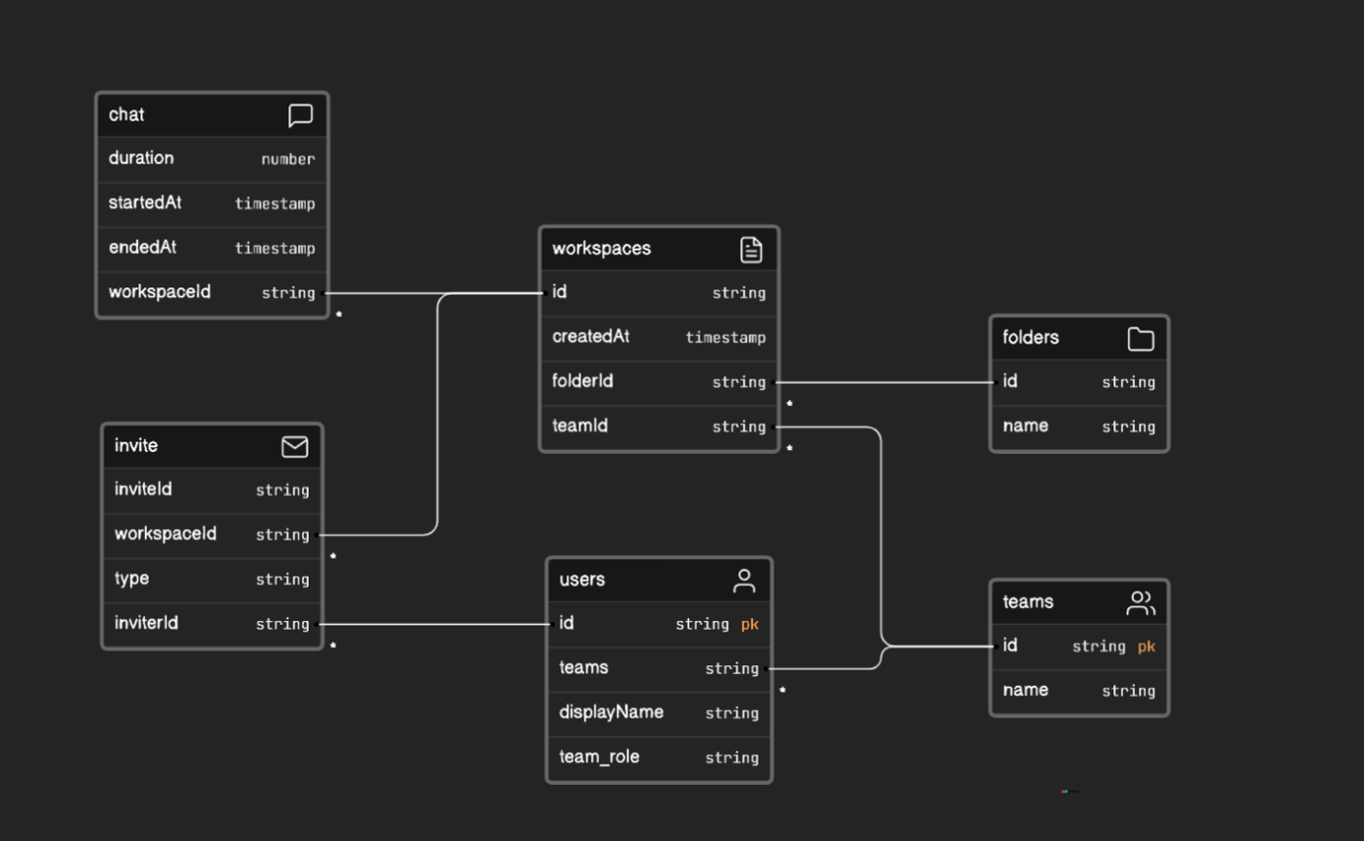

16

**3.2.2 Functional Requirements**

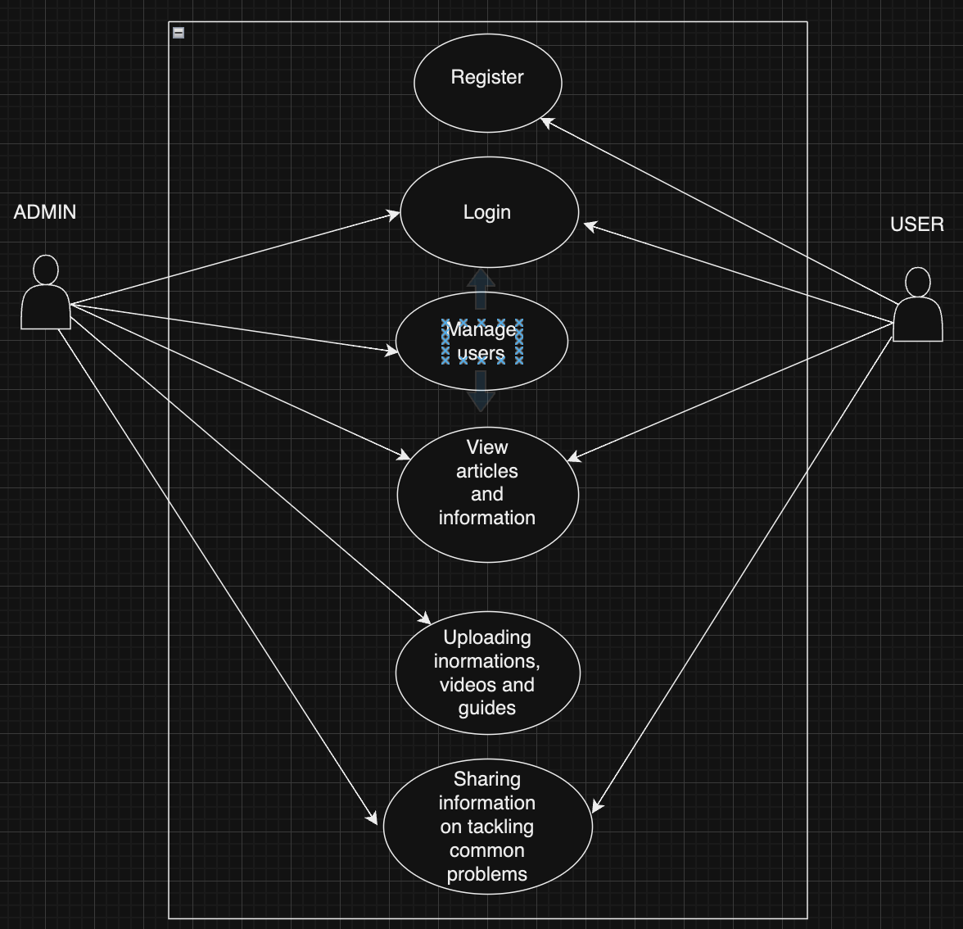

17

**3.2.3 System Architecture**

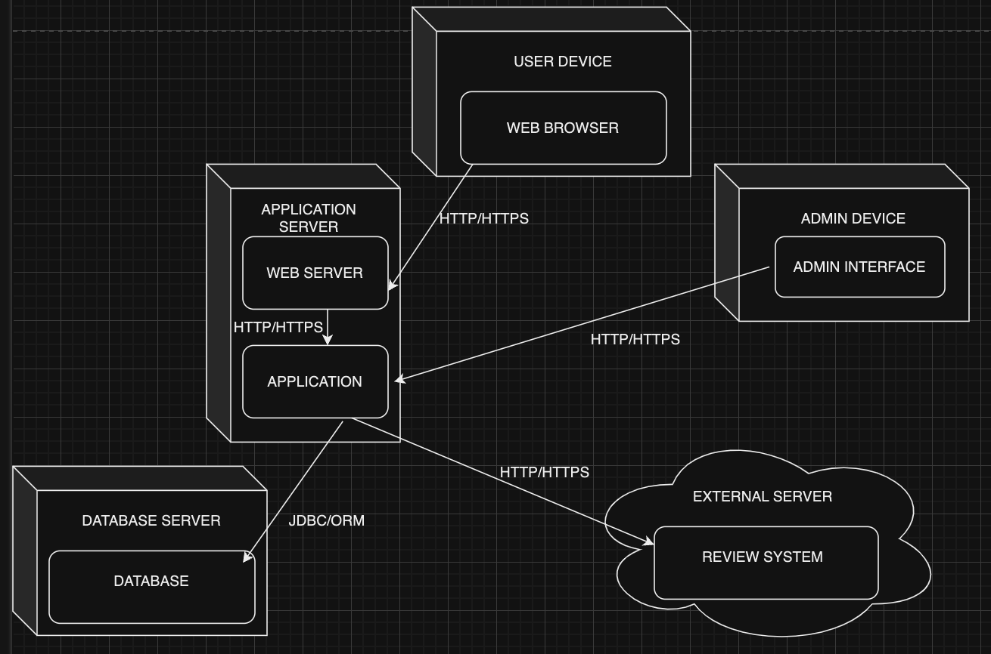

**3.2.4 Software Structure**

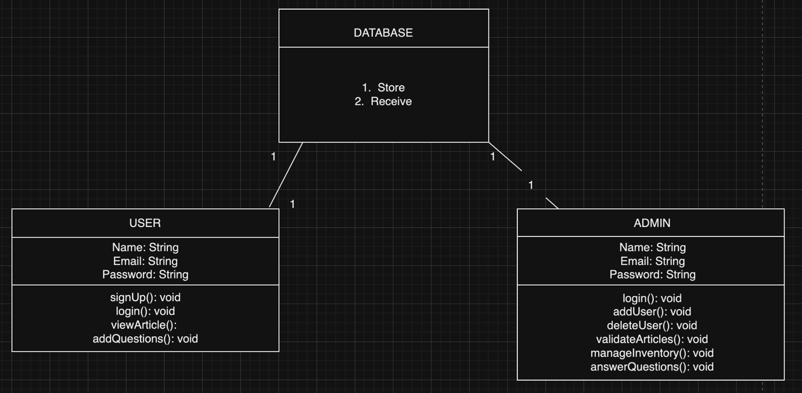

18

**3.2.5 Workflow of Use cases**

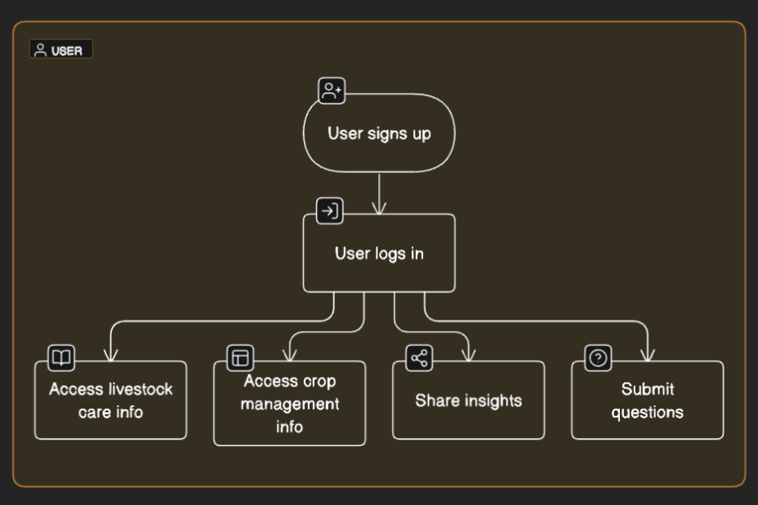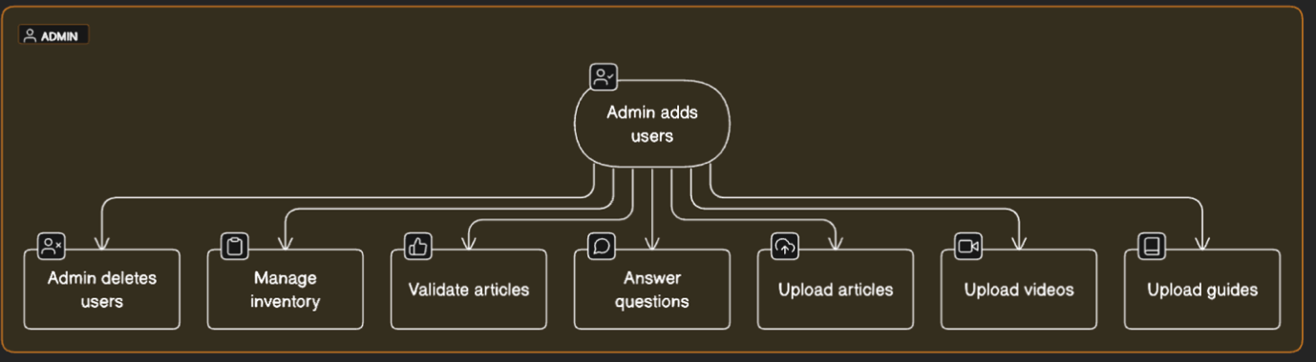

19

**REFERENCES**

1. Chawan M. Hamasalih & Tahir M. Layeeq “The importance of Agricultural Extension Program in Technology Transfer for Rural Farmer”

Available at: https://zjar.journals.ekb.eg/article_313661_a80ac31830aae6023f3bb20aef7ebebb.pdf

1. M. C. Madukwe & A. C. Anyanwu “The Challenges of Agricultural Extension in The 21st Century
2. S. Hamisu, A.M. Ardo, M. M. Makinta, L. Garba, & G. Musa “A Review on Current Status of Agricultural Extension Service in Nigeria”

Available at: <https://www.researchgate.net/publication/318892919_A_Review_on_Current_Status_of_Agricultural_Extension_Service_in_Nigeria>

1. Agricultural Extension as a course. Available at: <https://www.fecolartow.ng/department-of-agricultural-extension-and-management>
2. Kolawole Adebayo, Suresg Chandra Babu, Rahman Sanusi, & Motunrayo Sofola “Private Sector Participation in Agricultural Extension in Nigeria”

Available at: https://www.sciencedirect.com/science/article/abs/pii/B9780128022313000085

20