**CHAPTER ONE**

**INTRODUCTION**

**1.1 Background of the Study**

Prior to the establishment of Federal Road Safety Commission in 1988, there was no concrete and sustained policy action to address the carnage on Nigerian roads. Earlier attempts in this direction were limited to discrete and isolated attempts by some states of the Federation and individuals (Obayi, 2012).

The unpleasant trend in the nation’s road traffic system which resulted in upsurge in road traffic accidents made the Federal Government initiate a search for a credible and effective response to the challenge. In February 1988, the Federal Government established the Federal Road Safety Commission through Decree No .45 of the 1988 as amended by Decree 35 of 1992 referred to in the statue books as the FRSC Act cap 141 laws of the Federation of Nigeria (LFN). Passed by the National Assembly as Federal Road Safety Commission establishment Act 2000e.

Around the world road traffic injuries are a major public health challenges that requires concerted efforts for effective and sustained prevention. An estimated 1.2million people are killed in road crashes every year and as many as 50million suffer injuries. The world health organization believes that these figures could increase by more than half over the next 20years unless there is a firm commitment to road safety and accident prevention, especially in Nigeria, most adults will know of someone who has been killed or injured in a road traffic accident. It is a dead fact that many of these accidents and their consequences would have been avoided (Williams, 2007).

Road Traffic Accidents is when a vehicle or motorcycle collide with either a second vehicle or hits an individual, but Accident is far more than that, A road accident refers to any accident involving at least one road vehicle, occurring on a road open to public circulation, and in which at least one person is injured or killed. Intentional acts (murder, suicide) and natural disasters are excluded (National Institute of Statistics and Economic Studies, 2016). Road Traffic Accidents claim more than 1.2 million lives each year and have a huge impact on health and development they are among the major causes of deaths in young adults and children between the ages of 15 – 29 years (World Health Organization, 2015).

Road safety has become a major problem during the last decades in most of the developed countries all over the world. Traffic accidents have vast social and economic impacts every year, and public authorities seem sometimes unable to tackle effectively this problem. In other cases things are improving slowly but consistently due to the systematic, continuous and combined efforts of many organizations, public and private, involved in the fight for safer roads.

It is certainly wise to benefit from the experience of those who succeeded in this respect and avoid the experience of those who didn't. Road safety needs to be managed, and good management of road safety requires a lot of information. The latter can be obtained only by gathering systematically and continuously proper data from the field or from other sources. This data is needed both for studying road safety and for measuring the effectiveness of any interventions chosen and implemented on spot to reduce frequency and severity of road accidents. This is what the “good” experience shows. Fortunately, the new technological advances are in favor of the quick and easy data collection and thus new weaponry is at the Authorities' and individuals' disposal (Adebayo, 2014).

Therefore the Computerized Road Traffic Accident and Infraction Database System will help to keep records of all traffic accident and infraction committed by road users and also maintain the databases of the commission (FRSC).

**1.2 Statement of the Problem**

The collection management and dissemination of Road Traffic Accident and Infractions (RTAI) related events have represented a serious issue to road safety officers and all stakeholders alike due to the absence of a central repository from which all accident-related data can be stored and managed. Where accessible, these data are available in the paper-based form and this represents a bottleneck in updating the available data. Due to the difficulties encounter using the manual process such as time required to access and deliver accident related information, difficulties of seeing the appropriate officers on time and in order to eradicate the traditional process of accessing accident data and also to explore stakeholders to the use of technological devices in order to have effective communication with the department and also to keep track of Road Traffic Accident and Infractions.

* 1. **Aim and Objectives of the Study**

The aim of this project is to design a computerized system that will help the Federal Road Safety Commission to document all road traffic accidents and infractions incurred by the road users.

The specific objectives of this project are:

1. To design a road traffic accident and infraction management system.
2. To establish a centralized repository for incident data to enable efficient record-keeping and retrieval.
3. To enhance the tracking and management of traffic rule violations for improved enforcement.

**1.4 Scope of the Study**

This study is strived at finding out how effective the Computerization of Federal Road Safety Corps (FRSC) Kaduna Command will improve the operation of the commission. However, the research is limited to traffic offence section. This project work encompasses the relationship between the accident monitoring department and other stakeholders in terms gaining access to actual and accurate information on road accidents and infractions.

**1.5 Significance of the Study**

As a result of this project research and implementation, the following will be an added knowledge:

1. It will serve as reference to other researchers who may also wish to enhance this system.
2. Reduction of errors to enhance effectiveness.

**I.6 Definitions of Terms**

**Road Traffic Accident (RTA)**

An unexpected event occurring on the road involving vehicles, pedestrians, cyclists, or other road users, resulting in damage, injury, or loss of life.

**Infraction Management System**

A comprehensive system designed to monitor, detect, and manage traffic rule infractions. It involves the use of technology, policies, and enforcement measures to address violations, promote compliance, and enhance overall road safety.

**Intelligent Transportation Systems (ITS)**

Technological solutions integrated into the transportation infrastructure to improve the efficiency, safety, and sustainability of road networks.

**Artificial Intelligence (AI) in Road Safety**

The application of AI techniques, such as machine learning and data analytics, to analyze traffic patterns, predict potential accidents, and optimize road safety measures.

**Graduated Driver Licensing (GDL)**

A system for phased introduction of driving privileges, typically for novice drivers. GDL programs include stages with increasing driving responsibilities and additional training requirements to enhance the skills and experience of new drivers gradually.

**Integrated Traffic Management System**

A holistic approach to traffic management that combines surveillance technologies, data analytics, and communication systems.

**Public Awareness and Education Initiatives**

Programs and campaigns designed to inform and educate the public about road safety, traffic rules, and the consequences of traffic violations.

**Enforcement Gaps**

Discrepancies or weaknesses in the enforcement of traffic regulations, leading to challenges in addressing violations effectively. Enforcement gaps may include inadequate resources, inconsistent monitoring, or loopholes in legal frameworks.

**CHAPTER TWO**

**LITERATURE REVIEW**

**2.1 Content Management System**

In this section a critical study and review was performed on Information systems, Drupal Content Management System, MySql Database and other related research work from journals, articles, related project and other sources that have made contributions to the study of the subject in question. This study was done with the aim of providing an in-depth understanding of the topic, its importance, characteristics, problems and composite features of the system from the subject study. The study of scholarly work related to project management and planning was done to facilitate and aid in gaining understanding of the subject matter from the basic to the thorough level which will eventually help in streamlining the development of the affected system. This study will help in outlining the project needs and where to focus on.

**2.2 Decision Support System**

Decision Support Systems (DSS) have been in existence since the advent of computers and have aided us in making critical and correct decisions. DSS are created to help people make decisions by providing them information and analysis tools, DSS is a to model data and make quality decisions based upon it (Johnson et al., 2012).

James (2010) described DSS naturally constructed to back the solution of a certain problem or to assess an opportunity, it uses an interactive, flexible, adaptable computer based information system especially developed for supporting the solution, It uses data provides an easy to use interface and sometimes incorporate the decision maker’s insight.

DSS supports all the phases of Decision making it can be used by a single user or on the web where it can be accessed by so many users at different locations in that regards a Database server needs to be put in place to store and collect the data an application server to communicate between the web server and the Database server and a Web Browser to view the data by different users in separate locations (Lai and Chan, 2004)

Sapsford, & Jupp (2014) viewed Decision Support Systems as very valuable in situations in which the amount of available information is prohibitive for the intuition of an unaided human decision maker and in which precision and optimality are of great importance. As we have seen the use of DSS will continue to grow in so many areas as emerging technologies continue moving forward to find perfection.

In a world where everything is automated and user feedback is useful it will be of great help if DSS are incorporated into our technologies. A DSS always works together with an Information System which will be the next point of discussion.

**2.3 Information System**

Information System is the study of systems with a specific reference to information and the complementary networks of hardware and software that people and organizations use to collect, filter, process create and also distribute data, an emphasis is placed on an information system having a definite boundary, users, processors, storage, inputs, outputs and aforementioned communication networks (Marc, 1995).

Information systems found in the 1980’s textbooks was a pyramid of systems that reflected the hierarchy of the organization, although the pyramid model remains useful since it was formulated a lot of technologies have been developed and new categories of information systems have emerged.

Example of the new developed Information systems are:

1. Expert Systems
2. Enterprise Resource Planning
3. Geographic Information Systems (GIS)

Information System Development and application of Information Technology in organizations has a series of processes to develop and use an IS, depending on the choice of the developer the use of software engineering techniques is employed, techniques such as the Waterfall model, V- Shaped Model, Iterative Model, Spiral Model, Big Bang Model and Agile Model. Each of these techniques has its own strengths and weaknesses and depends on the type of Information System developed the model of choice can play a big role (Marc, 2014)

**2.4 Drupal Content Management System**

Drupal is an open source free content management framework which was developed using the PHP scripting language and distributed under the GNU General Public License(Merriam-Webster Dictionary, 1999).

Drupal is among the leading platforms for web content Management among Global Enterprises, Businesses, schools and even Government Organization making it cross so many branches of the various types of Website from Blogs to High End websites used for E-Commerce (W3Techs, 2011).

Although Drupal offers a sophisticated API (Application Programming Interface) for developers, basic Web-site installation and administration of the framework require no prior programming skills.

Interest in Drupal increased in 2003 when it helped build “DeanSpace” a website for Howard Dean a candidate of the Democratic party in the United States presidential primary campaign for the 2004 elections. DeanSpace used open source sharing of Drupal to support a decentralized network of approximately 50 disparate, unofficial proDean websites that allowed users to communicate with one another.

As of the year 2014 Drupal was being developed by a community and its popularity growing rapidly from July 2007 to June 2008 the drupal.org site provided more than 1.4 million download of Drupal software an increase of approximately 125% from the previous year (Buytaert, 2014).

As of January 2017, the amounts of sites using Drupal was approximately 1,180,000, this includes hundreds of well-known organizations, including corporations, media and publishing companies, Governments, non-profits, schools and individuals Drupal has won several open source awards and won the Web ware three times in a row (OSS CMS Award Previous Winners, 2013).

Drupal is robust as it runs on any computing platform that supports web servers that can run PHP and a database to store content and configuration. Drupal has a lot of modules which are used to augment and extend the functionality of a website, Drupal has also been able to incorporate 100 different languages and English as default, it also has right to left language support such as Arabic, Hebrew, and Persian.

The security of Drupal sites is very high as there are users working on developing patches as soon as a problem arises, thus making it very secured. As soon as there is a patch available Drupal sends a notification to all its users to update their systems for the patch to take action. With all the above mentioned uses and efficiency of Drupal it still has some problems, such as the Usability for new administrators it was hard to understand and work around the site, The learning curve for Drupal is also very high, It is also difficult for unit testing Drupal 7 doesn’t follow MVC (Model View Controller) framework and store all of its configurations to Database and as a result touching the code without going to the database is not possible.

**2.5 Database Management System**

A database is defined as a usually large collection of data organized especially for rapid search and retrieval. A database refers to a set of related data and the way it is organized access to a database is done by the use of a Database Management System (DBMS). Databases are used to support internal operations of organizations and to underpin online interactions with customer and suppliers. They are also used to hold administrative information and more specialized data, such as engineering data or economic models Examples of database applications include computerized library systems, flight reservation systems, computerized parts inventory systems, and many content management systems that store websites as collections of web pages in a database.

A database management system or DBMS is essentially a computerized data keeping (IBM, 1990). Users of the system are given facilities to perform several kinds of operations on such a system for either manipulating data in the database or the management of the database structure itself. A Database Management System (DBMS) is a single or set of computer programs that are responsible for creating, editing, deleting and generally maintaining a database or collection of records (Obbayi, 2017).

There are four main types of DBMS and a database model determines the way data is stored in them. They are namely:

1) Relational Database Management System

2) Flat File Based Database Management Systems

3) Hierarchical Database Management System

4) Network Database Management System

5) Object-Oriented Database Management System.

1) Hierarchical Databases: - In a hierarchical database records contain information about the groups of parent/child relationships just like a tree structure.

2) Network Database: - The network databases are mainly used on large digital computers. The connections can be made between different types of data.

3) Object-oriented Model: - In this Model we have to discuss the functionality of the object-oriented Programming. Ittakes morethan storage of programming language objects. Object DBMS's increase the semantics of the C++ and Java. It provides full-featured database programming capability, while containing native language compatibility. It adds the database functionality to object programming languages.

**2.6 Relational Database Management System (RDBMS)**

RDBMS are the most widely used database management systems today. They are relatively easy to use, Relational database management systems are named so because of the characteristics of normalizing the data which is usually stored in tables. The relationship between data files is relational, hierarchical and network database management systems require the user to pass a hierarchy in order to access needed data, but in relational databases connect data in different files by using common values known as keys, Data stored in relational database are have a unique Identifier for a set of records which is known as primary key, A primary key cannot be generated twice it must be unique to that record. When a record is needed in another table the primary key is used but in the new table it would be called a foreign key. In relational databases data can be changed without affecting the whole table. Relational database management systems include Oracle, MsSQL Server, IBM DB2, MySQL, SQLite and PostgreSQL among others.

**2.7 Road Accident Management**

There currently is no working software for managing, registering and visualization of road accidents in Nigeria, but there have been Research works related to this topic.

Is a proposed solution to Road accidents using a Geographical Information System and Microcomputer Accident Analysis Package in Malaysia. After going through the work it is noteworthy to notice that the system doesn’t store all the data needed on Accident as the owner of the paper was more concerned to zoning and having a GIS view of the Accident site (Silas, 2000).

The Dutch Injury Surveillance System provides a basis for priority-setting in injury control in the Netherlands, for obtaining information on the direct medical costs of injury, and for identifying research priorities (Horan & Mallonee, 2013).

Surveillance involves keeping records on individual cases, assembling information from those records, and analyzing and interpreting this information. The output from a surveillance system is intended to help users respond to the problem under surveillance by developing new – or improving existing – policies and strategies for prevention or intervention(WHO, 2012).

**2.8 Road Accident Management Using Geographic Information System**

In Greece unfortunately there is neither a conventional Accident Management System nor a GIS for the National Road Network. Though such as system - i.e. a GIS based system - was suggested in the past by a special study (Papaioannou & Basbas 1993) for all main activities of the General Secretariat of Public Works, nothing has been done so far. In a way this fact allows the Ministry people to employ the most suitable GIS based system, without having to take into account any existing hardware or software restrictions. However, it seems that there is an important shortage in terms of maturity in the agencies dealing with safety issues, since there is practically no experience at all in this area.

A relevant effort regarding Road Safety Management Systems has been made in the Technical University of Athens (Fratzeskakis & Sekopoulos, 1994), with the so called Road Safety Information System (RSIS). This system according to its creators can be used to prepare accident statistics, to identify hazardous locations, to evaluate results of road improvements, and to make accident predictions. The design of the Data Base is based on the latest version of the Road Accidents Report Sheet that is being used by the Police to report all road accidents.

**2.9 Measures to Prevent and Control Accident**

We must adopt or acquire sufficient safety education to develop positive safety attitudes and habits. Road Safety education should be introduced in the primary schools among pupils. In addition, Teachers’ Guide, Posters, leaflets and an activity book should be published and distributed to all Head Teachers, Information Technology and Physical Education personnel, and the pupils of all primary schools. Talks on road safety should be delivered to Secondary schools and higher institutions in Nigeria.

* Planning or ordering the environment to make it accident free. Government should construct and maintain good road network in the country. Enough road signs should be provided at strategic points to inform road users of sharp bends, pedestrian crossing, T-junctions, roundabouts, danger. The main objectives of campaign should be to reduce the annual road deaths to the barest minimum. Increase level of awareness and understanding of traffic codes for pedestrians on the road. Develop responsible attitude amongst pedestrians toward their own safety.
* Regular maintenance and repairs of vehicle is a very important factor in the prevention of road accidents. Minimum vehicle safety standards should not be compromised, good maintenance culture should be encouraged.
* Avoidance of haste, confusion procrastination while on the highway. Always drive at a speed limit which is reasonable, credible and acceptable by the FRSC and other road users. Over speeding dangerous overtaking should be avoided. Drivers should always endeavour to abide by traffic rules, give correct, prompt, adequate and clear signals without any procrastination.
* There should be a constant consciousness of hazardous situations like reckless driving by other drivers, bad road network, mechanically defective vehicles, impairment of visibility on highways.
* Avoid the use of mobile phone while driving.
* Make sure you use your seat belt.
* Avoid drink driving or driving under the influence of alcohol

**2.10 Notice of Offence Sheet**

The table below is a typical example the manual method of convicting traffic offenders in Nigeria.

|  |  |  |  |  |  |
| --- | --- | --- | --- | --- | --- |
| **S/N** | **TICK INFRINGEMENT** | **CODE** | **POINTS** | **PENALTY**  **(N)** | **CATEGORY** |
| 1 | Assaulting Marshal on duty | AMD | 10 | 10,000 | 2 |
| 2 | Attempting to corrupt Marshal on duty | ACS | 10 | 10,000 | 2 |
| 3 | Caution sign violation | CSV | 03 | 3,000 | 3 |
| 4 | Construction area speed limit violation | CAV | 03 | 3,000 | 1 |
| 5 | Dangerous driving | DGD | 10 | 50,000 | 1 |
| 6 | Do not move violation | DNM | 02 | 2,000 | 2 |
| 7 | Driver’s license violation | DLV | 10 | 10,000 | 2 |
| 8 | Driving under alcohol/drug influence | DUI | 05 | 5,000 | 2 |
| 9 | Driving with worn-out tyre | TYV | 03 | 3,000 | 1 |
| 10 | Driving with expired/without spare tyre | EWT | 02 | 2,000 | 3 |
| 11 | Excessive smoke emission | ESE | 05 | 5,000 | 1 |
| 12 | Failure to cover unstable materials | FCM | 05 | 5,000 | 1 |
| 13 | Failure to fix red flag on projected load | FFF | 03 | 3,000 | 1 |
| 14 | Failure to move over | FMO | 03 | 3,000 | 1 |
| 15 | Failure to report road crash | FRC | 10 | 20,000 | 1 |
| 16 | Fire extinguisher violation | FEV | 03 | 3,000 | 3 |
| 17 | Inadequate construction warning sign | ICW | - | 50,000 | 1 |
| 18 | Light/sign violation | LSV | 02 | 2,000 | 2 |
| 19 | Medical personnel/hospital rejection of road crash victim | RCV | - | 50,000 | 1 |
| 20 | Operating mechanically deficient vehicle | MDV | 05 | 5,000 | 1 |
| 21 | Obstructing marshal on duty | OMD | 03 | 3,000 | 2 |
| 22 | Operating a vehicle with forged documents | OFD | 10 | 20,000 | 2 |
| 23 | Overloading | OVL | 10 | 10,000 | 1 |
| 24 | Passengers’ manifest violation | PMV | 10 | 10,000 | 2 |
| 25 | Riding motorcycle without using crash helmet | RMH | 02 | 2,000 | 1 |
| 26 | Road obstruction | ROB | 05 | 5,000 | 1 |
| 27 | Road marking violation | RMV | 05 | 5,000 | 1 |
| 28 | Route violation | RTV | 10 | 10,000 | 1 |
| 29 | Seat belt use violation | SUV | 05 | 5,000 | 1 |
| 30 | Speed limit violation | SLV | 05 | 5,000 | 1 |
| 31 | Unauthorized removal/tampering with road sign | UTS | 05 | 5,000 | 1 |
| 32 | Under aged driving/riding | UDR | - | 10,000 | 1 |
| 33 | Use of phone while driving | UPD | 04 | 4,000 | 1 |
| 34 | Vehicle license violation | VLV | 03 | 3,000 | 2 |
| 35 | Number plate violation | NPV | 03 | 3,000 | 1 |
| 36 | Vehicle windshield violation | VWV | 03 | 3,000 | 1 |
| 37 | Wrongful overtaking | WOV | 03 | 3,000 | 1 |
| 38 | Projected load in excess of prescribed limit | PLE | 03 | 3,000 | 1 |
| 39 | Vehicle mirror violation | VMV | 03 | 3,000 | 1 |
| 40 | Learner driving regulation violation | LDV | 10 | 3,000 | 1 |
| 41 | Child restraint violation | CRV | 06 | 3,000 | 1 |
| 42 | Child sitting position violation | CPV | 06 | 3,000 | 1 |
| 43 | Driving right-hand steering vehicle | DRV | 10 | 3,000 | 1 |

NOTE: Custody fee on impounded motor Vehicle and Motorcycle/Tricycle is N200.00 and N100, respectively per day payable after initial 24 hours of grace (FRSC, 2015)

**2.11 Summary**

The advancement in Computer Science and Information Technology has helped across all aspect of human activities including the road accident management sections which is basically utilized to simplify performing activities that results in enjoying all the benefits that comes along. This led to the automation of several functions, from the Data gathering to the point of visualization and Decision Support on how to reduce the mortality on our roads.

**CHAPTER THREE**

**METHODOLOGY**

## 3.1 Introduction

This chapter delves into the intricacies of the methodology employed in the development of the Road Accident and Infraction Management System. The subsequent sections outline the project workflow, system development model, analysis of both the existing and proposed systems. The requirements elicitation, definition, and analysis processes are laid, laying the groundwork for the subsequent stages of system design and development. The structured approach ensures a comprehensive understanding of the project's intricacies, facilitating an effective transition from conceptualization to tangible implementation.

## 3.2 Project Workflow

This section shows a comprehensive workflow illustrating the sequential stages entailed in the development of the system. Figure 3.1 serves as a visual aid for the workflow stages.

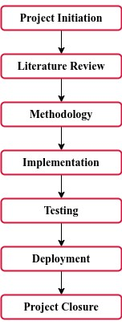

*Figure 3.1: Workflow Diagram*

**Workflow Stages:**

1. Project Initiation:
   * Definition of project objectives, scope, and stakeholders.
   * Conducting an initial feasibility study.
   * Establishment of project timelines and milestones.
2. Literature Review:
   * Comprehensive review of relevant literature to inform project development.
   * Identification and analysis of key concepts and methodologies in the field.
3. Methodology:
   * Detailed explanation of the chosen System Development Life Cycle (SDLC).
   * Analysis of the existing and proposed systems, including requirement elicitation anddefinition.
   * Use Case Analysis to portray system interactions.
4. Implementation:
   * Coding of the system based on the design specifications.
   * Adherence to coding standards and best practices.
5. Testing:
   * Implementation of testing strategies, including unit testing and integration testing.
   * Addressing and resolving identified issues during the testing phase.
6. Deployment:
   * Rollout of the developed system to a staging environment.
   * Performance of final testing and debugging.
7. Project Closure:
   * Evaluation of project success against defined objectives.
   * Documentation of lessons learned and areas for improvement.
   * Finalization of project documentation.

## 3.3 System Development Model

In this section, the chosen System Development Life Cycle (SDLC) for this system development is the Agile Software Developmnet Model. The selection of this model is based on its appropriateness for this project's objectives and requirements., offering a structured framework that accommodates the dynamic nature of software development. The phases of Agile Model is also provided as a diagram in figure 3.2.

### Rationale for Choosing the Agile Software Development Model

Implementing the Agile software development model in your Road Accident and Infraction Management System offers several benefits tailored to the dynamic and evolving nature of such projects. Here are detailed reasons for using the Agile model:

**Iterative Development**

The Agile model supports iterative and incremental development. Given the evolving nature of requirements in a road accident and infraction management system, this approach allows for frequent updates and adjustments based on changing priorities and feedback.

**Flexibility to Changing Requirements**

The requirements in systems related to road accidents and infractions can change due to regulatory updates, technological advancements, or shifting priorities. Agile's flexibility accommodates these changes seamlessly, enabling the project to adapt to evolving needs.

**Customer Collaboration**

Agile emphasizes continuous customer collaboration throughout the development process. For a system involving road safety, close collaboration with stakeholders, law enforcement agencies, and regulatory bodies is crucial. Agile ensures their feedback is incorporated promptly.

**Risk Management**

Agile's iterative approach enables early identification and mitigation of risks. It allows for testing and validating components as they are developed, reducing the likelihood of significant issues later in the project.

**Continuous Improvement**

Agile promotes a culture of continuous improvement. Through regular retrospectives, the development team can reflect on what worked well and what can be improved, enhancing efficiency and the quality of the road accident and infraction management system.

**Increased Stakeholder Satisfaction**

Regular feedback, collaboration, and a transparent development process contribute to higher stakeholder satisfaction. For a project involving multiple stakeholders, such as law enforcement, government bodies, and the public, this is paramount.

**Adaptability to Emerging Technologies**

The road safety domain is subject to technological advancements. Agile's adaptability allows the team to incorporate emerging technologies and innovations seamlessly, ensuring that the system remains up-to-date.

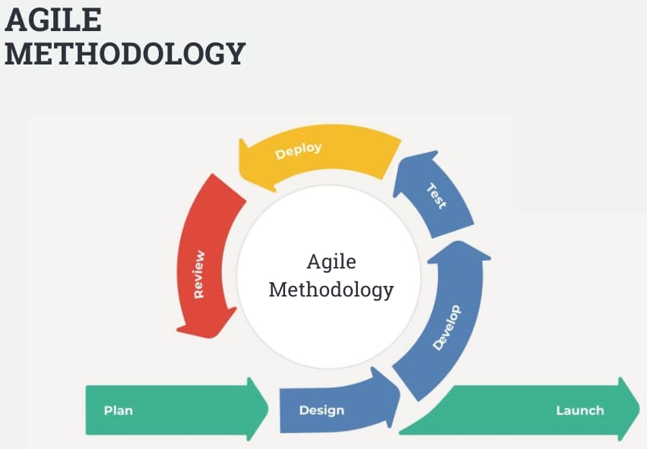

*Figure 3.2: Agile Software Development Model*

## 3.4 Analysis of Existing and Proposed System

This section involves a comprehensive analysis of both the existing system and the proposed ecommerce platform. The examination begins with a description of the existing system. Following this, the process of requirement elicitation, definition, and analysis is outlined to establish a clear understanding of the project's scope and objectives. Finally, the proposed system is introduced, incorporating aspects of system design, architecture, and database design. The goal is to present a thorough assessment that serves as the foundation for subsequent development phases.

### 3.4.1 Description of Existing System

The existing system for road accident and infraction management typically relies on traditional methods, combining manual processes with limited digital tools. Law enforcement agencies, traffic management authorities, and related entities play key roles in handling accidents and infractions.

**Manual Reporting**

Incident reporting primarily involves manual procedures. Police officers and first responders document accidents and infractions using paper forms, leading to a time-consuming and error-prone process. These reports serve as the foundation for legal proceedings and insurance claims.

**Data Silos**

Data generated during accident investigations and infractions are often stored in disparate systems, creating data silos. This fragmentation hampers data accessibility and sharing among relevant stakeholders, hindering a holistic understanding of road safety.

**Limited Data Analysis**

The existing system lacks advanced data analytics capabilities. Analysis of accident patterns, identification of high-risk zones, and proactive measures for traffic management are challenging due to the absence of robust data analysis tools.

**Delayed Information Dissemination**

Communication of important information, such as road closures, detours, and traffic advisories, faces delays in the existing system. This impacts the ability to respond promptly to incidents and manage traffic flow efficiently.

**Regulatory Compliance Challenges**

Ensuring compliance with changing traffic regulations and legal requirements poses challenges. Manual processes make it cumbersome to stay abreast of regulatory updates, leading to potential gaps in enforcement and reporting.

**Limited Public Engagement**

Citizen involvement in reporting incidents and providing real-time information is underutilized. The existing system lacks effective mechanisms for public engagement and contribution to road safety efforts.

### 3.4.2 Requirement Elicitation

The process of requirement elicitation for the proposed e-commerce platform involved the following;

* **PERSONAL INTERVIEW:** Some of the management staff were interviewed to share their feeling and experience about the manual system of processing and recording of traffic accidents and infractions. Their response was that the manual system which is known as the “Notice Of Offence Sheet” is highly cumbersome, boring and time consuming. They stressed that the manual system has not helped them much, since they have offenders on a daily, weekly, monthly and yearly on a high rate and the number keeps increasing on a regular basis. Making their office to look like a market place with crowds of people trouping in and out of their office at all times.
* **OBSERVATION**: A situation whereby files are littered around makes the office look untidy and unkept. I observed that due to insufficient space for storage of this files the office looks very much like a warehouse or better still a stuffy storehouse than like an office. Having also noticed that searching for a particular offenders’ record is time consuming and stressful, this makes the manual system ineffective.
* **INTERNET**: I ran lots of facts finding on the internet aid in my further research and acquisition of knowledge on Federal Road Safety commission concerning their manual system of Traffic Offence and my desire to change the manual system to a computerised system.

### 3.4.3 Requirements Definition

The meticulously defined requirements for the proposed e-commerce platform in Kano State encompass both functional and non-functional aspects, tailored to address the specific needs of businesses and consumers in the region.

**Functional Requirements:**

* Record Keeping:The system should maintain a centralized record of reported incidents and accidents for analysis and historical reference.
* Violation Tracking:The system should track and manage traffic rule violations, linking them to incidents and generating relevant reports.
* Analytics and Reporting:The system should provide analytical tools and reporting features for assessing road safety trends and patterns.

**Non-functional Requirements:**

**Performance**

- The system should handle a minimum of 1000 incident reports per day.

- Response time for user interactions should be within 3 seconds.

**Security**

- User authentication and authorization mechanisms to ensure data integrity and confidentiality.

- Encryption of sensitive data during transmission and storage.

**Reliability**

- The system should have a minimum uptime of 99.9%.

- Regular automated backups of the database.

**Scalability**

- The system architecture should allow for easy scaling to accommodate increased data and user load.

### 3.4.4 Requirement Analysis

The requirement analysis phase involves a comprehensive examination of the elicited functional and non-functional requirements, with a particular focus on system interactions through Use Case diagrams. The primary goal is to understand how users will engage with the platform and ensure that all identified scenarios are addressed in the subsequent stages of system development.

**Use Case Diagram:**

The Use Case diagram visually represents the various interactions between user(s) and the system. Each use case outlines a specific functionality or action within the system, elucidating the relationships and dependencies between different components. This analysis aids in identifying potential system behaviors, user roles, and the flow of actions within the platform.

Figure 3.3 below shows the interaction between users and the system.

TRAFFIC/ ADMIN

OFFICER

*Figure 3.3: Use Case Diagram*

**Use Case Descriptions:**

**User Login**

* The user/Admin can login using the username and password.
* **View Reported Accident/ Infraction**
* The User can view the reported accident and infraction that has being brought.
* **View Accident /Infraction Report**
* The user can view the accident and infraction cases that is saved.
* **Report New Accident/Infraction**
* The user can report or save new accident or infraction.
* **View Accident /Infraction History**
* The user can view accident and infraction history.

## 3.5 System Design

This section denotes the design phase of the system, detailing the proposed system's architecture and functionality. The design process encompasses the description of the system's core features, architectural design, and the structure of the underlying database.

### 3.5.1 Description of Proposed System

The proposed system introduces a user-friendly and efficient road accident and infraction system tailored to address the unique challenges observed in FRSC. The system prioritizes simplicity, accessibility, and real-time for easy and unique data security. The following diagrams provide a visual representation of the proposed system:

**Activity Diagram:**

The activity diagram illustrates the dynamic aspects of the system, showcasing the flow of activities between users and the platform. It emphasizes the sequences of actions and decisions in various scenarios, enhancing the understanding of user interactions. Figure 3.4 shows the flow of activities between users and the system.

Edit Accident/ Infractions Report

Input Data

Update Report?

Record is updated

No

Yes

*Figure 3.4: Activity Diagram*

### 3.5.2 Architectural Design

The architectural design employs class diagrams and package diagrams to articulate the structural aspects of the proposed system.

**Class Diagram**

Class diagram in the Unified Modeling Language (UML) is a type of static structure diagram that describes the structure of a system by showing the system’s classes, their attributes, operations (or methods), and the relationship among them.

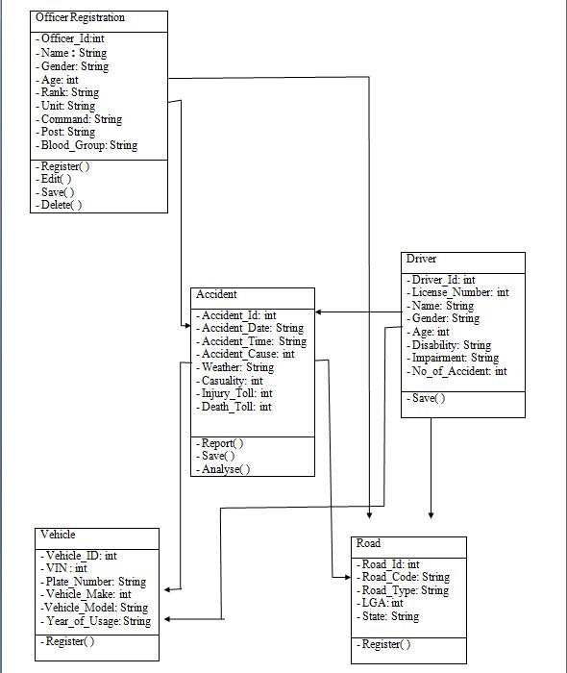

*Figure 3.5: Class Diagram*

**3.5.3 Database Design**

The database design is represented using the Entity Relationship (ER) diagram, outlining the relationships between different entities and their attributes.

**Entity Relationship (ER) Diagram:**

The ER diagram visually depicts the entities, attributes, and relationships in the database schema. It serves as a blueprint for organizing and storing data, ensuring data integrity and coherence. Figure 3.7 below shows the ER diagram.

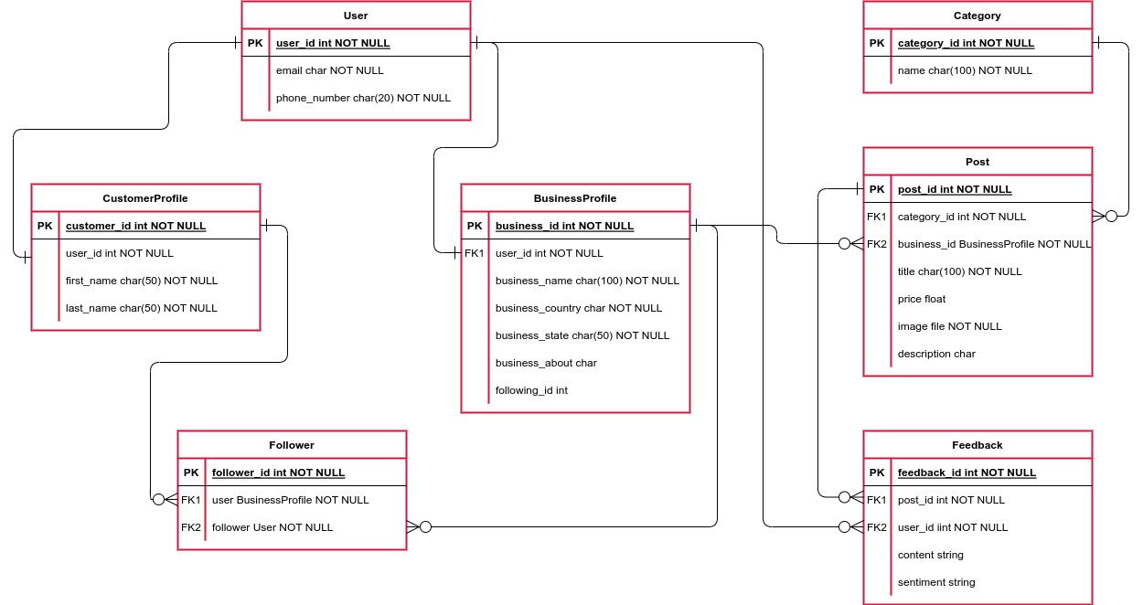

*Figure 3.7: Entity Relationship Diagram*

## 3.6 Summary

In this chapter, a comprehensive methodology for the development of the road accident and infraction system has been presented. The project workflow provides a visual representation of the sequential stages, guiding the entire development process. Adopting the Agile model as the System Development Life Cycle ensures a flexible and adaptive approach to the project implementation. The analysis of the existing and proposed systems sheds light on the current challenges faced by traditional saving of data in the FRSC, motivating the need for an enhanced, user-friendly system. The requirements elicitation process involves observation, interviews, and internet, ensuring a thorough understanding of the system's necessities. The identified functional and nonfunctional requirements serve as the foundation for subsequent stages, guiding the project towards successful implementation.

The Use Case Analysis employs Use Case diagrams to capture system interactions, providing a visual representation of user-friendly interactions. The non-functional requirements encompass operational, performance, and security aspects, setting the criteria for the system's effectiveness. Overall, this chapter sets the stage for the subsequent phases of implementation, testing, deployment, and project closure.