**Object Oriented Programming**

Final Term Spring 2020

Project Title

Restful Webservice In Springboot

Teacher Sheduled Assignment

Submitted To:

Dr. Nouman Riaz

Submitted By:

Usama Mustafa 19011519-001

Department:

Computer Science (Section A)

Semester:

2nd Semester

**GITHUB LINK**

**RESULTS and OUTPUTS**

**Login and Logout Security**

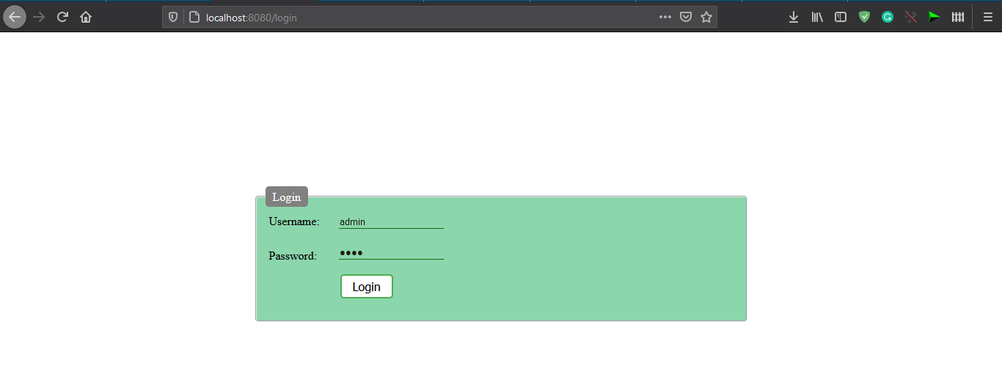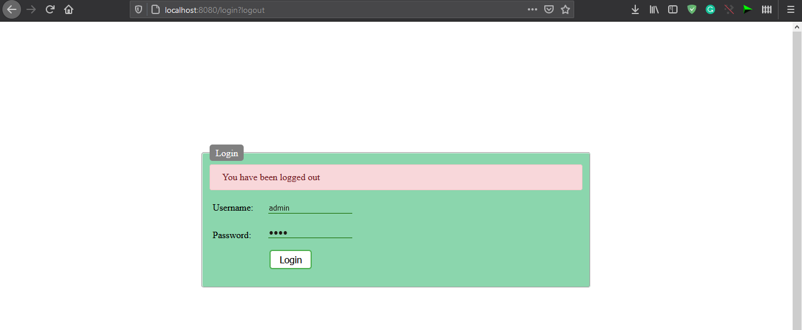**Main Page**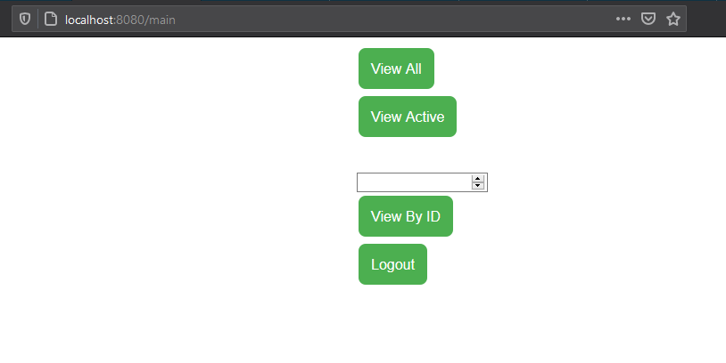

**View All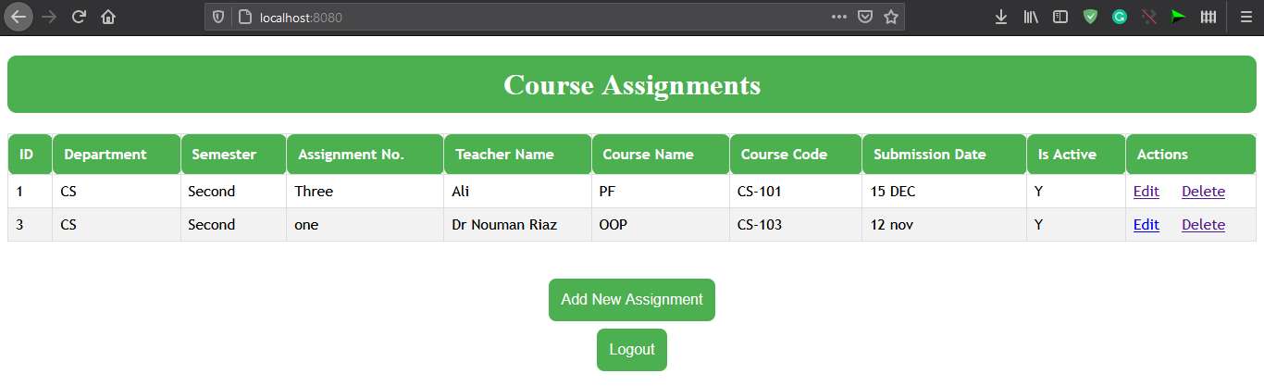 View By ID 1 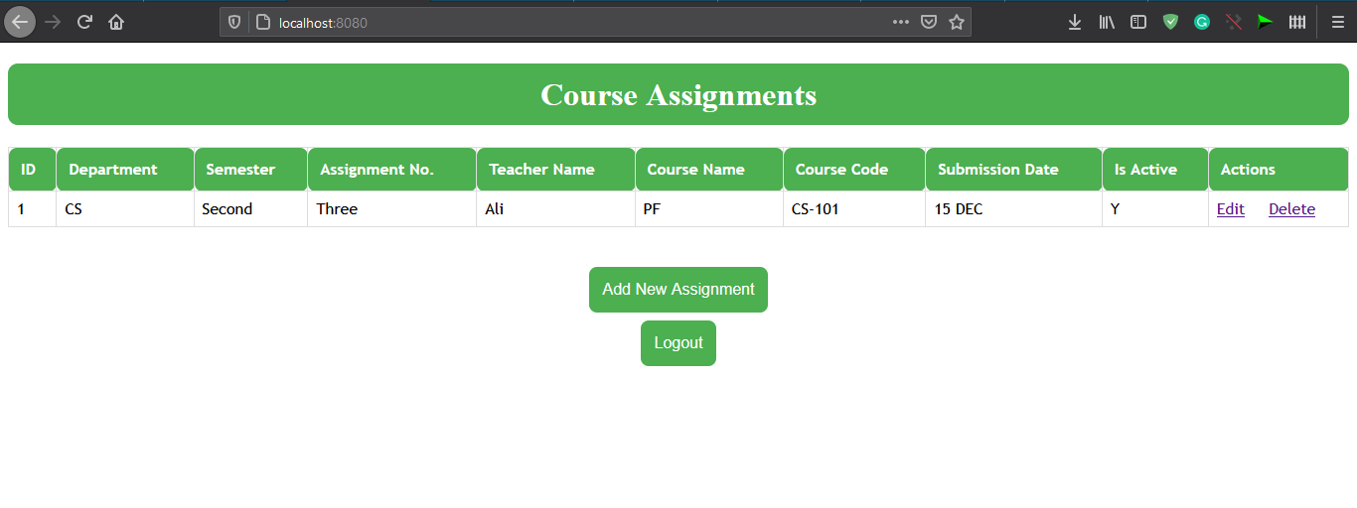 ViewActives**



**Edit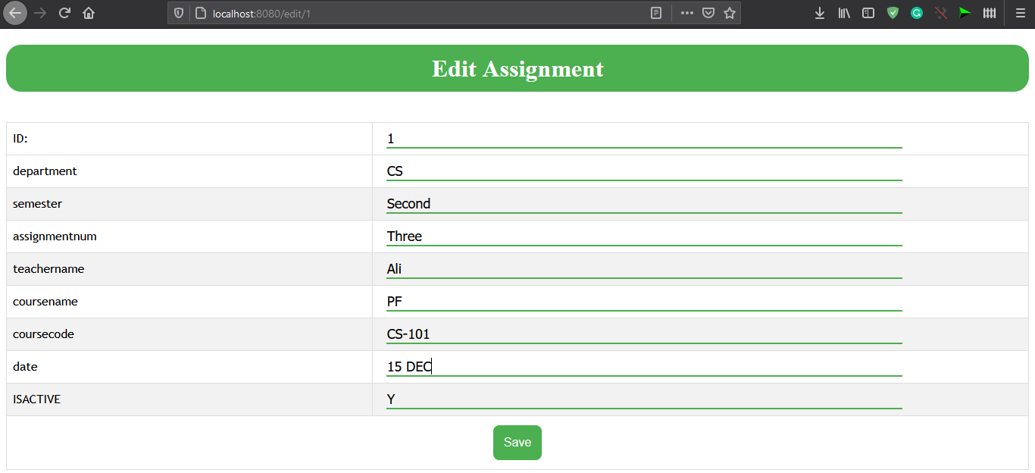 View After Edit**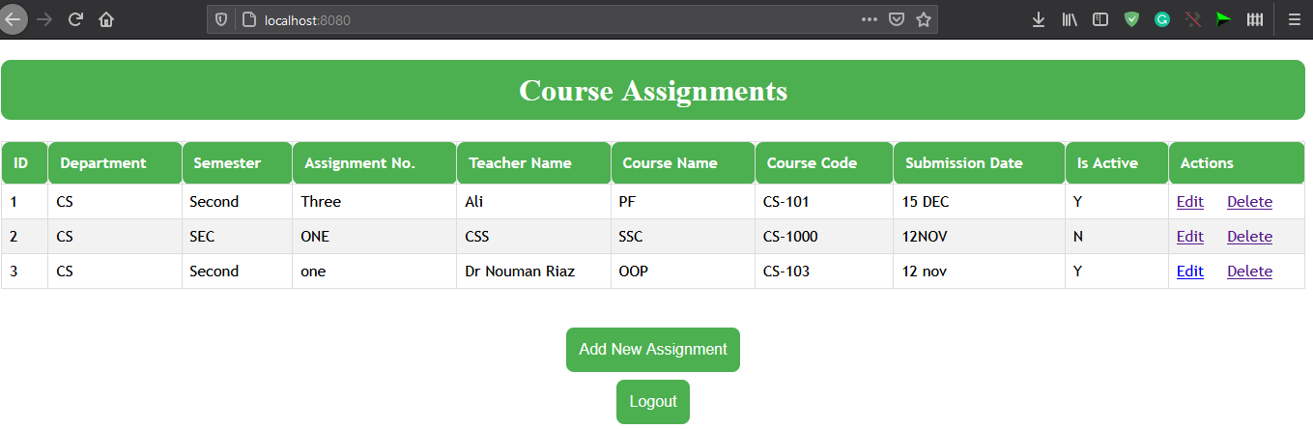

**View After Delete All**

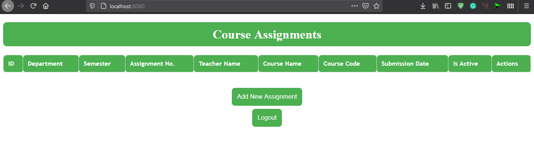

**CODE**

**Controller**

package com.uog.springboot.controller;  
  
import com.uog.springboot.model.Product;  
import com.uog.springboot.repository.CourseRepository;  
import com.uog.springboot.service.CourseService;  
import org.springframework.beans.factory.annotation.Autowired;  
import org.springframework.security.core.Authentication;  
import org.springframework.security.core.context.SecurityContextHolder;  
import org.springframework.security.web.authentication.logout.SecurityContextLogoutHandler;  
import org.springframework.stereotype.Controller;  
import org.springframework.ui.Model;  
import org.springframework.web.bind.annotation.*;  
import org.springframework.web.servlet.ModelAndView;  
  
import javax.servlet.http.HttpServletRequest;  
import javax.servlet.http.HttpServletResponse;  
import java.util.List;  
  
@Controller  
public class AppController {  
  
 @Autowired  
 private CourseService service;  
 private CourseRepository courseRepository;  
  
 @GetMapping("/login")  
 public String login(){  
 return "login";  
 }  
  
  
  
 @RequestMapping("/main")  
 public String viewmainPage(Model model) {  
  
 return "main";  
 }  
  
  
  
 @RequestMapping("/")  
 public String viewHomePage(Model model) {  
 List<Product> listProducts = service.listAll();  
 model.addAttribute("listProducts", listProducts);  
  
 return "index";  
 }  
  
  
 @RequestMapping("/new")  
 public String showNewProductPage(Model model) {  
 Product product = new Product();  
 model.addAttribute("product", product);  
  
 return "new_product";  
 }  
  
 @RequestMapping(value = "/save", method = RequestMethod.*POST*)  
 public String saveProduct(@ModelAttribute("product") Product product) {  
 service.save(product);  
 return "redirect:/";  
 }  
  
 @RequestMapping("/edit/{id}")  
 public ModelAndView showEditProductPage(@PathVariable(name = "id") int id) {  
 ModelAndView mav = new ModelAndView("edit_product");  
 Product product = service.get(id);  
 mav.addObject("product", product);  
  
 return mav;  
 }  
  
 @RequestMapping("/delete/{id}")  
 public String deleteProduct(@PathVariable(name = "id") int id) {  
 service.delete(id);  
 return "redirect:/";  
 }  
  
  
  
 @GetMapping("/logout")  
 public String fetchSignoutSite(HttpServletRequest request, HttpServletResponse response) {  
 Authentication auth = SecurityContextHolder.*getContext*().getAuthentication();  
 if (auth != null) {  
 new SecurityContextLogoutHandler().logout(request, response, auth);  
 }  
  
 return "redirect:/login?logout";  
 }  
  
  
// @RequestMapping(value = "/active", method = RequestMethod.GET)  
// public List<Product> get() {  
// List<Product> ass = new ArrayList<Product>();  
// ass = productRepository.findActive();  
// return "index";  
// }  
 @RequestMapping(value = "/view_by_id")  
 public String viewbyid(@RequestParam(name = "id") long id) {  
 ModelAndView mav = new ModelAndView("index");  
 Product product = service.get(id);  
 mav.addObject("listProducts", product);  
 return "index";  
 }  
  
}

**MODEL**

package com.uog.springboot.model;  
  
import javax.persistence.Entity;  
import javax.persistence.GeneratedValue;  
import javax.persistence.GenerationType;  
import javax.persistence.Id;  
  
@Entity  
public class Assignment {  
 private Long id;  
 private String department;  
 private String semester;  
 private String assignmentnum;  
 private String teachername;  
 private String coursename;  
 private String coursecode;  
 private String date;  
 private String ISACTIVE;  
  
  
 public Product() {  
 }  
  
 @Id  
 @GeneratedValue(strategy = GenerationType.*IDENTITY*)  
 public Long getId() {  
 return id;  
 }  
  
 public void setId(Long id) {  
 this.id = id;  
 }  
  
 public String getDepartment() {  
 return department;  
 }  
  
 public void setDepartment(String department) {  
 this.department = department;  
 }  
  
 public String getSemester() {  
 return semester;  
 }  
  
 public void setSemester(String semester) {  
 this.semester = semester;  
 }  
  
 public String getAssignmentnum() {  
 return assignmentnum;  
 }  
  
 public void setAssignmentnum(String assignmentnum) {  
 this.assignmentnum = assignmentnum;  
 }  
  
 public String getTeachername() {  
 return teachername;  
 }  
  
 public void setTeachername(String teachername) {  
 this.teachername = teachername;  
 }  
  
 public String getCoursename() {  
 return coursename;  
 }  
  
 public void setCoursename(String coursename) {  
 this.coursename = coursename;  
 }  
  
 public String getCoursecode() {  
 return coursecode;  
 }  
  
 public void setCoursecode(String coursecode) {  
 this.coursecode = coursecode;  
 }  
  
 public String getDate() {  
 return date;  
 }  
  
 public void setDate(String date) {  
 this.date = date;  
 }  
  
 public String getISACTIVE() {  
 return ISACTIVE;  
 }  
  
 public void setISACTIVE(String ISACTIVE) {  
 this.ISACTIVE = ISACTIVE;  
 }  
}

**Course Repo**

package com.uog.springboot.repository;  
  
import com.uog.springboot.model.Assignment;  
  
import org.springframework.data.jpa.repository.Query;  
import org.springframework.data.jpa.repository.JpaRepository;  
  
  
import java.util.List;  
  
public interface CourseRepository extends JpaRepository<Assignment, Long> {  
  
 @Query(value = "select * from Assignment where ISACTIVE='Y' ", nativeQuery=true )  
 public List<Assignment> findActive();  
}

**Security**

package com.uog.springboot.SecurityConfig;  
  
import org.springframework.security.config.annotation.web.builders.HttpSecurity;  
import org.springframework.security.config.annotation.web.configuration.EnableWebSecurity;  
import org.springframework.security.config.annotation.web.configuration.WebSecurityConfigurerAdapter;  
  
import javax.annotation.security.PermitAll;  
  
@EnableWebSecurity  
public class SecurityCustomConfig extends WebSecurityConfigurerAdapter {  
 @Override  
 protected void configure(HttpSecurity http) throws Exception{  
 http  
 .authorizeRequests()  
 .antMatchers("/resources/**").permitAll()  
 .anyRequest().authenticated()  
 .and()  
 .formLogin()  
 .loginPage("/login")  
 .permitAll()  
 .and()  
 .logout()  
 .permitAll();  
  
 }  
}

**CourseService**

package com.uog.springboot.service;  
  
import com.uog.springboot.model.Assignment;  
import com.uog.springboot.repository.CourseRepository;  
import org.springframework.beans.factory.annotation.Autowired;  
import org.springframework.stereotype.Service;  
  
import javax.transaction.Transactional;  
import java.util.List;  
  
@Service  
@Transactional  
public class CourseService {  
  
 @Autowired  
 private CourseRepository repo;  
  
 public List<Assignment> listAll() {  
 return repo.findAll();  
 }  
  
 public void save(Assignment Assignment) {  
 repo.save(Assignment);  
 }  
  
 public Assignment get(long id) {  
 return repo.findById(id).get();  
 }  
  
 public void delete(long id) {  
 repo.deleteById(id);  
 }  
}

**WEB Templates**

<!DOCTYPE html>  
<html xmlns="http://www.w3.org/1999/xhtml"  
 xmlns:th="http://www.thymeleaf.org">  
<head>  
 <meta charset="utf-8" />  
 <title>Edit Assignment</title>  
 <style>  
 #tablestyle {  
 font-family: "Trebuchet MS", Arial, Helvetica, sans-serif;  
 border-collapse: collapse;  
 width: 100%;  
 }  
  
 #tablestyle td, #tablestyle th {  
 border: 1px solid #ddd;  
 padding: 8px;  
 }  
  
 #tablestyle tr:nth-child(even){background-color: #f2f2f2;}  
  
 #tablestyle tr:hover {background-color: #ddd;}  
  
 #tablestyle th {  
 padding: 12px;  
 text-align: left;  
 background-color: #4CAF50;  
 color: white;  
 border-radius:8px;  
  
 }  
 h1{  
 background-color: #4CAF50;  
 padding-top: 12px;  
 padding-bottom: 12px;  
 color:#ffffff;  
 border-radius:20px;  
 }  
 input{  
  
 border-bottom: 2px solid #4caf50;  
 border-top: none;  
 border-right:none;  
 border-left:none;  
  
 outline: none;  
 background: none;  
 color: black;  
 font-size: 18px;  
 width: 80%;  
 float: left;  
 margin: 0 10px;  
}  
.button {  
 background-color: #4CAF50; /* Green */  
 border: none;  
 color: white;  
 padding: 12px;  
 text-align: center;  
 text-decoration: none;  
 display: inline-block;  
 font-size: 16px;  
 margin: 4px 2px;  
 transition-duration: 0.4s;  
 cursor: pointer;  
 font-family: sans-serif;-->  
}  
  
.button1 {  
 background-color: #4CAF50;  
 color: white;  
 border: 2px solid #4CAF50;  
 border-radius: 8px;  
}  
.button1:hover {  
 background-color: white;  
 color: black;  
}  
  
</style>  
</head>  
<body>  
<div align="center">  
 <h1>Edit Assignment</h1>  
 <br />  
 <form action="#" th:action="@{/save}" th:object="${product}"  
 method="post">  
  
 <table id="tablestyle">  
 <tr>  
 <td>ID:</td>  
 <td>  
 <input type="text" th:field="*{id}" readonly="readonly" />  
 </td>  
 </tr>  
 <tr>  
 <tr>  
 <td>department </td>  
 <td><input type="text" th:field="*{department}" /></td>  
 </tr>  
 <tr>  
 <td> semester</td>  
 <td><input type="text" th:field="*{semester}" /></td>  
 </tr>  
 <tr>  
 <td>assignmentnum</td>  
 <td><input type="text" th:field="*{assignmentnum}" /></td>  
 </tr>  
 <tr>  
 <td>teachername</td>  
 <td><input type="text" th:field="*{teachername}" /></td>  
 </tr>  
 <tr>  
 <td> coursename</td>  
 <td><input type="text" th:field="*{coursename}" /></td>  
 </tr>  
 <tr>  
 <td> coursecode</td>  
 <td><input type="text" th:field="*{coursecode}" /></td>  
 </tr>  
 <tr>  
 <td>date </td>  
 <td><input type="text" th:field="*{date}" /></td>  
 </tr>  
 <tr>  
 <td>ISACTIVE </td>  
 <td><input type="text" th:field="*{ISACTIVE}" /></td>  
 </tr>  
  
 <tr>  
  
 <td align="center" colspan="2"><button class ="button button1" type="submit">Save</button> </td>  
  
 </tr>  
  
 </table>  
 </form>  
</div>  
</body>  
</html>

<!DOCTYPE html>  
<html xmlns="http://www.w3.org/1999/xhtml"  
 xmlns:th="http://www.thymeleaf.org">  
<head>  
 <meta charset="utf-8"/>  
  
 <title>Course Assignments</title>  
  
 <style>  
 @import "https://use.fontawesome.com/releases/v5.5.0/css/all.css";  
 #tablestyle {  
 font-family: "Trebuchet MS", Arial, Helvetica, sans-serif;  
 border-collapse: collapse;  
 width: 100%;  
 }  
  
 #tablestyle td, #tablestyle th {  
 border: 1px solid #ddd;  
 padding: 8px;  
 }  
  
 #tablestyle tr:nth-child(even){background-color: #f2f2f2;}  
  
 #tablestyle tr:hover {background-color: #ddd;}  
  
 #tablestyle th {  
 padding: 12px;  
 text-align: left;  
 background-color: #4CAF50;  
 color: white;  
 border-radius:8px;  
  
 }  
 h1{  
 background-color: #4CAF50;  
 padding-top: 12px;  
 padding-bottom: 12px;  
 color:#ffffff;  
 border-radius:10px;  
 }  
  
  
.button {  
 background-color: #4CAF50; /* Green */  
 border: none;  
 color: white;  
 padding: 12px;  
 text-align: center;  
 text-decoration: none;  
 display: inline-block;  
 font-size: 16px;  
 margin: 4px 2px;  
 transition-duration: 0.4s;  
 cursor: pointer;  
 font-family: sans-serif;  
}  
  
.button1 {  
 background-color: #4CAF50;  
 color: white;  
 border: 2px solid #4CAF50;  
 border-radius: 8px;  
}  
.button1:hover {  
 background-color: white;  
 color: black;  
}  
  
  
/* Popup container - can be anything you want */  
.popup {  
 position: relative;  
 display: inline-block;  
 cursor: pointer;  
 -webkit-user-select: none;  
 -moz-user-select: none;  
 -ms-user-select: none;  
 user-select: none;  
}  
  
/* The actual popup */  
.popup .popuptext {  
 visibility: hidden;  
 width: 160px;  
 background-color: #555;  
 color: #fff;  
 text-align: center;  
 border-radius: 6px;  
 padding: 8px 0;  
 position: absolute;  
 z-index: 1;  
 bottom: 125%;  
 left: 50%;  
 margin-left: -80px;  
}  
  
  
  
/* Toggle this class - hide and show the popup */  
.popup .show {  
 visibility: visible;  
 -webkit-animation: fadeIn 1s;  
 animation: fadeIn 1s;  
}  
  
/* Add animation (fade in the popup) */  
@-webkit-keyframes fadeIn {  
 from {opacity: 0;}  
 to {opacity: 1;}  
}  
  
@keyframes fadeIn {  
 from {opacity: 0;}  
 to {opacity:1 ;}  
}  
  
  
</style>  
  
</head>  
<body>  
<div align="center">  
 <h1>Course Assignments</h1>  
</div>  
  
  
 <table id="tablestyle">  
 <thead>  
 <tr>  
 <th>ID</th>  
 <th>Department</th>  
 <th>Semester</th>  
 <th>Assignment No.</th>  
 <th>Teacher Name</th>  
 <th>Course Name</th>  
 <th>Course Code</th>  
 <th>Submission Date</th>  
 <th>Is Active</th>  
  
 <th>Actions</th>  
 </tr>  
 </thead>  
 <tbody>  
 <tr th:each="product : ${listProducts}">  
 <td th:text="${product.id}">Product ID</td>  
 <td th:text="${product.department}">department</td>  
 <td th:text="${product.semester}">semester</td>  
 <td th:text="${product.assignmentnum}">assignmentnum</td>  
 <td th:text="${product.teachername}">teachername</td>  
 <td th:text="${product.coursename}">coursename</td>  
 <td th:text="${product.coursecode}">coursecode</td>  
 <td th:text="${product.date}">date</td>  
 <td th:text="${product.ISACTIVE}">ISACTIVE</td>  
 <td>  
 <a th:href="@{'/edit/' + ${product.id}}">Edit</a>  
 &nbsp;&nbsp;&nbsp;  
 <a th:href="@{'/delete/' + ${product.id}}">Delete</a>  
 </td>  
 </tr>  
 </tbody>  
 </table>  
<br/><br/>  
<div align="center">  
  
<a class ="button button1" href="/new">Add New Assignment</a>  
 <br>  
 <a class ="button button1" href="/logout">Logout</a>  
 </div>  
</div>  
  
</body>  
</html>

<!DOCTYPE html>  
<html lang="en" xmlns:th="http://www.thymeleaf.org">  
<head>  
 <meta charset="UTF-8">  
 <title>Login</title>  
 <style>  
  
 .center  
 {  
 margin: 200px auto;  
 width: 50%;  
 padding: 10px;  
 }  
 .textbox  
 {  
 border: none;  
 border-bottom: 1px solid green;  
 background: transparent;  
 outline: none;  
 }  
 #feildset  
 {  
 background-color: #8bd6ad;  
 border-radius: 5px;  
 }  
 legend  
 {  
 background-color: gray;  
 color: white;  
 padding: 5px 10px;  
 border-radius: 5px;  
 }  
 label {  
 display: inline-block;  
 float: left;  
 clear: left;  
 width: 90px;  
 margin:5px;  
 text-align: left;  
 }  
  
 input[type="text"]  
 {  
 margin:5px 0px;  
 }  
  
 .button {  
 background-color: #4CAF50; /* Green */  
 border: none;  
 color: white;  
 padding: 5px 15px;  
 text-align: center;  
 text-decoration: none;  
 display: inline-block;  
 font-size: 16px;  
 margin: 20px 2px;  
 transition-duration: 0.4s;  
 cursor: pointer;  
 border-radius: 5px;  
}  
  
.button1 {  
 background-color: white;  
 color: black;  
 border: 2px solid #4CAF50;  
}  
.button1:hover {  
 background-color: #4CAF50;  
 color: white;  
}  
  
 .alert  
 {  
 background-color: red;  
 padding: .75rem 1.25rem;  
margin-bottom: 1rem;  
border: 1px solid transparent;  
border-radius: .25rem;  
 }  
 .alert-error {  
 color: #721c24;  
 background-color: #f8d7da;  
 border-color: #f5c6cb;  
}  
  
 </style>  
</head>  
<body>  
  
<div class="center">  
 <form name="form" th:action="@{/login}" method="post">  
 <fieldset id="feildset">  
 <legend>  
 Login  
 </legend>  
 <div th:if="${param.error}" class ="alert alert-error">  
 Invaild Username or Password  
 </div>  
 <div th:if="${param.logout}" class ="alert alert-error">  
 You have been logged out  
 </div>  
 <label for="username">Username:</label>  
 <input class="textbox" type="text" id="username" name="username" />  
 <br><br>  
 <label for="password">Password:</label>  
 <input class="textbox" type="password" id="password" name="password" />  
 <br>  
 <div class="form-actions">  
 <button class="button button1" type="submit" >Login</button>  
 </div>  
  
  
 </fieldset>  
 </form>  
 </div>  
  
</body>  
</html>

<!DOCTYPE html>  
<html lang="en">  
<head>  
 <meta charset="UTF-8">  
 <title>Mian Page</title>  
 <style>  
 .button {  
 background-color: #4CAF50; /* Green */  
 border: none;  
 color: white;  
 padding: 12px;  
 text-align: center;  
 text-decoration: none;  
 display: inline-block;  
 font-size: 16px;  
 margin: 4px 2px;  
 transition-duration: 0.4s;  
 cursor: pointer;  
 font-family: sans-serif;-->  
}  
  
.button1 {  
 background-color: #4CAF50;  
 color: white;  
 border: 2px solid #4CAF50;  
 border-radius: 8px;  
}  
.button1:hover {  
 background-color: white;  
 color: black;  
}  
  
#center{  
margin: 0 600px;  
}  
 </style>  
</head>  
<body>  
<div id="center">  
<a class ="button button1" href="/">View All</a>  
  
<a class ="button button1" href="/">View Active</a>  
 <br>  
 <br>  
 <br>  
 <form action="/view_by_id">  
 <input type="number" name="id" style="display:inline">  
 <input class ="button button1" type="submit" value="View By ID">  
 </form>  
  
<a class ="button button1" href="/logout">Logout</a>  
</div>  
  
  
</body>  
</html>

<!DOCTYPE html>  
<html xmlns="http://www.w3.org/1999/xhtml"  
 xmlns:th="http://www.thymeleaf.org">  
<head>  
 <meta charset="utf-8" />  
 <title>Create New Assignment</title>  
  
 <style>  
 #tablestyle {  
 font-family: "Trebuchet MS", Arial, Helvetica, sans-serif;  
 border-collapse: collapse;  
 width: 100%;  
 }  
  
 #tablestyle td, #tablestyle th {  
 border: 1px solid #ddd;  
 padding: 8px;  
 }  
  
 #tablestyle tr:nth-child(even){background-color: #f2f2f2;}  
  
 #tablestyle tr:hover {background-color: #ddd;}  
  
 #tablestyle th {  
 padding: 12px;  
 text-align: left;  
 background-color: #4CAF50;  
 color: white;  
 border-radius:8px;  
  
 }  
 h1{  
 background-color: #4CAF50;  
 padding-top: 12px;  
 padding-bottom: 12px;  
 color:#ffffff;  
 border-radius:20px;  
 }  
 input{  
  
 border-bottom: 2px solid #4caf50;  
 border-top: none;  
 border-right:none;  
 border-left:none;  
  
 outline: none;  
 background: none;  
 color: black;  
 font-size: 18px;  
 width: 80%;  
 float: left;  
 margin: 0 10px;  
}  
  
.button {  
 background-color: #4CAF50; /* Green */  
 border: none;  
 color: white;  
 padding: 12px;  
 text-align: center;  
 text-decoration: none;  
 display: inline-block;  
 font-size: 16px;  
 margin: 4px 2px;  
 transition-duration: 0.4s;  
 cursor: pointer;  
 font-family: sans-serif;-->  
}  
  
.button1 {  
 background-color: #4CAF50;  
 color: white;  
 border: 2px solid #4CAF50;  
 border-radius: 8px;  
}  
.button1:hover {  
 background-color: white;  
 color: black;  
}  
</style>  
  
</head>  
<body >  
<div align="center">  
 <h1>Create New Assignment</h1>  
 <br />  
 <form action="#" th:action="@{/save}" th:object="${product}"  
 method="post">  
  
 <table id="tablestyle">  
 <tr>  
 <td>department </td>  
 <td><input type="text" th:field="*{department}" /></td>  
 </tr>  
 <tr>  
 <td> semester</td>  
 <td><input type="text" th:field="*{semester}" /></td>  
 </tr>  
 <tr>  
 <td>assignmentnum</td>  
 <td><input type="text" th:field="*{assignmentnum}" /></td>  
 </tr>  
 <tr>  
 <td>teachername</td>  
 <td><input type="text" th:field="*{teachername}" /></td>  
 </tr>  
 <tr>  
 <td> coursename</td>  
 <td><input type="text" th:field="*{coursename}" /></td>  
 </tr>  
 <tr>  
 <td> coursecode</td>  
 <td><input type="text" th:field="*{coursecode}" /></td>  
 </tr>  
 <tr>  
 <td>date </td>  
 <td><input type="text" th:field="*{date}" /></td>  
 </tr>  
 <tr>  
 <td>ISACTIVE </td>  
 <td><input type="text" th:field="*{ISACTIVE}" /></td>  
 </tr>  
  
  
  
  
 <tr>  
 <td align="center" colspan="2"><button class ="button button1" type="submit">Save</button> </td>  
 </tr>  
 </table>  
 </form>  
</div>  
</body>  
</html>