Enterprise Retrieval-Augmented Generation Systems

1. Enterprise Architecture
A production RAG system is a pipeline: ingestion (load, clean, chunk, embed, store) runs asynchronously whenever documents are added, while the query path (embed query, retrieve, construct prompt, generate) runs synchronously per user question. The architecture is:
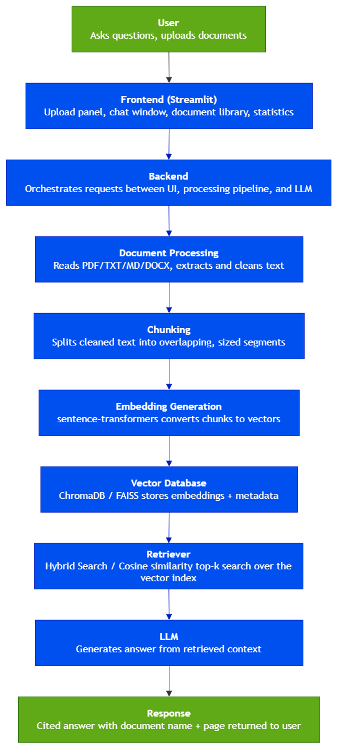
Figure 1. Architecture of RAG pipeline

2. Embeddings
Embeddings map text into a dense vector space where semantic similarity corresponds to geometric proximity. This project uses sentence-transformers' all-MiniLM-L6-v2, a 384 dimensional model that balances retrieval quality against CPU only inference speed, which matters for a fellowship project without dedicated GPU infrastructure. Similarity between a query embedding and a chunk embedding is measured with cosine similarity (equivalently, 1 minus cosine distance), which is scale-invariant and therefore robust to differences in passage length.
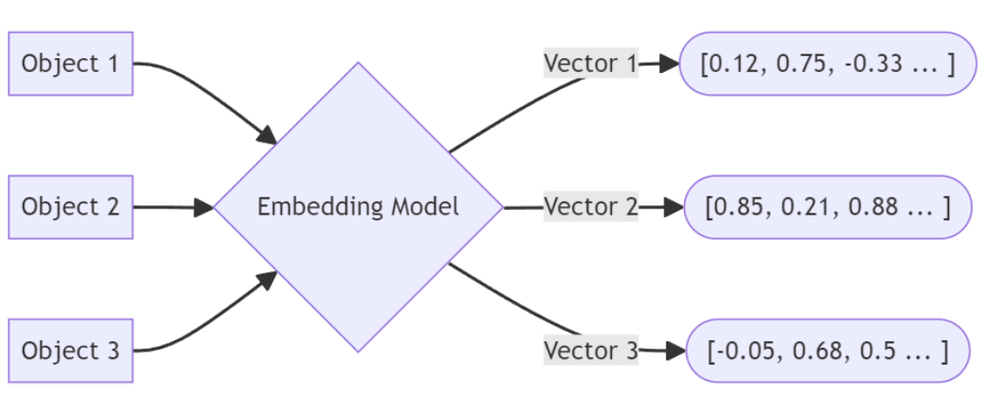
Figure 2. Vector Embeddings Structure

3. Chunking Strategy
Documents are split into overlapping chunks before embedding because embedding an entire document as one vector would blur distinct topics into a single, low precision representation, while embedding at the sentence level loses surrounding context. One of strategy is a recursive character splitter that prefers to break on paragraph and sentence boundaries before falling back to a hard character limit, and applies chunk overlap so that a sentence spanning a chunk boundary is not lost entirely from either chunk.
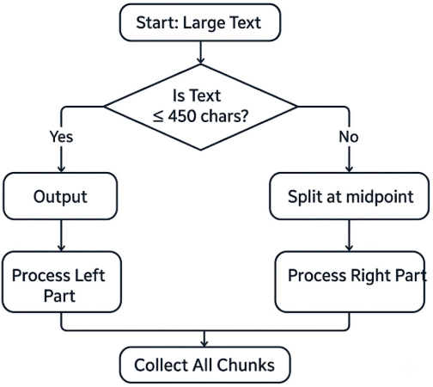
Figure 3. Recursive Character Splitter Chunking

4. Retrieval Pipeline
At query time, the user's question is embedded with the same model used for chunk indexing, and the top-k nearest chunks are retrieved from the vector database by cosine distance. A distance threshold is added so that when no chunk is genuinely relevant to the question, weak matches are discarded rather than passed to the LLM as if they were useful context a direct mitigation against hallucination introduced by forcing the model to answer from unrelated text. A hybrid mode additionally re ranks the retrieved candidates using literal keyword overlap with the query, useful for surfacing passages containing exact identifiers (e.g., a product code) that pure semantic search can under rank.
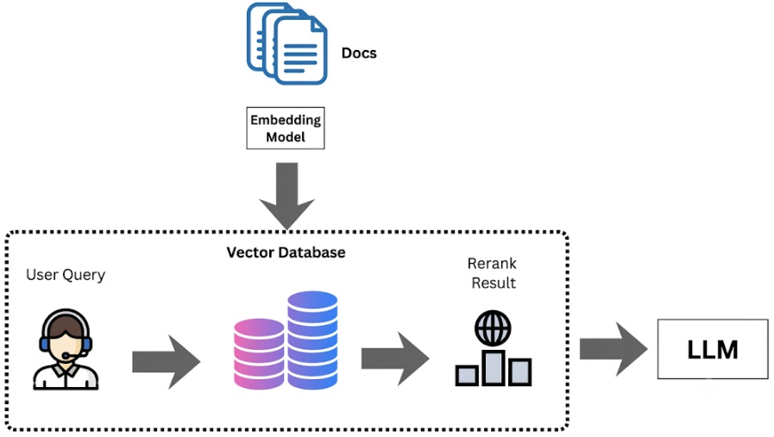
Figure 4. RAG Retrieval Pipeline

5. Prompt Construction
Retrieved chunks are formatted into labeled passages (source filename and page number) and inserted into a system prompt that instructs the model to answer only from the provided context, to cite the source and page after every claim, and to explicitly state when the answer is not present rather than guessing. This turns citation from a post hoc formatting step into a generation time constraint, which produces more consistently attributed answers than asking the model to add citations after the fact.
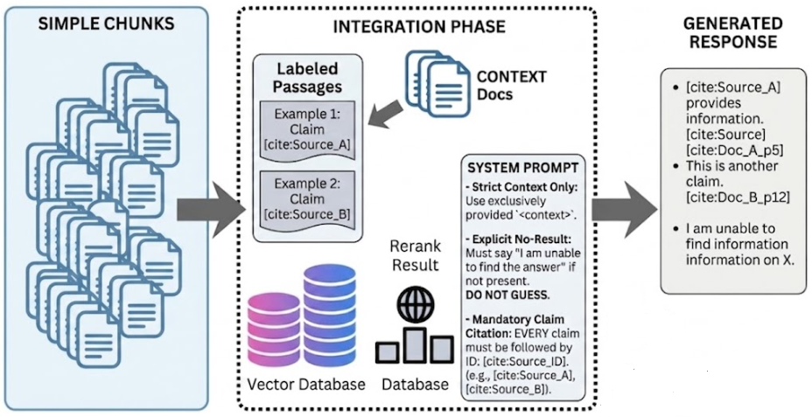
Figure 5. Chunks to Prompt Construction

6. Vector Database
ChromaDB is a full vector database built on top of HNSW style indexing that natively stores metadata alongside each vector, supports metadata filtered queries and deletes, and persists to disk without extra serialization code. For a project needing per document delete and per-document search (both explicit requirements here), ChromaDB's native metadata support and simple, built-in persistence made it the practical choice at this project's scale.
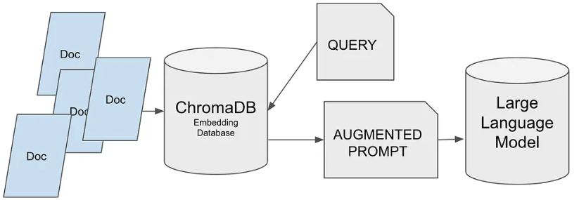
Figure 6. ChromaDB Vector Database

7. Hallucination Reduction
- Distance threshold filtering: chunks below a relevance threshold are never sent to the model.
- Citation enforcing system prompt: every claim must reference a specific source and page.
- Explicit 'not found' instruction: the model is told to say when an answer isn't in the context rather than fill the gap from parametric knowledge.
- Hybrid keyword reranking: reduces missed context hallucinations by surfacing exact match chunks (IDs, names, codes) that pure semantic search can overlook.
- Low generation temperature (0.2): reduces creative drift away from the supplied context.
- Source display in the UI: retrieved passages are shown alongside the answer so a user can independently verify the citation, which also surfaces retrieval failures that filtering alone might miss.

8. Future Improvements
- Reranking: a cross-encoder re-ranker over the top-k candidates would improve precision beyond what single-vector cosine similarity and keyword overlap achieve.
- Proper BM25 indexing: replacing keyword overlap re-ranking with a full BM25 scorer as document volume grows, for more precise term-relevance weighting.
- Configurable hybrid weighting: tuning the balance between keyword and semantic signal per query type instead of a fixed blend.
- Evaluation harness: automated context precision and answer faithfulness scoring (e.g., using an LLM as judge) instead of manual spot checking.
- Scaling: moving from a single node ChromaDB instance to a managed or sharded vector store (e.g., FAISS based) for multi-million-chunk corpora.
- Access control: per user metadata filtering so retrieval respects document level permissions in a multi-tenant deployment.

