1. Architecture Diagram
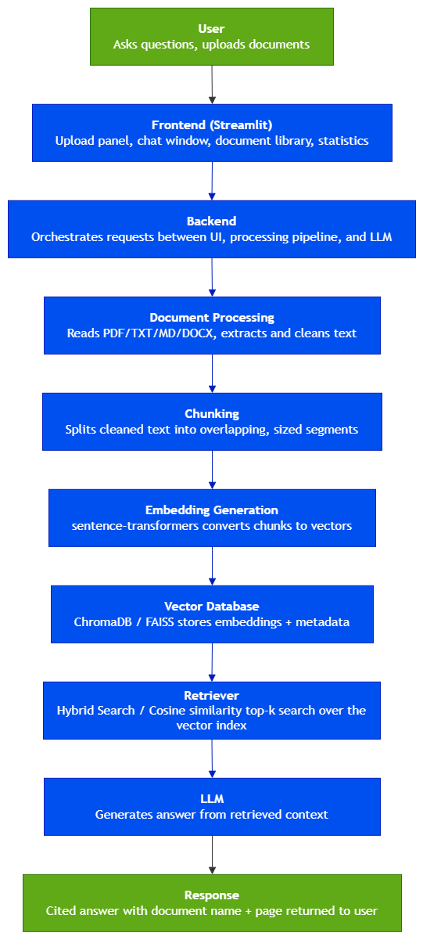
Figure 1. Architecture of RAG pipeline

2. Component Descriptions

Table 1 shows component description of rag pipeline:
Component | Responsibility | Key Technology
User | Uploads documents and asks natural language questions; views retrieved chunks and cited answers | Web browser (via Streamlit UI)
Frontend | Collects uploads, renders chat UI, shows retrieved chunks and stats | Streamlit
Backend | Coordinates pipeline calls, manages session state and API routing | Python service layer
Document Processing | Extracts raw text from PDF/TXT/MD/DOCX and cleans formatting artifacts | pypdf, python-docx
Chunking | Splits text into fixed size, overlapping segments with metadata | LangChain text splitters
Embedding Generation | Converts each chunk into a dense vector representation | sentence-transformers
Vector Database | Persists vectors + metadata; supports similarity, hybrid search and filtered search | ChromaDB
Retriever | Finds top-k most similar chunks to a query embedding | Cosine similarity / Hybrid search
Prompt Construction | Builds a grounded prompt from retrieved chunks + chat history | Prompt templates
LLM | Synthesizes a natural language answer strictly from provided context | LangChain LLM wrapper
Response Layer | Formats answer with citations (document, page, chunk ref) | Citation formatter

3. Data Flow Summary
- The user uploads one or more documents through the frontend upload panel.
- The backend routes the files to the Document Processing stage, which extracts and cleans raw text based on file type.
- The Chunking stage splits the cleaned text into overlapping segments, attaching metadata such as source filename and page number.
- Embedding Generation converts each chunk into a vector using a sentence-transformers model.
- Vectors and metadata are persisted in the Vector Database (ChromaDB).
- When a user asks a question, the Retriever embeds the query and performs a similarity search / Hybrid Search to fetch the top-k relevant chunks.
- Prompt Construction assembles a grounded prompt from the retrieved chunks and recent chat history.
- The LLM generates an answer strictly from the supplied context.
- The Response Layer attaches source citations (document name, page, chunk reference) and returns the final answer to the user.

4. Design Principles
- Statelessness: where possible: the vector database is the single source of persisted knowledge, keeping the application layer easy to scale horizontally.
- Transparency: retrieved chunks and citations are surfaced to the user rather than hidden inside the LLM call, supporting trust and debuggability.
- Extensibility: the architecture supports future additions such as hybrid search, reranking, or multi document comparison without structural changes.

