SUPPLIER
------------
After Signup as a supplier or admin created account for supplier when supplier login into his account
SUPPLIER DASBOARD
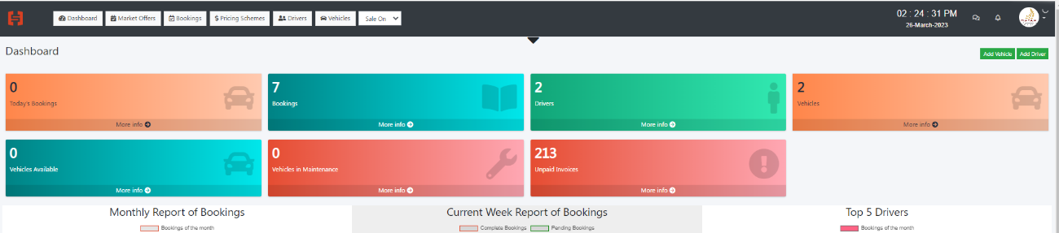

- DRIVERS
https://booking.hypersoftwares.com/drivers/create
Add New Driver
2 field need to add
Driver Language/Driver Password for login into his account
Password function we need to use in next phase where we will add driver application

NOTE: LOCATIONS
As I explained in next part of PRICING SCHEME regards Base Point and Pickup Radius
EACH SUPPLIER BASE POINT WHILTE CREATING SUPPLIER OR WHILE UPDATING HIS PROFILE
SUPPLIER CAN ADD HIS LOCATION WITH REDICUS OF SERVICE
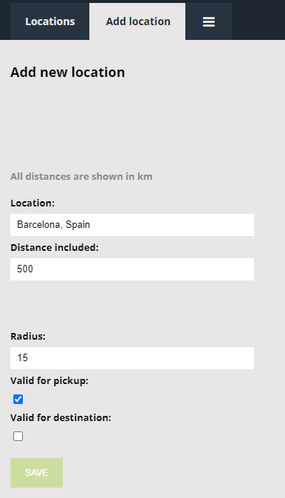
Location BASE OF SUPPLIER
Radius means from His Base radius example ROYAL FALCON LIMOUSINE
Based: Barcelona he can set his Radius 25km and distance 500km and valid for pickup and destination that mean royal falcon from /to Barcelona within radius of 25 km can provide service max range of 500km
Distance means from base to 500km/100km distance he can provide service

- PRICING SCHEMES

Pricing scheme is very important part of this project.
While creating PRICING SCHEME
https://booking.hypersoftwares.com/pricings/create
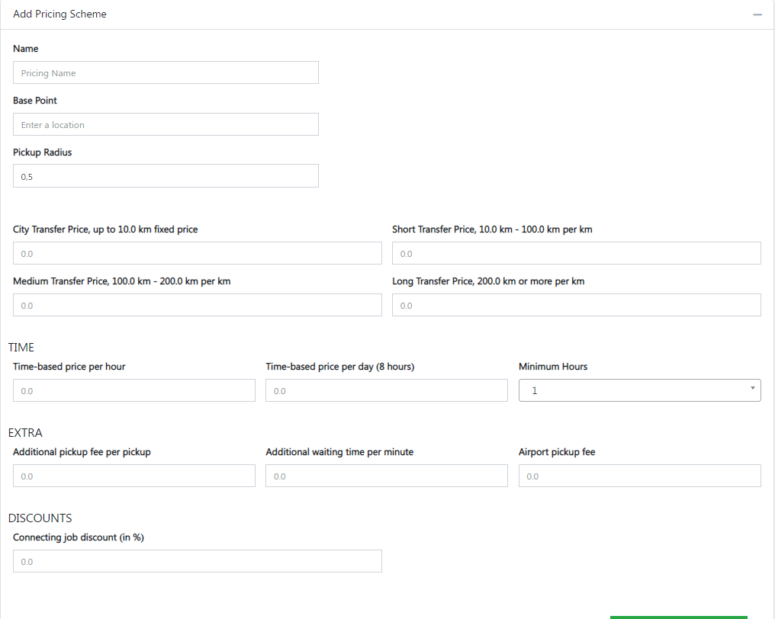
Base Point and Pickup Radius function
if Supplier Royal falcon limousine Base is Barcelona Pickup Radius 500km
that mean royal falcon providing Pickup and drop-off service from his base Barcelona to with is 500km radius
Origen or Destination Must be Supplier Base Location if it’s not one of both don’t show price of this supplier (NOTE: LOCATIONS)
City TARNSFER price up to 10km
That mean its fixed price for certain km if ride is less than that or up to 10 then this rate will apply for ride
If km is more than fix price km radius then fixed price + extra km will be calculated as final price for 12km
let’s say example
Fix price for 10km is 29,68€
One of customer requested ride for 12km so rate will be applying
29,68€+ 2,40€ (10-100km per km price for 2km) = 32,08€
from this price admin will charge his commission as per agreed on agreement

So, creating Pricing scheme supplier will add his per km rates and fix rate and his base and radius extra charges, etc.

Once Pricing scheme created (Economy Sedan, business sedan, first class Etc.)

There is option to add route
ADD ROUTE
https://booking.hypersoftwares.com/pricing/routes/3
This Option help to supplier Create zone wise route for pickup and drop off service with better rate
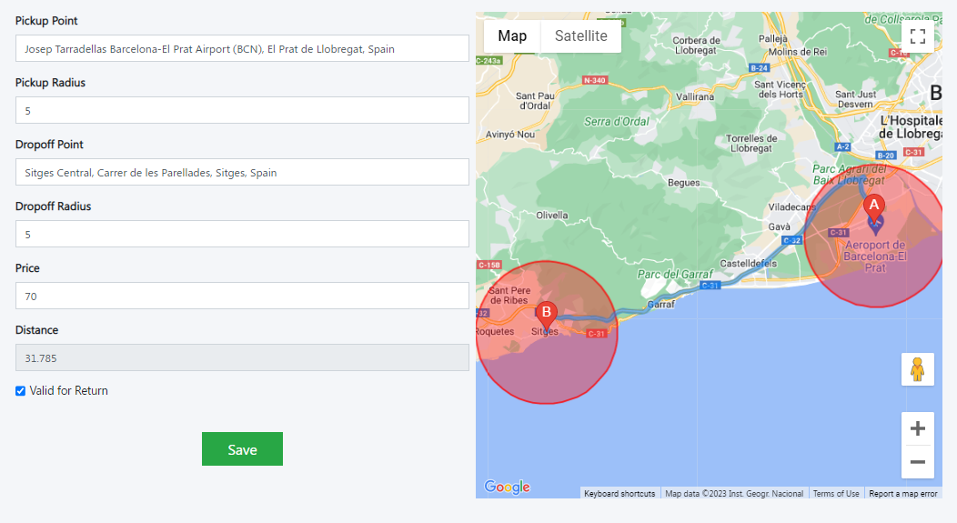
In map should be option for mark at map and create zone POINTS A & B
Question if there is per km rates already available then why need to add route?

A_ benefit for zone wise route its some destination or very famous and high demand tourist point so supplier can make his special routes as per his specialty
let’s Calculate Example Sitges
from Barcelona Airport to sitges its 32km aera as per km rate price for ride will be
29,68€ + 26,40€ =56,08€
But in ROUTE supplier Set 70€ for this route
So First Priority will be check route if route exist then show that rate if route no exist then show per km price of supplier

3-VEHICLES
Add Vehicles its Perfect

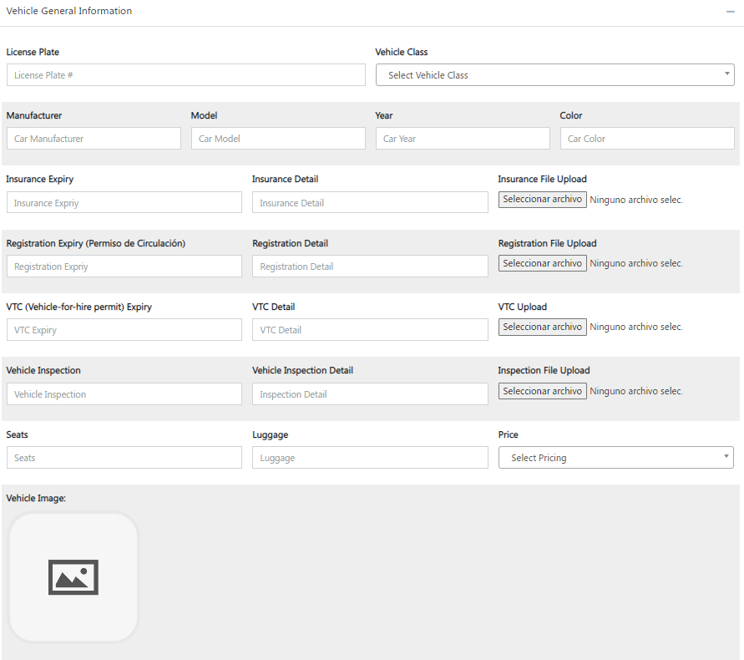

While edit vehicle it shows all suppliers pricing scheme its wrong it should have to show only
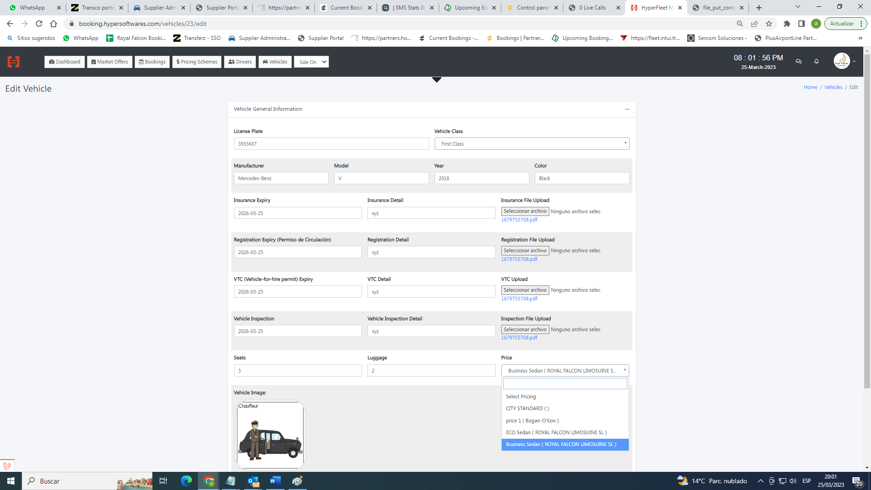

4-Manage Bookings
https://booking.hypersoftwares.com/bookings
Supplier Manage Booking Dashboard
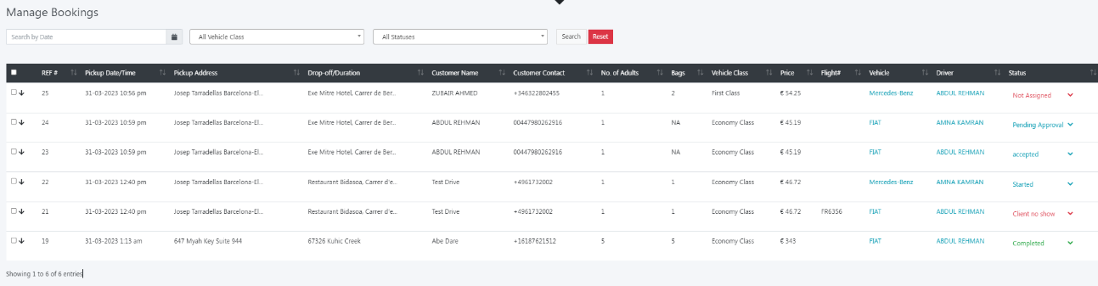
We need to make tab view for filter booking with different status
*NEW*
All booking which will land in supplier dashboard first of all will stay here after supplier take action
Accept/Reject (reject will popup window with reject reason)
* wrong Rate
* Vehicle not available
* other
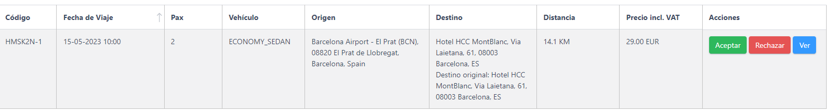
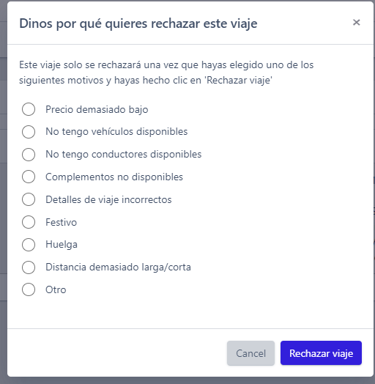
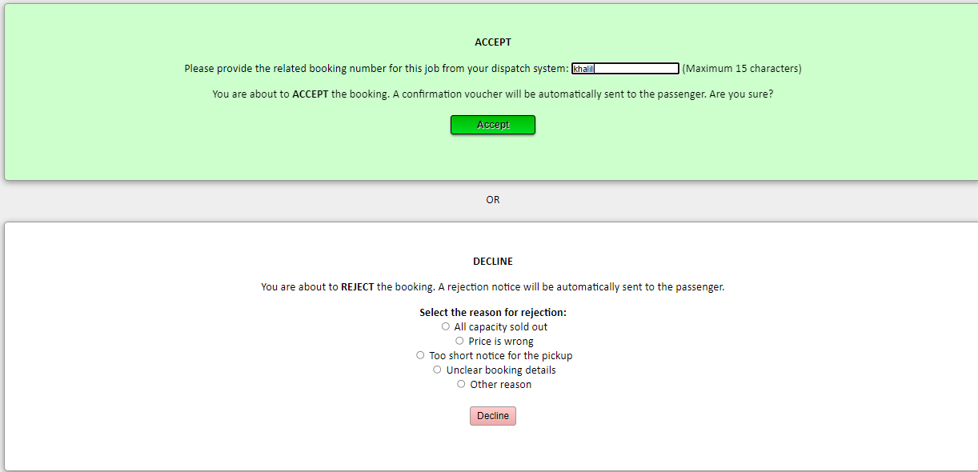

CONFIRMED
if supplier accept ride it will come into confirmed tab view (Customer will receive confirmation of his ride incase reject customer will not get charged and no confirmation he will receive)
UPDATED
if from admin/customer he makes cancellation request or make changes into ride it will come here for supplier account and its update
PAST
all complete booking with go to past tab view
CANCELLED
Booking which are canceled it will go to cancelled
MARKET https://booking.hypersoftwares.com/market-offers
Last Minutes ride like 2 hours before journey or last minutes last will be land in Market place and also booking from affiliated like travel agents, and hotels booking will land in Market Place
5-FINANCE
Report
here we have to allow to supplier he can run report with date filter from to
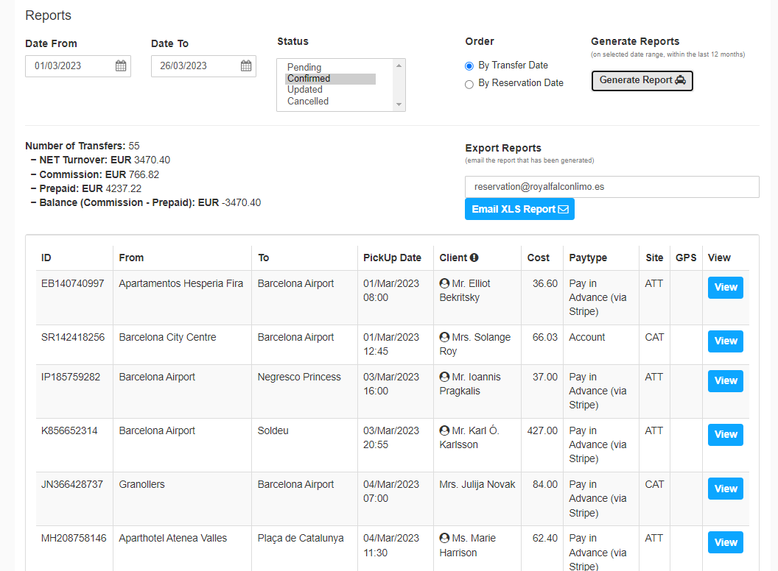
Also, we can add more filters like drivers/Vehicles
invoices
Auto Invoice will be Generated every 15 days

