SUPPLIER  
------------

After Signup as a supplier or admin created account for supplier when supplier login into his account

SUPPLIER DASBOARD  
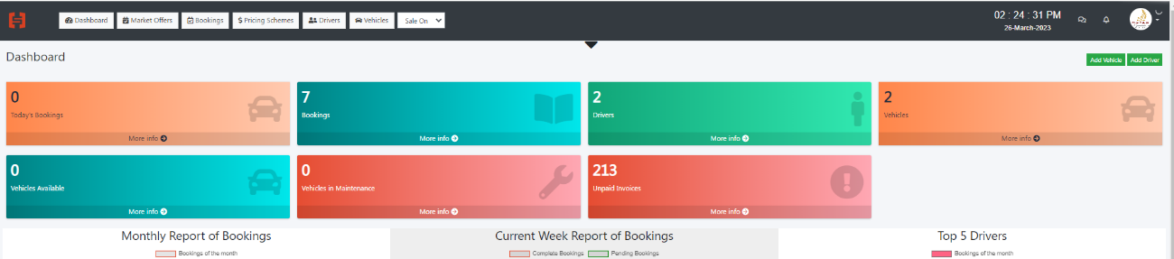

1. DRIVERS  
   https://booking.hypersoftwares.com/drivers/create

Add New Driver   
2 field need to add  
Driver Language/Driver Password for login into his account   
Password function we need to use in next phase where we will add driver application

NOTE: LOCATIONS

As I explained in next part of PRICING SCHEME regards Base Point and Pickup Radius

EACH SUPPLIER BASE POINT WHILTE CREATING SUPPLIER OR WHILE UPDATING HIS PROFILE

SUPPLIER CAN ADD HIS LOCATION WITH REDICUS OF SERVICE

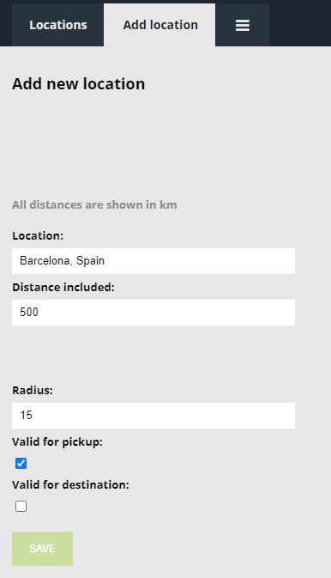

Location BASE OF SUPPLIER

Radius means from His Base radius example ROYAL FALCON LIMOUSINE

Based: Barcelona he can set his Radius 25km and distance 500km and valid for pickup and destination that mean royal falcon from /to Barcelona within radius of 25 km can provide service max range of 500km

Distance means from base to 500km/100km distance he can provide service

1. PRICING SCHEMES

Pricing scheme is very important part of this project.

While creating PRICING SCHEME

<https://booking.hypersoftwares.com/pricings/create>

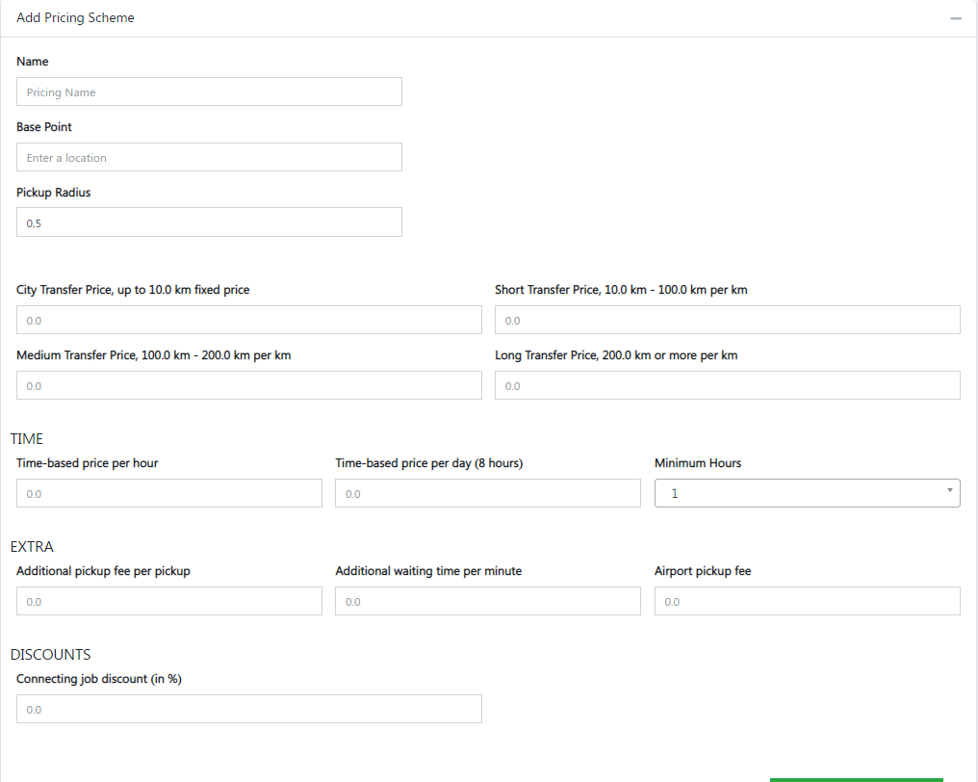

Base Point and Pickup Radius function   
if Supplier Royal falcon limousine Base is Barcelona Pickup Radius 500km   
that mean royal falcon providing Pickup and drop-off service from his base Barcelona to with is 500km radius   
Origen or Destination Must be Supplier Base Location if it’s not one of both don’t show price of this supplier (NOTE: LOCATIONS)

City TARNSFER price up to 10km   
That mean its fixed price for certain km if ride is less than that or up to 10 then this rate will apply for ride

If km is more than fix price km radius then fixed price + extra km will be calculated as final price for 12km

let’s say example

Fix price for 10km is 29,68€

One of customer requested ride for 12km so rate will be applying   
29,68€+ 2,40€ (10-100km per km price for 2km) = 32,08€   
from this price admin will charge his commission as per agreed on agreement

So, creating Pricing scheme supplier will add his per km rates and fix rate and his base and radius extra charges, etc.

Once Pricing scheme created (Economy Sedan, business sedan, first class Etc.)

There is option to add route

ADD ROUTE  
<https://booking.hypersoftwares.com/pricing/routes/3>

This Option help to supplier Create zone wise route for pickup and drop off service with better rate   
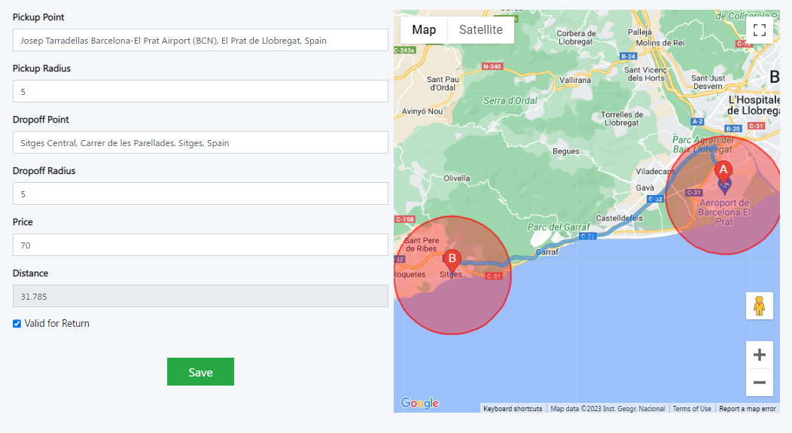

**In map should be option for mark at map and create zone POINTS A & B**

Question if there is per km rates already available then why need to add route?

A_ benefit for zone wise route its some destination or very famous and high demand tourist point so supplier can make his special routes as per his specialty  
  
let’s Calculate Example Sitges   
from Barcelona Airport to sitges its 32km aera as per km rate price for ride will be   
29,68€ + 26,40€ =56,08€   
  
But in ROUTE supplier Set 70€ for this route   
  
So First Priority will be check route if route exist then show that rate if route no exist then show per km price of supplier

**3-VEHICLES**

Add Vehicles its Perfect

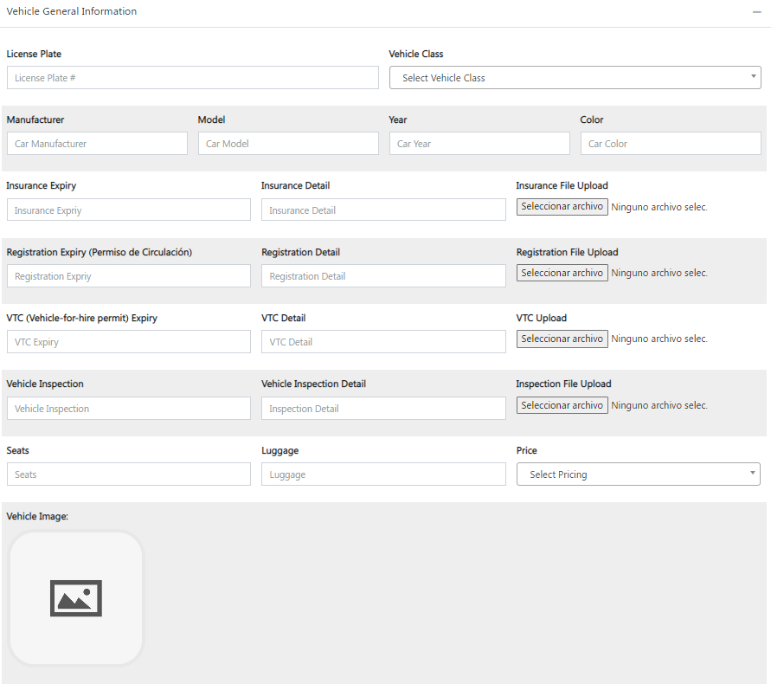

While edit vehicle it shows all suppliers pricing scheme its wrong it should have to show only

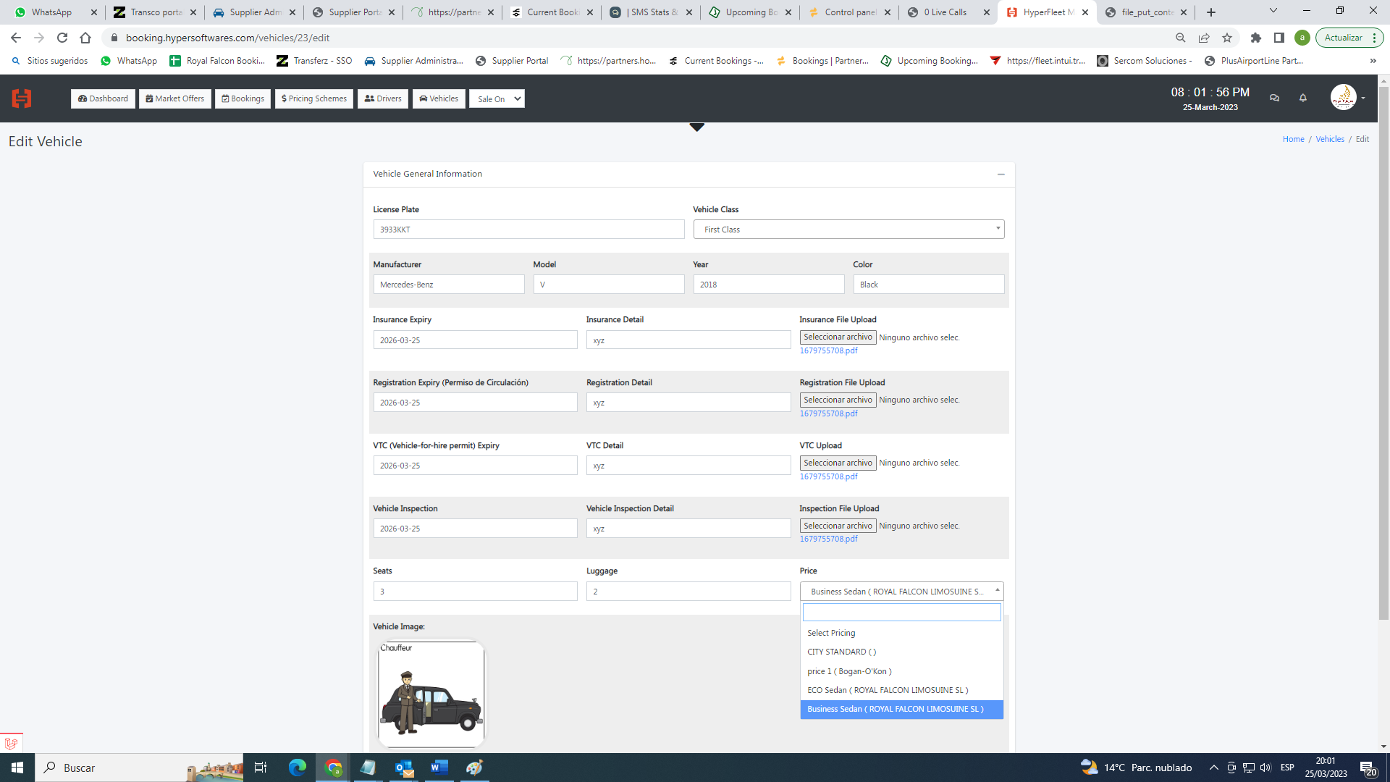

4-Manage Bookings

<https://booking.hypersoftwares.com/bookings>

Supplier Manage Booking Dashboard

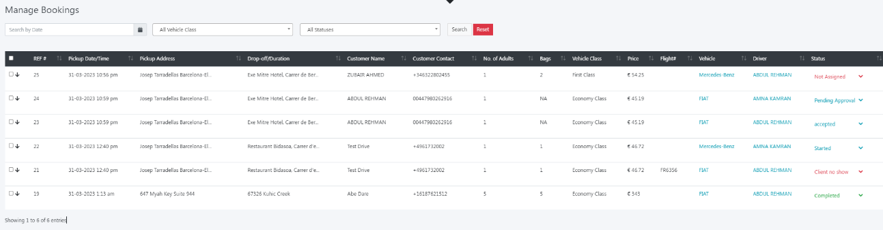

We need to make tab view for filter booking with different status

*NEW*   
All booking which will land in supplier dashboard first of all will stay here after supplier take action   
Accept/Reject (reject will popup window with reject reason)  
* wrong Rate  
* Vehicle not available  
* other  
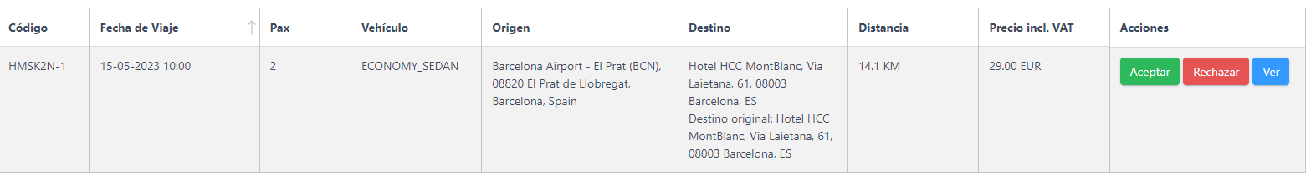

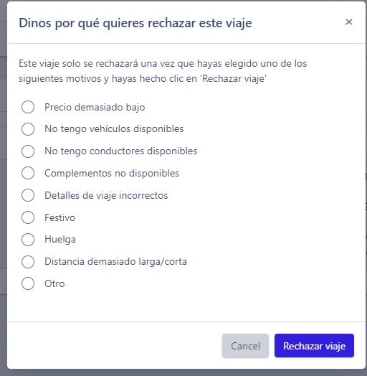

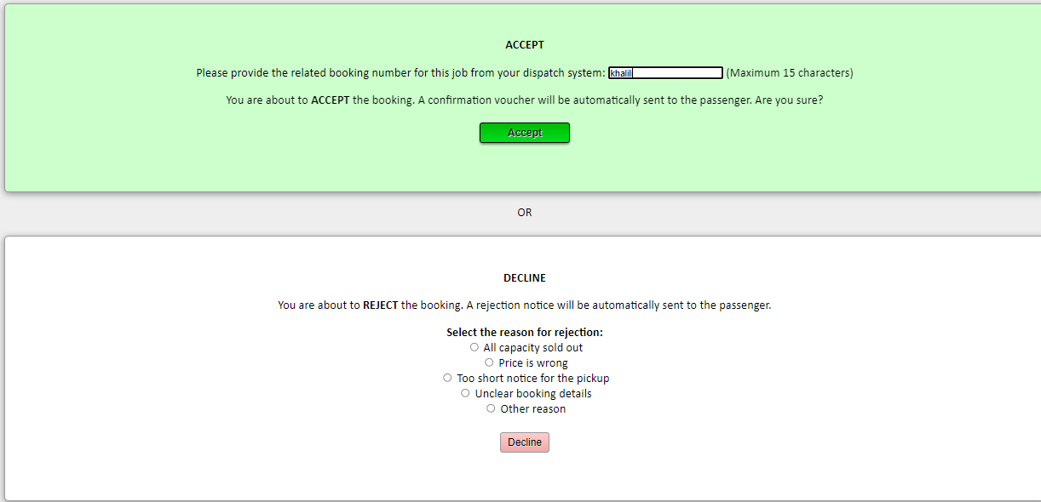

CONFIRMED  
if supplier accept ride it will come into confirmed tab view (Customer will receive confirmation of his ride incase reject customer will not get charged and no confirmation he will receive)  
  
UPDATED  
if from admin/customer he makes cancellation request or make changes into ride it will come here for supplier account and its update

PAST  
all complete booking with go to past tab view

CANCELLED

Booking which are canceled it will go to cancelled  
  
MARKET <https://booking.hypersoftwares.com/market-offers>

Last Minutes ride like 2 hours before journey or last minutes last will be land in Market place and also booking from affiliated like travel agents, and hotels booking will land in Market Place

**5-FINANCE  
Report  
here we have to allow to supplier he can run report with date filter from to   
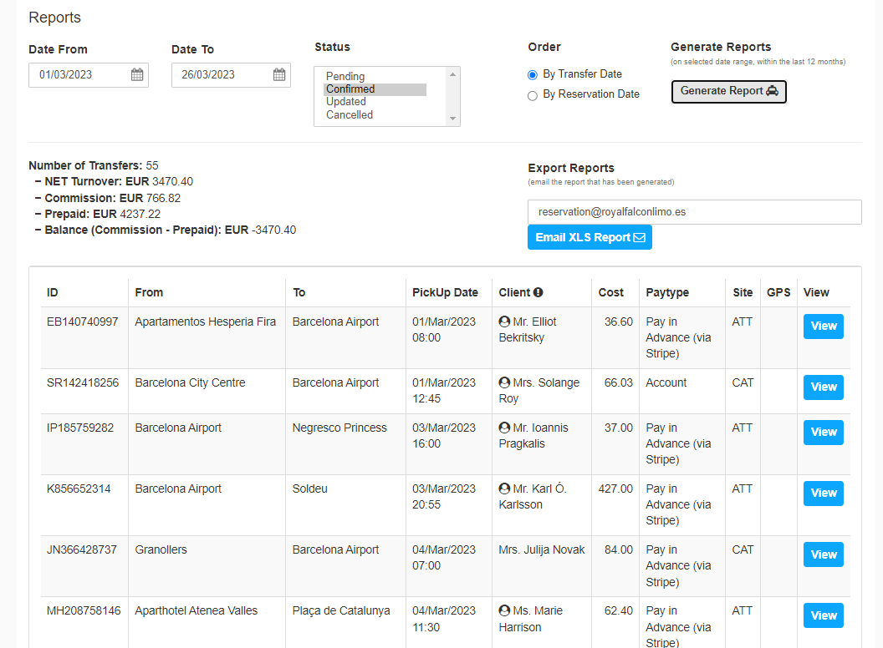**

**Also, we can add more filters like drivers/Vehicles**

**invoices  
  
Auto Invoice will be Generated every 15 days**