**RESUME**

**Usama Gani** 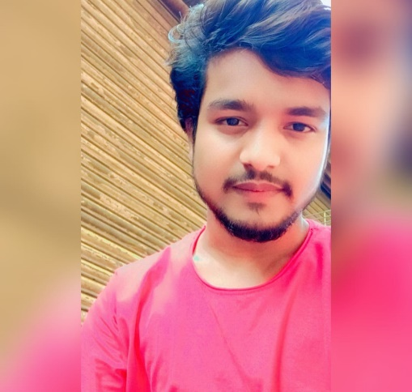

**Email id:** [mohdusama0772@gmail.com](mailto:mohdusama0772@gmail.com)

**Mobile No:** 895741768.

**Address: Lokmanya Tilak Nagar – Sakinaka -Mumbai** 400072.

**CAREER OBJECTIVE**

* Obtain a responsible position in an organization with the best capabilities, skills and knowledge.

**ACADEMIC QUALIFICATION:**

* 12th from H L V Inter college.
* 10th from C B S Public School.
* Pursuing BCA from Savitri phule University

**PROFESSIONAL SKILLS:**

* Basic knowledge of computer.
* Typing
* HTML, CSS, JAVASCRIPT
* C, C++ Lang MYSQL

**WORK EXPERIENCE:**

* Fresher

**PERSONAL DETAILS:**

Father’s Name : Abdul Gani

Date of birth : 29-05- 2002

Gender : Male

Nationality : Indian

Marital Status : Unmarried

Languages Known : English & Hindi