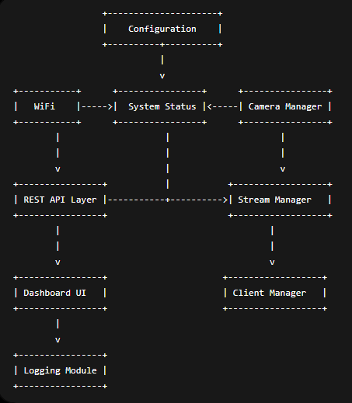

Module 1 — Configuration Manager

Responsibility
Stores every configurable value.
Examples
WiFi SSID
WiFi Password
Static IP
Gateway
DNS
Resolution
JPEG Quality
Brightness
Contrast
Saturation
Hostname
Stream Port
Eventually these values can be stored in NVS (Preferences).

Public API
Config.begin()
Config.load()
Config.save()
Config.resetDefaults()

Test Cases
✅ Load defaults
✅ Save configuration
✅ Reload configuration
✅ Invalid values

Module 2 — WiFi Manager
Responsible for
- Connecting WiFi
- Static IP
- Reconnect
- RSSI

API
connect()
disconnect()
isConnected()
getRSSI()
getIPAddress()

Test Cases
✅ Correct IP
✅ Wrong password
✅ WiFi restart
✅ Router reboot

Module 3 — Camera Manager
This is one of the biggest modules.
Responsibilities
- Camera init
- Restart
- Frame capture
- Change brightness
- Change contrast
- Change saturation
- Change resolution
- JPEG quality
- Flash LED
API
init()
restart()
capture()
setBrightness()
setContrast()
setSaturation()
setResolution()
setQuality()
flashOn()
flashOff()

Test Cases
Camera starts
Camera restart
Change settings
Capture frame
Memory leak test

Module 4 — Frame Buffer Manager
This is extremely important.
Instead of capturing once per client
We'll capture once
Store frame
Share frame
Responsibilities
Capture JPEG
↓
PSRAM Buffer
↓
Latest Frame
API
updateFrame()
getFrame()
releaseFrame()

Test Cases
10 FPS
20 FPS
Frame overwrite
Memory corruption

Module 5 — Stream Manager
Responsible only for MJPEG.
Responsibilities
Client connects
↓
Register
↓
Send Frames
↓
Disconnect
API
start()
stop()
addClient()
removeClient()
broadcast()

Test Cases
1 Client
2 Clients
5 Clients
10 Clients
Disconnect
Reconnect

Module 6 — REST API Manager
Every endpoint lives here.
/status
/stream
/snapshot
/restart
/brightness
/contrast
/saturation
/quality
/resolution
/flash
API
registerEndpoints()
sendJSON()
sendError()

Test Cases
Every endpoint
HTTP Codes
Invalid requests
Malformed JSON

Module 7 — Dashboard Manager
Everything HTML lives here.
Responsibilities
Serve
index.html
style.css
app.js
JavaScript calls REST APIs.

Test Cases
Page loads
Buttons work
Sliders work
Live stream

Module 8 — Client Manager
Tracks connected users.
Stores
IP
Connected Time
Client ID
Bytes Sent
Useful for
/status
Example
Clients = 4

Test Cases
Clients join
Leave
Duplicate
Timeout

Module 9 — System Monitor
Provides
Heap
PSRAM
FPS
CPU Load (estimated)
WiFi RSSI
Uptime
Camera Status

Test Cases
Memory
FPS
Reconnect

Module 10 — Logging Manager
Instead of
Serial.println()
Everything goes here.
Levels
INFO
WARNING
ERROR
DEBUG
Example
[INFO]
WiFi Connected

Test Cases
All log levels
Enable
Disable

Module 11 — Utilities
Shared helper functions.
Examples
String
JSON
Time
Conversions
Formatting
Validation

Module 12 — Main Application
The smallest module.
Literally
setup()
loop()
Should only be
Config.begin()
WiFi.begin()
Camera.begin()
REST.begin()
Stream.begin()
Nothing else.

Optional Module 13 — OTA Updates
Later
POST
/update
Upload firmware.
ESP reboots.

Optional Module 14 — Authentication
Future
Basic Login
JWT
API Key
Username Password

Build Order
This is the order I recommend because each layer depends only on the previous ones:
Phase | Module | Depends On
1 | Configuration Manager | None
2 | Logging Manager | None
3 | WiFi Manager | Configuration, Logging
4 | Camera Manager | Configuration, Logging
5 | Frame Buffer Manager | Camera Manager
6 | Stream Manager | Frame Buffer Manager
7 | REST API Manager | WiFi, Camera, Stream
8 | Dashboard Manager | REST API
9 | Client Manager | Stream Manager
10 | System Monitor | WiFi, Camera, Stream, Client Manager
11 | Main Application | All modules integrated
12 | Full Integration & Stress Testing | Entire system

Testing Strategy
I also recommend treating testing as a first-class part of the project. For each module, we should produce:
- Design document – purpose, responsibilities, public interfaces, and dependencies.
- Implementation – .h and .cpp files with clear documentation.
- Unit tests – validate the module's behavior in isolation where practical.
- Integration tests – verify interactions with dependent modules.
- Stress tests – evaluate stability under prolonged operation and edge cases (e.g., multiple clients, Wi-Fi reconnects, memory pressure).
- Acceptance criteria – clear pass/fail conditions before moving to the next module.
This approach ensures that by the time we reach full integration, every module has already been validated independently, making debugging much easier and resulting in a much more reliable firmware. I think this will produce a codebase that is genuinely suitable for a public GitHub repository rather than just another example sketch.

Build Order
This is the order I recommend because each layer depends only on the previous ones:
Phase | Module | Depends On
1 | Configuration Manager | None
2 | Logging Manager | None
3 | WiFi Manager | Configuration, Logging
4 | Camera Manager | Configuration, Logging
5 | Frame Buffer Manager | Camera Manager
6 | Stream Manager | Frame Buffer Manager
7 | REST API Manager | WiFi, Camera, Stream
8 | Dashboard Manager | REST API
9 | Client Manager | Stream Manager
10 | System Monitor | WiFi, Camera, Stream, Client Manager
11 | Main Application | All modules integrated
12 | Full Integration & Stress Testing | Entire system

