Clothes Management System
Software Requirements Specification

Version 1.0



Group Id: F25PROJECT9062E (BC240218288)
Supervisor Name : Asad Ullah

Revision History

Date (dd/mm/yyyy) | Version | Description | Author
30/Nov/2025 | 1.0 | The Clothes Management System is a desktop-based application designed to simplify and automate the daily operations of clothing inventory management. The system enables shop owners and administrators to efficiently store, organize, and monitor clothing items across multiple categories such as Men, Women, and Kids, as well as seasonal collections like Summer and Winter. Through a user-friendly Tkinter interface, even non-technical staff can easily add, update, search, and track clothing items without requiring advanced computer knowledge. The application ensures that all inventory details—including item specifications, stock levels, and pricing—are maintained in an organized and accessible format.  Beyond inventory control, the system offers powerful features for handling sales, purchases, and profit calculations. Each sale automatically deducts from available stock, while purchases update the inventory in real time. The built-in reporting module allows users to generate accurate daily, weekly, monthly, and yearly reports, covering stock levels, sold and purchased items, and overall profit. These reports support better decision-making and provide reliable records for business analysis. Developed using Python and Tkinter, the Clothes Management System delivers a complete, automated, and efficient solution for managing clothing shops of any size. | BC240218288

Table of Contents

- Scope (of the project)
- Functional Requirements Non Functional requirements
- Use Case Diagram
- Usage Scenarios
- Adopted Methodology
- Work Plan (Use MS Project to create Schedule/Work Plan)

SRS Document

- Scope of Project:
The scope of the Clothes Management System includes the development of a complete desktop-based application that manages every aspect of clothing inventory in a retail shop. The system allows administrators to register users, authenticate logins, and manage clothing items efficiently. It supports adding, updating, deleting, and searching inventory across categories such as Men, Women, Kids, and seasons like Summer and Winter. The system automates stock handling so that every sale and purchase transaction updates inventory levels in real-time, ensuring complete accuracy and preventing manual errors.
Additionally, the scope extends to powerful reporting and analytics features. The system can generate daily, weekly, monthly, and yearly reports related to stock levels, items sold, items purchased, and overall profit. These reports can be displayed digitally or printed for physical recordkeeping. Built using Python and Tkinter, the application provides an intuitive user interface suitable for shop owners and non-technical sales staff. Overall, the project aims to deliver a reliable, user-friendly solution that streamlines inventory control, improves business decision-making, and enhances the operational efficiency of clothing stores.
- Functional and non Functional Requirements:

Functional Requirements

- User Registration and Authentication
• Admin can register new users.
• Users can log in and log out of the system.
- Clothing Item Management
• Admin can add, update, or delete clothing items.
- Item Search
• Admin or users can search clothing items by name, ID, or other attributes.
- Sales Management
• Sold items are automatically deducted from available stock.
- Purchase Management
4. Purchased items are added to the inventory.
6 Stock Updates
4. Stock levels are dynamically updated with each sale or purchase.
7 Report Generation
1. Generate reports based on:
2. Daily, Weekly, Monthly, and Yearly intervals.
3. Total available stock.
4. Total sold and purchased items.
5. Profit reports over selected timeframes.

Non-Functional Requirements

Performance:
The application should respond to user actions within 2 seconds, including adding or searching items.
Usability:
The GUI must be simple, intuitive, and easy for non-technical staff to use without training.
Reliability:
The system must maintain consistent performance and avoid crashes, even when handling large inventories.
Security:
User login credentials must be stored securely, and unauthorized users should not gain access to admin features.
Scalability:
The system should handle an increasing number of items, users, and transactions without performance degradation.
Data Integrity:
Stock updates (sales and purchases) must always produce accurate and consistent inventory values.
Maintainability:
The codebase should be modular and easy to update, allowing new features or changes without affecting the whole system.
Availability:
The system must be available for use during business hours with minimal downtime.
Portability:
The application should run smoothly on all modern Windows versions (Windows 8, 10, 11).
Backup & Recoverability:
The system should allow regular backups of inventory and sales data to prevent data loss.

- Use Case Diagram(s):
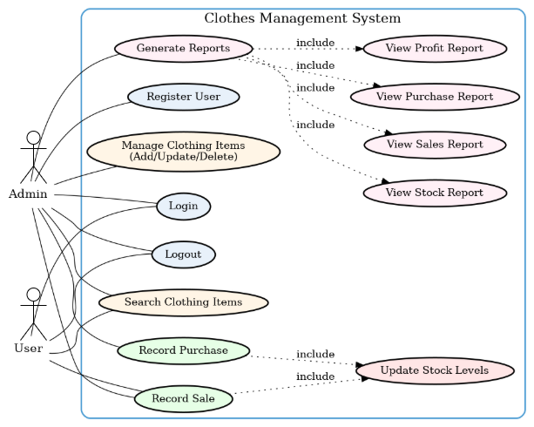

- Usage Scenarios:

Register User
Field | Details
Precondition | Admin must be logged into the system.
Postcondition | A new user account is created and stored.
Workflow | Admin selects 'Register User'.  The system displays a registration form.  Admin enters new user details.  The system validates information.  The system creates an account and confirms.
Result | A new user is successfully registered.
Author | BC240218288

Login
Field | Details
Precondition | Users must already be registered.
Postcondition | The user is logged in and the dashboard is shown.
Workflow | User enters username and password.  The system validates login credentials.  The system grants access to the dashboard.
Result | The user successfully logs into the system.
Author | BC240218288

Manage Clothing Items
Field | Details
Precondition | Admin is logged in.
Postcondition | The clothing item list is updated.
Workflow | Admin opens 'Manage Clothing Items'.  System displays options (Add/Update/Delete).  Admin performs required action.  The system validates and updates inventory.
Result | Inventory is updated with new information.
Author | BC240218288

Search Clothing Items
Field | Details
Precondition | User/Admin must be logged in.
Postcondition | Matching results are displayed.
Workflow | The user enters the item name or ID.  The system searches inventory records.  The system displays matching items.
Result | The user retrieves accurate search results.
Author | BC240218288

Record Sale
Field | Details
Precondition | Items must exist and have enough stock.
Postcondition | Sales are recorded and stock decreases.
Workflow | User selects 'Record Sale'.  The user enters an item and quantity.  The system verifies stock availability.  The system deducts stock and saves sales transactions.
Result | Sale recorded and stock automatically updated.
Author | BC240218288

Record Purchase
Field | Details
Precondition | Items must exist in the inventory.
Postcondition | Purchase is recorded and inventory increases.
Workflow | Admin selects 'Record Purchase'.  Admin enters the item and quantity purchased.  The system adds quantity to stock.
Result | Purchased stock added successfully.
Author | BC240218288

Update Stock Levels
Field | Details
Precondition | Sale or purchase must occur.
Postcondition | Stock quantity is updated in the database.
Workflow | The system receives sales or purchase events.  The system updates inventory automatically.
Result | Stock remains accurate and up-to-date.
Author | BC240218288

Generate Reports
Field | Details
Precondition | User/Admin must be logged in.
Postcondition | System displays selected report.
Workflow | User selects 'Generate Reports'.  The system asks for a report timeframe.  User selects type (Stock/Sales/Purchase/Profit).  The system generates a report and displays/prints it.
Result | Accurate report generated successfully.
Author | BC240218288

Adopted Methodology

In this project, I will use the vu process model methodology which is a combination of both waterfall and spiral models.

VU Process Model

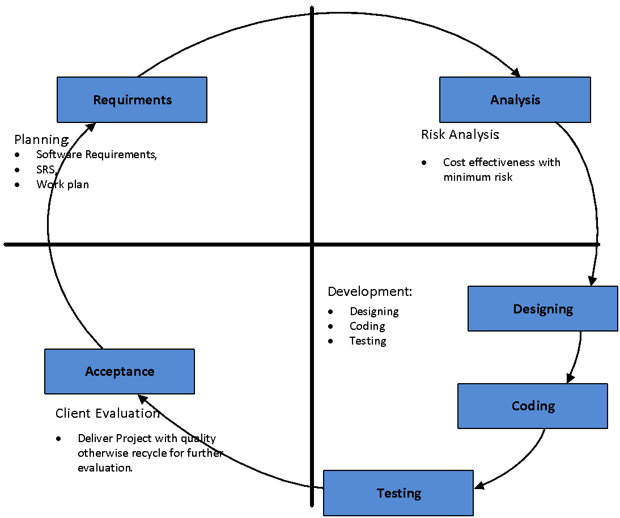

Waterfall Model
The Waterfall Model is a straightforward software development approach where the project moves through distinct stages in a set order, like water flowing down a waterfall. These stages usually include gathering requirements, designing the system, building it, testing, deploying, and maintaining it. Each stage must be finished before moving on to the next, with no going back.
This model works well for projects where the requirements are clear and unlikely to change. It is easy to follow and manage, but it can be hard to make changes once development is underway.

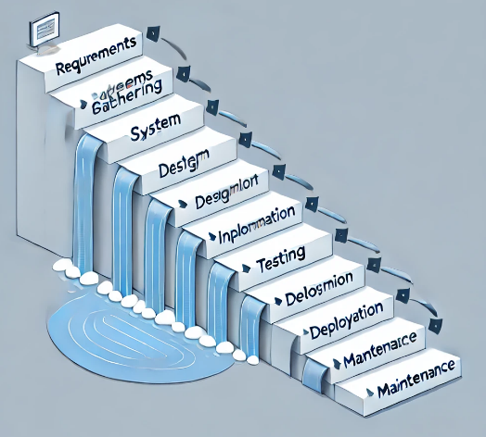

Spiral Model

The Spiral Model is a software development approach that merges aspects of iterative development with traditional waterfall methods. It prioritizes risk management and facilitates incremental, evolutionary progress, with continuous refinement and updates throughout the development process. This approach is particularly advantageous for large, intricate, and high-risk projects, where the requirements may change or evolve.

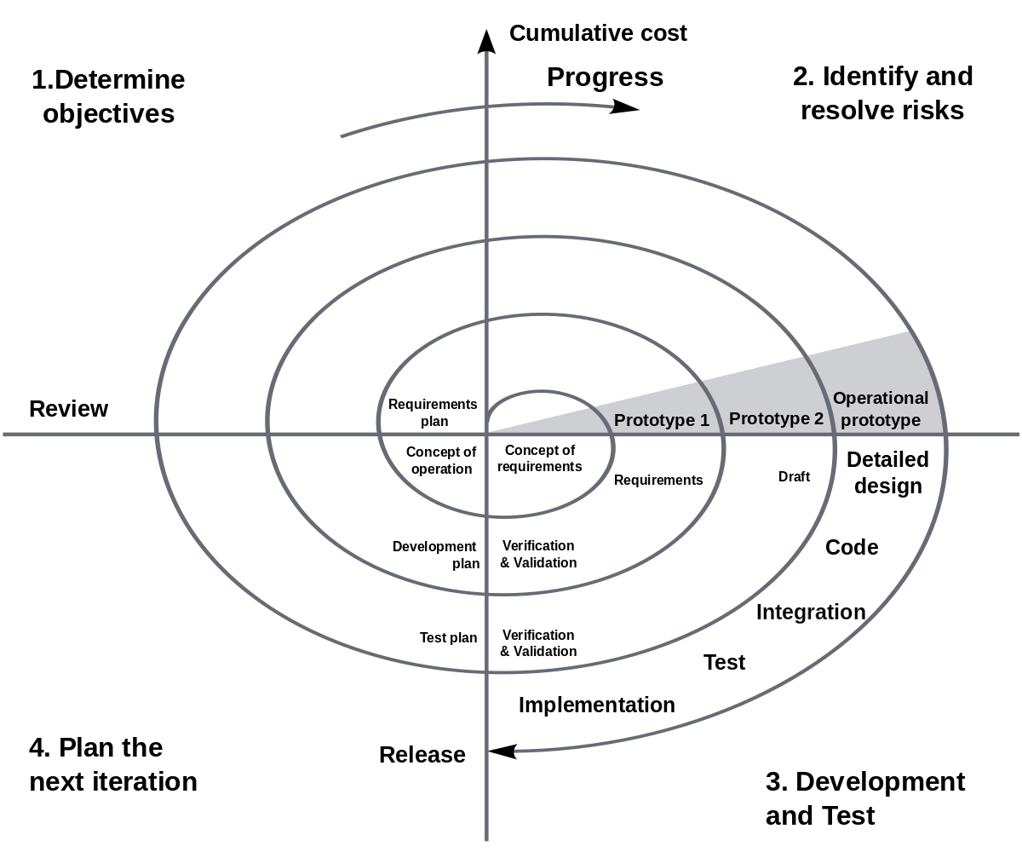

- Work Plan (Use MS Project to create Schedule/Work Plan)

