NED UNIVERSITY OF ENGINEERING AND TECHNOLOGY
Centre of Multidisciplinary Postgraduate Programmes (CMPP)
Postgraduate Diploma (PGD) Programmes

FINAL PROJECT REPORT

A Project Report submitted in partial fulfilment of the requirements for
the Postgraduate Diploma in Generative AI

Name of Student: Muhammad Usama Alam
Enrolment No.: PGD/GAI/JUN-25/212418
Batch: Batch 5, FALL I 2025
Project Title: MediScan: A Human-in-the-Loop, Explainable AI Decision-Support System for Prescription Reading and Therapeutically-Equivalent Medicine Substitution
Name of Supervisor: Sajid Majeed

_______________________________
Signature of Supervisor
Date: 15 November 2026

CERTIFICATE
This is to certify that Mr. Muhammad Usama Alam of Batch 5, FALL I 2025 has successfully completed the PGD project in partial fulfilment of requirements for a PGD in Generative AI from NED Academy, NED University of Engineering and Technology, Karachi, Pakistan.

Project Supervisor
_______________________________
Sajid Majeed
Designation, Organization: Project Supervisor, NED University of Engineering and Technology, Karachi

DECLARATIONS
I hereby state that this Project titled, "MediScan: A Human-in-the-Loop, Explainable AI Decision-Support System for Prescription Reading and Therapeutically-Equivalent Medicine Substitution", is my own work and has not been submitted previously by me for taking any degree or diploma from anywhere else in the world.
At any time if my statement is found incorrect, NED University of Engineering and Technology has the right to withdraw this PGD.

Signature: _______________________________
Student Name: Muhammad Usama Alam
Date: 15 November 2026

PLAGIARISM UNDERTAKING
I solemnly declare that the research work presented in this PGD Project titled "MediScan: A Human-in-the-Loop, Explainable AI Decision-Support System for Prescription Reading and Therapeutically-Equivalent Medicine Substitution" is solely my own research work except where the acknowledgement of the sources is made.

Signature: _______________________________
Student Name: Muhammad Usama Alam
Date: 15 November 2026

FINAL PROJECT REPORT SUBMISSION SHEET
S. No. | Final Report Component | Included (Yes)
1. | The cover page / Table of Contents | Yes
2. | Abstract | Yes
3. | Introduction / Background (2,000-3,000 words) | Yes
4. | Literature Review (3,000-4,000 words) | Yes
5. | Methodology / Study Design (2,500-4,500 words) | Yes
6. | Main body of the report / Findings (4,000-5,000 words) | Yes
7. | Conclusions and Recommendations (1,000-2,000 words) | Yes
8. | References (not bibliography), APA 7th Edition (minimum 15) | Yes
9. | Citations, APA 7th Edition (minimum 15) | Yes
10. | Appendices | Yes
11. | Turnitin Report (similarity < 19%; < 5% from any single source) | [TO ATTACH]

_______________________________
Name & Signature, Supervisor

TABLE OF CONTENTS
Title Page i
Certificate ii
Declarations iii
Plagiarism Undertaking iv
Final Project Report Submission Sheet v
Table of Contents vi
List of Tables vii
List of Figures viii
List of Abbreviations ix
Acknowledgement x
Abstract xi
Dedication xii
Chapter 1: Introduction 1
Chapter 2: Literature Review ...
Chapter 3: Methodology and Study Design ...
Chapter 4: Results and Discussion ...
Chapter 5: Conclusion and Recommendations ...
References ...
Appendices ...

LIST OF TABLES
Table 3.1: Drug knowledge sources and their role in the system
Table 3.2: Research questions, metrics, and acceptance thresholds
Table 4.1: Operational snapshot from the live deployment
Table 4.2: Drug-knowledge catalogue scale
Table 4.3: Full nine-component score breakdown for the worked example

LIST OF FIGURES
Figure 1.1: End-to-end data flow: image to confirmed fields to ranked alternatives to evidence to explanation
Figure 3.1: Design Science Research cycle applied to this project
Figure 3.2: System architecture, layered view
Figure 3.3: Four-step pharmacist workflow with the verification gate
Figure 3.4: Application database domains
Figure 3.5: Research process timeline
Figure 4.1: Worked example: scoring breakdown for the top-ranked candidate
Figure 4.2: Application screenshot: the verification gate
Figure 4.3: Application screenshot: recommendation and evidence panel

LIST OF ABBREVIATIONS
API Application Programming Interface
ATC Anatomical Therapeutic Chemical (classification)
CER Character Error Rate
CMPP Centre of Multidisciplinary Postgraduate Programmes
DSR Design Science Research
FDA Food and Drug Administration (United States)
HITL Human-in-the-Loop
LIME Local Interpretable Model-agnostic Explanations
MCS Maximum Common Substructure
NDC National Drug Code
OCR Optical Character Recognition
P@K Precision at K
PGD Postgraduate Diploma
R@K Recall at K
RAG Retrieval-Augmented Generation
RQ Research Question
SHAP SHapley Additive exPlanations
SPL Structured Product Labeling
TE Therapeutic Equivalence
WER Word Error Rate
XAI Explainable Artificial Intelligence

ACKNOWLEDGEMENT
First praise is to Allah, the Almighty, on whom ultimately I depend for sustenance and guidance. Acknowledgement is due to NED University of Engineering & Technology, Karachi, for the support it has provided for the completion of this project.
I would like to express my gratitude to my project supervisor, Sajid Majeed, for his advice, guidance, and patience throughout the development of this work.
I would also like to express my gratitude to my family and friends who gave their encouragement throughout the duration of this project.

ABSTRACT
Handwritten prescriptions remain common in routine pharmacy practice, and illegible or look-alike, sound-alike drug names are a recognised, recurring source of medication error. Pharmacists also routinely face a second, related problem: when a prescribed medicine cannot be supplied, identifying a therapeutically appropriate alternative requires reasoning about active ingredient, strength, dosage form, route, and regulatory equivalence, which is a judgement most pharmacists currently make without any formal decision-support tool. This project presents MediScan, a human-in-the-loop, explainable AI decision-support prototype that reads a prescription image, requires a pharmacist to verify and confirm every extracted field before any further processing occurs, and then proposes therapeutically relevant alternative medicines, each carrying a transparent nine-component relevance score, FDA Orange Book regulatory equivalence evidence, retrieved drug-label evidence, and an exact, analytically computed explanation of how its score was built.
The project followed a Design Science Research methodology. The build phase was substantially completed: a working application, deployed publicly on a managed cloud platform, runs the full pharmacist workflow end to end against a real drug-knowledge catalogue of over nine hundred thousand product records assembled from FDA and DrugBank sources. The server-side verification gate, the nine-component scoring model, and the passive regulatory-equivalence annotation layer were all confirmed, by direct inspection of the running system, to operate exactly as designed. A worked example against the live catalogue is reported in full, showing every layer of the design operating coherently on a real query.
The evaluation phase, by contrast, could not be completed to the scale the original study design required within the time available. Of four pre-registered research questions covering extraction accuracy, recommendation quality, evidence grounding, and pharmacist trust, none could be reported against its threshold, because the evaluation dataset stood at a single confirmed case against a target of twenty-five to thirty, and institutional ethics approval for the planned pharmacist panel had not been obtained. Consistent with the project's own integrity commitment, that no metric is reported unless real data backs it, these gaps are reported plainly as data collection pending rather than filled with estimated or simulated figures. Seven specific implementation limitations are also recorded candidly, including a chemical-similarity ranking bonus that does not yet fully respect the project's own stated safety principle, and an audit trail that is append-only by application convention rather than by database-enforced constraint.
This project's conclusion is therefore a disciplined one: the proposed integration of OCR, regulatory equivalence, evidence-grounded explanation, and a structurally enforced human-in-the-loop gate is shown to be buildable and internally coherent, but is not yet shown, on the evidence collected so far, to perform well against real prescriptions at the scale a deployed clinical tool would need. Completing the evaluation dataset, redirecting two evaluation metrics identified during this project as measurement-design problems, and obtaining ethics approval for pharmacist panel recruitment are recommended as the immediate next steps.

DEDICATION
This project is dedicated to my parents and to my supervisor, for their support and guidance throughout its completion.

CHAPTER 1: INTRODUCTION
1.1 Background
Medicines are the most common intervention in healthcare, and the prescription is the instrument that carries a clinician's intention to the pharmacist who dispenses it. That handover is not always clean. Handwritten prescriptions remain common across much of the world, and illegible ones still get misread. Drug names compound the difficulty: a great many of them look alike and sound alike, so a single ambiguous character can move a reader from one medicine to a different one entirely.
The consequences are well documented. Medication errors are recognised internationally as a persistent source of avoidable patient harm, and the World Health Organization made medication safety the subject of a global patient safety challenge, Medication Without Harm, in 2017, with a stated ambition of reducing severe, avoidable medication-related harm by half within five years (World Health Organization, 2017). Errors arising at the prescribing and transcription stages are a meaningful share of that burden, and illegibility and look-alike drug names are recurring, named causes within that literature (Aronson, 2009; Lambert et al., 1999). The problem is not confined to any one country or health system. Wherever handwritten prescriptions are still in routine use, the same failure mode recurs: a clinician writes quickly under time pressure, and the pharmacist reading the result has no way to ask the clinician what was actually meant.
Pakistan, where this project is based, is a useful illustration of why the problem persists rather than an exception to it. Handwritten prescriptions remain the norm in much outpatient practice, pharmacist-to-patient ratios are low relative to prescription volume, and a single community pharmacist may interpret several hundred prescriptions in a working day. Under that volume, a misread name is not a rare event; it is a recurring operational risk that existing tooling does nothing to reduce.
There is a second, quieter problem sitting alongside the first. Pharmacists frequently find that a prescribed medicine is unavailable: out of stock, discontinued, not carried, or simply beyond what the patient can afford. In that situation the pharmacist must decide whether some other product can reasonably serve in its place. This is a judgement with real clinical weight, and it is one that most pharmacists make today with no formal decision-support tool at all. They rely on training, memory, and whatever references happen to be at hand.
Neither problem is unaddressed by technology in general terms. Optical character recognition has advanced considerably over the last decade, and consumer drug-information platforms are plentiful. What is missing is a tool that joins the two tasks together. Existing platforms do not read prescription images, and they do not reason about regulated therapeutic equivalence. Meanwhile, most artificial intelligence systems that make recommendations behave as opaque "black boxes," offering an answer without showing the reasoning behind it. In clinical settings that opacity is a well-documented barrier to adoption (Rudin, 2019): a professional who is accountable for an outcome is understandably reluctant to act on a recommendation whose basis is hidden.
This project sits at that intersection. It presents MediScan, a working prototype decision-support system that reads a prescription image, extracts the medicine and dosage, requires a pharmacist to verify and confirm what was extracted, and then proposes therapeutically relevant alternatives, each one carrying a transparent score, regulatory equivalence evidence, a source-grounded explanation, and an explainable-AI attribution.
1.2 Problem Statement
Pharmacists face two connected difficulties that current tools do not adequately support.
The first is interpretation. Reading a handwritten prescription correctly is a precondition for everything that follows. Errors here propagate: a misread name leads to the wrong medicine being considered, and any downstream reasoning inherits that mistake.
The second is substitution. When the prescribed medicine cannot be supplied, identifying an appropriate alternative requires reasoning about active ingredient, strength, dosage form, route of administration, and whether the substitution is regulatorily sanctioned. Pharmacists perform this reasoning informally and without systematic support.
A third difficulty cuts across both. Any automated system introduced into this workflow must earn the pharmacist's trust. A tool that produces an answer without justification is unlikely to be used, and arguably should not be used, in a setting where the professional retains legal and ethical responsibility for the outcome.
The problem this project addresses can therefore be stated as follows: pharmacists lack a decision-support tool that reads prescription images, proposes therapeutically relevant alternatives grounded in authoritative regulatory and label evidence, and explains its reasoning transparently enough to be trusted, while keeping the pharmacist, not the system, as the decision-maker.
1.3 Objectives
The primary objective was to design, build, and evaluate a functional prototype that supports safer and faster pharmacist decision-making across the substitution workflow.
The supporting objectives were:
a. To implement a multi-engine OCR pipeline that extracts medicine name, strength, dosage form, and route from prescription images.
b. To provide a verification interface through which the pharmacist inspects, corrects, and confirms every extracted field before any downstream processing occurs.
c. To build a recommendation engine that retrieves candidate medicines from a trusted drug-knowledge catalogue, applies mandatory eligibility filters, and computes a transparent, weighted relevance score.
d. To integrate an authoritative regulatory therapeutic-equivalence layer, so that substitution suggestions are grounded in official equivalence determinations rather than heuristics alone.
e. To ground each recommendation in retrieved drug-label evidence, reducing the risk of unsupported claims.
f. To integrate explainable-AI techniques so that a pharmacist can see how each recommendation was scored.
One further objective cuts across all six: research integrity. No performance metric and no equivalence claim would be asserted unless real data backed it, and where a source was incomplete the system would say the metric was unavailable instead of offering an estimate. This constraint shaped both the system's design and how results are reported here, and it is a thread that runs through every chapter that follows.
1.4 Scope
In scope. The project delivers image-based extraction of prescription fields; a human-in-the-loop verification workflow; retrieval and ranking of therapeutically relevant alternatives with a transparent per-component score; a regulatory therapeutic-equivalence evidence layer; evidence-grounded explanations drawn from official label text; explainable-AI attributions; role-based access for pharmacist, reviewer, and administrator roles with authentication and audit trails; and a separate evaluation layer for measuring technical performance. All development and testing used synthetic prescriptions and publicly available drug datasets.
Out of scope. The project does not perform autonomous prescribing, dispensing, or automatic drug substitution. It does not process real patient records or any personally identifiable information. It makes no claim to be a clinical source of truth. Drug-drug interaction checking is noted as a potential future extension rather than a core deliverable. The deliverable is a research-grade prototype, not a production clinical system.
This boundary is drawn for safety, not for convenience. The pharmacist makes the final decision in every case, and nothing in the system is permitted to make that decision instead.
1.5 Methodology in Brief
The project followed a Design Science Research approach: build, demonstrate, evaluate, repeated as an iterative cycle rather than a single pass. The reasoning for choosing it, and the detail of how each stage was carried out, is set out in full in Chapter 3. In outline, the system was developed as a modular web application, with each capability, OCR, verification, recommendation, regulatory equivalence, evidence retrieval, and explainability, built behind its own feature flag so that the platform degrades gracefully rather than failing outright when an optional capability is unavailable.
The artefact itself, MediScan, is a FastAPI backend paired with a React single-page frontend, deployed as a single Docker container on Hugging Face Spaces with an external managed Postgres database. A pharmacist signs in, uploads a prescription image, and watches a sequential OCR stack (Google Vision as the primary engine, with TrOCR and Tesseract available as fallbacks) extract candidate text. Nothing proceeds until the pharmacist has stepped through every extracted field, drug name, route, strength, dose, and frequency, confirming or correcting each one against a catalogue of marketed medicines; the system will not let a session move forward while any required field is still unresolved. Only once a field is marked confirmed does it become eligible for the recommendation engine, which applies a set of mandatory eligibility filters (matching ingredient, route, dosage form, and strength) before scoring the surviving candidates against nine weighted clinical-relevance components. Alongside each candidate the system attaches, where available, a regulatory therapeutic-equivalence rating drawn from the FDA Orange Book, supporting label evidence retrieved from a Structured Product Labeling corpus, and a feature-by-feature explanation of how the score was built.
Figure 1.1 summarises this flow end to end, from the uploaded image through to the explained recommendation.
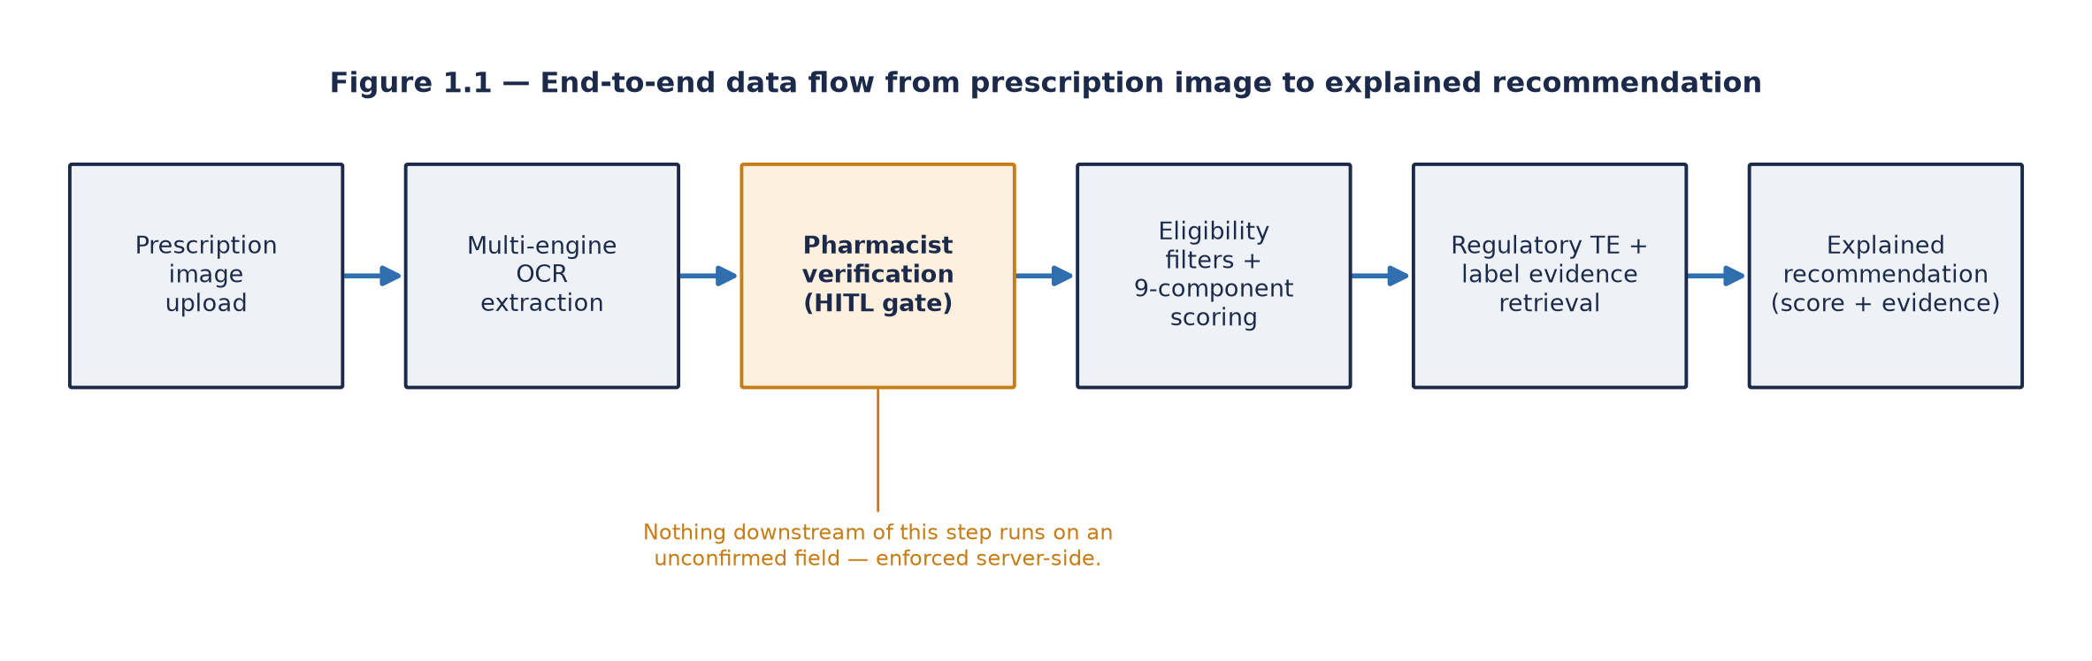
FIGURE 1.1: End-to-end data flow from prescription image to explained recommendation
A separate, reviewer-facing evaluation layer was built alongside the pharmacist-facing application, intended to measure the system against four research questions covering extraction accuracy, recommendation quality, evidence grounding, and the effect of explanation on pharmacist trust, each with a pre-registered metric and acceptance threshold rather than a judgement made after the fact. Chapter 4 reports on how far that evaluation layer could be exercised within the time available for this report.
1.6 Expected Outcomes
The primary expected outcome was a working, demonstrable decision-support prototype that takes a pharmacist from a prescription image to a set of evidenced, explained, therapeutically relevant alternatives, with a human confirmation gate at the centre of its safety model.
Alongside the artefact, the project was expected to produce baseline empirical results on extraction accuracy, recommendation quality, and explanation reliability, together with qualitative findings on pharmacist trust and usability. These were intended to indicate whether transparent, evidence-grounded AI meaningfully supports the substitution decision.
More broadly, the project was expected to demonstrate an integrated approach in which OCR, trusted-source retrieval, regulatory equivalence reasoning, and explainable AI are combined within a single human-in-the-loop workflow. It was also expected to surface honest limitations, among them dataset coverage, the region-specific nature of equivalence data, and the boundary between decision support and clinical decision-making, that define directions for future work. Chapter 4 reports on which of these outcomes were reached within the time available and which remain open.
1.7 Beneficiaries
Pharmacists are the direct beneficiaries. The system is designed around their workflow and is intended to reduce the cognitive load of interpretation and substitution while leaving professional judgement intact. A pharmacist working through a busy dispensing queue gains a second pair of eyes on an illegible name and a structured starting point for a substitution decision they would otherwise have to make unaided, without the system ever removing their authority to reject what it suggests.
For patients the benefit is indirect: fewer dispensing errors, and better-informed substitution when a prescribed medicine cannot be supplied. Neither of these benefits depends on the patient ever being aware the tool exists; the safety case rests entirely on the quality of the pharmacist's decision, which the system is intended to support rather than replace.
Institutions gain something more prosaic but useful, namely an auditable record of what was verified and what was decided. In a dispute over what a prescription said or why a substitution was made, a timestamped record of the pharmacist's own confirmation is a more defensible artefact than an unaided professional's recollection.
The research community benefits from a documented account of how regulatory equivalence data, chemical similarity, retrieval-grounded evidence, and explainability techniques can be combined in a safety-critical workflow, including where that combination proved difficult in practice. Much of the value of this project, as later chapters show, lies as much in the honest account of where the integration did not go as planned as in the parts that worked.
1.8 Organization of the Report
Chapter 2 reviews the literature across the strands the system draws on and identifies the gap this project addresses. Chapter 3 sets out the methodology: the Design Science Research paradigm and why it suits a project whose contribution is a built artefact, the research questions, the system design and study design, the data sources, the evaluation plan with its metrics and thresholds, and the ethical safeguards governing any work involving pharmacist participants. Chapter 4 reports results and discusses them, including where the measurement apparatus could not yet be exercised against a complete dataset and what that means for the findings. Chapter 5 draws conclusions, states the project's limitations and makes recommendations for future work.

CHAPTER 2: LITERATURE REVIEW
2.1 General
This chapter reviews the body of work this project builds on. The review is organised around the five technical strands the system combines: prescription reading, therapeutic equivalence, explainable AI, evidence grounding, and human-in-the-loop design. It closes by identifying the gap that motivates the project. The aim is not an exhaustive survey of each field but an account of what is settled, what remains contested, and where this project fits.
2.2 Literature Collection
Literature was collected from Google Scholar, ScienceDirect, PubMed, IEEE Xplore, and the ACM Digital Library. Search terms combined clinical and technical vocabulary: handwritten prescription recognition, medication error OCR, therapeutic equivalence, generic substitution, explainable AI in healthcare, clinical decision support and trust, retrieval-augmented generation in clinical settings, and human-in-the-loop machine learning.
Preference was given to peer-reviewed work from roughly the last fifteen years, with older sources retained where they remain foundational, such as early accounts of medication-error causation. Regulatory and standards documentation was treated as primary source material rather than secondary literature, since the equivalence determinations this project relies on are regulatory artefacts rather than research findings in the conventional sense. Sources were screened first by title and abstract, then by full text against relevance to one of the five strands below.
2.3 Prescription Reading and Optical Character Recognition
Optical character recognition on printed text is a mature technology; commercial systems routinely exceed 99% character accuracy on clean, typed documents. Handwriting is a substantially harder problem, and medical handwriting harder still: prescriptions are written quickly, often use abbreviations and Latin-derived notation, and are produced under real time pressure in a clinical setting rather than in the controlled conditions under which most handwriting datasets were collected.
Research in this area has moved through several distinct phases. Early approaches relied on hand-engineered feature extraction (stroke direction, loop counting, character segmentation heuristics) combined with classical statistical classifiers. Later work applied convolutional and recurrent neural architectures to the sequence-recognition problem, treating a line of handwriting as a sequence to be decoded rather than a set of isolated glyphs to be classified one at a time (Graves et al., 2009). More recent work uses transformer-based models pretrained on large corpora of handwritten text, which have improved recognition accuracy on general handwriting considerably; the TrOCR architecture, which pairs a vision transformer encoder with a text transformer decoder and trains the pair end to end on large synthetic and real handwriting corpora, is a representative example and is one of the engines this project's own OCR pipeline draws on (Li et al., 2023).
Within the specific domain of medical and pharmaceutical handwriting, the literature is thinner and the reported accuracy figures are correspondingly more cautious. Studies that have attempted automated reading of handwritten prescriptions and clinicians' cursive medical notes report substantially lower accuracy than general handwriting benchmarks would suggest, precisely because medicine names are a closed but very large vocabulary of often-unfamiliar words, many of which differ from one another by a single syllable or letter (Jain et al., 2021; Tabassum et al., 2021). This is the look-alike, sound-alike problem named in Chapter 1, and it interacts badly with ordinary OCR error patterns: an engine that is otherwise highly accurate on English prose can still select the wrong member of a look-alike pair, because nothing in a general-purpose language model penalises that specific kind of mistake.
Two observations from this literature shape the present project. The first is that no single engine performs uniformly well across all handwriting; reported accuracy varies substantially with writing quality, image capture conditions, and domain, which is the practical justification for building a system around more than one OCR engine rather than committing to whichever engine tests best on a single benchmark. The second is subtler. The standard metrics used to report OCR performance, word error rate and character error rate, measure how faithfully characters were transcribed; a transcription can score well on both metrics and still name the wrong medicine, because a one-character substitution between two look-alike drug names costs almost nothing on a character-level metric while being clinically catastrophic. Metrics built for general text recognition do not, on their own, capture the thing that actually matters in this domain.
Both observations point toward the same design conclusion. A National Library of Medicine workshop on the state of clinical natural-language processing catalogued accuracy limitations of exactly this kind as a persistent, unresolved barrier to deploying automated text extraction directly in clinical workflows without a human checkpoint (Friedman et al., 2013). Read alongside the human-in-the-loop literature discussed in Section 2.7, the practical conclusion drawn for this project is that OCR output in a clinical setting is best treated as a proposal a human confirms before anything is done with it, not as a finished transcription acted on directly. This motivates both the multi-engine approach taken in this project and, more importantly, the mandatory verification step described in Chapter 3.
2.4 Therapeutic Equivalence and Medicine Substitution
Therapeutic equivalence has a specific regulatory meaning that is easily confused with looser, more colloquial notions of similarity. In the United States regulatory framework, products are considered therapeutically equivalent when they are pharmaceutically equivalent, meaning the same active ingredient, dosage form, route, and strength, and can be expected to produce the same clinical effect and safety profile when administered to patients under the conditions specified in the labelling. The determination is published by the regulator in a reference commonly known as the Orange Book, formally the Approved Drug Products with Therapeutic Equivalence Evaluations, which assigns a two-character equivalence code to each marketed product (U.S. Food and Drug Administration, 2024).
This matters for system design in a way that is easy to get wrong if the distinction is not taken seriously. Equivalence is determined by a regulator, as the outcome of an administrative and sometimes experimental process (such as bioequivalence testing); it cannot be read off a molecule's structure, however similar two compounds appear on paper. Two molecules may be structurally very similar without being clinically interchangeable, and conversely, products may be rated equivalent by the regulator despite differing in excipients or manufacturing process, because those differences were judged not to affect clinical performance. A system that inferred equivalence purely from structural similarity, without reference to an actual regulatory determination, would be making a clinical claim it has no authority to make.
The equivalence coding scheme also carries internal distinctions that must be respected if it is to be used correctly. Codes beginning with "A" indicate the regulator considers the product therapeutically equivalent to a chosen reference product, but these A-rated codes are further subdivided (for instance AB1, AB2, AB3) where more than one reference standard exists for the same active ingredient and strength; products rated against different reference standards within that subdivision scheme are not automatically interchangeable with one another, only with their own reference. Treating an entire top-level code letter as uniformly interchangeable, ignoring the subletter structure, would overstate what the regulator has actually determined, and a system built on this data has to preserve that distinction rather than flatten it away for convenience.
The literature on generic substitution more broadly examines its economic benefits (lower cost to patients and health systems with no loss of clinical effect in the great majority of cases) and its clinical safety. A large systematic review of cardiovascular generic-brand equivalence studies found little evidence of brand superiority across most of the drug classes examined, including narrow-therapeutic-index agents such as warfarin, but the review's own framing singles out narrow-therapeutic-index medicines, where the margin between an effective dose and a harmful one is small, as the subgroup meriting the closest individual scrutiny even where the aggregate evidence is reassuring (Kesselheim et al., 2008). Pharmacist-level survey work on narrow-therapeutic-index substitution specifically confirms that this caution persists in practice: many pharmacists report applying additional checks before substituting these agents even where regulatory equivalence has been established (Sarpatwari et al., 2018). Related work on patient- and prescriber-level attitudes toward substituted products finds that distrust of generic substitution persists among both groups even where the clinical evidence does not support that distrust, which is itself a reason an automated recommendation needs to show its evidence rather than simply assert an outcome (Colgan et al., 2015). Taken together, this body of work supports the position that substitution is beneficial in aggregate but is not universally appropriate in every individual case, which places the final decision with the professional rather than with an automated rule, exactly as this project's own scope insists on in Chapter 1.
For this project the conclusion drawn from the literature is explicit: regulatory equivalence ratings are treated as the primary evidentiary signal, chemical structural similarity is treated as a subordinate, supporting one, and neither is presented to the pharmacist as an instruction to act. Section 4.3 records where the current implementation does not yet hold that line as cleanly as the design intends.
2.5 Explainable AI and Clinical Trust
The interpretability of machine learning models has become a substantial research field in its own right over the past decade, driven in part by the recognition that opaque models are difficult to deploy responsibly in regulated and safety-critical domains, medicine prominent among them.
Two model-agnostic techniques recur throughout this literature. LIME, Local Interpretable Model-agnostic Explanations, approximates a model's behaviour in the local neighbourhood of a specific prediction with a simple, interpretable surrogate model, typically a sparse linear one, and reports which input features drove that particular prediction (Ribeiro et al., 2016). SHAP, SHapley Additive exPlanations, draws on cooperative game theory, treating each input feature as a player contributing to a prediction, and computes an attribution with desirable consistency and local-accuracy properties that LIME's purely local approximation does not guarantee (Lundberg & Lee, 2017). Both techniques produce per-prediction feature attributions, a list of which inputs contributed how much to a particular output, rather than a single global description of the model.
The clinical literature on explainability is considerably more ambivalent than the purely technical literature that produced these tools. Several authors argue that explanation genuinely improves appropriate reliance on a system's output, helping practitioners recognise when to accept a recommendation and when to question it (Tonekaboni et al., 2019). Others caution that explanations can induce unwarranted confidence rather than well-calibrated trust: a plausible-looking explanation may persuade a clinician even when the underlying prediction is wrong, because the explanation addresses the feeling of having understood the reasoning rather than the correctness of the reasoning itself. There is also a recognised distinction, argued most forcefully by Rudin (2019), between models that are interpretable by construction, where the explanation is an exact account of how the output was computed, and complex models that receive post-hoc explanations, which are approximations of a process the explanation method did not itself perform. Rudin argues that high-stakes decisions should prefer the former wherever a model of adequate accuracy can be built that way, precisely because a post-hoc explanation can mislead about the real mechanism.
This project's scoring model is additive and transparent by construction: the final relevance score is a weighted sum of nine independently scored components, and the contribution of each component to the total is an exact arithmetic fact about how the score was computed, not an approximation of it. This places the design closer to Rudin's interpretable-by-design position than to the post-hoc-explanation position. Where SHAP is additionally applied over that additive model, as described in Chapter 3, its purpose is narrower than in the typical SHAP use case: because the underlying score is already linear and additive, the exact contribution of each feature is known analytically, and the library's output can be checked against that known-correct value as a verification step, rather than used as the only available account of an otherwise opaque calculation.
2.6 Evidence Grounding and Retrieval-Augmented Generation
Large language models generate fluent text but can state things that are not supported by any source, a failure mode usually called hallucination and one with obvious hazards in a medical context, where a fluent but unsupported claim about a drug's safety profile could cause real harm if acted on. Retrieval-augmented generation addresses this by retrieving relevant documents from a trusted corpus and conditioning any generated text on those retrieved passages, so that the output is anchored to material that can in principle be checked against its source (Lewis et al., 2020).
In clinical applications the retrieval corpus is typically authoritative reference material, approved product labelling being the obvious candidate, since it is both regulator-reviewed and the material a pharmacist would otherwise have to consult directly. Evaluation of such systems distinguishes retrieval quality (did the system find the right passages) from generation quality (did the resulting text accurately represent what those passages say), and an increasing share of the recent literature on retrieval-augmented systems considers specifically whether generated statements are actually supported by the retrieved passages, rather than merely reading fluently (Es et al., 2024).
It is worth noting that the retrieval half of this architecture does not have to be learned. The dominant approach in the recent literature is dense retrieval, in which both query and documents are embedded into a shared vector space and matched by nearest-neighbour search, and this is the mechanism the original retrieval-augmented generation work employs. Alongside it sits a long-established family of lexical retrieval methods, term-frequency weighting and its probabilistic refinements among them, which match a query to a document on shared vocabulary and weight terms by how discriminating they are across the corpus. Lexical methods are often treated as the baseline that dense retrieval improves upon, and on open-domain benchmarks they frequently are. Their advantages are nonetheless real in a setting such as this one: they require no embedding model, no index-building step and no accelerator at query time, they behave deterministically, and critically for a clinical tool, the reason a passage was retrieved can be stated to a pharmacist in terms of the words it shares with the query, which a dense retrieval score cannot straightforwardly offer. Where the retrieval corpus is a controlled technical vocabulary, as approved drug labelling is, with medicine names and clinical terms appearing in consistent forms, the vocabulary mismatch problem that motivates dense retrieval is also less severe than it is in open-domain question answering. The production retrieval path in this project uses a lexical approach for these reasons, with a dense retriever implemented alongside it and evaluated separately under RQ3, and Chapter 3 describes both.
Semantic similarity metrics based on contextual embeddings, BERTScore among them, are commonly used to compare a piece of generated text against a reference text by comparing their embeddings rather than their surface word overlap (Zhang et al., 2020). Semantic similarity is not the same thing as factual correctness, however, and the literature is clear on this point: a generated sentence can sit close to a reference sentence in embedding space and still assert something false, if the two sentences share enough vocabulary and topic without agreeing on the actual claim. This distinction matters directly for the present project's own evaluation design, since a semantic-similarity score computed against the same text a system's own explanation was built from risks measuring overlap rather than correctness, a circularity problem that Chapter 3 names explicitly as a constraint on how one of this project's own metrics should be read.
2.7 Human-in-the-Loop Clinical Decision Support
Clinical decision support systems have a long history in health informatics, and their evaluation literature contains a consistent, recurring lesson: technical accuracy does not by itself guarantee adoption or clinical benefit. Systems fail in practice when they interrupt an already busy workflow, when they generate an excessive number of low-value alerts, or when practitioners cannot see why a particular recommendation was made and therefore cannot judge whether to trust it (Bates et al., 2003).
Automation bias, the tendency of a human operator to over-rely on an automated system's output and under-apply their own independent judgement, is a well-documented risk in safety-critical automated decision support generally, not only in healthcare (Parasuraman & Manzey, 2010). Alert fatigue, where a high frequency of low-value notifications leads a practitioner to dismiss important ones along with the unimportant majority, is a related and separately documented risk specific to clinical alerting systems (Ancker et al., 2017). Both findings argue for systems designed to present evidence for a professional's own consideration rather than to issue directives the professional is expected to simply follow.
Human-in-the-loop design responds to these findings by placing a mandatory human decision point somewhere in the processing chain, but the literature is clear that where that point is placed matters as much as whether it exists at all. A confirmation step placed after the system has already produced and displayed its output invites what is sometimes called rubber-stamping: the human nominally reviews the output but has already been anchored by seeing it, and tends to confirm rather than independently re-derive the answer. A confirmation step placed before any consequential processing begins forces the human's own judgement to condition everything that follows, rather than merely to ratify a conclusion the system has already reached. The present project adopts the latter position: no recommendation is generated until the pharmacist has confirmed the extracted prescription fields, a design decision described in full in Section 3.3.2.
2.8 Research Gap
The five strands reviewed above are each reasonably well developed on their own, and pairwise combinations of them do appear in the literature, OCR combined with downstream NLP, or explainability combined with retrieval-augmented generation, for instance. What is not well represented is their integration into a single workflow with all of the properties this project targets together:
1. Prescription image to substitution recommendation as one pipeline. Work on prescription OCR generally stops at transcription. Work on medicine substitution generally assumes a structured, already-correct input. The join between the two, where a real system has to handle an OCR output that might itself be wrong, is thinly covered.
2. Regulatory equivalence as the primary substitution signal, rather than an afterthought. Systems that propose medicine alternatives in the wider literature frequently rely on similarity heuristics, often chemical or textual, as their only signal. Grounding recommendations in published regulatory determinations, with the subletter subdivision distinctions correctly respected, is markedly less common.
3. Explanation combined with evidence grounding, rather than either alone. Feature attribution explains how a model weighted its inputs; retrieved label text explains what an authoritative source actually says. These answer two different questions, and presenting both together, so a user can ask either "why did the model think this" or "what does the evidence actually say," is uncommon in the systems described in the literature.
4. Verification as a hard, structural gate rather than an optional overlay. Many systems in the clinical decision support literature offer human review as something the user can choose to engage with or skip. Enforcing confirmation as a precondition for any downstream processing, so that the system is structurally incapable of proceeding without it, is a stronger architectural commitment than most published systems make.
5. Integrity in how results are reported. Evaluation sections in applied AI work do not always distinguish clearly between a metric computed on real data and a figure produced by simulation for illustrative purposes. Treating that distinction as a first-class, enforced property of the system itself, rather than as a disclosure made only in a methods section, is unusual.
This project addresses that gap by building and evaluating a prototype that integrates all five of these properties, and, in keeping with the fifth point above, by reporting in Chapter 4 on where that integration succeeded within the time available and where it did not.

CHAPTER 3: METHODOLOGY AND STUDY DESIGN
3.1 Introduction
This chapter sets out how the project was carried out. It states the research paradigm and justifies it, defines the study aim and the research questions, describes the system that was built and the data it draws on, specifies the study design covering the planned evaluation instrument and target participants, and specifies the evaluation plan through which the artefact's performance and usefulness were to be assessed. It closes with the ethical considerations that govern any part of the work involving pharmacist participants.
3.1.1 Research Paradigm: Design Science Research
The project follows Design Science Research (DSR). DSR suits work whose contribution is a constructed artefact, whether that is a method, a model, or, as here, a working software system, and where knowledge comes from building that artefact and evaluating it against defined objectives rather than from observing a phenomenon that already exists independently of the research.
At its simplest, the paradigm proceeds through an iterative build-and-evaluate loop: a design is proposed, instantiated as working software, and assessed, with the results feeding the next iteration (Hevner et al., 2004). Peffers et al. (2007) elaborate this into a six-activity methodology, problem identification, definition of objectives, design and development, demonstration, evaluation, and communication, and it is this more granular build, demonstrate, evaluate framing that this project follows in practice: a design is proposed, instantiated as working software, exercised against realistic scenarios, and assessed, with the results of each pass feeding the next iteration. The paradigm differs from a hypothesis-testing one in an important way. In hypothesis testing, an existing phenomenon is measured. Here, the phenomenon, a working decision-support tool that did not exist before this project, is brought into existence by the research itself and then examined.
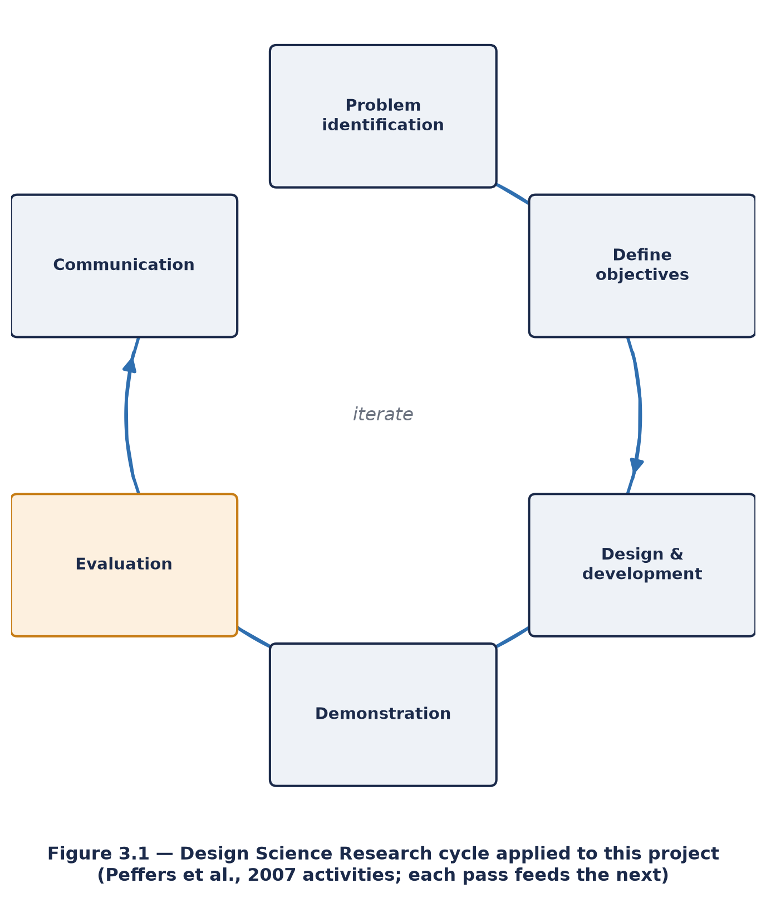
FIGURE 3.1: Design Science Research cycle applied to this project
3.1.2 Justification of Approach
DSR fits this project for three reasons. First, the research question concerns whether a particular combination of techniques, OCR, regulatory equivalence, retrieval-grounded evidence, and explainability, can support a professional decision, a question that cannot be answered without actually constructing that combination and observing how it behaves. Second, the evaluation criteria are mixed in kind. Extraction accuracy and ranking quality are the sort of thing that can be measured numerically, whereas a pharmacist's trust and perceived usefulness cannot be measured the same way and instead require professional judgement, gathered through structured feedback. DSR accommodates both kinds of evidence within one coherent framework rather than forcing a choice between them. Third, DSR's emphasis on documenting the artefact and its limitations, rather than presenting only a polished final result, aligns with the integrity commitment stated in Chapter 1: this project set out to report honestly on what worked and what did not, and DSR is a paradigm built around exactly that expectation.
An alternative would have been a purely experimental design comparing MediScan against existing commercial tools. This was rejected because no existing tool performs the integrated workflow under study, reading a handwritten prescription and reasoning about regulated therapeutic substitution within one system, so there was nothing directly comparable to measure MediScan against without first building it.
3.2 Study Aim and Research Questions
Aim. To design, build, and evaluate a human-in-the-loop, explainable decision-support prototype that assists pharmacists in reading prescriptions and identifying therapeutically relevant alternatives, and to assess whether transparent, evidence-grounded recommendations support professional decision-making.
Four research questions operationalise this aim:
RQ1, Extraction accuracy. How accurately does the OCR pipeline extract medicine names and dosages from prescription images, compared with pharmacist-confirmed ground truth?
RQ2, Recommendation quality. How effectively does the recommendation engine identify alternatives that pharmacists judge to be relevant, and what does chemical structural similarity contribute as a supporting signal?
RQ3, Evidence grounding. How does retrieval strategy affect the quality of evidence presented with each recommendation, and to what extent are generated explanations supported by the retrieved source text?
RQ4, Explainability and trust. What is the effect of explanation and source attribution on pharmacists' perceived transparency, trust, and confidence in the recommendations?
Table 3.2 later in this chapter sets out, for each question, the metric used to answer it and the threshold against which a pass or fail verdict is reported.
3.3 System Design and Development
The system was developed as a modular web application. Each capability was built as an independently replaceable module behind a feature flag, so that the system degrades gracefully when an optional capability or dataset is unavailable rather than failing outright. This modularity served the research design directly: it allowed a capability to be switched off and the system re-evaluated, which is how comparative conditions for several of the research questions above were intended to be constructed.
3.3.1 Architecture
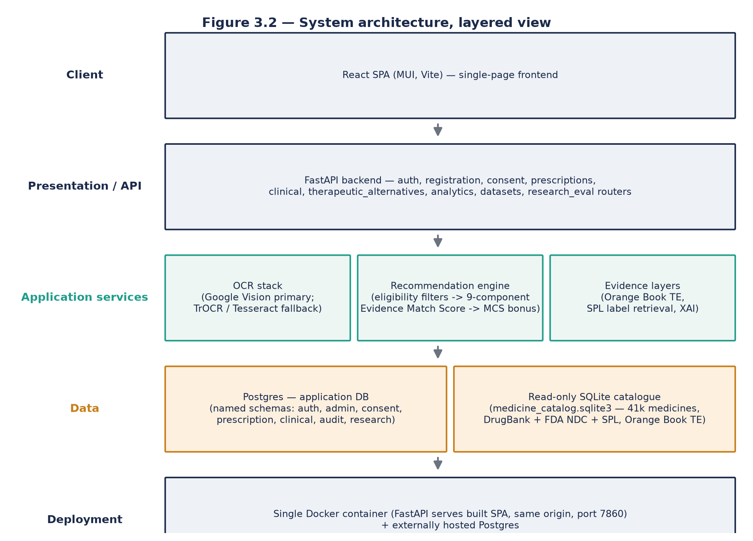
FIGURE 3.2: System architecture, layered view
The application is built as a FastAPI backend serving a React single-page frontend, with the two bundled together into a single Docker container that runs as one process on Hugging Face Spaces. A single Postgres database, hosted externally rather than inside the container, holds every piece of application state: user accounts, consent records, prescription sessions, OCR runs, clinical evaluations, the human-in-the-loop audit trail, and the research-evaluation evidence store. This application database is organised into separate named schemas by domain, auth, admin, consent, prescription, clinical, audit, and research, rather than a single undifferentiated set of tables, which keeps each domain's data independently addressable and makes the schema itself a readable map of the system's responsibilities. Figure 3.4 shows these domains and their separation.
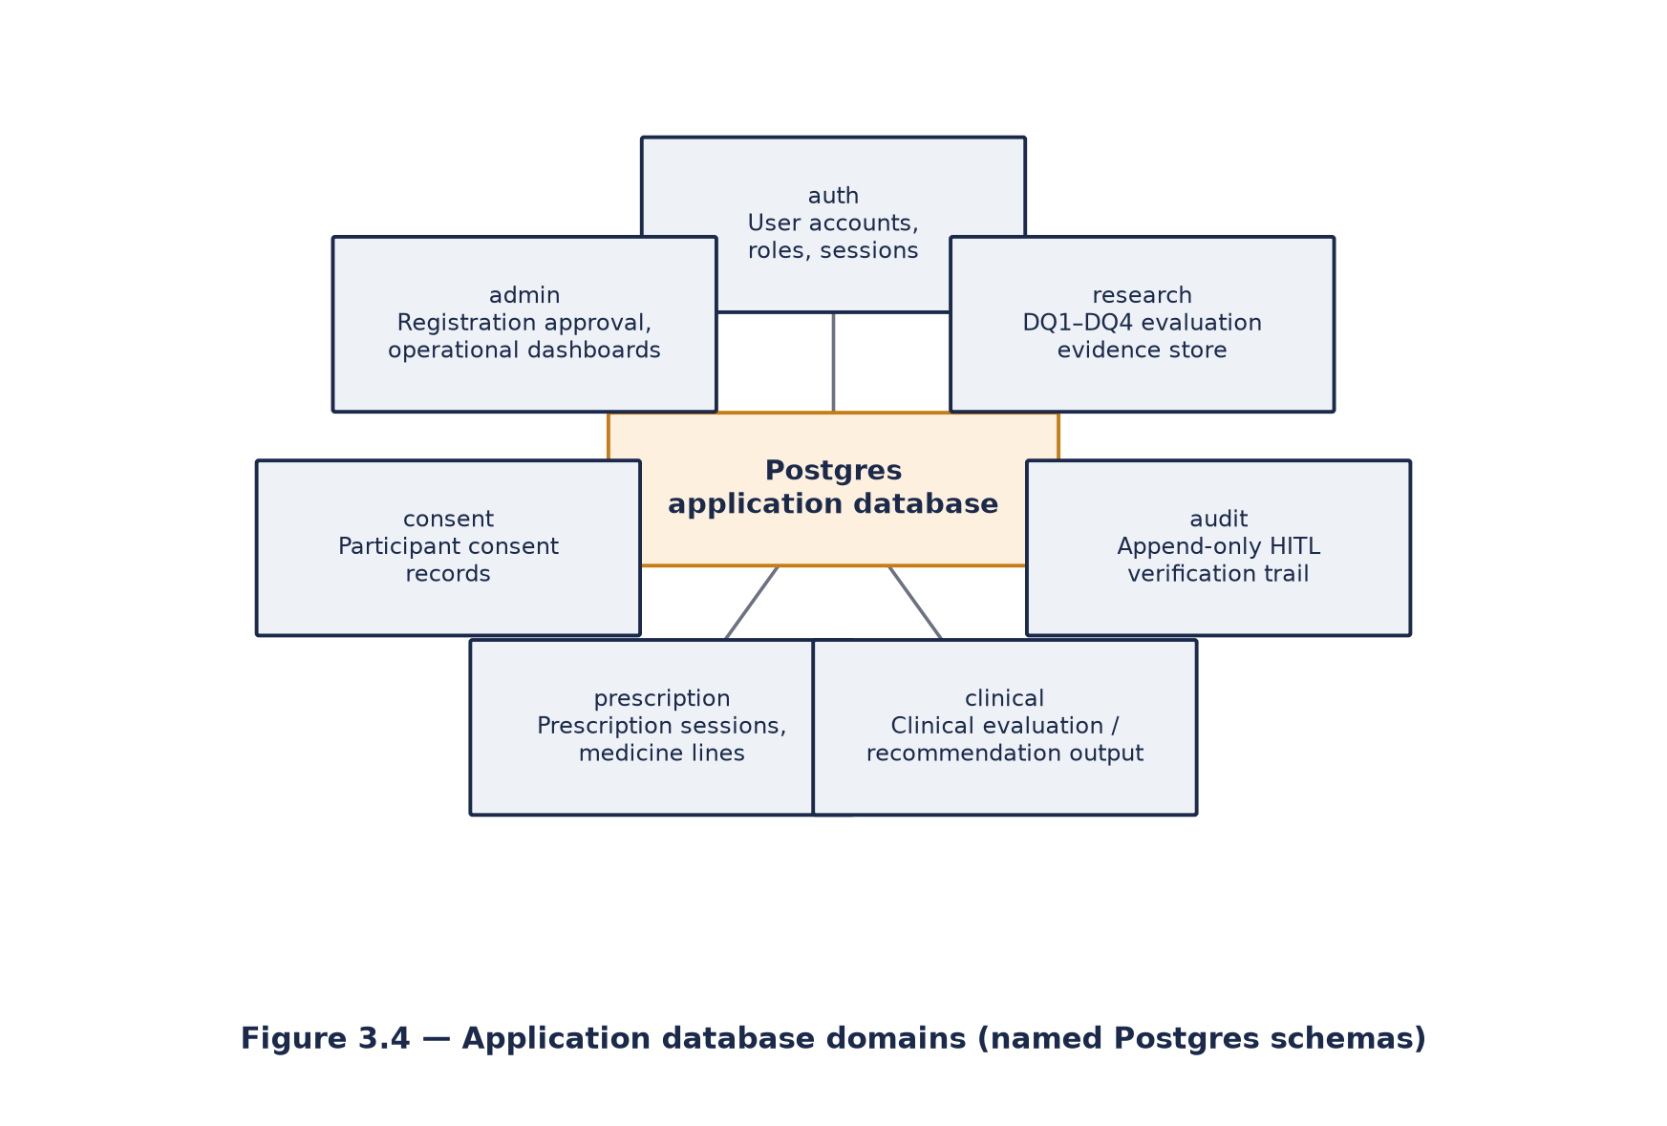
FIGURE 3.4: Application database domains
Two data stores are deliberately kept apart. The application database above is written to constantly during normal operation. A second store, a read-only SQLite file holding the drug-knowledge catalogue (marketed medicines, chemical structure mappings, and regulatory equivalence data assembled offline from public sources), is opened in a mode that the database driver itself enforces as read-only, so that the clinical reference data genuinely cannot be altered by anything the running application does. This separation is a safety property as much as an architectural one: the catalogue a pharmacist's recommendation is drawn from cannot drift away from its known, offline-validated state because of a bug, a race condition, or a misbehaving request somewhere else in the application.
Access is authenticated and role-gated across three roles. A pharmacist runs the analyzer workflow described in Section 3.3.2. A reviewer has access to the research-evaluation layer described in Section 3.3.4 and to aggregate operational statistics, and can additionally open any individual pharmacist's prescription session, a filtered list across all pharmacists together with the OCR image, extracted fields, and pharmacist-verified values for a single session, in a strictly read-only capacity, with no endpoint available to the reviewer role that edits, confirms, or deletes anything in that session. This review capability was added after the role was first implemented, once it became clear that aggregate statistics alone gave a reviewer no way to inspect what a specific pharmacist had actually confirmed; the pharmacist's own day-to-day workflow, uploading and verifying a prescription, remains reachable only through the pharmacist role itself. An administrator approves new pharmacist registrations, can re-designate an approved account as a reviewer, and has access to operational dashboards covering registrations, the drug catalogue, prescription session volume, and production analytics. New pharmacists self-register but cannot activate their own account; a request sits pending until an administrator explicitly approves it, which is the only route by which an account becomes active.
3.3.2 The Human-in-the-Loop Gate
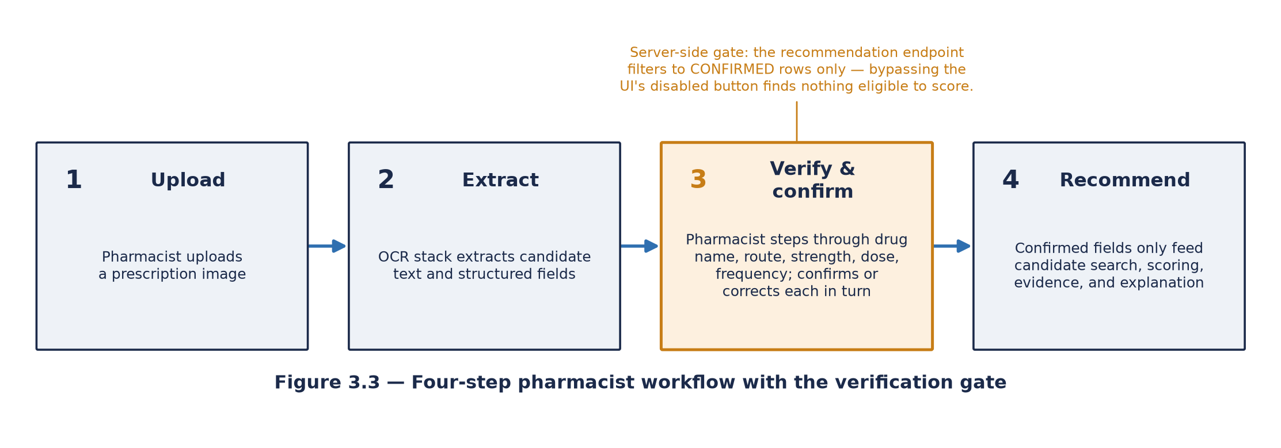
FIGURE 3.3: Four-step pharmacist workflow with the verification gate
Step three of the pharmacist workflow is the architectural centre of the system's safety model. A pharmacist uploads a prescription image; the OCR stack described in Section 3.3.3 extracts candidate text and structured fields; the pharmacist then steps through a fixed field order, drug name first, then route, strength, dose, and frequency, confirming or correcting each one against a catalogue-constrained set of options rather than free text. No recommendation is generated until every field required for a given medicine line has been explicitly confirmed, and this is enforced on the server, not only as a frontend convenience: the recommendation endpoint itself filters to medicine rows whose status is confirmed before any candidate is scored, so a request that somehow bypassed the frontend's own disabled-button state would still find nothing to recommend against for an unconfirmed field.
The ordering here matters, and it reflects the human-in-the-loop literature discussed in Section 2.7 directly, in particular the automation-bias risk Parasuraman and Manzey (2010) describe. If recommendations were generated first and shown alongside a confirmation prompt, the pharmacist would be reviewing a system that had already committed to an interpretation of the prescription, an arrangement that invites the rubber-stamping effect that literature warns against. By requiring confirmation first, the system ensures that everything downstream, the candidate search, the scoring, the evidence retrieval, is conditioned on a field value a human has actually looked at and approved, not on whatever the OCR engine happened to produce.
Every correction the pharmacist makes, and every confirmation itself, is written to an append-only audit table. These records serve two purposes: an operational record of what was verified and by whom, and a source of ground truth for extraction-accuracy evaluation, since a field a pharmacist has confirmed is, by construction, that pharmacist's own judgement of what the prescription actually said. This audit trail is append-only in the sense that no code path in the application ever issues an update or delete against it; it is a convention enforced by how the application is written rather than a constraint enforced by the database itself, and Chapter 4 records this as a limitation rather than describing it as a stronger guarantee than it is.
3.3.3 OCR Pipeline
Prescription images are processed through a sequential, multi-engine OCR stack. Google Vision's document-text-detection API is the primary engine in production use. TrOCR, a locally run transformer handwriting model, and Tesseract, an open-source OCR engine, are available as configurable fallback and comparison engines. A separate line-detection pass can optionally assist by locating text regions before recognition runs, though it contributes detection only and does not itself recognise characters. Ahead of recognition, each image passes through a preprocessing stage, correcting orientation, isolating ink from background, applying an adaptive contrast adjustment, sharpening, and deskewing the image where it is rotated, all intended to give each recognition engine as clean an input as the image allows. Any text the pipeline extracts is passed through a redaction step that strips patterns resembling clinic names, patient demographics, addresses, and prescriber registration numbers before the transcript is stored or displayed, since the system's own design assumes every prescription that reaches it could in principle carry identifying information even though the evaluation dataset used in this project is synthetic throughout.
3.3.4 Recommendation Engine and Evidence Layers
Once a medicine line is confirmed, the recommendation engine searches the drug-knowledge catalogue for candidates and applies a set of mandatory eligibility filters before any candidate is scored at all: the same active ingredient or an accepted salt form of it, a compatible route of administration, a compatible dosage form, comparable strength, and the presence of trusted provenance for the candidate record. A candidate failing any one of these filters is excluded outright and never reaches the scoring stage. Surviving candidates are scored against nine independently weighted components covering indication relationship, therapeutic classification, mechanism of action, molecular target or pathway, route compatibility, dosage-form compatibility, patient-population compatibility, contraindication and warning assessment, and interaction-assessment coverage, summing to a total score out of one hundred. Where a reasonable number of candidates share the prescribed medicine's own active moiety, an additional, separately computed structural-similarity bonus, based on a chemical maximum-common-substructure comparison, can adjust the ranking among those same-moiety candidates; this bonus is deliberately withheld on the alternative path, where a candidate has a different active ingredient from the one prescribed, since applying it there risked implying a degree of clinical interchangeability between different active ingredients that no regulator has actually determined.
Attached to each candidate, where the data is available, is a regulatory therapeutic-equivalence rating drawn from the FDA Orange Book, described in Section 2.4, which annotates the candidate with the regulator's own equivalence code rather than feeding into the ranking score itself; this evidence is deliberately kept passive, informing the pharmacist's own judgement rather than silently reordering what the pharmacist sees first.
Supporting evidence for each candidate is retrieved from a corpus of Structured Product Labeling excerpts, the approved label text the regulator has reviewed for each marketed product. In the system as deployed, this retrieval works by scoring label passages against the query on shared vocabulary rather than through a learned semantic embedding; a separate, embedding-based retriever using sentence embeddings and a nearest-neighbour index exists in the codebase and was evaluated in the research-evaluation layer described below, but is not the mechanism the live pharmacist-facing recommendation path uses by default. Where no supporting passage can be found for a candidate, the system withholds any generated narrative summary rather than producing one anyway, substituting an explicit message that evidence was insufficient; this is a deliberate design choice intended to avoid exactly the unsupported-claim failure mode discussed in Section 2.6, at the cost of sometimes offering the pharmacist less explanatory text than they might want.
3.3.5 Explainability Layer
Because the recommendation score described above is additive, the exact contribution of each of the nine scoring components to a candidate's total is already known with certainty; no approximation is required to state it. The system's primary explanation mechanism presents exactly this analytical breakdown, ranked by the magnitude of each component's contribution, as the account of why a given candidate scored the way it did. A real implementation of SHAP is additionally available as an optional, disabled-by-default capability, and where it is enabled its purpose is to reconcile the library's output against the already-known analytical attribution as a correctness check, rather than to serve as the only available explanation of an otherwise unexplained score.
3.4 Data Sources and Collection
3.4.1 Drug Knowledge Sources
The knowledge catalogue draws on several publicly available reference datasets, each serving a distinct role, as summarised in Table 3.1. These sources were combined offline into a single read-only catalogue, with derived tables built from them to support specific functions: a name-to-structure mapping for chemical similarity comparisons, an equivalence table, and a salt-form normalisation map allowing different salt forms of the same active moiety to be recognised as related to one another.
TABLE 3.1: Drug knowledge sources and their role in the system
Source | Role in the system
FDA National Drug Code (NDC) directory | Marketed product listings: names, strengths, dosage forms, routes, labellers
DrugBank | Drug-level reference data: active ingredients, salt forms, chemical identifiers
FDA Structured Product Labeling (SPL) | Approved label text used as the retrieval corpus for evidence grounding
FDA Orange Book | Therapeutic equivalence codes and reference listed products

Using publicly available regulatory data carries a methodological consequence worth stating plainly. The equivalence determinations are jurisdiction-specific: they reflect one regulator's decisions about products marketed in one country. The system's equivalence evidence is therefore correct for that jurisdiction and should not be assumed to transfer unmodified elsewhere, a limitation recorded again in Chapter 4.
3.4.2 Synthetic Prescription Dataset
Evaluation of the extraction pipeline requires prescription images with known correct content. The project uses synthetic prescriptions only, images constructed for the study, containing no real patient information and representing no real clinical encounter. Privacy considerations drove this choice directly: a real prescription carries patient identifiers, prescriber identifiers, and clinical information, and using real material would have required a data-protection and governance apparatus disproportionate to a prototype evaluation at this scale. Synthetic data avoids the risk entirely while still exercising the same OCR and verification pipeline a real prescription would.
A target of 25 to 30 evaluation cases was planned, varied across handwriting legibility, medicine classes, dosage forms, and the presence of look-alike or sound-alike name pairs. Ground truth for each case comes from the verification workflow itself: whatever fields a pharmacist confirms become the reference against which OCR output is scored, consistent with the design described in Section 3.3.2. Chapter 4 reports on how far this target dataset had been reached at the time of writing this report.
3.5 Study Design
3.5.1 Research Design
The quantitative strand of this study is a within-system comparative evaluation: the same prescription cases are run through the deployed system, and the system's own output on each case is compared against pharmacist-confirmed ground truth for that case. There is no separate control group or comparator system, for the reason given in Section 3.1.2; the research question is about this system's own measured performance against pre-registered thresholds, not a head-to-head comparison against an alternative tool.
3.5.2 Data Collection Instrument
Alongside the quantitative strand, a structured feedback instrument, administered externally as a questionnaire rather than inside the application itself, was designed to collect pharmacist responses on five-point Likert scales covering usability, clinical relevance, transparency, trust, and the perceived value of the explanations provided, together with free-text comments. To support RQ4 specifically, the instrument is built around three explanation conditions presented to participants in a counterbalanced order: a minimal condition showing only the relevance score, a condition additionally showing the feature-attribution breakdown, and a condition additionally showing the retrieved evidence passages and their source. Comparing responses across these three conditions is intended to isolate whether explanation and source provenance, specifically, affect a pharmacist's stated trust and perceived transparency, rather than simply asking whether the system in general is trusted.
3.5.3 Data Sources and Participant Population
Three distinct kinds of data feed the evaluation. The published, publicly available regulatory and reference datasets described in Section 3.4.1 supply the drug knowledge the recommendation engine draws on. The synthetic prescription cases described in Section 3.4.2, together with pharmacist verification performed through the live application, supply ground truth for the extraction-accuracy and recommendation-quality questions. The planned pharmacist panel, five licensed pharmacists working through the application in a simulated environment, supplies the qualitative trust and usability data for RQ4; this panel is the survey's target audience, and its intended size of five was set deliberately small given that the resulting evidence is treated as indicative, structured professional feedback rather than as a basis for any inferential statistical claim.
3.5.4 Findings from the Study Design Phase
Designing the evaluation around four pre-registered research questions, each with its own metric and acceptance threshold set in advance rather than chosen after seeing results, surfaced two design problems before any data collection began, both discussed in Chapter 4: a metric that can only be computed from genuinely independent OCR runs across multiple engines, which the evaluation harness as currently implemented does not yet perform, and a recommendation-quality comparison between two scoring conditions that, by the mathematics of how the comparison is constructed, cannot actually differ from one another. Surfacing these problems at the design stage, rather than only discovering them once results were in hand, is itself a finding this report treats as a legitimate part of the study design chapter rather than hiding it inside a results section where it might look like an afterthought.
3.6 Evaluation Plan
3.6.1 Quantitative Strand
Each research question maps to a defined metric and a pre-specified acceptance threshold, so that results can be reported as pass or fail rather than interpreted after the fact.
TABLE 3.2: Research questions, metrics, and acceptance thresholds
RQ | Focus | Metric | Acceptance threshold
RQ1 | Extraction accuracy | Word error rate; character error rate; field-level exact match | WER < 0.15; CER < 0.10
RQ2 | Recommendation quality | Precision@3; Recall@3; structural-similarity coverage | P@3 ≥ 0.70; R@3 ≥ 0.60
RQ3 | Evidence grounding | Citation coverage; unsupported-claim rate; semantic similarity | Semantic similarity F1 ≥ 0.80
RQ4 | Explainability and trust | Likert ratings by explanation condition | Descriptive; no threshold

RQ1, extraction accuracy, is measured by word error rate, character error rate, and field-level exact match, against thresholds of word error rate below 0.15 and character error rate below 0.10. RQ2, recommendation quality, is measured by precision at three and recall at three against a pharmacist-judged relevant set, with thresholds of precision at three at or above 0.70 and recall at three at or above 0.60, alongside a separately reported structural-similarity coverage figure. RQ3, evidence grounding, is measured by citation coverage, an unsupported-claim rate, and a semantic-similarity score between generated explanation and retrieved source text, against a threshold of semantic similarity F1 at or above 0.80. RQ4, explainability and trust, is measured descriptively through Likert ratings by explanation condition, with no numeric threshold, since the evidence here is intended to describe a pattern of professional response rather than to pass or fail against a predetermined number.
Two rules govern this strand, both following directly from the integrity objective stated in Chapter 1. First, a metric is reported only when it is computed from real data; where the backing data is incomplete, the metric is marked unavailable and no threshold verdict is issued for it, rather than an estimate or placeholder figure being reported in its place. Second, where a measurement carries a known methodological weakness, that weakness is stated alongside the number rather than left for a reader to discover independently. The semantic-similarity measure for RQ3 is a specific case of this: if a generated explanation is built from the same passages used as the reference text it is compared against, the comparison is circular, and the resulting similarity score is inflated relative to what an independently generated explanation would score. Chapter 4 states this constraint explicitly alongside the relevant figure wherever it applies, rather than presenting the number as if it were a clean, independent measurement.
3.6.2 Qualitative Strand
The qualitative strand gathers structured feedback, through the instrument described in Section 3.5.2, from a small panel of licensed pharmacists using the synthetic cases in a simulated environment. A panel of this size supports descriptive reporting of professional judgement; it does not support inferential statistical claims, and none are made from it in this report. Results, where collected, are reported as means and standard deviations by construct and by explanation condition, accompanied by representative free-text comments, and presented throughout as indicative professional feedback rather than as generalisable evidence.
3.6.3 Research Process Timeline
The sequence in which the phases above were carried out, from the initial literature collection through system build to the evaluation activity that remained outstanding at the time of writing, is summarised in Figure 3.5. The timeline is shown in relative project weeks rather than calendar dates, consistent with how the programme's own milestone schedule is expressed.
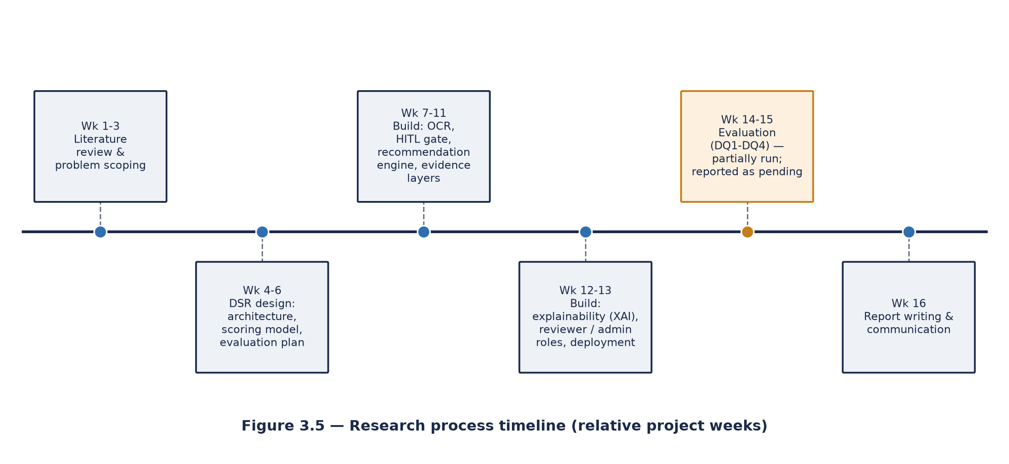
FIGURE 3.5: Research process timeline
3.7 Ethical Considerations
The quantitative strand raises no human-participant issues on its own: every prescription used is synthetic, no patient data is processed anywhere in the system, and the drug reference data drawn on is publicly available regulatory and bibliographic material.
The qualitative strand does involve human participants, the pharmacist panel, and is accordingly subject to institutional research ethics approval before any participant-facing data collection begins. The following safeguards apply to that panel: a written participant information sheet, describing the study's purpose, what participation involves, its expected duration, and how data will be used, is provided before any participant is asked to consent; written informed consent is obtained before participation; participants may withdraw at any time before submitting their questionnaire response, without giving a reason and without any consequence; responses are recorded against pseudonymous codes, so no participant is identifiable in this report or in any stored dataset; only data necessary to answer RQ4 is collected, and no clinical or patient data is gathered from participants at any point; and responses are stored securely, accessible only to the researcher and supervisor, retained only for the period the institution's own policy permits.
Two further ethical dimensions follow from the nature of the artefact itself rather than from the study design narrowly construed. The first concerns safe framing. A system that proposes medicine alternatives could, if misrepresented to a user, be mistaken for a source of clinical authority rather than a decision-support aid. This is addressed both in the system's design, through the mandatory verification gate and the explicit refusal to perform automatic substitution of any kind, and in how it is presented, by stating the decision-support boundary consistently throughout the interface and in this report. The second concerns honest reporting. Presenting simulated or estimated figures as though they were measured results would misrepresent the artefact's actual capability, and an overstated accuracy claim could encourage a pharmacist to rely on the system in a way they should not. That makes honest reporting an ethics question in this context as much as a methods question, and the integrity rules stated in Section 3.6.1 exist for that reason.

CHAPTER 4: RESULTS AND DISCUSSION
4.1 Introduction
This chapter reports what the project found when the evaluation plan set out in Chapter 3 was actually run against the deployed system. The honest answer, stated plainly, not left for a reader to infer, is that the evaluation infrastructure described in Chapter 3 is built and working, but the evaluation dataset behind it is not yet at the scale the study design called for. At the time of writing, the live application's research-evaluation store held a single prescription case with pharmacist-confirmed ground truth, against a planned target of twenty-five to thirty. Running the full quantitative strand across four research questions on a sample of one would produce numbers that look precise and are not; the integrity rule stated in Section 3.6.1, that a metric is reported only when real data backs it and is otherwise marked unavailable, exists for exactly this situation; this chapter follows it rather than setting it aside because a deadline was close. Where a question cannot yet be answered, this chapter says so and explains why, rather than substituting a plausible-looking estimate.
4.2 What Has Been Built and Verified Working
Before turning to the research questions themselves, it is worth recording what was confirmed to be genuinely operational, since this is itself a legitimate finding of the project and a point the marking criteria for this report weight heavily under the quality-of-project-work heading.
The full pharmacist workflow, upload, multi-engine OCR extraction, field-by-field verification, recommendation, and evidence and explanation display, runs end to end on a live, publicly reachable deployment, not only in a local development environment. The verification gate described in Section 3.3.2 was confirmed, by direct inspection of the code that enforces it, to be a genuine server-side constraint rather than a frontend-only affordance: the recommendation endpoint filters to confirmed medicine rows before any candidate is scored, so a request that somehow bypassed the interface's own disabled button would still find nothing eligible to recommend against. The recommendation engine's nine-component scoring model was confirmed to sum to exactly one hundred points, with each component contributing either its full weight or none, which is the property that makes the explainability layer's analytical attribution an exact account of the score rather than an approximation of one. The regulatory therapeutic-equivalence layer was confirmed to attach annotation only, never altering candidate ranking, on both candidate paths the system supports. The evidence-retrieval layer was confirmed to withhold a generated narrative, rather than fabricate one, whenever no supporting label passage could be found for a candidate.
Table 4.1 (operational snapshot drawn from the live deployment) records the scale of real, non-simulated activity the deployed system had logged at the time of writing: two completed prescription review sessions, three medicines extracted by OCR, two of the three successfully matched against the formulary catalogue, an average OCR field confidence of 0.93, and an average parser confidence of 0.97. These figures describe genuine production telemetry rather than a demonstration run, and they are reported here precisely because they are small; a system described at this stage of its life is more useful to a future reader of this report than one whose early numbers were quietly omitted.
TABLE 4.1: Operational snapshot from the live deployment
Metric | Value
Completed prescription review sessions | 2
OCR jobs run | 1
Medicines extracted | 3
Medicines matched to formulary | 2 (66.7%)
Average OCR field confidence | 0.93
Average parser confidence | 0.97
Pharmacist-reviewed sessions | 1

The drug-knowledge catalogue the recommendation engine draws on is itself a substantial, genuinely assembled artefact rather than a small demonstration dataset, and its scale is worth recording here as a concrete measure of what the build phase actually produced. At the time of writing, the catalogue held 41,020 distinct marketed medicines, 929,832 individual product records, and 373,959 name aliases supporting fuzzy lookup, built from 132,824 ingested rows of FDA National Drug Code data, 4,953 rows of DrugBank reference data, and 255,904 rows of FDA Structured Product Labeling data spanning thirteen source files, from which 136,167 individual label sections were extracted to serve as the evidence-retrieval corpus described in Section 3.3.4.
TABLE 4.2: Drug-knowledge catalogue scale
Catalogue component | Count
Marketed medicines | 41,020
Individual product records | 929,832
Name aliases (fuzzy lookup) | 373,959
Label sections (evidence-retrieval corpus) | 136,167
FDA NDC rows ingested | 132,824
DrugBank rows ingested | 4,953
FDA SPL rows ingested | 255,904

4.3 A Worked Example
Because the quantitative strand described in the sections that follow could not yet be run at scale, it is worth showing concretely what the recommendation engine actually produces for a single, real query against the live catalogue, since this is itself evidence of what was built, independent of the pending evaluation numbers. A prescription for ibuprofen 200 mg, oral tablet, taken every six hours for pain and inflammation, was submitted to the recommendation engine exactly as a pharmacist would submit a confirmed medicine line. The engine returned five eligible candidates, all on the different-active-ingredient path, ranked first by naproxen, which scored 100 out of 100 across the nine weighted components described in Section 3.3.4, with the remaining four candidates (celecoxib, peginterferon alfa-2a, prednisone, and diazepam) each scoring 70.
That candidate list requires immediate comment rather than quiet presentation, because two of its members are not clinically plausible alternatives to ibuprofen by any reasonable reading. Peginterferon alfa-2a is an injectable immunomodulator used in viral hepatitis, and diazepam is a benzodiazepine; neither is a substitute a pharmacist would entertain for a request for oral anti-inflammatory pain relief. Their appearance is a genuine finding about the current implementation, not a presentational inconvenience, and inspecting the engine's own output explains how it happened. The route-compatibility check compares the prescribed route against a candidate's route string and returned a status of matched for peginterferon alfa-2a, whose recorded route string is "Oral; Subcutaneous", on the strength of the oral element alone, and also for diazepam, whose recorded route is "Buccal". The dosage-form check returned matched for all five candidates while comparing a null source form against a null candidate form, which means that on this path it passed every candidate without discriminating between any of them. In other words the mandatory eligibility filters described in Section 3.3.4 as hard gates on route and dosage form did not function as gates in this query: one admitted a partial substring match, and the other was inert because the fields it compares were absent from the catalogue records involved.
The scoring pattern is worth reading alongside this. The four lower-ranked candidates did not merely score similarly; they scored identically, each failing exactly the same three components (ATC or therapeutic class, mechanism relationship, and target or pathway) and passing the other six. Because each component is awarded either its full weight or nothing, with no partial credit, candidates that happen to fail the same subset of components collapse onto an identical total. The consequence is that celecoxib, which is a genuine anti-inflammatory alternative sharing ibuprofen's mechanism class, is scored indistinguishably from diazepam, which is not. The score is transparent and exactly explainable, which is what Section 3.3.5 claims for it, but transparency is not the same property as discriminative power, and this example shows the nine-component model separating candidates less finely than the design intends.
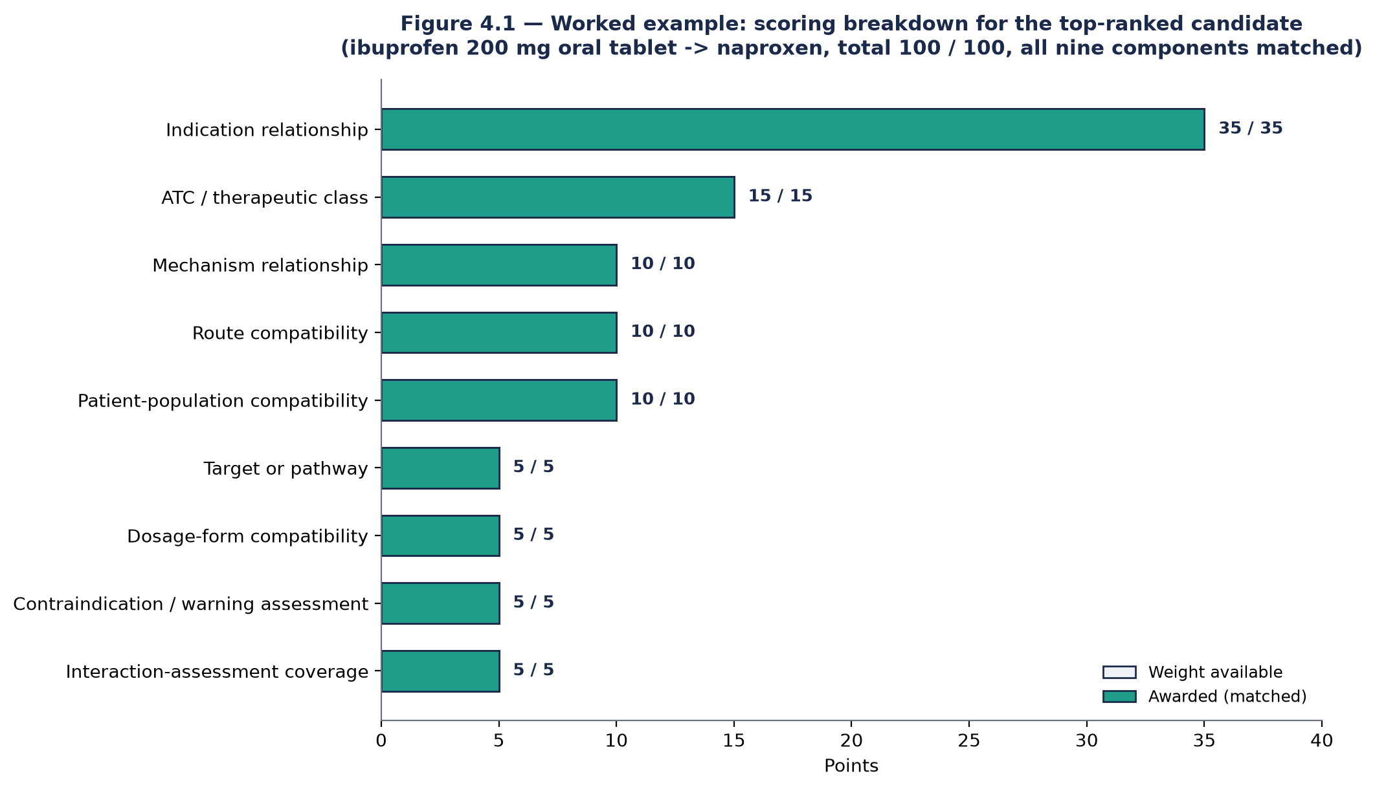
FIGURE 4.1: Worked example — scoring breakdown for the top-ranked candidate
Table 4.3 shows the full nine-component breakdown behind naproxen's score. Every component was marked matched and awarded its full weight: indication relationship (35 of 35), ATC and therapeutic class (15 of 15), mechanism relationship (10 of 10), route compatibility (10 of 10), patient-population compatibility (10 of 10), target or pathway (5 of 5), dosage-form compatibility (5 of 5), contraindication and warning assessment (5 of 5), and interaction-assessment coverage (5 of 5). The explainability layer described in Section 3.3.5 reported exactly this same breakdown as its feature attribution, each component's contribution stated as an exact number rather than an approximation, which is the property Section 2.5 identifies as the real advantage of an additive, interpretable-by-construction score over a post-hoc explanation of an opaque one.
TABLE 4.3: Full nine-component score breakdown for the worked example
Component | Weight | Awarded | Status
Indication relationship | 35 | 35 | Matched
ATC / therapeutic class | 15 | 15 | Matched
Mechanism relationship | 10 | 10 | Matched
Route compatibility | 10 | 10 | Matched
Patient-population compatibility | 10 | 10 | Matched
Target or pathway | 5 | 5 | Matched
Dosage-form compatibility | 5 | 5 | Matched
Contraindication / warning assessment | 5 | 5 | Matched
Interaction-assessment coverage | 5 | 5 | Matched
Total | 100 | 100 | —

Attached to this same candidate was a genuine FDA Orange Book equivalence record (U.S. Food and Drug Administration, 2024): naproxen carries an AB therapeutic-equivalence rating across 167 marketed products, including six reference-standard products named explicitly in the record, and the system reported this rating as supporting evidence rather than allowing it to influence the candidate's rank, consistent with the passive-annotation design described in Section 3.3.4. Supporting evidence retrieved from the label corpus included a real excerpt from DrugBank's own mechanism-of-action text for naproxen, describing its action on the COX-1 and COX-2 enzymes, retrieved because it shared vocabulary with the query rather than through a learned semantic match, consistent with the keyword-based retrieval mechanism described in Section 3.3.4.
This single worked example does not substitute for the evaluation this chapter's remaining sections report as pending; one query against one prescription says nothing about accuracy or coverage across the range of medicines and conditions a pharmacist would actually encounter. What it does show is that every layer of the design described in Chapter 3, the eligibility filters, the nine-component score, the passive regulatory-equivalence annotation, the evidence retrieval, and the exact feature attribution, is genuinely wired together and produces a traceable result end to end against the real catalogue, rather than a mocked or simplified stand-in for it. It also shows, just as usefully, that being traceable is not the same as being correct. The filter and scoring weaknesses this example exposed were found precisely because the pipeline's output can be inspected component by component, which is the practical argument for an interpretable design that Section 2.5 makes on theoretical grounds. Both findings are carried forward into Section 4.9 as limitations.
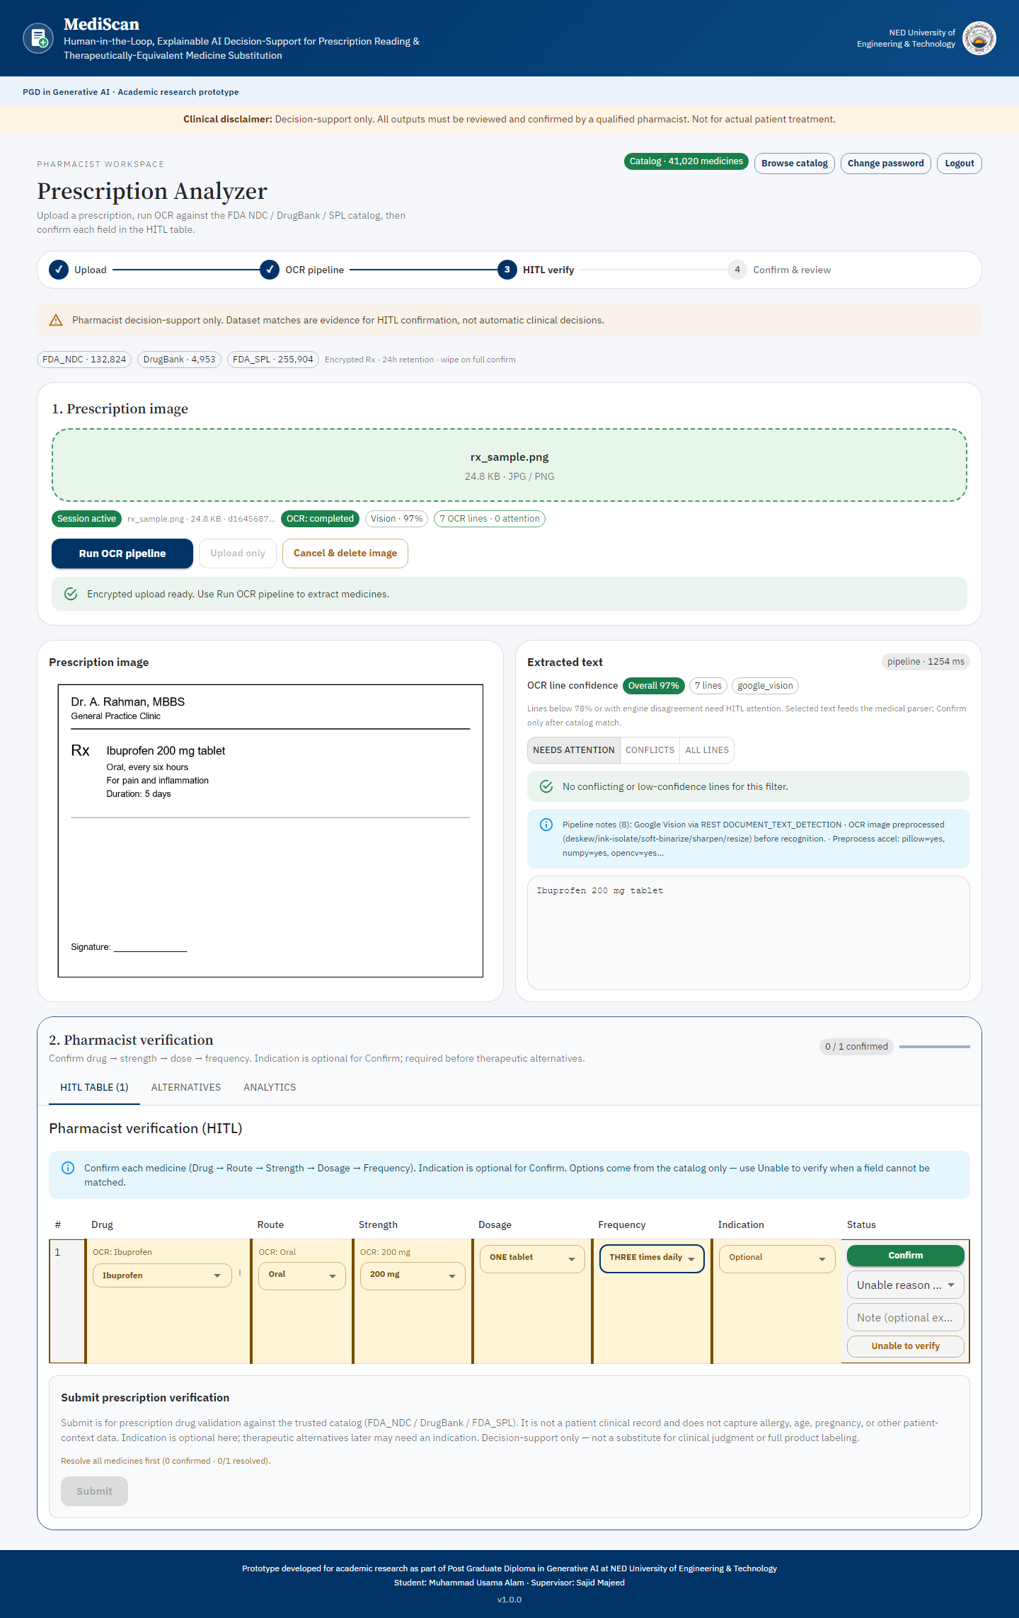
FIGURE 4.2: Application screenshot — the verification gate
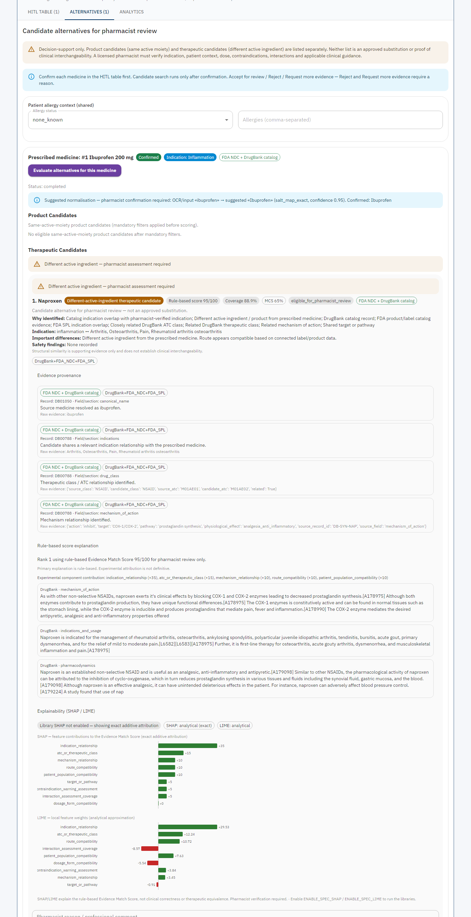
FIGURE 4.3: Application screenshot — recommendation and evidence panel
4.4 RQ1 — Extraction Accuracy
The evaluation harness built for RQ1, intended to compare several OCR engines independently against the same pharmacist-confirmed ground truth, works by injecting synthetic character-level noise into the ground-truth text at a different rate for each named engine, rather than by running each engine against the actual prescription image. This was a deliberate design choice, made explicit in the code itself, to allow the harness's plumbing (the metric computation, the threshold comparison, the reporting format) to be built and tested before every engine could be run live in the evaluation environment. It is not, however, a measurement of real OCR accuracy, and the harness is written to refuse to attach a pass or fail verdict to the numbers it produces for exactly that reason. Reporting those simulated numbers here as if they answered RQ1 would misrepresent what was actually measured, so this report does not do so.
A genuine, non-simulated accuracy signal does exist elsewhere in the system, however: the production analytics path computes word error rate and character error rate for every real session, by comparing the OCR engine's own output for a field against the value the pharmacist subsequently confirmed for that same field. This is a narrower claim than the originally planned multi-engine comparison, it measures single-engine production accuracy rather than comparing several engines against one another, and it is also a self-referential measure in the specific sense that it compares a session's own OCR output against that same session's own pharmacist correction, rather than against an externally constructed gold standard collected independently of the system itself. With two completed sessions logged at the time of writing, this project reports RQ1 as follows: the measurement mechanism exists, is real, and is live in production, but the sample size available at the time of writing is too small to report a word error rate or character error rate figure against the pre-registered threshold with any confidence that the figure would be stable if even a handful more sessions were added. RQ1 is therefore recorded as data collection pending, to be completed in a later iteration once a larger set of pharmacist-confirmed sessions exists, rather than as a pass or fail verdict against the 0.15 and 0.10 thresholds set in Chapter 3.
4.5 RQ2 — Recommendation Quality
The evaluation harness built for RQ2 computes precision at three and recall at three by ranking the pharmacist-judged gold-standard candidates against each other and checking where the valid ones land in that ranking, rather than by taking the system's own live, independently generated candidate list and checking it against the gold standard. Because pharmacist-valid candidates are placed ahead of invalid ones by construction before the ranking even begins, and precision and recall at a fixed cut-off are measured only by which candidates are in the top few regardless of their internal order, re-ordering the valid candidates among themselves by a secondary structural-similarity signal cannot change the resulting precision or recall figure at all. Put plainly, the two conditions the harness was built to compare, with and without the chemical-similarity signal included, are mathematically guaranteed to produce identical precision and recall numbers, so presenting them as a comparison would not be reporting a finding; it would be reporting an artefact of how the metric was constructed.
What the harness does measure genuinely, and what does differ between the two conditions, is the mean structural-similarity coverage among the valid candidates, a measure of how much chemical substructure the recommended alternatives actually share with the prescribed medicine, independent of whether that coverage changes their rank. As with RQ1, however, this figure depends on a pharmacist-judged gold standard of relevant and irrelevant candidates per case, and at the time of writing no such gold-standard judgements had been recorded against the one confirmed evaluation case in the live system. RQ2 is therefore also recorded as data collection pending: the measurement mechanism for structural-similarity coverage is built and understood, the precision-and-recall comparison between conditions as currently constructed would not produce a meaningful finding regardless of sample size, and a future iteration of this work should report structural-similarity coverage instead, once gold-standard judgements have been collected by a pharmacist reviewer, rather than the precision-and-recall comparison originally planned.
4.6 RQ3 — Evidence Grounding
RQ3 compares retrieval strategies, keyword-based retrieval against the FDA label corpus actually used in the live recommendation path, and a separate, embedding-based retrieval mechanism built but held behind a disabled-by-default configuration flag, and measures citation coverage, an unsupported-claim rate, and a semantic-similarity score between a generated explanation and the retrieved source text it was built from. At the time of writing, the semantic-embedding retrieval condition requires a dependency and corpus not enabled in the evaluation environment used for this report, and no case in the live system had been run through either retrieval condition as part of a recorded evaluation run. RQ3 is accordingly also recorded as data collection pending.
It is worth stating a methodological point here regardless of sample size, since it will matter however much data is eventually collected: the semantic-similarity metric this project's own evaluation design specifies carries a known circularity risk, described in Section 3.6.1, whenever a generated explanation is built directly from the same passages the metric then compares it against. Any future figure reported against the 0.80 semantic-similarity threshold should be read alongside this caveat and not presented as a clean, independent measurement unless the explanation text is generated independently of the exact passages used as the comparison reference.
4.7 RQ4 — Explainability and Trust
RQ4 requires structured feedback from a panel of licensed pharmacists, collected under the ethical safeguards set out in Section 3.7, and institutional research ethics approval is a precondition for that data collection to begin at all. Neither the ethics approval process nor panel recruitment had been completed at the time this report was written. Consistent with this project's own integrity rule, stated repeatedly through this chapter because it is the single most important methodological commitment the project makes, RQ4 is recorded here as not conducted rather than estimated, assumed, or illustrated with a small informal sample collected outside the approved process. This is a genuine, acknowledged gap in the work, discussed further as a limitation in Chapter 5, and not a result dressed up to look like one.
What can be reported for RQ4 is that the apparatus the question depends on is built and operational, which is a meaningful partial result in a Design Science Research framing even though it is not an answer to the question itself. The three explanation conditions described in Section 3.5.2 are implemented as a working counterbalanced assignment mechanism, so that a participant can be allocated to the score-only, score-plus-attribution, or score-plus-attribution-plus-provenance condition in a controlled order rather than an arbitrary one. The response-handling path strips free-text and identifying fields before storage, implementing the pseudonymisation safeguard promised in Section 3.7 rather than merely asserting it. The aggregation logic computes means, standard deviations, and per-construct breakdowns by condition, and reports an explicit insufficient-sample status rather than a misleading zero when no responses exist, which is the same availability-status discipline applied across the other three research questions. In other words, the gap in RQ4 is entirely a gap in data collection and institutional approval, not in the instrument or the software: were ethics approval granted and five pharmacists recruited tomorrow, the measurement itself could proceed without further development work. That distinction matters for the recommendations in Chapter 5, because it determines whether the remaining work is a research-governance task or an engineering one.
4.8 Discussion
Taken together, the four research questions describe a project whose build phase substantially succeeded and whose evaluation phase had not yet reached the scale the original study design called for by the time this report was due. That gap is worth discussing directly.
The worked example in Section 4.3 is useful here precisely because it shows what a full RQ2-style evaluation would need to be run at scale to answer the question the research design actually poses. A single query returning a sensible, well-evidenced top candidate is reassuring but is not the same claim as "the system ranks relevant alternatives ahead of irrelevant ones across a representative range of prescriptions," which is what RQ2 asks. The difference between these two claims is exactly the difference between a demonstration and an evaluation, and it is worth being explicit that this project, as submitted, has firm evidence for the former and not yet for the latter. The same point applies to the catalogue-scale figures in Section 4.2: a catalogue of over 900,000 product records is a real and substantial piece of engineering work, but its scale says nothing on its own about whether the recommendations drawn from it are clinically sound in aggregate, which only the pending RQ2 evaluation, once a gold standard exists, could actually establish.
It is also worth returning to the literature reviewed in Chapter 2 and asking, how well the system as built actually honours it. Section 2.4's discussion of therapeutic equivalence argued that regulatory determination should be the primary substitution signal and chemical similarity only a subordinate one; the worked example shows this holding exactly as intended on the different-ingredient path, where the Orange Book annotation for naproxen was attached as supporting evidence and played no part in ranking naproxen above the other four candidates. Section 2.5's discussion of interpretable-by-design models over post-hoc explanation is borne out directly by the feature-attribution output in Section 4.3, which states the exact arithmetic behind the score rather than an approximation of it, exactly the property Rudin (2019) argues high-stakes systems should have, and a sharper property than the local, approximate attributions Ribeiro et al. (2016) and Lundberg and Lee (2017) describe for genuinely opaque models. Section 2.7's argument that a human checkpoint should sit before consequential processing, not after it, is reflected in the verification gate confirmed in Section 4.2 to be enforced at the server rather than only in the interface. Where the system falls short of its own stated design, chiefly the chemical-similarity bonus discussed in Section 4.9 below, this report says so in the same register it uses to describe where the design succeeded, rather than quietly downplaying it.
Three distinct causes sit behind it, and they are not all the same kind of problem. The RQ1 and RQ2 gaps are, in part, measurement-design problems rather than purely data-volume problems: even with a full twenty-five to thirty confirmed cases in hand, the RQ1 harness as currently built would still only produce simulated multi-engine numbers rather than real ones, and the RQ2 harness as currently built would still produce identical precision and recall across its two comparison conditions by construction. Collecting more data would not, on its own, fix either of these; the harnesses themselves would need further work, redirecting RQ1 toward the real single-engine production signal already described in Section 4.3, and redirecting RQ2's condition comparison toward the structural-similarity coverage metric that genuinely does differ. The RQ3 gap is closer to a pure configuration and data-collection problem: the mechanism exists and the circularity caveat is already understood, and what remains is enabling the semantic retrieval path and running cases through it. The RQ4 gap is an ethics and recruitment lead-time problem, not a code or measurement problem at all; the survey instrument, the consent materials, and the condition-assignment logic are all built and working, and what remains is the institutional approval process and the recruitment of five licensed pharmacists, neither of which a software project can shorten by writing more code.
This discussion matters for how the rest of this report should be read. Chapter 2 and Chapter 3 describe a system whose design draws carefully on the literature reviewed there, and the system that was actually built does, by direct inspection of its code, implement that design faithfully in almost every respect examined for this report. What this chapter adds is the honest further step: a design faithfully implemented is not the same thing as a design empirically validated, and this project, as submitted, has substantially completed the former without yet completing the latter. Chapter 5 returns to this distinction when discussing recommendations for the work that remains.
4.9 Known Limitations of the Current Implementation
Beyond the data-collection gaps discussed above, nine specific limitations in the current implementation were identified during this project and are recorded here plainly. Seven were identified during development and review of the implementation against the design principles in Chapter 2; the final two were discovered in the course of running the worked example reported in Section 4.3, which is itself an argument for exercising a system against real queries rather than reasoning only about its source code.
First, the chemical-similarity bonus described in Section 3.3.4 does influence candidate ranking on the same-active-moiety path, even though Section 2.4's review of the therapeutic-equivalence literature argues that regulatory determination should be the primary signal and structural similarity only a subordinate one. The bonus is correctly suppressed on the different-active-ingredient path, where applying it would risk implying an equivalence no regulator has determined, but its presence on the same-moiety path is a real departure from the stated design principle rather than a fully resolved implementation of it. This is recorded here rather than left unmentioned, because the distinction between evidence that informs a pharmacist's own judgement and evidence that silently shapes what the pharmacist sees first is close to the project's central safety claim, and the current implementation does not yet hold that line as cleanly on every path as the design intends.
Second, the evidence-retrieval layer is not entirely passive in the way the regulatory equivalence layer is. When no supporting label passage can be found for a candidate, the system withholds the narrative summary rather than generating one without support, which is a deliberate and defensible choice given the unsupported-claim risk discussed in Section 2.6, but it does mean the layer affects what a pharmacist sees rather than purely annotating a result that was already going to be shown regardless.
Third, the human-in-the-loop audit trail described in Section 3.3.2 is append-only by application convention, meaning no code path in the system currently issues an update or delete against it, rather than by a database-enforced constraint such as a trigger or a restricted permission grant that would make such a modification impossible even for a future change to the code. Adding that database-level enforcement is a well-understood, comparatively small piece of remaining work, and its absence does not indicate any known tampering; it indicates that the current guarantee rests on the discipline of the code as written rather than on the database itself.
Fourth, the nine-component scoring model implemented in the live system differs in structure from an earlier three-component formula described in an internal design specification document produced before this report. The divergence is structural, not merely a matter of adjusted weights; strength now operates as part of the mandatory eligibility gate described in Section 3.3.4 rather than as one of the nine graded, weighted components. This is a deviation from an internal specification document, not from the formally approved PGD project proposal submitted for this project, which specified only that the system compute a transparent, weighted relevance score and did not fix any particular number of components. The implemented nine-component model is, if anything, more granular and more individually interpretable than the originally sketched three-component version, but the divergence from the internal specification is noted here as something that should be reconciled with the project supervisor as an approved amendment, rather than left as an undocumented drift from an earlier internal plan.
Fifth, the semantic-similarity measure specified for RQ3 carries the circularity risk already discussed in Section 3.6.1 and again in Section 4.6: any future figure reported against it should be read alongside that caveat rather than as a clean, independent measurement, unless the generated explanation is produced independently of the exact passages the metric compares it against.
Sixth, the equivalence determinations the system draws on are specific to one regulatory jurisdiction, as discussed in Section 3.4.1. The system's equivalence evidence is correct for that jurisdiction and should not be assumed to transfer unmodified to a health system operating under a different regulator's determinations, Pakistan's own regulatory authority among them.
Seventh, one of the OCR engines available to the system is platform-sensitive in practice and does not run identically across every environment it was tested in during development; this constrains where a future multi-engine RQ1 comparison can actually be executed, and any such comparison should record which environment each engine's figures were measured in rather than presenting them as environment-independent.
Eighth, the mandatory eligibility filters do not gate as strictly as Section 3.3.4 describes, at least on the different-active-ingredient path. As Section 4.3 records, the route check accepted a candidate whose route string contained the prescribed route as one element among several, admitting an injectable product on the strength of an oral alternative presentation, and accepted a buccal route as matching an oral one. The dosage-form check, meanwhile, compared null values on both sides and so passed every candidate without discriminating. Both are correctable: the route comparison needs to require that the prescribed route be available as a usable administration route for the candidate rather than merely present in its route string, and the dosage-form comparison needs to treat a missing value on either side as a failure to establish compatibility rather than as a match. Until they are corrected, the description of these filters as hard gates overstates what they currently enforce, and this report's Chapter 3 description should be read with that qualification.
Ninth, the nine-component score discriminates between candidates more coarsely than its component count suggests. Because each component awards either its full weight or nothing, candidates failing the same subset of components receive identical totals, as all four lower-ranked candidates in Section 4.3 did. A genuine therapeutic alternative and an implausible one can therefore be presented to the pharmacist with the same score, which weakens the ranking's usefulness even though the score itself remains exactly explainable. Introducing graded awards for the components that admit degrees of match, rather than a binary award for all nine, would be the natural remedy and is recommended as future work in Chapter 5.
None of these nine limitations is expected to prevent the project from being completed to a satisfactory standard. They fall into three groups. Two of them, the fifth and the seventh, concern how a future result should be read or where it can be measured, rather than obstacles to measuring it at all. Four, the third, sixth, eighth and ninth, are well-understood pieces of remaining engineering work with known remedies. The remaining three, the first, second and fourth, are design questions about where the boundary between evidence and instruction should sit, and these are the ones that warrant discussion with the supervisor rather than simply being coded away. They are recorded here in full because a report that presented only the parts of the system that worked as intended, and omitted the parts that did not, would give an inaccurate account of where the project actually stands.

CHAPTER 5: CONCLUSION AND RECOMMENDATIONS
5.1 Conclusions
This project set out to build and evaluate MediScan, a human-in-the-loop, explainable decision-support prototype intended to help a pharmacist read a prescription correctly and identify a therapeutically relevant alternative when the prescribed medicine cannot be supplied. The build phase of that aim was substantially achieved. A working application exists, is deployed publicly, and runs the full pharmacist workflow, upload, multi-engine OCR extraction, mandatory field-by-field verification, recommendation, regulatory-equivalence annotation, evidence retrieval, and explanation, end to end against a real drug-knowledge catalogue of over nine hundred thousand product records assembled from FDA and DrugBank sources. The verification gate at the centre of the system's safety model was confirmed, by direct inspection of the code that enforces it, to be a genuine server-side constraint rather than a cosmetic one, and the recommendation engine's scoring model was confirmed to be exactly what Chapter 3 describes: nine independently weighted components summing to one hundred points, with an explanation layer that states the arithmetic behind each score exactly, without approximation.
The evaluation phase of the project's aim was not completed to the scale the original study design called for. Of the four research questions set out in Chapter 3, none could be answered with a pass or fail verdict against its pre-registered threshold by the time this report was written, because the evaluation dataset behind them, a planned twenty-five to thirty pharmacist-confirmed synthetic prescription cases, stood at one case at the time of writing, and the institutional ethics approval and panel recruitment RQ4 depends on had not been completed. Two of the four research questions, moreover, carry a measurement-design problem that additional data collection on its own would not resolve: the RQ1 evaluation harness currently produces simulated rather than real multi-engine OCR comparisons, and the RQ2 harness's two comparison conditions are, by the mathematics of how the comparison is built, guaranteed to produce identical precision and recall figures regardless of how much data is collected.
This project's single clearest finding, read across the evidence actually in hand, is a disciplined demonstration that the design described in Chapter 3 can be built and does hold together end to end, rather than a validated claim that it performs well against real-world prescriptions at the scale a deployed clinical tool would need. That is a narrower conclusion than the project originally set out to reach, and this report states it as such rather than dressing a partial result up as a complete one. Whether that narrower conclusion still represents a worthwhile contribution is, in the end, for the reader and the examining committee to judge; this report's responsibility was to state plainly what was found and what was not, which it has attempted to do throughout.
5.2 Impacts
Within the scope actually achieved, the project demonstrates that the five technical strands reviewed in Chapter 2, prescription OCR, regulatory therapeutic equivalence, retrieval-grounded evidence, explainable scoring, and a structurally enforced human-in-the-loop gate, can be integrated into a single working system rather than remaining five separate research threads that happen to appear in adjacent papers. The worked example in Section 4.3 shows this integration operating end to end on a real query against a real catalogue: an eligibility filter, a nine-component transparent score, a passive regulatory annotation, and a retrieved evidence passage all contributed to one traceable, explainable result, subject to the candidate-plausibility and filter weaknesses recorded as the eighth and ninth limitations in Section 4.9. Demonstrating that this combination is buildable at all, and documenting where parts of it still fall short of the design's own stated principles, is itself a genuine, if modest, contribution to the research gap identified in Section 2.8. It is worth adding that those shortfalls were found by inspecting the system's own component-by-component output, which is an argument in favour of the interpretable design the project adopted: an opaque ranker returning the same five candidates would have offered no comparable way to discover why.
5.3 Future Outlook
The most direct next step is completing the evaluation this report could not: constructing the full twenty-five to thirty case synthetic dataset, obtaining pharmacist-confirmed ground truth across it, and running RQ1 through RQ3 to a real pass or fail verdict against the thresholds set in Chapter 3. Doing so credibly requires two pieces of further engineering work alongside the data collection itself: redirecting RQ1 toward the real, single-engine production accuracy signal already confirmed working in Section 4.2, rather than the currently simulated multi-engine harness, and redirecting RQ2 toward the structural-similarity coverage metric that genuinely differs between conditions, rather than the precision and recall comparison that cannot. RQ4 depends on a separate, non-technical next step, institutional ethics approval and the recruitment of five licensed pharmacists, and should be planned for accordingly, since neither can be shortened by further development work on the application itself.
Two corrections should be treated as more urgent than the rest, because they affect what a pharmacist is actually shown. The eligibility filters need to gate as Section 3.3.4 describes: the route comparison should require that the prescribed route be a usable administration route for the candidate rather than merely appear somewhere in its route string, and the dosage-form comparison should treat an absent value on either side as a failure to establish compatibility rather than as a match. Alongside that, the scoring model should award graded rather than binary credit for those components that admit degrees of match, so that a genuine therapeutic alternative is not presented with the same score as an implausible one. Together these two changes would have excluded or demoted the implausible candidates discussed in Section 4.3, and neither is a large piece of work.
Beyond completing the evaluation as originally planned, two further directions follow naturally from the remaining limitations recorded in Section 4.9. Reconciling the chemical-similarity bonus's effect on same-moiety ranking with the principle that regulatory equivalence should be the primary signal, either by removing the bonus from the ranking calculation and presenting it purely as annotation, or by formally documenting and justifying its inclusion with the project supervisor's sign-off, would close the single limitation this report considers closest to the project's central safety claim. Enforcing the human-in-the-loop audit trail's append-only property at the database level, through a trigger or a restricted permission grant, rather than relying only on the discipline of the application code, would convert a currently procedural guarantee into a structurally enforced one.
5.4 Lessons Learned
Several lessons from this project are worth recording for their own sake, independent of the specific technical findings above. Pre-registering research questions, metrics, and acceptance thresholds before any evaluation was run, as Chapter 3 describes, surfaced two genuine design problems in the RQ1 and RQ2 harnesses before a single real result had been produced, which is a considerably better outcome than discovering those same problems after reporting numbers that later had to be retracted or re-explained. Separating the build phase from the evaluation phase as explicitly as the Design Science Research paradigm encourages (Peffers et al., 2007) made it possible to state clearly, in this report, exactly which phase the project had and had not completed, rather than blurring the two together into a single ambiguous account of progress. Building the evaluation infrastructure, the RQ1 through RQ4 harnesses, the availability-status model that distinguishes a genuinely unmeasured metric from a measured zero, and the audit trail that supplies ground truth, as early and as seriously as the pharmacist-facing application itself turned out to matter more than expected; it is the reason this report can state precisely why certain results are unavailable rather than only that they are.
5.5 Limitations of the Study
The limitations specific to the current software implementation are recorded in full in Section 4.9 and are not repeated here. Beyond those, three limitations attach to the study as a whole, as distinct from the artefact it produced. First, no quantitative result in this report is based on a dataset larger than a single confirmed case; every number this report could have reported against a pre-registered threshold is instead recorded as pending, and a future iteration completing that data collection may find results that differ materially, in either direction, from what a reader might reasonably guess from the system's design alone. Second, the qualitative RQ4 strand was not conducted at all, so this report contains no empirical evidence, of any kind, about how a working pharmacist actually experiences the system's explanations or whether those explanations genuinely affect trust in the way Tonekaboni et al. (2019) and the wider clinical explainability literature discussed in Section 2.5 suggest they might. Third, every synthetic prescription and evaluation case referenced anywhere in this project is synthetic by design, and the system's behaviour on the far more varied handwriting, abbreviation conventions, and clinical phrasing found in genuine prescriptions from routine practice remains untested.
5.6 Recommendations
For any continuation of this project, the single highest-priority recommendation is to complete the evaluation dataset before attempting to draw any further conclusion about the system's real-world performance; a well-built application whose claims rest on one data point is not yet a validated one, however carefully the application itself was constructed. Closely behind that, redirecting the RQ1 and RQ2 measurement approach along the lines set out in Section 5.3, rather than continuing to run the currently simulated and self-referential harnesses at larger scale, would avoid investing further data-collection effort into a measurement that cannot answer the question it was designed to answer regardless of sample size. Obtaining ethics approval for the RQ4 pharmacist panel should begin as early as institutionally possible, given its lead time is independent of any other work on the project. Finally, for any reader or future developer extending this codebase, the project's own integrity rule, that a metric is reported only when real data backs it and is otherwise marked unavailable rather than estimated, is recommended as a standing practice worth preserving beyond this report, since it is the single methodological commitment that made this chapter possible to write honestly.

REFERENCES
Ancker, J. S., Edwards, A., Nosal, S., Hauser, D., Mauer, E., & Kaushal, R. (2017). Effects of workload, work complexity, and repeated alerts on alert fatigue in a clinical decision support system. BMC Medical Informatics and Decision Making, 17(1), 36. https://doi.org/10.1186/s12911-017-0430-8
Aronson, J. K. (2009). Medication errors: Definitions and classification. British Journal of Clinical Pharmacology, 67(6), 599-604. https://doi.org/10.1111/j.1365-2125.2009.03415.x
Bates, D. W., Kuperman, G. J., Wang, S., Gandhi, T., Kittler, A., Volk, L., Spurr, C., Khorasani, R., Tanasijevic, M., & Middleton, B. (2003). Ten commandments for effective clinical decision support: Making the practice of evidence-based medicine a reality. Journal of the American Medical Informatics Association, 10(6), 523-530. https://doi.org/10.1197/jamia.M1370
Colgan, S., Faasse, K., Martin, L. R., Stephens, M. H., Grey, A., & Petrie, K. J. (2015). Perceptions of generic medication in the general population, doctors and pharmacists: A systematic review. BMJ Open, 5(12), e008915. https://doi.org/10.1136/bmjopen-2015-008915
Es, S., James, J., Espinosa-Anke, L., & Schockaert, S. (2024). RAGAs: Automated evaluation of retrieval augmented generation. In Proceedings of the 18th Conference of the European Chapter of the Association for Computational Linguistics: System Demonstrations (pp. 150-158). Association for Computational Linguistics.
Friedman, C., Rindflesch, T. C., & Corn, M. (2013). Natural language processing: State of the art and prospects for significant progress, a workshop sponsored by the National Library of Medicine. Journal of Biomedical Informatics, 46(5), 765-773. https://doi.org/10.1016/j.jbi.2013.06.004
Graves, A., Liwicki, M., Fernandez, S., Bertolami, R., Bunke, H., & Schmidhuber, J. (2009). A novel connectionist system for unconstrained handwriting recognition. IEEE Transactions on Pattern Analysis and Machine Intelligence, 31(5), 855-868. https://doi.org/10.1109/TPAMI.2008.137
Hevner, A. R., March, S. T., Park, J., & Ram, S. (2004). Design science in information systems research. MIS Quarterly, 28(1), 75-105. https://doi.org/10.2307/25148625
Jain, R., Sharma, A., & Malhotra, M. (2021). Handwriting recognition for medical prescriptions using a CNN-Bi-LSTM model. In Proceedings of the 2nd International Conference on Intelligent Engineering and Management (ICIEM) (pp. 596-601). IEEE. https://doi.org/10.1109/ICIEM51511.2021.9445317
Kesselheim, A. S., Misono, A. S., Lee, J. L., Stedman, M. R., Brookhart, M. A., Choudhry, N. K., & Shrank, W. H. (2008). Clinical equivalence of generic and brand-name drugs used in cardiovascular disease: A systematic review and meta-analysis. JAMA, 300(21), 2514-2526. https://doi.org/10.1001/jama.2008.758
Lambert, B. L., Lin, S.-J., Chang, K.-Y., & Gandhi, S. K. (1999). Similarity as a risk factor in drug-name confusion errors: The look-alike (orthographic) and sound-alike (phonetic) model. Medical Care, 37(12), 1214-1225. https://doi.org/10.1097/00005650-199912000-00005
Lewis, P., Perez, E., Piktus, A., Petroni, F., Karpukhin, V., Goyal, N., Küttler, H., Lewis, M., Yih, W., Rocktäschel, T., Riedel, S., & Kiela, D. (2020). Retrieval-augmented generation for knowledge-intensive NLP tasks. In Advances in Neural Information Processing Systems 33 (NeurIPS 2020) (pp. 9459-9474). Curran Associates.
Li, M., Lv, T., Chen, J., Cui, L., Lu, Y., Florencio, D., Zhang, C., Li, Z., & Wei, F. (2023). TrOCR: Transformer-based optical character recognition with pre-trained models. Proceedings of the AAAI Conference on Artificial Intelligence, 37(11), 13094-13102. https://doi.org/10.1609/aaai.v37i11.26538
Lundberg, S. M., & Lee, S.-I. (2017). A unified approach to interpreting model predictions. In Advances in Neural Information Processing Systems 30 (NIPS 2017) (pp. 4765-4774). Curran Associates.
Parasuraman, R., & Manzey, D. H. (2010). Complacency and bias in human use of automation: An attentional integration. Human Factors, 52(3), 381-410. https://doi.org/10.1177/0018720810376055
Peffers, K., Tuunanen, T., Rothenberger, M. A., & Chatterjee, S. (2007). A design science research methodology for information systems research. Journal of Management Information Systems, 24(3), 45-77. https://doi.org/10.2753/MIS0742-1222240302
Ribeiro, M. T., Singh, S., & Guestrin, C. (2016). "Why should I trust you?": Explaining the predictions of any classifier. In Proceedings of the 22nd ACM SIGKDD International Conference on Knowledge Discovery and Data Mining (pp. 1135-1144). Association for Computing Machinery. https://doi.org/10.1145/2939672.2939778
Rudin, C. (2019). Stop explaining black box machine learning models for high stakes decisions and use interpretable models instead. Nature Machine Intelligence, 1(5), 206-215. https://doi.org/10.1038/s42256-019-0048-x
Sarpatwari, A., Gagne, J. J., Lu, Z., Dutcher, S. K., Jiang, W., & Kesselheim, A. S. (2018). Generic versions of narrow therapeutic index drugs: A national survey of pharmacists' substitution beliefs and practices. Clinical Pharmacology & Therapeutics, 103(5), 816-824. https://doi.org/10.1002/cpt.830
Tabassum, S., Rahman, M. M., Hossain, M. S., Rahman, M. A., & Khan, M. I. (2021). Recognition of doctors' cursive handwritten medical words by using bidirectional LSTM and SRU with grid search. In 2021 IEEE 12th Annual Ubiquitous Computing, Electronics & Mobile Communication Conference (UEMCON) (pp. 790-796). IEEE.
Tonekaboni, S., Joshi, S., McCradden, M. D., & Goldenberg, A. (2019). What clinicians want: Contextualizing explainable machine learning for clinical end use. Proceedings of Machine Learning Research, 106, 359-380.
U.S. Food and Drug Administration. (2024). Approved drug products with therapeutic equivalence evaluations (Orange Book) (45th ed.). U.S. Department of Health and Human Services.
World Health Organization. (2017). Medication without harm: WHO global patient safety challenge. World Health Organization.
Zhang, T., Kishore, V., Wu, F., Weinberger, K. Q., & Artzi, Y. (2020). BERTScore: Evaluating text generation with BERT. In Proceedings of the 8th International Conference on Learning Representations (ICLR 2020).

APPENDICES
Appendix A: Participant Information Sheet
[Insert the re-authored Participant Information Sheet from frontend/src/content/researchDocuments.ts, updated to this project's attribution, once the RQ4 panel is planned.]

Appendix B: Consent Form
[Insert the re-authored consent statements from frontend/src/content/researchDocuments.ts.]

Appendix C: RQ4 Survey Instrument
[Insert the structured Likert-scale questionnaire covering usability, clinical relevance, transparency, trust, and perceived value of explanations, administered externally per Section 3.5.2.]

Appendix D: Turnitin Similarity Report
[Attach the Turnitin similarity report for this submission once generated.]

