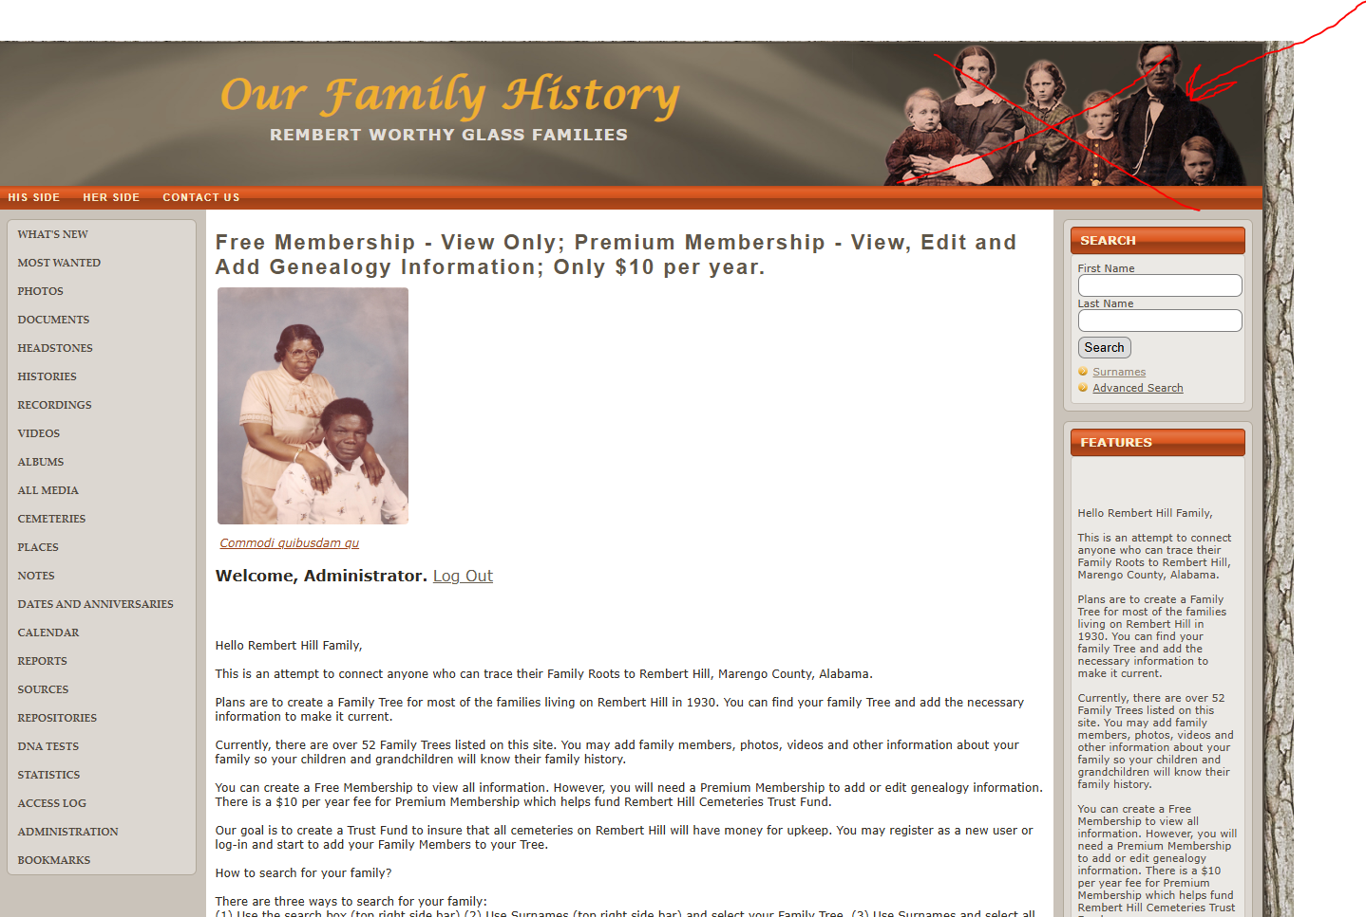
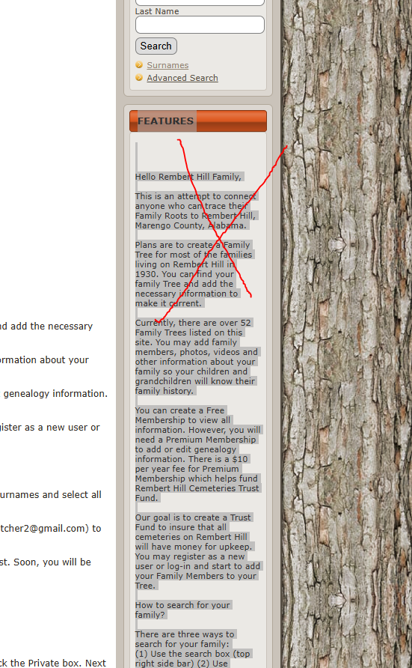
Rewrite it,
Pay on the Reunion (instead of “Donate” just write Pay)
Redirect to paypal.
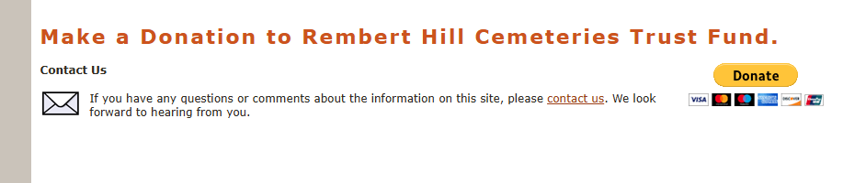

Paypal credentials
Paypal Account for Rembert Worthy Glass:

randyhatcher956@gmail.com PW Buildnow$2024
have to integrate paypal account for two purpose, one is for pay for reunion fee and one is register for membership

