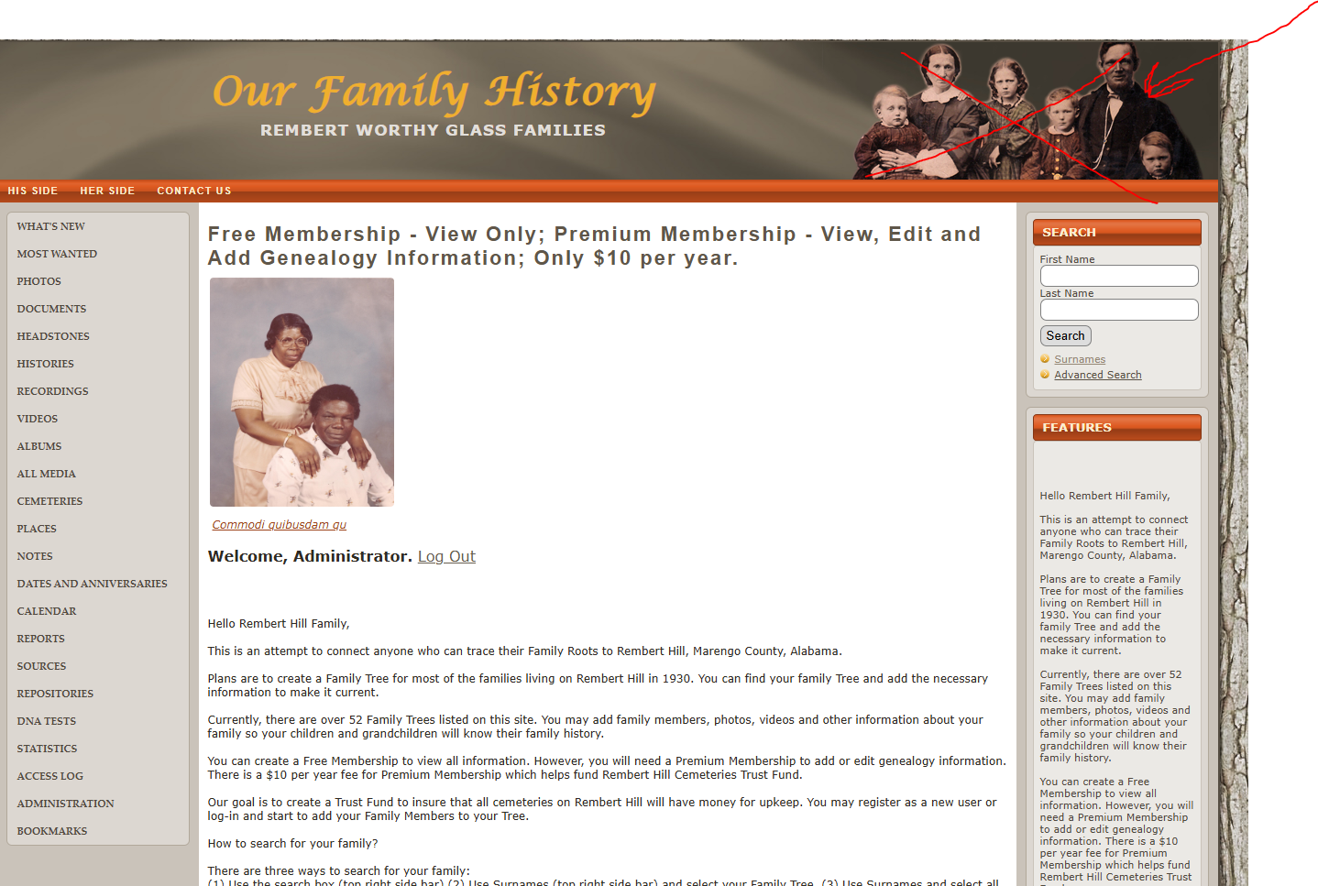

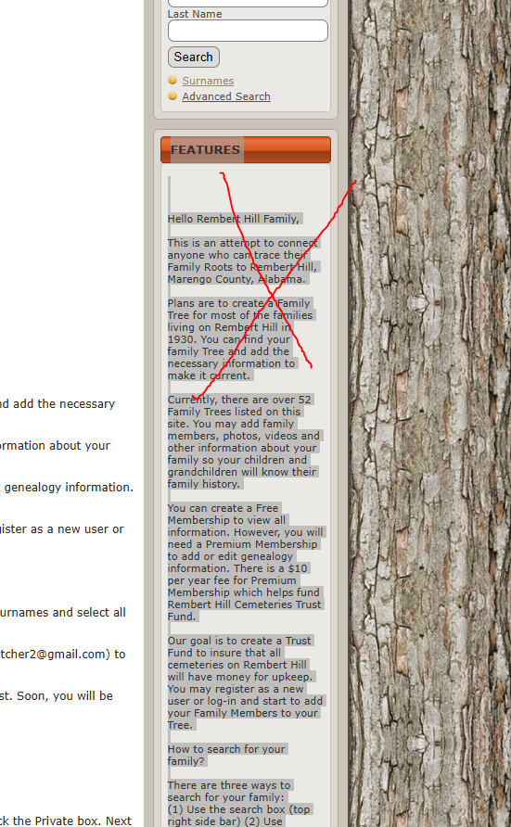

Rewrite it,   
Pay on the Reunion (instead of “Donate” just write Pay)

Redirect to paypal.

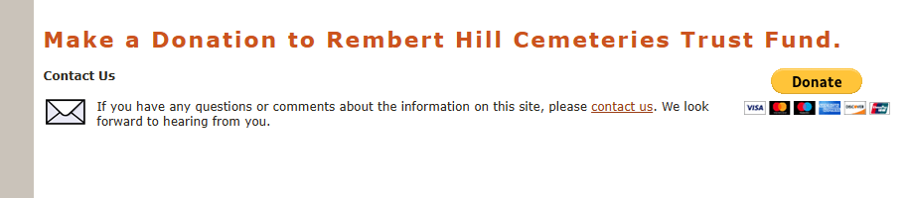

Paypal credentials   
Paypal Account for Rembert Worthy Glass:

randyhatcher956@gmail.com PW Buildnow$2024

have to integrate paypal account for two purpose, one is for pay for reunion fee and one is register for membership