**7PAM2000 Applied Data Science 1**

**Assignment 1**: Visualisation

**Name**: Usama Ali Shabab

# Dataset Link:

The [data](https://www.metoffice.gov.uk/research/climate/maps-and-data/historic-station-data) I am using is about the changing weather patterns at the Bradford station. You can find it at this website:

<https://www.metoffice.gov.uk/research/climate/maps-and-data/historic-station-data>

# Github Link:

[Github Repository](https://github.com/usamaalishabab/7PAM2000_Applied_Data_Science_Assignment_1)

# Graph 1: Temperature Trends in Bradford

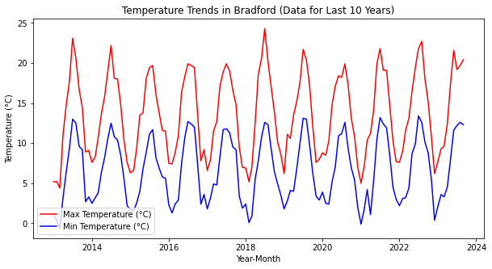

This graph is showing us that over the past 10 years in Bradford, both the maximum and minimum temperatures fluctuate throughout each year, typically reaching their highest points in summer and their lowest points in winter. The highest temperature in the last decade was in 2018, which means that the summer of 2018 was exceptionally hot. On the other hand, the lowest temperature was recorded in 2013, indicating an especially cold winter that year.

# Graph 2: Total Air Frost Days per Year in Bradford

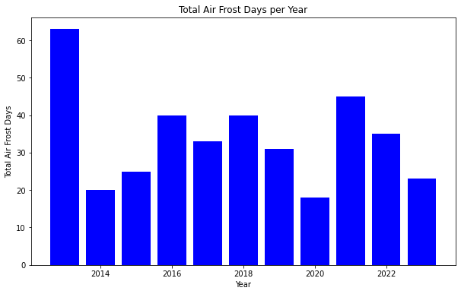

This graph helps us see how many days with frosty air there were each year, from 2013 to 2023. In 2013, there were the most frosty days, indicating a very cold winter that year. On the other hand, in 2020 there were the fewest days, suggesting a milder winter in that year.

A bar graph is perfect A bar graph is perfect for this data because it helps us to easily compare the total number of air frost days over different years. It also clearly shows the trend over time, making it easy to see if the number of air frost days is increasing or decreasing.

# Graph 3: Distribution of Sunshine Hours by Year and Month

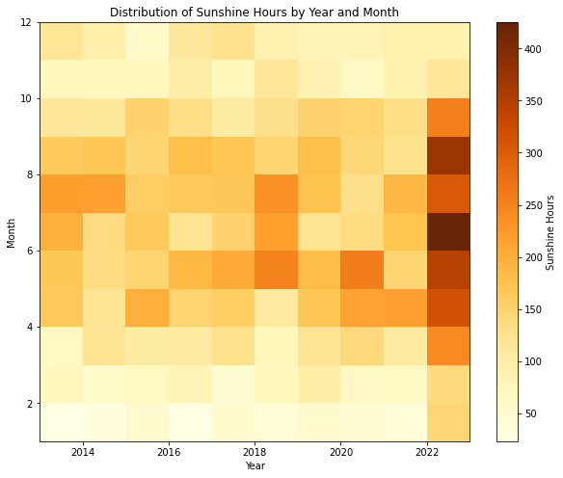

This graph is showing us how the number of sunshine hours has changed each month over the years from 2013 to 2023. The number of sunshine hours can help us understand the climate of a region. More sunshine hours could indicate a sunnier climate, while fewer could suggest a cloudier or rainier climate. We notice that in June 2023, there were the most hours of sunshine, which points to a sunnier and warner period in Bradford.

I have used 2D histogram because it allows us to visualize two dimensions (year and month) and a values (sunshine hours) at the same time. The color in each cell represents the value of sunshine hours, making it easy to spot patterns or trends over time and across months.